© 2024 Margaret Caton
Los Angeles, California

Sacred Refrains:

Arabic and Persian Dhikrs

in the Bahá’í Community

Margaret Caton

Contents
Introduction 1
Intoning Sacred Text 5
Dhikr as a Form of Spiritual Practice 9
Music in Islam 13
Historical Considerations and Examples 14
Formal Aspects of Dhikr 16
Dhikr Categories and Examples 18
Five categories of Dhikrs using Bahá’í Sacred Texts 21
Names and Attributes of God 22
Names and Attributes 23
Invocation 23
Possessives 23
Actions 23
Directives 23
Litany 24
1 Alláh’u’Abhá (الله أبهى) God the All-Glorious 24
Alláh’u’Abhá 1-1 (الله أبهى ١) God the All-Glorious 25
Alláh-u-Abhá, Yá Bahá’u’l-Abhá 1-2 (الله أبهى ٢ يا بهاء الأبهى) God the All-Glorious, O Thou Glory of Glories 26
2 Alláh’u’Rabbuná (اللهُ رَبُّنا) God, Thy Lord 26
3 Ant al-Káfí (لوح انت الكافي) Thou the Sufficing 28
4 Qad Atá’l-Málik (قد اتی المالک) He Who is the Sovereign 30
5 Qul Alláh’u’Ẓáhir (قل الله ظاهر) God is Manifest 32
6 Subbúhun Quddús (سبُّوحٌ قُدُّوسٌ) Holy, Holy 34
Subbúhun Quddús 6-1 (سُبُوحٌ قُدُوس) Holy, Holy 38
Subbúhun Quddús 6-2 (سُبُوحٌ قُدُوس) Holy, Holy 39
7 Ta’álá Man Aẓhar (تعالی من اظهر) The Exalted One 39
8 Yá Alláhu’l-Mustagháth (يا اللهُ المُسْتَغاث) O Thou God Who art Invoked 41
9 Yá Bahá’u’l-Abhá (يا بهاء الأبهى) O Thou Glory of Glories 44
Yá Bahá’u’l-Abhá 9-1 (يا بهاء الأبهى) O Thou Glory of Glories 45
Yá Bahá’u’l-Abhá, Yá ‘Alí’u’l-Alláh 9-2 (يا بهاء الأبهى يا علي الالله) 45
10 Yá Mannán (يَا مَنَّان) O Benefactor 46
11 Yá Núr An-Núr (يا نُورَ النّور) O Light of Light 49
12 Yá Núrassamáváti v’al-Araḍín (یا نورالسماوات و الارضین) O Light of the Heavens and the Earth 51
Praise and Thanks 53
13 Fasubḥána Rabb (فَسُبحانَ رَبِّ) Glory Be to the Lord 55
14 Iláhá Ma’búdá Maliká Maqṣúdá (الها معبودا ملکا مقصودا) My God, my Adored One, my King, my Desire! 55
15 Iláhá Ma’búdá Maqṣúdá Karímá Raḥímá (الها معبودا مقصودا کريما رحيما) My God, the Object of my Adoration 58
Iláhá Ma’búdá Maqṣúdá Karímá 1 (الها معبودا مقصودا کريما رحيما) My God, the Object of my Adoration 59
Iláhá Ma’búdá Maqṣúdá Karímá 2 (الها معبودا مقصودا کريما رحيما) My God, the Object of my Adoration 61
16 Iláhí Iláhí, Ashkuruka Fí (الهی الهی اشکرک فی) O God, My God! I Yield Thee Thanks 63
17 Lak al-Ḥamd (لَكَ الحَمْدُ) Praise Be to Thou 65
18 Subḥánaka Yá Hú (سُبْحانَكَ يا هُو) Glory Be to Thee, O Lord 67
Subḥánaka Yá Hú 1 (سُبْحانَكَ يا هُو۱) Glory Be to Thee, O Lord 69
Subḥánaka Yá Hú 2 (سُبْحانَكَ يا هُو۲) Glory Be to Thee, O Lord 70
Subḥánaka Yá Hú 3 (سُبْحانَكَ يا هُو۳) Glory Be to Thee, O Lord 71
19 Ta’álá’l-Karím (تَعالَی الكَريمُ) Glorified be the All-Merciful 72
20 Tabárak’al-Ladhí (تَبارَکَ الّذی) Hallowed be the Lord 73
Reliance and Trust 75
21 Aud’at-u Nafsí (اودَعتُ نَفسی) I Place Myself 76
22 Ay ‘Alím (ای علیم) O Thou Who art the All-Knowing! 79
23 Dar Har Ḥálat Umídvár Básh (در هر حالت امیدوار باش) Be Thou Ever Hopeful 82
24 Hal Min Mufarrijin (هَلْ مِن مُفِّرجٍ) Remover of Difficulties 83
Hal Min Mufarrijin 1 (۱ هَلْ مِن مُفِّرجٍ) Remover of Difficulties 86
Hal Min Mufarrijin 2 (۲ هَلْ مِن مُفِّرجٍ) Remover of Difficulties 87
Hal Min Mufarrijin 3 (۳ هَلْ مِن مُفِّرجٍ) Remover of Difficulties 89
25 Huva Ḥasbí (هُوَ حَسْبی) God is Sufficient 90
26 Iláhí Iláhí, Tu Bíná va Ágáhí (إلهی إلهی تو بينا و آگاهی) 95
27 Lawḥ-i Shafá (لوح شفا) (Tablet of Healing) 98
Lawḥ-i Shafá 1 (لوح شفا ١) (Tablet of Healing) 98
Lawḥ-i Shafá 2 (لوح شفا ٢) (Tablet of Healing) 100
28 Mánand-i Morgh-i Saḥar (مانند مرغ سحر) Even As the Bird of Dawn 103
Mánand-i Morgh-i Saḥar 1a (مانند مرغ سحر۱) Even As the Bird of Dawn 103
Mánand-i Morgh-i Saḥar 1b (مانند مرغ سحر۱) Even As the Bird of Dawn 105
Mánand-i Morgh-i Saḥar 2 (مانند مرغ سحر۲) Even As the Bird of Dawn 106
29 Qul Alláh-u Yakfí (قُل اللهُ يَكفی) God is Sufficient 107
Qul Alláh-u Yakfí 1 (قُل اللهُ يَكفی١) God is Sufficient 110
Qul Alláh-u Yakfí 2 (قُل اللهُ يَكفی٢) God is Sufficient 112
30 Qul Alláh Yakfí Min Kul-la Shay (قُلِ اللهُ يَكْفِي مِنْ كُلِّ شَيْءٍ) God is Sufficient in All Things 112
31 Qul Alláh Yakfí Kul-la Shay ‘An Kul-la Shay 116
(قلَ اللّه يكفى كلَّ شيء عن كلِّ شيء ) God Sufficeth All Things Above All Things 116
32 Tarání, Yá Iláhí (تَرانی يا الهی) Thou Seest Me, O My God 118
33 Yá Man Vajhuka Ka’batí (يا مَنْ وَجْهُكَ كَعْبَتِيْ) O Thou Whose Face 120
Aid and Assistance 123
34 Allahumma (اَلّلهُمَ) O God 125
Allahumma 1 (اَلّلهُمَ ۱) O God 125
Allahumma 2 (اَلّلهُمَ ۲) O God 127
35 Ay Ghaffár az Má Beh Júdat Dargodhar (درگذر ای غفّار از ما به جودت) O Pardoner, Forgive Us 128
36 Ay Karím Ín ‘Abd Rá Beh Khawd Vá Magodhár 131
(ای کریم این عبد را به خود وا مگذار) O God, Leave Not This Servant to Himself 131
37 Ay Parvardigár Ín ‘Álam-i Ẓolmání (ای پروردگار این عالم ظلمانی) O Lord, This World of Darkness 133
38 Ay Rabb Asqani Kás (أَيْ رَبِّ اسْقِنِي كَأْسَ الفَنَاءِ) Lord! Give me to Drink 134
39 Ay Rabba Faj’al Rizqí Jamálika (اَی رَبِّ فَاجْعَل رِزقی جَمالَکَ) O my Lord! Make Thy Beauty to Be My Food 137
40 Ay Rabba Ṭahhir Ádhán al-‘Ibád (ای رَبِّ طَهِّر آذان العباد) O Lord, Cleanse the Ears 139
41 Huvá Hú, Ay Maḥbúb-i Man (هُوَ هو ، ای محبوب من) He is God, my Beloved 141
42 Iláhá Ma’búdá ‘Ibádat (الها معبودا عبادت) O God, O Adored One, Your Servant 146
43 Iláhí Iláhí Dast-i Qudrat (الهی الهی دست قدرت) O God, my God, Draw Forth the Hand of Power 148
44 ‘Ináyatí Farmá va Mawhabatí (عنایتی فرما و موهبتی بنما) Grant us Thy Favor and Show Us Thy Bounty 150
45 Muḥtájím va Muntaẓiri Tá’íd-i Tu (محتاجیم و منتظر تائید تو) We are In Need and Looking for Thy Help 151
46 Qalban Ṭáhiran (قلباً طاهراً) Create in me a Pure Heart 153
Qalban Ṭáhiran 1 (قلباً طاهراً ١ ) Create in me a Pure Heart 154
Qalban Ṭáhiran 2 ( قلباً طاهراً ٢) Create in me a Pure Heart 155
47 Rabba Yassiri’l Umúr (رَبِّ يسّر الأمور) Ease our Affairs, O Lord 156
48 Subḥánika al-Lahumma Yá Iláhí (سبحانك اللّهمّ يا إلهي) Praised Be Thou, O Lord 157
Nearness and Love 160
49 Ay Dilbar-i Abhá, Ay Maḥbúb-i Yiktá (ای دلبر ابهی ای محبوب یکتا) O most Radiant Beauty, O Matchless Beloved 161
50 Ay Dúst dar Rawḍih-i Qalb (ای دوست در روضه قلب) O Friend! In the Garden of thy Heart 163
51 Ay Khudávand, Tu Sháhid va Ágáhí (ای خداوند، تو شاهد و آگاهی) O Lord, Thou dost See and Know 165
52 Ay Maḥbúb-i Qadím va Yár-i Dilnishín-i Man 167
(ای محبوب قدیم و یار دلنشین من) O my Eternal Beloved and my Adored Friend! 167
53 Himmatí Báyad (همّتی باید) Labour is Needed 169
54 Iláhá Karímá Raḥímá, Beh Dhikrat Zindiham (زنده‌ام الها کریما رحیما، به ذکرت) 170
My God, the Most Generous, the Most Compassionate! I am Alive through Thy Praise 170
55 Iláhá Parvardigár Rá Maḥbúbá Maqṣúdá (الها پروردگارا محبوبا مقصودا) My God, My Provider, my Beloved, my Desire 173
56 Parvardigárá, Har Ánchi Qalb-i Mará (پروردگارا ،هر آنچه قلب مرا) O Thou Provider, Whatever Distances my heart 174
57 Yá Maḥbúb al-‘Áshiqín (یا محبوب العاشقین) O Beloved of them that yearn after Thee 176
58 Yá Maḥbúbí va Maqṣúdí (يا محبوبی و مقصودی ) O Beloved and Desired One 178
Special verses used in place of the Obligatory Prayer: 180
Verse for Exemption (95 times) (Bahá’u’lláh, The Kitáb-i-Aqdas 1992, 23-24): 180
Verses while travelling (Bahá’u’lláh, The Kitáb-i-Aqdas 1992, 24): 181
Verse for Ablution 182
Lawḥ-i-Anta'l-Káfí (The Long Healing Prayer) 183
References 199
Playlist of Dhikr Recordings 210

Introduction

Dhikr is an Arabic word meaning an act of remembering, a reminder, or a practice that engenders remembering or reminding. Dhikr could refer to a spiritual service, an invocation, the Qur’an, or even a religious prophet, all acting as reminders of the divine. Dhikr is also the term used for a type of repeated invocation found in the Islamic and Bahá’í sacred traditions. Although the term refers particularly to Islamic practices, dhikr practices are similar to spiritual practices in other cultures, such as chanting mantras in Hindu traditions. The use of repeated phrases and invocations that includes chanting or singing of sacred phrases has been considered as a form of concentrative meditation (Naranjo and Ornstein 1971, 46-49).
Dhikr can mean, then, to remember, remind, mention, and invoke. In an Islamic context, it refers to remembering God and to remembering who we are and what we are called to be by God (quranreading.com n.d.). As a form of meditation or prayer, it also refers to a specific type of remembrance, such as the repetition of the names of God or short spiritual or sacred phrases as a spiritual practice. This specific form of dhikr can be done silently, spoken, sung, or even danced, employing musical instruments as well, particularly percussion instruments. This repetition in certain contexts may induce a trance-like state believed to heighten spiritual awareness and a sense of presence of and communion with God (Naranjo and Ornstein 1971, 30-31, 47-48, 156).
Though practice of the repetition of short sacred phrases exists in other traditions as well, the term and concept of dhikr itself grew out of an Arabic language and religious tradition. Dhikr has been and continues to be a powerful spiritual and communal practice in Islam, and its influence has continued into the Bábí and Bahá’í Faiths, particularly noticeable in the early beginnings during which time the followers faced overwhelming religious opposition and persecution. Historical references show the use of this practice of repeating sacred verses during sieges of the early Bábís by the Persian government, and during torture, imprisonment, and execution, and it was practiced as a means fortifying the followers’ spirits and strength in the face of tremendous hardships and difficulties and uniting them as a community. Even after the difficulties of nineteenth century Persia in regard to these fervent believers, the practice of dhikr has continued, not only in daily repetition of verses, but in group occasions and worship practices. Juliet Thompson in her Diary, in the early twentieth century, illustrates the practice of dhikr by a group when she was in ‘Akka, on her Bahá’í pilgrimage, where she witnessed seventy believers approaching on foot while chanting. They had walked for three months from Persia to visit ‘Abdu’l-Bahá, the son of Bahá’u’lláh, the Prophet Founder of the Bahá’í Faith. She mentioned that one of the seventy pilgrims recited a chant for them at dinner, which the seventy had sung as they journeyed that long way (Thompson 1983, 107-110):
Praise be to thee, powerful
Hand of ‘Abdu’l-Bahá
May my life be a sacrifice to the mighty
Hand of ‘Abdu’l-Bahá!

The purpose of this present work is not as a scholarly treatise per se or analysis of dhikr, but rather to make available and accessible a selection of recordings of dhikrs using Bahá’í sacred texts in Arabic and Persian languages. These particular dhikrs can be sung individually or in groups, as they are rhythmically measured and melodically composed. They are often categorized in Persian contexts as group dhikr, or dhikr-i dast-i jam’í, due to their fixed melody and steady beat that facilitates group practice. Although the recorded examples included are primarily composed and designed for group singing, they may also be sung by individuals.
In this work, the presented recordings, texts, and musical transcriptions are included primarily for purposes of learning the dhikrs themselves, as well as for learning something about them and their historical contexts. The recorded selections include more commonly known and practiced dhikrs within the Bahá’í community, as well as others that have been recorded by groups or individuals. These recorded examples, then, are a presentation of dhikrs that are available primarily in online formats, and thus would not necessarily be considered either a comprehensive or a representative selection of types that are widely used, as this may vary according to times, places, and communities. While a certain amount of scholarship and historical content is presented to support this collection, these aspects are included more as illustration where available, and are not meant to represent an exhaustive study of dhikr history or practice in Bahá’í contexts.
Although as an ethnomusicologist specializing in Persian music I have academic and experiential background in the study and practice of Persian classical music, until recently I had not focused on chanting or singing of sacred texts within Persian culture. In casual exposure, I had not distinguished song forms or anthems from repetitions of invocations or sacred verses. Neither had I distinguished the chanting of prayers from the singing of prayers and invocations. Singing composed melodies in steady measured rhythm seemed to me to be simply another form of spiritual hymn or song, for example. I had not yet realized that singing repetitions of short phrases could be considered a distinct type of spiritual practice, whether done by an individual or by a group.
One question at the onset is to examine what may distinguish a dhikr from the recitation of a prayer or singing an anthem (sorud). In reviewing the recordings collected and their designations, I found that a short prayer when repeated could be labelled as a prayer or as a dhikr, though dhikrs were traditionally brief invocations or short phrases excerpted from longer prayers. In terms of dhikr itself, the question occurs as to whether there is a difference between individual practice and group practice. We can consider that an individual does have the freedom to repeat phrases silently, or to chant or sing them aloud, whether in an improvised free style rhythmically and melodically or in a composed or fixed format.
I started this project of gathering dhikrs in Arabic and Persian available in the Bahá’í communities using Bahá’í sacred writings while hosting a Bahá’í devotional gathering on Zoom during the Covid pandemic. An Iranian friend asked me if I could find recordings of a list of 15 texts she was given called dhikr (in Persian pronounced zekr and in Arabic dhakar or dhikr). These were dhikr using Bahá’í sacred writings from the Báb, Bahá’u’lláh, and ‘Abdu’l-Bahá. Most of these were short phrases, most of which were in Arabic. I already knew a few of these dhikrs: “Allahumma,” “Subbúhun Quddús,” and “Hal Min Mufarrijin” and had heard them sung in Bahá’í gatherings.
Through the process of reviewing this material, I became aware that the repetition of the Greatest Name, Alláh-u-Abhá (God is Most Glorious) 95 times a day has been considered a dhikr, the repetition of the names of God having also been practiced in Islam, particularly in Sufi circles. I discovered further that dhikr may be repeated silently, spoken out loud, intoned, chanted, or sung. There is great freedom in reciting a dhikr by oneself in terms of style and form. However, when it comes to intoning dhikr in a group, for the most part there needs to be agreement on tempo, rhythm, melody, and form as well as other elements of music to keep the group together. In reviewing the background of dhikr in Islamic practice, particularly reviewing and audio and video recordings of dhikr, it also appeared that in Islamic tradition, movement and even dance, as well as percussive rhythm, have been common elements of the performance of group dhikr as well.
I was able to find recordings of all 15 dhikr I was given to research, presumably at the time serving as a list of dhikr in common usage in Iranian communities, as I later found this same list on a number of online sites, with the addition of one more dhikr in Persian, for a total of 16. During my inquiry, I also found other recordings labelled as dhikr using Bahá’í sacred texts, primarily available online. In order to choose examples to study and to introduce them to those who might wish to learn to sing them, my criteria for inclusion, in addition to the original 16, was the availability of a recording or someone I could record, the use of a sacred Bahá’í text, and the source’s labelling of the piece on the recording as a dhikr. Eventually I became able to recognize dhikr characteristics even if the dhikr was not labelled as such. For all but two of the dhikrs I also found official references and texts, particularly in the Bahá’í Reference Library (https://reference.bahai.org/fa/). There was also one dhikr from a hadith, and others with phrases from the Qur’an.
While dhikr as a practice has existed within the Bábí and Bahá’í communities, particularly prevalent during the early era of Bahá’í history in the mid-nineteenth century, its practice continues today in devotional and other gatherings, intermingled with chanted or recited prayers and other sacred writings. That dhikr practices were a part of the early Bábí and Bahá’í heritage can be observed in historical documents and accounts. To what extent its form, definition, and usages correspond to the dhikr practices in Islam, particularly in Sufism, or to early Bábí and Bahá’í history is subject to further study and analysis.
The recordings themselves represented in this collection do show similarities as well as variations and differences with Sufi dhikr practices and forms, the intensive study of which is not the intended purpose of this work. As an initial observation, it appears that, at least with the recordings presented here, some short invocations in use in Bahá’í contexts are similar and may compare with invocations to names and attributes of God found in Islamic tradition. However, in addition there are dhikrs using longer passages from Bahá’í prayers and tablets, even a complete short prayer, such as the “Remover of Difficulties” prayer, which have been labelled as dhikr in recordings. Given the emphasis on avoidance of ritual practices in the Bahá’í Writings, variations, as well as other developments of the practice of dhikr itself may be expected.
In the first portion of this treatise and compilation, I present a short background on the dhikr tradition in Islamic and Bahá’í contexts and in the second part I present and discuss the individual sung dhikr examples themselves, including the Writings they are from as well as, in some cases, historical context of usage. For general presentation and discussion of texts, I used the standard transliteration guidelines found in Bahá’í publications, but the pronunciation guide for the dhikr examples themselves follow the pronunciation style as found in the recordings.
The second portion, which represents the bulk and focus of the document, includes specific examples of Arabic and Persian dhikrs from the Writings of the Báb, Bahá’u’lláh, and ‘Abdu’l-Bahá (as well as the few examples using excerpts from the Qur’an). The presentation of the dhikrs may include a brief description or history of the material, the Arabic or Persian script, a translation, a Romanized pronunciation guide based on the recordings, as well as music notation and links to recorded examples. The musically notated dhikr examples include chord suggestions, pronunciation guide, and an English version as well as the original Arabic or Persian. The English use authorized translations where available or provisional translations, occasionally modified to fit the melody of the Arabic or Persian language dhikr recording. For the versions in English there also would be slight variations in the rhythm and melody. Though the music notation and chording for either the original language or translated versions do not always fit comfortably into Western rhythmic and melodic notation and chording, nonetheless, the notations and chord suggestions may be useful for studying and learning the dhikrs themselves as a supplement to listening to the recordings. The recordings themselves are grouped together in a separate playlist.
These melodic renderings of dhikrs have been composed or formed by traditional practices as well as by individuals and some have come into common usage. Individuals are able to compose a dhikr on sacred text, whether chanted or sung, repeating short phrases selected from the Bábí or Bahá’í Writings, whether they do so spontaneously in an improvised or composed fashion. The examples presented, in most cases, do not indicate names of composers or even performers, as these were usually not found on the labels and descriptions of these recordings.
In creating a dhikr, what is possible for an experienced singer to perform by themselves as a soloist may be different from what a group of amateur or even professional singers are able to perform in a group setting. As a solo singer, one may take great liberties in rhythmic and melodic nuances that would not only be difficult in a group rendition but may detract from the unity and clarity of the dhikr sound itself. Songs composed with indefinite and flexible melodies and rhythms and nuances that may be suitable for an individual may create a muddied and vague impression in group singing or performance.
Thus, individualistic nuances of ornamentation, slides, rhythmic variation, range of notes, as well as melodic intervals and nuances of melody are more limited in this group style of singing. Both the melody and the rhythm also need to be distinct and steady enough to be remembered and repeated consistently. With simple and steady rhythm, the group is bound together as a community in word, melody, and rhythm, creating a unifying sound and performance experience. When there is a well-known repertoire of dhikrs that are stylistically suited for group singing, one may more readily create a group experience of common energy and bonding by numerous repetitions of well-known dhikrs.
I would like to acknowledge the assistance, support and contributions of Sylvian Castel de Oro, participants of the Beach Communities Dhikr Devotional of the Los Angeles Bahá’í Community, the contributions to the repertoire by the Neakakhtar family in Pakistan, the articles written by and consultation with Steve Scholl and Daniel Pschaida, as well as the contributions and discussions from Jonah Winters and members of the Tarjuman and Tarikh discussion groups, particularly the translation assistance of Adib Masumian.

Intoning Sacred Text

The importance of music in promoting spiritual consciousness and development is mentioned in various passages in the Bahá’í Sacred Writings. The following succinct passage from a Tablet by ‘Abdu’l-Bahá illustrates and introduces the role and impact of chanting sacred texts (Research Department 2019, 2):
The Word of God may be likened to the life-giving breezes of the divine springtime. When chanted in spiritual tones, it bestoweth the breath of life and granteth true salvation. It bringeth forth a garden of roses from the pure soil, and wafteth its musk-laden fragrance throughout the world. (‘Abdu’l-Bahá, from a Tablet—translated from the Persian)
Although music in an Islamic context in the past was subject to much debate and controversy as to its “lawfulness” and merit, Bahá’u’lláh has made it clear, in His book of laws, the profound spiritual effects of music on an individual’s soul (Bahá’u’lláh, The Kitáb-i-Aqdas 1992, 38):
We have made it lawful for you to listen to music and singing. Take heed, however, lest listening thereto should cause you to overstep the bounds of propriety and dignity. Let your joy be the joy born of My Most Great Name, a Name that bringeth rapture to the heart, and filleth with ecstasy the minds of all who have drawn nigh unto God. We, verily, have made music as a ladder for your souls, a means whereby they may be lifted up unto the realm on high; make it not, therefore, as wings to self and passion. Truly, We are loath to see you numbered with the foolish.
Part of what is important and distinctive about the presentation and discussion of music in this book of laws and ordinances, is the bringing of music not only into the status of an acceptable form of practice and worship, but one with inestimable value, and bringing to an end the cloud of suspicion that has caused centuries of dispute over the lawfulness of the practice of music in Islamic traditions. In the past, even the repetitive chanting of the names and attributes of Allah, along with ritual dance and spiritual concerts that were associated with Sufi mystical orders, and which often led to a communal ecstatic state, have carried with them undertones of this same lingering association with that which is unworthy or unlawful. While reading and reciting silently or reading aloud is considered meritorious, the practice of chanting the verses melodiously or singing individual or group dhikr may unconsciously carry along with it traces of stigma from these past attitudes and beliefs. This practice as a result may be viewed by some as outmoded, ritualistic, esoteric, or even unseemly when associated with ecstatic states. Lest the presentation and discussion of the dhikrs presented in this document be a mere curiosity, something for solo performers, or relics from another era or culture, I find it important to address this issue directly. Thus, the following quotation from the book of laws, The Most Holy Book, explicitly spells out recitation “in the most melodious of tones”
Writings in the Bahá’í Faith speak of the salutary effects of intoning, reciting, chanting, and singing spiritual verses. A paragraph from The Kitáb-i-Aqdas: The Most Holy Book describes succinctly and powerfully, some of these effects, including the ability to transport the reciter into spiritual worlds beyond which they can perceive in ordinary reality (Bahá’u’lláh, The Kitáb-i-Aqdas 1992, 61: para. 116) :
They who recite the verses of the All-Merciful in the most melodious of tones will perceive in them that with which the sovereignty of earth and heaven can never be compared. From them they will inhale the divine fragrance of My worlds—worlds which today none can discern save those who have been endowed with vision through this sublime, this beauteous Revelation. Say: These verses draw hearts that are pure unto those spiritual worlds that can neither be expressed in words nor intimated by allusion. Blessed be those who hearken.
Emphasis is placed in the Bahá’í Sacred Writings on intoning, chanting, and singing the sacred texts in a beautiful voice, describing the effect this has in reinforcing the power and internalization of the words, as in the following quote from Bahá’u’lláh, in English (Bahá'u'lláh, Gleanings 1990, 295), and then in the original Arabic (Bahá'u'lláh, Muntabikhat-i az Ásár-i Haḍrat-i Bahá'u'lláh n.d., #136:189-190):
Intone, O My servant, the verses of God that have been received by thee, as intoned by them who have drawn nigh unto Him, that the sweetness of thy melody may kindle thine own soul, and attract the hearts of all men. Whoso reciteth, in the privacy of his chamber, the verses revealed by God, the scattering angels of the Almighty shall scatter abroad the fragrance of the words uttered by his mouth, and shall cause the heart of every righteous man to throb. Though he may, at first, remain unaware of its effect, yet the virtue of the grace vouchsafed unto him must needs sooner or later exercise its influence upon his soul. Thus have the mysteries of the Revelation of God been decreed by virtue of the Will of Him Who is the Source of power and wisdom.
ان اقرأ یا عبد ما وصل الیک من آثار الله بربوات المقرّبین لتستجذب بها نفسک و تستجذب من نغماتک افئدة الخلایق اجمعین و من یقرأ آیات الله فی بیته وحده لینشر نفحاتها ملائکة النّاشرات الی کلّ الجهات و ینقلب بها کلّ نفس سلیم ولو لن یستشعر فی نفسه ولکن یظهر علیه هذا الفضل فی یوم من الأیّام کذلک قدّر خفیّات الأمر من لدن مقدّر حکیم
Another selection emphasizes the effect of the sound vibrations of music ('Abdu'l-Bahá, Selections from the Writings of 'Abdu'l-Bahá 1978, 145:#129):
It is even as a voice wondrously sweet, or a melody played: although sounds are but vibrations in the air which affect the ear’s auditory nerve, and these vibrations are but chance phenomena carried along through the air, even so, see how they move the heart. A wondrous melody is wings for the spirit, and maketh the soul to tremble for joy.
It is encouraged, nay enjoined, in The Most Holy Book, to teach children sacred verses that they may recite them musically, “in most melodious tones”, in the places of worship while in a transported state inspired by one’s connection with the Almighty (Bahá’u’lláh, Kitáb-i Aqdas 1992, 74: para.150)
Teach your children the verses revealed from the heaven of majesty and power, so that, in most melodious tones, they may recite the Tablets of the All-Merciful in the alcoves within the Mashriqu’l-Adhkárs. Whoever hath been transported by the rapture born of adoration for My Name, the Most Compassionate, will recite the verses of God in such wise as to captivate the hearts of those yet wrapped in slumber. Well is it with him who hath quaffed the Mystic Wine of everlasting life from the utterance of his merciful Lord in My Name—a Name through which every lofty and majestic mountain hath been reduced to dust.
Here Mashriqu’l-Adhkár, which means “the Dawning-place of the praise of God”, is the name of the Bahá’í House of Worship and its dependencies (Bahá’u’lláh, The Kitáb-i-Aqdas 1992, 253). It is to be noted that adhkár is the plural for the word dhikr, meaning mention, remembrance. Abdu’l-Bahá refers to a pure heart as the dawning-place of the mention of God (Research Department 2017, 17):
Truly, pure and radiant hearts are the dawning-places of the mention of God from which the melodies of supplication and prayer continually reach the Concourse on high. I beg of God to make each of your hearts a divine temple in which the lamp of the Most Great Guidance may be lit. Should the hearts receive a bounty such as this, they would assuredly exert the utmost endeavour and become fully determined to build the Mashriqu’l-Adhkár, so that the outward frame may reveal the inward reality and the outer form give tidings of the inner meaning.
As to the nature of the music that forms part of the worship in these Houses of Worship, a number of passages from the statement prepared by the Research Department of the House of Justice based on excerpts from the Bahá’í Writings include vocal music based on sacred writings (Research Department 2017, 5):
Such worship may also include vocal music. In letters written on its behalf, the House of Justice clarifies that lyrics sung in the House of Worship should be “based upon Bahá’í or other sacred writings”, including the Writings and talks of ‘Abdu’l-Bahá, should “contain Bahá’í themes, may involve “the repetition of verses from prayers or selections from the Writings”, and may allow for “slight alterations in the text . . . to conform with musical requirements.” “The musical style of the piece can be determined by the composer, provided that he or she bears in mind the spiritual obligation to treat the Sacred Texts with the propriety, dignity and reverence due them.”
At times, there may still linger questions related to the allowability of music in a sacred context. I have heard, for example, questions about whether group singing of prayers is considered congregational prayer and therefore not allowed according to Bahá’í precepts. There exists guidance from the Bahá’í Universal House of Justice that may be appropriately applied to this question (Hornby 1999, 412) :
It is entirely proper to set prayers to music, and the friends are free to sing prayers in unison…. Singing by a congregation present at a service in the House of Worship should not be confused with congregational prayer prescribed by Bahá’u’lláh for the dead.
Similarly, in another letter from the Universal House of Justice in 1975 ( (Hornby 1999, 461) is stated:
You have asked whether it is permissible for the friends to chant a prayer collectively. There is a difference between chanting a prayer collectively and congregational prayer.
Finally, two Tablets from ‘Abdu’l-Bahá summarize the spiritually uplifting nature of singing and playing music with sacred texts. A Tablet from ‘Abdu’l-Bahá written to a renowned Persian court musician addresses the issue of various cautionary beliefs about music in the past and how music indeed is food for the soul ('Abdu'l-Bahá, Selections from the Writings of 'Abdu'l-Bahá 1978, 112:#74):
O bird that singeth sweetly of the Abhá Beauty! In this new and wondrous dispensation the veils of superstition have been torn asunder and the prejudices of eastern peoples stand condemned. Among certain nations of the East, music was considered reprehensible, but in this new age the Manifest Light hath, in His Holy Tablets, specifically proclaimed that music, sung or played, is spiritual food for soul and heart. The musician’s art is among those arts worthy of the highest praise, and it moveth the hearts of all who grieve. Wherefore, O thou Shahnáz, play and sing out the holy words of God with wondrous tones in the gatherings of the friends, that the listener may be freed from chains of care and sorrow, and his soul may leap for joy and humble itself in prayer to the realm of Glory.
Again, in another passage, is a Tablet written by ‘Abdul’Bahá on the spiritual power of music, written to this same court musician (The Universal House of Justice 1996, 5) (Caton 2021, 373-374):
O servant of Bahá! Music is regarded as a praiseworthy science at the Threshold of the Almighty, so that thou mayest chant verses at large gatherings and congregations in a most wondrous melody and raise such hymns of praise at the Mashriqu'l-Adhkár as to enrapture the Concourse on High. By virtue of this, consider how much the art of music is admired and praised. Try, if thou canst, to use spiritual melodies, songs and tunes, and to bring the earthly music into harmony with the celestial melody. Then thou wilt notice what a great influence music hath and what heavenly joy and life it conferreth. Strike up such a melody and tune as to cause the nightingales of divine mysteries to be filled with joy and ecstasy. (From a Tablet to an individual believer- translated from the Persian)

Dhikr as a Form of Spiritual Practice

Though one may set these sacred verses to music and perform them in a gathering, what about the use of these verses set to music as a spiritual practice per se? To what extent can melodious recitation of spiritual verses serve as a meditation practice, whether by an individual or in a group setting, particularly with group singing of these verses? Meditation as a form of spiritual practice is encouraged, but the method is in the main left up to the individual. It is, however, at the same time, enjoined to “Recite the verses of God every morn and eventide” (Bahá’u’lláh, The Kitáb-i-Aqdas 1992, 73).
‘Abdu’l-Bahá has talked about the benefits of meditation, in that it uses the power of insight to bring forth hidden mysteries and connect the meditator to spiritual realities ('Abdu'l-Bahá, Paris Talks 1972, 175):
Meditation is the key for opening the doors of mysteries. In that state man abstracts himself; in that state man withdraws himself from all outside objects; in that subjective mood he is immersed in the ocean of spiritual life and can unfold the secrets of things-in-themselves. To illustrate this, think of man as endowed with two kinds of sight; when the power of insight is being used the outward power of vision does not see. This faculty of meditation frees man from the animal nature, discerns the reality of things, puts man in touch with God.
As quoted in the previous section on intoning sacred text, the admonition found at the beginning of a compilation of Bahá’í prayers is to intone the verses of God with a sweet melody (Bahá'í Prayers 1991, v): “Intone, O My servant, the verses of God that have been received by thee, as intoned by them who have drawn nigh unto Him, that the sweetness of thy melody may kindle thine own soul, and attract the hearts of all men.” Then one might consider to what extent may intoning sacred verses, whether chanting or singing, be used or serve as a spiritual practice.
Claudio Naranjo groups meditation practices into three categories: the way of forms, the negative way, and the expressive way. In distinguishing these types, focus varies from concentration on symbols and objects to that of reflecting on what arises from within the meditator. He places dhikr, from the Islamic tradition, in the first category, that of concentrative meditative practice, as it focuses on a name or attribute of God through repetition, as with the mantras of the Hindu and Buddhist traditions (Naranjo and Ornstein 1971, 16-17, 47-48).
The necessity of remembering God is mentioned numerous times in the Qur’an. There have been differences among practitioners as to method. Among Sufi orders, dhikr, remembrance, is viewed as a means for achieving communion with God. They have distinguished three stages or levels of dhikr practice, dhikr of the tongue, the heart, and the innermost being (Geels 1993, 56-57).
F. Masumian discusses in her chapter on mantra meditation the power of the use of sacred formulas and the names of God throughout many religious practices, including for concentration, strength, healing, and courage. In its role in the Bahá’í Faith, she places particular emphasis on and presents numerous quotations from the Bahá’í writings on remembrance of The Greatest Name as a daily practice as well as calling upon its power in times of difficulty (F. Masumian 2013, 73-92).
Alláh’u’Abhá is considered a form of the Greatest Name of God, which is Bahá, or Glory. One can observe, then, at the outset, the enjoining of the recitation of “Alláh’u’Abhá” (God the All-Glorious) 95 times a day. As to the frequency and importance of its use, ‘Abdu’l-Bahá exhorts (U.S. Supplement Bahá' News No. 80 1964, 2):
The Greatest Name should be found upon the lips in the first awakening moment of early dawn. It should be fed upon by constant use in daily invocation, in trouble, under opposition, and should be the last word breathed when the head rests upon the pillow at night. It is the name of comfort, protection, happiness, illumination, love and unity.
In the Kitáb-i Aqdas the phrase in English is “repeat ‘Alláh-u-Abhá’ ninety-five times” (Bahá’u’lláh, The Kitáb-i-Aqdas 1992, 26). In the original Arabic, the Arabic word used for the translation “repeat” is يذکر (yodhkaro), which is a variation on the word dhikr (mention), and may be thought of as “repeatedly mention” or “mentioning” (Bahá’u’lláh, Kitáb-i Aqdas 1992, 18-19, para. 18).
The following are links to three recorded examples of 95 repetitions of “Alláh’u’Abhá”, ranging from simple to complex, the first two sung by an individual and the third an example of a group performance. The first example is a chant-like, simple melody repeated 95 times, accompanied by a drone instrument, an Indian tambura, centered around a single recitation tone, with inflection below and above https://www.youtube.com/watch?v=4uV1J81Anzs . The second version, performed by Roya Bauman, is sung solo and unaccompanied. It is organized into 5 repeated groups of 19 Alláh’u’Abhá phrases, each phrase consisting of two different 5-note melodic sets of either four or five phrases, each of which is repeated within each 19-phrase section (5+5+4+4+1), This is an example of a composed or fixed melody with measured rhythm organized in a complex way. Whether or not one would choose this relatively complex set as a daily practice is yet another question: https://www.youtube.com/watch?v=ifYJ0ibQKDU . A third example is a of a fusion performance group from London, The Shoreless Sea (formerly known as gyenyame), which also arranges the invocations into five groups of 19 each, based on a simple melody more akin to our first example. However, as a group performance piece, it introduces more complex melodies, harmonies, and rhythms, as well as adding another form of the Greatest Name, Yá Bahá’u’l-Abhá. It includes accompaniment by an orchestra consisting of santur, daf, violin, cello, and 6- and 12- string guitars: https://www.youtube.com/watch?v=8qk0jHXDmcM .
Beyond the use of repetitions of the Greatest Name in one’s daily practice, other dhikrs have been created and used in individual and group practices in a Bábí and Bahá’í context. Examples of these are included in this compilation. Documentation may include examples of the use of dhikr in difficult and extreme circumstances, particularly in the Bábí era, including reciting specific names of God or specific verses from the Báb or from the Qur’an to bolster, assuage, and sustain the believers under extreme circumstances of deprivation, torture, and danger. When reading these historical accounts, the power of this practice becomes evident.
Beyond the early beginnings of the Bahá’í era, the practice of dhikr has continued, using phrases from The Báb’s and Bahá’u’lláh’s Writings as well as those by ‘Abdu’l-Bahá, and is still being practiced to an extent among Arabic and Persian speakers. Certain dhikrs are known to non-Arabic and non-Persian speakers as well, though they might be viewed by some as a repeated song rather than as a dhikr. Dhikr, aside from its larger meaning of “mention” or “remember,” in practice commonly refers to repeated invocations or short repeated phrases from larger tablets or prayers. Translation of dhikrs or other repetitive chants into English or other languages are practiced to an extent, particularly the recitation of the short Remover of Difficulties prayer (See “Hal Min Mufarrijin”).
A question may arise as to the benefit of chanting in the original language versus using a translation. In some traditions, such as in the traditions of japa meditation, which uses repetition of mantras, placing emphasis on the quality of the sound vibration and pronunciation of the mantras is considered essential. The belief is that the mantras are constructed from combinations of the sounds from the sacred language of Sanskrit, for example. The Sanskrit names of God are believed to carry the ability to evoke the deity of the particular mantras that carries this name (Devananda 1981, 44, 51). Thus, in the traditional understanding of Hindu mantra chanting it is often thought that the effect of the mantra derives from the vibrational sound properties of the language itself (Lee 2020, 12).
As has been mentioned, in the Islamic tradition, Arabic is the language of revelation as it is the language of the Qur’an, Islam’s holy book. Because of Arabic’s station as the language of revelation, as well as other factors, the daily obligatory prayers, the salat, which originate from the Qur’an, are generally recited in Arabic regardless of the person’s country or native tongue, partly, though, as a way of unifying the Islamic community (Anwaar 2017). Of consideration is that in addition to the difficulty of keeping the exact meaning in translating from one language to another, the Qur’an in Arabic is seen as the word of Allah and any translation then becomes an interpretation by a human being (Sheriff n.d.). It is to be noted that in The Most Holy Book of the Bahá’í Faith, The Kitáb-i-Aqdas, the ordinance that is given to daily repeat the Greatest Name of God uses the Arabic phrase, Allah-u-Abhá (God the All-Glorious) (Bahá’u’lláh, The Kitáb-i-Aqdas 1992, 180: n33).
One of the aspects of dhikr practice that has been found in Judaism, Christianity, and Islamic practice is the existence over time and practice of the build-up of an altered state, what Rouget calls communion trance, an ecstatic trance state, as opposed to possession or identificatory trance. The intent of this practice is communication and communion with God, invoking and experiencing the presence of God (Sonneborn 1995, 38). One may quietly experience a meditative state, a sense of peace and communion with these repetitions, or experience a more ecstatic state as found in the Sufi spiritual concerts (samá’). Group dhikr can bring about not only an amplification of sound, a centering, a sense of community, and an experience of support, but an ecstatic trance state that has been known and observed to overcome pain and extreme hardship.
Referred to in a Bahá’í context, the mere repetition of verses is not what is indicated in this practice, but that the verses should be recited with joy and radiance (Bahá’u’lláh, The Kitáb-i-Aqdas 1992, 73-74: para. 149)
Pride not yourselves on much reading of the verses or on a multitude of pious acts by night and day; for were a man to read a single verse with joy and radiance, it would be better for him than to read with lassitude all the Holy Books of God, the Help in Peril, the Self-Subsisting.
As to the relevance of dhikr, as in the previous section, “the repetition of verses from prayers or selections from the Writings” are among the suggested forms. Further, ‘Abdu’l-Bahá has referred to joint singing as a devotional practice (Research Department 2019, 7: #32):
As for devotions other than obligatory prayer, if these be chanted jointly and with a pleasant and affecting melody, this would be most acceptable.

Music in Islam

Historically in Islam, music in general was considered problematic and, in many instances, unlawful, though this status and its parameters varied according to the atmosphere and the predominance and power of the Islamic clergy and jurists at various times and contexts. The practice of intoning and chanting the Qur’an was considered the model for what was sacred and allowable and, was called qará’at, reading, as opposed to ghiná’, or music. What became a distinguishing characteristic as to what was considered music and thus unlawful, was the presence of melodic characteristics such as ornamentation which excited the performers and listeners, inducing a state of secular ecstasy known as ṭarab. Another characteristic that defined music and thus ṭarab was the presence of musical instruments, particularly those used in the context of places where illicit activities were common, such as in drinking houses. Over time, there has been a certain relaxation of this prohibition, if the instruments were used for religious purposes, such as the ceremonial instruments used in the Shi’i passion plays, which used drums and horns, or in certain religious songs particularly used in mourning ceremonies, which also use drums and horns.
In some Islamic mystical orders, certain instruments were considered allowable or sacred, such as the tanbur, a long-necked stringed lute, and the daf, a large frame-drum. Many others permitted only the daf.
Although religious chanting tended to follow the modes of the classical Arabic and Persian music system, for example, the melodies were much simpler, and more word based, that is, one tone per syllable with minimal or no ornamentation. You can see with the examples provided in the next section with the shahadá, that the melodic range is limited as well.
Over time a hierarchy of what is considered ideal developed (reciting of the Qur’an), what is preferred, what is permissible, and what is not permissible. Criteria include sacred or spiritual text vs. secular, attitude and profession of the performers and listeners, as well as purpose, location, and context of the performance. Even in the mystical orders that permit and use music as a form towards elevating consciousness and providing union with the divine, these characteristics and criteria apply to an extent, though in some cases there is allowance for more expressiveness in terms of melody and instruments. Further, the concept of religious ecstasy, or wajd, is applied as opposed to the secular, emotional, or physical excitement of ṭarab.
Islamic jurists spent centuries debating the merits and legality of the use of music, particularly in sacred settings. Further, they discussed diverse types of trance states, debating whether it was a spiritually altered state or a hedonistic trance depending on how they viewed the appropriateness of the music involved. Most often it was the individual performer and listener themselves as well as the context and intent of the performance venue that was the origin of how the music was perceived and processed (Caton 2021, 113-115).
Recitation of the names and attributes of God, as in a dhikr, has been considered an allowable practice, as the general term and concept of dhikr as remembering, reminding, and mentioning is enjoined multiple times in the Qur’an and in the traditions of Islam (ḥadith). This repetition is designed to remind the person of their connection to God and to the Covenant with God and their purpose for living. By tradition, it can be done silently, aloud, alone or in a group. In its most basic form, dhikr is typically associated with repetitive chanting of one of the names or attributes of God (The Contemplative Life n.d.). In practice, one may chant different words for God, such as Allah or Hu, may recite the names of God, may praise God, recite a part of a sacred writing, or even, as in Islam, reciting the entire Qur’an may be considered as dhikr. The tasbih, a particular form of dhikr, is a short phrase glorifying God, for a specified number of repetitions, using prayer beads or a specific way of counting on the hands. In Islam, tasbih is known as the 33 repetitions of Subhánalláh, meaning Glorified is God (Tasbih 2021).

Historical Considerations and Examples

Dhikr as discussed in this work refers to remembrance of God, whether done silently, in action, or aloud. The dhikr I am particularly focused on here is dhikr that uses sound, dhikr that is intoned, with a defined melody and measured rhythm, intended more for group expression, though may be practiced by an individual as well. The existence of dhikr circles or groups (halq-i-yi dhikr) in mystic orders of Islam are also found in different forms among different global traditions, that is, group repetition of sacred names and phrases to heighten spiritual awareness and communion with the divine. The Islamic dhikr practices may range from simple intonation of the word, Hú (He is) to elaborate coordinated rituals with uniforms and musical instruments. I’ll refer to recorded examples of Sufi practices of group dhikr.
Traditionally, dhikr in an Islamic Sufi context seeks to induce a meditative and even trance-like state through various methods (Geels 1993, 78), including repetition of phrases, repetition of body movements along with those phrases, emphasis on breathing techniques, and often measured repetitive rhythms and drumming. In the dhikr examples, the use of back-and-forth movement of the body often accompanies the vocal repetitions, which lends itself to a duple or compound duple meter based on back-and-forth movement patterns. Though not given the name dhikr, religious cultures besides Islamic Sufism make use of music, rhythm, trance, and dance practiced individually or in a group in order to connect with a deeper part of themselves and with the divine. Certainly, when you have repetitive drum patterns, repetition of music and words along with its focused and sacred meaning, as well as intention, you can create this trance-like communion state, but whether it leads to a sense of spiritual elevation and communal consciousness raising, may be up to the individual, their intention, and the nature of the group setting.
The following includes a Sufi example of a dhikr on “Hú,” creating a continuous sound, through staggered breathing. Hú is the pronoun for God, referring to the essence of God. The seated group begins with the dhikr of “Hú” and then proceeds to group repetition of a dhikr that is a short phrase, ‘Astaghfirulláh (I seek forgiveness from Allah), coordinated and led by the leader, the shaykh. This is performed by members of a Naqshbandi Nazimiyya Order, led by Shaykh Nurjan Mirahmad. The Hú is intoned with staggered breathing, so that the sound is in effect continuous, while the short phrase that follows is intoned in unison with a simple melody and measured binary rhythm (2/4 time). Between Hú and the dhikr phrase are three repetitions of the shahada, the Islamic creed, first by the shaykh alone and the second and third by the group as a whole: https://www.youtube.com/watch?v=cLBKa1Rl8D8.
In another example, a group of female Sufis from Duisi, a village in the Pankisi Gorge in Georgia, in the Caucasus Mountains, sing the first part of the shahada, la ilaha illallah (There is no God but Allah), which is commonly used as a dhikr in Islam. One singer sings a lead phrase, and the group responds by intoning the dhikr refrain, in an overlapping call and response format, accompanying themselves with hand clapping, again with a simple melody and measured binary rhythm: https://vimeo.com/230304421, https://eurasianet.org/georgia-female-sufi-mystics-offer-alternative-example-of-religious-devotion.
In a film scene from “Beyond Words,” Qadiri dervishes in Iranian Kurdistan recite several phases in a dhikr session. In the first phase, the circle, while sitting, starts slowly, chants the first part of the shahada, as in the Georgian women example, then proceeds to a faster dhikr, on “Allah.” In the seated phase, the khalifa, the leader, walks in the middle, leading the chanting and counting on his beads. He calls them to stand and while they are standing, they start with a slower pace, and eventually increase it. They are accompanied by drums, particularly large frame-drums, daf. Movement is a part of this practice, starting slow and subtle, and then while standing the movement increases and becomes faster, as they move to the beat of the dhikr: https://www.youtube.com/watch?v=1kPtJxEO3qo
A more elaborate dhikr session shows a choregraphed multi-part ceremony, all designed with the same goal in mind as with simpler and more informal groups of meditative concentration and communion with the divine. This Turkish group is from the Ushshaki branch of the Khalwatiyya order of Sufism. They perform in sections. There are two inner circles, those in tan vests, with their shaykh, who executes the short dhikr phrases. There are two partial outer double circles, those in red vests, who do the melismatic singing, chanting, and drumming, often accompanying the inner circles’ dhikr chanting of short phrases. The drums consist of four daf (large frame-drum) and one naqáre (small double kettledrum). A group of five men dressed in black coats and trousers form an inner circle near the end of the ceremony. There are three men who perform the spinning meditation, one in white dress, two in red. The session, as in the previous example, begins with all seated, chanting slower dhikr, eventually increasing speed, and then standing up and performing more movements and chanting dhikr with the background of the singers in red vests. Note the coordinated movements of the participants to the beat of dhikr. The inner circles in tan, most often are chanting short dhikr, such as la ilaha illallah, Hú, Allah, and Allah Háy, particularly with a special kind of vocalization called a saw dhikr (zikr-i erre), where through a breathing technique they create a sound likened to the sawing of wood (Tosun 2016). As with the previous example, the ceremony builds in tempo, volume, and movement until it reaches a climax, with the addition in succession of spinning dervishes, the inner circle of men in black trousers with more exaggerated movements, and eventually winding the two circles of dhikr performers in tan vests into one packed layered circle with the shaykh in the middle before they stop and perform the closing: https://www.youtube.com/watch?v=MG7U1ZO7yeQ
One can study these mystical Islamic forms of dhikr in great detail, but the purpose in presenting them here is to provide examples of dhikr traditions that preceded and/or were concurrent with the performance of dhikr in the Bábí and Bahá’í traditions.
Sufi dhikr sessions and ceremonies have also performed on stage for concert audiences. The Roohtaf Ensemble, affiliated with the Ahl-e Haqq mystical order from western Iran, is comprised of both men and women, led by Seyed Arash Shahriari. It uses musical instruments, particularly the tanbur, a fretted stringed instrument, considered a sacred symbol, even likened to the voice of God (Tanbur 2016, 50-51). In this example, they are performing a composition based on the dhikr that is the opening to the Islamic creed, “la ilaha illallah”, with Hu added, thus, “la ilaha illallah hu”: https://www.youtube.com/watch?v=_Jjg70wQcos.

Formal Aspects of Dhikr

A dhikr in a Bahá’í context could be composed of any of the names of God, invocations such as Huvalláh, or short phrases taken from the Bahá’í sacred Writings, or even from Islamic Writings or Traditions that have been incorporated. There are well-known dhikrs in Arabic that have found currency in Bahá’í communities even outside of Iran and have even been performed by Bahá’í choirs around the world. One of the common characteristics of singing dhikr in groups is the use of musically measured rather than flexible or word-based rhythms. Thus, in the Sufi tradition, for example, this type of rhythm is often kept and emphasized using hand clapping, feet stomping, or large frame-drums that accompany the repetitions of the dhikr.
Particularly in the early phase of the Bábí and Bahá’í religions, this practice of repeating sacred names and phrases was a recognized part of religious life, especially of those who came from a Sufi (mystical Islamic) tradition. I find it important to understand and refer to surrounding and antecedent Islamic traditions that were prevalent in Persia during the emergence of this new religion, particularly as it concerns the practice of dhikr, which was also practiced in the Bábí and Bahá’í religions. Although the attitudes toward the music may differ, the musical style of that time was the matrix out of which the musical practices emerged in this new religion.
The practice of the repetition of sacred phrases was endorsed by both the Báb and Bahá’u’lláh. Bábís chanted dhikr for hours every night in the dungeon of the Black Pit (Síyáh Chál) when they were imprisoned and awaiting execution (Nabil, The Dawn-Breakers 1932, 631-632). Bahá’u’lláh on one occasion encouraged the recitation of the Remover of Difficulties prayer 500 or 1000 times, ‘that haply the Countenance of Glory may be unveiled to their eyes, and tiers of light descend upon them’ (Effendi, God Passes By 1979, 119). The repetition of Alláh’u’Abhá 95 times is part of Bahá’í daily obligatory devotional practice (Bahá’u’lláh, The Kitáb-i-Aqdas 1992, 26). In special circumstances, a specific number of repetitions of prescribed short sacred verses are provided in place of the obligatory prayer as well as for ablutions (Bahá’u’lláh, The Kitáb-i-Aqdas 1992, 23-24). For further reading on the topic of dhikr in the context of the Bábí and Bahá’í religions, refer to the article by Steven Scholl (Scholl 1983) and another by Juan Cole (Bahá'u'lláh, Tablet of the Sacred Night 1982).
As mentioned, the dhikrs in common usage in Islam are in the Arabic language, the language of revelation in Islam, that is, the language of the Qur’an. Islamic tradition has required the ritual prayers, the salat, to be performed in Arabic throughout the Islamic community. Even a remnant of this appears in the Baha’i Faith with the invocation of the Greatest Name (Alláh’u’Abhá) in the original language of Arabic, also with Arabic as the language of the Most Holy Book, the Kitáb-i-Aqdas. The question remains open as to whether the language of revelation has a numinous and vibratory quality that can carry the person beyond the utilitarian use of language, even bypassing the conscious mind. Though the caveat to this is that if a person does not understand what they are saying or chanting, whether this vibratory quality of the sound of the language may be enough to be effective in itself or whether it becomes pure imitative repetition. To what extent this makes the recitation of dhikr in Arabic or Persian more numinous with more vibratory influence than the translated phrases may vary.
Most of the original language dhikrs I have found in Bahá’í contexts are also in Arabic, with some in Persian, both considered languages of revelation in the Bahá’í Faith (Masumian and Zein 2020, 2). This leads again to the question of whether Arabic is preferred or has a special significance. However, except for the use of the Greatest Name in Arabic, Alláh’u’Abhá, as a greeting, in the daily recitation 95 times, as well as its part in the Long Obligatory Prayer and the Prayer for the Dead (Bahá’u’lláh, The Kitáb-i-Aqdas 1992, 254) (T. B.-B. Bahá'u'lláh 1991, 10, 41), Bahá’í Writings are translated in as well as recited in many different languages.
As dhikr practices came out of Islamic and Middle Eastern traditions, it may be expected as practiced more in those countries by Bahá’ís whose common language is Arabic and/or Persian, though the practice of repeating verses and sacred phrases in other languages as well is found among Bahá’ís of different language backgrounds. The focus of this study, however, is on the dhikr recordings in the original languages of the Writings, Arabic and Persian.

Dhikr Categories and Examples

The basic practice of dhikr in Islam is to invoke one or more of the 99 names of God by mentioning and repeating them (Dhikr n.d.). The 99 names of Allah are known collectively as Al-Asma-ul-Husna (The Most Beautiful Names). It has been noted that the Qur’an, in which many of the names are written, itself is a remembrance, a dhikr, of God, and a reminder of our true natures (Hulusi 2014). In the Qur’an, it is stated (7:180): “The Most Excellent Names belong to God: use them to call on Him” (Muhammad 2016). There is a well-known tradition (hadith) that the Prophet Muhammad stated there were 99 names of Allah and those who counted them would enter Paradise (at-Tirmidhi n.d.). Different translations and interpretations include having the words “enumerated” or “memorized” in place of “counted”, but the intention has been interpreted as indicating that repetition of the names would bring the person closer to God (Gonzalez 2017, 99).
The Islamic repetition of the 99 names of God as a group does not necessarily include repetition of just the quality attributed to God, such as the Mercy of God (Rahmán Alláh) but may have variations in the form, either stating the quality as a name of God, as in, The Merciful One (al-Rahmán), or invoking, for example, the merciful God; O Thou Merciful One (Yá Rahmán). The 99 names of Alláh as a whole can also be performed as a dhikr in Islam (sevapp 2020), the pattern and focus of the litany itself creating the repetitive rhythmic formula that can induce the suggestive state associated with dhikr (99 Names Of Allah God 2011). Islamic prayer beads are usually designed with 99 beads, for these names and attributes.
The following rendition repeats the 99 names of God, e.g., The Merciful One, using a steady duple metric rhythm (2/4), with a more through-composed melody with two groups of male voices, the lower voices acting as a reinforcing drone at octave or other intervals. That is, instead of repeating the same short melody for each name, it could be considered more of a chant-like melody, following a modal melodic framework: https://www.youtube.com/watch?v=ta_tTZrarE0.
The practice of reciting the “Al-Asma-ul-Husna” as a group may well be considered to resemble a litany, which is defined as a resonant or repetitive chant, a lengthy recitation or enumeration, with possible inclusion of a repetitive responsorial (Merriam-Webster 2020). In both the examples presented in the links below of the recitation of the 99 names of Allah, the performances include repeated words, such as Allah, or Subḥánaka (Glorified art Thou). In these two examples, calling this recitation a dhikr would adhere to the basic definition of dhikr, which is a reminder or mention of God’s name or names. Both pieces are labelled as dhikr, though the second example is also categorized as a nasheed, an Islamic song, traditionally considered to be sung without instrumental accompaniment other than percussion, which is usually a daf, (Wikipedia 2020).
While the basic practice of considering something as a dhikr as a repetitive chant, such as la ilaha illallah, or Allah, or one of the names of Allah, a litany enumerating the names of Allah also has a repetitive form, whether accompanied by a refrain or intermittent responsorial such as Allah or Subḥánaká, or each name being preceded by an invocation such as Yá (O). The unified theme of naming in a series may be considered a repetition in its form and rhythm as well as in its theme and content. Repetition of melody, even if only as a longer phrase of several motifs or short phrases, would add to the unification and repetitive nature of the performance. With a strong binary (as in 2/4) drumbeat, the hypnotic foundation for body and/or head movement swaying back and forth is reinforced. The association of repetitive elements; including rhythm, melody, and words creates the suggestive atmosphere for those repeating and listening to go into a meditative or alternate state that Rouget refers to as communion or “communial” trance (Rouget 1985, 26).
Dhikr on the Al-Asma-ul-Husna in the first of these two examples is preceded by a repetition of “la ilaha illallah” (There is no God save Allah), and uses repetitions of words and phrases, such as “Subḥánaká” (Glory Be to Thee), with the inclusion of the invocation of Yá (O) before each name, as in “Praised be to Thee, O Thou the Merciful.” This recitation is sung with a unison male choir accompanied by drum in binary rhythm, with a subdued instrumental background punctuated occasionally by a flute: https://www.youtube.com/watch?v=qmsaRQl2W2I (Damas Cultural Society n.d.). The second example is considered a dhikr that is a nasheed, an Islamic hymn, using Allah as a periodic responsorial, again with a unison male chorus, in a call and response format, accompanied by drum (Al-Alâwî 2017): https://www.youtube.com/watch?v=R-S01Qcd30I.
We might look at examples of Bahá’í dhikr that are more in the style of a litany, or series. The Long Healing Prayer by Bahá’u’lláh includes a lining out of names of God, followed in each case by a refrain that is the same for each verse series, which, in itself is a series of names, as responsorial refrain. This refrain has appeared as a sung dhikr as part of a rendition of this prayer (See “Antal Káfi”). Other dhikrs from prayers consist of or include a series of names and attributes (See “Yá Manán,” “Yá Núr al-Núr”).
What also might be considered as analogous to the Islamic litany on the 99 Names of Allah, would be a recitation of the names of the 19 months of the Bádí calendar. Each of the names of the Bahá’í 19 months are for qualities that represent one of the attributes of God, and each day of a particular month also has the name that corresponds to the name of the number of the corresponding month. For example, the eighth day of the month is Kamál, corresponding to the name of the eighth month. The first month is Bahá. The daily invocation of “Alláh’u’Abhá” corresponds to the name of the first month and the first day of each month (bahaiq n.d.). Steven Scholl mentions in his article on dhikr, that the Báb incorporated the Bádí (Bahá’í) calendar in daily devotions, that each day should include an invocation of God by reciting one of the names of God 95 times. On three particular days the name was specified and on the other days were left up to personal choice. His recitation of “Allah’u’Abhá” on the first day of every month was carried through into the Baha’i revelation as a daily invocation. (Scholl 1983).
The collection of dhikr recordings with Bahá’í texts in this work I have grouped into five categories, first, more traditional Names and Attributes of God, then the categories of Praise and Thanks, Reliance and Trust, Aid and Assistance, and Nearness and Love. Included with each dhikr is a pronunciation guide, links to recordings, melodic transcription, a translation, and the text they are from as well as references to historical use of a particular dhikr, where available. If a person wishes to use instrumental accompaniment, the musical key and chords correspond to the musical key of the recording they are from. The chords indicated are suggestions.
The criteria for selection of these dhikrs were that they had either been designated as dhikrs on the recording or were included in a collection of texts or recordings that had been labelled as dhikr, they were in measured rhythm, and that there was one or more accessible examples of recordings that were suitable for singing by both by amateurs and professionals either individually or in a group. Thus, I was able to discern that while there were recordings that could well fall into a traditional category of reciting the names and attributes of God, there were also examples of excerpts or even whole prayers that were labelled as dhikr, with an essential identifying characteristic of the presence of repetition. These other categories of dhikr were often more elaborate than the first category in length and form. There are a few recordings that had repetitive qualities and that could be modified or shortened to be sung as a dhikr.
Two interesting examples of dhikr are associated with the Babi chanting in the Síyáh Chál, the windowless underground dungeon called the Black Pit, where two rows of men used a simple call and response pattern sustained over many hours. Other examples extended beyond the narrower tradition of reciting the names of God, combining that with praise, gratitude, trust, supplication, or love, most of which were phrases of longer prayers or tablets. Many edged into a category of religious song or prayer, while still retaining at least some aspects of the chantlike repetitive nature of the traditional dhikr invocation of names and attributes of God.
Bowering mentions three types of dhikrs found in Sufi practice, classified according to number of beats in a rhythmic group. A two-beat dhikr, known as dhikr haykali or hamáyelí is accompanied by body movements. A three-beat dhikr is performed without visible movement or sound. A four-beat type is described with four movements of the head (Böwering 2011). I would say that reviewing the dhikr examples included in this present work, for the most part they have a duple feel, whether simple (2/4) or compound (4/4, 6/4, 6/8), and could be conducive to the back-and-forth motion of the breath as well as the body, as in the first type presented in this study below (Names and Attributes).
In the video examples of Sufi dhikr, body movement, even body percussion as well as drums are used regularly as part of this type of dhikr. Often the dhikr itself makes the in and out quality of the breath part of the dhikr experience, even to the extent of exaggerating the sound, as in the Turkish example. While this is not necessary for the practice of dhikr, nonetheless it can be reinforcing and helps in keeping a group together rhythmically. The use of repetitive drumming or other percussion such as hand clapping or foot stamping has been associated with inducing a person or group into a receptive and even a suggestive or an altered (trance) state. This state has been associated with a sense of peace, communion, and the presence of God through invoking the names and attributes of God with melody, repetitive rhythm, breathwork and body movement associated with this type of dhikr. As mentioned, the dhikr presented in this collection fall into this repetitive rhythmic framework, conducive to group dhikr and may be conducive to reinforcing body movement and breathwork, some more than others. It has been noted that trance does not causally occur with the music, but is primarily culturally conditioned (Herbert 2011, 204)
Whether one chooses to learn dhikrs in this work in their original language or in translation is, in most cases, up to the individual. Dhikr itself, though part of the Islamic tradition, as a mantra or concentrative practice has been an active and vital part of many cultures as well as in the Bábí and Bahá’í tradition and is still part of Bahá’í practice, at the least, in the daily repetition of the Greatest Name in the original language, as well as with the encouragement to repeat the short Remover of Difficulties prayer as well as the powerful dhikr “Yá Alláhu’l-Mustagháth” (O Thou God Who Art Invoked) in times of difficulties.
The dhikrs below are presented both in the original Arabic or Persian script with authorized translation when available or as provisional translations by scholars. Recordings, music transcriptions and chord suggestions as well as pronunciation guides are also included along with the original text and context when available. A total of 74 recordings are based on 58 different texts. The numbering system is based on these 58 different texts. The texts which use different melodies would be listed, for example, as 1-1 and 1-2, respectively. There are examples where the melody is the same but the performers and some stylistic features are different. These would be listed, for example, as 1a and 1b. The playlist of recordings are found at: https://bahai-library.com/caton_music/. Also included are recordings of the music transcription with suggested chords.

Five categories of Dhikrs using Bahá’í Sacred Texts

I have grouped the recordings of the dhikrs used in this treatise into five broad categories, that of Names and Attributes of God, Praise and Gratitude, Reliance and Trust, Aid and Assistance, and Nearness and Love. The presentation of recordings in each section will include a short title of the dhikr, the Arabic script of the text of the dhikr, the Arabic script of some of all of the text surrounding the dhikr if the dhikr was excerpted from a larger prayer or tablet, a translation of the dhikr into English, historical usage if available, and a musical transcription of the part of the recording that includes the dhikr, as well as links to online sources of the recordings. While almost all the recordings make use of texts from Sacred Writings of the Báb, Bahá’ulláh, and ‘Abdu’l-Bahá, a few incorporate excerpts from the Qur’an or hadith.
Since there are numerous recordings, if one were intended to choose some to learn, they might begin with basic dhikrs and those more commonly known in the Bahá’í communities: “Alláh’u’Abhá”, “Subbúhun Quddús”, Yá Alláhu’l-Mustagháth”, “Yá Bahá’u’l-Abhá”, “Subḥánaka Yá Hú”, “Hal Min Mufarrijin”, “Qul Alláh-u Yakfí”, and “Allahumma”,
The romanization of the Arabic and Persian script for purposes of the titles of the dhikrs will appear according to the transliteration system advocated by the Guardian Shoghi Effendi, which may be found in the volumes of The Bahá’í World (Momen 1991). A guide to this system may be found in the following link: https://www.bahai.org/library/transliteration/1#691938942 (Bahá'í Reference Library n.d.). The actual pronunciation guide is written according to the sung versions in the recordings. For example, the Arabic short “i” is pronounced with a short “e” sound and the Arabic long “í” is pronounced as “i” in most of the recordings.

Names and Attributes of God

Often, simple invocations, such as the names and attributes of God, as with ar-Raḥmán (All-Compassionate) or Alláh’u’Raḥmán (Allah is the Most Merciful) or calling on God by a particular name, such as Yá Raḥmán, O the All-Merciful, have been commonly used as dhikr. The dhikrs in this section generally follow this pattern of naming and addressing the attributes of God, with variations as to whether one or more names appear with or without an additional descriptor, and whether God is being described or invoked.
Most of the dhikr recordings in this first section are more analogous to traditional invocational practices found in Islamic, particularly Sufi, traditions. The short invocations with repetitive melodies are usually easier to learn and follow by those not previously exposed to the practice of repetitive singing of short phrases. A few, however, while short in text, are more difficult in melodic composition and thus more difficult to learn.
Many of the dhikr recordings in the other four sections in this compilation have longer texts and sometimes more complex and sophisticated melodic and/or rhythmic patterns and require more practice. Nonetheless, many of these compositions are quite beautiful and inspiring and worth the effort involved in learning them. A few, in particular, have gained popularity in Bahá’í contexts, where people may already know the words and the melodies. These include “Subḥánaka Yá Hú,” “Subbúhun Quddús,” “Hal Min Mufarrijin,” “Allahuma,” “Qul Alláh-u Yakfí,” and “Huva Hasbí.”
The following paragraphs delineate names and attributes that are included in these simpler, more traditional dhikrs. They may include invocation, possessives, actions, directives, or litany.

Names and Attributes

“Alláh’u’Abhá” is an example of describing an attribute of God as the All-Glorious, i.e., with the attribute of the Most Glorious or All-Glorious, as in “God the All-Glorious”.
“Ta’álá Man Aẓhar” names God as The Exalted One, and then elaborates, He Who hath revealed Himself: “The Exalted One, He Who hath revealed Himself.”

Invocation

“Yá Bahá’u’l-Abhá” is calling on or invoking as well as describing God, as “O Thou Glory of Glories.”
The powerful invocation “Yá Alláhu’l-Mustagháth” both addresses God with “O” and then specifically invokes God: “O Thou God Who Art Invoked.”
“Yá Núrassamáváti v’al-Arraḍín” is an invocation that addresses a name of God (Light) with a descriptor (of the heavens and earth), similar to the style of “Alláh’u’rabbuná”: “O Thou the Light of the heavens and earth.”

Possessives

“Alláh’u’Rabbuná” names God with the possessive, our or thy Lord. and then adds the additional descriptor of what He is lord of, the Mighty Throne, as in “God, thy God, Lord of the Mighty Throne.
In “Subbúhun Quddús,” God is called Lord, and what He is Lord of is mentioned and described, with the possessive “our” in “our Lord,” as well in “the Lord of the angels and the spirits.” The descriptor “holy” precedes this enumeration: “Holy, holy, the Lord our God, the Lord of the angels and the spirit .”

Actions

“Qad Atál-Málik” stretches the name or attribute of God further, the attribute or quality being “the Sovereign Lord of all” by announcing that “He Who is” this attribute has arrived, is here: “He Who is the sovereign Lord of all is come.”

Directives

“Qul Alláh’u’Ẓáhir” directs us to say or mention this quality, i.e., “Say: God is manifest above all things.”

Litany

The concept of a litany implies a series or list and has often been associated with a series of invocations by a leader, with an alternating response or responsorial by a group. “Ant al-Káfi,” the Long Healing Prayer, is a type of litany in that there is indeed a series of different invocations alternating with a refrain, which is kept the same throughout. The verse contains invocations to three attributes or names of God and three attributes of God in the refrain. The invocation “I call on Thee O” in the first verse is joined together with, “Exalted One, O Faithful One, O Glorious One,” with the refrain continuing the attributes of “Sufficing, Healing, and Abiding.” With the last attribute the refrain adds an additional invocation or calling upon, “O Thou the Abiding One.” In both the English recording and the Arabic recording, a group is indeed alternating with a leader. Of course, in personal prayer, one recites both the invocation and the refrain oneself and even in a group the leader can join in the refrain, or the invocation could be sung by one group and the refrain by another. The litanies here included are also invocations.
“Yá Mannán” addresses God with a litany of five different attributes, invoking each one separately: “O Benefactor, O Revealer of the Bayan and Countenance of the All-Praised and Creator of the contingent world.”
“Yá Núr An-Núr” is a similar litany of qualities, invoking each one separately with the invocation “O” (Yá): “O Thou Light of Light! O Thou Light above all Lights! O Thou Revealer of every Manifestation! O Thou the Compassionate! O Thou the Merciful!”

1 Alláh’u’Abhá (الله أبهى) God the All-Glorious

The Báb enjoined His followers to mention a name of God in every city 95 times each day of the month. On the first day of the Bádí calendar month, “Alláh’u’Abhá” was to be mentioned 95 times between the rising and setting of the sun (Scholl 1983) (Bab 1913, 49-50).
Bahá’u’lláh enjoined His followers to recite the Greatest Name, “Alláh’u’Abhá,” 95 times a day. In Note 33 of the Kitáb-i-Aqdas, explains (Bahá’u’lláh, The Kitáb-i-Aqdas 1992, 180):
“Alláh-u-Abhá” is an Arabic phrase meaning “God the All-Glorious.” It is a form of the Greatest Name of God (see note 137.) In Islám there is a tradition that among the many names of God, one was the greatest, however, the identity of this Greatest Name was hidden. Bahá’u’lláh has confirmed that the Greatest Name is “Bahá.”
Bahá in the abjad system of the Arabic alphabet has a numerical value of nine (9) (abahaiglossary.org 2020). There are derivatives of the name Bahá, which means light or glory. Abhá is a derivative that means most glorious (A. Q. Faizi 1968). Nader Saiedi describes how 95 times is the abjad number value of the word Lilláh,“for God”, indicating that all actions must be done for the sake of God (Saiedi 2008, 311-323, 333).
After the martyrdom of the Báb in Tabriz, Iran in 1850, an account by Husayn Hamadani relates that in Zanjan, Bábís were besieged by regiments sent by the Prime Minister. Behind the barricades each night they chanted Alláh-u-Abhá 92 times (Hamadani 1893, 157):
Now the followers of Mullá Muḥammad ‘Alí had nineteen barricades, and in each barricade were stationed nineteen men. When it was night one of them used to cry 'Alláhu Abhá' ninety-two times, according to <the number of> the name Muhammad, and the other eighteen used simultaneously to respond 'Alláhu Abhá,' and ere morning they used five times to chant the sacred texts of the new dispensation with melodious voice, and till the morning they were occupied with prayer.
The following are two different recorded examples of dhikr on Alláh’u’Abhá. The first version appears in the refrain of a Persian Bahá’í song and the second is a more Americanized version that was included with Yá Bahá’u’l-Abhá. Other recorded examples are mentioned in the section on dhikr as a spiritual practice (above).

Alláh’u’Abhá 1-1 (الله أبهى ١) God the All-Glorious

Recording, online link: https://bahai-library.com/caton_music/1_Allah-u-Abha_1.mp3
Transcription demo, online link: https://bahai-library.com/caton_music/sacred_refrains_demos/1_Allah-u-Abha_1_demo.mp3
الله أبهى
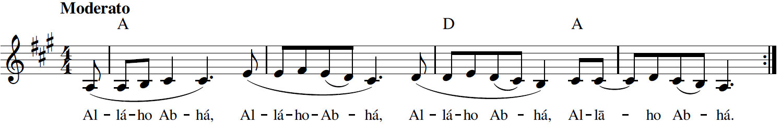
Al-lá-ho Ab-há


Alláh-u-Abhá, Yá Bahá’u’l-Abhá 1-2 (الله أبهى ٢ يا بهاء الأبهى) God the All-Glorious, O Thou Glory of Glories

Recording, online link: https://bahai-library.com/caton_music/1_Allah-u-Abha_Ya_Baha-ul-Abha_2.mp3

Transcription demo, online link: https://bahai-library.com/caton_music/sacred_refrains_demos/1_Allah-u-Abha_Ya_Baha-ul-Abha_2_demo.mp3
الله أبهى يا بهاء الأبهى
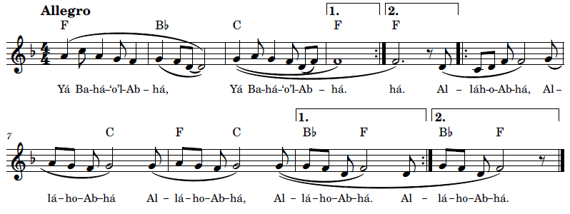
Yá Ba-há-o’l-Ab-há, Al-lá-ho Ab-há

2 Alláh’u’Rabbuná (اللهُ رَبُّنا) God, Thy Lord

The expression “God, thy Lord, the Lord of the Mighty Throne” is mentioned frequently in the writings of Bahá'u'lláh. For example, it appears in the Ṭarázát, in the fourth Ṭaráz: “’We will now mention unto thee Trustworthiness and the station thereof in the estimation of God, thy Lord, the Lord of the Mighty Throne.” (Tablets of Bahá'u'lláh 1978, 37). This same passage is found in Epistle to the Son of the Wolf (Bahá'u'lláh, Epistle to the Son of the Wolf 1988, 136) . This expression also appears in the writings of the Báb at the end of Tablets and Addresses.
The passageالله ربّنا و ربّ العرش العظيم ( Alláh’u’Rabbuná va Rabb’al-‘Arsh al-‘Aẓím) appears at the end of a prayer of Bahá’u’lláh published in several books and collections, including the collection titled Nasá’imu’r-Raḥmán (Bahá'u'lláh 1993, 37-38) available in the Arabic version of the Bahá’í Reference Library at https://reference.bahai.org/ar/t/c/NR1/nr1-36.html:
قل : الهی الهی اشهد بوحدانيّتک و فردانيّتک و بعزّک و عظمتک و سلطانک ، أنا عبدک وابن عبدک قد اقبلت إليک منقطعاً عن دونک و راجياً بدائع فضلک ، اسألک بأمطار
سحاب سماء کرمک و بأسرار کتابک أن تؤيّدنی علی ما تحبّ و ترضی . ای ربّ هذا عبد اعرض عن الاوهام مقبلاً إلی أفق الايقان و قام لدی باب فضلک و فوّض الامور إليک و توکّل عليک فافعل به ما ينبغی لسماء جودک و بحر کرمک . إنّک أنت المقتدر العليم الحکيم . اشهد يا الهی بأنّک أعلم بی منّی . قدّر لی ما يقرّبنی إليک و ينفعنی فی الآخرة و الأولی . إنّک أنت مولی الوری و فی قبضتک زمام الفضل و
العطاء . لا إله إلّا أنت الفضّال الکريم . البهاء علی أهل البهاء الّذين ما
منعتهم ضوضاء الامم عن مالک القدم . قاموا و قالوا اللّه ربّنا و ربّ العرش العظيم .

This expression also appears in the Writings of the Báb in Extracts from a Further Epistle to Muḥammed Sháh (T. Báb, Selections from the Writings of The Báb 1976, 28) (T. Báb, Muntakhibát 1978, 8):
Sanctified is God thy Lord, the Lord of the Mighty Throne, from that which the people wrongfully and without the guidance of His lucid Book, affirm of Him. Peace be upon them that beseech forgiveness from God thy Lord, saying: ‘Verily, praise be unto God, the Lord of the worlds.’
Recording, online link: https://bahai-library.com/caton_music/2_Allah-u_Rabbuna.mp3
Transcription demo, online link: https://bahai-library.com/caton_music/sacred_refrains_demos/2_Allah-u_Rabbuna_demo.mp3

اللهُ رَبُّنا وَ رَبُّ العَرشِ العَظيم
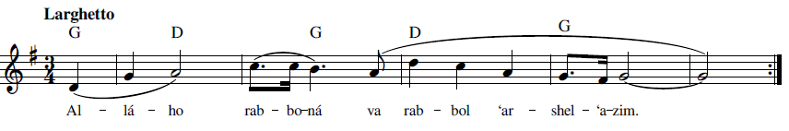
Al-lá-ho rab-bo-ná var rab-bol ‘ar-shel- ‘a-zim
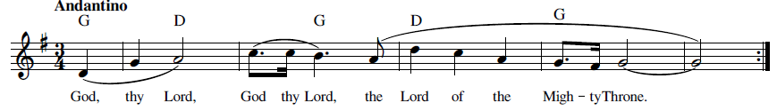
God, thy Lord, the Lord of the Mighty Throne

3 Ant al-Káfí (لوح انت الكافي) Thou the Sufficing

“The Long Healing Prayer” by Bahá’u’lláh (Lawḥ-i Ant al-Káfí) (T. B.-B. Bahá'u'lláh 1991, 91-98) (Bahá'u'lláh, Ad'iyyih-yi Hadrat-i-Mahbub 1920, 183) has a refrain throughout most of the prayer: “Thou the Sufficing, Thou the Healing, Thou the Abiding, O Thou Abiding One!” This refrain has been used in a dhikr-like fashion by the London fusion group The Shoreless Sea (formerly gyenyame), as they go through most of the verses of the prayer. The following links are to three different presentations. The first one is live, so that you may see how the performers interact with each other with vocalists, guitar, and polyrhythmic percussion to create this hypnotic pastiche (gyenyame 2007):
Recordings;
https://www.youtube.com/watch?v=LJdl98Ih5hk
https://soundcloud.com/the-shoreless-sea/the-sufficing-the-healing-the-abiding
https://www.bahaiblog.net/music/recording-artist/the-sufficing-the-healing-the-abiding-the-shoreless-sea/
In Arabic the refrain of this prayer is:
أنت الكافي وأنت الشافي وأنت الباقي يا باقي
In the Arabic rendition, most of “The Long Healing Prayer” is sung in a call-and-response style, with a soloist singing a verse in Arabic that calls on three names of God, each verse with a different three, followed by a refrain sung by a male chorus in unison that repeats the same three names of God: the Sufficing, the Healing, the Abiding. The melody of the verse uses different themes which follow a Middle Eastern style modal framework, while the refrain repeats a cadential formula each time. Most of the prayer is sung with measured rhythm except for the opening phrase, sections where the verse portion is read with a sung measured refrain background, and for the final solo chanted portion. Throughout, the vocalists are accompanied by a Persian instrument, the tár, a long-necked plucked lute. The refrain is sung by a male chorus accompanied by tár and by daf, a large frame-drum. As mentioned, about half-way through, the sung style alternates with two sections where the chanter reads the first part of each section and the refrain is sung continually in the background, before it returns to the original form of call and response singing. When the prayer reaches the part that has no refrain, the tár provides a measured ostinato background accompaniment to the vocalist who chants the rest of the prayer in non-measured rhythm in a traditional style of Arabic and Persian chanting.
For anyone wishing to follow along with this performance of the long healing prayer, Daniel Pschaida has provided a delineation of this prayer with English translation, Romanized transliteration, and Arabic script for each verse (Pschaida 2019): https://bahai-library.com/pschaida_healing_prayer_notes. A comment on the prayer and the recording is to note the dhikr-like quality of the entire prayer, which is in the form of a kind of litany, an enumeration and invocation of names and attributes of God.
In the style of most of the prayer, there is a verse and refrain, the format of which is itself repeated. The actual format within each verse is also repeated, in that “I call on Thee” begins each verse, which is then followed by three names or qualities of God, after which a (repeated) refrain of three qualities are named, ending with an appeal to the name of God which is the last attribute name, “O Thou Abiding One!” This in itself matches the format of calling on the names of God found in the “verse.” This overall form or formula lends itself to the call and response pattern found in both English and the Arabic performances, and in itself has many aspects of the kind of repetition found in a traditional dhikr, with the same hypnotic effect of form, concepts, and words. Further analysis of the format and content of this prayer can be found in Pschaida’s more recent article (Pschaida, Bahá'u'lláh's 'Long Healing Prayer' ("Lawḥ-i-Anta'l-Káfí") in Light of a Metaphysics of Unity 2022).
Recording, online link: https://bahai-library.com/caton_music/3_Ant_al-Kafi.mp3
Transcription demo, online link: https://bahai-library.com/caton_music/sacred_refrains_demos/3_Ant_al-Kafi_demo.mp3

أنت الكافي وأنت الشافي وأنت الباقي يا باقي
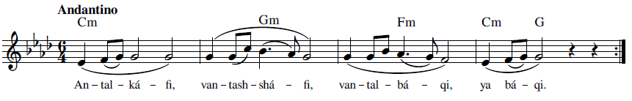
An-tal- ká-fi, van-tash- shá-fi, van-tal- bá-qi, yá bá-qi

Thou the Sufficing, Thou the Healing, Thou the Abiding, O Thou Abiding One!
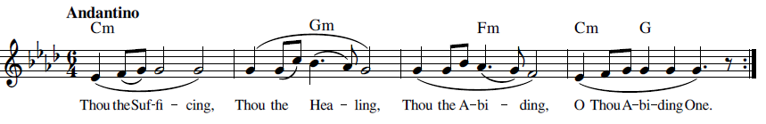

4 Qad Atá’l-Málik (قد اتی المالک) He Who is the Sovereign

This descriptive declaration is taken from paragraph 78 of the Kitáb-i-Aqdas, where Bahá’u’lláh is addressing the kings of the earth. The Arabic and English are as follows (Bahá’u’lláh, Kitáb-i Aqdas 1992, 75, para. 78) (Bahá’u’lláh, The Kitáb-i-Aqdas 1992, 48) :
يا معشر الملوک قد اتی المالک و الملک للّه المهيمن القيّوم. الّا تعبدوا الّا اللّه توجّهوا بقلوب نورآء الی وجه ربّکم مالک الاسمآء هذا امر لايعادله ما عندکم لو انتم تعرفون.
O kings of the earth! He Who is the sovereign Lord of all is come. The Kingdom is God’s, the omnipotent Protector, the Self-Subsisting. Worship none but God, and, with radiant hearts, lift up your faces unto your Lord, the Lord of all names. This is a Revelation to which whatever ye possess can never be compared, could ye but know it.



Recording, online link: https://bahai-library.com/caton_music/4_Qad_Atal-Malik.mp3
Transcription demo, online link: https://bahai-library.com/caton_music/sacred_refrains_demos/4_Qad_Atal-Malik_demo.mp3
الملک للّه المهيمن القيّوم قد اتی المالک و
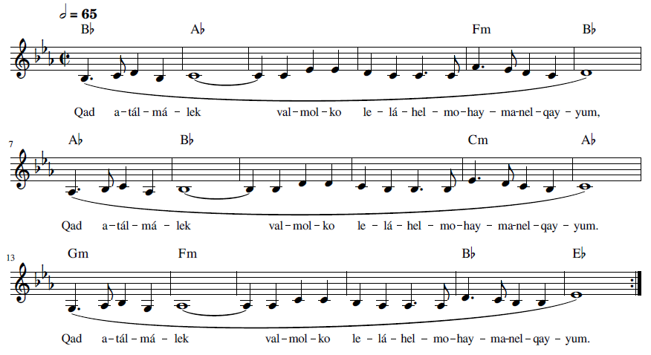
Qad a-tál- má-lek val- mol-ko le-lá-hel- mo-hay-ma-nel- qay-yum



He Who is the sovereign Lord of all is come
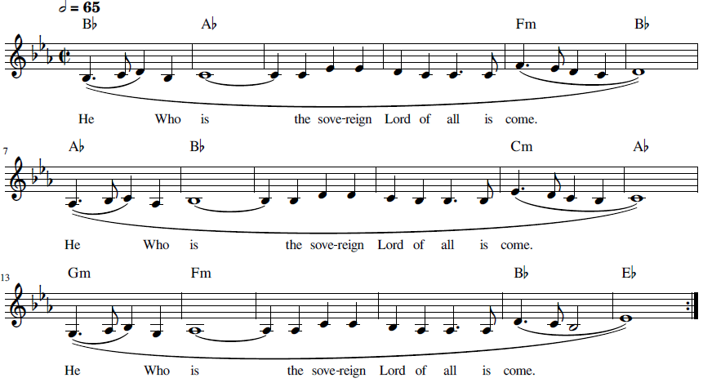

5 Qul Alláh’u’Ẓáhir (قل الله ظاهر) God is Manifest

This selection is from a Tablet of Bahá’u’lláh to Salmán (I, paragraph 16), in a collection of Bahá’u’lláh’s Tablets, published in Cairo in 1920 (Majmu`ih-'i Matbu`ih 1920, 143). This Tablet, called Lawḥ-i Salmán was revealed in Adrianople in honor of Sheikh Salmán, one of Bahá’u’lláh’s dedicated followers, who served as a messenger for His Tablets and correspondence with His followers. This Tablet includes an elucidation (tafsir) on a line from a poem by Rumi (Taherzadeh, Tablet to Salman I 2005). The original in Arabic follows:
ای سلمان * قل اللّهُ ظاهرٌ فوقَ کلّ شئ و الملک يومئذ للّه ثمّ ذَرِ النّاس بما عندهم * باری معارف قبل را بقبل بگذار * موسی که از انبيای اعظم است بعد از ثلاثين يوم که بقول عرفا در عشره اوّل افعال خود را در افعال حق فانی نمود * و در عشره ثانی صفات خود را در صفات حق * و در عشره ثالث ذات خود را در ذات حق * و گفته‌اند چون بقيَّه هستی در او باقی بود لذا خطاب لَنْ تَرانِی شنيد * و حال لسان اللّه ناطق و ميفرمايد يکبار أرِنی گو و صد هزار بار بزيارت ذوالجلال فائز شو * کجا است فضل اين ايّام و ايّام قبل
A provisional translation of this paragraph, by Juan Cole, is provided (Bahá’u’lláh, Commentary on a Verse of Rumi 2019):
[16] Salman, say: "God is manifest above all things and that day the dominion is God's. Leave the people to what is with them." Yes, leave the sciences of the past to the past. According to the mystics, Moses, who is among the greatest of prophets, during the first ten of thirty days annihilated his own deeds in the deeds of God. In the next ten days he annihilated his own attributes in those of God. In the final ten days he annihilated his own essence in the essence of God. They said that since a remnant of being remained in him, therefore God said to him, "You shall never see me." Now the tongue of God is speaking. Say, "Show me!" once, and attain to the presence of the All-Glorious a hundred thousand times! Compare the grace inherent in these days with that of the past.
Recording, online link: https://bahai-library.com/caton_music/5_Qul_Allah-u-Zahir.mp3
Transcription demo, online link: https://bahai-library.com/caton_music/sacred_refrains_demos/5_Qul_Allah-u-Zahir_demo.mp3
قل الله ظاهر فوق كل شيء
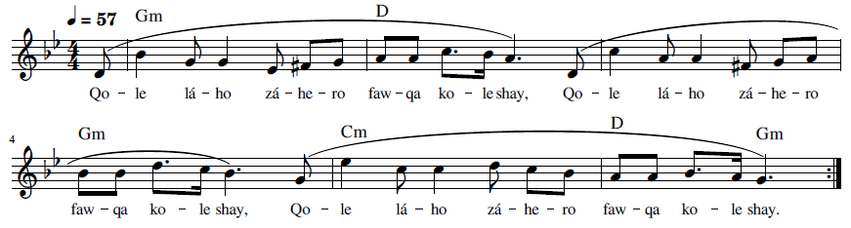Qo-le lá-ho zá-he-ro faw-qa ko-le shay



Say: God is manifest above all things
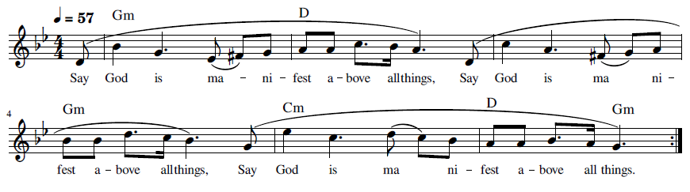

6 Subbúhun Quddús (سبُّوحٌ قُدُّوسٌ) Holy, Holy

This dhikr is found in Islamic devotional practice. It is taken from the hadith on the Authority of Aisha, a wife of the Prophet Mohammed, as a saying of the Prophet in his kneeling and prostration (Aisha 2006):
عن عائشة -رضي الله عنها- أنّ رسولَ اللهِ -صلى الله عليه وسلم- كانَ يقول في ركوعه وسجودِه: .«سبُّوحٌ قُدُّوسٌ رَبُّ المَلاَئِكَةِ وَالرُّوحِ»
‘Ā’ishah (may Allah be pleased with her) reported that the Messenger of Allah (may Allah’s peace and blessings be upon him) used to recite in his bowing and prostration: "You are the Most Glorious, the Most Holy, and the lord of the angels and of the Spirit."
This phrase leaves out the word “Rabbuná” that is found in the Bábí version, but the variant “va Rabbuná” is found also in Islamic texts and chants. The following links show examples of Islamic dhikr that include “va rabbuná”: https://www.youtube.com/watch?v=tjjryziDlJA and الذكر "سبوح قدوس ربنا ورب الملائكة والروح" مكرر ١٠٠٠ مرة - الحاج حسين غريب - YouTube.
As narrated in The Dawn-Breakers, this dhikr was recited as a greeting for Quddús !” (Nabil, The Dawn-Breakers 1932, 352):
Quddús, as he rode along in their midst, appeared as the day-star that shines amidst its satellites. As the company slowly wended its way towards the fort, there broke forth the hymn of glorification and praise intoned by the band of his enthusiastic admirers. “Holy, holy, the Lord our God, the Lord of the angels and the spirit!”
The whole passage from which this is taken shows the ceremony and respect which Quddus was given by the occupants of the fort of Ṭabarsí in Persian (Nabil, Tárikh-i Nabil 1991, 318-319) and English (Nabil, The Dawn-Breakers 1932, 352):
بهر حال اصحاب قلعه چون مژدهء تشريف فرمائی قدّوس را بقلعه شنيدند بجوش و خروش آمدند جناب قدّوس چون نزديک قلعه رسيدند يکنفر را بقلعه فرستادند که ورود ايشانرا باصحاب اعلان کند اين مژده قوای اصحاب را تجديد کرد جناب ملّا حسين با شور و نشاط شديدی بهمراهی صد نفر از اصحاب به پيشباز قدّوس رفتند اين صد نفر هر کدام دو شمع در دو دست خود گرفتند جناب ملّا حسين بشخصه آن شمع ها را روشن کردند و باصحاب فرمودند به پيشباز قدّوس بروند روشنائی شمعها تاريکی شب را از بين برد در وسط جنگل مازندران چشم اصحاب به طلعت قدّوس افتاد با کمال اشتياق بحضورش شتافتند اطراف اسب قدّوس حلقه زدند و اظهار خضوع و عبوديّت نمودند همان طور که شمعها را در دست داشتند از دنبال قدّوس روان شدند همهء اصحاب پياده بودند تا بقلعه رسيدند جناب قدّوس در بين اصحاب مانند ماه در بين ستارگان ميدرخشيدند اصحاب در ضمن سير، اشعار ميخواندند، بمدح و تمجيد لب ميگشودند و همه با هم با کمال فرح و نشاط جملهء " سُبّوحُ قُدّوس ربّنا و ربّ الملائکة و الرّوح " را بصدای بلند تکرار ميکردند جناب ملّا حسين قبل از همه اين جمله را ميفرمودند و سايرين جواب ميدادند صدای اصحاب از ميان جنگل منعکس ميشد همينطور سير ميکردند تا بقلعه رسيدند جناب قدّوس پياده شدند تکيه بضريح مقبرهء طبرسی کرده فرمودند " بقيّةُ اللّهِ خيرٌ لکم إن کنتم مؤمِنينَ " (قرآن ٨٩:١١) اوّل بيان جناب قدّوس بتلاوت همين آيه شروع شد و آنچه را که حضرت رسول (ص) بشارت داده بودند در اين مقام مصداقش کاملاً ظاهر شد زيرا حديثی هست که حضرت رسول ( ص ) فرمودند وقتی که مهدی ظهور ميکند پشت خودش را به قلعه ميدهد و بسيصد و سيزده نفر از اصحابش که دورش حلقه زده‌اند می فرمايد " بقيّة اللّهِ خيرٌ لکُم إن کُنْتُم مُؤمِنينَ " ( قرآن ٨٩:١١).
The news of the impending arrival of Quddús bestirred the occupants of the fort of Ṭabarsí. As he drew near his destination, he sent forward a messenger to announce his approach. The joyful tidings gave them new courage and strength. Roused to a burst of enthusiasm which he could not repress, Mullá Ḥusayn started to his feet and, escorted by about a hundred of his companions, hastened to meet the expected visitor. He placed two candles in the hands of each, lighted them himself, and bade them proceed to meet Quddús. The darkness of the night was dispelled by the radiance which those joyous hearts shed as they marched forth to meet their beloved. In the midst of the forest of Mázindarán, their eyes instantly recognized the face which they had longed to behold. They pressed eagerly around his steed, and with every mark of devotion paid him their tribute of love and undying allegiance. Still holding the lighted candles in their hands, they followed him on foot towards their destination. Quddús, as he rode along in their midst, appeared as the day-star that shines amidst its satellites. As the company slowly wended its way towards the fort, there broke forth the hymn of glorification and praise intoned by the band of his enthusiastic admirers. “Holy, holy, the Lord our God, the Lord of the angels and the spirit!” rang their jubilant voices around him. Mullá Ḥusayn raised the glad refrain, to which the entire company responded. The forest of Mázindarán re-echoed to the sound of their acclamations.
Also, Mullá Ḥusayn repeated this verse when he circled around the shrine where Quddús was sleeping, in Persian (Nabil, Tárikh-i Nabil 1991, 320) and English (Nabil, The Dawn-Breakers 1932, 353-354):
اغلب اوقات ميديدم که شبها جناب ملّا حسين در اطراف مکانيکه حضرت قدّوس خوابيده بود گردش ميکردند نيمه‌های شب جناب ملّا حسين از اطاق خودشان بيرون ميآمدند و آهسته بمحلّی که حضرت قدّوس خوابيده بودند توجّه ميکردند و جملهء سبّوحٌ قدّوسٌ ربّنا و ربّ الملائکةِ و الرّوح را در آن احيان تکرار ميفرمودند
“Many a night I saw Mullá Ḥusayn circle round the shrine within the precincts of which Quddús lay asleep. How often did I see him emerge in the mid-watches of the night from his chamber and quietly direct his steps to that spot and whisper the same verse with which we all had greeted the arrival of the beloved visitor!”
This dhikr is mentioned in two additional places in the course of this narrative. One is during a Naw-Rúz celebration inside the fort of Tabarsi (Nabil, Tárikh-i Nabil 1991, 354-355) (Nabil, The Dawn-Breakers 1932, 389):
در ضمن اينکه دشمنان بتهيّهء حملهء جديدی مشغول بودند، اصحاب جناب قدّوس بمشکلات و مصائب وارده بنظر بی‌اعتنائی مينگريستند و مشغول تهيّهء لوازم انعقاد جشن نوروز بودند، در جريان جشن بشکر خداوند متعال پرداختند که آنها را مورد فضل و احسان خويش قرار داده و برکات خود را بآنان مبذول داشته با اينکه گرسنه بودند تمام مصيبت‌ها و بليّات را فراموش کرده بودند و بخواندن اشعار سرگرم بودند هنگام شب صدای اصحاب قلعه باطراف می‌پيچيد و در ساعات روز فرياد آنان که جملهء ( سبّوحٌ قدّوسٌ رَبّنا و ربّ الملائکةِ و الرّوح ) را ميگفتند بگوش قريب و بعيد ميرسيد تکرار اين جمله که پيوسته و مستمرّ بود باعث اشتعال شجاعت و اطمينان در وجود اصحاب بود
Whilst their enemies were preparing for yet another and still fiercer attack upon their stronghold, the companions of Quddús, utterly indifferent to the gnawing distress that afflicted them, acclaimed with joy and gratitude the approach of Naw-Rúz. In the course of that festival, they gave free vent to their feelings of thanksgiving and praise in return for the manifold blessings which the Almighty had bestowed upon them. Though oppressed with hunger, they indulged in songs and merriment, utterly disdaining the danger with which they were beset. The fort resounded with the ascriptions of glory and praise which, both in the daytime and in the night-season, ascended from the hearts of that joyous band. The verse, “Holy, holy, the Lord our God, the Lord of the angels and the spirit,” issued unceasingly from their lips, heightened their enthusiasm, and reanimated their courage.
The last mention is at the final siege of Ṭabarsí (Nabil, Tárikh-i Nabil 1991, 368) (Nabil, The Dawn-Breakers 1932, 403-404):
آنگاه بجانب قلعه روان شدند هر چه يافتند غارت کردند و قلعه را با خاک يکسان نمودند بعد باقی اصحاب را احاطه کردند و گلوله باران نمودند اگر از ميان اصحاب کسی هدف گلوله نشده بود با شمشير صاحب منصبان و اسلحهء سربازان بشهادت رسيد اصحاب جناب قدّوس در حين مفارقت جان از بدن زبانشان بجملهء سبّوح قدّوس ربّنا و ربّ الملائکة و الرّوح ناطق بود اين همان ذکری بود که با کمال شجاعت در اوقات شادی و سرورشان ميگفتند در حين وفات هم با همان شجاعت اين کلمات را ميگفتند شهادت آن نفوس مقدّسه باکليل افتخار جاودانی مکلّل گشت.
From this savage act they turned their attention to the fort, plundered it of its contents, and proceeded to bombard and demolish it completely. They then immediately encompassed the remaining companions and opened fire upon them. Any who escaped the bullets were killed by the swords of the officers and the spears of their men. In the very throes of death, these unconquerable heroes were still heard to utter the words, “Holy, holy, O Lord our God, Lord of the angels and the spirit,” words which in moments of exultation had fallen from their lips, and which they now repeated with undiminished fervour at this crowning hour of their lives.



Subbúhun Quddús 6-1 (سُبُوحٌ قُدُوس) Holy, Holy

Recording, online link: https://bahai-library.com/caton_music/6_Subbuhun_Quddus_1.mp3
Transcription demo, online link: https://bahai-library.com/caton_music/sacred_refrains_demos/6_Subbuhun_Quddus_1_demo.mp3
سُبُوحٌ قُدُوسٌ رَبُنا وَ رَبُ المَلائِكَة وَالرّوح
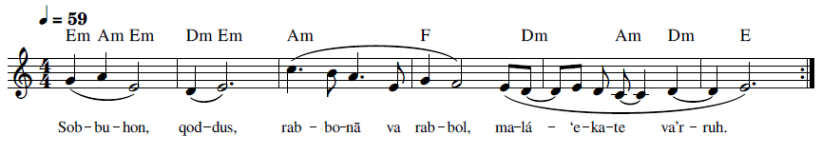
Sob-bu-hon, qod-dus, rab-bo-nā va rab-bol, ma-lá-‘e-ka-te va’r-ruh
Holy, holy, the Lord our God, the Lord of the angels and the spirit.
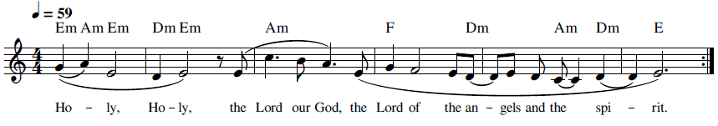

Subbúhun Quddús 6-2 (سُبُوحٌ قُدُوس) Holy, Holy

Recording, online link: https://bahai-library.com/caton_music/6_Subbuhun_Quddus_2.mp3
Transcription demo, online link: https://bahai-library.com/caton_music/sacred_refrains_demos/6_Subbuhun_Quddus_2_demo.mp3
سُبُوحٌ قُدُوسٌ رَبُنا وَ رَبُ المَلائِكَة وَالرّوح
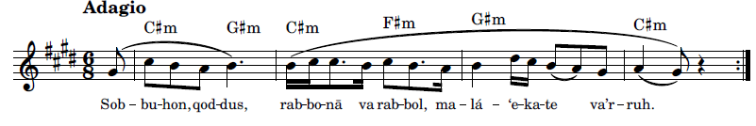Sob-bu-hon, qod-dus, rab-bo-nā va rab-bol, ma-lá-‘e-ka-te va’r-ruh

Holy, holy, the Lord our God, the Lord of the angels and the spirit
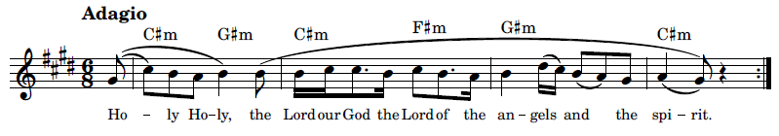

7 Ta’álá Man Aẓhar (تعالی من اظهر) The Exalted One

The text of “Ta’álá Man Aẓhar” appears asتعالی من اظهر نفسه in a few Tablets of Bahá’u’lláh, for example, in the Afnan Library Online (fourth line) (Majmú'ih-i Áthár-i Qalam-i 'Alá n.d., 91). According to Steven Phelps, it is a commentary on the Fire Tablet (Phelps 2020, 10: BH100018). There is a brief commentary on this Tablet in Adib Taherzadeh’s Revelation of Baha’u’llah, volume 3 (Taherzadeh, The Revelation of Bahá'u'lláh: 'Akká, The Early Years, 1868-77 1984). The same example is found in Ishráqát va Chand Lawḥ-i-Dígar, found in the Bahá’í Reference library (Ishráqát va Chand Lawḥ-i-Dígar n.d., 2):
هو الظّاهر النّاطق المقتدر العليم الحکيم
الحمد للّه الّذی اظهر بسلطانه ما اراد و زيّن اليوم بنسبته اليه
و سمّاه فی کتب السَمآء بيوم اللّه و فيه ظهر ما بشّر به رسله و کتبه
و زبره فلمّا اتی الوعد اشرق نيّر الظّهور انّه هو مکلّم الطّور بسلطان
ما خوّفته شوکة العلمآء و الامرآء و ما منعته سطوة الجبابرة و لا
ظلم الفراعنة قام امام الوجوه و قال تاللّه انا المکنون و انا المخزون
و انا الّذی بذکری تزيّنت سمآء البرهان بانجم البيان
و الامکان بنور العرفان تعالی من اظهر نفسه و انزل برهانه
و اسمع الکلّ آياته البهآء و التّکبير علی ايادی امره بين عباده
الّذين جعلهم تراجمة وحيه و ما انزله فی کتابه و بهم ماج بحر العرفان
A provisional translation in English is offered by Masumian (Adib Masumian 1/20/22):
He is the Manifest, the Lord of Utterance, the AllPowerful, the All-Knowing, the All-Wise Praise be to God, Who hath manifested, through His sovereign might, what He hath willed; beautified this Day through His relationship to it; and named it, in the heavenly Scriptures, “the Day of God,” wherein appeared that which His Messengers and Books have heralded. And when the promise was fulfilled, the Daystar of Revelation shone forth; He it is, in truth, Who conversed on Sinai, invested with such sovereignty that He is neither afraid of the majesty of the divines and rulers, nor deterred either by the ascendancy of tyrants or the oppression of Pharaohs. He arose before the faces of men and declared, “By God! I am the Hidden One! I am the Treasured One! I am He through Whose mention the firmament of proof was adorned with the stars of utterance, and the contingent realm embellished with the light of understanding!” Exalted be He Who manifested His Self, revealed His Testimony, and enabled all to hear His verses of glory! And salutations be upon them who are the Hands of His Cause among His servants, whom He hath made the conveyors of His revelation and whatever He hath set down in His Book. Through them hath the sea of recognition surged . . .
Another Provisional translation:
He is The Manifest, The Eloquent, the Omnipotent, The All-Knowing, the All-Wise!
Praise be to God, who has manifested by His sovereignty what He willed and has graced the day thereby and He called it in the Book of Heaven, “The Day of God” and on it appeared that which was promised in His books and by His Messengers. And when the promise appeared, the light of appearance shone with authority. The contention of scholars and rulers did not frighten Him, nor did the tyranny of the oppressors impede Him. The oppression of the Pharoahs rose before Him and he spoke, I am the Hidden and the Treasure and I am the One Whose mention adorned the sky of proof with the star of eloquence and possibility with the light of gnosis, the Exalted One, the One Who hath revealed Himself and sends down His proof. Listen to the verses of glory, and the magnifying of His commands among His servants Whom he made the exemplars of His revelation and what He revealed in His book and with them the sea of knowledge billowed.

Recording, online link: https://bahai-library.com/caton_music/7_Taala_Man_Azhar.mp3

Transcription demo, online link: https://bahai-library.com/caton_music/sacred_refrains_demos/7_Taala_Man_Azhar_demo.mp3

تعالی من اظهر نفسه
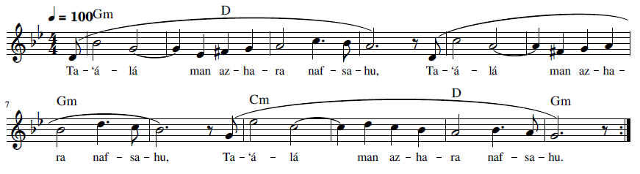
Ta-‘á-lá man az-ha-ra naf-sa-hu

The Exalted One, He Who hath revealed Himself
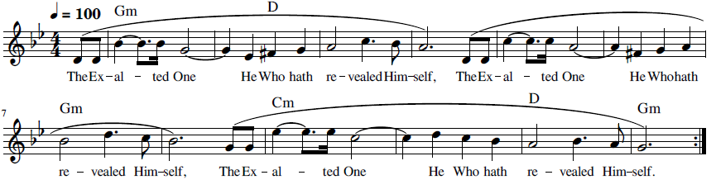

8 Yá Alláhu’l-Mustagháth (يا اللهُ المُسْتَغاث) O Thou God Who art Invoked

“Yá Alláhu’l-Mustagháth” is an invocation revealed by the Bab to be recited in times of trouble and difficulty (great need). The word Mustagháth, according to Shoghi Effendi, is translated as “He Who is invoked for help.” It refers to Bahá’u’lláh and the time of Bahá’u’lláh’s dispensation. The Universal House of Justice has mentioned two ways to write it in Roman script. It can be transliterated as Yá Ilahá’l-Mustagháth, which is “O Lord of the time of Mustagháth” or as Yá Alláhu’l-Mustagháth, translated as “O Thou God Who art invoked” (The Universal House of Justice 2001):
Beyond this translation, the word Mustagháth has other meanings and implications. The Báb referred to Mustagháth as the time when God’s Manifestation of each age will be revealed, and specifically referring to the revelation of the next Manifestation, Bahá’u’lláh (Saiedi 2008, 356-357). The Báb prescribed repeating this invocation 2098 times (T. Báb, Amr va Khalq 1986, 4:58) when in great need. Later, ‘Abdu’l-Bahá in one Tablet said it was to be repeated 95 times and in another, 81 times. Still later, Shoghi Effendi indicated that the number of repetitions is left up to the individual (The Universal House of Justice 2001).
The abjad numerical value for the word Mustagháth is 2001 (Saiedi 2008, 357). In a summary of the Báb’s Persian Bayan, Vahid VII Chapter 10, E.G. Browne states that no name among the names of God equals this name in number (2001) and that it is “the supreme fruit of the Names which has reached the Extreme of Manifestation.” Further, that the limit of time between the appearance of Manifestations should not exceed the number of Mustagháth, though the phrase, “if God please,” is included in this statement (Browne 1987).
In the Tablet of Letters, the Báb explained the mystery of the Mustagháth, which some took to refer to the science of divination (jafr) (Nabil, The Dawn-Breakers 1932, 304-305). Baha’u’lláh refers to the time of Mustagháth as the time of the One Who is destined to be made manifest: “We, moreover, swear fealty to the One Who, in the time of Mustagháth, is destined to be made manifest, as well as to those Who shall come after Him till the end that hath no end” (Bahá'u'lláh, Gleanings 1990, 73). In the Tablet of Letters, the Báb, alluding to the 19 years that would elapse between the Báb’s and Bahá’u’lláh’s declaration, refers to 19 temples, the last of which is the named the Huva’l-Mustaghíth, the name of Him Whom God shall make manifest (Saiedi 2008, 357).
Anecdotes have been recorded about how ‘Abdu’l-Bahá recited this prayer during difficulties and these stories continue to be circulated, particularly those conveyed by ‘Ali Kuli Khan and his wife Florence Breed, who heard them directly either from ‘Abdu’l-Bahá or from Shoghi Effendi. While these stories are conveyed to us as personal experiences, they have helped create a mystique around this invocation and its power. The invocation itself has been revealed by the Báb and has continued to be part of the Bahá’í Faith, confirmed by ‘Abdu’l-Bahá and Shoghi Effendi, as well as the Universal House of Justice, in official communications. The following story has been relayed by Muriel Ives Barrow Newhall (Newhall 1998, 8):
It was in 1912 that Dr Ali Kuli Khan—preparing for the visit of ‘Abdu’l Bahá to Washington—began to consider the questions he would ask Him upon His arrival. And, thinking it over, Dr Khan realized that the one thing he wanted most to know was some prayer he might utter quickly and from deep within his heart, when the moment came when, as the representative of his country (then Persia) in Washington he must make some instant diplomatic decision. When these moments came, as they did frequently— Dr Khan felt that while he always sincerely did his best, his wisdom was very limited and finite. If only he might have a prayer that would draw to him a greater wisdom. Ah, if he only might have such a prayer. So the day came when ‘Abdu’l-Bahá was to arrive and Dr Khan, accompanied by the Washington believers, drove to the station to meet Him. The greeting was warm and deeply moving, and Khan’s heart was still filled with this one question he wanted most to ask the Master. And they were perhaps halfway back, driving up Pennsylvania Avenue, when ‘Abdu’l Bahá suddenly told Khan this story: It had happened when Bahá’u’lláh had been gone from Baghdad for some two years. At that time no one knew where He was and all hearts were sick with the fear that they never would see Him again. At this time ‘Abdu’l-Bahá was a small boy, and the continued absence of His Beloved Father had become unendurable. So, one night, all night long, the little boy (whom, even then, Bahá’u’lláh referred to as The Master) paced restlessly up and down saying, shouting, beseeching, Yá Alláhu’l-Mustagháth! Yá Alláhu’l-Mustagháth! all night long. And in the morning, when dawn was breaking, a messenger came to the door to say that a stranger was at the city gate and had sent word to the Family that He wished them to bring to Him fresh raiment and water to bathe in …. So ‘Abdu’l-Bahá knew His beloved Father had returned. And Dr Khan knew the cry that he, too, might utter in his moments of need: Yá Alláhu’l-Mustagháth (which I am told means Oh, Thou help me in my extremity!). This was told me by Ali Kuli Khan at Green-Acre in 1933.
Marzieh Gail relates a story told by her mother, Florence Breed, the wife of ‘Ali Kuli Khan (Gail 1991, 310):
Shoghi Effendi also had the burden of the believers’ personal griefs. Florence once asked him for a very powerful prayer, and he answered, ‘What could be better than Yá Alláhu’l-Mustagháth?’ This is rendered ‘O God, the One Who is invoked’—its implication being, Who is called upon in times of extreme distress and peril. It was her understanding that this was the prayer repeated over and over by the Master, as He paced His garden when the Turkish ship was coming to take Him away.
This story dovetails with the account in Shoghi Effendi’s God Passes By on page 271, when ‘Abdu’l-Bahá narrowly escaped from being taken aboard a ship by a Commission of officers from the Turkish government, and where He had been observed pacing the night before in His courtyard (Effendi, God Passes By 1979, 271).
Though this is not an exhaustive discussion of the concept of Mustagháth, nor of the power of this invocation, it may well indicate the benefit of intoning this short prayer when needed.
Video Recording: In Hawaii, Aziz Yazdi shared remembrances of ‘Abdu’l-Bahá, which includes a story about this dhikr: Remembrances of Abdu'l-Baha by Aziz Yazdi: https://www.youtube.com/watch?v=hkyXFJfD5y8

Recording, online link: https://bahai-library.com/caton_music/8_Ya_Allah-ul-Mustaghath.mp3
Transcription demo, online link: https://bahai-library.com/caton_music/sacred_refrains_demos/8_Ya_Allah-ul-Mustaghath_demo.mp3
يا اللهُ المُسْتَغاث
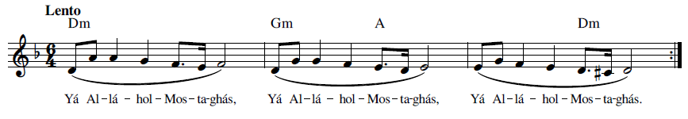
Yá Al-lá-hol- Mos-ta-ghás
O Thou God Who art invoked
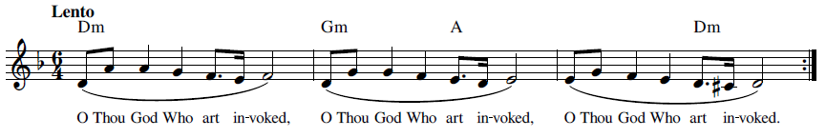

9 Yá Bahá’u’l-Abhá (يا بهاء الأبهى) O Thou Glory of Glories

O that I could travel, even though on foot and in the utmost poverty, to these regions, and, raising the call of "Yá Bahá’u’l-Abhá" in cities, villages, mountains, deserts and oceans, promote the divine teachings! This, alas, I cannot do. How intensely I deplore it! Please God, ye may achieve it. ('Abdu'l-Bahá, Tablets of the Divine Plan 1993, 41-42)
This invocation means “O Thou Glory of Glories” and is considered as one of the forms of the Greatest Name, the Greatest Name being Bahá (Bahá’u’lláh, The Kitáb-i-Aqdas 1992, 180, N.33). Shoghi Effendi wrote that “Concerning the Greatest Name; this term refers both to “Alláh-u-Abhá” and to “Yá Bahá’u’l-Abhá.” The first is a form of Bahá’í greeting and should be used, while the other is an invocation, meaning “O Thou Glory of Glories!” These two words are both referred to as the Greatest Name.” (Effendi, Letter 1936, 15-17).

Yá Bahá’u’l-Abhá 9-1 (يا بهاء الأبهى) O Thou Glory of Glories

Recording, online link: https://bahai-library.com/caton_music/9_Ya_Baha-ul-Abha_Ya_Ali-ul-Allah.mp3
Transcription demo, online link: https://bahai-library.com/caton_music/sacred_refrains_demos/9_Ya_Baha-ul-Abha_1_demo.mp3
يا بهاء الأبهى
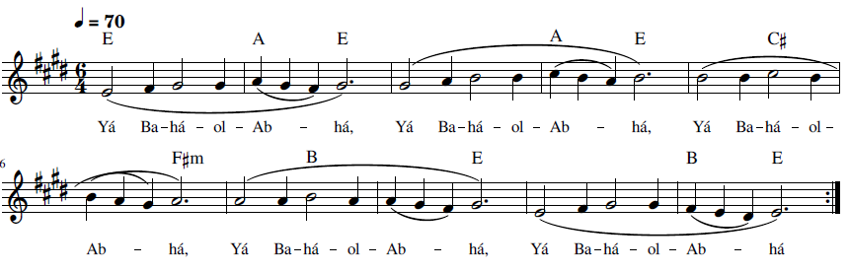
Yá Ba-há-ol-Ab-há

Yá Bahá’u’l-Abhá, Yá ‘Alí’u’l-Alláh 9-2 (يا بهاء الأبهى يا علي الالله)

The triumphal cry Yá Bahá’u’l-Abhá resoundeth on every side, and the call Yá ‘Alíyyu'l-Alá ringeth throughout all regions. No stir is there in the world save that of the Glory of the One Ravisher of Hearts, and no tumult is there save the surging of the love of Him, the Incomparable, the Well-Beloved. ('Abdu'l-Bahá, Selections from the Writings of 'Abdu'l-Bahá 1978, 233)
These two phrases are invocations to Bahá’u’lláh and to the Báb, meaning “O Thou Glory of Glories” (or “O Glory of the All-Glorious”) and “O Exalted of the Most Exalted One.” Hand of the Cause Abu'l-Qásim Faizi wrote about this invocation, indicating its role as inspiration during a particular time in Bahá’í history (A. Faizi 1968):
Yá Bahá’u’l-Abhá—This is an invocation. It means “O Glory of the All-Glorious.” In this connection we recall the soul stirring message of the Guardian in 1953 to the Intercontinental Conferences where he refers to “Yá Bahá’u’l-Abhá” and Yá ‘Aliyyu’l-‘Alá” as the “battle cry” of the pioneers and teachers in the many fields of this world-embracing spiritual Crusade. The first, as already stated, means “O Glory of the All Glorious,” while the second means “O Exalted of the Most Exalted One.” (The Báb) There is nothing in the Writings which says we have to repeat such an invocation a specific number of times each day. However, what a thrill it would be for us in times of dire need, to seek God’s guidance, His support and strength, by addressing Bahá’u’lláh and the Báb directly with these beautiful invocations!
Recording, online link: https://bahai-library.com/caton_music/9_Ya_Baha-ul-Abha_Ya_Ali-ul-Allah.mp3
Transcription demo, online link: https://bahai-library.com/caton_music/sacred_refrains_demos/9_Ya_Baha-ul-Abha_Ya_Ali-ul_Allah_2_demo.mp3
يا بهاء الأبهى يا علي الالله
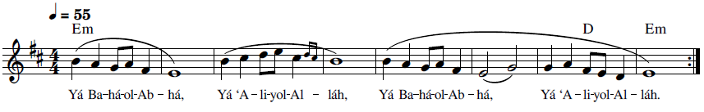
Yá Ba-há-ol-Ab-há, Yá ‘A-li-yol-Al-láh

10 Yá Mannán (يَا مَنَّان) O Benefactor

The text of “Yá Mannán” is from the Tablet of the Sacred Night (Lawḥ-i-Laylatu'l-Quds) revealed by Bahá’u’lláh, dedicated to the night of the Báb’s declaration of His station as a Messenger of God. Cole refers to ‘Abdu’l-Hamid Ishraq-Khavari’s comments that Bahá’u’lláh revealed a number of tablets on the Sacred Night with the intention that dervish or Sufi Bahá’ís should read those Tablets on that night (The Universal House of Justice 1996).
The dhikr has made adaptations to the original text, which is from the last paragraph of this Tablet (Bahá'u'lláh, Lawh-i-Laylatu'l-Quds n.d.):
فَسُبْحانَكَ يا إِلهيْ أَسْئَلُكَ بِاسْمِكَ الَّذِيْ بِهِ تَمَوَّجَتْ بُحُوْرُ أَسْمائِكَ فِيْ مَلَكُوْتِ صِفاتِكَ لِتَسْتَشْرِقَ شَمْسُ تَقْدِيْرِكَ مِنْ أُفُقِ قَضائِكَ وَاسْتَظْهَرَ بَدْرُ تَدْبِيْرِكَ عَنْ شَطْرِ إِمْضائِكَ بِأَنْ تَجْمَعَ يا مَحْبُوْبيْ هؤُلاءِ فيْ ظِلِّ شَجِرَةِ وَحْدانِيَّتِكَ ثُمَّ ارْزُقْهُمْ يَا إِلهيْ سِرًّا مِنْ بَدايِعِ نَعَماءِ عِزِّ فَرْدانِيَّتِكَ لِيَسْتَطْعِمُوا بِهَا كَمَا اسْتَظْهَرُوا جَهْرَةً مِنْ بَدايِعِ آلاءِ عِزِّ صَمَدانِيَّتِكَ ثُمَّ أَنْزِلْ يَا مَحْبُوبيْ فيْ قُلُوْبِهِمْ مَا يُطَهِّرُهُمْ عَنْ دُوْنِكَ وَيُقَرِّبُهُمْ إِلَى مَكْمَنِ رِضَائِكَ وَمَنْبَعِ إِرَادَتِكَ حَتَّى لَا يَتَكَلَّمُوا إِلَّا بِحُبِّكَ وَلَا يَتَنَفَّسُوْنَ إِلَّا بِوُدِّكَ وَلَا يَتَوَجَّهُوا إِلَى جَهَةٍ إِلَّا بِشَطْرِ رَحْمَتِكَ وَجُوْدِكَ وَلَا يَرْفَعُوْا أيْدَاهُمْ إِلَّا إِلَى سَمَاءِ عِزِّكَ وَإِكْرَامِكَ وَلَا يَفْتَحُوْا عُيُوْنَهُمْ إِلَّا إِلَى بَدَايِعِ إِشْرَاقِ أَنْوارِ بَهْجَتِكَ أَيْ مَحْبُوْبيْ فَأَشْرِبْهُمْ مِنْ كُأُوْسِ الحَيَوانِ مِنْ يَدِ هَذَا الغُلَامِ فِيْ هَذَا الرِّضْوَانِ لِيَنْقَطَعَهُمْ عَنْ هَيْكَلِ الشَّيْطانِ وَيَتَّفِقُوْنَ عَلى أَمْرِكَ فِيْ هذا الأَحْيانِ وَيَذْكُرُوْنَكَ فيْ العَشِيِّ وَالإِشْرَاقِ فِيْ ظِلِّ عِنايَتِكَ يَا مَنَّانُ وَيَا مُنْزِلَ الْبَيانِ وَمَظْهَرَ السُّبْحانِ وَمُوْجِدَ الإِمْكانِ ثُمَّ أَسْئَلُكَ يا مَحْبُوْبيْ بِأَنْ تَرْفَعَ الاخْتِلافَ بَيْنَ هَؤلاءِ ثُمَّ أَقْمِصْهُمْ عَنْ قَمِيْصِ عِنايَتِكَ وَخِلَعِ أَلْطَافِكَ بِحَيْثُ لَا يَحْكُوْنَ إِلَّا عَنْ بَدايِعَ آثارِ عِزِّ قَيُّوميَّتِكَ وَلَا يَهُبُّ مِنْهُمْ إِلَّا يُهْدَى بِهِ المُمْكِناتُ إِلَى ساحَةِ عِزِّ مَحْبُوبِيَّتِكَ لَعَلَّ يَتَعارَجُنَّ إِلَى هَواءِ قُرْبِ تَوْحِيْدِكَ وَيَصْعَدُنَّ إِلَى قَضَاءِ قُدْسِ تَفْرِيْدِكَ وَلَعَلَّ بِذلِكَ يَتَّحِدُوْنَ فِيْ جِوَارِ رَحْمَتِكَ وَيَكُوْنُنَّ كَنَفْسٍ واحِدَةٍ تِلْقاءَ مَدْيَنِ عِزِّ كِبْرِيائِكَ ثُمَّ أَسْئَلُكَ يا إِلهيْ بِأَنْ تُطَهِّرَ قُلُوْبَهُمْ عِنْ عَجَاجِ المُمْكِنَاتِ وَغُبَارِ الْكائِناتِ لِتُصَفَّى بِذلِكَ مَرايا أَفْئِدَتِهِمْ لِيَنْطَبِعَ فِيْها بَدايِعُ إِشْرَاقِ أَنْوَارِ جَمَالِكَ المُنيْرِ وَإِنَّكَ أَنْتَ المُعْطِيْ القَائِمُ الخَبِيْرُ وَإنَّكَ أَنْتَ عَلَى كُلِّ شَيْءٍ قَديْرٌ.
A provisional translation of the last paragraph is as follows (Bahá'u'lláh, Tablet of the Sacred Night 1982):
Praise be to Thee, O my god. I beseech Thee by Thy Name whereby the oceans of Thy names have swelled in the realm of Thine attributes, so that the sun of Thy decree might appear in the East above the horizon of Thy judgment; and whereby the moon of Thy Plan hath striven to rise above the horizon of the realm of Thy command, to gather these persons together, O my Beloved, under the shade of the tree of Thy Oneness. Then nourish them in secret, O my God, with the wonders of the favor bestowed by Thy uniqueness; that they may taste thereof, just as they sought aid publicly from the wonders of the bounties of Thy divinity. Then send down upon their hearts, O my Beloved, what will purify them from all else save Thee and bring them nigh unto the hidden sanctuary of Thy good-pleasure and the source of Thy Will, that they might not speak save with love for Thee nor draw a breath save with devotion to Thee nor turn their faces toward any direction save the realm of Thy compassion and generosity, nor raise their hands save toward the heaven of Thy glory and nobility, nor open their eyes save to the marvels of the effulgence of the lights of Thy joy. Yes, my Beloved: give them to drink of the cup of life from the hand of this Youth in this garden, that they may be severed from the temple of Satan and be agreed upon Thy Cause in these times, and may make mention of Thee at eventide and sunrise in the shade of Thy grace, O Benefactor, O Revealer of the Bayan and Countenance of the All-Praised and Creator of the contingent world. Then I beseech Thee, O my Beloved, to remove all contention from among them, and clothe them in the garment of Thy loving-kindness and the robe of Thy kindness, in such wise that they shall not speak save of the wonders of the tokens of Thy Self-subsistence, nor shall there waft from them anything save that by which contingent beings will be guided to the court of Thy love, that they might ascend into the atmosphere of nearness to Thy Unity and soar into the expanse of Thy sacred uniqueness; and that they might thereby be united in the precincts of Thy mercy, becoming as one soul before the city of Thy Grandeur. Then I beseech Thee, O my God, to cleanse their hearts from the grime of contingent things, and the dust of beings so that the mirrors of their hearts might be polished and therein can be reflected the marvels of the light of Thy scintillating Beauty. Verily, Thou art the Giving, the Unshakeable, the Omniscient, and Thou art Powerful over all things.
In the text of the dhikr, “Yá” (O), which is an invocation in front of the first two attributes of the Báb, is substituted for the “and”, or “va”, in front of the subsequent two attributes and Yá Bahá’u’lláh is added at the end, perhaps as an invocation and also acknowledgement of His revealing of the Tablet. As well, the order of two of the phrases has been reversed.
Recording, online link: https://bahai-library.com/caton_music/10_Ya_Mannan.mp3
Transcription demo, online link: https://bahai-library.com/caton_music/sacred_refrains_demos/10_Ya_Mannan_demo.mp3
Original text: يَا مَنَّانُ وَيَا مُنْزِلَ الْبَيانِ وَمَظْهَرَ السُّبْحانِ وَمُوْجِدَ الإِمْكانِ
یا منان ، یا منزل البیان ، یا موجد الامکان ، یا مظهر السبحان ، یا بهاالله
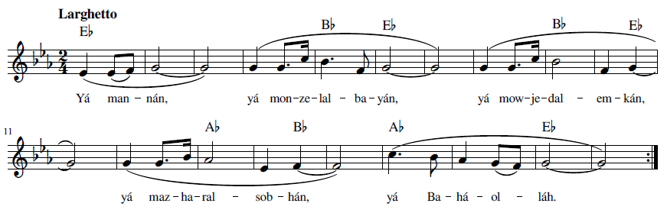
Yá ma-nán, yá mon-ze-lal- ba-yán, yá mow-je-dal- em-kán,
yá maz-ha-ral- sob-hán, yá Ba-há-ol-láh



O Benefactor, O Revealer of the Bayan. O Countenance of the All-Praised,
O Creator of the contingent world, O Thou Glory of Glories

O, Gracious, O, Source of the Bayán, O, Creator of the world, O, Bearer of All Praise,
Yá Bahá’u’lláh
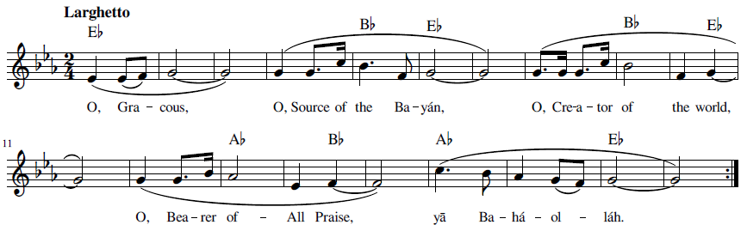

11 Yá Núr An-Núr (يا نُورَ النّور) O Light of Light

“Yá Núr An-Núr” is from a prayer for protection in Arabic revealed by Bahá’u’lláh (Majmú' iy-i-Alváh-Mubárakiy-i-hazrat-i-Bahá'u'lláh 1920 Cairo, 275) (Prayer for Protection 1996):

بسمه العليّ المتعالی الاعلی
فسبحانک اللّهمّ يا إلهی و سيّدی و مولائی و معتمدی و رجائی و کهفی و ضيائی * أسألک باسمک المکنون المخزون الّذی لا يعلمه سواک بأن تحفظ حامل هذه الورقة من کلّ بلاءٍ و وباء و من کلّ شيطان و شيطانة و من شرّ الأشرار و کيد الکفّار * و احفظه يا الهی من کلّ أوجاع و آلام يا من بيدک ملکوت کلّ شئ و انّک علی کلّ شئ قدير * تفعل ما تشاء و تحکم ما تريد * يا مالک الملوک يا سلطانَ العطوف يا قديمَ الإِحسان يا ذا المنّ و الکرم و الامتنان * يا شافی الأمراض يا کا فی المهمّات يا نورَ النّور يا نوراً فوق کلّ نور * يا مظهر کلّ ظهور *
يا رحمن يا رحيم * فارحم حامل هذه الورقة برحمتک الکبری و بجودک العظيم يا جوّاد يا
وهّاب * و احفظه بحفظک من جميع ما يکرهه فؤاده انّک أقدر الأقدرين * و انّما البهاء من عند اللّه عليک يا أيّتها الشّمس الطّالعة فاشهد علی ما قد شهد اللّه علی نفسه انّه لا إله إلّا هو العزيز المحبوب *

In His Name, the Exalted, the All-Highest, the Most Sublime!
Glorified art Thou, O Lord my God! O Thou Who art my God, and my Master, and my Lord, and my Support, and my Hope, and my Refuge, and my Light. I ask of Thee, by Thine Hidden and Treasured Name, that none knoweth save Thine own Self, to protect the bearer of this Tablet from every calamity and pestilence, and from every wicked man and woman; from the evil of the evil-doers, and from the scheming of the unbelievers. Preserve him, moreover, O my God, from every pain and vexation, O Thou Who holdest in Thy hand the empire of all things. Thou, truly, art powerful over all things. Thou doest as Thou willest, and ordainest as Thou pleasest.
O Thou King of Kings! O Thou kind Lord! O Thou Source of ancient bounty, of grace, of generosity and bestowal! O Thou Healer of sicknesses! O Thou Sufficer of needs! O Thou Light of Light! O Thou Light above all Lights! O Thou Revealer of every Manifestation! O Thou the Compassionate! O Thou the Merciful! Do Thou have mercy upon the bearer of this Tablet, through Thy most great mercy and Thine abundant grace, O Thou the Gracious, Thou the Bounteous. Guard him, moreover, through Thy protection, from whatsoever his heart and mind may find repugnant. Of those endued with power, Thou, verily, art the most powerful. The Glory of God rest upon thee, O thou rising sun! Do thou testify unto that which God hath testified of His own Self, that there is none other God besides Him, the Almighty, the Best-Beloved.

Recording, online link: https://bahai-library.com/caton_music/11_Ya_Nur_An-Nur.mp3
Transcription demo, online link: https://bahai-library.com/caton_music/sacred_refrains_demos/11_Ya_Nur_An-Nur_demo.mp3

يا نُورَ النّور يا نُوراً فَوقَ كُلّ نُور، يا مُظهِرَ كُلِّ ظُهور يا رَحمنُ يا رَحيم
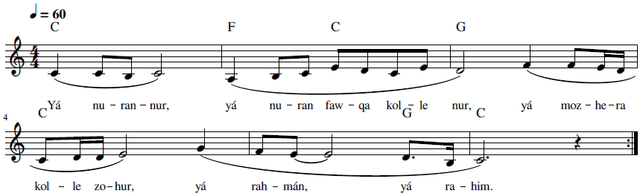
Yá nu-ran- nur, yá nu-ran faw-qa kol-le nur, yá moz-he-ra kol-le zo-hur, yá rah-mán, yá ra-him

O Thou Light of Light! O Thou Light above all Lights!
O Thou Revealer of every Manifestation!
O Thou the Compassionate! O Thou the Merciful!
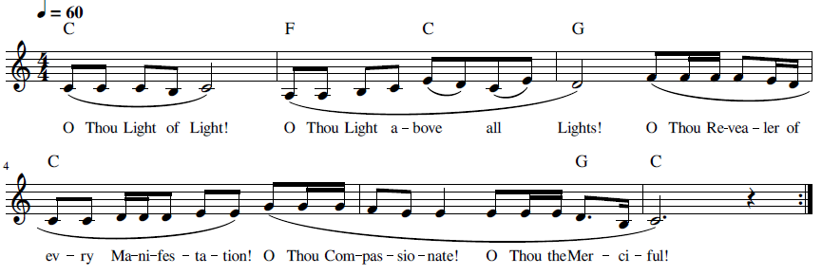

12 Yá Núrassamáváti v’al-Araḍín (یا نورالسماوات و الارضین) O Light of the Heavens and the Earth
“The Verse of Light” is a sentence from the Surah of Light in the Qur’an (24:35): “God is the Light of the heavens and earth.” (Muhammad 2016, 223). References to and commentaries on the Verse of Light from the Qur’an are found in a number of places in the Bahá’í Writings, notably Bahá’u’lláh’s Lawḥ-i-Áyiy-i-Núr (Tablet of the Verse of Light) (Lambden, Tafsīr al-ḥurūfāt al-muqaṭṭa`āt (Commentary on the Isolated Letters) of Baha'-Allah) 2015). This phrase is found in one of the Tablets of Bahá’u’lláh, (Bahá'u'lláh, Eqtidárát va Chand Lawh-i Digar n.d., 253) in a prayer from that Tablet (Bahá'u'lláh, Ad'iyyih-yi Mubarikih 1992, #8:27-29):
يا إِلهِيْ وَسَيِّدِيْ وَمَحْبُوْبَ فُؤادِيْ وَرَجاءَ قَلْبِيْ وَالْمَذْكُوْرَ فِيْ ظاهِرِيْ وَباطِنِيْ, أَسْئَلُكَ بِاسْمِكَ الَّذِيْ أَنْفَقَ نَفْسَهُ فِيْ سَبِيْلِكَ وَحَمَلَ الْبَلايا فِيْ حُبِّكَ وَإِظْهارِ أَمْرِكَ بِأَنْ تُرْسِلَ عَلى هذِهِ الدِّيارِ نَفَحاتِ قَمِيْصِ رَحْمَتِكَ وَأَلْطافِكَ, أَيْ رَبِّ هؤلاءِ عِبادُكَ وَهذِهِ دِيارُكَ, وَلَوْ أَنَّهُمُ احْتَجَبُوا بِأَهْوائِهِمْ وَبِها مُنِعُوا عَنِ التَّوَجُّهِ إِلى شَطْرِ فَضْلِكَ وَالإِقْبالِ إِلى كَعْبَةِ عِرْفانِكَ وَلكِنْ أَنْتَ الَّذِيْ سَبَقَتْ رَحْمَتُكَ
الْكائِناتِ وَأَحاطَ فَضْلُكَ الْمُمْكِناتِ, أَسْئَلُكَ بِاسْمِكَ الْباطِنِ الَّذِيْ ظَهَرَ بِسُلْطانِكَ وَجَعَلْتَهُ مُهَيْمِناً عَلى مَنْ فِيْ أَرْضِكَ وَسَمائِكَ بِأَنْ لا تَدَعَ هؤُلاءِ بِأَهْوائِهِم, فَأَنْزِلْ عَلَيْهِمْ ما يَجْعَلُهُمْ مُقْبِلِيْنَ إِلى شَطْرِ عِنايَتِكَ وَنَاظِرِيْنَ إِلى وَجْهِكَ، فَانْظُرْ يا إِلهِيْ بِلَحَظاتِ رَحْمانِيَّتِكَ وَخُذْ أَيادِيْهِمْ بِقُدْرَتِكَ وَسُلْطانِكَ, أَنْ أَخْرِجْ يا إِلهِيْ مِنْ جَيْبِ عِنايَتِكَ يَدَ قُدْرَتِكَ, وَبِها فَاخْرُقْ حُجُباتِ الَّتِيْ حالَتْ بَيْنَهُمْ وَبَيْنَكَ لِيَسْرُعُنَّ الْكُلُّ إِلى شَرِيْعَةِ قُرْبِكَ وَيَطُوْفُنَّ حَوْلَ إِرادَتِكَ وَمَشِيَّتِكَ, لَوْ تَطْرُدُهُمْ مَنْ يُخَلِّصُهُمْ مِنَ النّارِ يا نُوْرَ السَّمواتِ وَالأَرَضِيْنَ.
This has been provisionally translated into English by Joshua Hall (Bahá'u'lláh, Supplications by Bahá'u'lláh 2017, #19: 9-10)
O my God, my Master, the Beloved and Desire of my heart, Whose remembrance and praise grace my lips and resound in the depths of my soul! I beseech Thee by Thy name, the very name of the One Who gave His life in Thy path, Who bore hardships for love of Thee and in order to establish Thy Cause, to send unto these lands the fragrant breezes carrying the perfume of Thy robe of compassion and tender mercy. 9 O Lord, these are Thy servants and these are Thy lands. Even though they have been shut out as by a veil because of their own desires and therefore hindered from orienting themselves to Thy grace and from turning toward the holy sanctuary of Thy knowledge, yet Thy mercy shall ever surpass the expanse of the universe and Thy grace shall forever embrace the whole of creation. I beseech Thee by Thy hidden name which was made manifest in Thy sovereignty and which Thou didst make supreme over all in heaven and on earth, to abandon them not to their own desires. Send down, then, upon them such as shall enable them to turn toward the direction of Thy providence and to lay their eyes upon Thy countenance. Look upon them, O my God, with the gaze of Thy mercy, and take them by the hand in Thy power and sovereignty. Draw forth, O my God, from the robe of Thy loving-kindness the hand of Thy might, and tear away the veils which have come between them and Thee, that they might all hasten on the path to the wellspring of Thy nearness and circle round Thy will and behest. Shouldst Thou cast them aside, who is there to deliver them from the Fire, O Thou the Light of the heavens and earth?



Recording, online link: https://bahai-library.com/caton_music/12_Ya_Nurassamavati_val-Aradin.mp3
Transcription demo, online link: https://bahai-library.com/caton_music/sacred_refrains_demos/12_Ya_Nurassamavati_val-Aradin_demo.mp3

یا نورالسماوات و الارضین
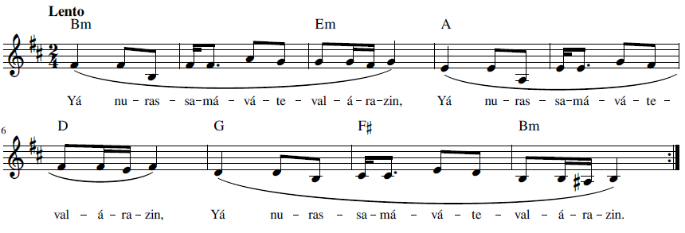Yá nu-ras-sa-má-vá-te-val-á-ra-zín
O Light of the heavens and earth
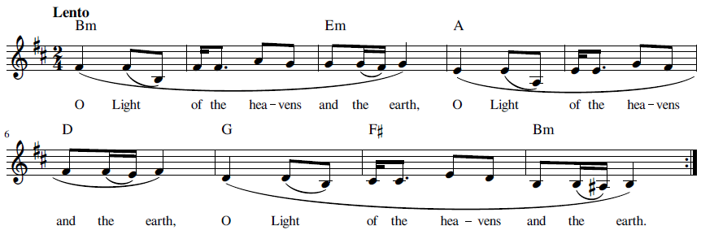

Praise and Thanks

While the first section on names and attributes of God describes, names, and calls upon the qualities of God, this section goes a step farther and praises and shows gratitude for these attributes. “Fasubḥána Rabb” uses the phrase “glory be to” for the attributes of mercy and grace, as “Glory be to the Lord of bountiful mercy, of infinite grace.” The last part of this text serves as a closing of lines in the Qur’an. “Iláhí Iláhí, Ashkurukafí” gives both praise and thanks to God: “O God, my God! I yield Thee thanks at all times and render Thee praise under all conditions.” This is the second line of a prayer of gratitude, which follows the opening line of naming the attributes of might and grandeur.
The longer dhikr, “Iláhá Ma’búdá Maliká Maqṣúdá,” in addition to including an invocation to four attributes of God in terms of what God means to the invoker, using the possessive “my,” it also expresses thanks for what God has done for the reciter: “My God, my Adored One, my King, my Desire! What tongue can voice my thanks to Thee? I was heedless, Thou didst awaken me. I had turned back from Thee, Thou didst graciously aid me to turn towards Thee.” The dhikr itself includes two expressions of what God has done for the reciter, though the complete prayer contains more descriptions and in addition is a prayer of supplication. This is an example of using the text of two opening lines of a prayer, which both address and acknowledge God..
“Iláhá Ma’búdá Maqṣúdá Karímá,” another longer dhikr, is included in two versions, which both start with the same invocation which names a litany of descriptors of God, praises God’s power: “My God, the Object of my adoration, the Goal of my desire, the All-Bountiful, the Most Compassionate!” The first version follows the invocation with the second line of the prayer, which praises God: “All life is of Thee and all power lieth within the grasp of Thine omnipotence.” This dhikr is included in two versions, The second version, after the same initial invocation, continues the praise of God’s power, as well as His justice and grace. Both then use examples of opening a prayer with praising God.
“Lak il-Ḥamd,” expresses both praise and thanks, indicating the place God has in the hearts of His devotees: “Praised be Thou, Who art the Desire of the world, and thanks be to Thee, O Well-Beloved of the hearts of such as are devoted to Thee!” This dhikr is part of the closing of a paragraph which is in itself a praise of the Creator. “Subḥánaka Yá Hú” is a refrain from the Tablet of the Bell which follows a series of different invocations and praises God for His essential attributes of beingness: “Praise be to Thee, O Thou Who art “He,” O Thou besides Whom there is none but “He”!” “Ta’álá’l-Karím” is from an exclamation of praise following the declaration of the principle of the abolishment of holy war and refers to two attributes of God, mercy, and grace: “Glorified be the All-Merciful, the Lord of grace abounding “Tabárak al-Ladhí” is the opening line of a prayer for protection. It praises God’s power: “Hallowed be the Lord in Whose hand is the source of dominion.”
As observed in these examples, the expression of praise may serve as part of the opening or salutation of a prayer as is traditional in some religious traditions, and it may also serve as part of a closing of a prayer or of a paragraph, as well as serve as a refrain that follows a statement or section.

13 Fasubḥána Rabb (فَسُبحانَ رَبِّ) Glory Be to the Lord

The closing phrase, ذُو الفَضل ِ العَظيم, appears in the Qur’an, as a sentence ending, (quran.com n.d.), as well as in the Writings of the Báb and Bahá’u’lláh. The source of the opening phrase is currently unknown, although the words are found separately or in various combinations in the Bahá’í Writings. For example, the phrase الفيّاض الغفور الرّحيم (Al-fayyáḍ al-ghafúr ar-raḥím), similar to the phrase in the dhikr, appears in Bahá’u’lláh’s Commentary on the Fire Tablet ( (Bahá'u'lláh, Ishráqát n.d., 35). The dhikr itself appears among a list found in Bahá’í sources of 15 or 16 commonly known dhikrs (B. '.-B. Báb 2017).
Recording, online link: https://bahai-library.com/caton_music/13_Fasubhana_Rabb.mp3
Transcription demo, online link: https://bahai-library.com/caton_music/sacred_refrains_demos/13_Fasubhana_Rabb_demo.mp3

فَسُبحانَ رَبِّ الفَيّاض الرّحيم ِ ذُو الفَضل ِ العَظيم
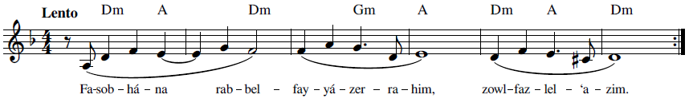
Fa-sob-há-na rab-bel- fay-yá-zer- ra-him, zowl- faz-lel- ‘a-zim
Glory be to the Lord of bountiful mercy, of infinite grace.
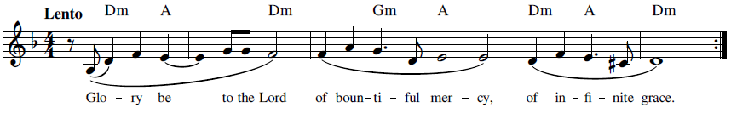

14 Iláhá Ma’búdá Maliká Maqṣúdá (الها معبودا ملکا مقصودا) My God, my Adored One, my King, my Desire!
“Iláhá Ma’búdá Maliká Maqṣúdá” is from a prayer of gratitude and supplication revealed by Bahá’u’lláh. The original prayer in Persian is as follows (Bahá'u'lláh, Ad'iyyih-yi Hadrat-i-Mahbub 1920, 323-324):
الها معبودا ملکا مقصودا
به چه لسان تو را شکر نمایم؟ غافل بودم آگاهم فرمودی مُعرِض بودم بر اقبال تأیید نمودی مرده بودم از آب حیات زندگی بخشیدی پژمرده بودم از کوثر بیان که از قلم رحمن جاری شده تازگی عطا کردی. پروردگارا وجود کلّ از جودت موجود از بحر کرمت محروم مفرما و از دریای رحمتت منع مکن. در هر حال توفیق و تأیید می طلبم و از سماء فضلْ بخشش قدیمت را سائلم. تویی مالک عطا و سلطان ملکوت بقا.

It has been translated into English (Bahá'u'lláh, Prayers and Meditations by Bahá'u'lláh 1987, 264-265):
My God, my Adored One, my King, my Desire! What tongue can voice my thanks to Thee? I was heedless, Thou didst awaken me. I had turned back from Thee, Thou didst graciously aid me to turn towards Thee. I was as one dead, Thou didst quicken me with the water of life. I was withered, Thou didst revive me with the heavenly stream of Thine utterance which hath flowed forth from the Pen of the All-Merciful.
O Divine Providence! All existence is begotten by Thy bounty; deprive it not of the waters of Thy generosity, neither do Thou withhold it from the ocean of Thy mercy. I beseech Thee to aid and assist me at all times and under all conditions, and seek from the heaven of Thy grace Thine ancient favor. Thou art, in truth, the Lord of bounty, and the Sovereign of the kingdom of eternity.




Recording, online link: https://bahai-library.com/caton_music/14_Ilaha_Mabuda_Malika_Maqsuda.mp3

Transcription demo, online link: https://bahai-library.com/caton_music/sacred_refrains_demos/14_Ilaha_Mabuda_Malika_Maqsuda_demo.mp3

الها معبودا ملکا مقصودا به چه لسان تو را شکر نمایم غافل بودم اگاهم فرمودی معرض بودم بر اقبال تایید نمودی
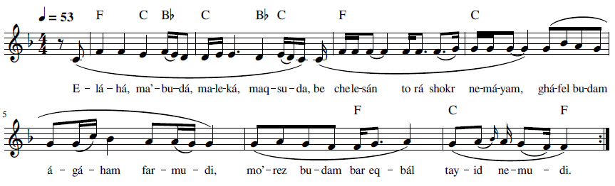
E-lá-há, ma’-bu-dá, ma-le-ká, maq-su-dá, be che le-sán to rá shokr ne-má-yam,
ghá-fel bu-dam á-gá-ham far-mu-di, mo’-rez bu-dam bar eq-bál tay-id ne-mu-di
My God, my Adored One, my King, my Desire! What tongue can voice my thanks to Thee?
I was heedless, Thou didst awaken me, I had turned back from Thee,
Thou didst graciously aid me to turn towards Thee.
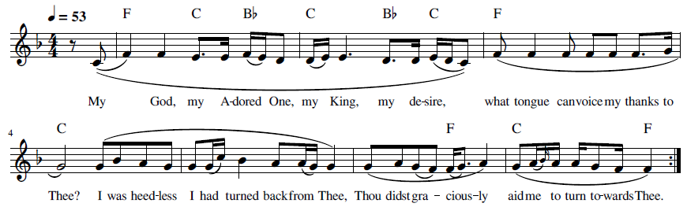

15 Iláhá Ma’búdá Maqṣúdá Karímá Raḥímá (الها معبودا مقصودا کريما رحيما) My God, the Object of my Adoration

The following two dhikrs are both from the same prayer, found in English in Prayers and Meditations by Bahá’u’lláh.The initial invocation is the same, both melody and text, but after that different text is used for each version In Persian this prayer is found in Ad'iyyih-yi Hadrat-i-Mahbub (Bahá'u'lláh, Ad'iyyih-yi Hadrat-i-Mahbub 1920, 326-328) This prayer is also found in Persian in Lawḥ-i-ibn-I Dhib (Bahá'u'lláh, Lawh-i-ibn-i Dhib 2001, 8), Majmuih-yi Adhkár va Idiyyih (Bahá'u'lláh, Majmuih-yi Adhkár va Idiyyih n.d., #160: 169-170), and Majmuih-yi Munáját-I Áthár-I Qalam-I ‘Alá (Bahá'u'lláh, Majmú'ih-i Munáját-i Áthár-i Qalam-i 'Alá 1966, 146-148).
الها معبودا مقصودا كريما رحيما
جانها از تو و اقتدارها در قبضه قدرت تو . هر كه را بلند كنی از ملك بگذرد و بمقام
(( و رفعناه مكاناً عليّاً )) رسد و هر كه را بيندازی از خاك پست تر بلكه هيچ از او بهتر . پروردگارا با تباه كاری و گناهكاری و عدم پرهيزكاری مقعد صدق ميطلبيم و لقای مليك مقتدر ميجوئيم. امر امر توست و حكم آن تو و عالم قدرت زير فرمان تو . هر چه كنی عدل صرفست بل فضل محض . يك تجلّی از تجلّيات اسم رحمانت رسم عصيانرا از جهان براندازد و محو نمايد و يك نسيم از نسائم يوم ظهورت عالم را بخلعت تازه مزيّن فرمايد. ای توانا ناتوانانرا توانائی بخش و مردگانرا زندگی عطا فرما شايد ترا بيابند و بدريای آگاهيت راه يابند و بر امرت مستقيم مانند . اگر از لغات مختلفهء عالم عرف ثنای تو تضوّع شود همه محبوب جان و مقصود روان، چه تازی چه فارسی. اگر از آن محروم ماند قابل ذكر نه، چه الفاظ چه معانی . ای پروردگار از تو ميطلبيم كلّ را راه نمائی و هدايت فرمائی . توئی قادر و توانا و عالم و بينا.
The English translation is found in Prayers and Meditations follows (Bahá’u’lláh, Prayers and Meditations by Bahá’u’lláh 1987, #160: 252-253) and in Epistle to the Son of the Wolf (Bahá'u'lláh, Epistle to the Son of the Wolf 1988, 9-10):
MY God, the Object of my adoration, the Goal of my desire, the All-Bountiful, the Most Compassionate! All life is of Thee and all power lieth within the grasp of Thine omnipotence. Whosoever Thou exaltest is raised above the angels, and attaineth the station: “Verily, We uplifted him to a place on high!”; and whosoever Thou dost abase is made lower than dust, nay, less than nothing.

O Divine Providence! Though wicked, sinful, and intemperate, we still seek from Thee a “seat of truth,” and long to behold the countenance of the Omnipotent King. It is Thine to command, and all sovereignty belongeth to Thee, and the realm of might boweth before Thy behest. Everything Thou doest is pure justice, nay, the very essence of grace. One gleam from the splendors of Thy Name, the All-Merciful, sufficeth to banish and blot out every trace of sinfulness from the world, and a single breath from the breezes of the Day of Thy Revelation is enough to adorn all mankind with a fresh attire.

Vouchsafe Thy strength, O Almighty One, unto Thy weak creatures, and quicken them who are as dead, that haply they may find Thee, and may be led unto the ocean of Thy guidance, and may remain steadfast in Thy Cause. Should the fragrance of Thy praise be shed abroad by any of the divers tongues of the world, out of the East or out of the West, it would, verily, be prized and greatly cherished. If such tongues, however, be deprived of that fragrance, they assuredly would be unworthy of any mention, be they words or thoughts.

We beg of Thee, O Providence, to show Thy way unto all men, and to guide them aright. Thou art, verily, the Almighty, the Most Powerful, the All-Knowing, the All-Seeing.

Iláhá Ma’búdá Maqṣúdá Karímá 1 (الها معبودا مقصودا کريما رحيما) My God, the Object of my Adoration

Recording, online link: https://bahai-library.com/caton_music/15_Ilaha_Mabuda_Maqsuda_Karima_1.mp3
Transcription demo, online link: https://bahai-library.com/caton_music/sacred_refrains_demos/15_Ilaha_Mabuda_Maqsuda_Karima_1_demo.mp3
الها معبودا مقصودا کريما رحيما جانها از تو و اقتدارها در قبضه قدرت تو
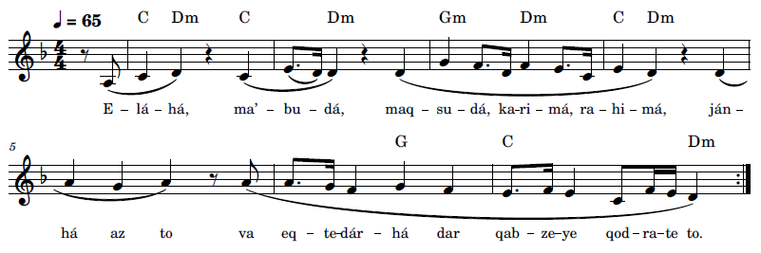
E-lá-há, ma’-bu-dá, maq-su-dá, ka-ri-má,
ra-hi-má, ján-há az to va eq-te-dár-há dar qab-ze-ye qod-ra-te to
My God, the Object of my adoration, the Goal of my desire, the All-Bountiful,
the Most Compassionate! All life is of Thee and all power lieth within the grasp of
Thine omnipotence.
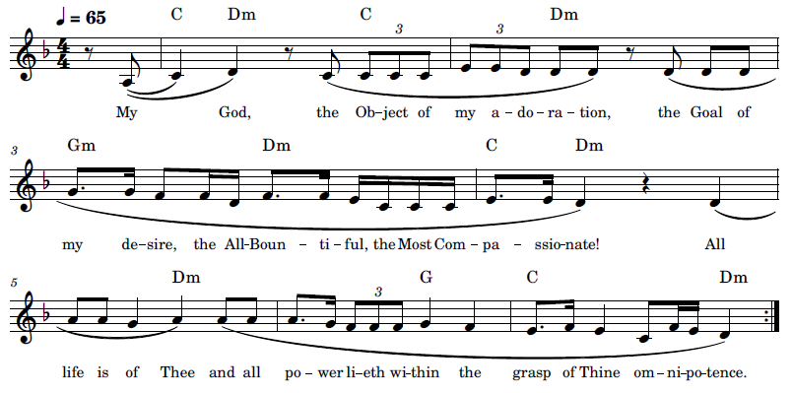
English lyrics based on the paraphrased translation below:
My God, My Adored One, My Desire, Bountiful, Merciful! All life is of Thee and all power is in the hand of Thy Might.
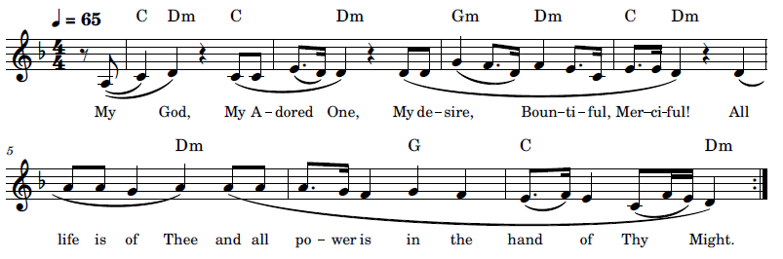

Iláhá Ma’búdá Maqṣúdá Karímá 2 (الها معبودا مقصودا کريما رحيما) My God, the Object of my Adoration

Recording, online link: https://bahai-library.com/caton_music/15_Ilaha_Mabuda_Maqsuda_Karima_2.mp3
Transcription demo, online link: https://bahai-library.com/caton_music/sacred_refrains_demos/15_Ilaha_Mabuda_Maqsuda_Karima_2_demo.mp3
الها معبودا مقصودا کريما رحيما
امر امر توست و حكم آن تو و عالم قدرت زير فرمان تو . هر چه كنی عدل
صرفست بل فضل محض
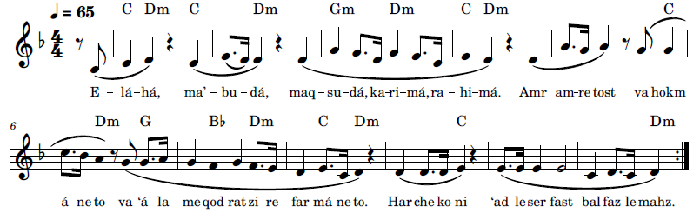
E-lá-há, ma’-bu-dá, maq-su-dá, ka-ri-má, ra-hi-má. Amr am-re tost va hokm á-ne to va ‘á-la-me qod-rat zi-re far-má-ne to. Har che ko-ni ‘ad-le ser-fast bal faz-le mahz



Authorized English translation version:
My God, the Object of my adoration, the Goal of my desire, the All-Bountiful, the Most Compassionate! . . . It is Thine to command, and all sovereignty belongeth to Thee, and the realm of might boweth before Thy behest. Everything Thou doest is pure justice, nay, the very essence of grace.
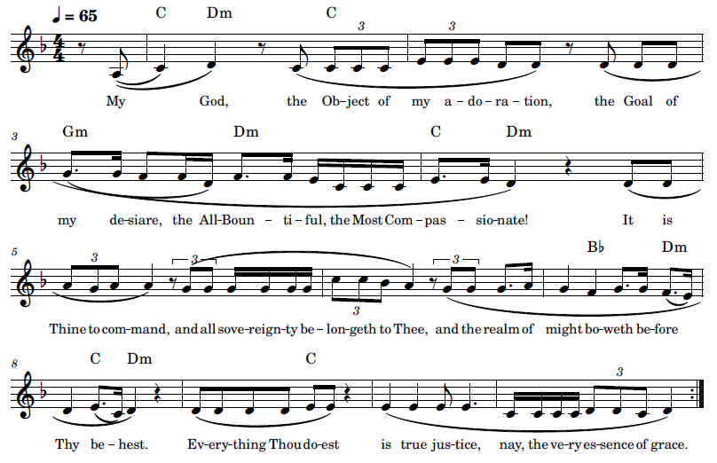

English lyrics are based on the paraphrased translation:
My God, My Adored One, My Desire, Bountiful, Merciful! Command is Thine, and rule is Thine, the realm of might boweth before Thy behest. What Thou doest is true justice, nay, pure grace.
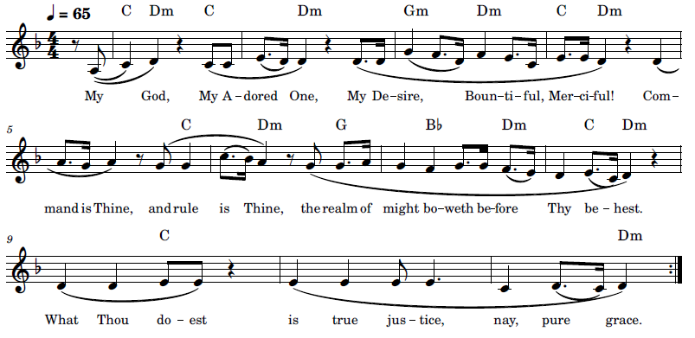

16 Iláhí Iláhí, Ashkuruka Fí (الهی الهی اشکرک فی) O God, My God! I Yield Thee Thanks

This dhikr is from a prayer of gratitude revealed by Bahá’u’lláh. The English translation of this prayer begins with “He is God, exalted is He, the Lord of might and grandeur!” and is immediately followed by “O God, my God! I yield Thee thanks at all times and render Thee praise under all conditions” (Bahá'u'lláh, Additional Prayers Revealed by Bahá'u'lláh 2018).
The original prayer in Arabic is as follows (Bahá'u'lláh, Ad'iyyih-yi Hadrat-i-Mahbub 1920, 49-52):
"هو اللّه تعالی شأنه العظمة و الاقتِدار "
الهی الهی أشكرك فی كلّ حال و أحمدك فی جميع الاحوال * فی النّعمة الحمد لك يا اله العالمين و في فقدها الشّكر لك يا مقصود العارفين * في البأساء لك الثّناء يا معبود من فی السّموات و الارضين و فی الضّرّاء لك السّناء يا من بك انجذبت أفئدة المشتاقين * فی الشّدّة لك الحمد يا مقصود القاصدين و فی الرّخاء لك الشّكر يا أيّها المذكور فی قلوب المقرّبين * فی الثّروة لك البهاء يا سيّد المخلصين و في الفقر لك الامر يا رجاء الموحّدين* في الفرح لك الجلال يا لا إله إلّا أنت و في الحزن لك الجمال يا لا إله إلّا أنت * في الجوع لك العدل يا لا إله إلّا أنت و في الشّبع لك الفضل يا لا إله إلّا أنت * فی الوطن لك العطاء يا لا إله إلّا أنت و فی الغربة لك القضاء يا لا إله إلّا أنت * تحت السّيف لك الافضال يا لا إله إلّا أنت و فی البيت لك الكمال يا لا إله إلّا أنت* فی القصر لك الكرم يا لا إله إلّا أنت و فی التّراب لك الجود يا لا إله إلّا أنت * فی السّجن لك الوفاء يا سابغ النّعم و فی الحبس لك البقاء يا مالك القدم * لك العطاء يا مولی العطاء و سلطان العطاء و مالك العطاء أشهد انّك محمود فی فعلك يا أصل العطاء و مطاع فی حكمك يا بحر العطاء و مبدأ العطاء و مرجع العطاء*

The following is a musical rendition of the whole prayer:
دعای شکر بهائی https://www.youtube.com/watch?v=kV7TjZPOzkw
The English translation is as follows (Bahá'u'lláh, Additional Prayers Revealed by Bahá'u'lláh 2018):
He is God, exalted is He, the Lord of might and grandeur!
O God, my God! I yield Thee thanks at all times and render Thee praise under all conditions. In prosperity, all praise is Thine, O Lord of the Worlds, and in its absence, all gratitude is Thine, O Desire of them that have recognized Thee! In adversity, all honour is Thine, O Adored One of all who are in heaven and on earth, and in affliction, all glory is Thine, O Enchanter of the hearts of those who yearn after Thee! In hardship, all praise is Thine, O Thou the Goal of them that seek after Thee, and in comfort, all thanksgiving is Thine, O Thou whose remembrance is treasured in the hearts of those who are nigh unto Thee! In wealth, all splendour is Thine, O Lord of them that are devoted to Thee, and in poverty, all command is Thine, O Thou the Hope of them that acknowledge Thy unity! In joy, all glory is Thine, O Thou besides Whom there is none other God, and in sorrow, all beauty is Thine, O Thou besides Whom there is none other God! In hunger, all justice is Thine, O Thou besides Whom there is none other God, and in satiety, all grace is Thine, O Thou besides Whom there is none other God! In my homeland, all bounty is Thine, O Thou besides Whom there is none other God, and in exile, all decree is Thine, O Thou besides Whom there is none other God! Under the sword, all munificence is Thine, O Thou besides Whom there is none other God, and in the safety of home, all perfection is Thine, O Thou besides Whom there is none other God! In the lofty mansion, all generosity is Thine, O Thou besides Whom there is none other God, and upon the lowly dust, all favour is Thine, O Thou besides Whom there is none other God! In prison, all fidelity is Thine, O Thou the Bestower of gifts, and in confinement, all eternity is Thine, O Thou Who art the ever-abiding King! All bounty is Thine, O Thou Who art the Lord of bounty, and the Sovereign of bounty, and the King of bounty! I bear witness that Thou art to be praised in Thy doings, O Thou Source of bounty, and to be obeyed in Thy behests, O Thou Ocean of bounty, He from Whom all bounty doth proceed, He to Whom all bounty doth return!
Recording, online link: https://bahai-library.com/caton_music/16_Ilahi_Ilahi_Ashkuruka_Fi.mp3
Transcription demo, online link: https://bahai-library.com/caton_music/sacred_refrains_demos/16_Ilahi_Ilahi_Ashkuruka_Fi_demo.mp3
الهی الهی اشکرک فی کل حال و احمدک فی جمیع الأحوال
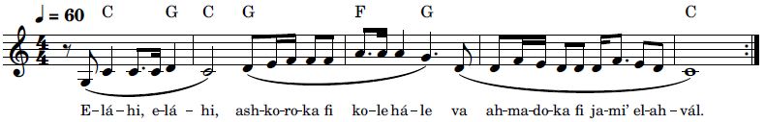
E-lá-hi, e-lá-hi, ash-ko-ro-ka fi kol-le há-le va ah-ma-do-ka fi ja-mi’ el-ah-vál
O God, my God! I yield Thee thanks at all times and render Thee praise under all conditions.
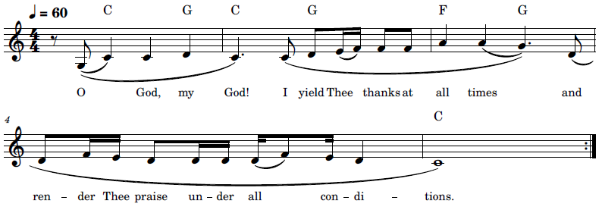

17 Lak al-Ḥamd (لَكَ الحَمْدُ) Praise Be to Thou
This text of “Lak il-Ḥamd” is from Epistle to the Son of the Wolf, Persian (Bahá'u'lláh, Lawh-i-ibn-i Dhib 2001) and English (Bahá'u'lláh, Epistle to the Son of the Wolf 1988, 42-43 para 72):
یا شیخ نفحات وحی از دونش ممتاز و بیان الهی مابین کتب بمثابهٔ آفتاب مشرق و لائح طوبى لمن وجد و عرف و قال لک الحمد یا مقصود العالم و لک الشّکر یا محبوب افئدة المخلصین
O Shaykh! No breeze can compare with the breezes of Divine Revelation, whilst the Word which is uttered by God shineth and flasheth as the sun amidst the books of men. Happy the man that hath discovered it, and recognized it, and said: “Praised be Thou, Who art the Desire of the world, and thanks be to Thee, O Well-Beloved of the hearts of such as are devoted to Thee!”
This exhortation was also quoted in a paragraph from the letter of June 7, 1992 to the Baha’is of the world, from the Universal House of Justice on the occasion of the hundredth year commemoration of the ascension of Baha’u’llah (The Universal House of Justice 1992):
No worldly power could thwart the purpose of the Most Exalted Pen. Through the copiousness of His writings, He poured upon the planet the healing waters of the Word of God renewed. Descending upon Him like a spring rain, His Revelation comprises some one hundred volumes—“volumes replete with unnumbered exhortations, revolutionizing principles, world-shaping laws and ordinances, dire warnings and portentous prophecies, with soul-uplifting prayers and meditations, illuminating commentaries and interpretations, impassioned discourses and homilies, all interspersed with either addresses or references to kings, to emperors and to ministers, of both the East and the West, to ecclesiastics of divers denominations, and to leaders in the intellectual, political, literary, mystical, commercial and humanitarian spheres of human activity.” Foremost among His Books is His Kitáb-i-Aqdas, the charter of the future world civilization in which He has announced the Laws of God for this age. Our hearts thrill to the prospect that during the course of this centennial year, the annotated English translation of this Mother Book of Bahá’u’lláh’s Revelation is to be published. We acknowledge with astonished joy the prolific legacy of this divine outpouring. And we exclaim: “Praised be Thou, Who art the Desire of the world, and thanks be to Thee, O Well-Beloved of the hearts of such as are devoted to Thee!”



Recording, online link: https://bahai-library.com/caton_music/17_Lak_al-Hamd.mp3
Transcription demo, online link: https://bahai-library.com/caton_music/sacred_refrains_demos/17_Lak_al-Hamd_demo.mp3
َكَ الحَمْدُ يا مَقْصُودَ العالَمْ وَ لَكَ الشُّكرِ يا مَحبوبَ اَفْئِدَة ِ المُخلِصين
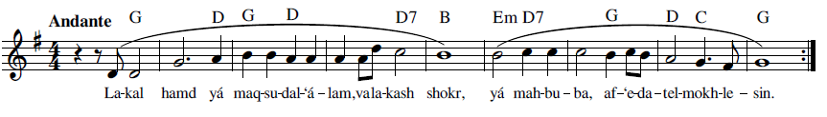
La-kal hamd yá maq-su-dal- ‘á-lam, va la-kash-shokr,
yá mah-bu-ba, af-‘e-da-tel- mokh-le-sin
Praised be Thou, Who art the Desire of the world, and thanks be to Thee,
O Well-Beloved of the hearts of such as are devoted to Thee!
The English lyrics are based on the above translation:
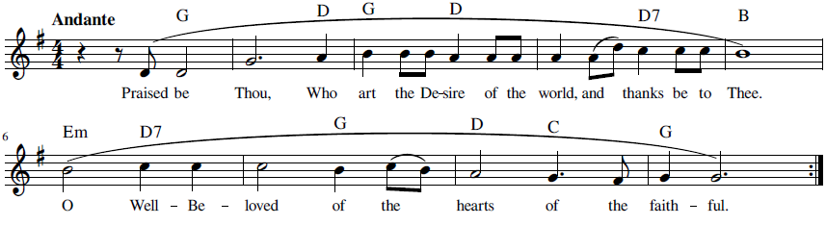

18 Subḥánaka Yá Hú (سُبْحانَكَ يا هُو) Glory Be to Thee, O Lord

Although the following three renditions may appear to be two different dhikrs, they are based on the same text. The second arrangement was well known in Tehran at the time I was living there in the 1970’s and was performed by its composer throughout the city for Bahá’í gatherings and holy day celebrations, particularly at Riḑván.
This text is the refrain from the Tablet of the Bell, revealed by Bahá’u’lláh in 1863 in Istanbul on the anniversary of the Declaration of the Báb. The name of the Tablet comes from the phrase “Ring out the bell” in the opening section. Lambden notes references to the náqús (bell) in the Bahá’í writings, and that Bahá’u’lláh describes Himself in a number of His Writings as the náqús (bell) that summons the faithful (Lambden, Tablet of the Bell 2003)..
Taherzadeh refers to this Tablet as conducive to group chanting (Taherzadeh, The Revelation of Bahá'u'lláh, vol. II 1977, 18-19):

Here, the matchless utterances of Bahá'u'lláh, original and profound, are possessed of such beauty and rhythm as no pen can describe. Composed in a style that lends itself to collective chanting, this Tablet creates an atmosphere of ecstasy and joy when chanted by the believers.
In his study of devotional practices in the Bahá’í community, Armstrong-Ingram mentions the chanting of The Tablet of the Bell by Haydar-‘Ali and his companions in Egypt, and how hearing this Tablet was instrumental in converting Na’im to the Bahá’í Faith. He further described that he interviewed two Bahá’ís that had been brought up in the Bahá’í community in Tehran in the 1930s and 1940s, who mentioned that the verses of the tablet would be sung by one person and the rest of the group would join in the refrain (Armstrong-Ingram 1987, 21)
A talk in Persian on the Tablet of the Bell is found in the following link, along with a rendition of the dhikr: سبحانک یا هو https://www.youtube.com/watch?v=rM3PP1hdgA4.
The following are the opening paragraphs in the Arabic text of the Lawh-i-Náqús (Bahá'u'lláh, Lawh-i-Náqús n.d., 100-101)
هُوَ الْعَزيزُ هذِه رَوْضَةُ الْفِرْدَوْسِ ارْتَفَعَتْ
فيها نَغْمَةُ اللّهِ الْمُهَيْمِنِ الْقَيُّومِ وَ فيهَا اسْتَقَرَّتْ حُورِيّاتُ الْخُلْدِ ما مَسَّهُنَّ اَحَدٌ اِلَّا اللّهُ الْعَزيزُ
الْقُدُّوسُ وَ فيها تَغَرَّدَ عَنْدَليبُ الْبَقآء عَلی اَفْنانِ سِدْرَةِ الْمُنْتَهی بِالنَّغْمَةِ الَّتی تَتَحَيَّرُ مِنْهَا الْعُقُولُ
وَ فيها ما يُقَرِّبُ الْفُقَرآءَ اِلی شاطِی الْغَنآء وَ يَهْدِی النّاسَ اِلی کَلِمَةِ اللّهِ وَ اِنَّ هذا لَحَقٌّ مَعْلُومٌ بِسْمِکَ الْهُوْ وَ اِنَّکَ اَنْتَ الْهُوْ يا هُوْ يا راهِبَ الْأَحَدِيَّةِ اضْرِبْ عَلَی النّاقُوسِ بِما ظَهَرَ يَومُ اللّهِ وَ اسْتَوی جَمالُ الْعِزِّ عَلی عَرْشِ قُدْسٍ مُنيرٍ سُبْحانَکَ يا هُوْ يامَنْ هُوَ هُوْ يا مَنْ لَيْسَ اَحَدٌ اِلّا هُوْ يا هُودَ الْحُکْمِ اضْرِبْ عَلَی النّاقُورِ بِاسْمِ اللّهِ الْعَزيزِ الْکَريمِ بِمَا اسْتَقَرَّ هَيْکَلُ الْقُدْسِ عَلی کُرْسِيِّ عِزٍّ مَنيعٍ سُبْحانَکَ يا هُوْ يا مَنْ هُوَ هُوْ يا مَنْ لَيْسَ اَحَدٌ اِلّا هُوْ يا طَلْعَةَ الْبَقآء اضْرِبْ بِاَنامِلِ الرُّوحِ عَلی رَبابِ قُدْسٍ بَديعٍ بِما ظَهَرَ جَمالُ الْهُوِيَّةِ فی رِداءِ حَريرٍ لَميعٍ سُبْحانَکَ يا هُوْ يا مَنْ هُوَ هُوْ يا مَنْ لَيْسَ اَحَدٌ اِلّا هُوْ يا مَلَکَ النُّورِ انْفُخْ فِی الصُّورِ فی هذَا الظُّهُورِ بِما رَکِبَ

The opening paragraphs of the English translation of the Tablet of the Sacred Night illustrate the use of this dhikr text as a refrain (Bahá'u'lláh, Tablet of the Bell n.d., 19):

He is the All-Glorious.
This is the garden of Paradise, wherein arise the anthems of God, the Help in Peril, the Self-Subsisting; wherein ascend the soul-entrancing melodies warbled by the Nightingale of Eternity upon the twigs of the Divine Lote-Tree; wherein abide the Maids of Heaven whom none hath touched save God, the All-Glorious, the Most Holy; and wherein lieth enshrined that which draweth the needy to the shores of the ocean of true wealth and guideth the people to the Word of God. And this, verily, is naught but the manifest truth.
By Thy name “He”! Verily Thou art “He,” O Thou Who art “He”!
O Monk of the Divine Unity! Ring out the bell, for the Day of the Lord is come and the Beauty of the All-Glorious hath ascended His blessed and resplendent throne. Praise be to Thee, O Thou Who art “He,” O Thou besides Whom there is none but “He”!
O Húd, Prophet of the Divine Decree! Sound the clarion in the name of God, the All-Glorious, the Most Bountiful, for the Temple of holiness hath been established upon the seat of supernal glory. Praise be to Thee, O Thou Who art “He,” O Thou besides Whom there is none but “He”!
O Countenance of immortality! Pluck with the fingers of the spirit the sacred and wondrous strings, for the Beauty of the Divine Essence hath appeared, arrayed in a silken vesture of light. Praise be to Thee, O Thou Who art “He,” O Thou besides Whom there is none but “He”!

Subḥánaka Yá Hú 1 (سُبْحانَكَ يا هُو۱) Glory Be to Thee, O Lord

Recording, online link: https://bahai-library.com/caton_music/18_Subhanaka_Ya_Hu_1.mp3
Transcription demo, online link: https://bahai-library.com/caton_music/sacred_refrains_demos/18_Subhanaka_Ya_Hu_1_demo.mp3
سُبْحانَكَ يا هُو يا مَنْ هُوَ هُو يا مَنْ لَيسَ اَحَدٌ اِلّا هُو
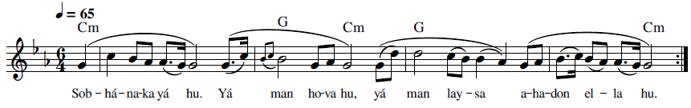
Sob-há-na-ka yá hu. Yá man ho-va hu, yá man lay-sa a-ha-don el-la hu



Praise be to Thee, O Thou Who art “He,”
O Thou besides Whom there is none but “He”!
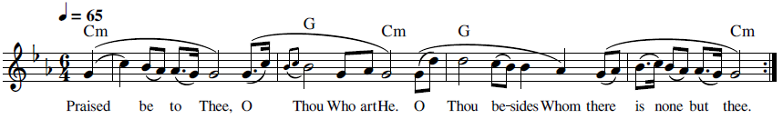

Subḥánaka Yá Hú 2 (سُبْحانَكَ يا هُو۲) Glory Be to Thee, O Lord

The refrain from Tablet of the Bell is used in both these recorded examples and both use the same melody for the refrain. The composer of the melody and the additional words is Delilah Tabibi, whom I accompanied on piano in Tehran in the early 1970’s when she performed at different meetings and Holy Day celebrations leading groups in singing this dhikr. The first example is an excerpt from an such an occasion where she herself is leading a group, and includes some of her lyrics. This version was my first introduction to group dhikr singing. The second example a is different group performance just using the refrain with the same melody as the first version.
Recording, online link: https://bahai-library.com/caton_music/18_Subhanaka_Ya_Hu_2a.mp3
Recording, online link: https://bahai-library.com/caton_music/18_Subhanaka_Ya_Hu_2b.mp3
Transcription demo, online link: https://bahai-library.com/caton_music/sacred_refrains_demos/18_Subhanaka_Ya_Hu_2b_demo.mp3

سُبْحانَكَ يا هُو يا مَنْ هُوَ هُو يا مَنْ لَيسَ اَحَدٌ اِلّا هُو
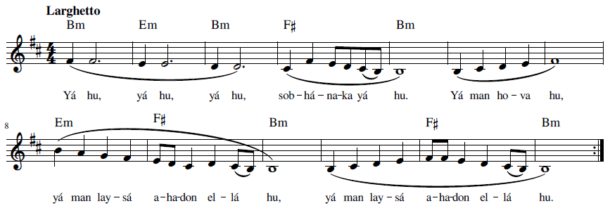
Yá hu, yá hu, yá hu, sob-há-na-ka yá hu. Yá man ho-va hu,yá man lay-sá a-ha-don el-lá hu,
yá man lay-sá a-ha-don el-lá hu

O Thou, O Thou, O Thou, Praise be to Thee, O Thu Who art “He.”
O Thou besides Whom there is none but “He”! (2x)
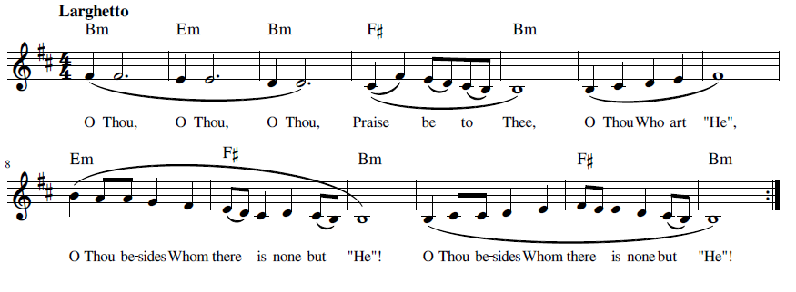

Subḥánaka Yá Hú 3 (سُبْحانَكَ يا هُو۳) Glory Be to Thee, O Lord

Recording, online link: https://bahai-library.com/caton_music/18_Subhanaka_Ya_Hu_3.mp3
Transcription demo, online link: https://bahai-library.com/caton_music/sacred_refrains_demos/18_Subhanaka_Ya_Hu_3_demo.mp3
سُبْحانَكَ يا هُو يا مَنْ هُوَ هُو يا مَنْ لَيسَ اَحَدٌ اِلّا هُو
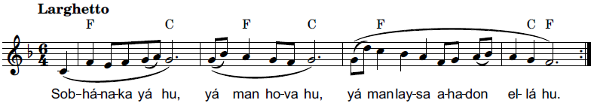
Sob-há-na-ka yá hu, yá man ho-va hu,
yá man lay-sa a-ha-don el-lá hu

Praise be to Thee, O Thou Who art “He,”
O Thou besides Whom there is none but “He”!
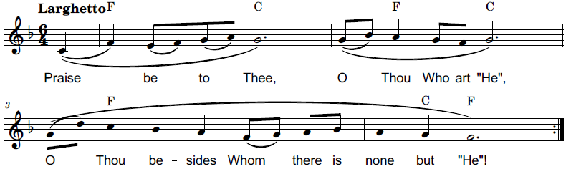

19 Ta’álá’l-Karím (تَعالَی الكَريمُ) Glorified be the All-Merciful

The Bishárát is one of the Tablets revealed in 1891 by Bahá’u’lláh after the Kitáb-i Aqdas. This Tablet consists of a sequence of 15 laws and principles presented in sequential and numerical order, referred to as Glad-Tidings. It was intended as a proclamation as well as a clarification of Bahá’í teachings and was sent to a number of scholars, including the noted orientalist E.G. Browne (Ioannesyan and Buck 2010, 3)
The first Glad-Tidings from the Tablet of Bishárát, was written in celebration of the abolishing of holy war. Included is the original text in Persian (Bahá'u'lláh, Bishárát n.d.) and the translation in English (Bahá'u'lláh, Tablets of Bahá'u'lláh 1978, 21):
يا اهل ارض بشارت اوّل که از امّ الکتاب در اين ظهور اعظم بجميع اهل عالم عنايت شد محوحکم جهاد است از کتاب تعالی الکريم ذو الفضل العظيم الّذی به فُتح بابُ الفضل علی من فی السّموات و الارضين .
O people of the earth!
The first Glad-Tidings which the Mother Book hath, in this Most Great Revelation, imparted unto all the peoples of the world is that the law of holy war hath been blotted out from the Book. Glorified be the All-Merciful, the Lord of grace abounding, through Whom the door of heavenly bounty hath been flung open in the face of all that are in heaven and on earth.

Recording, online link: https://bahai-library.com/caton_music/19_Taalal-Karim.mp3
Transcription demo, online link: https://bahai-library.com/caton_music/sacred_refrains_demos/19_Taalal-Karim_demo.mp3
تَعالَی الكَريمُ ذُو الفَضلِ العَظيمُ
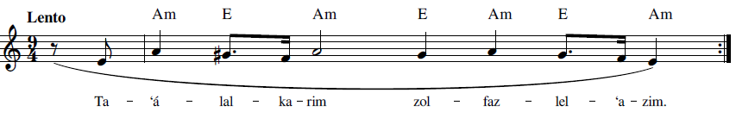
Ta-‘á-lal- ka-rim zol- faz-lel-‘a-zim
Glorified be the All-Merciful, the Lord of Grace Abounding
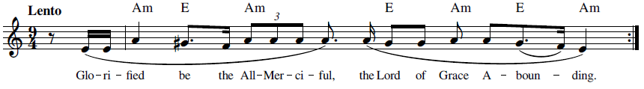

20 Tabárak’al-Ladhí (تَبارَکَ الّذی) Hallowed be the Lord

The text for “Tabárak’al-Ladhí” is originally from the opening phrase of the Surah al-Mulk in the Qur’an (Al-Mulk n.d.). It is also the first sentence of a prayer for protection by the Báb (T. Báb, Muntakhibát 1978, 121):
بسم الله المتكبّر المتجبّر
تبارك الله الّذي بيده الملك يبدع ما يشاء بامره كن فيكون لله الامر من قبل ومن بعد ينصر من يشاء بامره انّه لقويّ عزيز لله العزّة في ملكوت الامر والخلق وما بينهما وكان الله قويّاً عزيز ولله القوّة كلّها من قبل ومن بعد وكان الله قويّا قويّا ولله ملك السّموات والارض وما بينهما وكان الله على كلّ شيء محيطا ولله خزائن السّموات والارض وما بينهما وكان الله على كلّ شيء حفيظا ولله بدع السّموات والارض وما بينهما وكان الله على كلّ شيء شهيدا ولله حكم السّموات والارض وما بينهما وكان الله ذا حكمٍ سريعا ولله مقادير السّموات والارض وما بينهما وكان الله على كلّ شيء حفيظا ولله مفاتيح السّموات والارض وما بينهما ينفق كيف يشاء بامره وكان الله واسعاً عليما قل حسبي الله الّذي في قبضته ملكوت كلّ شيء يحفظ من يشاء من عباده بجنود السّموات والارض وما بينهما وكان الله على كلّ شيء حفيظا سبحانك اللّهمّ فاحفظنا من بين ايدينا ومن خلفنا ومن فوق رؤسنا وعن ايماننا وعن شمائلنا ومن تحت ارجلنا ومن كلّ شطرٍ نسب الينا انّك لعلّى كلّ شيء حفيظ...
The English translation of this prayer for protection is found in Selections from the Writings of the Báb (T. Báb, Selections from the Writings of The Báb 1976, 171):
In the Name of God, the Lord of overpowering majesty, the All-Compelling.
Hallowed be the Lord in Whose hand is the source of dominion. He createth whatsoever He willeth by His Word of command “Be,” and it is. His hath been the power of authority heretofore and it shall remain His hereafter. He maketh victorious whomsoever He pleaseth, through the potency of His behest. He is in truth the Powerful, the Almighty. Unto Him pertaineth all glory and majesty in the kingdoms of Revelation and Creation and whatever lieth between them. Verily He is the Potent, the All-Glorious. From everlasting He hath been the Source of indomitable strength and shall remain so unto everlasting. He is indeed the Lord of might and power. All the kingdoms of heaven and earth and whatever is between them are God’s, and His power is supreme over all things. All the treasures of earth and heaven and everything between them are His, and His protection extendeth over all things. He is the Creator of the heavens and the earth and whatever lieth between them and He truly is a witness over all things. He is the Lord of Reckoning for all that dwell in the heavens and on earth and whatever lieth between them, and truly God is swift to reckon. He setteth the measure assigned to all who are in the heavens and the earth and whatever is between them. Verily He is the Supreme Protector. He holdeth in His grasp the keys of heaven and earth and of everything between them. At His Own pleasure doth He bestow gifts, through the power of His command. Indeed His grace encompasseth all and He is the All-Knowing.
Say: God sufficeth unto me; He is the One Who holdeth in His grasp the kingdom of all things. Through the power of His hosts of heaven and earth and whatever lieth between them, He protecteth whomsoever among His servants He willeth. God, in truth, keepeth watch over all things.
Immeasurably exalted art Thou, O Lord! Protect us from what lieth in front of us and behind us, above our heads, on our right, on our left, below our feet and every other side to which we are exposed. Verily Thy protection over all things is unfailing.
...
There is an explanation in the video of its source and use as a Bahá’í dhikr: https://www.youtube.com/watch?v=-HCXGFkKroU

Recording, online link: https://bahai-library.com/caton_music/20_Tabarak_al-Ladhi.mp3
Transcription demo, online link: https://bahai-library.com/caton_music/sacred_refrains_demos/20_Tabarak_al-Ladhi_demo.mp3
تَبارَکَ الّذی بِيَدِهِ المُلک
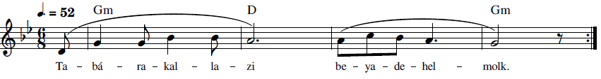
Ta-bá-ra-kal- la-zi be-ya-de-hel- molk
Hallowed be the Lord in Whose hand is the source of dominion.
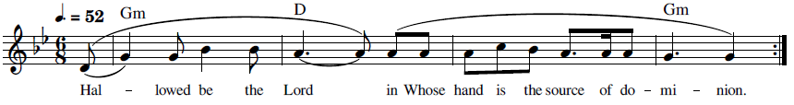

Reliance and Trust

The dhikrs in this section have a slightly different focus, one of dependance and reliance on the will of God and God’s power, guidance, and protection. “Aud’at-u Nafsí” is from a prayer for protection and the dhikr is a simple statement of that reliance: “I have committed myself wholly to Thy care and protection. Shelter me, then, O Protector of the Worlds.” “Ay ‘Alím” first invokes a name of God, then provides a disclaimer, “wayward though we be” and “though ignorant,” for the statements of reliance on two of God’s attributes, bounty, and wisdom: “O Thou Who art the All-Knowing! Wayward though we be, we still cling to Thy bounty; and though ignorant, we still set our faces toward the ocean of Thy wisdom.”
“Dar Har Ḥálat Umídvár Básh” is from a letter addressed to a follower reassuring them that God’s bounties never cease to flow, thus to be ever mindful of that.
The well-known short Remover of Difficulties prayer, “Hal Min Mufarrijin,” does not ask for removal of difficulties per se, but rather states the position of God as the supreme remover of difficulties, and the place of humankind as dependent upon and followers of His commands: “Is there any Remover of difficulties save God? Say: Praised be God! He is God! All are His servants, and all abide by His bidding!”
“Huva Hasbí” states the uniqueness of God’s sufficiency: God sufficeth and sufficeth unto all, and He alone is sufficient.” “Iláhí Iláhí, Tu Bíná va Ágáhi” is another dhikr that declares the reciter’s unique reliance on God as a haven and refuge: “O God, my God! Thou seest me, Thou knowest me; Thou art my Haven and my Refuge. None have I sought nor any will I seek save Thee.”
The short healing prayer, “Lawḥ-i Shafá,” states what characteristics of God can address specific needs of the reciter and what actions on the reciter’s part will call forth these qualities: “Thy name is my healing, O my God, and remembrance of Thee is my remedy.” In their prayer, the believer elaborates on a quality of their remembrance is their love and that by and in that love they hope for closeness to God: “Nearness to Thee is my hope, and love for Thee is my companion.” They then name God’s mercy as a quality that would heal them: “Thy mercy to me is my healing and my succor in both this world and the world to come. Thou, verily, art the All-Bountiful, the All-Knowing, the All-Wise.” The prayer, then, while not directly asking for healing emphasizes reliance on God for succor as well as healing.
“Mánand-i Morgh-i Saḥar” declares the reciter’s love for God that so captures him that he is continually mentioning His name and invoking Him: “even as the bird of dawn, I may be held captive in the snare of Thy love, and lift up day and night, fervently and tearfully, the cry of “’Yá Bahá’u’l-Abhá!’.” “Qul Alláh-u Yakfí” is another dhikr which encourages the believer to place their trust in God’s trustworthiness, reliability, and sufficiency: “God is sufficient unto me; He verily is the All-sufficing! In Him let the trusting trust.” “Qul Alláh Yakfí Min Kul-la Shay” is the complete version of the prayer that was created by putting together the opening of this prayer and a phrase from the Qur’an.
In “Tarání, Yá Iláhí,” which is the refrain from a prayer for the month of fasting, the reciter declares his observable deep reliance on God’s name and attributes. “Thou seest me, O my God, holding to Thy Name, the Most Holy, the Most Luminous, the Most Mighty, the Most Great, the Most Exalted, the Most Glorious, and clinging to the hem of the robe to which have clung all in this world and in the world to come.”

In “Yá Man Vajhuka Ka’batí” the reciter describes how he worships and relies on a series of specific attributes of God as well as his own acts of reliance and worship: “O Thou Whose face is the object of my adoration, Whose beauty is my sanctuary, Whose court is my goal, Whose remembrance is my wish, Whose affection is my solace, Whose love is my begetter, Whose praise is my companion, Whose nearness is my hope.”

21 Aud’at-u Nafsí (اودَعتُ نَفسی) I Place Myself

“Aud’at-u Nafsí” is from a prayer for protection by Bahá’u’lláh in Arabic (Bahá'u'lláh, Ad'iyyih-yi Hadrat-i-Mahbub 1920, 208-209):
سبحانك اللّهمّ لأشهدنّك و كلّ شیء علی أنّك أنت اللّه لا إله إلّا أنت لم
تزل كنت مقدّساً عن ذكر شیء و بذلك تكون بمثل ما قد كنت من قبل
لا إله الّا أنت و إليك المصير * أسألك اللّهمّ يا إلهی بأن تحفظ حامل تلك
الورقة البيضاء من شرّ و بلاء و طاعون و وباء * و انّك من تشاء فانّك أحطت
كلّ شیء علماً أودعت نفسی تحت حفظك و حمايتك فاحفظه يا حفّاظ العالمين
The provisional translation into English is as follows (Bahá'u'lláh, I beseech Thee, O Lord my God n.d.):
Praised be Thou, O Lord! I testify—and indeed, all things bear witness—that Thou art God, and that there is none other God but Thee. From eternity Thou hast been exalted above the praise of every created thing, and Thou wilt continue to remain the same as Thou hast always been. No God is there besides Thee, and it is unto Thee that we make our ultimate journey. I beseech Thee, O Lord my God, to protect the bearer of this snow-white Scroll from every mischief, every affliction, and every plague. Thou keepest safe whomsoever Thou willest as Thou pleasest, and Thy knowledge encompasseth all things. I have committed myself wholly to Thy care and protection. Shelter me, then, O Protector of the Worlds.
MacEoin found six prayers that had been used as talismans, that is, written down and used for protection for the reader, wearer, or others. He includes this prayer among them (MacEoin 1994, 48, 139(#5)). The prayer itself refers to the scroll that it is written on and to the person who bears this prayer scroll and asks God for protection for that person. This prayer has also been referred to in the Leiden List as the Talisman of the final destination, referring to MacEoin’s translation, “In Thee is our final destination” (Leiden List 1999).



Recording, online link: https://bahai-library.com/caton_music/21_Audat-u_Nafsi.mp3
Transcription demo, online link: https://bahai-library.com/caton_music/sacred_refrains_demos/21_Audat-u_Nafsi_demo.mp3
أودعت نفسی تحت حفظك و حمايتك فاحفظه يا حفّاظ العالمين
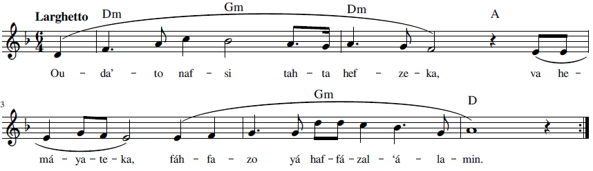
Ou-da’-to naf-si tah-ta hef-ze-ka, va he-má-ya-te-ka,
fáh-fa-zo yá haf-fá-zal- ‘á-la-min
I have placed myself under Thy care and protection.
Shelter me, O the Keeper of the worlds.

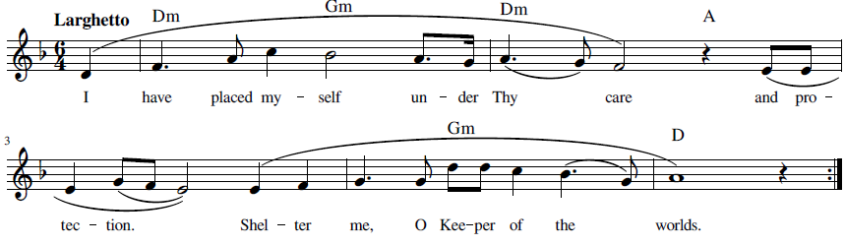



22 Ay ‘Alím (ای علیم) O Thou Who art the All-Knowing!

“Ay ‘Alím” is from a prayer in Persian by Bahá’u’lláh (Bahá'u'lláh, Majmuih-yi Adhkár va Idiyyih n.d., 164-165):
الها معبودا مسجودا مقتدرا
شهادت ميدهم كه تو بوصف ممكنات معروف نشوی و باذكار موجودات موصوف نگردی ادراكات عالم و عقول امم بساحت قدست علی ما ينبغی راه نيابد و پی نبرد . آيا چه خطا اهل مدينه اسما را از افق اعلايت منع نمود و از تقرّب ببحر اعظمت محروم ساخت؟ يك حرف از كتابت امّ البيان و يك كلمه از آن موجد امكان . چه ناسپاسی از عبادت ظاهر كه كلّ را از شناسائيت باز داشتی؟ يك قطره از دريای رحمتت نار جحيم را بيفسرد و يك جذوه از نار محبّتت عالم را برافروزد . ای عليم اگر چه غافليم ولكن بكرمت متشبّث و اگر چه جاهليم ببحر علمت متوجّه. توئی آن جوادی كه كثرت خطا ترا از عطا باز ندارد و اعراض اهل عالم نعمتت را سدّ ننمايد . باب فضلت لازال مفتوح بوده شبنمی از دريای رحمتت كلّ را بطراز تقديس مزيّن فرمايد و رشحی از بحر جودت تمام وجود را بغنای حقيقی فائز نمايد. ای ستّار پرده بر مدار لازال ظهورات كرمت عالم را احاطه نموده و انوار اسم اعظمت بر كلّ تابيده . عبادت را از بدايع فضلت محروم منما و آگاهی بخش تا بر وحدانيّتت گواهی دهند و شناسائی ده تا بسويت بشتابند. رحمتت ممكنات را احاطه نموده و فضلت كلّ را اخذ كرده از امواج بحر بخششت بحور طلب و طمع ظاهر هر چه هستی توئی مادونت لايق ذكر نه الّا بالدّخول فی ظلّك و الورود فی بساطك . در هر حال آمرزش قديمت را ميطلبيم و فضل عميمت را ميجوئيم . اميد چنان كه نفسی را از فضلت محروم نسازی و از طراز عدل و انصاف منع ننمائی . توئی سلطان كرم و مالك عطا و المهيمن علی من فی الأرض و السّماء.
The English translation of this prayer by Bahá’u’lláh is as follows (Bahá'u'lláh, Prayers and Meditations by Bahá'u'lláh 1987, 245-247):
My God, Thou Whom I adore and worship, Who art Most Powerful! I testify that no description by any created thing can ever reveal Thee, and no praise which any being is able to utter can express Thee. Neither the comprehension of any one in the whole world, nor the intelligence of any of its peoples, can, as it befitteth Thee, gain admittance into the court of Thy holiness, or unravel Thy mystery. What sin hath kept the inmates of the city of Thy names so far from Thine all-glorious Horizon, and deprived them of access to Thy most great Ocean? One single letter of Thy Book is the mother of all utterances, and a word therefrom the begetter of all creation. What ingratitude have Thy servants shown forth that Thou hast withheld them, one and all, from recognizing Thee? A drop out of the ocean of Thy mercy sufficeth to quench the flames of hell, and a spark of the fire of Thy love is enough to set ablaze a whole world.
O Thou Who art the All-Knowing! Wayward though we be, we still cling to Thy bounty; and though ignorant, we still set our faces toward the ocean of Thy wisdom. Thou art that All-Bountiful Who art not deterred by a multitude of sins from vouchsafing Thy bounty, and the flow of Whose gifts is not arrested by the withdrawal of the peoples of the world. From eternity the door of Thy grace hath remained wide open. A dewdrop out of the ocean of Thy mercy is able to adorn all things with the ornament of sanctity, and a sprinkling of the waters of Thy bounty can cause the entire creation to attain unto true wealth.
Lift not the veil, O Thou Who art the Concealer! From eternity the tokens of Thy bounty have encompassed the universe, and the splendors of Thy Most Great Name have been shed over all created things. Deny not Thy servants the wonders of Thy grace. Cause them to be made aware of Thee, that they may bear witness to Thy unity, and enable them to recognize Thee, that they may hasten towards Thee. Thy mercy hath embraced the whole creation, and Thy grace hath pervaded all things. From the billows of the ocean of Thy generosity the seas of eagerness and enthusiasm were revealed. Thou art what Thou art. Aught except Thee is unworthy of any mention unless it entereth beneath Thy shadow, and gaineth admittance into Thy court.
Whatever betide us, we beseech Thine ancient forgiveness, and seek Thine all-pervasive grace. Our hope is that Thou wilt deny no one Thy grace, and wilt deprive no soul of the ornament of fairness and justice. Thou art the King of all bounty, and the Lord of all favors, and supreme over all who are in heaven and on earth.



Recording, online link: https://bahai-library.com/caton_music/22_Ay_Alim.mp3
Transcription demo, online link: https://bahai-library.com/caton_music/sacred_refrains_demos/22_Ay_Alim_demo.mp3

ای علیم اگرچه غافلیم ولکن به کرمت متشبث و اگرچه جاهلیم به بحر علمت متوجه
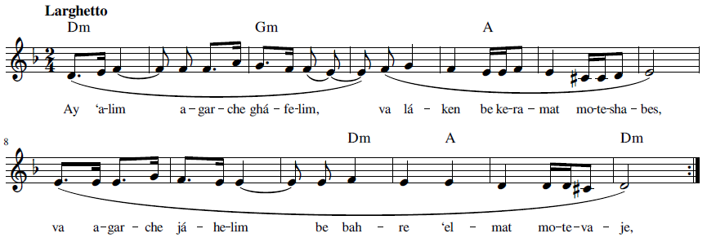
Ay ‘a-lim a-gar-che ghá-fe-lim, va lá-ken be ke-ra-mat mo-te-sha-bes,
va a-gar-che já-he-lim be bah-re ‘el-mat mo-te-va-je
O Thou Who art the All-Knowing! Wayward though we be, we still cling to Thy bounty;
and though ignorant, we still set our faces toward the ocean of Thy wisdom.

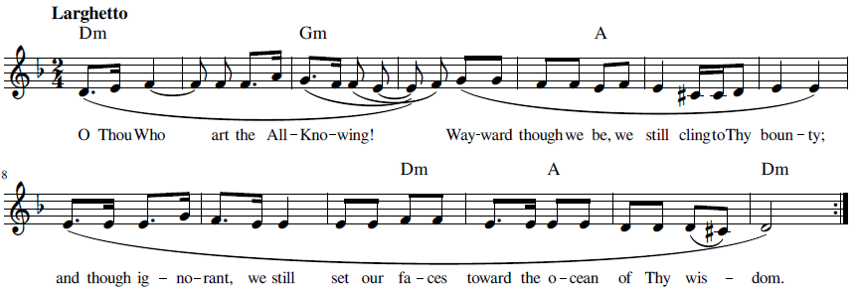

23 Dar Har Ḥálat Umídvár Básh (در هر حالت امیدوار باش) Be Thou Ever Hopeful

The text of this dhikr is taken from a letter from ‘Abdu’l Bahá published in Selections from the Writings of ‘Abdu’l-Bahá ('Abdu'l-Bahá, Muntabakhát-i az Makátib-i Hadrat-e 'Abdu'l-Bahá, 1 1979, 200,#178). To be noted, the text of the letter has the word hál whereas the dhikr uses hálat for the third word:
يا امة اللّه نامه شما که بتاريخ ٩ديسمبر ١٩١٨ بود رسيد و از مضمون اطّلاع حاصل گرديد ابدا اميد را از خدا قطع منما در هر حال اميدوار باش زيرا الطاف حق در هر حالت از انسان منقطع نگردد اگر از جهتی قلّت يابد از جهات سائره کاملست در هر صورت انسان در دريای الطاف مستغرق است لهذا در هيچ حالتی نوميد نشو اميدوار باش حضور مجالس احبّا مجرّد بجهت تنبّه و تذکّر و ازدياد حبّ و تعلّق بملکوت ابهی است و اگر چنانچه ميل تامّ و رغبت کلّيّه برفتن به پيلزبرگ مونتانا داشته باشيد مأذونيد شايد سبب شويد که در ميان آن گروه عمله شمعی روشن نمائيد و جمعی را متنبّه و متذکّر کنيد تا توجّه بخدا نمايند و استفاضه از ملکوت الهی کنند *
The English translation is as follows ('Abdu'l-Bahá, Selections from the Writings of 'Abdu'l-Bahá 1978, 215)
O MAIDSERVANT of God! Thy letter dated 9 December 1918 was received. Its contents were noted. Never lose thy trust in God. Be thou ever hopeful, for the bounties of God never cease to flow upon man. If viewed from one perspective they seem to decrease, but from another they are full and complete. Man is under all conditions immersed in a sea of God’s blessings. Therefore, be thou not hopeless under any circumstances, but rather be firm in thy hope.
Attendance at the gatherings of the friends is specifically to keep them alert, vigilant, loving and attracted to the divine Kingdom.
If thou hast a full and eager desire to travel to Phillsburg, Montana, thou art permitted, perchance thou mayest be able to ignite a candle amid that group of miners and may make them awake and vigilant so that they may turn to God and may acquire a share from the Bounty of the divine Kingdom.

Recording, online link: https://bahai-library.com/caton_music/23_Dar_Har_Halat_Umidvar_Bash.mp3
Transcription demo, online link: https://bahai-library.com/caton_music/sacred_refrains_demos/23_Dar_Har_Halat_Umidvar_Bash_demo.mp3

در هر حالت امیدوار باش زیرا الطافِ حق در هر حالت از انسان منقطع نگردد
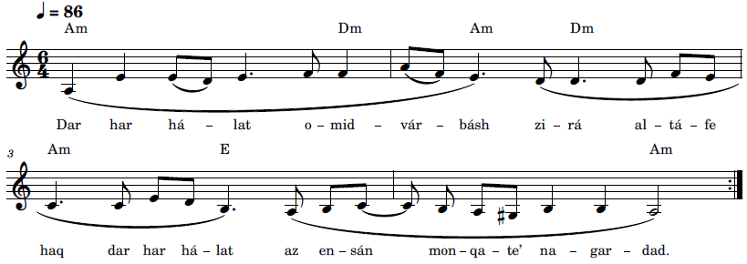
Dar har há-lat o-mid-vár básh zi-rá al-tá-fe haq dar har há-lat az en-sán mon-qa-te’ na-gar-dad
Be thou ever hopeful, for the bounties of God never cease to flow upon man.
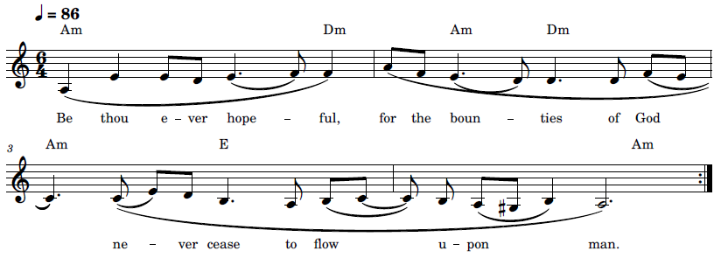

24 Hal Min Mufarrijin (هَلْ مِن مُفِّرجٍ) Remover of Difficulties

The “Remover of Difficulties” is a short prayer, well known in English as well as in Arabic. It was revealed by the Báb and is the prayer attributed as being the one the Báb gave to his wife, Khadíjih-Bagum. The Persian of this passage is as follows (Nabil, Tárikh-i Nabil 1991, 164):

امّا حضرت حرم از اوائل حال بعظمت مقام هيکل مبارک آگاه بود در عبادت و قوّت ايمان بجز حضرت طاهره نظير و نندی نداشت. حضرت اعلی جميع وقايع آينده را تا دورهء شهادت و غيرها بمشارٌ اليها اخبار فرمودند و تأکيد کردند که کلمه‌ای از اين مطالب را بوالدهء حضرت اظهار نکند و سفارش فرمودند که در بلايا صبر کند و بقضای الهی راضی باشد. در ورقه‌ای مناجاتی مرقوم فرمودند و بحضرت حرم دادند و فرمودند هر وقت اضطراب و پريشانی تو زياد شد اين دعا را بخوان من در خواب بتو ظاهر ميشوم و اندوه ترا زائل ميسازم. حضرت حرم بعدها در هنگام پيش آمد مشکلات باين رويّه عمل فرمودند و بهدايت هيکل مبارک در هر مرتبه از پريشانی و اضطراب رهائی يافتند.
The English of this passage is as follows (Nabil, The Dawn-Breakers 1932, 191-192):
The wife of the Báb, unlike His mother, perceived at the earliest dawn of His Revelation the glory and uniqueness of His Mission and felt from the very beginning the intensity of its force. No one except Táhirih, among the women of her generation, surpassed her in the spontaneous character of her devotion nor excelled the fervor of her faith. To her the Báb confided the secret of His future sufferings, and unfolded to her eyes the significance of the events that were to transpire in His Day. He bade her not to divulge this secret to His mother and counselled her to be patient and resigned to the will of God. He entrusted her with a special prayer, revealed and written by Himself, the reading of which, He assured her, would remove her difficulties and lighten the burden of her woes. “In the hour of your perplexity,” He directed her, “recite this prayer ere you go to sleep. I Myself will appear to you and will banish your anxiety.” Faithful to His advice, every time she turned to Him in prayer, the light of His unfailing guidance illumined her path and resolved her problems.

This prayer has long been in use and chanted or sung as a dhikr. There are different renditions of this prayer in Arabic, which vary in chanting or singing style and the use of metered (steady) and non-metered rhythm (flexible).

This prayer is found in Selections of the Writings of the Báb (T. Báb, Muntakhibát 1978, 156) (T. Báb, Selections from the Writings of The Báb 1976, 217):

هَلْ مِن مُفِّرجٍ غَيرُ اللهِ قُلْ سُبْحَانَ اللهِ هُوَ اللهُ كلٌّ عِبَادٌ لَهُ وكلٌّ بأمرِهِ قَائِمُونَ

Is there any Remover of difficulties save God? Say: Praised be God1 He is God! All are His servants and all abide by His bidding!

Shoghi Effendi related a description of Bahá’u’lláh advocating the use of this prayer (Effendi, God Passes By 1979, 119)

Mírzá Áqá Ján himself has testified: “That Blessed Beauty evinced such sadness that the limbs of my body trembled.” He has, likewise, related, as reported by Nabíl in his narrative, that, shortly before Bahá’u’lláh’s retirement, he had on one occasion seen Him, between dawn and sunrise, suddenly come out from His house, His night-cap still on His head, showing such signs of perturbation that he was powerless to gaze into His face, and while walking, angrily remark: “These creatures are the same creatures who for three thousand years have worshipped idols, and bowed down before the Golden Calf. Now, too, they are fit for nothing better. What relation can there be between this people and Him Who is the Countenance of Glory? What ties can bind them to the One Who is the supreme embodiment of all that is lovable?” “I stood,” declared Mírzá Áqá Ján, “rooted to the spot, lifeless, dried up as a dead tree, ready to fall under the impact of the stunning power of His words. Finally, He said: ‘Bid them recite: “Is there any Remover of difficulties save God? Say: Praised be God! He is God! All are His servants, and all abide by His bidding!” Tell them to repeat it five hundred times, nay, a thousand times, by day and by night, sleeping and waking, that haply the Countenance of Glory may be unveiled to their eyes, and tiers of light descend upon them.’ He Himself, I was subsequently informed, recited this same verse, His face betraying the utmost sadness. . . . Several times during those days, He was heard to remark: ‘We have, for a while, tarried amongst this people, and failed to discern the slightest response on their part.’ Oftentimes He alluded to His disappearance from our midst, yet none of us understood His meaning.” (Effendi, God Passes By 1979, 119).

The Persian of this paragraph is as follows (Effendi, Qarn-i Badí' 1992, 249-250)

ميرزا آقاجان شخصاً شهادت ميدهد که در آن ايّام چنان آثار حزنی از وجه مبارک مشهود بود که ارکان جودم بلرزه می آمد" و باز طبق آنچه در تاريخ نبيل مذکوراست ميرزا آقاجان نقل ميکند "قبل از ايّام هجرت يومی جمال مبارک را بين فجر و طلوع آفتاب مشاهده نمودم که با شب كلاه که هنوز بر رأس مبارک بود بطور بغتی از بيت خارج ميشدند در اين حين چنان آثار اضطراب و تشويش در هيكل اقدس مشهود بود که قدرت مواجهه با وجه مبارک از من سلب گرديد. هيكل قيّوم در حين مشی بکمال غضب وشدّت باين بيانات قهريّه ناطق "اين نفوس همان نفوسی هستند که مدّت سه هزار سال به رستش اصنام مألوف و معبودی جز عجل زرين نداشتند الحال نيز بهمان اوهام معتکف چه نسبتی بين اين نفوس واهيهء سافله و طلعت احديّه موجود و چه ارتباطی بين اين عبدهء اوثان و مقصد اعلی و غايت قصوای حبّ و شوق مشهود." ( ترجمه ) ميرزا آقاجان ميگويد "من از هيمنهء اين بيانات بر جای خشک شده و گوئی روح ازبدنم خارج گرديد" تا آنکه بالاخره فرمودند "باين عباد بگو اين ذکر را خوانند هل من مفرّج غير الله قل سبحان الله هو الله كلّ عباد له و كلّ بامره قائمون. بگو اين اذکار منيعه را پانصد بار بل هزار بار شب و روز درحال نوم و يقظه تلاوت نمايند شايد جمال الهی کشف نقاب کند و انوار سبحانی از مشرق ارادهء رحمانی بر عالم و عالميان اشراق نمايد." بعد دريافتم که آن وجود اقدس نيز بلسانه الاطهر همين آيه را تلاوت ميفرمود در حالی که آثار حزن شديد بر وجه نورش محسوس و مشهود بود. در آن ايّام هيكل مبارک غالباً ذکر فراق و جدائی ميفرمودند که از جميع کناره خواهند جست ولی احدی از احبّا مقصود و منظور مبارک را درک نميکرد. هنگامی ميفرمودند "چندی در بين اين قوم مکث نموديم ولی ادنی توجّه و اقبال و کمترين تذکّر و انتباهی از آنان مشاهده نگرديد.‶

Hal Min Mufarrijin 1 (۱ هَلْ مِن مُفِّرجٍ) Remover of Difficulties

Recording, online link: https://bahai-library.com/caton_music/24_Hal_Min_Mufarrijin_1.mp3
Transcription demo, online link: https://bahai-library.com/caton_music/sacred_refrains_demos/24_Hal_Min_Mufarrijin_1_demo.mp3

هَلْ مِن مُفِّرجٍ غَيرُ اللهِ قُلْ سُبْحَانَ اللهِ هُوَ اللهُ كلٌّ عِبَادٌ لَهُ وكلٌّ بأمرِهِ قَائِمُونَ
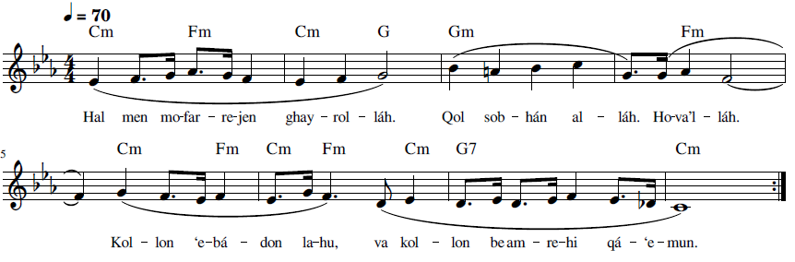
Hal men mo-far-re-jen ghay-rol-láh. Qol sob-hán al-láh. Ho-va’l-láh.
Kol-lon ‘e-bá-don la-hu, va kol-lon be am-re-hi qá-‘e-mun

Is there any Remover of difficulties save God? Say: Praised be God! He is God!
All are His servants, and all abide by His bidding!

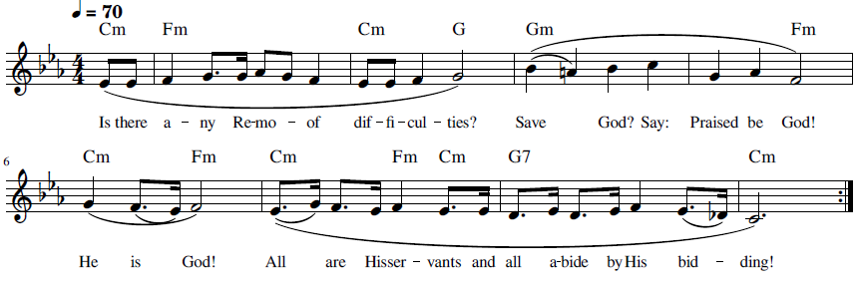

Hal Min Mufarrijin 2 (۲ هَلْ مِن مُفِّرجٍ) Remover of Difficulties

Recording, online link: https://bahai-library.com/caton_music/24_Hal_Min_Mufarrijin_2.mp3
Transcription demo, online link: https://bahai-library.com/caton_music/sacred_refrains_demos/24_Hal_Min_Mufarrijin_2_demo.mp3

هَلْ مِن مُفِّرجٍ غَيرُ اللهِ قُلْ سُبْحَانَ اللهِ هُوَ اللهُ كلٌّ عِبَادٌ لَهُ وكلٌّ بأمرِهِ قَائِمُونَ
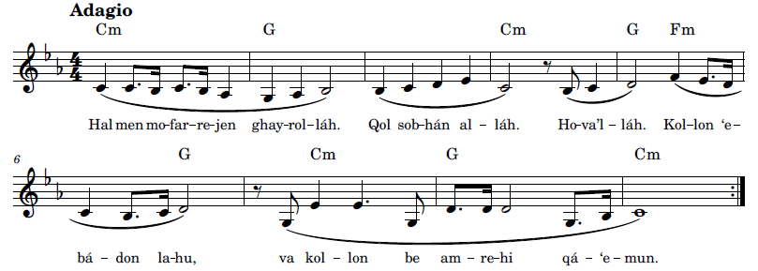
Hal men mo-far-re-jen ghay-rol-láh. Qol sob-hán al-láh. Ho-va’l-láh.
Kol-lon ‘e-bá-don la-hu, va kol-lon be am-re-hi qá-‘e-mun

Is there any Remover of difficulties save God? Say: Praised be God! He is God!
All are His servants, and all abide by His bidding!
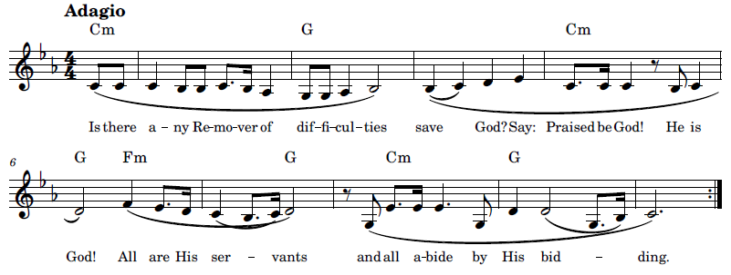





Hal Min Mufarrijin 3 (۳ هَلْ مِن مُفِّرجٍ) Remover of Difficulties

Recording, online link: https://bahai-library.com/caton_music/24_Hal_Min_Mufarrijin_3.mp3
Transcription demo, online link: https://bahai-library.com/caton_music/sacred_refrains_demos/24_Hal_Min_Mufarrijin_3_demo.mp3

هَلْ مِن مُفِّرجٍ غَيرُ اللهِ قُلْ سُبْحَانَ اللهِ هُوَ اللهُ كلٌّ عِبَادٌ لَهُ وكلٌّ بأمرِهِ قَائِمُونَ
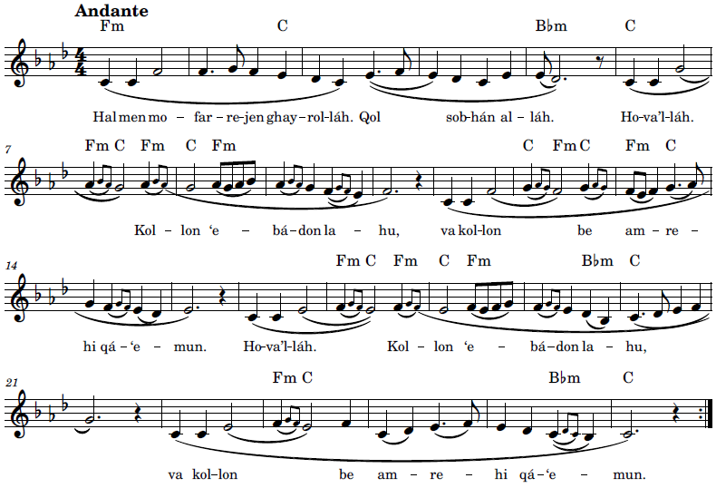

Hal men mo-far-re-jen ghay-rol-láh. Qol sob-hán al-láh. Ho-va’l-láh.
Kol-lon ‘e-bá-don la-hu, va kol-lon be am-re-hi qá-‘e-mun

Is there any Remover of difficulties save God? Say: Praised be God! He is God!
All are His servants, and all abide by His bidding!
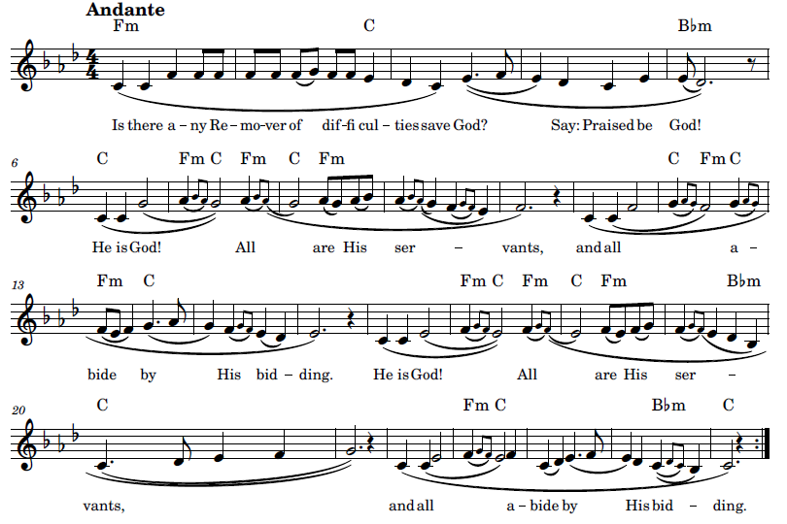

25 Huva Ḥasbí (هُوَ حَسْبی) God is Sufficient

In 1852, there was an attempt by two Bábí youths on the life of Naser al-Din Shah, after which a number of Bábís, including Babá’u’lláh, were imprisoned in an underground dungeon known as the Black Pit, the Síyáh Chál. Bahá’u’lláh was imprisoned there for a period of four months. He recalled that each night the Bábís, who were chained together in two rows, would chant together till dawn, so resoundingly that the shah in his nearby palace heard them and remarked on it, though did not stop them. Nabil describes this, as told to him by Bahá’u’lláh (Nabil, The Dawn-Breakers 1932, 631-632):
From His own lips I have often heard the following account: “All those who were struck down by the storm that raged during that memorable year in Tihrán were Our fellow-prisoners in the Síyáh-Chál, where We were confined. We were all huddled together in one cell, our feet in stocks, and around our necks fastened the most galling of chains. The air we breathed was laden with the foulest impurities, while the floor on which we sat was covered with filth and infested with vermin. No ray of light was allowed to penetrate that pestilential dungeon or to warm its icy-coldness. We were placed in two rows, each facing the other. We had taught them to repeat certain verses which, every night, they chanted with extreme fervour. ‘God is sufficient unto me; He verily is the All-sufficing!’ one row would intone, while the other would reply: ‘In Him let the trusting trust.’ The chorus of these gladsome voices would continue to peal out until the early hours of the morning. Their reverberation would fill the dungeon, and, piercing its massive walls, would reach the ears of Násiri’d-Dín Sháh, whose palace was not far distant from the place where we were imprisoned. ‘What means this sound?’ he was reported to have exclaimed. ‘It is the anthem the Bábís are intoning in their prison,’ they replied. The Sháh made no further remarks, nor did he attempt to restrain the enthusiasm his prisoners, despite the horrors of their confinement, continued to display.
The text of the dhikr, as presented in the Persian, differs, according to source and translation. One version of Nabil’s narrative in Persian states that Bahá’u’lláh taught the Bábís to chant the dhikr that begins with “Qul Alláh-u Yakfí.” Shoghi Effendi quotes a version of the passage in Nabil’s narrative where “Huva Hasbí” is used as the dhikr (Effendi, Tawqi'át-i Mubárakih--Khatáb bih Ahibá-yi Sharq 1992, 437-438):
و در تاریخ نبیل اعظم راجع بشدائد این سجن اکبر این عبارات مدوّن و مسطور: ”چون بانبار رسانیدند در سیاه‌چالی که در قدیم خزینهٴ حمّام بوده جایشان دادند و زنجیر قره‌کهر که در سنگینی معروف است بر گردن و بند گران بر پایشان نهادند و تا سه ٣ یوم مطلقاً نه اکلی موجود و نه شربی و نه سکونی مشهود و نه نومی“
و همچنین در تاریخ خود مینگارد ”در ایّام حضور بارها از لسان مبارک شنیده شد که میفرمودند جمیع این نفوسی که در فتنهٴ سنهٴ حین بشهادت رسیدند در انبار طهران با من بودند و ماها دو دسته بودیم که روبروی یکدیگر پا در خلیلی و گردن در زنجیر بودیم من بآنها ذکری تعلیم نموده بودم که شبها بصوت بلند خوانده میشد یک دسته میگفتند هو حسبی و حسب کلّ شیء دستهٴ دیگر در جواب میگفتند و کفی باللّه حسیباً بهمین منوال در منتهای شوق و اشتعال هر شب تا نیمه‌های شب صدای ذکر مرتفع بود بحدّی که یک شب شاه در عمارت خود شنیده بود و پرسیده بود که این چه صداست گفته بودند که بابیها هر شب ذکر میکنند و این صدای ذکر آنهاست ...“
For reference are similar passages in the published Nabil’s Narrative, in English (Nabil, The Dawn-Breakers 1932, 608, 631-632) and in Persian (Nabil, Tárikh-i Nabil 1991, 563, 576-577). The following is a provisional translation of the above passage from Shoghi Effendi:
And in the history of Nabil Azam, regarding the hardships of this great prison, these accounts are well known: "When they were brought to that storage place in the Black Pit that formerly was the reservoir for the bathhouse, they placed them there, and they put the chains of Qarákuhar, which is famous for its weight, on their necks, and heavy shackles on their feet, and they stayed there for three days with absolutely no food or drink and no discernible rest or sleep.”
And also in his history, he relates "During days of His presence, it was heard many times from His Blessed lips that He pronounced that all these souls who were martyred during the disturbance of that year were with Me in the dungeon of Tehran, and we were in two groups facing each other with our feet in shackles and our necks in chains. I had taught them a dhikr that nightly was sung loudly, one group would say “God sufficeth and sufficeth unto all” [huva ḥasbi va ḥasbu kulli shaí], the other group would say in response, “and He alone is sufficient” [va kafá billáhi hasiban] in the same way in the height of passion and fervor, every night until the midst of the night, the sound of the dhikr was so loud to the degree that one night the king had heard it in his palace and asked what is this sound. They said that the Bábís chanted dhikr every night and that was the sound of their dhikr... “
This second account is also explained in the following video: هو حسبی و حسب کل شی https://www.youtube.com/watch?v=lhd1uvVgfXs.
Bahá’u’lláh Himself gives an account of his imprisonment in which the dhikr is quoted as “Huva Hasbí” (Bahá'u'lláh, La'alyiu'l-Hikmat, v. 2 1990, 281-282):

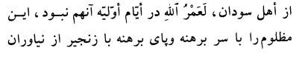
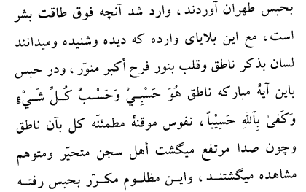
Provisional translation in English:
Bareheaded, barefoot, and fettered with chains, this Wronged One was conducted from Níyávarán to the prison in Ṭihrán, where befell Me what exceedeth the capacity of mankind to endure. In spite of these calamities, of which the people are apprised since they have seen and heard them, My tongue was engaged in voicing praise and My heart illumined with the light of the greatest joy. While in that prison, I would proclaim these words: "God is sufficient unto Me and unto all things; sufficient is He as a Reckoner." Well-assured, believing souls would all likewise recite this verse, and as we lifted up our voices, the inmates of the prison were visibly astonished and afraid.
While Bahá’u’lláh explains that he taught the Bábís this dhikr of “Huva Hasbí,” it is not clear whether He revealed this, or whether it was from another source or sources. That being said, however, the first phrase is similar to a phrase in an epistle by the Báb and the second phrase is found in the Qur’an.
The first phrase is found in an epistle addressed to Muhammad Shah written in Chihríq, the first part of which is as follows (T. Báb, Muntakhibát 1978, 9)
سبحان الّذي يعلم ما في السّموات وما في الارض وانّه لا اله الاّ هو الملك القهّار العظيم. هو الّذي يقضي يوم الفصل بالحقّ وانّه لا اله الاّ هو الفرد الجبّار المنيع وهو الّذي بيده ملكوت كلّ ‏شيء لا اله الاّ‏ هو الوتر الاحد الصّمد العليّ الكبير.اشهد لله حينئذٍ بما قد شهد الله علی ‏نفسه من ‏قبل ان ‏يخلق شيئاً انّه لا ‏اله الاّ هو العزيز الحكيم واشهد على كلّ ما ابدع وما يبدع بمثل ما قد شهد عليه في سلطان عزّته انّه لا اله الاّ هو الفرد القائم البديع .توكّلت على الله ربّ كلّشيء لا اله الاّ هو الفرد الرّفيع والى الله القى نفسي واليه افوّض امري لا اله الاّ هو الملك ‏الحقّ ‏المبين ‏و‏انّه ‏هو‏ حسبي يكفي ‏من كلّشيء ولا يكفي ‏منه شيء في ‏السّموات ‏ولا ‏في الارض وانّه لهو القائم الشّديد.
The Muntakhibát is found in the English translation, Selections from the Writings of the Báb (T. Báb, Selections from the Writings of The Báb 1976, 18), with the translation of the above passages as follows:
GLORY be unto Him Who knoweth all that is in the heavens and in the earth. Verily there is no God but Him, the sovereign Ruler, the Almighty, the Great.
He is the One Who on the Day of Severing shall pass judgment through the power of Truth; indeed no God is there besides Him, the Peerless, the All-Compelling, the Exalted. He is the One Who holdeth within His grasp the kingdom of all created things; there is none other God but Him, the Single, the Incomparable, the Ever-Abiding, the Inaccessible, the Most Great.
At this moment I testify unto God, even as He testified unto Himself before the creation of all things: Verily there is no God save Him, the All-Glorious, the All-Wise. And I bear witness unto whatsoever He hath fashioned or will fashion, even as He Himself, in the majesty of His glory, hath borne witness: No God is there but Him, the Peerless, the Self-Subsisting, the Most Wondrous.
In God, Who is the Lord of all created things, have I placed My whole trust. There is no God but Him, the Peerless, the Most Exalted. Unto Him have I resigned Myself and into His hands have I committed all My affairs. No God is there besides Him, the supreme Ruler, the resplendent Truth. Indeed all-sufficient is He for Me; independently of all things doth He suffice, while nothing in the heavens or in the earth but Him sufficeth. He, in very truth, is the Self-Subsisting, the Most Severe.
The second phrase, the response, is found in the Qur’an at the end of Surah 4:6 and Surah 33:39 (quran.com n.d.):
وَابْتَلُوا الْيَتَامَىٰ حَتَّىٰ إِذَا بَلَغُوا النِّكَاحَ فَإِنْ آنَسْتُم مِّنْهُمْ رُشْدًا فَادْفَعُوا إِلَيْهِمْ أَمْوَالَهُمْ ۖ وَلَا تَأْكُلُوهَا إِسْرَافًا وَبِدَارًا أَن يَكْبَرُوا ۚ وَمَن كَانَ غَنِيًّا فَلْيَسْتَعْفِفْ ۖ وَمَن كَانَ فَقِيرًا فَلْيَأْكُلْ بِالْمَعْرُوفِ ۚ فَإِذَا دَفَعْتُمْ إِلَيْهِمْ أَمْوَالَهُمْ فَأَشْهِدُوا عَلَيْهِمْ ۚ وَكَفَىٰ بِاللَّهِ حَسِيبًا الَّذِينَ يُبَلِّغُونَ رِسَالَاتِ اللَّهِ وَيَخْشَوْنَهُ وَلَا يَخْشَوْنَ أَحَدًا إِلَّا اللَّهَ ۗ وَكَفَىٰ بِاللَّهِ حَسِيبًا
In the same time period as the Bábís were chanting in the Síyáh Chál, others were being tortured in the Tehran bazaars and it was noted that they too were chanting a verse, found in Note 2 on page 613 of the Dawn-Breakers (Périgord 1939, 74-75):
“On that day, a spectacle was witnessed in the streets and bazaars of Tihran which the people can never forget. Even to this very day, it remains the topic of conversation; one still feels a shocking horror which the years have not been able to lessen. The people saw marching, between executioners, children and women with deep holes cut into their flesh in which lighted wicks were inserted. The victims were dragged with ropes and goaded on with whips. Children and women went forth singing this verse: `In truth, we come from God and unto Him do we return.' Their voices were raised triumphant above the deep silence of the crowd, for the citizens of Tihran were neither mean nor great believers in Islam. When one of the victims fell to the ground and they prodded him up with bayonets, if the loss of blood which dripped from his wounds had left him any strength, he would begin to dance and to cry out with even greater enthusiasm: `In truth, we come from God and unto Him do we return!' "
Because the better-known dhikr is included in the published version of Nabil’s narrative in Persian (Nabil, Tárikh-i Nabil 1991, 577) as “Qul Alláh-u Yakfi”, the presence of a different dhikr in two other sources, one from Shoghi Effendi and one from Bahá’u’lláh’s Writings, presents an interesting conundrum. “Huva Ḥasbi,” particularly in the simple melodic version available in recordings, appears to be the one easier to chant or sing in a group in a call-and-response manner.
Recording, online link: https://bahai-library.com/caton_music/25_Huva_Hasbi.mp3
Transcription demo, online link: https://bahai-library.com/caton_music/sacred_refrains_demos/25_Huva_Hasbi_demo.mp3
هُوَ حَسْبی وَ حَسْبُ كُلِّ شَئئ وَ كَفی بِالله حَسيباً
This dhikr has 19 beats and 19 syllables. The first phrase, the call, has 10 beats and the second phrase, the response, has 9 beats.
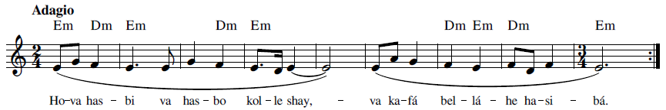
Ho-va has-bi va has-bo kol-le shay va ka-fá bel-lá-he ha-si-bán
God is sufficient unto Me and unto all things; sufficient is He as a Reckoner.
God sufficeth and sufficeth unto all, and He alone is sufficient.
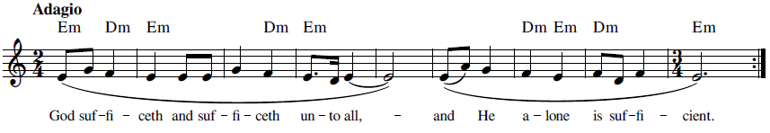

26 Iláhí Iláhí, Tu Bíná va Ágáhí (إلهی إلهی تو بينا و آگاهی)

This dhikr is found in the first line of a prayer by ‘Abdu’l-Bahá (Persian text of the prayer) ('Abdu'l-Bahá, Majmuih-yi-Munajatha 1992, #26, page 27):

هُوالحقّ القيّ
إلهی تو بينا و آگاهی که ملجأ و پناهی جز تو نجسته و نجويم و به غير از سبيل محبّتت راهی نپيموده و نپويم در شبان تيره نوميدی ديده ام به صبح اميد الطاف بی نهايتت روشن و باز و در سحر گاهی اين جان و دل پژمرده به ياد جمال و کمالت خرم و دمساز هر قطره ای که به عواطف رحمانيّتت موفّق بحريست بيکران و هر ذرّه ای که به پرتو عنايتت مُؤيّد آفتابيست درخشنده و تابان پس ای پاک يزدان من اين بنده پر شور و شيدا را در پناه خود پناهی ده و بر دوستی خويش در عالم هستی ثابت و مستقيم بدار و اين مرغ بی پر و بال را در آشيان رحمانی خود و در شاخسار روحانی خويش مسکن و مأوائی عطا فرما . ع ع

The following is the English translation of this prayer (Bahá'í Prayers 1991, 107):
He is the Compassionate, the All-Bountiful! O God, my God! Thou seest me, Thou knowest me; Thou art my Haven and my Refuge. None have I sought nor any will I seek save Thee; no path have I trodden nor any will I tread but the path of Thy love. In the darksome night of despair, my eye turneth expectant and full of hope to the morn of Thy boundless favor and at the hour of dawn my drooping soul is refreshed and strengthened in remembrance of Thy beauty and perfection. He whom the grace of Thy mercy aideth, though he be but a drop, shall become the boundless ocean, and the merest atom which the outpouring of Thy loving kindness assisteth, shall shine even as the radiant star.
Shelter under Thy protection, O Thou Spirit of purity, Thou Who art the All-Bountiful Provider, this enthralled, enkindled servant of Thine. Aid him in this world of being to remain steadfast and firm in Thy love and grant that this broken-winged bird attain a refuge and shelter in Thy divine nest that abideth upon the celestial tree. ‘Abdu’l-Bahá

Recording, online link: https://bahai-library.com/caton_music/26_Ilahi_Ilahi_Tu_Bina_va_Agahi.mp3
Transcription demo, online link: https://bahai-library.com/caton_music/sacred_refrains_demos/26_Ilahi_Ilahi_Tu_Bina_va_Agahi_demo.mp3
اِلهی اِلهی تو بينا و آگاهی که مَلجَأ و پناهی جز تو نجسته و نجويم
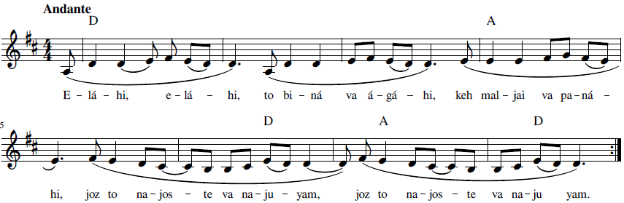
E-lá-hi, e-lá-hi, to bi-ná va á-gá-hi, keh mal-jai va pa-ná-hi,
joz to na-jos-te va na-ju-yam



O God, my God! Thou seest me, Thou knowest me; Thou art my Haven and my Refuge.
None have I sought nor any will I seek save Thee.

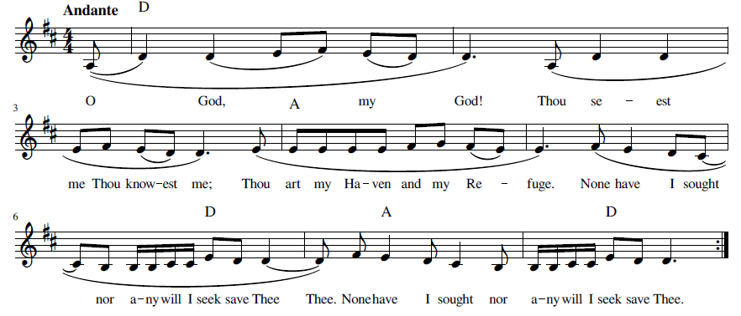

27 Lawḥ-i Shafá (لوح شفا) (Tablet of Healing)

This dhikr is from the well-known short healing prayer. The complete prayer in English is (Bahá'u'lláh, Prayers and Meditations by Bahá'u'lláh 1987, 262-263) :
Thy name is my healing, O my God, and remembrance of Thee is my remedy. Nearness to Thee is my hope, and love for Thee is my companion. Thy mercy to me is my healing and my succor in both this world and the world to come. Thou, verily, art the All-Bountiful, the All-Knowing, the All-Wise.
The prayer in Arabic follows (Bahá'u'lláh, Majmuih-yi Adhkár va Idiyyih n.d., 176: #170):
يا إِلهِي اسْمُكَ شِفائِي وَذِكْرُكَ دَوائِي وَقُرْبُكَ رَجَائِيْ وَحُبُّكَ مُؤْنِسِيْ وَرَحْمَتُكَ طَبِيبِيْ وَمُعِيْنِيْ فِي الدُّنْيا وَالآخِرَةِ وَإِنَّكَ أَنْتَ المُعْطِ العَلِيمُ الحَكِيمُ.

Lawḥ-i Shafá 1 (لوح شفا ١) (Tablet of Healing)

يا إِلهِي اسْمُكَ شِفائِي وَذِكْرُكَ دَوائِي وَقُرْبُكَ رَجَائِيْ وَحُبُّكَ مُؤْنِسِيْ

Though included in an album (آلبوم یا نورالنور) (Album Yá Nur al-Nur) of recognizable dhikr, this version is not likely a dhikr per se, but does have some dhikr-like qualities, particularly in the musical rendition, such as a series of like phrases of the same structure and approximate length, beginning with “Yá Illáhí” and ending with a rhyming attribute, as in, for example:
Yá e-lá-hi, es-mo-ka she-fá-i,
Yá e-lá-hi, ze-kro-ka da-vá-i

The first section then, could be used as a dhikr. The following is a shortened version of the recording, only going to the end of the second line (munesi) and repeating. Note in the recording the initial “Yá Illáhí” (O my God) is repeated before each phrase instead of va (and).

Recording, online link: https://bahai-library.com/caton_music/27_Lawh-i_Shafa_1.mp3
Transcription demo, online link: https://bahai-library.com/caton_music/sacred_refrains_demos/27_Lawh-i_Shafa_1_demo.mp3
يا إِلهِي اسْمُكَ شِفائِي وَذِكْرُكَ دَوائِي وَقُرْبُكَ رَجَائِيْ وَحُبُّكَ مُؤْنِسِيْ
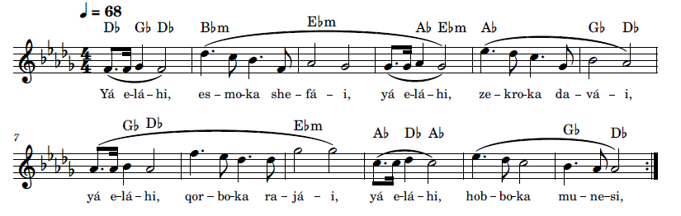
Yá e-lá-hi, es-mo-ka she-fá-i, yá e-lá-hi, ze-kro-ka da-vá-i,
yá e-lá-hi, qor-bo-ka ra-já-i, yá e-lá-hi, hob-bo-ka mu-ne-si



O my God, Thy name is my healing, O my God, remembrance of Thee is my remedy.
O my God, nearness to Thee is my hope, O my God, love for Thee is my companion.
The version in English like the Arabic version can be furthered shortened by ending with the word “comparison” and repeating from the beginning:
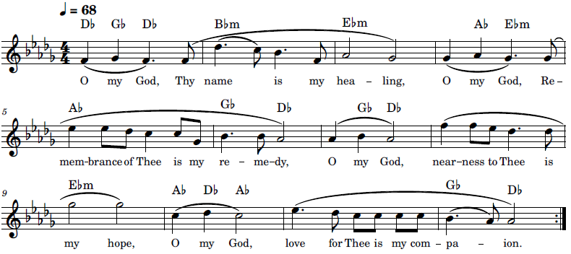
The following is a transcription of the complete recording of the prayer. The remedies are repeated and then the last sentence provides the ending.
يا إِلهِي اسْمُكَ شِفائِي وَذِكْرُكَ دَوائِي وَقُرْبُكَ رَجَائِيْ وَحُبُّكَ مُؤْنِسِيْ وَرَحْمَتُكَ
طَبِيبِيْ وَمُعِيْنِيْ فِي الدُّنْيا وَالآخِرَةِ وَإِنَّكَ أَنْتَ المُعْطِ العَلِيمُ الحَكِيمُ.
Yá e-lá-hi, es-mo-ka she-fá-i, yá e-lá-hi, ze-kro-ka da-vá-i,
yá e-lá-hi, qor-bo-ka ra-já-i, yá e-lá-hi, hob-bo-ka mu-ne-si,
yá e-lā-hi, rah-ma-to-ka ta-bi-bi va mo-‘i-ni feyd- don-yá
val- á-khe-rat. Vaen-na-ka an-tal- mo’-tel ‘a-li-mol -ha-kim
O my God, Thy name is my healing, O my God, remembrance of Thee is my remedy.
O my God, nearness to Thee is my hope, O my God, love for Thee is my companion.
O my God, Thy mercy to me is my healing and my succor in both this world
and the world to come. Thou, verily, art the All-Bountiful, the All-Knowing, the All-Wise.

Lawḥ-i Shafá 2 (لوح شفا ٢) (Tablet of Healing)

This second version of the healing prayer is a complete rendition of the text, keeping to the original version of the text, that is, using “and” (va) to begin each phrase after the opening phrase, which shortens it and makes it more manageable as a dhikr.

Recording, online link: https://bahai-library.com/caton_music/27_Lawh-i_Shafa_2.mp3
Transcription demo, online link: https://bahai-library.com/caton_music/sacred_refrains_demos/27_Lawh-i_Shafa_2_demo.mp3

يا إِلهِي اسْمُكَ شِفائِي وَذِكْرُكَ دَوائِي وَقُرْبُكَ رَجَائِيْ وَحُبُّكَ مُؤْنِسِيْ وَرَحْمَتُكَ
طَبِيبِيْ وَمُعِيْنِيْ فِي الدُّنْيا وَالآخِرَةِ وَإِنَّكَ أَنْتَ المُعْطِ العَلِيمُ الحَكِيمُ.
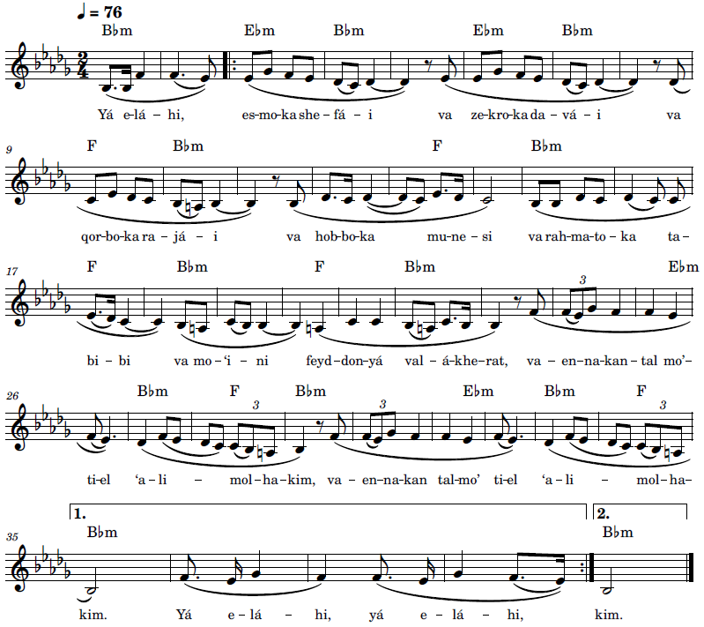Yá e-lá-hi, es-mo-ka she-fá-i va ze-kro-ka da-vá-i
va qor-bo-ka ra-já-i va hob-bo-ka mu-ne-si
va rah-ma-to-ka ta-bi-bi va mo-‘i-ni feyd- don-yá
val- á-khe-rat, va-en-na-kan-tal- mo’-ti-el ‘a-li-mol -ha-kim

O my God, Thy name is my healing, O my God, remembrance of Thee is my remedy.
O my God, nearness to Thee is my hope, O my God, love for Thee is my companion.
O my God, Thy mercy to me is my healing and my succor in both this world
and the world to come. Thou, verily, art the All-Bountiful, the All-Knowing, the All-Wise.
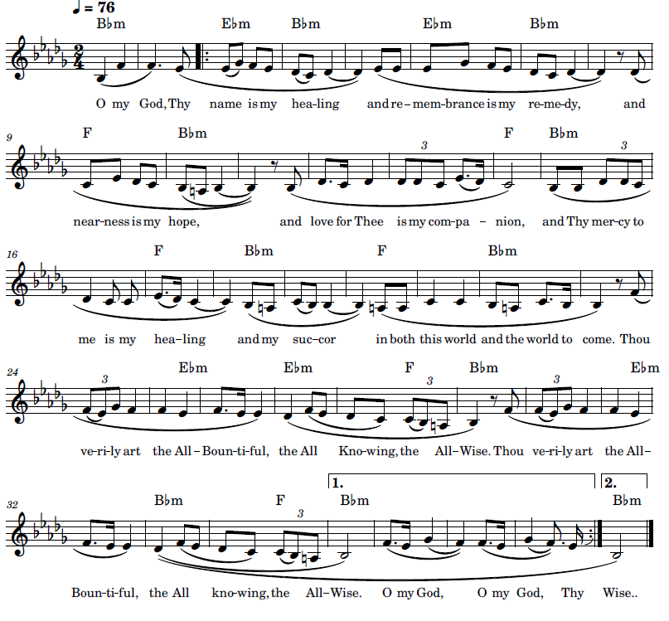

28 Mánand-i Morgh-i Saḥar (مانند مرغ سحر) Even As the Bird of Dawn

This text, which is part of a prayer by ‘Abdu’l-Bahá, has been performed as a measured song as a complete prayer (example 1) as well as the last part as dhikr (example 2). An excerpt of the recorded full version of the prayer can be used as a dhikr (see example 1).
The following is the original prayer in Persian ('Abdu'l-Bahá, Majmuih-yi-Munajatha 1992, 39: #38):
هُواللّه
ای خداوندِ مهربان، اين دل را از هر تَعلّقی فارغ نما و اين جان را به هر بشارتی شادمانی بخش، از قيدِ آشنا و بيگانه آزاد کن و به محبّتِ خويش گرفتار نما تا بکُلّی شيدایِ تو گردم و ديوانۀ تو، جز تو نخواهم و جز تو نجويم و به‌غير از تو نپويم و بجز رازِ تو نگويم، مانند مـرغِ سحر در دامِ محبّت تو گرفتار گردم و شب و روز بنالم و بزارم و بگريم و بگويم: يا بهاء‌الابهی
The complete provisional translation of the prayer in English is as follows ('Abdu'l-Bahá, O Thou kind Lord! n.d.):
O Thou kind Lord! Sever this heart from all attachments, and with every one of Thy joyful tidings bestow gladness upon this soul. Free me from the fetters of friend and stranger alike, and captivate me with Thy love, that thereby I may grow completely crazed and maddened for Thee, such that I may neither desire nor seek aught else but Thee; that I may search for no other path but Thine, and refrain from uttering aught else but Thy mystery; and that, even as the bird of dawn, I may be held captive in the snare of Thy love, and lift up day and night, fervently and tearfully, the cry of “Yá Bahá’u’l-Abhá!”

Mánand-i Morgh-i Saḥar 1a (مانند مرغ سحر۱) Even As the Bird of Dawn

Recording, online link: https://bahai-library.com/caton_music/28_Manand-i_Morgh-i_Sahar_1a.mp3
Transcription demo, online link: https://bahai-library.com/caton_music/sacred_refrains_demos/28_Manand-i_Morgh-i_Sahar_1a_demo.mp3
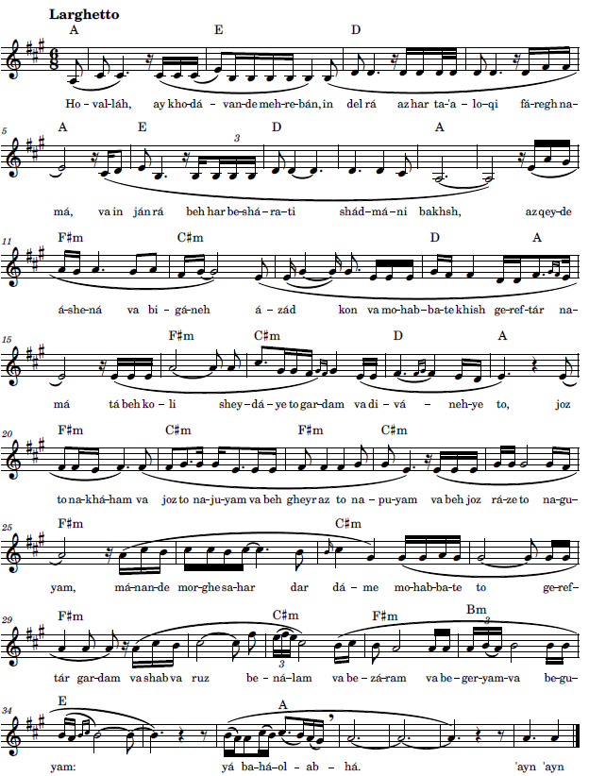

Ho-val-láh, ay kho-dá-van-de meh-re-bán, in del rá az har ta-‘a-lo-qi fá-regh na-má, va in ján rá beh har be-shá-ra-ti shád-má-ni bakhsh,
az qey-de á-she-ná va bi-gá-neh á-zád kon va beh mo-hab-ba-te khish ge-ref-tár na-má
tá beh ko-li shey-dá-ye to gar-dam va di-vá-neh-ye to, joz to na-khá-ham va joz to na-ju-yam va beh gheyr az to na-pu-yam va be joz rá-ze to na-gu-yam,
má-nan-de mor-ghe sa-har dar dá-me mo-hab-ba-te to ge-ref-tár gar-dam va shab va ruz be-ná-lam va be-zá-ram va be-ger-yam va be-gu-yam: yá ba-há-ol- ab-há
‘ayn ‘ayn’

Mánand-i Morgh-i Saḥar 1b (مانند مرغ سحر۱) Even As the Bird of Dawn

The dhikr transcription below was excerpted from a melodic and rhythmically measured version of the entire prayer by ‘Abdu’l-Bahá, the transcription of which follows.
Recording, online link: https://bahai-library.com/caton_music/28_Manand-i_Morgh-i_Sahar_1b.mp3
Transcription demo, online link: https://bahai-library.com/caton_music/sacred_refrains_demos/28_Manand-i_Morgh-i_Sahar_1b_demo.mp3

مانند مرغ سحر در دام محبت تو گرفتار گردم و شب و روز بنالم و بزارم و بگریم و بگویم یا بهاءالابهی
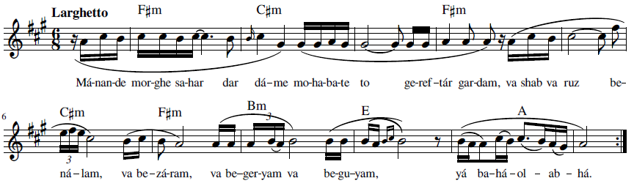
Má-nan-de mor-ghe sa-har dar dá-me mo-ha-ba-te to ge-ref-tár gar-dam,
va shab va ruz be-ná-lam, va be-zá-ram, va be-ger-yam va be-gu-yam: yá ba-há-ol-ab-há

Even as the bird of dawn, I may be held captive in the snare of Thy love,
and lift up day and night, fervently and tearfully, the cry of “Yá Bahá’u’l-Abhá!”
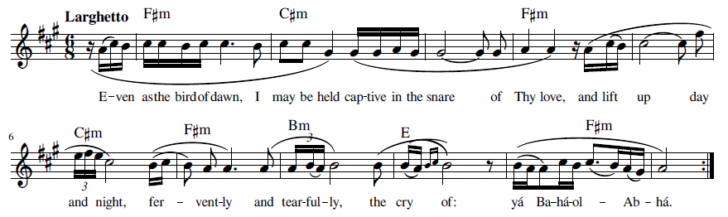

Mánand-i Morgh-i Saḥar 2 (مانند مرغ سحر۲) Even As the Bird of Dawn

Recording, online link: https://bahai-library.com/caton_music/28_Manand-i_Morgh-i_Sahar_2.mp3
Transcription demo, online link: https://bahai-library.com/caton_music/sacred_refrains_demos/28_Manand-i_Morgh-i_Sahar_2_demo.mp3
مانند مرغ سحر در دام محبت تو گرفتار گردم و شب و روز بنالم و بزارم و بگریم و بگویم یا بهاءالابهی
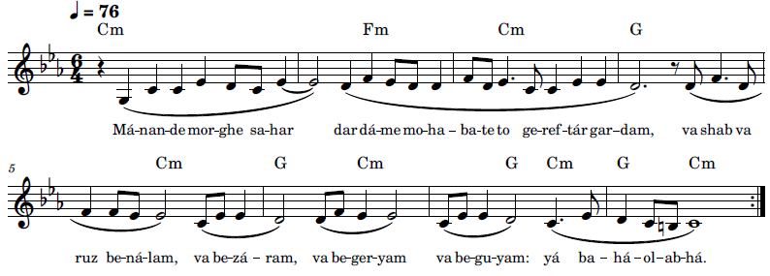
Má-nan-de mor-ghe sa-har dar dá-me mo-ha-ba-te to ge-ref-tár gar-dam,
va shab va ruz be-ná-lam, va be-zá-ram, va be-ger-yam va be-gu-yam: yá ba-há-ol-ab-há
Even as the bird of dawn, I may be held captive in the snare of Thy love,
and lift up day and night, fervently and tearfully, the cry of “Yá Bahá’u’l-Abhá!
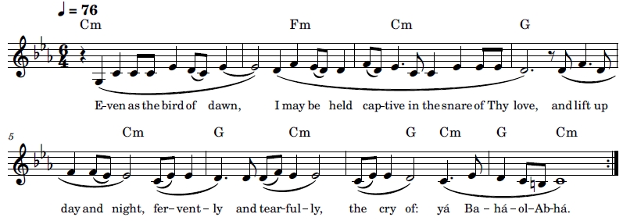

29 Qul Alláh-u Yakfí (قُل اللهُ يَكفی) God is Sufficient

This well-known dhikr has been referred to in Eshraq Khavari’s translation into Persian of Nabil’s Dawn-Breakers as the text that the Bábís chanted in the Síyáh Chál while awaiting execution, though there are other texts that indicate that it was the dhikr “Huva Hasbi” (See 24 “Huva Hasbí”). The melody for the recording is the same one that has been used for the English words found in English in the Dawn-Breakers (Nabil, The Dawn-Breakers 1932, 632).

In the Persian translation by Eshraq Khavari, the version of the dhikr is “Qul Allah Huyak Fí,” as follows (Nabil, Tárikh-i Nabil 1991, 576-577)
در خصوص ساير اشخاصی که با حضرت بهاءاللّه در سياه چال محبوس بودند مطالب ذيل را از حضرت بهاءاللّه شنيدم فرمودند: نفوسی که در آن سال درآن سامان بشهادت رسيدند با من در سياه چال محبوس بودند هوای آن زندان بی‌اندازه متعفّن و سنگين و زمينش مرطوب و کثيف و مملوّ از حشرات موذيّه و فضايش تاريک و نور آفتاب را بهيچ وجه در آن راهی نبود جميع ما را در يک محلّ محبوس نمودند پای ما در زنجير و گردن ما در اغلال بود ما در دو صف رو بروی هم نشسته بوديم نزديک طلوع فجر در هر شب ذکری بآنها ميگفتيم که بصدای بلند ميخواندند صف اوّل ميگفتند قُلِ اللّهُ يَکفِی مِن کُلّ شَئٍ صف ديگر جواب ميدادند وَ عَلَی اللّهِ فَليَتَوَکِّلِ المُتَوَکِّلُونَ ( قرآن ١٦:١٤) زندان بقصر شاه نزديک بود صدای اذکار مؤمنين بگوش ناصر الدّين شاه ميرسيد و با وحشت ميپرسيد اين صدا چيست و از کيست؟ ميگفتند صدای ذکر بابيان است
According to the scholar Adib Masumian, this translation was made from ʻAbdu'l-Jalíl Bey Saʻd's Arabic translation of The Dawn-Breakers, from which Eshraq Khavari translated it into Persian, and contains the following text of this verse (Zarandi 1888, 506):

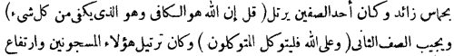
The first half of this dhikr consists of the first part of a prayer by the Báb. The following version of this prayer has a slight variation in that ‘an is used in place of min Arabic (T. Báb, Nasá'im al-Rahmán 1993, 5) and English (Bahá'í Prayers 1991, 29) as follows:
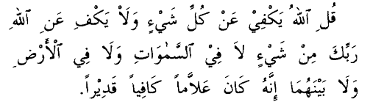
قُلِ اللهُ يَكْفِي عَنْ كُلِّ شَيْءٍ وَلا يَكْفِي عَنِ اللهِ رَبِّكَ مِنْ شَيْءٍ لا فِي السَّموَاتِ وَلا فِي الأَرْضِ وَلا بَيْنَهُمَا إِنَّهُ كانَ عَلاَّماً كافِياً قَدِيراً.
Say: God sufficeth all things above all things, and nothing in the heavens or in the earth but God sufficeth. Verily, He is in Himself the Knower, the Sustainer, the Omnipotent.
The Persian Bayan contains the opening that is the same as the first half of this dhikr (T. Báb, INBA vol. 62 (Iranian National Bahá'í Archives) Persian Bayán 1976) :
قل اللّه يكفى من كلّشيئ و لا يكفى عن اللّه ربّك من شيئ لا فى السموات
و لا فى الارض و لا ما بينهما انّه كان علّاماً كافياً قديراً

The second part of this dhikr is from the Qur’an, Surah 14 Ayah 12 (Muhammed, Surah 14. Ibrahim, Ayah 12 n.d.):
وَمَا لَنَآ أَلَّا نَتَوَكَّلَ عَلَى ٱللَّهِ وَقَدْ هَدَىٰنَا سُبُلَنَا ۚ وَلَنَصْبِرَنَّ عَلَىٰ مَآ ءَاذَيْتُمُونَا ۚ وَعَلَى ٱللَّهِ فَلْيَتَوَكَّلِ ٱلْمُتَوَكِّلُونَ
How should we not put our trust in Allah when He hath shown us our ways? We surely will endure that hurt ye do us. In Allah let the trusting put their trust!
In The Dawn-Breakers, the words to this dhikr are translated as in the following quote (Nabil, The Dawn-Breakers 1932, 632):
We were placed in two rows, each facing the other. We had taught them to repeat certain verses which, every night, they chanted with extreme fervour. ‘God is sufficient unto me; He verily is the All-sufficing!’ one row would intone, while the other would reply: ‘In Him let the trusting trust.’
Mentioned in a number of sources is the story of a Shirazi youth (Nabil, The Dawn-Breakers 1932, 633-634) (Balyuzi 1980, 94-98) (Zarqání 1998, 141-142), who was one of the martyrs from the Black Pit in Tehran. Juliet Thompson describes ‘Abdu’l Bahá’s telling of the story of how this martyr went to his death singing and dancing (Thompson 1983, 320-321)
The Master’s whole aspect suddenly changed. It was as though the spirit of the martyr had entered into Him. With that God-like head erect, snapping His fingers high in the air, beating out a drumlike rhythm with His foot till we could hardly endure the vibrations set up, He triumphantly sang “The Martyr’s Song.”
“I have come again, I have come again, By way of Shiraz I have come again! With the wine cup in My hand! Such is the madness of Love!”



Qul Alláh-u Yakfí 1 (قُل اللهُ يَكفی١) God is Sufficient

Recording, online link: https://bahai-library.com/caton_music/29_Qul_Allah-u_Yakfi_1a.mp3
Recording, online link: https://bahai-library.com/caton_music/29_Qul_Allah-u_Yakfi_1b.mp3
Transcription demo, online link: https://bahai-library.com/caton_music/sacred_refrains_demos/29_Qul_Allah-u_Yakfi_1b_demo.mp3
قل اللّه يكفى من كلّشيئ وعَلَی اللهِ فَلْيَتَوَكّلِ المُتَوَكّلون

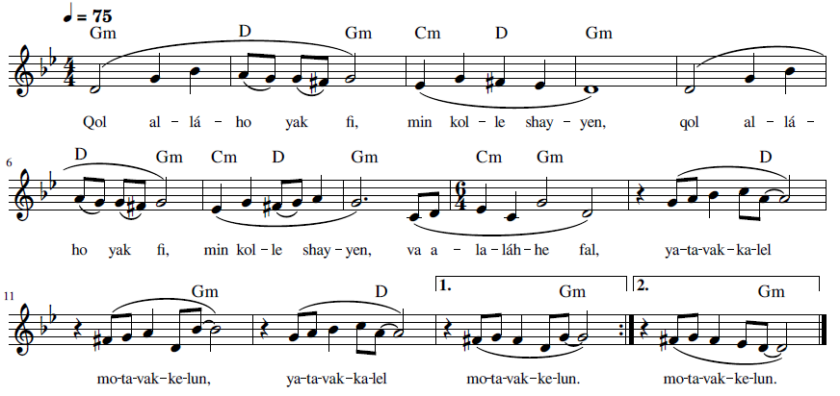
Qol al-lá-ho yak fi, min kol-le shay-yen,
va a-la-láh-he fal, ya-ta-vak-ka-lel mo-ta-vak-ke-lun

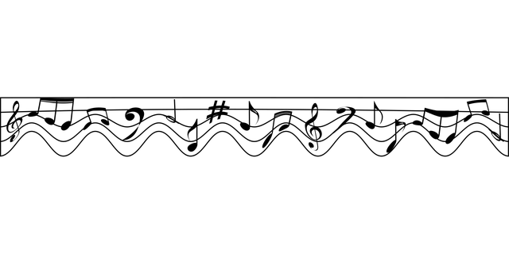

God is Sufficient unto me; He verily is the All-Sufficing!
In Him let the trusting trust

The English lyrics were adapted to the melody of the Arabic version:

God is sufficient unto me. He is the All-Sufficing. (repeat)
Let the trusting trust Him (sing 5 times).
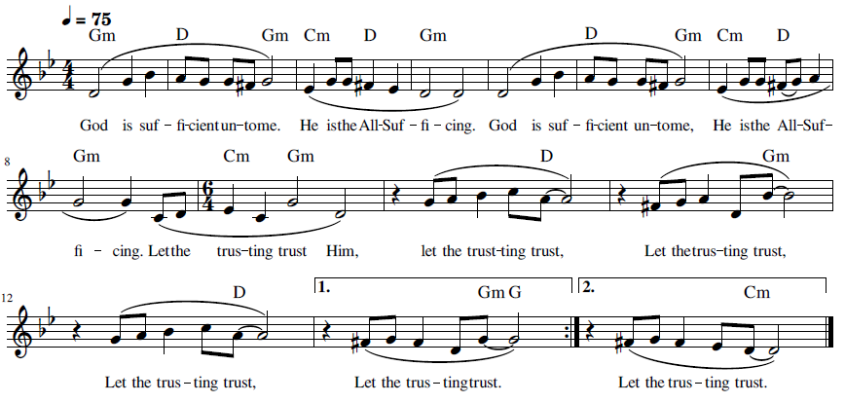

Qul Alláh-u Yakfí 2 (قُل اللهُ يَكفی٢) God is Sufficient
Recording, online link: https://bahai-library.com/caton_music/29_Qul_Allah-u_Yakfi_2.mp3
Transcription demo, online link: https://bahai-library.com/caton_music/sacred_refrains_demos/29_Qul_Allah-u_Yakfi_2_demo.mp3
قُلِ اللّهُ يَکفِیعَنْ كُلِّ شَئٍ وعَلَی اللهِ فَليَتَوَکِّلِ المُتَوَکِّلُونَ
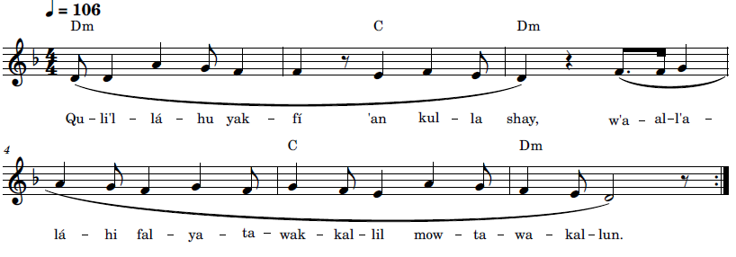Qu-li’l-lá-hu yak-fí ‘an kul-la shay, w’al-la-lá-hi fal-ya-ta-wak-kal-lil mu-ta-wa-kal-lun
God is sufficient unto me. He verily is the All-sufficing! In Him let the trusting trust.
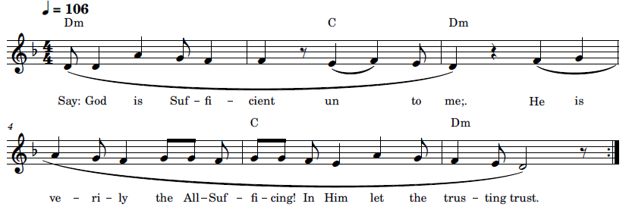

30 Qul Alláh Yakfí Min Kul-la Shay (قُلِ اللهُ يَكْفِي مِنْ كُلِّ شَيْءٍ) God is Sufficient in All Things

This dhikr appears in the Bab’s Persian Bayan, at the end of the sixth gate of the ninth Vahid (T. Báb, INBA vol. 62 (Iranian National Bahá'í Archives) Persian Bayán 1976, 326/322):
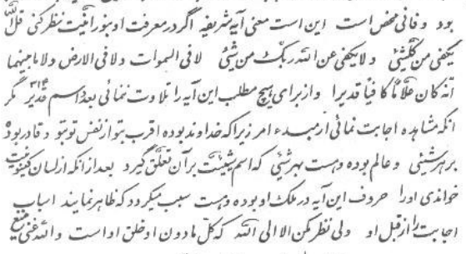
اين است معنى آيه شريفه اگر در معرفت او بنور انيّت نظر كنى
قل اللّه يكفى من كلّشيئ و لا يكفى عن اللّه ربّك من شيئ لا فى السموات
و لا فى الارض و لا ما بينهما انّه كان علّاماً كافياً قديراً
و از براى هيچ مطلب اين آيه را تلاوت ننمائى بعدد اسم قدير (314)
مگر انكه مشاهده اجابت نمائى از مبدء امر زيرا كه خداوند بوده اقرب
بتو از نفس تو بتو و قادر بوده بر هر شيئ و عالم بوده و هست بهر شيئ كه اسم
شيئيّت بر آن تعلق گيرد بعد از انكه از لسان كينونيت خواندى او را حروف اين
آيه در ملك او بوده و هست سبب ميگردد كه ظاهر نمايند اسباب اجابت را از قبل او
ولى نظر مكن الا الى اللّه كه كلّ مادون او خلق او است و اللّه غنى منيع

The following is a provisional translation of this passage:
This is the meaning of the holy Verse if you view its wisdom with a luminous eye. God sufficeth in all things, and nothing in the heavens or in the earth or in whatever lieth between them but God, thy Lord, sufficeth. Verily, He is in Himself the Knower, the Sustainer, the Omnipotent. And you do not recite this Verse for any matter to the number of Qadir (314) without beholding a response from Him Who is the Dayspring of Revelation, as God is closer to you than you are to yourself, and is powerful over all things, and was and is mindful of all things that bear the name of being. After you recite it in the tongue of the divine Essence, the letters of this Verse in His kingdom from everlasting unto everlasting cause the means of His answer to appear. Take heed that you look not to anything but God, for all of the least of it is His creation. And God is the Self-Subsisting, the Most High.
The pronunciation is according to the recording (Arabic pronunciation). Changes to the text as sung in this recording is made to conform to the text in the Bayan: min for ‘an (first line) and add má before lá in line three.
Although made for the text in the Seven Proofs, the following recording can help with the Arabic pronunciation: https://theutteranceproject.com/2020/12/30/say-god-sufficeth/
Recording, online link: https://bahai-library.com/caton_music/30_Qul_Allah_Yakfi_Min_Kul-la_Shay.mp3
Transcription demo, online link: https://bahai-library.com/caton_music/sacred_refrains_demos/30_Qul_Allah_Yakfi_Min_Kul-la_Shay_demo.mp3
قُلِ اللهُ يَكْفِي مِنْ كُلِّ شَيْءٍ وَلا يَكْفِي عَنِ اللهِ رَبِّكَ مِنْ شَيْءٍ لا فِي السَّموَاتِ وَلا فِي الأَرْضِ وَلاما بَيْنَهُمَا إِنَّهُ كانَ عَلاَّماً كافِياً قَدِيراً.
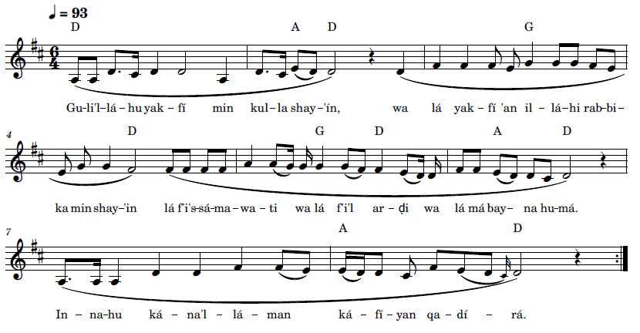
Gu-l’il-lá-hu yak-fí min kul-la shay-in, wa lá yak-fí ‘an il-lá-hi rab-bi-ka min shay-‘in,
lá fí’s-sá-ma-wa-ti wa lá fí’l ar-ḍi wa lá má bay-na hu-má.
in-na-hu ká-na’l-lá-man ka-fí-yan qa-dí-ra.



Say: God sufficeth in all things, and nothing in the heavens or in the earth
or whatever lieth between them but God, thy Lord, sufficeth.
Verily, He is in Himself the Knower, the Sustainer, the Omnipotent.
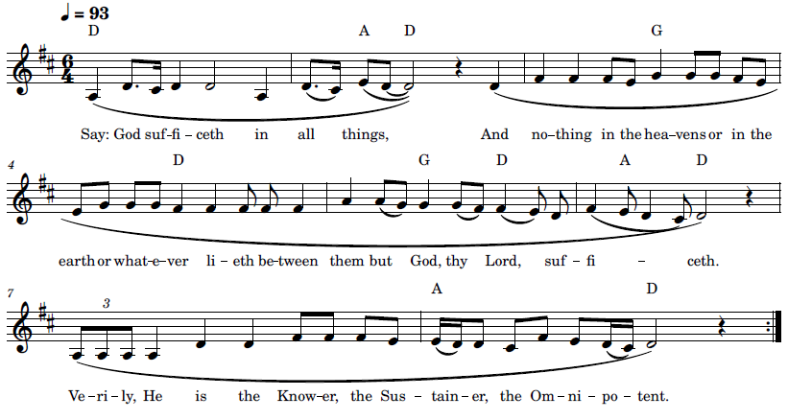
An example of a dhikr on the complete prayer can be heard in the following links:
From the Bayan:
- https://www.youtube.com/watch?v=CNZNcMAq9nA
- https://www.youtube.com/watch?v=GTNz4CGD9Z8
- https://www.facebook.com/watch/?v=505745607495797
From the Seven Proofs
- https://www.facebook.com/watch/?v=325225385897620 b.
- https://www.youtube.com/watch?v=PBs1ZD3t1J8
- https://t.me/Alvah_O_Asare_Elahi June 21, 2022
- https://www.youtube.com/watch?v=AgvSAb4cweg
- « Say: God Sufficeth » – by The Báb – in Arabic with English Subtitles – The Utterance Project

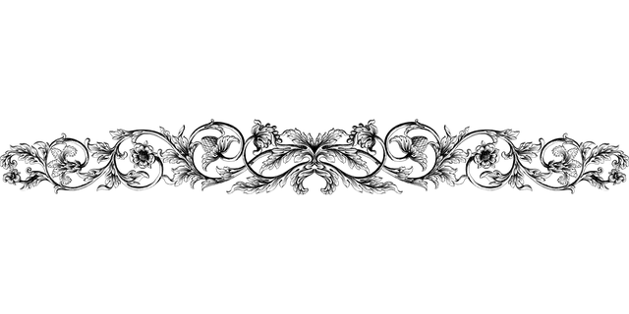

31 Qul Alláh Yakfí Kul-la Shay ‘An Kul-la Shay

(قلَ اللّه يكفى كلَّ شيء عن كلِّ شيء ) God Sufficeth All Things Above All Things

This dhikr is a Verse or Prayer from the Seven Proofs very similar to the Verse in the Persian Bayan and appears in Selections from the Writings of the Báb with Verse in Arabic and explanation in Persian (T. Báb, Muntakhibát 1978, 87-88) (T. Báb, Selections from the Writings of The Báb 1976, 123):
منقطع شو از ما سوى اللّه ومستغنى شو بخدا از ما دون او واين آيه را تلاوت كن
قلَ اللّه يكفى كلَّ شيء عن كلِّ شيء ولا يكفى عن اللّه ربّك مِن شيء لا فى السّموات ولا فى الارض ولا ما بينَهما انّه كان علاّماً كافياً قديراً
وكفايت اللّه را موهوم تصوّر ننموده كه آن ايمان تو است در هر ظهورى بمظهر آن ظهور وآن ايمان تو را كفايت ميكند از كلّ ما على الارض وكلّ ما على الأرض تو را كفايت نميكند از ايمان اگر مؤمن نباشى شجرۀ حقيقت امر باِفناء تو ميكند واگر مؤمن باشى كفايت ميكند تو را از كلّ ما على الارض اگر چه مالك شيء نباشی...

RID thou thyself of all attachments to aught except God, enrich thyself in God by dispensing with all else besides Him, and recite this prayer:
Say: God sufficeth all things above all things, and nothing in the heavens or in the earth or in whatever lieth between them but God, thy Lord, sufficeth. Verily, He is in Himself the Knower, the Sustainer, the Omnipotent.
Regard not the all-sufficing power of God as an idle fancy. It is that genuine faith which thou cherishest for the Manifestation of God in every Dispensation. It is such faith which sufficeth above all the things that exist on the earth, whereas no created thing on earth besides faith would suffice thee. If thou art not a believer, the Tree of divine Truth would condemn thee to extinction. If thou art a believer, thy faith shall be sufficient for thee above all things that exist on earth, even though thou possess nothing.

The pronunciation is according to the Arabic pronunciation in the recording. There is a pronunciation guide that is useful in helping to learn this Verse: https://theutteranceproject.com/2020/12/30/say-god-sufficeth/

Recording, online link: https://bahai-library.com/caton_music/31_Qul_Allah_Yakfi_Kul-la_Shay_An_Kul-la_Shay.mp3 (The recording leaves out the má between the lá and baynáhumá and is added in the transcription.)
Transcription demo, online link: https://bahai-library.com/caton_music/sacred_refrains_demos/31_Qul_Allah_Yakfi_Kul-la_Shay_An_Kul-la_Shay_demo.mp3

قلَ اللّه يكفى كلَّ شيء عن كلِّ شيء ولا يكفى عن اللّه ربّك مِن شيء لا فى السّموات ولا فى الارض ولا ما بينَهما انّه كان علاّماً كافياً قديراً
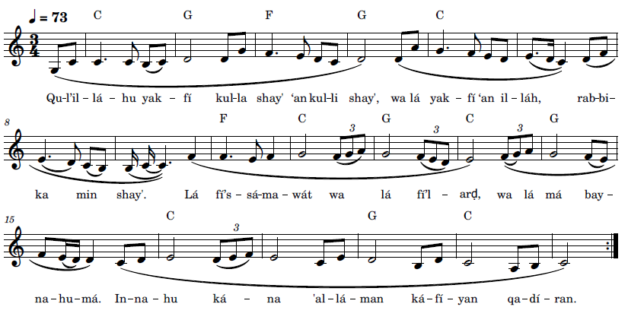
Gu-l’il-lá-hu yak-fí kul-la shay’in ‘an kul-li shay,’ wa lá yak-fí ‘an il-láh rab-bi-ka min shay.’
Lá fí’s-sa-ma-wát wa lá fí’l arḍ wa lá má bay-na-hu-má.
In-na-hu ká-na ‘al-lá-man ká-fí-yan qa-dí-ran



Say: God sufficeth all things above all things, and nothing
in the heavens or in the earth or in whatever lieth between them but God, thy Lord,
sufficeth. Verily, He is in Himself the Knower, the Sustainer, the Omnipotent.

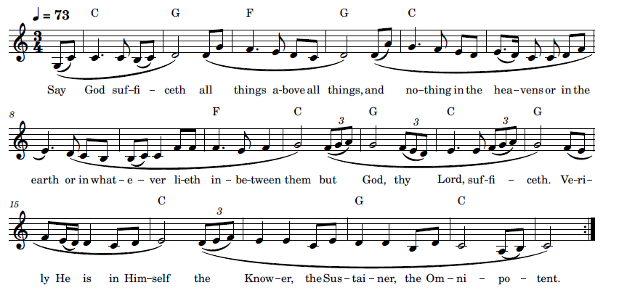

32 Tarání, Yá Iláhí (تَرانی يا الهی) Thou Seest Me, O My God

The text of “Taráni, Yá Iláhí”, is the refrain of a Bahá’í prayer by Báha’u’lláh for the month of fasting, the first part of which is presented below in Arabic (Bahá'u'lláh, Majmuih-yi Adhkár va Idiyyih n.d., 192-193) and then in English (Bahá'u'lláh, Prayers and Meditations by Bahá'u'lláh 1987, 288-289):
أَللَّهُمَّ إِنِّيْ أَسْئَلُكَ بِالآيَةِ الكُبْرى وَظُهُورِ فَضْلِكَ بَيْنَ الوَرَى أَنْ لا تَطْرُدَنِي عَنْ بابِ مَدِينَةِ لِقائِكَ وَلا تُخَيِّبَنِي عَنْ ظُهُوراتِ فَضْلِكَ بَيْنَ خَلْقِكَ، تَرَانِي يا إِلهِي مُتَمَسِّكًا بِاسْمِكَ الأَقْدَسِ الأَنْوَرِ الأَعَزِّ الأَعْظَمِ العَلِيِّ الأَبْهى وَمُتَشَبِّثًا بِذَيْلٍ تَشَبَّثَ بِهِ مَنْ فِي الآخِرَةِ وَالأُولی، أَللَّهُمَّ إِنِّي أَسْئَلُكَ بِنِدائِكَ الأَحْلى وَالكَلِمَةِ العُلْيا أَنْ تُقَرِّبَنِي فِي كُلِّ الأَحْوالِ إِلى فِناءِ بابِكَ وَلا تُبْعِدَنِي عَنْ ظِلِّ رَحْمَتِكَ وَقِبابِ كَرَمِكَ، تَرَانِي يا إِلهِي مُتَمَسِّكًا بِاسْمِكَ الأَقْدَسِ الأَنْوَرِ الأَعَزِّ الأَعْظَمِ العَلِيِّ الأَبْهى وَمُتَشَبِّثًا بِذَيْلٍ تَشَبَّثَ بِهِ مَنْ فِي الآخِرَةِ وَالأُولی،

I beseech Thee, O my God, by Thy mighty Sign, and by the revelation of Thy grace amongst men, to cast me not away from the gate of the city of Thy presence, and to disappoint not the hopes I have set on the manifestations of Thy grace amidst Thy creatures. Thou seest me, O my God, holding to Thy Name, the Most Holy, the Most Luminous, the Most Mighty, the Most Great, the Most Exalted, the Most Glorious, and clinging to the hem of the robe to which have clung all in this world and in the world to come.

I beseech Thee, O my God, by Thy most sweet Voice and by Thy most exalted Word, to draw me ever nearer to the threshold of Thy door, and to suffer me not to be far removed from the shadow of Thy mercy and the canopy of Thy bounty. Thou seest me, O my God, holding to Thy Name, the Most Holy, the Most Luminous, the Most Mighty, the Most Great, the Most Exalted, the Most Glorious, and clinging to the hem of the robe to which have clung all in this world and in the world to come.

Recording, online link: https://bahai-library.com/caton_music/32_Tarani_Ya_Ilahi.mp3
Transcription demo, online link: https://bahai-library.com/caton_music/sacred_refrains_demos/32_Tarani_Ya_Ilahi_demo.mp3

تَرانی يا الهی مُتَمَسِّكاً بِاسْمِكَ الاَقدَسِ الاَنْوَر ِ الاَعِزِّ الاَعظم ِ العَلیّ ِ الاَبهی و مُتَشَبِّثاً بِذَيل ٍتَشَبَّثَ بِه مَنْ فِی الآخِرَةِ وَ الاولی
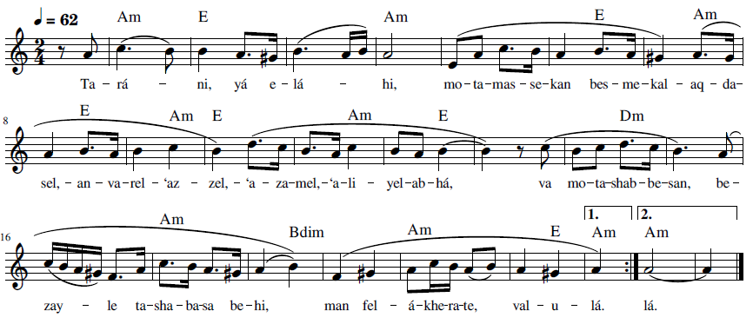
Ta-rá-ni, yá e-lá-hi, mo-ta-mas-se-kan bes-me-kal-, aq-da-sel,-
an-va-rel- ‘az-zel,- ‘a-za-mel,- ‘a-li-yel- ab-há,
va mo-ta-shab-be-san, be-zay-le ta-sha-ba-sa be-hi, man fel- á-khe-ra-te, val- u-lá.

Thou seest me, O my God, holding to Thy Name, the Most Holy,
the Most Luminous, the Most Mighty, the Most Great, the Most Exalted, the Most Glorious,
and clinging to the hem of the robe to which have clung all in this world and the world to come

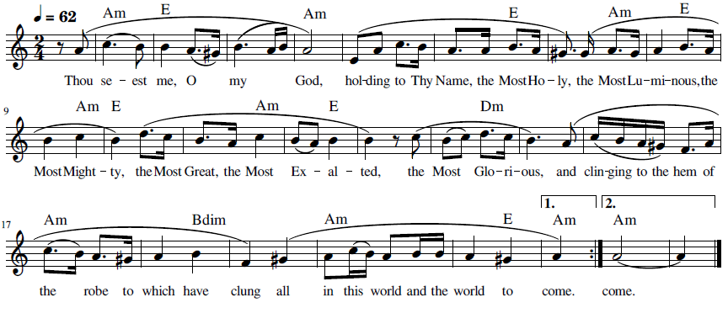

33 Yá Man Vajhuka Ka’batí (يا مَنْ وَجْهُكَ كَعْبَتِيْ) O Thou Whose Face

This dhikr is from the last part of a prayer by Bahá’u’lláh, Arabic (Bahá'u'lláh, Majmuih-yi Adhkár va Idiyyih n.d., 111-112) and English version follow (Bahá'u'lláh, Prayers and Meditations by Bahá'u'lláh 1987, #98:163-164):
سُبْحَانَكَ يا مَنْ فِي قَبْضَتِكَ زِمَامُ أَفْئِدَةِ العارِفِينَ وَفِي يَمِينِكَ مَنْ فِي السَّمَواتِ وَالأَرَضِينَ، تَفْعَلُ ما تَشآءُ بِقُدْرَتِكَ وَتَحْكُمُ ما تُرِيدُ بِإِرادَتِكَ، كُلُّ ذِيْ مَشِيَّةٍ مَعْدُومٌ عِنْدَ ظُهُوراتِ مَشيَّتِكَ، وَكُلُّ ذِي إِرادَةٍ مَفْقُودٌ لَدَى شُئُوناتِ إِرادَتِكَ، أَنْتَ الَّذِيْ بِكَلِمَتِكَ اجْتَذَبْتَ قُلُوبَ الأَصْفِيآءِ عَلَى شَأْنٍ انْقَطَعُوا فِي حُبِّكَ عَمَّا سِواكَ، وَأَنْفَقُوا أَنْفُسَهُمْ وَأَرْواحَهُمْ فِي سَبِيلِكَ وَحَمَلُوا فِي حُبِّكَ ما لا حَمَلَهُ أَحَدٌ مِنْ بَرِيَّتِكَ، أَيْ رَبِّ أَنَا أَمَةٌ مِنْ إِمائِكَ تَوَجَّهْتُ إِلى مَدْيَنِ رَحْمَتِكَ وَأَرَدْتُ بَدائِعَ أَلْطَافِكَ، لأنَّ كُلَّ جَوارِحِيْ تَشْهَدُ بِأَنَّكَ أَنْتَ الْكَرِيمُ ذُو الفَضْلِ العَظِيمِ، يا مَنْ وَجْهُكَ كَعْبَتِي وَجَمالُكَ حَرَمِي وشَطْرُكَ مَطْلَبِي وَذِكْرُكَ رَجائِي وَحُبُّكَ مُؤنِسِيْ وَعِشْقُكَ مُوجِدِيْ وَذِكْرُكَ أَنيسِيْ وَقُرْبُكَ أَمَلِي وَوَصْلُكَ غَايَةُ رَجَائِي وَمُنْتَهى مَطْلَبِيْ، أَسْئَلُكَ أَنْ لا تُخَيِّبَنِي عَمَّا قَدَّرْتَهُ لِخِيرَةِ إِمائِكَ، ثُمَّ ارْزُقنِي خَيْرَ الدُّنْيا وَالآخِرَةِ وَإِنَّكَ أَنْتَ سُلْطَانُ البَرِيَّةِ لا إِلهَ إِلاَّ أَنْتَ الغَفُورُ الْكَرِيمُ.

Magnified be Thy name, O Thou in Whose grasp are the reins of the souls of all them that have recognized Thee, and in whose right hand are the destinies of all that are in heaven and all that are on earth! Thou doest, through the power of Thy might, what Thou willest, and ordainest, by an act of Thy volition, what Thou pleasest. The will of the most resolute of men is as nothing when compared with the compelling evidences of Thy will, and the determination of the most inflexible among Thy creatures is dissipated before the manifold revelations of Thy purpose.
Thou art He Who, through a word of Thy mouth, hath so enravished the hearts of Thy chosen ones that they have, in their love for Thee, detached themselves from all except Thyself, and laid down their lives and sacrificed their souls in Thy path, and borne, for Thy sake, what none of Thy creatures hath borne.
I am one of Thy handmaidens, O my Lord! I have turned my face towards the habitation of Thy mercy, and have sought the wonders of Thy manifold favors, inasmuch as all the members of my body proclaim Thee to be the All-Bounteous, He Whose grace is immense.
O Thou Whose face is the object of my adoration, Whose beauty is my sanctuary, Whose court is my goal, Whose remembrance is my wish, Whose affection is my solace, Whose love is my begetter, Whose praise is my companion, Whose nearness is my hope, Whose presence is my greatest longing and supreme aspiration! Disappoint me not, I entreat Thee, by withholding from me the things Thou didst ordain for the chosen ones among Thy handmaidens, and supply me with the good of this world and of the world to come.
Thou art, verily, the Lord of creation. No God is there beside thee, the Ever-Forgiving, the Most Bountiful.



Recording, online link: https://bahai-library.com/caton_music/33_Ya_Man_Vajhuka_Kabati_a.mp3

Transcription demo, online link: https://bahai-library.com/caton_music/sacred_refrains_demos/33_Ya_Man_Vajhuka_Kabati_a_demo.mp3

Recording, online link: https://bahai-library.com/caton_music/33_Ya_Man_Vajhuka_Kabati_b.mp3

يا مَنْ وَجْهُكَ كَعْبَتِيْ وَجَمالُكَ حَرَمِيْ وَشَطْرُكَ مَطْلَبِيْ وَذِكْرُكَ رَجائِيْ
وَحُبُّكَ مُؤنِسِيْ وَعِشْقُكَ مُوجِدِيْ وَذِكْرُكَ أَنِيسِيْ وَقُرْبُكَ أَمَلِي
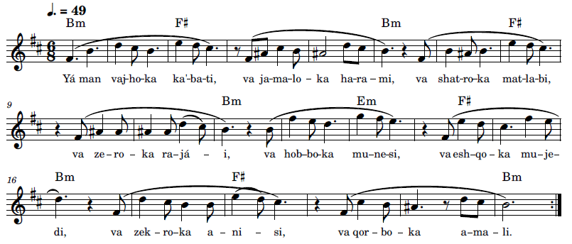
Yá man vaj-ho-ka ka’-ba-ti, va ja-má-lo-ka ha-ra-mi,
va shat-ro-ka mat-la-bi, va ze-kro-ka ra-já-i,
va hob-bo-ka mu-ne-si, va esh-qo-ka mu-je-di,
va zek-ro-ka a-ni-si, va qor-bo-ka a-ma-li

O Thou Whose face is the object of my adoration, Whose beauty is my sanctuary,
Whose court is my goal, Whose remembrance is my wish,
Whose affection is my solace, Whose love is my begetter,
Whose praise is my companion, Whose nearness is my hope.
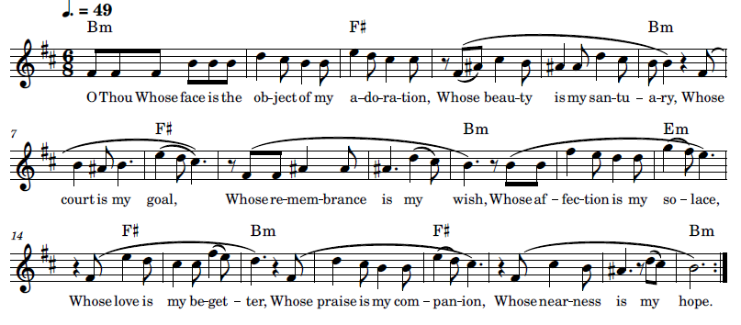

Aid and Assistance

This section involves dhikrs which include a petition from the reciter, asking for help with various needs, including protection, removing difficulties, forgiveness, and freedom from attachment. The requests vary from asking God to address a specific need to helping the petitioner become more faithful and detached from all but God.
“Allahumma” begins with invoking God and naming attributes of God, then follows with asking for God to favor the reciter by dispelling their difficulties, and then concludes with describing God as clement and beneficent: “O God, praised and holy! O God, merciful and bountiful! Dispel our difficulties by Thy grace and favor. Verily, Thou art the Clement, the Beneficent.” Elements of the previous types of dhikrs are present here, including invoking God by name, praising God, mentioning God’s attributes, building on all that are included in the previous types of examples, with the addition of supplicating, beyond mentioning their reliance upon Him.
“Ay Ghaffár az Má Beh Júdat” calls upon God as the Pardoner and Concealer and asks God to forgive them, to cover them, and grant them His favor: “O Thou the Forgiver! Deal with us charitably by Thy beneficence. O Thou the Concealer! Cover our transgressions through Thy generosity. O Thou the Bounteous! Deny us not Thy grace.” “Ay Karím Ín ‘Abd Rá Beh Khawd” invokes an attribute of God, asking Him not to leave him alone and concludes also with two of God’s names: “O Most Generous, leave not this servant to himself, Thou Who art the Powerful and Mighty.” “Ay Parvardigár Ín ‘Álam-i Ẓolmání” calls on a name of God, and then requests God’s light: “O Thou Provider, turn this dark world of gloom into a world of light.”

In “Ay Rabb Asqani Kas,” the petitioner calls upon God directly and makes four requests, each related to an attribute or capacity of God: “Lord! Give me to drink from the chalice of selflessness; with its robe clothe me, and in its ocean immerse me. Make me as dust in the pathway of Thy loved ones.” “Ay Rabb-a Faj’al Rizgí Jamálika” invokes God and asks for God to make the petitioner able to remember and rely on God’s attributes: “O my Lord! Make Thy beauty to be my food, and Thy presence my drink, and Thy pleasure my hope, and praise of Thee my action, and remembrance of Thee my companion, and the power of Thy sovereignty my succorer.”

“Ay Rabb-a Tahhir Ádhán al-‘Ibád” requests God to clear his ears of the past so that the reciter would be able to hear the Words of God’s Revelation: “O Lord, cleanse the ears of Thy servants of all tales of the past, so they may hearken unto the melodies sung by the nightingale of Thy Revelation.” “Huvá Hú, Ay Maḥbúb-i Man,” which is taken from three parts of a Tablet, addresses and asks God to help the petitioner to focus only on God: “He is God! O my Beloved, I call on Thee to cause my sorrowful heart to be heedless of all but Thee and to be involved only with Thee.” “Iláhá Ma’búdá ‘Ibádat” invokes God and asks for a share of God’s abundance: “O God, O Adored One, deprive not Thy servant of the fruit of existence and grant a portion from the sea of Thy bounty.”

“Iláhí Iláhí Dast-i Qudrat” invokes God and asks for freedom from attachment to the world: “Draw forth the hand of power from the stronghold of might and free these souls mired in the clay of the world.” “‘Ináyatí Farmá va Mawhabatí” after an opening invocation asks for God’s assistance in His followers’ efforts to strive and elevate their efforts in serving God and elevating themselves and humanity.

“Muḥtájím va Muntaẓiri Tá’íd-i Tu” simply states the seeker’s need and asks for help, illustrating the expansive effect it would have on him: “We are in need and looking for Thy help. If Thy favor does appear, the drop becomes the ocean, the spark becomes the sun.” In “Qalban Ṭáhiran,” the reciter asks simply for purity of heart: “Create in me a pure heart, O my God.” “Rabba Yassiril Umúr” asks God for relief and upliftment: “Ease our affairs, O Lord, and gladden our hearts. Show us such beneficence as is born of Thine abundant bounty.”

“Subḥánika al-Lahumma Yá Iláhí” is a lengthy dhikr with a list of appeals, amounting to helping the petitioner focus only on God: “Praised be Thou, O Lord my God! Sanctify mine eye, and mine ear, and my tongue, and my spirit, and my heart, and my soul, and my body, and mine entire being from turning unto anyone but Thee. Give me then to drink from the cup that brimmeth with the sealed wine of Thy glory.”

34 Allahumma (اَلّلهُمَ) O God

“Allahumma” is one of the best known of the Arabic dhikrs, aside from that of the Greatest Name, and has been sung by national and international Bahá’í choirs. It is based on an Arabic prayer by the Báb (T. Báb, Nasá'im al-Rahmán 1993, 5).

Allahumma 1 (اَلّلهُمَ ۱) O God

Recording, online link: https://bahai-library.com/caton_music/34_Allahuma_1.mp3
Transcription demo, online link: https://bahai-library.com/caton_music/sacred_refrains_demos/34_Allahuma_1_demo.mp3
اَلّلهُمَ يا سُبُّوحُ يا قُدّوسُ يا رَحمنُ يا مَنانُ. فَرِّجْ لَنا بِالفَضْلِ وَ
الاِحْسان اِنَّكَ رَحمنُ مَنّانُ
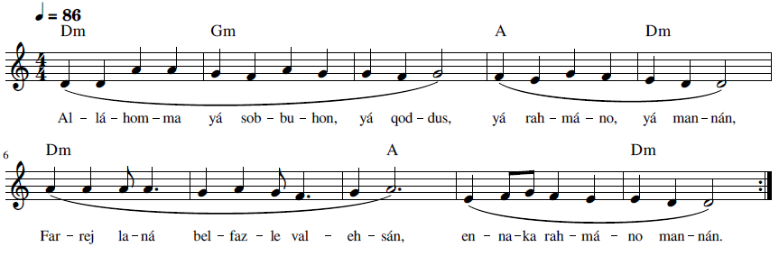
Al-lá-hom-ma yá sob-bu-hon, yá qod-dus, yá rah-má-no, yá man-nán.
Far-rej la-ná bel-faz-le val-eh-sán,
en-na-ka rah-má-no man-nán

O God, praised and holy! O God, merciful and bountiful!
Dispel our difficulties by Thy grace and favor.
Verily, Thou art the Clement, the Beneficent.

O God, my God! O Praised! O Holy! Merciful and Bountiful! Comfort us by Thy grace and favor. Thou art the Clement, Generous.

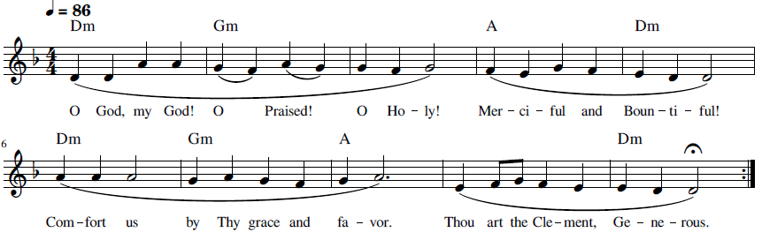



Allahumma 2 (اَلّلهُمَ ۲) O God

Recording, online link: https://bahai-library.com/caton_music/34_Allahuma_2.mp3
Transcription demo, online link: https://bahai-library.com/caton_music/sacred_refrains_demos/34_Allahuma_2_demo.mp3

اَلّلهُمَ يا سُبُّوحُ يا قُدّوسُ يا رَحمنُ يا مَنانُ. فَرِّجْ لَنا بِالفَضْلِ وَ
الاِحْسان اِنَّكَ رَحمنُ مَنّانُ
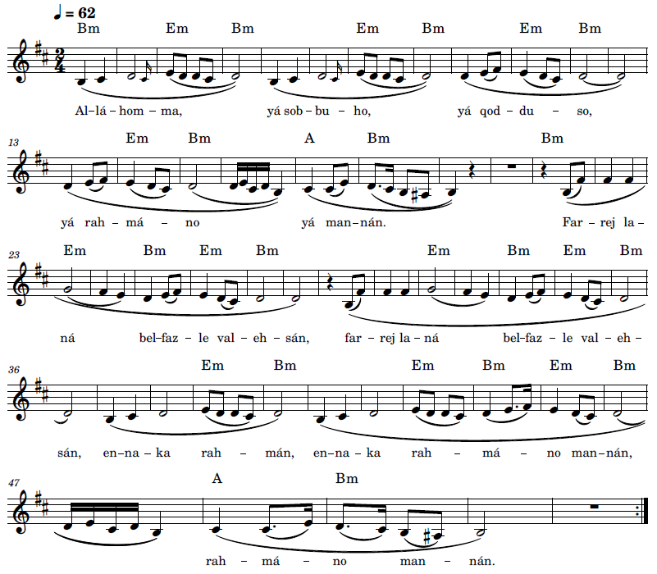
Al-lá-hom-ma yá sob-bu-hon, yá qod-dus, yá rah-má-no, yá man-nán.
Far-rej la-ná bel-faz-le val-eh-sán,
en-na-ka rah-má-no man-nán
O God, praised and holy! O God, merciful and bountiful!
Dispel our difficulties by Thy grace and favor.
Verily, Thou art the Clement, the Beneficent.

O God, my God! O Praised! O Holy! Merciful and Bountiful! Comfort us by Thy grace and favor. Thou art the Clement, Generous.
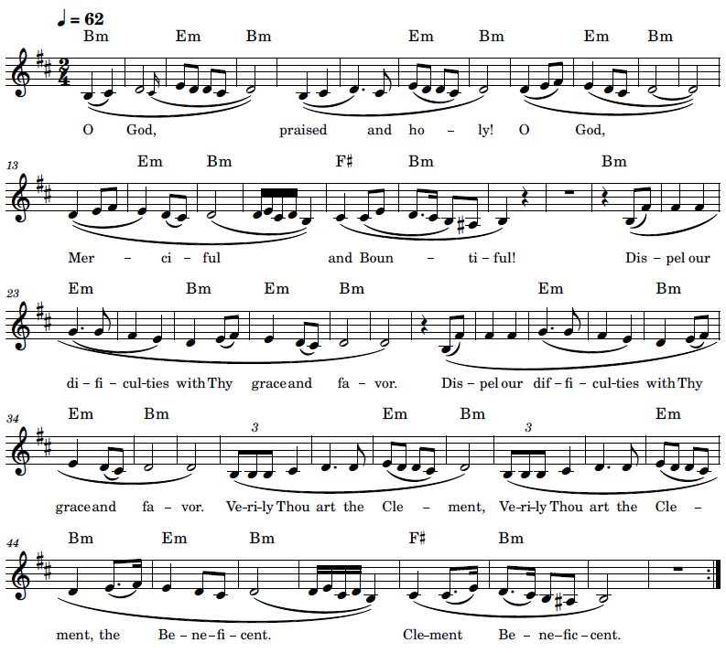

35 Ay Ghaffár az Má Beh Júdat Dargodhar (درگذر ای غفّار از ما به جودت) O Pardoner, Forgive Us

Ay Ghaffár is from the last part of a prayer revealed by Bahá’u’lláh (Bahá'u'lláh, Ad'iyyih-yi Hadrat-i-Mahbub 1920, 341-343):
الها بی‌نيازا كريما رحيما ملكا مالكا
همه عباد تواند و از كلمه تو از عدم بوجود آمدند و معترفند بر فقر خود و غنای تو و جهل خود و علم تو و ضعف خود و اقتدار تو و عجز خود و سلطان تو . ای كريم ما را از امطار سماء رحمتت محروم منما و از امواج بحر كرمت منع مكن . اين نهالهای وجود بيد عنايت تو غرس شده حال وقت ترقّی و نموّ است و منتظر نيسان عنايت تو و ربيع مكرمت تو بوده و هست از آب « و جعلنا من الماء كلّ شیء حيّ » ما را منع منما. آثار كرمت از قبل در دانی و قاصی و مطيع و عاصی مشاهده شد و حال موجود و مشهود. پس ببرهان ثابت شد كرمت محدود نبوده و عفوت توقّف نكرده و جودت از موجودات منع نشده. در هر حال آثار فضل بی منتهايت بابصار عدل و انصاف مشاهده شده و ميشود . نزد بحر غفران عصيان اين عباد مذكور نه و در عرصه ثروت و غنا فقر و احتياج اين عباد را مقداری نه. از بدايع عطايت ميطلبيم و دست رجا ببارگاه عظمتت بلند نموده‌ايم . ای غفّار از ما بجودت درگذر و ای ستّار بكرمت ستر نما و ای فضّال فضلت را باز مدار . مجرميم و لكن از توايم محروم منما. بعيديم و لكن بساط قربت را آمل و سائليم ما را منع مكن . توئی راه نما و احب عطا . لا اله الّا أنت ربّ العرش و الثّری و مالك الآخرة و الاولی.
A provisional translation into English is provided below:
My God, independent of all things, most generous and merciful, my Sovereign supreme!

All are Thy servants, and through Thy Word did they come from nonexistence into being. They confess to their poverty and Thy wealth, to their ignorance and Thy knowledge, to their weakness and Thy strength, to their helplessness and Thy sovereign might. Deprive us not, O Bountiful One, of the rain of the heaven of Thy mercy, neither do Thou debar us from the waves of the sea of Thy munificence. These saplings of existence were planted by the hand of Thy loving-kindness. Now is the time for them to grow and develop; they have anticipated and continue to await the vernal showers of Thy grace and the springtime of Thy favor. Withhold not from us that water whereof it is said: “We have made every living thing out of water” [Qur’án 21:30]. The signs of Thy generosity have been formerly observed in both the near and the far, in the obedient and the rebellious alike, and today they are present and apparent. It is thus proven that Thy bounty hath never been limited, that Thy pardon hath never ceased, and that Thy generosity hath never been refused any living thing. Under all circumstances have the tokens of Thine endless benevolence been beheld with the eyes of justice and fairness. Before the ocean of Thy forgiveness, the rebellion of these servants is unworthy of mention, and in the realm of Thine abundant wealth, the poverty and need of these thralls amount to nothing whatever. We seek the wonders of Thy bestowal, and have lifted up the hands of our hope unto the court of Thy grandeur.

O Thou the Forgiver! Deal with us charitably by Thy beneficence. O Thou the Concealer! Cover our transgressions through Thy generosity. O Thou the Bounteous! Deny us not Thy grace. Sinners are we, yet from Thee have we come; leave us not bereft. Distant are we, yet to the precincts of Thy nearness do we imploringly aspire; prevent us not therefrom. Thou art He Who showest the way, the Possessor of gifts. No God is there but Thee, Lord of the throne on high and of earth below, King of this world and the world to come.

Recording, online link: https://bahai-library.com/caton_music/35_Ay_Ghaffar_az_Ma_Beh_Judat_Dargodhar.mp3
Transcription demo, online link: https://bahai-library.com/caton_music/sacred_refrains_demos/35_Ay_Ghaffar_az_Ma_Beh_Judat_Dargodhar_demo.mp3
ای غفار از ما به جودت درگذر و ای ستّار، به کرمت سَتر نما و ای فضال، فضلت را باز مدار
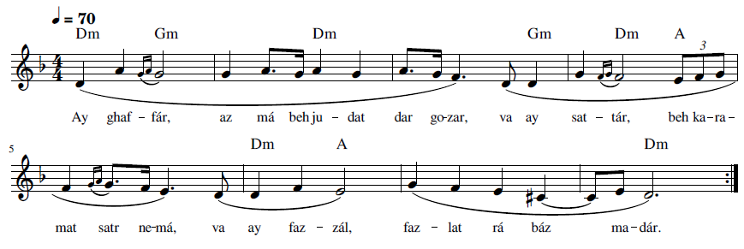Ay ghaf-fár, az má beh ju-dat dar go-zar, va ay sat-tár, beh ka-ra-mat satr ne-má,
va ay faz-zál, faz-lat rá báz ma-dár

O Pardoner, in Thy bounty forgive us and, O Concealer, in Thy kindness cover us,
and O Gracious One, grant us Thy favor
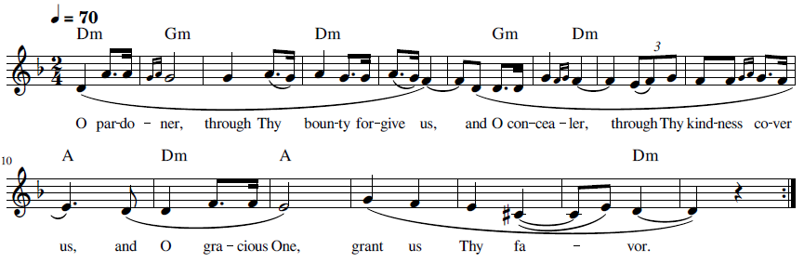

36 Ay Karím Ín ‘Abd Rá Beh Khawd Vá Magodhár

(ای کریم این عبد را به خود وا مگذار) O God, Leave Not This Servant to Himself

The text for “Ay Karím Ín ‘Abd Rá Beh Khawd Vá Magodhár” is found near the end a prayer by Baha’u’llah. The following is the Persian (Bahá'u'lláh, Ad'iyyih-yi Hadrat-i-Mahbub 1920, 348-350) and then the English translation (Bahá'u'lláh, O Thou Who art the All-Merciful n.d.):
كريما رحيما
گواهی ميدهم به وحدانيّت و فردانيّت تو و از تو ميطلبم آنچه را كه بدوام ملك و ملكوت باقی و پاينده است. توئی مالك ملكوت و سلطان غيب و شهود . ای پروردگار مسكينی ببحر غنايت توجّه نموده و سائلی بذيل كرمت اقبال كرده او را محروم منما. توئی آن فضّالی كه ذرّات كائنات بر فضلت گواهی داده توئی آن بخشنده ئی كه جميع ممكنات بر بخششت اعتراف نموده. اين بنده از كلّ گذشته و بحبال جود و اذيال كرمت تمسّك و تشبّث جسته و در جميع احوال بتو ناظر و ترا شاكر . اگر اجابت فرمائی محمودی در امر و اگر ردّ نمائی مُطاعی در حكم . توئی آن مقتدری كه كلّ نزد ظهورش عاجز و قاصر مشاهده شوند . ای كريم اين عبد را بخود وا مگذار توئی قادر و توانا و مالك جود و عطا.
O Thou Who art the All-Merciful, the Most Compassionate! I bear witness to Thy oneness and Thy singleness, and I seek from Thee that which shall last for as long as the dominions of earth and heaven will endure. Thou art the Lord of the Kingdom, the Sovereign of the seen and the unseen.
O divine Providence! This poor one hath set his face toward the ocean of Thy wealth, and this lowly suppliant hath turned to the hem of Thy generosity; deprive him not thereof. Thou art that All-Gracious One unto Whose bounteousness the atoms of all beings have testified. Thou art that Bestower Whose beneficence every living thing hath acknowledged. This servant hath renounced everything, holding fast the cord of Thy favor and cleaving tenaciously to the robe of Thy munificence. His gaze is fixed on Thee at all times, and he yieldeth Thee thanks under every circumstance. Shouldst Thou deign to answer him, Thou art to be praised in Thy behest, and shouldst Thou choose to reject him, Thou art to be obeyed in Thy decree. Thou art that All-Powerful One before Whose revelation all things are powerless. Leave not this servant to himself, O Most Generous One!
Thou art the Almighty, the Most Powerful, the Lord of grace abounding.
Recording, online link: https://bahai-library.com/caton_music/36_Ay_Karim_In_Abd_Ra_Beh_Khawd_Va_Magodhar.mp3
Transcription demo, online link: https://bahai-library.com/caton_music/sacred_refrains_demos/36_Ay_Karim_In_Abd_Ra_Beh_Khawd_Va_Magodhar_demo.mp3
ای کریم این عبد را به خود وا مگذار تویی قادر و توانا
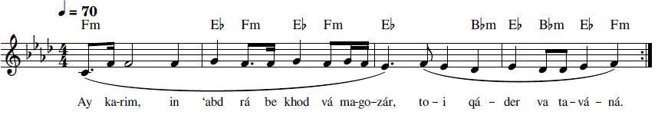
Ay ka-rim, in ‘abd rá be khod vá ma-go-zár, to-i qá-der va ta-vá-ná
O Most Generous, leave not this servant to himself, Thou Who art the Powerful and Mighty
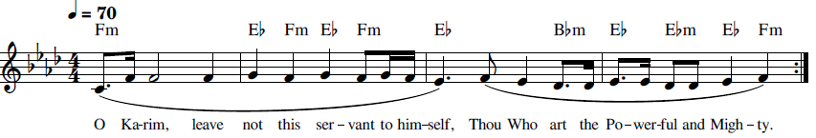

37 Ay Parvardigár Ín ‘Álam-i Ẓolmání (ای پروردگار این عالم ظلمانی) O Lord, This World of Darkness

“Ay Parvardigár Ín ‘Álam-i Ẓolmání” is the first part of a prayer by ‘Abdu’l-Bahá ('Abdu'l-Bahá, Majmuih-yi-Munajatha 1992, 270-271):
هُو اللّه
ای پروردگار اين عالم ظلمانی را جهان انوار فرما و مظاهر شيطانی را ابرار و اخيار کن ابر رحمت بلند فرما و باران موهبت ببار و نسيم جانپرور بوزان و انوار شمس حقيقت ساطع فرما تا اين گياه پژمرده طراوت و لطافت يابد و درختان بی برگ و شکوفه سبز و خرم گردد کوران بينا شوند و کران شنوا گردند نادانان دانا گردند و جاهلان واقف اسرار يزدان شوند توئی مقتدر و مقدّر و مصوّر و مهربان انَّک انت العزيز الکريم المنّان . ع ع

A provisional translation into English is as follows

O Thou Provider, turn this dark world of gloom into a world of light, purify and sanctify satanic allusions, raise the cloud of mercy and rain down Thy blessings upon us and waft the life-animating breeze and radiate the light of the sun of truth so that this drooping plant may become fresh and tender, and barren trees become verdant and blossoming, the blind become sighted and the deaf hearing, the foolish wise and the ignorant aware of the Divine secrets. Thou art the Powerful, the Ordainer, the Fashioner, and the Compassionate. Verily, Thou art the Exalted, the Generous, and the Beneficent.



Recording, online link: https://bahai-library.com/caton_music/37_Ay_Parvardigar_In_Alam-i_Zolmani.mp3
Transcription demo, online link: https://bahai-library.com/caton_music/sacred_refrains_demos/37_Ay_Parvardigar_In_Alam-i_Zolmani_demo.mp3
ای پروردگار این عالم ظلمانی را جهان انوار فرما
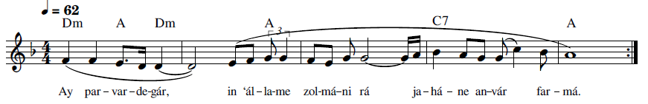Ay par-var-de-gár, in ‘ál-lam-e zol-má-ni rá ja-há-ne an-vár far-má
O Thou Provider, turn this dark world of gloom into a world of light.
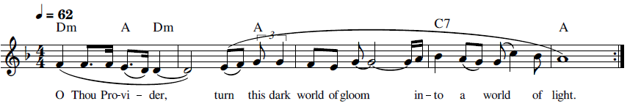

38 Ay Rabb Asqani Kás (أَيْ رَبِّ اسْقِنِي كَأْسَ الفَنَاءِ) Lord! Give me to Drink

This dhikr is from the Tablet of Visitation (Munáját-al-Leqá’) of ‘Abdu’l-Bahá ('Abdu'l-Bahá, Nasá'im al-Rahmán 1993, 123-124):
هُوَ الأَبْهَى
إِلَهِي إِلَهِي إِنَّي أَبْسُطُ إِلَيْكَ أَكُفَّ التَّضَرُّعِ وَالتَّبَتُّلِ وَالابْتِهَالِ وَأُعَفِّرُ وَجْهِي بِتُرَابِ عَتَبَةٍ تَقَدَّسَتْ عَنْ إِدْرَاكِ أَهْلِ الحَقَائِقِ وَالنُّعُوتِ مِنْ أُوْلِي الأَلْبَابِ أَنْ تَنْظُرَ إِلَى عَبْدِكَ الخَاضِعِ الخَاشِعِ بِبَابِ أَحَدِيَّتِكَ بِلَحَظَاتِ أَعْيُنِ رَحْمَانِيَّتِكَ وَتَغْمُرَهُ فِي بِحَارِ رَحْمَةِ صَمَدَانِيَّتِكَ. أَيْ رَبِّ إِنَّهُ عَبْدُكَ البَائِسُ الفَقِيرُ وَرَقِيْقُكَ السَّائِلُ المُتَضَرِّعُ الأَسِيرُ، مُبْتَهِلٌ إِلَيْكَ مُتَوَكِّلٌ عَلَيْكَ مُتَضَرِّعٌ بَيْنَ يَدَيْكَ يُنَادِيْكَ وَيُنَاجِيْكَ وَيَقُولُ: رَبِّ أَيِّدْنِيْ عَلَى خِدْمَةِ أَحِبَّائِكَ وَقَوِّنِيْ عَلَى عُبُودِيَّةِ حَضْرَةِ أَحَدِيَّتِكَ وَنَوِّرَ جَبِيْنِيْ بِأَنْوَارِ التَّعَبُّدِ فِيْ سَاحَةِ قُدْسِكَ وَالتَّبَتُّلِ إِلَى مَلَكُوتِ عَظَمَتِكَ وَحَقِّقْنِيْ بِالفَنَاءِ فِيْ فِنَاءِ بَابِ أُلُوْهِيَّتِكَ وَأَعِنِّيْ عَلَى المُوَاظَبَةِ عَلَى الانْعِدَامِ فِيْ رَحْبَةِ رُبُوبِيَّتِكَ. أَيْ رَبِّ اسْقِنِي كَأْسَ الفَنَاءِ وَأَلْبِسْنِيْ ثَوْبَ الفَنَاءِ وَأَغْرِقْنِيْ فِيْ بَحْرِ الفَنَاءِ وَاجْعَلْنِيْ غُبَارًا فِيْ مَمَرِّ الأَحِبَّاءِ وَاجْعَلْنِي فِدَاءً لِلْأَرْضِ الَّتِيْ وَطِئَتْهَا أَقْدَامُ الأَصْفِيَاءِ فِيْ سَبِيْلِكَ يَا رَبِّ العِزَّةِ وَالعُلَى. إِنَّكَ أَنْتَ الكَرِيمُ المُتَعَالِ. هَذَا مَا يُنَادِيْكَ بِهِ ذَلِكَ العَبْدُ فِيْ البُكُورِ وَالآصَالِ. أَيْ رَبِّ حَقِّقْ آمَالَهُ وَنَوِّرْ أَسْرَارَهُ وَاشْرَحْ صَدْرَهُ وَأَوْقِدْ مِصْبَاحَهُ فِيْ خِدْمَةِ أَمْرِكَ وَعِبَادِكَ. إِنَّكَ أَنْتَ الكَرِيمُ الرَّحِيمُ الوَهَّابُ وَإِنَّكَ أَنْتَ العَزِيزُ الرَؤُوْفُ الرَّحْمَنُ. (عبدالبهاء عبّاس)
The following is the English translation of the Tablet of Visitation revealed by ‘Abdu’l-Bahá:
He is the All-Glorious!
O God, my God! Lowly and tearful, I raise my suppliant hands to Thee and cover my face in the dust of that Threshold of Thine, exalted above the knowledge of the learned, and the praise of all that glorify Thee. Graciously look upon Thy servant, humble and lowly at Thy door, with the glances of the eye of Thy mercy, and immerse him in the Ocean of Thine eternal grace.
Lord! He is a poor and lowly servant of Thine, enthralled and imploring Thee, captive in Thy hand, praying fervently to Thee, trusting in Thee, in tears before Thy face, calling to Thee and beseeching Thee, saying:
O Lord, my God! Give me Thy grace to serve Thy loved ones, strengthen me in my servitude to Thee, illumine my brow with the light of adoration in Thy court of holiness, and of prayer to Thy kingdom of grandeur. Help me to be selfless at the heavenly entrance of Thy gate, and aid me to be detached from all things within Thy holy precincts. Lord! Give me to drink from the chalice of selflessness; with its robe clothe me, and in its ocean immerse me. Make me as dust in the pathway of Thy loved ones, and grant that I may offer up my soul for the earth ennobled by the footsteps of Thy chosen ones in Thy path, O Lord of Glory in the Highest.
With this prayer doth Thy servant call Thee, at dawntide and in the night-season. Fulfill his heart’s desire, O Lord! Illumine his heart, gladden his bosom, kindle his light, that he may serve Thy Cause and Thy servants.
Thou art the Bestower, the Pitiful, the Most Bountiful, the Gracious, the Merciful, the Compassionate.



Recording, online link: https://bahai-library.com/caton_music/38_Ay_Rabb_Asqani_Kas.mp3
Transcription demo: https://bahai-library.com/caton_music/sacred_refrains_demos/38_Ay_Rabb_Asqani_Kas_demo.mp3
أَيْ رَبِّ اسْقِنِي كَأْسَ الفَنَاءِ وَأَلْبِسْنِيْ ثَوْبَ الفَنَاءِ وَأَغْرِقْنِيْ فِيْ بَحْرِ الفَنَاءِ وَاجْعَلْنِيْ غُبَارًا فِيْ مَمَرِّ الأَحِبَّاءِ
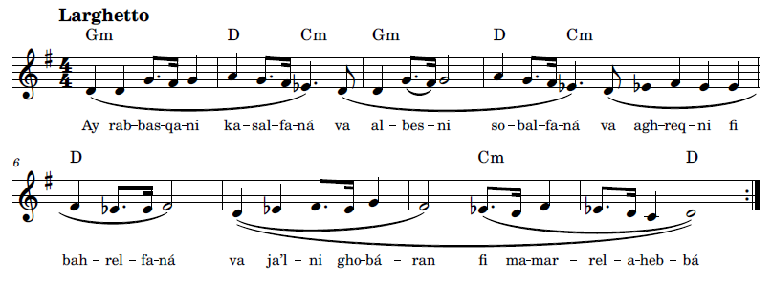
Ay rab-bes- qa-ni ka-sal- fa-ná va al-bes-ni so-bal- fa-ná va agh-req-ni fi bah-rel- fa-ná
va ja’l-ni gho-bá-ran fi ma-mah-rel- a-heb-bá


Lord! Give me to drink from the chalice of selflessness; with its robe clothe me,
and in its ocean immerse me. Make me as dust in the pathway of Thy loved ones.
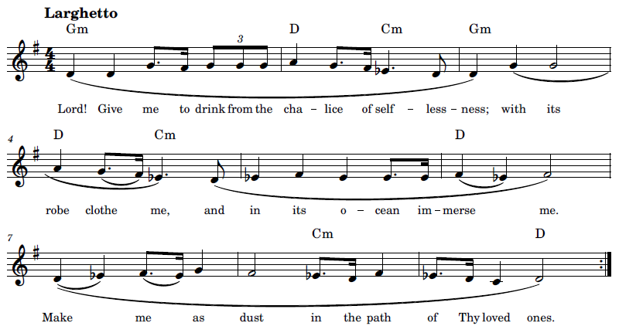

39 Ay Rabba Faj’al Rizqí Jamálika (اَی رَبِّ فَاجْعَل رِزقی جَمالَکَ) O my Lord! Make Thy Beauty to Be My Food

“Ay Rabb Faj’al Rizgí Jamálika” is from a prayer by Bahá’u’lláh, Arabic (Bahá'u'lláh, Majmuih-yi Adhkár va Idiyyih n.d., 175) and English (Bahá'u'lláh, Prayers and Meditations by Bahá'u'lláh 1987, 339) as follow:
أَيْ رَبِّ فَاجْعَلْ رِزْقِي جَمالَكَ وَشَرابِي وِصالَكَ وَأَمَلِي رِضائَكَ وَعَمَلِي ثَنائَكَ وَأَنيْسِيْ ذِكْرَكَ وَمُعِينِيْ سُلْطانَكَ وَمُسْتَقَرِّي مَقَرَّكَ وَوَطَنِي المَقامَ الَّذِيْ جَعَلْتَهُ مُقَدَّسًا مِنْ حُدُوداتِ المُحْتَجِبِينَ وَإِنَّكَ أَنْتَ المُقْتَدِرُ العَزِيْزُ القَدِيرُ.

O my Lord! Make Thy beauty to be my food, and Thy presence my drink, and Thy pleasure my hope, and praise of Thee my action, and remembrance of Thee my companion, and the power of Thy sovereignty my succorer, and Thy habitation my home, and my dwelling-place the seat Thou hast sanctified from the limitations imposed upon them who are shut out as by a veil from Thee. Thou art, verily, the Almighty, the All-Glorious, the Most Powerful.
Recording, online link: https://bahai-library.com/caton_music/39_Ay_Rabba_Fajal_Rizqi_Jamalika.mp3
Transcription demo, online link: https://bahai-library.com/caton_music/sacred_refrains_demos/39_Ay_Rabba_Fajal_Rizqi_Jamalika_demo.mp3
أَيْ رَبِّ فَاجْعَلْ رِزْقِي جَمالَكَ وَشَرابِي وِصالَكَ وَأَمَلِي رِضائَكَ وَعَمَلِي ثَنائَكَ وَأَنيْسِيْ ذِكْرَكَ وَمُعِينِيْ سُلْطانَكَ
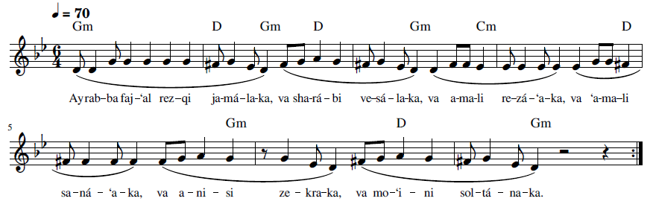
Pronunciation and translation:
Ay rab-ba faj-‘al rez-qi ja-má-la-ka, O my Lord! Make Thy beauty to be my food,
va sha-rá-bi ve-sá-la-ka, and Thy presence my drink,
va a-ma-li re-zá-‘a-ka, and Thy pleasure my hope,
va ‘a-ma-li sa-ná-‘a-ka, and praise of Thee my action,
va a-ni-si ze-kra-ka, and remembrance of Thee my companion,
va mo-‘i-ni sol-tá-na-ka. and the power of Thy sovereignty my succorer.

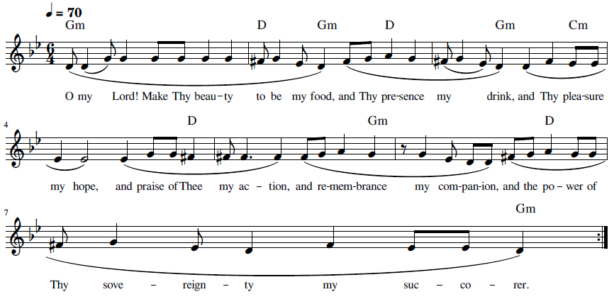

40 Ay Rabba Ṭahhir Ádhán al-‘Ibád (ای رَبِّ طَهِّر آذان العباد) O Lord, Cleanse the Ears

The text of “Ay Rabb Tahir Azán al- ‘Ibád” is from a lengthy prayer by Bahá’u’lláh (Bahá'u'lláh, Ad'iyyih-yi Hadrat-i-Mahbub 1920, 22-23) an excerpt of which is below:

* أی ربّ نوّر أبصار قلوبهم
ليعرفنّ ما قدّرت لهم بجودك و احسانك و يعلمنّ بانّك ما أردت ضرّ أحبّائك الّا لبلوغ عبادك الی ذروة العرفان يا من بيدك جبروت الامر و ملكوت الخلق لا إله إلّا أنت العزيز المقتدر المنّان.

أی ربّ طهّر آذان العباد عن قصص القبل كلّها ليستمعنّ نغمات الّتی تتغنّی بها ورقاء أمرك فی سرّ كلّ الاشياء لئلّا يقاسوا أمرك بما عندهم من توهّمات الّذين كفروا بك و بآياتك و يلقون الشّبهة في افئدة بريّتك. لأنّی أجد أكثر عبادك منعوا عنك بما تمسّكوا بالتّماثيل الّتي كانت بينهم و القصص الّتي سمعوا من آبائهم * أی ربّ فاجعلهم خلقاً بديعاً ثمّ أسمعهم ما أردت و انّك أنت المقتدر علی ما تشاء لا آله الّا أنت العزيز الكريم

A provisional translation of this paragraph in English is provided below:

O Lord, illumine the eyes of their hearts so that they may know what Thou hast intended for them through Thy bounty and kindness, and also to know that Thou didst not want to harm Thy lovers, just for your worshipers to reach the peak of mystic knowledge, O Thou in Whose hand is the power of command and the kingdom of creation. There is no god but Thee, the Mighty, the All-Powerful, the Gracious.
O Lord, cleanse the ears of Thy servants of all tales of the past, so [use of “that” means redoing the lyrics] they may hearken unto the melodies sung by the nightingale of Thy Revelation of the secret of all things, lest they measure Thy Cause against the idle fancies of those who disbelieved in Thee and in Thy verses and instilled doubt into the hearts of Thy creatures. Inasmuch as I find most of Thy worshipers have been held back from Thee, clinging to the idols among them and the tales of the Ancients, cause them, O Lord, to become a new creation and to hearken to Thy Will. Verily, powerful art Thou to do whatsoever Thou willest. There is no god but Thee, the Mighty, the Generous.

Recording, online link: https://bahai-library.com/caton_music/40_Ay_Rabba_Tahhir_Adhan_al-Ibad.mp3
Transcription demo, online link: https://bahai-library.com/caton_music/sacred_refrains_demos/40_Ay_Rabba_Tahhir_Adhan_al-Ibad_demo.mp3
أی ربّ طهّر آذان العباد عن قصص القبل كلّها ليستمعنّ نغمات الّتی تتغنّی بها ورقاء أمرك
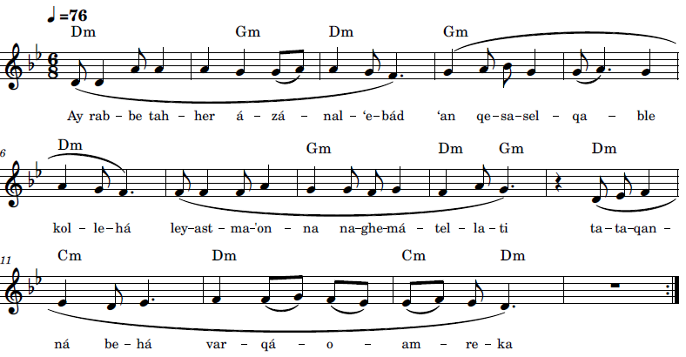
Ay rab-ba tah-her á-zá-nal-‘e-bád ‘an qe-sa-sel- qa-ble kol-le-há
ley-ast ma-‘on-na na-ghe-má-tel- la-ti ta-ta-qan-ná be-há var-qá-‘o am-re-ka
﻿

O Lord, cleanse the ears of Thy servants of all tales of the past,
so they may hearken unto the melodies sung by the nightingale of Thy Revelation.
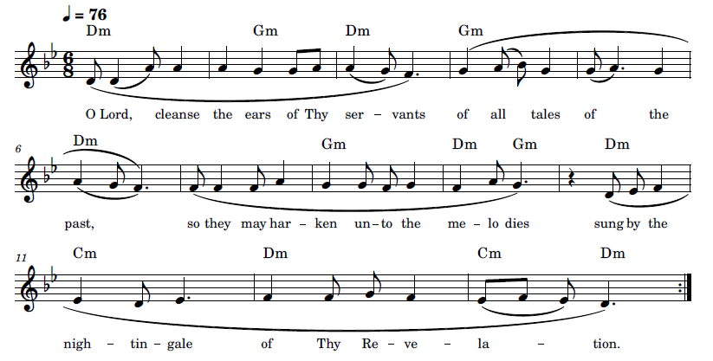

41 Huvá Hú, Ay Maḥbúb-i Man (هُوَ هو ، ای محبوب من) He is God, my Beloved

The text of “Huvá Hú” is taken from three parts of a long Tablet revealed by Bahá’u’lláh (Bahá'u'lláh, Ad'iyyih-yi Hadrat-i-Mahbub 1920, 219, 270, 275). This Tablet has eight sections, each in Arabic with a Persian explanation. As the Tablet is addressed to God, it also is in the form of a prayer (Waldridge 1996). It covers pages 217-285, with the actual Tablet starting on p. 219. The Tablet is the Musíbat-i-Hurúf-i-'Álín, or the Suffering of the Exalted Letters revealed during the Baghdad period after the death of his cousin Muhammad Vazir and addressed to his cousins Maryam and Havvá, the sister and wife of Muhammad, respectively. By “letter” is meant a believer, particularly the Letters of the Living, as well as all followers. This lengthy Tablet includes themes covering life’s journey toward perfection, its sufferings and hardships, and eventual death and loss of loved ones. Joshua Hall mentions that this Tablet is often recited at funerals of Bahá’ís of Eastern backgrounds. A more expanded summary as well as translation can be found on his website (Hall 2017).
Illustrated below are three sections from which the dhikr text was excerpted. Huvá Hú is from the first part of the Tablet (in Arabic) (Section I, pp. 219-220):
ص ٢١٩
) هو هو )
سبحانك اللّهمّ يا الهی كيف يتحرّك القلم و يجری المداد بعد ماانقطعت نسائم الوداد و اشرقت شمس القضاء من أفق الامضاء و خرج سيف البلاء من غمد البداء و ارتفعت سماء الاحزان و نزّل من حاب القضاء رماح الافتتان و سهام الانتقام . بحيث افلت أنجم السّرور فی قلوب احبّائك و انعدمت مقادير البهجة فی افئدة أصفيائك و تتابعت
ص ٢٢٠
الرّزايا حتّی وصلت الی مقام لن يقدر أحد أن يحملها ولن تطيق نفس أن تقرّبها. بحيث أغلقت أبواب الرّجاء و انقطعت نسائم الوفاء و هاجت روائح الفناء. و عزّتك يبكی القلم و يضجُّ المداد و انصعق اللّوح و ارتعشت الابدان و انهدمت الاركان . فآه آه عمّا قضی و امضی و ذلك من عنايتك الأولی .
He is that He is

Glory be unto Thee, O Lord my God! How is the pen to write and the ink to flow, inasmuch as the gentle breezes of affection have been stilled, the daystar of the divine decree hath arisen from the horizon of fulfillment, the sword of tribulation hath been unsheathed from the scabbard of creation, the firmament of sorrow hath been upraised, and the arrows of hardship and the darts of trials have rained down from the clouds of fate, in such wise that the stars of joy in the hearts of Thy loved ones have fallen, every measure of happiness in the souls of Thy chosen ones hath been effaced, and successive tribulations have waxed so severe that no man hath the power to bear them, nor any soul the ability to withstand them. For the doors of hope have been slammed shut, the sweet-scented breezes of fidelity have ceased to waft, and the odours of extinction have been diffused. I swear by Thy glory! The pen weepeth, the ink crieth aloud, the Tablet hath swooned away, bodies have trembled, and pillars have quaked. Alas, alas, for what hath been decreed and come to pass! Verily, this is the first token of Thy loving Providence.

The last section (VIII) was specifically revealed for Maryam and Havvá (Yazdani 2007, 6). The opening in Arabic is (263-264)
ص ٢٦٣

وانّك أنت يا الهی و محبوبی و رجائی تعلم بأنّ الرّزايا قد اشرقت من أفق القضاء واحاطت الامكان و ما فيه و غلبت الاكوان و ما لها و بها و لكن اختصصتها فی هذه الزّمان للطّلعتين و سمّيت أولاهما باسم الّتی اختصصتها و جعلتها أمّ الخلائق اجمعين و الأخری باسم الّتی اصطفيتها علی
ص ٢٦٤
نساء العالمين
O my God, my Beloved and mine Aspiration, Thou knowest full well that these hardships have arisen from the horizon of Thy decree and have encompassed the contingent realm and whatsoever abideth therein. They have overcome all created things and all that pertaineth unto them. But Thou hast chosen in these times two women: the first Thou hast named after her whom Thou hadst singled out and made to be the mother of all creation, and the second Thou hast named after her whom Thou hadst chosen above all the women in the world.

The next part of text of the dhikr, Ay Maḥbúb-i Man, is from the Persian (Section 8), first from the opening (270-271):

و بدرستيكه تو ای محبوب من مشاهده ميفرمائی كه رزايا و بلايا از مشرق قضا ظاهر گشته و امطار قهر از جميع جهات باريدن گرفت و ارياح حزن بوزيدن آمد . بسی جانهای بيشمار كه در راه دوست نثار شد و چه سرهای نامدار كه بر دار مرتفع گشت و در آنی راحتی دست نداد و در شبی عيشی ميسّر نشد. كمند عشق تو سرهای عارفان را بسته و تير حبّ تو جگرهای عاشقان را خسته .

The provisional translation of the opening paragraph of the Persian explanation is as follows:

Verily, Thou, O my Beloved, bear witness that hardships and calamities emerged from the dawning-place of misfortune, and the rain of animosity began to pour from all sides, and the winds of sorrow began to blow. Countless souls were sacrificed in the path of the Friend, and what renowned heads who were raised on the gallows, and not for a moment was comfort obtained nor at night the possibility of ease. The lasoo of Thy affection captured the heads of the mystics and the arrow of Thy love pierced the hearts of the lovers.

The third part of the text of the dhikr is the eighth section Persian explanation is from the following context in the interior of this section (274-277):

بسی غلّها كه در صدور پنهان گشته و چه بغضها كه در قلوب كتمان شده . از حبس ظاهر بيرون آمده و بسجن نفوس مشركه مسجون گشته و تيرهای ظنونات از كلّ جهات ميريزد و اسياف حسد از جميع اطراف بمثل باران ريزنده ميبارد. و لكن با همه اين بلايا و محن و رزايای محكم متقن اميد هست كه از خدمت باز نماند و رجل از استقامت نلغزد و عيون بجای پا بخدمت بايستد. در اينوقت كه دموع از خدّم جاری و دم حمرا از قلبم ساريست ندا ميكنم ترا كه قلب حزينم را از غير خود غافل گردانی و بخود مشغول نمائی تا از همه مقطوع شود و بتو در بندد زيرا كه بسته تو هرگز نگسلد و مقبول تو هرگز مردود نشود سلطان است اگر چه محكوم عباد شود و منصور است اگر چه نفسی او را ياری ننمايد و محبوبست اگر چه مردود باشد. در اينوقت مشعل توحيد برافروزد و مرآت تفريد از هيكل تجريد حكايت نمايد و مزمار عراقی بلحن حجازی آيه ( كلّ شیء هالك الّا وجهه ) بنوازد زيرا كه دستهای عارفين كوتاه و تو در مكمن بلند عزّت مستقرّ و قلوب عاشقين مضطرب و تو در كمال استقلال بر مخزن رفعت مستقيم. خيال كجا راه يابد تا در آن سماء با فضا طيران نمايد و فكر كجا بار يابد تا در عرصه فِناء قدس قدم گذارد؟ توهّمات عباد بمنزله غبار است، و غبار تيره مكدّر كجا بذيل قدس مطهّر رسد و يا نظره محدود بر روی منير تو وارد آيد؟

A provisional translation of the excerpt from the Persian is as follows:

So much rancor was concealed in their breasts and what hatreds were hidden in their hearts. They emerged from their confinement and were imprisoned in the jails of the unbelievers, and the arrows of doubt were fired from every side and the swords of envy fell from all around like rain. However, with all these afflictions and suffering and tribulations, there is hope that this will not hinder endeavors and the foot will not falter in perseverance and the eyes will stand in the place of the foot on the path of service.
In this time that tears flow from my cheeks and a trail of red streams from my heart, I call on Thee to cause my sorrowful heart to be heedless of all but Thee and to be involved only with Thee till it is cut off from all and is tethered to Thee; who is bound to you will never fail, and who is accepted by Thee will never be rejected. He is sovereign, although condemned by Thy servants, and is victorious, although no soul holds him dear, and beloved, although he be rejected.
In this time the torch of Oneness is ignited, and the mirrors of Unity tell the tale from the body of Singleness. And the Iraqi flute plays the Verse (everything will be destroyed except His face) in the tune of Hejaz. Because the reach of the mystics is short and Thou in residing art deep ever-abiding grandeur and the hearts of the lovers are confounded and Thou art standing still in absolute autonomy. Where does imagination find way to soar in that spacious heaven and where does thought go to find entry to set foot in the court of the Holy Divinity? The illusions of the worshiper are like dust, and where does the dark dust of gloom reach the sanctuary of Holiness or a limited vision take in Thy radiant face?
The following is a provisional translation by Adib Masumian:
How numerous are the jealousies that lie hid in the breasts of men, and what enmities are concealed in their hearts! He hath left the outward dungeon [the Síyáh-Chál] only to be confined to the prison of the ungodly. The arrows of idle fancies are falling from every angle, and the swords of envy, even as a copious shower, are raining down on all sides. And yet, notwithstanding all these dire calamities and grievous afflictions, there is still hope that He may not be deterred from His service—that His feet may not falter in His perseverance, and His eyes fix themselves on servitude in their stead. At this time when tears stream down My cheeks, and crimson blood floweth from My heart, I call on Thee to make My sorrow-stricken soul oblivious of all but Thyself and engrossed in Thee alone, that it may be severed from aught else and bound only to Thee, for Thy captive shall never separate himself from Thee, nor can anyone who hath met with Thine approval ever be truly rejected. Such a one is a king, condemned by mankind though he may be; he is victorious, although none render him aid; he is loved, even should he be an outcast. At this juncture, the Torch of Divine Unity blazeth forth; the Mirror of Singleness reflecteth the Temple of Oneness; and the Persian flute playeth, in Arabian tones, the verse “All on the earth shall pass away, but the face of thy Lord” [Qur’án 28:88], for the hands of the mystics can scarcely stretch out, while Thou art established in the lofty habitation of glory, and the hearts of the lovers are vexed, while Thou, with the utmost independence, standest firm in the treasury of sublimity. What way can be imagined by which to soar in that spacious heaven, what means conceived through which to set foot in the realm of holiness? The vain imaginings of men are like unto dust. How can the darksome dust ever smirch Thy spotless hem of sanctity, or the limited glance ever fall upon Thy luminous Face?



Recording, online link: https://bahai-library.com/caton_music/41_Huva_Hu_Ay_Mahbub-i_Man.mp3
Transcription demo, online link: https://bahai-library.com/caton_music/sacred_refrains_demos/41_Huva_Hu_Ay_Mahbub-i_Man_demo.mp3

هُوَ هو ، ای محبوب من ندا می کنم تو را که قلب حزینم را از غیر خود غافل گردانی و به خود مشغول نمایی
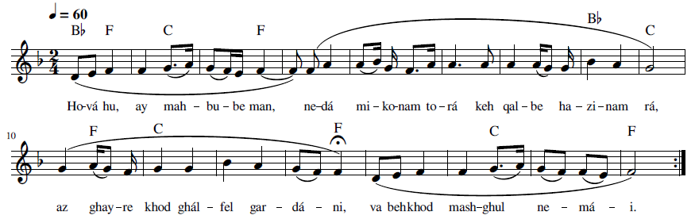
Ho-vá hu, ay mah-bu-be man, ne-dá mi-ko-nam to-rá keh qal-be ha-zi-nam rá,
az ghay-re khod ghál-fel gar-dá-ni, va beh khod mash-ghul ne-má-i
He is God! O my Beloved, I call on Thee to cause my sorrowful heart
to be heedless of all but Thee and to be involved only with Thee.
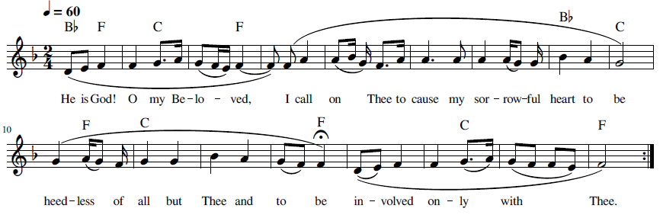

42 Iláhá Ma’búdá ‘Ibádat (الها معبودا عبادت) O God, O Adored One, Your Servant

This dhikr is taken from the first part of a prayer in Persian by Bahá’u’lláh (Bahá'u'lláh, Ad'iyyih-yi Hadrat-i-Mahbub 1920, 307-308):
اِلَها مَعبُودا
عبادت را از ثمرۀ وجود محروم منما و از بحرِ جودت قسمت عطا فرما. توئی مقتدری كه قوّتِ عالم قُوّتت را ضعيف ننمود و شوكت اُمَرای اَرض تو را از مَشيّتت باز نداشت. از تو می‌طلبم فَضلِ قديمت را و عِنايتِ جديدت را. توئی فضّال و توئی غفّار و توئی بخشنده و توانا.
The provisional translation in English is as follows;
O God, O Adored One, deprive not Thy servant of the fruit of existence and grant a portion from the sea of Thy bounty. Thou art the All-Powerful, Whom the strength of the world does not weaken Thy might and the splendor of the princes of the world does not deter Thy command. I seek from Thee Thy ancient grace and present favor. Thou art the Beneficent and Thou art the Pardoner and Thou art the Generous and Able.
Recording, online link: https://bahai-library.com/caton_music/42_Ilaha_Mabuda_Ibadat.mp3
Transcription demo, online link: https://bahai-library.com/caton_music/sacred_refrains_demos/42_Ilaha_Mabuda_Ibadat_demo.mp3

الها معبودا عبادت را از ثمره وجود محروم منما و از بحر جودت قسمت عطا فرما
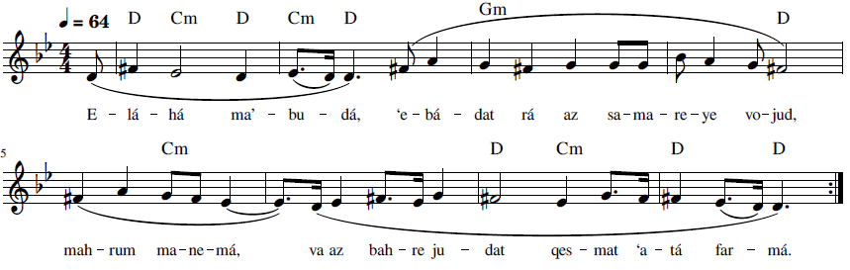
E-lá-há ma’-bu-dá, ‘e-bá-dat rá az sa-ma-re-ye vo-jud, mah-rum ma-ne-má,
va az bah-re ju-dat qes-mat ‘a-tá far-má

O God, O Adored One, deprive not Thy servant of the fruit of existence
and grant a portion from the sea of Thy bounty

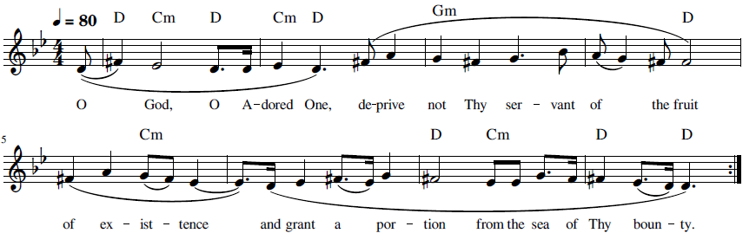

43 Iláhí Iláhí Dast-i Qudrat (الهی الهی دست قدرت) O God, my God, Draw Forth the Hand of Power
This dhikr is from a prayer by Bahá’u’lláh (Bahá'u'lláh, Ad'iyyih-yi Hadrat-i-Mahbub 1920, 358-359) (Bahá'u'lláh, Majmú'ih-i Munáját-i Áthár-i Qalam-i 'Alá 1966, 168-169) :
اين مظلوم عوض كلّ استغفار مينمايد و يقو
الهی الهی اوليای خود را حفظ فرما. توئی آن كريمی كه عفوت عالم را احاطه نموده بر عبادت رحم فرما و تأييد نما بر اعمال و اخلاق و اقوالی كه لايق ايّام توست . بيك كلمه عليا بحر بخششت موّاج و بيك اشراق نيّر امر آفتاب جود و غفران ظاهر و هويدا . همه بندگان تواند و باميد كرمت زنده‌اند . دست قدرت از جيب قوّت بر آر و اين نفوس در گل مانده را نجات ده . توئی مالك اراده و سلطان جود لا اله الّا أنت العزيز الوهّاب
This wronged One imploreth pardon on behalf of all, and saith:
O God my God! Protect Thy loved ones. Thou art the All-Bountiful Whose forgiveness hath encompassed all humanity. Have mercy on Thy servants, and confirm those actions, virtues, and speech that are worthy of Thy Days. With one exalted Word, the Ocean of Thy generosity hath surged, and through a single ray from the Day-Star of Thy Revelation, the Sun of Thy bounty and forgiveness is manifest and evident. All are Thy servants and live through the hope of Thy beneficence. Draw forth the hand of power from the stronghold of might and free these souls mired in the clay of the world. Thou art, in truth, the Lord of creation and the King of bounty. No God is there but Thee, the Mighty, the Bestower.
Recording, online link: https://bahai-library.com/caton_music/43_Ilahi_Ilahi_Dast-i_Qudrat.mp3
Transcription demo, online link: https://bahai-library.com/caton_music/sacred_refrains_demos/43_Ilahi_Ilahi_Dast-i_Qudrat_demo.mp3

الهی الهی دست قدرت از جیب قوت برآر و این نفوس در گل مانده را نجات ده
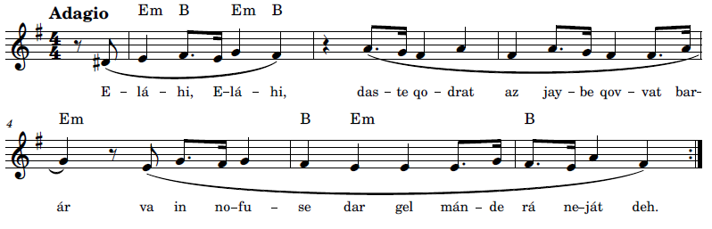
E-lá-hi. e-lá-hi, das-te qo-drat az jay-be qov-vat bar-ár
va in no-fu-se dar gel mán-de rá ne-ját deh

O God, my God! Draw forth the hand of power from the stronghold/place/source of might
and free these souls mired in the clay of the world.
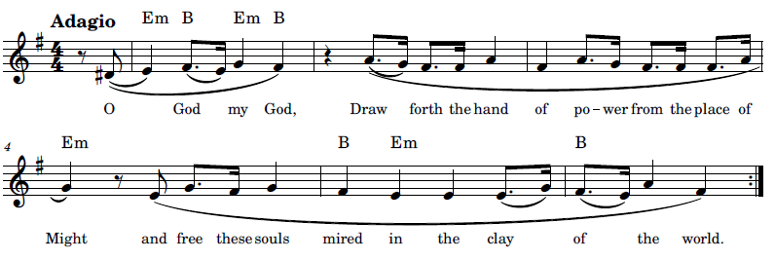

44 ‘Ináyatí Farmá va Mawhabatí (عنایتی فرما و موهبتی بنما) Grant us Thy Favor and Show Us Thy Bounty

This this dhikr is taken from a prayer by ‘Abdu’l-Baha ('Abdu'l-Bahá, Majmuih-yi-Munajatha 1992, 42,#42)
هُوالابهی
ای خداوند مهربان، عنايتی فرما و مُوهبتی بنما تا همّت اين بينوايان بلند گردد و بند‌ها بُگسَليم و از بيگانگان بيزار شويم و به تو دل بنديم و به تمامی در دامِ عشقت گرفتار شويم، آتشی در دل بر فروزيم و حُجباتِ ماسِوی بسوزيم و چشم از مادون بدوزيم و به مشاهدۀ جمال در ملکوتِ ابهايت باز کنيم.ع ع
A provisional translation in English: .
He is the All-Glorious!
O kind Lord, grant us Thy favor and show us Thy bounty so that the effort of these poor ones will rise up and we will break our chains and become weary of strangers and we will fasten our hearts to Thee and we will be completely caught in the snare of Thy love, we will ignite a flame in our hearts and burn the veils of all else and close our eyes to the world and open them to behold the beauty of the Kingdom of Glory.



Recording, online link: https://bahai-library.com/caton_music/44_Inayati_Farma_va_Mawhabati.mp3
Transcription demo, online link: https://bahai-library.com/caton_music/sacred_refrains_demos/44_Inayati_Farma_va_Mawhabati_demo.mp3
عنايتی فرما و مُوهبتی بنما تا همّت اين بينوايان بلند گردد
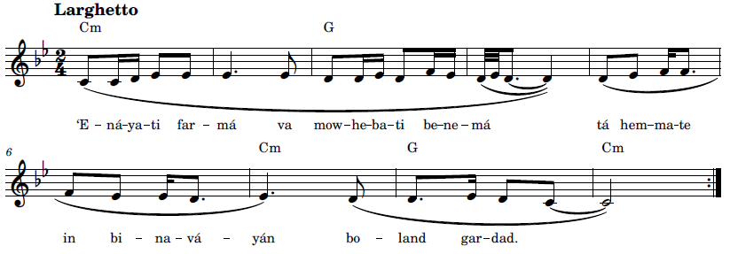
‘E-ná-ya-ti far-má va mow-he-ba-ti be-ne-má tá hem-ma-te in bi-na-vá-yán bo-land gar-dad
Grant us Thy favor and show us Thy bounty so that the effort of these poor ones will rise up.
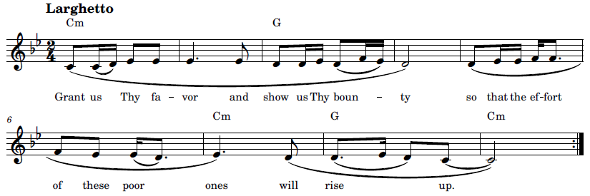

45 Muḥtájím va Muntaẓiri Tá’íd-i Tu (محتاجیم و منتظر تائید تو) We are In Need and Looking for Thy Help

“Muḥtájím va Muntaẓiri” is from a prayer by ‘Abdu’l-Bahá, the complete text in Persian ('Abdu'l-Bahá, Majmuih-yi-Munajatha 1992, 46) is as follows:
هُو اللّه
خداوند مهربانا ، اين جمع در ظلّ رحمت تو اند و اين نفوس متوجّه به ملکوت تو. خدايا ، بندگانيم کرم عنايت کن . فقرائيم از کنز آسمانی بخش . نادانيم به حقايق اشياء دلالت کن . ضعيفيم قوّت آسمانی رسان . فانی هستيم به عالم بقا در آر . محتاجيم و منتظر تأييد تو. اگر عنايتت رسد قطره دريا شود ، ذرّه آفتاب گردد . اگر از الطافت محروم ماند از هر چيز بی بهره و نصيب شود . پس عنايت کن و مرحمت فرما تا علم وحدت عالم انسانی بلند نمائيم و نورانيّت آسمانی شرق و غرب را احاطه کند . جميع احزاب متّحد شوند و حيات ابدی جويند و ترويج وحدت عالم انسانی نمايند و صلح عمومی انتشار دهند . توئی کريم توئی معطی توئی مهربان . ع ع
He is God!
O kind Lord! This gathering is beneath the shelter of Thy mercy and these souls are turning toward Thy kingdom. O God, we are servants, grant us favor. We are poor, bestow upon us heavenly treasure. We are ignorant, show us the truths of existence. We are weak, bring us heavenly strength. We are mortal, show us the realm of eternity. We are in need and are looking for Thy help. If Thy favor [does appear?] appears, the drop becomes the ocean, the spark becomes the sun. If one is deprived of kindness, he will be without a portion and a share of all things. Then aid us and bestow mercy upon us so that we will raise the banner of the unity of the world of humanity and heavenly illumination may surround the East and the West. All parties become united and seek eternal life, and promote the oneness of humankind, and advance universal peace. Thou art generous, Thou are ever-giving, Thou art kind. ‘Abdu’l-Bahá ‘Abbásocal


Recording, online file: https://bahai-library.com/caton_music/45_Muhtajim_va_Muntaziri_Taid-i_Tu.mp3
Transcription demo, online link: https://bahai-library.com/caton_music/sacred_refrains_demos/45_Muhtajim_va_Muntaziri_Taid-i_Tu_demo.mp3
محتاجیم و منتظر تائید تو؛ اگر عنایتت رسد قطره دریا شود، ذره آفتاب گردد
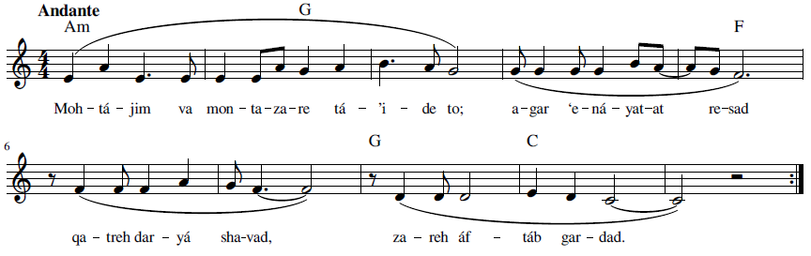
Moh-tá-jim va mon-ta-za-re tá-’i-de to; agar ‘e-ná-ya-tet re-sad qa-treh dar-yá sha-vad,
za-reh áf-táb gar-dad
We are in need and looking for Thy help. If Thy favor does appear, the drop becomes the ocean, the spark becomes the sun.
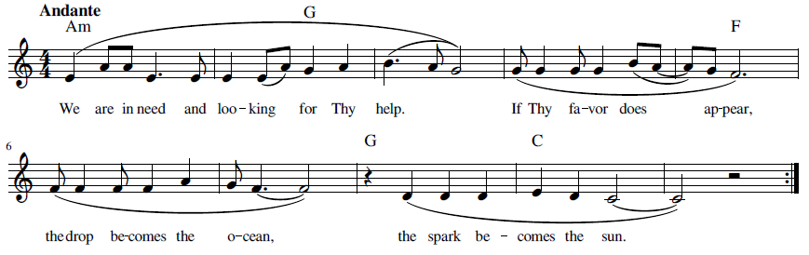

46 Qalban Ṭáhiran (قلباً طاهراً) Create in me a Pure Heart

“Qalban Táhiran” is from a prayer by Baha’u’llah. This recording might not be considered a dhikr, but it was included in an album of dhikr, though not labelled as such. Since it is not chanted, but rather sung, and the first line is repeated once, with a similar melody in the first two phrases, this could become a dhikr by just using the first two phrases, as above. The Arabic (Bahá'u'lláh, Ad'iyyih-yi Hadrat-i-Mahbub 1920, 57-58) and English texts (Bahá'u'lláh, Prayers and Meditations by Bahá'u'lláh 1987, 248) of the complete prayer are as follows:

قلباً طاهراً فاخلق فىَ ياإلهى سراً ساكناً جدد فى يامُنائى وبروح القوة ثبتنىعلى أمرك يامحبوبى وبنور العظمة فأشهدنى علىصراطك يارجائى وبسلطان الرفعة إلى سماء قدسك عرّجنى ياأوّلى وبأرياح الصمدية فأبهجنى ياآخرى وبنغمات الأزلية فاسترحنى يامؤنسى وبغناء طلعتك القديمة نجنى عن دونك ياسيدى وبظهور كينونتك الدائمة بشرنى ياظاهر فوق ظاهرى والباطنَ دون باطنى.
Create in me a pure heart, O my God, and renew a tranquil conscience within me, O my Hope! Through the spirit of power confirm Thou me in Thy Cause, O my Best-Beloved, and by the light of Thy glory reveal unto me Thy path, O Thou the Goal of my desire! Through the power of Thy transcendent might lift me up unto the heaven of Thy holiness, O Source of my being, and by the breezes of Thine eternity gladden me, O Thou Who art my God! Let Thine everlasting melodies breathe tranquillity on me, O my Companion, and let the riches of Thine ancient countenance deliver me from all except Thee, O my Master, and let the tidings of the revelation of Thine incorruptible Essence bring me joy, O Thou Who art the most manifest of the manifest and the most hidden of the hidden!

Qalban Ṭáhiran 1 (قلباً طاهراً ١ ) Create in me a Pure Heart

Recording, online link: https://bahai-library.com/caton_music/46_Qalban_Tahiran_1.mp3
Transcription demo, online link: https://bahai-library.com/caton_music/sacred_refrains_demos/46_Qalban_Tahiran_1_demo.mp3

قلباً طاهراً فاخلق فىَ ياإلهى
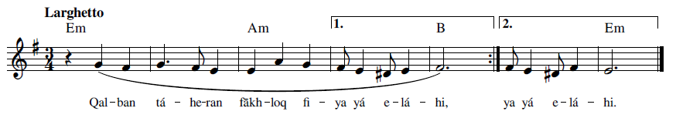
Qal-ban tá-he-ran fākh-loq fi-ya yá e-lá-hi

Create in me a pure heart, O my God
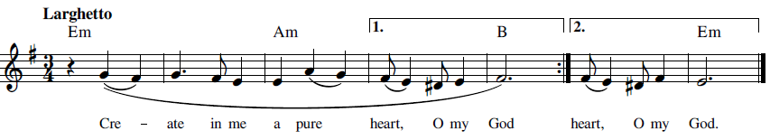

Qalban Ṭáhiran 2 ( قلباً طاهراً ٢) Create in me a Pure Heart

Recording, online link: https://bahai-library.com/caton_music/46_Qalban_Tahiran_2.mp3
Transcription demo, online link: https://bahai-library.com/caton_music/sacred_refrains_demos/46_Qalban_Tahiran_2_demo.mp3

قَلْبًا طاهِرًا فَاخْلُقْ فِيَّ يا إِلهِيْ، سِرًّا ساكنًا جَدِّدْ فِيَّ يا مُنائِي
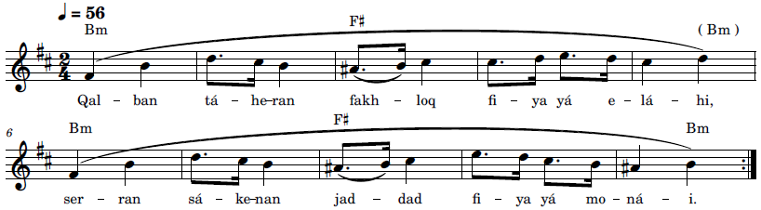
Qal-ban tá-he-ran fakh-loq fi-ya yá e-lá-hi, ser-ran sá-ke-nan jad-dad fi-ya yá mo-ná-i

Create in me a pure heart, O my God, and renew a tranquil conscience within me, O my Hope!
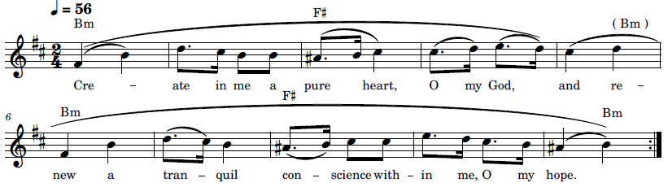

47 Rabba Yassiri’l Umúr (رَبِّ يسّر الأمور) Ease our Affairs, O Lord

This dhikr is taken from a prayer by ‘Abdu’l-Bahá ('Abdu'l-Bahá, Majmuih-yi-Munajatha 1992, 294: #294) :
هو الله
رَبِّ يسّر الأمور و اشرح الصّدور و اسمح بالفضل الموفور و ادخلنا
فی جنّة السّرور و الحبور برحمتک يا عزيز و يا غفور. ع ع
A provisional translation into English is as follows:

Ease our affairs, O Lord, and gladden our hearts. Show us such beneficence as is born of Thine abundant bounty, and cause us, by Thy mercy, to enter the Paradise of blissful joy, O Thou the Almighty, O Thou the Ever-Forgiving.


Recording, online link: https://bahai-library.com/caton_music/47_Rabba_Yassiril_Umur.mp3
Transcription demo, online link: https://bahai-library.com/caton_music/sacred_refrains_demos/47_Rabba_Yassiril_Umur_demo.mp3
رَبِّ يسّر الأمور و اشرح الصّدور و اسمح بالفضل الموفور
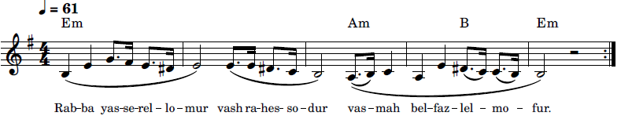
Rab-ba yas-se-rel- lo-mur vash ra-hes- so-dur vas-mah bel-faz-lel- mo-fur
East our affairs, O Lord, and gladden our hearts. Show us such beneficence as is born of Thine abundant bounty
O Lord, ease our affairs, gladden our hearts. Bless us with Thine abundant bounty.
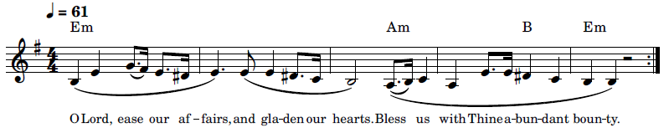

48 Subḥánika al-Lahumma Yá Iláhí (سبحانك اللّهمّ يا إلهي) Praised Be Thou, O Lord

This prayer is found near the end of a Tablet Surah al-‘Ibád (Surah of the Servants) by Bahá’u’lláh, a passage of which follows (Bahá'u'lláh, Surat al-'Abád 2002):
ثمّ اعلم بأنّ حضر بين يدينا لوحا و‌فيه نادى أحد من المحبّين ربّه المنّان المقتدر العزيز الجميل قل إنّا سمعنا ندائك و‌أجبناك بهذه الكلمات المقدّس المحبوب لتشكر اللّه في نفسك ثمّ في لسانك و‌تكون من الّذينهم بآيات اللّه لا يستهزئون أن استقم يا عبد في حبّك موليٰك و‌لا تضطرب إذا أتاك أمر محتوم و‌لا تخف من أحد فتوجّه بوجه ربّك و‌توكّل على نفسنا المهيمن القيّوم وقل سبحانك اللّهمّ يا إلهي طهّر عيني ثمّ أُذني ثمّ لساني ثمّ روحي ثمّ قلبي ثمّ نفسي ثمّ جسمي ثمّ جسدي عن التّوجّه إلى غيرك ثمّ أشربني عن كأس عزّك المختوم قل تاللّه قد ظهر عين الكافور في هذا الظّهور و‌انفجر التّسنيم في هذا السّلسبيل الّذي كان على هيئة الغلام المشهود أن يا عبد فادخل يدك فيه و‌لا تردّها إلى نفسك خاليا و‌لو تقطع بسيوف الّذين هم كانوا بآيات اللّه هم معرضون فاستعن في كلّ أمر باسمي العزيز المقتدر المحبوب ثمّ اشرب منه في سرّك ثمّ ابذل على الّذين تجد في قلوبهم نفحات الرّوح و‌كانوا من الّذينهم بآيات اللّه هم مهتدون وكذلك أذكرناك في اللّوح وصرّفنا لك الآيات لتوقن في نفسك بأنّا نعطي كلّ شيء ما يغنيه عن الّذينهم كفروا وأشركوا و‌كانوا بربّهم أن يشركون
This is an example of a prayer that has been turned into a dhikr. The English of this prayer is found in Additional Prayers Revealed by Bahá’u’lláh (Bahá'u'lláh, Additional Prayers Revealed by Bahá'u'lláh 2018):



Recording, online link: https://bahai-library.com/caton_music/48_Subhanika_al-Lahumma_Ya_Ilahi.mp3
Transcription demo, online link: https://bahai-library.com/caton_music/sacred_refrains_demos/48_Subhanika_al-Lahumma_Ya_Ilahi_demo.mp3

سبحانك اللّهمّ يا إلهي طهّر عيني ثمّ أُذني ثمّ لساني ثمّ روحي ثمّ قلبي ثمّ نفسي ثمّ جسمي ثمّ جسدي عن التّوجّه إلى غيرك ثمّ أشربني عن كأس عزّك المختوم
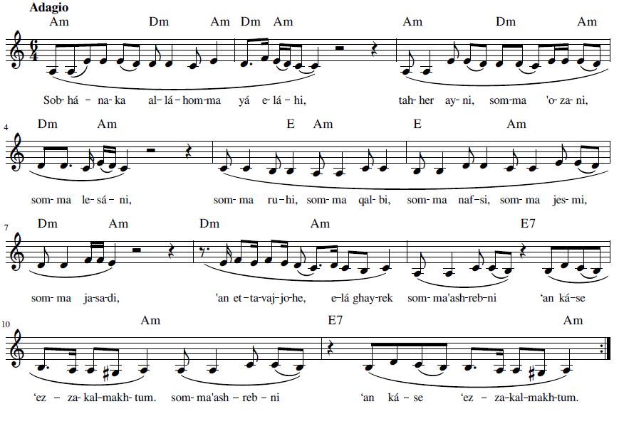
Sob-há-na-ka al-lá-hom-ma yá e-lá-hi, tah-er ay-ni, som-ma o-za-ni,
som-ma le-sá-ni, som-ma ru-hi, som-ma qal-bi, som-ma naf-si, som-ma jes-mi, som-ma ja-sa-di, ‘an et-ta-vaj-jo-he, e-lá ghay-rek som-ma’ash-reb-ni ‘an ká-se ‘ez-za-kal-makh-tum.

Praised be Thou, O Lord my God! Sanctify mine eye, and mine ear,
and my tongue, and my spirit, and my heart, and my soul, and my body, and mine entire being from turning unto anyone but Thee. Give me then to drink from the cup that brimmeth
with the sealed wine of Thy glory.
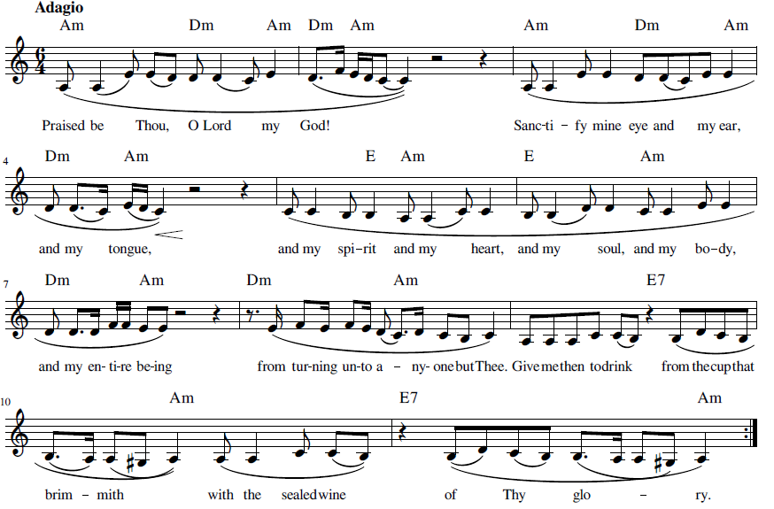

Nearness and Love

This section focuses on love of God, nearness to God and may include supplications to that effect.
“Ay Dilbár-i Abhá, Ay Maḥbúb-i Yiktá” begins with an invocation to his Beloved and states that he has withdrawn all attachment and devotion of anyone or anything but God.
“Ay Dúst dar Rawḍih-i Qalb,” from the Persian Hidden Words, may be an invocation and an admonition for His followers, to humanity, to plant and foster love in their hearts, only.
“Ay Khudávand, Tu Sháhid va Ágáhí” begins with an invocation and then expresses the lovers whole-hearted devotion to God.
“Ay Maḥbúb-i Qadím va Yár-i Dilnishín-i Man” again addresses God as a Beloved and laments his feeling of remoteness, appealing to and asking God how long must he remain this state as one might appeal to a Beloved he wishes to be close with.
“Himmatí Báyad,” from the Valley of Search states to humanity the requisites to attaining reunion with God, namely effort and wholehearted devotion and love.
“Iláhá Karímá Raḥímá, Beh Dhikrat” addresses God by His name and attributes and states that he lives through remembering and praising Him as well as the hope of reunion.
“Iláhá Parvardegár Rá Maḥbúbá Maqsúdá” addresses God by four different names and asks to be admitted, rather, not to be barred from, His presence: “My God, my Provider, my Beloved, my Desire! Deprive not Thy servants thereof, and debar them not from the court of Thy holiness and nearness.”

“Parvardigárá, Har Ánchi Qalb-i Mará” begins with an invocation, then an appeal to God to remove anything that separates the follower from God.
“Yá Maḥbúb al-‘Áshiqín” is an invocation to a beloved, which could as well be placed under the category of names and attributes, but speaks more specifically about the relationship and feeling of His followers toward Him and appreciation of the love He bears for them.
“Yá Maḥbúbí va Maqṣúdí” opens with an invocation to the Beloved and then appeals to that Beloved to remove all barriers and veils in the lover that separate him from His Beloved.

49 Ay Dilbar-i Abhá, Ay Maḥbúb-i Yiktá (ای دلبر ابهی ای محبوب یکتا) O most Radiant Beauty, O Matchless Beloved

This dhikr text is from a prayer by ‘Abdu’l-Bahá ('Abdu'l-Bahá, Majmuih-yi-Munajatha 1992, 37-38: #36):
هواللّه
ای دلبرِ ابهی ای محبوبِ یکتا، دل از هر دو جهان برداشتیم چون عَلَمِ محبّت برافراشتیم، رخ از عالم و عالمیان برتافتیم چون رویِ دلجوی تو یافتیم، چشم از غیر تو بستیم چون به جمالِ تو گشودیم. ای معشوقِ حقیقی، پرتوی در دل‌ها افکن و جلوه‌ای در قلوب بنما تا از هر قیدی آزاده گردیم و بکلّی گرفتار تو شویم، شعلۀ میثاق گردیم و نُجومِ بازغه از مَطلَعِ اشراق ع ع
The following is a provisional translation in English:
He is God!
O most radiant Beauty, O matchless Beloved, we took our heart from both worlds when we raised the banner of love, we turned our face away from the world and its inhabitants when we found Thy pleasing Face, we closed our eyes from other than Thee when we opened them to Thy beauty. O true Beloved, cast a ray of light into our hearts and make it glow so that we may be freed from all bonds and become completely captured by Thee, become flame of the Covenant and stars rising from the Horizon of illumination. A.A.
Recording, online link: https://bahai-library.com/caton_music/49_Ay_Dilbar-i_Abha_Ay_Mahbub-i_Yikta.mp3
Transcription demo, online link: https://bahai-library.com/caton_music/sacred_refrains_demos/49_Ay_Dilbar-i_Abha_Ay_Mahbub-i_Yikta_demo.mp3
ای دلبر ابهی ای محبوب یکتا، دل از هر دو جهان برداشتیم چون عَلَمِ محبّتت برافراشتیم
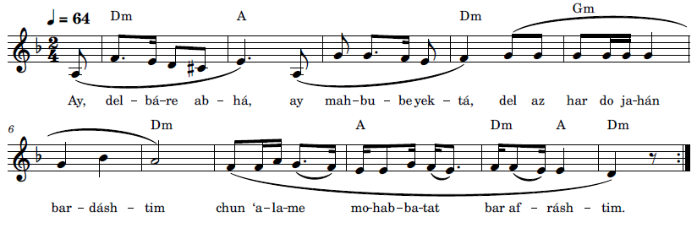
Ay, del-bá-re ab-há, ay mah-bu-be yek-tá, del az har do ja-hán bar-dásh-tim
chun ‘a-la-me mo-hab-ba-tat bar af-rásh-tim
O most radiant Beauty, O matchless Beloved, we took our heart from both worlds
when we raised the banner of love.
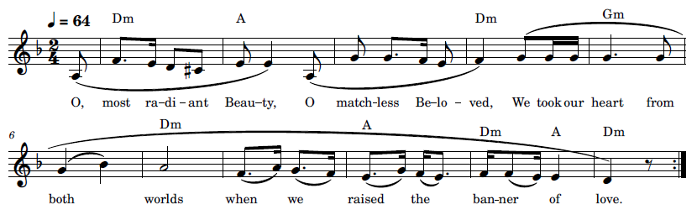

50 Ay Dúst dar Rawḍih-i Qalb (ای دوست در روضه قلب) O Friend! In the Garden of thy Heart

This dhikr is from the Hidden Words of Bahá’u’lláh, number 3 (Bahá'u'lláh, Kalimát-i Maknunih-i Fársí n.d., 504, #3):
ای دوست
در روضهٴ قلب جز گل عشق مکار و از ذیل بلبل حبّ و شوق دست مدار مصاحبت ابرار را غنیمت دان و از مرافقت اشرار دست و دل هر دو بردار
The English translation is as follows (Bahá'u'lláh, The Persian Hidden Words n.d., 8, #3)
O Friend!
In the garden of thy heart plant naught but the rose of love, and from the nightingale of affection and desire loosen not thy hold. Treasure the companionship of the righteous and eschew all fellowship with the ungodly.

Recording, online link: https://bahai-library.com/caton_music/50_Ay_Dust_dar_Rawdih-i_Qalb.mp3
Transcription demo, online link: https://bahai-library.com/caton_music/sacred_refrains_demos/50_Ay_Dust_dar_Rawdih-i_Qalb_demo.mp3
ای دوست در روضهٴ قلب جز گل عشق مکار
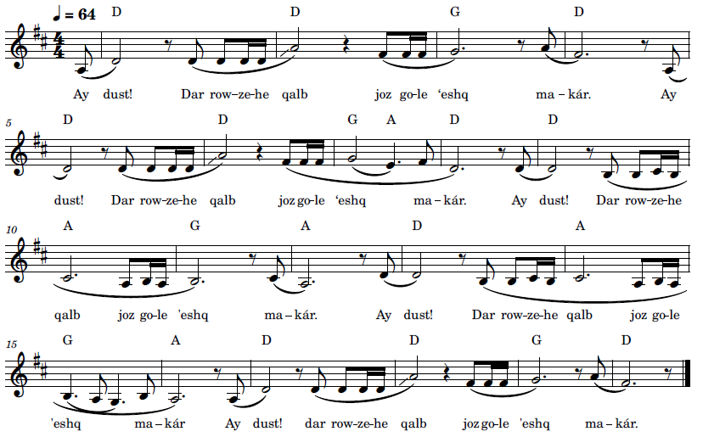
Ay dust! Dar row-ze-he qalb joz go-le ‘eshq ma-kár.



O Friend! In the garden of thy heart plant naught but the rose of love.
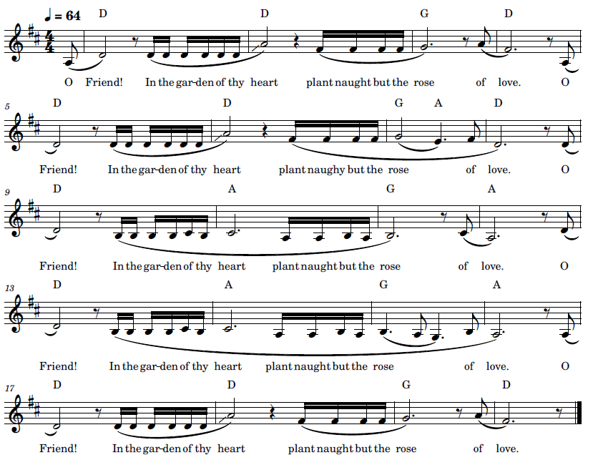

51 Ay Khudávand, Tu Sháhid va Ágáhí (ای خداوند، تو شاهد و آگاهی) O Lord, Thou dost See and Know

This dhikr is the first line of a prayer from ‘Abdu’l-Bahá ('Abdu'l-Bahá, Majmuih-yi-Munajatha 1992, 41: #41):
هُوالابهی
ای خداوند، تو شاهد و آگاهی که در دل و جان جز آرزویِ رضای تو مُرادی ندارم و جز در بَزمِ ميثاق راهی و کامی نجويم، شب و روز دردمندِ دردِ تو‌ام و روز و شب مجروحِ تيغ و خدنگِ تو، جز به مَلَکوتِ ابهايت ناله و فغانی نکنم و جز در پناه احديّتت امن و امان نجويم، بيزار از هر بيگانه‌ام و به يگانگیِ تو دل بسته‌ام، از غيرِ تو بيزارم و از مادونت در کنار. ای پروردگار، موفّق بدار تا از سودائيان تو گردم و از شيدائيان تو شوم، سر دفترِ مجنونانِ روی تو گردم و رسوائيان کوی تو، اين موهبت را شايان فرما و اين عنايت را رايگان کـن. تـوئی پـروردگار و تـوئی آمـرزگار. ع ع
The provisional translation into English is as follows:
He is the All-Glorious!
O Lord, Thou dost see and know that I have no desire in my heart and soul except to obtain Thy good pleasure, and I seek no way or pursuit but the banquet of Thy Covenant. Night and day I am afflicted with the Thy pain and day and night wounded by Thy sword and arrow. I do not wail and lament except for Thy Glorious Kingdom and seek no refuge and security except in the sanctuary of Thy Unity. I am tired of every stranger and my heart holds fast to Thy Oneness. I am weary of other than you and have put aside that which is inferior to Thee. O Lord, grant me success so that I may become one of your passionate and distracted admirers, head of the rank of those lost in Thy love and infamous in Thy courtyard. Make possible this blessing and grant this divine favor. Thou art the Provider and Thou art the Merciful. ‘A. ‘A.
Recording, online link: https://bahai-library.com/caton_music/51_Ay_Khudavand_Tu_Shahid_va_Agahi.mp3

Transcription demo, online link: https://bahai-library.com/caton_music/sacred_refrains_demos/51_Ay_Khudavand_Tu_Shahid_va_Agahi_demo.mp3

ای خداوند، تو شاهد و آگاهی که در دل و جان جز آرزویِ رضای تو مُرادی ندارم
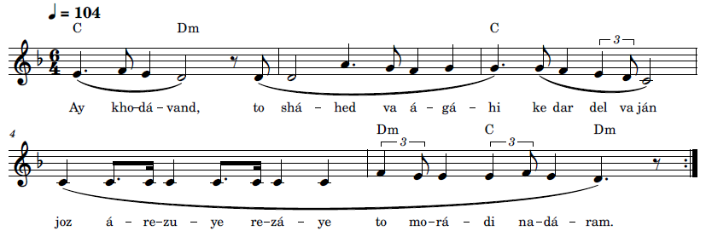
Ay kho-dá-vand, to shá-hed va á-gá-hi ke dar del va ján
joz á-re-zu-ye re-zá-ye to mo-rá-di na-dá-ram

O Lord, Thou dost see and know that I have no desire in my heart and soul
except to obtain Thy good pleasure.
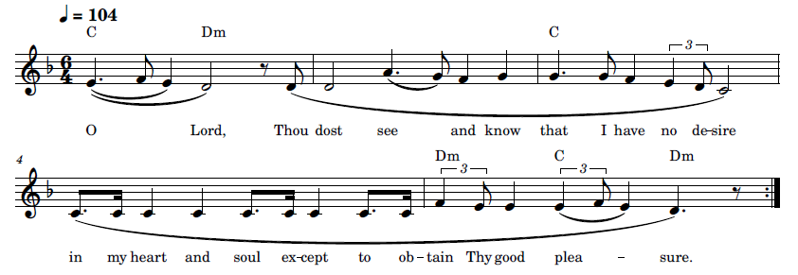

52 Ay Maḥbúb-i Qadím va Yár-i Dilnishín-i Man

(ای محبوب قدیم و یار دلنشین من) O my Eternal Beloved and my Adored Friend!
The text of this dhikr is from a prayer of ‘Abdu’l-Bahá ('Abdu'l-Bahá, Bíst va Shish Munáját 2021, #4):
هو اللّه
ای محبوب قدیم و یار دلنشین من تا چند اسیر حرمان و مبتلای هجران گردم بخلوتگاه ملکوت راه بنما و در جلوه‌گاه لاهوت مشمول عین عنایت کن ای یزدان سلمانیم رحمانیم کن امکانیم لا مکانیم نما آفاقیم اشراقیم کن خاکدانیم آسمانیم فرما تا جانفشانی کنم و کامرانی نمایم تاج
موهبت بر سر نهم و نعرۀ یا بهآءاللّه‌ الابهی بلند کنم ع ع

The English translation is as follows ('Abdu'l-Bahá, Twenty-Six Prayers Revealed by 'Abdu'l-Bahá 2021, #4)

O my eternal Beloved and my adored Friend! How long shall I remain bereft of Thy presence and sorely afflicted by remoteness from Thee? To the retreats of Thy heavenly Kingdom lead me, and at the scene of the appearance of Thy supernal Realm cast upon me the glance of Thy loving-kindness.
O Thou Omnipotent Lord! Number me among the denizens of the Kingdom. This mortal world is my abode; grant me a habitation in the realms of the Placeless. To this earthly plane I pertain; shed upon me the effulgence of Thy glorious light. In this world of dust I dwell; make me an inmate of Thy heavenly realm, so that I may lay down my life in Thy path and attain to my heart’s desire, may crown my head with the diadem of divine favour and raise the triumphal cry of “O Glory of God, the Most Glorious!”
Recording, online link: https://bahai-library.com/caton_music/52_Ay_Mahbub-i_Qadim_va_Yar-i_Dilnishin-i_Man.mp3
Transcription demo, online link: https://bahai-library.com/caton_music/sacred_refrains_demos/52_Ay_Mahbub-i_Qadim_va_Yar-i_Dilnishin-i_Man_demo.mp3
ای محبوب قدیم و یار دلنشین من تا چند اسیر حرمان و مبتلای هجران گردم
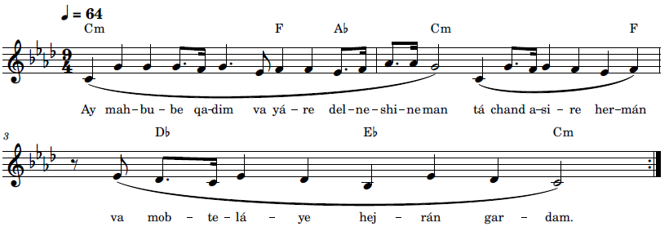
Ay mah-bu-be qa-dim va yá-re del-ne-shi-ne man tá chand a-si-re her-mán
va mob-te-lá-ye hej-rán gar-dam



O my eternal Beloved and my adored Friend! How long shall I remain bereft of Thy presence and sorely afflicted by remoteness from Thee?

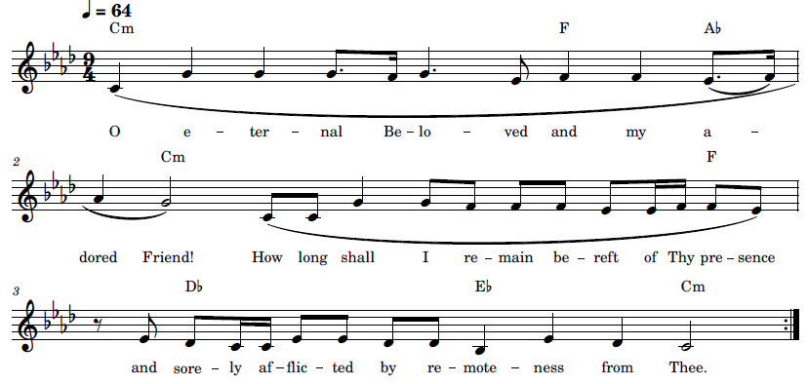

53 Himmatí Báyad (همّتی باید) Labour is Needed

This dhikr is taken from the Valley of Search from Bahá’ulláh’s Seven Valleys (Bahá'u'lláh, Haft Vádí n.d., 4). The text on the recording has one word change that is not in the original text, that is, in the second phrase sháyad is put in place of báyad. Báyad is the correct word there.
طالب صادق جز وصال مطلوب چیزی نجوید و حبیب را جز وصال محبوب مقصودی نباشد و این طلب طالب را حاصل نشود مگر بنثار آنچه هست یعنی آنچه دیده و شنیده و فهمیده همه را بنفی لا منفی سازد تا بشهرستان جان که مدینۀ الّا است واصل شود همّتی باید تا در طلبش کوشیم و جهدی باید تا از شهد وصلش نوشیم اگر از این جام نوش کشیم عالمی فراموش کنیم
The English translation of this paragraph (Bahá'u'lláh, The Call of the Divine Beloved 2018, 17) (Bahá'u'lláh, The Seven Valleys n.d.) (Bahá'u'lláh, The Seven Valleys n.d.)
The true seeker hunteth naught but the object of his quest, and the sincere lover hath no desire save reunion with his beloved. Nor shall the seeker reach his goal unless he sacrifice all things. That is, whatever he hath seen, and heard, and understood—all he must set at naught with “no God is there”, that he may enter into the realm of the spirit, which is the city of “but God.”21 Labour is needed, if we are to seek Him; ardour is needed, if we are to drink the nectar of reunion with Him; and if we taste of this cup, we shall cast away the world.
Recording, online link: https://bahai-library.com/caton_music/53_Himmati_Bayad.mp3
Transcription demo, online link: https://bahai-library.com/caton_music/sacred_refrains_demos/53_Himmati_Bayad_demo.mp3

همّتی باید تا در طلبش کوشیم و جهدی باید تا از شهد وصلش نوشیم
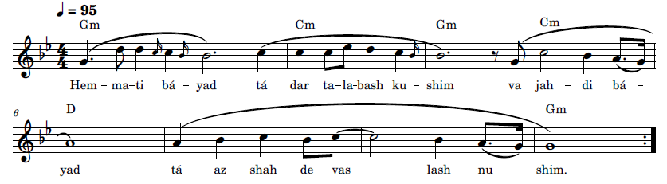
Hem-ma-ti bá-yad tá dar ta-la-bash ku-shim
va jah-di bá-yad tá az shah-de vas-lash nu-shim.
Labour is needed, if we are to seek Him; ardour is needed,
if we are to drink the nectar of reunion with Him.

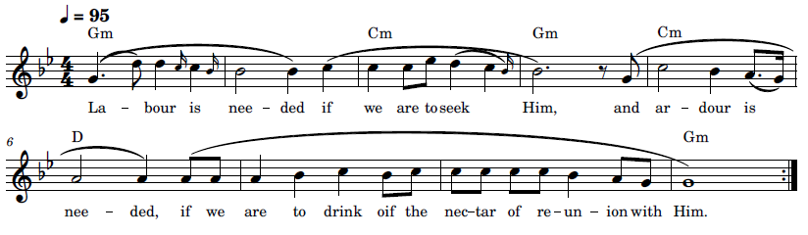

54 Iláhá Karímá Raḥímá, Beh Dhikrat Zindiham (زنده‌ام الها کریما رحیما، به ذکرت)

My God, the Most Generous, the Most Compassionate! I am Alive through Thy Praise

This dhikr is from the opening and a phrase near the end of a prayer of Bahá’lláh (Bahá'u'lláh, Ad'iyyih-yi Hadrat-i-Mahbub 1920, 362):
هُوالنّاصِرالمُعينُ
(اِلهَا كَريما رَحيما)
به تو توجّه نموده‌ام و به حَبل عنايتت مُتِمَسّكم و به ذِيلِ كَرَمَت مُتشَبّث. توئی آن كَريمی كه يك قطره از دريای غُفرانت عِصيان عالميان را مَحو نمايد و يك كلمه از فَمِ عنايتت آب حَيوان بر اهلِ امكان مبذول دارد. ای بخشندۀ يكتا، عبدت را محروم منما و از بحر رحمتت قسمتی عطا نما و از دريایِ جودت نصيبی مقدّر فرما. السُن عالم قابل ذكرت نه و اَفئده اُمَم لايق ادراك هستيت نَه. هستیِ تو وَرایِ اِدراكِ عُقول و فوق عرفانِ نفوس بوده و هست. به كمالِ عجز و ابتهال بخشش قديمت را می‌طلبم و فضلِ عَميمت را می‌جويم. تـو دانـا و آگاهی، به ذكرت زنده‌ام و به اميد لَقايت موجود و پاينده، آن كن كه سزاوار بخشش تو است نه لايقِ ذكـر و ثنایِ من. لا اِلهَ اِلّا اَنتَ الغَفُورُالكَريمُ. اَلحَمدُ لَكَ اَنتَ مَقصُودُ القاصِدين.
A provisional translation into English by Adib Masumian is as follows (Bahá'u'lláh, My God, the Most Generous n.d.):
He is the Helper, the Giver of victory
My God, the Most Generous, the Most Compassionate! I have turned my face unto thee, holding fast to the cord of Thy loving-kindness and clinging to the hem of Thy munificence. Thou art that All-Bountiful One a single drop from the ocean of Whose pardon washeth away all the world’s sins, and one from the mouth of Whose grace bestoweth the water of life unto all humanity.
O peerless Giver! Deprive not Thy servant; grant him a portion from the ocean of Thy mercy, and ordain for him a share from the sea of Thy generosity. The tongues of the world are not fit to render Thee praise, and the hearts of men are unworthy of apprehending Thy reality, which hath ever lain beyond the comprehension of their minds and transcended the ken of their understanding. In a state of utmost helplessness and ardent supplication, I beseech Thine ancient grace and seek Thine all-pervasive bounty. Thou are well aware that I am alive through Thy praise, and that I exist through the hope of standing in Thy presence. Do that which beseemeth Thy grace, and what befitteth my glorification of Thee.
No God is there but Thee, the Ever-Forgiving, the Most Generous. Praise be unto Thee; Thou art the Goal of every searching soul.
Recording, online link: https://bahai-library.com/caton_music/54_Ilaha_Karima_Rahima_Beh_Dhikrat.mp3
Transcription demo, online link: https://bahai-library.com/caton_music/sacred_refrains_demos/54_Ilaha_Karima_Rahima_Beh_Dhikrat_demo.mp3
الها کریما رحیما، به ذکرت زنده ام و به امید لقایت موجود و پاینده
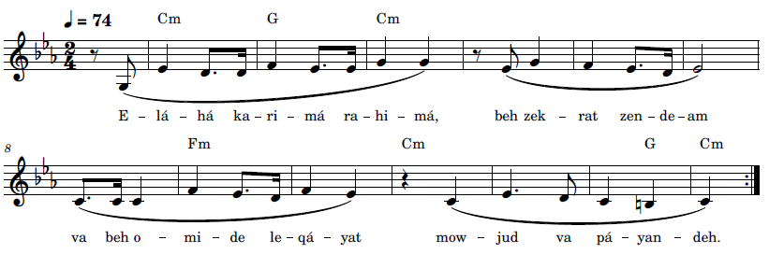
E-lá-há ka-ri-má ra-hi-má, beh zek-rat zen-de-am
va beh o-mi-de le-qá-yat mow-jud va pá-yan-deh
My God, the Most Generous, the Most Compassionate! I am alive through Thy praise,
and I exist through the hope of standing in Thy presence.
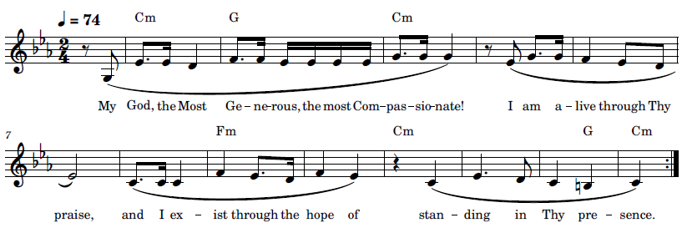

55 Iláhá Parvardigár Rá Maḥbúbá Maqṣúdá (الها پروردگارا محبوبا مقصودا) My God, My Provider, my Beloved, my Desire
The text of the dhikr “Iláhá Parvardigár Rá” is from a prayer by Bahá’u’lláh in Persian (Bahá'u'lláh, Ad'iyyih-yi Hadrat-i-Mahbub 1920, 351). The English translation follows (Bahá'u'lláh, My God, my Provider n.d.):
الها پروردگارا محبوبا مقصودا
بتو آمده‌ام و از تو ميطلبم آنچه را كه سبب بخشش تو است . توئی بحر جود و مالك وجود . لازال لحاظت علّت ظهور بخشش و عطا . عباد خود را محروم منما و از بساط قدس و قرب منع مفرما . توئی بخشنده و مهربان . لا اله الّا أنت العزيز المنّان.
My God, my Provider, my Beloved, my Desire! Unto Thee have I come, imploring from Thee that which is conducive to Thy grace. Thou art the Ocean of bounty, the Lord of all being. From eternity Thy glance hath been the source of beneficent bestowals. Deprive not Thy servants thereof, and debar them not from the court of Thy holiness and nearness. Thou art the Giver, the Kind. No God is there but Thee, the Almighty, the All-Bounteous.
Recording, online link: https://bahai-library.com/caton_music/55_Ilaha_Parvardigar_Ra_Mahbuba_Maqsuda.mp3
Transcription demo, online link: https://bahai-library.com/caton_music/sacred_refrains_demos/55_Ilaha_Parvardigar_Ra_Mahbuba_Maqsuda_demo.mp3
الها پروردگارا محبوبا مقصودا عباد خود را محروم منما و از بساط قدس و قرب منع مفرما
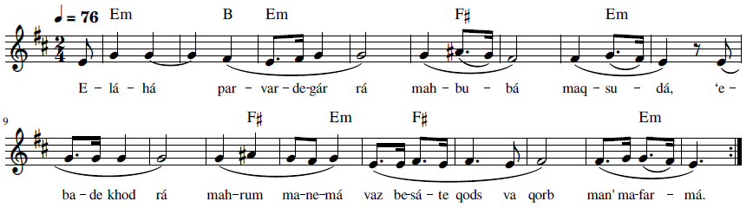E-lá-há par-var-de-gár rá mah-bu-bá maq-su-dá, ‘e-ba-de khod rá mah-rum ma-ne-má
vaz be-sá-te qods va qorb man’ ma-far-má
My God, my Provider, my Beloved, my Desire! Deprive not Thy servants thereof,
and debar them not from the court of Thy holiness and nearness.
My God, my Provider, my Beloved, my Desire! Deny not Thy servants,
and bar them not from the court of sanctity and nearness.

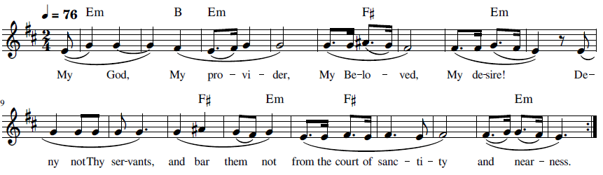

56 Parvardigárá, Har Ánchi Qalb-i Mará (پروردگارا ،هر آنچه قلب مرا) O Thou Provider, Whatever Distances my heart

This dhikr is from a short prayer that has been attributed to ‘Abdu’l-Bahá on a number of different online sites, for example, in a collection of prayers from ‘Abdu’l-Bahá (bahaiworldreligion.com n.d.). According to the research department at the Bahá’í World Centre, it is not possible to authenticate this at this time as “neither an original manuscript nor an authenticated transcription of it has been found in the Archives at the World Centre” (letter from the Department of the Secretariat, November 23, 2023).

In the recording it is sung as a round.

Recording, online link: https://bahai-library.com/caton_music/56_Parvardigara_Har_Anchi_Qalb-i_Mara.mp3
Transcription demo, online link: https://bahai-library.com/caton_music/sacred_refrains_demos/56_Parvardigara_Har_Anchi_Qalb-i_Mara_demo.mp3
هوالله
پروردگارا هر آنچه قلب مرا از قلوب یارانت دور می سازد از من بگیر. ع ع
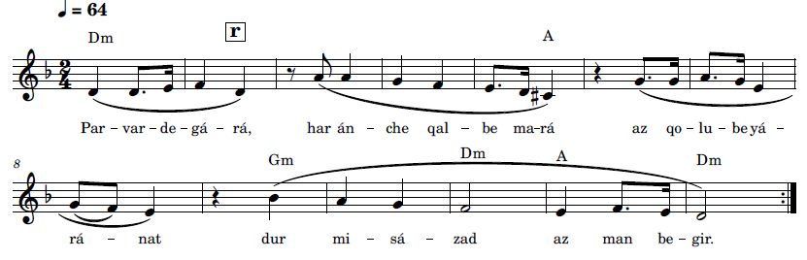
Par-var-de-gá-rá, har án-che qal-be ma-rá az qo-lu-be yá-rá-nat dur mi-sá-zad
az man be-gir

O Thou Provider, whatever distances my heart from the hearts of Thy loved ones,
take it from me.

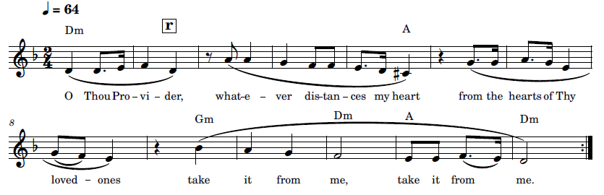

57 Yá Maḥbúb al-‘Áshiqín (یا محبوب العاشقین) O Beloved of them that yearn after Thee

The webpage that was the source of this recording indicated in its title that their recordings were recitations from a selection of works from Baha’u’llah. Although I could not locate the exact phrase of the dhikr text in the sources I referred to, I was able to find an expanded version of this phrase in the Tablet revealed on the Ninth Day of Ridvan (Bahá'ulláh n.d., 315-316).
فَوَ عِزَّتِکَ يا مَحْبُوبَ الْمُشْتاقيْنَ وَ مَقْصُودَ الْعاشِقيْنَ لَوْ يَنْظُرُ اَحَدٌ مِنْ اَهْلِ النَّظَرِ هذَا اللَّوْحَ الْأَطْهَرَ لَيَجْری مِنْهُالدَّمُالَّذيْ ذابَ مِنْ کَبِديْ بِمَا احْتَرَقَ فی حُبِّکَ وَ حُبِّ الَّذيْنَ مُنِعُوا عَنْ لِقائِکَ بَعْدَ الَّذی اَقْبَلُوا اِلَيْکَ و اَسْتَقَرُّوا فِی الْمَديْنَةِ
The English translation of this source is found in Days of Remembrance (Bahá'u'lláh, Days of Remembrance: Selections from the Writings of Bahá'u'lláh for Bahá'í Holy Days 2017, #17, para. 7):
I swear by Thy glory, O Beloved of them that yearn after Thee and Desire of those who cherish Thy love! Were any man of insight to press upon this holy Tablet, he would see the blood of my heart flowing from it, a blood that hath melted for the love of Thee and of those who have been hindered from beholding Thy face after having directed their steps towards Thee and having come to abide within the city or its precincts.

Recording, online link: https://bahai-library.com/caton_music/57_Ya_Mahbub_al-Ashiqin.mp3
Transcription demo, online link: https://bahai-library.com/caton_music/sacred_refrains_demos/57_Ya_Mahbub_al-Ashiqin_demo.mp3

یَا مَحْبُوبَ الْعَاشِقِیْنَ
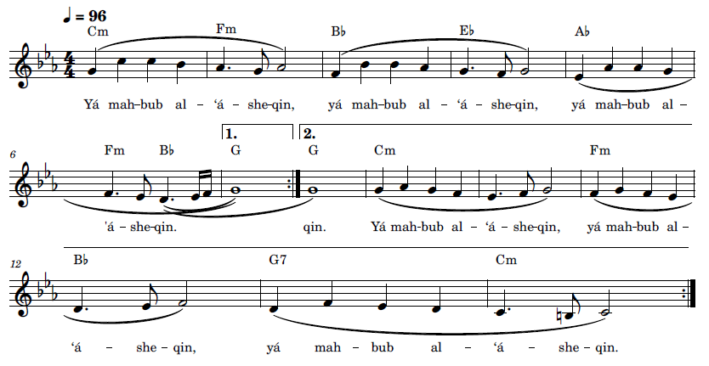
Yá mah-bub al-‘á-she-qin

Paraphrased translation: O Beloved of the lovers.
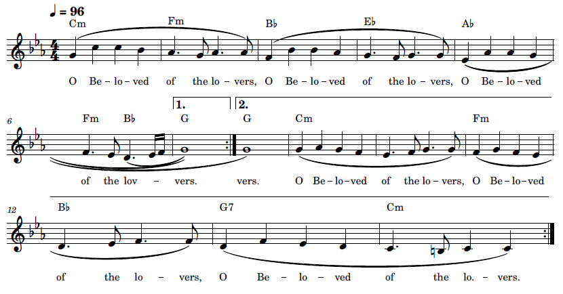

58 Yá Maḥbúbí va Maqṣúdí (يا محبوبی و مقصودی ) O Beloved and Desired One

The dhikr text is taken from two parts of the following prayer from Bahá’u’lláh (Bahá'u'lláh, Ad'iyyih-yi Hadrat-i-Mahbub 1920, 371-372):
در مقام مناجاة و ابتهال با غنيّ متعال به اين كلمه ناطق شو:
يا محبوبی و مقصودی و غاية آمالی، مشاهده مينمائی اين عبد فانی را كه
بتو توجّه نمود و از تو كوثر باقی طلبيده عنايت فرما آنچه سزاوار
بزرگی توست و لايق ايّام تو . سؤال ميكنم ترا باسم اعظم كه حجبات
عباد را خرق نمائی و باب رحمت را بر ايشان بنمائی و بگشائی نائمين را
بيد شفقت و لطف بيدار نمائی و غافلين را بنداء بزم لطيف آگاه
سازی تا كلّ بتو توجّه كنند و بتو اقبال نمايند . أی ربّ لا تحرمهم عن
فيوضات سحاب رحمتك و نسائم ربيع الفضل فی ايّامك . أشهد أنّ
رحمتك سبقت الكائنات و عنايتك أحاطت من فی الأرضين و
السّموات . لا اله الّا أنت الغفور الكريم.

In the mode of prayer and supplication with the Almighty, speak this word:
O Beloved and Desired One and my Highest Aim, Thou seest this mortal servant who hath turned to Thee and sought from Thee the Eternal Fountain, grant that which is worthy of Thy greatness and deserving of Thy days. I ask of Thee in the Greatest Name to rend the veils of Thy servants and reveal and open to them the door of Thy mercy; with the hand of compassion and kindness awaken those asleep and inform the heedless of the call of the divine banquet until all turn toward and rely upon Thee. O Lord, deprive them not of the bounty of the clouds of Thy mercy and the breezes of the spring of Thy grace in Thy days. I bear witness that Thy mercy hath preceded all beings and that Thy care hath encompassed those in the earth and in the heavens. There is no God but Thee, the Merciful, the Generous.

Recording, online link: https://bahai-library.com/caton_music/58_Ya_Mahbubi_va_Maqsudi.mp3
Transcription demo, online link: https://bahai-library.com/caton_music/sacred_refrains_demos/58_Ya_Mahbubi_va_Maqsudi_demo.mp3

یا محبوبی و مقصودی و غایت آمالی سوال می کنم تو را به اسم اعظم که حجبات عباد را خرق نمایی و باب رحمت را بر ایشان بنمایی و بگشایی
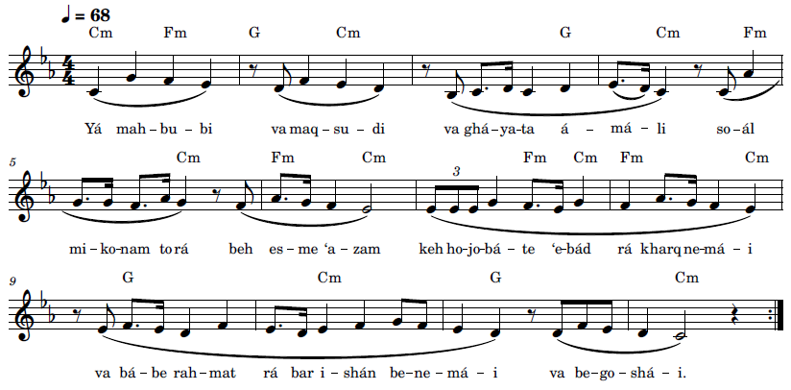
Yá mah-bu-bi va maq-su-di va ghá-ya-ta á-má-li
so-ál mi-ko-nam to rá beh es-me ‘a-zam keh ho-jo-bá-te ‘e-bád rá kharq ne-má-i
va bá-be rah-mat rá bar i-shán be-ne-má-i va be-go-shá-i

O Beloved and Desired One and my Highest Aim,
I ask of Thee in the Greatest Name to rend the veils of Thy servants and reveal and open to them the door of Thy mercy.

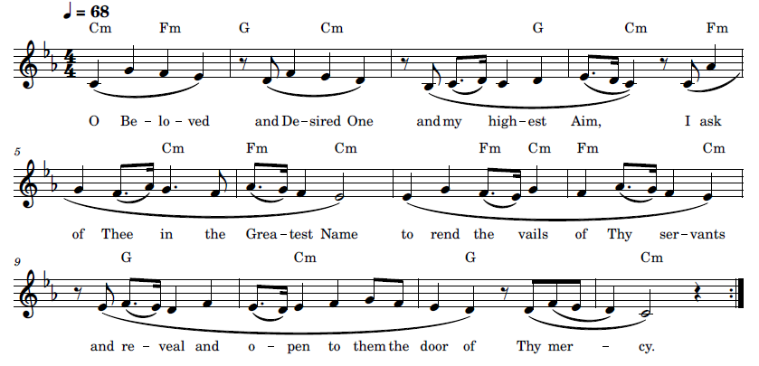

Special verses used in place of the Obligatory Prayer:

In Islam, it has been part of the tradition, the sunnah, to repeat particular phrases enjoined by the teachings and practices of the Prophet Muhammad based on the hadith. These dhikr go by different names, according to different wordings, such as God is Great, Allahu Akbar, or Glorified is God, Subhána-llah, the latter of which is known as tasbih (Qara'at n.d.), which also is the word for the prayer beads used for counting dhikr. The tasbih phrase may be found within longer phrases, including the mentioning of specific attributes. This tasbih is also found in two of the Bahá’í exemption verses used in place of the obligatory prayer. The exemption dhikr for travelers is very similar to the Tasbíh of Taráwíh (Scribd n.d.) used by Moslems after the last obligatory prayer of the night during their month of fasting, Ramadan (Mischler n.d.). The opening line of that dhikr is Subhána dhi ‘l-mulki wa ‘l-malakút.
We have commanded you to pray and fast from the beginning of maturity; this is ordained by God, your Lord and the Lord of your forefathers. He hath exempted from this those who are weak from illness or age, as a bounty from His Presence, and He is the forgiving, the Generous. (Bahá’u’lláh, The Kitáb-i-Aqdas 1992, 22-23)

Verse for Exemption (95 times) (Bahá’u’lláh, The Kitáb-i-Aqdas 1992, 23-24):
God hath exempted women who are in their courses from obligatory prayer and fasting. Let them, instead, after performance of their ablutions, give praise unto God, repeating ninety-five times between the moon of one day and the next “Glorified be God, the Lord of Splendour and Beauty.” Thus hath it been decreed in the Book, if ye be of them that comprehend.
Glorified be God, the Lord of Splendour and Beauty
سبحان اللّه ذی الطلعة و الجمال
Sob-há-nal- lá-he zit- tal-’a-te val- ja-mál (x95)

Verses while travelling (Bahá’u’lláh, The Kitáb-i-Aqdas 1992, 24):

When travelling, if ye should stop and rest in some safe spot, perform ye—men and women alike—a single prostration in place of each unsaid Obligatory Prayer, and while prostrating say “Glorified be God, the Lord of Might and Majesty, of Grace and Bounty.” Whoso is unable to do this, let him say only “Glorified be God;” this shall assuredly suffice him. He is, of a truth, the all-sufficing, the ever-abiding, the forgiving, compassionate God. Upon completing your prostrations, seat yourselves cross-legged—men and women alike—and eighteen times repeat “glorified be God, the Lord of the kingdoms of earth and heaven.” Thus doth the Lord make plain the ways of truth and guidance, ways that lead to one way, which is this Straight Path. Render thanks unto God for this most gracious favour; offer praise unto Him for this bounty that hath encompassed the heavens and the earth; extol Him for this mercy that hath pervaded all creation.
While prostrating, say a single time: Glorified be God, the Lord of Might and Majesty, of Grace and Bounty.” In Arabic it is:
سبحان الله ذی العظمة و الاجلال و الموهبة و الافضال
Sob-há-nal- lá-he zil- ‘a-za-ma-te val- ja-lál val mow-he-ba-te val- af-zál
In place of this verse, if unable to do so, say “Glorified be God”:
سبحان الله
Sob-há-nal- láh
Then seated cross legged recite 18 times: « Glorified be God, the Lord of the kingdoms of earth and heaven”, in Arabic:
سبحان الله ذی‌ الملک و الملکوت
A similar text is the opening of a Tarawih, the tasbih of tarawih. The tarawih are special prayers in Islam during Ramadan that are chanted at night after the last salat of the day (ramadhan.org.uk 2021): سُبْحَانَ ذِي الْمُلْكِ وَالْمَلَكُوتِ. An example of chanting that includes this text is found on the following website: https://www.ramadhan.org.uk/tarawih/ . The next example is a Qawali based on the tasbih-i tarawih: https://www.youtube.com/watch?v=oCgbHGV-FhY

The following dhikr is adapted from the Qawali melody and rhythm (above):
Transcription demo, online link: https://bahai-library.com/caton_music/sacred_refrains_demos/59_Verse_while_traveling_demo.mp3
سبحان الله ذی‌ الملک و الملکوت
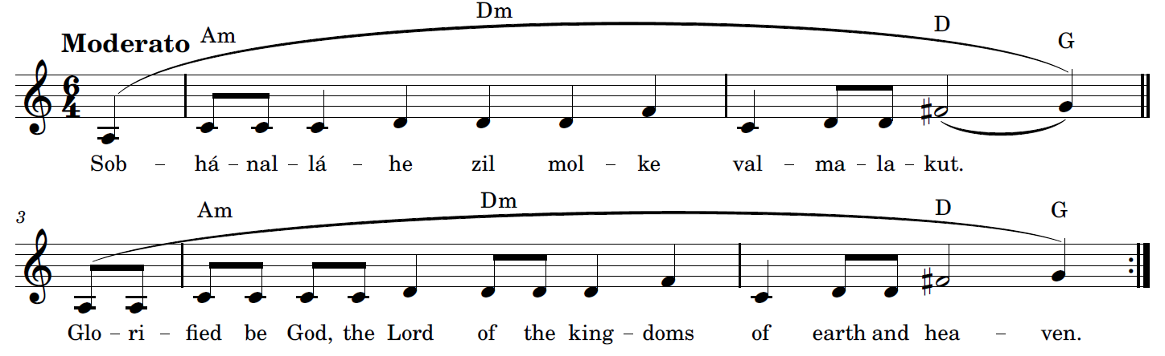 Sob-há-nal- lá-he zil- mol-ke val- ma-la-kut

Verse for Ablution

Let him that findeth no water for ablution repeat five times the words “In the Name of God, the Most Pure, the Most Pure,” and then proceed to his devotions. Such is the command of the Lord of all worlds. (Bahá’u’lláh, The Kitáb-i-Aqdas 1992, 23)
بسم الله الاطهر الاطهر
Bes-mel-lá-hel- at- ha-rel- at-har.

Lawḥ-i-Anta'l-Káfí (The Long Healing Prayer)

The following is a transcription and arrangement of the majority of the “Long Healing Prayer,” based on the recording provided for the refrain in the main section of this work. This arrangement adds material based on the recording for those sections that are not sung in the recording, including the invocation and the 40 verses which contain the 119 names of God, as well as the refrain, though not the part that follows. The 14 verses in the beginning and the 7 verses at the end, as well as the refrain are kept as in the original recording, while material from the verses of the first 14 melodic sequences are used for the parts of the recording that were read. In all there are 6 different melodic patterns that are used for the verses. Transcription demos will be provided for each pattern, in addition to an adaptation of the invocation in measured rhythm. Variations for the last two melodic patterns are also included as well as for the final refrain.
The invocation, using the invocation that the authorized English translation is based on, is set to the melody of the recording, but within the time signature and rhythmic pattern of the verses and refrain. The music is structured loosely according to the Persian modal system, the dastgáh modal system, which begins on a basic or tonic note and is succeeded by melodies on successively higher and higher tonal groupings until finally returning to the tonic.
Recommended reading for an in-depth discussion of The Long Healing Prayer, in its formal aspects as well as historical and metaphysical antecedents and associations and its rhythmic and musical properties suitable for the practice of dhikr, is Daniel Pschaida’s article, “Bahá’u’lláh’s ‘Long Healing Prayer’ (“Lawḥ-i-Anta’l-Káfí”) in Light of a Metaphysics of Unity” (Pschaida 2021)
Transcription demo, online link: https://bahai-library.com/caton_music/sacred_refrains_demos/60_Ant_al-Kafi_Invocation_demo.mp3
Invocation هُوَ الشّافيُ الكافيُ المُعينُ الغَفورُ الرَّحيم
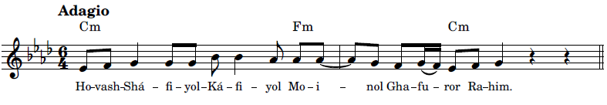

Transcription demo for 1A, online link: https://bahai-library.com/caton_music/sacred_refrains_demos/60_Ant_al-Kafi_Verse_1A_demo.mp3
بِكَ يَا عَلِيُّ بِكَ يَا وَفِيُّ بِكَ يَا بَهِيُّ أنت الكافي وأنت الشافي وأنت الباقي يا باقي 1A
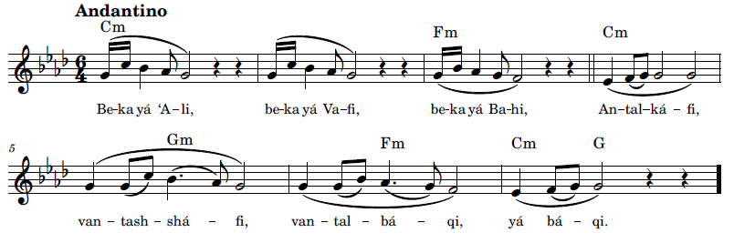
بِكَ يَا سُلْطَانُ بِكَ يَا رَفْعَانُ بِكَ يَا دَيَّانُ أَنْتَ الكَافِي وَأَنْتَ الشَّافِي وَأَنْتَ البَاقِي يَا بَاقِي 2A
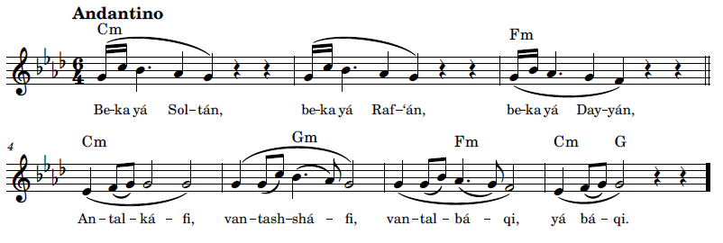

Transcription demo for 3B, online link: https://bahai-library.com/caton_music/sacred_refrains_demos/60_Ant_al-Kafi_Verse_3B_demo.mp3
بِكَ يَا أَحَدُ بِكَ يَا صَمَدُ بِكَ يَا فَرْدُ أَنْتَ الكَافِي وَأَنْتَ الشَّافِي وَأَنْتَ البَاقِي يَا بَاقِي 3B
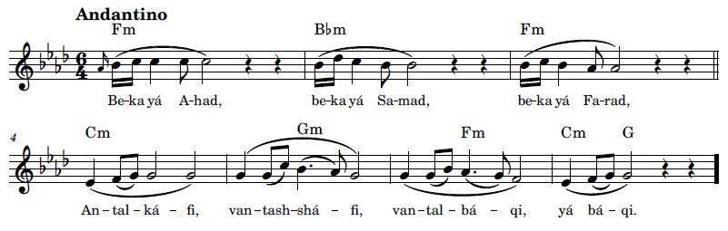
بِكَ يَا سُبْحَانُ بِكَ يَا قُدْسَانُ بِكَ يَا مُسْتَعانُ أَنْتَ الكَافِي وَأَنْتَ الشَّافِي وَأَنْتَ البَاقِي يَا بَاقِي 4B
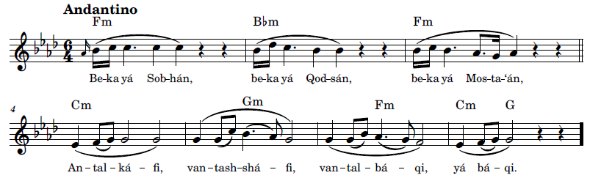
Transcription demo for 5C, online link: https://bahai-library.com/caton_music/sacred_refrains_demos/60_Ant_al-Kafi_Verse_5C_demo.mp3
بِكَ يَا عَلِيْمُ بِكَ يَا حَكِيْمُ بِكَ يَا عَظِيْمُ أَنْتَ الكَافِي وَأَنْتَ الشَّافِي وَأَنْتَ البَاقِي يَا بَاقِي 5C
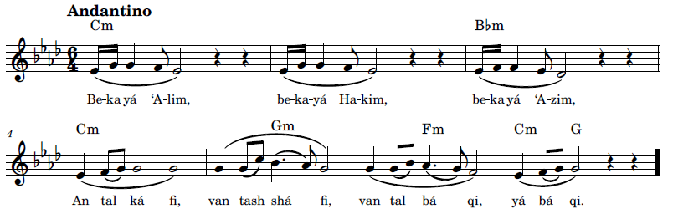
بِكَ يَا رَحْمَنُ بِكَ يَا عَظْمَانُ بِكَ يَا قَدْرَانُ أَنْتَ الكَافِي وَأَنْتَ الشَّافِي وَأَنْتَ البَاقِي يَا بَاقِي 6C
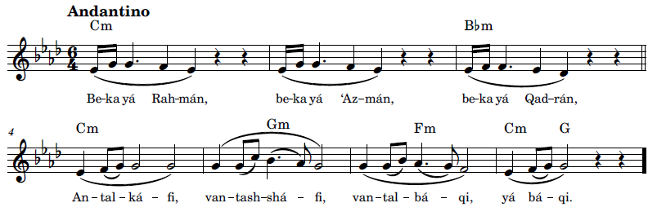
بِكَ يَا مَعْشُوْقُ بِكَ يَا مَحْبُوْبُ بِكَ يَا مَجْذُوْبُ أَنْتَ الكَافِي وَأَنْتَ الشَّافِي وَأَنْتَ البَاقِي يَا بَاقِي 7B
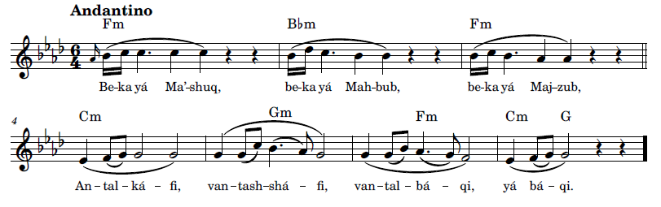
بِكَ يَا عَزِيْزُ بِكَ يَا نَصِيْرُ بِكَ يَا قَدِيْرُ أَنْتَ الكَافِي وَأَنْتَ الشَّافِي وَأَنْتَ البَاقِي يَا بَاقِي 8B
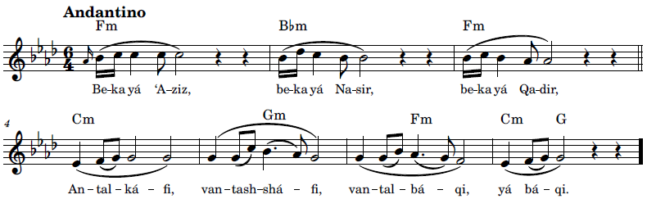

بِكَ يَا حَاكِمُ بِكَ يَا قَائِمُ بِكَ يَا عَالِمُ أَنْتَ الكَافِي وَأَنْتَ الشَّافِي وَأَنْتَ البَاقِي يَا بَاقِي 9C
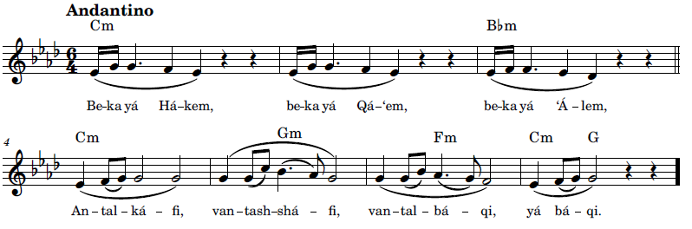
بِكَ يَا رُوْحُ بِكَ يَا نُوْرُ بِكَ يَا ظُهُوْرُ أَنْتَ الكَافِي وَأَنْتَ الشَّافِي وَأَنْتَ البَاقِي يَا بَاقِي 10C
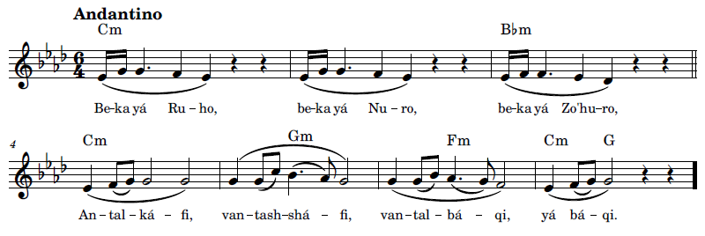
بِكَ يَا مَعْمُوْرُ بِكَ يَا مَشْهُوْرُ بِكَ يَا مَسْتُوْرُ أَنْتَ الكَافِي وَأَنْتَ الشَّافِي وَأَنْتَ البَاقِي يَا بَاقِي 11B
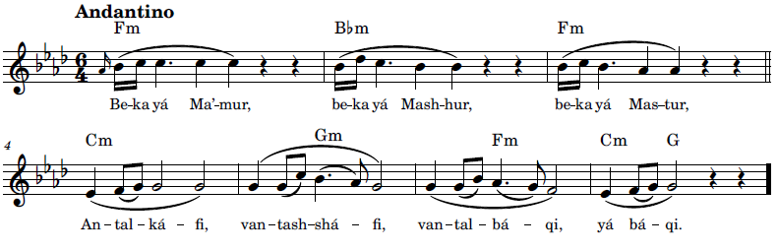

بِكَ يَا غَائِبُ بِكَ يَا غَالِبُ بِكَ يَا وَاهِبُ أَنْتَ الكَافِي وَأَنْتَ الشَّافِي وَأَنْتَ البَاقِي يَا بَاقِي 12B
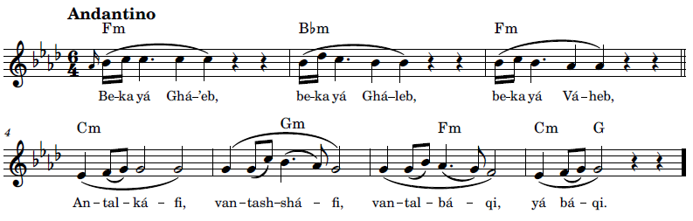
Transcription demo for 13D, online link: https://bahai-library.com/caton_music/sacred_refrains_demos/60_Ant_al-Kafi_Verse_13D_demo.mp3
بِكَ يَا قَادِرُ بِكَ يَا نَاصِرُ بِكَ يَا سَاتِرُ أَنْتَ الكَافِي وَأَنْتَ الشَّافِي وَأَنْتَ البَاقِي يَا بَاقِي 13D
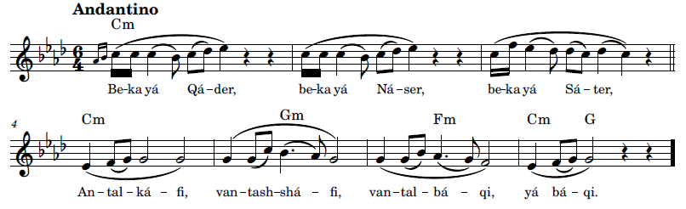
بِكَ يَا صَانِعُ بِكَ يَا قَانِعُ بِكَ يَا قَالِعُ أَنْتَ الكَافِي وَأَنْتَ الشَّافِي وَأَنْتَ البَاقِي يَا بَاقِي 14D
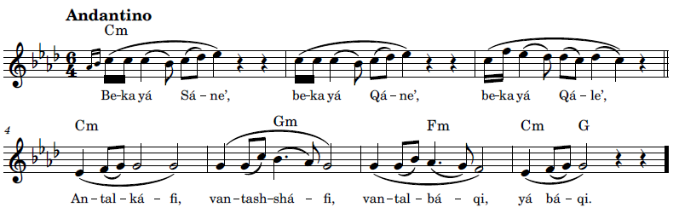

بِكَ يَا طَالِعُ بِكَ يَا جَامِعُ بِكَ يَا رَافِعُ أَنْتَ الكَافِي وَأَنْتَ الشَّافِي وَأَنْتَ اَلْباقي يَا بَاقِي 15B
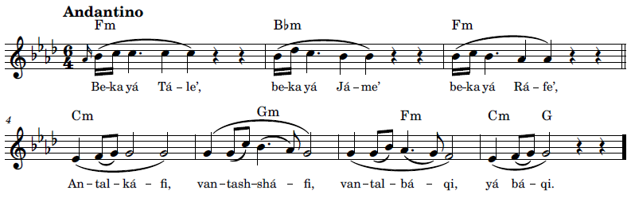
بِكَ يَا بَالِغُ بِكَ يَا فَارِغُ بِكَ يَا سَابِغُ أَنْتَ الكَافِي وَأَنْتَ الشَّافِي وَأَنْتَ البَاقِي يَا بَاقِي 16B
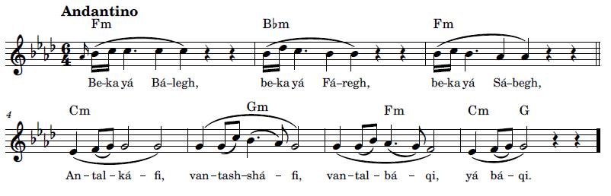

بِكَ يَا نَافِعُ بِكَ يَا مانِعُ بِكَ يَا صانِعُ أَنْتَ الكَافِي وَأَنْتَ الشَّافِي وَأَنْتَ البَاقِي يَا بَاقِي 17C
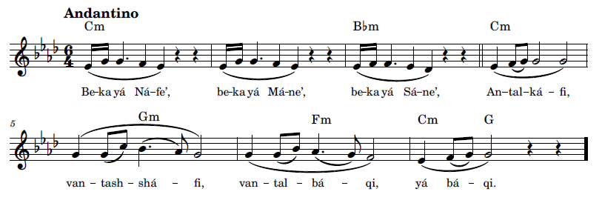
بِكَ يَا جَلِيْلُ بِكَ يَا جَمِيْلُ بِكَ يَا فَضِيْلُ أَنْتَ الكَافِي وَأَنْتَ الشَّافِي وَأَنْتَ البَاقِي يَا بَاقِي 18C
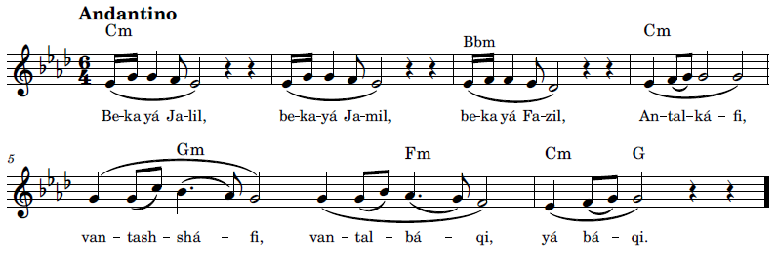

بِكَ يَا عَادِلُ بِكَ يَا فَاضِلُ بِكَ يَا بَاذِلُ أَنْتَ الكَافِي وَأَنْتَ الشَّافِي وَأَنْتَ البَاقِي يَا بَاقِي 19A
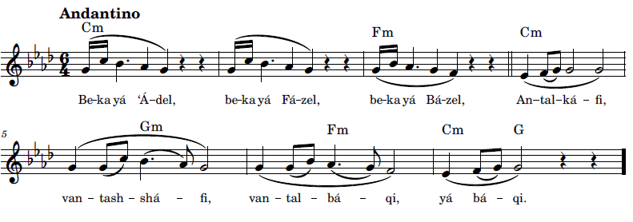
بِكَ يَا قَيُّوْمُ بِكَ يَا دَيْمُوْمُ بِكَ يَا عَلُوْمُ أَنْتَ الكَافِي وَأَنْتَ الشَّافِي وَأَنْتَ البَاقِي يَا بَاقِي 20A
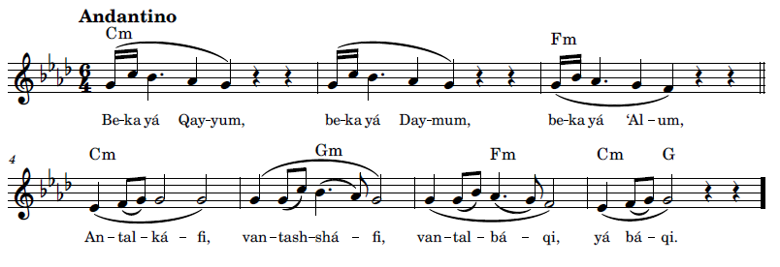
بِكَ يَا عَظُوْمُ بِكَ يَا قَدُوْمُ بِكَ يَا كَرُوْمُ أَنْتَ الكَافِي وَأَنْتَ الشَّافِي وَأَنْتَ البَاقِي يَا بَاقِي 21B
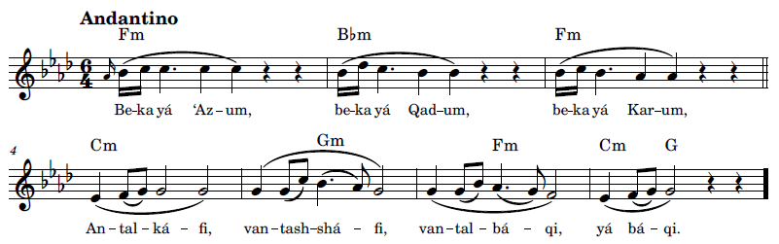

بِكَ يَا مَحْفُوْظُ بِكَ يَا مَحْظُوْظُ بِكَ يَا مَلْحُوْظُ أَنْتَ الكَافِي وَأَنْتَ الشَّافِي وَأَنْتَ البَاقِي يَا بَاقِي 22B
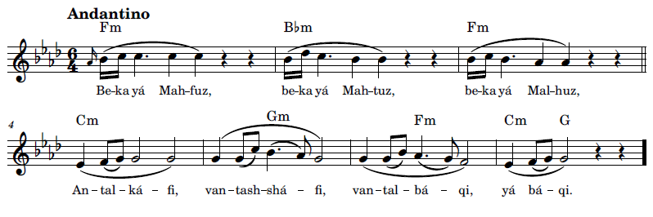
بِكَ يَا عَطُوْفُ بِكَ يَا رَؤُوْفُ بِكَ يَا لَطُوْفُ أَنْتَ الكَافِي وَأَنْتَ الشَّافِي وَأَنْتَ البَاقِي يَا بَاقِي 23C
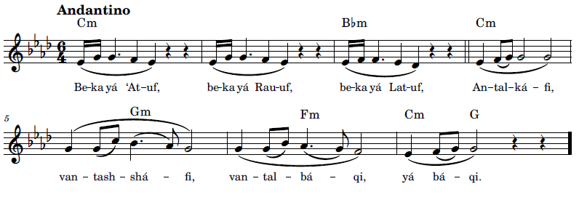
بِكَ يَا مَلَاذُ بِكَ يَا مَعَاذُ بِكَ يَا مُسْتَعَاذُ أَنْتَ الكَافِي وَأَنْتَ الشَّافِي وَأَنْتَ البَاقِي يَا بَاقِي 24C
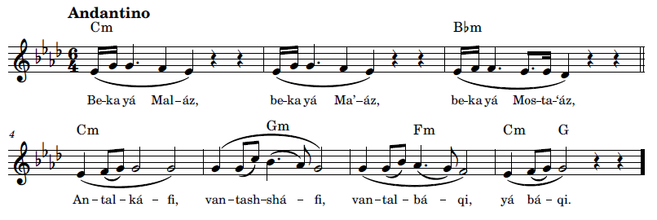

بِكَ يَا غَيَّاثُ بِكَ يَا مُسْتَغَاثُ بِكَ يَا نَفَّاثُ أَنْتَ الكَافِي وَأَنْتَ الشَّافِي وَأَنْتَ البَاقِي يَا بَاقِي 25B
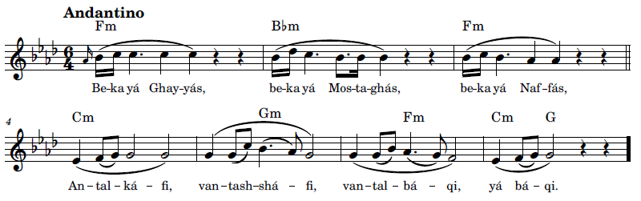
بِكَ يَا كَاشِفُ بِكَ يَا نَاشِفُ بِكَ يَا عَاطِفُ أَنْتَ الكَافِي وَأَنْتَ الشَّافِي وَأَنْتَ البَاقِي يَا بَاقِي 26B
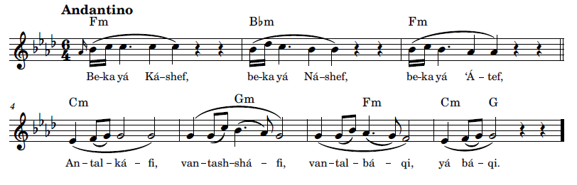
بِكَ يَا جَانُ بِكَ يَا جَانَانُ بِكَ يَا إِيْمَانُ أَنْتَ الكَافِي وَأَنْتَ الشَّافِي وَأَنْتَ البَاقِي يَا بَاقِي 27C
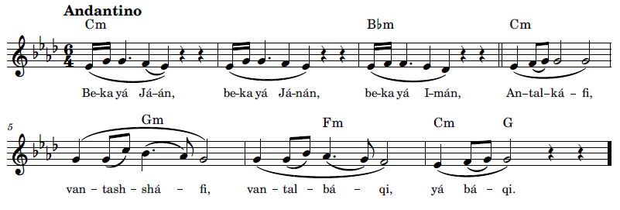

بِكَ يَا سَاقِيْ بِكَ يَا عَالِيْ بِكَ يَا غَالِيْ أَنْتَ الكَافِي وَأَنْتَ الشَّافِي وَأَنْتَ البَاقِي يَا بَاقِي 28C
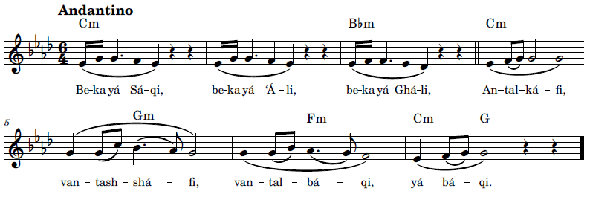
بِكَ يَا ذِكْرَ الأَعْظَمِ بِكَ يَا إِسْمَ الْأَكرَمِ بِكَ يَا رَسْمَ الأَقْدَمِ أَنْتَ الكَافِي وَأَنْتَ الشَّافِي وَأَنْتَ البَاقِي يَا بَاقِي 29B
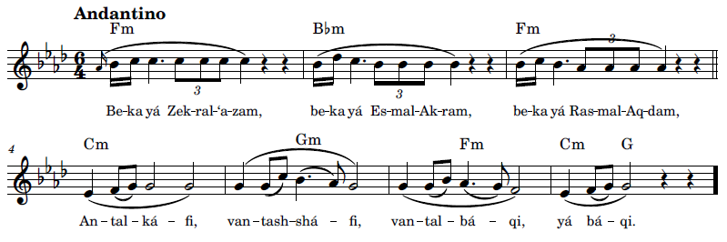

بِكَ يَا سُبُّوْحُ بِكَ يَا قُدُّوْسُ بِكَ يَا نُزُّوْهُ أَنْتَ الكَافِي وَأَنْتَ الشَّافِي وَأَنْتَ البَاقِي يَا بَاقِي 30B
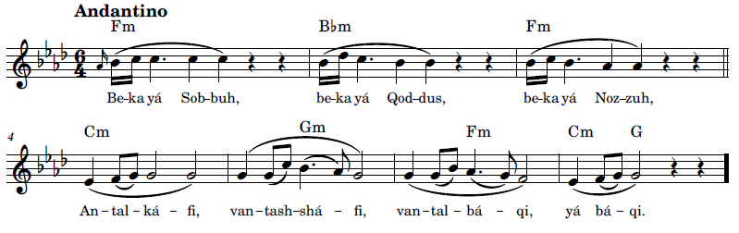
بِكَ يَا فَتَّاحُ بِكَ يَا نَصَّاحُ بِكَ يَا نَجَّاحُ أَنْتَ الكَافِي وَأَنْتَ الشَّافِي وَأَنْتَ البَاقِي يَا بَاقِي 31D
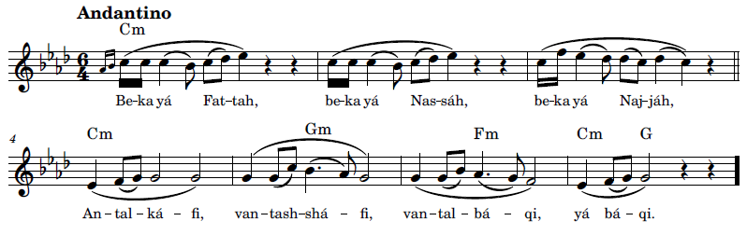
بِكَ يَا حَبِيْبُ بِكَ يَا طَبِيْبُ بِكَ يَا جَذِيْبُ أَنْتَ الكَافِي وَأَنْتَ الشَّافِي وَأَنْتَ البَاقِي يَا بَاقِي 32D
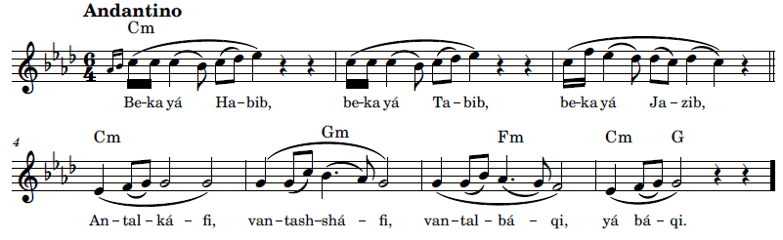

بِكَ يَا جَلَالُ بِكَ يَا جَمَالُ بِكَ يَا فَضَّالُ أَنْتَ الكَافِي وَأَنْتَ الشَّافِي وَأَنْتَ البَاقِي يَا بَاقِي 33B
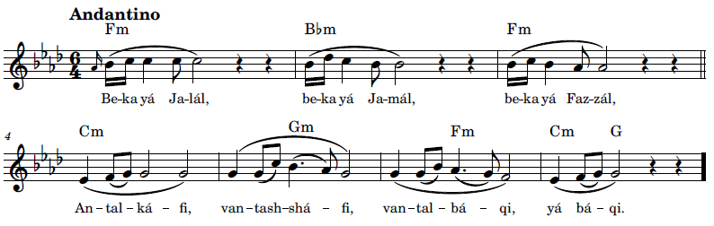
Transcription demo for 34E1, online link: https://bahai-library.com/caton_music/sacred_refrains_demos/60_Ant_al-Kafi_Verse_34E1_demo.mp3
بِكَ يَا وَاثِقُ بِكَ يَا عَاشِقُ بِكَ يَا فَالِقُ أَنْتَ الكَافِي وَأَنْتَ ٱلشّافي وَأَنْتَ البَاقِي يَا بَاقِي 34E1
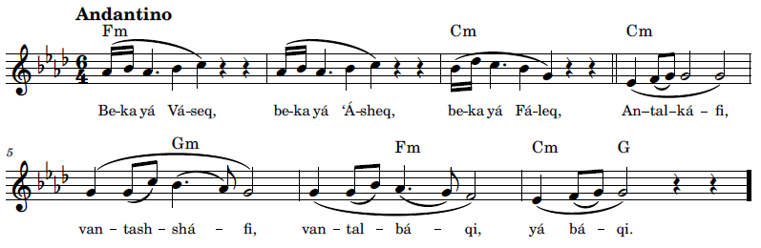
بِكَ يَا وَهَّاجُ بِكَ يَا بَلَّاجُ بِكَ يَا بَهَّاجُ أَنْتَ الكَافِي وَأَنْتَ الشَّافِي وَأَنْتَ البَاقِي يَا بَاقِي 35E1
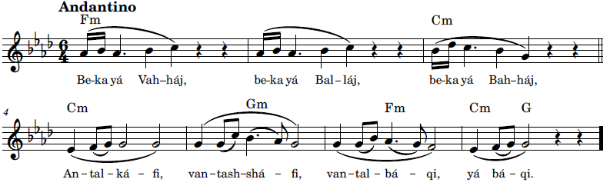
Transcription demo for 36E2, online link: https://bahai-library.com/caton_music/sacred_refrains_demos/60_Ant_al-Kafi_Verse_36E2_demo.mp3
بِكَ يَا وَهَّابُ بِكَ يَا عَطَّافُ بِكَ يَا رَآَّفُ أَنْتَ الكَافِي وَأَنْتَ الشَّافِي وَأَنْتَ البَاقِي يَا بَاقِي 36E2
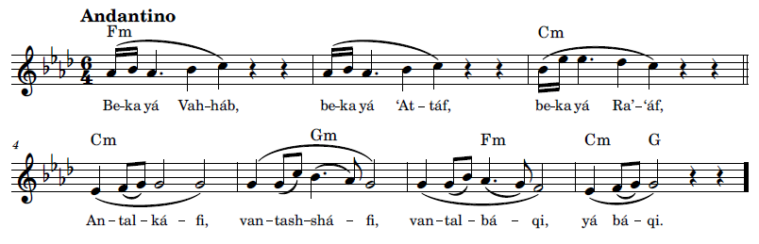
Transcription demo for 37E3, online link: https://bahai-library.com/caton_music/sacred_refrains_demos/60_Ant_al-Kafi_Verse_37E3_demo.mp3
بِكَ يَا ثَابِتُ بِكَ يَا نَابِتُ بِكَ يَا ذاوِتُ أَنْتَ الكَافِي وَأَنْتَ الشَّافِي وَأَنْتَ البَاقِي يَا بَاقِي 37E3
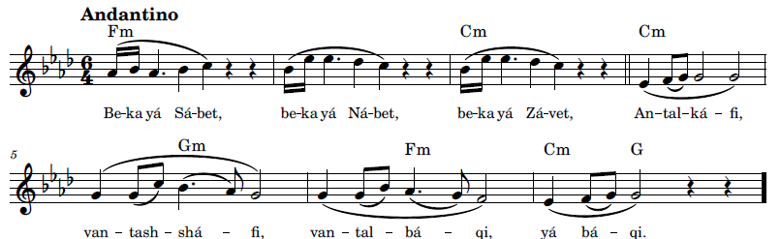

بِكَ يَا نَافذُ بِكَ يَا لاَحِظُ بِكَ يَا لاَفِظُ أَنْتَ الكَافِي وَأَنْتَ الشَّافِي وَأَنْتَ البَاقِي يَا بَاقِي 38E3
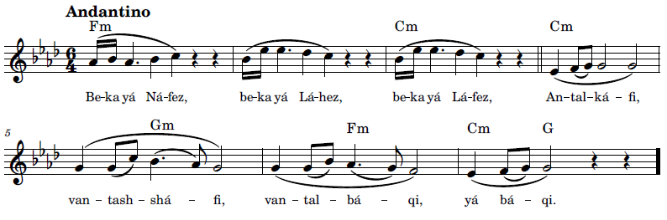
Transcription demo for 39F1, online link: https://bahai-library.com/caton_music/sacred_refrains_demos/60_Ant_al-Kafi_Verse_39F1_demo.mp3
يَا ظَاهِرٌ مَسْتُوْرٌ يَا غَائِبٌ مَشْهُوْرٌ يَا نَاظِرٌ مَنْظُوْرٌ أَنْتَ الكَافِي وَأَنْتَ الشَّافِي وَأَنْتَ البَاقِي يَا بَاقِي 39F1
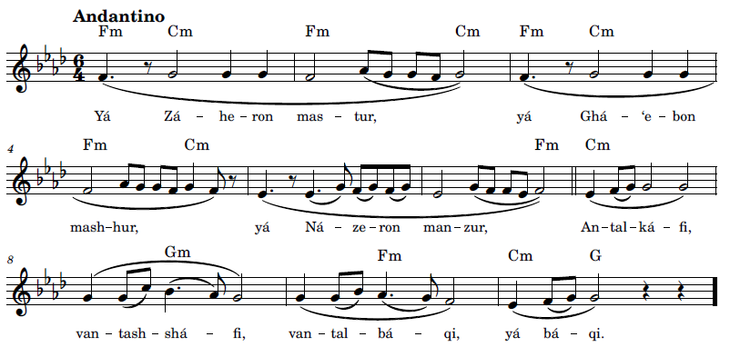

Transcription demo for 40F2, online link: https://bahai-library.com/caton_music/sacred_refrains_demos/60_Ant_al-Kafi_Verse_40F2_demo.mp3
يَا قَاتِلَ عُشَّاقٍ يَا وَاهِبَ فُسَّاقٍ 40F2
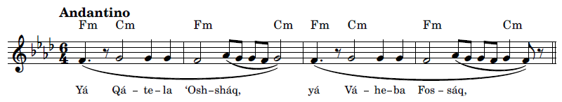
Transcription demo for 40Refrain, online link: https://bahai-library.com/caton_music/sacred_refrains_demos/60_Ant_al-Kafi_Verse_40Refrain_demo.mp3
يَا كَافِي بِكَ يَا كَافِي يَا شَافِي بِكَ يَا شَافِي يَا بَاقِي بِكَ يَا بَاقِي أَنْتَ البَاقِي يَا بَاقِي 40Refrain
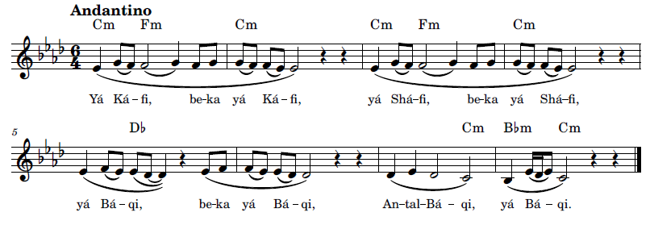

References
abahaiglossary.org. 2020. "Abjad." A Bahá’í Glossary. March 26. Accessed September 4, 2020. http://www.abahaiglossary.org/terms/A/Abjad.html.
'Abdu'l-Bahá. 1976. Bahá’í World Faith—Selected Writings of Bahá’u’lláh and ‘Abdu’l-Bahá (‘Abdu’l-Bahá’s Section Only). Wilmette, Illinois: U.S. Bahá'í Publishing Trust. Accessed February 2, 2021. https://reference.bahai.org/en/t/c/BWF/bwf-81.html.
—. 2021. "Bíst va Shish Munáját az Hadrat-i 'Abdu'l-Bahá." Bahá'í Reference Library. Accessed August 2, 2023. https://www.bahai.org/fa/library/authoritative-texts/abdul-baha/prayers-abdul-baha/.
—. 1992. "Majmuih-yi-Munajatha-Hadrat-i-Abdu’l-Baha." Bahá'í Reference Library. Accessed September 15, 2020. https://reference.bahai.org/fa/t/ab/MMA/mma-4.html#pg1.
—. 1979. "Muntabakhát-i az Makátib-i Hadrat-e 'Abdu'l-Bahá, 1." Bahá'i Reference Library. Bahá'i Publishing Trust, Chicago, Illinois. Accessed July 29, 2023. https://reference.bahai.org/fa/t/ab/SWA1/swa1-1.html.
—. 1993. Nasá'im al-Rahmán. Bahá'ís of Northwest Africa. Accessed June 2, 2021. https://reference.bahai.org/fa/t/c/NR1/nr1-121.html#pg123.
—. n.d. "O Thou kind Lord!" Adib Masumian. Accessed January 25, 2021. https://adibmasumian.com/translations/abdul-baha-prayer-detachment-from-all-but-god/.
—. 1972. Paris Talks. London: Bahá'í Publishing Trust. Accessed February 2, 2021. https://reference.bahai.org/en/t/ab/PT/pt-55.html.utf8?query=Meditation%7Ckey%7Copening&action=highlight#gr14.
—. 1978. Selections from the Writings of 'Abdu'l-Bahá. Haifa: The Universal House of Justice. Accessed July 29, 2023. https://www.bahai.org/library/authoritative-texts/abdul-baha/selections-writings-abdul-baha/1#324741256.
—. 1993. Tablets of the Divine Plan. Wilmette, Illinois: Bahá'í Publishing Trust.
—. 2021. "Twenty-Six Prayers Revealed by 'Abdu'l-Bahá." Bahá'í Reference Library. March. Accessed August 2, 2023. https://www.bahai.org/library/authoritative-texts/abdul-baha/prayers-abdul-baha/.
Aisha. 2006. "Hadith: Glory be to the Holy, Lord of the angels and the Spirit." HadeethEnc.com. Accessed September 7, 2020. https://hadeethenc.com/ar/browse/hadith/6015.
Al-Alâwî, Ali îbn al-Hussein. 2017. "Esma'a al-Hûsnâ Zikr-Dhikr." Ali îbn al-Hussein Al-Alâwî. May 14. Accessed September 4, 2020. https://www.youtube.com/channel/UC8t5kfndKW-eUOP3D_RoObg/videos, https://www.youtube.com/watch?v=R-S01Qcd30I.
Anwaar, Amna. 2017. "Ever wondered why we offer Salah in Arabic only?" IslamicFinder. May 19. Accessed January 8, 2021. https://www.islamicfinder.org/news/ever-wondered-why-we-offer-salah-in-arabic-only/.
Armstrong-Ingram, R. Jackson. 1987. Music, Devotions, and Mashriqu’l-Adhkár. Vol. Studies in Bábí and Bahá'í History: Volume Four. Los Angeles, California: Kalimát Press. Accessed January 19, 2021. https://bahai-library.com/pdf/a/armstrong-ingram_music_devotions_OCR-text.pdf.
at-Tirmidhi, Imam Abu `Isa Muhammad. n.d. "ninety-nine names." Sunnah.com. Accessed September 3, 2020. https://sunnah.com/search?q=ninety-nine+names.
Austin, Diane. n.d. "Music Psychotherapy." Dr. Diane Austin. Accessed August 26, 2020. http://dianeaustin.com/music/.
Australasian Islamic Resource Centre. 2011. 99 Names Of Allah God. Accessed September 6, 2020. https://www.youtube.com/watch?v=ta_tTZrarE0.
Báb, Bahá'u'lláh, 'Abdu'l-Bahá. 2017. "Adhkár-i Bahá'í." Vargha.ir. Accessed September 13, 2020. http://vargha.ir/index3.php?name=%D8%A7%D8%B0%DA%A9%D8%A7%D8%B1+%D8%A8%D9%87%D8%A7%D8%A6%DB%8C.
Bab, Seyyèd Ali Mohammed dit Le. 1913. Le Béyan Persan. Translated by A.L.M. Nicolas. Vol. 3. 4 vols. Paris: Librairie Paul Geuthner.
Báb, The. 1986. Amr va Khalq. Edited by Fadil Mazandarani. Vol. 4. 4 vols. Langenhain.
—. 1976. "INBA vol. 62 (Iranian National Bahá'í Archives) Persian Bayán." Afnan Library. Accessed August 18, 2023. https://afnanlibrary.org/d/inba_v062/?page=326.
—. 1978. "Muntakhibát-i yát az Ásár-e Hazrat-i Nuqtay Allah." Bahá'í Reference Library. Iranian National Bahá'í Publishing . Accessed January 20, 2021. https://reference.bahai.org/fa/t/tb/SWB/swb-5.html#pg1.
—. 1993. "Nasá'im al-Rahmán." Bahá'í Reference Library. Accessed January 23, 2021. https://reference.bahai.org/fa/t/c/NR1/nr1-1.html#pg1.
—. n.d. "O God, praised and holy!" Adib Masumian. Accessed January 26, 2021. https://adibmasumian.com/translations/the-bab-allahumma/.
—. 1976. Selections from the Writings of The Báb. Translated by Habib Taherzadeh. Haifa: The Universal House of Justice. https://www.bahai.org/library/authoritative-texts/the-bab/selections-writings-bab/.
Bahá’u’lláh. 2019. "Commentary on a Verse of Rumi." Windflower Translations. Edited by translator Juan Cole. Alison Marshall. Accessed September 9, 2020. http://www.whoisbahaullah.com/windflower/translations-on-this-site/translations/127-commentary-on-a-verse-of-rumi.
—. n.d. Ishráqát va Chand Lawḥ-i-Dígar. Accessed September 7, 2020. https://reference.bahai.org/fa/t/b/I/i-2.html.
—. 1992. "Kitáb-i Aqdas." Bahá’í Reference Library. Accessed September 8, 2020. https://reference.bahai.org/fa/t/b/KA/ka-31.html#pg1.
—. 1920. Majmu`ih-'i Matbu`ih. Reprinted, H-Bahai: East Lansing, Mi., 2001. Edited by Ed. Muhyi'd-Din Sabri Kurdi Sanandaji Kanimishkani. Cairo. Accessed September 6, 2020. https://www.h-net.org/~bahai/areprint/baha/M-R/M/matbuih/misr.htm; https://reference.bahai.org/fa/t/b/MR/mr-144.html#pg143.
—. n.d. Majmú'ih-i Áthár-i Qalam-i 'Alá. Vol. INBA Vol. 39. Accessed September 7, 2020. http://www.afnanlibrary.org/inba_v039-2/.
—. 1987. Prayers and Meditations by Bahá’u’lláh. Wilmette: US Bahá’í Publishing Trust. https://reference.bahai.org/en/t/b/PM/pm-98.html.
—. 1992. The Kitáb-i-Aqdas: The Most Holy Book. Haifa: The Universal House of Justice. Accessed January 29, 2021. https://reference.bahai.org/en/t/b/KA/ka-1.html.
Bahá'í Reference Library. n.d. "The Transliteration System Used in Bahá'í Literature." Bahai.org. Accessed July 16, 2023. https://www.bahai.org/library/transliteration/1#691938942.
bahaiq. n.d. "About the Bahá’í Calendar." The Bahá'í Calendar. Accessed September 4, 2020. http://calendar.bahaiq.com/about/.
bahaiworldreligion.com. n.d. "Majmú'h-i Munájáthá va Alváh-i Hadrat-i 'Abdu'l-Bahá." bahaiworldreligion.com. Accessed August 11, 2023. https://bahaiworldreligion.com/ .
Bahá'u'lláh. 2018. "Additional Prayers Revealed by Bahá'u'lláh." Bahá'í Reference Library. Accessed September 13, 2020. https://www.bahai.org/library/authoritative-texts/bahaullah/additional-prayers-revealed-bahaullah/199744240/1#715760313.
—. 1920. "Ad'iyyih-yi Hadrat-i-Mahbub." Bahá'í Reference Library. September 28. Accessed January 21, 2021. https://reference.bahai.org/fa/t/b/AHM/ahm-1.html#pg1.
—. 1992. Ad'iyyih-yi Mubarikih. Vol. 1. 3 vols. Rio de Janeiro: Editora Baha'i--Brasil. Accessed January 21, 2022. https://reference.bahai.org/fa/t/b/.
—. n.d. "Ayyam-i-Tisih: Lawh-i-Náqús." Bahá'í Reference Library. Accessed January 19, 2021. https://reference.bahai.org/fa/t/c/AT/at-100.html.
—. 2017. "Days of Remembrance: Selections from the Writings of Bahá'u'lláh for Bahá'í Holy Days." Bahá'í'i Reference Library. Bahá'í World Centre. January 1. Accessed June 16, 2023. https://www.bahai.org/library/authoritative-texts/bahaullah/days-remembrance/4#211521601.
—. 1988. "Epistle to the Son of the Wolf." Bahá'í Reference Library. Accessed September 14, 2020. https://reference.bahai.org/en/t/b/ESW/index.html.
—. 1988. "Epistle to the Son of the Wolf." Bahá'í Reference Library. Accessed September 14, 2020. https://reference.bahai.org/en/t/b/ESW/index.html.
—. n.d. "Eqtidárát va Chand Lawh-i Digar." Bahá'í Reference Library. Accessed September 11, 2020. https://reference.bahai.org/fa/t/b/IQT/iqt-253.html#pg253.
—. 1990. Gleanings from the Writings of Bahá'u'lláh. Translated by Shoghi Effendi. US Bahá'í Publishing Trust. https://reference.bahai.org/en/t/b/GWB/gwb-136.html#pg295.
—. n.d. "Haft Vádí." Bahá'í Reference Library. https://reference.bahai.org/fa/t/b/SV/sv-1.html#pg1.
—. n.d. "I beseech Thee, O Lord my God." Adib Masumian. Accessed January 23, 2022. https://adibmasumian.com/translations/protect-bearer-snow-white-scroll/.
—. n.d. "Ishráqát va Chand lawh-i Dígar." Bahá'í Reference Library. Accessed August 13, 2023. https://reference.bahai.org/fa/t/b/I/i-1.html#pg1.
—. n.d. "Kalimát-i Maknunih-i Fársí." Kitábkhánih-i Maráj'i va ásár-e Bahá'í. Accessed July 26 , 2023. https://reference.bahai.org/fa/t/b/PHW/phw-3.html.
—. 1990. "La'alyiu'l-Hikmat, v. 2." Bahá'í Reference ibrary. Accessed January 23, 2021.
—. 2001. "Lawh-i-ibn-i Dhib." Bahá'í Reference Library. Bahá' Publishing Trust, Canada. Accessed September 15, 2020. www.bahai.org/r/414633630.
—. n.d. "Lawh-i-Laylatu'l-Quds." oceanoflights.org. Accessed September 10, 2020. https://oceanoflights.org/bahaullah-st-001-1-ar/.
—. n.d. "Lawh-i-Salmán_1 – Gleanings From The Writings of Bahá’u’lláh." OceanofLights.org. Accessed February 18, 2023. https://oceanoflights.org/bahaullah-st-076-fa/.
—. 1920 Cairo. "Majmú' iy-i-Alváh-Mubárakiy-i-hazrat-i-Bahá'u'lláh." Bahá'í Reference Library. Accessed September 11, 2020. https://reference.bahai.org/fa/t/b/MR/mr-276.html#pg275.
—. 1966. Majmú'ih-i Munáját-i Áthár-i Qalam-i 'Alá. Vol. 1. 2 vols. Accessed June 16, 2021. https://reference.bahai.org/fa/t/b/MMQ1/mmq1-1.html.
—. n.d. "Majmuih-yi Adhkár va Idiyyih min Áthár-i Hadrat-i Bahá'u'lláh." Bahá'í Reference Library. Accessed January 21, 2021. https://reference.bahai.org/fa/t/b/PM/pm-1.html.
—. n.d. "Majmuih-yi-Alvah ba’d az Kitáb-i-Aqdas: Bishárát." Bahá'í Reference Library. Accessed January 20, 2021. https://reference.bahai.org/fa/t/b/TB/tb-3.html.
—. n.d. "Muntabikhat-i az Ásár-i Haḍrat-i Bahá'u'lláh." Bahá'í Reference Library. Accessed July 5, 2021. https://reference.bahai.org/fa/t/b/GWB/gwb-136.html.
—. n.d. "My God, my Provider." Adib Masumian. Accessed January 27, 2021. My God, my Provider.
—. n.d. "My God, the Most Generous, the Most Compassionate." Adib Masumian. Accessed August 2, 2023. https://adibmasumian.com/translations/bahaullah-prayer-ahm-362-363/.
—. 1993. "Nasá'imu'r-Rahmán." Bahá'í Reference Library. azár. Accessed January 15, 2021. https://reference.bahai.org/ar/t/c/NR1/nr1-1.html#pg1.
—. n.d. "O Thou Who art the All-Merciful." Adib Masumian. Accessed January 27, 2021. https://adibmasumian.com/translations/bahaullah-prayer-ahm-348-350/.
—. 1996. "Prayer for Protection." Baha'i Library Online. August 12. Accessed September 11, 2020. https://bahai-library.com/bahaullah_prayer_protection.
—. 1987. "Prayers and Meditations by Bahá'u'lláh." Bahá'í Reference Library. Accessed September 13, 2020. https://reference.bahai.org/en/t/b/PM/index.html.
—. 1982. "Resáleh-i Tasbih va Tahlíl." Bahá'í Reference Library. Accessed March 10, 2022. https://reference.bahai.org/fa/t/b/RTT/rtt-206.html#pg207.
Bahá'ulláh. n.d. "Resálih-i Ayyám-i Tis'ih." Bahá'í Reference Library. Accessed June 16, 2023. https://reference.bahai.org/fa/t/c/AT/at-315.html.
Bahá'u'lláh. 2017. "Supplications by Bahá'u'lláh." Bahá'í Writings in Provisional Translation: A Collection by Joshua Hall. October 19. Accessed January 22, 2022. https://joshuahalltranslations.com/supplications-by-bahaullah/.
—. 2002. "Surat al-'Abád." oceanoflights.org. Accessed January 29, 2021. https://oceanoflights.org/bahaullah-st-124-ar/.
—. n.d. "Tablet of the Bell." Bahá'í Reference Library. Accessed January 19, 2021. https://www.bahai.org/library/authoritative-texts/search#q=days%20of%20remembrance.
Bahá'u'lláh. 1982. "Tablet of the Sacred Night." In Risalih-'i Tasbih va Tahlil, edited by Ishraq-Khavari, translated by Juan Cole, 174-181. New Dehli: New Delhi Publishing Trust. http://bahai-library.com/bahaullah_layla_quds_cole.
—. 1978. Tablets of Bahá'u'lláh revealed after the Kitáb-i-Aqdas. Haifa: The Universal House of Justic. https://www.bahai.org/library/authoritative-texts/bahaullah/tablets-bahaullah/1#030537471.
—. 2018. The Call of the Divine Beloved. Haifa: Bahá'í Woirld Centre.
—. n.d. "The Hidden Words, Part Two, From the Persian." https://www.bahai.org/. Accessed July 26, 2023. https://www.bahai.org/library/authoritative-texts/bahaullah/hidden-words/3#305986377.
—. n.d. "The Seven Valleys." Bahá'í Reference Library. Accessed August 1, 2023. https://www.bahai.org/library/authoritative-texts/bahaullah/call-divine-beloved/4#893325872.
Bahá'u'lláh, The Báb, and 'Abdu'l-Bahá. 1991. Bahá'í Prayers: A Selection of Prayers Revealed by Bahá'u'lláh, The Báb, and 'Abdu'l-Bahá. Wilmette, Illinois: Bahá'í Publishing Trust. Accessed February 5, 2021. https://www.bahai.org/library/authoritative-texts/prayers/bahai-prayers/.
Balyuzi, H.M. 1980. Bahá'u'lláh: The King of Glory. Oxford: George Ronald.
Blomfield, Lady Sara Louise. 1940. The Chosen Highway. Wilmette: Bahá'í Publishing Trust. Accessed January 24, 2021. https://bahai-library.com/blomfield_chosen_highway&chapter=2.
Böwering, Gerhard. 2011. "Dekr: i. In Sufism." Encyclopaedia Iranica Vol. VII (Fasc. 3): 229-233. https://iranicaonline.org/articles/dekr.
Browne, The Báb and E.G. 1987. "A Summary of the Persian Bayan." In Selection from the Writings of E. G. Browne on the Babi and Baha'i Religions, by Moojan Momen, 316-406. Oxford: George Ronald. Accessed September 8, 2020. https://bahai-library.com/browne_momen_persian_bayan.
Caton, Margaret. 2021. A Persian Ode: Musical Life in Safavid and Qajar Iran. Los Angeles, California.
Community Development Committee. 1964. "U.S. Supplement Bahá' News No. 80." bahai.media. October. Accessed February 6, 2021. https://file.bahai.media/9/99/US_Supplement_80.pdf.
Damas Cultural Society. n.d. "Dhikr--The 99 Names of Allah--Al-Asma Al-Husna." Damas Cultural Society. Accessed September 4, 2020. https://damas.nur.nu/5920/tasawwuf/dhikr/99-names-of-allah-video.
Devananda, Swami Vishnu. 1981. Meditation and Mantras. New York: OM Lotus Publishing Company.
Effendi, Shoghi. 1979. God Passes By. U.S. Bahá’í Publishing Trust. Accessed September 8, 2020. https://reference.bahai.org/en/t/se/GPB/.
—. 1936. "Letters from the Guardian to Australia and New Zealand." Bahá'í Reference Library. September 23. Accessed September 12, 2020. https://reference.bahai.org/en/t/se/LANZ/lanz-13.html.
—. 1992. Qarn-i Badí'. Translated by Nosratollah Moddat. Ontario: Baha'i Institute of Persian Language Education. Accessed October 18, 2021. https://reference.bahai.org/fa/t/se/GPB/gpb-265.html.
—. 1992. "Tawqi'át-i Mubárakih--Khatáb bih Ahibá-yi Sharq." Bahá' Reference Library. Accessed January 23, 2021. https://reference.bahai.org/fa/t/se/TM/tm-4.html#pg1.
Faizi, A.Q. 1968. "Explanation of the Symbol of the Greatest Name." Bahá'í Library Online. Accessed September 12, 2020. https://bahai-library.com/faizi_symbol_greatest_name.
Faizi, Abu'l Qasim. 1968. "Explanation of the Symbol of the Greatest Name." Bahá’í Library Online. Accessed September 4, 2020. https://bahai-library.com/faizi_symbol_greatest_name.
Francisco. 2017. "Difference Between Amulets and Talismans." differencebetween.net. September 27. Accessed January 25, 2022. http://www.differencebetween.net/miscellaneous/religion-miscellaneous/difference-between-amulets-and-talismans/#:~:text=Amulets%20and%20talismans%20are%20magic,or%20to%20ward%20off%20evil.&text=Amulets%20are%20worn%20by%20people,to%20the%20person%20wearin.
Gail, Marzieh. 1991. "Arches of the Years." Baha'i Library Online. Accessed September 8, 2020. https://bahai-library.com/gail_arches_years.
Geels, Anton. 1993. "A Note on the Psychology of Dhikr: The Halveti-Jerrahi Order of Dervishes in Istanbul." Scripta Instituti Donneriani Aboensis. Accessed January 11, 2021. https://journal.fi/scripta/article/view/67206.
Gonzalez, Celen Ibrahim-Lizzio and Teresa Soto. 2017. "Al-Asma al-Husna (Allah's Most Beautiful Names)." Islam: A Worldwide Encyclopedia 98-101. file:///C:/Users/peggy/Downloads/Al_Asma_al_Husna_Allahs_Most_Beautiful.pdf.
gyenyame. 2007. "The Sufficing, The Healing." on the Digital Album: The Mystery. Comp. The Long Healing prayer by Bahá’u’lláh. Video of a live performance 01.04.07 at ULU Live. Accessed September 5, 2020. https://www.youtube.com/watch?v=LJdl98Ih5hk.
Hall, Joshua. 2017. "The Suffering of the Exalted Letters." Bahá'í Writings in Provisional Translation: A Collection by Joshua Hall. March 21. Accessed January 28, 2022. https://joshuahalltranslations.com/the-suffering-of-the-most-exalted-letters/.
Hamadani, Husayn. 1893. "The New History (tarikh-i-jadid) of mirza Ali-Muhammed the Bab." Baha'i Library Online. Edited by translator E. G. Browne. Accessed August 25, 2020. https://bahai-library.com/hamadani_browne_tarikh_jadid.
Herbert, Ruth. 2011. "Reconsidering Music and Trance: Cross-cultural Differences and Cross-disciplinary Perspectives." Ethnomusicology Forum.
Hornby, Helen Bassett. 1999. Lights of Guidance: A Bahá'í Reference File. New Delhi: Bahá'í Publishing Trust.
Hulusi, Ahmed. 2014. "Al-Asma Ul-Husna." ahmedhulusi.org: Discover Your Essential Reality. June 20. Accessed September 2, 2020. https://www.ahmedhulusi.org/en/book/the-power-of-prayer/the-exalted-magnificent-and-perfect-qualities-of-the-names-of-allah-al-asma-ul-husna.
Ioannesyan, Youli A., and Christopher Buck. 2010. "Baha’u’llah’s Bisha¯ra¯t (Glad-Tidings): A Proclamation to Scholars and Statesmen." Bahá'í Library Online. Accessed January 20, 2021. https://bahai-library.com/buck_ioannesyan_bisharat_proclamation.
Lambden, Stephen. 2015. "Tafsīr al-ḥurūfāt al-muqaṭṭa`āt (Commentary on the Isolated Letters) of Baha'-Allah)." https://hurqalya.ucmerced.edu/. May 17. Accessed September 12, 2020. https://hurqalya.ucmerced.edu/node/451/.
—. n.d. "The Surat al-`Ibad of Mirza Husayn `ali Nuri, Baha'-Allah." https://hurqalya.ucmerced.edu/. Accessed January 29, 2021. https://hurqalya.ucmerced.edu/node/484/.
—. 2003. "The Tablet of the Bell (Law˙-i-Náqús) of Bahá’u’lláh or The Tablet of “Praised Be Thou, O ‘He’!” (Law˙-i-Subhánaka yá Hu[wa])." Bahá'í Library Online. Accessed January 19, 2021. https://bahai-library.com/lambden_naqus.
Lee, Hayden. 2020. "Fashioning the Word-Tool: The Instrumental Character of the Word in Yogic Mantra Meditation and Phenomenology." Philosophy East and West, Project MUSE, 10.1353/pew.0.0196, June 11. Accessed February 8, 2021. https://muse.jhu.edu/article/758204.
MacEoin, Denis. 1994. Rituals in Babism and Bahaism. London: British Academic press.
Masumian, Adib, and Violetta Zein. 2020. "The Languages of Revelation of the Baháa'í Writings." Bahá'í Library Online. Accessed July 20, 2022. https://bahai-library.com/pdf/m/masumian_languages_bahai_writings.pdf.
Masumian, Farnaz. 2013. The Divine Art of Meditation. Oxford: George Ronald.
Merriam-Webster. 2020. "Litany." Merriam-Webster.com Dictionary. September 1. Accessed September 4, 2020. https://www.merriam-webster.com/dictionary/litany.
Mischler, Ælfwine. n.d. "Tarawih Prayer." IslamOnline. Accessed May 8, 2023. https://islamonline.net/en/tarawih-prayer-2/.
Momen, Moojan. 1991. "Transliteration." Bahá'í Library Online. Accessed January 11, 2021. https://bahai-library.com/momen_transliteration.
Muhammad, Prophet. 2016. Qur'an. Translated by M.A.S. Abdel Haleem. Oxford: Oxford University Press.
Muhammed. n.d. "Al-Mulk." quran.ksu. Accessed January 20, 2021. http://quran.ksu.edu.sa/translations/english/562.html.
—. n.d. "Surah 14. Ibrahim, Ayah 12." alim.org. Accessed January 29, 2021. https://www.alim.org/quran/compare/surah/14/12/.
Nabil. 1991. "Tárikh-i Nabil." Baha'i Reference Library. Accessed January 23, 2021. https://reference.bahai.org/fa/t/nz/DB/db-33.html#pg1.
—. 1932. "The Dawn-Breakers: Nabíl’s Narrative of the Early Days of the Bahá’í Revelation." Bahá'í Reference Library. Accessed January 11, 2021. https://reference.bahai.org/en/t/nz/DB/index.html.
Naranjo, Claudio, and Robert E. Ornstein. 1971. On the Psychology of Meditation. New York: The Viking Press. Accessed February 7, 2021. https://archive.org/details/onpsychologyofme00nara/mode/2up.
Newhall, Muriel Ives Barrow. 1998. "Mother's Stories: Recollections of Abdu'l-Baha." Bahá’í Library Online. Accessed September 8, 2020. http://bahai-library.com/ives_mothers_stories_abdulbaha.
Périgord, Emily McBride. 1939. Translation of French Foot-notes of the Dawn-Breakers. Translated by Emily McBride Périgord. Wilmette, Illinois: Bahá'í Publishing Trust. Accessed January 31, 2021. https://bahai-library.com/dawnbreakers_french_footnotes_english.
Phelps, Steven. 2020. "A Partial Inventory of the Central Figures of the Bahá'í Faith." loomofreality.org. November 3. Accessed January 19, 2022. http://blog.loomofreality.org/wp-content/uploads/2020/12/Partial-Inventory-2.02.pdf.
Pschaida, Daniel Azim. 2021. "Bahá’u’lláh’s “Long Healing Prayer” (“Lawḥ-i-Anta’l-Káfí”) in Light of a Metaphysics of Unity." Journal of Bahá'í Studies (Ottawa Association for Bahá'í Studies North America) 31 (3): 93-130. Accessed March 27, 2022. https://journal.bahaistudies.ca/online/article/view/302/427.
—. 2019. "Bahá’u’lláh's Long Healing Prayer: Parallel Translation and Notes on Iterations / Recensions." Baha'i Library Online. Accessed September 5, 2020. https://bahai-library.com/pschaida_healing_prayer_notes.
—. 2022. "Bahá'u'lláh's 'Long Healing Prayer' ("Lawḥ-i-Anta'l-Káfí") in Light of a Metaphysics of Unity." Bahá'í Library Online. March. Accessed August 16, 2022. https://bahai-library.com/pschaida_healing_prayer_metaphysics.
Qara'at, Muhsin. n.d. "Dhikr at-Tasbih." Al-Islam.org. Accessed May 8, 2023. https://www.al-islam.org/commentary-prayer-muhsin-qaraati/dhikr-tasbih.
quran.com. n.d. "Va Kafá Billáh-i Hasíbá." quran.com. Accessed January 24, 2021. https://quran.com/search?query=%D9%83%D9%8E%D9%81%DB%8C+%D8%A8%D9%90%D8%A7%D9%84%D9%84%D9%87+%D8%AD%D9%8E%D8%B3%D9%8A%D8%A8%D8%A7%D9%8B.
—. n.d. "Zawl Fazl-i 'zim." quran.com. Accessed January 25, 2021. https://quran.com/search?query=%D8%B0%D9%8F%D9%88+%D8%A7%D9%84%D9%81%D9%8E%D8%B6%D9%84+%D9%90+%D8%A7%D9%84%D8%B9%D9%8E%D8%B8%D9%8A%D9%85.
quranreading.com. n.d. "8 Benefits of Dhikr - Remembrance of Allah." Quran Reading. Accessed January 9, 2021. http://www.quranreading.com/blog/8-benefits-of-dhikr-remembrance-of-allah/.
ramadhan.org.uk. 2021. "Tarawih." Ramadhan: Keep Calm&Read Quran. Accessed February 11, 2022. https://www.ramadhan.org.uk/tarawih/.
Research Department. 2019. Prayer and Devotional. A Compilation of Extracts from the Writings of Bahá’u’lláh, the Báb, and ‘Abdu’l-Bahá, Haifa: Universal House of Justice.
Research Department. 2017. The Institution of the Mashriqu’l-Adhkár. Universal House of Justice, Haifa: Bahá'í Reference Library. Accessed January 10, 2022. https://www.bahai.org/library/authoritative-texts/compilations/institution-mashriqul-adhkar/institution-mashriqul-adhkar.pdf?771961d0.
Rouget, Gilbert. 1985. Music and Trance: A Theory of the Relations between Music and Possession. Chicago: University of Chicago Press.
Saiedi, Nader. 2008. Gate of the Heart: Understanding the Writings of the Báb. Waterloo, Ontario: Association for Bahá’í Studies and Wilfrid Laurier University Press. Accessed September 4, 2020. http://chupin.ru/library/NaderSaiedi/Gate_of_the_Heart.pdf.
Scholl, Steven. 1983. "The Remembrance of God: An Invocation Technique in Sufism and the Writings of The Báb and Bahá'u'lláh." Bahá'í Studies Bulletin 2 (3): 73-106. Accessed August 25, 2020. https://bahai-library.com/scholl_dhikr_remembrance_god.
Scribd. n.d. "Tasbíh of Taráwíh." slideshre.net. Accessed May 8, 2023. https://www.slideshare.net/kingabid/tasbih-tarawih-pdf.
sevapp. 2020. "Asmaul Husna: 99 Names of Allah - Dhikr & Quiz." Google Play. March 27. Accessed September 6, 2020. https://play.google.com/store/apps/details?id=com.sevapp.asmaul_husna_99_names_of_allah_dhikr&hl=en_US.
Seyedeh Sara Seyedahmady Zavieh, Mohammad-Reza Darvishi, and Azadeh Mehrpouyan. 2016. "Tanbur as Stringed Music Instrument: Role, Qualities, Influences on Yarsanism." IJASOS- International E-Journal of Advances in Social Sciences. April. Accessed January 11, 2021. http://ijasos.ocerintjournals.org/tr/download/article-file/232081.
Sheriff, Ahmed H. n.d. "Why Pray in Arabic?" Al-Islam.org. Accessed January 8, 2021. https://www.al-islam.org/articles/why-pray-arabic-ahmed-h-sheriff.
Sonneborn, Daniel Atesh. 1995. Music and Meaning in American Sufism: The Ritual of Dhikr at Sami Mahal, a Chistiyya-derived Sufi Center. Los Angeles: University of California.
Taherzadeh, Adib. 2005. "Tablet to Salman I." The Covenant Library. December. Accessed September 7, 2020. https://d9263461.github.io/cl/Baha'i/Others/ROB/V2/p283-290Ch13.html?back=%3C.
—. 1977. The Revelation of Bahá'u'lláh, Volume II: Adrianople, 1863-1868. Vol. 2. 4 vols. Oxford: George Ronald. Accessed January 23, 2022. https://d9263461.github.io/cl/Baha%27i/Others/ROB/V2/Cover.html.
—. 1984. The Revelation of Bahá'u'lláh: 'Akká, The Early Years, 1868-77. Vol. 3. 4 vols. Oxford: George Ronald, Publisher. Accessed January 3, 2022. https://d9263461.github.io/cl/Baha'i/Others/ROB/V3/p221-252Ch11.html#p231.
The Contemplative Life. n.d. "Dhikr." The Contemplative Life. Accessed September 1, 2020. https://www.thecontemplativelife.org/dhikr.
McGlinn, Sen, ed. 1999. "The Leiden list of the works of Baha'u'llah." Bahá'í Library Online. Accessed January 24, 2022. http://web.archive.org/web/20070930181707/http:/bahai-library.com/resources/leiden.list/leiden.list.html#513.
The Universal House of Justice. 2001. ""Yá Alláhu'l-Mustagháth":." Bahá’í Library Online. December 28. Accessed September 8, 2020. https://bahai-library.com/uhj_source_transliteration_mustaghath.
—. 1992. "7 June 1992 – To the Bahá’ís of the World." June 7. Accessed September 14, 2020. https://www.bahai.org/library/authoritative-texts/the-universal-house-of-justice/messages/19920607_001/1#089609017.
The Universal House of Justice. 1996. Bahá'í Writings on Music:. compilation, Oakham, England: Bahá'í Publishing Trust.
—. 1996. "Lawh-i-Laylatu'l-Quds." Bahá'í Library Online. August 20. Accessed September 10, 2020. https://bahai-library.com/resources/tablets-notes/lawh-laylat-quds/notes.html.
Thompson, Juliet. 1983. The Diary of Juliet Thompson. Los Angeles, California: Kalimat Press.
Tosun, Necdet. 2016. "Zekri Erre." Zikir. April 26. Accessed January 10, 2021. http://zikrierre.blogspot.com/2016/04/zikri-erre.html.
Waldridge, John. 1996. "The Exalted Letters (Hurúfát-i-'Álín): Overview." bahai-library.com. Accessed January 28, 2022. https://bahai-library.com/walbridge_hurufat_alin_overview.
Wikipedia. 2020. "Nasheed." Wikipedia. August 9. Accessed September 4, 2020. https://en.wikipedia.org/wiki/Nasheed.
—. 2021. "Tasbih." Wikipedia. January 2. Accessed January 11, 2021. https://en.wikipedia.org/wiki/Tasbih.
Yazdani, Gloria. 2007. "Bahá’u’lláh’s Four Tablets to Maryam." bahai-library.com. Online Journal of Bahá‟í Studies, Volume 1. Accessed January 28, 2022. https://bahai-library.com/shahzadeh_four_tablets_maryam.
Zarandi, Nabil. 1888. "Matáli' Al-Anvar." Bahá'í Reference Library. Accessed January 31, 2021. https://reference.bahai.org/ar/t/nz/DB/db-56.html#pg1.
Zarqání, Mírzá Maḥmúd-i. 1998. Maḥmúd's Diary. Translated by Mohi Sobhani with the assistance of Shirley Macias. Oxford: George Ronald.

Playlist of Dhikr Recordings

This list of dhikr recordings runs in order of number, title, name of recording, author of text, source of text.
- Names and Attributes of God
- Alláh’u’Abhá, (The Báb, Persian Bayán, Bahá’u’lláh, Kitáb-i-Aqdas)
  - Ay_Yad-I-Toh.mp3
  - Ya Baha'ul'Abha Allah-u'Abha.mp3
- Alláh’u Rabbuná, Alaho-rabona.mp3, (The Báb, Muntakhibát-i yát az Ásár-e Hazrat-e Nuqtay Allah ; Bahá’u’lláh, Nasá'imu'r-Rahmán)
- Ant al-Káfí, دعای انت الکافی.mp3 (Bahá’u’lláh, Lawh-i-Anta'l-Káfí in Ad'iyyih-yi Hadrat-i-Mahbub)
- Qad Atá’l-Málik, 08 قد اتی المالک.mp3 (Bahá’u’lláh, Kitáb-i-Aqdas)
- Qul Alláh’u’Ẓáhir, 09قل الله ظاهر.mp3 (Bahá’u’lláh, Lawh-i Salmán in Majmu`ih-'i Matbu`ih)
- Subbúhun Quddús (Muhammad, Islamic hadith)
  - 07 سبوح قدوس.mp3
  - سبوح قدوس.mp3
- Ta’álá Man Aẓhar, 05 تعالی من اظهر.mp3, (Bahá’u’lláh, Majmú'ih-i Áthár-i Qalam-i 'Alá)
- Yá Alláhu’l-Mustagháth, 17 یا الله المستغاث.mp3, (The Báb, in Amr va Khalq, v. 4)
- Yá Bahá’u’l-Abhá and Yá Bahá’u’lláh Yá ‘Ali’u’l-Alláh (Bahá’u’lláh, Kitáb-i-Aqdas; ‘Abdu’l-Bahá, Tablets of the Divine Plan and Selections from the Writings of ‘Abdu’l-Bahá), Yá ‘Ali’u’l-AlláhYABAHA_U_LL_ABHA CONFERANCE1992.mp3
- Yá Mannán, کانال نیایش- ذکر یا منان.mp3, (Bahá’u’lláh, in Tablet of the Sacred Night (Lawh-i-Laylatu'l-Quds))
- Yá Núr An-Núr, Nur-al-Nur.mp3, (Bahá’u’lláh, in Majmú' iy-i-Alváh-Mubárakiy-i-hazrat-i-Bahá'u'lláh)
- Yá Núrassamáváti v’al-Araḍín, کانال_نیایش_ذکر_یا_نورالسماوات_وا.mp3, (Bahá’u’lláh, in Lawh-i-Áyiy-i-Núr (Tablet of the Verse of Light))
- Praise and Thanks
- Fasubḥána Rabb, Track 13.mp3, فَسُبحانَ رَبِّ, (second part from the Qur’an)
- Iláhá Ma’búdá Maliká Maqṣúdá,کانال_نیایش_ذکر_الها_معبودا_ملکا.mp3, (Bahá’u’lláh, in Ad'iyyih-yi Hadrat-i-Mahbub)
- Illáhá Ma’búdá Maqṣúdá Karíma Raḥímá (Bahá’u’lláh, Ad'iyyih-yi Hadrat-i-Mahbub)
  - ELAHA.JANHA AZ TO.mp3,
  - Amr-Amre-To_(www.BahaiGlory.com).mp3
- Iláhí Iláhí Ashkuruka Fí, کانال_نیایش_ذکر_الهی_الهی_اشکرک_فی_کل .mp3, (Bahá’u’lláh, Nasá'imu'r-Rahmá)
- Lak il-Ḥamd, 13 لک الحمد.mp3, (Bahá’u’lláh, in Lawh-i-ibn-i Dhib)
- Subḥánaka Yá Hú (Bahá’u’lláh, in Ayyam-i-Tisih: Lawh-i-Náqús (Tablet of the Bell))
  - سبحانک یا هو.mp3,
  - A. Yá Hú, B. SOBHANAKA-YAHOO (2).MP3,
  - 06 سبحانک یاهو.mp3
- Ta’ála’l-Karím, 04 تعالی الکریم.mp3, (Bahá’u’lláh, in Majmuih-yi-Alvah ba’d az Kitáb-i-Aqdas: Bishárát)
- Tabárak’al-Ladhí, 03 تبارَک الذّی.mp3, (The Báb, Muntakhibát-i yát az Ásár-e Hazrat-e Nuqtay Allah)
- Reliance and Trust
- Aud’at-u Nafsí, 02 اودَعتُ نَفسی.mp3, (Bahá’u’lláh, Ad'iyyih-yi Hadrat-i-Mahbub)
- Ay ‘Alím, کانال_نیایش_ذکر_ای_علیم_اگرچه_غافلیم.mp3, (Bahá’u’lláh, in Majmuih-yi Adhkár va Idiyyih min Áthár-i Hadrat-i Bahá'u'lláh)
- Dar Har Hálat Umídvár Básh, در_هر_حالت_امیدوار_باش.mp3 ('Abdu'l-Bahá Muntabakhát-i az Makátib-i Hadrat-e 'Abdu'l-Bahá, 1)
- Hal Min Mufarrijin (The Báb, in Muntakhibát-i yát az Ásár-e Hazrat-e Nuqtay Allah)
  - کانال_نیایش_ذکر_هل_من_مفرج_غیرالله.mp3
  - 15 هل من مفرج.mp3,
  - کانال نیایش - هل من مفرج غير الله.mp3
- Huva Hasbí, 16 هو حسبی.mp3 (the first phrase similar to a phrase written by The Báb, in Muntakhibát-i yát az Ásár-e Hazrat-e Nuqtay Allah (Selections from the Writings of the Báb): the second phrase is from the Qur’an)
- Iláhí Iláhí Tu Bíná va Ágáhí, Maha Record20200902161737.mp3 (‘Abdu’l-Bahá, Majmuih-yi-Munajatha-Hadrat-i-Abdu’l-Baha)
- Lawḥ-i Shafá (Bahá’u’lláh, Majmuih-yi Adhkár va Idiyyih min Áthár-i Hadrat-i Bahá'u'lláh)
  - 14 لوح شفا.mp3
  - ya illahiii.mp3
- Mánand-i Morgh-e Saḥar (‘Abdu’l-Bahá, Majmuih-yi-Munajatha-Hadrat-i-Abdu’l-Baha)
  - Two version of the same melody, second one is the dhikr portion
    - Monajate Doaye Del (www.BahaiGlory.com).mp3
    - manande murgh az sahar.mp3
  - مانند مرغ سحر.mp3
- Qul Alláh-u Yakfí (the first phrase is from The Báb’s Persian Bayán or the Nasá'im al-Rahmán and the second phrase is from the Qur’an)
  - Two versions of the same melody
A: قل الله يكفي عن كل شيء Bahai Prayer.mp3,
B: A: 10 قل الله یکفی.mp3
  - Baha_044_1
- Qul Alláh Yakfí Min Kul-la Shay, Qol Allah Yakfi complete edited.mp3 (The Báb, Persian Báyan)
- Qul Alláh Yakfí Kul-la Shay ‘An Kul-la Shay, y2mate_com_Qul_Allahu_Yakfi_Cover_by_Saba_Jaberi_قل_الله_يكفي_كل (The Báb, Muntakhibát-i yát az Ásár-e Hazrat-i Nuqtay Allah)
- Tarání, Yá Iláhí, کانال نیایش- ذکر ترانی یا الهی.mp3 (Báha’u’lláh, Majmuih-yi Adhkár va Idiyyih min Áthár-i Hadrat-i Bahá'u'lláh)
- Yá Man Vajhuka Ka’batí (Bahá’u’lláh, in Majmuih-yi Adhkár va Idiyyih min Áthár-i Hadrat-i Bahá'u'lláh)
  - Two versions of the same melody
    - ذکر مبارک مخصوص ایام ذکر_مبارک_مخصوص_ایام_صیام.mp3
    - Adeel 4jHmcIJvOgg).mp3
- Aid and Assistance
- Allahumma (The Báb, Nasá'im al-Rahmán)
  - 01 اَللّهُم یا سبوح.mp3
  - اَلّلهُمَ_يا_سُبُّوحُ_يا_قُدّوسُ.mp3
- Ay Ghaffár az Má Beh Júdat Dargodhar, ذکر ای غفار - کانال نیایش.mp3 (Bahá’u’lláh, Ad'iyyih-yi Hadrat-i-Mahbub)
- Ay Karím Ín ‘Abd Rá Beh Khawd Vá Magodhár , کانال نیایش_ای کریم این عبد را.mp3 (Bahá’u’lláh, Ad'iyyih-yi Hadrat-i-Mahbub)
- Ay Parvardigár Ín ‘Álam-i Ẓolmání, ای پروردگار این عالم ظلمانی.mp3 (‘Abdu’l-Bahá, in Majmuih-yi-Munajatha-Hadrat-i-Abdu’l-Baha)
- Ay Rabb Asqani Kas, ای رب اسقنی.mp3 (‘Abdu’l-Bahá, Nasá'im al-Rahmán)
- Ay Rabba Faj’al Rizqí Jamálika, AY RABE FAJAL REZGHI JAMALAKA.mp3 (Baha’u’llah, Majmuih-yi Adhkár va Idiyyih min Áthár-i Hadrat-i Bahá'u'lláh)
- Ay Rabba Tahhir Ádhán al-‘Ibád, ای رب طهر آذان العباد.mp3 (Bahá’u’lláh, Ad'iyyih-yi Hadrat-i-Mahbub)
- Huvá Hú, Ay Maḥbúb-i Man, hova hoo.neda mikonam to ra ke ghalbe hazinam.mp3 (Bahá’u’lláh, in Ad'iyyih-yi Hadrat-i-Mahbub)
- Iláhá Ma’búdá ‘Ibádat, کانال_نیایش_ذکر_الها_معبودا_عبادت.mp3 (Bahá’u’lláh, Ad'iyyih-yi Hadrat-i-Mahbub)
- Iláhí Iláhí Dast-i Qudrat, elahi.daste ghodrat.mp3 (Bahá’u’lláh, Ad'iyyih-yi Hadrat-i-Mahbub)
- ‘Ináyatí Farmá va Mawhabatí, عنایتی_فرما_موهبتی_بنما.mp3 (‘Abdu’l-Bahá, Majmuih-yi-Munajatha-Hadrat-i-Abdu’l-Baha)
- Muḥtájím va Muntaẓiri Tá’íd-i Tu, Mohtajim va montazere taeide to.mp3 (‘Abdu’l-Bahá, Majmuih-yi-Munajatha-Hadrat-i-Abdu’l-Bahá)
- Qalban Ṭáhiran (Bahá’u’lláh, Ad'iyyih-yi Hadrat-i-Mahbub)
  - قلبا طاهرا.mp3
  - قلبا_طاهرا.mp3
- Rabbi Yassiri’l Umúr, دعای طلب دعای دسته جمعی جدید.mp3 (‘Abdu’l-Bahá, Majmuih-yi-Munajatha-Hadrat-i-Abdu’l-Baha)
- Subḥánika al-Lahumma Yá Iláhi, سُبحانک_اللهُمَّ_یا_الهی_طهر_عینی.mp3 (Bahá’u’lláh, Surat al-'Abád)
- Nearness and Love
- Ay Dilbar-i Abhá, Ay Maḥbúb-i Yiktá, ای_دلبر_ابهی_0.mp3 (‘Abdu’l-Bahá, Majmuih-yi-Munajatha-Hadrat-i-Abdu’l-Baha)
- Ay Dúst dar Rawḍih-i Qalb,ای_دوست_در_روضه_قلب_0.mp3 (Bahá’u’lláh, Kitábkhánih-i Maráj'i va ásár-e Bahá'í)
- Ay Khudávand, Tu Sháhid va Ágáhí, ای_خداوند_تو_شاهد_و_آگاهی_0.mp3 (‘Abdu’l-Bahá, Majmuih-yi-Munajatha-Hadrat-i-Abdu’l-Baha)
- Ay Maḥbúb-i Qadím va Yár-i Dilnishín-i Man, ای_محبوب_قدیم_و_یار_دلنشین_من.mp3 (‘Abdu’l-Bahá, Bíst va Shish Munáját az Hadrat-i 'Abdu'l-Bahá)
- Himmatí Báyad, همتی_باید_تا_در_طلبش_کوشیم.mp3 (Bahá’u’lláh, Haft Vádí)
- Iláhá Karímá Raḥímá, Beh Dhikrat Zindiham, الها_کریما_رحیما .mpeg (Bahá’u’lláh, Ad'iyyih-yi Hadrat-i-Mahbub)
- Iláhá Parvardigár Rá Maḥbúbá Maqṣúdá, Elaha Parvardegara Mahbooba Maghsooda.mp3 (Bahá’u’lláh, Ad'iyyih-yi Hadrat-i-Mahbub)
- Parvardigárá, Har Ánchi Qalb-i Mará, پروردگارا_هر_آنچه_قلب_مرا.mp3 (attributed to ‘Abdu’l-Bahá, bahaiworldreligion.com)
- Yá Maḥbúb al-‘Áshiqín, Baha_045_1.mp3 (Bahá’u’lláh, Resálih-i Ayyám-i Tis'ih)
- Yá Maḥbúbí va Maqṣúdí, یا_محبوبی_مقصودی.mp3 (Bahá’u’lláh, Ad'iyyih-yi Hadrat-i-Mahbub)

The Bahá’í Faith was founded in nineteenth century Iran, emerging from the Bábí religion in 1863 in Baghdad when Mirzá Ḥusayn-‘Alí Núrí Bahá’u’lláh declared He was the Messenger of God predicted by Siyyid ‘Alí Muḥammad Shírází the Báb as well as by other religions. The Writings of the Báb, Bahá’ulláh, and his son ‘Abdu’l-Bahá are considered sacred literature.
In Israel, formerly Palestine.
Based on steady pulses or beats.
کتابخانه مراجع و آثار بهائی.
Traditions containing the words and actions of the Prophet Muhammad.
The son of Bahá’u’lláh.
Included are Writings of The Báb.
From a letter of the Universal House of Justice to the National Spiritual Assembly of Australia, February 6, 1973..
Mirza ‘Abdollah.
https://www.bahai.org/library/authoritative-texts/prayers/bahai-prayers/1#521936016
Long-necked plucked string instrument.
A hammered dulcimer.
A large frame-drum with rings.
Meditative repetition of a mantra, a sacred name or phrase.
In Islam, the declaration of faith.
Dhikr of Huuuu-The Healing Power of Sufi Meditation; Sufi Meditation Center; Vancouver, Canada.
I testify that there is no God but Allah and I testify that Muhammed is the messenger of Allah.
Dhikr of Huuuu-The Healing Power of Sufi Meditation Sufi Meditation Center.
Georgia: Female Sufi Mystics Offer Alternative Example of Religious Devotion.
Scene from "Beyond Words.”
God is the Ever-Living.
Sufi Zikir, Sufi Dhikr ( Halvet-i Uşşaki ).
Roohtaf Ensemble - Lâ ilâhe İlla Hû.
The Bábí religion is considered antecedent to the Bahá’í Faith. The Bahá’í calendar is dated from the beginning of the Bábí religion.
https://reference.bahai.org/en/t/nz/DB/db-45.html.utf8?query=dawn-breakers%7C631&action=highlight#pg631
www.bahai.org/r/510226625
Paragraph 18 in https://www.bahai.org/library/authoritative-texts/bahaullah/kitab-i-aqdas/5#425697371
Paragraphs 10, 13, and 14 in https://www.bahai.org/library/authoritative-texts/bahaullah/kitab-i-aqdas/5#425697371
https://bahai-library.com/scholl_dhikr_remembrance_god
http://bahai-library.com/bahaullah_layla_quds_cole
اَلاسْمَاءُ الْحُسناى.
Names of Allah.
Esma'a al-Hûsnâ Zikr-Dhikr - 99 Names of ALLAH (sbwt) - Islamic Nasheed.
i.e., suitable for group singing.
Underlining is not in the original, and is used here for illustration and emphasis.
Arabic system of assigning a numerical value to letters of the alphabet:
Sources: Recitation of 95 Alláh'u'Abhá: https://www.youtube.com/watch?v=RBPUnG_uNKE; Allah'u'Abha (Baha'i song): https://www.youtube.com/watch?v=Y0CJ-H68C54; Ay_Yad-I-Toh.mp3, 5/3/2018: https://t.me/Naqamaterooh
Recording of the musical transcription below of the melody and suggested chords.
Performed by Dale Nomura and Peggy Caton.
https://www.bahai.org/library/authoritative-texts/bahaullah/tablets-bahaullah/2#580894915
https://reference.bahai.org/en/t/b/ESW/esw-7.html#pg136
Per Omid Ghaemmaghami, June 8, 2020.
https://www.bahai.org/library/authoritative-texts/the-bab/selections-writings-bab/2#782326076
https://reference.bahai.org/fa/t/tb/SWB/swb-12.html#pg8
Source: Alaho-rabona.mp3, March 3, 2021, https://t.me/niaayesh
https://reference.bahai.org/en/t/c/BP/bp-80.html
https://reference.bahai.org/fa/t/b/AHM/ahm-183.html#pg183
Sources: دعای انت الکافی به زبان عربی https://www.youtube.com/watch?v=LAz-b1ta_wg; دعای انت الکافی.mp3, 3/17/2020, https://t.me/niaayesh
Refrain from the Long Healing Prayer by Bahá’u’lláh.
https://reference.bahai.org/fa/t/b/KA/ka-105.html#pg75
Paragraph 78 of the Kitáb-i-Aqdas: www.bahai.org/r/671336235
Sources: http://aeenebahai.org/fa/node/4447/%D8%A7%D8%B0%DA%A9%D8%A7%D8%B1-%D8%B4%D9%85%D8%A7%D8%B1%D9%87-%DB%B3%DB%B4 (not secure); قد اتی المالک.mp3, 1/18/2018: https://t.me/nourmusic
Per communication with Vahid Rafati. https://reference.bahai.org/fa/t/b/MR/mr-144.html#pg143
Provisional translation by Juan Cole.
Source: 09 قل الله ظاهر.mp3, Jan. 18, 2018: https://t.me/nourmusic
Provisional translation by Juan Cole
This dhikr is found in Islamic devotional practice.
https://hadeethenc.com/ar/browse/hadith/6015
https://reference.bahai.org/en/t/nz/DB/db-38.html#pg352
https://reference.bahai.org/en/t/nz/DB/db-38.html#pg353
Bábí and Bahá’í new year, ca. March 21, i.e., spring equinox.
https://reference.bahai.org/en/t/nz/DB/db-39.html#pg389
https://reference.bahai.org/en/t/nz/DB/db-39.html#pg403
Sources: سبوح قدوس ربنا و رب الملائکه و الروح https://www.youtube.com/watch?v=RYsDSu0qrpg; 07 سبوح قدوس.mp3, 1/18/2018, https://t.me/nourmusic
This dhikr is found in Islamic devotional practice
Source: سبوح قدوس.mp3, December 3, 2017: https://t.me/Naqamaterooh
Source: Vahid Rafati.
By author.
Source: 05 تعالی من اظهر .mp3; November 28, 2017: https://t.me/niaayesh
The Báb.
https://reference.bahai.org/en/t/nz/DB/db-36.html#pg304
Sources: ذکر ۹۵ مرتبه یاالله المستغاث https://www.youtube.com/watch?v=5cp5OAbLGKs; (Nour group) 17 یا الله المستغاث.mp3, 1/18/2018, https://t.me/nourmusic
https://reference.bahai.org/en/t/b/KA/ka-50.html
Sources: Bahai Melody - Ya Baha'u'l-Abha https://www.youtube.com/watch?v=bDNZrW60aoo; Ya Baha'u'l-Abha https://www.youtube.com/watch?v=ofPOI_Ajul0; Yabaha_U_Ll_Abha, Conferance1992.mp3, 12/3/2017, https://t.me/Naqamaterooh
Same recording(s) for 9-1 and 9-2.
لوح ليلة القدس.
Sources: Ya Mannan - Bahai Prayer - دعای دسته جمعی بهایی یا منان https://www.youtube.com/watch?v=2nAOtUQjCDM; 3/4/2020, یا منان.mp3: https://t.me/niaayesh
Provisional translation based on the translation of the original text, by Juan Cole (Tablet of the Sacred Night 1982)
Provisional translation by author.
Sources: يا نور النور https://www.youtube.com/watch?v=bexAE7Twd_E; Nur-al-Nur.mp3, 2/29/2020: https://t.me/niaayesh
https://reference.bahai.org/fa/t/b/RTT/rtt-232.html . This source shows the pronunciation of مظهر to be مُظَهّرٌ rather than مَظْهَر, the former meaning endorser or developer and the latter meaning appearance. This is also the way it is pronounced in the recording.
Supplications-by-Bahaullah-1.pdf (joshuahalltranslations.com)
Source: یا نورالسماوات.mp3, 10/26/2016: https://t.me/niaayesh
Although I could not find a source text or attribution for this dhikr, I have found it included in Bahá’í dhikr lists. The phrase ذُو الفَضل ِ العَظيم appears in the Writings of the Báb and Bahá’u’lláh as well as in the Qur’an.
Source: Unknown Artist--Track 13.mp3.March 17, 2020: https://t.me/niaayesh
Provisional translation by author
https://reference.bahai.org/fa/t/b/AHM/ahm-323.html#pg323
Sources: https://donyayebahai.org/sites/default/files/Avazhaye%20Khosh%20Janan%20Track%203.mp3; الها_معبودا_ملکا.mp3, 3/14/2017: https://t.me/niaayesh
https://reference.bahai.org/fa/t/b/AHM/ahm-326.html#pg326
https://reference.bahai.org/fa/t/b/ESW1/esw1-9.html#pg8
https://reference.bahai.org/fa/t/b/PM/pm-165.html#pg169
https://reference.bahai.org/fa/t/b/MMQ1/mmq1-148.html#pg146
https://www.bahai.org/library/authoritative-texts/bahaullah/prayers-meditations/6#402308779
Source: ELAHA.JANHA AZ TO.mp3, December 30, 2015: https://t.me/niaayesh
Paraphrase by author to fit the melody.
Source: Amr-Amre-To_(www.BahaiGlory.com).mp3, , April 7, 2016: https://t.me/niaayesh
Lyrics paraphrased by the author to fit the melody.
https://reference.bahai.org/fa/t/b/AHM/ahm-49.html
https://www.bahai.org/library/authoritative-texts/bahaullah/additional-prayers-revealed-bahaullah/199744240/1#715760313, www.bahai.org/r/055420149
Source: الهی_الهی_اشکرک_فی_کل.mp3, 6/11/2016: https://t.me/niaayesh
https://reference.bahai.org/en/t/b/ESW/esw-3.html#pg42
Sources: Dhikr and explanation, لک الحمد یا مقصود العالم https://www.youtube.com/watch?v=9CWuOlUI2Io; Gorúh-i Núr - 13 لک الحمد.mp3, March 18, 2020: https://t.me/niaayesh
Paraphrased by the author to fit the melody.
Bahá’u’lláh.
A series of Bahá’í holy days held in April.
https://d9263461.github.io/cl/Baha%27i/Others/ROB/V2/p001-028Ch01.html#p18
“In the Tafsír-i-Hú Bahá’u’lláh explains that the name “He” (or Huva, consisting of the letters Há’ and Váv) is God’s Most Great Name, for it is a mirror in which all of God’s names and attributes are reflected together”: https://www.bahai.org/library/authoritative-texts/bahaullah/days-remembrance/10#129432470
Sources: سبحانک یا هو Prayer https://www.youtube.com/watch?v=rJHfzkK3NRg; سبحانک یا هو.mp3, March 3, 2020: https://t/niaayesh
Source: Delilah Tabibi, Iranian Bahá’í archives tape 85, Side A-5: Yá Hú (Khanum-e Tabibi va Khanum-e Peggy)
Source: سُبْحانَكَ يا هُو.mp3, 3/10/2020: https://t.me/niaayesh
Sources: سبحانک یا هو https://www.youtube.com/watch?v=rM3PP1hdgA4; 06 سبحانک یاهو.mp3, 1/18/2018, https://t.me/nourmusic
https://www.bahai.org/library/authoritative-texts/bahaullah/tablets-bahaullah/2#207731241
Sources: https://donyayebahai.org/sites/default/files/6.mp3; Gorúh-i Núr - 04 تعالی الکریم.mp3, 3/3/2020: https://t.me/niaayesh
https://reference.bahai.org/fa/t/tb/SWB/swb-125.html#pg121
https://www.bahai.org/library/authoritative-texts/the-bab/selections-writings-bab/8#497089401
Sources: تبارک الذی بیده الملک https://www.youtube.com/watch?v=-HCXGFkKroU; Gorúh-i Núr - 03 تبارَک الذّی.mp3, 3/16/2020: https://t.me/niaayesh
https://reference.bahai.org/fa/t/b/AHM/ahm-208.html#pg208
Provisional translation by Adib Masumian: https://adibmasumian.com/translations/protect-bearer-snow-white-scroll/
A talisman is believed to give the wearer personal power and positive energy; an amulet has the power to ward off evil or negative energy (Francisco 2017).
Source: اودَعتُ نَفسی.mp3, 1/18/2018, https://t.me/nourmusic
Provisional translation by author.
https://bahaiprayers.net/Book/Full/%D9%81%D8%A7%D8%B1%D8%B3%DB%8C/5
https://reference.bahai.org/fa/t/b/PM/pm-160.html#pg164
https://reference.bahai.org/en/t/b/PM/pm-153.html#pg246
Sources: https://donyayebahai.org/sites/default/files/Avazhaye%20Khosh%20Janan%20Track%202.mp3; ای_علیم_اگرچه_غافلیم 1. .mp3, 11/17/2016: https://t.me/niaayesh
https://reference.bahai.org/fa/t/ab/SWA1/swa1-216.html#pg200
https://www.bahai.org/library/authoritative-texts/abdul-baha/selections-writings-abdul-baha/7#768197896 , www.bahai.org/r/768197896
Source: http://aeenebahai.org/fa/taxonomy/term/365
https://reference.bahai.org/en/t/nz/DB/db-28.html#pg192
https://reference.bahai.org/fa/t/nz/DB/db-196.html
https://reference.bahai.org/fa/t/tb/SWB/swb-160.html#pg156
https://reference.bahai.org/en/t/se/GPB/gpb-8.html#pg119
Sources: Prayer Chanted in Arabic "Is there any Remover of difficulties save God?" https://www.youtube.com/watch?v=HJURsgSH6I4; اذکار بهائی https://www.youtube.com/watch?v=T2JeLyGRAtI; کانال_نیایش_ذکر_هل_من_مفرج_غیرالله.mp3; January 19, 2017: https://t.me/niaayesh
Sources: هَلْ مِن مُفِّرجٍ غَيرُ اللهِ - [www.BahaiGlory.com] https://www.youtube.com/watch?v=NQuHs5Gb-sA; 15 هل من مفرج.mp3, March 1, 2020: https://t.me/niaayesh
Sources: Prayer by The Bab (Chanted by Bahai Youth) - هل من مفرج غير الله من آثار حضرة الباب https://www.youtube.com/watch?v=-CqmKdrr3X0; مناجاة بهائي - هل من مفرج غير الله https://www.youtube.com/watch?v=ovDzOhvw3y4; کانال نیایش - هل من مفرج غير الله.mp3; کانال نیایش - هل من مفرج غير الله.mp3, March 2, 2019: https://t.me/niaayesh
(Nabil, The Dawn-Breakers 1932, 599).
Forty, according to Bahíyyih Káanum, the daughter of Bahá’u’láah (Blomfield 1940, 41).
www.bahai.org/r/708495973 and https://reference.bahai.org/fa/t/se/TM/tm-441.html#pg437
By author.
https://reference.bahai.org/fa/t/b/LH2/lh2-281.html
Huva Hasbí va Hasb-o Koll-i Shay va Kafá Biláh-i Hasibá.
Provisional translation by Adib Masumian.
https://reference.bahai.org/fa/t/tb/SWB/swb-13.html#pg9
https://www.bahai.org/library/authoritative-texts/the-bab/selections-writings-bab/2#036013397
Sources: هو حسبی و حسب کل شی https://www.youtube.com/watch?v=lhd1uvVgfXs; https://donyayebahai.org/sites/default/files/11.mp3;16 هو حسبی.mp3, 1/18/2018, https://t.me/nourmusic.
Provisional translation by Adib Masumian
Provisional translation by author.
This dhikr is from an earlier published edition of this prayer.
https://reference.bahai.org/en/t/c/BP/bp-22.html.utf8?query=Compassionate%2C%7CAll-Bountiful%21&action=highlight#gr1
Sources: Performed byMaha Neakakhtar: Maha Record20200902161737.mp3; إلهی تو بينا و آگاهی https://www.youtube.com/watch?v=YWxzD6eDoVo
https://reference.bahai.org/en/t/b/PM/pm-170.html
https://reference.bahai.org/fa/t/b/PM/pm-172.html
Source: لوح شفا.mp3, 1/18/2018:https://t.me/nourmusic
Performed and melody composed by Maha Neakakhtar: ya illahi.mp3.
https://reference.bahai.org/fa/t/ab/MMA/mma-42.html#pg39
Provisional translation by Adib Masumian: https://adibmasumian.com/translations/abdul-baha-prayer-detachment-from-all-but-god/
Sources: این دل را از هر تعلقی فارغ نما https://www.youtube.com/watch?v=jZIxGeL4roA; Monajate Doaye Del (www.BahaiGlory.com).mp3, November 29, 2018: https://t.me/niaayesh
Performed by Maha Neakakhtar: manande murgh az sahar.mp3.
Provisional translation by Adib Masumian: https://adibmasumian.com/translations/abdul-baha-prayer-detachment-from-all-but-god/
Sources: دعای جمعی فارسی https://soundcloud.com/user-182036575/gvkhk2nddfco; بخشی از مناجاتی از حضرت عبدالبهاء به همراهی پیانو در مایه ی اصفهان January 14 2018: https://t.me/Naqamaterooh
https://reference.bahai.org/en/t/nz/DB/db-45.html#pg632
https://reference.bahai.org/fa/t/nz/DB/db-608.html#pg576
January 29, 2021.
https://reference.bahai.org/ar/t/nz/DB/db-561.html#pg506
https://reference.bahai.org/fa/t/c/NR1/nr1-3.html#pg5
https://www.bahai.org/library/authoritative-texts/prayers/bahai-prayers/3#956545707
https://oceanoflights.org/bab-pub04-03-ar/
Sources: Ghol Allah O Yakfi https://www.youtube.com/watch?v=dIbdN3nda3U; قل الله يكفي عن كل شيء Bahai Prayer.mp3, 3/8/21: https://t.me/niaayesh
Source: 10 قل الله یکفی.mp3, 3/9/2019: https://t.me/niaayesh
Page 577 of the Dawn-breakers translated into Persian.
Note that here min is substituted for the ‘an in the recording.
Page 632 of the Dawn-breakers in English.
Source : https://almunajat.com/chanting_collection_2.htm #44
Source: https://www.youtube.com/watch?v=CNZNcMAq9nA
https://oceanoflights.org/bab-pub04-03-ar/
First line is a provisional translation by author.
Source: y2mate_com_Qul_Allahu_Yakfi_Cover_by_Saba_Jaberi_قل_الله_يكفي_كل https://t.me/Alvah_O_Asare_Elahi June 21, 2022; https://www.youtube.com/watch?v=PBs1ZD3t1J8
https://reference.bahai.org/fa/t/b/PM/pm-188.html
https://reference.bahai.org/en/t/b/PM/pm-177.html
Sources: A Bahai prayer for Fasting مناجات ایام صیام از آثار حضرت بهاءالله - YouTube; Doaye Ayyame Siyam دعای ایام صیام https://www.youtube.com/watch?v=TvOZcFBu7dw;کانال نیایش- ذکر ترانی یا الهی.mp3, 3/14/2020: https://t.me/niaayesh
https://reference.bahai.org/fa/t/b/PM/pm-107.html
https://reference.bahai.org/en/t/b/PM/pm-98.html#pg164
Source: ذکر مبارک مخصوص ایام صیام https://www.youtube.com/watch?v=DHkfTSamFYA; ذکر_مبارک_مخصوص_ایام_صیام.low, March 3, 2020 https://t.me/Alvah_O_Asare_Elahi
Source: Performed by Adeel Neakakhtar: Bahai Arabic Prayer Cover (Zikr) https://www.youtube.com/watch?v=4jHmcIJvOgg
https://reference.bahai.org/ar/t/c/NR1/nr1-3.html#pg5
Sources: الهم ياسبوح يا قدوس يا رحمن يا منان https://www.youtube.com/watch?v=FG-qPfkfD9o; 01 اَللّهُم یا سبوحmp3, 3/12/2019: https://t.me/niaayesh
Note: Hannān that is often sung is incorrect; It is Rahmān. (see Reference above).
Provisional translation by Adib Masunian (T. Báb, O God, praised and holy! n.d.).
Provisional translation by author.
Source: اَلّلهُمَ_يا_سُبُّوحُ_يا_قُدّوسُ.mp3, September 27, 2019: https://t.me/Naqamaterooh
Provisional translation by Adib Masunian (T. Báb, O God, praised and holy! n.d.).
Provisional translation by author.
https://reference.bahai.org/fa/t/b/AHM/ahm-341.html
Provisional translation provided by Adib Masumian, 1/27/22.
Sources: https://donyayebahai.org/sites/default/files/Avazhaye%20Khosh%20Janan%20Track%2010.mp3; ای غفا.mp3, 4/23/2016: https://t.me/niaayesh
Provisional translation by author.
https://reference.bahai.org/fa/t/b/AHM/ahm-349.html
Provisional translation by Adib Masumian.
Sources: https://donyayebahai.org/sites/default/files/Avazhaye%20Khosh%20Janan%20Track%2011.mp3; کانال نیایش_ای کریم این عبد را.mp3, 3/6/2020: https://t.me/niaayesh
Provisional translation by author.
https://reference.bahai.org/fa/t/ab/MMA/mma-273.html
Provisional translation by author.
Sources: ای پروردگار این عالم ظلمانی را جهان انوار فرما https://www.youtube.com/watch?v=cdkuKD99WVo; https://donyayebahai.org/sites/default/files/In%20Alame%20Zolmani.mp3; ای پروردگار این عالم ظلمانی.mp3, 3/15/2020: https://t.me/niaayesh
Provisional translation by author.
https://reference.bahai.org/fa/t/c/NR1/nr1-122.html
https://www.bahai.org/library/authoritative-texts/prayers/bahai-prayers/5#485843095
Sources: «مناجات لقاء In the Máye of Shushtari (in the dastgáh of Homáyun, dhikr is 5+ minutes in): https://www.youtube.com/watch?v=uygmiuG4Oco; Zekr Daste Jamie (az monajate legha), December 3, 2017: https://t.me/Naqamaterooh; ی رب اسقنی..., January 5, 2019: https://t.me/niaayesh
https://reference.bahai.org/fa/t/b/PM/pm-171.html#pg175
https://reference.bahai.org/en/t/b/PM/pm-168.html.utf8?query=O%7Cmy%7CLord%21%7CMake%7CThy%7Cbeauty%7Cbe%7Cmy%7Cfood&action=highlight#gr1
Sources: Bahai Prayer - Ay Rabe Fajal Rezghi - اي رب فاجعل رزقي جمالك https://www.youtube.com/watch?v=0B_Inp9rxdQ; AY RABE FAJAL REZGHI JAMALAKA. Mp3:March 9, 2019, https://t.me/niaayesh
https://reference.bahai.org/fa/t/b/AHM/ahm-23.html#pg23
Provisional translation by author with consultation with Ismael Velasco and others from Tarjuman.
Sources: Baha'i Prayer - ای رَبِّ طَهِّر آذان العباد https://www.youtube.com/watch?v=vYNzQMkeEw4; ای رب طهر آذان العباد.mp3, December 28, 2015: https://t.me./niaayesh; ای رب طهر آذان العباد.mp3, December 3, 2017: https://t.me/Naqamaterooh
Provisional translation with assistance from Ismael Velasco, Ruwa Pokorny, and Shahrokh Monjazeb.
https://reference.bahai.org/fa/t/b/AHM/ahm-219.html#pg219
The first eighteen followers of the Bábí Faith.
Provisional translation by Joshua Hall: https://joshuahalltranslations.com/the-suffering-of-the-most-exalted-letters/
Provisional translation by Joshua Hall. Ibid.
Provisional translation by author.
Provisional translation by author.
Surah 28: 88.
Provisional translation by Adib Masumian, provided 3/19/2022.
Source: hova hoo.neda mikonam to ra ke ghalbe hazinam.mp3, 11/1/2017: https://t.me/niaayesh
Provisional translation by author.
https://reference.bahai.org/fa/t/b/AHM/ahm-307.html#pg307
Provisional translation by author.
Sources: https://donyayebahai.org/sites/default/files/Avazhaye%20Khosh%20Janan%20Track%201.mp3; الها_معبودا_عبادت.mp3, 1/14/2017: https://t.me/niaayesh
Provisional translation by author.
https://reference.bahai.org/fa/t/b/AHM/ahm-358.html
https://reference.bahai.org/fa/t/b/MMQ1/mmq1-170.html
Provisional translation with assistance from Adib Masumian and Shahrokh Monjazeb.
Source: elahi. Daste ghodrat.mp3, October 25, 2017: https://t.me.niaayesh
Provisional translation.
https://reference.bahai.org/fa/t/ab/MMA/mma-45.html
See also the translations for Tablets 164 and 167 on the Nayriz: https://nayriz.org/template.php .
Sources: https://www.youtube.com/watch?v=e_6cDQouwWk; http://aeenebahai.org/fa/taxonomy/term/365?page=1
Provisional English translation by author.
https://reference.bahai.org/fa/t/ab/MMA/mma-49.html
Provisional translation.by author.
Sources: https://donyayebahai.org/sites/default/files/Mohtajim%20va%20Montazere%20Taeed%20to.mp3; Mohtajim va montazere taeide to.mp3, 3/2/2020: https://t.me/niaayesh
Provisional translation by author.
https://reference.bahai.org/fa/t/b/AHM/ahm-57.html
https://reference.bahai.org/en/t/b/PM/pm-155.html
Source: قلبا طاهرا.mp3, 1/18/2018: https://t.me/nourmusic
Source: http://aeenebahai.org/fa/taxonomy/term/365?page=1
https://reference.bahai.org/fa/t/ab/MMA/mma-297.html#pg294
Provisional translation by Adib Masumian: https://adibmasumian.com/translations/abdul-baha-prayer-ease-affairs/
Sources: دعای طلب تائید، گشایش و عزت در امور https://www.youtube.com/watch?v=LYyD7KXw4Xw; دعای دسته جمعی جدید.mp3 December 20, 2019: https://t.me/Andishebahai
Provisional translation by Adib Masumian.
Provisional translation by author.
(Lambden, The Surat al-`Ibad n.d.).
https://www.bahai.org/library/authoritative-texts/bahaullah/additional-prayers-revealed-bahaullah/182178792/1#533738942
Sources: “Subhanika al-Lahum” is labelled as a group prayer in the recording (du’á-i dast-i jam’í). Refer particularly to the rhythmic sound of the daf with its rings. دعای دسته جمعی، سُبحانک اللهُمَّ یا الهی; https://www.youtube.com/watch?v=tAZc8V7r_y4&list=PLaDxiO1rZxMdhvN34iaZwiPtgu9TDyXYl&index=6; سُبحانک_اللهُمَّ_یا_الهی_طهر_عینی.mp3, 1/14/2021: https://t.me/niaayesh
https://www.bahai.org/library/authoritative-texts/bahaullah/additional-prayers-revealed-bahaullah/182178792/1#533738942
https://reference.bahai.org/fa/t/ab/MMA/mma-40.html
Sources: https://www.youtube.com/watch?v=CLnZkCWPCb4; https://www.facebook.com/watch/?v=1054296461998827; http://aeenebahai.org/fa/taxonomy/term/365?page=2
www.bahai.org/r/607855955
Source: http://aeenebahai.org/fa/taxonomy/term/365?page=2
https://reference.bahai.org/fa/t/ab/MMA/mma-44.html#pg41
Sources: https://www.youtube.com/watch?v=JesGcMrIEhg; http://aeenebahai.org/fa/taxonomy/term/365?page=2
https://www.bahai.org/library/authoritative-texts/abdul-baha/prayers-abdul-baha/2#874596006 , www.bahai.org/r/874596009
Source : http://aeenebahai.org/fa/taxonomy/term/365?page=3
https://reference.bahai.org/fa/t/b/SV/sv-4.html#pg4 , https://www.bahai.org/fa/library/authoritative-texts/bahaullah/seven-valleys-four-valleys/2#953962732 , www.bahai.org/r/953962732
https://www.bahai.org/library/authoritative-texts/bahaullah/call-divine-beloved/4#128047120 , www.bahai.org/r/324331174
Sources: http://aeenebahai.org/fa/taxonomy/term/365?page=2
https://reference.bahai.org/fa/t/b/AHM/ahm-362.html#pg362
Source : http://aeenebahai.org/fa/taxonomy/term/365?page=2
Removal of the word “that” due the context of the excerpt.
https://reference.bahai.org/fa/t/b/AHM/ahm-351.html
Provisional translation by Adib Masumian.
Sources: الها پروردگارا۲ https://www.youtube.com/watch?v=o59ncTv4xgo https://donyayebahai.org/sites/default/files/Avazhaye%20Khosh%20Janan%20Track%2012.mp3; Elaha Parvardegara Mahbooba Maghsooda.mp3, 10/30/2018: https://t.me/niaayesh
Provisional translation by Adib Masumian.
Provisional translation by author.
Sources: https://soundcloud.com/dignified/monajat?in=manouher-amini/sets/omid; http://aeenebahai.org/fa/taxonomy/term/365
Provisional translation by author.
www.bahai.org/r/973384268 .
Source: https://almunajat.com/chanting_collection_2.htm #45
https://reference.bahai.org/fa/t/b/AHM/ahm-371.html#pg371
Provisional translation.
Source: http://aeenebahai.org/fa/taxonomy/term/365
https://reference.bahai.org/fa/t/b/KA/ka-43.html
https://reference.bahai.org/fa/t/b/KA/ka-43.html
https://reference.bahai.org/fa/t/b/KA/ka-44.html
https://www.britannica.com/art/qawwali
A special prayer during the month of fasting in Islam.
https://reference.bahai.org/fa/t/b/KA/ka-41.html
https://bahai-library.com/pschaida_healing_prayer_metaphysics
Replaces شَافِعُ.
الأَقْدَمِ and الْأَكرَمِ changed places.
Replaces حَافِظُ.
Alternate arrangement.

