**Ásíyih Khánum Called Navváb**

**Entitled**

**Varaqiy-i-Ulyá “The Most Exalted Leaf”**

**The Wife of Baha'u'llah**

**by Boris Handal**

2023

Table of Contents

1 - A Mother of Consolation 1

2. A Prayer from Bahá'u'lláh 11

3. The Consort of Bahá'u'lláh 12

4. Bahá'u'lláh's Words Addressed to Navváb 23

5. The Burial of the Purest Branch and Mother of ‘Abdu’l-Bahá 26

Bibliography 32

# **1 - A Mother of Consolation**

Among the greatest women of the Bahá'í Faith and apostles of the Cause of God, is Ásíyih, the saintly wife of Bahá'u'lláh.

Many different people who knew her over the years have attested to the exemplary character of her life, as the consort of Bahá'u'lláh, faithful believer and self-sacrificing mother.

The Blessed Perfection called her Navváb —Highness— which was the way Persian nobles addressed their wives. She was also honoured with the designation of being the "Most Exalted Leaf" by Bahá'u'lláh. In that context, Bahá'u'lláh represents the Tree of Life, while His female relatives assumed the name "Leaves" and the male ones received the appellation "Branches" of that same blessed Tree.

The services and patience that this illustrious lady exemplified every day of her life, transcends the author's ability in his desire to pay her a just tribute. Those qualities can only be appreciated from the very words of the Manifestation of God when he refers to her station, which are quoted at the end of this chapter.

Within these expressions, we can also see Bahá'u'lláh as Husband and at the same time Prophet, showering His affection for Navváb and His Branches and Leaves, all of whom shared with magnanimity of heart the severity of the successive banishments and imprisonments.

According to Shoghi Effendi, Navváb “…during almost forty years, continued to evince a fortitude, a piety, a devotion and a nobility of soul which earned her from the pen of her Lord the posthumous and unrivalled tribute of having been made His ‘perpetual consort in all the worlds of God’.”[1]

Navváb was the daughter of a wealthy Vizier (court minister) of Persia named Mírzá Ismá'íl of Yalrúd. Like her illustrious husband, she came from the highest and most distinguished circles of the Persian nobility.

Her given name was Ásíyih, the name of the most distinguished woman of the Faith of Moses, who was the wife of the Pharaoh of Egypt. For believing in that Divine Messenger she was punished in the desert under the burning sun with arms and hands tied to four stakes with a heavy rock on her chest.

The sister of Bahá'u'lláh had previously married the brother of Ásíyih and those festivities were so magnificent that the people, besides being astonished at the lavish nuptials, said that they were "adding wealth to wealth".

The marriage of Bahá'u'lláh and Ásíyih was also a truly lavish marriage which took place around the month of October 1835. A specially hired jeweller worked in Ásíyih's house for six months in order to do the work on the trousseau and ceremonial jewels. Suffice it to say, to better understand the magnitude of the fortune, that the buttons of the wedding garment were of gold set with precious stones, and that the trousseau of the bride had to be brought to Bahá'u'lláh's house loaded on forty mules. Such was the excellence of this wedding that it would be talked about in the royal court and around the country for a long time.

From this home spiritual jewels sprouted that, like the reflection of diamonds, illuminated the world of humanity. The offspring of this blessed couple were: 'Abdu'l-Bahá, Bahíyyih Khánum[2], Mírzá Mihdí and another young boy who died during the early years of exile in Baghdád. This material grandeur however, never surpassed the spiritual grandeur of Navváb, but rather gave it a special splendour. Her personal qualities were recognized by all; her beauty, her keen intelligence, her special charm, grace and virtuosity.

Their daughter Bahíyyih Khánum accompanied Bahá'u'lláh "hand in hand" and endured His life of tribulations. In her *Spoken Chronicles*, she recounted what her dear mother was like as she remembered her in the early years while they lived in Tehran, the capital of Persia. It also gives an account of the scenes that Bahá'u'lláh lived through at the beginning of His ministry. Bahíyyih Khánum, upon the death of her mother, received the same designation from Bahá'u'lláh of being "The Most Exalted Leaf".

Let Bahíyyih Khánum’s words let us again live those moments:

I wish you could have seen her as I first remember her, tall, slender, graceful, eyes of dark blue – a pearl, a flower amongst women.

I have been told that even when very young, her wisdom and intelligence were remarkable. I always think of her in those earliest days of my memory as queenly in her dignity and loveliness, full of consideration for everybody, gentle, of a marvelous unselfishness, no action of hers ever failed to show the loving-kindness of her pure heart; her very presence seemed to make an atmosphere of love and happiness wherever she came, enfolding all comers in the fragrance of gentle courtesy.

Even in the early years of their married life, they, my father and mother, took part as little as possible in State functions, social ceremonies, and the luxurious habits of ordinary highly-placed and wealthy families in the land of Persia; she, and her noble-hearted husband, counted these worldly pleasures meaningless, and preferred rather to occupy themselves in caring for the poor, and for all who were unhappy, or in trouble.

From our doors nobody was ever turned away; the hospitable board was spread for all comers.

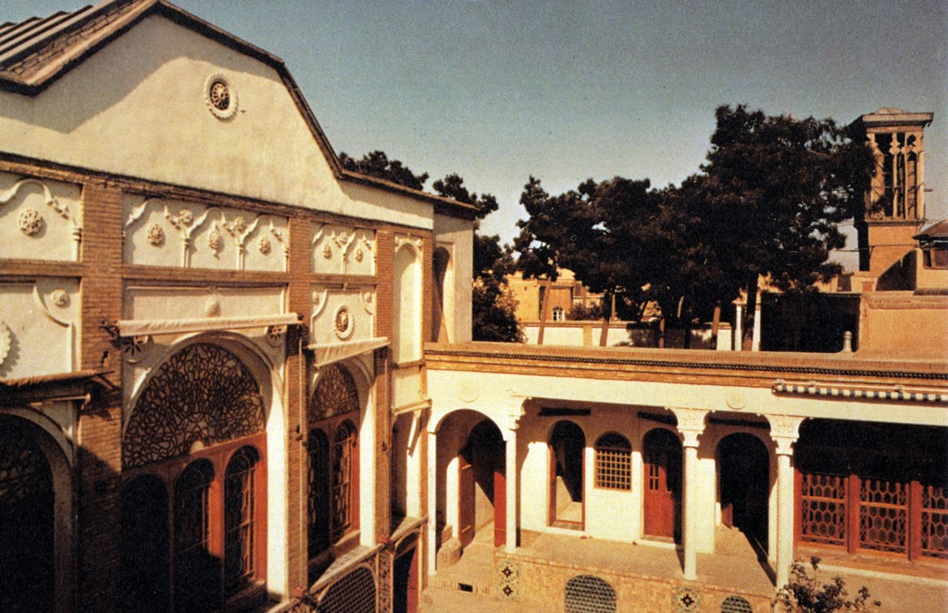

*House of Bahá'u'lláh in Tehran – Bahá’í Media*

Constantly the poor women came to my mother, to whom they poured out their various stories of woe, to be comforted and consoled by her loving helpfulness.

Whilst the people called my father "The Father of the Poor," they spoke of my mother as "The Mother of Consolation," though, naturally, only the women and little children ever looked upon her face unveiled.

So our peaceful days flowed on.

We used to go to our house in the country sometimes; my brother ‘Abbás[3] and I loved to play in the beautiful gardens, where grew many kinds of wonderful fruits and flowers and flowering trees; but this part of my early life is a very dim memory. [4]

One day I remember very well, though I was only six years old at the time. It seems that an attempt had been made on the life of the Sháh by a half-crazy young Bábí.

My father was away at his country house in the village of Niaviran, which was his property, the villagers of which were all and individually cared for by him.

Suddenly and hurriedly a servant came rushing in great distress to my mother.

"The master, the master, he is arrested - I have seen him!

He has walked many miles! Oh, they have beaten him! They say he has suffered the torture of the bastinado![5] His feet are bleeding! He has no shoes on! His turban has gone! His clothes are torn! There are chains upon his neck!

My poor mother's face grew whiter and whiter.

We children were terribly frightened and could only weep bitterly.

Immediately everybody, all our relations, and friends, and servants fled from our house in terror, only one man-servant, Isfandíyár remained, and one woman. Our palace, and the smaller houses belonging to it were very soon stripped of everything; furniture, treasurers, all were stolen by the people.

Mírzá Músá, my father's brother, who was always very kind to us, helped my mother and her three children to escape into hiding. She succeeded in saving some few of the marriage treasurers, which were all of our vast possessions left to us. These things were sold; with the money my mother was able to pay the goalers to take food to my father in the prison, and to meet other expenses incurred later on.

We were now in a little house, not far from the prison. Mírzá Yahyá (Subh-i-Azal) had run away in terror to Mázindarán, where he remained in hiding.

Oh, the terrible anxiety my beloved mother suffered at that time! Surely greater than any woman, about to become a mother (as I afterwards knew), could possibly have strength to bear.

The prison[6] into which my father had been cast was a terrible place, seven steps below the ground; it was ankle deep in filth, infested with horrible vermin, and of an indescribable loathsomeness. Added to this, there was no glimmer of light in that noisome place. Within its walls forty Bábís were crowded; murderers and highway robbers were also imprisoned there.

My noble father was hurled into this black hold, loaded with heavy chains; five other Bábís[7] were chained to him night and day, and here he remained for four months. Picture to yourself the horror of these conditions.

Any movement caused the chains to cut deeper and deeper not only into the flesh of one, but of all who were chained together; whilst sleep or rest of any kind was not possible. No food was provided, and it was with the utmost difficulty that my mother was able to arrange to get any food or drink taken into that ghastly prison.

Meanwhile, the spirit which upheld the Bábís never quailed for a moment, even under these conditions. To be tortured to a death, which would be the Martyr's Crown of Life, was their aim and great desire.

They chanted prayers night and day.

Every morning one or more of these brave and devoted friends would be taken out to be tortured and killed in various ways of horror.

When religious fanaticism was aroused against a person or persons, who were accused of being infidels, as was now the case with the Bábís, it was customary not simply to condemn them to death and have them executed by the State executioner, but to hand the victims over to various classes of the populace.

The butchers had their methods of torture; the bakers theirs; the shoemakers and blacksmiths yet others of their own. They were all given opportunities of carrying out their pitiless inventions on the Bábís.

The fanatics became more and more infuriated when they failed to quench the amazing spirit of these fearless, devoted ones, who remained unflinching, chanting prayers, asking God to pardon and bless their murderers, and praising Him, as long as they were able to breathe. The mob crowded to these fearful scenes, and yelled their execrations, whilst all through the fiendish work, a drum was loudly beaten.

These horrible sounds I well remember, as we three children clung to our mother, she not knowing whether the victim was her own adored husband. She could not find out whether he was still alive or not until late at night, or very early in the morning, when she determined to venture out, in defiance of the danger to herself and to us, for neither women or children were spared.

How well I remember cowering in the dark, with my little brother, Mírzá Mihdí the Purest Branch, at that time two years old, in my arms, which were not very strong, as I was only six. I was shivering with terror, for I knew of some of the horrible things that were happening, and was aware that they might have seized even my mother.

So I waited and waited until she should come back. Then Mírzá Músá, my uncle, who was in hiding, would venture in to hear what tidings my mother had been able to gather.

My brother ‘Abbás usually went with her on these sorrowful errands.

We listened eagerly to the accounts she gave to my uncle. This information came through the kindness of a sister of my grandfather, who was married to Mírzá Yúsif, a Russian subject, and a friend of the Russian Consul in Ṭihrán. This gentleman, my great uncle by marriage, used to attend the courts to find out some particulars as to the victims chosen for execution day by day, and thus was able to relieve to some extent my mother's overwhelming anxiety as these appalling days passed over us.

It was Mírzá Yúsif, who was able to help my mother about getting food taken to my father, and who brought us to the two little rooms near the prison, where we stayed in close hiding. He had to be very careful in thus defying the authorities, although the danger in this case was mitigated by the fact of his being under the protection of the Russian Consulate, as a Russian subject.

Nobody at all, of all our friends and relations, dared to come to see my mother during these days of death, but the wife of Mírzá Yúsif, the aunt of my father.

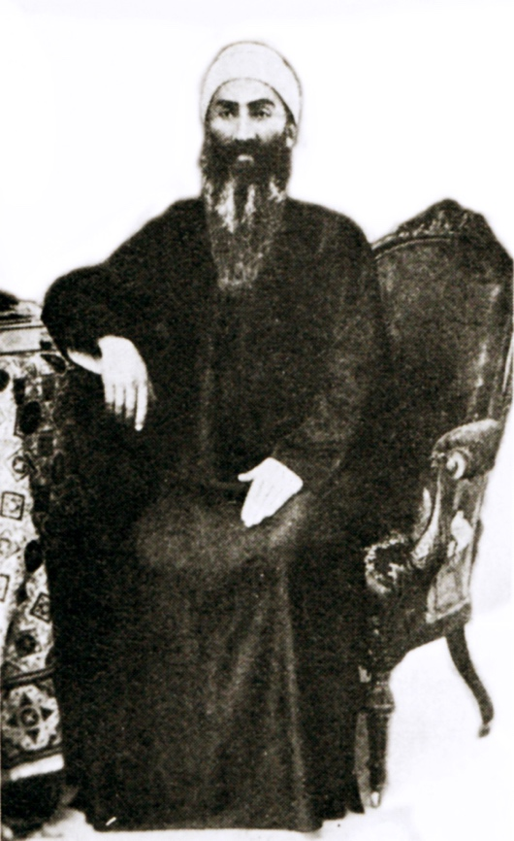

*Mírzá Músá, Brother of Bahá'u'lláh– Bahá’í Media*

One day the discovery was made by Mírzá Yúsif that our untiring enemies, the most fanatical of the mullás,[8] were plotting the death of Mírzá Ḥusayn 'Alí Núrí,[9] my father.

Mírzá Yúsif consulted the Russian Consul; that powerful friend determined that this plan should be at once frustrated.

An amazing scene took place in the Court, where the sentences of death were passed. The Russian Consul rose and fearlessly addressed those in court:

"Hearken to me! I have words of importance to say to you" (his voice rang out, the president and officials were too amazed to reply).

"Have you not taken enough cruel revenge? Have you not already murdered a large enough number of harmless people, because of this accusation, of the absurd falseness of which you are quite aware? Has there not been sufficient of this orgy of brutal torture to satisfy you? How is it possible that you can even pretend to think that this august prisoner planned that silly attempt to shoot the Sháh?

"It is not unknown to you that the stupid gun, used by that poor youth, could not have killed a bird. Moreover, the boy was obviously insane. You know very well that this charge is not only untrue, but palpably ridiculous.

"There must be an end to all this.

"I have determined to extend the protection of Russia to this innocent nobleman; therefore beware! For if one hair of his head be hurt from this moment, rivers of blood shall flow in your town as punishment.

"You will do well to heed my warning, my country is behind me in this matter."

An account of this scene was given to my mother by Mírzá Músá, when he came for tidings.

Needless to say how eagerly my brother and I listened, and how we all wept for joy.

Very soon afterwards we heard that, fearing to disregard the stern warning of the Russian Consul, the Governor gave orders that my father should be permitted to come forth from that prison with his life. It was also decreed that he and his family were banished.

They were to leave Tihrán for Baghdád. Ten days were allowed for preparation, as the beloved prisoner was very ill indeed.

And so he came to our two little rooms.

Oh, the joy of his presence!

Oh, the horror of that dungeon, where he had passed those four terrible months.

Jamál-i-Mubárak (a name given to my father, i.e., literally the Blessed Beauty) spoke very little of the terrible sufferings of that time! We, who saw the marks of what he had endured, where the chains had cut into the delicate skin, especially that of his neck, his wounded feet so long untended, evidence of the torture of the bastinado, how we wept with my dear mother.

He, on his part, told of the steadfast faith of the friends, who had gone forth to meet their death at the hands of their torturers, with joy and gladness, to attain the crown of martyrdom.

The glory had won so great a victory that the shame, and pain, and sorrow, and scorn were of comparatively no importance whatever!

Jamál-i-Mubárak had a marvellous divine experience whilst in that prison.

We saw a new radiance seeming to enfold him like a shining vesture, its significance were to learn years later. At that time we [the Holy Family] were only aware of the wonder of it, without understanding, or even being told the details of the sacred event.

My mother did her best to nurse our beloved, that he might have some strength to set out upon that journey on which we were to start in ten days' time.

Now was a time of great difficulty.

How could she prepare?

The poor, dear lady sold almost all that remained of her marriage treasurers, jewels, embroidered garments, and other belongings for which she received about four hundred tumans.[10] With this money she was able to make some provision for the terrible journey. (The Government provided nothing for those whom they exiled.)

This journey was filled with indescribable difficulties. My mother had no experience, no servants, no provisions, and very little money left. My father was extremely ill, not having recovered from the ordeals of the torture and the prison. No one of all of our friends and relations dared to come to our help, or even to say good-bye, but one old lady, the grandmother of Ásíyih Khánum.

Our faithful servant, Isfandíyár, and the one negro woman who did not fear to remain with us, did their best. But we three children were very young, my brother eight, and I six years old. Mírzá Míhdi, the "Purest Branch," was very delicate, and my mother allowed herself to be persuaded to leave the little fellow, only two years old, with her grandmother, though the parting with him was very sad.

At length we started on that fearful journey, which lasted about four weeks [sic][11]; the weather was bitterly cold, snow was upon the ground.

On the way to Baghdád we sometimes encamped in wilderness places, but in that month of December, the cold was intense, and we were not well prepared!

My poor mother! How she suffered on this journey, riding in a takht-i-raván, borne on a jolting mule! And this took place only six weeks before her youngest son was born!

Never did she utter one word of complaint. She was always thinking of some kindness for somebody, and sympathy she gave unsparingly to all in their difficulties.[12]

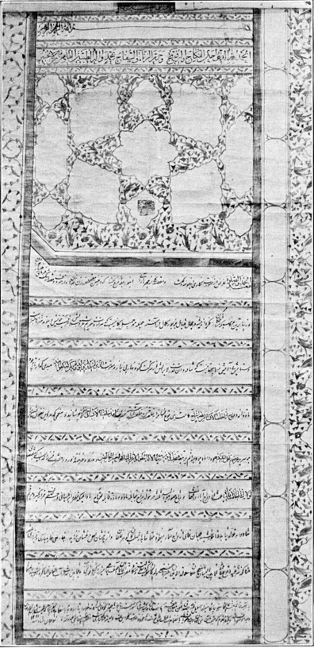

*Certificate of Marriage of Bahá'u'lláh and Ásíyih Khánum– Bahá’í Media*

# **2. A Prayer from Bahá'u'lláh**

This prayer was revealed in the exile that He suffered with His wife, children and two of His brothers.

My God, My Master, My Desire!… Thou hast created this atom of dust through the consummate power of Thy might, and nurtured Him with Thine hands which none can chain up.… Thou hast destined for Him trials and tribulations which no tongue can describe, nor any of Thy Tablets adequately recount. The throat Thou didst accustom to the touch of silk Thou hast, in the end, clasped with strong chains, and the body Thou didst ease with brocades and velvets Thou hast at last subjected to the abasement of a dungeon. Thy decree hath shackled Me with unnumbered fetters, and cast about My neck chains that none can sunder. A number of years have passed during which afflictions have, like showers of mercy, rained upon Me.… How many the nights during which the weight of chains and fetters allowed Me no rest, and how numerous the days during which peace and tranquillity were denied Me, by reason of that wherewith the hands and tongues of men have afflicted Me! Both bread and water which Thou hast, through Thy all-embracing mercy, allowed unto the beasts of the field, they have, for a time, forbidden unto this servant, and the things they refused to inflict upon such as have seceded from Thy Cause, the same have they suffered to be inflicted upon Me, until, finally, Thy decree was irrevocably fixed, and Thy behest summoned this servant to depart out of Persia, accompanied by a number of frail-bodied men and children of tender age, at this time when the cold is so intense that one cannot even speak, and ice and snow so abundant that it is impossible to move.[13]

# **3. The Consort of Bahá'u'lláh**

In the years when Bahá'u'lláh was still living in Iran, He had become the champion of the teaching of the Faith of the Báb, constantly visiting on horseback the different towns and villages of His native province and other provinces. regions, and participating in historical events such as the Badasht Conference and assisting in the Ṭabarsí episode.

He had His residence in Tehran which was a focus of the activities of the Persian friends. Distinguished Bábís of the time flocked to His house, such as Mullá Ḥusayn, Quddús, Vahíd, Nabíl, Ḥujjat, Táhirih, etc. Frequently He was absent from home to weather adverse situations in order to further the interests of the Cause of the Báb.

His material and spiritual help was always provided when it was required. Three times He was imprisoned on Persian soil, before His banishment to Baghdád, under unspeakable conditions. He was tortured until He bled several times on His feet, placed under the weight of fifty-pound chains, deprived of food and drink and finally stripped of His earthly possessions.

Ásíyih opened her house for the Faith. Nabíl, the noted historian of the Faith, remembers her once curing an eye ailment with an ointment that she prepared herself. Ásíyih was also in contact other brilliant women like Táhirih, who lived in her house for a while.

And when by that decree of the Sháh of Persia, the Holy Family had to cross the borders of the country forever, Ásíyih with great detachment exchanged the comforts that vast wealth had provided her with the difficulties and privations of successive exiles in strange lands. Without immediate family or friends, they were forced to leave all behind.

Bahá'u'lláh did so, both in Baghdád ('Iraq) and in Constantinople, Adrianople, and lastly, the Most Great Prison of 'Akká. She [Ásíyih] diligently took care of the housework despite the fact that her hands were never trained in it. Bahíyyih Khánum recounted the days of the trip to Baghdád. In the same *Spoken Chronicles* we read:

When we came to a city, my dear mother would take the clothes and wash them at the public baths; we also were able to have baths at those places. She would carry the cold, wet clothes away in her arms - drying them was an almost impossible task; her lovely hands, being unused to such coarse work, became very painful.

We sometimes stayed at a caravanserai - a sort of rough inn. Only one room was allowed for one family, and for one night - no longer. No light was permitted at night, and there were no beds. Sometimes we were able to have tea, or again a few eggs, a little cheese, and some coarse bread.

My father was so ill that he could not eat the rough food – my mother was very distressed and tried to think of some way of getting different food, as he grew more weak through eating nothing.

One day she had been able to get a little flour, and at night, when we arrived at the caravanserai she made a sweet cake for him. Alas! – the misfortune – being dark, she used salt instead of sugar. So the cake was uneatable! Quite a tragedy in it way.

The Governor of Ṭihrán sent soldiers with us to the frontier, where Turkish soldiers met us and escorted us to Baghdád.

When we first arrived there, we had a very little house, consisting of my father's room, and another one which was my mother's and in which were also my eldest brother, the baby, and myself.

When Arab ladies came to see us, this was the only reception room. These ladies came because they had been taught by Ṭáhirih, Qurratu'l-`Ayn, during her visit to Baghdád.

One day when an old lady was there, I was told to prepare the samovar[14]– it was very heavy to carry upstairs, for my arms were not extremely strong. The old lady said: "One proof that the Babi teaching is wonderful is that a very little girl served the samovar!"

My father was amused, he used to say, "Here is the lady converted by seeing your service at the samovar!"[15]

Bahíyyih Khánum’s narrative continues:

Mírzá Músá and his wife were always devoted to Bahá'u'lláh. This uncle, Mírzá Músá, who came into exile with us, was a very kind helper in everything. At one time he did almost all the cooking, for which he had a talent; he would also help with the washing.

Ásíyih Khanum, my dear mother, was in delicate health, her strength was diminished by the hardships she had undergone, but she always worked beyond her force.

Sometimes my father himself helped in the cooking, as that hard work was too much for the dainty, refined, gentle lady. The hardships she had endured saddened the heart of her divine husband, who was also her beloved Lord. He gave this help both before his sojourn in the wilderness of Sulaymaníyyih, and after his return.[16]

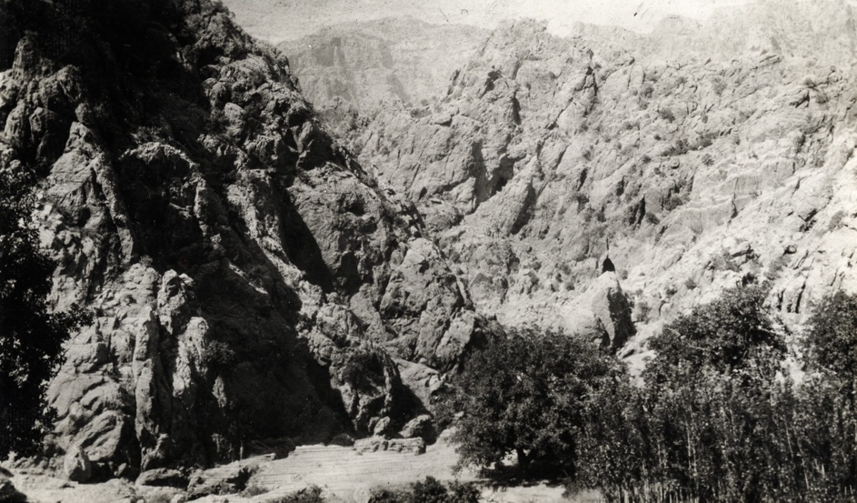

*The Mountains of Sulaymaníyyih – Bahá’í Media*

Without warning Bahá'u'lláh left his home on April 10, 1854, separating Himself from his family and the Bábí community for two years to recluse Himself in that mountain wilderness for prayer and meditation in preparation for His declaration of His divine mission.

Bahíyyih Khánum recounted of that long separation:

Now our great anxiety was concerning the whereabouts of Jamál-i-Mubárak.

All this time my mother and Mírzá Músá made every possible inquiry. My brother's [17]distress at the prolonged absence was pathetic. On one occasion he prayed the whole night a certain prayer with the one intention, that our father might be restored to us.

The very next day, he and our uncle, Mírzá Músá, overheard two people speaking of a marvellous one, living as a dervish in the open mountain district of Sulaymaníyyih; they described him as "The Nameless One," who had magnetized the countryside with his love. And they immediately knew that this must be our Beloved.

Here at last was a clue!

Without delay, Shaykh Sultán, our faithful friend, with one of the other disciples, set forth on their quest. Needless to say how our hearts went with them, and that our prayers for their success were unceasing.

Hope now brought its brilliance into the dark shadow of our anxiety, which had saddened our lives for two years.

As these days of intensified waiting passed by, our faith as well as our hope increased and grew. We knew that in the days that were very near at hand, our wanderer, our father, would be once more with us.

My mother had made a coat for him out of some pieces of precious Persian stuff (Tirmih – red cloth), which she had carefully kept for the purpose out of the remains of her marriage treasures. It was now ready for him to put on.

At last! At last! As my mother, my brother, and I sat in a breathless state of expectancy, we heard a step. It was a dervish.[18] Through the disguise we saw the light of our beloved one's presence!

Our joy cannot be described as we clung to him.

I can see now my beloved mother, calm and gentle, and my brother holding his father's hand fast, as though never again could he let him go out of his sight, the lovely boy almost enfolded in the uncouth garment of the dervish disguise. I could never forget this scene, so touching and so happy. [19]

Those days of happiness were crowned when the tender Mírzá Mihdí was brought from Persia.

The Sacred Family lived in a simple house, with a low roof made of mud and straw, and enhanced with a small garden. Inside was a single sofa, made of palm branches, on which Bahá'u'lláh sat.

Many Persian believers, rich and poor, as well as princes, peasants and theologians, began to visit that house and seek the presence of the Blessed Perfection. Despite this poverty, there was always a plate of food to share with the numerous visitors.

Many times His clothes had to be washed and dried at night, to be used the next day, because these were the only clothes He had. 'Abdu'l-Bahá once remarked:

Contentment is real wealth. If one develops within himself the quality of contentment he will become independent. Contentment is the creator of happiness. When one is contented he does not care either for riches or poverty. He lives above the influence of them and is indifferent to them. When we were in Baghdád often with one pound of meat we served dinner to fifteen or twenty people. We cooked with it Persian stew and filled the pot with water so everyone could have a bowl of soup. Notwithstanding this we were all very happy and thought that ours was the most delicious dinner.[20]

The stay in Baghdád lasted for a period of ten years. In all that time the spiritual ascendancy of the Blessed Beauty, and the fame that spread in the city because of His wisdom and holiness gradually aroused the envy and zeal of the enemies of the Cause.

As a result of the influence of these enemies, the Turkish government summoned Bahá'u'lláh to the city of Constantinople, the capital of the Empire. The Sultan's order, promoted with the support of the Sháh of Persia, ended the tranquil and normal life they were beginning to enjoy among the population of Baghdád.

Before leaving Baghdád, Bahá'u'lláh withdrew to a garden on the outskirts of the city, and there the Blessed Beauty declared His mission to members of His family and to a group of His believers and companions.

During the trip of more than three months, they were accompanied by officers and guards. In Constantinople, the "Dome of Islam", they remained for a few months, until the sovereign ordered a subsequent banishment to Adrianople, as severe in its rigor as had been the first.

It is said that on the route the companions suffered from intense cold and had to light bonfires to keep warm and also melt the ice from the springs to obtain a supply of water. They oftentimes continued the forced march, sometimes even at night and under heavy rains.

Bahá’u’lláh referred to the city of Adrianople as “the place which none entereth except such as have rebelled against the authority of the sovereign”. “Neither My family, nor those who accompanied Me, had the necessary raiment to protect them from the cold in that freezing weather.” “The eyes of Our enemies wept over Us, and beyond them those of every discerning person.” ‘They expelled Us from the city (Constantinople)”, He rebukes the Sultan, “with an abasement with which no abasement on earth can compare.’”[21]

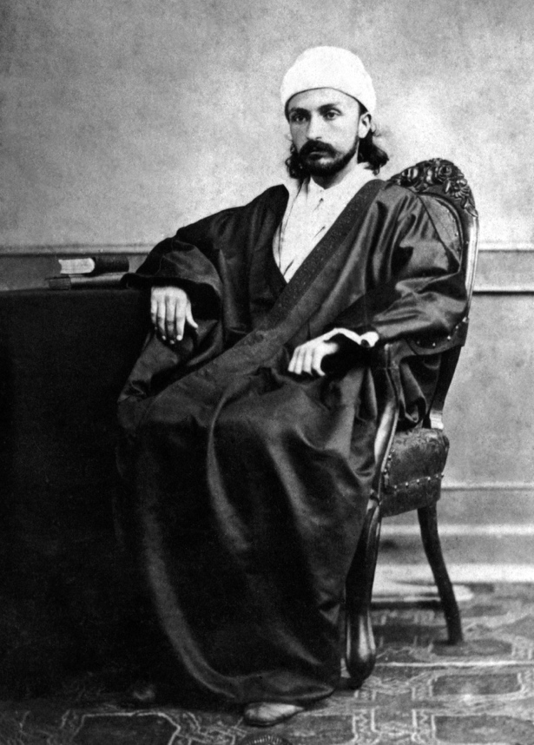

*‘Abdu’l-Bahá in Adrianople, c. 1868 – Bahá’í Media*

When they arrived at Adrianople, they were all settled in an inn for travellers, which was changed shortly thereafter for a house. The prevailing poverty meant that at times the only food available was bread and cheese. From that city, located on the European continent, and inhabited mostly by Christians, Bahá'u'lláh addressed His historic and momentous appeals to the kings and rulers of the earth.

The Holy Family and the group of exiled Bahá'ís stayed for about five years in that place. In the final years, the Covenant-breakers, the enemies of the Faith headed by Mírzá Yaḥyá, unleashed a campaign of slander against Bahá'u'lláh.

This half-brother, convulsed with jealousy over Bahá'u'lláh's spiritual leadership, decided to put him to death on several occasions, one of which has been described by the Guardian of the Faith.

Desperate designs to poison Bahá’u’lláh and His companions, and thereby reanimate his own defunct leadership, began, approximately a year after their arrival in Adrianople, to agitate his mind. Well aware of the erudition of his half-brother, Áqáy-i-Kalím[22], in matters pertaining to medicine, he, under various pretexts, sought enlightenment from him regarding the effects of certain herbs and poisons, and then began, contrary to his wont, to invite Bahá’u’lláh to his home, where, one day, having smeared His tea-cup with a substance he had concocted, he succeeded in poisoning Him sufficiently to produce a serious illness which lasted no less than a month, and which was accompanied by severe pains and high fever, the aftermath of which left Bahá’u’lláh with a shaking hand till the end of His life. So grave was His condition that a foreign doctor, named Shíshmán, was called in to attend Him. The doctor was so appalled by His livid hue that he deemed His case hopeless, and, after having fallen at His feet, retired from His presence without prescribing a remedy. A few days later that doctor fell ill and died. Prior to his death Bahá’u’lláh had intimated that doctor Shíshmán had sacrificed his life for Him. To Mírzá Áqá Ján,[23] sent by Bahá’u’lláh to visit him, the doctor had stated that God had answered his prayers, and that after his death a certain Dr. Chupán, whom he knew to be reliable, should, whenever necessary, be called in his stead.[24]

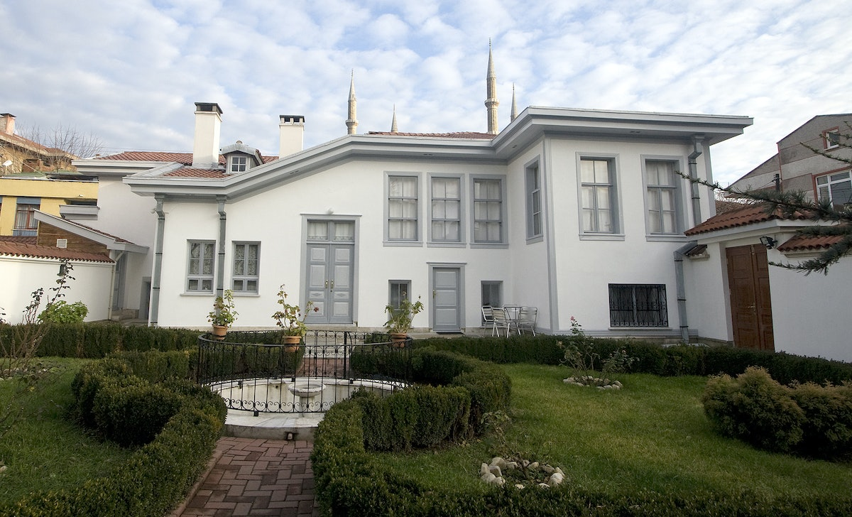

*Recent Photograph of the House of Bahá’u’lláh in Adrianople – Bahá’í Media*

Mírzá Yaḥyá, on another occasion, poisoned the water well from which the Holy Family drew water for daily consumption.

By all means possible, Mírzá Yahya and his followers tried to discredit Bahá'u'lláh. All of their accomplishments precipitated a very serious crisis involving highly influential adversaries in the government who were also involved in their campaign. As a result, on July 26, 1868, the Sultan of Turkey signed an edict whereby Bahá'u'lláh, His family and a group of Bahá'ís were once again sentenced to exile.

This edict was a life sentence of banishment to the penal colony of 'Akká, considered to be the worst imprisonment to be found throughout the Ottoman Empire. The Sacred Family's grief reached its critical point. The court ministers, the monarch himself and the Persian ambassador issued strict instructions to ensure that the confinement would be carried out exactly in detail according to the imperial order. The isolation was to be total.

The Bahá'ís in Persia —the Cradle of Faith— were shaken by this sudden a storm of adversity around the figure of Bahá'u'lláh. The Blessed Perfection arrived in that terrible prison-city on August 31 of the same year. They all arrived by boat and entered through a door that faces the sea. They were immediately taken to the "barracks" where they were incarcerated.

Ásíyih then continued to demonstrate the benignity of her soul, and personally encouraged and cared for the friends, who were often very sick in that putrid atmosphere, taking on her shoulders the household affairs, trying in each case to reduce the anguish of others.

Many times she was the teacher of her children. At other times it was Bahá'u'lláh or their uncle Mírzá Músá[25].

It was in this prison that Bahá'u'lláh’s young and much loved son, Mírzá Mihdí, died in the year 1870 while absorbed in his devotions. As was his wont to pace on the roof of the prison cell while performing his devotions, he inadvertently fell through a skylight, dying hours later. On his death bed, this noble youth asked his Father that his life be a sacrifice so that the Bahá'ís might one day come to His presence.

Ásíyih Khánum could hardly bear this blow. Providence had snatched the youngest of all from her in Baghdád, when she had no one on hand to call upon for help. Now, she was given another test that seemed to exceed the mental strength of this true saint. She was overwhelmed with pain and despair.

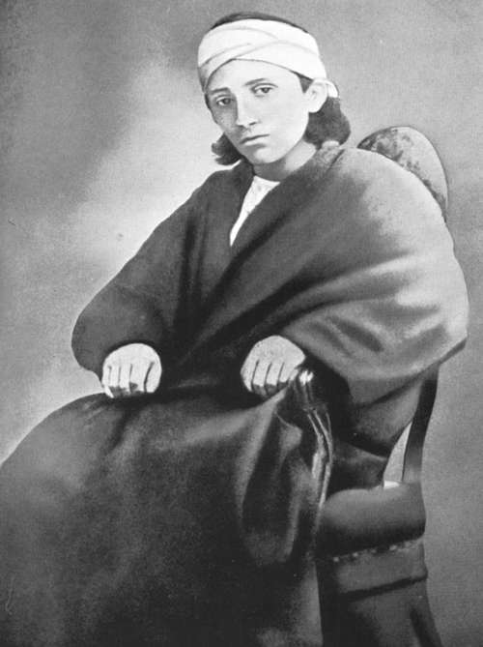

Mírzá Mihdí, the Purest Branch *– Bahá’í Media*

Bahíyyih Khánum, also grieving the loss of her beloved younger brother, recounted her mother's sentiments:

The death of this youngest and favourite child – of a very gentle and sweet disposition – nearly broke his mother’s heart. We feared for her reason. When the Blessed Perfection was told of the condition of his wife, he went to her and said: ‘Your son has been taken by God that His people might be freed. His life was the ransom, and you should rejoice that you had a son so dear to give to the cause of God.’ When our mother heard these words she seemed to rally, – knelt, and kissed the Blessed Perfection’s hands, and thanked him for what he had said. After that she did not shed a tear.[26]

Truly, a great magnanimity of spirit!

A few months later all the prisoners left the prison barracks and were transferred to a rented house within the prison-city.

Her tiny room was simple and bare – the narrow, white bed, which was also the divan in the daytime; a very small table, on which was her prayer and other holy books, her "Qalam-dán" (pen case), and leaflets for writing; there was also her rosary, sometimes a flower in a pot, and lastly an old painted box holding her other frock and her other undergarment.

Bahá'u'lláh had only two coats (made of Barak, a Persian woollen cloth); they were apt to wear out, and much of her time was spent, as I remember her, in patching darning them and His stockings. [27]

My eyes will always see her in her blue dress, with a white "niqab"[28] on her head, and little black slippers on her tiny feet, Her sweet, smiling face, and her wrapt expression, as she chanted prayers in her musical voice.[29]

Ásíyih died in 'Akká in the year 1886 after having a fall. Her strength had also been sapped with the passage of time.

According to her granddaughter’s posthumous testimony:

One sad day I came in from my lessons, finding many people gathered together in a troubled way. I asked "What is the matter?"

"Your grandmother is very ill."

I saw Bahá'u'lláh go into her room; after a time He came out; she had passed from the sadness and grief-filled days of her life on earth.

How we all wept! We missed her beautiful presence; her unfailing loving-kindness, and her perfect unselfishness had endeared her to us all.

Lovely and loving, refined and dainty, keenly intelligent, with more strength of character than of physique. A strong sense of humour was also one of her many gifts. [30]

Her funeral was attended by the main personalities of 'Akká, Christian and Muslim priests, school children who sang poems aloud expressing their sadness at the loss of that illustrious lady. The following year, Mírzá Músá died.

In the building of the International Archives of the Bahá'í Faith, her mirror, hair, scarf, glasses (one of them broken) and her letters are kept as precious relics.

In the year 1939, the Guardian, Shoghi Effendi, removed the remains of Navváb and Mírzá Mihdí from two 'Akká cemeteries and built for them worthy marble mausoleums on Mount Carmel, near the Shrine of the Báb, within whose sacred precinct 'Abdu'l-Bahá is also entombed.

Bahá'í pilgrims visiting these twin tombs can infuse their souls with the sanctified atmosphere of that holy place, and prayerfully recall the life and work of Navváb, the wife of Bahá'u'lláh.

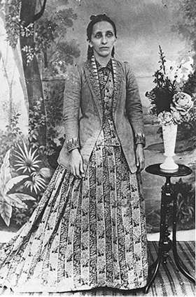

Bahíyyih Khánum *in 1895 – Bahá’í Media*

# **4. Bahá'u'lláh's Words Addressed to Navváb**

"The first Spirit through which all spirits were revealed, and the first Light by which all lights shone forth, rest upon thee, O Most Exalted Leaf, thou who hast been mentioned in the Crimson Book! Thou art the one whom God created to arise and serve His own Self, and the Manifestation of His Cause, and the Day-Spring of His Revelation, and the Dawning-Place of His signs, and the Source of His commandments; and Who so aided thee that thou didst turn with thy whole being unto Him, at a time when His servants and handmaidens had turned away from His Face.... Happy art thou, O My handmaiden, and My Leaf, and the one mentioned in My Book, and inscribed by My Pen of Glory in My Scrolls and Tablets.... Rejoice thou, at this moment, in the most exalted Station and the All-highest Paradise, and the Abha Horizon, inasmuch as He Who is the Lord of Names hath remembered thee. We bear witness that thou didst attain unto all good, and that God hath so exalted thee, that all honour and glory circled around thee.  
  
"O Navváb! O Leaf that hath sprung from My Tree, and been My companion! My glory be upon thee, and My loving-kindness, and My mercy that hath surpassed all beings. We announce unto thee that which will gladden thine eye, and assure thy soul, and rejoice thine heart. Verily, thy Lord is the Compassionate, the All-Bountiful. God hath been and will be pleased with thee, and hath singled thee out for His own Self, and chosen thee from among His handmaidens to serve Him, and hath made thee the companion of His Person in the day-time and in the night-season.  
  
"Hear thou Me once again ... God is well-pleased with thee, as a token of His grace and a sign of His mercy. He hath made thee to be His companion in every one of His worlds, and hath nourished thee with His meeting and presence, so long as His Name, and His Remembrance, and His Kingdom, and His Empire shall endure. Happy is the handmaid that hath mentioned thee, and sought thy good-pleasure, and humbled herself before thee, and held fast unto the cord of thy love. Woe betide him that denieth thy exalted station, and the things ordained for thee from God, the Lord of all names, and him that hath turned away from thee, and rejected thy station before God, the Lord of the mighty throne.  
  
"O faithful ones! Should ye visit the resting-place of the Most Exalted Leaf, who hath ascended unto the Glorious Companion, stand ye and say: 'Salutation and blessing and glory upon thee, O Holy Leaf that hath sprung from the Divine Lote-Tree! I bear witness that thou hast believed in God and in His signs, and answered His Call, and turned unto Him, and held fast unto His cord, and clung to the hem of His grace, and fled thy home in His path, and chosen to live as a stranger, out of love for His presence and in thy longing to serve Him. May God have mercy upon him that draweth nigh unto thee, and remembereth thee through the things which My Pen hath voiced in this, the most great station. We pray God that He may forgive us, and forgive them that have turned unto thee, and grant their desires, and bestow upon them, through His wondrous grace, whatever be their wish. He, verily, is the Bountiful, the Generous. Praise be to God, He Who is the Desire of all worlds; and the Beloved of all who recognize Him." [31]

‘Abdu’l-Bahá wrote how His mother Navváb “suffered in the path of God, all of which she endured with patience and thanked God therefore and praised Him, because He had enabled her to endure afflictions for the sake of Bahá’.[32]

The beloved Guardian wrote about the singular position of Navváb as described in the Bible:

And, finally, ‘Abdu’l-Bahá Himself in one of His remarkably significant Tablets, has borne witness not only to the exalted station of one whose ‘seed shall inherit the Gentiles’, whose Husband is the Lord of Hosts, but also to the sufferings endured by her who was His beloved mother. ‘As to thy question concerning the 54th chapter of Isaiah,’ He writes, ‘This chapter refers to the Most Exalted Leaf, the mother of ‘Abdu’l- Bahá. As a proof of this it is said: “For more are the children of the desolate, than the children of the married wife.” Reflect upon this statement, and then upon the following: “And thy seed shall inherit the Gentiles, and make the desolate cities to be inhabited.” And truly the humiliation and reproach which she suffered in the path of God is a fact which no one can refute. For the calamities and afflictions mentioned in the whole chapter are such afflictions which she suffered in the path of God, all of which she endured with patience and thanked God therefor and praised Him, because He had enabled her to endure afflictions for the sake of Bahá. During all this time, the men and women (Covenant-breakers) persecuted her in an incomparable manner, while she was patient, God- fearing, calm, humble and contented through the favour of her Lord and by the bounty of her Creator.’[33]

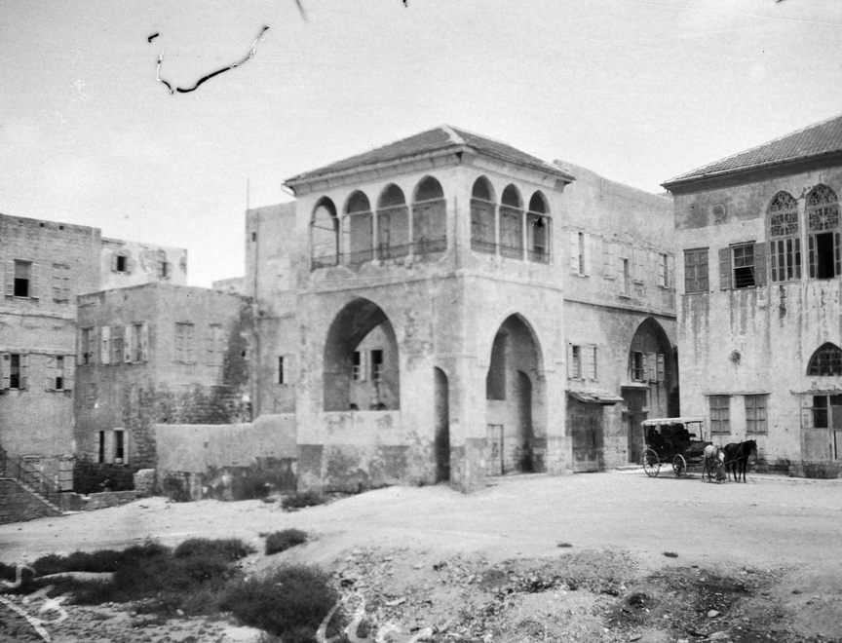

*The House of ‘Abbúd where Ásíyih Khánum passed away in 1886 (1920s photograph) – Bahá’í Media*

# **5. The Burial of the Purest Branch and Mother of ‘Abdu’l-Bahá**

Written by Rúḥíyyih Rabbani[34]

The garden is dark. Twilight has fallen on Mount Carmel and the veils of dusk have deepened over the bay of ‘Akká. A group of men stand waiting by the gate, beneath the steps. Suddenly there is a stir, the gardener runs to illumine the entrance and amidst the white shafts of light a procession appears. A man clothed in black rests the weight of a coffin on his shoulder. It is the Guardian of the Cause and he bears the mortal remains of the Purest Branch, Bahá’u’lláh’s beloved son. Slowly he and his fellow bearers mount the narrow path and in silence approach the house adjacent to the resting place of the Greatest Holy Leaf. A devoted servant speeds ahead with rug and candelabra from the Holy Shrines and swiftly prepares the room. The gentle, strong face of the Guardian appears as he enters the door, that precious weight always on his shoulder, and the coffin is laid temporarily to rest in a humble room, facing Bahjí, the Qiblih of the Faith. Again those devoted servants, led by their Guardian, return to the gate and again remount the path with another sacred burden, this time the body of the wife of Bahá’u’lláh, the mother of the Master.

What a wave of joy seems to come onward with those simple processions! A joy indefinable, touched with deep tenderness and pathos. Like a great white pearl the marble temple marking the grave of Bahíyyih Khánum glows in the light of its reflectors, seeming afire on the dark mountain side, lighting up and watching over those two approaching the scene of their last resting place.

When we enter to pay our respects to those beloved, revered and long since departed ones, their presence seems to fill the room. At last, after seventy years, that saintly mother lies reunited beside her son of whom Bahá’u’lláh wrote: ‘He was created of the light of Bahá.’ Side by side, facing ‘Akká, the sweet fumes of attar of rose with which they have been anointed by the Guardian filling the room, they lie. And above them, lit by the flickering lights of the sentinel candles, the picture of The Greatest Holy Leaf hangs, her beautiful eyes, so full of love and that purity which is goodness itself, looking out over her mother and brother. What cause for joy and gratitude!

That tender youth, born to affliction, reared in exile, died in prison, buried in solitary haste! Here he lies, raised up from the earth by the hands of the Guardian of his Father’s Faith, removed from the lonely isolation of the Arab cemetery where he had been interred so long ago and placed beside his illustrious sister and holy mother, that mother who was affectionately known as ‘Búyúk Khánum’ or ‘Great Lady’. Slender, stately, lovely to look on with white skin and blue eyes and dark hair; she who, when Bahá’u’lláh was thrown into the dungeon of Ṭihrán, was abandoned by friend and foe alike and who purchased food for her children by selling the gold buttons of her robes; she who was forced to leave this same son, then a delicate child of four, behind her when she followed Bahá’u’lláh into exile; she whose tender hands, unaccustomed to work, bled as she washed the clothes of her family; who remained patient, devout, serene and selfless to the end of her life, and who was laid to rest near ‘Akká in a cemetery away from her son, now lies beside him, so to remain forever more.

As we meditate beside those two eloquent coffins, covered with woven cloths, strewn with jasmine from the Threshold of the Báb’s Tomb, so all pervading is the presence of their spirits – or maybe it is their memory, as perfume lingers when the flower is withered – that the very room they rest in for so short a while becomes itself filled with the sweet peace of a shrine.

Not only has the Guardian raised them to rest in their rightful graves, put them where the whole world may see their honour and their glory, but in some mysterious way he has given them back to us. So long ago they passed away, so quietly, in days of such turmoil and oppression, were they laid to rest, that their places, at least to us of the West, were on written pages of the history of our Faith. But now their places are in our hearts. The veil of time and obscurity separating us has been rent asunder, and we find, to our joy and astonishment, two glowing and holy figures drawing nigh to us, entering into our lives, and ready to help us on that path which leads to their Lord and ours, Bahá’u’lláh.

How warm and living his personality suddenly seems, no longer a name, albeit a revered one, Mihdí, the Purest Branch, but a sweet and selfless youth filled with love and devotion for Him who was not only his earthly but heavenly Father as well. Slight of frame, small of stature, black of hair, scarce twenty years of age, when at the time of his death he acted as the amanuensis of Bahá’u’lláh and the character of his script has remained to us as a tender reminder that he stood only on the threshold of manhood.

Bahá’u’lláh Himself in numerous Tablets has mentioned this beloved son of His, recounting His long separation from him when he was left behind in Írán and was deprived of his family; how later he suffered the exiles and imprisonments of his Father until that fateful day when, as Bahá’u’lláh wrote: ‘He has suffered martyrdom at a time when he lay imprisoned at the hands of his enemies.’

The cruelty of exile and banishment became the rigour of complete incarceration during Mihdí’s short life time. Upon entering the prison city of ‘Akká they were confined in the barracks itself, and it was during this strict period of Bahá’u’lláh’s imprisonment, when they suffered the greatest privations and were the victims of terrible epidemics, that the Purest Branch passed away. No one of the devout and faithful, who, some on foot, some on mule back, made the long and arduous journey to see the face of their Lord, was admitted to His presence. They were forced to content themselves with a brief glimpse of Him as He stood in a window facing the little hill beyond the walls and moat where they were wont to await His appearance.

It was under such circumstances that one night, whilst walking on the roof of the fortress, the Purest Branch fell through the opening leading below and was fatally injured. It was the custom of those prisoners to get what air and exercise they could in this manner, and no doubt that youth, lost to all but his thoughts and meditations, stepped unawares through the unguarded sky light. Although the ceilings of oriental rooms are very high, it was not a fall which necessarily would cause the death of a person. But the Purest Branch was terribly injured. He bled profusely from the mouth, and his thigh was so battered and bleeding that his garment could not be removed but was torn from him – that pitiful relic which the Greatest Holy Leaf preserved for posterity and which to this day may be seen with the stains of his life’s blood upon it. He survived for about thirty hours after the fall. The doctors, hastily called in, were powerless to help him, but we cannot but believe that it lay within the power of his Father to spare his life, if He had so willed it.

Bahá’u’lláh asked of His dying son if he desired to live, but he replied that his sole desire was that the gates of the prison should be opened so that the believers might visit their Lord. Bahá’u’lláh granted that youth’s earnest wish and sat beside His youngest son as they made him ready for the grave, and it was in those tragic circumstances that He revealed the following: ‘At this very moment My son is being washed before My face after Our having sacrificed him in the Most Great Prison . . .’ ‘Glorified art Thou, O Lord, My God! Thou seest Me in the hands of Mine enemies, and My son blood-stained before My face!’ Such sentences as these were wrung from the heart of the Blessed Beauty as He gazed upon His child. But then thundering forth came these marvellous words: ‘I have, O My Lord, offered up that which Thou has given Me, that Thy servants may be quickened and all that dwell on earth be united.’ The tremendous significance of these words is inescapable; Bahá’u’lláh designates to His own child the *rôle* of blood offering in order that the unity of all men which He has proclaimed may come about. The sacrifice of Isaac by Abraham is accomplished.

After, in secrecy, poverty, and haste, the Purest Branch had been interred, his gentle mother, the victim of so many sorrows and deprivations, saddened and wept unceasingly. Bahá’u’lláh on learning of her plight came to her and assured her she had no cause for grief for God had accepted this precious son as His Ransom to draw not only the believers nigh unto their Lord but to unify all the sons of men. After hearing these words that saintly soul was greatly comforted and ceased to mourn her heavy loss.

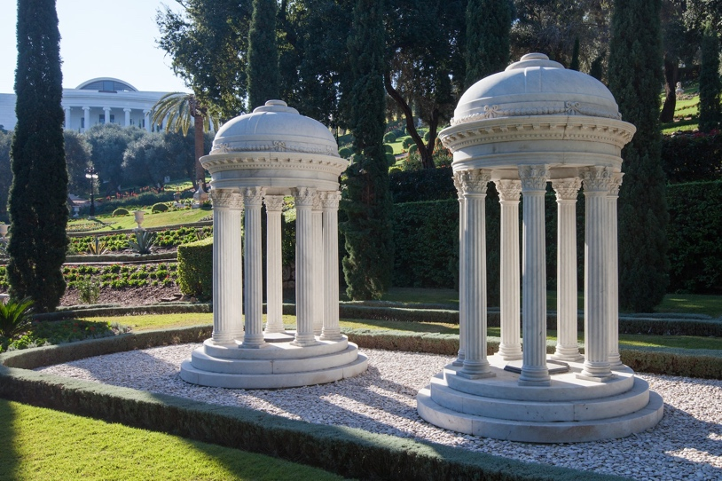

*Resting Places of the Purest Branch (Mírzá Mihdí), the son of Bahá’u’lláh,*

*and Navváb (Ásíyih Khánum), the wife of Bahá’u’lláh, in the Monument Gardens*

*– Bahá’í Media*

And who was such a mother? Not merely a holy and faithful woman, willing in the path of God to sacrifice her all, but she of whom Isaiah, in his 54th chapter, says: ‘For thy Maker is thy husband; the lord of hosts is his name; and thy Redeemer the Holy One of Israel; the God of the whole earth shall he be called.’ ‘For the mountains shall depart, and the hills be removed; but my kindness shall not depart from thee, neither shall the covenant of my peace be removed, saith the lord that hath mercy on thee.’ And she to whom Bahá’u’lláh revealed the following: ‘Hear thou Me once again, God is well pleased with thee . . . He hath made thee to be His companion in every one of His worlds and hath nourished thee with His meeting and presence so long as His name and His remembrance and His kingdom and His empire shall endure.’

How fleeting and priceless the days that this mother and son lie side by side in that small room! To be privileged to draw close – in that strange and pitiful closeness one feels to a coffin in which all that remains of dear ones after the soul has flown rests, a token and reminder of our common mortality and immortality – is something never to be forgotten. Thousands will read these Prayers and Tablets of Bahá’u’lláh and ‘Abdu’l-Bahá forever immortalizing them. They will supplicate those radiant spirits to intercede on their behalf. They will seek humbly to follow in their noble footsteps. But it will never, so it seems to me, be as sweet and touching as to see them lying there together under the watchful eyes of Bahíyyih Khánum.

Whilst their tombs were still in process of excavation from the solid rock of the mountain, the Guardian had learned that the Covenant-Breakers were protesting against the right of the Bahá’ís to remove the Mother and brother of ‘Abdu’l-Bahá to new graves, actually having the temerity to represent to the government their so called claim as relatives of the deceased. As soon, however, as the civil authorities had the true state of facts made clear to them – that these same relatives had been the arch-enemies of the Master and His family, had left the true Cause of Bahá’u’lláh to follow their own devices, and had been denounced by ‘Abdu’l-Bahá in His Will and Testament – they approved the plan of the Guardian and immediately issued the necessary papers for the exhumation of the bodies. Without risking further delay Shoghi Effendi, two days later, himself removed the Purest Branch and his mother to Mount Carmel where, watched over by the loving devotion of the believers, and safeguarded from any danger of insult or injury, they could await, close to Bahíyyih Khánum’s shrine, their reinterment.

The last stone is laid in the two vaults, the floors are paved in marble, the name plates fixed to mark their heads, the earth smoothed out, the path that leads to their last resting place built, but storm and rain sweep unceasingly over the crest of the mountain postponing the final arrangements until the day before Christmas dawns, bright and clear, as if a sign that this is the appointed time. At sunset we all gather in that humble, twice blessed house. We hear the voice of one of the oldest and most devoted believers of the Near East raised, at the command of his Guardian, in prayer. Tremulous, faint, yet filled with a poignant faith and love hard to describe but never to be forgotten, he prays. As voice follows voice, one of them, that of the Guardian himself, it seems as if one could almost hear the refrain of those prayers sung in triumphant joy by an invisible concourse on high.

And now, again on the shoulder of the Guardian, they are borne forth to lie in state in the Holy Tomb of the Báb. Side by side, far greater than the great of this world, they lie by that sacred threshold, facing Bahjí, with candles burning at their heads and flowers before their feet. It is the eve of the birth of Christ. She who was foretold of Isaiah, he who was the son of Him of Whom Jesus said: ‘Howbeit when he, the Spirit of truth, is come, he will guide you into all truth,’ rest quietly here their last night before the earth hides them forever more from the eyes of men.

The following sunset we gather once again in that Holy Shrine. The Guardian chants the Tablet of Visitation, first in the Tomb of the Báb, then in the Tomb of the Master. The privileged friends who have been able to make the pilgrimage to Haifa for this sacred occasion enter with the Guardian a second time the Báb’s Shrine. Slowly, held aloft on the hands of the faithful, led by Shoghi Effendi, who never relinquishes his precious burden, first the mother of ‘Abdu’l-Bahá and then the Purest Branch are ushered from that Holy Spot. Once they circumambulate the Shrines, the coffin of beloved Mihdí, supported by the Guardian, followed by that of the Master’s mother, passes us slowly by. Around the Shrine, onward through the lighted garden, down the white path, out onto the moonlit road, that solemn procession passes. High, seeming to move of themselves, above the heads of those following, the coffins wend their way. They mount the steps and once again enter that gate leading to Bahíyyih Khánum’s resting place. They pass before us, outlined against the night sky, across whose face fitful clouds make sport of the full moon. They approach, the face of the Guardian close to that priceless burden he bears. They pass on towards the waiting vaults.

Now they lay the Purest Branch to rest. Shoghi Effendi himself enters the carpeted vault and gently eases the coffin to its preordained place. He himself strews it with flowers, his hands the last to caress it. The mother of the Master is then placed in the same manner by the Guardian in the neighbouring vault. Not six feet apart they rest. The silent faces of the believers in the brilliant light of the lamps, form a waiting circle. Masons are called to seal the tombs. Respectfully and deftly they fulfil their task. Flowers are heaped upon the vaults and the Guardian sprinkles a vial of attar of rose upon them. The pungent scent is caught up on the breeze and bathes our faces. And now the voice of Shoghi Effendi is raised as he chants those tablets revealed by Bahá’u’lláh and destined by Him to be read at their graves.

Surely this is a dream? It cannot be I that stand here gazing at these new-made graves, laid in the breast of ancient Carmel! Beneath me stretches an endless vista. ‘Akká gleams white across the bay, that onetime prison city where these two were so long captives, near which they were once buried. The reaches of the sea and plain lie before me, opening out to where the moon silvers the rims of the mountains of the Holy Land, the Land of the Prophets, the Land of the loved ones of God, the Land chosen to be the Seat of the Ark of God in this most glorious Day. Forever and increasingly about the resting place of this mother, sister, brother of ‘Abdu’l-Bahá, the life-giving activities of their Faith will gather. Close to them, focused on their shrines, great institutions will rise to strengthen the soul and body of mankind. And forever interwoven with those institutions will be the memory and example of these three holy persons. Their way has become our way and they lead us on before, heading the ranks of Bahá’u’lláh’s followers.

# **Bibliography**

Blomfield, Lady. *The Chosen Highway*. Oxford: George Ronald, reprinted, 2007.

Phelps, Myron. *Abbas Effendi: His Life and Teachings*. New York: G. P. Putnam’s Son, 1903.

Rabbani, Rúḥíyyih. *A Manual for Pioneers*. New Delhi: Bahá’í Publishing Trust, 1974.

Rabbani, Rúḥíyyih. ‘The Burial of the Purest Branch and the Mother of ‘Abdu’l-Bahá’, in *Bahá’í World*, vol. 8, pp. 253–258, 1974.

Shoghi Effendi. *God Passes By*. Wilmette, IL: Bahá’í Publishing Trust, rev. ed. 1995.

Shoghi Effendi. *Messages to America*. Wilmette, IL: Bahá’í Publishing Committee, 1947.

*Acknowledgment: I would like to thank Ernie and Diana Jones for their editorial assistance.*

1. Shoghi Effendi, *God Passes By,* p. 108.
2. Title of dignitary or a courtesy title for women, e.g., Maryam Khánum.
3. Name of ‘Abdu’l-Bahá.
4. Lady Blomfield, *The Chosen Highway,* pp. 39-40.
5. The bastinado consisted of a long pole with a rope hanging from its ends. These ends were in the shape of knots where the victim’s feet were placed and then adjusted. Two people held each side of the stick, while a third strongly whipped the soles of the feet of the victim until they bled.
6. The prison was also known as Síyáh-Chál (the Black Pit). 
7. Followers of the Báb.
8. Muslim priests.
9. Original name of Bahá'u'lláh.
10. Iranian currency.
11. The actual journey took four months.
12. Quoted in Lady Blomfield, *The Chosen Highway*, pp. 40-46.
13. Shoghi Effendi. *God Passes By*, pp. 108-109.
14. Metal urn made often of brass to boil water for tea.
15. Lady Blomfield, *The Chosen Highway,* pp. 46-47.
16. Lady Blomfield, *The Chosen Highway*, pp. 46-47.
17. ‘Abdu’l-Bahá’u’lláh.
18. A hermit.
19. Lady Blomfield, *The Chosen Highway,* p. 53-54.
20. Words attributed to ‘Abdu’l-Bahá, in Ruhíyyih Rabbani, *Manual for Pioneers*, p. 20.
21. Bahá’u’lláh, quoted in Shoghi Effendi, *God Passes By*, p. 161.
22. Mírzá Músá, brother of Bahá’u’lláh.
23. Amanuensis of Bahá’u’lláh
24. Shoghi Effendi, *God Passes By,* p. 165.
25. Mírzá Músá, brother of Bahá’u’lláh.
26. Quoted in Phelps, *Life and Teachings of Abbas Effendi,* p. 68.
27. Quoted in Blomfield, *The Chosen Highway,* pp. 93-4.
28. Veil
29. Quoted in Blomfield, *The Chosen Highway*, pp. 93-4.
30. Quoted in Blomfield, *The Chosen Highway,* pp. 93-4.
31. Bahá’u’lláh, quoted in Shoghi Effendi, *Messages to America,* p. 36.
32. ‘Abdu’l-Bahá, quoted in Shoghi Effendi, *Messages to America*, p. 36.
33. Shoghi Effendi, *Messages to America,* pp. 35-36.
34. Rabbani, Rúḥíyyih. ‘The Burial of the Purest Branch and the Mother of ‘Abdu’l-Bahá’, in *Bahá’í World*, vol. 8, pp. 253–258, 1974.