The Family of Mullá Ḥusayn

by Boris Handal

2023

Table of Contents

1. Introduction 5
2. The lion-hearted 8
3. The family of Mullá Ḥusayn 13
Bibliography 23

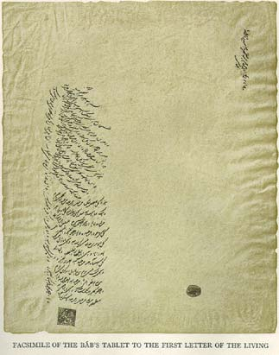
Figure 1: Tablet of the Báb to the First Letter of the Living - Mullá Ḥusayn-i-Bushru'i (Bahá'í Media)

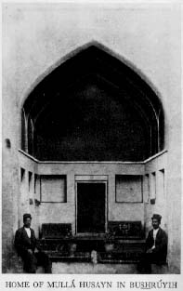
Figure 2: Old View of the House of Mullá Ḥusayn (Bahá'í Media)

Introduction

His full name was Mullá Ḥusayn-i-Bushrú’í. According to the oriental form of that time to form the names: Mullá, for being a priest and scholar of theology and Muslim law; Ḥusayn by birth name, and Bushrú’í for being a native of Bushrúyih, a village in the province of Khurásán, at the eastern end of Iran. He was born around the year 1813.

His father, Ḥájí Mullá ‘Abdu’lláh was a wealthy cloth dyer. Mullá Ḥusayn’s mother was a devoted and gifted poetess. Three of their five children would become outstanding believers.

For nine years, since he was eighteen years old, Mullá Ḥusayn sat at the feet of the wise Siyyid Káẓim in Karbilá in 'Iráq. He became one of the most esteemed and beloved students. Siyyid Káẓim, had dedicated himself to cultivating the minds and hearts of his disciples about the advent of the divine Messenger that all the religions of the past had promised. Mullá Ḥusayn is also known by his designation as the Bábu’l-Báb, the Gate of the Gate. Many believers just called him báb.

Mullá Ḥusayn, the Bábu'l-Báb holds a singular station in the Cause of the Báb because of his services and devotion, as discussed in chapter eight. Of him Bahá’u’lláh had said:

Among them was Mullá Ḥusayn, who became the recipient of the effulgent glory of the Sun of divine Revelation. But for him, God would not have been established upon the seat of His mercy, nor ascended the throne of eternal glory.

His days were spent traversing the dusty roads and the ancient cities of the kingdom of Persia, all leading to his glorious spiritual victory at Shaykh Ṭabarsí, an old religious sanctuary precariously converted into a fort. The astounding events that took place there during 1848-1849 spread like wildfire among all the people of his country and became a source of inspiration for poets and writers.
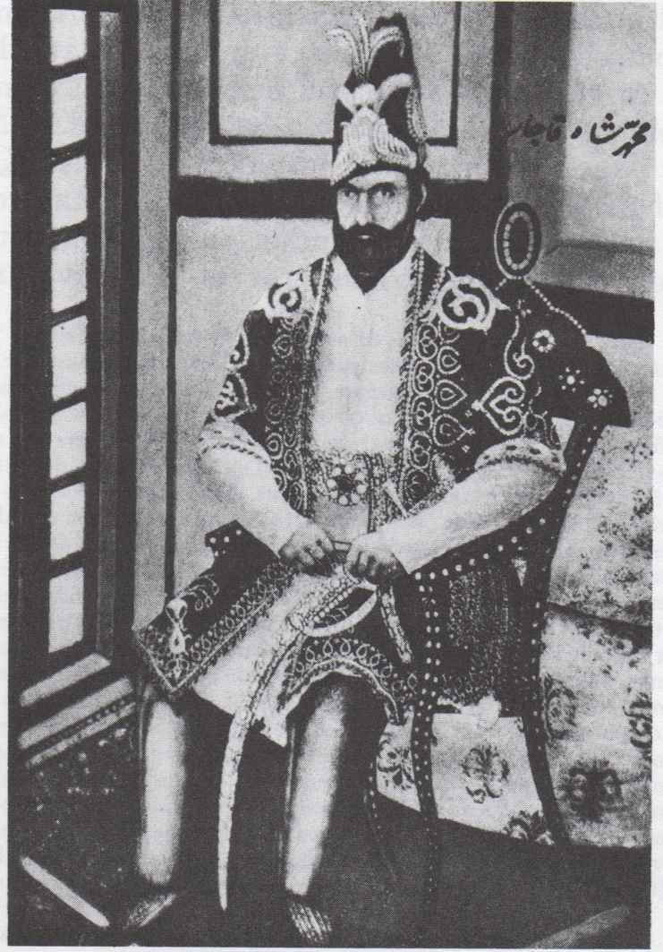
Figure 3: Portrait of Muḥammad Sháh (Bahá'í Media)

Shoghi Effendi highlighted his role in Shaykh Ṭabarsí:

The audacity of Mullá Ḥusayn who, at the command of the Báb, had attired his head with the green turban worn and sent to him by his Master, who had hoisted the Black Standard, the unfurling of which would, according to the Prophet Muḥammad, herald the advent of the vicegerent of God on earth, and who, mounted on his steed, was marching at the head of two hundred and two of his fellow-disciples to meet and lend his assistance to Quddús in the Jazíriy-i-Khaḍrá (Verdant Isle)—his audacity was the signal for a clash the reverberations of which were to resound throughout the entire country.
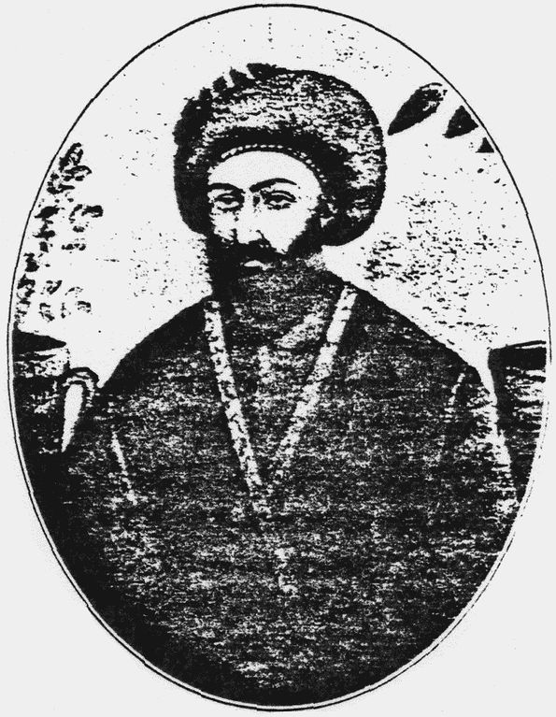
Figure 4: Portrait of Siyyid Káẓim (Bahá'í Media)

The lion-hearted

The life of this hero of God always revolved around always fulfilling the pleasure of his Best-Beloved. At his passing on 2 February 1849, Mullá Ḥusayn’s name was fully robed in glory becoming a celebrated personage in the annals of the world’s religions. Endowed with unparalleled heroism, a shrewd judgment and consummate wisdom, he was able to enthuse and empower his co-religionaries into service to the Cause of the Báb.

Gifted also with a virtuosity full of purity and a spiritual power worth of admiration by all, Mullá Ḥusayn was admired even by those who declared themselves to be his adversaries. With a heart yearning to please his Lord, he set out to conquer the citadels of people’s hearts and enlist them for the promotion and defence of the Cause. So great and genuine was the devotion that radiated from him and so unassailable the power of his oratory that his dynamic presence in any place where he passed through ignited intense interest and immediately became the focus of attraction. Even the most indifferent of the people were moved by the fervour of those sentiments. His fidelity was reflected in his actions, words, enthusiasm and oratory in promoting the Cause of the Báb, rapidly enlightened the spirits of any listener, spectator or audience. As the Báb had affirmed:

Let not the deeds of those who reject the Truth shut you out as by a veil. Such people have warrant over your bodies only, and God hath not reposed in them power over your spirits, your souls and your hearts.

Even the clergy slightly yielded their resistance and opposition to the preaching and mature knowledge he held, despite the Bábu’l-Báb publicly denouncing their vices and immoral practices. His overwhelming utterance, full of irrefutable proofs and arguments, easily defeated the few remaining opponents who still dared to challenge him. As seen in the previous accounts, streams of seekers came looking for him, swearing allegiance to the Cause he professed. From whatever condition they came from, Mullá Ḥusayn’s activities had prompted them to pursue with equal zeal and tenacity the dissemination of the seeds of Truth.
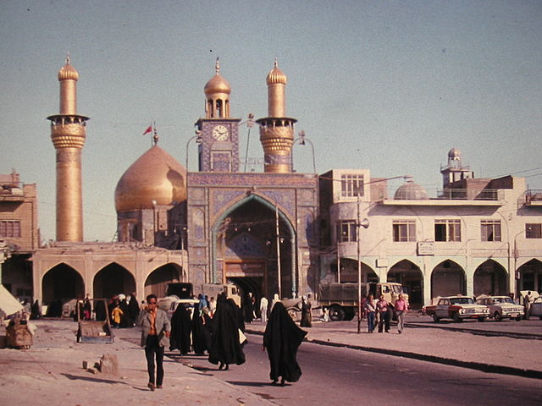
Figure 5: The city of Karbilá (Public domain)

From Mullá Ḥusayn’s point of view, every person, regardless of rank or social background, should have the opportunity to hear how he himself became enlightened with the teachings of the Báb. On his travels, he carried manuscripts and copies of the revelation of the Báb. With those sacred writings, he addressed prominent ecclesiastical authorities and government officials throughout the country. Adolfo Rivadeneyra (1841-1882), a Spanish diplomat in Persia and an Orientalist, compared Mullá Ḥusayn to Saint Paul because of his intense missionary zeal. The Báb had told him at the farewell:

Even as the cloud that rains its bounty upon the earth, traverse the land from end to end, and shower upon its people the blessings which the Almighty, in His mercy, has deigned to confer upon you.

When Mullá Ḥusayn entered a mosque, disregarding those present, he would go up to the pulpit and begin to announce the Good News proclaimed from Shíráz. Without considering the danger with which an extremely cruel, fanatical and at the same time degraded clergy harassed him, he continued to urge the population to approach and drink from the same Source of Life. He took advantage of the slightest opportunity to talk about the Manifestation of God; It was like a fire that unexpectedly ignites at night during the city's sleep and ends up engulfing itself in flames. As the Báb had written:

Regard not the all-sufficing power of God as an idle fancy. It is that genuine faith which thou cherishest for the Manifestation of God in every Dispensation. It is such faith which sufficeth above all the things that exist on the earth, whereas no created thing on earth besides faith would suffice thee.

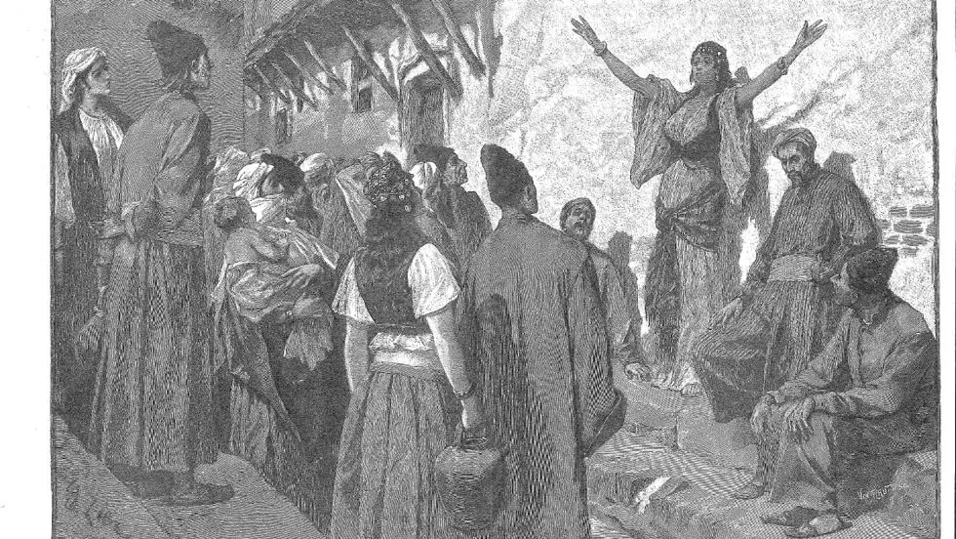
Figure 6: Drawing by Edouard Zier, who imagines Ṭáhirih in public without a veil (Journal des Voyages, June 5, 1892)

Dr Farzam Arbab, former member of the Universal House of Justice, once recalled:

A Hand of the Cause once taught me how Mullá Ḥusayn, that immortal hero of our Faith, had written some stanzas of a poem on a wall in his house. The poet begins by saying: “True men have obtained their achievements only by great efforts” and then turning to himself, he asks: “What do you think, O feeble creature, who spends your time entirely in taking care of yourself?”

The Guardian of the Faith called him the “lion-hearted Mullá Ḥusayn”. This was because he was undoubtedly daring in his interventions, impetuous and fierce in promoting the message he purposed and was irrepressible and with skill, courage and dexterity, he proposed himself to win victories for the Cause of God. Like a majestic lion roaring in a thicket the Bábu’l-Báb created confusion chiefly among the faint-hearted and an intense animosity among those who wished him ill, as they were apparently convinced of Mullá Ḥusayn’s superior merits. He showed every sign of being at the head of a host of angels. Fearless and unyielding, he lashed out scathingly and those tenets long regarded as fundamental truths of religion and declared them to be false.

His life principles were high and noble. He considered that his teaching his religion was itself a service to his nation and his fellow citizens. His determined character and achievements, however, did not detract him from revealing his soft and delicate nature, so that these two personality facets together added an uniquely brilliant shine. Mullá Ḥusayn also had a marked affinity for poetry and developed keen literary judgment and taste.

The Báb revealed in honour of Mullá Ḥusayn, “eulogies, prayers and visiting Tablets of a number equivalent to thrice the volume of the Qur’án”. The Báb had also stated that the dust of Mullá Ḥusayn’s grave, in Shoghi Effendi’s words, “was so potent as to cheer the sorrowful and heal the sick".

When the Báb learned about the deaths of Quddús and Mullá Ḥusayn, He became so desponded and downhearted that stopped revealing for five months. Later, the Báb recommenced His work around November-December 1849 and commissioned Sáyyah to set out on pilgrimage on His behalf to visit the graves of the martyrs of Shaykh Ṭabarsí. “Bring back to Me”, the Báb stated, “as a remembrance of your visit, a handful of that holy earth which covers the remains of My beloved ones, Quddús and Mullá Ḥusayn.”
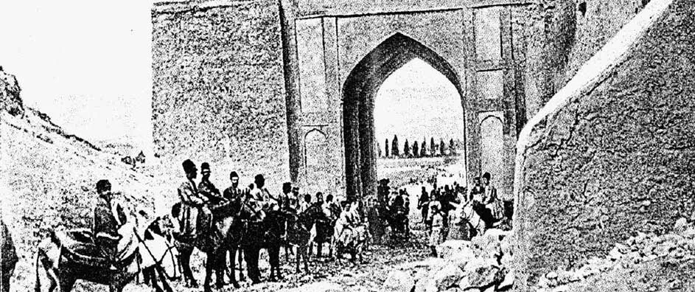
Figure 7: Old Gate to Shíráz (Bahá'í Media)

The family of Mullá Ḥusayn

Mullá Ḥusayn never got married. We know that Siyyid Káẓim offered him his daughter's hand in marriage. However, the proposition was respectfully declined as Mullá Ḥusayn had something else in mind for his future, as seen in this book.

Mullá Ḥusayn, like the eye of the storm, dragged the other members of his family into the maelstrom—the depth of her relatives' feelings we could hardly fathom and adequately describe.

The services of Mullá Ḥusayn's mother and sister also need to be highlighted. To the latter, Bahá'u'lláh bestowed the title of Varaqatu’l-Firdaws (the Nightingale of Paradise), and by this name, she was better known in the Bábí community.

It is well known that the glorious history of our Cause, from its earliest days to the present, has been built in significant proportion by the courageous deeds of women. Among them are Ṭáhirih (The Pure One), the most outstanding woman in the Faith of the Báb and a poetess and heroine.

At the end of 1843, this lady made up the pretext of going to Karbilá and visiting its holy places when she intended to meet Siyyid Káẓim. Her father and her husband, both well-known priests from her hometown (Qazvín), gladly agreed to her request, and so she was able to leave for Karbilá.

Great was her sadness and disappointment when upon arrival, she learned of the death of the wise man. In brief, she recovered, and with determination, she devoted herself to directing the classes of Siyyid Káẓim. At this point in Ṭáhirih’s life, the figures of Mullá Ḥusayn’s mother and sister appear. To the latter, Bahá'u'lláh bestowed the title of Varaqatu’l-Firdaws (the Nightingale of Paradise), and by this name, she was best known in the Bábí community.

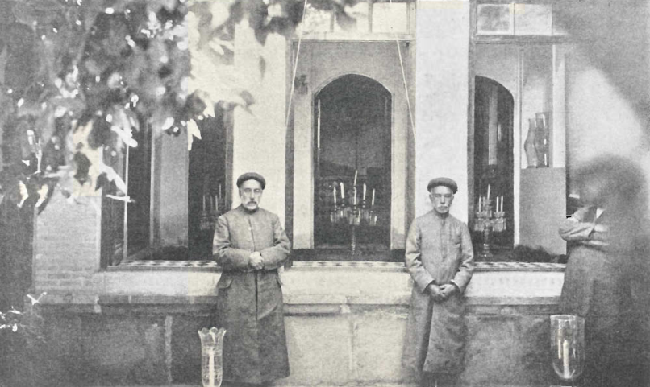
Figure 8: House of the Báb, 1920's (Bahá'í Media)

Through Varaqatu’l-Firdaws, Ṭáhirih came to associate in Karbilá with another pious woman named Shams-i-Ḍuḥá by Bahá’u’lláh. She also stood out as a distinguished female personality in the Cause of the Báb. His title means the Morning Sun, and he did justice to his designation as all recognized the quality of his character. Even Muslims called her the Bahá’í Lady of Light. She was the wife of an admired believer and their son was nominated as the King of Martyrs.

The Cause of God witnessed in the early years a formidable association and drive with these four outstanding ladies: Varaqatu’l-Firdaws, her mother, and also of Mullá Ḥusayn, Ṭáhirih and Shams-i-Ḍuḥá. Detachment, sacrifice, courage, purity and consecration are all their attributes.

We must remember for a moment that in the East, particularly at that time, women were relegated to a position inferior to men and treated with great prejudice, denying them access to social rights as we now understand them. Seeing these four women walking alone and teaching a Cause that otherwise was a reason for severe religious conflict does not stop admiring us greatly.

Unsurprisingly, when Ṭáhirih accepted and openly and resolutely proclaimed the new Revelation, a great tumult broke out among various sectors of the city, especially among those counted as unable to overcome her skill and wisdom.

The mob, inflamed and roused, moved in a mob to his house, arrived, broke down the door and by mistake took Shams-i-Ḍuḥá who was there at that moment. They blindly immediately took her out of the house, dragged her through the streets and made her the object of ridicule and insults from the fanatical population.

Amidst all this tumult the voice of a government official could be heard informing that Ṭáhirih had been arrested and another woman had been wrongly seized. At that moment, the crowd stopped mistreating Shams-i-Ḍuḥá.

Ṭáhirih 's arrest took too long because the Karbilá authorities decided to wait for instructions from Baghdád and Constantinople before proceeding. In these cities was located the headquarters of the government of the Sultan of Turkey.

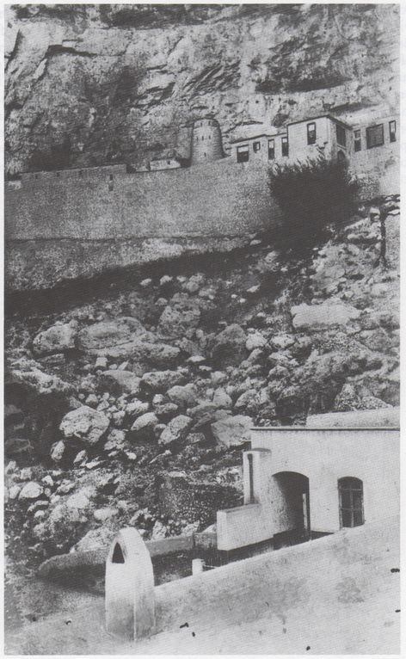
Figure 9: The Castle of Máh-Kú (Bahá'í Media)

Ṭáhirih, seeing the delay with which the authorities were taking a decision, bravely offered to go to Baghdád on her own and receive the orders there. Without much trouble, she was given the respective permission to leave Karbilá together with Varaqatu'l-Firdaw, his mother and Shams-i-Ḍuḥá. His departure was accompanied by stoning attacks from fans along with his insults.

When they arrived in Baghdád, they stayed with a certain Shaykh Muḥammad-i-Shibl, from whose place where they once again endeavoured with all their energy and zeal to propagate the teachings of the Faith of the Báb. However, it did not take long for the activity and presence of these souls to be felt, and, as in Karbilá, the conservative sectors raised their voices in protest, awakening a general outcry throughout the population. The commotion and the apprehension of these ladies for any eventual aggression by the mob made them move to a residence owned by Ṭáhirih's family. However, things took on more force, and the public protest encouraged by the priests grew a lot, so the Muftí (Judge) took action and ordered them transferred to his own house. They stayed there for three months, always taking advantage of the days to spread the seeds of the Faith.

These conditions were maintained until the government order forced them to leave Sultan's territory since Karbilá, Baghdad and Constantinople were located in the domain of this monarch. In this way, they had to undertake the long journey back to Persia. To his satisfaction, they had already done much work.

Varaqatu'l-Firdaws, the sister of Mullá Ḥusayn, was the wife of Shaykh Abú-Turáb-i-Qazviní. Before he was a Bábí, he had been a noted disciple of Siyyid Káẓim and, in time, a distinguished servant of the Báb and Bahá’u’lláh.

At the beginning of the Faith of the Báb, this brother-in-law of Mullá Ḥusayn thought to hide his beliefs despite his great love for the Báb. However, later, his activities were enough for him to be recognized, being denounced for this reason. Years later, he was arrested in the Síyáh Chál, the same prison where Bahá’u’lláh was imprisoned, and there he died.

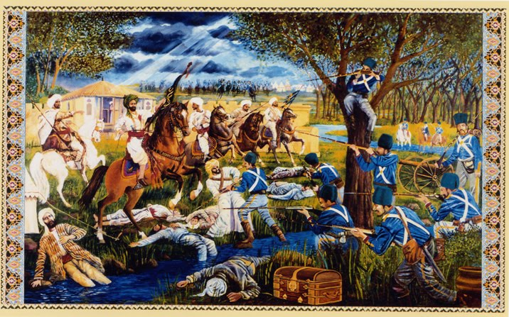
Figure 10: The defenders of Shaykh Ṭabarsí (courtesy of Ivan Lloyd).

According to a testimony of someone who knew him:

[He] was a scholar and philosopher such at is rarely met with and believed with the utmost sincerity and purity of purpose, while such was his love and devotion to the Báb that if anyone did so much as mention the name of His Supreme Holiness (the souls of all beside him be His sacrifice) he could not restrain his tears. Often have I seen him, when engaged in the perusal of the writings of His Supreme Holiness, become almost beside himself with rapture, and nearly faint with joy. Of his wife he used to say: "I married her three years ago in Karbilá. She was then but an indifferent scholar even in Persian, but now she can expound texts from the Qur’án and explain the most difficult questions and most subtle points of the doctrine of the Divine Unity in such wise that I have never seen a man who was her equal in this, or in readiness of apprehension. These gifts she has obtained by the blessing of His Holiness the Supreme and through converse with her holiness the Pure (Qurratu'l-‘Ayn). I have seen in her a patience and resignation rare even in the most self-denying men, for during these three years, though I have not sent her a single dinar for her expenses and she has supported herself only with the greatest difficulty, she has never uttered a word; and now that she has come to Ṭihrán, she refrains altogether from speaking of the past, and though, in accordance with the wishes of Jináb-i-Bábu’l-Báb [Mullá Ḥusayn], she now desires to proceed to Khurásán, and has literally nothing to put on save one well-worn dress which she wears, she never asks for clothes or travelling-money, but ever seeks reasonable excuses wherewith to set me at my ease and prevent me from feeling ashamed. Her purity, chastity, and virtue are boundless, and during all this while no unprivileged person hath so much as heard her voice.

Mullá Ḥusayn's mother also became a staunch servant of the Cause. It is enough to know that her sons Mullá Ḥusayn and Mírzá Muḥammad Ḥasan Khán, her grandson Muḥammad Báqir and two of her sons-in-law won for themselves the glorious palms of martyrdom, to understand what that woman, mother and believer, endured until the rest of her days. Her life is a lesson in complete surrender.

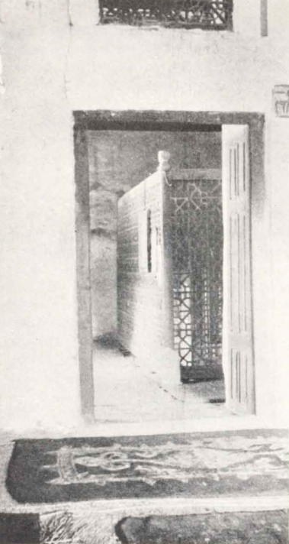
Figure 11: Doorway to inner Shrine of Shaykh Ṭabarsí where Mullá Ḥusayn is buried (Bahá'í Media)

Mírzá Ḥusayn of Hamadán, a notable historian of the Faith, wrote concerning the mother of Mullá Ḥusayn, the following account he heard from another person:

But the virtues of the daughter were surpassed by those of the mother, who possessed rare attainments and accomplishments, and had composed many poems and eloquent elegies on the afflictions of her sons. Although Jináb-i-Bábu'l-Báb had warned her of his approaching martyrdom and foretold to her all the impending calamities, she still continued to exhibit the same eager devotion and cheerful resignation, rejoicing that God had accepted the sacrifice of her sons, and even praying that they might attain to this great dignity and not be deprived of so great blessedness. It is indeed wonderful to meditate on this virtuous and saintly family, the sons so conspicuous for their single-minded devotion and self-sacrifice, the mother and daughter so patient and resigned.

Mírzá Muḥammad Ḥasan Khán and Mírzá Muḥammad Báqir, Mullá Ḥusayn's brother and nephew, respectively, were both his companions during all his travels, except for the pilgrimage he once undertook to Máh-Kú where the Báb was imprisoned.

They travelled together from the time of Siyyid Káẓim, were also in Shíráz on the night of the historic meeting with the Báb on May 22, 1844, were conferred the rank of Letters of the Living, and continued serving indefatigably until they sacrificed their lives in the Fort of Ṭabarsí in the first half of 1849.

An eyewitness left the following heart-wrenching account of the farewell to the fort and the death of Mullá Ḥusayn’s nephew

When the companions were leaving the fort, we all went to the tomb of Mullá Ḥusayn to say farewell to him. We all were weeping. And when at last we started to go, little Mírzá Muḥammad-Báqir [Mullá Ḥusayn’s nephew] did not want to leave the tomb. He embraced it and wept bitterly.

The companions tried to separate him but he would not agree, and said that he would never leave that tomb. We told Quddús about it and, as he had already mounted his horse, he ordered us to mount him and take him with us. They put him on a horse, but after a short ride he fainted and fell down. When he recovered his senses, we mounted him on a horse in the second line with Mullá Yúsif-i Ardibílí [a Letter of the Living], but he fell again, and died. Quddús, on seeing this, instructed us to carry his body as far as the bathhouse of Dizvá, where it was washed and buried.

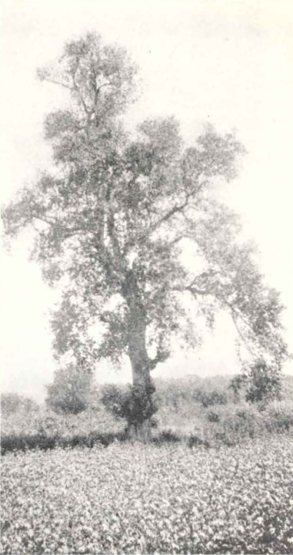
Figure 12: Tree from which Mullá Ḥusayn was shot (Bahá'í Media)

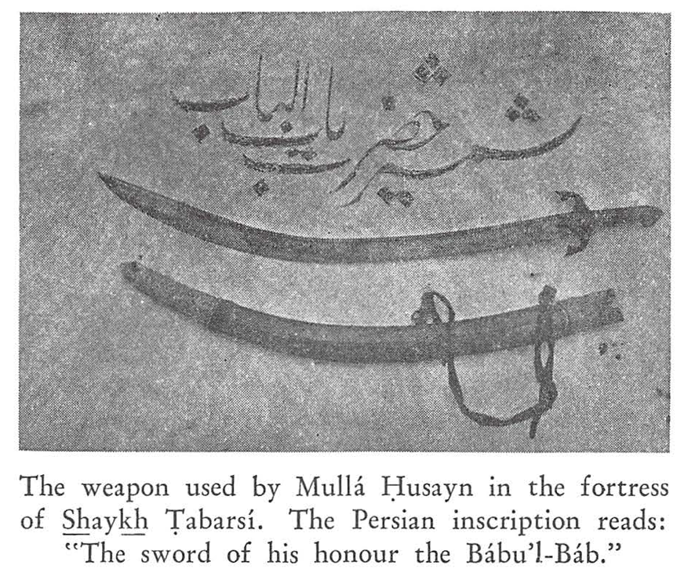
Figure 13: The sword of Mullá Ḥusayn (Bahá'í Media
Regarding this brother of Mullá Ḥusayn, we must note that when that massacre of the Bábís took place, he was chained and later executed. The same narrator quoted above noted:

When I, Mírzá Jání, met Mírzá Muḥammad-Ḥasan, he was but seventeen years of age, yet I observed in him a dignity, gravity, composure, and virtue which amazed me. After the death of Jináb-i-Bábu’l-Báb, His Holiness Quddús bestowed on him the sword and turban of that glorious martyr, and made him captain of the troops of the True King. As to his martyrdom, there is a difference of opinion as to whether he was slain at the breakfast-table in the camp, or suffered martyrdom with Jináb-i-Quddús in the square of Bárfurúsh.

Another notable family member martyred in the same circumstances was Mullá Ḥusayn’s brother-in-law. According to Nabíl's testimony, he was the father of Mírzá ‘Abu'l-Ḥasan and Mírzá Muḥammad Ḥusayn and, when this outstanding storyteller was writing his work (1887-1888), Varaqatu’l-Firdaws was under the care of these two souls.

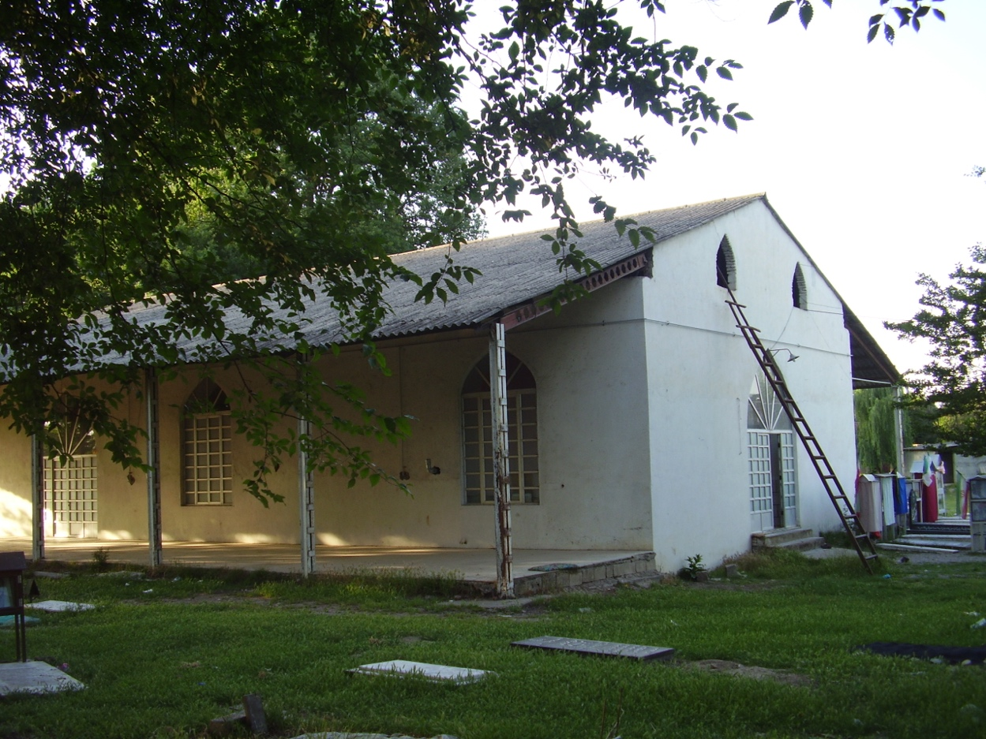
Figure 14: Modern photo of Shaykh Ṭabarsí (Bahá'í Media)

Bibliography

‘Abdu’l-Bahá. Memorials of the Faithful. Wilmette, IL: Bahá’í Publishing Trust, ed. 1971.
Arbab, Farzam. En camino hacia la gloria del servicio. Asamblea Espiritual Nacional de los Bahá’ís de Colombia.
Bahá’u’lláh. The Kitáb-i-Íqán. Wilmette, IL: US Bahá’í Publishing Trust, 1989.
Hamadání, Mírzá Ḥusayn, ed. and trans. Edward G. Browne. The New History (Tarikh-i-Jadid) of Mirza 'Ali Muhammed, the Bab. Amsterdam: Philo Press, 1975.
Mehrabkhani, Ruhollah. Mullá Ḥusayn: Disciple at Dawn. Los Angeles: Kalimát Press, 1987
Nabíl-i-A‘ẓam. The Dawn-Breakers: Nabíl’s Narrative of the Early Days of the Bahá’í Revelation. Wilmette, IL: Bahá’í Publishing Trust, 1970.
Nabíl-i-A‘ẓam. The Dawn-Breakers: Nabíl’s Narrative of the Early Days of the Bahá’í Revelation. Wilmette, IL: Bahá’í Publishing Trust, 1970.
Rivadeneyra, Adolfo. Viaje and Interior de Persia, vol. 1. Madrid: Imprenta y estereotipia de Aribau y ca, 1880.
Shoghi Effendi. God Passes By. Wilmette, IL: Bahá’í Publishing Trust, ed. 1979.
The Báb. Selections from the Writings of the Báb. Bahá’í World Centre, 1982.

Acknowledgment: I would like to thank Ernie and Diana Jones for their editorial assistance.

Bahá’u’lláh. The Kitáb-i-Íqán, p. 223.
Shoghi Effendi. God Passes By, p. 38.
The Báb. Selections, pp. 161–162.
Adolfo Rivadeneyra. Viaje and Interior de Persia, vol. 1, p. 239.
The Báb in Nabíl-i-A‘ẓam. The Dawn-Breakers, p. 85.
The Báb. Selections, p. 193.
Farzam Arbab. En camino hacia la gloria del servicio. Asamblea Espiritual Nacional de los Bahá’ís de Colombia.
Shoghi Effendi. Dios Pasa, p. 120.
Shoghi Effendi. God Passes By, p. 50.
Shoghi Effendi. God Passes By, p. 50.
Nabíl-i-A‘ẓam. The Dawn-Breakers, pp. 4031-432
Ruhollah Mehrabkhani. Mullá Ḥusayn, p. 50.
‘Abdu’l-Bahá, Memorials of the Faithful, p. 173-174.
The Taríkh-i-Jadíd pp. 93-95, cited in Nabíl-i-A‘ẓam, The Dawn-Breakers, p. 383-384.
The Taríkh-i-Jadíd pp. 93-95, cited in Nabíl-i-A‘ẓam, The Dawn-Breakers, p. 384.
According to Ruhollah Mehrabkhani, Mírzá Muḥammad-Báqir was perhaps twenty-two years old (Mullá Ḥusayn, p. 284).
Mírzá Abú Ṭálib-i Shahmírzadí, cited in Ruhollah Mehrabkhani, Mullá Ḥusayn: Disciple at Dawn, pp. 284-285.
The Taríkh-i-Jadíd pp. 93-95, cited in Nabíl-i-A‘ẓam, The Dawn-Breakers, p. 383.

