Siyyid Yaḥyá-i-Dárábí
Entitled
Vaḥíd “The Incomparable”

by Boris Handal

2023

Table of Contents

1 - The Commissioner of Muḥammad Sháh 1
2 - Bahá'u'lláh and Vaḥíd in Tehran 7
3 - The Episode of Yazd 11
4 - From Yazd to Nayríz 17
5 - The Episode of Nayríz (May-June 1850) 21
6 - The Martyrs of Nayríz 26
7 - Vaḥíd, the Incomparable 29
Bibliography 32

1 - The Commissioner of Muḥammad Sháh

Siyyid Yaḥyá-i-Dárábí, called Vaḥíd, was born in the village of Dáráb near Shíráz, within the Persian province of Fárs.

Vaḥíd in Arabic means exclusive, singular, unique; matchless, unequalled or incomparable.

His family was of noble lineage. His father, Siyyid Ja'far, was a descendant of the Prophet Muḥammad and, at the same time, a character well recognised for his pious character and extensive culture, especially within the philosophical and religious fields. Due to his fame and merits, he earned the name Káshfí, which means discoverer.

Vaḥíd's family was also the possessor of vast wealth. Their possessions extended to three palaces, one in Yazd, another in Nayríz and one more in Dáráb; all luxuriously furnished. As a gifted child, Vaḥíd gave his relatives surprising evidence of having inherited the qualities of his father and of his teacher, winning the respect and admiration that was accorded to his father.

'Abdu'l-Bahá has said of him that he "had committed to memory no less than thirty thousand traditions and was highly esteemed and admired by all classes of people. He had achieved universal renown in Persia, and his authority and erudition were widely and fully recognised."

For some years Vaḥíd had settled in the capital of Tehran and continued to develop these gifts, being able to connect with the sovereign Muḥammad Sháh and have contact with the royal court and important officials of the kingdom.

The sovereign and his prime minister held him in high regard. Due to his high standards of rectitude, knowledge and trustworthiness, he was entrusted with a very prestigious mission, which became his approach to the Cause of God.

As we will discuss, Vaḥíd became one of the most beloved disciples of the glorious Báb. When Vaḥíd was thirty-five years old, the new Movement proclaimed from Shíráz began to show signs of a wonderful power of growth, and in the eyes of its opponents its penetrating influence threatened to spread rapidly to entire cities and different social strata.

The appearance of the Báb's teachings brought into question the fundamental principles of the old Muslim orthodoxy and ignited a spark causing great commotion among the Muslim clergy and they decided to bring it to a stop at all costs, resulting in many disturbances throughout the country which eventually reached the attention of the monarch.

Muḥammad Sháh chose Vaḥíd from all of the people under his dominion to proceed to Shíráz, the centre of the flourishing Faith, and on his behalf to inquire into the nature and scope of the Báb's Revelation.

The monarch communicated the confidential nature of the mission entrusted to him through Mírzá Luṭf-'Alí, the master of ceremonies of the court who was the host of Vaḥíd in his own house on behalf of the king.

Vaḥíd set out for Shíráz to personally meet with the Báb and ascertain the necessary information to arrive at a conclusion as to the validity of the Báb's claims and send a report to the sovereign.

However, the next few days would demonstrate the overwhelming effect that the Manifestation of God-—the Báb—would have on the heart of Vaḥíd during three interviews until He had captivated his being.

The first of these audiences was held in the house of Ḥájí Mírzá Siyyid 'Alí, the uncle of the Báb. Vaḥíd’s expectation of this meeting was for him to ask the Báb the intricate questions he had prepared beforehand, as he had in mind to find some weak points within His teachings. However, the answers he received, brilliant for their conciseness, erudition and simplicity, turned the initial pride with which he had entered the audience into humiliation.

Realising his inferiority, Vaḥíd nonetheless vowed to continue, raising certain theological issues of abstruse understanding to be clarified. As Vaḥíd prepared to begin his interrogation, he was surprised that what he had planned to ask had suddenly been erased from his memory. His astonishment increased when the Báb began to give him a complete elucidation of each of the questions he proposed to ask.

Completely confused by such a powerful confirmation of the beautiful and superhuman power of the Báb, he decided to retire to try to put his thoughts in order. Vaḥíd recalled those moments:

I resolved that in my third interview with the Báb, I would in my inmost heart request Him to reveal for me a commentary on the Súrih of Kawthar. I determined not to breathe that request in His presence. Should he, unasked by me, reveal this commentary in a manner that would immediately distinguish it in my eyes from the prevailing standards current among the commentators on the Qur’án, I then would be convinced of the Divine character of His Mission, and would readily embrace His Cause. If not, I would refuse to acknowledge Him. As soon as I was ushered into His presence, a sense of fear, for which I could not account, suddenly seized me. My limbs quivered as I beheld His face. I, who on repeated occasions had been introduced into the presence of the Sháh and had never discovered the slightest trace of timidity in myself, was now so awed and shaken that I could not remain standing on my feet. The Báb, beholding my plight, arose from His seat, advanced towards me, and, taking hold of my hand, seated me beside Him.’

“Seek from Me,” the Báb said, “whatever is your heart's desire. I will readily reveal it to you.” I was speechless with wonder. Like a babe that can neither understand nor speak, I felt powerless to respond. He smiled as He gazed at me and said: 'Were I to reveal for you the commentary on the Súrih of Kawthar, would you acknowledge that My words are born of the Spirit of God? Would you recognise that My utterance can in no wise be associated with sorcery or magic?' Tears flowed from my eyes as I heard Him speak these words.

All I was able to utter was this verse of the Qur'án: 'O our Lord, with ourselves have we dealt unjustly: if Thou forgive us not and have not pity on us, we shall surely be of those who perish.'

It was still early in the afternoon when the Báb requested Ḥájí Mírzá Siyyid 'Alí to bring His pen-case and some paper. He then started to reveal His commentary on the Súrih of Kawthar. How am I to describe this scene of inexpressible majesty? Verses streamed from His pen with a rapidity that was truly astounding. The incredible swiftness of His writing, the soft and gentle murmur of His voice, and the stupendous force of His style, amazed and bewildered me. He continued in this manner until the approach of sunset. He did not pause until the entire commentary of the Súrih was completed. He then laid down His pen and asked for tea. Soon after, He began to read it aloud in my presence. My heart leaped madly as I heard Him pour out, in accents of unutterable sweetness, those treasures enshrined in that sublime commentary. I was so entranced by its beauty that three times over I was on the verge of fainting. He sought to revive my failing strength with a few drops of rose-water which He caused to be sprinkled on my face. This restored my vigour and enabled me to follow His reading to the end.

Vaḥíd had then embraced the New Faith.

He fulfilled his obligation to make known to the imperial court, with a report, the experiences he had lived in the presence of the Báb. But he no longer desired to return to the imperial court. He understood at once and fully the greatness of the Cause which he had embraced, and with equal ease, he cast off his high position and became a travelling teacher of the Faith of the Báb.

Through these encounters, Vaḥíd gained unshakable confidence in the victory of the Cause of God and, full of this conviction, he rose above any obstacle with undaunted firmness at the service of his Lord.

However, the news of his conversion spread like wildfire. Being the most prominent and learned of his colleagues at court, some of them were in fear of the influence he could have on people of positions close to him.

The first obstacle Vaḥíd encountered was found in the residence where he was staying - in the house of the rapacious and bloodthirsty Ḥusayn Khán, governor of the province. This governor, realising that Vaḥíd continued to spend much of his time in the company of the Báb rather than associating with the regional and local dignitaries who came to greet him, sent the sovereign an explanatory letter slandering Vaḥíd.

Great was the governor’s surprise when the sovereign, in his reply, stated that "It is strictly forbidden to any one of our subjects to utter such words as would tend to detract from the exalted rank of Siyyid Yaḥyáy-i-Dárábí. He is of noble lineage, a man of great learning, of perfect and consummate virtue. He will under no circumstances incline his ear to any cause unless he believes it to be conducive to the advancement of the best interests of our realm and to the well-being of the Faith of Islam."

Although this epistle nominally nullified what the governor planned to do, he remained secretly bent on promoting discord.

At that time, Vaḥíd received a mandate from the Báb to go to Burújird to teach the Faith to his father. Consequently, he went to his father, who neither accepted nor rejected the Message but decided to go his own way. Vaḥíd also began teaching the Faith of the Bab in the Kurdistán region.

From then on, Vaḥíd began a series of extensive visits to different towns in the kingdom, vigorously spreading the teachings.

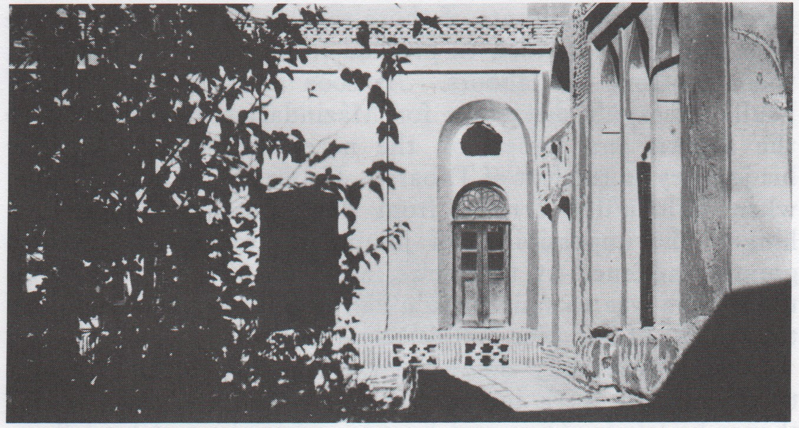
Figure 1: Vaḥíd's house at Yazd – Courtesy Bahá’í Media

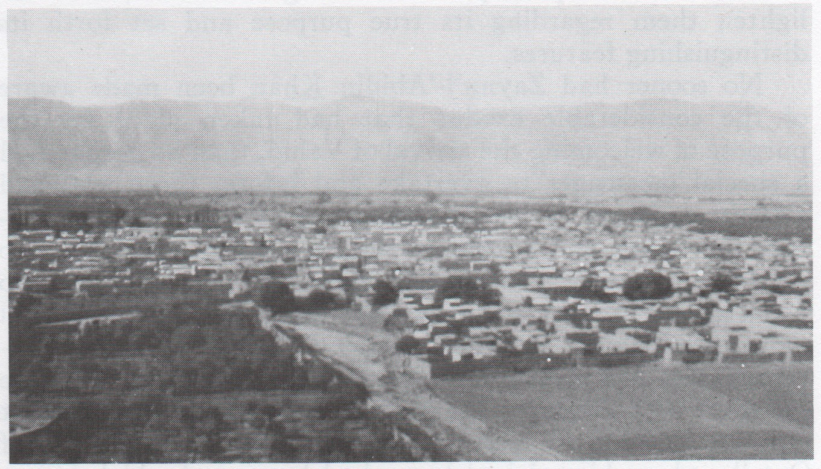
Figure 2: Panorama of Nayríz - Courtesy Bahá’í Media

2. Bahá'u'lláh and Vaḥíd in Tehran

During this itinerary Vaḥíd met Bahá'u'lláh in the capital.

This meeting happened at the time when the Blessed Beauty was then known to the people as Mírzá Ḥusayn 'Alí,since He had not yet received His mission as the Messenger of God.

However, at that time, He was known to the believers as Jináb-i-Bahá and His august figure, after the banishment and captivity of the Báb in the wild mountains of Ádhirbáyján, stood as the leader and inspiring force of persecuted Bábí community.

These groups of believers, still small and scattered throughout the length and breadth of Persian territory, believed sincerely in the Revelation of the Báb and were ready to shed their blood, given the occasion. Although they did not have a general knowledge of the Revelation, that is to say, they still lived within the precepts of the Muslim religion —their native faith— they nevertheless maintained a surprising firmness in His Cause.

By the time of Vaḥíd's visit to the capital, the tragic events of the Ṭabarsí Fort had already taken place, where Mullá Ḥusayn, Quddús and about five hundred Bábís had heroically withstood the combined military and ecclesiastical forces of the country until massacred through treachery.

This event convulsed the internal life of the domain and had become a real headache for the opponents of the New Faith. However, the massacre served to fan the fire that latently burned in the hearts of the Bábís to promote their doctrine. As this bloody struggle unfolded, believers flocked from different directions and offered to enlist in the ranks of Mullá Ḥusayn, as defenders of the Fort. There was the case of fathers and mothers who delivered their sons as sacrifices to the Cause of God.

Bahá'u'lláh was also among those who offered His help to the besieged companions. On His second attempt however, he was unable to carry out his wish in view of the deteriorated conditions at that time as a strict siege had been set up around the Fort. When trying to approach the Fort, Bahá'u'lláh was arrested and later mistreated and tortured.

Vaḥíd was also one of those preparing to join the ranks of the glorious Fort Ṭabarsí. When on his way through Tehran, he received the unfortunate news that all contact with his companions had been cut off, and he felt very sad, but only for a short time, because at that time, Bahá'u'lláh was returning from Tehran after His failed attempt to join the Fort defenders.

Although the news of the fate of the Bábís frustrated Vaḥíd’s desire to be of some special service to his Faith, his meeting with the Blessed Beauty turned frustration into great joy because he was also invited to be His guest, where he came to understand the true greatness of Bahá'u'lláh's station.

During this time, a prominent believer named Sayyáh came to Bahá'u'lláh's residence in Tehran. He was returning from a pilgrimage to the graves of Mullá Ḥusayn and Quddús at the request of the Báb. These two great Bábís had died as a consequence of the tragedy of the Fort of Ṭabarsí.

It was the middle of 1849 when Sayyáh's stay in Tehran took place, described by an eyewitness:

It was the depth of winter when Sayyáḥ, returning from his pilgrimage, came to visit Baha'u'llah. Despite the cold and snow of a rigorous winter, he appeared attired in the garb of a dervish, poorly clad, barefooted, and dishevelled. His heart was set afire with the flame that pilgrimage had kindled. No sooner had Siyyid Yaḥyáy-i-Dárábí, surnamed Vaḥíd, who was then a guest in the home of Baha'u'llah, been informed of the return of Sayyáḥ from the Fort of Ṭabarsí, than he, oblivious of the pomp and circumstance to which a man of his position had been accustomed, rushed forward and flung himself at the feet of the pilgrim. Holding his legs, which had been covered with mud to the knees, in his arms, he kissed them devoutly. I was amazed that day at the many evidences of loving solicitude which Baha'u'llah evinced towards Vaḥíd. He showed him such favours as I had never seen Him extend to anyone. The manner of His conversation left no doubt in me that this same Vaḥíd would ere long distinguish himself by deeds no less remarkable than those which had immortalised the defenders of the Fort of Ṭabarsí.

Sayyáḥ remained a few days in that home. He was, however, unable to perceive, as did Vaḥíd, the nature of that power which lay latent in his Host.

Another person of the time wrote:

When, after the lapse of some time I again had the honour of meeting Áqá Siyyid Yaḥyá [Vaḥíd] in Ṭihrán, I observed in his august countenance the signs of a glory and power which I had not noticed during my first journey with him to the capital, nor on other occasions of meeting, and I knew that these signs portended the near approach of his departure from the world. Subsequently he said several times in the course of conversation: ‘This is my last journey, and hereafter you will see me no more'; and often, explicitly or by implication, he gave utterance to the same thought.

'Abdu'l-Bahá, in His book Memorials of the Faithful, recounted how, as He was sitting as a very young boy on Ṭáhirih's lap, He listened to a discussion between this heroine and Vaḥíd, on the other side of the curtain. Undoubtedly there were other encounters in which they had the opportunity to be together.

Most likely, these meetings with Ṭáhirih were held in the house of Bahá'u'lláh, although she was a virtual prisoner in the residence of the mayor of the city, it is presumed that due to Bahá'u'lláh's social position, she was allowed to leave on certain occasions under His guarantee.

Lady Blomfield, who was present when 'Abdu'l-Bahá gave a talk in London mentioning the closeness of Bahá'u'lláh, Ṭáhirih and Vaḥíd, wrote years later: “He ['Abdu'l-Bahá], being a little boy, was sitting on the knee of Qurratu'l-'Ayn, who was in the private parlour of His mother, Asíyih Khánum, the door of this room being open, they could hear from behind the curtain, the voice of Siyyid Yaḥyáy-i-Dárábí, who was talking and 'arguing with my Father'.”
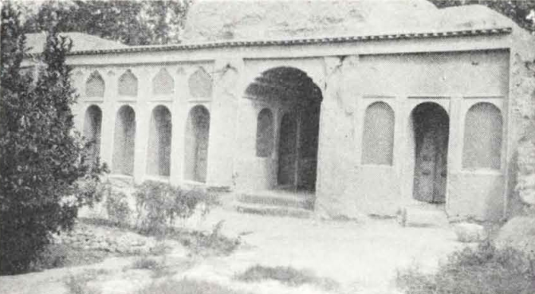
Figure 3: House of Vaḥid (Siyyid Yaḥyáy-i-Darabi) in Nayríz, Persia - Courtesy Bahá’í Media

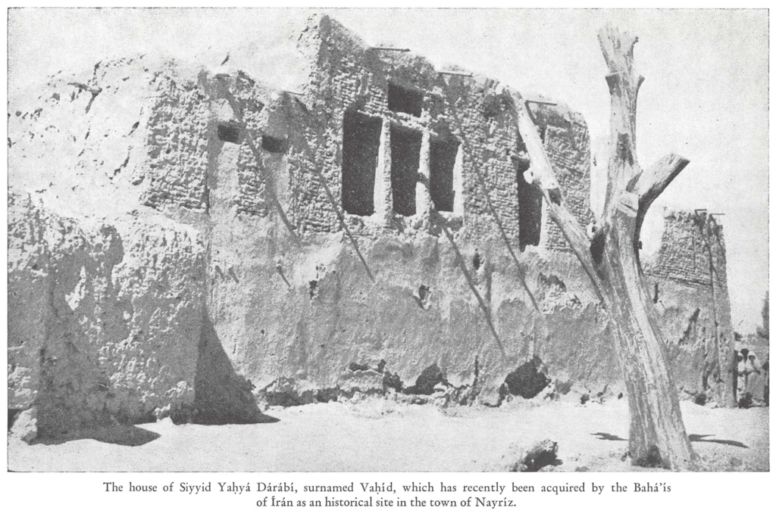
Figure 4: House of Vahid in Nayriz - Courtesy Bahá’í Media

3 - The Episode of Yazd

After his three interviews with the Báb, Vaḥíd needed no additional proof of the validity of His divine Mission and served Him with complete love and devotion. According to Vaḥíd‘s own testimony, the date of these interviews occurred within the months of April and May 1846.

Although Vaḥíd was endowed with magnificent knowledge, in the end it only served him to authoritatively proclaim the Báb’s Cause. Without hesitation, he would clarify this evidence in the eyes of the people, the court and the clergy. Undoubtedly, for many of them, any expression coming from his lips was considered the truth itself.

Vaḥíd decided to direct his steps from Tehran towards Yazd, a city where he had a luxurious residence. He visited Qazvín, Qum, Káshán, Iṣfahán, Ardistán and Ardikán, teaching the Faith of the Báb. During one of the visits to Qazvin, Vahid took the opportunity to visit the Báb in the prison of Máh-Kú:

Having stayed a while in Qazvín, however, Vahíd could no longer hold back his longing, and therefore he proceeded on foot to the mountainous citadel to behold once again his heart’s desire. This journey took place in the middle of winter and one can only imagine the joy and tranquility that such a visit brought to the heart and mind of Vahíd, and the excitement that stirred in the depths of his soul. Though we remain scantily informed of this arduous journey or of what transpired between Vahíd and the young prophet, we must note that it was the satisfaction engendered in this final visit that caused Vahíd to rededicate himself to the promotion of the faith and propelled him forward towards the next and final phase of his life.

Earlier, when completing the mission given to him by the king to investigate the teachings of the Báb, he passed through the city of Yazd, on which occasion he spoke publicly to the population explaining the reason for his journey to Shíráz. The people of Yazd, aware of his capabilities, had assured Vaḥíd that they would abide by whatever verdict he reached.

Vaḥíd's arrival to Yazd also coincided with the Feast of Naw Rúz and the anniversary of the Declaration of the Báb. He offered a splendid banquet at his residence to which the most important dignitaries and officials within the jurisdiction were invited.

They arrived in large numbers to welcome him, but the sumptuous reception was the cause of envy of more than one, particularly a certain Navváb —a prominent theologian— who maliciously argued that there was another purpose behind the hospitality other than the celebration of the National Festival of Naw-Rúz. Vaḥíd gave a shrewd and accurate response exposing his attitude, making him look ridiculous amid the audience's laughter.

But above all, Vaḥíd seized the moment to openly declare the Mission of the Báb, finally explaining how he had embraced His Cause and was inclined to spread it.

No one dared to refute his vast erudition, even less so when he lucidly explained the proofs and signs of the New Manifestation of God, inviting others to follow him. For forty days he opened his house in Yazd to meetings where he taught the Faith of the Báb.

A certain number of those present were moved to accept his teachings and become new Bábís. Others did not have a positive response and silently harboured resentment towards him and the Cause. Such bitterness later became evident when they condemned his presence in the city.

Vaḥíd continued unperturbed with his work and was surrounded by the faithful. In this house, he diligently attended to the numerous friends and believers who came from many different areas seeking his guidance.

However, his opponents were exacerbated by their inability to stop the growing ascendancy of Vaḥíd. One day, troops of the governor surrounded his house, the governor having been stirred up by the intrigues of Navváb. Despite this siege, Vaḥíd continued teaching from a window in the upper floor.

A mob had also joined the troops and tried to force the entrance to the house. A few minutes later the situation had become uncontrollable with even greater danger and the believers asked Vaḥíd for his advice. He replied to them:

This very sword that lies before me was given me by the Qá'im Himself. God knows, had I been authorised by Him to wage holy warfare against this people, I would, alone and unaided, have annihilated their forces. I am, however, commanded to refrain from such an act.
Pointing at the horse standing in front of his house, Vaḥíd remarked:

This very steed the late Muḥammad Sháh gave me, that with it I might undertake the mission with which he entrusted me, of conducting an impartial investigation into the nature of the Faith proclaimed by the Siyyid-i-Báb. He asked me to report personally to him the results of my enquiry, inasmuch as I was the only one among the ecclesiastical leaders of Ṭihrán in whom he could repose implicit confidence. I undertook that mission with the firm resolution of confuting the arguments of that siyyid, of inducing Him to abandon His ideas and to acknowledge my leadership, and of conducting Him with me to Ṭihrán as a witness to the triumph I was to achieve. When I came into His presence, however, and heard His words, the opposite of that which I had imagined took place. In the course of my first audience with Him, I was utterly abashed and confounded; by the end of the second, I felt as helpless and ignorant as a child; the third found me as lowly as the dust beneath His feet. He had indeed ceased to be the contemptible siyyid I had previously imagined. To me, He was the manifestation of God Himself, the living embodiment of the Divine Spirit. Ever since that day, I have yearned to lay down my life for His sake. I rejoice that the day I have longed to witness is fast approaching.

Soon thereafter the voice of a Bábí named Muḥammad 'Abdu'lláh, who was believed to have disappeared, was heard. He and other friends had dispersed the attacking forces shouting, "Yá Ṣáḥibu’z-Zamán!” (O Thou Lord of the Age!). In their haste, the troops had tried to take refuge in Fort Nárín.

Such an outstanding victory demonstrated the elevated spirit of those who followed Vaḥíd and their readiness to defend their Faith at any cost.

Vaḥíd then elaborated on the difficult circumstances that would take place in the future. He instructed Muḥammad 'Abdu'lláh to leave the city and thus avoid any confrontation that might further inflame the heated atmosphere.

Navváb meanwhile, seemingly unable to believe in the spiritual and moral superiority of the handful of believers rather than in their physical resistance, was preparing a stronger attack on the house. Vaḥíd, becoming aware of this turn of events, ordered one of those present to go through the streets of the city to proclaim the nature and purpose of the Revelation of the Báb and request the people to not attack Vaḥíd and his followers and to maintain a state of peace.

The impact produced by the eloquent address of that believer calmed the spirits and attracted the sympathy of a large number of people.

Soon thereafter, Muḥammad 'Abdu'lláh disobeyed Vaḥíd's orders to leave the city and instead had proceeded to Fort Nárín chasing the troops who were desperately seeking refuge. The obstinate Navváb, not giving up his initial designs, again provoked certain elements of the population, inducing them to fight against Muḥammad 'Abdu'lláh.

The evil governor took advantage of Muḥammad 'Abdu'lláh’s disobedience and sent another regiment to reinforce the attack on the group of inattentive believers, who came off badly from the pitched battle, with wounded Muḥammad 'Abdu'lláh being brought into the presence of Vaḥíd.

The angry mob also congregated at Vaḥíd's house, asking for the body of the Bábí. Given the seriousness of the situation, Vaḥíd determined to respond with a sortie consisting of seven believers he selected from around him, who hastily repelled the attack by shouting Alláh-u-Akbar (God is Most Great).

Once again, victory fell to the Bábís and demonstrated the overwhelming character of the Faith of the Báb. Vaḥíd immediately left Yazd with two of his four children, entrusting his wife to the other two. He also told the friends that they should disperse and leave the city.

When leaving his luxurious palace Vaḥíd foretold with much emotion of its final fate:

This palatial residence I have built with the sole intention that it should be eventually demolished in the path of the Cause, and the stately furnishings with which I have adorned it have been purchased in the hope that one day I shall be able to sacrifice them for the sake of my Beloved. Then will friend and foe alike realise that he who owned this house was endowed with so great and priceless a heritage that an earthly mansion, however sumptuously adorned and magnificently equipped, had no worth in his eyes; that it had sunk, in his estimation, to the state of a heap of bones to which only the dogs of the earth could feel attracted. Would that such compelling evidence of the spirit of renunciation were able to open the eyes of this perverse people, and to stir in them the desire to follow in the steps of him who showed that spirit!
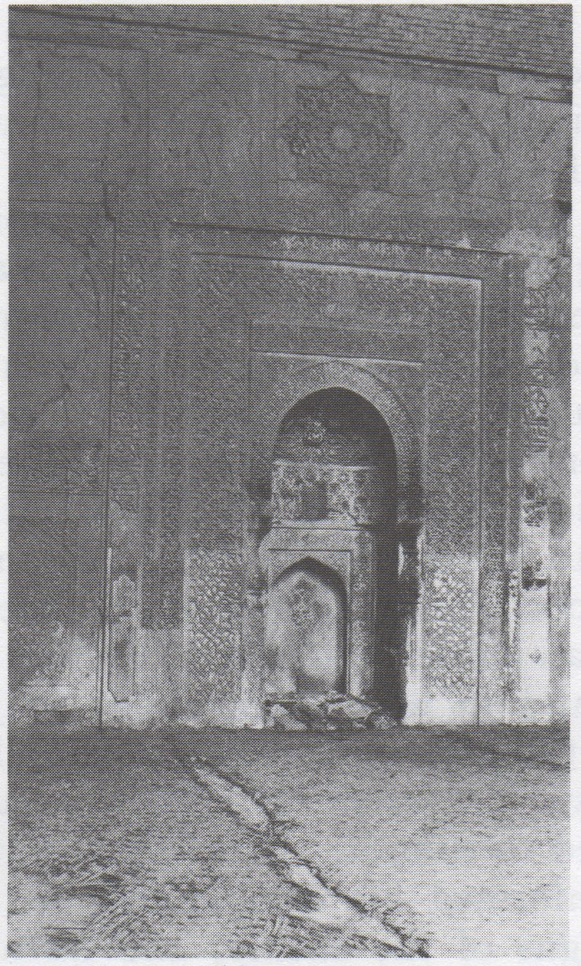
Figure 5: The Masjid-i-Jámi‘ at Nayríz, where Vaḥíd addressed the congregation- Courtesy Bahá’í Media

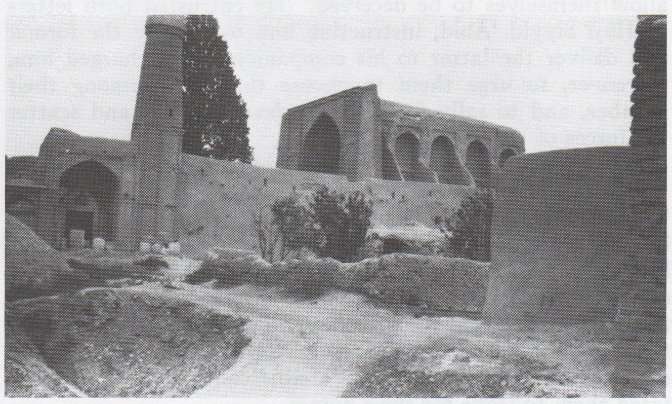
Figure 6: The Masjid-i-Jámi at Nayríz, where Vaḥíd addressed the congregation - Courtesy Bahá’í Media

4. From Yazd to Nayríz

Vaḥíd's departure from the city of Yazd was the signal for that uncontrolled mob to approach his house, storming it and finally leaving it in ruins —in the condition its owner had previously predicted.

Vaḥíd then departed to Nayríz, 364 kilometres away, in whose jurisdiction he owned another enviable mansion. People likewise praised his position and learning there.

Making his way through the wild mountains and walking long distances, he finally managed to take refuge in a small cave. He was travelling with two of his four sons. The cave was not far from the home of a brother of his, who provided him with the essential resources to continue the remaining march through the different villages that he would have to pass through until his arrival in Nayríz.

Vaḥíd's high spirit allowed him to decipher his destiny beyond what others could understand. On one particular occasion when he was preparing to leave Tehran for the last time, he told another believer: “The saints of God are able to foretell coming events, and I swear, by that loved One in the grasp of whose power my soul lies, that I know and could tell where and how I shall be slain, and who it is that shall slay me. And how glorious and blessed a thing it is that my blood should be shed for the uplifting of the Word of Truth!'"

Nabíl assures the existence of a Tablet of the Báb addressed to the believers of Nayríz in general. It was Vaḥíd who, upon his arrival, revealed the truths contained in that epistle.

It is not surprising that as Vaḥíd got closer to Nayríz, he felt his approaching martyrdom and began to sense the sublimity of the remaining days he would spend intensely spreading the Faith.

"Through whichever village I pass," he was heard to say more than once, "and fail to inhale from its inhabitants the fragrance of belief, its food and its drink are both distasteful to me."

In every place he stopped, as soon as he dismounted his horse, his invariable custom was to go to the local mosque and proclaim the Cause of the Báb.

In Bavánát-i-Fárs, he succeeded in recruiting the most prominent clergyman. Continuing on his way, he then made a stop in Rúníz and days later, he was met with a large delegation from the town of Chinár-i-Súkhtih that had come out to welcome him, knowing of his trip to Nayríz.

In the following days, a large number of admirers from different localities continued to arrive, despite the retaliatory measures dictated by the governor Zainu'l-'Abidín Khán.

This evil governor had surely foreseen the growing ascendancy of the teachings of which Vaḥíd was a distinguished bearer and was filled with a feeling of fear for losing his power, to the point that he decided to entrench himself in one of the forts in the vicinity of the city of Nayríz.

Meanwhile, Vaḥíd and his group were getting closer to the city. They stayed for a short time in a sanctuary near a village whose inhabitants came out to receive him despite the strict prohibitions of the local clergy.

The gradual rapprochement with the people, the speculations and increasing curiosity woven around the character of the Revelation of the Báb along with the expectations among his group regarding the tensions with the governor caused the news of his arrival to spread like wildfire throughout the district.

Under these conditions, they arrived at a sector very close to Nayríz, where a crowd had gathered to see and listen to him. Vaḥíd arrived at Nayríz on 18 May 1850 and as was his wont, immediately went to the main mosque and in its precinct gave an eloquent speech, openly proclaiming the advent of the Promised Messenger. From the pulpit, Vaḥíd pronounced:

Am I not he whom you have always considered your shepherd and your guide? Have you not always depended on my teaching for the direction of your conscience in the path of salvation? Am I not he whose words of counsel you have always obeyed? What has happened that you should treat me as though I were your enemy and the enemy of your religion? What lawful deeds have I forbidden? What illicit action have I permitted? With what impiety can you charge me? Have I ever led you into error? And behold! That because I have told you the truth, because I have loyally sought to instruct you, I am oppressed and persecuted! My heart burns with love for you and you persecute me! Remember! Remember well, whosoever saddens me, saddens my ancestor Muḥammad, the glorious Prophet, and whosoever helps me, helps him also. In the name of all that is sacred to you let all those who love the Prophet follow me!

The crowd of people replied: "We have heard and we obey!" The arguments and evidence he presented were so convincing and his magnificent references to the greatness of this New Day were so overwhelming and infectious that the spirit generated in his listeners
caused no less than 1,500 souls to declared their faith that same afternoon. Among those souls were those who later became worthy and exemplary followers of His Holiness the Báb.

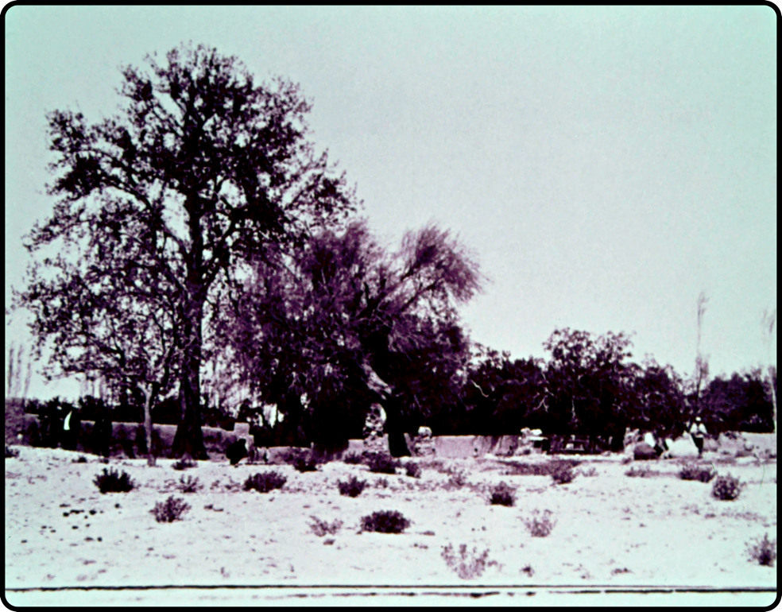
Figure 7: Vaḥíd used to address his couple of dozen men under this big plane tree before the enemy drew close - Courtesy Bahá’í Media

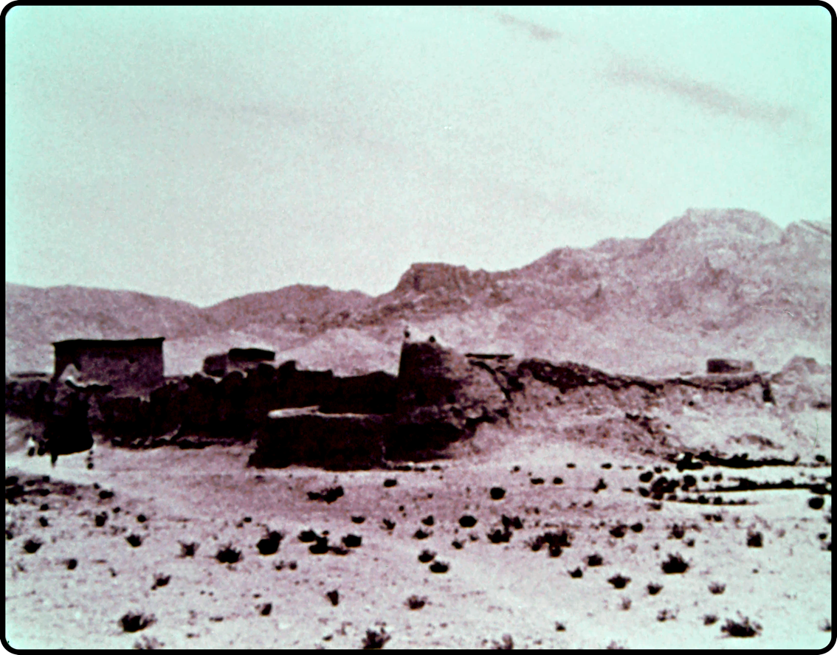
Figure 8: Ancient mud Fort of Khájih - Courtesy Bahá’í Media

5. The Episode of Nayríz (May-June 1850)

Upon learning of these recent events, the governor became very angry and in an attempt to eliminate Vaḥíd ‘s growing influence he ordered the additional recruitment of about a thousand men and also ordered the arrest of Vaḥíd.

Vaḥíd learned of this and sent a handful of his companions to take themselves to the Fort of Khájih, near the city, as a precautionary measure. He instructed them to raise defences and prepare the structure to repel any eventual attack. When the fighting began at daylight on 28 May 1850, Vaḥíd had joined the rest of the occupants.

From the beginning of the attacks the hostilities and incursions of the governor's forces increased in intensity. However, to the great astonishment of the troops, the extraordinary character of the Faith of the besieged Bábís was shown through their unexpected and overwhelming success in each of the battles. The outlook for the troops was disheartening and appeared to be bleak due to their constant defeat and losses.

Despite the continuous troop reinforcements, the governor could not understand why they were continually being defeated by a mere handful of seventy-two souls – composed of decrepit older people and young people on the threshold of their lives.

To his dismay, Zaynu’l-‘Ábidín Khán realized that the spirit of the believers had grown even stronger and that his present troops were unable to defeat them. As a result, he launched an even larger-scale organised raid.

Shortly before this attack, Vaḥíd had received a message from the governor ordering him to surrender and turn himself in to the authorities. In his response, Vaḥíd explained in detail the spiritual nature of his mission and rebuked the governor for his discourtesy by his hostile reception and the actions taken against him and his companions, and expressed his readiness to defend his Faith by all means at his disposal.

Zaynu’l-‘Ábidín Khán ignored Vaḥíd’s response and ordered an attack on the Bábís which resulted in the attackers having to retreat to a village. Frustrated by this series of defeats, the governor requested additional troops and ammunition from the Prince of Shíráz.

Realising the army’s determination to exterminate them, the Bábís strengthen their position with a series of trenches and barricades around the Fort and allocated believers to strategic positions.

As a result of Zaynu’l-‘Ábidín Khán’s request to the Prince of Shíráz, a general conscription was called for and several more regiments provided with artillery were added, resulting in an army of 1,000 soldiers to besiege the Khájih Fort.

One day, according to the historian Nabíl, "At the hour of sunrise, a certain number of them, acting in accordance with the instructions of Vaḥíd, sallied forth, and with extraordinary rapidity forced the besiegers to disperse. No more than three of the companions met their death in the course of that encounter.”

In an intrepid sortie, fifteen Bábís left the Fort shouting Alláh-u-Akbar and managed to repel the numerically superior forces of the governor accomplishing such an outstanding triumph resulting in temporarily extinguishing the enemies’ hopes.

Such a display of courage and bravery induced the Prince of Shíráz to exterminate all the Bábís in the fort. Vaḥíd remained defiant and informed Zaynu’l-‘Ábidín Khán that:

I am willing to depart why is it that, instead of according us the welcome which befits a descendant of the Prophet, he has deprived us of water and has incited his men to besiege and attack us? If he persists in denying us the necessities of life, I warn him that seven of my companions, whom he regards as the most contemptible among men, will inflict upon his combined forces a humiliating defeat.

Nabíl described this incident in his chronicle:

No sooner had the signal been given than they arose and, hurrying to their steeds and rifles, marched out of the gate of the Fort. Undaunted by the fire which spouted from the mouths of the cannons and by the bullets which rained upon their heads, they plunged headlong into the midst of their adversaries. This sudden encounter lasted for no less than eight hours, during which that fearless band was able to demonstrate such skill and bravery as amazed the veterans in the ranks of the enemy. From the town of Nayríz, as well as from its surrounding fortifications reinforcements rushed to the aid of the small company that had withstood so valiantly the combined forces of a whole army. As the scope of the struggle extended, the voices of the women of Nayríz, who had rushed to the roofs of their houses to acclaim the heroism which was being so strikingly displayed, were raised from every side. Their exulting cheers swelled the roar of the guns, which acquired added intensity by the shout of "Alláh-u-Akbar!" which the companions, in a frenzy of excitement, raised amidst that tumult. The uproar caused by their womenfolk, their amazing audacity and self-confidence, utterly demoralised their opponents and paralysed their efforts. The camp of the enemy was desolate and forsaken, and offered a sad spectacle as the victors retraced their steps to the Fort.

Historian Siyamak Zabihi‐Moghaddam wrote that “During the battle, the cries of Babi women in Nayriz, cheering the Babi fighters on, could be heard from every side and contributed to demoralizing the troops”.

Such a display of infallible superiority prompted the governor to seek another method by which he might succeed. He, therefore, decided, supported by his officers, to set a trap for Vaḥíd to get him out of the Fort and thus lay hands on him. Betrayal appeared in their minds as the only way to subdue him.

Without a doubt, for any faithful believer in the Faith of Muḥammad, a promise sealed in a copy of the Qur’án constituted a sacred and inescapable commitment.

The Governor, trying in any way to win Vaḥíd's confidence and induce him to leave the Fort, determined to send him a message conveying his regret at having failed to recognise the true purpose of the Cause which Vaḥíd had espoused. In a courteous tone, the hypocrite invited him to his camp to talk more serenely about his belief. He sent him a Qur'án with his written commitment to prove his intentions.

Vaḥíd received the Qur’án reverently and devoutly kissed it. He quickly realised that the only feeling the governor harboured was to lay an ambush for him. Vaḥíd, however, accepted this invitation saying: "Our appointed time has struck. Our acceptance of their invitation will surely make them feel the baseness of their treachery."

On 17 June 1850, as Vaḥíd was saying goodbye to his companions for the last time, he forbade them in his absence to undertake any incursions, but he advised them to be diligent in defending the Fort.

For three days and three nights, Vaḥíd was ceremoniously attended along with his five other companions who made up the procession. It was the object of the highest consideration. On the first day, before a meeting with the governor and high officials, he addressed them in a highly eloquent tone and full of majesty: "I am come to you armed with the testimony with which my Lord has entrusted me. Am I not a descendant of the Prophet of God? Wherefore should you have risen to slay me? For what reason have you pronounced my death-sentence, and refused to recognise the undoubted rights with which my lineage has invested me?"

These expressions made a deep impression on more than one person who listened to him. It led them to consider Vaḥíd's statements more seriously and aroused feelings of affection and respect for him.

Within this environment, the governor was the least affected, desiring to end Vaḥíd's life as soon as possible as well as the remnant of believers within the walls of the Fort. He used another strategy to bring about the final and complete evacuation of the fort, making them defenceless prey in his bloody claws by making Vaḥíd expressly consent to ordering his friends to leave the Fort.

As Vaḥíd already foresaw the results of his consent in advance, he delivered an additional and confidential note to the bearer of the message in which he told them to ignore the communication because, in reality, the governor's plans were different. Instead, he urged them to try to disperse in the dead of night to a place of safety.

Unfortunately, the person entrusted with the message went to the governor and showed it to him. The governor ordered him not to deliver the message and commissioned him to communicate to the besieged in the name of Vaḥíd the false news that the entire army had converted to the Faith and the time had come to return peacefully to their homes.

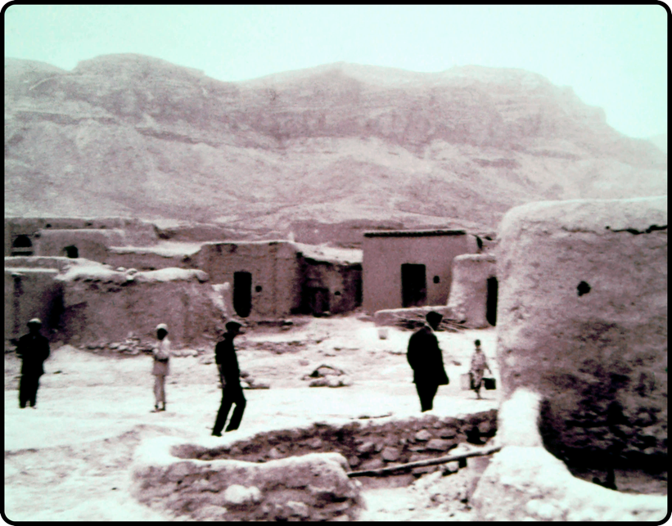
Figure 11: Dozens of mud dwellings, in one of which, at the corner nearest the town, Vaḥíd made his quarters -- Courtesy Bahá’í Media

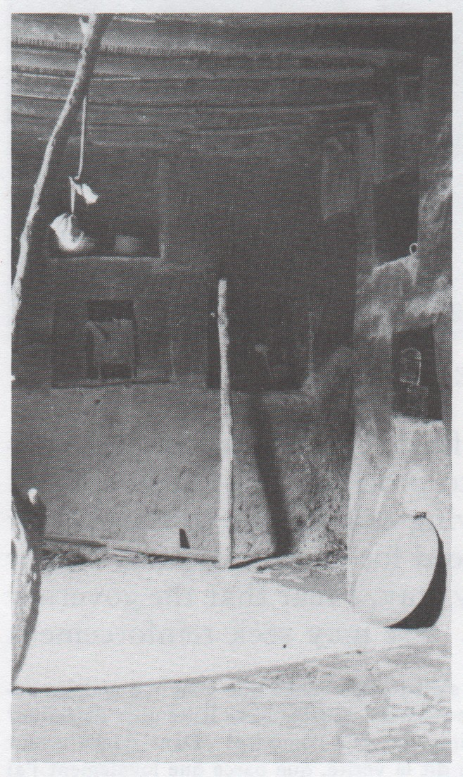
Figure 10: Vaḥíd's room in the Fort of Khájih - Courtesy Bahá’í Media

6. The Martyrs of Nayríz

Although, at first instance, the friends were surprised by such information, they decided to obey what they presumed to be the advice of their beloved chief. Meanwhile, the governor had ordered his troops to intercept the evacuation of the Fort.

At the same time, another group of officials were sent to the main mosque with the purpose of blocking any planned escape of the Bábís to that enclosure, where according to custom, they could find protection.

The desperate believers, betrayed and bewildered by this ploy, fell victim to the trap in great numbers, while some sought refuge in the mosque.

Immediately, Zaynu'l-'Abidín Khán decided to lay hands on the one who was the main leader of that glorious band. Acting with implacable hatred, they unrolled Vaḥíd's turban, the sign of his sacred lineage, and tied it around his neck.

The mob, inflamed by the proclamations of the now jubilant local clergy and soldiers, paraded Vaḥíd through the streets of the city. The fire of fanaticism was lit to such an extent that the women of Nayríz, in a horrifying spectacle, danced around his dying body to the beat of a cymbal and drums.

Amid this macabre amusement, the voice of Vaḥíd could be heard exclaiming: "Thou knowest, O my Beloved, that I have abandoned the world for Thy sake, and have placed my trust in Thee alone. I am impatient to hasten to Thee, for the beauty of Thy countenance has been unveiled to my eyes. Thou dost witness the evil designs which my wicked persecutor has cherished against me. Nay, never will I submit to his wishes or pledge my allegiance to him."

Nabíl recorded for posterity the massacre that followed:

The extinction of that life was the signal for a fierce onslaught on the lives and property of those who had identified themselves with his Faith. No less than five thousand men were commissioned for that villainous task. The men were seized, chained, ill-treated, and eventually slaughtered. The women and children were captured and subjected to brutalities which no pen dare describe. Their property was confiscated, and their houses were destroyed. The Fort of Khájih was burned to the ground. The majority of the men were first conducted in chains to Shíráz, and there, for the most part, suffered a cruel death. Those whom Zaynu'l-'Abidin Khán, for purposes of personal benefit, had plunged into dark and subterranean dungeons were, as soon as his object had been achieved, delivered into the hands of his myrmidons, who perpetrated upon them acts of unspeakable cruelty. They were paraded at first through the streets of Nayríz, after which they were subjected to atrocious treatment in the hope of extracting from them whatever material advantage their persecutors had hitherto been unable to obtain. These having satisfied their greed, each victim was made to suffer an agonising death. Every instrument of torture their executioners could devise was utilised to quench their thirst for revenge. They were branded, their nails were pulled out, their bodies were lashed, an incision was made in the nose through which a string was driven, nails were hammered into their hands and feet, and in that piteous state each of them was dragged through the streets, an object of contempt and derision to all the people.”

Vaḥíd's inert body was subjected to the most humiliating barbarity. His head was cut off after he had been stoned to death, his skin was peeled off, and his skull was stuffed with straw and sent to the Prince of Shíráz as a war trophy. That date was recorded in the pages of the golden history of the Faith as June 29, 1850.

According to Zabihi‐Moghaddam, a massacre of Bábí men and women of Nayríz followed the treason:

The Chinar-Sukhtih quarter, where most of the Babis lived, was plundered and occupied for three to four weeks by the troops, including the newly arrived forces from Shiraz. Even part of the Bazar quarter was plundered. The soldiers also searched for and managed to seize some of the Babi men. The women were also captured. The Fort of Khajih was burnt down.

Ten days later after the death of Vaḥíd, the Báb was martyred in the city of Tabríz.

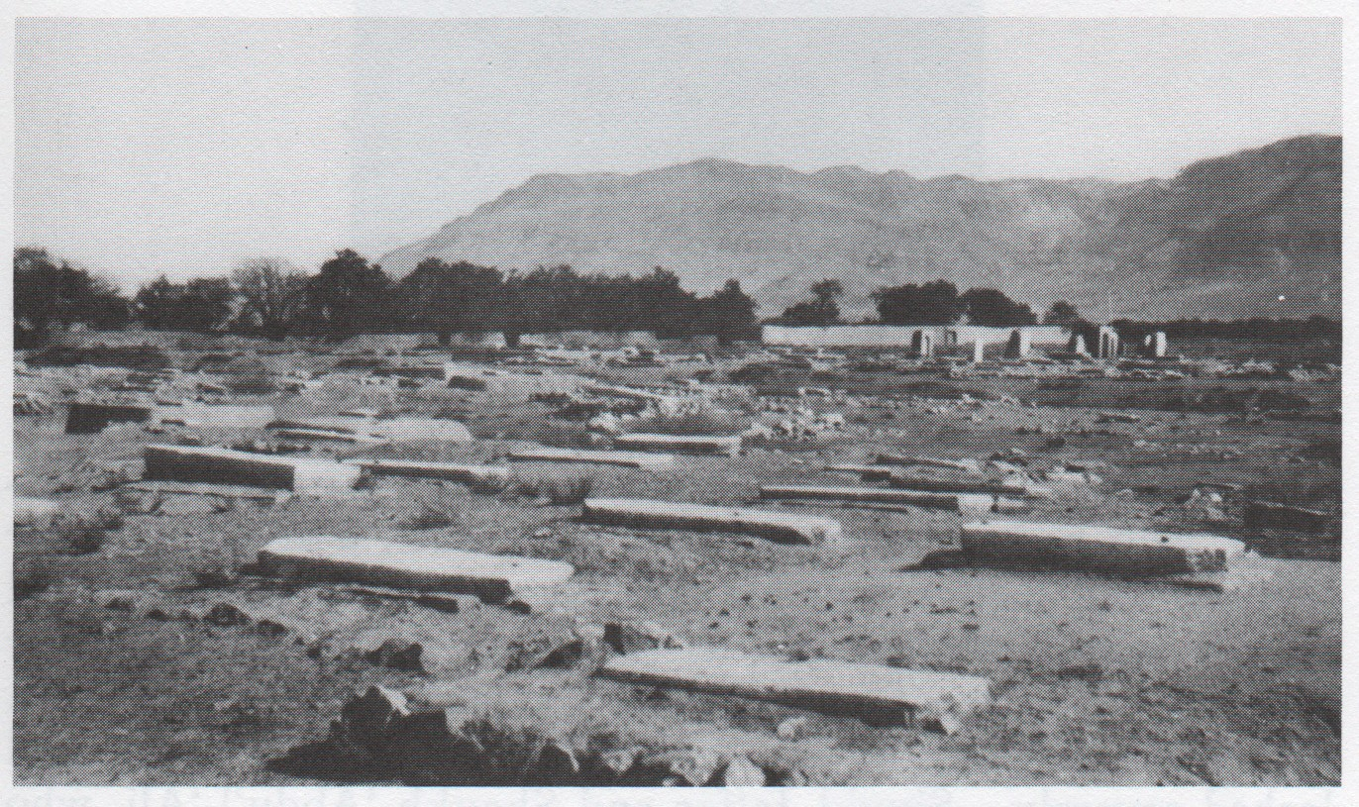
Figure 11: Graves of martyrs at Nayríz - Courtesy Bahá’í Media

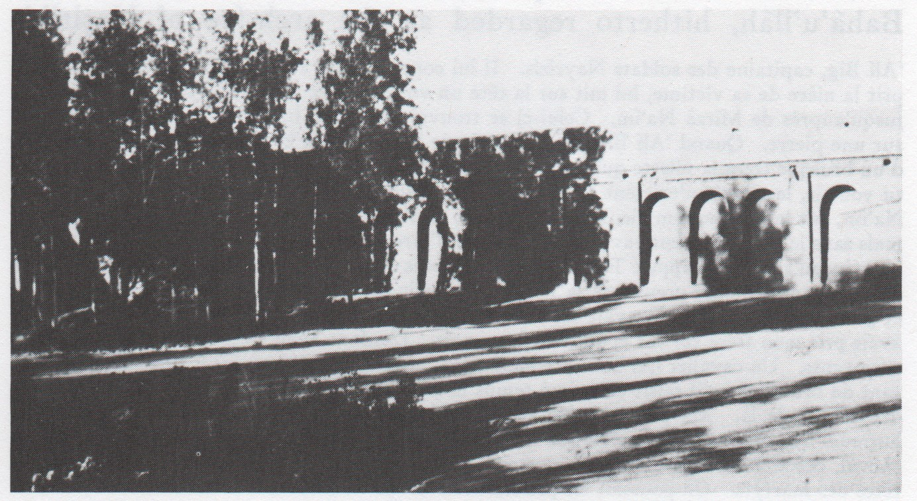
Figure 12: The Hadíqatu’r-Rahmán, where the heads of the martyrs of Nayríz lie buried - Courtesy Bahá’í Media

7 - Vaḥíd, the Incomparable

Vaḥíd's story is the story of a seeker. He sincerely searched for the truth, investigated it and found it, and later gave his life for it. Any and all obstacles that prevented him from recognising the truth of the Blessed Báb were put behind him, so he could persevere to the end. Such happiness was ignited in his heart that it gave him the courage to live it and teach it.

He did not give heed to those around him, much less those who bitterly tried to induce him to renounce his faith or rose against him. The fire of love for God inflamed his soul in service. The ardour of that same fire impelled him simultaneously to overcome any obstacle, put aside wealth, honours and positions, and renounce everything that was not the pleasure and desire of his Lord.

Vaḥíd's life is, for any student of the Bábí Revelation, an inexhaustible subject on which he or she should stop and ponder.

The tributes to his memory given by the sacred pens of the Blessed Báb, Bahá'u'lláh, 'Abdu'l-Bahá and Shoghi Effendi form a singular and precious legacy, both for the beautiful allusions with which he is described, and also because they reveal to us the true greatness of his position. His vast knowledge, the steadfastness of his faith, his reverent love for the Báb, the pristine light of his righteous conduct, his heightened sense of justice, and the splendour of his spirit, cast an unmistakable halo over him within the history of the Cause of God.

In the Dalá'il-Sab'ih (Seven Qualifications), a book written by the Báb during his imprisonment in the castle of Máh-Kú, His Holiness The Exalted refers to Vaḥíd in the following words:

Behold again the number of the name of God (Siyyid Yaḥyá)! This man was living a holy, peaceful life in such a way that no one could deny his talents or his sanctity, all admired his greatness in the sciences and the heights he had attained in philosophy. Refer to the commentary of the Súratu'l-Kawthar and to the other treatises written for him, which prove how high a place he occupies in the sight of God!

Bahá'u'lláh called Vaḥíd in the Kitáb-i-lqán as "that unique and peerless of his age." In the Lawḥ-i-Ayyúb (Tablet of Job) also known as Súriy-i-Ṣabr (Sura of Patience), a work revealed by the Tongue of Greatness in honour of a believer who participated in the revolt of Nayríz, He reminds the handful of His followers gathered in the Garden of Riḍván during the event of His Declaration, of the altruism with which Vaḥíd and his companions endured the sufferings at the hands of the opposing forces.

"In the Súriy-i-Ṣabr," comments the historian Adib Taherzadeh, "Bahá'u'lláh extols the station of Vaḥíd in words no pen can befittingly describe. He pays glowing tribute to the staunchness of his faith and the loftiness of his vision, declares that he had remained faithful to the Covenant of God and affirms that he had fulfilled his pledge to his Lord. He bids him rejoice among the 'Concourse on high’ for being remembered in this Tablet, a Tablet so exalted that the Holy Books of the past had derived their essence from it.”

The Master 'Abdu'l-Bahá refers to Vaḥíd as "a remarkable man, a precious soul", as the "great Siyyid Yaḥyá". In turn, the Guardian of the Faith pointed him out as "a man of immense erudition and the most preeminent figure to enlist under the banner of the new Faith," and "the most learned, the most influential, and the most accomplished among the followers of the Báb”.

In truth, he was Vaḥíd, the Incomparable.
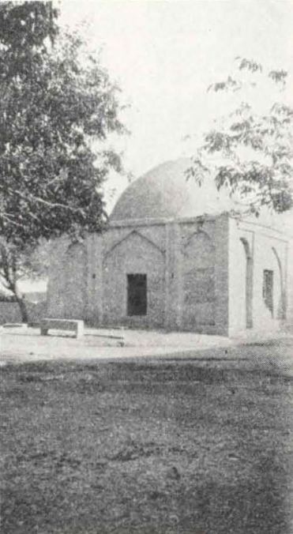
Figure 13: Burial place of Vaḥid in Nayríz - Courtesy Bahá’í Media

Bibliography

'Abdu'l-Bahá. Memorials of the Faithful. Wilmette, Illinois: Bahá’í Publishing Trust, 1971.
Arabic & Fársí Transcription List & Glossary for Bahá’ís. Available from: bahai-library.com
Bahá'u'lláh. The Kitáb-i-Íqán. Wilmette, IL: US Bahá’í Publishing Trust, 1989.
Blomfield, Lady. The Chosen Highway. Oxford: George Ronald, reprinted, 2007.
Nabíl-i-A‘ẓam. The Dawn-Breakers: Nabíl’s Narrative of the Early Days of the Bahá’í Revelation. Wilmette, IL: Bahá’í Publishing Trust, 1970.
Rabbani, Ahang. The Bábís of Nayriz: History and documents. In Witnesses to Bábí and Bahá’í History. Available online at: https://bahai-library.com/pdf/r/rabbani_babis_nayriz.pdf
Shoghi Effendi. God Passes By. Wilmette, IL: Bahá’í Publishing Trust, rev. ed. 1995.
Taherzadeh, Adib. The Revelation of Bahá’u’lláh. Vol. 1: ‘Akká 1853–63. George Ronald, Oxford. 1974.
Zabihi‐Moghaddam, Siyamak. ‘The Babi‐state conflicts of 1848-50’. Vahman, Fereydun. In The Báb and the Bábí Community of Iran (ed. Fereydun Vahman), pp. 314-376.

Acknowledgment: I would like to thank Ernie and Diana Jones for their editorial assistance.

Arabic & Fársí Transcription List & Glossary for Bahá’ís. Available from: bahai-library.com
Nabíl-i-A‘ẓam, The Dawnbreakers, p. 171
A Súrih of the Qur’án.
Nabíl-i-A‘ẓam, The Dawnbreakers, p. 174.
Nabíl-i-A‘ẓam, The Dawnbreakers, pp. 174-175
Nabíl-i-A‘ẓam, The Dawnbreakers, pp. 175-176.
Nabíl-i-A‘ẓam, The Dawnbreakers, p. 177.
His Honour Bahá.
Nabíl-i-A‘ẓam, The Dawnbreakers, p. 432.
Nabíl-i-A‘ẓam, The Dawnbreakers, p. 465, footnote 1.
Lady Blomfield, The Chosen Highway, p. 22.
Ahang Rabbani, The Bábís of Nayriz, p. 59.
Persian National Day for New Year
Nabíl-i-A‘ẓam, The Dawnbreakers, p. 469.
Nabíl-i-A‘ẓam, The Dawnbreakers, p. 469.
Nabíl-i-A‘ẓam, The Dawnbreakers, p. 473.
Nabíl-i-A‘ẓam, The Dawnbreakers, p. 465, footnote 1
Nabíl-i-A‘ẓam, The Dawnbreakers, p. 476.
Siyamak Zabihi‐Moghaddam, The Babi‐state conflicts of 1848-50, p. 342.
Quoted in Nabíl-i-A‘ẓam, The Dawnbreakers, p.478, f.2
Nabíl-i-A‘ẓam, The Dawnbreakers, . 479
Siyamak Zabihi‐Moghaddam, The Babi‐state conflicts of 1848-50, p. 343.
Nabíl-i-A‘ẓam, The Dawnbreakers, pp. 482.
Nabíl-i-A‘ẓam, The Dawnbreakers, pp. 482-483.
Nabíl-i-A‘ẓam, The Dawnbreakers, pp. 187-487.
Siyamak Zabihi‐Moghaddam, The Babi‐state conflicts of 1848-50, p. 345.
Nabíl-i-A‘ẓam, The Dawnbreakers, pp. 489.
Nabíl-i-A‘ẓam, The Dawnbreakers, pp. 490.
Nabíl-i-A‘ẓam, The Dawnbreakers, p. 495
Nabíl-i-A‘ẓam, The Dawnbreakers, p. 347.
Siyamak Zabihi‐Moghaddam, The Babi‐state conflicts of 1848-50, p. 345.
Cited in Nabíl-i-A‘ẓam, The Dawnbreakers, p. 495, footnote 2.
Bahá'u'lláh, The Kitáb-i-lqán, p. 188.
The reunion of holy souls in the afterlife.
Adib Taherzadeh, The Revelation of Bahá'u'lláh, Vol. 1, p. 276.
Nabíl-i-A‘ẓam, The Dawnbreakers, p. 171
'Abdu'l-Bahá, Memorials of the Faithful, p. 125
Shoghi Effendi, God Passes By, p. 50.
Nabíl-i-A‘ẓam, The Dawnbreakers, p. 653

