THE DAWN-BREAKERS Novel

by

James J Keene

© 2021 James J Keene
Preface

A movie screenplay is often based on a novel. However, this novel is based on the film script by the author, recently published as a book in "THE DAWN-BREAKERS Movie".

Some may prefer to read the novel version of the story. The screenplay version might provide a different experience. What if the reader is handed the script and asked to be the Director of the production, "What do you see, hear and feel?"

This is the question that readers of either the movie or novel versions may answer. Those answers suggest a variety of experiences of the story linked to the imagination of each reader.

The objective of the author is that the experience based on either the movie script or this novel version may enrich the lives of readers.

The working title of the movie is "The Dawn-Breakers". This title has become well known among Baha'is from the important historical account written by Shoghi Effendi, Guardian of the Baha'i Faith from 1921 to 1957.

In about 1986, the author and a prospective investor in the film production were invited to meet with Ruhiyyih Khanum (1910-2000), the widow of the late Guardian, in her suite while at the Theater Hotel, Vienna, Austria. The investor argued to Ms. Khanum that the movie should not have the same title as the Guardian's book. Her response was simple and brief, with a few words to the effect that she did not see any problem at all concerning the movie title.

At that time, the author had sent hundreds of pages including the script and supporting documents to the international administrative body of the Baha'i Faith, known as The Universal House of Justice, in Haifa, Israel. In a written reply, The House advised that the author should maintain control of the project and that they were praying for its success.

In the 1980s before "The Dawn-Breakers" screenplay was written, a detailed chronology of the story did not exist. Yes, many were familiar with the broad outline of the story based on various books that described its key episodes. So to write the film script, the author had to create a time-line of events in the story. This chronology was published in "THE DAWN-BREAKERS Movie", 2021, 30 pages in Appendices A and B.

After the author sent the script and related documents to The Universal House of Justice, one of the members began correspondence with the author. In one of these letters, he noted that he had shared the chronology with persons in the Baha'i community interested in Babi history. This may or may not have been appropriate since the documents at that time had been marked as proprietary materials of Keene Productions. Whatever the case, it appeared that there may have been some public release of the documents, perhaps mainly to Baha'i scholars.

Fast forward to the present writing of the novel version of the screenplay over three decades later. The internet was searched for illustrations for this book. Happily, it was noted that many sources now featured Babi history in chronology tabulations of events and dates, Wiki articles, videos and books, all closely following the chronology created by the author. Is this all original research or did the author's chronology play a role in some of these developments? In any case, the outcome is welcome.

In much of these works, historical figures are portrayed mostly in a one-dimensional, even zero-dimensional, manner. That is, the people are treated as if they were just cardboard cutouts or perfect saints. This can be both unrealistic and boring. In contrast, the movie script and this novel pose the question: what if these figures were real human beings? People who laugh, scream, cry, tell jokes, bleed, shout, smile, dream, get muddy. People with both weak and strong moments.

Finally, some housekeeping items may be helpful.

The dialogue in a screenplay might not include the name of a particular character. Hence, the script might invent descriptive names, like, say, "Waitress" or "Cop #1". This practice is continued in the novel version. Examples: A bread vender is "Bread". A wool vender is "Wool".

Many of the real names of characters are long and unfamiliar to many readers. Thus, many characters are identified with short names. Examples: Mulla Husayn is "Husayn", Abbas Quli-Khan is "General".

Scholarly accounts may carefully include accents on vowels in names of people, places and things. Sorry, folks. No vowel accents here. Technically, there is no ambiguity since each name, whether with or without accents, refers to the same person, place or thing.

The lights are dimming.
THE DAWN-BREAKERS is about to begin.

James J Keene
July 9, 2021

Contents

Anticipation of the Mission of the Bab 1
The Shaykhi Movement in Karbala 11
Proclamation of the Mission of the Bab 27
The State Reacts - Shiraz 37
Biela's Comet Split in Two 45
Vahid Investigates the Babis 57
Shiraz Governor Ordered to Kill the Bab 67
The State Reacts - Isfahan 77
The Bab Disappears 93
The State Reacts - Tehran 101
The Bab Imprisoned at the Mak-Ku Fortress 111
The Babis Act 119
Mulla Husayn Walks from Mashhad to Mah-Ku 131
Islamic Clerics Agree to Execute Tahirih 141
Christian Missionary Watches the Babis 147
Mulla Husayn Back in Mashhad 151
Badasht Conference and the Trial of the Bab 155
Dream of a Tabriz Youth 169
Babis March from Mashhad to Mazindaran 173
Babis Attacked Again by Religious Fanatics 187
Babi Defense at Tabarsi Shrine 199
Tabarsi Fort 1.0 205
Tabarsi Fort 2.0 213
Babis Target Munitions to Disable Besiegers 225
Fifteen Minutes of Fame for a General 233
Tabarsi Fort 3.0 243
Babis Betrayed and Massacred at Tabarsi 247
Babi Numbers Increase Throughout Persia 251
Turmoil and Death in the Capital 255
Siege of Zanjan Babis by the Shah's Troops 265
Martyrdom of the Bab 275
Postscript 287

Anticipation of the Mission of the Bab

This is the true story
of a youth from Shiraz known as the Bab

HAIFA, PALESTINE, 1843

At the Mediterranean shore of the small port of Haifa, Palestine, the sun is about to rise over Mt. Carmel, a barren mass rising right from the shoreline. Austin Wright and Captain move with the gentle sway of a fifty-foot cargo boat, where they sit on the stern rail. Three Arab locals are unloading sacks of grain: one in the hold, one on deck and one stacking the sacks on a cart on the small pier to which the boat is moored.
"A long way from America," says Captain.
"I can't believe I'm here," replies Wright.
"Don't start on that again."

A rooster crows at dawn. A few voices and a baby crying come from the few modest houses lining the street leading up the mountain. Each off-loaded sack thuds on the cart.

Wright: 32, an American Christian missionary, earnest, clean-shaven with moustache, a talker, seeks an audience.
Captain: unkempt beard, middle-aged British adventurer.

The Arab on deck throws a fifty-pound sack to the pier. As it leaves his hands, he hears the sound of wood and rope under suddenly increased tension.
The line attaching the bow to the pier has no slack and the bow rises slightly increasing its tension as each sack is off-loaded.
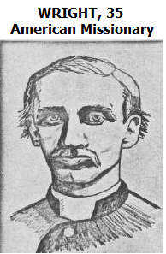
"People are buying white robes in London ... to climb a mountain like that," Wright says, gesturing toward Mt. Carmel.
Captain is a skeptic. "These people are insane."
The Arab on deck listens to the conversation as he works.
"They're coming here. You'll see!"
Wright gazes up at Mt. Carmel, "It began in 1755 with the great earthquake of Lisbon, Portugal."
A sea swell begins a slow roll of the boat as the Arab tosses another sack off the boat.
The bowline is about to give way. The rope unravels and slips. The deck and pier cleats strain and wood creaks. Cargo shifts below deck. A couple having an argument scream in one of the nearby shacks. It sounds like an earthquake.
The bowline is so tight that the boat can no longer move. Wright continues, "This one ranks first among all recorded earthquakes, killing 60,000 people in six minutes."
The bow-pier attachment gives way. The pier plank with the mooring cleat at the bow breaks loose. The boat bobs up and down. Wright almost goes overboard. Captain grips the stern rail.
"Jesus," Captain says, as he shakes his head in resignation while the Arabs hasten to refasten the bow. A small swell from the sea slams the boat into the pier.
"Are we sinking?" Wright asks with an impish smile.
Captain replies with playful sarcasm, "Just an earthquake."
"Ah. Then in 1780 there was the Dark Day. Imagine."
The picture in Wright's mind is a New York street with people looking up, circa 1780. The mid-day sun begins to darken.
"An eclipse?" asks Captain.
"No, the cause was not known," replies Wright. His imagined flashback to the event continues. The sun and sky darken. Star constellations become visible. New York people and animals react, run and look. The moon becomes visible in the darkening sky. Wright continues, "but in the day-time darkness the moon appeared red as blood."
A few seagulls fly by. Dogs are barking in the distance.
Wright looks for a reaction. But Captain just glances up at Mt. Carmel.
The sun has now arisen above the horizon. The sacks keep thumping their way from boat hold to pier cart. The Arab at mid-ship still listens to Wright's description,
"The third thing. The historic shooting star displays of 1799 and 1833. I tell you. All around the world, serious people are preparing for the sudden appearance of Christ next year."
Hearing this, the Arab drops a sack of grain on the deck, as if it had become electrified and steps forward crying out in Arabic, "Shi'ihs are waiting for the prophet in Karbala!"
Wright looks to Captain for the English translation, "The Muslims also are waiting for their prophet to return in Karbala."
The Arab can speak a little English and barks out, "Next year. Big trouble," before resuming his work.
Closing his eyes Captain says, "Descend from the clouds, eh?"

Captain recalls having a drink ten years ago with Lt. Francis Farrant and Lt. Justin Sheil in the countryside near Hamadan, Persia. They are in a military tent. They see dancing light from camp fires and hear depraved partying of Persian soldiers in the night.
"Ten years ago in '33, Farrant, Sheil and I were training the Persian cavalry forces of Fath-'Ali Shah. Suddenly there was silence. We looked outside."

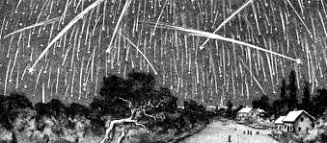
They look up at the cloudless sky of Nov 13, 1833. Against the constellations of fixed stars, with that of Leo seen prominently, hundreds of shooting stars appear as flying sparks. This is the famous "Leonid" meteor shower. The dramatic burning of each entering meteor is heard. The breaking of several meteors into pieces is even louder. Fireballs created by large meteorites are breathtaking, followed by thunderclaps. This shooting star display is said to be the biggest recorded in history.

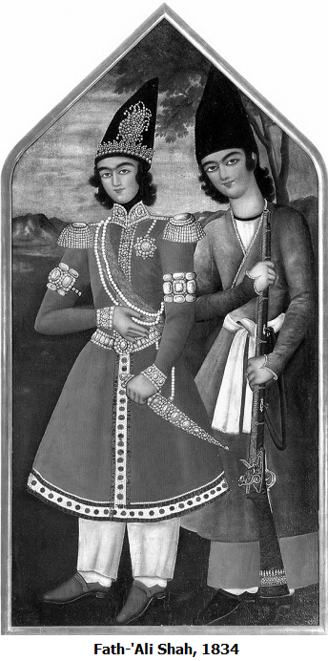

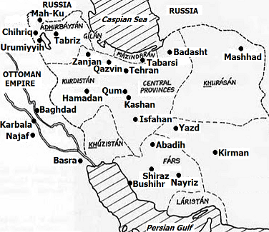
QAZVIN

Two women walk briskly down a narrow street in the noon sun. We suppose they are women by their voices, since they are completely covered in black veils and the only opening is a cloth grid of a few square inches for them to see out. Their black forms contrast the light brown mud walls along the dusty street. They are Tahirih and Mardiyyih.

Tahirih: 26, is beautiful, a "man's woman", a child prodigy, known as the most educated woman in Persia, a renowned poetess. At age 13, Tahirih had been forced to marry her cousin, now about 35, the son of a Mulla who is a brother of her father. Thus, Tahirih was related as wife-cousin, niece and daughter respectively to three powerful clerics in Qazvin.
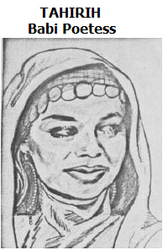
Her sister, Mardiyyih, 20, is her attractive and faithful companion.

Others are on the street, as Tahirih's husband passes them.
"That was my husband. Now I've had it."
"If he knew it was us," Mardiyyih replies.
They both laugh. The other women on the street are covered in identical head-to-toe veils which are indistinguishable.

Tahirih's Husband: 35, is cruel and arrogant, but unable to subdue her free spirit and outstanding intellect.

The two women stop at a door along the walled narrow street. It opens just enough to see a man inside. It's Tahirih's uncle, mid-40s, open mind and heart.
Tahirih's eyes are barely visible behind the cloth grid opening in the full body veil. It appears that nothing is happening in this very brief encounter. However, Tahirih discretely passes a letter to her uncle. She pulls it from her sleeve handing it to her uncle, who then disappears behind the door. Not a word is spoken. The women scurry off.
As her uncle, his eyes not yet adjusted to the outdoor, mid-day sun brightness, is about to close the door, he notices a small disturbance down the street. A vendor points to the sky as he hawks copperware vessels from a street cart to potential customers. High in the sky, strange circles or halos appear around the sun. Tahirih's uncle glances upward as he closes the door.
It is dark inside the front door hall. He blinks with watered eyes.
He sees a long darkened hall, much like a tunnel, opening into a bright inner courtyard.
He squeezes his eyes shut again.
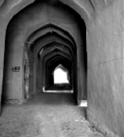
The light at the end of the passageway is replaced with that of the sun with halos in negative image. It is the after-image still tingling in his visual system. Words cannot describe the beautiful bursts of swirling colors that his vivid imagination freely adds to this unusual image. Blinking several times, in a stroboscopic series of images, he sees his hand rise into the passageway holding the letter from Tahirih. The letter is bound with a ribbon with its wax seal and addressed in Persian calligraphy. The letter rises to match the position of the sun after-image and mix with it. Tahirih's uncle whispers, "Karbala."

Tahirih's room has no windows and the subdued lighting comes from roof ports and the doorway, which opens as she and Mardiyyih romp in. The room is not big, but by the time they reach the other side, they have quickly shed their veils down to simple dresses. They dislike the veil, the discomfort associated with it and waste no time in getting it off now that they have arrived in their own women's quarters. Even though it is a cool day, they are covered with sweat, from the excessive clothing, the vigorous walk and the excitement of their mission. It almost looks like they had been swimming. Tahirih's face is particularly enticing. They embrace. Both are filled with emotion.
Mardiyyih says, "Now you can teach us again tonight."
"Um-hum. Tell the women."
Behind them, Tahirih's desk is filled with papers and books. Mardiyyih, then Tahirih, notice something on the floor behind a chair.
A closer look reveals bits of shredded manuscripts. Furthermore, some books have been torn apart and the ink well had been emptied over precious documents. They sigh at the view of this destruction.
Good thing the women had not yet fully released their embrace, so they can grab each other in sudden fear as a voice booms, "Women should not read and your 'poetry' is disgraceful ... Give it up ... and you can see my children again."
Tahirih's Husband had not yet left the room when the two women entered. He makes his statement and leaves. This is closer to the last, than to the first, altercation between Tahirih and her husband. Tears flow. He is gone but she calls out, "Our children ... my children."
Mardiyyih, speechless, tries to comfort her older sister.

The Shaykhi Movement in Karbala

KARBALA

Mysterious halos appear around the sun quite different in pattern than before. They are seen above the Shi'ih holy city of Karbala in Ottoman Turkish territory (now Iraq), near the provincial capital of Baghdad.
Tens of thousands of Persians flock to this city for its holy shrine of Imam Husayn, a sacred figure in Shi'ih Islam history. And they come to the city, at times, simply to get out of Persia for a while.

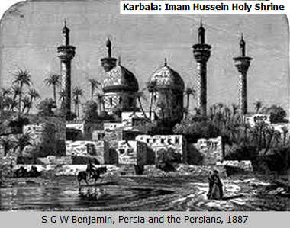
RESIDENCE OF SIYYID KAZIM, KARBALA

Siyyid Kazim has paused and is about to finish a talk to a group of some thirty men in a shady porch-like enclosure opening into the courtyard of his ample residence.

Siyyid Kazim, 59, is a Persian spiritual leader of the Shaykhi movement and perhaps the most prominent and respected resident of Karbala. As a measure of his stature, when Turkish troops sacked the city a few months ago (January, 1943) to put down an uprising of a rival Persian faction, the residence of Siyyid Kazim was hardly touched.

As Siyyid Kazim thumbs to a page in the Qur'an, some listeners are seen, including Javad, Sadiq, Mamaqani, Mulla and Karim.

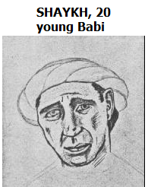
And there is Shaykh seated at the periphery.

Shaykh and a friend, Eyes, late teens, are slightly apart from the group.

There is an empty spot between Shaykh and Eyes on which a ray of light seems to dance on the tiles. The ray shines through a hole in an awning, flapping in the breeze.
Siyyid Kazim speaks, "I am spellbound by the vision. I am mute with wonder ... I am powerless to divulge the mystery and find the people incapable of bearing its weight." He closes the Qur'an and retires through a door to an inner parlor. His listeners begin to disperse.

In the center of Siyyid Kazim's parlor, Farrant sits, cross-legged, at the head of a Persian rug near a tea set. When Siyyid Kazim enters. Farrant, now 35, stands immediately showing deference.
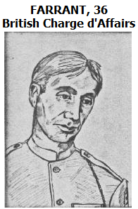
"I heard your statement." says Farrant.
"You're a Christian. You know that the 2,000 year period of Daniel is about to elapse."
"There is discussion."
"Questions?"
"If you permit it, sir," Farrant replies. "The British Ambassador at Istanbul..."
Farrant and Siyyid Kazim plunge into a discussion of the affairs of the day.

Back in the courtyard, Eyes begins to move closer, but is detained by a gesture from Shaykh who then places his hand on the spot between them, where the ray of sunlight dances. The dancing of this illuminated spot seems magical.
Shaykh is older than Eyes, sort of the difference between college graduate and high school age.
Shaykh says, "Let me tell you about this spot. A few years ago an intimate of Siyyid Kazim awoke me at dawn." Bingo, just the inside story Eyes wanted.

Shaykh recalls how he, Siyyid Kazim and an intimate associate of Siyyid Kazim walked a Karbala street. Vendors are opening their shops. A man, putting on his turban, eyes them. The intimate associate of Siyyid Kazim is easily into his forties. Clearly, the younger Shaykh, tagging behind the two men, is thrilled to be part of whatever these illustrious gentlemen are about to do. Shaykh narrates, "The morning light had just broken. I followed them through the streets of Karbala. We reached a house. In the open door stood a youth."
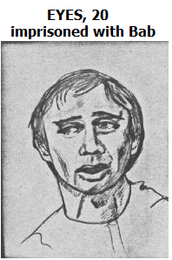
Eyes is captivated as Shaykh continues, "He had an expression of kindliness I can never describe. He embraced each of us."
Eyes is leaning forward and has to be reminded not to block the light ray on the spot between them as Shaykh speaks.
"At the upper floor, we entered a chamber bedecked with flowers ... the loveliest perfumes. We sat. At the center ... a silver cup. The youth said, 'A drink of a pure beverage shall their Lord give them'."
Eyes says, "Words from the Qur'an."
Shaykh continues, "Siyyid Kazim drank from the silver cup, forbidden by Islam."

By now, Shaykh and Eyes are alone in the courtyard. Shaykh jumps up to better dramatize the end of his story.
"Three days later, the same youth arrived and sat right there."
The light ray dances on the tiles as Shaykh points. Eyes gives the spot a little more room.
"Siyyid Kazim was speaking to an assembly."
Now Shaykh has stepped up to the spot where Siyyid Kazim speaks some twenty-five feet away and acts out his description, "As soon as his eyes fell upon that young man, he said, 'What more shall I say? Lo, the Truth is more manifest than the ray of light that has fallen upon that lap!'"
Of course, Shaykh has puffed up his posture to his idea of the dignity with which Siyyid Kazim presents himself. He swings his arm around to emphasize how Siyyid Kazim had pointed to the spot where "the youth" had been.
"Some of Siyyid Kazim's listeners, Husayn, Quddus, Mulla, Sadiq, Javad and finally Mamaqani, turned their heads toward him. They all looked curiously. But the mean-looking, one-eyed Mamaqani, an ugly scar over the bad eye, looked disdainfully."
Shaykh surveys the courtyard to see if it is still empty. It is. They are alone.
"O.K. Ask me ... Ask me who this youth is."
Eyes grins, jumps up, raising his hand to be recognized as Siyyid Kazim's students would do and asks, "Can you reveal his name?"
Slitting his throat with his finger, acting Siyyid Kazim's role, Shaykh answers grimly, "If I divulge his name, we both would be put to death instantly."

After a journey from Qazvin, Persia, over the mountains to Karbala, Tahirih's uncle has delivered her letter to Siyyid Kazim one summer night in his parlor.
The opened letter from Tahirih is centered on Siyyid Kazim's writing table. Siyyid Kazim holds another letter, his reply, and speaks to Tahirih's uncle, "Your niece. The most educated woman in Persia. A renowned poetess. Now this."
The uncle asks, with his eyes, "Now this, what?"
Siyyid Kazim hands to him his sealed letter, with these words, "In my reply, I address her as Qurratu'l-'Ayn, 'Solace of the Eyes.' She has already stepped beyond poetry."

CHRISTIAN MISSION, URUMIYYIH

The Christian Mission at Urumiyyih is a handsome stone structure in the northwest of Persia, near the Russian and Turkish borders. This building still stands today. Urumiyyih is now called Rizaiyyih, Iran.
In the front parlor, the American Wright is speaking with a visiting British Bishop, near retirement, who does not share Wright's expectations. Bishop reads the religious newspaper, "Midnight Cry." Not lifting his eyes from the paper, he pays only minimal attention to Wright.
Wright is enthused, "In America, William Miller and Joseph Smith say the coming is imminent."
Bishop replies, "Here it says that British and American societies are spreading the Gospel in every part of the world."
"Just so! Everything is in place."
In his own low key manner, Bishop is skeptical, "With Mt. Ararat not far away and all the cloudiness lately, it might seem so."
Wright has found a listener, "The Sunnis and Shi'ihs say that..."
For the first time, Bishop looks at Wright with more than a glance, "Nothing simple can cross the bridge between us and Islam."
Sensing that he was not getting anywhere, Wright steps outside while Bishop continues relaxing and reading.

In the May-June night air, Wright strolls the crest of a slope with distant mountains barely visible. He looks back at the mission building, thinking, "We say 1844. They say 1260. In our calendar, 1844."
Swiftly, clouds part. Wright beholds the appearance of a stunning sight, the Great Comet of 1843. It was not called "The Great Comet" for nothing. It was so astounding that it was first seen during bright sunlight.
Wright begins to romp, jump and run away from the mission into the darkness. As he dashes off like a child, he screams as if the rocky empty slopes are lined with listeners. Wright always seeks an audience, "Their 1260 is our 1844."

Seated in the mission parlor, Bishop looks up momentarily from his paper. Perhaps the voice (of Wright) he hears in the distance is a whirling dervish. Not to worry. It is not uncommon that human voices in the distance interrupt the night silence.

As Wright's exclamations are now quite loud, a dervish peers at Wright from among some large rocks.
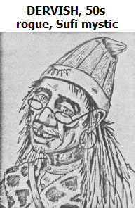
Dervish is a sight rivaling that of the Great Comet. In his 50s, he has long stringy hair and mustache, an unusual outfit accented by his leopard's skin cloak and little round spectacles about to slide down his nose. His face has sharp but pleasant features. With wandering dervishes of this type, one may be dealing with a con-man or simply a bum or a genuine mystic spiritualist of the Sufi tradition.

The moving clouds reveal a fuller view of the Great Comet. Wright shouts, "That's it! It's happening!"

Wright is now dancing, twirling, his arms out-stretched and vocalizing loudly something not quite understandable. The mountains seem crowned by the giant comet glowing above.

Dervish inspects the ecstatic trance of Wright. He fingers his prayer beads and scratches his chin with the curved-blade hatchet commonly carried by such individuals. He seems to be considering several unspoken theories: "This Westerner has seen me here and is making fun of me" or "This Westerner is really with it, whatever it is."
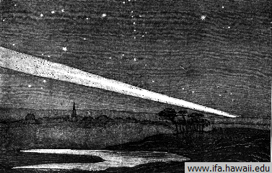

Suddenly, Wright freezes as his twirl throws him eye to eye with Dervish. A bit dizzy, Wright notices the sharp, curved hatchet blade. Dervish howls, tosses the hatchet aside, jumping up to twirl in his own reverie. His spectacles fall at Wright's feet. Wide-eyed, exhausted, Wright sighs and dashes after him.
Now two "whirling dervishes" dance on a hill crest below the Great Comet.

THE BAB'S FAMILY RESIDENCE, SHIRAZ

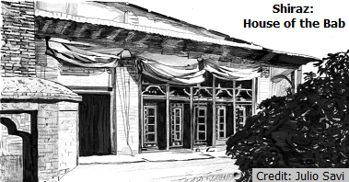
Illuminated by a lantern, a beautiful, very young baby lies still in a Persian style crib. Its eyes are open. It is absolutely motionless. After a few heart beats, the horror of this sight hits home. All is not well.
These are the moments after the death of the only child of a quiet, young man, who will later assume the title of "the Bab," meaning "the gateway" to a new era of history, our modern age.
The Bab's Wife and Mother, tears gushing, sob and wail, hugging the lifeless child and clinging to each other.

It is a silent night, but for an ethereal and profoundly sad Persian chant. These intonations are prayers offered by her husband, the Bab, on this solemn occasion.

Later, the Bab's Wife, despondent, sits on a bench in the small courtyard. She looks up in the direction of the source of the chant, coming from the roof of a second story of the house. Her eyes are wet and red. The Bab's Mother appears and comforts her.
She tells the mother, "He said he was not destined to leave any children."
"Come to bed ... He will not stop until morning."
The Great Comet dominates the night sky. From the courtyard, it appears to connect with a place on the roof of the house. The prayerful chanting continues.

COURTYARD OF SIYYID KAZIM, KARBALA
December, 1843

According to custom, Siyyid Kazim has been prepared for burial. This is not a dream. He is dead. Light filters through moving tree leaves illuminating his figure. Prior to his death, however, there was a dream of a modest Shepherd of similar age to Siyyid Kazim. Consider his story, near the mosque of Baratha, not far from Baghdad.

BARATHA, COUNTRYSIDE NEAR BAGHDAD

In the same position as Siyyid Kazim now lies on his back, the sun-burned and wind-worn face of this Shepherd appears, also in the shade, illuminated by light filtering through moving foliage. The Shepherd opens his eyes and rises to a sitting position, as if rising from the dead. He smiles, seeing his livestock and dog nearby. But he just had a disturbing dream.

IN FRONT OF MOSQUE-I-BARATHA

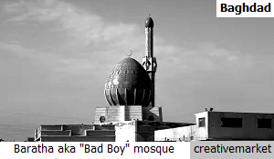
Camels loaded with possessions mill about in front of the mosque. A group of some twenty men have gathered under a palm in the foreground. The Shepherd and his dog approach with hesitation. He is about the leave, when two men in the group, Sadiq and Javad smile and beckon him to join them.
Just as the Shepherd finds himself among the men, one of them turns for a close look at him. It is Siyyid Kazim. The Shepherd almost collapses. His dog whines when the one-eyed Mamaqani approaches.
Recomposed, the Shepherd quotes from his dream to Siyyid Kazim, "'When you shall have returned to Karbala, there, three days after your return, you will wing your flight to Me'."
Sadiq and Javad, but not Siyyid Kazim, become disturbed.
The Shepherd finishes his account, "That's what the voice said, 'Tell him, from Me'."
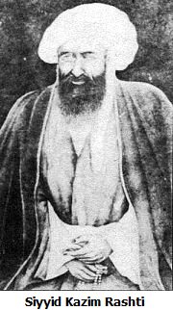
Suspicious that a conspiracy might be afoot with respect to their leader, Siyyid Kazim, some of the men can barely restrain themselves. No fool, the Shepherd realizes what methods might be used to extract further information. He sees that he cannot make a run for freedom. He is surrounded. Siyyid Kazim's men would not have harmed him, but the Shepherd is relieved when Siyyid Kazim intervenes smiling, "This was a dream?"
Looking around at the men, the Shepherd carefully pronounces in his most credible tone of voice, "Yes, that's right. A dream." His dog wags its tail.
Then Siyyid Kazim states, "There is no doubt of the truth of this dream."
The emotions of the men shift from anger and suspicion toward confusion and grief as Siyyid Kazim continues,
"Would you not wish me to die, that the Promised One may be revealed?"

COURTYARD OF SIYYID KAZIM
1844

Tahirih's uncle had personally delivered Siyyid Kazim's reply to her letter. This kind uncle, Tahirih and her sister, Mardiyyih, then embarked on the long journey to Karbala to study under Siyyid Kazim. Upon their arrival, Mardiyyih awaits a reunion with her husband, Ali, who was already in Karbala as a student of Siyyid Kazim.
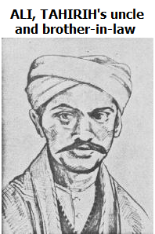
Alas, Siyyid Kazim had passed away before their arrival. Now Karbala was buzzing with the expectation that a new era was beginning and a new prophet might appear.
The courtyard of Siyyid Kazim's residence is empty. Mardiyyih stands in the doorway to the women's area of the household.
Three men enter the courtyard from the street entrance, Shaykh, Tahirih's uncle and Ali, about 22.
"Ali!" cries Mardiyyih.
Shaykh and Tahirih's uncle stop at the entrance and politely look away as Ali runs to embrace Mardiyyih.

"To have traveled so far only to find that Siyyid Kazim had..." Ali says.
Mardiyyih whispers, "Umm ... you're here."

Husayn, 31, is another of Siyyid Kazim's students. As many of Siyyid Kazim's following, he is a scholar, devoted to religious studies, a Muslim cleric known as "Mulla Husayn." He is handsome and on this day, as he appears on the street in front of Siyyid Kazim's residence, his popularity is evident.
Husayn is not large, either by build or stature and may even be considered on the fragile side physically. He is serious, determined and possessed of an attractive personality that makes him a natural leader. A slight tremor is seen whenever he uses his right hand.

Mounted on horses, Husayn followed by his Brother and Nephew ride toward the residence of Siyyid Kazim. Husayn's Brother and Nephew, younger men, are almost constant companions devoted to Husayn.
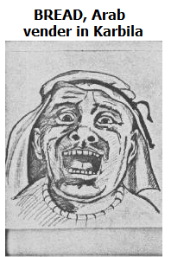
Attracted by the sound of a crowd, Tahirih's uncle and Shaykh emerge from the front entrance of Siyyid Kazim's residence to see the three men near the stand of a bread vendor.

This vendor -- let us call him "Bread" -- is short, stout, flabby, unkempt, gruff, without class.

In the threshold of the dwelling next to Siyyid Kazim's, Husayn's mother, early 40's and his sister, Bibi, mid teens, wearing face veils, scarfs and dark dresses, watch the scene.
"Look at him!" Bibi says.
Husayn's mother, standing behind Bibi, wraps her arms around Bibi and replies stoically, "Take a good look at your brother."

A young boy, who will be called Street, then 10 years old, is thrilled to touch Husayn's saddle, as the crowd presses in.

From a window on the outer side of the parlor of Siyyid Kazim's residence, Tahirih lifts her shawl to cover her face and peers out at Husayn.
Near the rump of Husayn's horse, Street cups his hands to form a step to hoist his younger brother -- call him Kid, only five years old -- up on to the horse. High-strung and prancing in place, the horse shifts position. Street and Kid hit the ground.

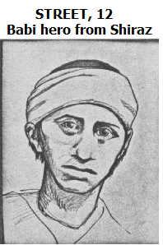
Kid and Street are brothers visiting Karbala with their father, a widower; are "lower class" and often seem unaware of "manners"; they wear something distinctive to be easily recognized about three years later.

Above the voices of well-wishers all speaking at once, the Bread vendor calls to Husayn, "Stay in Karbala! It is you they want. Thousands are coming! Big business!" as if a bread vendor could select or appoint the Promised One.
Husayn is expressionless. His Brother and Nephew are shocked by the crassness of this remark.
Street and Kid, grinning, are again positioned beside the rump of Husayn's horse.
We notice the tremor in his right hand when Husayn pulls out a coin. He tosses it to the Bread vender, who eyes it before enclosing it in his fist.
Plop! Kid lands on the horse's rump behind Husayn.
The Bread vender steps back from his stand, opening his arms. No one doubts the meaning. Quickly and orderly, the group cleans all the bread from the stand.
Joy in her eyes, Tahirih chuckles. Everyone is having fun.
Kid pulls himself up to sit behind Husayn. Though very young and with his hands on Husayn's shoulders, clearly Kid is daring and agile. The crowd cheers him.
Two glassy-eyed men seated smoking water pipes stare straight ahead, as if none of this activity was taking place.
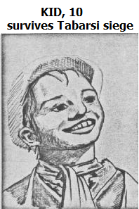
Surveying and enjoying the near anarchy, the Bread vender notices that Husayn is staring at him and runs into his shop.
Kid manages to stand behind Husayn on the horse.
The Bread vendor reappears, carrying more bread from the shop for the people. More cheers.
Husayn's Brother and Nephew laugh, seeing that Kid behind Husayn and out of Husayn's view, has raised an arm in a victory expression and bows to the crowd, as if the cheers were only for him. Realizing what is happening, Husayn also laughs and snatches Kid down to his lap and hugs him.
At that instant, the eyes of Tahirih and Husayn meet and remain interlocked as Husayn's horse continues shifting position. No question of the profound mutual admiration.

Tahirih turns away from the window. The shawl raised to cover her face slips down. She is glowing. She repositions the shawl over her face when she notices that Mardiyyih and Ali are standing on the other side of the room in the doorway. Looking out the window again, she says, "Mulla Husayn will not rest until he has found the treasure hard to attain."
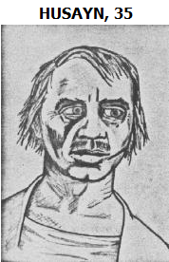
Turning to Mardiyyih and Ali, she touches a sealed letter to her cheek, crossing the room toward them.
"And when you, Ali, shall have also found him, would you offer this expression of my love and devotion?" she asks as she places this letter in Ali's hand.
Mardiyyih beams with pride at her husband.

Proclamation of the Mission of the Bab

THE BAB'S FAMILY RESIDENCE, SHIRAZ

Uncle, early 40s, raised the Bab almost as a father and is a successful merchant. His dress is elegant but not ostentatious. He is a gracious host to the new friends of his nephew, Siyyid 'Ali-Muhammad (later known as the Bab).

The house of the Bab is part of a complex near to the residence of the Bab's Uncle.


It is night. Looking up from a small courtyard, Husayn can be seen standing at the top of a stairway to the second floor. His posture is casual but it might seem that he is guarding the entrance. The Bab's Wife emerges carrying a tray with tea cups and descends the stairs.

Quddus: 22, confident, relaxed, but respectful; handsome, with a sensitive face of a poet; clean-shaven. His dress is colorful and unusual, even bizarre, compared to other young men of his class who were religion students.

Ali and Quddus sit in the courtyard. The Bab's Wife passes them. Uncle asks, "Would you men like some tea?"
Ali, "Oh ... no thank-you, sir, we're fine."

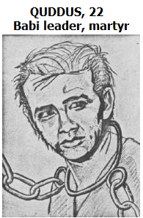
Uncle, "I hope my young 'Ali-Muhammad is not keeping you waiting."
Ali, "Ah ... no ... Actually, he..."
In the interior hallway behind Husayn, Mulla enters from a room and heads for Husayn and the stairs.
Quddus nudges Ali to signal that Husayn and Mulla are descending the stairs.
Quddus chimes in to Uncle, "Actually, sir, we were just on our way out. You have been more than kind."

Mulla: named Mulla 'Ali, a little older than Husayn and sports a full beard with strands of gray.

The four men exit the house of the Bab to the street from the front entrance, which is a double door in a wall enclosing the residence. As Husayn closes the doors, Mulla grabs both arms of Ali in a friendly, excited manner, "Listen to this."
Back against the wall, Ali looks to Quddus, "I was going to tell him..."
Quddus, "Tell him what? What would you say to the uncle of the Bab who has been like a father to him?"
Mulla, "Listen, 'Ali. I am to deliver a message to Qurratu'l-Ayn."
Across the narrow street on the second story, a woman opens a curtain to look.
Husayn, "Gentlemen, let's go."

Posted as a sample at https://bahai-library.com/keene_dawnbreakers_novel . Purchase online at https://www.amazon.com/gp/product/B09895BRXC . Page format small because copied from the Kindle edition.

