DER HERR IST NAHE  
THE LORD IS NEAR

The Divine Mystery of the  
Transformation of Mt. Carmel

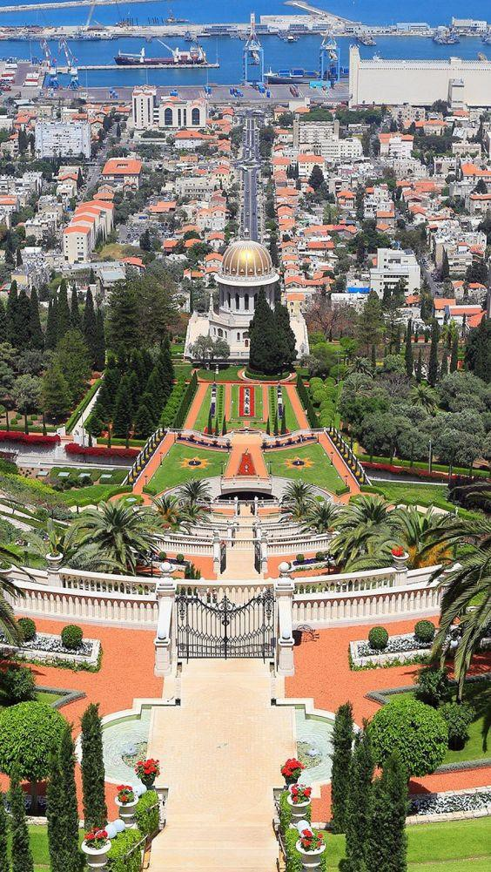

A Meditation by Harry Liedtke

**A**mram Mitzna, who at the time was Mayor of the city of Haifa, wrote the following introduction for a spectacular tourist book that was distributed around the world to promote one of the city’s main attractions:

*“The Eighth Wonder of the World—The Bahá’í Gardens surrounding the monumental Shrine of the Báb.*

*Magnificently designed nineteen terraces gently glide towards the quarter of the German Colony.*

*Spread down the northwestern slopes of Mount Carmel, colorfully planted in meditating beauty, they carefully follow the hilly topography.*

*Elaborate water fountains, sculptured ornaments, a wide variety of plants and other decorative elements are set in perfect harmony ….”*

Could it be that this sweeping panorama embodies a mystery of profound spiritual significance that is expressed in the unique alignment of the nineteen terraces on which future rulers from every part of the globe will one day ascend God’s Holy Mountain to pay homage to their Lord?

The broad avenue of the old German Colony and its continuation in the form of regal terraces leading directly to the Queen of Carmel, the Shrine of the Báb, should perhaps be recognized as a subtle expression of divine approbation of the lives and sacrifices of those who had renounced fame and fortune in their ardent quest for their Beloved.

In the East, Shaykh Aḥmad, “bereft of all earthly possessions, and detached from all save God,” and Siyyid Káẓim, “became increasingly aware of the approach of the Hour at which the promised One was to be revealed.”[1] In the West, at about the same time, devout believers in Jesus Christ also knew in their heart of hearts that His Second Coming was near.

Members of the *Templer Society* in Württemberg, southwest Germany, felt irresistibly drawn to the Holy Land. Their faith in Jesus Christ and their studies of the Bible had kindled a belief that the return of the Lord was imminent and that He would come to Mt. Carmel. They sold their farms and most of their possessions, and moved to Haifa. The founder of their society, Christoph Hoffmann, accompanied by his principal lieutenant, Georg David Hardegg, disembarked in Haifa harbor on October 30, 1868.

|  |  |  |
| --- | --- | --- |
|  | Christoph Hoffmann at left and Georg David Hardegg at right. |  |

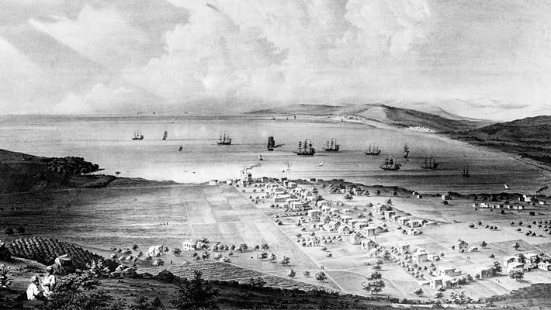

The Templer Colony at the foot of Mount Carmel. Painting from 1877 by architect Yaakov Schumacher when the colony was in its 9th year.

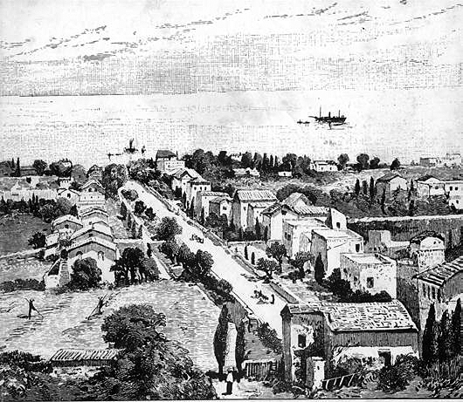

German colony in Haifa, 1875.

As the newcomers were surveying the untamed wilderness of Mount Carmel, little did they realize that their Lord had actually arrived here by sea exactly 60 days ahead of them, and that He was being kept incarcerated under dreadful conditions in the prison fortress of ‘Akká, just across the Bay of Haifa. On August 12, 1868, just as Christoph Hoffmann and Georg Hardegg made ready to leave their native Germany, Bahá’u’lláh, His family and companions were escorted out of Adrianople, arriving five days later at the Turkish port of Gallipoli. After three harrowing days of uncertainty they were taken aboard a steamship of the Austrian Lloyd bound for Alexandria, Egypt. Bahá’u’lláh was heard to remark in jest,“*Would it not be a treat if the liner should sink*,” but then He added with power and authority, “*But it will not sink, even if it is battered by all the waves*.”[2]

Their ship docked at Alexandria, Egypt, on the morning of the sixth day. Here the prisoners transferred to another liner of Austrian Lloyd and resumed their voyage that same night. They arrived at Port Said on the next morning and left again that same evening for Jaffa and Haifa. Bahá’u’lláh and His companions eventually reached Haifa on the morning of Monday, August 31, 1868. They were rowed to shore and a few hours later left on a sailing vessel for ‘Akká which they entered through the old Sea Gate. Here, mocked by a jeering populace as “the God of the Persians”,[3] Bahá’u’lláh and His family and friends, were immediately confined to the Citadel, banished for life, and not allowed contact with the outside world.

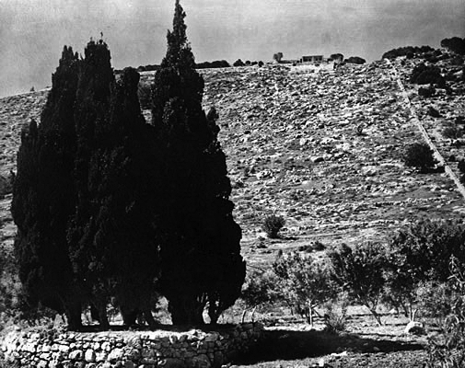

The untamed wilderness of Mt. Carmel

In the meantime, across Haifa bay, the new German arrivals meditated on where best to establish their Colony. They decided on an area that lay about halfway between the town of Haifa and the Lower Cave of Elijah. They lost no time to lay out an impressive avenue that was to be 30 meters (100 feet) wide. Running at right angles from the waterfront it headed straight for the slope of Mt. Carmel. Their own Architect, a Ya’akov Schumacher, had especially come all the way from America to supervise layout and construction. Initially five homes were built on either side of the avenue. Surrounded by a semi-wilderness, their new tree-lined “Main Street” and its solid dwellings of European design now presented an agreeable passage from Mt. Carmel to the sea. It would definitely be fit for the returning Lord of Hosts to walk on.

A mere seven years later, by 1875, the small German Colony had grown to 311 inhabitants and 85 buildings, among them a school and two flour mills. Signs in German language were mounted above the

entrance doors to proclaim the deep faith and conviction of the occupants:

“Der Herr ist nahe … The Lord is near.”

It was the whole truth without them ever knowing it.

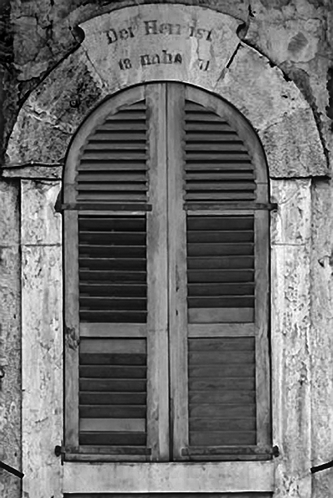

Engraving on a Templer house dating from 1871.

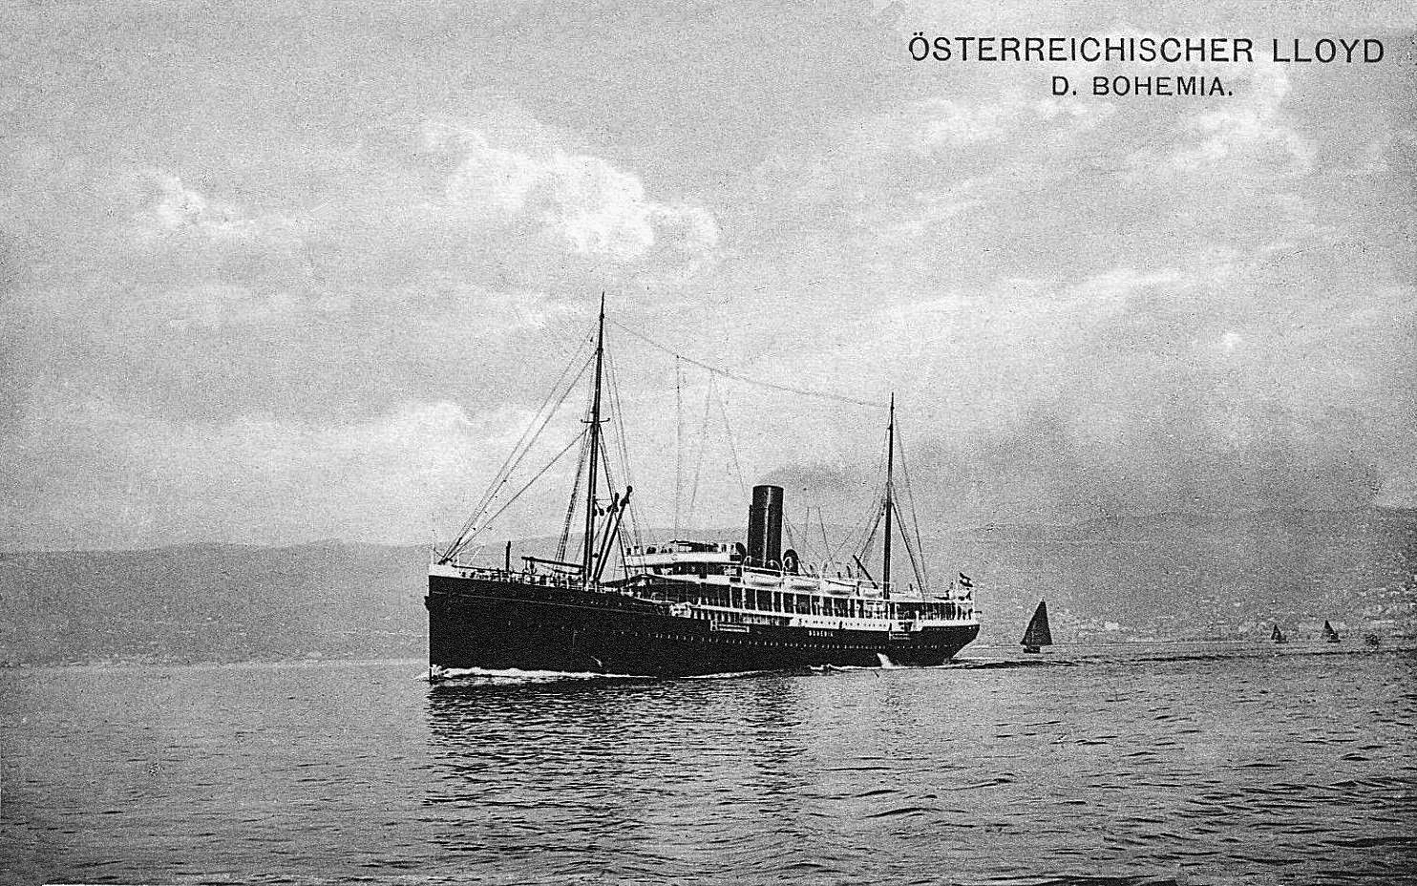

Steamboat Bohemia of Austrian Lloyd

When Europeans wished to travel to Haifa in those early days, they had to take the sea route from Alexandria via Port Said and Jaffa. As this sea link was operated on a rather limited frequency, it was by a strange twist of fate that the German advance party had literally just missed the boat and thereby a possible shipboard encounter with Bahá’u’lláh.

It may have been providential, for would they really have recognized their Lord in the person of a 51-year old Persian prisoner Who was accompanied by some 60 fellow exiles, both male and female? Were they not expecting the traditional figure of Christ to appear on God’s Mountain? Instead, having taken the journey just two months after Bahá’u’lláh, they remained blissfully unaware of the party of Persian prisoners. Their ignorance thus allowed them to pursue their cherished dream of building a lasting monument to their intense longing. There would have been absolutely no reason for this ambitious project, had they known that the Lord they were waiting for had already arrived and was languishing in ‘Akká’s Great Prison. Neither could they have known that a century later and for many generations to come, the fruit of

their labors would point straight as an arrow up the slope of Mt. Carmel towards the Arc of Bahá’u’lláh.

On June 23, 1870, Mírzá Mihdí, the Purest Branch, the 22-year old second-born son of Bahá’u’lláh, severely injured himself when he fell through a skylight while walking on the prison roof absorbed in his prayers. “I wish the people of Bahá to be able to attain Your presence,” was his dying supplication to His Father. “And so it shall be, God will grant your wish.”[4] Bahá’u’lláh accepted the sacrifice of his young life. Just four months later, urgent troop re-deployments within the Ottoman Empire required the use of ‘Akká’s barracks and forced the authorities to empty the prison. The exiles were now moved to less restricted accommodations, first within the city walls of ‘Akká and later to palatial homes in the verdant countryside of Mazra‘ih and Bahjí.

But it was not until August 1883, a full 15 years after He had first set foot in the Holy Land, that Bahá’u’lláh returned to Haifa. According to H. M. Balyuzi in his book *Bahá’u’lláh, the King of Glory*, this visit lasted only “a few days, and He stayed in Bayt-i-Fanduq, a house in the German Colony, part of which still stands today. … The third visit [to Haifa] was [seven years later] in 1890. … He stayed, at first, near Bayt-i-Zahlan, near the town, and then He moved to a house in the German colony which was known as the Oliphant House.”[5] His last visit to Haifa was in 1891, the year before His passing. On this occasion He stayed for over three months in the house of Ilyás Abyad near the German colony.

And so it came to pass that the Lord of the Age stood on God’s Mountain, just as the seers had prophesied, and that He walked along the broad, tree-lined avenue that had been so lovingly prepared for His coming. But none of those who were expecting His imminent arrival recognized Him the way that Mullá Ḥusayn had once recognized the Báb, or “knew Him by His gait”,[6] as Quddús, the Last Letter of the Living, had discovered his Beloved.

It happened just as it had been foretold in the Bible; Bahá’u’lláh had come as the proverbial *Thief in the Night*.

Quoting further from H. M. Balyuzi’s book; “One day, when standing by the side of some lone cypress trees nearly half-way up the slopes of Mt. Carmel, Bahá’u’lláh pointed to an expanse of rock immediately below Him, telling his eldest Son [‘Abdu’l-Bahá] that on that spot should be built the mausoleum to enshrine the remains of the Martyr-Prophet, the glorious Herald of His own advent ….”[7]

What we should realize today, a little over a century later, is this: What Bahá’u’lláh saw lying before Him was not just an expanse of Mt. Carmel’s exposed rock, but also, and in perfect alignment, the full length of the broad avenue of the German Colony. By choosing this precise spot, as if aided by a surveyor’s instrument, instead of pointing to any number of possible sites on the mountain, Bahá’u’lláh deliberately and for all time established a symbolic link between the coming of the Báb and the expectations of a small group of Europeans who were certain that their Lord would appear here in this unadorned wilderness and not at some celebrated seat of earthly power.

The first pilgrimage to God’s Holy Mountain by people from the West had thus received a measure of divine confirmation by the Lord of Hosts Who had arrived here from the East.

So when you visit Haifa today and look up to the Shrine of the Báb from the Avenue below, or when you look back from the Shrine to the old homesteads of those early seekers, the full meaning of faith and renunciation is suddenly revealed, the coming together of East and West can be discerned, and the close link between the Manifestation of God and the world of humanity becomes evident.

Perhaps it would be a huge understatement to describe this mystic embodiment of the spirit and the overwhelming beauty it has brought to God’s Holy Mountain as being merely *The Eighth Wonder of the World*. Its true rank is known to God alone.

A Postscript: When the author was in high school, he took private lessons in Latin from an old retired teacher by the name of Hermann Häberlin who lived in Vaihingen, a suburb of Stuttgart. In the early 1880’s, when Häberlin was 21 years old, his first teaching job was at the school of the Templer Colony in Haifa. He reminisced to the author about the “lawless bands of Bedouins” that made travel outside Haifa’s city limits very dangerous. He also frequently mentioned the religious fervor that prevailed in the German Colony. But he never indicated that anybody was then aware that there were “Persian prisoners” in the area. Another “coincidence” was that the early Templers and their school teacher Häberlin came—of all the places in Germany—from the area of Stuttgart, precisely the place where at the beginning of the 20th century the Faith of Bahá’u’lláh was first established in Germany and where ‘Abdu’l-Bahá was visiting. HL

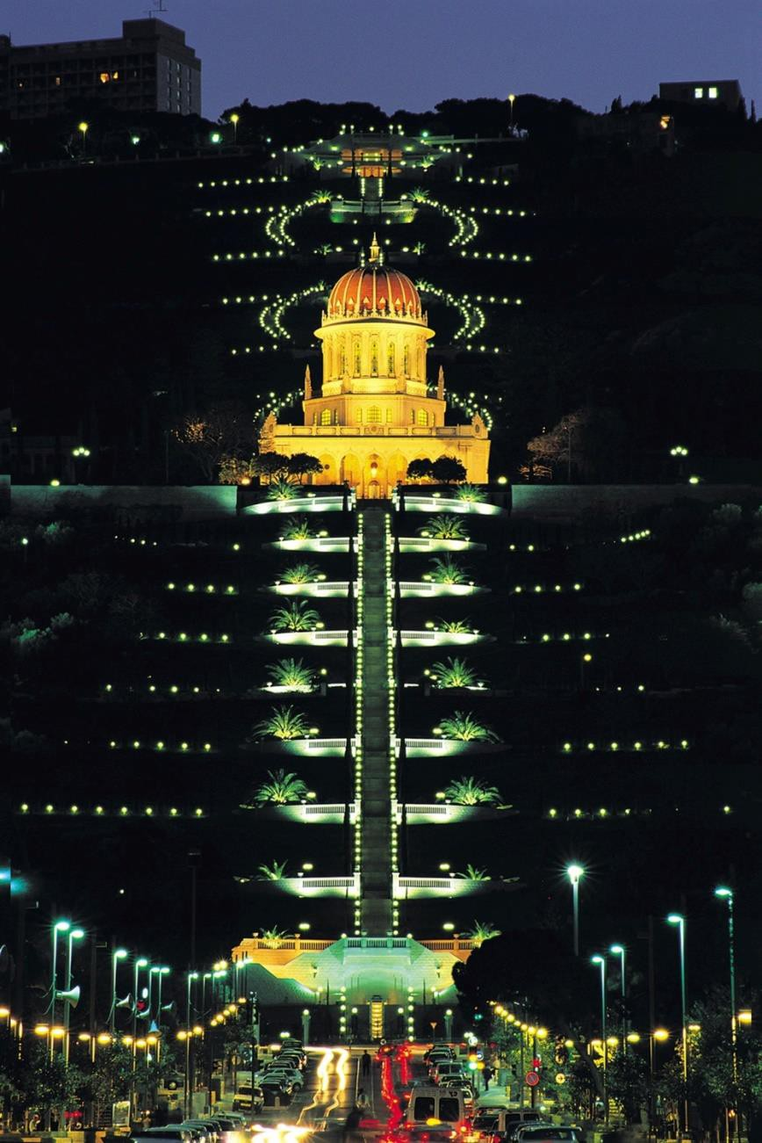

1. Nabíl, *The Dawn-Breakers*, pp. 2 & 24.
2. H. M. Balyuzi, *Bahá’u’lláh, the King of Glory*, p. 264.
3. Shoghi Effendi, *God Passes By*, p. 186.
4. H. M. Balyuzi, *Bahá’u’lláh, the King of Glory*, p. 311–2.
5. idem, p. 374.
6. H. M. Balyuzi, *The Báb: The Herald of the Day of Days*, p. 23.
7. H. M. Balyuzi, *Bahá’u’lláh, The King of Glory*, p. 374.