WELCOME TO

THE MEMOIRS OF SHAMSI SEDAGHAT

By

Shamsi Sedaghat

Assisted by Mr. Hillary Chapman

2023

Table of Contents
Introduction 1
Chapter 11
Early years in Ashgabat and Iran 11
Chapter 2
Mashhad-Brighton-Pilgrimage to the Holy Land-pioneering to Africa 42
Chapter 3
Pioneering to Cyprus 71
Chapter 4
First Baha’i World Congress in London and Return to Iran 89
Chapter 5
New Delhi Conference and subsequent trips to Kampala, Brighton, Palermo, and Haifa 103
Chapter 6
Trinidad and Tobago: January 1969 Laying the administrative foundations in Trinidad 121
Chapter 7
Teaching in Jamaica, the opening of the Couva Clinic and the declaration of Dr. Harry Collymore 173
Chapter 8
Teaching in the Caribbean 1975-1977 205
Chapter 9
Travel Teaching 1977-1978: The Caribbean Islands, Central America 266
Chapter 10
Visit to the United States: Washington DC, November 1977, and Subsequent Trips to Central and South America 291
Chapter 11
Visit to the Bahamas, February 1978 320
Chapter 12
Travel teaching: United States, Africa, and Europe 373

Chapter 13
My departure from Bermuda to Liberia 394
Chapter 14
Arrived in Washington DC, 1979 464
Chapter 15
Pioneering to several other countries and islands 473
Chapter 16
Decision to pioneer to the Bahamas 484
Chapter 17
Decision to pioneer to Odessa, Ukraine, 1990 536
Chapter 18
Turkmenistan Ashgabat 614

Appendix A
Baha’i services 667
Appendix B
Professional Resume 672
Additional Photos 674

Introduction
Dear Friends,
In 1964, when our family returned to Iran from our pioneering post in Cyprus, the National Spiritual Assembly of the Baha’is of Iran and, later, the National Spiritual Assembly of the Baha’is of the United Kingdom wrote to me that the Universal House of Justice had written to all National Assemblies around the world and asked them to collect the memories of pioneers and travel teachers for the archives at the Baha’i World Center. At that time, I was too busy with my hospital work and Baha’i service to be able do this. Years later when I was in Odessa, Ukraine, Mr. Hushmand Fatheazam, former member of the Universal House of Justice, who was a constant source of support to me in my Baha’i services, again encouraged me greatly to tape my memoirs, send them to America, and he would get the book published.

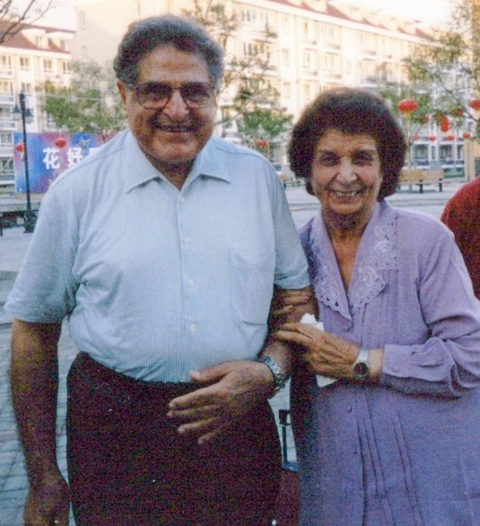
Former member of the Universal House of Justice
Mr. Hushmand Fatheazam with Shamsi

Therefore, I decided to write this simple account of my daily activities.
Over my seven decades plus of service, I have met and served with many hundreds of wonderful Baha’is and have done my best to include the names of some of these beloved friends in the pages that follow. I ask your forgiveness if I have misspelled or omitted any names and any other shortcomings which this book may have.
In 2015, I wrote to the Supreme Institution of the Universal House of Justice about my decision to write my memoirs, and I asked their guidance. The Supreme Body honored me with the following guidance:

Letter from the Universal House of Justice
“Dear Bahá’í Friend,
The Universal House of Justice has received your email letter dated 30 May 2015, requesting guidance on whether you should remain in Turkmenistan or go to the United States temporarily in order to write your memoirs. Also received was your email letter dated 10 June 2015, forwarded by your National Spiritual Assembly, in which you ask whether you may include in your book some of the writings of the Guardian, communications from the House of Justice, and letters written to you by various National Assemblies. We have been asked to convey the following.
The House of Justice was pleased to learn that you intend to document your many years of service to the Faith and encourages your efforts on this endeavor. No doubt your accounts will be a valuable history and a source of inspiration for future generations to come. With regard to where you should live while writing your book, it is suggested that you consult with family members and friends whose judgement you trust after prayerfully weighing the relevant factors involved, such as personal circumstances, and giving due regard to practical issues, including what may best help you in carrying out this task. The House of Justice appreciates your desire not to be absent from your pioneering post for too long, however, this should not preclude you from completing this undertaking wherever you know is best.
Concerning the published writings of the Guardian, you are free to include extracts from these in your book. Similarly, if any of the letters—written by or on his behalf—that you want to use have already been published, no additional permission is necessary….Rest assured of the supplications of the House of Justice in the Holy Shrines that your steps may be divinely guided and that your aspirations to be of service to the Cause may be fulfilled….
With loving Bahá’í greetings,
Department of the Secretariat”
After receiving this letter, I consulted with my sister, Mrs. Guitty Ejtemai, and a few others in the United States, and they advised me to come to McLean, VA, United States of America, for this purpose. Therefore, I packed five suitcases full of my papers, notebooks, reports, and photo albums, and travelled from Ashgabat, Turkmenistan, where I have been pioneering and travel teaching for the last twenty-five years, to McLean, VA, United States of America, to live with my brother Mr. Farhad Sedaghat, who was elderly and in poor health to start writing my biography. His apartment was near the home of my sister, Guitty, and brother-in-law, Mr. Abdul Hossein Ejtemai.
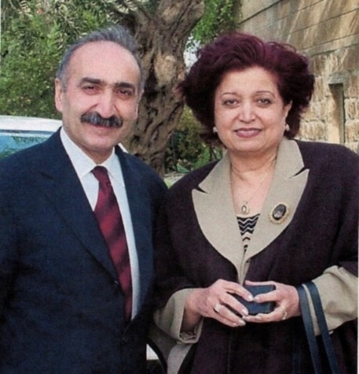
R. to l. Mrs. Guitty Ejtemai, my sister, next to her husband, Mr. Hossein Ejtemai (son of my youngest uncle, Gholam Hasan Ejtemai), who are two shining stars of our family
There I could have access to more assistance and better facilities.
I would like to write a few words about Guitty Jan and Hossein Agha. Guitty is my youngest sister, and she is very active in the Faith. Her profession was in radio where she was the chief editor of the Iran section at the Voice of America. Later, she was the director of the Baha’i Radio station. Despite being very busy, she made sure that I had everything I needed to write my book. Without her constant efforts, I would not have been able to complete this big task. Hossein Agha’s generosity and good will helped us tremendously.
In this biography, I shall write the story of my life which will include: my education, travel teaching trips, pioneering posts, and above all, the account of my pilgrimage of eleven days to the Holy Land of Israel where I had the bounty of meeting the Beloved Guardian Shoghi Effendi and his wife, Hand of the Cause Ruhiyyih Khanum, and visiting the Baha’i holy places in Akka and Haifa, Israel, in January 1955. My observations and recollections of what the Beloved Guardian said are in no way authoritative and should be taken merely as pilgrim’s notes.
After reading the story of my lifelong service to our beloved Cause, the methods and approaches I used, and the conversations I held with many individuals, the reader will understand that it has not been easy for me. But when you go deep into the reality of things, you know that there is nothing more honorable and rewarding than to be rejected when speaking about reality. You are sure that the world’s problems have existed and will continue until mankind becomes more educated, understanding, polite, respectful, loving, and gives up its prejudices of race, religion, and nationality.
I would like to thank my friends and co-workers, especially medical and surgical doctors for helping me with my physical problems. Of course, I couldn’t remember all of their names or their spellings, but nevertheless I shall write about those whom I remember who helped me privately or professionally. No doubt each one of them knows that God is our Creator therefore He knows about them and their goodly deeds and will surely reward them generously in this world and the worlds to come.
My hope is that this book may inspire others to arise and dedicate their time to the most important task of teaching. Of course, I would like to thank my principal assistant and skilled writer, Mr. Hillary Chapman (a grandson of Hand of the Cause of God Mr. Leroy Ioas and the son of Mr. Christian and Mrs. Anita Chapman) for helping and assisting me to organize and write this biography. Mr. Chapman has great patience, a calm character, and a good knowledge of the world. We worked for several years (on and off due to my bad health) together at my temporary home in Virginia. I thank him sincerely and beseech Baha’u’llah to reward him in both worlds, this and the one to come, and to live long to be able to assist others.
While I was in the United States, many wonderful individuals helped me in numerous ways, especially people in the medical field who attended to my many needs and ailments. I would like to thank them all, including: Dr. Haideh Sabet, a wonderful doctor full of love and compassion who always had a smile on her face and who was the first doctor to attend to my physical problems when I entered the United States; Dr. Radman Mostaghim, who treated me and referred me to Dr. Dugget who in turn treated my general condition; Dr. Abbas Bashir-Elahi, and many other devoted doctors who attended to my needs with love and dedication; Dr. Rowshan Bashir who helped relieve some of my other existing problems with some success. Recently Dr. Vahid Sedaghat, Dr. Navid Foroutan, Dr. Nastaran Ejtemai, Dr. Nasrin Ejtemai, Dr. Solmaz Pirzadeh, as well as our wonderful pharmacists, my cousin Mrs. Fereshteh Ejtemai Walker (whose husband, Mr. (Smiling) Mark Walker, declared the Faith on the night of their wedding) and their daughters Mona and Melody; and, especially, Mr. Hossein Ejtemai (grandson of Abdu’l-Hussein Ejtemai, who is my oldest uncle), who has been a great support in supplying my medications—his generosity has been outstanding and his support has been excellent. They were among the many kind and loving members of my own family in the medical field or other professions who always helped me in any way they possibly could.
I am most grateful to all of them and many, many other individuals whose names I have not mentioned and pray that God will keep them and their families in good health, prosperity and great success in their lives.
Shamsi Sedaghat
McLean, Virginia, 2019

I would like to let the friends know that this book is about Baha’u’llah and His World-embracing Principles. You will read more about this later in this book. Here is a brief summary reprinted below from a teaching pamphlet.

Baha’u’llah, Prophet-Founder of the Baha’i Faith
Never has there been a futurist, a forecaster, or a prophet whose vision has so accurately foreseen the critical features of these times. Writing more than a century ago, Baha’u’llah called for a complete restructuring of the global social order – a restructuring that was “inevitable” as humanity emerged into a new stage in its history.
The new age, Baha’u’llah indicated, would be marked by certain characteristics. They would include:
- The elimination of all forms of prejudice;
- Full equality between the sexes;
- Recognition of the essential oneness of the world’s great religions;
- The elimination of extremes of poverty and wealth;
- Universal education and a universal auxiliary language;
- The harmony of science and religion;
- A sustainable balance between nature and technology; and
- The establishment of a world commonwealth, in which all nations are united, and the autonomy of its state member and the personal freedom and initiative of individuals is safeguarded.
These principles have also inspired this century’s most dynamic movements, offering a testament to the extraordinary degree to which Baha’u’llah accurately forecast the predominant issues now faced by humanity.
Who is Baha’u’llah?
Baha’u’llah was born in Iran in 1817. He was the son of one of the viziers (ministers) of the King of Persia. As a young man, he turned his back on a life of wealth and, sacrificing freedom and material possessions, devoted his life to the promulgation of laws, precepts and principles designed to carry humanity forward. His mission, Baha’is believe, represents the culmination of the work of Krishna, Moses, Zoroaster, Buddha, Christ, and Muhammad.
Named Mirza Husayn-‘Ali at his birth in Tehran on November 12, 1817, Baha’u’llah became a follower of the Bab as a young man. Baha’is consider the Bab, which means the “Gate” in Arabic, a prophet in his own right. The Bab announced on May 23, 1844 that his mission was to prepare humanity for the imminent appearance of a new messenger from God, the one promised to all the religions of the world.
This is the story of that evening:
“On a hot and sunny May afternoon at the gate of the city of Shiraz, the young Muslim cleric, Mullah Husayn, stepped out of obscurity into world history and he didn’t even know it. He met the Bab, then known as Siyyid Ali Muhammad at the city gate of Shiraz.
Siyyid Ali Muhammad invited him to his home for dinner. Evening was approaching. He told Mulla Husayn not to worry about his companions who had gone ahead: “Commit them to the care of God; He will surely protect and watch over them.”
Mulla Husayn followed the young Siyyid Ali Muhammad to his house:
“We soon found ourselves standing at the gate of a house of modest appearance. He knocked at the door, which was soon opened by an Ethiopian servant. “Enter therein in peace, secure” were His words as He crossed the threshold and motioned me to follow Him. His invitation, uttered with power and majesty, penetrated my soul.”
The two stepped into the refreshing little courtyard of the traditional two-story Persian home and climbed up the stairs to the upper room.
Siyyid Ali Muhammad asked Mulla Husayn about his quest. Mulla Husayn responded that his teacher had told him to go forth and seek the Promised One of the age. When he told the young Siyyid the signs of the person of the Promised One, Siyyid Ali Muhammad said: “Behold, all these signs are manifest in Me.”
Shocked by this answer, Mulla Husayn thought about arguments as to why this was impossible. He presented a theological essay he had written and used it to test this young man. Siyyid Ali Muhammad briefly looked over Mulla Husayn’s complex and intricate points about the ‘Promised One’ in scripture. Then the young man revealed the hidden, deeper meanings which Mulla Husayn had neither seen nor understood in the sacred text. Siyyid Ali Muhammad’s insights were completely original, and his words contained great power and authority.
Soon, out of the blue, he offered to write a commentary on the Qur’anic chapter about Joseph, the son of Jacob. Mulla Husayn was stunned by this offer because his teacher had told him that only the Promised One would be capable of doing this. The words flowed effortlessly from Siyyid Ali Muhammad’s mouth and pen:
“The overpowering effect of the manner in which He wrote was heightened by the gentle intonation of His voice which accompanied His writing. Not for one moment did He interrupt the flow of the verses which streamed from His pen.…I sat enraptured by the magic of His voice and the sweeping force of His revelation.”
Mulla Husayn knew that he had found the object of his quest: the Promised One of God, the Renewer of the world. Siyyid Ali Muhammad proclaimed to him:
“O thou who art the first to believe in Me! Verily I say, I am the Báb, the Gate of God, and thou art the Bábu’l-Báb, the gate of that Gate. Eighteen souls must, in the beginning, spontaneously and of their own accord, accept Me, and recognize the truth of My Revelation. Unwarned and uninvited, each of these must seek independently to find Me. .”
Mulla Husayn remembered that the revelation hit him like a “thunderbolt”; he was “blinded and overwhelmed”:
“…the knowledge of His Revelation had galvanized my being. I felt possessed of such courage and power that were the world, all its peoples and its potentates, to rise against me, I would, alone and undaunted, withstand their onslaught. The universe seemed but a handful of dust in my grasp. I seemed to be the voice of Gabriel personified, calling unto all mankind: `Awake, for, lo! the morning Light has broken. Arise, for His Cause is made manifest. The portal of His grace is open wide; enter therein, O peoples of the world! For He Who is your Promised One is come!'"”
Baha’u’llah and other followers of the Bab were brutally persecuted by the clergy and government of Iran, who viewed the Bab’s claim as heretical to orthodox Islam. More than 20,000 of the Bab’s followers perished in a series of massacres throughout Iran. The Bab was arrested, beaten and imprisoned.
Before his imprisonment, the Bab gave this talk to his principal followers, the Letters of the Living:
“O My beloved friends! You are the bearers of the name of God in this Day. You have been chosen as the repositories of His mystery. It behoves each one of you to manifest the attributes of God, and to exemplify by your deeds and words the signs of His righteousness, His power and glory. The very members of your body must bear witness to the loftiness of your purpose, the integrity of your life, the reality of your faith, and the exalted character of your devotion. For verily I say, this is the Day spoken of by God in His Book: "On that day will We set a seal upon their mouths yet shall their hands speak unto Us, and their feet shall bear witness to that which they shall have done".
Ponder the words of Jesus addressed to His disciples, as He sent them forth to propagate the Cause of God. In words such as these, He bade them arise and fulfil their mission: "Ye are even as the fire which in the darkness of the night has been kindled upon the mountain-top. Let your light shine before the eyes of men. Such must be the purity of your character and the degree of your renunciation, that the people of the earth may through you recognize and be drawn closer to the heavenly Father who is the Source of purity and grace. For none has seen the Father who is in heaven. You who are His spiritual children must by your deeds exemplify His virtues, and witness to His glory. You are the salt of the earth, but if the salt have lost its savour, wherewith shall it be salted? Such must be the degree of your detachment, that into whatever city you enter to proclaim and teach the Cause of God, you should in no wise expect either meat or reward from its people. Nay, when you depart out of that city, you should shake the dust from off your feet. As you have entered it pure and undefiled, so must you depart from that city. For verily I say, the heavenly Father is ever with you and keeps watch over you. If you be faithful to Him, He will assuredly deliver into your hands all the treasures of the earth, and will exalt you above all the rulers and kings of the world."
O My Letters! Verily I say, immensely exalted is this Day above the days of the Apostles of old. Nay, immeasurable is the difference! You are the witnesses of the Dawn of the promised Day of God. You are the partakers of the mystic chalice of His Revelation. Gird up the loins of endeavour, and be mindful of the words of God as revealed in His Book: "Lo, the Lord thy God is come, and with Him is the company of His angels arrayed before Him!" Purge your hearts of worldly desires, and let angelic virtues be your adorning. Strive that by your deeds you may bear witness to the truth of these words of God, and beware lest, by "turning back", He may "change you for another people", who "not be your like", and who shall take from you the Kingdom of God. The days when idle worship was deemed sufficient are ended. The time is come when naught but the purest motive, supported by deeds of stainless purity, can ascend to the throne of the Most High and be acceptable unto Him. "The good word riseth up unto Him, and the righteous deed will cause it to be exalted before Him". You are the lowly, of whom God has thus spoken in His Book: "And We desire to show favour to those who were brought low in the land, and to make them spiritual leaders among men, and to make them Our heirs". You have been called to this station; you will attain to it, only if you arise to trample beneath your feet every earthly desire, and endeavour to become those "honoured servants of His who speak not till He hath spoken, and who do His bidding". You are the first Letters that have been generated from the Primal Point, the first Springs that have welled out from the Source of this Revelation. Beseech the Lord your God to grant that no earthly entanglements, no worldly affections, no ephemeral pursuits, may tarnish the purity, or embitter the sweetness, of that grace which flows through you. I am preparing you for the advent of a mighty Day. Exert your utmost endeavour that, in the world to come, I, who am now instructing you, may, before the mercy-seat of God, rejoice in your deeds and glory in your achievements. The secret of the Day that is to come is now concealed. It can neither be divulged nor estimated. The newly born babe of that Day excels the wisest and most venerable men of this time, and the lowliest and most unlearned of that period shall surpass in understanding the most erudite and accomplished divines of this age.
Scatter throughout the length and breadth of this land, and, with steadfast feet and sanctified hearts, prepare the way for His coming. Heed not your weaknesses and frailty; fix your gaze upon the invincible power of the Lord, your God, the Almighty. Has He not, in past days, caused Abraham, in spite of His seeming helplessness, to triumph over the forces of Nimrod? Has He not enabled Moses, whose staff was His only companion, to vanquish Pharaoh and his hosts? Has He not established the ascendancy of Jesus, poor and lowly as He was in the eyes of men, over the combined forces of the Jewish people? Has He not subjected the barbarous and militant tribes of Arabia to the holy and transforming discipline of Muhammad, His Prophet?
Arise in His name, put your trust wholly in Him, and be assured of ultimate victory.”
On July 9, 1850, he was executed publicly by firing squad in the city of Tabriz.
Because of his family’s influential position, Baha’u’llah escaped death, but was consigned to a notorious dungeon in Teheran in 1852. After four months in chains, he was exiled to Baghdad.
There, in 1863, Baha’u’llah openly declared his mission as a messenger of God in the Rezvan Garden near Baghdad, Iraq. However, because of continuing opposition by the government and religious authorities, Baha’u’llah suffered a series of exiles, first to Constantinople (Istanbul, Turkey), then to Adrianople (Edirne, Turkey) and eventually to the prison city of Acre (Akka, Israel).
In 1867, while in Adrianople (Edirne), Baha’u’llah began writing a series of letters to the kings, rulers, and religious leaders of his time, addressing them both as individuals and collectively. Among those he addressed individually were Napoleon III of France, Queen Victoria of England, Kaiser Wilhelm I of Germany, Czar Alexander II of Russia, Emperor Franz Josef of Austria, Pope Pius IX, Sultan ‘Abdu’l-‘Aziz of the Ottoman Empire, and Nasiri’d-Din Shah of Persia.
In these letters, Baha’u’llah announced his mission. He told of the drawing of a new age and warned of coming revolutions and changes in the world’s political and social order. Baha’u’llah proclaimed the need for humanity to accept new principles. He called for the general efforts at disarmament, for example, and warned against dealing unjustly with the poor. He also urged the world’s rulers to band together into a commonwealth of nations, saying that only by acting collectively to ban war could lasting peace be established.
God has “the desire of beholding the entire human race as one soul and one body,” wrote Baha’u’llah. “All men have been created to carry forward an ever-advancing civilization.”
In 1868, Baha’u’llah reached the final destination of his long exile: the prison city of Acre. While a prisoner of the Ottoman Empire, he continued to write, composing before the end of his life more than 100 volumes which comprise the basic scriptures of the Baha’i Faith.
Towards the end of his life, even though still under sentence of exile and prison, Baha’u’llah was allowed to move outside of the city walls to an abandoned estate known as Bahji. In this spot, on May 29, 1892, Baha’u’llah passed away. Baha’u’llah’s body is enshrined at Bahji, which is a place of pilgrimage for Baha’is.
(the above is copied from a small teaching pamphlet)

Chapter 1

Early years in Ashgabat and Iran
In Iran during the early 1900s, many people spoke about Ashgabat, Turkmenistan, a city near Iran. Ashgabat, Turkmenistan, was well-known to Iranians as a country where one could go easily, settle down, work, and better one’s life. Ali Agha Sedaghat (my future father) was living in the town of Taft near Yazd, Iran, when he decided to travel to Ashgabat and see the possibilities there for himself. Around 1918, he arrived in Ashgabat which was a large town with some Iranians (mostly Muslims and some Baha’is) and Russians, Turkmens, Armenians, and a few other nationalities living there. Soon he found several Muslim friends and found a job as a tanner.
One day, my father, Ali Agha Sedaghat and his friend were walking down Makhtumkuli Street (Swaboda) in Ashgabat when they passed an imposing structure with multiple sides and a spacious entrance that rose into a pointed arch. He knew that this was no ordinary mosque, so he asked his friend about the building who told him this was a place in which people gathered for the worship of God. Ali Agha wanted to go inside but his friend did not, and they parted ways. At the door, Ali Agha was welcomed. “Befarmaid, befarmaid! (welcome, welcome) Are you a new comer?” He was, and the greeter ushered him in.
Ali Agha looked around at the graceful arches that lined the sides and opened onto windows through which light streamed in. Across the room, men and women sat in their sections and some ladies’ hair was covered by colorful scarves. All had prayer books and were quietly reading their prayers.
He went to sit with the men and waited for the Imam to come out and lead the congregation. No one came forward. He continued to wait. Still no one came forward.
Finally, he got up and went out to the entrance and asked the greeter why there was no Imam and nothing happening. He was informed that there were no priests here. Ali Agha asked why there were no priests since all religions had priests. “Not in the Baha’i Faith,” said the greeter. If he wanted to know more about the new religion, the greeter could guide him to the right person. Ali Agha replied that he wanted to know more, so the greeter called over one of the Baha’is who helped seekers, and they arranged a meeting.
So, began two years of almost nightly study for Ali Agha. He came home from working at his tannery business, washed, dressed, and went out to a Baha’i meeting with his Qur’an under his arm. Over the many months of discussions, he found nothing that contradicted his Qur’an and grew increasingly interested in the new teachings.
Ali Agha was fortunate because he had come upon one of the pre-eminent Baha’i communities of his time. Ashgabat, located near the ruins of an old Silk Road city, was a young town founded by Russians in 1881 to counter the British influence in nearby Iran; to its north lay the Karakum Desert and to the south, the Kopet Dag. A Baha’i community had appeared in 1884 made up mostly of Persian Baha’is who had left Iran to settle in Ashgabat because of the greater religious freedom in Russia. The Baha’i community of Ashgabat included several Apostles of Baha’u’llah—the Egyptian scholar Mirza Abu’l-Fazl Gulpaygani who moved there to teach the Baha’i Faith between 1889 and 1894, and Vakílu'd-Dawlih, a cousin of the Bab. As early as the time of Baha’u’llah, Baha’is had taken the initial steps to build the beautiful building which Ali Agha passed that day. Guided by Abdu’l-Baha, construction began in 1902 under the supervision of Vakílu'd-Dawlih and was completed by 1919. This was the first Baha’i House of Worship or Mashriqu’l-adkhar, (“Dawning-place of the remembrance of God”) in the Baha’i world. Of these temples, Baha’u’llah wrote:
“O people of the world! Build ye houses of worship throughout the lands in the name of Him Who is the Lord of all religions. Make them as perfect as is possible in the world of being, and adorn them with that which befitteth them, not with images and effigies. Then, with radiance and joy, celebrate therein the praise of your Lord, the Most Compassionate. Verily, by His remembrance the eye is cheered, and the heart is filled with light.”
With all these blessings, the Baha’i community of Ashgabat grew gradually and had nice gatherings. After two years of almost nightly investigation about the Faith, my father declared the Baha’i Faith and happily came home and told his wife about it.

Story of my father’s acceptance of the Baha’i Faith

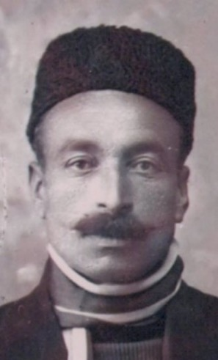
Mr. Ali Agha Sedaghat
One night, he came home very late and asked his young wife, Leqaiyyih, to make him a cup of tea. She was nervous because this was an unusual request at such a late hour, but she did as she was asked. He told her that he had something important to tell her and that she should hear him out and then could ask questions. My mother wondered if she had done something wrong or if he was going to ask for a divorce. He told her that he had been attending Baha’i meetings and had learned important principles such as the equality of men and women and that she was permitted from that day to remove the chador and wear a scarf instead. He said he would ask a Baha’i lady to come to the home and teach her to read and write. When he went to Baha’i gatherings, he would take her with him, and when he invited guests over, he would ask that the wives come as well so that my mother could participate. Their children would be educated, especially the girls, since mothers were the first educators of children.
He assured her, though, that he would not force her to become a Baha’i or to stay with him if she wanted to leave. She was free to take her belongings and those of their child, Qamar, who was a year old, and he would load them onto a horse-drawn carriage, a doroshkeh, and have them driven back to her family’s home. For his part, he had decided to make some changes in his life, like giving up his occasional drinking and cutting back on his smoking with the goal of someday ceasing altogether; though smoking was not forbidden in this new religion, ‘Abdu’l-Baha had strongly discouraged it because of its harmful effects on a person’s health. She began to cry saying that now that he was becoming an angel, he was sending her away. He again assured her that she could remain his wife if she did not object to his acceptance of the Baha’i Faith. She enthusiastically agreed. He told her not to tell anyone of his conversion which could lead to problems with their Muslim family.
The following morning, Leqaiyyih thought about the strange new turn of events in her life. Her own understanding of the world was limited due to her not having a formal education. Though she was from a wealthy family of shopkeepers and merchants, she had never been taught to read or write. It seemed so strange to her that her husband had joined a new religion which would allow her greater freedom.
Her family members began to see a change in her husband. He had matured, and his outlook became more positive. The extended family realized that Ali Agha was changing for the better so there seemed to be no harm in the change he had made. Leqaiyyih’s mother even resumed visiting her daughter’s house surreptitiously by telling everyone she was going to the Turkmen market, Tekeh Bazar, during which time she’d make a quick visit to her daughter and help her with chores. Gradually, the ladies of the Ashgabat Baha’i community helped her to learn more about the Faith until she decided that she too wanted to be a Baha’i.
Into this devout family, I was born on November 28th, 1925, to Ali and Leqaiyyih Sedaghat. This was the date when ‘Abdu’l-Baha passed away. When my father came back home at 3 a.m. that same night from the observance of the Anniversary of ‘Abdu’l-Baha’s passing in the hall next to the Baha’i temple, he saw that there were some friends in our house. He asked what was going on, and he was told by a friend, “I congratulate you for your nice little girl who was born not a long time ago.” Of course, my father was very happy to hear this good news. He entered the room, took his new baby up in his arms, kissed her, and put her back in the cradle, then sat down, and everyone enjoyed the occasion.

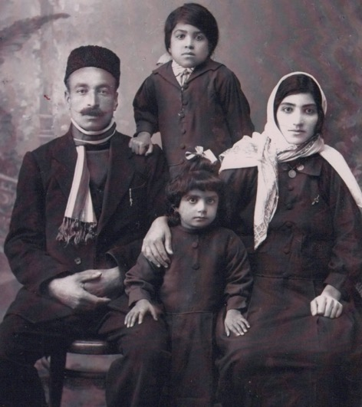
L. to r.: 1) my father, Mr. Ali Agha Sedaghat, 2) Shamsi (myself),
3) my mother Mrs. Leqaiyyih Sedaghat, 4) my oldest Qamar Sedaghat (in the back)
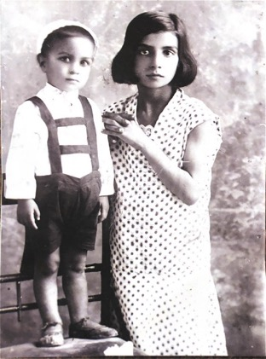
Shamsi, nine-years-old on the right, with her younger brother Farhad, who passed away young c. 1935
The Sedaghat family had ten children, five of whom passed away young: the two girls were both named Soraya, two of the boys including the one pictured were named ‘Farhad’ and the third boy was named Muhamad Agha

Gradually my father, Ali Agha, became an active Baha’i in a thriving community. Such was the love for the Faith of the Ashgabat Baha’is that in the pre-dawn darkness, people could be seen walking swiftly through the street towards the House of Worship; almost everyone who was out this early was a Baha’i going to dawn prayers. Women sat in the upper balcony and gradually they joined the men downstairs. Prayers and invocations began to be offered before sunrise with the Baha’is chanting spontaneously as the spirit moved them. Those with naturally powerful voices such as my father filled the hall with the sound of the Writings, moving the hearts of the other worshippers. Most prayers were offered in Persian as this was the language most common to the Baha’is who came from a variety of nationalities. Of course, there were a few offered in Arabic and in Russian as well, but these languages were much less understood.
My attraction to prayer
My father gradually started to teach me some prayers. As a child, I became filled with a love for prayer. I wanted to know all the prayers the other children knew, so I sat by myself and went over prayers line by line until I had memorized a few of them. In later years, I even committed the entire Tablet of Carmel to memory; when I first saw the Shrine of the Bab in Haifa on my pilgrimage, I chanted on the deck of the steamer the whole of the Tablet in praise of the Holy Mountain. While still a young girl, I learned the techniques of chanting by heart and regularly chanted at Baha’i gatherings for which the adults praised me.
In our classes, our adult teachers explained to us the power of prayer and the promise of what result it could bring, and we believed this wholeheartedly. We also learned songs written by Bibi Sakineh, whose title was “Teyr,” (meaning ‘bird’) who taught us Baha’i principles and ideas. Some songs were call and response: the boys would sing, “Miravim ma zir-e tiq,” and the girls would answer, “Jan dahim ma bi dariq,” then they would sing together, “jan feshaniyo fada kari mosallam shod be ma.” (we are ready to sacrifice our life and die in the Faith of Baha/sacrifice and self-forgetfulness have been so decreed to us/we will undergo the sword/willingly give heart and soul/sacrifice and self-forgetfulness have been so decreed to us.)
The power of the community’s prayers was evident in its spiritual prosperity. Soon, the Baha’i community of Ashgabat numbered several thousand. The Muslim authorities viewed the community with respect and understood the independence of the Faith from Islam because of the murder of a Baha’i, Haji Muhammad-Rida, in 1890, and the subsequent reaction shown by the Baha’is to it.
Martyrdom of Haji Muhammad-Rida in Ashgabat
Two men from Tabriz, Iran, who were enemies of the Faith, had attacked Haji Muhammad-Rida in the streets, stabbing him thirty-two times while an assembled crowd cheered them on. The dress with thirty-two holes in it was kept in the Baha’i archives in Ashgabat. The Russian authorities quickly apprehended the culprits. More attacks on Baha’is were planned on the following day. Mirza Abu’l Fazl Gulpaygani and a Baha’i delegation met with the Russian authorities and were able to convince them that the accusations by the Shi’ah that the Baha’is were enemies of Islam and insulted the faith of Islam were untrue and that they were law-abiding citizens who respected the beliefs of others. The authorities readily agreed that the Baha’is were blameless in this situation. They held a court with all parties present including Christians who spoke up in support of the Baha’is with whom they had developed good relations. The verdict condemned the two principal aggressors to death and banished several others to Siberia. After the verdict, members of the families of the guilty men asked Abu’l Fazl to intercede on their behalf with the Russian General Kamarov to have the sentence reduced. Mr. Abu’l-Fazl consulted with other Baha’is, and several accompanied him to the authorities and asked for mercy. On the day of the execution the Russian General announced to the assembled crowd that the death sentences had been commuted because of the intercession of the Baha’is and that, instead, the guilty men would all be banished to Siberia for fifteen years. Abu’l-Fazl noted the important effect this announcement had in terms of the way the Baha’is were later viewed in Ashgabat:
“In truth, this incident greatly enhanced the position of the friends and increased their standing and prestige. From what some in the audience have described, this intercession so profoundly touched the eminent Christians present on the field of execution that some were moved to tears, saying, "Consider the devotion of the Babi community to the qualities of forgiveness, leniency, compassion, kindness and forbearance that they even intercede on behalf of those who slay them, and in such wise show mercy towards those who spend days and nights plotting their murder!”
From the beginning of the incident of the martyrdom until now, the divine benediction and bounties have ceaselessly encompassed the friends and the exalted and blessed Almighty has confirmed our every step. Before the authorities of the Russian Government, our truthfulness, wisdom, honesty, integrity and charity towards all nations and the uprightness of conduct under all conditions had been demonstrated.”

Baha’u’llah wrote of this episode in The Epistle to the Son of the Wolf:
“Likewise, ponder thou upon the martyrdom of Hájí Muhammad-Ridá in the City of Love (Ishqábád). The tyrants of the earth have subjected that wronged one to such trials as have caused many foreigners to weep and lament for, as reported and ascertained, no less than thirty-two wounds were inflicted upon his blessed body. Yet none of the faithful transgressed My commandment, nor raised his hand in resistance. Come what might, they refused to allow their own inclinations to supersede that which the Book hath decreed, though a considerable number of this people have resided, and still reside, in that city.
…For the victims of oppression to intercede in favor of their enemies is, in the estimation of rulers, a princely deed. Some must have certainly heard that this oppressed people have, in that city (Ishqábád), pleaded with the Governor on behalf of their murderers, and asked for the mitigation of their sentence. Take, then, good heed, ye who are men of insight!”

Since then, the Faith was understood to be both a new religion and worthy of admiration. At the laying of the foundation of the House of Worship, the governor-general of Turkistan was present. Hundreds of public meetings were held; the restriction against teaching Christians was even lifted so Baha’is could invite Russians to learn about the Faith.

Mashriqu’l-Azkar, Baha’i temple of Ashgabat

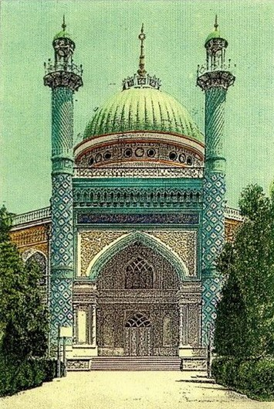
The first Baha’i House of Worship in the world which was built in Ashgabat, Turkmenistan
The centerpiece of the community was the House of Worship, the exterior of which was finished by 1919. Two minarets reaching skyward stood on either side of the two-story portico with its graceful, pointed arch through which one entered. A five-story rotunda topped by a gold-colored steel dome rose above the nine-sided first floor ambulatory that gave out into the surrounding garden. Inside on the third floor was chiseled into the stone a calligraphic representation of the Greatest Name, “Ya Baha’u’l-Abha”— “O Glory of the All-Glorious”. The Temple was in the center of the city, so its gold dome could be seen from a long distance. Along with the raising of the external ornamentation, the other dependencies envisioned by Baha’u’llah for houses of worship were built, schools for boys and girls, a travelers’ hospice, a medical dispensary that sold medicine at a lower than market-rate price, a library, and a reading room. Later, Shoghi Effendi would write of this great edifice:
“…a lasting witness to the fervor and the self-sacrifice of the Oriental believers. …must rank not only as the first major undertaking launched through the concerted efforts of His followers in the Heroic Age of His Faith, but as one of the most brilliant and enduring achievements in the history of the first Bahá'í century."
After the Bolshevik victory in 1922 that ended the Russian Civil War, the new Soviet regime consolidated its control over its vast territory. Restrictions were gradually imposed on the Baha’is in Ashgabat. The Temple was expropriated in 1928 and re-opened to Baha’is only under the terms of a lease, the schools were taken over, the Baha’i teachers were eventually dismissed, and community members were arrested and exiled. Police raids were conducted on Baha’i homes, while youth activities especially were closely monitored. Some Baha’is identified as communists to keep their jobs and protect their families.
Our departure to the town of Marv (Mary)
With the spread of the Soviet system, private enterprise was abolished which included my father’s independently owned tannery. Mother’s family of prosperous shopkeepers had already left for Iran by then and taken their wealth with them. Father, a skilled tanner, was offered a position heading a state tannery in the large town of Marv (today’s Mary). So it was that in 1930, our family left Ashgabat for Marv.
Shortly after our arrival in Marv, we were met by my kind younger maternal uncle, Mr. Golam Hasan Ejtemai, who was a teacher in the government school. (Years later he became the father of my future brother-in-law, Mr. Hussein Aqa Ejtemai, future husband of my youngest sister, Guitty Jan. Hasan Aqa, though Muslim, later married a Baha’i lady, Hosniyeh Khanum Safai. Her father, Mr. Safai, was a Baha’i writer and poet and had been one of the expert carpenters of the Baha’i House of Worship in Ashgabat, Turkmenistan. Mr. Hasan and Mrs. Hosniyeh Ejtemai went on to have five children: three of them—Mr. Hussein Ejtemai, Mrs. Fereshteh Ejtemai, and Mrs. Farideh Negarestani and their families—are active Baha’is and serving the Faith admirably and two others—Mehri Khanum and Aqa Reza—although they are not declared Baha’is yet, are loving towards all the people as well as Baha’is. Hosniyeh Khanum was an active Baha’i in Iran. She was a member of the local assembly of Taybat and a strong pillar of the Faith and although my uncle was not a Baha’i, he was a great supporter of the principles, and his son, Mr. Hussein Ejtemai, declared. He is married to my youngest sister Guitty Jan who are Baha’is and shining stars in our family as well as in the Baha’i community. Hosniyeh Khanum passed away at the age of ninety-seven in Vienna, Virginia, in the United States. In 2017, she was buried according to the Baha’i rite with utmost dignity.)

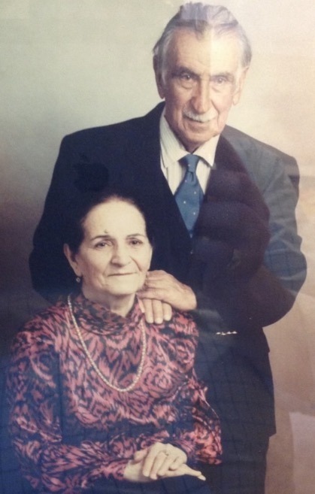
Mrs. Hosniyeh Safai Ejtemai and Mr. Gholam Hassan Ejtemai, mother and father of Mr. Hossein Ejtemai.
Mr. Ata’ullah Namdar, a very knowledgeable and active Baha’i who worked in the Iranian Embassy in Marv, gave us accommodations in the large house in which he lived. Our new life began in Marv. Father worked as the director of the state-run tannery, Qamar and I attended government schools, and mother ran the household, looking after our daily affairs.
We attended Baha’i classes which were held whenever a teacher was available. The Baha’is of Marv were active though much less numerous than in Ashgabat.
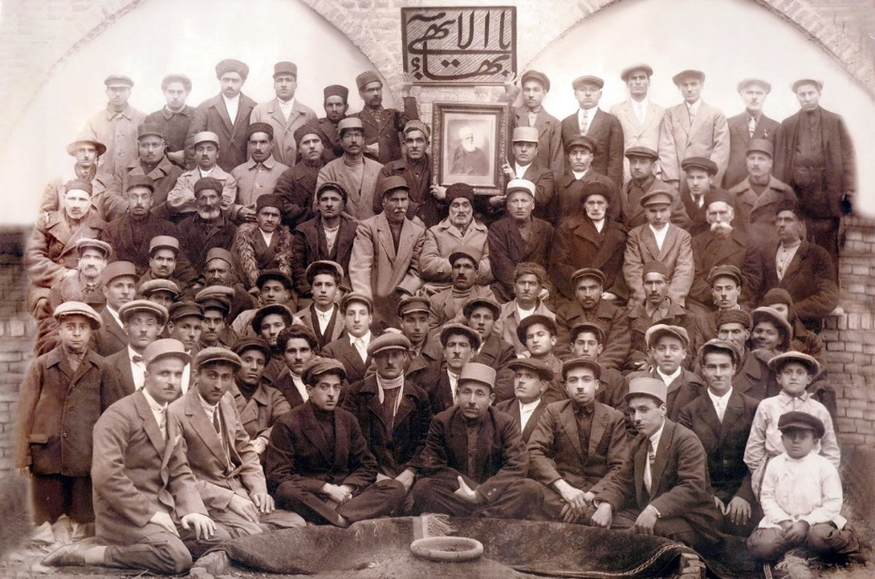
Baha’is in Marv: My father, Ali Sedaghat, is in the 3rd row from the back, seated 2nd from the left; Mr. Namdar is the first person on the left in the first row
Most of our Baha’i gatherings in Marv were held in private homes while bigger meetings were at the larger center during which children sang and chanted, and sometimes dozed in the laps of their mothers. My parents were both active in the community and when they had to go out and leave us at home, they gave us specific instructions about when to do homework, play, eat, and go to bed, and we were happy to comply.

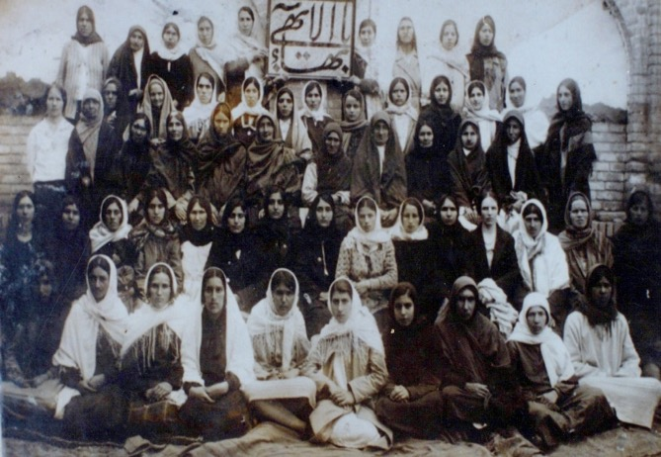
The Baha’i ladies of Marv. Mrs. Leqaiyyih Sedaghat, Shamsi’s mother, is sitting 4th from the left, second row
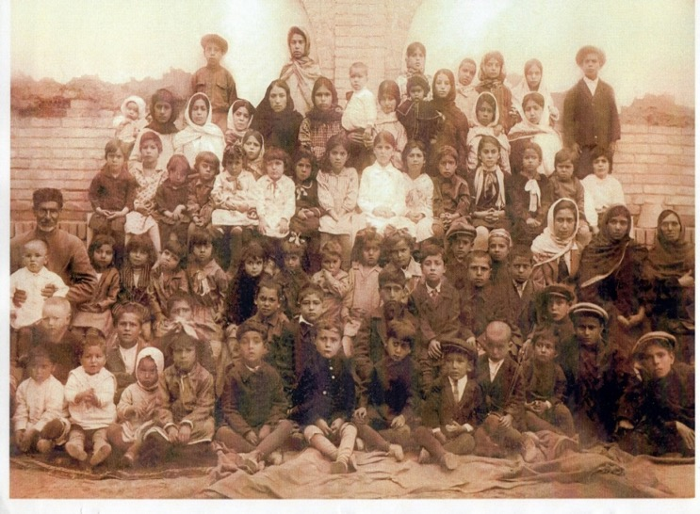
Shamsi is in the back row, 3rd from the right; sister Qamar Khanum is 3rd from the left in the second row from the back (the row with a child) next to the lady with the black scarf
Our return to Ashgabat
Father quickly found that running a state-run business in the Soviet system was highly restrictive, and he longed for greater freedom. So, we returned to Ashgabat in 1933 and moved back into our home. Private enterprise, though, had been largely abolished so father had to do various jobs to earn an income which was supplemented by renting out two rooms in our house in Ashgabat to a Persian Baha’i, Mr. Akhkar, a Baha’i university professor and his Russian wife and two children. (His sister Mehri Khanum and her husband Ali Agha Seyffodinov and their young families had been very active members of the Ashgabat Baha’i community.) As the Soviet structure turned increasingly authoritarian, the government forced its citizens into new forms of housing, work, and farming. The collectivization of agriculture was underway leading to disastrous consequences. Due to housing shortages in the cities, families were forced to share living space. All facets of life became communal. One day the police rang our doorbell. We were worried simply because from the way they rang we understood that it was the police. We opened the door. The officers came in and counted the number of rooms and the number of people who lived in the house. By chance, the Akhkar family had recently left. We were then informed that we could keep one room for the parents, one for the children, and one for guests, and the other two would be made available to be rented to a Russian family. Unfortunately, our new non-Baha’i co-residents tended to stay up late drinking and singing making it difficult for us to get the rest we needed for our demanding school days.
My sister and I continued our schooling. We had completed the primary grades and now moved into secondary school. Our parents were intent on us receiving an education, developing a profession, and learning about the Faith. I started studying pharmacology, and Qamar went into midwifery. I studied the Persian language as well with a very educated Baha’i, Khanum Takamul, (whose daughter Jashniyeh Khanum and son-in-law Mr. Ismail Zabihi Mogaddam were born and raised in Ashgabat but then had to leave. Years later, they returned as pioneers to Ashgabat and served the Faith admirably for years and then relocated to Germany for health reasons. In Germany, they sold their Ashgabat apartment to an active Iranian believer, Mr. Namdar, who in turn donated the apartment to the Baha’i Faith in Ashgabat to be used as a guest residence or center for the Baha’i Faith. I am grateful to all of them. They have a son Soheil Agha Zabihi, a very active Baha’i, and his wife, Parisa Khanum, who is a much-loved professional Baha’i singer in Germany. Presently, Mr. Ismail Zabihi has passed away and his wife, Jashniyyih Khanum, lives in a comfortable nursing home (in 2017) in Germany where she remains independent even at ninety-six years of age. She still speaks English, Russian, Farsi, and Turkish and teaches the Faith whenever the opportunity presents itself. May God reward them for all their lovely services.)

Our exile to my father’s birthplace, Iran
About 1937-8 the Great Terror struck the Soviet people. The Stalinist regime asserted itself against all perceived enemies and fired, imprisoned, executed, and exiled many people to labor camps. In Ashgabat, the authorities took the House of Worship back and turned it into a secular art gallery. They arrested many male Baha’is and deported women and children to Iran.
At that time, we had Iranian passports with visas which had to be renewed annually. When we attempted to renew them in 1938, we were denied. We were given just a few days to leave for Iran, but father pleaded with the authorities for a delay because I suffered from stomach ailments and needed to go to the hospital, so we were given a two-week reprieve. So I went to the hospital and had my small operation. I was released and started to help with the packing up.
In this single moment, our lives were thrown into complete turmoil. Everything my father had built up and knew was here in Ashgabat. Where would we go, and what was he to do? Mother set about selling the house while father and sixteen-year-old Qamar, two-year-old Soraya, and I, who was thirteen years old, packed up most of our earthly belongings requiring thirty or more crates. The day came when we had to leave. Everything was loaded onto the train cabin and father, Qamar, Soraya, and I said goodbye to Ashgabat (we were the first Baha’i family to leave Ashgabat). Mother had to stay behind to close on the house, and she would join us at the Iranian border at Artyk later that evening.
At the customs office in Artyk
The train came to Artyk, the border town on the Turkmen side. The crates were offloaded, and we waited for mother to arrive. The custom officers brought us and our luggage to the Iranian custom office for inspection. Father was made to pull the nails out of numerous crates so that the guards could inspect our belongings. My sister and I were dismayed as we watched our father re-open everything that we had so carefully packed. We complained to each other in Persian about what was going on because we had nothing for them to find. A Tajik guard who understood Persian overheard us and told his fellow guards what we had been saying to each other, and he said that apparently there was nothing of value to be found in our crates, so they told us that we could take the luggage and leave, but we could not do that as small Soraya’s name was in mother’s passport, and mother had not arrived yet. So, they permitted us to wait for her arrival.
Fortunately, the whistle of an inbound train sounded. Mother arrived. In her arms she had three fur coats. She had stayed behind to sell our house but knowing that the Soviet money would be useless in Iran, she had bought three very expensive fur coats as an investment which could be re-sold later. Though mother never had a formal education, she was gifted with great common sense and practicality.
Left Turkmenistan and arrived in Iran
With the fur coats on, we took our suitcases and crossed over onto Iranian soil where we got a lorry to the small village of Lotf-Abad. There we put our luggage in a room in the customs office so they would be safe and proceeded to the home of my family’s close friend for the night. They were very nice people. We spoke a bit about our ordeals. Our host gently encouraged us to be patient and be assured that everything would settle down and that we would start a new successful life in Iran. We thanked him for his kind and consoling words, ate a delicious meal, and went to bed. Apparently, he has been a Baha’i, but he did not tell us about it. I heard about it years later after his passing to Abha Kingdom in Uzbekistan from an old friend of his.
On the way to Mashhad we made two more stops
Early the next morning, we got up, had our breakfast, found another animal driven cart, and went to the customs office where we got our luggage and put it in the cart. Then we climbed on and sat on the luggage and left for the town of Daragaz. There we stayed with my maternal aunts, uncles, and grandmother who were also years ago in Ashgabat but returned to Iran before we did. We expressed our happiness at seeing them, but we were upset about having been uprooted. They comforted us again and said they would help us. We stayed with them for fifteen days during which we met several of the Baha’is who invited us to their homes, and we heard about their activities.
My cousin, Khavar Khanum and her husband, Abdu’l-Husayn, helped us a lot and most of their children are now in the U.S. Abdu’l-Husayn was the son of the gentleman whom we met in Lotf-Abad. Years later I met Mr. Aqa Sadeq Monjazeb in Uzbekistan, and Mr. Sadeq told me about the goodness of this gentleman and that he was a Baha’i.
Arrived in Quchan
We left for the town of Quchan where we stayed a night in the caravanserai and had something to eat and then rested. The next morning after breakfast we got a new means of transport called ‘palaki’, a horse covered with something called ‘kejaveh,’ a cover slung over the back of the horse with two big pockets in which people could sit (I hope I explained this correctly). We had two horses, one for me and my older sister Qamar and the other for my father and my mother with two-year-old Soraya. The ride was very uncomfortable, and the weather was cold and snowy as we passed through the mountainous roads called “Allah’u’Akbar,” 1800 meters above the sea level. Sometimes my father walked, taking the reins of the horse to guide it through the difficult roads. He was shivering in the rain and snow and guiding our ‘Mercedes Benz’ transport! Anyway, we were praying that nothing could happen to our dear father and that we would safely reach Mashhad.

Our Arrival in Mashhad
Praise be God we finally reached the caravanserai of Mashhad, the capital of the large Western province of Khorasan, which was the hometown of the great Iranian epic poet, Ferdowsi, and contained the sacred remains of the Eighth Imam, Imam Reza, which drew thousands of the faithful to the city each year for pilgrimage.
Years ago, at the dawn of the Baha’i era, Mullah Husayn and Quddus, two of the Bab’s most prominent followers, had arrived in Mashhad and spread the news of the new Revelation.
Having been informed by the Baha’is of Daragaz that we were coming to Mashhad, a welcoming party was at the caravanserai to greet us made up of Mr. Rashidi and Mr. Badii and their wives, and Mr. Soltani and his wife and his sons, Hussein Agha and Qudrat Agha, (who pioneered years later to Brazil with their parents where Hussein Agha founded the Soltaniyyih School in one of the towns as a school for the benefit of the citizens of that area, ran a good business, and served the Faith. Qudrat Agha started his own business in another town, and all served the Faith admirably. I stayed with them in 1970 after returning from the La Paz Conference in Bolivia, South America, which was attended by Hand of the Cause Ruhiyyih Khanum Rabbani. While in Bolivia and later in Brazil as a guest of Mr. and Mrs. Soltani, I joined the Baha’is for teaching activities, and we had very successful results).
Back in Mashhad, while in the caravanserai, our luggage was loaded onto carriages, and we made our way to a rented home prepared for us with a spare room in which we could live. When the owner decided to sell the house, we bought it. The house consisted of five rooms, a kitchen, and an outhouse, with one big room upstairs. Thanks to the common sense and ingenuity of mother who bought the fur coats, father was able to sell them to wealthy people in Mashhad, Iran, and afford a house and start his business. We set ourselves up, and our lives in Mashhad began.
Father opened a small tannery in Mashhad
Father told local Baha’is that he was a tanner by trade and would like to start such a business in Mashhad, so they helped him find a plot of land outside of town where my father set up his tannery. He bought all the necessary equipment and hired several young men to be his assistants who were also exiles from Ashgabat and needed employment. He used a large room of our house as a workplace where he finished the work by ironing and polishing the leather to prepare it for sale. Soon word got around that our father was an expert craftsman and a person of integrity who always charged a fair market price and never gouged anyone so more and more customers came to our house to buy his leather. Father worked constantly. I remember seeing him winters late at night sweating over the leather by the glow of a gas lamp that gradually sucked oxygen from the enclosed space. He developed terrible asthma from this physically taxing and dangerous work, but he never complained or asked for pity. He simply got on about the business of building up his tannery. I may have inherited from him this capacity for perseverance and stoicism in the face of hardships.
He provided well for his growing family and also gave of his income to support the work of the Faith. He and another Baha’i family financially supported the homefront pioneering of a Baha’i couple who were helping to fulfill the goals of the regional Mashhad teaching plan; Shoghi Effendi had called on Baha’is who could not pioneer themselves to support materially those who could.
Declaration of my paternal grandmother, Sakineh Khanum
My paternal grandfather’s name was Sadegh, and my paternal grandmother’s name was Mullah Sakineh. My father had two brothers by the name of Mr. Muhammad Hussein Egrary and Mr. Muhammad Hasan Quddusi, and a sister, Mrs. Robabeh Moulavi. Several of their children accepted the Faith. His seventy-four-year-old mother taught the Qur’an to a group of ladies and guided them spiritually. When she came to us, she was seventy-four years old. We kept her with us and gave her a big room which was upstairs on the other side of the house. They had family, and they and several of their children became Baha’is and some of them now live in the United States. She came down during the day, ate and chatted with us and then went back to her room to sleep. She took Baha’i books upstairs and read. She never spoke or asked questions about the Faith until one day, she gathered the members of our family and said:
“I would like to talk with you all. When you were in Ashgabat, I heard that Ali Agha had become a Baha’i and I heard many accusations about people who became Baha’i, but I knew my son was a good person, so I wanted to find out the truth about the Faith. I’ve been taking your books upstairs where I could read them without anyone influencing me. From today I am convinced that this religion is true and from God and I am declaring myself as a Baha’i and I advise all my children to study the Faith deeply and accept it and serve it.”
We were very happy to hear of this step she was taking, and all rose to embrace her and welcome her to the Faith.
My father’s two brothers---Mr. Eghrari and Mr. Quddusi---passed away during the years when we were in Iran though both were younger than my father. We took several of their children into our home, so we had a few new companions in our family. Mother prepared billowing piles of rice and ‘abgusht,’ a thick stew with lamb and peas which we sopped up with flat bread. These children gradually gain their own lives and independence.
We started our government schools
My sister and I resumed our education. Qamar entered nursing school, while I prepared for the entrance exam for 6th grade in the government school. Once I began speaking up in class and reciting poetry with confidence, the students came to know and respect me.
Shoghi Effendi’s advice
The Baha’i youth had by then received guidance from Shoghi Effendi that we should study the Arabic and English languages, so I enrolled in an English language class taught by a local Baha’i youth. Soon I was able to read and write basic English, a skill that allowed me later to earn money as a teacher of Farsi to English-speaking foreigners residing in Mashhad, including the wife of the British Consul-General, doctors at the American Christian Hospital, and representatives of the American Presbyterian Church. (In later dates, their recommendation letters to the American Hospital authorities helped me tremendously).
I seemed to have a natural gift also for teaching and organizing meetings. My sister and I attended a class on the Baha’i Faith for women and girls; many of the twenty-five Baha’i women and girls who had come from Ashgabat knew little about the Faith though they were firm in their belief. Mrs. Tahirih Pakazema (a daughter of a well-known Baha’i teacher and academic), noticed that I was a quick learner and hard worker. She recommended to the local spiritual assembly that I serve as a first grade Baha’i teacher, and I was given a class of my own to teach (I was only sixteen years-old).
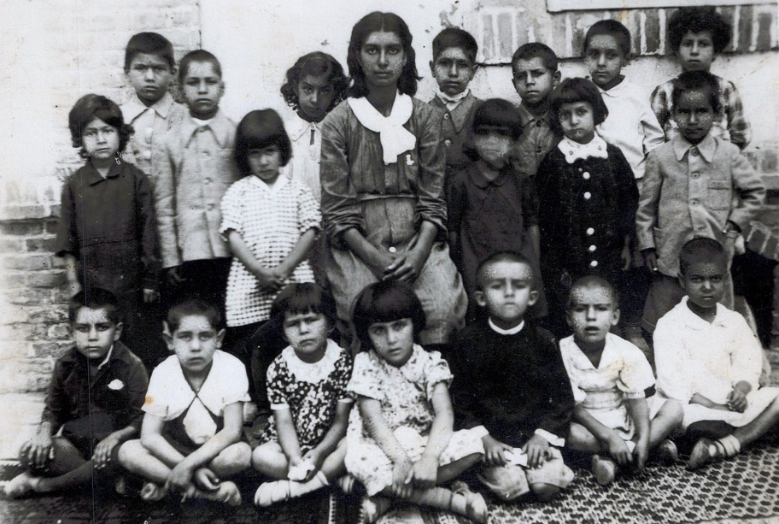
Shamsi with her children’s class in Mashhad; my sister Soraya standing second from the right in the second row
The children’s classes met all year round at 10-12 a.m. on Friday mornings—the day off in Iran. I was sixteen and filled with excitement at becoming a teacher. I wore my regular school uniform to teach. My class was orderly, and the children learned about the Baha’i principles and virtues, as well as basic manners. When all the students had arrived for class and settled in, I asked a student to start our lesson with a prayer. If a student forgot the prayer in the middle of chanting it, they could say “Eyn, Eyn,” which means ‘Abdu’l-Baha Abbas, and sit down. In this way, they were not anxious about whether they could finish a prayer and so were always willing to recite their prayers in front of others. Once the prayers were completed, I asked the children questions about our last class to help them recall what they were learning. Students encouraged each other by applauding when a correct answer was given. We finished the class by singing joyous songs. Once they were confident in singing together, they performed the songs for the Holy Days and feasts bringing much joy to the other Baha’is. To assess the students’ knowledge of the Faith, the teachers gave exams each year, and prizes were given for certain achievements. I felt fulfilled when I saw their development and the glint in their eyes when they received their rewards.
Attending Mr. Alavi’s classes
My father’s wish for me was as mine i.e. to serve the Cause of God. He would provide for all my material needs so that I could focus my energy on the important work of the cause instead of going to the regular school.
Other adults must have believed in my capacity as well because I was selected one of only five young people invited to study privately with Mr. Siyyid Abbas Alavi, our Baha’i scholar (he had been a high-ranking Muslim teacher of the Arabic language, jurisprudence, and logic, as well as Qur’anic principles, prior to accepting the Baha’i Faith). Other Muslims accused him of leaving Islam for other man-made reasons, to which his response was: “Sorry my friends, I have not left the religion of Islam, rather my Islamic religion has been completed by this new Revelation.”
Mr. Alavi opened his home at dawn for our class in which he taught the Arabic language and the Baha’i principles. We the “honored students” arrived at his home every dawn at 6:30 a.m. and waited for him to let us in.
A kind man who did not wish us to wait in the dark of the street for a long time, he would come out of his room and rush through the yard and open the door even if he was not quite ready.
The lessons lasted until 7:30 a.m. The other students included Mr. Alavi’s younger daughter, Mehri Khanum, Mr. Vahid Ma’ani, Mr. Mahmud (Isa) Rastegar, and Mr. Qudrat Soltani (each of whom at later dates became well-known Baha’i teachers in many parts of the world).
Mr. Alavi taught us with a sense of humor, telling us that with each right answer, we had earned twenty qeran and that after several correct answers, we had amassed a whole toman. Then, when we got a wrong answer, he exclaimed that we had lost the whole toman to which we asked why a whole toman for one incorrect answer to which he responded, “Because this question was the most important one of all, and you did not answer correctly!”
Kelas-e Aliy-e Tabliq, a Baha’i academy
Another major Baha’i educational opportunity was given to me when I was invited to go and study in Tehran.
In those days, the Baha’i National Assembly of Iran assigned one deepened teacher to each major locality in the country. Our teacher in Mashhad was Mr. Eshraq Khavari, one of the most highly regarded scholars of the Faith in Iran.
Then, in the mid-40’s, the National Assembly founded an institute for Baha’i higher education (kelas-e Aliy-e Tabliq) and invited scholars from around the Iranian Baha’i community to come to Tehran as faculty; among those invited were Mr. Abbas Alavai and Mr. Eshraq Khavari from Mashhad.
Before leaving Mashhad, Mr. Eshraq Khavari expressed to me his interest in having me come as a student; I was thrilled but not sure if father would approve of my leaving Mashhad. Mr. Eshraq Khavari moved to Tehran and, six months later, he formally invited me to go and study at the institute. He also wrote to my father that I could live in his family’s home and that he and his wife and children would look after me.

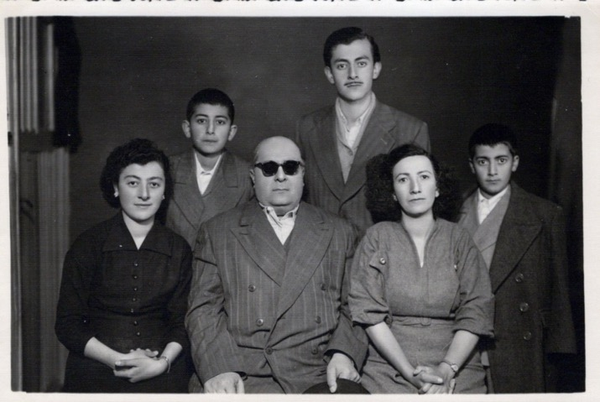
Front row: l. to right: 1) Miss Eshraqiyyih, 2) Mr. Abdu’l-Hamid Eshraq Khavari,
3) Showkat Khanum, his wife,
Back row l. to r., his children: 4) Soheil, 5) Hooshang, 6) Partow
Though father did not want me to leave Mashhad, the honor of studying at such a prestigious Baha’i educational institution and living with such a distinguished family as Mr. Eshraq Khavari’s were enough to convince him that I should go.
I prepared myself, said goodbye to friends and family, and left by bus for Tehran with my father. I was filled with a feeling of awe that I would be studying with some of the most well-known Baha’is of Iran, but I also felt anxious about being able to complete the three-year curriculum.
Once I had arrived in Tehran and settled into my room in Mr. Eshraq Khavari’s house near the institute, I turned for guidance and support for the first time in my life to the Beloved Guardian, Shoghi Effendi. I wrote him a letter in 1946 requesting his prayers for my successful completion of this demanding course of study and my further service to the Cause.
To us Baha’i youth, Shoghi Effendi was the towering figure in our lives whose image we had seen in photographs, whose importance we knew about from the writings of ‘Abdu’l-Baha, whose humility we had heard about in stories, and whose guidance we revered.
Out of the endless stream of prayer requests, petitions, letters asking for guidance, and reports that he received from the Baha’is throughout the world, Shoghi Effendi took the time, through his secretary Mr. Nur’u’ddin Zein, to write to me these strong words of encouragement, my translation of which follows here; I received three letters in all from Shoghi Effendi in response to different requests at different times for guidance and I have placed them all here so his letters can be all together for the reader to see.
The veracity of my intentions and the purity of my heart had been admitted to his presence. The Guardian asked God that I may win the ball of success from my fellow students in learning the tenets of the Cause and the knowledge of spiritual truth and be successful in glorious services. As my aim and purpose was the promulgation and propagation of the Lights of that Chosen King, certainly His Bounties and Favors will surround me and will enable me to attain my heart’s desire. However, with utmost confidence I must prepare myself in the service of the Beloved of the worlds, continue the studies, adorn myself with the heavenly qualities and virtue so as to become perfect from every point of view.
I certainly needed the prayers of the Blessed Guardian because the institute courses were demanding. There were courses on Baha’i Laws, Administration, History, prophecies, Logic, Philosophy, and the Arabic language given by an outstanding faculty of scholars of the Faith.

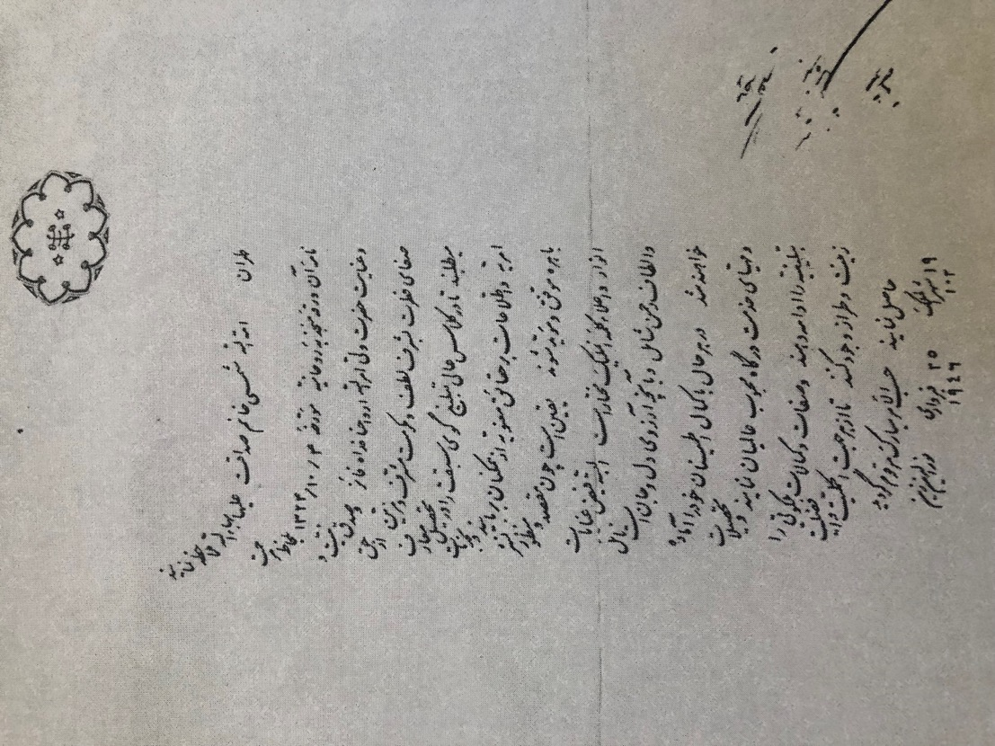
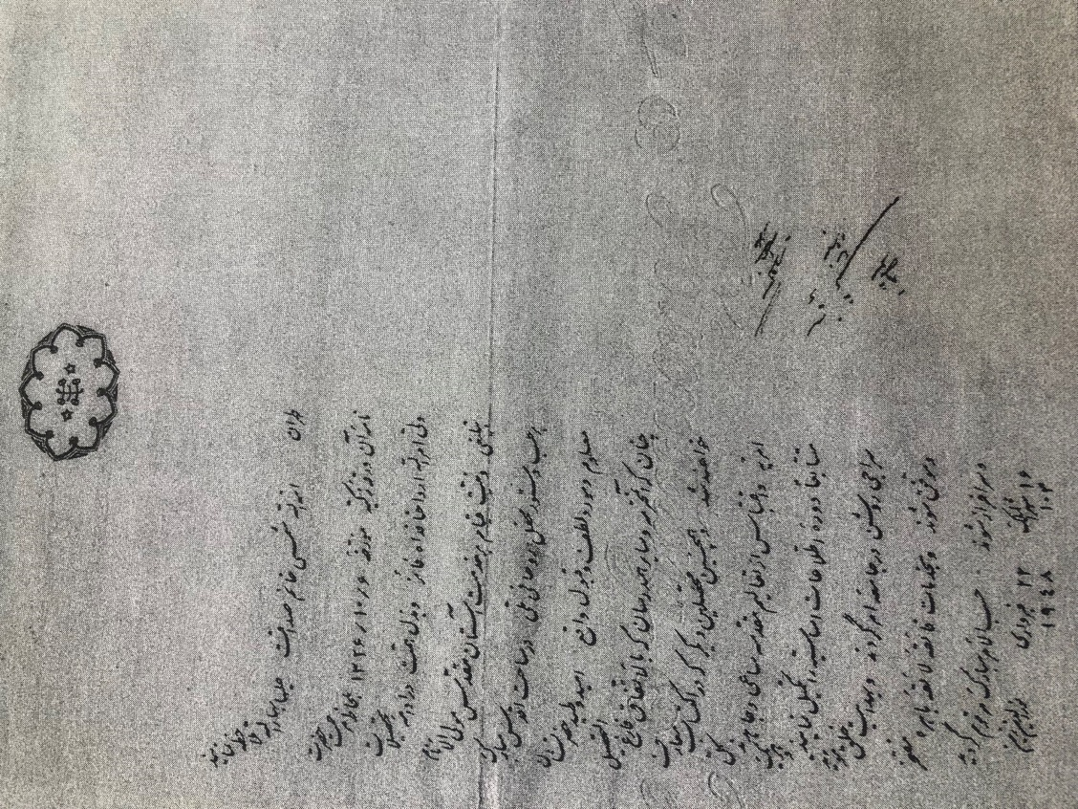
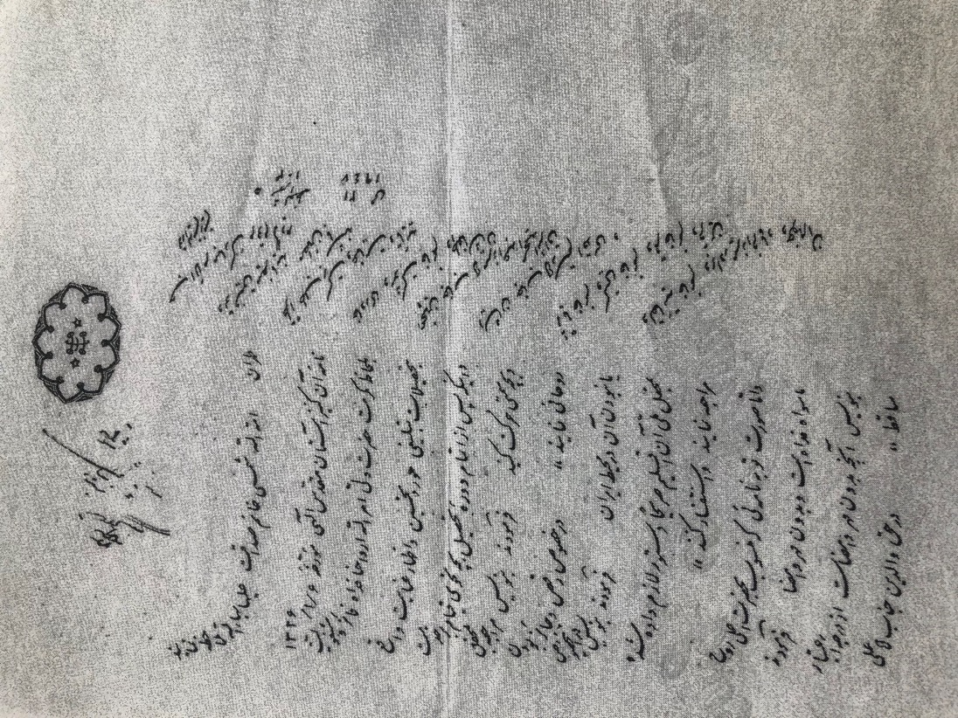
Letters of Shoghi Effendi to Shamsi Sedaghat
I studied constantly, resting very little, along with the other twelve students who included Mr. Heshmat Moayyad, later a professor of Near Eastern languages and civilization at the prestigious University of Chicago, who continued to lead a very active Baha’i life, and Mr. Farzan Nedjad (the former Mr. Sabzkar), who became a dedicated pioneer and served the Cause in Canada. With the exception of one or two teachers whose perfect scores were less than nineteen, I earned nineteen out of nineteen in all subjects on my annual report card and was the first in my class. The director of the institute, Mr. Azizullah Soleymani, signed our certificates. He was a highly educated man from Yazd who took a personal interest in each one of the students and wrote many valuable books about the Baha’i Faith and persons who had served the Faith to the best of their ability.
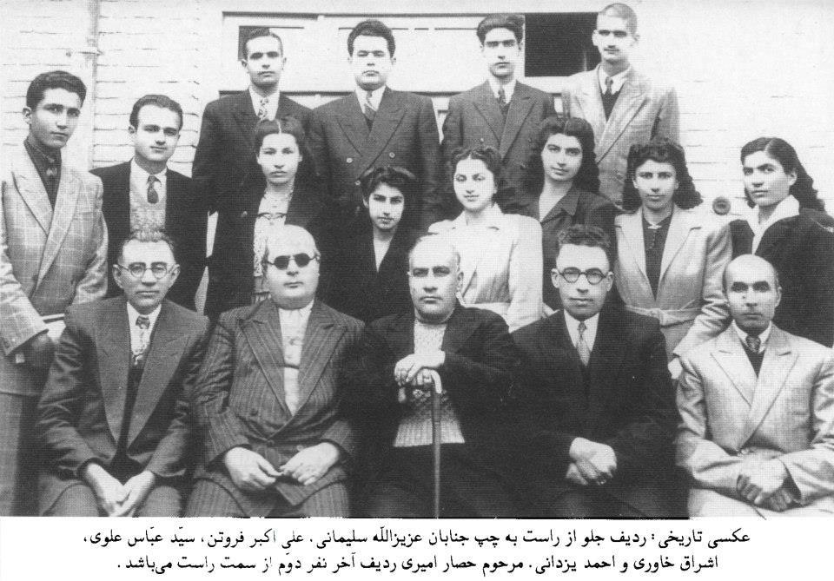
These are the scholars and students of the school for Baha’i higher education (kelas-e Aliy-e Tabliq).
Seated right to left in the front row are the following scholars: Mr. Azizullah Suleymani (Director of the Academy), Mr. A. A. Furutan (Secretary of the National Spiritual Assembly of Iran), Mr. Abbas Alavi, Mr. Eshraq Khavari, Mr. Yazdani (member of the National Spiritual Assembly of Iran). The names of the students: Middle row l. to r.: 1) ?, 2) ?, 3) Miss Tuba Tebyani?, 4) Miss Mehri Alavi, 5) Bahereh Khanum?(niece of Prof. Firuz Kazemzadeh), 6) Shamsi, 7) Ms. Ansari?, 8) Ms. Muluk Khadem
Back row l. to r.: 1) Mr. Heshmat Moayyad, 2) Mr. Baghdadi, 3) Mr. Hesar Amiri (he was a student and not one of the teachers as stated in the Farsi), 4) ? (the question marks mean that I know them but forgot their names)
Assisting my Teacher Mr. Abdu’l-Hamid Eshraq Khavari
My learning did not stop at the door of the institute. Mr. Eshraq Khavari asked me to serve as his assistant on his numerous Baha’i research and writing projects. A prolific scholar, he was working on books such as a summary of the translation of Nabil’s Narrative (Talkhis-e Tarikh-e Nabil), a compilation on the nine Baha’i Holy Days (Resaleh-ye Ayyame Tes-eh), a compilation of Baha’i Writings (Tasbih-o Tahlil), and a multi-volume compilation titled The Heavenly Food (Maedeh-ye Asemani), four volumes of commentary on the Kitab Iqan of Baha’u’llah, among many others. In this age before xerox machines and scanners, I had to carefully copy by hand passages which Mr. Eshraq Khavari wanted to be included in the main text. The most difficult of all was the proofreading. I had to use a brush with finger nail polish to cover the mistakes in the stenciled copy and, after it dried, I corrected them. To acknowledge my work, Mr. Eshraq Khavari included my name along with those of two other Baha’is, Mr. Mowlavi Nejad, who later pioneered to Aden in Yemen with his wife, and Mr. Habib Hezari, the son of Mr. Ardeshir Hezari, from a well-known Baha’i family of Zoroastrian origin from Qazvin. Mr. Habib later served the Faith in England before his passing to the Abha Kingdom. Later, I asked Mr. Eshraq Khavari not to include my name since it had been my privilege to assist him with his important scholarly work. Wishing to show his appreciation, he later insisted on presenting us with signed copies of his works through the Secretary of the National Spiritual Assembly of Iran, Mr. Ali Akbar Furutan.
Three years of intensive study and hard work were only interrupted by summers when I returned to Mashhad and surrounding towns during which I was asked to share what I was learning in Tehran. These trips were very rewarding for me because everyone—old and young—eagerly awaited what I had to say, and the friends were inspired to arise and to teach and to serve to the best of their abilities.
My Services in Khorasan
My time at the Institute came to an end, and I was eager to re-enter the path of full-time service. The National Assembly was interested in having me go to Tabriz in the Turkish-speaking area of Iran as I knew the Turkish language. I knew that my father was not happy at the prospect of me moving so far from home, so I decided to write the Beloved Guardian and ask his advice, and he lovingly replied that I should refer this matter to the Assembly there. When I did, Mr. A.A. Furutan, the Secretary of the National Assembly, let me know that my father had written a letter to the National Spiritual Assembly expressing his wish that I be sent to Mashhad to serve the Cause there and in other parts of Khorasan, and he would provide me with all the necessary support, financial and otherwise, and therefore the Assembly wanted me to follow my father’s wishes, so I packed up and left Tehran for Mashhad.
The National Assembly of Iran and the local Assembly of Mashhad appointed me to serve on various committees and soon my life was full again of productive activities. For example, the teaching committee was responsible for the propagation of the Faith throughout the city. We drew up plans and submitted them to the Assembly for their review. Our primary method of introducing the Faith to others was to hold a fireside (an informal gathering in a Baha’i home and invite our friends, neighbors, and coworkers). There we served food and offered hospitality. These gatherings might also be for Holy Days, a personal celebration, or a purely social evening. We included Baha’is who were knowledgeable about the Faith to circulate among the guests and, if appropriate, one of them would be designated to speak about a topic related to the gathering or to the situation in the world.
The Youth Committee kept me travelling throughout the Mashhad region.
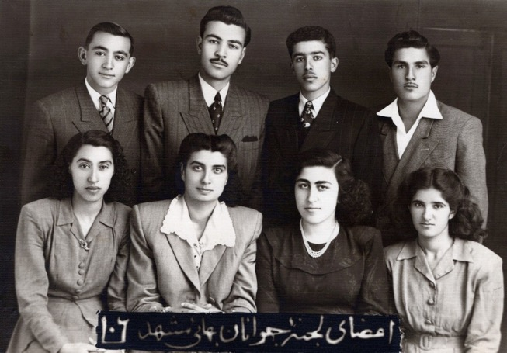
The Youth Committee of Mashhad: Front row l. to r: 1) Ms. Farideh Sharghi, 2) Shamsi, 3) Ms. Farideh Tamaddon, 4) Ms. Monireh Allahverdi Back row l. to r.: 1) Mr. Namdar Jr., 2) ?, 3) Mr. Parviz Mehrain, 4) Mr. Usuf Navai (the question mark means that I know them but forgot their names)
The committee received letters from towns and villages requesting help, especially with deepening women and girls. I was often designated to go and meet with the friends; I travelled to Daragaz, Quchan, Shirvan, Bojnurd, Nishapur, Sabzevar, Koshkbag, Sadkharv, and Torbate-Heidariye, among others. One trip was to the remote mountain village of Sad Kharv. I donned a chador, mounted a donkey, and set off for the village. By the time I reached the village my legs were stiff, and I had to be assisted to climb off the donkey. The Baha’is greeted me with great affection, and I was brought indoors. Once I was inside and among the Baha’i friends, the chador could be removed. I was invited to sit in front of the Korsi, a low table in the middle of the floor covered with a blanket or quilt under which heat was distributed over our legs from a container filled. The Baha’is were eager to hear all that I could teach them about the Faith and about events in the wider Baha’i world. We spoke about the subjects which they wanted to know about, and they asked questions which I could explain according to the written principles of the Faith.

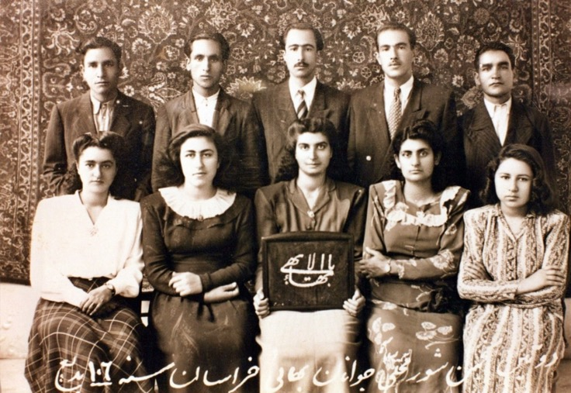
Second consultative conference of the representatives of the Baha’i youth of Khorasan:
Front row l. to r.: 1) Ms. Samimi?, 2) Ms. Farideh Tamaddon, 3) Shamsi, 4) Ms. Navai, 5) ?
Second row: 1)?, 2) ?, 3) Mr. Ruhi Roshani, representative of the National Youth Committee of Iran from Tehran, 106 BE 4) ?, 5)?
(the question marks mean that I know them but forgot their names)
In the community of Mashhad, I also served on the Ladies Committee and the Feast Committee. The Ladies’ Committee deepened, trained, and educated the women and girls. The Feast Committee prepared the programs especially the Writings that were to be chanted and read. We consulted on the theme of the Feast and the main ideas we wanted to teach the friends. The selections we chose had to be copied by hand. A young man with a bicycle came to distribute them to the home of several readers so that they would have time to practice reading as not everyone could read correctly; this was a big task because there were multiple feasts in this large community.
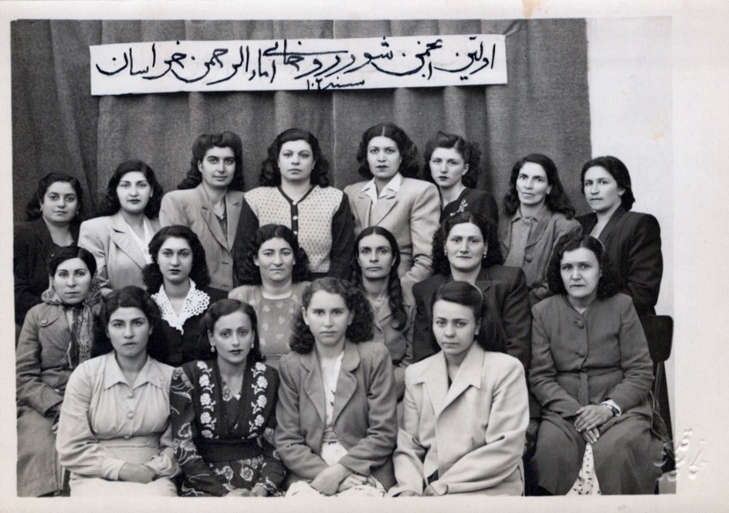
First consultative conference of the Baha’i ladies of Khorasan, 1950s
First row: I don’t remember their names
Second row l. to r.: 1) ? , 2) ?, 3) Mrs. Nushabadi (wife of one of our Baha’i teachers), 4) Mrs. Golpayegani, daughter of Siyyid Mehdi Golpayegani (one of our well-known Baha’i scholars), 5) ?, 6)?
Third row l. to r.: 1) Ms. Jahantab Shahidi, 2) Ms. Gamar Shahidi ?, 3) Shamsi, 4) Mrs. Mehraeen (well-known Baha’i teacher), 5) Mrs. Qamar Sedaghat Aghdassi, 6) ?, 7) Mrs. Golpayegani’s sister, 8) Mrs. Shadravan ?(the question mark means that I know them but forgot their names)
These fruitful years in Mashhad during which I applied so much of what I had learned at the Baha’i institute in Tehran were coming to a close. At the beginning of the 1950’s, new international plans were announced and, soon, I began a new life as an international travel teacher and later, a pioneer for the Faith.

Chapter 2

Mashhad-Brighton-Pilgrimage to the Holy Land-pioneering to Africa
My intensive study in the Baha’i institute and my teaching trips throughout the Khorasan region intensified my love for the Faith. I burned with the desire to serve on a broader scale than I had so far.
In the 1950’s international pioneering was the form of service to which Shoghi Effendi attached the greatest importance. In his message to the National Convention of the British Isles in 1950, he congratulated the British Baha’is on their successful completion of the Six-Year Plan and gave them a “one-year respite” after which a new plan would be launched. What immediately caught my attention was that there would be a two-year ‘Africa Plan’. Of unique importance to this plan was that four National Assemblies were being called on to collaborate which would strengthen the union between these Institutions in advance of the continental teaching conferences, the formation of the International Baha’i Council, the launching of a World Crusade, and finally the election of the Universal House of Justice:
The Message of the Beloved Guardian, Shoghi Effendi, about the Africa Plan
“FERVENTLY PRAYING PARTICIPATION BRITISH AMERICAN PERSIAN EGYPTIAN NATIONAL ASSEMBLIES UNIQUE EPOCHMAKING ENTERPRISE AFRICAN CONTINENT MAY PROVE PRELUDE CONVOCATION FIRST AFRICAN TEACHING CONFERENCE LEADING EVENTUALLY INITIATION UNDERTAKINGS INVOLVING COLLABORATION ALL NATIONAL ASSEMBLIES BAHÁ’Í WORLD THEREBY PAVING WAY ULTIMATE ORGANIC UNION THESE ASSEMBLIES THROUGH FORMATION INTERNATIONAL HOUSE JUSTICE DESTINED LAUNCH ENTERPRISES EMBRACING WHOLE BAHÁ’Í WORLD ACCLAIM SIMULTANEOUS INAUGURATION CRUSADE LINKING ADMINISTRATIVE MACHINERY FOUR NATIONAL ASSEMBLIES EAST WEST WITHIN FOUR CONTINENTS AND BIRTH FIRST INTERNATIONAL COUNCIL WORLD CENTRE FAITH TWIN COMPELLING EVIDENCES RESISTLESS UNFOLDMENT EMBRYONIC DIVINELY APPOINTED WORLD ORDER BAHÁ’U’LLÁH.”
In March 1951, the eleven-member International Baha’i Council was appointed by Shoghi Effendi, and in April 1951, the Two-Year Africa Plan was underway.
I was more than eager to go to Africa.
Recommendation letters to assist with entry visa to England
To be able to settle in one of these territories in Africa, I would have to go to England and try to get a visa from there as I was not a British citizen. My teacher Mr. Eshraq Khavari encouraged me in my efforts to pioneer to Africa. I wrote to Mr. Habib Hezari, an active Baha’i in Iran, son of Mr. and Mrs. Ardeshir Hezari, and helpful assistant to our teacher, Mr. Eshraq Khavari, and very good friend of ours, for his assistance to me in finding a nursing school and work in England. I had taught Persian to English-speaking foreigners in Mashhad and was able to supply their letters of recommendations in my application.
Letter of Mrs. Duke
Mrs. Duke, the wife of the British Consul General in Mashhad wrote on my behalf:
“The Matron
The Royal Sussex County Hospital
Eastern Road
BRIGHTON 7
Dear Matron,
I am writing to introduce Miss Shamsi Sedaghat who has for several months been teaching me Persian. She is a most intelligent girl and I think should make a success of her nurse’s training as she is not afraid of hard work and is also extremely keen to learn.
I realize that you do not usually accept probationers without an interview, but of course in her case an interview is not possible: for this reason, she is enclosing, with the completed application form, letters from various people here who know her and her work.
I can really recommend her most highly. She has already a good working knowledge of English and should not find difficulty in understanding her lectures or general instructions.
I can vouch for this as I knew no Persian when I started my lessons with her, and all the explanations had to be in English.
Yours sincerely,
M.C. Duke,
C.B. Duke, Esq., C.I.E., I.B.E.,
Consul General, Meshed.”
Letter of Rev. Woodward
Rev. Woodward of the Iran Mission of the Board of Foreign Missions of the Presbyterian Church testified that:
“…She is strong and healthy physically, mentally above normal, and has a very pleasing personality.
The quality which seems to be the most outstanding is that of taking initiative and responsibility; this is what makes me feel that she would be successful in almost anything she might take up.”
Mr. Hezari took these letters of recommendation and a few others to various hospitals in London and Brighton, and I was admitted to several. Mr. Eshraq Khavari, my teacher, and Mr. A.A. Furutan, Secretary of the National Spiritual Assembly of Iran and later appointed a Hand of the Cause by the Beloved Guardian, were delighted about my success in finding a placement in England. Father accepted my leaving as “his sacrifice to Baha’u’llah.” He took me to Tehran for my departure. We then received a letter that my mother had become ill due to my sudden departure from Mashhad for faraway England. My father consulted with Mr. Furutan, and they decided that my father should return to Mashhad and leave me in his care. With tears in his eyes, my father said goodbye to me and returned to our hometown.
My visa for England arrived, and Mr. Furutan and others took me to the airport. My great pioneering adventure had begun.
My arrival in England
When the plane landed in the new world of England and the West, Mr. Hezari and Mrs. Tabandeh Peyman, a cousin of Prof. Firuz Kazemzadeh, were there to welcome me. I stayed the night in her flat in London, and then Mr. Hezari took me to Brighton which I had chosen over my other options because of its proximity to London and the fact that there were a few Baha’is there, so I would be a good addition to the community. I immediately loved this vibrant seaside town that swelled with visitors from London who came down to enjoy the sea air. Mr. Hezari brought me to the P.T.S. (Preliminary Training School) and from there to the nurses’ boarding house which was not very far from the hospital, and I was given a small room with some of the necessary facilities for living. Mr. Hezari stayed half a day, gave his phone number, and returned to London.
No sooner had I settled myself in than I let Mr. Hezari know that I was eager to meet with the National Baha’i Assembly of the British Isles and begin the process of finding a pioneering post in Africa where the Faith was on the move.
In response to the Guardian’s call, a small group of Baha’is from Iran and Great Britain that included Mr. Musa and Mrs. Samiheh Banani, Mr. Ali and Mrs. Violette Nakhjavani and their baby daughter, Bahiyyih, and Mr. Philip Hainsworth, arose and moved to Kampala, Uganda, in the late summer of 1951. I met them at the London Baha’i center, and the Banani family told me that when I had my visa, I could come and stay with them in Kampala. Mr. Musa Banani was of Iraqi Jewish background and had accepted the Faith during World War I (At a later date, he was elevated to the rank of Hand of the Cause of God by Shoghi Effendi). Mr. Ali Nakhjavani (who was later elected to the Universal House of Justice), whose parents were from Azerbaijan, had grown up in Haifa with Shoghi Effendi, was educated in Beirut, and returned to Iran to serve the Faith. In Iran he was elected to the National Spiritual Assembly, married Miss Violette, the daughter of Mr. and Mrs. Musa Banani, who in later dates travelled the world with Hand of the Cause Ruhiyyih Khanum Rabbani as her companion. Ruhiyyih Khanum was the wife of the Beloved Guardian, Shoghi Effendi. Mr. Hainsworth became a Baha’i in 1938, in England, and had served on the National Spiritual Assembly of England since 1947 before leaving for the pioneering field in Africa. The first Holy Day held in Kampala was in the home of a native Ugandan followed soon by the first two declarations of people of native Ugandan background in October and December. The first Baha’i Assembly of Kampala was elected in April 1952. One of the great flowers of the teaching efforts in Uganda was the declaration of a third person of native Ugandan background, Mr. Enoch Olinga, who had been attending study sessions given by Mr. Nakhjavani. Mr. Olinga became a very effective teacher of the Faith, a Knight of Baha’u’llah, known by the title “Father of Victories”, and was later appointed by Shoghi Effendi as a Hand of the Cause, the youngest person to be so designated. Mr. Banani and Mr. Olinga would come into my life in the future. The Faith in East Africa grew exponentially in the following years.
Eager to join the teaching efforts in Africa, I arranged to meet Mr. Hezari and go to visit the Secretary of the National Assembly, Mr. John Ferraby, who was also on the Pioneering Committee. Mr. Ferraby had become a Baha’i in 1941 though the incessant bombing during the World War II blitz had made it difficult for him to meet any local believers. He was working full-time for the Faith ten years later as the Assembly Secretary, managing the Baha’i Publishing Trust, and finding and preparing pioneers for the Africa campaign which involved interfacing with African officials.
Mr. Ferraby took me to the Ugandan and Kenyan embassies but the rules for getting a visa were strict. I did not, for example, have enough money on hand for a whole year and had not graduated yet from the British nursing school so even after a year-long effort, I was not given a visa. Finally, I wrote to Mr. Lutfu’llah Hakim, Shoghi Effendi’s secretary for the Baha’is of the East, explaining that I had not been successful in getting an entry visa for any African country and would he kindly seek the advice of the Beloved Guardian. I gave this letter to the son of Mr. Lutfu’llah Hakim, Iraj Agha, to send to his father and ask him to give it to Shoghi Effendi. In response, I received a letter from Mr. Lutfu’llah Hakim praising my efforts and conveying the beloved Guardian’s advice that I should finish my training, because with its successful completion, I would have greater opportunities for pioneering and service. I accepted this guidance, stayed in Brighton, and focused on my studies, my work in the hospital, and built up a Baha’i community in my new town.
I continued my daily spiritual commitments
The demands of the hospital and school did not stop me from teaching the Faith to waiting souls who might be interested in the Faith.
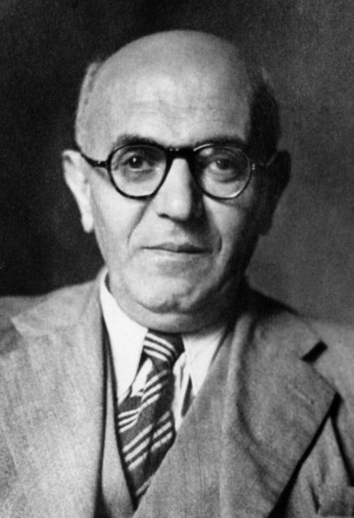
Dr. Lutfu’llah Hakim, the private secretary of the Beloved Guardian
The Faith became known to my coworkers initially because of my keeping of the Fast. I woke up before dawn to eat and pray but the hospital cafeteria was closed at that time and our ration cards were given to the hospital to feed us. Under such conditions, the Fast was very difficult.
I was happy to fast because it was my religious duty but some of the nurses did not understand the nature of the religious teachings which I followed. In Britain, Mahatma Gandhi of India was well-known as the one who had ended British colonial rule in India. One of the non-violent methods he used to accomplish this was to fast in protest. A few of the nurses thought that I was one of his followers because I was fasting as well. They reported me to the head nurse who in turn reported me to the Director of Nurses and Midwives who immediately wrote my name on the blackboard and asked me to report to her office. I was surprised by this because to report to the matron’s office was a serious reprimand. I tidied myself up and went to her office. As soon as I opened her door and entered, she shouted at me wanting to know why she was hearing that I was a follower of Gandhi and fasting as he did. She wanted to know if I knew that we were not in India and that I was a nurse and studying and working and that if I did not eat, I would not be able to perform my duties well. “If you continue fasting, she said, I will send you back to Iran.” As soon as she finished, I had tears in my eyes, and I politely told her that I was not a follower of Gandhi, I was a Baha’i, a new religion which had started in 1844 and that we accepted all religions and respected people of all races and creeds. I quoted Baha’u’llah that “The world is one country and mankind its citizens.” I had been fasting since I was fifteen, except when I had been ill or travelling. The Baha’i Fast required abstinence from eating, drinking, and smoking after sunrise and before sunset. We prayed and read from the Holy Books before the sun came up and ate a breakfast then refrained from eating, drinking, or smoking for the daylight hours. Sometimes we lost weight during the Fast but that was alright because it was good for our health. After hearing my explanation, the Director calmed down and asked how I was able to fast here. I told her I got up at five a.m., washed and dressed and said my prayers. Then I went to the bathroom and turned on the hot water and when it had heated up, I brought some in for tea and ate whatever I had saved from the previous night’s supper. At lunch time I went to my room and rested. For supper, I went with the second dinner group of nurses to eat as I was a junior nurse. After she heard my story, she asked the head cook to make a big plate of food for me with meat as well as a few sweets and some extra food for the morning as I was practicing my religious beliefs and fasting during the day. Then she phoned the sister in charge of the ward where I was working and instructed her that from that day, she should send me to the dining room with the first group as I was fasting according to my religious teachings and should eat when the sun sets.
I saw in this incident how following the teachings of the Faith caused a better outcome for me, helped me introduce the Faith to my colleagues, and have an adequate meal. One day I had a terrible headache; I had had these before. The nurse in charge gave me two pills and sent me to my room to sleep but said that she would have to report this to the Director of the boarding house for nurses. I fell asleep in my room and was woken up by the knocking on my door by the Director of the dormitory who came and said that she’d been told I had a headache and that if everyone stopped working because they had a headache there would be no nurses in the hospital. After she had reprimanded me, her eyes fell on the Baha’i ring stone symbol (of the Greatest Name) on my wall and asked me, “It is in Arabic, what does it mean?” I said, “Do you speak Arabic?”, and she answered, “Yes, I learned it in Egypt. Explain it for me.” I answered that the three horizontal lines represent first God, the Creator, second, the Manifestations of God (prophets), and third, the world of Man (humanity) which are joined by the vertical line representing the Holy Spirit that joins the three worlds. The five-pointed stars on either side are the Twin Manifestations of God (prophets) for this age, the Bab and Baha’u’llah. After hearing this, her tone became gentler and friendlier.
She invited me to go to a spiritual meeting in a home with her though because of the great class consciousness in England at that time, I had to sit behind her on the bus and when we reached our destination, she said I should go into the apartment after her. I followed all of her instructions, and we entered the room. Once in the apartment, the head nurse and I and everyone else in the room became as equals, and we enjoyed our friendship without a problem.
The ladies in the room were studying the Bible. They read a passage about Jesus washing the feet of the disciples. An explanation about His humility was given, and I gave my explanation which was that Jesus was showing them how to serve in a way that God wanted them to serve—if you want to serve God, you have to serve his people according to what they need etc… The ladies appreciated all of our explanations.
We read different passages and discussed them and then had refreshments and happily returned to our homes. Since then the director of the dormitory was much friendlier towards me when she saw my respect for His Holiness Christ.
The hospital authorities found me to be a responsible person and gave me permission to live off-site. I rented a room at a nearby hotel run by Mrs. Denis Dewar, a Scandinavian woman married to an Englishman. After learning that I was a Baha’i and hearing some of the teachings, she allowed me to hold meetings in their hotel, even putting a large sign outside her windows that read, ‘Wednesday, 5-8 pm, Baha’i meetings, all welcome, free, no collection.’
She developed a great interest in the Faith. She also loved her two large dogs so much that she asked me one day what Abdu’l-Baha had said about the lives of dogs after death. I told her that the Writings teach that animals are part of the natural world and with the end of this life, the dogs do not continue into the next world. This answer—though correct—infuriated her, and she told me that she did not want to have anything to do with a religion that taught that her dogs’ lives ended after their death. She ceased all contact with me and the other Baha’is.
Years later, after I had left England for nine years of pioneering in Cyprus with my parents and then returning to Iran, I ran into a Baha’i who asked me if I remembered a Mrs. Dewar, and I said yes, of course, I knew her from Brighton, but she had distanced herself from the Faith. “Shamsi,” the Iranian Baha’i told me excitedly, “I met her in Haifa while she was on pilgrimage. After you left, her husband passed away, she had to sell her hotel, and her two beloved dogs became ill and had to be put down. After these tests, she became involved with the Faith again and became a very active Baha’i and then came for pilgrimage.”
From the experience with Mrs. Denis Dewar, I learned that one must take into consideration the listener when teaching the Faith and be cautious about not being too abrupt in one’s answers because this can become the cause of alienation.
Progress of the Faith in Brighton
The teaching activities picked up in Brighton, including Baha’i public meetings and proclamations of the Faith in newspapers and soon we elected a Spiritual Assembly which included Mr. Gholam Hussein Hakim, a known sculptor (he was a relative of Dr. Lutfu’llah Hakim, one of the Iranian secretaries of Beloved Shoghi Effendi in Haifa), and his wife and young daughter.
We met frequently in each other’s homes. I found a true teaching partner in Ms. Doreen Geary, the daughter of wealthy owners of an antique dealership. I first met her when she came to the hospital with a bad nosebleed. She was very appreciative of the care she had received from me. After she was discharged, she came back one day and brought me flowers and sweets and invited me over to the home she shared with her parents, which was a mansion with large well-tended gardens.
I was surprised to see that when their dealership bought an estate, most of the objects in it were taken to an area outside of the town and left there to be taken for free and only the most valuable items kept for sale.
This visit gave me the opportunity to introduce her to the Faith. Eventually Doreen became a Baha’i and joined me in the teaching activities; she also helped me to improve my English language skills.
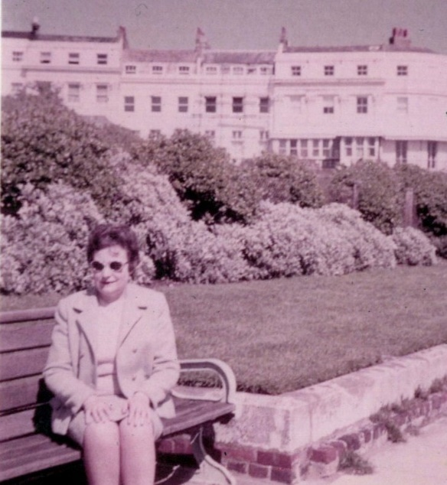
Ms. Doreen Geary, antique dealer and my sincere Baha’i friend

We taught the Faith in towns and villages in the region catching the early and cheaper train out of Brighton, finding a hall and then organizing and advertising a public meeting on a topic such as the equality of men and women or the role of youth in developing society.
Though she was the daughter of a privileged family, Doreen rolled up her sleeves and helped with all aspects of this work including setting up the chairs and tidying up the hall. As I spoke, she helped me find various English words which I didn’t know.
To convey the Baha’i principles properly I gave these presentations with the help of large charts that I had printed showing the basic teachings of the Faith:
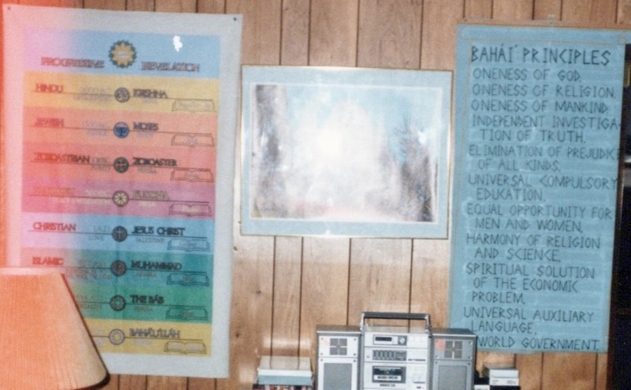
My charts: progressive revelation on the left and the principles on the right
1. All of the world’s religions have taught the same fundamental truths and have been expressing the same spirit of God.
2. True religion is the only basis for a peaceful and progressive world society.
3. The fundamental purpose of religion is to promote concord and harmony.
4. Religion and science must travel hand in hand for the benefit of humanity.
5. There must be an unobstructed search for truth in all fields of knowledge.
6. All forms of superstition and prejudice must be eliminated.
7. Men and women should have equal opportunities, rights, and privileges.
8. All children everywhere should have adequate mental and spiritual education to prepare them for membership in a world society.
9. Extremes of both poverty and wealth must be abolished.
10. There should be work for all, and work should be recognized as a dignified expression of the human spirit.
11. An international, auxiliary language should be selected and taught throughout the world, to help promote understanding and peace.
12, There must be a federal world government to maintain universal peace based on the Word of God.
The meetings were often full, and we provided pamphlets with the address of the Baha’is of Brighton printed on them so that people could follow-up if they were interested.
In December 1952, I decided it was time to go on pilgrimage to seek the wisdom of Shoghi Effendi and feel the spirit of the Holy Places.
I cabled the Guardian on December 28th:
“TSK 6089CWHIG 670 73Haifa, 7 28 12-15
Lt. RP 10/6 Rabbani Haifa

Humbly beg permission deeply respected Beloved Guardian make pilgrimage
July period holidays
Devoted servant Shamsi Sedaghat
Bahai London”
I received a cable from Shoghi Effendi, the Guardian of the Baha’i Faith:
“SEDAGHAT CARE BAHAI LONDON
POSTPONE PILGRIMAGE
SHOGHI”
The Baha’i world was on the move as an international framework of the Faith was emerging during those years. The Baha’is of the British Isles, the U.S., Iran, and Egypt had been collaborating on the Two-Year Africa Plan. The Iranian Baha’i community had already prosecuted a forty-five-month plan from October of 1946 to July of 1950, which included as its goals to send out pioneers internationally, to establish local Assemblies in Kabul, Mecca, and Bahrain, and to form four new groups in the Arabian Peninsula. To inaugurate the inter-continental phase of the growth of the international Baha’i community, Shoghi Effendi called for the holding of four intercontinental teaching Conferences. These were held in Kampala, Uganda; Wilmette, United States; Stockholm, Sweden; and New Delhi, India.
Ten-Year World Crusade
Then in his Ridvan Message of 1952, Shoghi Effendi opened the worldwide vision to all Baha’is by announcing the launching of a Ten-Year World Crusade:
“The avowed, the primary aim of this Spiritual Crusade is none other than the conquest of the citadels of men's hearts. The theatre of its operations is the entire planet. Its duration a whole decade. Its commencement synchronizes with the centenary of the birth of Bahá’u’lláh's Mission. Its culmination will coincide with the centenary of the declaration of that same Mission. The agencies assisting in its conduct are the nascent administrative institutions of a steadily evolving- divinely appointed order. Its driving force is the energizing influence generated by the Revelation heralded by the Báb and proclaimed by Bahá’u’lláh. Its Marshal is none other than the Author of the Divine Plan. Its standard-bearers are the Hands of the Cause of God appointed in every continent of the globe. Its generals are the twelve national spiritual assemblies participating in the execution of its design. Its vanguard is the chief executors of ‘Abdu’l-Bahá's master plan, their allies and associates. Its legions are the rank and file of believers standing behind these same twelve national assemblies and sharing in the global task embracing the American, the European, the African, the Asiatic and Australian fronts. The charter directing its course is the immortal Tablets that have flowed from the pen of the Center of the Covenant Himself. The armor with which its onrushing hosts have been invested is the glad tidings of God's own message in this day, the principles underlying the order proclaimed by His Messenger, and the laws and ordinances governing His Dispensation. The battle cry animating its heroes and heroines is the cry of Yá-Bahá'u'l-Abhá, Yá ‘Alíyyu’l-A`lá.”
The Ten-Year Crusade had four major objectives: to develop the institutions at the World Center, to consolidate local Baha’i communities in countries which were the administrative bases for the operation of the Plan, to consolidate local communities in territories already opened to the Faith, and to bring the Faith to the main remaining territories on the planet without Baha’is.
Pulsing with excitement, I longed to be a part of these endeavors. Straightaway upon hearing the Crusade, I offered myself as a pioneer to the National Spiritual Assembly of the British Isles. I received a response with guidance from the Assembly:
“9th July, 1953.
Miss Shamsi Sedaghat
Royal Sussex Hospital,
Brighton.
Dear Shamsi,
The National Assembly reviewed pioneer offers at its meeting last weekend and was glad to hear of your anxiety to answer the Guardian’s appeal. We fully realize how much you would like to be pioneering overseas without delay.
However, we remember that the Guardian advised you to finish your nursing training, and as this will open all British colonial territories to you we still feel this is the best thing to do, even if it means you having to make the sacrifice of not pioneering this year. There will be much work to be done for the Faith in the future, and whereas you would have very great difficulty at present in obtaining entry to any colonial territory, when you have completed your nursing training many countries will be opened to you, especially if you also qualify as a midwife. We can only ask you to bide as patiently as you can until the time for your service comes.
With warm Baha’i greetings,
John Ferraby, Secretary.”
Intercontinental teaching conference in Stockholm
This desire to serve abroad reached a pitch of intensity when I attended the inter-continental teaching Conference in Stockholm, in July 1953. Hundreds of Baha’is gathered to hear a written appreciation from Shoghi Effendi about the teaching efforts of European Baha’i communities and then to heed his call for:
“The privileged prosecutors of so revolutionizing, so gigantic, so sacred and beneficent a campaign are, on the morrow of its launching, and, at such a crucial hour in the destinies of the European continued, summoned to undertake.”
The Guardian then outlined thirteen goals to be achieved including the formation of National Assemblies in the Scandinavian and Benelux countries, the ones on the Iberian peninsula, France, Austria, Italy, and Switzerland; the construction of the first House of Worship in Europe to be built in Germany; the purchasing of land for future Houses of Worship; the opening of virgin territories and the consolidation of numerous national communities; the translation of Baha’i literature into ten additional languages; teaching the Basque and the Gypsy, among others.
His letter finished by a rousing call to believers to arise, comparing the deeds of those who would to:
“…the feats accomplished nineteen hundred years ago, by that little band of God-intoxicated disciples who, fearlessly preaching the Gospel of a newly arisen Messiah, contributed so decisively to the illumination, the regeneration and the advancement of the entire European continent.”
Of course, Shoghi Effendi’s rousing call ignited the hearts of all of us to arise and pioneer and serve. This made my distress even more acute. I poured out my heart to Hand of the Cause Mr. Furutan who brought me to the Hand of the Cause Dorothy Baker for consolation. After she heard my story, she asked me who had instructed me to complete my studies to which I replied, Shoghi Effendi, and she followed this by asking who had authored the Ten-Year Crusade, and I answered, Shoghi Effendi. She then simply pointed out that the author of both of these was Shoghi Effendi so that by completing my studies I was not being contrary to the call of the Crusade nor missing out on it and that I should not be troubled because the two would come together.
The descendant of a distinguished family of American reformers, the Beechers, Hand of the Cause Mrs. Dorothy Baker had met Abdul-Baha during his trip through the United States in 1912 and had served the Faith ever since. A gifted public speaker, she travelled extensively, presenting the Baha’i teaching on race unity. She pioneered to Colombia and travel taught throughout Europe and served on the National Assembly of the United States for many years. By the time I met this great lady of the Faith, she had been appointed a Hand of the Cause by the Beloved Guardian, Shoghi Effendi.
Before the end of the Stockholm Conference, the youth were able to meet with Hand of the Cause Mr. Furutan who reminded all the Iranian believers not to forget our Persian language. For the rest of the Conference I was light-hearted and returned to my seaside city of Brighton walking on air, reinforced by the guidance I received from Hand of the Cause Mrs. Dorothy Baker.
With renewed vigor from the Conference, I resumed teaching the Faith in Brighton and serving on the Spiritual Assembly; in addition, I became involved with the work of the National Persian Affairs Committee. In 1954 and with only a few months of my training left, I again applied for pilgrimage.
This time, I was accepted for January:
“SEDAGHAT HEALTH PHONE BRIGHTON
ADVISE JANUARY
SHOGHI”
On my way to the Holy Land via Cyprus in 1955
By early 1955, I had loaded my belongings into the car of Ms. Doreen Geary and her father and was driven to the seaport to catch my ship to London, Genoa, Cyprus, and then the Holy Land. On the way to the port, Doreen gave me a letter from a Baha’i pioneer in Cyprus, Mr. Hugh McKinley, who had been in Brighton where we both had served on the Assembly, before he went to Cyprus with his mother, Mrs. V. McKinley, who was eighty-years-old at the time. They both became Knights of Baha’u’llah for Cyprus. The letter said that they had been on pilgrimage, and one day he had spoken about me and my service in Brighton and my wish to pioneer. Ruhiyyih Khanum then asked Shoghi Effendi, our Beloved Guardian about it. He said it would be very good if I could pioneer to Cyprus and serve the Faith there. As soon as I heard this, I said let’s go back to Brighton and get the rest of my luggage so that I can go to Cyprus after my pilgrimage which we did.
My visit to the Holy Land for pilgrimage
On the steamer crossing the Mediterranean to Haifa, I met Mr. Fred Grant while standing in line for lunch who asked me if I was Jewish. I answered him that I believed in all prophets down from Abraham, and now I was a Baha’i and proceeded to tell him about Baha’u’llah and His Exiles and His resting Place in Israel. Mr. Grant said he was going to Tel Aviv but would visit Haifa and find out more about the Baha’i Faith from Mr. Hakim, who was also of Jewish background. Mr. Grant had survived the Holocaust by escaping on his bicycle though many of his family members had been killed. In Israel, he met Dr. Lutfu’llah Hakim, and he learned more about the Baha’i Faith. When he returned to his home in Australia, he met with Hand of the Cause Mrs. Clara Dunn and others, and after a few years, he accepted the Faith. Mr. Grant was the first Australian of Jewish background to become a Baha’i. His wife, Mrs. Eva Steiner, was also a Holocaust survivor and became a Baha’i a few years later, and they served the Baha’i Faith admirably.
In 2020, Eva (Steiner) Grant reached out to the National Assembly of the United States to reconnect to Shamsi:
“Dear Shamsi Sedaghat, We are Baha’is in Sydney, Australia. Shamsi Sedaghat is from Ali-Akbar Furutan, Hand of the Cause of God’s, family. Shamsi met and told my husband about the Baha’i Faith (before we were married). Fred Grossman, later Grant, in 1954 they were both on a ship on the way to Haifa. Fred became a devoted Baha’i on his return home to Sydney, Hand of the Cause Clara Dunn, opened the door to Fred at the Sydney Baha’i Center, in 1957 he declared. Shamsi gave the name of Dr. Hakim. Fred carried it always in his pocket…and Dr. Hakim opened the door for him to visit the Shrine of the Bab.
The point is I am Fred’s widow. I became a Baha’i in 1962, and we have a son now 59 years old also a Baha’i. Shamsi does not know that Fred lived a devoted Baha’is life. We were founding members of our LSA since 1962. I feel it in my heart that she would be happy to learn this. She should know what happened.
Mr. Furutan’s brother and family lived near Washington DC in the early 1980s. I went to a feast in their home and met there Shamsi’s mother and Shamsi’s 3-4 sisters…would you please be so kind and forward this noted to the FURUTAN FAMILY so they can pass this on to Shamsi, then she and I can continue….
PS Fred is buried in the Baha’i section in the Cemetery 10 minutes from the Sydney House of Worship.”
Here is an article about the Grants that gives their family background and the story of the first Baha’i group and then assembly of Randwick, Australia:
“Fred and Eva Grant
The third founding member of the Randwick group was Fred Grant (1931-1987). Mr. Fred Grant was the first Jewish man to join the Faith in Australia. He already resided in Carrington Road Coogee when he visited the Baha’i holy Shrines in Haifa in 1955 and declared in May 1957, after attending many meetings at Baha’i Headquarters, 2 Lang Road Paddington. He married Eva Rachel Steiner in May 1960, and Eva herself declared in 1962.
The story of how Fred and Eva survived the holocaust is remarkable and will be described in brief here. Mr. Grant was born Mordechai Grossman, 23 August 1931, in the small town of Luchenyetz, in Czechoslovakia. Jews of Hungarian Nationality were boarded onto trucks and thrown out of the country. Hungary would not accept them, and tens of thousands were on the border, with nowhere to go. When a family of distant relations disappeared, Fred began to sense trouble. He acquired identity papers from another boy and became Michael Harangozo (meaning “Bell-ringer”) and left home on 26 May 1944, without telling his mother. He was thirteen years-old and had practiced for leaving home by riding a bicycle on all-day trips to other towns to watch soccer and left with only a bag of apples. Fred was on the first train from Budapest back into Czechoslovakia after the German retreat and discovered amidst the physical destruction that most of his family had perished in Nazi concentration camps.
Fred heard of the Faith from Ms. Shamsi Sedaghat in 1955 while travelling by ship to Haifa, Israel. Through Ms. Sedaghat Fred met Dr. Lutfullah Hakim, the Persian secretary of the Beloved Guardian, Shoghi Effendi. Shamsi gave the name of Dr. Hakim to Dr. Grant and asked him to go to Haifa and meet Dr. Hakim and learn all about the Baha’i Faith. Mr. Grant promised to do that, and he did. On his return to Sydney he visited Hand of the Cause Clara Dunn at 2 Lang Rd.
Eva Steiner was born in 1940 in St. Martin, Czechoslovakia. At the age of four she arrived at Theresienstadt Concentration camp with her mother and grandmother. All three survived but all other members of the family were killed. She lived in Jerusalem, Israel, for seven years from 1949, before migrating to Australia in 1956. The Grant family, especially following the birth of their son John in 1961, provided an initial foundation for the community. While many members had passed through Renwick, few had settled, and the pattern remained the same for several decades. Most community members were young and single, still seeking their life-partner and their calling. Just a handful of families arrived and stayed for the longer term. Renwick Community came to accept this pattern and made every member welcome for however long they could stay.
In 1961 young Baha’is John Walker and Bruce Saunders moved into the area, and Mae Beatis’ son John declared. Larger activities began to be held for the purpose of making the Baha’i Faith more widely known. A meeting was held in La Perouse following National Convention, in April 1961, at which South Australian Baha’i, Howard Harwood, showed slides of the Holy Land and of Aboriginal Baha’is in South Australia and Victoria.
By Ridvan 1962, there were five adult Baha’is in Randwick, and the Regional Teaching Committee decided to name it a ‘goal area’. Rockdale and Warringah were also named as goal areas at the time. The ‘goal’ was to establish a Community with at least nine members by Ridvan 1963, so that a Local Spiritual Assembly could be formed.
Activities continued at an increased pace in 1962. Stanley Bolton visited to show slides on 30 June. On 31 July Marion Adams addressed an audience of 50 at the University of New South Wales during a lunch hour meeting, and on 1 August Peter Khan spoke to an audience of similar size. Following the declaration of Don Wilkinson in May, there were seven members in the Community, and by October, following the declaration of Eva Grant there were eight Randwick Baha’is. Then Anna Phillips arrived from Fiji and the formation of Randwick Assembly was announced in the Australian Baha’i Bulletin for October. The celebrations were short-lived, however, as it was later realized that one of the ‘members’ actually lived outside the boundaries of Randwick municipality. Another member moved at the same time and the search for the eighth and ninth members resumed.
Early in 1963, prior to the April deadline, the Community achieved its much sought-after status as an Assembly with the arrival of Robert Greenfield from Port Adelaide, South Australia, and the celebration by Bruce Saunders of his 21st birthday. Although, the first local Assembly in all of Sydney had been established at the Dunns’ home in Randwick, the Assembly had been, strictly speaking, an Assembly for the entire city. Now, in 1963, an Assembly had been established for Randwick municipality alone. Its members were Arthur Hicks, Mae Beat, Fred and Eva Grant, Robert Greenfield, Bruce Saunders, Anna Phillips, Barry O’Brien (secretary) and Don Wilkinson. The advice given to Assemblies by Shoghi Effendi so many years before now became more relevant, and no doubt the Assembly members spoke at length in the first years about the ways in which they could respond to it. The Community calendar included observance of the Baha’i Feasts and Holy Days, firesides and public meetings, and support for activities of the House of Worship, dedicated at Mona Vale in September 1961.”
My arrival in Cyprus
I reached Cyprus where I was met by the Knight of Baha’u’llah, Mr. Hugh McKinley, who took me to his home where I met his eighty-year-old mother, Mrs. Violette McKinley, who was also a Knight of Baha’u’llah. There were other Knights of Baha’u’llah, Mr. Abbas Vekil and his wife Samireh Khanum (and their little child named Leroy after Mr. Leroy Ioas, the Hand of the Cause). I stayed for a few days. We met a small group of Baha’is. I learned about the progress of the Faith there, and the approval of my pioneering to Cyprus by the Beloved Guardian through the McKinleys. I got the necessary papers to be able to return to Cyprus and then left for my beloved pilgrimage.
As the steamer pulled in the port of Haifa, I stood on the top and looked in awe at the approaching Holy Mountain and the golden dome of the Shrine of the Bab. I chanted the Tablet of Carmel to myself in praise of this Spot:
“Render thanks unto thy Lord, O Carmel. The fire of thy separation from Me was fast consuming thee, when the ocean of My presence surged before thy face, cheering thine eyes and those of all creation, and filling with delight all things visible and invisible. Rejoice, for God hath in this Day established upon thee His throne, hath made thee the dawning-place of His signs and the dayspring of the evidences of His Revelation…”
Stepping off the steamer, I was welcomed by Dr. Lutfu’llah Hakim, Shoghi Effendi’s secretary for the Baha’is of the East. This distinguished Baha’i had been born into a Jewish family of medical doctors in Iran; his grandfather was the first Iranian Jew to become a Baha’i. He had moved to Haifa to serve at Abdul-Baha’s request who also asked Dr. Hakim to accompany Shoghi Effendi to Oxford, England. Dr. Hakim went on to become one of the original members of the Universal House of Justice in 1963.
Before I could begin my pilgrimage, we had to secure my return passage to Cyprus. At the ticket office, we learned that there was one ship returning to Cyprus in seven days and another in eleven days after my arrival in Israel. I wanted to stay as long as possible, but Mr. Hakim told me that he would have to ask permission from Beloved Shoghi Effendi. So, he brought me to the Eastern Pilgrim House on Mt. Carmel (this house was paid for and built by a Baha’i from Ashgabat called Agha Mirza Ja’far, son of Mirza Hadi Shirazi). I settled in my room while Mr. Hakim went to Shoghi Effendi for permission (I was praying fervently for the later date of return). When Dr. Hakim came back, he told me that Shoghi Effendi heard his question, then looked at him with a smile on his face and said you should book the ship that will return in eleven days. That news made me so happy that I—with tears in my eyes—, shouted, “Thank-you, Ya Baha’u’llabha!”
Before going to meet Shoghi Effendi and his wife, Ruhiyyih Khanum, I was taken to the Shrines to prepare myself with prayer. Abdul-Baha had supervised the construction of the first structure over the tomb of the Bab begun in 1906 which consisted of six rooms by 1909. The Bab’s remains finally reached the safety of the Holy Land in 1899 after fifty years of being transferred perilously from one secret location to another in Iran until it reached the Holy Land where it remained for ten years in hiding in the room of the Greatest Holy Leaf (Varaqiyyih-'Ulyá), Bahiyyiyh Khanum. Shoghi Effendi wrote about the evening when the Holy Remains were finally buried:
“When all was finished, and the earthly remains of the Martyr-Prophet of Shíráz were, at long last, safely deposited for their everlasting rest in the bosom of God’s holy mountain, ‘Abdu’l-Bahá, Who had cast aside His turban, removed His shoes and thrown off His cloak, bent low over the still open sarcophagus, His silver hair waving about His head and His face transfigured and luminous, rested His forehead on the border of the wooden casket, and, sobbing aloud, wept with such a weeping that all those who were present wept with Him. That night He could not sleep, so overwhelmed was He with emotion.”
Beloved Shoghi Effendi added three more rooms to the developing structure. The Guardian had a “perfect sense of taste and proportion.” Sutherland Maxwell—an internationally renowned architect—was living in the Holy Land at Shoghi Effendi’s invitation. Years of fruitful collaboration began between the two. During the 1940s, Mr. Maxwell designed stairs, walls, pillars, lights, garden entrances, and the gate for the main entrance of the Shrine of the Bab which Shoghi Effendi loved so much that the original drawing was framed and mounted above his bed. In 1942, Shoghi Effendi asked Mr. Maxwell to design a superstructure for the Shrine that would look neither too Western nor too Eastern. The two men went back and forth over the design for the next year. Shoghi Effendi with his superb eye made many unorthodox suggestions such as making the clerestory above the arcade and beneath the dome taller and thinner, giving the design a much more graceful rather than squat appearance. Hundreds of drawings went back and forth across the street between Shoghi Effendi’s residence and Mr. Maxwell’s drawing room. The result, which I saw on that first pilgrimage, spoke for itself and the effort and talent that made it a timeless symbol of holiness.
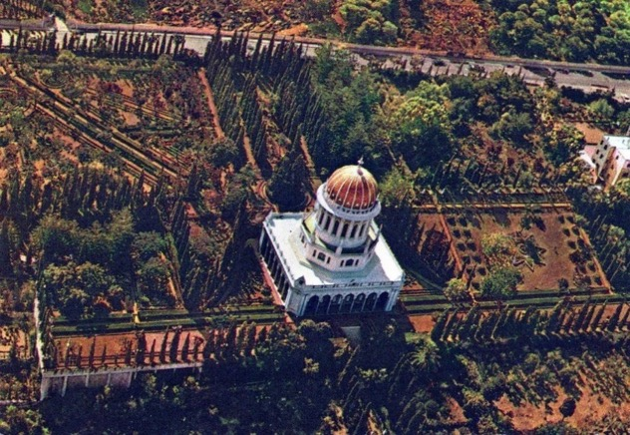
Aerial view of the Shrine of the Bab
In those days, all pilgrims were the guests of Shoghi Effendi. The pilgrims from the East and the West met with Shoghi Effendi separately. He would walk with Western men and women and separately with Eastern men to the Shrines but not with the Eastern women. The Eastern women met with Ruhiyyih Khanum first and soon after, she joined the Beloved Guardian in his receiving room, and then the Eastern women joined them. I was the only woman from the East on pilgrimage on the first two days. I was joined after two days by a lady from the East. A car came to take me to the house of Abdul-Baha at 10 Haparsim St., a two-story house in light brown stone with a graceful entrance of three pointed arches supported by two slender columns and funded by the wealthy American Baha’i, Hand of the Cause Mrs. Amelia Collins. After Abdu’l-Baha’s passing it became the residence of Shoghi Effendi and Ruhiyyih Khanum, and sometimes for Mrs. A. Collins, and the reception place for the Eastern lady pilgrims.

My Pilgrimage
January 11-January 22, 1955
I was taken in and met Ruhiyyih Khanum, the Guardian’s consort, and the daughter of Mr. Sutherland Maxwell and Mrs. May Maxwell. Ruhiyyih Khanum had been an active Baha’i since her youth. Her family had been blessed by having the Master stay in their home during his visit to Montreal. Knowing that she was a free spirit, her mother started the first Montessori school in Canada in her home so that her daughter could give free reign to her interests and talents. An active Baha’i youth who served on the Montreal Assembly as a young adult, Ruhiyyih Khanum made two pilgrimages on which she met Shoghi Effendi. She married Shoghi Effendi at the age of twenty-six and was his constant companion, unfailing support, and tireless co-worker during their marriage.
When I greeted her that day, her youthful beauty was still written all over her face and, to my great surprise, she spoke excellent Persian. We spent an hour together during which I learned about her life in Haifa and of the activities of the Holy Family while Shoghi Effendi was at the Shrines with the Eastern male pilgrims. We heard Shoghi Effendi come in from the mountain and walk down the corridor to his receiving room. Ruhiyyih Khanum signaled to me that it was time to go into his receiving room. She got up and left towards the room of Shoghi Effendi and asked Mr. Iraj Hakim, son of Dr. Lutfu’llah Hakim, to usher me in.
Heavenly Days of pilgrimage
First Day: I went near the door but crying I could not enter the room. Then I heard the voice of the Guardian saying, “Befarmaid, Besmillah!” (Please come in! In the name of God!). I summoned up my courage, entered the room, and greeted him. I took a few more steps towards him with tears running down my face. He said, “Befarmaid, Khosh-amadid! Geryeh nakonid, Beneshinid!” (Come in, welcome! Do not cry! Be seated!). Thanks to His direction, I knew now to sit down without any formalities. Shoghi Effendi sat on the couch on which Abdu’l-Baha had sat but on the other end.
Shoghi Effendi spoke first and asked me if I was coming from England. I answered, “Bale, Qorban! (Yes, my Beloved!)” He inquired about the unity and activities of the Baha’is in England, and I replied that yes, they were united in London where I had spent much time. Then the Beloved Guardian, Shoghi Effendi, congratulated me on my decision to pioneer to Cyprus and expressed the wish that I start corresponding with the Baha’is of Iran to encourage them to pioneer to this country as well. He said he had encouraged American, British, and Iranian Baha’is to pioneer there. Cyprus was the island where Mirza Yahya Azal, Baha'u'llah's half-brother and a Covenant-Breaker, had been banished by the Turkish government and lived for over forty years, and he explained that the name of the island had been known as the ‘sheytan jazirasi’ (the island of Satan) and wanted to know if I knew that. I replied, “Yes, my beloved.” Then he indicated that now the Baha’is must change it into the ‘island of Rahman’ (the island of the Clement One). Only Nicosia and a few other localities had Baha’is living in them. These localities should be raised to Assembly status and then it would be possible to elect a National Spiritual Assembly. He then inquired about the well-being of the Knights of Baha'u'llah, Mr. Vekil and his wife, Mrs. Samireh Khanum, and I replied that they were doing well and making friends among the local people and the other Knights of Baha’u’llah, Mrs. Violet McKinley, and her son, Hugh, were also well and were settling in and getting to know people and teaching them. Then after few more words He got up, said goodbye and left. We came to Ruhiyyih Khanum’s room and then left for our pilgrim house.
Second day: On the second day of my pilgrimage, January 12th, 1955, after meeting Ruhiyyih Khanum and other guest ladies in her reception room and discussing various spiritual subjects, Shoghi Effendi arrived, and Ruhiyyih Khanum joined him, and we followed her. I again had the honor of meeting the Beloved Guardian. This time, I was calmer and happier. I heard his voice beckoning, "Besmellah, Befarmaid!" After I had entered and taken a seat, he said, “Balatar, Berfamaid” and I moved up a few more seats. He wanted to know if I had visited the shrines and if I knew that there were two shrines: one for the Bab and another for ‘Abdu'l-Baha. I answered, “Baleh, Qorban.” He said the pilgrimage took place inside the Shrines, and outside in the gardens, the souls were refreshed.
The construction of the Shrine had begun over forty years ago. The Guardian recounted how the Bab’s Sacred remains journeyed in hiding for decades in Iran before arriving in the Holy Land where they were hidden in the room of the Greatest Holy Leaf for another ten years. ‘Abdu’l-Baha showed the remains to the assembled Baha’is to verify that they had arrived intact, and he buried them with great solemnity in a marble sarcophagus sent by the Baha’is of Burma. The Guardian then spoke of how Baha’is had owned none of the land but one by one, plots had been bought, progress on the Shrine advanced despite the increasing conflict in Palestine, and the final design was unveiled in time for the one-hundredth anniversary of the Declaration of the Bab to Mullah Husayn in 1844.
Third day: On the third day, January 13th, seven believers from Iran joined us. During the first two days, I had been the only pilgrim from the East. Among them were Khanum Munavvar Arbab and her husband, Mr. Arbab, who were very active Baha’is from the town of Daragaz. As usual, the ladies met first with Ruhiyyih Khanum and benefitted from the days’ good news. When the Beloved Guardian arrived after having been with the Eastern male Baha’i pilgrims on Mt. Carmel, Ruhiyyih Khanum joined him. Then we went, Mrs. Arbab and I, and stood respectfully outside the Guardian’s room until we heard his voice beckon us in. With utmost respect and humility, we entered his presence. As soon as we entered, Shoghi Effendi said: Befarmaid, Besmellah! Balatar befarmaid! translation: Please come in, in the Name of God! Be seated! He told us how dear the Iranian Baha’is were to him and asked us if we had visited the Shrines, and we assured him that we had.
Again, he reminded us that the Iranian Baha’is were very dear to his heart. After initial inquiries, the Guardian spoke to us about the importance of pioneering. This act of service would attract the bounties of the All-Merciful and pioneering from big cities to smaller towns was of special value. He stressed that if believers could not leave their country then they should re-locate to small villages. Isolated centers should be opened, then the localities developed, and an Assembly formed. Women must also pioneer and win the laurels of teaching from the men. I enthusiastically replied “Inshallah! (God willing).” He stressed that the Baha’is of Tehran must be encouraged to move to towns and villages in the provinces to teach the Cause because pioneering would attract the Blessings of God. At this moment, I asked him about my plans for Cyprus, and he emphatically replied that I should go and that he had asked American Baha’is numerous times to move to that island. Then I asked about my family members and their pioneering to Cyprus. He approved of their plans but guided me that when I went back to Cyprus, I should try to remove any obstacles so that when they arrived at their post, there would not be any difficulties. My father, he assured me, would be very successful in international service. Here, in my heart, I said to myself, “What about me? Will I be successful too?” After a few seconds, the Beloved Guardian looked at me with a slight smile and said that I, too, would be successful in international service. After further conversation, he left the room. I was so happy that tears poured from my eyes. I went into Ruhiyyih Khanum’s room and wrote down this account.
In addition to these moments of privilege with Shoghi Effendi, I had the honor of helping with a few of the ladies in the Pilgrim House to prepare food for the pilgrims. Among them was Hand of the Cause Mrs. Amelia Collins who had served for years on the National Spiritual Assembly of the Baha’is of the United States before being called to the Holy Land by Shoghi Effendi. She had vast experience having worked with assemblies throughout the Americas on consolidation. Her husband, who was very wealthy, never became a Baha’i though he supported his wife’s work. He was in poor health back in America, and Shoghi Effendi asked Mrs. Collins to return to the U.S. and care for him, and so she went back. He had given much of his fortune to charity and changed his will before he died leaving his wife with all of his estate. After his passing, Mrs. Collins returned and contributed much of her wealth to the purchase of land and maintenance and development of the Baha’i World Center, Temple funds in several countries, and Baha’i publishing and translation. Shoghi Effendi appointed her a Hand of the Cause and a member of the International Baha’i Council.
Fourth day: One afternoon, on the fourth day of my pilgrimage, January 14th, I was with Ruhiyyih Khanum and Mrs. Amelia Collins when pilgrims from Iran brought several high-quality rugs for the Baha’i properties. Decorating the rooms was one of Ruhiyyih Khanum’s responsibilities, and she set about deciding where to place these gifts. She asked for my assistance in sewing a cover for the curtain railings for the windows which I did joyfully as I was eager to help. While I was sewing, we heard Shoghi Effendi arrive. Ruhiyyih Khanum immediately followed him to his room and asked us to join them. Then Mrs. Arbab and I walked towards his door and paused outside until we heard the Guardian’s voice saying, “Befarmaid, Besmellah!” We stepped into the room and greeted them with “Allah-u-Abha,” and we sat. He asked us if we were comfortable in the Pilgrim House and if we had visited the Shrines, and we gratefully answered that we were well, and that we had visited the Shrines. Then the Guardian described his vision for the world administrative center. There would be an arc with the International Archives building on it and later, the Seat of the Universal of House Justice which would legislate, and an office for the Hands of the Cause who would spearhead the teaching of the Faith. Abdu’l-Baha had forbidden anything from being built around the Shrine of the Bab which was the heart of the Holy Mountain; this was the spiritual center of the Faith. The World Center’s completion would take until the Golden Age. He then explained the future works and then got up and said goodbye and left with Ruhiyyih Khanum.
Fifth day: On the fifth day of pilgrimage, January 15th, Mrs. Arbab, myself and some other ladies were in the presence of Ruhiyyih Khanum when Shoghi Effendi arrived. He went into his sitting room, and Ruhiyyih Khanum followed him from a corridor entrance. Mrs. Arbab and myself went to the pilgrim’s door and waited outside until I heard the Guardian say, “Befarmaid! Besmellah!” We entered the room and sat down. He asked us if we had seen the photograph of Baha’u’llah, the precious objects, holy relics, and Writings housed in the large archive. We answered, “Yes, my beloved.” Then he continued and told us he had received items from the Aghsan and Afnan families as well as other Baha’is, collected and arranged them during the war years, and noted on each the names of those who had donated them. Currently, there were two archives, one for the pilgrims to visit which housed the items of major importance and a second one in a storeroom containing the objects of a lesser importance. All of these would be exhibited in one large archive building to be built later; he mentioned that Mason Remey had drawn a beautiful classical design for the Archives. Tehran would have to build its own archives and keep the numerous important objects related to the Faith in that country. Around the International Archives building, he said, there would be the seat of the Universal House of Justice and the International Teaching Center. Haifa would be the center for international gathering, and in the future, there would be centers for gathering in every country. The Hands of the Cause would travel throughout the world, and the Institution of the Hands would be greatly expanded. Beloved Shoghi Effendi then looked at me and said that I should go and explain this to Baha’is, and I answered “Chashm Gorban” (means “Over my eyes” or “I will obey it sincerely”). Then he looked over at Mrs. Arbab and said that she should also explain it to the female Baha’is to which she replied positively. He continued by speaking about the Universal House of Justice, that it was “Safinat-Ullah” (the Ship of God) which Baha’u’llah called the ‘Ark of God’ in the Tablet of Carmel. The Ark of God symbolized the Law of God. When he was finished, he said that tomorrow we would be spending two nights at Bahji and visit the Shrine of Baha’u’llah. I replied, “Insha’Allah” (“God-willing”).
Sixth and Seventh days: We spent the sixth and seventh days and nights of pilgrimage in Bahji and surrounding areas on the other side of the bay of Haifa; Mrs. Arbab and I were the only two women in the group of eight pilgrims. This country home, Bahji, outside of Akka was purchased by ‘Abdul-Baha for Baha’u’llah and their family members. Here Baha’u’llah spent the last years of his life surrounded by the beauty of nature instead of the prison city into which he had been condemned. Later, he was buried at a nearby place making that spot the holiest place on earth. Bahji was a sparkling white two-story mansion with an arcade with rounded arches on the first floor surrounded by formal gardens. The Guardian had struggled mightily against the Covenant breakers to take back this whole property. Once they had been removed, Shoghi Effendi and crews of men worked without rest such that four days later, gardens had been laid out according to the Guardian’s plans. We approached the Shrine with feelings of love, humility, admiration, and respect, and tearfully offered supplications inside His Shrine. A small tree-filled garden grew in the middle surrounded by Persian rugs. In the corner a small room contained the remains of the Manifestation of God. Above, a glass roof allowed light to flood the Sacred space.
From the Mansion we went to Akka, the fortress city built by the Crusaders and used by the Ottoman rulers as a prison because of its thick walls and location on the rocky seacoast, described by Shoghi Effendi as:
“the most desolate of the cities of the world, the most unsightly of them in appearance, the most detestable in climate, and the foulest in water. It is as though it were the metropolis of the owl."
The stone prison cells into which the Holy Family was cast were in disrepair, and we could sense how desolate this must have been that hot summer in 1868. Our guide told us of their suffering and especially of the death of Baha’u’llah’s youngest son, Mirza Mihdi, the Purest Branch. Shoghi Effendi recounted this tragedy:
“He was pacing the roof of the barracks in the twilight, one evening, wrapped in his customary devotions, when he fell through the unguarded skylight onto a wooden crate, standing on the floor beneath, which pierced his ribs, and caused, twenty-two hours later, his death, on the 23rd of Rabi'u'l-Avval 1287 A.H. (June 23, 1870). His dying supplication to a grieving Father was that his life might be accepted as a ransom for those who were prevented from attaining the presence of their Beloved.”
In those days, Covenant-breakers occupied rooms near the entrance gate into Akka. When they saw Baha’i pilgrims coming to see Baha’u’llah, they informed the authorities who turned the Baha’is away. The best the pilgrims could hope for was to see the Hand of Baha’u’llah waving a white handkerchief outside the window of his cell which they would gaze upon from afar on top of the ramparts on the edge of Akka.
From this place, we visited the other houses in Akka made holy by Baha’u’llah. The House of Abbud near the prison was the first house rented for Baha’u’llah upon his release from the prison cell. The house was not large enough for the many believers so the one next to it owned by Udi Khammar—also the owner of the property at Bahji—was rented. From a room in this second house overlooking the waves crashing on the stone wall of Akka, Baha’u’llah wrote the Book of Laws, the Kitab-i-Aqdas that opened with these words:
“In the name of Him who is the Supreme Ruler over all that hath been and all that is to be:
The first duty prescribed by God for His servants is the recognition of Him Who is the Dayspring of His Revelation and the Fountain of His laws, Who representeth the Godhead in both the Kingdom of His Cause and the world of creation. Whoso achieveth this duty hath attained unto all good; and whoso is deprived thereof hath gone astray, though he be the author of every righteous deed. It behoveth everyone who reacheth this most sublime station, this summit of transcendent glory, to observe every ordinance of Him Who is the Desire of the world. These twin duties are inseparable. Neither is acceptable without the other. Thus, hath it been decreed by Him Who is the Source of Divine inspiration.”
To welcome the growing number of pilgrims, Abdu’l-Baha purchased the house of Abdullah Pasha, a former governor of Akka. We also visited the two-story stone house in the countryside at Mazra’ih, also formerly owned by Abdullah Pasha, which His Holiness Baha’u’llah lived in during the summers of 1877-9, and the ‘Verdant Isle’, the garden of Ridvan, a few miles outside of Akka where Baha’u’llah could enjoy the sounds and sight of nature.
Eighth day: We returned to Haifa to continue the pilgrimage. On the eighth day, January 18th, Mrs. Arbab and I were welcomed into the presence of Ruhiyyih Khanum. When the Beloved Guardian arrived at 5 p.m., we went to meet him. Ruhiyyih Khanum went in first, and we entered through the pilgrims’ door. As always, he greeted us with the words, “Besmellah, Befarmaid!” We entered the room humbly and took our seats. We were asked if we had visited the Shrine of Baha’u’llah, and we answered, “Yes, our beloved!” Then he inquired if we had seen the gardens around the Shrine which at night was a sea of light. I agreed saying, “Yes, my beloved! It is paradise!” He wanted to know if we had visited the mansion of Bahji, and we answered, “Yes, our beloved!” Then he stated that our pilgrimage was complete. Then we heard about the mansion of Bahji and how it had been occupied for forty years by Covenant-Breakers while Abdu’l-Baha had been living in the House of Abbud. Though the Covenant-breakers—including members of the Aghsan and Afnan and their numerous supporters—, had created big problems, they were in time eventually defeated. The Shrine of the Bab was now light upon light, and the Shrine of Baha’u’llah, a sea of light. In the future pilgrims would come in troops. I asked the Beloved Guardian if the procedures for pilgrimage would be the same in the future. He indicated that they would be similar—pilgrims would visit the Shrines of Baha’u’llah and then the Bab and other holy places, and then they would visit the House of Baha’u’llah in Baghdad, then the Holy places in Iran including the Siyah Chal. He asked me if I had heard that the Siyah Chal had been purchased by the Baha’is, and I answered, “Yes, I had my beloved!” In the future, the Guardian said, all the Baha’i holy places would be purchased—the place in Tabriz where the Bab was martyred, the prisons of Mahku and Chiriq where He had been imprisoned as well. All remaining Holy sites would have to be purchased. Then he looked at Mrs. Arbab and said that she must explain this to the Baha’is of Iran. A few minutes later, the Guardian said goodbye and left.
On the ninth day of my pilgrimage, January 19th, 1955, we were again in the presence of Ruhiyyih Khanum when the Guardian arrived. She joined him, and then I proceeded to the door of his room. When I heard him say, “Befarmaid, Befarmaid!” I entered, greeted him, and took a seat. He wanted to know what I had done that day. I told him that we had visited the archives, and he wanted to know which archives—the small or main one. I answered that we had seen the main one. He wanted to know if we had seen the photograph of His Holiness Baha’u’llah, the painting of His Holiness the Bab, and the picture of the Master, and I answered that we had seen them all. He recounted how he had gathered many Holy relics and kept track of the names of the donors, writing these out in English and in Farsi and how he was busy erecting the buildings of the World Center which would consist of multiple buildings. The first would be the International Archives building. In the second and third epochs of the history of the Faith, the other buildings would be built. This construction would continue until the Golden Age. Mr. Remey, the Hand of the Cause of God, had designed the Archives building, the significance of which was not yet known to the believers but would be in the future. It seemed that ‘Abdu’l-Baha did not want any buildings in the immediate vicinity of the Shrine of the Bab which must be surrounded instead by gardens on all sides.
This Shrine would be the spiritual heart of Mt. Carmel. The administrative buildings would be erected in the vicinity of the tomb of the Greatest Holy Leaf. The Guardian had been tracing out the Arc on Mt. Carmel by using only his eyes to measure. When he had finished what he wished to tell us about the buildings of the World Center, he encouraged me to correspond constantly with the friends in England and in Iran and to write to them in their respective languages as I knew both and explain to them all that I had heard. I answered that, yes, my beloved, I would obey with the help of God. The Guardian reminded us that the World Order of the Blessed Beauty was new and that the old order would be shaken up, destroyed, and perish. He finished by asking me to write all that down and communicate it to the friends. Then, he bade us goodbye and left.
Tenth day: On the tenth day of my pilgrimage, I met again with Ruhiyyih Khanum. When she heard Shoghi Effendi come in, she rose to go to join him. I then went to his door, and when I heard his voice say Befarmaid, I went in and sat down with his permission. He observed that this was my last night of pilgrimage. He said that if it had not been my last night there, he would have sent me to Bahji. He asked me if I had heard the good news brought by Ms. Claire Gong, a pioneer in Africa who had just arrived in the Holy Land. In just two years’ time, the Faith had reached ninety tribes, 200 centers had been established, Baha’i literature had been translated into more than forty languages, and out of seventy goal islands, sixty-four had been opened. He repeated three times that only six islands in the Pacific and Atlantic Oceans were left to be opened. He told me that I must let Baha’is know this. I answered that, “Yes, my beloved, I will obey you.” He said that if he had time, he would write each Baha’i individually and encourage them to pioneer but this was impossible as he was very busy with the amount of work he had, so I must correspond with the Baha’is of Tihran and encourage them to leave Iran for the pioneering field or if that was not possible, at least to leave the big city for the towns and villages. This would be more useful to the Faith and better for them spiritually as Tihran had many temptations. The greater the effort made to go pioneering, the greater the reward for the friends. Baha’is must follow the example of Dr. Muhajir who pioneered to remote locations. He repeated that I must correspond with the Baha’is in Iran and encourage them to go pioneering, and I answered that, “Yes, my beloved, I will do this.” He finished by stressing that the pioneers must not leave their pioneering posts as this will result in the loss of the gains made in the numbers of assemblies.
Prior to my meeting with Shoghi Effendi, I prayed in the room in which ‘Abdu’l-Baha had passed. When I met the Beloved Guardian, I could not stop weeping. He spoke to me of the great international plans, the intercontinental conferences, and the necessity of pioneering. He encouraged me to go to Cyprus and spread the Cause all over that island. I replied that, “With the help of “Divine Power” I will.” Then he left the room. I came back to Ruhiyyih Khanum’s room and after a short time, I took the food which was ready for the Eastern pilgrims and went by car to the Pilgrim House.
Eleventh day: On the eleventh day of my pilgrimage, I visited Ruyhiyyih Khanum, and she advised me to be strong, to go forward in the face of difficulties, and to send her love to all the Baha’is in Cyprus. Then Beloved Shoghi Effendi arrived. She first joined him, and I entered into the presence of the Beloved Guardian by his permission. I met with Shoghi Effendi for the last time. Before I could take my usual seat, he beckoned me to go further into the room and sit opposite him. He asked me if I was sad, and I answered, “Very much my Beloved.” He said that I must be happy because I was going to Cyprus which is under the Shadow of God. Then he informed me that inter-island conferences would soon be held in five regions around the world: the North Atlantic, the South Atlantic, the Pacific, the North Sea, and the Mediterranean. Baha’is would be appointed from each region as representatives. Here again, I asked Shoghi Effendi for his advice about the pioneering of my parents to Cyprus. He asked me where my family was at the moment, and I answered, Mashhad, Khorasan, Iran. He advised me to go to Cyprus first and make all the necessary arrangements, and then they should come over, thus they would have no problems after their arrival to Cyprus. Then he re-iterated that I must encourage Baha’is to leave the capitals so that the Faith would be disseminated throughout the countries. He stood up to leave after a few more words. I wanted to ask for permission to come on pilgrimage again but was too shy to do so. As he was leaving, he turned to me and said in the future when all the circumstances permit, I would come again, and then he left.
After his departure, we went to Ruhiyyih Khanum’s receiving room, sat and—as I was overcome with emotion and was crying non-stop—, Ruhiyyih Khanum looked at me and asked me, what more could I have wanted—"Shoghi Effendi has given you everything! Now,” she said, “You must leave this holy place and go and serve the Cause as a pioneer in Cyprus and thank-God for all the bounties that you have received.” I said, “Beloved Ruhiyyih Khanum, that is why I am crying! I am thanking him for all his undeserved bounties that he has bestowed upon this humble one.”
With this priceless gift, I was on my way to my first pioneering post.

Chapter 3

Pioneering to Cyprus
I left the blessed presence of Shoghi Effendi for my pioneering post in Cyprus at the age of twenty-nine. I settled in the capitol of Cyprus, Nicosia. This ancient city of small roads and warm sunshine had been continuously inhabited for over four millennia and sat in a plain near the center of the island and included several nationalities such as Greeks, Turks, and Armenians, among others. I got married, found work in the surgical room of a small hospital run by the much-respected Dr. Zambarloukos, a Greek Cypriot who had studied general surgery in Europe and returned to Cyprus to contribute to the medical community on the island.
Two trained operating nurses from Australia were working there, but were returning home in a month, and I was taking their places, so I had to learn their job. I observed in detail the routines of the doctors and their nurses and noted down in Farsi all the specialized terms for each implement and steps of the operations in the surgery ward where I would be starting in one month. I memorized each doctor’s personal method for prepping himself and the patient.
After one month of observation, my first day came assisting the doctors as an operating room nurse. Because of my extensive preparation, I performed the duties exactly the way the doctors liked and needed. After the first operation was over, the surgeon looked at me with astonishment and asked how I could possibly have known everything.
After six months at the hospital, I realized that my family back home needed my help to join me in Cyprus per approval of the Beloved Guardian. So, I resigned from the hospital and left for Mashhad, Iran, and there, as my father was not well, I got a Power of Attorney and was then able to help sell our four houses and my father’s tannery. I had to do all this work in a short time. We were the first Baha’i family from Mashhad, Khorasan to go pioneering internationally, and the Assembly was delighted to have local Baha’is arising to serve in such a vital and important way. The friends gave us a goodbye party, and Hand of the Cause Mr. Tarazu’llah Samandari invited us to his home for dinner and served us personally and promised to pray for the success of our pioneering efforts.
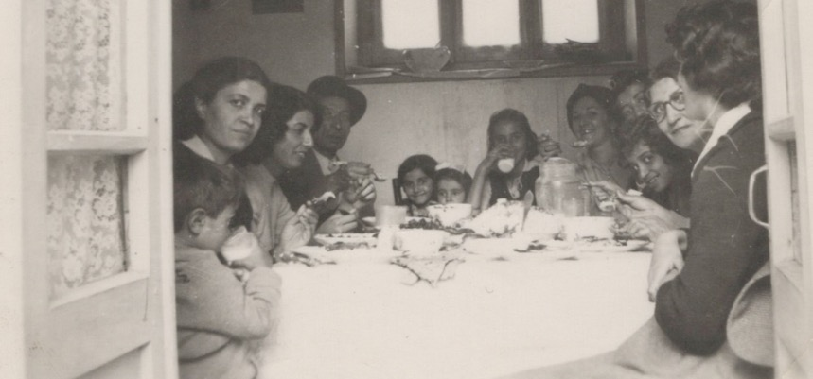
Dinner at the home of Mr. Tarazollah Samandari, ten days before leaving to pioneer in Cyprus. From r. to l. around the table: 1) Soraya Sedaghat, 2) Mrs. Leqaiyyih Sedaghat, 3) Guitty Sedaghat, 4) Farhad Sedaghat, 5)-8) ?, 9) Mr. Ali Sedaghat, 10) Shamsi, 11) Qamar Aghdassi, 12) her son, Esfandiar Aghdassi (the question mark means I forgot their names)

We went to Tehran with much luggage and waited there until we received our visas. Mr. Ali Akbar Furutan, the Secretary of the National Spiritual Assembly of Iran and, later, Hand of the Cause, called a friend in the Customs Department at the airport to explain that our items should be declared as ‘used materials’ and, as a result, the rates were reduced which greatly helped our family budget, and we left for Cyprus. When we landed in Nicosia, Mr. Abbas Vekil and his wife, Mrs. Samireh Khanum, Knights of Baha’u’llah for Cyprus, Mr. Hashemi and his wife, pioneers, and a few others were there to welcome us. As my husband was not there, Mr. and Mrs. Vekil kindly took us to their home where we stayed.
They were very kind and looked after us for several days until we found an apartment in the Greek section of town located at 25A Nikiforou Foka Street and settled there. For my father, being in a strange land away from all that he knew was an even greater test. My father cabled the Beloved Guardian about our arrival and begged his prayers to which Shoghi Effendi replied:
“REZVAN SEDAGHAT
PRAYING SUCCESS
SIGNED SHOGHI”
Life in Cyprus
This lifted our spirits. Soon life took on a regular rhythm. My youngest sister Guitty Jan—now Guitty Ejtemai—entered St. Joseph’s Convent school, a Catholic school, (after being homeschooled for a bit during which I helped her with her language lessons). She was nine years old. My brother Farhad, aged fifteen, attended a government school, and my other sister Soraya—now Soraya Furutan—, aged twenty, went to a school for midwifery. My parents found that they could communicate with local people by using their Turkish language and, in this way, were able to make new friends. Mother cooked, and we gradually began inviting people over, breaking through the veil of foreignness.
Must be steadfast during tests
I soon learned, though that pioneering included one major component for spiritual growth: tests. As the Guardian had explained to a believer:
“It is part of the preciousness of this great work being done in the teaching field that it should be done through real sacrifices and not without heartaches attending it.…Bahá’ís cannot but believe that suffering is often an essential part of our service.”
Tests in Cyprus
After arriving in Cyprus, I had to pass through several tests. One of them was my brief marriage which ultimately failed.
Another test for me soon arose. One Friday I was cycling through town—bicycles were the main form of transportation. I was in a great mood because I had just secured a position at the Nicosia General Hospital which provided me with a good income and opportunities for teaching. I would be starting after the weekend. They gave me uniforms for a week and a locker to put them in it. While riding back to my house, I came into the business district where the streets were narrower and busier. I was hit by a car and fell to the ground and broke my right wrist. A crowd quickly gathered around me. I told people not to worry that I would be alright and to please keep my bicycle and get me a taxi to the hospital. I was put into a taxi and driven to the hospital where I had just been offered a job and was now showing up as a patient in the emergency room. All were astonished. The nurses were surprised to see me because I had just been there. My arm was put in a cast. They got me a taxi, and I was sent home. My parents were sitting out on the balcony, and I was nervous that my accident would upset them. I explained to them the situation and told them not to worry but by nightfall, my hand had turned blue, and so I had to go back to the hospital. I phoned Ms. Jeanne Kranen, a Baha’i pioneer from Holland, who came over and got a taxi and accompanied me there. The doctor was surprised by the gravity of the injury. I thanked Baha’u’llah for leading me back to this hospital. The cast was split and left open, and then my arm was left in a split cast, bandaged, and placed in a sling around my neck with the instruction that I keep it elevated. One month later I returned to the hospital because the fracture had not been fixed properly, so my arm cast had to be removed under anesthesia and set correctly. Three months of convalescence at home followed. Though I had no money coming in, the hospital very kindly saved my position for me. After three months my arm had not fully healed, but the hospital allowed me to start work and do light tasks so that I could earn a little money.
I received an unexpected blessing
Riding a bicycle brought me unexpected blessings. I needed a car for my family and work and had been disappointed a few weeks earlier when a used car, which I had put a down payment on, had been sold to someone else. At the time, I said nothing and left. After a month, I was again riding my bike in town when an Armenian man called out to me who recognized me because I had been of great help to his sister when she was in the hospital. He wondered why I was riding a bike. He told me he owned a car dealership and that I should come by, and he would sell me a car at a very good price. I agreed to the generous terms he offered which consisted of small monthly payments. I signed all the documents in his dealership and drove away in the Simca Around car. My parents were greatly surprised when I drove up in this beautiful new car.
The dealer told me to come see him directly if I had any problems with the car, and he would have them fixed. One day I drove too close to a car which had some lumber sticking out of both of its sides, and my car got side-swiped and was badly damaged. I happened that day to be taking a Baha’i lady and her newborn from the hospital back to their home but thankfully no one was injured. I drove the lady and her baby back to their home and comforted her and then went to the car dealer and repair shop. As soon as the owner of the shop saw the damage to the car, he told me not to worry. He would make it as good as new. I left the car with him and took a taxi home. When my parents saw me arriving home in a taxi, they worried and asked about the car. I very calmly explained the situation and told them that the car would be ready in two days’ time at no charge. A few days later, the car dealer called me to tell me that my car was ready, and I could come to pick it up. The repairs were so well-done that one would never have known that the car had been in an accident.
Gradual progress in Cyprus
As we weathered the tests of pioneering, we experienced confirmations in our Baha’i work. When we settled in Nicosia, there were already a few Baha’is in Cyprus who had been carrying out the teaching work.
Mr. Abbas Vekil and his wife, Samireh Khanum, moved to Cyprus in August of 1953, when she was eight months pregnant. They had decided in an instant to pioneer after hearing the call for the Ten-Year Crusade while on their honeymoon in Istanbul, Turkey. As they were the first pioneers to Cyprus, the Beloved Guardian, Shoghi Effendi, named them “Knights of Baha’u’llah”. Samireh had a dream that Beloved Shoghi Effendi held her hand, raised her up, and moved her. During their first year in Cyprus, she gave birth to their son, Leroy, named after Hand of the Cause Mr. Leroy Ioas (who was a Hand of the Cause serving Shoghi Effendi in Haifa at that time). Mr. Abbas Vekil was able to obtain a job in a Turkish bank in Nicosia. His knowledge of French, Arabic, Persian, Turkish, and English helped him develop contacts among the Turkish Cypriots.
We had two American pioneers by the names of Ms. Frances Jones and Ms. Mildred Mehl who were living in different towns in Cyprus and both were active Baha’is. Ms. Jeanne Kranen, a pioneer from Holland, had also settled in Cyprus and was an active member of our small community. She worked as an English teacher to make ends meet but this did not hamper her from serving others and the Faith. A young man, Mr. Cyrus Mavaddat pioneered to Prodromos which was a town high in the mountains and over eighty kilometers west of Nicosia where he studied agriculture and was a very active Baha’i. He married a Greek lady, Ms. Angeliki; she later declared, and both were devoted Baha’is. Another pioneer family was Mr. and Mrs. Hashemi and their two daughters who were there for about a year. They were active Baha’is also and then left for another pioneering post. The first Turkish Cypriot to become a Baha’i was Mr. Hassan Shashmaz, a telephone technician and poet/writer who was of Turkish origin. When we cabled Shoghi Effendi of his enrollment, the Beloved Guardian was delighted and counselled us to concentrate on the Turks and that the results would be excellent.
Years later, he wrote to me about the progress of the Faith in Cyprus:
“19/11/79 Nicosia
Very Dear Baha’i Sister, Shamsi Sedaghat, How are you my most beloved sister, Let God Bless You.
We are fine. The plant you planted growing speedily and steadily.
We have Kibris Merkezi Ruhani Mahfeli (Cyprus National Spiritual Assembly of Baha’is) We had a conference at Famagusta. This year or better next year, 22 until 25 of February 1980, we shall have another, 2nd one at Kyrenias. We rented a hotel. Many Baha’is will be invited from Arab countries and Turkey. Few from West. Because I am member of NSA I have been at Lagenheim in Germany for a Baha’i conference. If you have been here at Conference at Famagusta, marvelous. I am asked to write a letter to say progress notes about Cyprus history. There I was asked to talk at Conference with those notes. I spoke, when I proceeded I lost myself in the spirituality of the case. I brought out some photos and I said “now you will see at least the photo of the greatest farmers of the Baha’i Faith and showed your photos with some others waving them in the air. If you wanted see all the members of Conference were in such condition in the Feast I cannot explain all those having comments approached to see me and I hear tic tic tic minutes continued to get photographs of me with those biggest famous farmers. Photos in my hand in the air waving them to the Baha’is of Conference. One of photos was Shamsi’s, the brightest sun of the Faith, … my best beloved sister, Salam, Allah’u’abha from all of us…Hassan Shashmaz”

Gradual progress of the Cyprus community
The community progressed step by step. We developed friendly relations with officials and made them aware of the basic tenets of the Baha’i Faith. Though we held a few public meetings, we followed a more indirect method of teaching—building friendships with local people. Shoghi Effendi had always counselled wisdom in teaching which sometimes called for being bold and direct and other times required a more cautious and indirect approach. The pioneer would have to decide depending on the situation.
Shoghi Effendi writes:
"These pioneers, in their contact with the members of divers creeds, races, and nations …must neither antagonize them nor compromise with their own essential principles. They must be neither provocative nor supine, neither fanatical nor excessively liberal, in their exposition of the fundamental and distinguishing features of their Faith. They must be either wary or bold, they must act swiftly or mark time, they must use the direct or indirect method, they must be challenging or conciliatory, in strict accordance with the spiritual receptivity of the soul with whom they come in contact...”
We opened our home every Wednesday night for a fireside until gradually more than twenty people were attending. Shoghi Effendi had explained that the fireside was the most effective method for the teaching of the Cause:
Use of the fireside
Shoghi Effendi explained the importance of the fireside:
“… I would like to comment that it has been found over the entire world that the most effective method of teaching the Faith is the fireside meeting in the home. Every Bahá’í as a part of his spiritual birthright, must teach, and the one avenue where he can do this most effectively is by inviting friends into his home once in 19 days, and gradually attracting them to the Cause. After the individuals have confidence in the pioneer, and the pioneer in the individuals, then they can be taught and confirmed in the Faith. This method is far more effective than advertising in newspapers, public lectures etc. The Guardian is encouraging the believers over the world, including those on the home fronts, to engage in this method of teaching.”
“…The friends must realize their individual responsibility. Each must hold a Fireside in his or her home, once in 19 days, where new people are invited, and where some phase of the Faith is mentioned and discussed. If this is done with the intent of showing Bahá’í hospitality and love, then there will be results. People will become interested in ‘what’ you are interested in, and then be interested in studying. Individual firesides will bring the knowledge of the Faith to more people, under favorable circumstances, and thus constantly enrich its circle of friends, and finally its members. There is no substitute for the teaching work of the individual.”
Showing hospitality
My beloved mother showed all our guests great hospitality. She kept our best food for these evenings. We prepared a variety of delicious Persian dishes, homemade cakes, and sweets. One evening, a guest requested permission to ask a question, and we were delighted because we thought he would ask something about the Faith. He said that he and others had enjoyed our hospitality very much and that he had been encouraged to have such meetings in his home as well but could not afford to do so. He thought that we received money from Haifa for each declaration so would it be possible for us to share these funds with him, that he could open his home in the same way. Our father gently replied that he had wondered if others had thought that as well. He assured the man that no funds were provided for new declarations and that our family provided the hospitality that was within our budget. Upon hearing this answer, the man handed me an envelope saying that there were several letters of resignation in it and that if they were not assisted financially, they would leave the Faith. I took the letter and, without opening it, gently tore it and put it in the waste paper basket and said to them, “beloved friends you accepted the Faith voluntarily and can leave it voluntarily and that either way you will always be welcome in our home.” After hearing this answer, everyone stayed, and some of them even continued to attend future Baha’i gatherings as well.
Teaching in the hospital
I also endeavored to teach my colleagues at the hospital where everyone came to know that I was a Baha’i. Gradually several of them came to our home and were introduced to the principles of the Faith. I developed friendly relationships with my patients as well. I tried to live the Baha’i teachings: preferring others over oneself, treating everyone justly, being truthful and trustworthy, and showering all with love. I took responsibility for all aspects of my patients’ care including medical supplies, food distribution, and general comfort. For example, a patient one day showed me the bowl of food he had received from the hospital which contained some broth, a few potatoes, and a bone with only a little meat on it. Then I checked the bowls of other patients and found the same thing. I went to the kitchen and asked the cook why there was practically no meat on the bones, and he assured me that there should be enough. We walked over to the ward, and he checked the bowls of the patients and saw that I was right. He assembled his assistants in the kitchen and asked them about the meat while I looked around and found a cabinet with a pot full of boneless meat and pointed it out to the kitchen staff. I asked that the meat be cooked and distributed to the patients that night and that no further mention of this incident be made to anyone. The cook was very upset and thanked me, promising that this would not happen again, which it did not as long as I was there.
Expression of gratitude
Patients also expressed their gratitude to me for caring for them though sometimes in unusual ways. Once my mother called me in my office to let me know that a Greek man had arrived leading a donkey laden with two huge baskets full of tomatoes, grapes, and cucumbers, and asking for ‘sister Shamsi’. She put him on the phone, and he told me that he had brought these gifts from his garden for me out of gratitude for the care I had given his daughter who had been very ill but had subsequently recovered. I thanked him but asked him not to do this again! For me, the greatest gift was the recovery of his daughter.
The work of a small group of Baha’is of the community
Thanks to the teaching efforts of our small group of Baha’is, waiting souls were found, and the Faith progressed. Mr. Marshall, an American attached to the U.S. Navy was a Baha’i and taught the Faith to Mr. Fred Parry who was attached to the U.S. Marine Corps (both were very active Baha’is). Other new declarations came from local Cypriots. Mr. Hassan Shashmaz was the first Turkish Cypriot Baha’i and a shining star in Cyprus, and his wife, Hurmuz Khanum, who served the Faith, and their four young children, two girls, Aysha and Havva, and two boys, Ali and Rustam. They actively attended our meetings before moving some years later—after we had left Cyprus--to Ankara in Turkey. Our parents enjoyed them very much because they could speak with them in Turkish.
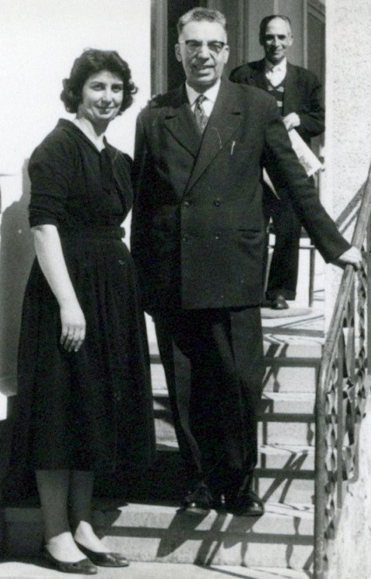
Shamsi meeting Hand of the Cause Mr. Furutan in Turkey during her Cyprus years
Formation of the first local Spiritual Assembly of Nicosia
In 1956, we were able to form the first Spiritual Assembly of Nicosia made up of Mr. Hashemi, Mrs. Hashemi, Mr. Ali Sedaghat, Mrs. Leqaiyyih Sedaghat, Ms. Shamsi Sedaghat, Mr. Carapetian, Ms. Jeanne Krannen, Mr. Abbas Vekil, and Mrs. Samireh Vekil. We cabled the Universal House of Justice about the good news of the Assembly’s formation. Later, it was incorporated, and we held many successful meetings and had many declarations.

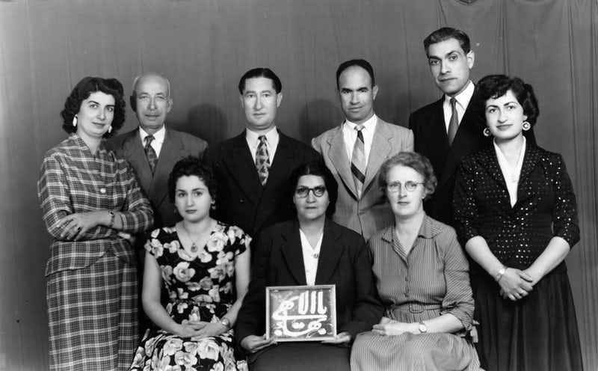
The first local Spiritual Assembly of Nicosia, Cyprus
Back row, l. to r.: Shamsi Sedaghat, Mr. Ali Sedaghat, Mr. Hashemi, Mr. Carapetian, Mr. Abbas Vekil, Mrs. Samireh Vekil
Front Row l. to r.: Mrs. Hashemi, Mrs. Leqaiyyih Sedaghat, Ms. Jeanne Kranen

Visits of Hands of the Cause and other dignitaries
Our community was inspired by visits from the Hands of the Cause and other Baha’i visitors from abroad. We were fortunate to have Hand of the Cause Mr. A.A. Furutan in our home in Cyprus for ten wonderful days. We have many wonderful stories of his service to our beloved Faith. During a memorable gathering, Hand of the Cause John Ferraby anointed each one of us with attar of roses given to him by beloved Shoghi Effendi. Mr. Ali Nakhjavani accompanied Hand of the Cause Mr. Samandari to Cyprus. They stayed with our family which we all remember with great fondness.

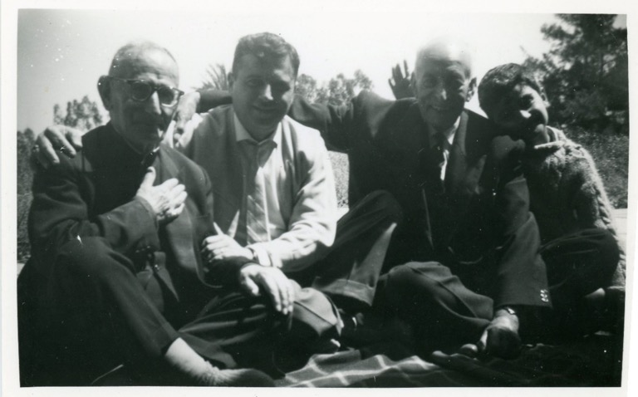
Hand of the Cause Mr. Taraz’u’llah Samandari, Mr. Ali Nakjavani (future member of the Universal House of Justice), my father, Mr. Ali Sedaghat, my brother, Mr. Farhad Sedaghat.

Hand of the Cause Mr. Giachery helped to deepen the friends during his stay and tried to reconcile my marriage, but it did not last long. Mr. Habib Manavi, a long-time pioneer in Turkey, came to Cyprus and helped us to understand how we could be steadfast as pioneers. The visit of my older sister Qamar Khanum Aghdassi and her little son Isfandiar, who were returning from a Baha’i Conference in Germany, brought great joy to our family.

Visit of Mr. Abdu’l Misagh Misaghiyyih
Mr. Abdu’l Misagh Misaghiyyih, a great benefactor and the owner of the Misaghiyyih Hospital in Tehran as well as a good friend of our family, was very impressed at the level of the Baha’i activity in Cyprus. He bought a piece of land in my name on which to build a Baha’i center in the future. I kept the land until we incorporated the Spiritual Assembly of Nicosia in 1959, and then I transferred the land to the Assembly.
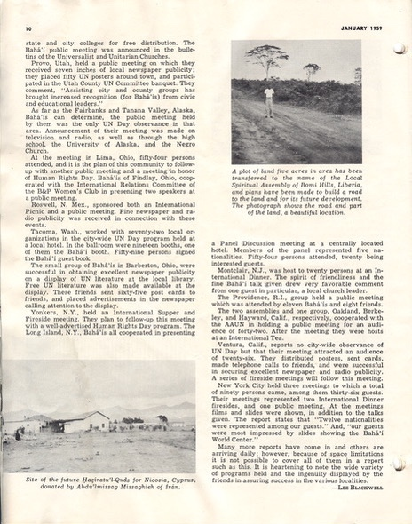
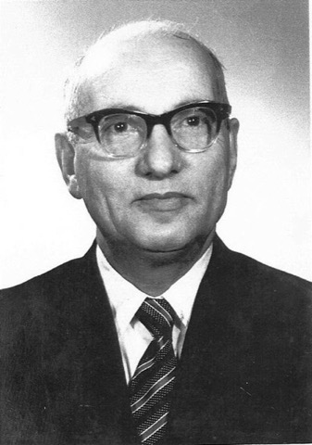
Mr. Abdu’l-Misagh Misaghiyyih
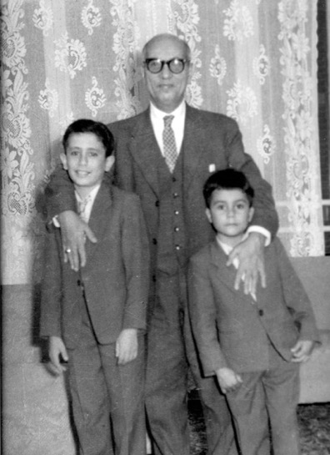
Mr. Abdu’l Misagh Misaghiyyih and Ali Shashmaz (l.) and Rustam Shashmaz (r.), the sons of Mr. Hasan Shashmaz, the first Turkish Cypriot Baha’i
Years later a very nice center was built there which is still in use today. I received the following letter of appreciation.
“Dear Shamsi Sedaghat,
The Nicosia Spiritual Assembly and friends thank you for all you have done to keep Mr. Misaghiyih’s gift for all these years in your name and for your enthusiasm with which you saw it being transferred at last in the name of the Incorporated Assembly of Nicosia. We have also sent a letter to Mr. Misaghiyih to inform him about this historic act and to thank him once again for his generous gift to help the cause here.”
North Cyprus Baha’i Center
Today a Baha’i Center stands on this land, which is used by the Baha’is of North Cyprus, the Turkish side of the island; on special occasions the center hosts gatherings for the friends from all over the island during the day though at night the Baha’is from the South must return home.
The incorporation of the Spiritual Assembly of Nicosia in 1959 was a milestone in the consolidation of Baha’i institutions in Cyprus and was the result of our cultivation of good relations with the authorities. The photo of the incorporated assembly is printed in The Baha’i Faith, Volume 13. The members at that time were: Ms. Jeanne Kranen, Mr. Ali Sedaghat, Mrs. Leqaiyyih Sedaghat, Ms. Shamsi Sedaghat, Miss Soraya Sedaghat, Mr. Hassan Shashmaz, Mr. Cyrus Mavaddat, Mr. Marshall Watson, Mr. Fred Parry.
According to the incorporation papers, the Assembly was “To have exclusive jurisdiction and authority in matters concerning the Baha’i Faith over all local activities…” and its functions included “…maintaining the integrity and accuracy of all Baha’i teaching whether written or oral …,” “To make available the published literature of the Faith,” “To collect and disburse funds.” The charter defined the local Assembly’s administrative relationship to the future National Spiritual Assembly. With respect to local believers, “…its sacred duty…” would be “…to maintain full and complete unity throughout the Baha’i community.”

The members of the incorporated Assembly of Nicosia, Cyprus

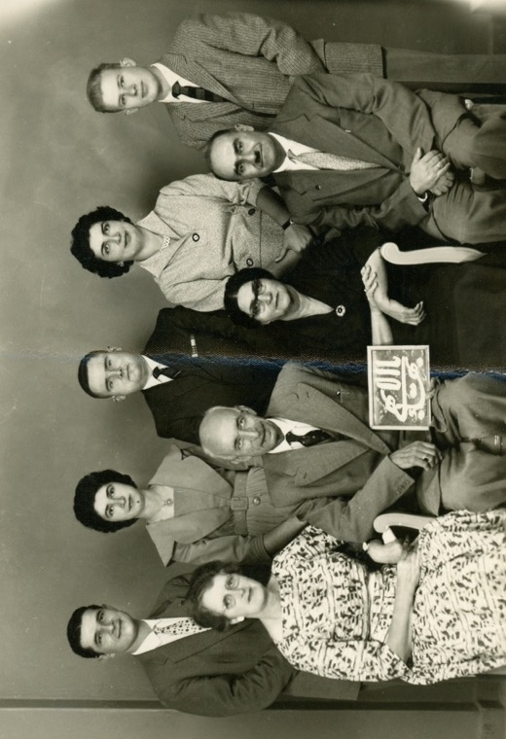
Members of the first incorporated spiritual assembly of Nicosia, Cyprus, 1959.
Back row l. to r.: Mr. Cyrus Mavaddat, Ms. Soraya Sedaghat, Mr. Fred Parry, Ms. Shamsi Sedaghat, Mr. Marshall Watson
Front row l.to r.: Ms. Jeanne Kranen, Mr. Ali Sedaghat, Mrs. Leqaiyyih Sedaghat, Mr. Hassan Shashmaz.

Return of my sister and brother to Iran
That same year was a time of change for our family. Soraya, my younger sister, had completed her midwifery training at Nicosia Hospital, but she did not have the permit to work in Cyprus, so she returned to Iran. Later she married Mr. Khosrow Furutan, a nephew of Hand of the Cause Mr. A.A. Furutan.

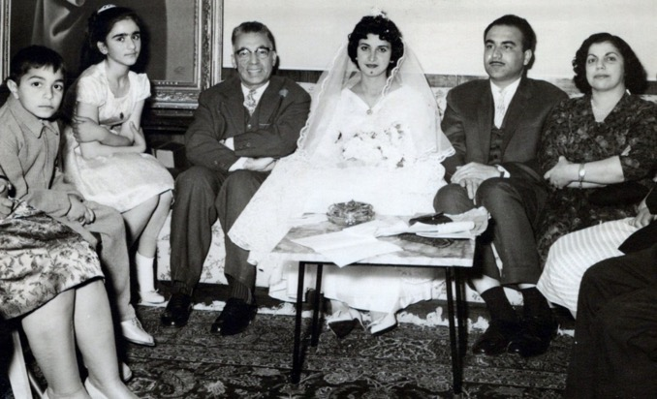

From r. to l.: Mrs. Furutan, Mr. Khosrow Foroutan, Mrs. Soraya Sedaghat Foroutan, Hand of the Cause Mr. A.A. Furutan, girl unknown,
young Esfandiar Aghdassi who is the son of my eldest sister and her husband, (Mrs. Ghammar and Mr. Rostam Aghdassi) who is now a businessman and married Mrs. Shamila Khanum Shahidian, both are very active Baha’is; Mrs. Leqaiyyih Sedaghat (only partially seen).
Later, they pioneered to the Czech Republic and now they are in California. Our brother, Farhad, also had to return to Iran as his visa did not give him permission to work as well as study in Cyprus.
Our family and I decided to move to Famagusta to help form the second assembly in Cyprus. This city on the east coast of Cyprus was ancient, and it had become the major tourist center of the island. There were seven Baha’is including us, and two very interested seekers who took declaration cards with them home to sign and return the next day, the First Day of Ridvan Holy Day, April 21st, to form our assembly by a joint declaration. For unknown reasons, they were not able to come, so we were not able to form our assembly. Years later when the situation of the country improved, the two seekers, Mr. Mustafa Salman, and Mr. Erol Elkar, both of Turkish backgrounds, filled out their declaration cards and sent them to the National Spiritual Assembly of the Baha’is of the British Isles which was responsible for the Cyprus community. They were enrolled, and then they went on to serve the Faith including on assemblies. I met them again thirty-five years later, on a return teaching trip to Cyprus to be described in a subsequent chapter. May God bless all their services to His Cause and to humanity. I was glad to see them active and the Faith growing.
Work at the Famagusta General Hospital
I secured an excellent job as a supervisor at the Famagusta General Hospital. My professional life had flourished in Cyprus. I began there as a staff nurse and then underwent maternity training upon completion of which I received a certificate which qualified me to be a nursing ‘sister’—one degree higher than a staff nurse—and the head of the nurses and midwives. I worked either the 7 a.m.-3 p.m., 3 p.m.-11 p.m., or 11 p.m.-7 a.m. shift. I occasionally worked weekends during which I supervised the nurses and midwives for the entire hospital.
I put my heart into my work. I moved constantly around the ward, checking on patients, following up with nurses, and disregarding the end of my shift if necessary, to finish my work. I treated all patients the same irrespective of ethnicity. Many felt the need to thank me and brought me olives, eggs, and other fruits as a gift. Of course, their well-being was always the greatest reward for me, and I shared any material gifts with my staff.
Result of my severe headaches
One day in the hospital I had a severe headache. I took two pills and went home at the end of my shift. At home, the headache persisted, so my father sent me back to the hospital to get a diagnosis. To make him happy, I complied. Still wearing the same uniform, I returned to the hospital that night. Everyone was surprised that I had returned so I explained the situation. I lay down on my bed in my office, took a couple of pills and slept. In the morning, a well-known doctor who was also a patient at the time and who had heard I was not feeling well came to see me. I explained to him how I was feeling, and he examined my abdomen by scraping with his fingernail small x across it. Immediately, there was some redness and swelling. He speculated that I might have an allergy to dairy, fish, and eggs and asked me when my headaches had started. I told him I had been having them since I moved to England where I regularly drank milk and ate omelets made with powdered eggs and sometimes fish. The headaches continued in Cyprus. He counselled me not to eat any of these foods for one week and after that eat two eggs and see how I feel and then repeat this for each of the other two, milk and fish. If a headache returned after eating one of these foods, I should take Panadol, pain relieving tablets, and see the results. I followed his advice, abstained from these foods for one week and then ate two eggs. My headache returned so I took two Panadol tablets. Then I repeated this with fish, and again a headache came on which was even worse than the one before. Again, Panadol helped. Then I drank a glass of milk, and the headache returned. Therefore, on the doctor’s advice and this experience, I cut out dairy, fish, and eggs from my diet. This change reduced my headaches but resulted in a drastic drop in my intake of calcium which caused an onset of osteoporosis, the only consistent health problem I have had over the course of my life, which contributed to breaking two wrists, a shoulder, and my right leg. Doctors examined me twenty-seven years later in the United States and conducted blood tests and found that I was allergic to many foods but primarily by those suggested by the doctor in Cyprus. They advised me then that I should eat milk, fish, and eggs, for their calcium and take allergy medications such as Claritin at the same time to prevent the onset of the headaches. I accepted this advice and my headaches were reduced tremendously but I developed osteoporosis which resulted in my breaking many of my bones.

Chapter 4

First Baha’i World Congress in London and Return to Iran
The Baha’i community continued to progress in Cyprus. Our spirits were lifted further -a few years later in 1963 when my family wanted to fly to London to participate in the First Baha’i World Congress to celebrate one-hundred years since Baha’u’llah’s Declaration in the Garden of Ridvan and the first election of the Universal House of Justice. We didn’t have enough money to take everyone in the family. Guitty had to go because she would be continuing her schooling in England. We were worried that our mother would have to be left in Cyprus and that she would miss out on this blessed gathering. As we were whispering between each other about this, mother walked in and burst out laughing saying that she knew, “What we were discussing,” and that we mustn’t worry because she had her own money. She explained that when she went to the market, she economized by buying cheaper items and then kept the money she had saved, and now she had over 700 hundred pounds in savings that she could use to go to the Congress; my mother had always been practically minded and an excellent manager of money. We were very pleased by this and all went to buy our tickets and then set off for London.
Arrival in London
In London we rented an apartment where we could all stay. We re-united with Soraya who had come from Iran with her two-year-old daughter Sholeh and was pregnant again. She gave birth to Navid, her first son, while we were there.
The Congress showed the success of the Ten-Year Crusade which had just finished. Baha’is from over fifty countries attended, and Hand of the Cause Mr. Enoch Olinga welcomed them all during the first session in the Royal Albert Hall. I assisted the non-English speaking friends, especially Iranians, by translating for them when they were having difficulty figuring out signs and directions in English. Baha’is were able to greet the members of the Universal House of Justice who had recently been elected. Over those days, I met several of the beloved Hands of the Cause and friends from all over the Baha’i world. The Congress gave us lots of knowledge, experience, wisdom, and courage in teaching and proclamation of our beloved Faith. I could write pages about the power and glory of the Congress.
After the Conference, we sent Sholeh back to Iran with my older sister Qamar Khanum Aghdassi, while we stayed with Soraya who was recuperating in a hospital in London. When she was ready, she returned to Iran, and the rest of us went back to our pioneering post in Cyprus.

Deterioration of the situation in Cyprus
We were spiritually re-fortified for our pioneering efforts in Cyprus but found that the situation on our island was deteriorating fast. When the British were driven out by Cypriot nationalists in 1960, the independent Republic of Cyprus was proclaimed. Once the colonial power had left, the Greeks and Turks worked together but then after a few years, they turned on each other, and the increasing communal violence resulted in ‘Bloody Christmas’ December 21, 1963, after which the situation between the two groups deteriorated terribly. In 1964, the Greeks staged a coup d’état.
I still had to go to work amidst all these tensions and violence. My father had tried to convince me not to go, but I re-assured him that I would be in no danger because of my British passport. I drove slowly through the streets presenting my passport to the patrols.
The situation at the hospital was frenzied cars everywhere, horns blaring, patients lying around some looking half or nearly dead. I raced up the stairs and was greeted by several men with weapons who told me to go to my office and sit there as they would be in charge that day. I insisted that I be allowed to take care of my patients, that I was a foreigner and not involved in whatever was going on. I walked around the ward and checked on the numerous patients, changing dressings and giving medications. All the beds were full as was the morgue. Few doctors, though, were around. I ended up staying in the hospital for eleven days during this crisis, but I had no way of phoning my family because the phone lines had been cut. The wounded Greeks and Turks arrived in a constant stream. After eleven days, the director of the hospital asked British soldiers to accompany me back to my house. We returned in a convoy of three cars with me in the middle one, and onlookers wondering who was going by. My parents wept with relief upon seeing me. We knew that we had to leave the island.
My father went to check on the other Baha’is
While I was in the hospital, my father went looking for Mr. Abbas Vekil, his wife Samireh Khanum, and their children who lived nearby. He discovered that they were not at home but were in a safe place. The neighbors attacked my father because they heard him speaking in Turkish but did not know he was Persian. He kept repeating “Persida, Persida!” (“Persian, Persian!”), but the attackers did not understand what he was saying. When they finally let him go, he returned home and told mother about his ordeal but asked her not to tell me when I came back from the hospital as he didn’t want to upset me. I heard about this years later when we returned to Iran, and my father had passed away.
I thought it was important to call the Baha’i World Center and speak with Mr. Nakhjavani, a member of the Universal House of Justice, about the situation in Cyprus. I phoned him. He was upset by the news and advised us that it was more prudent at this time to leave Cyprus. I wrote to the National Spiritual Assembly of the British Isles to explain the situation in Cyprus and inform it of our decision to leave the island for Iran. Soon we heard from the Assembly that they were sorry to hear about the situation and agreed with our decision. We readied ourselves to leave. The next day, I dressed in my nurse’s uniform for protection and carried my curfew pass so that I could go out safely and get our visas and sell some of our unwanted household goods such our silver cutlery to the silver shops, and a few Persian carpets.
Changing currency for Iran
Once I was done, I had Cypriot money which needed to be converted into English currency, so we could use it outside of Cyprus. I went to the bank and went to see its director. Though I did not recognize him at first, this was the same man who bought the second-hand car that I had been intent on buying and had already made a down payment and had received its title. At the time, I had been very upset but wished him well, telling him that I hoped he would enjoy the car. I said to myself that maybe this loss was God’s Will. I had completely forgotten about this incident, which was some two years old but now, in my time of crisis, I came across this man again. He recognized me and asked if I knew who he was. I answered that I did not, and he reminded me that he had bought a second-hand car that should have been mine, and then I remembered him. He then recounted how two months after the purchase, he had been involved in an accident which had totaled the car. He felt badly about what he had done in the past and asked me what he could do for me now. This was a God-arranged meeting. I explained to him about our imminent departure from Cyprus and that I needed to convert my Cypriot currency into 1,000 British pounds which in those days was a great deal of money. He invited me to be seated, and he would see what he could do. The banks were closed and so his help was crucial. He made calls to the other banks in town and explained to the bankers that I had been serving in hospitals in Cyprus for the past nine years and had helped many people in the past so now it was time for me to be helped in return. Thanks to his efforts, the necessary money was procured. We exchanged money, and he wished me a good day and a happy future, and I departed.
I came home and started to pack our suitcases and say goodbye to a few of our Greek friends. We entrusted to our Greek landlord a suitcase full of Baha’i books, letters, and files, that one of our Baha’i friends would come to collect as soon as we left.
We had had many difficult tests in Cyprus and also important victories such as the incorporation of the Nicosia Baha’i Assembly; the gift of land for a Baha’i Center from Mr. Abdu’l Missagh Misaghiyyih, the owner of the Misaghiyyih hospital in Tehran; the newly enrolled Baha’is, and the many friends we made. All of which were the achievements of a small band of Baha’is who served steadfastly, such as Mr. Carapetian, an Armenian who was the first native believer in Cyprus; Mr. Hassan Shashmaz, the first Turkish Cypriot Baha’i and his wife, Hurmuz Khanum, and their children, Aishe, Havva, Ali, and Rustam; Mrs. Francis Jones, Mrs. Mildred Mehl, Mr. Marshall Watson, Mr. Fred Parry, Mr. H. McKinley and his mother, Mrs. Violet; Mr. and Mrs. Abbas and Samira Vekil, (the last four individuals were Knights of Baha’u’llah), and their children; Ms. Jeanne Kranen; Mr. Abbas Moeen and his wife; Mr. Cyrus Mavaddat and his family; Mr. Hashemi and his wife and teenage daughters, and Mr. Mobin and his wife, and others.
We could now leave Cyprus. After nine years of pioneering there, our family reluctantly left its pioneering post, and we returned to Iran.
Our return to Iran and the passing of my father
On the plane bound for Tehran via Beirut, mother and I sat several rows behind father. I saw his head slump forward and thought he was simply tired from all the events in Cyprus and needed to sleep. After landing in Tehran, he could not get up by himself, and we called for help. Airport staff came with a wheelchair and aided him off the plane. He mumbled that he didn’t feel well. Over one hundred Baha’is were there to greet us, but we were worried that they would see father in a wheelchair. So, I went to the window and told them not to worry, that father was alright, he was just a little tired. Then we went through customs, and we greeted everyone who was waiting outside. Then my elder sister Qamar Khanum took us to her home. The next day we took him to Dr. Ezzatullah Rassekh, a prominent Baha’i heart doctor, who quickly concluded that father had suffered a small heart attack and should be hospitalized. Father preferred to stay at home as his three daughters were trained nurse-midwives, and he would have his family all around him. We all agreed this was the best. We bought a big tank of oxygen, and all medical facilities and set-up a small treatment room. He spent his days resting in bed being cared for by us with occasional visits from Dr. Rassekh. One day we were helping him eat, and he was talking when he slumped over. My sister Qamar Khanum touched his face and spoke gently to him, “father, father, wake-up, eat your food”, but there was no response. I immediately gave him the necessary medication through the intravenous drip and gently called his name. He opened his eyes and asked, “Why did you wake me up? I was eating a very nice spiritual food”, then he closed his eyes again. Mother told us not to disturb him anymore. We kept quiet and saw that our father had left us peacefully. The atmosphere in the small treatment room became that of a memorial meeting. We were all crying but there was nothing we could do except pray for the acceptance of his pure soul into Baha’u’llah’s Presence. We called the doctor and then family, friends, and the Baha’i administrative body. Soon, several of the friends came over to show us what to do. Father’s body was then taken to the mortuary, kept for two days until everything was ready. Then two friends washed his body and anointed it with attar of rose, then wrapped it in five pieces of thin white silk in accordance with the laws of the Baha’i Faith. Then a Baha’i ring for the departed was put on the second finger of his right hand, and his body placed in the coffin which was brought into a room in which family and friends were waiting. We offered prayers and spoke about his life and service as a pioneer, chanted the Prayer for the Dead, and then brought the coffin to the gravesite where he was interred, and fresh flowers were placed all around. Eventually, rows of trees and fresh flowers were planted which beautified the area and could be seen from afar. Many Baha’is including members of Baha’i institutions expressed their sympathies to us. Several Baha’is of Tehran organized large memorial meetings in private homes. We were honored because we had been the first Baha’is to pioneer internationally from Mashhad. Years later, when the country was in the throes of another anti-Baha’i pogrom, the Baha’i cemetery in Tehran was bulldozed and all the graves, including our father’s, were desecrated and the beautiful grave buildings demolished.
Baha’is were very upset but could do nothing at the time. Years later when our family members moved from Iran to the United States, they bought burial plots in Mt. Comfort Cemetery in Alexandria, Virginia, where later, my mother, Mrs. Leqaiyyih Sedaghat, was buried. She was the first person from our family to be buried there. To remember our dear father, we decided to add a bronze plaque on the gravestone below my mother’s name that read, “In memory of Mr. Ali Sedaghat, 1888-1964, Tehran, Iran, an international pioneer in Cyprus.” My uncle, Mr. Gholamhassan Ejtemai, my eldest sister, Mrs. Ghamar Aghdassi, and her husband, Mr. Rostam Aghdassi, Mrs. Hosniyeh Safai Ejtemai, mother of Mr. Hussein Ejtemai, and recently my brother Farhad Sedaghat were all buried there as well in time, and the place was beautified by trees and flowers that were planted around it. Today it is our family cemetery.
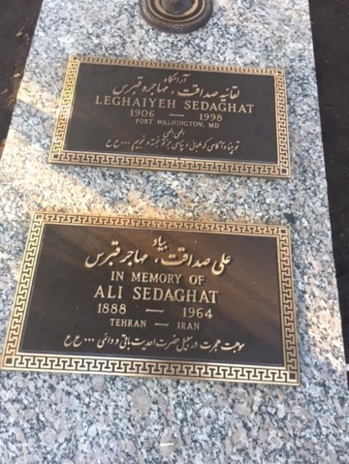
Gravesite of my father and mother in Virginia
How my sister Guitty Jan heard about our father’s passing
We had not told my younger sister Guitty about our father’s passing. She was in France completing her studies. She had written to us asking why our father had not been writing to her as he usually did, and we wrote back explaining that he needed rest, so we wrote instead of him. We didn’t want Guitty to quit her studies in France which she would have done had she known that our father had passed away. Guitty loved Europe but had promised our father that she would come home to Iran when she had completed her studies.
Guitty finished her schooling and on her return trip, she passed through Germany for the opening ceremony of the Baha’i House of Worship in Lagenheim near Frankfurt, to be opened by the Hand of the Cause, Ruhiyyih Khanum. On the way to the opening ceremony of the Temple, she sat on the bus next to a prominent Baha’i gentleman. She introduced herself as Guitty Sedaghat. He asked her if she was related to Shamsi Sedaghat. When she acknowledged that Shamsi was her sister, he expressed his sympathy for the passing of her father. Guitty was shocked. When he saw her anguish, he asked if Mr. Ali Sedaghat was her father, and she said yes. He continued by asking if her father had passed away a few months ago, and she answered that she had not heard this. Then he realized that Guitty had not been informed of her father’s death. So, he scrambled to fix his indiscretion by saying that he was sorry that he must have been mistaken and was thinking of another Ali Sedaghat, but the damage was done. Guitty put all the missing pieces together and realized that she had been kept in the dark regarding the death of our father. She stayed only a few days longer in Germany to attend the opening of the Temple in Frankfurt after which she returned to Iran.
Pars Hospital in Ahwaz
My pioneering dreams did not die with the death of my father. After a period of grieving, I announced to my family my intention of returning to the pioneering field. My mother was very unhappy about this as she felt I was needed to be near her at this time in Iran. I wanted to respect mother’s wishes, and so I stayed though my heart was calling me abroad. I heard there was a Pars hospital in Tehran which was in the process of opening another one in Ahwaz, which is in the province of Khuzestan in southwestern Iran and one of the hottest areas in the country, to serve the employees of the Khuzestan Water Work and Power Authority (sazemane-e ab va Barq-e Khuzestan). This hospital needed an administrator who could be in charge of all internal affairs such as nursing and midwifery, x-ray-laboratory, and other parts of the hospital.
I made an appointment and went to this hospital to see the person who was in charge of employment. I presented my diplomas and recommendations for applying for the job at the hospital in Ahwaz. He was very pleased to see me, and we spoke about the conditions of the future hospital, schedule, and salary, and I agreed with all the conditions and decided to leave for Ahwaz soon.
I came home and explained the situation and what I have decided, and the family was very pleased. Soon I left for Ahwaz. There I met with Dr. Esmail Rafi, the Director of the Hospital and his partners. Dr. Rafi, a very pleasant doctor, showed me the new two-story building which had been built as a residence and had not been designed or equipped to be a hospital yet. He and his partners thought it could be turned into a functioning hospital if they could find a qualified person who could develop it into a full medical facility with an operating room, delivery room, pharmacy, and all other necessary facilities. When Dr. Rafi saw my professional certificates and letters of recommendations, he was eager to have me take on this difficult job, and we agreed that I would live on a first-floor room and would have free meals and receive 3,000 tumans a month as a salary. I would work a full regular week and be on call on Sundays, my day off. We signed a contract, and I moved into my room. The next day I started to hire nurse/midwifes, cleaning personnel, x-ray technicians, pharmacists, and other necessary employees. People were eager to work there because the pay was good, the facilities were excellent, and the cafeteria food was palatable. I made the interior beautiful which the patients appreciated. The hospital was opened by the Governor-General, Dr. Ansary, and many other dignitaries.

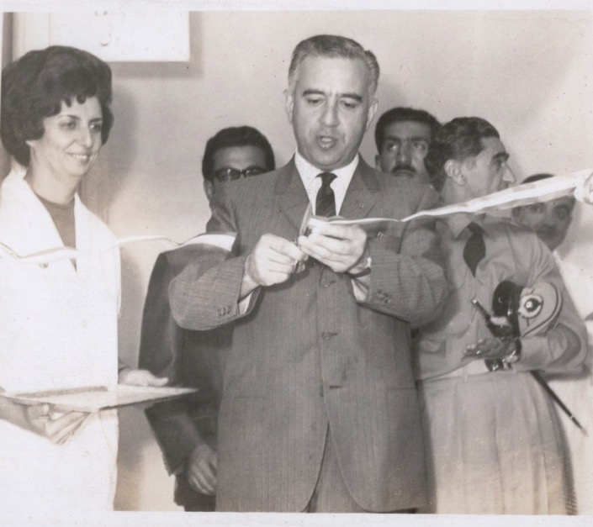
Governor-General Dr. Ansari and Shamsi at the ribbon cutting ceremony for the Ahwaz Hospital; behind Dr. Ansari are government officials.
While touring the facility, a visiting doctor looked around admiringly, and while he was smoking, he said that the hospital looked wonderful, but the only problem was that there were no ashtrays anywhere. I replied that there was one and pointed to the ‘No Smoking’ sign on the wall. When he and the others saw it, they laughed aloud for several minutes. He put out his cigarette and threw it out an open window.
Arrival of Guitty Jan in Abadan, Iran
I wrote to Guitty Jan to come from Germany to Ahwaz where I was working. I went to the Abadan airport to bring her.
As soon as she came off the airplane, she asked me with eyes full of tears what happened to our father. I told her the story. She was very upset. We wept together, and she remained upset for several days. I took her to Ahwaz.
Though she was young and small of stature, she was very able and proficient in English, French, and Farsi, our mother tongue. She was encouraged to stay in Ahwaz and get a job.
She agreed and went for an interview with Mr. Elliott to be his secretary and translator. Mr. Elliott, a British man, who was the head of the water and power department of Khuzestan agreed to pay her the princely salary of 2,500 tumans a month.
When I saw the kind of money she had been offered, I realized I was being under paid for my level of responsibility. I contacted my bosses in Tehran to tell them my younger sister was making almost as much money as I was and that my salary should be higher.
They agreed and raised my monthly salary to 5,000 tumans and gave me a fully equipped two-bedroom house and use of the hospital van with a driver for my official use when I needed it. We agreed on the terms, and I continued my work.
Ahwaz Hospital progressed
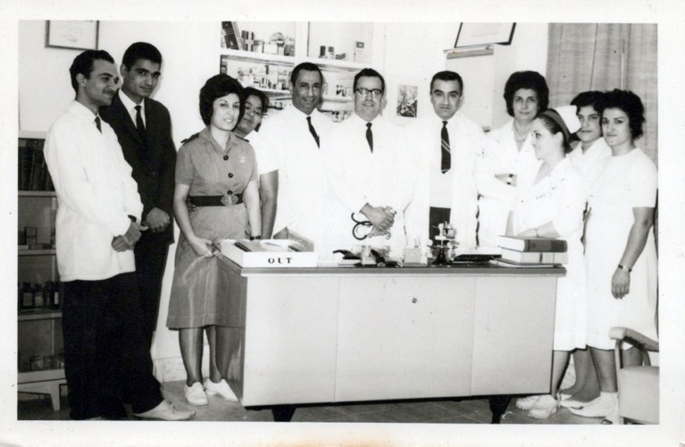
Doctors and nurses at the Ahwaz Hospital
l. to r.: 1) pharmacist, 2) assistant secretary, 3) staff nurse, 4) ?, 5) Dr. Sasani, 6) Dr. Rafii, Director of the hospital
7) Dr. Rahnamoon, assistant director, 8) Shamsi, 9) ?, 10) ?, 11) ?
(the question mark means that I know them but forgot their names)
The staff and I worked hard to make the new hospital a first-class facility which garnered much praise. Once the hospital was functioning successfully and the Baha’i community was strong and progressing well with many active Baha’is such as Dr. Yusuf Navai, and his wife Dr. Farideh Khanum, who had their own private x-ray department, Mr. Razi and his wife, Farangiz Khanum, and others, I decided to go to Tehran, find a pioneering post, and leave the country.
I resigned my post—although the Director of the Ahwaz hospital did not want me to resign. Eventually, the Director in Tehran accepted my resignation and I went to Tehran, but my family was not happy about my leaving for pioneering so soon.
This is a letter of recommendation I received from the Directors of the Pars Hospitals in Ahwaz and Tehran. Both highly recommended me for any future employment wherever I might go.
Here is the letter of recommendation from the Ahwaz Hospital:
“This is to certify that Miss Shamsi Sedaghat (McKinley) a graduate nurse-midwife has been working in Ahwaz Pars Hospital as a matron and administrator from March 1964 till March 1966. She has been very efficient and capable in carrying out her duties as mentioned above and the Medical staff has been very satisfied with her services rendered. She is recommended highly to any institution requiring her services.
M. Massoud, MD,
Director of Pars General Hospital”

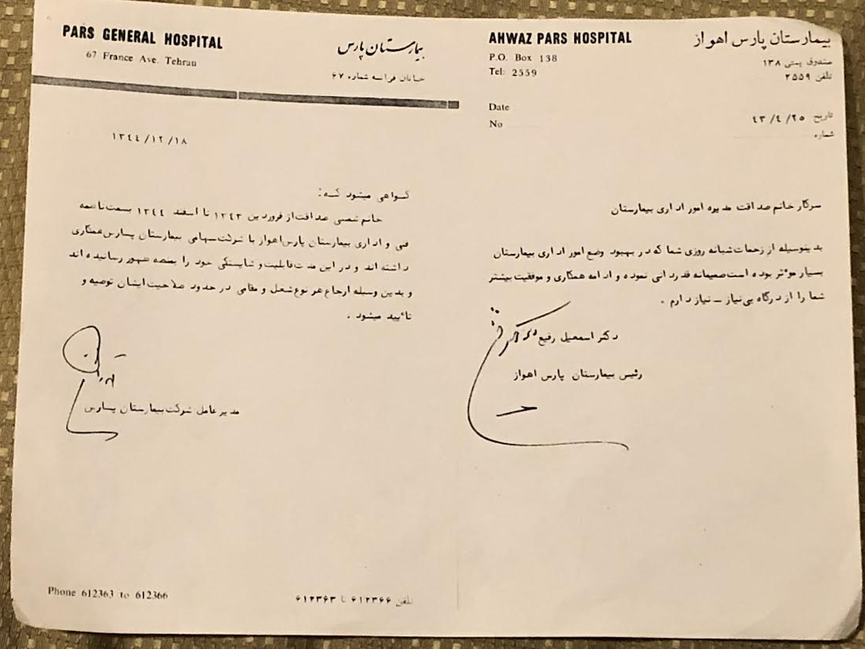

Opportunity to be employed in oil company hospital
I heard that the 140-bed National Iranian Oil Company Hospital in Tehran was looking for a Director for the Nursing and Midwifery Department. Since my family wanted me to stay in Tehran for a longer time, I applied for the job. I was just right for the position but due to my religion, they were reluctant to employ me.
Many years ago, Iranian military polo team came to Cyprus
One day when I was back in Cyprus, we read in the newspaper that a polo team of the Iranian military would be playing a match with the Cypriot team. Though the place where the match was being played was three hours away on the coast in Limassol, I suggested we go and watch the game.
When father, mother, Guitty, and I got there, I saw a group of Iranian players and called out to one of them “Salamon Alaykum, Jinabi Agha! Greetings be upon you, sir!” The players turned around and asked me if I was Iranian, and I answered that I was, so he called the others to come over because there were several Iranians. They came, and we introduced ourselves. They were very happy and indicated a section where we could all sit together and cheer for the Iranian team. There was much to celebrate because the team won the match. The players told us that they would be returning to Nicosia and would get in touch with us.
Once they got to Nicosia, they called us, and we invited them over for a big homemade Persian meal. They arrived at our home in two jeeps, all dressed in their military uniforms which caused the neighbors to peer out of their windows.
The captain of the team, Mr. Isfandiari, was a relative of the Queen of Iran. Inside our house, they were eating the meal and socializing. They saw our photographs of Baha’i sites and the Greatest Name hanging on the wall. Though no one mentioned the word Baha’i while we ate and socialized, one of the players came up to me and quietly said that he knew General Soratpoor, whose picture was hanging there. This general was a Baha’i, and the polo player was letting me know that he had recognized that we were Baha’is also. I said “Yes, we are Baha’is too.”
We offered to help the players with their shopping expedition in the city as they did not speak Turkish or Greek, and they agreed, and my sister, Soraya, and I all went shopping together. They all signed our guest book and filled it with complimentary notes and a few of them included their photographs and told us that if we ever needed anything in Iran not to hesitate to call on them.
After we arrived in Iran, I was so upset by my father’s passing that I did not contact anyone; I found a job and left for Ahwaz in the south of Iran. After two years in Ahwaz, I returned to Tehran and found a job in the oil company hospital, but they had some restrictions and could not employ me.
Therefore, I phoned one of the generals who was on the polo team. I told him about our return from Cyprus and the story of my father’s passing away and that I had now come back to Tehran, and there was a good job for me in the oil company hospital, but they could not employ me due to some restrictions. He said to give him five minutes time, and he would phone me back.
This general phoned the authorities and told them a little about me including my positions in Cyprus, the three hours I had driven to meet them at the match to support them, the great help I had given with translation among the different ethnicities in Cyprus, and the excellent work I had done in Cyprus.
Now I was back in my home of Iran, and there was no one to help me. The general asked the authorities that I be given employment as I had excellent qualifications. They accepted his recommendation.
After this phone call, I was immediately hired and given a good position, so I happily went to work in the oil company hospital in Iran.
Tried to resign from oil company hospital
After a little more than two years working in the oil company hospital, I decided to resume my life as a Baha’i pioneer and go to the Intercontinental Conference in New Delhi. Therefore, I submitted my letter of resignation to Dr. Rouhani, the Head of the Medical and Health group of all the National Iranian Oil Company Hospitals. He read it, tore it up and threw it in the wastepaper basket and said, “now that everyone likes you and now that there have been so many improvements in our hospital due to your hard work, you must not resign.” He asked that, “You stay for an additional year and train your replacement then leave.”
He praised me for all of my hard work and offered me fifty days of holiday during which I could go to India and come back rested. I accepted Mr. Rouhani’s suggestion that I stay just one year longer.

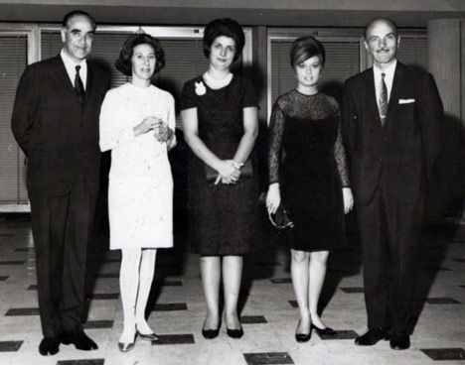
L. to r.: Dr. Masud Rouhani and his wife, Shamsi, Mr. Taba’s secretary (?), and Mr. Taba, representative of the United Nations

Dr. Rouhani, Head of the Medical and Health group of the National Iranian Oil Company Hospitals
.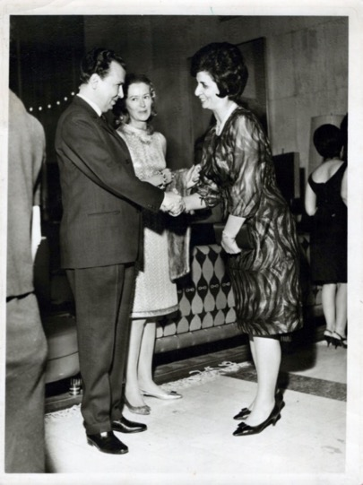
Reception for the attendees of the Middle Eastern Nursing Conference: L. to r.: Dr. Rouhani, his wife, and Shamsi.

I decided now to leave for India to attend the major Baha’i conference there. Though I didn’t know it then, life was taking me elsewhere, and I would never actually return to Iran and to the oil company hospital.
Recommendation of Dr. Carapetian
The Chief of the hospital, Dr. Carapetian, later wrote a glowing recommendation for me about my service at the hospital in Tehran. The letter is as follows:
“N.I.O.C. Tehran Hospital
Sept. 10, 1967
Miss Shamsi Sedaghat has been working with us for the past 15 months, as a Matron.
Our unit is a very busy 140 bed general Hospital in the capital, giving service to medical population of 35000. There are four outside area dispensaries, run and controlled by the hospital staff. Our nursing strength is 100 persons, consisting of 50% graduate Nurses, 30% assistant Nurses and 20 % orderlies.
Miss Sedaghat is a talented organizer and has displayed extreme skill and initiation, in coordinating the activities of the Nursing Staff with the other functions of our set up.
As a personality, she is dignified, punctual and disciplinary. She is very conscientious and understands all the problems of the Nursing staff.
It has been a pleasure for me to have her with us. With great regret I learn that, because of personal reasons. She has to resign.
Should she refer for employment, her knowledge and experience must be highly appreciated. She would be an asset to the nursing service in any place, at any time.
R.R. Carapetian, M.D., F.R.C.S.
Consulting Surgeon and Chief of N.I.O.C. Hospital
Tehran, Iran”

Letter from the National Spiritual Assembly of the Baha’is of Iran to me for service in Ahwaz

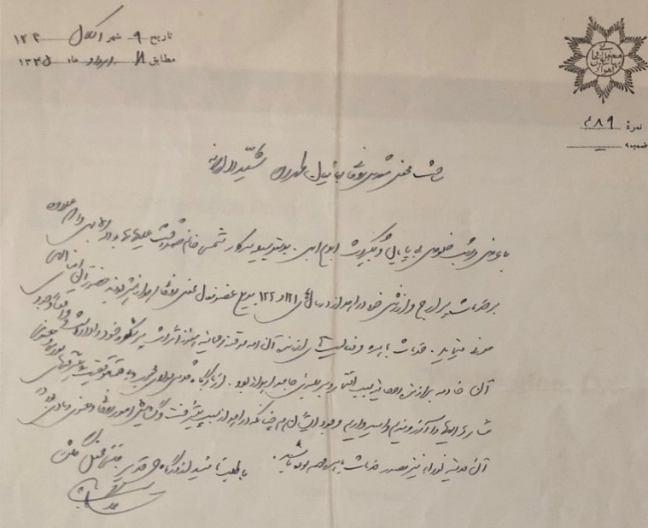

Chapter 5

New Delhi Conference and subsequent trips to Kampala, Brighton, Palermo, and Haifa
I left Tehran for the Inter-Continental Baha’i Conference in New Delhi, October 7-11, 1967, as a representative of the Continental Pioneer Committee for Asia on which I served. Mr. Jalal Sahihi was the second member who accompanied me.
The Universal House of Justice had called for six intercontinental conferences to celebrate the Centenary of Baha’u’llah’s Proclamation to the Kings of His Message of peace, love, and the unity of mankind. The gatherings were held in Wilmette, IL, United States; Panama City, Panama; Frankfurt, Germany; Kampala, Uganda; Sydney, Australia; and New Delhi, India, which is where I went because I was representing the South Asia Teaching Committee.
When I stepped off the plane I was taken to the hotel. Then we went to the Baha’i Center, I was asked to chair one of the sessions.
The Conference was held on the grounds of the National Haziratu’l-Quds of India, a large, stately, and imposing building. We gathered under a huge tent made up of cloth with the vibrant colors of India.
More than three thousand people were in attendance from Arabia, Burma, Ceylon, India, Indonesia, Iran, Israel, Japan, Korea, Laos, Thailand, Malaysia, Nepal, Philippines, Sikkim, Taiwan, Turkey, Ethiopia, Uganda, Canada, the U.S., Australia, the British Isles, and Germany.
Bus loads from all around India brought Baha’is from Uttar Pradesh, Madhya Pradesh, Mysore, Gujarat and other provinces and major cities. Messages poured in from all around the Baha’i world.
Opening of the Conference
The Conference opened with a greeting from the Chairperson of the National Assembly of India, Mrs. Shirin Boman, who welcomed the Hands of the Cause, representatives of National Assemblies, Auxiliary Board Members, and the many other Baha’is.
Prayers were offered in numerous languages, but simultaneous translation was provided in three: Hindi, English, and Farsi.
Short speeches by Hands of the Cause of God
Hand of the Cause Mr. Faizi said:
“I am coming from a visit to Adrianople with five other Hands who were commissioned to attend the other five intercontinental Conferences including Amatu’l-Baha Ruhiyyih Khanum. The House of Justice made this pilgrimage to Adrianople possible, comfortable and so exalted with spiritual feelings that they asked each Hand to take the spiritual impact of the house in Adrianople to the Conferences.”
Hand of the Cause Mr. Varqa and Hand of the Cause Gen. Ala’i addressed us saying that at the first Conference in New Delhi in 1953, there had been twelve National Assemblies in the world and that day, after the Ten-Year Crusade, there were eighty-one. Hand of the Cause Mr. Muhajir recalled that after the 1953 Conference there had been mass conversions in Africa and after the 1958 Conference in Asia, there had been mass conversion in Asia. After the World Congress in 1963, six-thousand new localities were opened to the Faith. A message from Hand of the Cause Agnes Alexander was read aloud. Members of the National Assemblies were invited to rise and introduce themselves. That evening the attendees held a unity feast together. The following Hand of the Cause Mr. Faizi spoke again this time reading the Message from the Universal House of Justice to the Conference. The Conference sent messages to the Universal House of Justice and to Hand of the Cause Ruhiyyih Khanum informing her of the declaration of Tibetans to the Faith.
The new Tibetan believers were introduced the next day by Hand of the Cause Mr. Faizi, who also invited those who had taught the Faith in India to come forward; these included an old man who was crippled but had gone from village to village enrolling numerous people. Hand of the Cause Mr. Ala’i spoke on the importance of proclamation that afternoon. A public meeting was held hosted by the Agriculture Minister of India who praised the Faith, and which included a presentation by Mrs. Shirin Fozdar on universal brotherhood and religious unity. I was the chairperson of the session on the morning of Tuesday, October 10th, and spoke about the achievements of the South Asia Teaching Committee. That morning Hand of the Cause Mr. Varqa educated us on the Institution of the Hands. Persian believers met privately with Hand of the Cause Mr. Faizi to express their desire to contribute to the teaching work in India to assure the victory of the Nine-Year Plan there.

Powerful pilgrimage
Hand of the Cause Mr. Faizi recalled the powerful pilgrimage the Hands had just experienced:
“The Proclamation of Baha’u’llah and its celebrations started last week in the Shrine of Baha’u’llah when nine members of the House of Justice and six Hands prostrated in the most exalted place of this planet and the nearest point to the Kingdom of God in the name of all the friends in the whole world and prayed for the success for each individual member of the Baha’i world community, assemblies and these gatherings. It was perpetuated in the Mansion of Baha’u’llah where around a small table of 15 persons sat in absolute silence and reverence, where each Hand received direct instructions of the House of Justice, the Portrait of Baha’u’llah, and the Book of Proclamation of the Ancient Beauty. Afterwards we all gathered in the room of Baha’u’llah where He ascended to the Abha Kingdom and left His physical temple on this earth for the most great blessing. The day after that all the members of the House of Justice and the members of their families went to the airport to see off each Hand. They even came to the Customs, they even came to the stairs of the plane and embraced each Hand …”
The Universal House of Justice wrote:
“…these Intercontinental Conferences will be centers of spiritual illumination inspiring the friends to redouble their efforts in further expanding and consolidating the Faith of God, to arise to fill the remaining goals, to undertake travelling teaching projects and to offer generously of their substance to the various funds, particularly to the vital project of erecting the Panama Temple, the foundation stone of which is being laid by Amatu’l-Baha Ruhiyyih Khanum during the course of these Conferences.”
Indian believers were housed in large tents at the Talkatora Gardens and held nightly sessions during which they spoke in Hindi about their teaching experiences and plans, and people came forward to offer themselves as travelling teachers including several people who had been Baha’is for less than two weeks.
The proclamation events of the Conference included a presentation of Baha’u’llah’s Proclamation to the Kings by Hand of the Cause Mr. Faizi and members of the National Spiritual Assembly of India to the President of India, Dr. Zakir Hussain.
All too soon, the Conference came to an end with the friends tearfully saying goodbye to each other in the gardens. I was deciding on my next steps. Hand of the Cause Mr. Muhajir recommended that I go to Hong Kong and assist with the election of the first National Assembly there. Mr. Eshraq Khavari asked that I join him as a translator on his teaching trip through South Asia. Then I received an urgent message to go to the National Baha’i Office.
Immediately I went to the office of the Secretary of the NSA, Mr. Ramnick Shah. Hand of the Cause Mr. A.Q. Faizi was there. We greeted each other, and he said that this cable had come from Kampala.
Cable from Mrs. Nakhjavani
He handed me the cable from Mrs. Nakhjavani and asked me for my reply. This was the cable:
“FAIZI CARE BAHAIFAITH DELHI
PLEASE CABLE IF SHAMSI SEDAGHAT AGREES COME KAMPALA AFTER CONFERENCE HELP CARE AGHAJAN DESPERATE NEED
DEEPEST LOVE
VIOLETTE”
I read the cable and said to Mr. Faizi that since my arrival here, I had received two proposals already: one by Hand of the Cause Mr. Muhajir suggesting that I pioneer to Hong Kong where they had to have the election of a National Spiritual Assembly, and the second by my Baha’i teacher Mr. Eshraq Khavari, who wanted me to be his translator and go with him to Pakistan, Burma, and other countries to teach the Baha’i Faith. I replied to Mr. Faizi: “The problem is that I am still employed by the oil company hospital in Iran as Director of the Nursing and Midwifery Department from which I have to resign.” Mr. Faizi recommended, “Pray about these two suggestions and see what comes to your heart.” But he said to me, “If you ask me, Mr. Faizi, shall I go to assist Mr. Banani, I will tell you pack up and go now.” When he said that, I exclaimed, “Mr. Faizi, I shall pack up and go now!” Then one day we were invited to the residence of the Ambassador from Iran with several Hands of the Cause and other Baha’i dignitaries. There, I went to the Ambassador’s office with one of his officers and wrote a letter of resignation to the Chief Medical Director of the oil company hospital in Iran, Dr. Rouhani, and gave it to one of Dr. Rouhani’s relatives who was present there to take it to Iran and give it to Dr. Rouhani and explain to him the urgency of the situation.
On my way to Kampala, Uganda
I decided instantly that this is what I would do and after years of wanting to go to Africa, I was soon on my way. I stayed two more days and as the Conference finished, I took my suitcases and said goodbye to Mr. Eshraq Khavari, my beloved teacher, mentor and others and left for Bombay (Mumbai). At the airport, I was permitted to board the plane for Kampala on the condition that I was allowed entry into that country when I arrived there. If not, I would have to return to India by the same airline. I signed the agreement, and I left India. When I arrived in Kampala, my British passport was valid, and I had no problems at the airport. When they asked me the reason for my arrival in Kampala, I said that I had come to help look after our loved and precious friend, Mr. Musa Banani, who had undergone an operation on his left leg. The immigration officer knew him, and he said that he had heard Mr. Banani had a big operation. Without further questions, he gave me a three months visa and permitted me to use their phone. I called Mrs. Banani and as soon as she heard my voice, she said: “Shamsi Jan, Ali (Nakhjavani) is trying to get a visa for you and send it to India from Israel.” I immediately replied that I had arrived at the Entebbe airport in Kampala, and I had secured a visa already! She was so happy and said, “Oh my God, I shall be there with Violette Khanum in forty minutes and then put the phone down.” I spoke with the officers, introduced myself, told them about my professional background, and said that I had left everything to come to help for a while. He praised me for my actions and showed me where to sit until my hosts arrived.
I was met by the Banani family at the airport
Mrs. Banani and Violette Khanum arrived, and we were very happy to see each other again—the last time having been in 1951 when I met them in London when on their way to Kampala. They explained to me about their life and the service which they rendered there. They spoke about Mr. Banani and the amputation of his left leg due to gangrene in his toes caused by his diabetes. Nevertheless, he and all the visitors who came to visit him left very refreshed and happy. During the operation all the family tried to be present, including Mr. Ali Nakhjavani and his wife Mrs. Violette Nakhjavani although Mr. Nakhjavani had to leave to go back to the Holy Land as soon as the operation was completed. He was a member of the Universal House of Justice.
After my arrival to Kampala, he honored me by the following cable:

“CANNOT FIND ADEQUATE WORDS EXPRESS MY SENTIMENTS ADMIRATION GRATITUDE DEEPLY MOVED FURTHER EVIDENCE YOUR NOBLE SPIRIT OFFER ASSIST DEAR BANANIS ASSURE YOU ARDENT PRAYERS HOLY SHRINES YOUR BEHALF
NAKHJAVANI”
Smile from Mr. Banani
Mrs. Violette Nakhjavani was trying to rejoin Ruhiyyih Khanum who was on a teaching trip in Central America. Mrs. Banani had been distraught about her husband’s condition but once I arrived, they were so happy, and Mr. Banani smiled for the first time since his surgery according to his wife and daughter. I mostly made sure he was comfortable, administered his medications, read him correspondence, and helped him as a translator with his visitors who came from the Baha’i community to meet him. He enjoyed reminiscing and telling me stories of his life. Mrs. Banani and I sometimes went to the market to buy food and products to keep the house running. I slept in the same room as Ruhiyyih Khanum when she had been there.
Viewing of Baha’u’llah’s portrait
After the Kampala intercontinental conference, the portrait of Baha’u’llah had been carefully wrapped and placed in the room she had stayed in, waiting to be returned to the archives at the World Center. Mrs. Banani asked Mr. Banani about the possibility of my viewing the photo. When he said that would be alright, I washed my hands and face and prayed in preparation to see the countenance of the Manifestation of God. When I visited that glorious countenance, I begged His acceptance of my humble service to His Faith. Then I wrapped the photograph and put it back in its place.
My employment in a government hospital
Mrs. Nakhjavani had told me that I could get a job in government hospitals, so she took me to the Ministry of Health where I told them about my educational and professional qualifications and that I would receive my documents very soon from Iran. They were eager to employ me in a hospital and as soon as my documents were received, I started to work. Mrs. Violette Nakhjavani was happy that her mother had a helper, so she left Kampala to join Ruhiyyih Khanum in Central America to continue their teaching trip.

Work at the Kampala Hospital
I was given work in the new Makerere University Hospital’s private section which was on the 6th floor. The 1,000-bed hospital had several buildings each with six floors with every floor allocated to a different department such as maternity, surgical, medical, pediatric, and so on. My shift began at 7 a.m. and lasted until 3 p.m. if not longer. The director of nursing and midwifery was a Ugandan lady and worried that I as a newcomer was looking to take over her job, so she was not very friendly towards me. One day I invited her into my office and told her about my background, my faith, and my intentions to serve. I lovingly re-assured her that I was not there to try and replace her and that most likely I would be moving on after a period of service, so she had nothing to worry about and if she had a challenging project or situation at work, I was ready to assist in any way I could. She seemed like she became more comfortable.
There were difficult situations in the hospitals especially when it came to women from the countryside. Rural women who came into the maternity ward were often in a bad condition. We washed them, changed their dresses, combed their hair thoroughly, put clean hospital gowns on them and gave them a bed in which to wait for the doctor to come. When the doctor arrived, he sometimes did not recognize his patient as the same one he had seen in the emergency room downstairs because she had undergone such a metamorphosis. Often, the senior hospital staff did not want to touch this kind of patient but when they saw that I would do the job myself, this became the talk of the hospital, and they gradually began following my example until such treatment became a routine job.
When I finished at the hospital, I would come home to see our dear Mr. Banani. He was happy and smiling after having been bathed with the assistance of his male home attendant, and myself and Mrs. Banani as usual were happy to see each other. She had made delicious food. We sat together, ate, and spent the evening reminiscing about the life of service of the Banani family. I never tired of hearing these inspiring stories of victories for the Faith.
My departure for England
The health condition of Mr. Banani had improved, so I could leave them gradually for England to undergo my midwifery training and get the State Certified Midwife certificate (SCM) with which I could then qualify for a good position in hospitals throughout the British and former British territories. I asked Mr. Banani’s permission to pray for my future services to our beloved Faith. During the time I had lived in the Bananis’ home, he asked me to remind him each day when it was time for the noonday prayer which I did. Each day after completing the short prayer, he continued to pray for almost an hour for the Universal House of Justice, the Hands of the Cause, the national spiritual assemblies, the local spiritual assemblies, and the pioneers for the success of their service to His Cause. When I was leaving the home of the Bananis, I asked Mr. Banani, “please do not forget me and pray for me and for the success of my service to our Beloved Cause” which he promised. He also assured me that he would place my name at the head of the prayer list of pioneers and pray every day for me. His promise meant a great deal to me, and over the years, I’ve often thought of his prayers and their sustaining power and asked him to guide me during my decisions.

Letters from Mrs. Banani to me
I received many lovely letters from Mrs. Banani expressing her appreciation and gratitude for the help I had given her and her dear husband which I have kept and treasured. Some years later, after his passing, I received the following letter of gratitude:

“P.O. Box 480
Kampala, Uganda
14th September 1971.Dear Miss Sedaghat,
The loving condolences you sent me and the members of the family on the occasion of the passing of dear Aghajan, Hand of the Cause, Musa Banani, brought solace to our hearts. The knowledge that at our moment of intense grief there are those who associate themselves in such sorrow is a source of great comfort.
Aghajan’s last moments preceding his coma, from which he never recovered were spent by him in an attitude of devotion as he was uttering his daily prayers. Indeed, during the last few years of his life, he spent some 5-6 hours every day wrapped in profound supplication to Baha’u’llah.
On behalf of myself and the members of the Banani and Nakhjavani families, I wish to extend to you our heartfelt gratitude for the sentiments you have expressed and the prayers you have offered for the progress of his radiant soul in the Abha Kingdom,
With deep love,
Samiheh Banani
Mamajoon would like us to thank you especially for your beautiful cable. She will be going to Haifa for a few weeks to take a rest and hopes to be able to write to you more fully from there.”
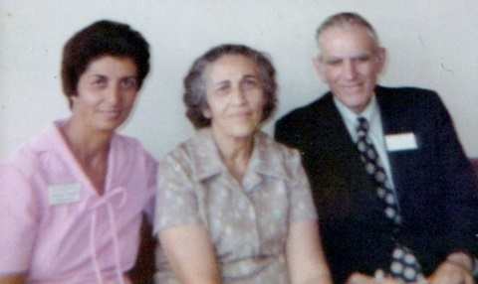
Samiheh Khanum, wife of Hand of the Cause Mr. Musa Banani, seated next to Shamsi; the third person, I think, is Mr. Salim Nunu, a very generous and active Baha’i
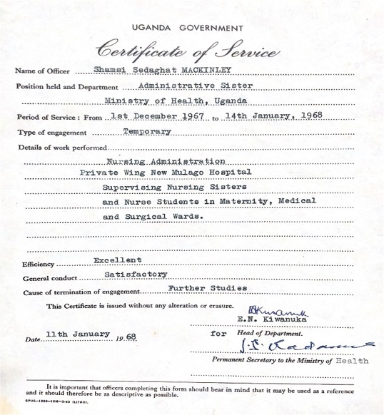
Certificate of recommendation from the Ministry of Health, Uganda
Arrival in England
While I was in Kampala, I had applied to several hospitals in England for midwifery training and decided to accept the offer from the Sussex Maternity hospital because it was in Brighton, a place which I already knew.
I was re-united with my friend Doreen Geery and roomed on the top floor of her large two-story antique dealership. At the hospital, the supervisor looked over my resume and told me that instead of doing the full six-month program, I could shorten it to three months and then sit for the exam as I already had a training certificate from Cyprus and eight years of professional experience. Then I could do my practicum in another six months and finish the whole program and get the Midwifery Certificate.
Doreen helped me a great deal with learning English and preparing for the exam. I was also glad to see that the Baha’i community was active: the Nineteen-day Feasts were well attended, and seekers were declaring.
After three months of study, I sat for the exam and passed it. Then I moved to the town of Cookfield to do my practicum. The state requirement was to complete forty-five home deliveries. I was always accompanied by a licensed midwife. We visited the homes of expectant mothers on a weekly basis and ran down a checklist of items they needed to have in the home for the birth such as a tub, towels, blankets, soap, dresses, and napkins. We brought all the necessary medical equipment. If we saw a problem with one of the pregnant women, we took them to the hospital for care.
Conference in Palermo
During the third and final month of this practicum I heard that there was going to be an International Baha’i Teaching Conference to raise pioneers held in Palermo, Sicily, and that all attendees would then be able to travel on to Haifa to participate in the Centenary observance of Baha’u’llah’s arrival in Akka.

Message from the Universal House of Justice
“OCCASION HUNDRED FIFTIETH ANNIVERSARY BIRTH BLESSED BEAUTY WE CONTEMPLATE WITH HEARTS OVERFLOWING GRATITUDE INESTIMABLE BOUNTIES CONFERRED BY GOD THROUGH HIS SUPREME MANIFESTATION ENSURING FULFILLMENT GLORIOUS LONG PROMISED KINGDOM NOW EVOLVING WOMB TRAVAILING AGE DESTINED CONFER PEACE UNDREAMT FELICITY MANKIND. ANNOUNCE CONVOCATION TWENTY-THIRD TO TWENTY-FIFTH AUGUST 1968 FIRST OCEANIC CONFERENCE BAHÁ’Í WORLD PALERMO SICILY HEART SEA TRAVERSED GOD'S MANIFESTATION CENTURY AGO PROCEEDING INCARCERATION MOST GREAT PRISON. TWOFOLD PURPOSE CONFERENCE CONSIDER MOMENTOUS FULFILLMENT AGE-OLD PROPHECIES TRIUMPH GOD'S MESSENGER OVER EVERY GRIEVOUS CALAMITY AND CONSULT PLANS PROPAGATION CAUSE ISLANDS LANDS BORDERING MEDITERRANEAN SEA. PARTICIPANTS INVITED HOLY LAND IMMEDIATELY FOLLOWING CONFERENCE ATTEND COMMEMORATION ARRIVAL LORD HOSTS THESE SACRED SHORES RECONSECRATE THEMSELVES THRESHOLD HIS SHRINE PROSECUTION GLORIOUS TASKS AHEAD.
THE UNIVERSAL HOUSE OF JUSTICE”
Permission from Nursing Council for fifteen days’ leave
Attending the Conference would require me leaving England for fifteen days. I asked my supervisor for permission, and she said that, though such a thing had never been granted, she would call London and ask on my behalf. She phoned her superior in London who just happened to be meeting with the Nursing Council at that very moment and relayed to her my request. Her superior got my file and talked it over with the council. Soon we got a call back that though this request was highly unorthodox, given my experience and good work, I could take fifteen days away and could simply make it up when I returned. Elated, I called the Baha’i National Office in London to ask about joining the other friends on the plane to Sicily. Ms. Betty Reed, the Secretary of the National Assembly, told me that all the places on the plane had been taken but that just that morning one person had dropped out, so I could take that last remaining place. I knew this trip was meant to happen and that Mr. Banani’s prayers were at work, so she booked me for the trip, and soon we left for Palermo, Sicily.
Location of Conference
More than 2,000 Baha’is came to the ancient city of Palermo. The Universal House of Justice described the location in its message to the Conference:
“The great sea, on one of whose chief islands you are now gathered, within whose hinterland and islands have flourished the Jewish, the Christian and Islamic civilizations is a befitting scene for the first Oceanic Bahá'í Conference. Two millenniums ago, in this arena, the disciples of Christ performed such deeds of heroism and self-sacrifice as are remembered to this day and are forever enshrined in the annals of His Cause. A thousand years later the lands, bordering the southern and western shores of this sea witnessed the glory of Islam's Golden Age. [The classical age of Islamic civilization, the eighth through thirteenth centuries.]”
“In the day of the Promised One this same sea achieved eternal fame through its association with the Heroic and Formative Ages of His Cause. It bore upon its bosom the King of kings Himself, the Centre of His Covenant crossed and re-crossed it in the course of His epoch-making journeys to the West, during which He left the indelible imprint of His presence upon European and African lands; the Sign of God on earth frequently journeyed upon it. [Bahá'u'lláh sailed upon the Mediterranean Sea in 1868 during His journey from Gallipoli to 'Akká. 'Abdu'l-Bahá, the Centre of Bahá'u'lláh's Covenant, accompanied Bahá'u'lláh on that journey and later sailed upon the Mediterranean in the course of His travels to Egypt, Europe, and North America, 1910-13. Shoghi Effendi, the Sign of God on earth, traversed the Mediterranean in his travels to England to study at Oxford University and in the course of later visits to Europe.] It enshrines within its depths the mortal remains of the Hand of the Cause of God Dorothy Baker and around its shores lies the dust of apostles, martyrs, and pioneers. Forty-six Knights of Bahá'u'lláh are identified with seven of its islands and five of its territories. Through such and many other episodes, Mediterranean lands -- ancient home of civilizations -- have been endowed with spiritual potentiality to dissolve the encrustations of those once glorious but now moribund social orders and to radiate once again the light of Divine guidance.”
Excerpts from the Universal House of Justice message
The Universal House of Justice then made a plea to the Conference to help win the goals of the present Nine-Year Plan:
“At this midway point of that Plan, although great strides have been made, more than half the goals are still to be won. The greatest deficiencies are in the opening of new centers where Bahá'ís reside and the formation of Local Spiritual Assemblies, which inevitably affects the ability to establish National Spiritual Assemblies. A dramatic upsurge of teaching — effective teaching — is necessary to make up the leeway; pioneers are needed, teachers must travel, funds must be provided. It is our hope that there will be engendered at this Conference, through your enthusiasm, prayers and spirit of devotion, a great spiritual dynamic to reinforce that grand momentum which, mounting steadily during the next four years, must carry the community of the Most Great Name to overwhelming victory in 1973.”
Calls for pioneers
During the conference there was a call for pioneers to come up on stage and sign their names which I readily did. I walked over to the table and gave my name and preferred places for pioneering, which at the time were Canada, where I knew I could get work, or any of the Eastern block or Soviet territories. Over 125 Baha’is came forward to pioneer and another hundred volunteered to travel teach.
Arrival in Haifa
At the end of the Conference, we flew to Haifa. The numerous Baha’is arriving in Haifa and Akka were in stark contrast to the small band that accompanied Baha’u’llah in 1868 as a prisoner which demonstrated the triumph of His Cause. We gathered at Bahji and Akka to remember this final last exile of the Manifestation of God.
Soon after my arrival, I was summoned to the Eastern Pilgrim House by one of the Counselors from Iran, Mr. Hadi Rahmani, a very active Baha’i, where several members of the Universal House of Justice were waiting for me, including Dr. David Ruhe and Mr. Ali Nakhjavani. They thanked me for helping Mr. and Mrs. Banani during a time of need. Now, they had another request. They said that when the Hand of the Cause of God, Mr. Samandari, arrived in Haifa, Ruhiyyih Khanum noticed that Mr. Samandari’s health had declined. When he was persuaded to go to the hospital, the doctor there found several things wrong with him, so he was hospitalized. The members of the House of Justice told me that although there were a few other beloved friends such as Dr. Tahzib, Dr. Soheil Samandari, his grandson, and others there to help, they wanted me to represent them in taking care of him also. Of course, I immediately agreed and was ready to go to the hospital so Mr. Hadi Rahmani, an energetic Baha’i counsellor from Iran, accompanied me to the hospital.
My visit to Elisha Hospital
When I entered the Elisha hospital in Haifa, I greeted Hand of the Cause Mr. Samandari with “Allah’u’Abha” to which he opened his eyes and responded, “Allah’u’Abha.” He recognized me immediately from our Iran and Cyprus days and said “On qadde ráná che shod” (“What happened to that nice height?”) −because I was a taller than average woman. Counselor Hadi Rahmani replied “Jenabe Samandari, qadd hanuz ráná ast vali ishan ruyé takhté shoma khám, shodeh-and” (“Mr. Samandari, the height is still nice and tall but now she has bent her body over your bed to see you!”). We all laughed, and his memory was so sharp that he was able to ask me about the health of each member of my family—our mother, Soraya, even my younger sister Guitty, saying “Guitty Khanum, chetorand?” (“How is Guitty Khanum?”). I answered that all were well.
Soheil Samandari, his grandson, Dr. Tahzib, and several nurses were also taking care of him, so I came in for the evening to do overnight shifts. Each day after the commemoration, I was taken to Mr. Samandari’s bedside and kept him company, giving him spiritual support. One afternoon, Mr. Nakhjavani was driving me to the hospital and asked me about my future plans. I told him that I had volunteered at the Palermo Conference for pioneering either to Canada or to the Eastern bloc/Soviet states.
He told me to write directly to the Universal House of Justice, and let it decide for you. I accepted and wrote a short letter to the House of Justice introducing myself and my humble service to our beloved Faith and requesting their guidance regarding a place for pioneering.
I sealed the envelope and gave it to another member of the Universal House of Justice to pass on to the Supreme Institution and left the rest in God’s Hands. I was prepared to go wherever the Universal House of Justice thought I could best serve the Cause.
I spent each of those six days from 6 p.m. to 6 a.m. in Mr. Samandari’s company. When he was awake, we were speaking about many things. Though he spoke slowly, some of the dynamic energy that had animated him throughout his life remained.
He had a small physical stature but was always bursting with energy, especially when it came to the work of the Faith and could speak in a loud declamatory tone. He was frugal in his habits, often eating small amounts of simple food.
When I was departing, I asked for his prayers for my humble services to the Cause of God. He opened his eyes and said: “Ajrekom end-Allah, fi Amane-Allah,” meaning, “Let your reward be with God, be under the protection of God.”
Passing of the Hand of the Cause Mr. Samandari
I had been in Haifa for six days, so I had to leave the Holy Land. I tore myself away from Mr. Samandari and made my way to the airport near Tel Aviv. Our plane was due in two days, so we had to spend the time there. The next day we received a message that our beloved Hand of the Cause Mr. Samandari had passed away. He attained his wish to pass away in the Holy Land and lived long enough to witness the centenary of Baha’u’llah’s arrival on these sacred shores. Though deprived through illness from participating in the Commemoration at Bahji, his funeral, by God’s intervention, was an unforgettable part of the historic and eventful week of activities associated with the pilgrimage of an unprecedented number of friends from both East and West.
We asked permission to attend the funeral. The House of Justice wrote that all participants at the Conference may attend the funeral, so we were able to go back to Haifa.
His funeral was the first major Baha’i funeral since the passing of ‘Abdu’l-Baha. Hundreds of people were in attendance. Police were there to help with the cars and traffic. Crowds had lined up to get into ‘Abdu’l-Baha’s house. The coffin was in the salon surrounded by flowers and the Samandari family members. The overflow crowd spilled out into the garden. I waited by the door and then was told that there was room for one more, so I entered and was present for the special prayers for the departed and the chanting of the three tablets the Master had written to the Samandari family. Then the coffin was lifted into the hearse by several members of the Universal House of Justice and driven to the cemetery. At the burial prayers were offered again, and flowers were placed. Then we all came back to the Shrine of the Bab and offered additional prayers. When we were done, we left for Tel Aviv and flew the next day to London and then Brighton.
On return to Brighton, England, I received a reply from the Universal House of Justice
Back in Brighton, I finished my practicum and sat for my first and second examinations of the Central Midwives Board. I was ready to go pioneering and wrote to the Supreme Body. I received the following reply:
“22 September, 1968
Miss Shamsi Sedaghat
1, Clyde Road,
Brighton, England
Dear Bahá’í Friend,
We have your letter of 1st September, 1968, expressing your wish to pioneer and asking for suggestions.
We have just received from the National Spiritual Assembly of Venezuela a request for someone to go to Trinidad as there is need there for one having administrative experience.
If you would be interested in pioneer service in this area, please let us know and we will be glad to put you in touch with the National Assembly of Venezuela and the Pioneer Committee for the Americas.
We deeply appreciate the loving Spirit of devotion and dedication which has prompted this offer of service. We shall offer our prayers at the Holy Shrines that you may be enabled to attain your heart’s desire.
With loving Bahá’í greetings,
The Universal House of Justice”
My reply to the Supreme Body the same day
I replied that very same day:
“The Universal House of Justice,
Baha’i World Centre,
P.O. Box 155,
HAIFA,
Israel.
Beloved Friends,
With great joy I have today received your letter dated 22nd inst., advising me to pioneer and serve the Cause in Trinidad.
I wish to express my humble gratitude for this great honor which has been bestowed upon me by your Supreme body and my acceptance of this pioneer post. Will you kindly advise me what steps should be taken next, and whether I should seek employment in Trinidad, as I must obtain a position in order to support myself?
I would like to thank you for the loving prayers which you are offering for my future service to the Cause…
With respect and obedience to your further instructions.
In His Service,
Shamsi Sedaghat”
Reply of the Supreme Body, the Universal House of Justice, to me
Then one morning, a letter arrived from Haifa, from the Universal House of Justice. I washed my hands and face, prayed, opened the envelope, and read the letter:
“Miss Shamsi Sedaghat
1, Clyde Road,
Brighton,
England.
Dear Bahá’í Friend,
We joyfully received your letter of 27 September, 1968, accepting our suggestion that you pioneer in Trinidad.
We are sharing a copy of your letter with the National Spiritual Assembly of Venezuela and the Pioneer Committee for the Americas asking that they contact you and offer their assistance in settling in your new pioneer post. Undoubtedly the National Assembly of Venezuela will be able to advise you regarding employment in Trinidad.
We wish to express our gratitude and appreciation for your loving acceptance of the pioneer post in Trinidad, and we assure you of our continuing prayers at the Holy Shrines on your behalf,
With warm Baha’i greetings,
The Universal House of Justice”
Trinidad Embassy in London
I straightaway went to the Embassy of Trinidad in London and presented my professional credentials and expressed my desire to move there. The representative at the Embassy was delighted that such a qualified person was interested in working in Trinidad and told me I would be hearing from them very soon.
The National Assembly of Venezuela wrote to me expressing its delight that I would be pioneering to Trinidad and referred me to two pioneers who were already settled in Trinidad and were working as nurses, Miss Nikou Raoufian and Miss Maryam Shaker.
They wrote to me in December, going over some practical matters of employment, explaining that Trinidad and Tobago only accepted English-trained nurses. I received my Midwifery Certificate on the 31st of December 1968, after passing my exams; I already had my British registered nurses’ certificate since 1954.
Reply from the Embassy of Trinidad
I was expecting my letter of acceptance from the embassy, but unfortunately, I received the following letter:
“Office of the High Commissioner
For Trinidad and Tobago
51 South Audley St.
London, WIY6ES
2nd January, 1969

Ms. Shamsi Sedaghat
1 Clyde Rd.
Brighton, Sussex

Dear Ms. Sedaghat,
Further to our recent discussion, I write to confirm that my government is unable to offer you employment as a nurse/midwife at the present time as there are a number of eligible local candidates available who are waiting appointment.
Yours sincerely,
Cecil E. Alleyne
For Acting High Commissioner.”
So, I sent a copy of the Embassy’s letter to the Universal House of Justice informing it of the situation and begging their prayers and letting it know the date of my arrival in Trinidad. I also wrote to Ms. Shaker, a Baha’i pioneer in Trinidad, of my arrival on January 14th.
Without a job I relied only on the power of the Blessed Beauty. I was heading out on faith to a region of the world that was unknown to me just the year before. My life as a pioneer had been on the ancient island of Cyprus on the Mediterranean Sea, and now I would begin one of the most fruitful periods of service in my life but this time on the islands of Trinidad and Tobago in the Caribbean Sea.

Chapter 6

Trinidad and Tobago: January 1969
Laying the administrative foundations in Trinidad
In January 1969, I was flying over the Atlantic Ocean into a region of the world which was completely unfamiliar to me and with no guarantee of work or housing but confident nevertheless that Baha’u’llah was guiding and protecting me, as I set about doing His work.
The island of Trinidad was the southernmost island in the Caribbean Sea, less than ten miles off the coast of Venezuela. My guiding institution for this pioneering post was the National Spiritual Assembly of Venezuela. I wrote to the Universal House of Justice:
“1 Clyde Road
Preston Circus
BRIGHTON,
Sussex, U.K.
12th January, 1969.
The Universal House of Justice
Baha’i World Centre,
Haifa,
Israel
Greatly Respected and Beloved Friends,
In your last letter to me dated 6th October 1968, you kindly mentioned that you are sharing a copy of it with the N.S.A. of Venezuela and the Pioneer committee for the Americas.
Since then, on 22nd October 1968, I received a letter from the Pioneer Committee for the Americas (copy of which you have already) offering their help and mentioning that the N.S.A. of Venezuela would write and advise me re: employment in Trinidad, and another one on 27th November 1968 for which I have thanked them and replied accordingly.
…the N.S.A. of Venezuela again wrote to us…expressing their delight and happiness, offering their assistance in whatever way they can towards our settlement in Trinidad, and putting us in touch with two Iranian nurses who are both members of the National Teaching Committee of Trinidad.
I have since heard from them both, one on December 14th, 1968, and the other on January 5th, 1969, informing me about the rules of employment in Trinidad for which I am grateful, but as I was anxious to settle in Trinidad before the opening of their annual Carnival in February 1969, I had already contacted the High Commissioner’s Office for Trinidad and Tobago in London and applied for employment in one of the Government Hospitals in Trinidad, and forwarded my documents with the necessary forms and fees for registration as a nurse/midwife. Although the reply is not favorable at the present time, I was advised by an Officer from the High Commissioner’s Office there might be a possibility of obtaining employment in the near future in one of the Government Hospitals if I contact the appropriate authorities personally, or, there might be a possibility of a position in the Private or Oil Company Hospitals. Therefore, I have taken his advice not to delay matters any longer and will leave England on 14th January 1969 for Trinidad.
Humbly I beg your prayers and spiritual assistance for my future services….
Sincerely in His Service,
Shamsi Sedaghat.”
Reply of the Universal House of Justice to me
The Universal House of Justice wrote a letter of encouragement to me upon my arrival:
“Miss Shamsi Sedaghat
Trinidad and Tobago
c/o the National Spiritual Assembly
of the Bahá’ís of Venezuela
Dear Bahá’í Friend,
Your letter of January 12 brought us the good news that you had decided to leave for Trinidad, although your first attempts to retain a position there had not been entirely successful.
The spirit of dedication which has prompted you to proceed to your pioneering post will no doubt attract divine blessings and open the way for you to settle in that important territory and to engage in valuable pioneering labors. Our loving prayers will be offered at the Holy Shrines that all obstacles may be removed from your path and that you will attain your heart’s desire in service to His Cause….
With loving Bahá’í greetings,
The Universal House of Justice”
My arrival in Trinidad
After I landed at the airport, I walked up to the immigration desk. The officer asked me for my address. I told him that I had none. He asked me where I was going. I answered that I didn’t know but I had written ahead and expected some people to be there to greet me. He kindly motioned for me to sit awhile and told me that, once he was finished with his work, he would help me find a taxi and a place to stay. When he was done, he walked over and picked up one of my small suitcases, and we left. As soon as we came out of immigration, I heard my name being called out, “Shamsi, Shamsi”, so I looked around and saw a man and woman coming towards me. I greeted them with, “Allah‘u’Abha”, (“God is Glorious”) and they responded, “Allah‘u’Abha”. The officer asked me if I knew them, and I said no. Puzzled, he wanted to know how they had recognized me. “It may have been from my Iranian features or my heavy luggage,” I answered. Since he saw that I was okay, he wished me a happy visit, said goodbye, and left.
The two Baha’is were Mr. Leslie and Mrs. Rodha Vaughn, pioneers from the United States. They took me to my guest house, where I settled in and then ate supper with them. They told me about themselves and my new home, Trinidad, and after they left, I went to bed.
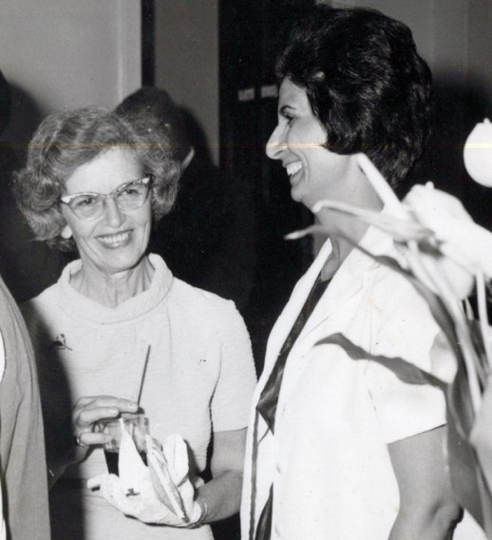
Mrs. Rodha Vaughn and Shamsi, in Trinidad, 1969
Visited nursing registration department
The next morning, I asked the owner of the guest house if he knew the location of the Ministry responsible for nursing and midwifery, and he said yes and offered to take me there himself. At the Ministry building, I presented my certificates of education and letters of recommendation from the hospitals where I had worked over the past years and requested to be registered as a nurse/midwife. I told the official that I was seeking employment and would go wherever I could be useful. He eagerly accepted my papers as he was very pleased to welcome to Trinidad a nurse/midwife with my credentials and assured me that I would receive a reply in the mail.
A few days later, Mr. and Mrs. Leslie Vaughn and another Iranian pioneer, Ms. Maryam Shaker (Sewell), a trained midwife who worked at Agustos Long Hospital Texaco and other hospitals, invited me to go to the airport with them to pick up a travelling teacher who was arriving from England, and I agreed. At the airport, she pointed out that the Minister of Health, Dr. Max Awon, a gynecologist of Chinese background, was there. She led us over to him as he waited to meet his wife’s flight from Ireland, and she introduced us to him. While I shook his hand, Ms. Shaker said to him, “Mr. Minister, do not let this hand stay idle because these hands have assisted in the deliveries of hundreds of babies. These hands are able to deliver many more children who are in need of skilled midwives.” After a brief conversation, the Minister was impressed and invited me to meet him at his office the following morning at 11 a.m. This was just the kind of assistance I needed to start my professional life in Trinidad and Tobago.
Meeting the Minister of Health, Mr. Max Awon
I walked into the ministry the following morning, and the secretary asked me if I had an appointment. I told her that I didn’t and then proceeded to recount the story of my chance encounter with the Minister and of his invitation to meet him the next day. She motioned for me to sit down as she went in to see him. Soon, the Minister came out and greeted me warmly then ushered me into his office.
He looked over my credentials and all of my letters of recommendation and was very pleased. He said he was certain that I would be employed, though possibly not in Port of Spain, the capital. I replied that I was willing to accept employment in any town. He gave me the necessary forms to fill out and assured me that a reply would be forthcoming.
There were no positions in government hospitals
Fifteen days later and much to my disappointment, a letter arrived from the Ministry stating that there was no position for me because there were enough Trinidadian nationals to fill the current openings. The Minister, though, called me personally two days later to tell me that I must not be disappointed because he and I might be able to open our own private clinic.
Some days later, we drove to potential locations but each one was too expensive. So, the Minister of Health wrote a letter addressed to Mr. Hugh Harris, Minister of Home Affairs, stating that I had valuable qualifications which were much needed on the island and that Mr. Harris should write to the chief immigration officer to issue the necessary work permission to me. Mr. Harris did, and I took the letter over to the office of the deputy Minister who read it and agreed that my skills were much needed, so he in turn wrote a recommendation to Mr. Hugh Ferriera, the chief immigration officer, asking him to issue a work permit to me. Once I received the permit, I went out in search of work.
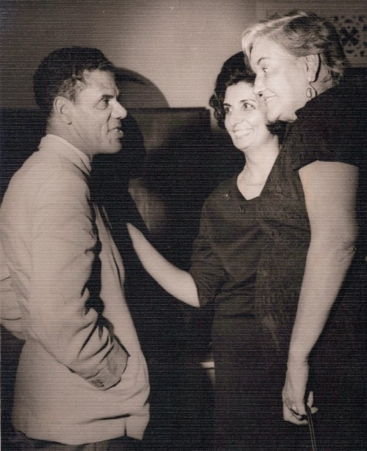
Mr. Hugh Ferriera, Chief Immigration Officer, Trinidad, Shamsi, and Ms. Jean Meanshal, our wonderful journalist
Tried to open a private clinic
To open a clinic, I needed start-up capital and a local business partner by law. I had bought shares some years back in Tehran which were currently in a Swiss bank account and had increased in value. I wrote to the Swiss bank which held them asking that the shares be sold, and the money transferred to me in Trinidad as soon as possible. The bank’s response was not encouraging. The shares had gone up in value, and the bank did not think it was a good idea to sell them at such a time. So, I wrote a second letter urging them to sell the shares and send the money as soon as possible, otherwise I would have to leave the island for lack of a job. This time, the bank sold the shares, and I received the money in a week’s time. A few months later, I read in the newspaper that this bank had gone bankrupt, and the values of the shares had plummeted. It was a bounty of God that I had sold the shares in time and for a good price so that I was able to open my clinic.
I found a business partner
I found a business partner thanks again to my good friend and fellow Baha’i pioneer from Iran, Ms. Maryam Shaker (now Sewell).
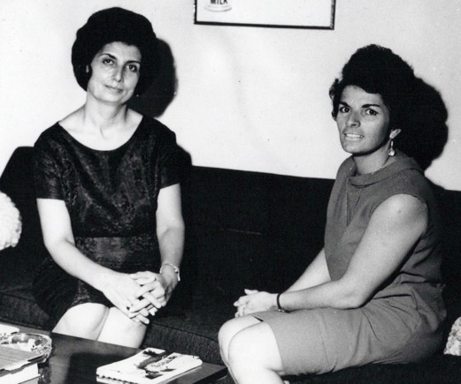
Shamsi and Ms. Maryam Shaker in Trinidad, 1969
She knew a Dr. Hugh Spicer who owned a private practice and attended to patients in several hospitals. When we went to meet him, he was impressed by my certificates, credentials, and letters of recommendation, and agreed that we open a clinic together in a large house he owned at 9A Stanmore Ave., in Port of Spain. The house was going to be a hospital as there were some medical facilities already in it, but it needed many instruments, blankets, kitchenware, and other items as well as working staff. On May 2nd, 1969, we met at the house (future hospital) to sign the necessary legal documents. After that I began to turn the house into a hospital.
According to the Baha’i calendar, that day—May 2nd, 1969 —was the 12th day of the Ridvan (Rezvan) Festival, the last full day of the twelve days that Baha’u’llah, the Prophet-Founder of the Baha’i Faith had spent with His Family and friends in the garden designated later as the Garden of Ridvan, meaning ‘Paradise’, located across the river and outside of Baghdad. The first, the ninth, and the twelfth days of their stay in the garden were designated as Holy Days on which work should be suspended. On the first day, April 21st, Baha’u’llah entered the garden at three in the afternoon and informed his closest followers that he was the Promised One of God foretold in all the Holy Books and “He Whom God Shall make Manifest” prophesied by the Bab. On the ninth day, the rest of Baha’u’llah’s Family led by His eldest son, Abbas Effendi, called ‘Abdu’l-Baha, the Servant of “Baha”, arrived in the garden from Baghdad, and Baha’u’llah again declared His Mission in front of them. The twelfth day, May 2nd, was His final day in the Garden, and at noon on the next day, May 3rd, Baha’u’llah left for His exile to Constantinople.
Dr. Hugh Spicer, myself, and the Rezvan Clinic
I wanted to name our new clinic, the ‘Rezvan’ Clinic and open it on an auspicious day to bless this endeavor. Dr. Spicer thought that the name would be too difficult for Trinidadians to say. I replied that I would gradually teach them this one word, ‘Rezvan,’ while I learned hundreds of names and addresses in English which I had never heard. He smiled and accepted the name of ‘Rezvan.’ He was also concerned about the date of the opening ceremony for the clinic which I wanted to be Thursday, May 23rd, 1969. He asked me why a Thursday and not a Saturday, the day on which big events were normally held. I replied that for Baha’is it was considered praiseworthy to begin initiatives that benefitted humanity on these Holy Days, so I wanted to open my clinic on the 23rd of May, the anniversary of the Declaration of the Bab, which had happened on that date in 1844. Dr. Spicer once again acceded to my proposal. I also requested that I be able to take off from work at the clinic on the nine Baha’i Holy Days. Other than those days, I would work on all the holidays of the other religions and be on call 24 hrs. a day. Dr. Spicer readily agreed to this and other stipulations, and we drew up a contract which set-up our clinic as a joint partnership.
I worked incessantly for 21 days buying the necessary beds, linens, medical supplies, and other hospital equipment and hiring the personnel, so that our seven-bed obstetric, medical, and minor surgery clinic was ready to be opened on the 23rd of May.
Article from the newspaper on the opening
The opening was announced in the May 22nd, 1969, edition of the newspaper, Trinidad Guardian:
“When the Minister of Health, Dr. Max Awon, cuts the ribbon at the entrance to 9A Stanmore Avenue tomorrow night, it will mean the realization of the dream of Shamsi Sedaghat, one of the most charming and highly-qualified women I have met in a long time.
Her story is simply one of dedication, hard work, and, as a result, success. Born in Ashqabad (Turkmenistan), in one of the former republics of the USSR, her family had to move to Iran when she was thirteen. She finished her secondary education in Iran. At the age of 26, she left for England, and in three years, obtained her certificates in general nursing and nutrition.
The opportunity came to put her experience to the test when, the following year, she went to the island of Cyprus, where she worked in St. Barbara’s Polyclinic as the theatre sister (operating room) and in the wards for one year. She then joined the Government as nursing supervisor at Nicosia General Hospital and Famagusta General Hospital. But the general situation became worse in Cyprus, and after 9 years, she thought of her home, her father’s land, Iran.
So excellent were her qualifications, and so high were her recommendations that it was not long before she was asked to become administrator and matron in charge of a hospital. No problem was too big or too tough for this dedicated woman to tackle…working shoulder to shoulder with contractors, plumbers, painters, and carpenters, the Pars General Hospital, at Ahwaz, in the center of the oil belt, with 40 beds, was officially opened by the Governor-General of the state.
Word of ability spreads fast, in any part of the world, and after 24 months at Pars, which she had built from scratch to a highly-efficient hospital, Miss Sedaghat came to Tehran and agreed to accept the position as Administrative Matron of the General Hospital of the National Iranian Oil Company Hospital (in Tehran), a position which, until then, had always been held by the British personnel. In the doctrine of her religion, Baha’i: “the world is but one country, and mankind its citizens. Let not a man glory in that he loves his country, but let him rather glory in this – that he loves his kind.”
And so, after 15 months, she went to Uganda, where she was appointed Administrative Sister in the Ministry of Health, in charge of the private wing at the new Mulago Hospital, supervising sisters in the Medical, Surgical, and Maternity Wards. After a few months in Uganda, “it was time,” as Miss Sedaghat simply puts it, “to return to my alma mater,” for, in nursing and midwifery, as in everything else, progress continues.
So back in England where she spent less than a year on a refresher course on maternity training (because she was trained in midwifery in Cyprus) and received a midwifery certificate, SCM (State Certified Midwife).This time she set her sights on Trinidad. Here, hospitals were adequately staffed, and with her direct approach, administrative ability and with her dedication to serve, it didn’t take Shamsi Sedaghat long to decide that a nursing clinic was the answer.
No. 9A Stanmore Avenue was, accordingly, completely renovated to create the ideal atmosphere for a modern, efficient nursing home, which will offer the most up-to-date obstetrics and medical services. The seven-bed home, which will be under the administration of the highly-qualified and dedicated woman, will assure each patient the utmost care and personal attention. Tomorrow, Rezvan Clinic will open its doors with warm, friendly caring arms to the people of Trinidad.”

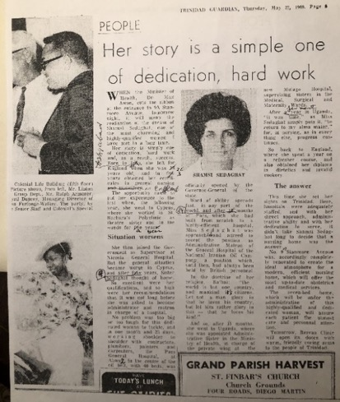
Article on Shamsi and the opening of the clinic in the Trinidad Guardian

Rezvan Clinic in Port of Spain opened

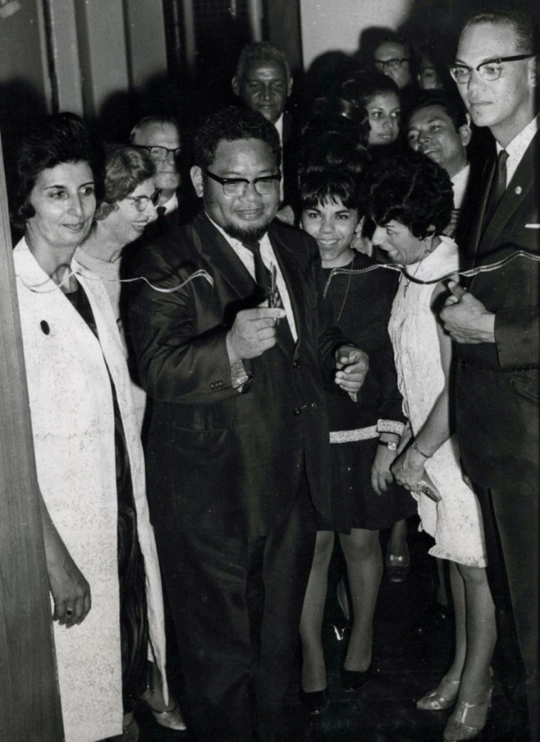
Ceremony of the opening of the Rezvan Clinic in Port of Spain.
L. to r.: Shamsi; Dr. Max Awon, Minister of Health, cutting the ribbon; Mr. Hugh Harris, Minister of Home Affairs, is behind Dr. Awon; Mrs. Nikoo Amarsingh and Mrs. Maryam Shaker, Baha’i pioneers, and Dr. Hugh Spicer, my business partner
In the presence of Dr. Max Awon, the Minister of Health, Mr. Hugh Ferriera, the head of the Department of Immigration, Mr. Hugh Harris, the permanent secretary of the ministry of Home Affairs, the Chief Medical Officer of Trinidad and Tobago, and other high government officials, doctors, bank officials, businessmen, and Baha’i friends, the Rezvan Clinic in Port of Spain was opened.
Dr. Awon expressed his regret to me later at not having been able to employ me at the government hospital due to some restrictions, but he conveyed his joy at the creation of this clinic which was much needed in the city.

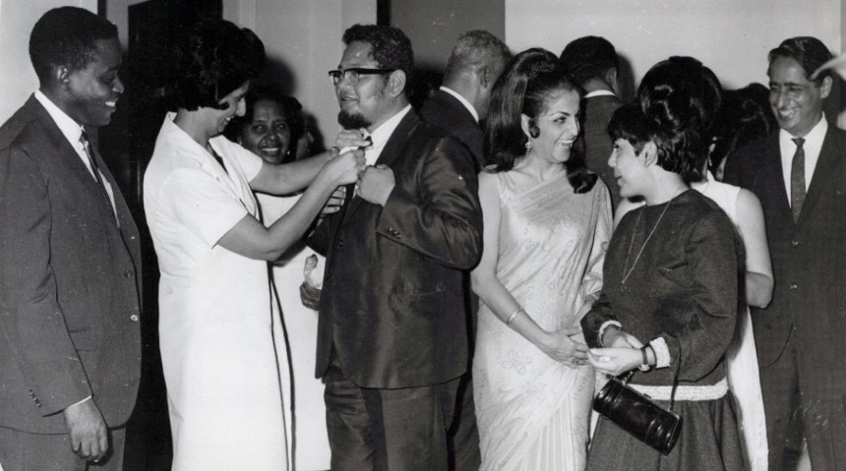
Shamsi fixing Dr. Max Awon’s tie after he asked her to at the opening; the photographer took the picture as she was doing it?!
This opening was a great proclamation of the Faith. During my brief speech at the ceremony, I mentioned that my faith impelled me to serve humanity. I gave interviews to the assembled press. During the television interview, I was allowed to show some of my slides including the ones of the Baha’i House of Worship in Kampala, Uganda. The coverage was sympathetic to the Faith, and I gave out pamphlets on the Baha’i teachings to any reporter who asked for one.
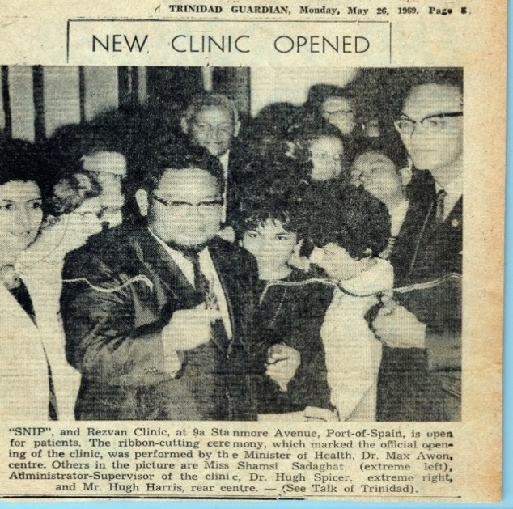
Article in the Trinidad Guardian, May 26th, 1969, covering the opening of the Rezvan Clinic

After everyone had left, I thanked Baha’u’llah for all the bounties he was showering upon His powerless pioneers in every corner of the globe including here in Trinidad.
A letter to the Universal House of Justice
In my excitement I wrote a detailed account to the Universal House of Justice of what had transpired so early in my pioneering efforts:
“9A Stanmore Ave.
Port of Spain, Trinidad

26th May, 1969

The Supreme Body
The Universal House of Justice
Baha’i World Centre
HAIFA-ISRAEL
Beloved Friends,
Your letter of 27th January 1969 was a great assurance for my success and settlement in this island because it conveyed your loving prayers for removal of all obstacles from my path.
Yes, all obstacles were removed one after the other, and finally when I was refused from a post in a private Hospital, one day prior to its commencement, I decided to open a Private clinic in Partnership with one of the local doctors.
So immediately I instructed my Bank manager in Geneva to liquidate all my shares, which I had for many years and send the money here. He did so and as soon as the money was received, I signed a contract for 5 years with above mentioned Dr. on the 2nd day of May i.e. 12th day of Ridvan (Rezvan), and I moved in the premises.
After 21 days hard work finally on 23rd of May, the Bab’s Declaration Day, the REZVAN clinic was officially opened by the Minister of Health, Dr. Max Awon, in the presence of the Permanent Secretary of the ministry of the Home Affairs, Mr. H. Harris (who helped me to obtain my work permit), Chief Medical Officer, High Ranking government officials, Doctors, Bank officials, Business personnel and some Baha’i friends.
As you see from enclosed article, I had press and TV interviews and I mentioned my primary intention of coming to this island. In my TV interview I was allowed to show some of my slides including the Baha’i House of Worship in Kampala.
My interviewers were very sympathetic towards the faith and they were presented some Baha’i pamphlets, by their own request.
During my speech, at the opening ceremony once again I mentioned the Faith and my duty as a Baha’i to serve mankind.
The Minister of Health after praising this humble servant expressed his sorrow for not being able to employ me in the government hospital due to some restrictions, but he conveyed his joy and happiness for such an enterprise which was much needed in this city.
The clinic is an obstetric and medical clinic with seven beds and all other facilities.
My partner is Dr. Hugh Spicer…So far, he has been very cooperative and understanding. Prior to the signing of the contract I explained to him my purpose of settlement in this island and what would be my future activities. He had no objection at all, and agreed to include in the contract the suspension of work by me during the 9 Baha’i Holy Days
Praised Be Baha’u’llah for all these bounties, which constantly showers upon His powerless Pioneers in every corner of the globe….
Please may I ask for your future prayers for prosperity of our new enterprise, so as to enable us to carry out our spiritual duties and to fulfill the goals of the nine-year plan in this island.
With deepest love and respect
In your service,
Shamsi Sedaghat”
I received a letter from the Universal House of Justice
The House of Justice wrote back assuring me of its continued prayers:
“Miss Shamsi Sedaghat
9A Stanmore Ave.
Port-of-Spain
Trinidad
Dear Bahá’í Friend,
We were very happy to receive your letter of 26 May informing us of the successful opening of your clinic in Port-of-Spain….
Be assured of our loving prayers at the Holy Shrines for the success of your enterprise and for your devoted efforts on behalf of our beloved Faith. Please extend our warm greetings to Miss Geary and assure her that she is also remembered in our prayers.
With warm Bahá’í greetings,
The Universal House of Justice”
Because of the positive coverage the clinic received in the media, patients began showing up the very next day.

Patients started to arrive
On May 24th, Mr. and Mrs. Alfred Aguiton came into the clinic and asked if we were open. I said yes and welcomed them in. I examined Mrs. Aguiton. She was eight months pregnant. They looked around the clinic and liked what they saw, so they booked a place in the clinic for her delivery.
She came in two more times before giving birth on June 23rd. I safely delivered her first baby. The following day Mr. Aguiton, the father of the baby, came to the clinic with a camera and a tape recorder and asked if he could interview me for the radio. Then I realized he was a radio announcer. He interviewed me and recorded it and later, it was broadcast giving the clinic much publicity.
The clinic would become a way for me to get to know the citizens of Trinidad who came there to have their babies delivered. One of our earliest patients later wrote me a letter of gratitude for her safe delivery at the clinic.
A letter of gratitude from my patient
“Dear Sister Shamsi,
Thank-you sister for the quick, easy, and safe delivery, for the kind, careful, methodical, and affectionate attention my daughter and I received during the three days we spent under your professional care and for the friendliness and warm reception shown to my visitors. May God grant you health, strength, and wisdom to continue to serve humanity as you have so humbly done before here in Trinidad and in other parts of the world.
May those who are privileged enough to come into contact with you appreciate your service and more so, the people of my country, Trinidad…
May God bless you,
Love, Mrs. LaBarde”
Involvement in Baha’i activities
My involvement in the Baha’i work in Trinidad developed as quickly as my clinic. In January I received a call for a by-election to fill vacancies on the Spiritual Assembly of Port of Spain created by the resignation of two members who had left the country and the non-functioning of two others. I was subsequently elected to serve on the Spiritual Assembly of Port of Spain.
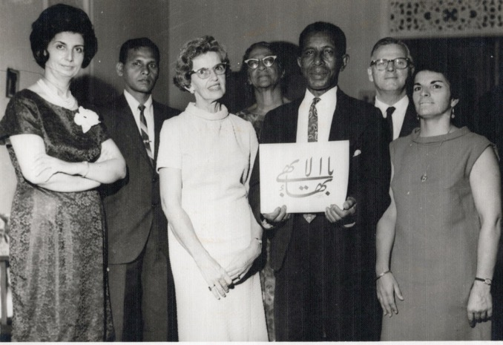
Spiritual Assembly of the Baha’is of Port of Spain:
Back row l. to r.: Mr. Fitzroy Sookoo, Ms. Enid Cox, Mr. Leslie Vaughn
Front row l. to r.: Shamsi, Mrs. Rhoda Vaughn, Mr. Leo Frazier,
Ms. Maryam Shaker. Two members were missing.

Letter from the National Spiritual Assembly of Venezuela
The National Assembly of Venezuela expressed its appreciation and wrote to me that:
“Miss Shamsi Sedaghat
Trinidad and Tobago
C/o Mr. Leopold Fraser, Sec.
LSA of Port of Spain,
Dear Baha’i Friend,
We would like to extend to you a very warm welcome to Trinidad and Tobago. We cannot tell you how happy we are to have you there.
This is a very important post that you are filling, and the responsibilities are great, but the rewards will be great also. You know of course that Trinidad is working towards the goal of having its own National Spiritual Assembly, so much teaching and grounding is needed to be done, especially in the area of administration.
The Vaughns from the United States have also arrived and have already done much to help the situation there. We hope that you will work very closely with them. They are wonderful Baha’is and dear people. They will be a big help to you these days, we feel sure. Please let me know if there is anything that we can do to help also. We stand ready to the best of our ability…We would appreciate any news of yourself. If you have an address, a job etc.…
Again let us say we are most happy to have you here.
Sincerely in His Service,
Asamblea Espiritual Nacional
De los Baha’is de Venezuela
Martha F. Posner, Sec.”
In March, the Assembly appointed me to the Teaching Committee of Port of Spain on which I served as the chairperson and was also invited to meet with the National Goals Committee of Trinidad and Tobago to discuss the development of teaching plans.

Letter from Auxiliary Board Member Mr. Peter McLaren
I received a warm letter of welcome from the Auxiliary Board Member for Propagation, Mr. Peter McLaren:
“Avenida 3D No. 70-16
Colonia Bella Vista
Maracaibo, Venezuela
18 March, 1969
Miss Shamsi Sedaghat
18 Rosalina Street
Port-of-Spain
Trinidad
Dear Baha’i Friend,
This short note is to express to you a warm welcome to Trinidad and Tobago and to assure you of our deep gratitude for the important services you are rendering the Faith of Baha’u’llah in that country. Letter from other Baha’is indicate that you are already actively involved in the numerous and urgent teaching tasks which face us at this time, and this news has, of course, made us very happy indeed.
I plan to make a one-week visit to Trinidad, arriving March 29th, and look forward to meeting you at that time.
With warm Baha’i greetings,
Peter McLaren”

Letter from the NSA of Venezuela
Then in early June, the National Assembly of Venezuela asked me to serve on the National Properties Committee:
“Miss Shamsi Sedaghat
Miss Maryam Shaker
Mr. Leo Fraser

Dear Baha’i Friends,
At the last meeting of the National Assembly on May 30-June 1st, it was decided that, since there is so much work that must be done in Trinidad and Tobago prior to the formation of the National Assembly there, it is advisable to form two national committees.
We have kept the membership of these committees small in order to facilitate obtaining a quorum and to make functioning easier. However, we would like to remind you who constitute these committees to make use of the many friends as possible in the carrying out of your goals.
1. Obtain the Haziratu’l Quds in coordination with the L.S.A. of Port-of-Spain.
2. Look for suitable land for endowment property, and prepare and put into action a plan for its purchase.
3. Obtain from the government of Trinidad and Tobago recognition of the Baha’i holy days. (Baha’i children should be excused from school on these days.)
These are very difficult, but very important goals and they must be realized as soon as possible.
As you probably know, the House of Justice has already decided that your neighbors in the Guianas are to form their National Assembly next Ridvan.
It is imperative that we demonstrate to the House of Justice that Trinidad and Tobago will be ready for their National in the near future. We must demonstrate to them that we can forge ahead, and especially that we can obtain successfully the goals that they have set for us.
This Assembly feels confident that you people sincere and dedicated as you are, will be able to achieve the goals of this committee.
We stand ready to assist you in any way that we can,
Sincerely in His service,
Asamblea Espiritual Nacional
Martha F. Posner, Sec.”

Our future Baha’i Center in Port of Spain
We found an old house at 3 Petra Street in Wood Brook which was badly in need of repair. I had gotten to know local people who came to respect me for the medical service I rendered to them, so I was able to call on their assistance to help us renovate the house.
The Hindu owner of the property sold it to us for a lower price because he said “…it would be dedicated to God and not used for gambling and drinking.” The National Assembly gave the committee a funding update early the following year that it had $3,380 in hand.
The National Spiritual Assembly of Venezuela wrote to me the following letter:
Letter of the NSA of Venezuela
“Miss Shamsi Sedaghat
National Properties Comm. For Trinidad and Tobago
Rezwan Clinic
9A Stanmore Ave., Port of Spain
Trinidad, W.I.
Dear Shamsi,
Congratulations on the wonderful job you are doing in regard to the Hazirat-‘ul-Quds.
The second house sounds even better than the first….
Due to your quick action it looks as though there is a very good possibility that we will be able to get this house….
Sincerely in His service,
Asamblea Espiritual Nacional
De los Baha’is de Venezuela
Martha F. Posner, Secretary”
To get a permit for the Center, I went to the Mayor of Port of Spain, Mr. Hamilton Holder, and the Chief Engineer.
We spoke for over thirty minutes about the Faith and its principles, and I gave them a few Baha’i books. Mayor Hamilton Holder commented that “you are doing a very fine job for Trinidadians and helping your Baha’i Faith. I wish you success in both. We were impressed very much by the Baha’i Teachings.”
Opening of the Baha’i Center
As a result of these efforts, we were successful in purchasing, renovating, and establishing a Haziratu’l Quds (Baha’i Center) for Port of Spain.
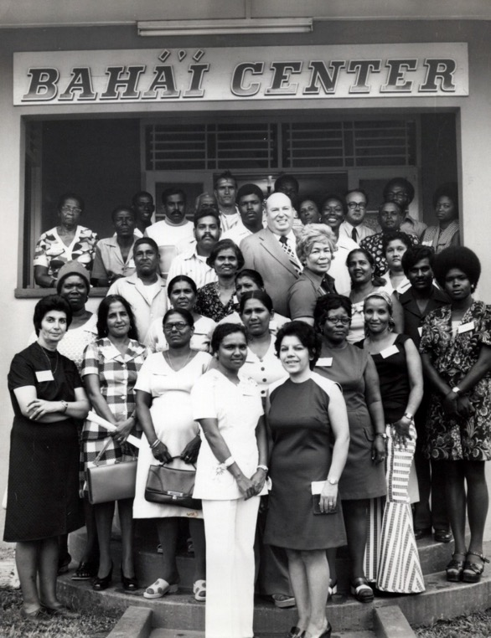
After a Baha’i Conference with Counselor Donald Witzel (in the middle), Baha’is of Trinidad standing in front of the first Baha’i Center in Port of Spain
L. to r. 1st row: 1) ?, 2) Mrs. Nikoo Amarsingh
L. to r. 2nd row: 1) Shamsi, 2) Mrs. Jaytoon Abdul
In the middle: Counselor Mr. Donald Witzel; in front of him, Ms. Lillian Fraser, reporter, and next to her, Mrs. Dolly Hanumansingh and other devoted Baha’is
Back row r. to l. : 6) Mr. Hardeen, 7) Mr. Caverley, 8) Mrs. Caverley
(A few of the names that I remember)
The opening of the Center was covered by the Trinidad Guardian:
“TALK OF TRINIDAD
Despite the power failure on Friday afternoon the official opening of the first National Baha’i center in Trinidad took place…The Mayor of Port of Spain, Councilor J. Hamilton Holder, who cut the ribbon…stressed on the simplicity of the basic principles of the faith which was “the unification of mankind”. He felt that more and more people would make use of the center to learn about the faith which could make a great contribution to all. Among the many guests at the opening ceremony were the Chief Justice of Trinidad and Tobago, Sir Arthur McShine, the Indian High Commissioner, Mr. L.N. Ray, and Mr. Wilfred Henry.”
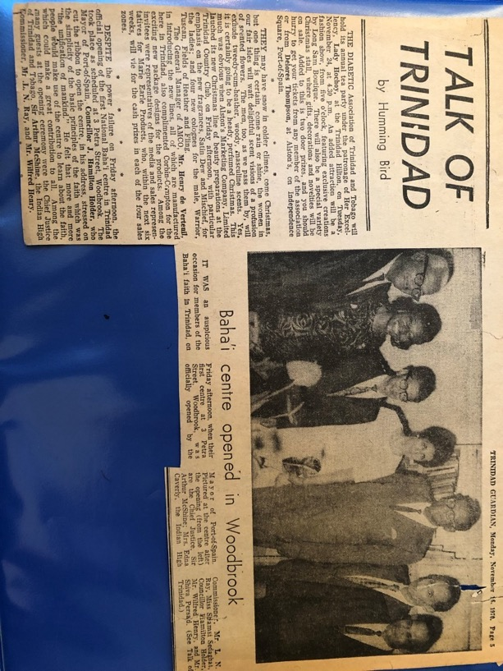
Announcement in the Guardian of the opening of the Baha’i Center in Port of Spain

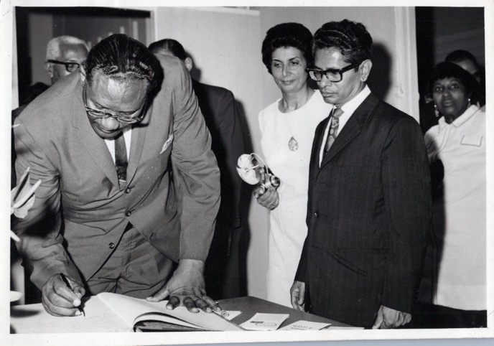
L. to r.: Mayor of Port of Spain Hamilton Holder signing guest book at the opening of the Baha’i Center for Port of Spain, Shamsi, and the Indian High Commissioner, Mr. L.N. Ray.
First Baha’i Institute
On July 19th and 20th the National Teaching Committee of Trinidad and Tobago held its first Baha’i institute to stimulate teaching. The program focused on different approaches to teaching the Faith. The friends were deepened on this topic by the Auxiliary Board Member, Mr. Peter McLaren, and other speakers. I spoke on the spirit of the Faith at the end of the two-day institute.
Appointed to the National Publicity Committee
The next month, I received a letter from the National Spiritual Assembly of Venezuela asking me to serve on the National Publicity Committee to promote informational materials to the media. In this brief time after my arrival in Trinidad, I had already been able to speak about my clinic and the Faith on television and radio and had received newspaper coverage. I made a special effort to cultivate contacts in the media and with prominent people to bring greater attention to the Faith and, ultimately, to its teachings.
Mrs. Lilian Fraser accepted the Faith and visited the Holy Land and Iran
Ms. Lilian Frasier was a well-known radio announcer in Trinidad. She had her own show called “The Woman’s Program” on Radio Trinidad in the mornings but was not a Baha’i when we first met. I always brought international Baha’i figures such as Hands of the Cause, travel teachers, and others to be on her radio show. Gradually, her interest in the Faith grew. I pointed out to her one day that she was interviewing Baha’is, announcing Baha’i events, and expressing ideas on the air that were so similar to those of the Faith that we considered her to be a Baha’i in spirit. I asked her whether she had thought about becoming a Baha’i herself. She replied that she was very impressed by the principles and the unifying teachings of the Baha’i Faith, and she was ready to accept the Faith. Her declaration brought the Baha’is great joy. We encouraged her to go on pilgrimage to the Holy Land and from there, visit the Baha’is and Baha’i Holy places in Iran.
Just in time Hand of the Cause Gen. Khazeh arrived in Trinidad from Iran and had a radio interview with Ms. Fraser. He also said that it was important that she go to the Holy Land for pilgrimage and visit Iran as well. He would try to arrange the trip. He got in touch with the friends in England and with assistance of Mr. Afshar—an active Baha’i in the United Kingdom—within three months, she was on her way to Haifa where she met many of the friends, visited many of the Holy Places, refreshed herself spiritually, and then left for Iran. In Tehran, Hand of the Cause Gen. Khazeh met her again. He took her to meet the Baha’is and speak about the progress of the Faith in Trinidad and Tobago.
Talk by Ms. Lillian Fraser in the Hadigeh garden in Tihran
One day in the garden of Hadigeh in Tehran, a beautiful and spacious garden used by Baha’is, there was a meeting with numerous people at which she spoke about the progress of the Faith in Trinidad and Tobago and the formation of many local spiritual Assemblies in the Islands. She mentioned that all the success was due to the sacrifice of the friends there. Many of the Baha’is present there were encouraged to help the islands but did not know how to do so. Fortunately, a family decided to send $5,000 in the name of their late father to a Baha’i friend in Trinidad for the purposes of replacing her old car with a new one, so she could use it to get around the island more effectively as she served the Faith. That Baha’i friend in Trinidad wrote to them that buying a bus would be preferable because more people could be transported but this would require additional funds. The family agreed and sent an additional $3,000.
After further consultation, we thought the money should be put towards the building of a Baha’i Center in Palmyra on the land which Dr. Harry Collymore donated for this purpose on the day of his acceptance of the Faith. We wrote to the family and explained that we thought the bus could get into an accident and then it would no longer be useful whereas a building would be permanent. Happily, the family agreed, and their donation was used for the ‘Palmyra Center’ along with those of other Baha’is.
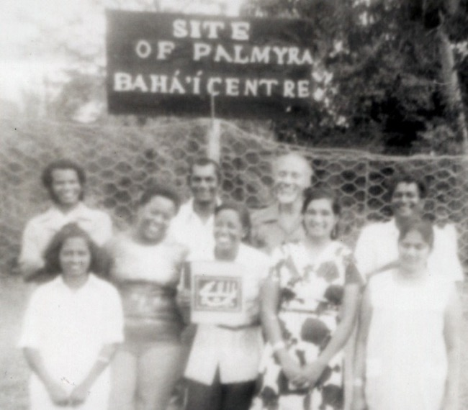
Site for the future Palmyra Baha’i Center on land donated by Dr. Harry Collymore, second row second from the right
Palmyra Baha’i Center
Once the Palmyra Baha’i Center was built, this center was used by the Baha’is in the Palmyra area and southern Trinidad who gathered there and enjoyed the grounds which were full of citrus and other fruit trees. A commemorative plaque was placed inside the center with the inscription that some of the funds for the building of the Center had been donated by the family of the late Mr. Surush Eydoon from Iran for the elevation of his soul.
Ms. Frasier returned to Trinidad after visiting the Baha’i Holy places in Israel and Iran and became a passionate teacher of the Faith over the years, even answering questions and letters about the Faith on air. Years later, she left radio and moved to the Baha’i Center in Port of Spain and served the Faith until her ascension to the Abha Kingdom, may God elevate her spirit.
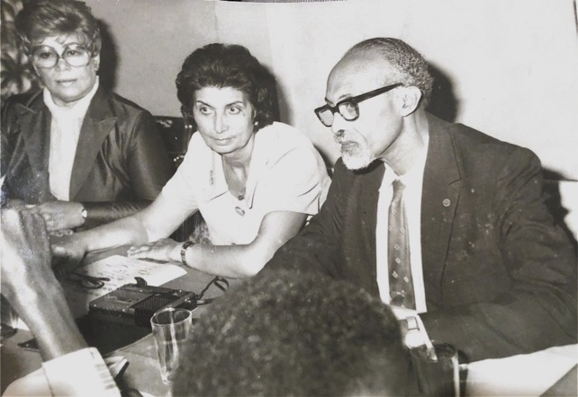
Ms. Lillian Frasier, Shamsi, Dr. Collymore speaking about the Faith in Trinidad and Tobago c. 1970s
Guardian newspaper article
A writer for the Guardian newspaper, Ms. Jean Minshall, who went by the pen name ‘Humming Bird,’ covered Baha’i activities regularly on her society page, ‘Talk of Trinidad.’ When I hosted a dinner at my Rezvan clinic for Ms. Maryam Shaker (Sewell) who was leaving to study in the United States, ‘Humming Bird’ wrote: “the guests…were lavish in their praise for the unusual and delicious dishes of the East which were served…” On this particular social occasion, I showed slides to the guests which were related to the Faith. I always wanted to use such gatherings to engage in some sort of proclamation to further awareness of the Faith.
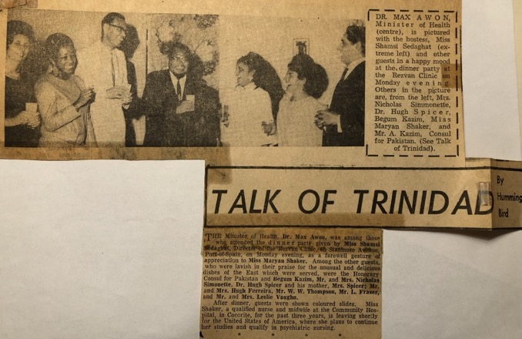
Going away dinner for Maryam Shaker
Humming Bird also wrote about a Naw-Ruz dinner which I hosted in March of 1970, describing the food as a “gourmet’s spread”. During the dinner I made a special presentation to Mr. and Mrs. Aguiton and their nine-month-old daughter, Rhonda, who was the first baby born at the Rezvan Clinic in Port of Spain.
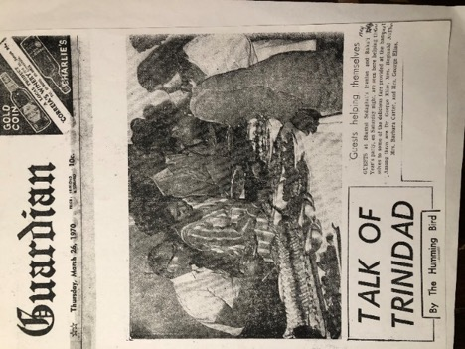
Photo of Shamsi’s New Year dinner in the Talk of Trinidad
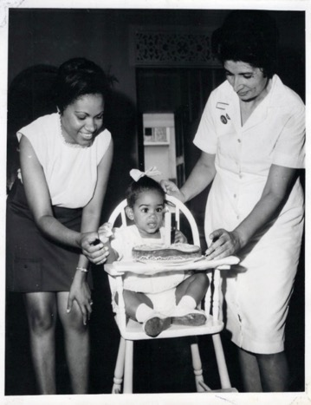
Mrs. Aguiton, Rhonda Aguiton, and Shamsi
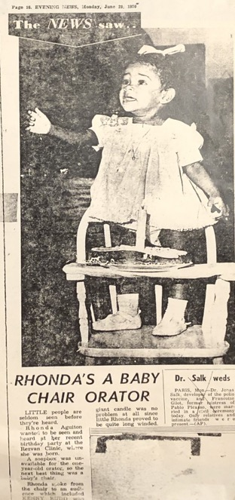
Photo and announcement of baby Aguiton
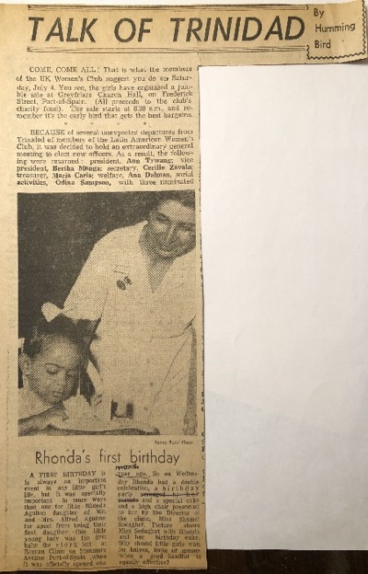
Photo of baby Rhonda’s first birthday in Talk of Trinidad

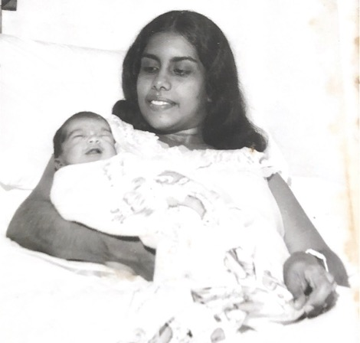
Baby Nagassar, born at the Rezvan Clinic; Shamsi was the midwife

Declaration of the Mayor of Port of Spain
At the following year’s Naw-Ruz dinner, the Mayor of Port of Spain, Mr. Hamilton-Holder and his wife, and the Indian High Commissioner, Mr. Mozaffar Agha, and his family attended. The Mayor was always receptive to Baha’is. He encouraged the growth of the Faith but recommended that we proceed wisely and gradually in the development of the community. In one of our meetings, he got up and expressed his wish to accept the Baha’i Faith. That was a very happy and joyous occasion for all of us. This acceptance of the Faith came at the conclusion of his term as he had retired from politics. He was a highly honored public servant in Trinidad. He has since passed away; may he rest in peace and glory. I hope that one day his son Reginald who called me his “godmother” and later moved to Canada (I don’t know where) will join the path of his father if he reads the Baha’i literature and sees the assistance that his father gave to us during his time as the Mayor of Port of Spain.
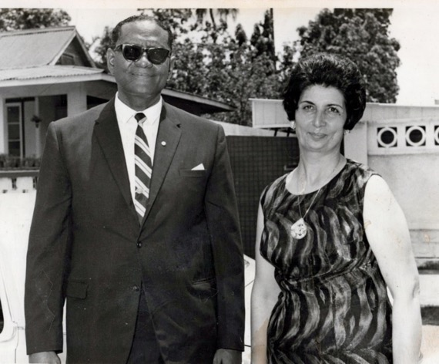
Mayor of Port of Spain Hamilton Holder and Shamsi.
Arrival of Sir Arthur McShine to our Baha’i class
One Sunday I had a class on ‘moral teaching’ in Farsi (called ‘Dars-e Akhlaq) at my clinic outside on the first floor, next to the clinic. Suddenly we saw a car come and stop, and Sir Arthur McShine, Attorney-General, stepped out of the car. We were surprised. I got up and welcomed him and he said, “Oh, you have a youth gathering here, can I join you?” I said, “By all means, please come in and be seated!” So, he came and sat down, and I introduced him to my students in the class. He said, “Please continue your lessons,” so we did. One of the children—who were all between the ages of ten and twelve—got up and started to recite a prayer called the Tablet of Ahmad.
Ahmad was the name of one of the early Babis who later became a Baha’i and was with Baha’u’llah in Baghdad. When the Ottoman government exiled Baha’u’llah from Baghdad to Istanbul, Baha’u’llah took several of the believers with him, and he said to the others to stay there or go back to Iran and teach the Faith. Ahmad obeyed Him but in later date he asked permission to join Baha’u’llah. Baha’u’llah wrote this Tablet to Ahmad and instructed him to go to Iran and teach the Faith. Ahmad obeyed him and went to Iran and began to teach, saying to Babis that the prophet whom the Bab had foretold had come. Of course, first the Babis had much opposition but gradually many accepted the Faith and served admirably, and some were martyred but the Faith started to progress.
Shoghi Effendi, the Guardian of the Baha’i Faith, writes the following about some of these special prayers:
“These daily obligatory prayers, together with a few other specific ones, such as the ‘Healing Prayer’, the ‘Tablet of Ahmad’, have been invested by Baha’u’llah with a special potency and significance and should therefore be accepted as such and be recited by the believers with unquestioning faith and confidence, that through them they may enter into a much closer communion with God and identify themselves more fully with his Laws and Precepts.”
When the first student recited a few lines of the Tablet of Ahmad, Sir Arthur McShine asked another student to continue the recitation. She got up and picked up where the other student had left off. This was repeated with several other students. Then Sir Arthur McShine asked that they give the prayer book to him. He took it and asked on what page was the prayer, and one of the students shouted out the page. He opened to the page and said, “Listen to how you should read or say this prayer. This is an important writing and should be read properly.” Then he started from the beginning of the Tablet, (the Holy Writings). He read slowly, loudly, and clearly. His reading was so powerful that my tears started running. I said in my heart, “O Baha’u’llah, see how this powerful and dignified personality of our country who is not a Baha’i respects your writings and teaches the children how they should read your Tablet.” When he finished reading the Tablet, he said to the children, “This is the way you should read the writing so that when someone hears it, they will understand and enjoy it.” I thanked him sincerely and expressed my heart’s desire that he could, now and again, when he was passing through our town, make a short stop like he did today and share some of his knowledge with us as well. He thanked me and replied, “I think that you are an excellent teacher. See how these beautiful children have memorized this long tablet and recited it by heart without stopping. It was excellent!” I added, “Although I have also reminded them about the points you advised them, but now that they have heard it again from you, they will—without any question—follow your advice.” Sir Arthur McShine was very happy. Then we served some refreshments and he left.
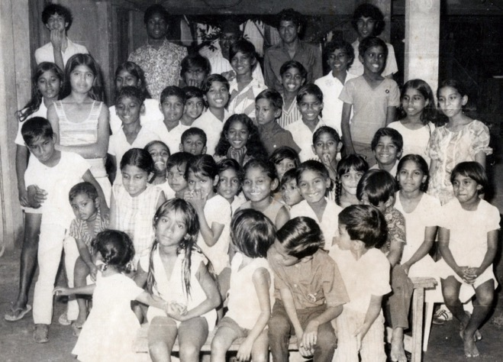
One of the classes for the Baha’i children and their friends in Trinidad
Arrival of one of the Prime Ministers from Africa
I made every effort to reach out and welcome travelling dignitaries who were visiting Trinidad and may have had previous contact with the Faith. The Prime Minister of an African country was in Trinidad and Tobago on a state visit, and we read in the Baha’i News that he had met Ruhiyyih Khanum when she visited his country. With a group of Baha’is which included Mr. Masoud Khamsi, a Counsellor for South America (later a member of the International Teaching Center in Haifa) who was visiting Trinidad at the time, Ms. Lillian Fraser, and I went to greet the Prime Minister in his hotel. When we met him, we showed him the article in the Baha’i News about his meeting with Hand of the Cause Ruhiyyih Khanum in his palace. He was pleased to see the article and praised the Baha’i Faith and its peaceful principles and said, “The Baha’is are very good citizens.” We spoke about the progress of the Baha’i Faith in the world and then left on very cordial terms.
Participation of Sir Arthur McShine in Law Conference in India
When prominent Trinidadians travelled abroad, I made every attempt to put the Baha’is of those countries in contact with them. For example, in January of 1971, Attorney General Sir Arthur McShine travelled to a Law Conference in India when he was Acting Governor-General. He had become a good friend of the Baha’is when Hand of the Cause Ruhiyyih Khanum had paid a courtesy call to him when he was temporarily replacing the Governor-General, Sir Ellis Clark, who was away.
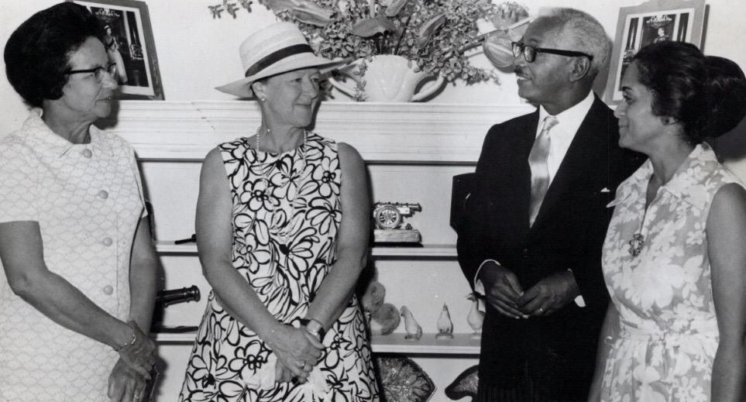
L. to r.: 1) Mrs. McShine, 2) Hand of the Cause Ruhiyyih Khanum,
3) Sir Arthur McShine, 4) Mrs.Violette Nakjavani
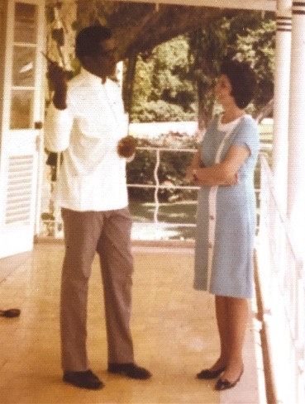
Shamsi speaking with a staff member at the residence of the Governor-general of Trinidad, Mr. Ellis Clark
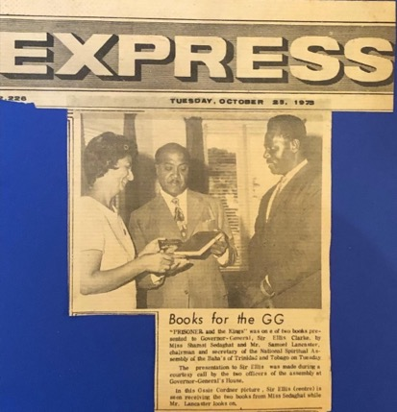
Article from 1973 in Trinidad, showing Shamsi on the left with Sir Ellis Clark, (in the center) the Governor-General of Trinidad and Tobago, and Mr. Samuel Lancaster, the Secretary of the National Spiritual Assembly of the Baha’is of Trinidad and Tobago

Once again, I had Hand of the Cause Mr. Zikrullah Khadem as my guest and the same day, I was invited by Acting Governor General Sir Arthur McShine (Chief Justice of Trinidad and Tobago) to the Governor’s residence. I phoned the Governor’s secretary at the residence, and I asked if I could take my honorable guest with me as well. She replied, “Give me ten minutes, and I’ll get an answer for you soon.” After a short time, she phoned me back and said, “Sir Arthur said who can refuse this good lady? Her guest will be welcomed as well.” At the event, the Governor-General and Mr. Khadem were introduced, and they spoke for a while, and we explained the problem of our guest’s visa to the Attorney General who immediately went into his office, picked up the phone, and got the problem fixed. When I learned that Attorney General McShine would be attending a Law Conference in New Delhi, India, where there was a well-established Baha’i community, I immediately wrote to Mr. Ramnick Shah, the Secretary of the National Spiritual Assembly of India, and asked to meet him and thank him for his support of the Baha’i community in Trinidad. Mr. Shah and a Baha’i delegation went to the hotel to call on him, but he was not there at that moment, so the bouquet of flowers was left along with a note of welcome to India.
A thank-you letter from Sir Arthur McShine
Mr. McShine expressed his appreciation for the gesture and remembered that he had received Madam Rabbani when she was in Trinidad and counted me among his friends:
He wrote:
“I wish most sincerely to thank you for your kindness in calling on me at my hotel and for your charming gesture of sending me flowers to adorn my room and as an earnest sign of your goodwill. I do appreciate these gestures and for them I am most grateful.
I had the pleasure last year of receiving your Mrs. Rabbani when she visited Trinidad, and the representative in Trinidad Shamsi Sedaghat I am proud to number among my friends. I shall, though be very busy with the Law Conference, try to meet you personally when I can more adequately thank you for everything…”
Letter of the Secretary of the National Spiritual Assembly of India,
Mr. Shah, to me
Mr. Shah later wrote to me:
“We thank you so much for your letter of 27th December 1970, informing about the visit of Sir Arthur McShine, Chief Justice of Trinidad and also of Mr. Hudson Phillips, Attorney General, who participated in the Law Conference in Delhi.
We did not get the information whether Mr. Hudson Phillips had attended the Conference, but Sir Arthur McShine arrived here two days late and as we were not able to contact him personally, we left the message in his hotel and also presented flowers to him.
To our pleasant surprise, he called us at the Baha’i House this morning and was with us for 15 minutes. Sir Arthur McShine was full of praises for the Baha’is of Trinidad and particularly about you and your work. We found him very sympathetic to the Cause and in fact he loves the teachings of Baha’u’llah.
We are grateful to you for giving us an opportunity to meet Sir Arthur McShine and hope that you will again write to us whenever any important personality from your country visits India.”
Trying to achieve the goals of the Nine-Year Plan
In early 1970, the Baha’is of Trinidad were working to accomplish the goals of the Nine-Year Plan which had been inaugurated in 1964. The worldwide goals for the Plan included raising the number of National Assemblies to 180, of local Spiritual Assemblies to 13,700, the incorporation of at least 1,700 of them, the acquisition of 52 Haziratu’l-Quds (Baha’i Center) and 54 national endowments, and the wide extension of the recognition by civil authorities of the Baha’i Holy Days and Baha’i Marriage Certificates.
In its Ridvan Message of 1970, the Universal House of Justice called for the formation of four new National Spiritual Assemblies by Ridvan of the following year, and one of these was to be in Trinidad and Tobago with its seat in Port of Spain. To accomplish this goal the National Teaching Committee for Trinidad and Tobago appointed representatives from among the pioneers and other Baha’i teachers. The objective was to assist with the formation of nine local Spiritual Assemblies. When I first arrived in Trinidad there was only one functioning Assembly, so this goal showed that the Faith was making real progress in Trinidad.
To help give impetus to the teaching efforts, the National Spiritual Assembly of Venezuela and the Teaching Committee organized a two-day teaching conference on March 27-28. The sessions were opened by a ‘Call to the Waiting Souls of Trinidad and Tobago” by Counsellor Donald Witzel and followed by presentations on such topics as teaching methods in cities and small town, how to reach the Hindu population, Baha’i Laws and Administrative Principles, as well as much singing and fellowship. I spoke about the great teachers of the Faith in Baha’i history in preparation for the finale which was a consultation on the goals for Trinidad and how we were going to meet them.
Guidance from the Universal House of Justice
The Universal House of Justice guided this process, eagerly awaiting the minutes of our meetings so it could correct our decisions if necessary and keep us on the right course forward. If it was an urgent matter, I received a phone call from a designated member of the House of Justice who provided corrective guidance. Over my years as a pioneer in Trinidad, I witnessed the growth of numerous Assemblies, so many in fact, that in later years we consolidated villages into larger administrative units so that we would have fewer Assemblies, but these would function more effectively.
There was dynamic teaching as well. The firesides at the clinic grew so much that the neighbors wondered what was going on. They saw the Faith not so much as a religion but as a way of life. I even made a special area for children so that the adults would not be disturbed. Seekers became Baha’is, and the community grew in strength.
Visit of Hand of the Cause Ruhiyyih Khanum Rabbani
Our community was blessed in the spring of 1970 with a three-day visit of Hand of the Cause Ruhiyyih Khanum and her travelling companion, Mrs. Violette Nakhjavani (wife of the member of the Universal House of Justice, Mr. Ali Nakhjavani, and daughter of the Hand of the Cause Mr. Musa Banani and his wife Samihe Khanum). They had just completed a three-month drive across Africa from East to West, visiting Baha’i communities, meeting dignitaries, and encouraging the friends, and they were now on a five-week tour of the Caribbean.
I took them to call on various dignitaries on the island including Attorney General Sir Arthur McShine and Mayor Hamilton-Holder. Mr. McShine was serving at the time as acting Governor-General; during our visit we became better acquainted and discussed many aspects of the Baha’i teachings with him. Madam Rabbani told him about many of the courtesy calls she had made to heads of state and of their positive reactions to the Faith. Mr. McShine observed that he had seen the same positive atmosphere whenever he met Baha’is and praised the Baha’i principles of unity and friendship. We had a very good visit. He escorted us to the outside door, and we left.
Luncheon with dignitaries at the Queens Park Hotel
I hosted a luncheon at the Queen’s Park Hotel attended by the Chief Immigration Officer, Mr. Hugh Ferriera, the Indian High Commissioner, Mr. Ray, the Pakistani Consul Mr. and Mrs. Kazim, Mr. Mansingh Amarsingh, an Indian table tennis champion who was a Baha’i, and his fiancé, Ms. Nikoo Raufian, a Baha’i pioneer of Iranian background, and the Mayor Hamilton Holder.
Ruhiyyih Khanum made enlightening remarks peppered with humor. I also used this occasion to host the public marriage engagement of Mr. Amarsingh and Ms. Raufian, who were from different cultures which demonstrated the Baha’i teachings on unity. Then they exchanged wedding rings there.
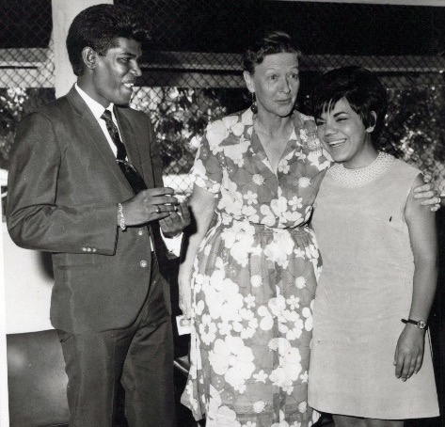
Hand of the Cause Ruhiyyih Khanum Rabbani standing between
Ms. Raufian and Mr. Amarsingh who was about to give her the ring.

The whole event was covered favorably by “Humming Bird” for the Guardian newspaper. Ruhiyyih Khanum also wanted to speak with the pioneers, so we all gathered in the private room of my clinic where she removed her shoes and sat on a comfortable sofa while she drank tea and spoke lovingly to us, encouraging us to work for the growth of the Faith and to be steadfast in the Cause which helped us tremendously.
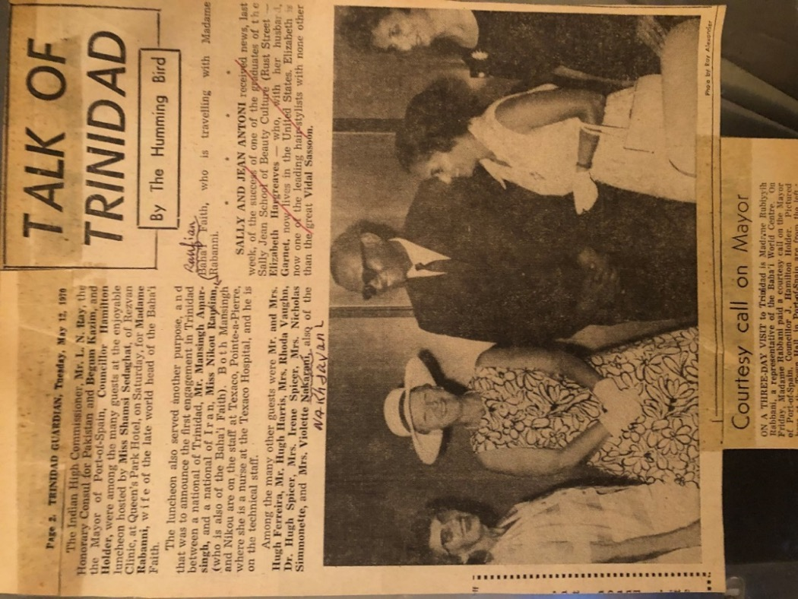
Photo in the Trinidad Guardian of the courtesy call by Ruhiyyih Khanum to Hamilton Holder, the Mayor of Port of Spain; Ruhiyyih Khanum in the white hat, then left to right: Mayor Holder, Mrs. Violette Nakhjavani, Shamsi
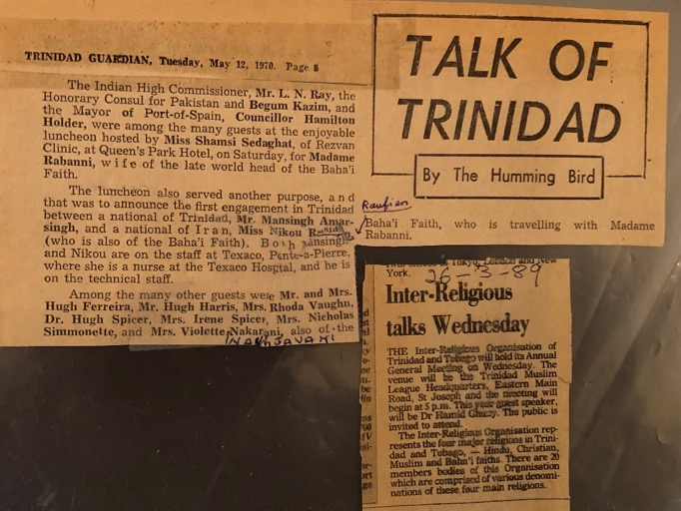
Article in the Trinidad Guardian covering luncheon for dignitaries held by Shamsi Sedaghat
My letter to Hand of the Cause Ruhiyyih Rabbani
Later I wrote a thank-you letter to her:
“Amatu’l-Baha Ruhiyyih Khanum
Dear and Beloved Ruhiyyih Khanum,
It was such a bounty to have you in our Trinidad and partake from the ocean of your devotion, knowledge, experience, wisdom, and loving kindness. I am sure that your visit to other Caribbean Islands has been as successful as ours.
We have been overjoyed with the results of your visit here. Many of my high-ranking official friends commented on your TV and radio interviews and wished you could address a public meeting if there was no state of emergency.
We had one inquiry published in our local newspaper to which we answered immediately by quoting the Beloved Guardian’s writings as you advised us. Also, we wrote a personal letter to an inquirer giving him my address for any further information he wished.
Enclosed please find your letters, newspaper clippings and pictures of your historic and unforgettable visit to our Trinidad. We pray hard that one day you will pay another visit to us for a longer duration.
With deepest love and affection,
Shamsi.”
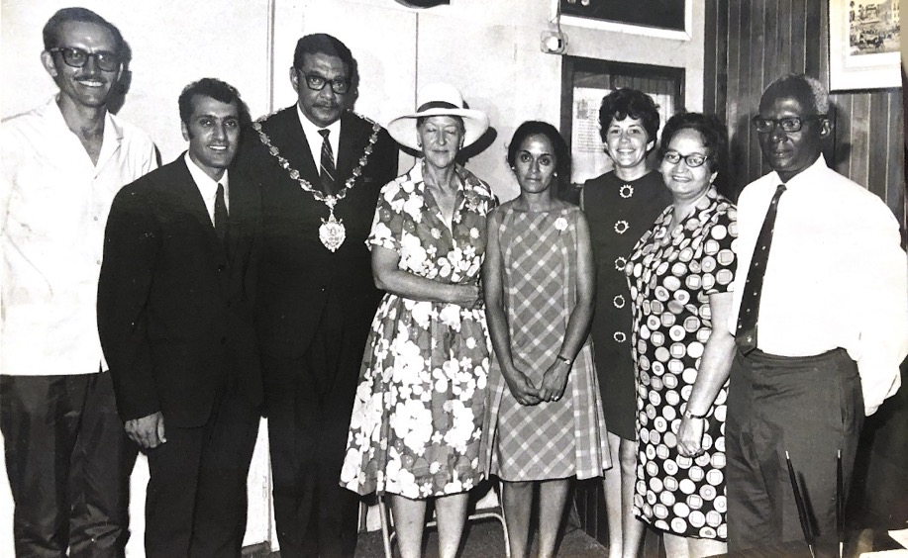
Ruhiyyih Khanum with the President of Guyana
l. to r.: 1) Mr. Hooper Dunbar, Counsellor for South America, 2) Mr. Jamshid Arjomandi, Chairman of the National Spiritual Assembly of Guyana, 3) President of Guyana, 4) Hand of the Cause Ruhiyyih Khanum, 5) Violette Nakhjavani, wife of Mr. Ali Nakhjavani, member of the Universal House of Justice, 6) I don’t remember the name, 7) Mrs. Hanhfield, 8) Mr. H. Dolphin

Incorporation of the local Spiritual Assembly of the Baha’is of Port of Spain
The Baha’is of Trinidad achieved important administrative goals that year. Dr. Max Awon submitted the act of incorporation for the local Assembly of Port of Spain and read it aloud in Parliament; prior to that a committee had been sent to my clinic to go over the terms of the incorporation of the Assembly. On the 24th of March, Parliament passed the Act officially incorporating the Local Spiritual Assembly of the Baha’is of Port of Spain, the current members or ‘Trustees’ of which were Mr. Fitzroy Sookoo, Ms. Shamsi Sedaghat, Mr. Leopold A. Fraser, Ms. Maryam Shaker, Mr. Leslie Vaughn, Ms. Rhoda Vaughn, Ms. Drucilla Phillips, Ms. Enid Cox, and Mr. Percival Parris. The text of the by-laws came to us from the National Spiritual Assembly of England and was the same as had been used in Cyprus to incorporate the Assembly of Nicosia, Cyprus.
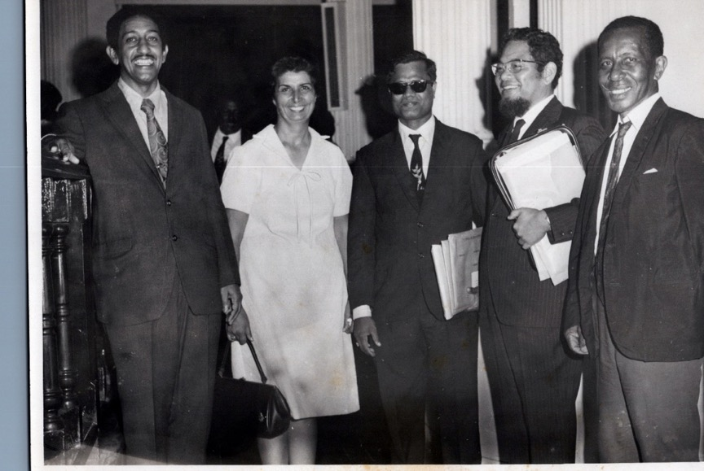
The day that the Parliament passed the Act of Incorporation:
L. to r.: 1) Mr. Carter, secretary of the Senate committee?, 2) Shamsi, Chairperson of the local Assembly, 3) government official ?, 4) Dr. Max Awon, Minister of Health, 5) Mr. Leopold Fraser, Secretary of the local Assembly,
First official Baha’i wedding
This incorporation allowed the Baha’i community to be represented in an official capacity. The first official Baha’i wedding was held in Trinidad on August 4th, 1970, between Mr. Joel Gardner Caverly, a music educator from Massachusetts, and Ms. Edna Ruth Green, from Savannah, Georgia, and it was announced in The Express, August 14th edition.
Marriage of Edna Ruth and Joel Caverly
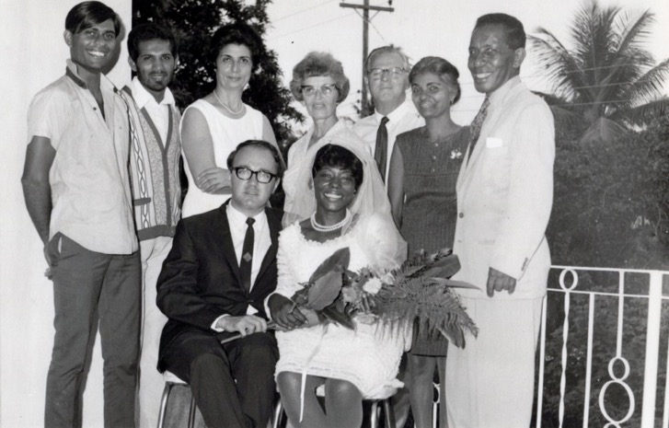
Front row, r. to l.: Miss Edna Ruth and Mr. Joel Caverly
Back row r. to l.: 1) Mr. Leopold Frasier, 2) ?, 3) Mr. Leslie Vaughn,
4) Mrs. Rhoda Vaughn, 5) Shamsi, 6) and 7) ?
(the question mark means that I know them but forgot their names)
My participation in inter-religious committee
Over the summer, the Baha’is were invited in their new official capacity to join the inter-religious committee of Trinidad and Tobago on which I served. In this capacity, the United Artists of Trinidad Inc. asked me to serve as one of the judges in the slogan contest to find a phrase that would capture the idea of the “unity of nations and religions.” Trinidad was ethnically diverse with citizens of African and East Indian backgrounds primarily, with some Middle Eastern and European as well, as different religions such as different branches of Christianity—Anglicans, Presbyterians, Evangelicals, Baptists, Roman Catholics etc.—Hinduism, Islam, Afro-Caribbean religions, and the Baha’i Faith. I compiled a list of phrases taken from the Baha’i Writings. The committee of judges read all of the submitted slogans and whittled all the submissions down to ten and unanimously agreed on one: “Unity in Diversity.” At the awards ceremony, Mr. Leopold Frasier, the Secretary of the Spiritual Assembly of Port of Spain, received the prize on behalf of the Baha’i community. The Guardian newspaper announced the winning slogan in its edition of September 13, 1970:
“‘Unity in Diversity’ is the slogan which has won the contest sponsored jointly by the Empire Cinema and United Artists of Trinidad Inc.
The intention of the contest was to promote racial harmony and fraternity.
Following are the winners:
First Prize: “Unity in Diversity” submitted by Mr. Leopold A. Fraser (on behalf of the National Spiritual Assembly of the Baha’is of Trinidad and Tobago).
Second Prize: “All For One, One For All, We Have Risen From Our Fall,” submitted by Miss Elizabeth Devrick (?).
Third Prize: “Beautiful Is All Of Us, So Why the Fury, Why The Fuss?”
Exemption of Baha’i children from attending school on the Baha’i Holy Days
On the 9th of July, the Ministry of Education and Children granted an official exemption from attending school on Baha’i Holy Days for Baha’i children despite the doubts of many people that this would be given to us. When I called on the Minister of Education to seek this exemption, I took with me a Baha’i World, volume 13 (1953-1964), which included examples of the incorporations of Assemblies and Holy Day exemptions from around the world, so he could see that other countries had done this. He agreed to the exemption and wrote it by hand on a piece of paper. I asked him to please write it on official letterhead as the Baha’is would be using it for a formal request from the schools which he did. The letter is as follows:
“MINISTRY OF EDUCATION AND CULTURE
Alexandria Street, St. Clair, Port-of-Spain
9th July, 1970.
Dear Sir, I am to inform you that permission is given to members of the Baha’i Faith to be exempted from attending classes during their holy days, if they so desire. The days are – March 21; April 21; April 29; May 2; May 23; May 29; July 9; October 20; November 12.
Yours truly,
Sgd. LUIS A. BARRADAS,
For Permanent Secretary,
Ministry of Education and Culture”
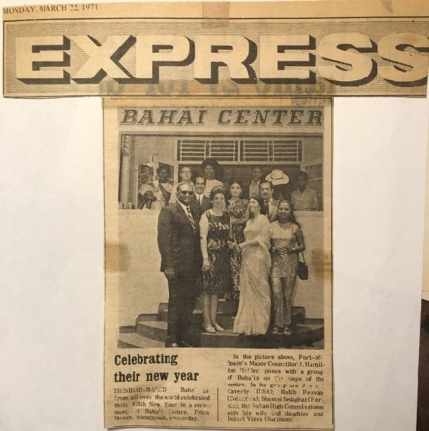
Photo of Mayor Hamilton Holder and Baha’is of Trinidad on the occasion of the Baha’i New Year, 1971

The meaning of the Baha’i Holy Days is as follows
March 21: the Baha’i New Year, end of the Fast
April 21, April 29, May 2: three Holy Days of the Ridvan period when Baha’u’llah declared Himself to be the Manifestation of God
May 23: the Bab declared Himself the Manifestation of God and forerunner of Baha’u’llah
May 29: Ascension of Baha’u’llah
July 9: Martyrdom of the Bab
October 20: Birth of the Bab
November 12: Birth of Baha’u’llah
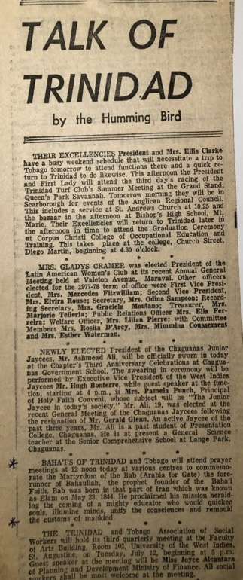
Announcement of Holy Day in the Talk of Trinidad, the Guardian

In August, the Caverleys, an inter-racial couple, became the first Baha’i couple to be married in Trinidad by a Baha’i marriage officer. By October we had secured the last remaining legal paper, a license to be a marriage officer, which was given to Mr. Leopold Fraser, my co-worker on the Port of Spain Baha’i local assembly.
Arrival of Hand of the Cause Mr. Zikru’llah Khadem and the election of the National Spiritual Assembly of the Baha’is of Trinidad and Tobago
The culmination of the administrative development of the Faith in Trinidad during those years was the election of the country’s first National Spiritual Assembly in Ridvan, 1971. This milestone was covered by the Trinidad Guardian, in its Friday, April 23rd, edition:
“Mr. Khadem, Hand of the Cause of God of the Baha’i Faith, and representative of the Universal House of Justice in Haifa, is arriving in Trinidad today to witness the coming into being of the National Spiritual Assembly of the Baha’is in Trinidad.
Mr. Khadem, who is coming from America, is among several high-ranking members of the faith who will be at the first election of the National Spiritual Assembly of Trinidad and Tobago.
This country is among seven electing National Assemblies this week, bringing to 101 the number of such assemblies in the world. Other countries are Lesotho, Ivory Coast, Mali and Upper Volta, the Solomon Islands, Sudan, Chad and Congo Brazzaville, and Gabon. …
Also, in Trinidad for this coming of age of the Baha’is are Dr. Weldon Woodard, chairman of the National Spiritual Assembly of Venezuela, and Mr. Donald Witzel, who is a Counsellor of the Baha’i Faith attached to South America.
Representatives from the United States, Curacao, Surinam, and Guyana were also witness to the national election.
Twenty-one local assemblies were elected in their districts, on Wednesday.
The first National Baha’i Spiritual Assembly of Trinidad and Tobago will be elected tomorrow (April 24th, 1971) at the Baha’i Centre, 3 Petra Street, at a National Convention. Nineteen delegates of Baha’is in Trinidad and Tobago will elect nine persons from the Baha’i Faith to form the first assembly.”

Result of the election of the National Spiritual Assembly of the Baha’is of Trinidad and Tobago, April 24th, 1971

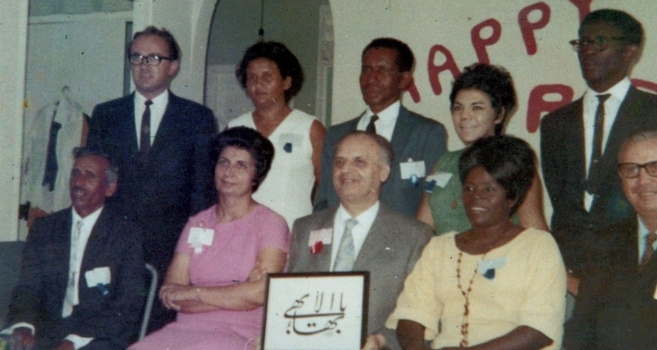
Back row l. to r.: Mr. Joel Caverley, Ms. Gloreen Richards, Mr. Leopold Fraser, Mrs. Nikoo Amarsingh, Mr. Laciford Rock. Front row l. to r.: Mr. Ramdass Ramkisson, Shamsi, Hand of the Cause Mr. Khadem, Ms. Alma Lyons, Dr. Lavern Johnson

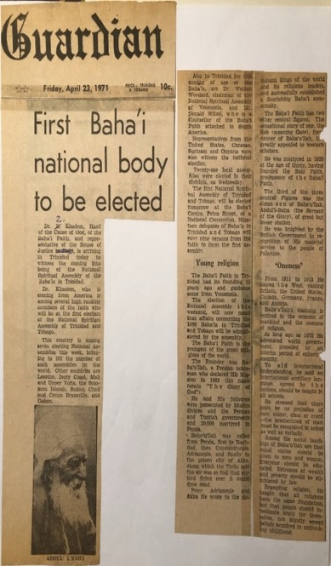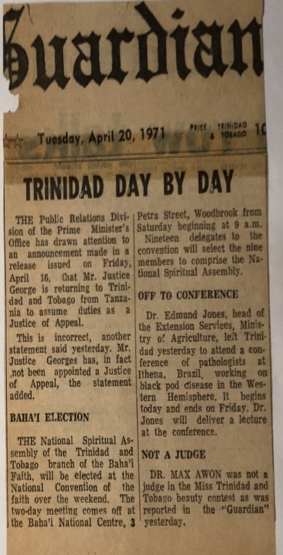
Announcements of the election of the National Spiritual Assembly of Trinidad in The Guardian

The following Thursday the newspaper, the Guardian, announced the election results: Shamsi Sedaghat, Chairman, from Port of Spain; Leo Fraser, Secretary; Joel Caverley, Treasurer; Laciford Rock, Vice-Chair; Ramdass Ramkisson and Gloreen Richards from Las Lomas; Alma Lyons from Mason Hall; Lavern Johnson from Port-of-Spain; Nikoo Amarsingh from San Fernando.
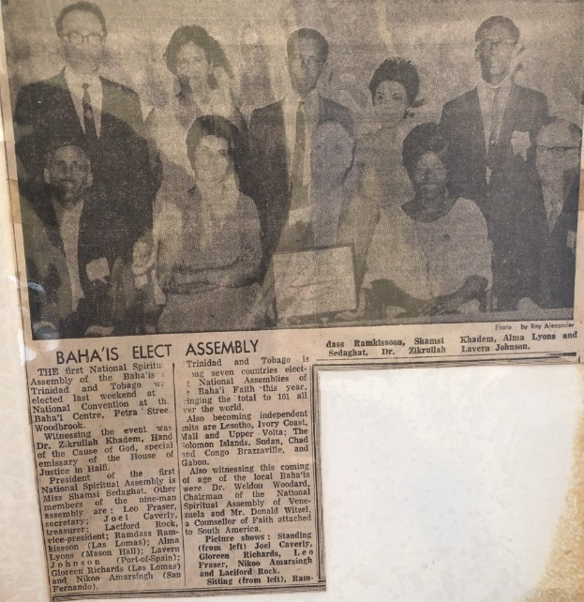
Article and photo in the Trinidad Guardian about the election of the National Spiritual Assembly of Trinidad and Tobago
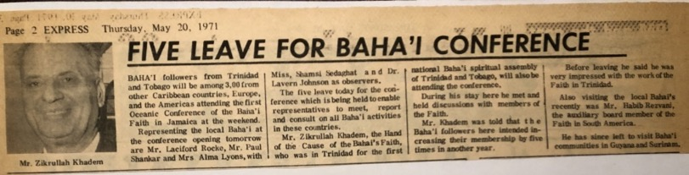
Article in The Express about the Oceanic Baha’i Conference
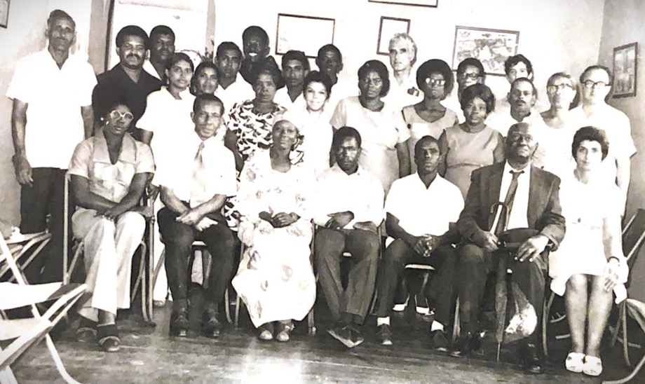
The Baha’i community of Port of Spain, c. 1970s
Incorporation of the National Spiritual of the Baha’is of Trinidad and Tobago
The election of the national body was confirmed by an Act by the Parliament for the incorporation of the ‘National Spiritual Assembly of the Baha’is of Trinidad and Tobago’. I was invited along with two other Baha’is to meet with the Special Select Committee of the Senate to present all the relevant papers in support of the incorporation of the new National Assembly in November 1971:
“Parliament
Red House Port-of-Spain
Trinidad
Trinidad and Tobago
4th November, 1971

Madam,
I have been directed by the Chairman of the Special Select Committee of the Senate appointed to consider and report on a Private Bill entitled “An Act for the incorporation of a body to be known as “The National Spiritual Assembly of the Baha’is of Trinidad and Tobago” to request you to attend a meeting of the Committee which will be held on Tuesday 9th November, 1971 at 3.00 p.m. in the Parliament Library, Red House, Port of Spain.
You are requested to bring all papers and records required to substantiate the facts and other allegations in the Bill. Your Association may be represented by three (3) of its members or by counsel.
I have the honor to be, Madam,
Your obedient servant,
Mr. Carter, Secretary”
Over the course of the early 1970’s the Baha’i community became strong in the hands of capable believers, so I increasingly turned my attention to the wider world of the Caribbean and beyond and undertook a series of lengthy and fruitful travel teaching trips.

Chapter 7

Teaching in Jamaica, the opening of the Couva Clinic and the declaration of Dr. Harry Collymore
The Baha’i community in Trinidad and Tobago was on a solid foundation—its institutions were recognized by the State and important legal permissions had been granted and its National Assembly brought into being. The dynamic growth of the Faith in Trinidad could serve as an inspiration and model for other islands, and there was only one year left to reach the goals of the Nine-Year Plan. That year I was called to serve outside of Trinidad and began the first of several lengthy and fruitful travel teaching trips throughout the Caribbean.
The Caribbean Conference in Jamaica, 1971
I had attended the Caribbean Conference in 1971 held in Jamaica, one of a group of such gatherings that included ones in the South Pacific, the North Pacific, and the North Atlantic, called for by the Universal House of Justice to make a final push at winning the goals of the Nine-Year Plan. I travelled to Jamaica with several Baha’is from Trinidad, Mr. Laciford Rocke, Mr. Paul Shankar, Mrs. Alma Lyons, and Dr. Lavern Johnson. Our departure and the progress of the Faith in Trinidad was noted in an article in The Express, May 20th, 1971, which stated that the local Baha’is had told their visitor, Hand of the Cause Mr. Z. Khadem, that the Faith would increase five-fold in Trinidad. Hands of the Cause Mr. Z. Khadem and Mr. John Robarts attended the Caribbean Conference. Prior to the opening, Mr. Robarts and Mr. Dan Jordan, the Vice-Chairman of the National Spiritual Assembly of the Baha’is of the United States, discussed the Baha’i Faith privately with the Governor-General of Jamaica, His Excellency Sir Clifford Campbell. The opening and the proceedings of the Conference were covered in the May 20th edition of the Daily Gleaner newspaper. The Governor General officially opened the Conference followed by talks on “The Proclamation of the Baha’i Faith,” “Role of Youth in the Baha’i Faith,” “The Teaching of People of African Descent,” and “Pioneering for the Baha’i Faith.” Saturday a major proclamation concert was held at the National Arena featuring world renowned musicians Dizzy Gillespie and Seals and Crofts. Counsellors for Central America Alfred Osborne, Artemus Lamb, and Carmen de Burafato, Counsellor for North America Lloyd Gardiner, and Counsellors for South America Hooper Dunbar and Donald Witzel, came to enrich the conference with their insights and to encourage the believers. Throughout the Conference, classes on the Faith were held aboard the S.S. New Bahama Star which functioned as a floating teaching institute. Immediately after the docking of the vessel, Mr. Glenford Mitchell, the Secretary of the National Spiritual Assembly of the Baha’is of the United States, also presented Mr. Eli Matalon, the Mayor of Kingston, the capital of Jamaica, with a scroll of greeting from the Mayor of Miami, Florida. The Universal House of Justice wrote that “This Conference is an occasion to sum up what has been won, to determine to achieve the remaining goals for expansion in these blessed lands, and to consolidate the old and new communities of the Most Great Name.” Over the course of the Plan the number of local assemblies in the Caribbean had grown from 147 to 500 and that sixteen National Assemblies had been formed. The final day, Sunday, included direct teaching activities.
We had good success in teaching during that trip, and then I returned to Trinidad to continue my Baha’i work there. I went back to Jamaica the following year, in 1972, going by way of Panama where I had the privilege of attending the dedication of the Baha’i House of Worship in Panama City.
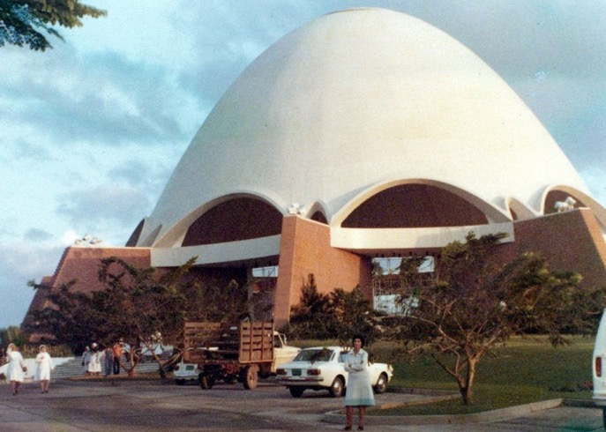
Shamsi at the House of Worship in Panama standing in front of the white car
Hand of the Cause Amatu’l-Baha Ruhiyyih Khanum had laid its foundation stone on behalf of the Universal House of Justice in October of 1967. Sitting atop “Singing Hill” above Panama City, the Temple was built of local stone placed together in patterns that evoked Native American fabric designs. The Universal House of Justice wrote for its opening.
Letter from the Universal House of Justice
“With praise and gratitude to God the whole Bahá'í world acclaims the dedication of the Mother Temple of Latin America, an edifice which glorifies the Cause of Bahá'u'lláh at that point where, the beloved Master asserted, "the Occident and the Orient find each other united through the Panama Canal," where "The teachings, once established..., will unite the East and the West, the North and the South."”
This historic project, in a hemisphere of infinite spiritual potentiality, fulfills one of the most important goals of the Nine-Year Plan, and brings untold joy to the hearts of the friends in every land. Privileged are they who share in the raising of this glorious Silent Teacher with deeds of loving generosity and sacrifice. A crown to the labors of all those who have striven to establish the Faith of Bahá'u'lláh in Latin America, this Mashriqu'l-Adhkar the rallying point for the Bahá'ís of those lands, whether they are of the blessed Indian peoples or represent the other races whose diversity enriches the nations of that hemisphere, will be a fountainhead of spiritual confirmations.”
Second visit to Jamaica, 1972
On May 9th, 1972, I set off for my travel teaching post to Jamaica accompanied by a representative of the National Assembly of Jamaica. Ms. Elaine Anglin, the Assembly Secretary, met me and provided me with loving hospitality on and off for two weeks. During my meeting with the National Assembly two days later, I was asked to travel to the town of Port Antonio to teach with Mrs. Gayle Bond, a pioneer from Canada, and plans were also made for an Assembly member to accompany me to the Daily Gleaner newspaper which had an editor who had been referred to me by one of his colleagues in Trinidad.

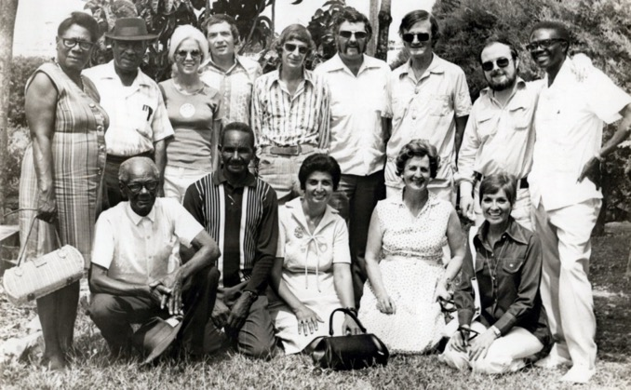
A group of active Baha’i friends in Jamaica, 1972
A few of those whom I remember are as follows:
front row r. to l.: Ms. Terry Madisson, Mrs. Gayle Bond, and Shamsi.
The following day, I went for an interview at the Gleaner accompanied by Mr. Elias Zoohuri and Mr. Yvor Stoakley, during which I presented the essential principles and news about the dedication of the Temple in Panama. Most importantly I secured a meeting with the editor of the paper, Mr. Sealy, during which he agreed to give the Faith the same free publicity given to other religions on the islands and to publish extracts of talks given by distinguished Baha’i visitors to Jamaica.
Obtained a weekly spot on the radio
Mr. Fitz-Henley, Auxiliary Board Member—who was known by the staff—, Mr. Stoakley, and I went to the Jamaica Broadcasting Corps where we arranged for an interview and secured a weekly spot on the radio. I expressed my surprise to the managing director that there was no weekly radio program on the Faith, and he responded that the Baha’is had not practiced the Scriptural command to “Ask and it shall be answered!” Some days later, the director contacted us to inform us that the Baha’is could have one half hour slot per evening during the week nights, a major victory for the Faith in Jamaica; later, the content of these broadcasts would be restricted by concerns about not offending the deeply Christian islanders with statements about Baha’u’llah being the Return of Christ. I ended up giving two short interviews on May 28th and May 30th for the “Women’s World” program which were sympathetic to the Faith. Local Jamaicans recognized me later from my Persian accent and as the ‘Persian lady’ who lived in Trinidad whom they had heard on the radio. The most wide-reaching media interview took place later in June when Mr. Balfore and Mr. Wenty Bowen, senior producer/director of the Jamaica Broadcasting Corporation, interviewed me for thirty minutes for the television show, “Perspective.”
Interview with media
Mr. Bowen and a staff of four arrived with cameras at the National Baha’i Center at 208 Mountain View Ave. where many friends had gathered, and they took footage of the front, photos of the Houses of Worship, and interviewed me for twenty-five minutes While I was being interviewed, Ms. Lois Falconer spoke at length about the Faith with Mr. Fitz-Henley. We presented Mr. Bowen, the producer, with Paris Talks and Christ and Baha’u’llah. At the end of June, we watched the broadcast of “Perspective” which ended up including at least fifteen minutes of the original interview.
Visit to Port Antonio
After giving the interview, we left for our teaching goal area of Port Antonio, a booming tourist town sixty miles to the north on the coast, as the National Assembly asked us. The friends there were holding an election for their local assembly, and we offered to assist. They were happy to see us, especially Mrs. Bond, formerly Ms. Keass, who had lived there twenty-one years ago. She showed them an album with photos from those years which included a few of the Baha’is present, and this warmed everyone up. I was asked to explain the Baha’i election process, and then Mrs. Bond and I stepped outside. When the voting was completed, and the Assembly constituted, we consulted together on teaching plans for the coming six days.
On May 10th, Mr. Seymour and Mr. Gray from the Assembly and I met with Mr. Robinson, the principal of the Junior Secondary School and spoke with him about the Baha’i teachings and gave him the book The Prisoner and the Kings by William Sears. He was an educated man with a Baha’i spirit. We had hoped to return to speak with students, but this was not possible due to exams.
We met with officers in charge of the agency for youth and development and, after hearing about the Faith, they were eager to have us speak with the various youth clubs which were meeting throughout the week. They gave us a speaking schedule for the following days. That night we held a very joyous evening at the Baha’i Center as Baha’is came out who had not been at a gathering in a while.
Meeting the Mayor Councilor Dyce and speech at youth club
The morning of May 11th, we met the Mayor Councilor Dyce at an event in front of Town Hall. We invited him to the proclamation meeting we were planning for Sunday night, and I asked for permission to announce the meeting over the loudspeaker. In the evening, Mr. Seymour, Mr. James, Mrs. Bond, and I went to the Halifax Youth Club. There were forty youth present, and I spoke to them about progressive revelation and other Baha’i teachings. The eager youth asked many questions, and a spontaneous seven-minute talk was given by Mr. James which made an impression on them.
Slide show and speech at town hall
On May 12th, we prepared posters in the morning for the Sunday meeting. Mrs. Bond went to the Center at 7:30 p.m., to give a presentation to Baha’is about pioneering and showed her slides of her service in the Canadian Arctic which fascinated the local Baha’is. Meanwhile I went with Mr. Thompson to the San San Police Youth Club and spoke to thirty youth. When I was done, I taught them a few Baha’i songs, and all the hearts were uplifted as we sang together with the youth singing like they had known these songs all their lives.
The next morning, May 13th, we went to the Junior Secondary School to speak to senior members of the youth clubs in Port Antonio and surrounding areas. I explained the Baha’i teachings to the thirty students present and questions were answered by Mrs. Bond and Mr. Seymour. When another student tried to interrupt the discussion, the others silenced him because they wanted to learn more.
All of Sunday, May 14th, 1972, we prepared for the public meeting at the Town Hall. Mr. Seymour and Mr. James drove around town announcing the meeting over the loudspeaker mounted on the car. When the program began, there were forty adults and fifty children. After prayers and readings, I spoke about the agreement of science and religion and showed colored slides related to the Faith. I was happy at the end that so many people had learned about the Faith.
Dedication of Baha’i National Center
I was back in Kingston on May 18th, 1972, for the dedication of the National Haziratu’l-Quds at which Hand of the Cause Mr. Giachery and his wife were present and encouraged the believers; they also paid a courtesy call to his Excellency the Governor-General Dr. Clifford Campbell.
Two days later I met with the Baha’is who would be planning the radio show and who seemed overwhelmed by the task. I advised them to start simple by planning programs that opened with a prayer followed by a song and then the reading of one of Abdu’l-Baha’s talks from Paris Talks or The Promulgation of Universal Peace and then close with a prayer and a song. This simple format would be easy to plan and effective and instructive to the listeners.

Visit to Yallahs
On Sunday, I travelled with Mr. Elias Zoohuri, the recording secretary of the National Assembly, to the coastal town of Yallahs to the east of Kingston. We invited and transported members of the local Assembly to the center there and I spoke with them about the duties of a local Assembly and then left the meeting so the voting for officers could proceed.
Celebrated the Anniversary of the Bab’s Declaration
We gathered at the Baha’i Center in Kingston to celebrate the Declaration of the Bab, during which I spoke about the history of the Bab. The spirit of the meeting was heightened when the power went out and nine candles were lit. A schoolteacher, Ms. Bryden, came to the celebration after hearing her eight-year-old daughter speak enthusiastically about the Baha’i Faith. Her brother had attended the Panama conference and returned enkindled with the spirit of the Faith which attracted his younger sister. Subsequently, she spoke in her class about the Baha’i Faith, and her teacher asked to learn more about it. At a public meeting on the 27th of May at which I presented a slide show, Ms. Bryden accepted the Faith, making her eight-year-old student her ‘spiritual mother’; three days later the young girl’s mother also declared.
On the Holy Day itself we decided to go out and do some direct teaching in the Mountain View Terrace with Glen Lissner, Mr. Zoohuri, Mr. Fitz-Henley, and Ms. Elaine Anglin. We split up into three teams and over the course of the day, we found one waiting soul, Ms. Carol Maltos, and two Baha’is who had ceased coming around and were eager to become engaged again in the Faith.
The help of the National Teaching Committee
The National Teaching committee gathered the Baha’is of Kingston and surrounding parishes together on May 28th for a teaching conference in which the duties of the local assemblies, the importance of the Nineteen-Day feasts, and methods of teaching were covered, after which ten Baha’is including our new declaree, Ms. Bryden, got into a van equipped with loudspeakers and carrying literature and slides and drove to Yallahs. There, we set up in the town square and presented the Faith to over fifty people who had gathered around us in the street lit only by the van’s headlights. On our return to Kingston late the next night we observed the anniversary of the Ascension of Baha’u’llah in a solemn and powerful three and a half-hour commemoration. We returned to Yallahs the following day and gave a slide show at which two new souls were awakened whom we welcomed into the Baha’i Faith.

Expansion of mass teaching and public talks
It was then decided to dedicate much of June to mass teaching efforts. Several teams were appointed, and they were assigned different areas of the city. For the first ten days, two teaching teams went out, one in the morning, the other in the evening, to locate old believers, deepen them, and encourage them to participate; they taught the Faith as the opportunities arose. On one evening, numerous youths gathered around us on the street corner, eager to listen and learn more. Mrs. Lois Lissner kept the Baha’i center open every night for seekers and new believers and provided us with material support such as song sheets. I went with a group of teachers to Hope Gardens which then divided up into three teams; mine consisted of myself, and Hedy and Nilu Zoohuri, who were eight and fourteen, respectively. We all taught until three that afternoon. Five young female college students accepted the Faith. The Lissner team found one seeker who became a Baha’i in subsequent days.
Meeting at Kingston Baha’i Center
On Saturday night, June 10th, 1972, we held a Baha’i night at the Kingston Baha’i Center to which we invited the Baha’i community, reporters, and our friends from the “Women’s World” radio program. I gave a short talk about the Faith which was followed by two films, “It’s Just the Beginning” and “Have you Heard the News my Friend?”, and songs from the youth which were well-accepted.
Teaching results in many declarations
We were fortunate to have several additional opportunities to speak with youth. I spoke to a class in the 5th form on progressive revelation and some Baha’i principles along with Mr. Glen Lissner, Mrs. Shahin Zoohuri and her youngest daughter Hedi. The students were lively and asked many questions and were happy to learn Baha’i songs and a Baha’i prayer. The wife of the headmaster who taught at the school asked for Baha’is to return for another visit in the future. At the Mountain View Terrace community center three days later, we had a large gathering at which Mr. Leslie Haughton taught Baha’i songs to thirty children followed by a short talk by me and then the showing of two films. Mr. Fitz-Henley ably answered questions from the several dozen adults present. At the end, five youth embraced the Faith. On the 16th of June, a teaching team made up of Mr. Fitz-Henley, Mr. Zoohuri and his children, Mr. Effion Whyte, Ms. Bryden, Ms. Senior, and I went to the Excelsior Secondary School, run by Mr. Wesley Powell who knew of the Faith from relatives in the United States, to speak with students about the Faith. (Mr. Jack West and I had secured this meeting through a contact we made during one of our direct teaching days.) There were several declarations including Ms. Marjorie Goulbourne and a Chinese student, Rose Lyn. Later in the month, Mr. Fitz-Henley, myself, and others went to visit Baha’is in Clairmont with a view to training youth there to become mass teachers.
Village meetings
Meetings in villages attracted large numbers of children and youth. A new Baha’i, Ms. Leila Tomlinson, asked us to come to her village, August Town, so a teaching team made up of Ms. Leslie Houghton, Ms. Lissner, Jack West, and myself, went there and obtained the use of the community center. I spoke and showed slides to the 106 children and youth who came. We taught them songs, and the village Sunday school teacher was very pleased and kept a copy of the songs for future use in her class. This session was followed by another ten adults who had a wonderful spirit. Direct teaching continued as a teaching team made up of Mr. Yvor Stoakley, Mr. Watkins, Mrs. Lissner, two newly declared Baha’is, and I went to Hermitage Village and divided it up into three teams and taught the Faith in the village. A June 20th meeting attracted 110 children and youth who were so excited that they did not want to leave even when the children’s session was over. Later we held a quieter meeting for adults at the home of a new Baha’i, Ms. Bryden. The following day Mr. and Mrs. Lissner gave a presentation with slides which was well-received. By the end of our efforts, five new people had declared.
My simple food
We taught the Faith without ceasing. I made little time for eating, often choosing bread and cheese rather than full meals. Mrs. Lissner remembered this in a letter she wrote to me when I was back in Trinidad:
“Nearly every day we think of you and laugh—Lois (i.e. Mr. Lissner) will say—well, what will we have to eat? And at least once every day I say—how about something different—How about some bread and cheese? It is so satisfying, especially if we’ve been out teaching and Lois doesn’t feel like cooking. But we laugh because we remember how the friends teased you about always having bread and cheese—guess they were expecting you to cook pheasant under glass. Anyway, we read in Mr. Balyuzi’s book, Abdu’l-Baha, where Abdu’l-Baha always had bread and cheese when he was alone—So what was good enough for Him must be good enough for us.”
Thanks to the efforts of Mr. Lissner, Mr. Zoohuri, and especially Mr. Fitz-Henley who accompanied me on all my teaching trips and interviews, I was able to put into practice what I had learned from previous experiences in the field of teaching and proclamation and felt that our joint efforts had furthered the cause in Jamaica. After a few days I thanked all for their love and sincere assistance, said goodbye, and left for Trinidad.

Rezvan Clinic in Pointe-a-Pierre
My return to Trinidad was noted in the ‘Talk of Trinidad’ section of the Trinidad Guardian’s Wednesday, July 12, 1972, edition:
“Many patients of Rezvan Clinic, formerly of Port of Spain, and now located at Plaisance Park, Pointe-a-Pierre, must have been wondering during the past few weeks what and where was the clinic’s capable administrator cum nurse and midwife, Miss Shamsi Sedaghat from Panama, “Sister Shamsi,” as she is familiarly known, stopped off in Jamaica at the invitation of the Baha’is there and she has only three days ago returned to Trinidad. In Jamaica, she was kept busy with radio, TV, and newspaper interviews and lectures on the Baha’i Faith. “It was one of the busiest times I have spent,” she said. Back in Trinidad, Shamsi has asked me to let her friends know that she will be most happy to see them again”
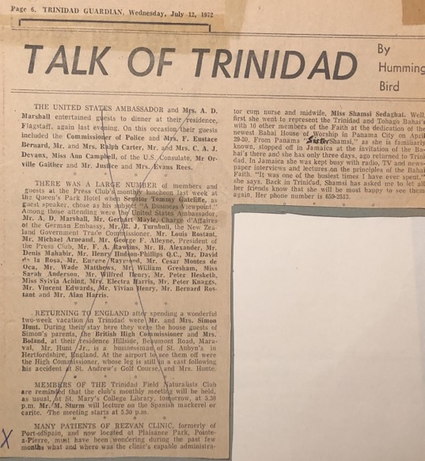
Notice announcing Shamsi’s return to Trinidad.

Informed the Universal House of Justice about the Rezvan Clinic in Pointe-a-Pierre
By moving my clinic to Plaisance Park, 188 Long Circular Rd., Pointe-a-Pierre (South), I hoped I would succeed in my endeavors but unfortunately my clinic in this area was not sustainable because of existing other medical institutions. Therefore, I wrote the following letter to our Supreme Body, the Universal House of Justice, in January 1973, about my tests:
“The Universal House of Justice
Haifa, Israel
Beloved friends,
…moving to South Trinidad has affected the patronage of my clinic, resulting in very little income. This problem did not bother me for the past 15 months, as I had some reserves. I must say not only did it not bother me but gave me more time to help the friends in teaching and consolidation.
Unfortunately, this bounty is coming to an end as I cannot support myself anymore, especially as I wish to attend the International Convention in Haifa and then pay a visit to my family in Iran.
On my return from Iran I do not know what to do. May I go to U.S.A. work for six months, gain some capital and return to Trinidad and continue my private practice and serve the Faith? Or under your direction and guidance pioneer to another territory where I could obtain a government job, ensure a steady income, and serve the faith more freely?
I beg your infallible body to guide my steps, pray and guarantee my continued humble services to our Beloved Faith,
With loving Baha’i greetings,
In His Service,
Shamsi Sedaghat.”
The reply of the Universal House of Justice
The Universal House of Justice sent me an encouraging reply with guidance:
“Miss Shamsi Sedaghat
Rezvan Clinic,
Plaisance Park,
Point-a-Pitre,
Trinidad
Dear Bahá’í Friend,
We have reviewed your letter of January 25th and fully appreciate the difficulties facing you. The very promising nature of the Bahá’í community of Trinidad and Tobago, and your own constructive role in the work of the National Spiritual Assembly there leads us to hope that you may find it advantageous to settle somewhere in the islands where you can be self-supporting and continue your valuable services to the Cause. We urge you to consult your National Spiritual Assembly on this matter, which is of great importance to both them and you and we will pray that the way will open for you to continue to serve the Faith in that area where your efforts have been so confirmed and rewarding.
With loving Bahá’í greetings,
The Universal House of Justice”
Rezvan Clinic in Couva, 1973
In 1973, I moved the Rezvan Clinic to its final home in Couva, De Gannes St. Isaac Ext., south of Port of Spain, in an area with a large East Indian population and burgeoning industrial activity. I informed the Universal House of Justice of the opening:
“THE UNIVERSAL HOUSE OF JUSTICE
BAHA’I WORLD CENTRE
HAIFA, ISRAEL
Beloved Friends,
With great respect and utmost humility, I acknowledge the receipt of your letter dated 12th February 1973, and I wish to express my joy for the unexpected bounties which your August Body has bestowed upon this humble servant and offer my sincere obedience and total submission to your instructions.
I consulted our N.S.A. and they advised me to settle wherever I think is most suitable for my Clinic.
For several months I was trying to move to Couva, one of the most thickly populated towns in Central Trinidad, where we have fourteen (14) Local Spiritual Assemblies around it, but no success. Immediately after your Bounties and Prayers I was offered an Excellent building with a reasonable rent in the same town. Praise be to God. So, I moved here since 1st April 1973, and hoping to have Opening Ceremony on June 23rd, 1973, with the presence of representatives of the Minister of Health and other High-ranking Government Officials, to whom I am known well.
Humbly beg your further prayers for my continued servitude to the threshold of Baha’u’llah.
With warmest greetings,
In His Service,
Shamsi Sedaghat”

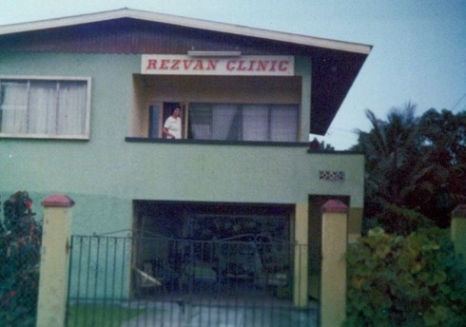
Rezvan Clinic in Couva, central Trinidad
Reply of the Universal House of Justice
The Universal House of Justice encouraged me in the following letter:
“Miss Shamsi Sedaghat
Rezvan Clinic, Isaac Extension
Couva, Trinidad, West Indies
Dear Bahá’í Friend,
We were delighted to receive the good news on your letter of April 9th and congratulate you on the happy opportunity which has enabled you to establish your clinic in Couva. As you say, in so populated a district, you will have ample opportunity to serve both the spiritual and physical needs of the people. We wish you every success in your devoted efforts and will pray for you at the Sacred Threshold.
With loving Bahá’í greetings,
The Universal House of Justice”
Rezvan Clinic opened in Couva
At the opening, Mr. Teasley Taitt, the permanent secretary to the Ministry of Health for Trinidad and Tobago, praised the clinic and read the statement from the Minister of Health:
“Mr. Chairman, Parliamentary representative for Couva, distinguished guests, ladies and gentlemen:
Let me say two things at the outset, firstly, The Honorable Kamaluddin Mohammed, Minister of Health has asked me to express to you his sincere regrets at his inability to attend this function this evening, due to a previous important commitment, but has sent a message to you which I shall read presently.
Secondly, I am very happy to be here this evening to say that my family has already benefitted by the high standard of service rendered by the Rezvan Clinic when it was operated in Port-of-Spain during 1970. My last son was born there, and the fact that my wife and son are here this evening is evidence of our satisfaction with the Rezvan Clinic.
The Honorable Minister’s message is as follows:
The Ministry of Health has as one of its primary objectives the delivery of a Health Care to the people of this country at the highest possible standards, given the limitations of human resources and equipment.
On doing this a network of major General Hospitals with full specialist services, district Hospitals and Health Offices have been provided. In fact, there is in this area a distinct hospital at Couva with a modern maternity unit and a new casualty department, which offers as all hospitals do, a twenty-four-hour service to the community. The government is going one step further, and with the help of the World Bank Loan will commence the construction in January 1974 of a new type of health center with a delivery unit in the following areas where there are no district hospitals:
Chaguanas Rio-Claro Petit Valley Diego Mart
And in addition, the delivery unit to the existing health center at Roxborough, Tobago. These units will operate on a twenty-four-hour basis.
But the government alone cannot under the present circumstances provide all the health services to the entire country... The need exists for the health services now provided in the rural areas to be assisted in some way by privately operated clinics and nursing homes which must be efficiently managed according to the highest professional standards.
It is in this context that today I welcome the opening of the Rezvan Clinic in Couva. Miss Sedaghat is a Nurse with wide experience gathered from years of work in her native Iran, Cyprus, Africa, the United Kingdom and right here in Trinidad where she has operated successful Clinics under the same name “Rezvan” both in Port of Spain and Plaisance Park, Point-a-Pitre. Always on the lookout for the areas in which these services are required, she decided to come to Couva, the surrounding area of which is expected to be soon burgeoning with industrial activity.
Miss Shamsi Sedaghat, it is for these reasons that I welcome the opening of the Rezvan Clinic in Couva and on behalf of the Honorable Kamaluddin Mohamed, Minister of Health, I now wish to congratulate you on the choice of location for this venture and to formally declare this Rezvan Clinic open, and wish you and the residents who will utilize its services good health.”
Rezvan Clinic and the staff
The new clinic had five rooms. The admitting and delivery rooms along with bathrooms were downstairs. The living room, bathroom, kitchen, and dining room which provided excellent food were upstairs.
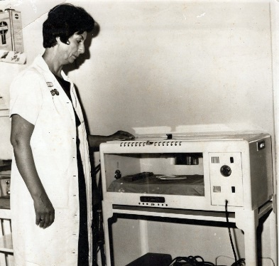
Shamsi with an incubator at the Couva clinic
The clinic provided patients with a calm and loving atmosphere which helped make it a popular place for expectant mothers to deliver. We always had a nurse on duty and on call even if we had no clients. Other clinics sometimes lost their clients to us. I did much of the cooking myself which surprised people and could be quite demanding when patients had special dietary needs. Local women performed domestic chores such as washing the linens in a big tub in the back and hanging them on the clothes line as we didn’t have adequate laundry facilities in the beginning. When one or the other staff couldn’t come to work for some reason, I did the work myself. I managed the financial affairs of the clinic and did the shopping myself. I took no days off except for the Baha’i Holy Days and even worked weekends if there was a patient.
The new clinic kept me very busy but thriving teaching activities continued.
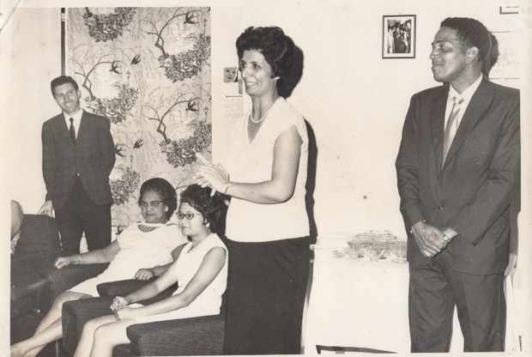
R. to l. 1) ?, 2) Shamsi giving a fireside at the Couva Clinic, 3-4) seated ?, 5) Counselor Peter McLaren
Our children’s classes attracted nearly thirty children every week.
Counsellor Peter McLaren from South America wrote to me words of encouragement after my move to Couva:
“I appreciate your intense desire to spend all of your time in service to the Cause and can certainly understand the frustrations you sometimes feel because your responsibilities in the Clinic keep you there most of the time. Nevertheless, your bounty in receiving direct guidance from the Supreme House of Justice, and your complete obedience to them in having remained at your pioneering post in Trinidad and having found a way to earn your living there, will undoubtedly bring you rich spiritual rewards, if you have patiently persevered along the path they have indicated for you. Even at present you are rendering many important services including serving as Chairman of the National Spiritual Assembly, teaching weekly Baha’i children’s class to 25 or 30 of those beautiful, spiritual children, and you have had the bounty of training such a capable and devoted Baha’i teacher as Mr. Junior Nicholas. You cannot imagine the joy I felt in my heart that Sunday morning watching and listening to the children with their shining faces as they recited prayers, recounted some Baha’i history and teachings, and sang the songs. If you continue teaching these children, you will soon have 25 or 30 more devoted Baha’i teachers in the Couva area.”
Election of the Universal House of Justice
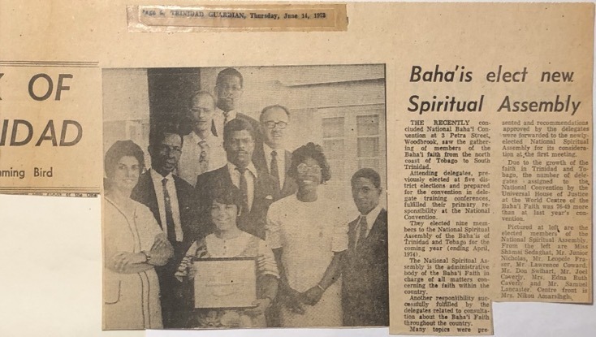
Article announcing election of National Assembly of Trinidad, in May, 1973.
Counsellor Hooper Dunbar, later a member of the House of Justice, spoke with the friends in Trinidad in February 1973. He gave exciting updates about the growth of the Faith around the world that 60,000 centers had been opened to the Faith, the number of National Assemblies had increased from 12 to 114, and that the purpose of these Assemblies at this point is to spread the Faith. He also reminded believers about the different ways each believer can participate according to the House of Justice: all can teach the Faith, all can live the life drawing others to Baha’u’llah, all can give to the Fund, all can study the Writings.
I had the great privilege that same year of being able to participate in the international convention for the election of the Universal House of Justice. I travelled to Haifa with fellow delegates from Trinidad and Tobago, Dr. Laverne Johnson, Mr. Donald Swihart, and Mr. Leo Fraser, who were also my colleagues on the National Spiritual Assembly. Our trip was covered by the Trinidad Guardian which published photos of us and several other delegates to the convention in its May 16, 1973 edition.
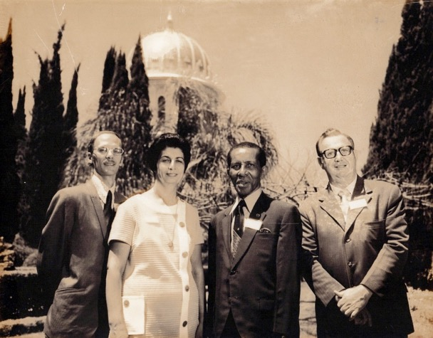
Four delegates from Trinidad to the International Convention 1973
L. to r: Mr. Donald Swihart, Shamsi, Mr. Leo Fraser, and Dr. Laverne Johnson
This sacred election took place every five years, and all the members of National Assemblies around the world gathered in Haifa to cast their ballots for the Universal House of Justice and consult on the state of the Baha’i communities; the members who could not make it, could send in the ballots in advance. The new Baha’i year opened with praise from the Universal House of Justice in its Ridvan Message, 1973: “We announce with joyful and thankful hearts the completion in overwhelming victory of the world-encircling Nine Year Plan. The Army of Light has won its second global campaign”.
The delegates cast their ballots on the morning of April 29th. At 4 p.m. that afternoon we commemorated the Ninth Day of Ridvan, and in the evening reviewed the achievements of the Nine-Year Plan. The next morning opened with early prayers at the site of the future seat of the Universal House of Justice followed later that morning by an address from Amatu’l-Baha Ruhiyyih Khanum. At the end of her talk the results of the election were announced. The newly elected members of the Supreme Institution were Mr. Ali Nakhjavani, Mr. Hushmand Fatheazam, Mr. Amoz Gibson, Mr. Ian Semple, Mr. David Hoffman, Mr. Charles Wolcott, Mr. Borrah Kavelin, Mr. David Ruhe, Mr. Hugh Chance. The two following days, the delegates consulted on the theme of the Convention: “What are the major challenges to the Baha’i World during the next decade and how are they to be met?” The closing address to this two-day consultation was given by Hand of the Cause Mr. William Sears. The final day of the Convention, May 2nd, was entirely devotional. We celebrated the Twelfth Day of Ridvan and the Centenary of the Revelation of the Kitab-i-Aqdas by visiting the House of Abbud and going in the afternoon for devotions at the Haram-i-Aqdas at Bahji. After this visit, we made one last pilgrimage to the Shrine of the Bab in Haifa, and then headed back to Tel Aviv where several delegates caught airplanes back to their respective countries.
Visit of the Hand of the Cause Mr. A.M. Varqa
In August of 1973, Hand of the Cause Mr. A.M. Varqa came to Trinidad. A fourth generation Baha’i, his grandfather had been an Apostle of Baha’u’llah, and after his passing, his father was appointed a Hand of the Cause as well. Shoghi Effendi had appointed him to this position in 1955. He was travelling on behalf of the Supreme Body to encourage the friends to win the goals of the plan. A fluent speaker of English and French, he was visiting French and English-speaking countries in the Caribbean Islands. He had arrived in Trinidad from French Guyana and then would go on from there to Barbados, Martinique, Guadeloupe, Haiti, and other smaller islands and would finish his trip in French Canada. We were fortunate have him for several days in Trinidad during which he spoke multiple times to the friends in Diego Martin and Central Trinidad. During his stay, I delivered at the Rezvan Clinic in Couva the second daughter of Mr. Mansing and Mrs. Nikoo Amarsingh, Farah-Diba. Nikoo Khanum was a nurse/midwife who was working in a private hospital. I was privileged to have the Hand of the Cause Mr. Varqa staying at my place in the Clinic, at the same time. All together we said prayers that day for baby Diba that she would grow up to serve the Faith. She grew up to serve for four years at the Baha’i World Center, Haifa, in the finance department. There she took a photograph with Hand of the Cause Mr. Varqa. She visited India where she served for a month at the Baha’i Temple. Back in Trinidad she served on the Assembly of Port of Spain and as Cluster Coordinator and taught children’s class. Now she is married with a daughter and a son, Olya and Kasra, and lives in Canada where she works as a system analyst and serves the Faith with her family to the best of her ability.
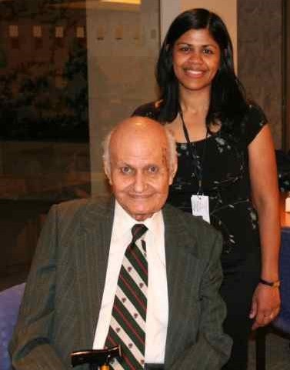
Hand of the Cause Mr. Varqa and Ms. Diba Amarsingh
Visit to Barbados, December 1973
From December 22-30, 1973, I taught at the Nine-Day Teacher Training Institute in Barbados at the request of the National Spiritual Assembly of the Baha’is of the Windward Islands. I was asked to teach about the “Central Figures and History of the Faith”: The Life and Teachings of the Bab, Baha’u’llah, and ‘Abdu’l-Baha, the Will and Testament of ‘Abdu’l-Baha, Shoghi Effendi and the Guardianship, the Institution of the Hands of the Cause, and the Universal House of Justice.
I spent much of 1974-5 in Trinidad. Among other Baha’i activities, I gave public talks at non-Baha’i service organizations. I spoke at an Ecumenical Service organized by the Union of Women’s Citizens under the sponsorship of the National Commission on the Status of Women, held at the Town Hall Auditorium in Port-of-Spain. The theme of the discussion was “Women and Men: The next 25 years.” The panelists gave their views on a variety of issues related to the goals of International Women’s Year – “Equality, Development and Peace.” On another occasion I addressed the 16th Annual Convention of Alcoholics Anonymous Trinidad and Tobago at the Naparima Bowl, Paradise Pasture, in San Fernando. The organizers wrote to me:
“In your untiring quest for the image of a spiritual community, we believe that your participation in our convention at this particular stage of our evolution, would go a long way to give a new dimension of hope and reality to a group of people whose lives and those of their respective families, have been ravaged by dissipation, fear, illusion, frustration, insecurity, and human tragedy. In the abundance of good will to others, we know that you will not fail us for which we shall always be grateful. Once again, I want to thank-you for that wonderful lecture and show you delivered at the Rehab Center on Wednesday last, you are welcome at all our AA meetings…”
In March 1974, the new Five-Year Plan was announced as the “…the third global plan embarked upon by the Army of Light in its implementation of ‘Abdu’l-Bahá’s Divine Plan…” whose three major objectives were the “…preservation and consolidation of the victories won; a vast and widespread expansion of the Bahá’í community; development of the distinctive character of Bahá’í life particularly in the local communities.” At the Baha’i World Center construction would begin on the seat of the Universal House of Justice with the hope of completing it within the term of the Plan, and the building of Mashriqu’l Azkars in India and Samoa would be initiated.

The declaration of Dr. Harry Collymore
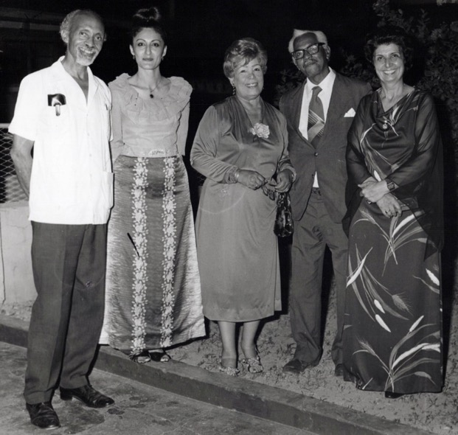
L. to r.: Dr. Harry Collymore, Mrs. Jamalabadi, Ms. Lillian Frasier,
Chief Justice Sir Arthur McShine, and Shamsi
I first met Dr. Harry Collymore, a Trinidadian, after the delivery of one of the daughters of Mr. and Mrs. Mansing Amarsing in my clinic. Months later, their new born seemed to have a blood clot in her neck so she could not move her head easily. I was away on my teaching trips for several months. When I returned, I noticed the problem. I wanted to consult with a physician immediately. Mrs. Nikoo Amarsing phoned several private doctors in the town of San Fernando to get an appointment for that evening, but she had no success because they were all closing for the day. I told her to call Dr. Harry Collymore because of his reputation. She did, and the secretary answered the phone and told her that work was finished for the day and that Dr. Collymore was about to leave the office. This time I asked Mrs. Amarsing to hand the phone over to me. I introduced myself and Mrs. Amarsing to the secretary and explained the baby’s symptoms and asked her to pass on our request for a short visit to Dr. Collymore. This time the secretary handed Dr. Collymore the phone, and he agreed to see us.
“Oh, I have seen you on television”
On entering his office, he looked at me and said, “Oh, I have seen you on television when you opened your clinic in Port of Spain. You are a Baha’i, aren’t you?”, and I answered, “Yes, I am!” He told me that he had enjoyed the interview he had seen on television. During the interview to which he was referring, I had included references to the Baha’i teachings in my answers. It seemed that those answers were compatible with his spiritual ideas because he had been able to understand the spiritual dimensions of my answers.
At his clinic, he examined our baby and said that there was a small blood clot in the baby’s neck but assured us that the blood clot would be absorbed into the body, so no operation was necessary. Astonishingly, he refused acceptance of the payment for his professional services even though our visit had kept him at work late. As I later learned, he treated many other patients in this same courteous and generous manner.
The result of a dog bite
The process of the enrollment into the Faith of this distinguished man began in December of 1974 with, of all things, a dog bite. It was as follows.
At eight o’clock one morning, before preparing to do a circumcision on a baby that I had delivered a week earlier in my clinic, I walked over to my neighbor’s house to give him a message. The door of the house was open and as I approached it, the dog which had been left unleashed, ran at me. I tried to escape him, but he caught up to me, lunged and bit my lower left leg. I fell and broke my left wrist. I limped over to the clinic. The neighbors all came out of their houses when they heard the commotion and ran over to me asking, “Sister Shamsi why did this happen to you of all people who has been so good to all of us, you who are a woman of God…why did God do this to you…” I replied that our Heavenly Father knows what He is doing, He is kind and loving, and he never would do anything without a reason. The injury would help me to empathize more fully with any injured who showed up at my clinic whom I treated before sending them on to the hospital for further treatment. I told them that there also must be some additional hidden meaning which would reveal itself later.
I calmed everyone down, received help to bandage my wound, put my arm in the sling, put the sling around my neck and elevated it and took two painkillers. I telephoned the grandmother of the boy who was going to bring the baby for circumcision. She was Mrs. Joyce Ramlogan who owned a well-known restaurant along with her husband. I explained to her the accident and asked her to come drive me to the Emergency Department at the San Fernando General Hospital. She came over immediately and expressed her dismay at the incident. On the way to the Hospital, she told me that she knew the director, Dr. Harry Collymore, who was an orthopedic surgeon, and that she was going to ask him to attend to me personally. I replied, “Oh, I know him. One day we took Mr. and Mrs. Amarsing’s daughter, Diba, to the hospital about her neck problem. I told the whole story to Dr. Collymore and hoped he would have time to attend to her.” Upon arrival at the Hospital, Mrs. Ramlogan left me in the Emergency Room and went upstairs to the doctor’s office. While I waited many people including some of the doctors recognized me and rushed towards me to inquire about my injury and to ask if they could help. In several minutes Mrs. Ramlogan returned and soon after, Dr. Collymore phoned to Dr. Hussein who was in charge of the emergency room and gave him the necessary instructions. I was given a tetanus shot, the wound on my right leg was cleaned and re-bandaged, my injured wrist was x-rayed, and then I sat and waited for Dr. Collymore. A half an hour later, Dr. Collymore arrived and the medical personnel stood up at attention, and I got up as well. He greeted me, expressed his sorrow over the incident, looked at the x-ray and said that it was a collis fracture but that I should not worry because it would heal in six weeks. Then he took my left hand and showed it to the young Dr. Hussein and asked him with a smile, “Do you mind if I attend to this hand myself because it was doing so much for this country?” Of course, he agreed and soon after, the nurses took me to a room and put me in a bed. While Dr. Collymore was administering a local anesthetic to me, he noticed the ring on my right finger. As all the nurses waited, he asked me if this was a Baha’i ring. I replied that it was. Then he asked me to explain its meaning. At first, I was surprised by this question being asked at this particular moment when I was in such terrible condition, but I told myself that the wisdom behind this injury might be to teach the Baha’i Faith to such a distinguished person, so I raised up my right finger on which I was wearing my ring and tried to sit up to explain the ring stone symbol. When Dr. Collymore saw my excitement, he smiled and counseled that I mustn’t get excited and that I could explain it briefly to him while I lay in bed. I forgot all my pain as I hurriedly explained all the symbolism before he could even set the fracture. He took a small pin and pricked my arm to check if it was numb yet. My arm involuntarily jumped up. He apologized for hurting me and said that we had some more time before the anesthetic took effect, so I could continue my explanation. I resumed answering his question, and his interest grew. The young nurses stood around looking bored, like they wanted to hurry off to lunch. As soon as my arm was ready, he applied the cast and sent me to have another x-ray. The cast was well set so he gave me follow-up instructions, especially when I sit to use a small stool under my injured foot and then sent me home and asked me to come to his private clinic three days later for follow-up.
Back to my clinic
Back at my clinic, many of my friends were anxiously waiting for my return since they had heard about the attack of the dog. They cried when they saw my arm in a cast hanging limp in a sling and my left lower leg bandaged and wondered why God would allow such an injury. I, on the other hand, was grateful to my neighbor’s dog whose attack had given me the opportunity to speak to the distinguished Dr. Collymore about the most recent messenger of God. I started comforting my friends and patients and assured them that I was quite alright and that the doctor had promised me that the injuries would be healed in six weeks.
The owner of the dog was very worried that I would bring charges against him because he had left his dog loose with the door of the house open, but I assured him that I would not take any action, though I had been advised that I could get substantial compensation from him for the temporary loss of the use of my hand.
Attended Dr. Collymore’s private clinic
I attended Dr. Collymore’s clinic for follow-up. When I arrived, he had not come back from the hospital yet and many patients were waiting for him. As soon as he arrived, he walked into the clinic, and the nurse came out and called my name. I excused myself from the others in the waiting room, and with the help of my friend, Mrs. Ramlogan, made my way into the clinic. The others in the waiting room who knew me were surprised at seeing me injured. Inside, Dr. Collymore asked me about my injury and my pain. I answered that I had some pain. He changed the cast and said that my injury was healing well, and he would see me again in another two weeks. After putting on the new cast, he refused payment again. I warmly thanked him and left.
Visit of Dr. Collymore to my clinic
Three days later, Dr. Collymore and his wife Dorothy stopped by the Rezvan Clinic in Couva. My nurse Ester and I were both surprised and overjoyed by this unexpected visit. I was upstairs working. I quickly sat down on a chair and propped my foot up on a stool. When he came upstairs and saw me, he said wonderful, that it was very good that I was keeping my leg up. Suddenly the nurses started laughing, and he asked, “Why, is there something wrong?” I took my foot off the stool and said to him, “Dr. Collymore, how can I sit and put my leg on a chair while I have so much work to do.” He re-assured me that even doing it a little was a good thing. Then he and his wife sat for a while and had some refreshments. He toured the rest of the clinic, admiring the delivery room and other facilities and offered his services whenever they might be needed.
While he was in our large sitting room, he noticed the charts and Baha’i Writings which hung on the wall. He got up to read them and asked many questions. This time I was in much better shape and in much calmer surroundings to be able to give him more complete answers and explanations than when I was lying injured in the hospital. Before he left, he asked me for a book about the Baha’i Faith. I gave him Baha’u’llah and the New Era which includes a short history of the Faith and a summary of many of its laws and principles.
A few hours later Dr. Collymore rang
Three hours later he phoned me from the hospital to tell me that in between operations, he had read three quarters of the book and that so far, he had no objections. Then with his usual pleasant laughter, he said: “I think I have been a Baha’i all my life and I did not know it”. I replied that were he to read more of Baha’u’llah’s Writings—who revealed one-hundred volumes of books and letters—he would find answers to many of his questions.
So began his serious investigation of the Faith. He read many Baha’i Writings, met many of the friends, attended Baha’i gatherings, and received prayers and good wishes for the success of his spiritual search.
One day during one of his visits to our clinic, we had a long discussion about the Faith and as he was leaving, I put a declaration card (card used to accept the Baha’i teachings and to enroll someone in the Baha’i Faith) in his shirt pocket. He took the card out of his pocket looked at it and asked what it was, and I told him that he could sign it when he was ready to accept the Faith. Once again with his typical pleasant laughter, he said: “You are an optimist, aren’t you?” He put the card back in his shirt pocket and with his face beaming with joy left the clinic.
On March 9, 1975 at 10 a.m., he phoned and told me that his mind was too much occupied with the Baha’i Faith, and that he could not rest until he was absolutely satisfied with his investigation. He asked me if I was busy and, if so, he could come to me and if not, I could go to him and sit for a few hours and talk more about the Faith. Fortunately, the clinic did not have any maternity deliveries that day, so I accepted his invitation and told him that I would be there shortly. Excited, I asked my nurse, Esther, who had accepted the Faith a month earlier and knew Dr. Collymore very well, to help me pack my small bag with as many Baha’i Writings as it could carry, in case I needed them for reference. Before leaving the clinic, I asked her to do nothing else on that day other than pray for the enlightenment of Dr. Collymore’s heart, and for guidance for me in answering his questions. Many members of our Baha’i community, especially the children who knew him well, loved him and prayed for the success of his spiritual search. We knew that the Holy Prophets had taught that the believers are chosen by God; Jesus Christ had said “Many are called but few are chosen” and the Prophet Mohammed had said, “Yahdi man Yasha, va Yozello man Yasha”, meaning that, God guides whom He wants and misguides whom He wishes. God chooses individuals for the fulfillment of his will. The only assistance that individual could give to a true seeker was information and prayers--the rest depended on the efforts of the seeker himself through constant prayer and supplication to the Almighty God for His Guidance.
I left my clinic to Dr. Collymore’s private hospital in Palmyra
I drove from Couva to Langmore House, Palmyra Village, San Fernando, where I found the doctor walking in his orchard. He approached my car, greeted me, and asked me before going in to his apartment to come and see a piece of land, so I followed him to a lot near the entrance to his orchard. He asked me what I thought about this parcel of land, and I replied that it was very well-located. He continued with “What would you think if I built a hospital here with you as its director and a big hall next to it for the use by people of all religions?” I replied that I appreciated his trust in offering me a position of such great responsibility, but that it was not in my plans to do more professionally than what I was doing at that time. I was more interested in the well-being of mothers and the education of children and youth than in administering the affairs of a big hospital catering to adults who were often injured in alcohol-related accidents. He graciously accepted my answer and said no more, and we went inside where I was greeted by his wife, Mrs. Dorothy Collymore, a well-mannered Englishwoman, and after some informalities, Dr. Collymore broached the topic of the Faith and expressed his views which were all compatible with the Baha’i teachings. But his main obstacle was understanding why he had to change the name of his religion to ‘Baha’i’ if he already accepted the divinity of all religions and agreed with the principles of the Faith. Could he not believe in the Baha’i Faith and simply remain a Christian publicly? I had a hard time convincing him otherwise. One of my answers was that if with the coming of a new Prophet no one changed his name from one religion to the other, then how could the new religions be differentiated from those of the past. For example, Judaism taught “an eye for an eye and a tooth for a tooth,” but Jesus said, “But I say to you, do not resist who is evil, but whoever slaps you on your right cheek turn to him the other also” Then I asked him which one of the two did he accept? He replied the second one. Then I said, that this reply indicated that he was a Christian as he had differentiated himself from the other by the new religious principle. By accepting the Baha’i principles, which are in conformity with the educational, economic, and social progress of humanity today, he would not lose the spirit of the previous religion but would enhance it by adding new divine principles which were compatible with the present-day society.
That time was the fasting period for Baha’is
This was the period of the Fast and the time for breaking the fast for the day was approaching. We had been speaking from 11 in the morning until 5 p.m., and we were both exhausted, and I asked him to eat a small sandwich, but he refused because he was refraining from eating out of respect for my Fast. I opened a page from The World Order of Baha’u’llah by Shoghi Effendi, about world religions and gave it to him to read.
He took the book and started to read
“Ceasing to designate to itself a movement, a fellowship and the like—designations that did grave injustice to its ever-unfolding system—dissociating itself from such appellations as Bábí sect, Asiatic cult, and offshoot of Shí’ih Islám, with which the ignorant and the malicious were wont to describe it, refusing to be labeled as a mere philosophy of life, or as an eclectic code of ethical conduct, or even as a new religion, the Faith of Bahá’u’lláh is now visibly succeeding in demonstrating its claim and title to be regarded as a World Religion, destined to attain, in the fullness of time, the status of a world-embracing Commonwealth, which would be at once the instrument and the guardian of the Most Great Peace announced by its Author. Far from wishing to add to the number of the religious systems, whose conflicting loyalties have for so many generations disturbed the peace of mankind, this Faith is instilling into each of its adherents a new love for, and a genuine appreciation of the unity underlying, the various religions represented within its pale.”
He read this first paragraph, closed the book, and saw the name of “Shoghi Effendi” on the cover of the book and asked me who he was, and I replied that he was the Guardian of the Baha’i Faith and the great grandson of its Prophet-Founder, Baha’u’llah.
He continued and read the second paragraph and again closed the book and read the name loudly and slowly…Shoghi Effendi…and asked, “Did I pronounce it properly?” I said yes. Then he opened the book again, read the passage on to the end, closed the book and sat silently. When I saw his silence, I said, “Dr. Collymore I am sure that you are convinced intellectually that the Baha’i Faith is a Divine Religion, but what you have to do now is to convince your heart and this can be done easily by you as you are a master in yoga and meditation.” I saw he immediately sat up on his chair and gathered his legs into a cross-legged position as though he were doing yoga. He put his hands over his knees, closed his eyes, and meditated for some time. I sat quietly said a special prayer called “Tablet of Ahmad” and asked the Almighty God to enlighten the heart of this noble and skilled physician and to enable him to realize the Truth so that with a new Spirit, he could extend his valuable services in Trinidad and to other parts of the world.
After his meditation, Dr. Collymore got up and left
Dr. Collymore finished his meditation, got up, looked at me, said nothing but went to his room, changed his clothing, came out and with two hands holding the signed Declaration Card which I had given to him when he had come to my clinic and said that “Shoghi Effendi did it…”
His declaration took place at 5 p.m., on the 9th March 1975, in his clinic which was also his home. With great joy and happiness, I welcomed him to the Baha’i world family and wished him long life of service to his country and the world at large. He in turn thanked me for my patience, my prayers, and the prayers of the friends.
I immediately phoned my nurse Esther to give her the good news and asked her to prepare supper to break our fast. Although Dr. and Mrs. Collymore asked me to stay and break my fast there, I politely refused as I was in a hurry to get home and break this exciting news to the members of our National Assembly. I gathered my reference books bid them both goodbye and walked downstairs to leave.

Dr. Collymore asked me to see the land again
Before leaving the compound Dr. Collymore once again asked me to visit the plot of land which he had shown me on my arrival. He asked me again what I thought about this land. I politely replied: “Dr. Collymore, you have already asked me about it on my arrival, and I have given you my views. Why do you ask me again?” With his typical smile, he said: “I thought that the Baha’is had patience! I haven’t finished my words yet.” I said, “Sorry, please continue your conversation,” then he asked with a smile, “Is this land suitable to have a Baha’i center built on it?” I jumped up excitedly and answered: “Yes, it is a perfect place for a Baha’i Center” With a joyful and radiant face he said: “Then this will be my donation to the Baha’i Faith.” What good news this would be for our community I said to him--first his declaration and second, his generous donation of land for the Baha’i Center. On that moment due to all the excitement I could not find worthy enough praise for him, except to express my sincere gratitude for this great gift on which, in the years to come, the Palmyra Center would be built.
Dr. Collymore last question on that day
That day, before I left Dr. Collymore’s property, he said, “I have one more question and that is how do I fast?” I asked, “Do you want to fast?” He replied, “Didn’t I sign my card just now which stated that I will observe all the Baha’i Laws?” I laughed, and then I expressed that fasting is very simple. You get up in the morning before sunrise, say prayers, eat breakfast, and then refrain from food, drink, and smoking, until sunset at which point you say prayers and break your fast with a meal. There were also deep spiritual meanings to this practice that he would gradually learn over time. Then I left the place for Couva with a feeling of awe and wonder about this precious individual, and a great joy and happiness about the donation of the land.
Back to Rezvan Clinic, Couva
Back at my clinic, my dear Esther had prepared a nice dinner to break our fast and celebrate this historic event. Before breaking our fast, I called all the other members of our National Assembly, informed them of this great news, and invited them as well as Dr. Collymore for the following evening, March 10th, 1975, to come to the Rezvan Clinic and break the fast together and welcome Dr. Collymore to the Baha’i Faith.
Dr. Collymore at my clinic
The next night eight members of the National Spiritual Assembly were present when Dr. Collymore arrived. All of us gave him a standing ovation, welcomed him individually, said prayers, and sat to break our fast. Then after some discussion with his permission we drafted a cable to the Baha’i International Center in Haifa, Israel, informing them of the good news. The next day we received the reply from our Universal House of Justice expressing its joy over his enrolment:
“SHAMSI SEDAGHAT
PORTOFSPAIN
Rejoiced enrolment distinguished friend. Urge early integration Baha’i work.
UNIVERSAL HOUSE OF JUSTICE”
This cable overjoyed us.
Election of the National Spiritual Assembly of the Baha’is of Trinidad and Tobago
Dr. Collymore attended the Baha’i meetings, and friends invited him to their homes. A month and a half later in April 1975, he was invited to the National Convention for the election of the members of the National Spiritual Assembly of Trinidad and Tobago. When he arrived for his first time in the Baha’i Center, all the Baha’is automatically stood up and welcomed him as he was well-known and loved by the inhabitants of the country. After attending to some parts of the program, the delegates started to vote by secret ballot for the names of nine members of the Assembly. After the ballots were collected and counted by a committee, the following individuals were elected: Mr. Ramdass Ramkissoon, Mr. Don Swiheart, Mr. Joel Caverly, Mr. Leo Fraser, Ms. Edna Ruth Caverly, Ms. Nikou Amarsingh, Mr. Fitzroy Soukoo. Dr. Harry Collymore, Ms. Shamsi Sedaghat.
Services of Dr. Harry Collymore to the community at large
Dr. H. Collymore was one of them, for which he received much applause. When the officers were elected, he was elected as a vice-chairman and before I went pioneering to the Bahamas, in Rezvan of 1980, he was elected chairperson instead of me. He served in this capacity for almost twenty years. He was writing and presenting one-minute Baha’i spots on radio which aired nightly on Radio Trinidad in prime time just before the 8 pm main news which many people listened to. His television interviews, public lectures, private discussions all contributed to the spiritual enlightenment of the population. For example, one of the regular listeners to his radio program was our great friend the late Chief Justice Sir Arthur McShine, who occasionally would phone me and express his joy in listening to those one-minute spots of Dr. Collymore on the radio. All this was due to the guidance of the Universal House of Justice who urged in its telegram for the “early integration” of Dr. Collymore into the work of the Cause which meant that there was no need for extensive deepening prior to his service in the community.
In those early years of the Faith in Trinidad, the Baha’i Faith was not known to many people in that region so a prominent person like Dr. Collymore gave great weight to the Faith and made its acceptance by people much easier as well as bringing tremendous joy to the hearts of the friends. Even in his office he taught the Faith. I remember that he placed numerous Baha’i pamphlets and brochures in a small bookstand in the corner of his waiting room with a big sign written on the top that read: “FREE, TAKE ONE” and, behold, at the end of the day, the book stand was empty! The next day he would fill it again.
Dr. Collymore also served Trinidad and Tobago at large and was regarded as one of its pre-eminent citizens. He founded the Cheshire Homes and Rehabilitation Society in Trinidad and Tobago and was an active member of the Paraplegic Association and the Rotary Club, among his many community activities. At the time of his passing away, more than a thousand people including many dignitaries came to his home for his memorial meeting which was arranged by his family and the Baha’i friends. The Universal House of Justice was informed by our National Spiritual Assembly about his ascension and asked for their prayers for the elevation of his spirit. Their reply was the following message:
“We are deeply saddened by the news of the passing of noble-minded and steadfast promoter of the Cause of God, Dr. Harry Collymore. His long years of teaching and administrative service, including more than two decades as a member of the National Spiritual Assembly of Trinidad and Tobago, are warmly remembered. The recognition of his outstanding endeavors as a physician dedicated to community service earned the highest honor in the nation, and his unceasing efforts and generous spirit contributed to the emerging prestige of the Cause in Trinidad and Tobago. We extend our loving sympathy to his family and all others who mourn his loss and assure them of our heartfelt prayers at the Holy threshold for the progress of his radiant soul throughout the divine worlds. We advise you to hold a befitting memorial gathering in his honor.”
Dr. Collymore’s declaration was a spiritual blessing for Trinidad and Tobago and a great honor to our Baha’i community, and I heard that his memorial meeting was one of the most dignified gatherings in recent years in Trinidad.

Chapter 8

Teaching in the Caribbean 1975-1977
During the summer and fall of 1975, I undertook a teaching trip to the Leeward Islands on behalf of its National Assembly and then to Guyana. In July, the National Spiritual Assembly of the Leeward and Windward Islands were holding an International Teaching Conference in Antigua and invited me to teach a class for new West Indian believers who were unfamiliar with the basic history of the Faith. The Teaching Conference was held from August 15-17 at the Technical College in St. John’s, Antigua. The National Assembly opened the gathering on Friday night, and the first speaker Saturday morning was the Hand of the Cause Mr. Varqa who spoke on developing the distinctive character of a Baha’i life. Counsellors from around the region such as Mr. Paul Lucas, Mr. Artemus Lamb, Mr. Alfred Osborne, Ms. Carmen Burafato, and Mr. Rowland Estall, educated the friends on strengthening local assemblies, the history and development of the Covenant, the role of institutions in the Faith, organizing activities for women, children, and youth, and the goals of the new Five-Year Plan. We were blessed again to hear from Hand of the Cause Mr. Varqa on Saturday about the Covenant and its history and development as well as to listen on Saturday night to his personal reflections on his life of service.
The National Spiritual Assembly of the Leeward and Windward Islands asked me to coordinate the teaching and proclamation efforts which accompanied the conference. Mrs. Edith Holbert was our selfless host who housed ten teachers in her hotel and took motherly care of all of us. She and I decided to arrange a series of courtesy calls to government officials with the object of explaining the goals of the conference and the summer school and to present them with literature on the Baha’i Faith. We would also approach media outlets for interviews. Mr. Elsworth Blackwell, Secretary of the National Spiritual Assembly of the Baha’is of Haiti, joined us in these efforts, and we obtained the name and contact information of all the government ministers from the Tourism Department.
Courtesy call to the Honorable B.A. Peters and the Honorable G.H. Walters
On the 19th of August, we met with the Honorable B.A. Peters, the Minister of Education, Health, and Culture, and spoke with him about Baha’i principles of education and finished by presenting him with Some Answered Questions, Baha’u’llah and the New Era, and The Foundation for World Unity. Immediately afterwards, we went to meet with the Honorable G.H. Walters, Minister of Planning, Development, and External Affairs. While we had a wide-ranging discussion, he seemed especially interested in my Iranian origins as he had been to Tehran. Over the course of our conversation, he, and Counsellor Osborne, who was part of our team, discovered that they had relatives in common through the Benjamin family in Antigua.
Radio and TV interviews
That afternoon, we had a 45-minute radio interview and were referred to the television station where we were given a half hour free time that Saturday evening. The following evening, we held a public meeting which Minister Lee and his wife attended as it was held with his permission at the Teacher Training College. He spoke there in praise of the Baha’i Faith.
Courtesy Call to the Honorable S.U. Prince and the Honorable R.V.L. Hall
On the 22nd of August, our team (Mr. E. Blackwell, Mrs. Hazel Lovelace, Mrs. Edee Holbert) went to meet the Honorable S.U. Prince, Minister of Finance, Industry, and Tourism, who was so impressed by the Baha’i principles that he thought that all politicians should know about them, so we should present Baha’i literature to every member of Parliament and gave us the contact information for the clerk of the House of Representatives. We presented the Minister with Baha’u’llah and the New Era, Some Answered Questions, and The Divine Art of Living. Later we secured an appointment with the clerk and explained to him our request to which he consented. We presented him with enough copies of Gloria Faizi’s The Baha’i Faith, an excellent introductory book on the Faith, for distribution to the members of the Parliament. Each book was inscribed by the secretary of the National Spiritual Assembly, Mrs. Lorena Kerfoot, and we took a photo all together to mark the occasion. Later that morning, our team called on the Hon. R.V.L. Hall, the Minister of Agriculture, Lands, and Fisheries, and we spoke about the Baha’i view on agriculture and other principles of the Faith. We signed his visitor’s book and presented him with Baha’u’llah and the New Era, Some Answered Questions, and The Divine Art of Living and warmly departed.
Picnic at the Galley Bay Surf Club
In the afternoon we joined the other Baha’i teachers and the eight new believers for a picnic at the Galley Bay Surf Club. At 7:30 p.m., we had a half-hour television interview live with Mr. Billy Ryan for which we were joined by Counsellor Osborne and which generated many questions from viewers. An hour later, Mrs. Holbert hosted a dinner party with Counsellor Estall for all the new Baha’is at the Galley Bay Hotel.
Courtesy call to the Honorable Victor McKay
The following day, Mrs. Holbert and I paid a courtesy call to the Minister of Public Works and Housing, the Hon. Victor McKay, to whom we explained some of the Baha’i principles. Knowing that I was from Iran, he spoke about his visit to Syria, Lebanon, and other Middle Eastern countries and showed us photographs of his trip. We presented him with copies of Baha’u’llah and the New Era, Some Answered Questions, and The Divine Art of Living, and the permanent secretary took photos.
Visited Lady Jacobs
At 4 p.m. we visited Lady Jacobs, the wife of the Governor-General of Antigua. We spoke with her for an hour about the Faith and gave her Gloria Faizi’s introduction to the Baha’i Faith. Though she made efforts to have us meet with her husband the Governor Sir Walter Jacobs, this did not prove possible due to scheduling. Later, we gave his secretary copies of The Bab, Baha’u’llah, and ‘Abdu’l-Baha by Mr. Balyuzi. Similarly, the Minister of National Security, Legal Affairs, and Labor was otherwise occupied with Police Parade week and was unavailable, so we gave books for him to his secretary. The highlight of our teaching and proclamation was the evening we held at the Jardines at St. Johns to which we invited new believers and recent contacts to come and share their experiences in finding out about the Faith. These included Mrs. Cenac, wife of a Magistrate, Mr. Dunbar Cenac; Julian Rodgers, the most well-known disc jockey on Antigua, whose wife was a Baha’i, and Mrs. Lee, wife of the Minister of Education. I had met Mrs. Lee on several occasions, including when I first landed and attended a social reception where she was a guest, and she later participated in the history class I gave. After deep conversations about the Faith, she declared much to my delight. At the Jardines, she expressed her joy at being a member of the family of Baha’u’llah.
Visit to Guyana, 1975
I arrived in Guyana on September 7th, 1975, in the evening, accompanied by Mr. Dean Stevens, and we were met at the airport by the Chairman of the National Spiritual Assembly of Guyana, Mr. Henry Dolphin, who brought us to his home where his wife, Mrs. Sheila Dolphin, and a few of the friends greeted us warmly. The following morning, Dean and I were accompanied by the representatives of the National Teaching Committee and the Publicity Committee, Mr. Sidney Friday, and Mr. Sonny Griffith, to meet the Program Director of the Guyana Broadcasting Station, Mr. Ronald Saunders, who turned up an hour late because he had been attending another event. Mr. Saunders invited us into his office and asked what he could do for us. Mr. Stevens introduced himself and said that we had come to see if we could be of service to their station by way of giving technical advice. Mr. Saunders thanked him for his offer but said that he didn’t think that their problem was shortage of skilled personnel as he and his colleagues had been educated abroad and had degrees, rather what they needed was money to make structural improvements to the station. Mr. Friday then spoke up and said that we were there also to request some free radio time, if possible, to present the Baha’i teachings on the air to which Mr. Saunders immediately gave a lengthy reply that this would not be possible because he did not want to allocate much time for religious programming and that if he did, he would charge for the time because his job was to sell radio time and increase the revenues of the station. After saying a few “Remover of Difficulties” to myself, I requested permission to speak. I asked Mr. Saunders if he knew anything about the Baha’i principles which he didn’t. I began to explain some of them, but he cut me off. I politely objected and reminded him that we had waited over an hour, that we too were professionals—especially Mr. Stevens who was an inventor—and that it was his turn to wait while we briefly explained our aims and principles. He smiled and agreed, and I proceeded to explain the nature of our program with examples from Trinidad, and the impact which the Baha’i principles would have on children youth, and adults, especially in the area of women’s education. I assured him of our loyalty and obedience to the government of the land and of our respect for all races and religions. Furthermore, I suggested that I was sure that he was interested in the upliftment and well-being of his fellow citizens through education and correct training rather than selling a particular program to make money. Well-behaved youth, I asserted, would contribute more towards the construction of the country than its destruction which alone would add to the country’s overall prosperity. Mr. Saunders nodded his head negatively every time I repeated and asked for only five minutes of radio time, and suddenly he turned to Mr. Stevens and said, “She’s something else”. Then he looked back at me and said, “Alright you can have five minutes”. We were overjoyed. Mr. Stevens immediately gave him his business card and offered his services. He later inspected all Guyana Broadcasting’s installations. Two days later we received letter from Mr. Saunders confirming his offer and allocating to the Baha’i community ten minutes of free radio time every Friday from 1-1:10 p.m., beginning on September 12th, 1975.
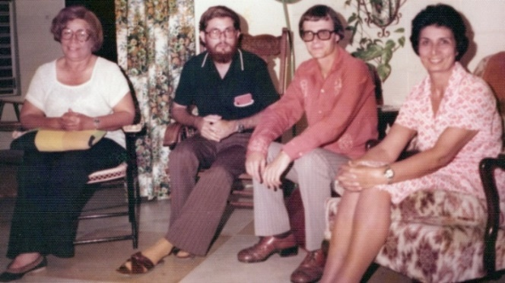
L.to r.: 1) Ms. Lillian Frasier, 2) Mr. Andersen ?, 3) Mr. Stevens, 4) Shamsi
Later that same day at 3 p.m., we met with Mr. Ayube Hamid, the Sales Manager of Radio Demerara, who received us cordially and listened to the same request we had made at the earlier meeting. He informed us that the station had permitted Baha’is to broadcast programs on special occasions and hoped that having received airtime from Guyana Broadcasting might make it easier for them to do the same. He would discuss it with Mr. Rafiq Khan, the General Manager as soon as Mr. Khan returned from abroad.
In the meantime, he would arrange an interview for Mr. Stevens on Pat Cameron’s program the following day. Mr. Stevens again offered his technical expertise in return for these efforts on behalf of the Baha’is.
Attended Nineteen-Day Feast
By 5 p.m. we were at the Nineteen-Day feast in the home of Mr. and Mrs. Frank Sheffey where we met some of the Baha’is of the Eccles group, East Bank Demerara, and at 7 p.m., I met with the National Spiritual Assembly. I related to it our success at the radio and offered help in reaching out to prominent persons and presenting them with Baha’i literature as well as visiting children’s classes and possibly developing some radio programs.
Courtesy calls to dignitaries
In the following days, we made courtesy calls to several individuals. Mrs. Viola Burnham, the wife of the Prime Minister, received us warmly.
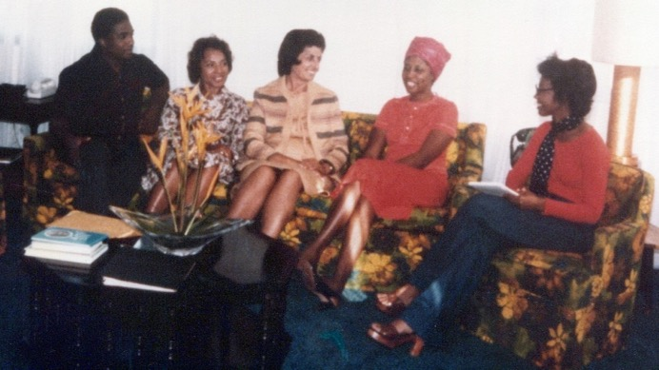
Courtesy call to Mrs. Viola Burnham, wife of the Prime Minister of Guyana.
L. to r.: 1) Mr. Hopton Fitz-Henley, 2) ?, 3) Shamsi, 4) Mrs. Viola Burnham, 5) secretary of Mrs. Burnham? (the question mark means that I know them but forgot their names)
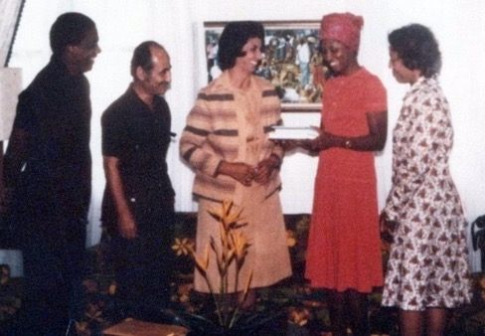
L. to r.: 1) Mr. Hopton Fitz-Henley, Auxiliary Board Member for Jamaica,
2) Mr. Elias Zohoori, Secretary of the NSA of Jamaica, 3) Shamsi,
4) Mrs. Burnham, wife of the Prime Minister of Guyana, 5) ?
(the question mark means that I know them but forgot their names)

She accepted several books of Baha’i literature after a discussion that centered on the loyalty of Baha’is to the government of the land, love and respect for all mankind, contributions to the betterment of society especially by children and youth, and the promotion of the equality of men and women.
Mrs. Burnham had become interested in the Faith after hearing about it when she headed the women’s delegation of her country to the Congress on International Women’s Year in Mexico. In addition to this fruitful meeting, we also had additional ones individually with Mr. Cammie Ramsaroop, the Leader of the House Assembly, Mr. A. Mohammed, the Permanent Secretary of the Ministry of Information, and Mr. Kenneth Short, the Mayor of Georgetown. Announcements with photos of all these meetings appeared in the local paper. I received coverage in the Sunday Chronicle. The article was titled “Baha’i Lady stresses role of education in equality fight” and used the analogy of the two wings of a bird to describe the issue of the equality of men and women.
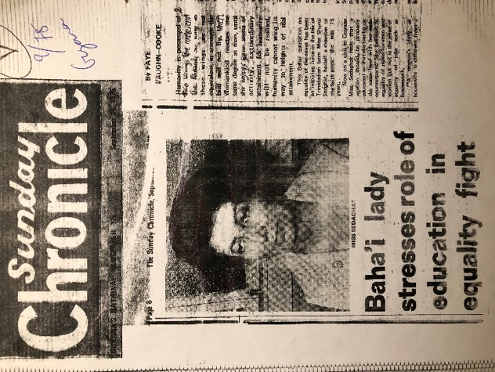
Shamsi in the Sunday Chronicle
Lecture at the government training college
Mr. Henry Dolphin arranged a lecture at the Government Training College for Teachers where 220 students were present. After an opening prayer offered by Mr. Dolphin and a passage on the equality of the sexes from Paris Talks read by Mrs. Dolphin, I spoke on the equality of the sexes and the contribution that youth could make to advancing world civilization. The lecture was followed by questions with the whole session lasting over two hours. The enthusiasm was so great that the students applauded whenever I gave answers that met with their approval and jeered anyone in the audience who challenged the teachings. Many students asked for literature which Mr. Dolphin promised to supply. I also gave a lecture at the YMCA to 115 girls who had dropped out of school as well as to their teachers. I spoke on the role of women at home and in society and briefly explained the concept of progressive revelation. Baha’i literature was presented to the secretary of the YMCA who expressed interest in attending Baha’i firesides in the future. I had several opportunities to teach among the Baha’is at Eccles, Craig, Georgetown, Annandale, Plaisance, Parika, Linden, Goed Portuin, and La Grange. I told uplifting teaching stories, and the visits were blessed with seven enrollments. In the village of Anna Catherine, West Coast Demerara, the National Youth Committee organized one-day mass teaching during which I was accompanied by zealous youth, all relatives of the only Baha’i in the village, Nazalene Khan, who had laid much of the groundwork; three local youth enrolled as a result of this effort. I also attended children’s classes at the Baha’i Center, Georgetown, Hydroni, East Bank Essequibo, and Plaisance, East Coast Dem. I was impressed with the lovely children and the beautiful songs and prayers which they knew. I shared my experiences with them and their devoted teachers, Mrs. Dolphin, Ms. King, and Mrs. Widmer.
Mr. and Mrs. Dolphin and Mr. and Mrs. Widmer were kind enough to hold tea parties to which they invited their friends and dignitaries, and the occasion arose to speak about the Faith. The lawyer of the National Assembly, Mr. Donald Trotman, seemed interested in learning more so I gave him Gloria Faizi’s introduction to the Baha’i Faith. I was also taken by Mr. and Mrs. Dolphin to dinner at the home of Mr. Yesu Persaud, the Managing Director of the Demerara Sugar Company, where I met the Minister of Agriculture, Mr. Kennard and his wife, Dr. Iris Sookdeo, a lecturer in sociology at the University of Guyana, Faculty of Social Sciences, among other local dignitaries.
Letter of National Spiritual Assembly of Guyana, Surinam, and French Guiana
The National Spiritual Assembly of the Bahá’ís of Guyana, Surinam, and French Guiana later wrote a loving letter of appreciation to me for all these teaching efforts:
“MISS SHAMSI SEDAGHAT
REZVAN CLINIC
COUVA, TRINIDAD

Our Dearly Loved Baha’i Friend,

Your detailed and exciting report of your visit to Guyana has arrived and we write to thank you so very much for all you have done for us.
As we recall those wonderful 17 days you spent with us and the amount of events achieved in both the fields of proclamation and teaching we indeed feel overwhelmed with the bounties bestowed upon us all. The atmosphere, wherever you went, was charged with a real sense of importance and urgency which must be attached to all our attempts to proclaim the healing message of Baha’u’llah. With you in our midst, we seem to have been able to overcome barriers that before seemed insurmountable and to achieve such tremendous victories in all spheres of our activities throughout Guyana.
All of us who were able to be with you, dear Shamsi, were able to learn so very much. Your depth of understanding the significance of this Faith, your total and selfless devotion to carry out its injunction to teach, and your deep love for mankind have touched all of us: we will never be the same and we all can feel still that we have made strides, great strides, in all our goals of the Five-Year Plan.
We wrote to try to convey to you our most sincere and heartfelt appreciation for so totally and effectively devoting your every minutes and full energy to our various proclamation and teaching efforts.
We are now in their midst of Baha’i proclamation week in Georgetown and there is a beautiful and large banner across the Baha’i Center with moving quotations proclaiming the station of Baha’u’llah. The air is singing with this announcement and our hearts are joyous that the eagerness and devotion which you exemplified for us has carried to these efforts.
Indeed our lives have been enriched by your example and our assurance of his assistance even stronger as we try to go forward to proclaim His Name to all the citizens of the world. Please accept this expression of our many thanks for all you did so lovingly and selflessly while here and we look forward to more visits and assistance as we continue with our services in His Name,
With warm Baha’i love,
Mrs. Ellen Widmer, Secretary”
Visit to Leeward and Windward Islands, 1976
The following summer and fall of 1976, I undertook a twelve-island teaching and proclamation trip at the request of the National Spiritual Assembly of the Leeward and Windward Islands. I taught at the summer school in Antigua in August which I had done the previous year. The sessions consisted of a week of concentrated study for juniors and adults; special magistrate Mr. Cenac Dunbar never missed a class.
Courtesy call to the Chief Justice of Antigua to present Baha’i literature

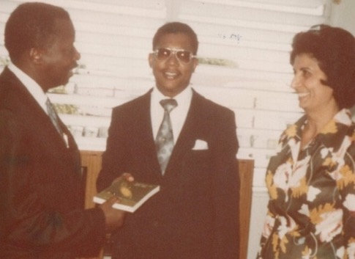
L. to r.: 1) Chief Justice of Antigua, 2) Mr. Dunbar Cenac, Baha’i magistrate, and 3) Shamsi
Courtesy call to a government minister in Antigua and presentation of Baha’i literature to him

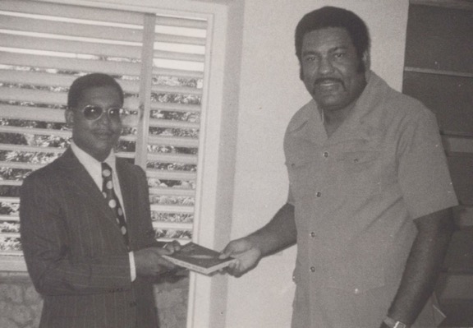
Mr. Dunbar Cenac and a government Minister in Antigua
Letter from Ms. Edie Holbert, May 1976
Before coming to Antigua, I received an exciting update on the Baha’i activities on the island from Ms. Edie Holbert:
“…So much has happened since I saw you. We’ve finally gotten our Meeting House. It’s a perfect property—one block off the park and right next to the Country Pond. We can buy it for the price of the land—because the lovely old large town house was badly damaged by the earthquake and the owner got total loss payment. Well we’re fixing it up and will make several fine offices to rent. This will eventually pay it off. Now I find that right across the street is the site of the new Administration Building!! Isn’t Baha’u’llah great. There was a new concrete black building on the property—undamaged—and that is now our meeting house. It’s really charming! We have a nice area of land—very run down and messy but with love and work we’ll have a garden for Baha’u’llah….”
Visit to St Croix, 1976
After the summer school, I flew to Saint Croix to the west near Puerto Rico where I was met by Mrs. Ethel Harris a pioneer who lived in the town of Frederiksted.
That same night a unity feast was held in her home and as the evening progressed, I told them about the summer school and the atmosphere became very warm.
I began a series of activities and appointments organized by the Assemblies of Frederiksted and Christiansted. The next day, I called on an eighty-two-year-old believer, Mrs. Johanna Rasmussen, who had been a Baha’i for two years and expressed her happiness at being a Baha’i. She hoped to donate a part of her property to the Faith—a small room on her property was already being used as a ‘Baha’i Information Center’.
In the afternoon we visited an aluminum plant as a guest of Mr. Dale Parker. He introduced me to the plant’s reporter who interviewed me for their magazine.
That evening we held a small but lively public meeting in the Baha’i Information Office in Christiansted. After the lively discussion, I was approached by a school supervisor, Mr. Owen, who made an appointment to come and visit us at Ethel’s on September 9th.

Attended different kinds of meetings and interviews
We rose at dawn the following morning for prayers in the home of Mrs. Marjorie Tyson and afterwards, we ate cake as it was her birthday.
For lunch Ethel invited a reporter, Mrs. Benita Cannon, from the St. Croix Avis newspaper, and we spoke for three hours about the Baha’i principles after which she invited us to a formal interview very soon.

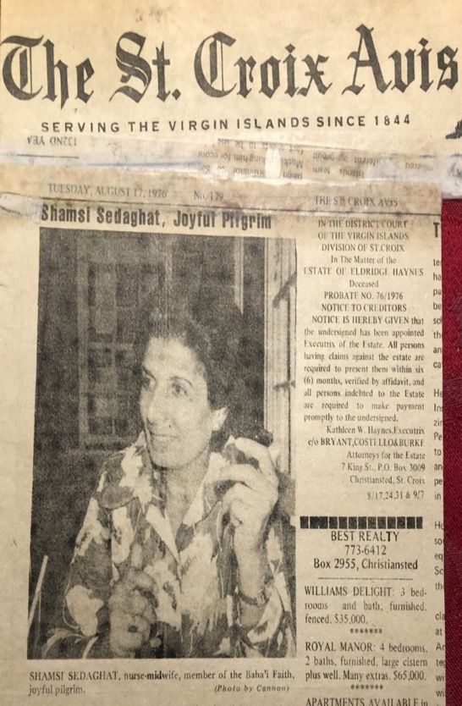
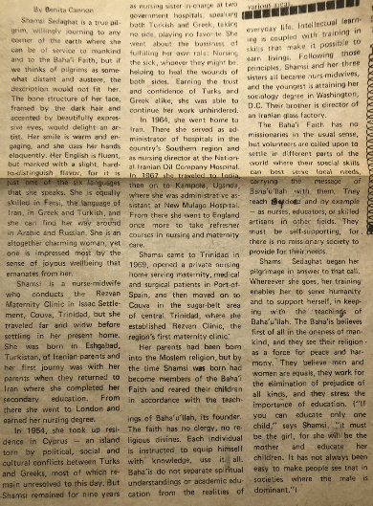
Article on Shamsi in the St. Croix Avis

That afternoon we visited Dale Parker’s children’s class. Most of the students were not Baha’is. I demonstrated a simple and effective type of lesson plan which they could use in the future. A Baha’i from Puerto Rico held a social event in his home that evening which I attended and turned into a fireside that lasted until midnight.
Next afternoon, the school supervisor, Mr. Owen, came for a visit during which we spoke at length about the Faith and gave him several books of Baha’i literature and a declaration card in case he decided that he wanted to become a Baha’i. He also asked for a Baha’i emblem, and we gave him a medallion with the Greatest Name on it which he put on straightaway. Radio and newspaper interviews were arranged for the following day. I visited a youth class which included a young Muslim friend of the youth who was interested in learning about the Faith’s fulfillment of Islamic prophecies. The day finished with a meeting with the Assembly of Frederiksted during which we consulted about community affairs including Mrs. Rasmussen’s desire to transfer her property to the Baha’i community; three of us went to meet with her the next day and draft the letter for the transfer.
I had a press interview and addressed that Baha’is should start their own radio show
The following morning, Mrs. Benita Cannon, the reporter from the St. Croix Avis came to interview me and Mrs. Ethel Harris at 11 a.m. After the comprehensive interview, we took a photo, and a long article was published in the newspaper; I was described in the heading as a “Joyful Pilgrim,” “…a true pilgrim willingly journeying to any corner of the earth where she can be of service to mankind and to the Baha’i Faith…” At 2 p.m. I went for an interview on the ‘Health Corner’ radio show during which I included the Baha’i teachings as I answered questions about my nursing experience. The interview aired on the Radio, but I could still hear it from Saint Thomas. Mr. and Mrs. Smith held a going away party for me that evening which was attended by Baha’is from various communities, their friends, and Mrs. Brenda Marshall who had conducted the radio interview. Impressed by the happy atmosphere, she encouraged Baha’is to start their own radio show to broadcast the Baha’i teachings over the island and not to be shy—she had been shy when she started out on radio and had overcome it, so we could do the same!
Visit to St. Thomas
The next morning, Mr. Wolly Cluett drove me to the 10 a.m. water boat bound for Saint Thomas, a small island just north of Saint Croix. I was met in Saint Thomas by the Auxiliary Board Member, Mrs. Shirley Mather, and Mr. Jeff Bailey, a member of the Assembly of Saint Thomas and Denis. At the Baha’i Center, I was greeted by Mr. Bill Nedden, the Secretary of the National Assembly of the Leeward and Windward Islands, and my loving hostess during my stay, Mrs. Toni Isaac. That evening I met the Assembly and the National Teaching Committee who gave me a detailed schedule of activities.
Visit to St. John’s and discussions with the friends
On the morning of August 13th, I travelled to the nearby island of Saint John’s with a member of the National Teaching Committee Clement Wellington, a Baha’i youth. Several teaching events had been planned, and we had been instructed to say the Tablet of Ahmad nine times before our teaching activity. After repeating the prayer five times, our concentration wandered. We decided to stop and wait for our guests. Though there were no seekers, we had an in-depth and friendly discussion with the local Baha’is about attracting waiting souls to the Cause. I reminded the friends that prayer was important but had to be combined with actions.
A potluck dinner and consultation with the members of the National Spiritual Assembly
Back on Saint Croix the following day, my hostess organized a pot luck dinner attended by Baha’is, their friends, and a few people from the media. The next morning, I met with the National Assembly, and we consulted on various issues of Baha’i administration in the islands. The Assembly asked for my assistance in launching their nine-month teaching project in several parishes on the islands of Antigua and Montserrat as well as visiting Saint Barth’s to help by “…visiting and consulting with members of the Local Spiritual Assembly or Baha’i group below on the topic of the “Nine Month Plan”. The Assembly asked that this task be completed by the end of September and that my recommendations and report be forwarded to it so that the goals could be won by April 21st, 1977. As part of this effort I should visit the parishes of Saint John, Antigua; Saint Peter, Saint Anthony; and Saint George, Montserrat. I enthusiastically agreed. That evening, I held a deepening at the Baha’i Center for Baha’is and their friends.
Several media interviews
Mrs. Toni Isaac accompanied me the next day to the television station for a five-minute interview with Mrs. Leona Bryant which was broadcast the following evening at 6:55 p.m. At 8 p.m., Mr. Nedden brought me to the WSDA radio station for an hour-long interview with Mr. Milt Lindsay who was sympathetic to the Faith and so enthusiastic that many listeners called in, and he invited me back for the following evening. When we returned to the Baha’i center, the friends who had assembled there to listen to the show gave us a hero’s welcome.
Another interview took place the following morning on WVWI radio’s “Louis Noble Show” which lasted an hour with many interesting questions; Mrs. Isaac participated with me in answering questions. Mr. Sam King, the host of the “Sam King Show”, came by the house in the afternoon for a 25-minute interview that aired at 7 p.m., on August 20th. Fifteen Baha’is and I had dinner at Mr. Jeff Bailey’s house and watched the short television interview which was broadcast at 6:55 p.m. Then it was off to participate in another segment of the Milt Lindsay show. He asked listeners to prepare questions and repeated several of those from the previous evening, this time offering answers of his own. A lively hour-long interview took place with Mr. Bailey contributing as well. We invited Mr. Lindsay back to Mr. Bailey’s home which he accepted, and a joyous social evening ensued. One person declared, Mr. Jeff Horrocks, an American who worked as the head janitor and florist at the Governor’s Mansion and who was well-known on the island. He warmly welcomed us and brought us for a tour of the mansion during which we were interviewed by the Public Relations Officer, Mr. Lee Scott. A brief account of our visit with our picture appeared in the Daily News. A few days after his enrollment in the Faith, Mr. Horrocks courageously resigned from his church.
A reporter for the Daily News, Mr. Guirty, came to the home the following afternoon to conduct an interview for the paper. Baha’is gathered in the evening for dinner with Counsellor Artemus Lamb for which I prepared several dishes including Iranian sweet rice.
Attended several informal gatherings and a Nineteen-Day feast
The radio programs had some effect as the next morning, a young seeker came to Center who had heard us on air. We had a fireside and gave him some Baha’i literature.
Mrs. Joyce Owens held a luncheon for ladies during which I had the opportunity of discussing the Baha’i teachings on the equality of the sexes. Baha’is gathered for the Feast of Asma that evening during which I spoke about preparing for ‘entry by troops’ which seemed to inspire the believers.
A public meeting at the Emancipation Garden
We held a public meeting the following evening at the Emancipation Garden. Sufu Kenyata and his band opened with some wonderful music followed by prayers and readings from the Writings. I spoke for forty-five-minutes about Progressive Revelation. Those who were interested came to Baha’i Center afterwards for a reception and a fireside.
The next afternoon, Friday, August 21st, I went to Saint John’s with Mr. Horrocks. We were met by Ms. Sandy Agerer and Toni Tsemeca, but this time we went around the island meeting people and inviting them to the public meeting at the Hill Top Restaurant that had been advertised in the previous days (August 20th, 1976), when the Daily News interviewed me and had printed a full article on the talks, my background, the essential principles of the Faith, and little bit about the person of Baha’u’llah.
We spoke with shop and boutique owners whom the women knew as well as schoolteachers we had met on a previous visit. About five seekers attended that evening including three young women from New York City who promised to learn more about the Faith back home.
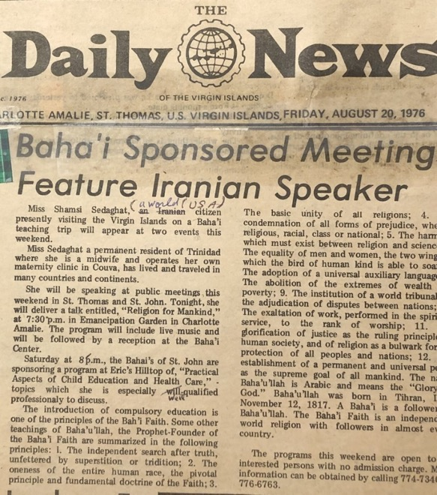
Article on Shamsi in the Daily News, Virgin Islands, 1976
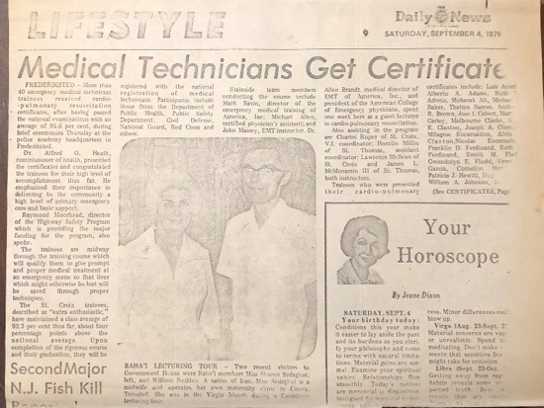
Photo of Shamsi and Bill Nedden in the Daily News, Virgin Islands, 1976

I returned to Saint Thomas the following day, August 22nd, where we were met by the Auxiliary Board Member, Mrs. S. Mather. At 6 p.m. that evening, I attended a deepening class for Baha’is at the Baha’i Center. The topic was the “Baha’i Life” and the mode of conduct pertaining to the dress and general appearance of Baha’is, especially women. The meetings were cordial, and the participants contributed their thoughts.
On the 23rd, I helped with a deepening that evening on the Bab and His Life with the help of a map drawn by Mr. Wolly Cluet. The next evening, August 24th, we ate dinner with friends from Trinidad, Mr. and Mrs. Chandru Chugani, who had owned the Kirpalani stores and had opened the Novelty Gift Shop here in Saint Thomas. I bid goodbye to the friends on Saint Thomas after dawn prayers on the 25th and went to catch the plane for Saint Martin.
Visit to St Martin, August 25th, 1976
I was met on Saint Martin, an island divided into French and Dutch ruled areas, by Ms. Terry Madisson, Ms. Marian Barnes, and her son, Robert, and we were joined later by Ms. Barbara Joyce.
That afternoon we recorded a fifteen-minute Baha’i radio program for future use and in the evening, Ms. Madisson hosted a Baha’i fireside. I was told not to speak about the Faith directly because the owner of an ice-cream company was coming who did not want to hear anything of religion. When he and his wife arrived, though, she welcomed me to Saint Martin and straightaway said that she had come to hear about the Baha’i Faith. So, there I was explaining the Baha’i Faith directly. The concourse on High guided me as to what I should say and how to say it such that people would become interested. A lively discussion ensued, and guests left with copies of Paris Talks. The ice cream magnate had brought a large container of ice cream which was entirely emptied but he left with his mind full of new learnings about the Faith.
The next morning, August 26th, Ms. Joyce took me for a television interview, but the camera was not working, so we rescheduled for the following day. In the afternoon, we called on Mr. Louis Guy and his wife Barbara, who had been very active in the community but then withdrew from activity. Mrs. Guy had a radio show on PJD-2 radio St. Martin. She was willing to interview me about my career but not about the Faith. I told her I was interested in speaking primarily about the Faith and encouraged her by telling her of the great role she could play in proclaiming the Faith through her show. She agreed to have me come on Sunday the 29th for an interview. We held a deepening that evening on the French side of the island at the home of Terry Madisson. Mrs. Lulie Kingsale declared that evening, and we all welcomed her.
We went back to the television station the next morning, August 27th, but the camera was still not working. The crew went to get a new camera out which they were using for the first time, and I told them they were lucky that their new camera was being blessed in its first use with a program on the Baha’i Faith. We taped four 15-minute segments on the history of the Faith, its principles, progressive revelation, and other topics; I used the charts that I had brought, and we viewed the first segment two days later.
Speech at the Rotary Club
Ms. Madisson and I went to the Rotary Club for a lunch-time presentation on the history of the Faith and its key principles. I was welcomed by the President of the club. In attendance was American artist Mr. Romare Bearden whose mother Bessy had interviewed ‘Abdu’l-Baha for the Chicago Defender of which she was the editor. Romare Bearden’s reputation as an American artist who depicted the lives of African Americans grew steadily over the decades. I gave a half an hour talk on the history of the Faith and its principles and invited all in attendance to join us at our proclamation meetings at the St. Tropez Hotel and at the Little Bay Hotel to view The Green Light Expedition and learn more about the Faith.
We held dawn prayers the next morning, August 28th, on the fort with Baha’is from both the Dutch and French communities. After that we went to PJD-3 radio. Mrs. Griffith introduced me to the station’s director, Mr. Van James, who happened to be there that morning on emergency business. He scheduled me for an interview on August 31st. At 5 p.m., I attended Ms. Joyce’s children’s class. Most of the students were from non-Baha’i families. I taught a simple lesson as a model which could be used in the future if needed. We held a public meeting at the Little Bay Hotel that evening on the Dutch side. I spoke about the “Pattern of the future world society” which was followed by Ms. Madisson singing several of her Baha’i songs and a showing of Hand of the Cause Ruhiyyih Khanum’s film, The Green Light Expedition. Numerous people were present including two members of the local Rotary Club.

Several media interviews
The next morning, August 29th, found me again involved with media, this time in an interview with Mrs. Guy. I was somewhat hesitant about this interview because of Mrs. Guy’s reluctance to broach Baha’i subjects. I prayed to overcome this feeling, and when I got to the station, she and I chatted for a while until the atmosphere was friendly.
We recorded a 15-minute segment on a topic which mixed the Faith with my professional life. That afternoon we watched the first of the four 15-minute segments we had recorded for television and held a public meeting at the St. Tropez Hotel on the French side. Again, the Green Light Expedition was shown along with my talk on “Progressive Revelation” and Ms. Madisson’s songs. The audience included the President of the local Rotary Club and his family, the Guy family, the manager of the Hotel and senior staff, and several Baha’is who had become inactive.
We had a fireside afterward with the hotel manager and the President of the Rotary and others. The manager offered us the use of the large conference room in the hotel free of charge for future gatherings.
I used my day off on August 30th to catch up on personal chores, but I was again involved with interviews for the media on the morning of August 31st. I was interviewed by Ms. Alfrida A. Gumbs the editor of the St. Maartener who was sympathetic to the Faith; we invited her to a reception for media at Ms. Madisson’s home.
An hour later, I was interviewed by Mrs. Romelia Dollison, editor of The New Age. In her article, Mrs. Dollison listed ten of the basic principles of the Faith such as the Oneness of Mankind and the Independent Investigation of Truth.
At 2 p.m., I had an interview at PJD-2 radio with Vance James Jr., a well-known personality in Philipsburg. The interview lasted twenty-five minutes and was aired again that evening.
Again in the same evening, I went for my second interview with Mrs. Guy. The interaction was considerably warmer, and the conversation turned completely to the Faith. We also had an opportunity to talk for a while off the air; her husband was also present.
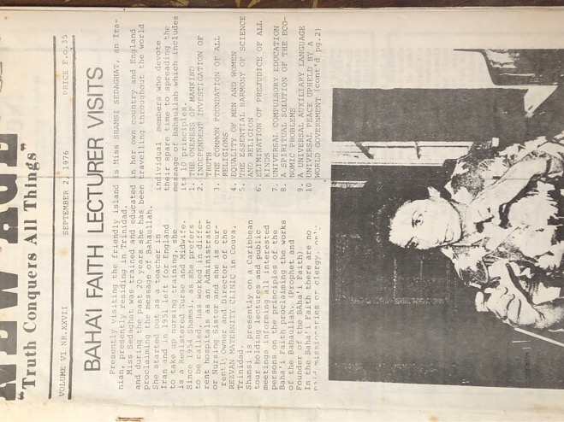
Article announcing Shamsi’s visit on St. Martin, 1976
The next day, September 1st, Ms. Terry Madisson and I went to visit friends of hers and invite them to our media reception planned for September 3rd. By coincidence we met a surgeon from Suriname who knew of the Faith from a Persian Baha’i woman, Dr. Nosrat Rabbani, a very active Baha’i in Curacao, so we invited him to the reception. I spent the afternoon with new pioneer Ms. Marian Barnes and her two sons offering love and encouragement as well as advice based on my experience. Ms. Terry Madisson and I spent the evening making a presentation on the Faith at the Jaycees Club which included my talk on progressive revelation, the history of the Faith, and some of its principles followed by Ms. Madisson’s songs. We had a rich discussion on the moral and social conditions of the world and the role youth could play to improve them. The discussion went on until after midnight and had to be terminated due to the lateness of the hour so the President of the Jaycees, Mr. Brison, asked us to lunch with him the next day, and we finished our conversation and departed.
The next day, the 2nd of September, we were at home in the morning, and for lunch we went to the Panoramique restaurant with Mr. Brison, Mr. Leo Friday, Mr. Roland Duncan, and Ms. Ruth Olivacce and had a nice meal. Mr. Brison and Mr. Friday were delighted that Mr. Duncan, a lawyer, had joined us and was asking questions about the Baha’i Faith because he had previously been closed to the ideas of religion.
That evening a farewell gathering was held for me at the home of Ms. Marian Barnes. I invited all the new declarees to tell their enrollment stories. Mrs. Guy explained that she had become inactive but had come to realize that the Cause of God should not be judged by its followers, and now she hoped to make up for lost time. This statement brought great joy to the gathering. I praised the spirit of the friends and wished them to be united going forward and all the success in their service to the Cause of Baha’u’llah.
On the night of September 3rd, we held our gathering for media contacts during which I spoke and showed slides. The editor of the Saint Martineer came along with his wife who was an artist and expressed her wish to design invitation cards for Baha’i gatherings which she did. The following day I said goodbye to some of my Baha’i friends who were present such as Ms. Terry Madisson, Ms. Barbara Joyce, Ms. Marian Barnes and her two sons who were among the most active and energetic Baha’is in the islands and left Saint Martin’s for Antigua.
Visit to Antigua, September 1976
I made two return visits to Antigua, the first for two-weeks in September and the second for one week in October. My two-week visit to Antigua was covered by the newspaper The Leader of Antigua.
The article described my work in Trinidad and included my previous visit to Antigua during which I taught at the summer school. I made it clear in the article that my goal was to speak about the Baha’i Faith. I emphasized the universality of its teachings and the importance of service. I explained that “It does not have a secret doctrine; it does not have any priesthood or professional clergy. Its mission is that of uniting the world in one common faith and one order; (our) religion must show men how to build a just world, to show men how to achieve world order and how, by high moral standards and a new basis of belief, they can become citizens of one world.” The reporter finished with a summary of the essential principles of the Baha’i Faith.
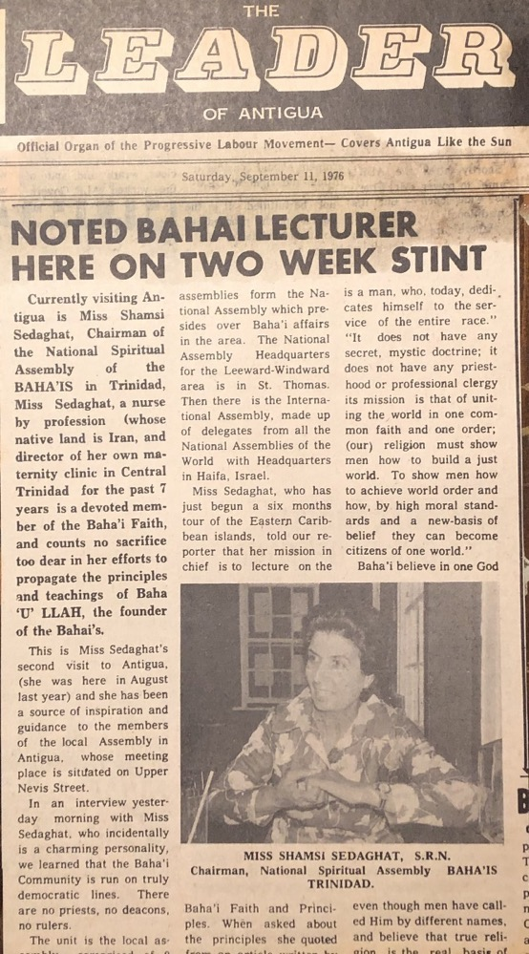
Article on Shamsi in the Leader, Antigua, 1976.
I lectured at Lions Club, Rotary Club, and the Jaycees. At the Jaycees, I was even able to offer a prayer to open the meeting in addition to giving a full-length talk.
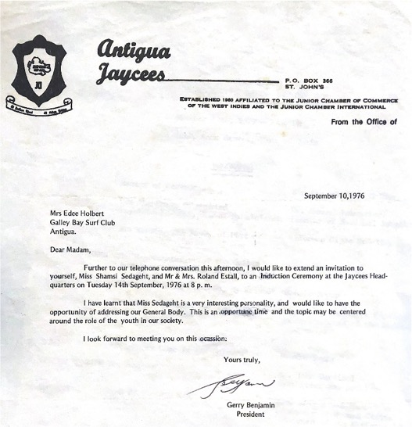
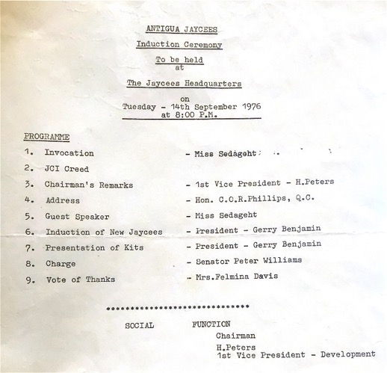
Invitation and program, Jaycees meeting in Antigua
Altogether, I gave five talks at the Meeting House which included slides and songs. I made three visits to Bethesda in St. Paul’s Parish. On one of these visits I spoke at the Women’s Club with about twenty women in attendance who were very interested in what they heard. At the public meeting at the Union Hall, I spoke along with Dr. John Yates and Mr. Al Millington to between 150-200 persons of all ages. The meeting lasted for three hours as the audience was very interested and asked that we return.
The friends gave me a farewell party at Galley Bay to which they invited local dignitaries and Baha’is. Their goal was to give one more ‘shot in the arm’ to our contacts. Among the guests were the president of the Lions Club and his wife—both of whom were doctors—a well-known businessman from St. John’s, the manager of Antigua and Barbuda Broadcasting, and Mr. David Looby who is a good friend of Dr. John Yates. The party lasted from 10:30 a.m. until 1:30 p.m. Refreshments were served. I told stories about my recent trip to Montserrat. There, I met and discussed the Faith with Rev. William Lake, a young, much-loved, and respected Anglican clergyman. The guests were excited to hear of his interest in the Faith, of his having received copies of Baha’u’llah and Christ and Thief in the Night, and of his promise to be in touch with the Baha’is of Montserrat, especially since the Reverend was a relative of Dr. Ramsey who was in attendance.
Most importantly I was able to secure an appointment with Mr. Dave Looby for the next day to set up the much-awaited Baha’i Radio Program for Antigua. He used the tapes made in Saint Martin’s. In the next days, the program became a reality. The Baha’is in Antigua were offered a regular 15-minute free weekly program slot every Sunday afternoon. The time slot was perfect, the news was at 12:30 pm, then classical music from 1-2 p.m., and then the Baha’i program from 2-2:15 p.m. Dr. John Yates had been building relationships with the radio programmers for over a year, and my teaching trip brought the effort to fruition. In one evening, we worked out a format and the program proceeded to be recorded and aired. We all felt the presence of Baha’u’llah’s Hand in helping us achieve this important victory. The program helped develop very good relations between the Baha’i community and the radio staff. I suggested that Mr. Looby be interviewed about the Faith and he stated that Baha’u’llah’s teachings were the answer to the world’s problems.
The Secretary of the Spiritual Assembly of St. John’s, Ms. Edie Holbert, wrote to the National Spiritual Assembly of the Leeward and Windward Islands the following:
“…I just want to write and tell the N.S.A. what a terrific job Shamsi has done. Of course, you’re heard this from all the islands – but I’m sure she out did even her fantastic self here.
She turned Antigua upside down …
Just want to say that Shamsi has been an inspiration to the island – and a bombshell!...Shamsi to Dave Looby said it is time now to interview you – and she did – and how. His comments about the Faith were that Baha’u’llah’s teachings were the answer to the world’s problems.”
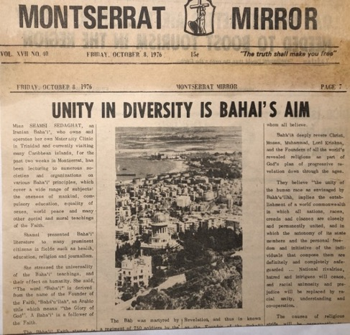
Article on Shamsi’s visit to Monserrat, October,1976, an island she visited after Antigua and before Dominica on the 1976 trip.
Visit to Dominica, October 1976
In pursuance of the goals of the Nine Month Plan of the National Teaching Committee of the Leeward and Windward Islands, I went south to Dominica on October 13th. I was given hospitality and aided by Mr. Frank Pacassi; his wife Pat was away on National Spiritual Assembly business. The New Chronicle and The Star announced my visit with an article that gave some biographical information and explained some of the basic principles of the Faith. We did some public proclamation also in the market place by mounting a small display in front of which people stopped to read the posters, hear a little bit about the Faith from us, and leave with a pamphlet.
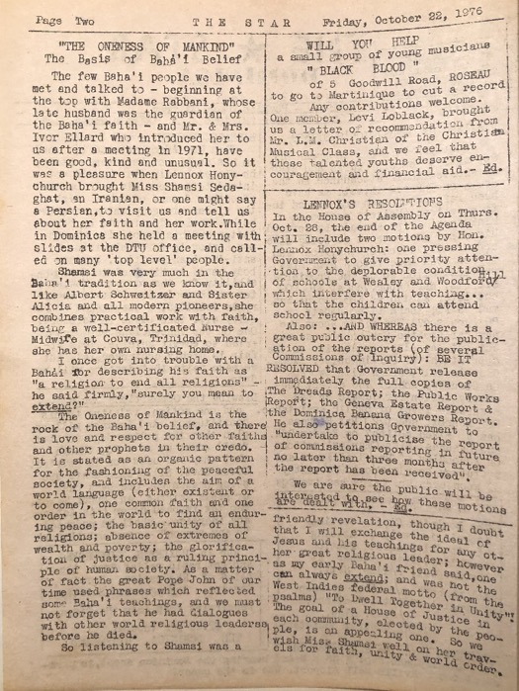
Article on Shamsi in the Star, Dominica, 1976.
Mr. Frank Pacassi and I made a courtesy call to the Minister of Education, Mr. M. Christian, to obtain permission to address students at the various schools. I presented him with Baha’u’llah and the New Era. The Minister was full of enthusiasm for the Baha’i teaching on the “Oneness of Mankind” and not only permitted me to visit the schools, he urged me to do so. As a result, we were able to give two lectures to students, once at the Technical College and another time at the government Grammar School; at both presentations combined, over three-hundred students and teachers heard about the Baha’i principles. Fifteen youth came to a fireside at the home of Ms. Mona George at which one young artist, Jerry Didley, declared. I met privately with a young Baha’i, Mr. Lennox Honeychurch, who despite his interest in the Faith had become immersed in local politics. I encouraged him to adhere to Baha’i principles and to gradually sever himself for all such activities and, instead, serve his people and government with his gifts of poetry and writing. This talented young man introduced me to some of his friends and arranged my interview with the editor of The Star, Mrs. Phyllis Shand Allfrey, who praised the Baha’i principles and secured the Union Hall for our public meeting.
Over sixty people attended the public meeting, most of whom were youth. I showed color slides of the Holy Land and the Baha’i Houses of Worship. The highlight of the meeting was the presence of the Minister of Education, Mr. Christian, who praised the good behavior of the youth and appreciated being able to be present and congratulated me for my ‘good work’. On the last day of my visit, I lectured at the Lions Club and the Jaycees and then attended the celebration of the Birth of the Bab at the home of the Permanent Secretary of the Minister of Finance, Mr. Lazar, a non-Baha’i friend of Ms. Mona George’s.
Visit to St. Lucia, October 1976
On the 21st of October I left for Martinique and then on the 25th, I went south to St. Lucia for a week. Upon arrival, no one was there to meet me, so I made my way to the Tourist Board and found a guest house, the Planter’s Inn, which could accommodate me. I immediately began arranging my activities.
I was interviewed with Mr. Guy Ellis, and so the Thursday, October 28th, edition of The Voice announced that I was in St. Lucia to “…spread the Baha’i Message of unity and brotherhood among all human beings.” The article went on to give a biography of my life and to announce our public meeting. Two radio interviews took place, one with Ms. Drusilla Blanchard arranged by the Program Director of Radio St. Lucia, and the other with Ms. Emelda Charles of Radio Caribbean. I taped one television interview. Mr. Don Norville, Manager of the Guyana and Trinidad Mutual Life Insurance Co. organized a talk for me at the Rotary Club; I spoke on the essential principles of the Faith. A public meeting was held in the Town Hall in Castries after we were able to secure it from the Town Clerk with whom we spoke about the Faith. I gave a talk and showed colored slides which were followed by numerous questions.
Friends and new believers were won during this week in Saint Lucia. The proprietor of the Planter’s Inn where I was staying read Baha’u’llah and the New Era in two days and promised to keep in touch with the Baha’is. A newly declared Baha’i, Mrs. B. Jean Baptiste, came to a small fireside which was held in the home of Mr. and Mrs. Freidman and showed herself to be energetic and sincere.
The highlight of the visit was being introduced to Mr. Lennox James, by a young Baha’i, by Mr. Priestley Louison. Lennox had heard my interview with Mr. Julian Rogers on Radio Antilles and agreed with the Baha’i views I expressed and hoped to meet him when I came to Saint Lucia. He was from Grenada originally, had a young family, and ran the Caricon Agencies. We met Lennox by chance when Priestley and I were on our way to Radio Caribbean and ran into him on the street. He and Priestley came later to the guest house, and we discussed the Faith at length. He helped me prepare the public meeting, and he declared the same night. I saw that this young man would be a great asset to the Faith in Saint Lucia despite his young age. He is respected throughout the island and has a well-known business which takes him to other islands regularly. When it was time to leave Saint Lucia on November 1st, Lennox took me to the airport in his car.
Visit to Barbados, November 1976
I spent the next week in Barbados, the easternmost island of the Lesser Antilles and located southeast of Saint Lucia. Mrs. Eve Johnson, the recording secretary of the National Assembly of the Baha’is of the Leeward and Windward Islands, met me at the airport and drove me straight to Rediffusion where I had a twenty-two-minute interview with Mrs. Carolyn Barrow. Later, that same day, I taped two ten-minute segments at the Caribbean Broadcasting Corporation for the regularly scheduled Baha’i program. Afterwards Ms. Emily Kramer made a delicious meal for us. We ate and discussed the plans for my visit.
The Advocate News interviewed me allowing me to renew my friendship with its sales manager, Mr. Fitzroy Jackman, whom I had met in 1972 on a previous teaching trip to Barbados. The article presented the essential Baha’i principles along with a few brief facts about my life and repeated my emphasis on youth:
“Stating that the Baha’i Faith now places stress on the importance of youth, Miss Sedaghat said that in the Baha’i writings it is believed that youth today must show a greater maturity than any previous generation, for they are called upon to pass through, perhaps the gravest crisis in the history of the world and they must meet their destiny with faith, steadfastness, assurance, and poise.”
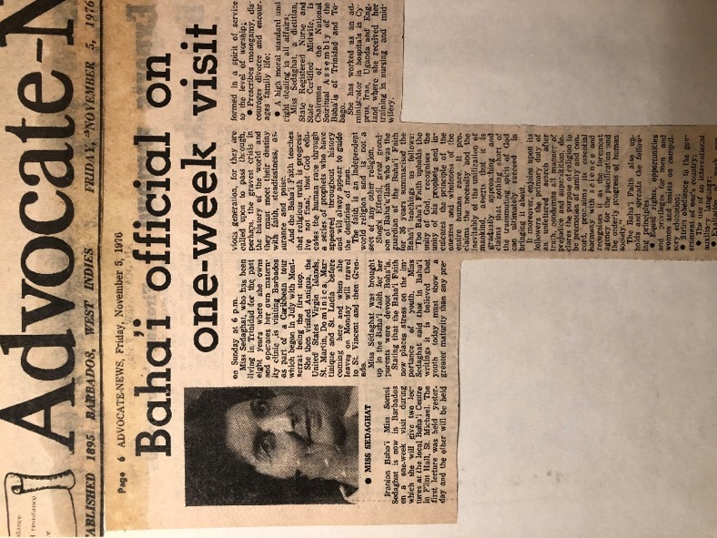
Article announcing Shamsi’s visit to Barbados, 1976.
A sixteen-minute television interview went very well, and its broadcast reached neighboring islands as I later found out on St. Vincents. When I arrived at the airport there, a person approached me and said they had seen me on television and asked me if I would be holding any meetings while I was on St. Vincent? I replied, “I hope so.”
The highlight of my stay in Barbados was an unexpected interview from a radio host, Mr. Glyne Walrond of Rediffusion. He invited me out of the blue for an interview on Sunday, November 7th. I went filled with suspicion since I had not requested it. When I arrived, I asked him why he wished to speak with me and what his questions were. He replied that he had heard my interview with Mrs. Barrow and wanted a chance to interview me himself. Though he told me the questions would be the same, I saw on his desk a notepad filled with his handwriting. Once we got underway, it became clear to me that his intention was to corner me on issues of prophecy, the appearance of false prophets, the immortality of man and God, and the fact that we were teaching about Baha’u’llah instead of Jesus Christ. I answered his questions drawing on my knowledge of Bible prophecies. The time ran out, and we did not get to all his prepared questions. He thanked me for being his guest. I saw in this exchange, the power of the Spirit of Baha’u’llah which helped me answer the many questions.
I gave four lectures on progressive revelation using my charts at several area schools: Queen’s College, St. Michael’s Girl’s School, Modern High School, and St. Leonard’s Girls School. Over 400 students were reached as well as their teachers and many asked deep questions. We also held two public meetings on Friday and Sunday at the Baha’i Center in Flint Hall, St. Michael. On that same Sunday, I gave a deepening for fifteen youth and others at the Baha’i Center during which we studied the Life of the Bab and Baha’u’llah followed by songs which uplifted the hearts. At the house of Mr. Victor Jackman in Christ Church, we had another deepening. I encouraged the fifteen members of the Baha’i Youth Club which helped them.
My friend and fellow National Assembly member from Trinidad, Dr. Harry Collymore wrote to me and asked that I look for Mr. Torrev Pilgrim from whom he had first heard mention of the Baha’i Faith in England in 1957. I telephoned Mr. Pilgrim, and we met at the Baha’i Center. He took me to his yoga center and introduced me to his students. He asked me to speak with them about the Faith which I did. I encouraged him personally to be an active Baha’i by serving the Cause and living the life. He said that he missed the Faith and the fellowship with the Baha’i community, and after attending our public meeting, promised to come more regularly.
Thanks to Dr. Collymore again, I met up with his sister, Mrs. Marjorie Saunders, the wife of Rev. Philip Saunders of the Methodist Church. She telephoned me and invited me to lunch. Over a meal, we spoke extensively about the Faith, and I gave her husband a copy of Paris Talks which he promised to read. I found the Reverend to be open-minded about religion and encouraged Mrs. Eve Johnson to give him more books later. After my departure Rev. and Mrs. Saunders travelled to Trinidad where they stayed with Dr. Collymore who showed them the land he had donated to the Faith on which a Baha’i Center would later be built—today there is a very nice Baha’i Center built on it, and the friends in the south of Trinidad are using it.

Visit to St. Vincent, November 1976
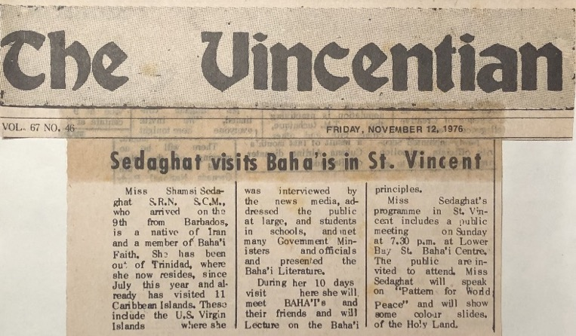
Article announcing Shamsi’s visit to St. Vincent, 1976.
After Barbados, I travelled due west and spent almost all the rest of November in St. Vincent and Grenada. After leaving Barbados in the late afternoon, I landed 45-minutes later in St. Vincent. The immigration officer asked me where I would be staying, and I answered the Baha’i Center on Lower Bay Street. There was no such place he replied and said I would have to give him the correct address.
I walked over to the tourist desk and as soon as I walked up the young lady asked me if I was the same Baha’i lady who had been on Barbados television the night before. I said yes, I was, and she asked me if I was going to be speaking on the island somewhere as she was interested in coming to learn more. I asked her if she knew any Baha’i whose address I could give to the immigration officer. She answered yes and picked up the phonebook to look up the address of James Sutherland. Mr. Sutherland was actually the father of one of the Baha’is who were waiting outside to pick me up—Lennox Sutherland, the other being Mrs. Shirley Howard. I gave the immigration officer the address of the place where I’d be staying.
The two drove me to the ‘Baha’i Information Center’ on Lower Bay Street which was the home of two Canadian pioneers—Mrs. Helen Marshall and Mrs. Eva Statz. The next day Mrs. Shirley Howard, who was responsible for public information in the community, came to pick me up to arrange appointments for interviews to help promote the public meetings we would be holding.

News media interview
I had two interviews with Mrs. Nora Peacock, the editor of the Vincentian; one was short at the beginning of my stay and helped to announce the coming public meeting and the longer one took place toward the end of my stay and was published under the heading “Baha’i Teaching Aims at World Peace”.
Baha’i Teaching Aims at World Peace
“During her lectures, she stressed that the Baha’i Faith upholds the basic truths and beliefs as taught by the founders of all the world’s Great Faiths…“They teach their religion is the foundation of true civilization and progress”, Miss Sedaghat explained. She said there are certain principles given by Baha’u’llah, the founder of the Baha’i Faith, which will result in a united world…”
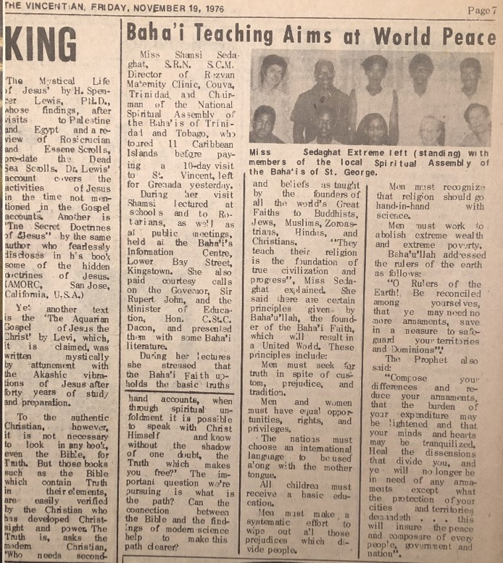
Article on Shamsi and the Faith in the Vincentian, St. Vincent, 1976
The article then gave a brief summary of the essential Baha’i principles and closed with two passages from Baha’u’llah’s Writings about disarmament and the role of leaders in creating peace.
Radio interviews
I had two radio interviews with Mrs. Jean Duncan, and she also copied two five-minute segments on Baha’i education which I had taped originally for Radio Trinidad and which she would later air on Radio 705 St. Vincent. An informative half hour television interview was conducted by Ms. Jean Duncan.
I met individually with the Jaycees President Mr. Toppin, Mr. Frank Diabreau, a Rotarian and Head of the Royal Bank, and Dr. A.F. Gathere, a member of the Lions Club. I spoke with each about the Faith, presented a few Baha’i books, and offered to give a talk at their respective clubs.
Even on such short notice, the Rotarians moved their scheduled speaker and put me in the program instead. After my talk, I was presented with a Certificate of Appreciation by the President of the Club, Mr. Bollers.
Coincidentally enough, this was the same individual who Mrs. Johnson from Guyana had asked me to meet. I sat next to him during the meal, and we were able to speak about the Faith. Later I went to meet his wife in the well-known store where she was the assistant manager, and we spoke at length about the Faith.

Celebration of the Birth of Baha’u’llah and other meetings
The next talk I gave was for the celebration of the Birth of Baha’u’llah that evening, November 11th, at the Baha’i Center which was attended by many non-Baha’is. I gave an overview of the Life of Baha’u’llah and His Exiles and finished with a summary of some of the essential principles of the Faith.
We held a public meeting at the Baha’i Center three days later, on Sunday, which was attended by a variety of seekers including Dr. Inniss, a dentist and Rotarian, who had heard me speak at the Club and took me up on my invitation to attend the public meeting. He was extremely interested and became annoyed when a fervent Christian young man kept interrupting the talk by repeatedly quoting from the Bible to which the dentist said that he already knew those passages from the Bible and was there to learn about the Baha’i Faith. At this meeting, the local Baha’is announced that they would be having regular firesides on Mondays.

Meetings with the Minister of Education and the Governor-General
I was able to call on two prominent St. Vincentians thanks to my friend Dr. Harry Collymore. His uncle Magistrate Carl Collymore lived on the island, and Dr. Collymore had asked him to reach out to me when I was there. As he didn’t know the addresses of any local Baha’is, he contacted the Immigration Department and was given the name of Helen Marshall. The next morning after my arrival, he and his wife showed up at Helen’s residence asking for me. I was out speaking at a grammar school, so he went to pick me up, and we ate together and did some sightseeing. We spoke at length about the Faith, and I gave him literature on it. He offered to take me to the Governor General, Sir Rupert John, to whom he was related, and to the Minister of Education, the Hon. Dacon C. St. Clair.
Meeting the Minister of Education
On November 15th Magistrate Collymore and I called on the Minister of Education who received us warmly. We spoke about the Faith for an hour, and he asked about the Baha’i views on education and the spread of the Faith in the Caribbean and St. Vincent to which I gave a short reply. He encouraged me to return for a longer period and speak in as many schools as I could about the oneness of mankind and the relinquishing of prejudice. He asked if we had any centers on the island, and I told him that there was one that we rented on Lower Bay Street but that we were looking to buy a parcel of land in Clear Valley on which we could build a new one. He said that this was an excellent area as there were many youth there who needed training. He suggested that we investigate applying for some of the Crown Land available in that area. Our visit finished with my gift of Baha’u’llah and the New Era and Pattern for Baha’i Life. Then we thanked him and departed.
Meeting with the Governor General
Immediately after this fruitful visit to the Minister of Education, we called on the Governor at his mansion. Magistrate Collymore and I waited in the mansion’s ample lounge until the governor’s arrival. He came in accompanied by a married couple from the United States who had come for a boat racing event. The group discussed the new President-elect in the United States and what changes would be coming in that country. I interjected the Baha’i views on the various subjects they were discussing. I gave a small leaflet by Hand of the Cause Dr. Ugo Giachery titled, “One God, One Truth, One People” and opened it to the first page and gave it to the Governor to read aloud: “O kings of the earth we see you increasing every year your expenditures, and laying the burden thereof on your subjects. This, verily, is wholly and grossly unjust…” The Governor’s voice boomed around the room with the words of Baha’u’llah from Gleanings. One could feel the power of these commanding words engulfing everyone present in this impressive hall with its huge portraits of British monarchs hanging on the wall. I visualized the conditions which Baha’u’llah had to endure in the prison city after revealing these words, and the wealth of the rulers to whom He had written and here was a representative of the British Crown reading his words aloud in a thundering voice. The American couple became excited and asked if they could find Baha’i literature in public libraries, and I answered that in some countries you might find them in libraries or bookshops but there would be some in community libraries. They promised to find out more about the Faith when they got back to the States. They commented that I must be a very brave woman to be travelling alone and teaching these powerful principles to people who think the opposite of them. On the contrary, I replied, many are thinking these same thoughts, and one day God’s Plan would be accepted by many. The governor went to get two books presented him by an American travel teacher, Mrs. Sheila Banani, daughter of member of the Universal House of Justice Mr. Charles Wolcott, Baha’u’llah and the New Era and the most recent edition of The Baha’i World. Again, I opened the first book to a passage relevant to our discussion on government and asked him to read; the Governor read it aloud moving us all by the idea that these same principles being discussed today had been given by God over one hundred years ago, but no one had taken much notice of it. While he had not read the books yet, he had been much moved by our visit and hoped he would be able to see us again sometime in the future.
Visit to the Baha’i Center
We left our visit with the governor at 6 p.m., and Magistrate Collymore and I made our way to the Baha’i Center for a 7 p.m. fireside. Mr. Frank Diabreau from Guyana who managed a branch of the Royal Bank of Canada, and his wife, and Mr. Taylor, a mechanic who had recently declared, and his teacher were there. Mr. Diabreau asked many questions and was eager to learn more, so I gave him a copy of Baha’u’llah and the New Era for the Rotary Club. He said he would read it first before passing it on to the Rotary Club. I heard later that he had maintained his interest in the Faith and maintained his friendship with Baha’is and has even invited Ms. Eva Stats to one of his official gatherings and has been reading many other Baha’i books.
A phone call from the Secretary of the NSA of the Leeward and Winward Islands
I received a phone call from Mrs. Paccassi, the Secretary of the National Assembly of the Baha’is of the Leeward and Windward Islands which was in session that day, appointing me to assist the committee on St. Vincent in charge of finding suitable land for a Haziratu’l-Quds and that the particulars would be given to me by the Secretary of the St. George Assembly. I accepted the task and after reading the letter with the specifics, I drove with Mr. Lennox Sutherland, Ms. Helen Marshall, and Ms. Eva Statz to Lowman’s Hill. I noticed that the land was high up on a hill and away from a population center, so it was not suitable for this purpose though it may have made a good endowment property. From the high vantage point, I saw a thickly populated village in the distance. I was told this was Clare Valley and that many Baha’is lived there. I asked to be taken there where we met Mr. James Marshall and his family who were all Baha’is. We explained the purpose of our visit and asked if he knew of any vacant land for sale. He pointed out a good parcel of land almost opposite to his house on the main road which was for sale. He took us to the person in charge who let us know that Sister Sprott was the owner of the property and that she worked at a nearby hospital. Her parcel was made up of five pieces of land ranging from 60c per sq. foot to 75 c per sq./ft. We all liked the location of the land because of its proximity to a main road and this Baha’i family.
The next day, Mr. Dick Emanuel and I went to the hospital to meet Sister Sprott. She was busy in the operating room, so Dick was not permitted beyond a certain point in the hospital. I was allowed in after much persuasion. She was busy but became friendly after I introduced myself professionally and because she recognized me from the media coverage of me. I explained to her the purpose of my visit. She said that she did not want to sell the parcel in pieces and that, if she did, it would be at a higher price. Our first effort to visit the land with her fell through so we went to visit another piece of land in Clare Valley, but it was out of the way and too hilly. We decided to try again with Sister Sprott, and this time we unanimously agreed that we wanted the first parcel which had 5216 sq. feet. We negotiated with Sister Sprott and were able to settle on the original price. We thanked her and left the rest of details for the National Spiritual Assembly to decide.

Visit to Grenada, 1976
Before returning to Trinidad, I spent ten days on the island of Grenada. The newspaper The Torchlight announced my arrival in its Sunday, November 21st, 1976, edition. A list and summary explanation of the major Baha’i principles was included. I addressed the Lions, the Jaycees, and the Rotary Clubs.
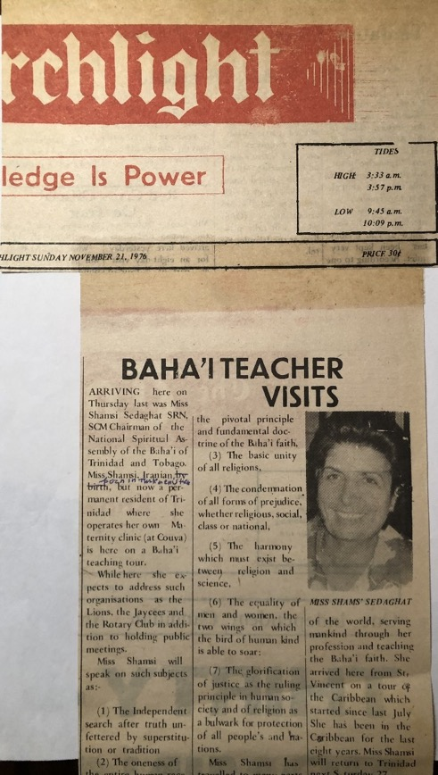
Article in The Torchlight on Shamsi’s visit

I gave an interview for which I had been sent these questions in advance:
1) Could you tell us what does Baha’i mean and what are the principles?
2) Is Baha’u’llah the last prophet of God?
3) What is the Baha’i view about the other religions?
4) Do you think that World Peace is at hand?
I was happy to have the questions and replied briefly according to the Baha’i explanations which satisfied the interviewer.
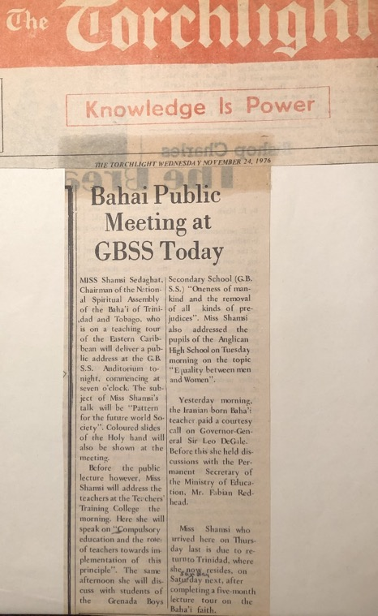
Article announcing Shamsi’s talks on Grenada, 1976.

At the Anglican High School, I spoke to over 500 students and fifteen of their teachers on the topic of “Equality between both Sexes” which ended in a great deal of applause. At the Teacher Training College, I talked on the subject of “Compulsory education and the role of teachers towards implementation of this principle.” That same afternoon I spoke on the “Oneness of mankind and the removal of all kinds of Prejudices.” We held a public meeting at the Grenada Boys Secondary School located in St. Joseph’s Convent on the topic of “The dangers of disobedience to prophetic commands concerning morality.” Our fireside topics in Baha’i homes included “Progressive revelation,” “Compulsory education,” “Role of youth towards world peace,” and “Pattern for a future society.” The highlight of my visit was a courtesy call with the Governor-General of the island Mr. Leo DeGale, and the Secretary of the Ministry of Education, Mr. Fabian Redhead, accompanied by local Baha’is, Mr. L. Wilson, Mr. Graeme Stratton, and Mr. Arthur Winner. The meeting lasted an hour and a half during which the Governor-General learned about the progress of the Faith in the Caribbean and the positive effect of the moral and social teachings of the Faith.

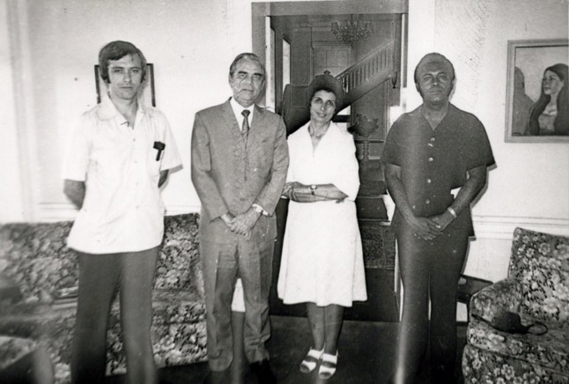
L. to r.: 1) ?, 2) Governor-General Sir Leo Degale, 3) Shamsi, 4) ?
(question mark means I forgot their names)

The Torchlight newspaper praised my teaching trip:
“Baha’i Lecturer Ends Her Five Months Caribbean Tour
Miss Shamsi Sedaghat, Director of Rezvan Maternity Clinic in Couva, Trinidad leaves Grenada today after 10 days visit to this island. Miss Sedaghat who is the Chairman of the National Spiritual Assembly of the Baha’is of Trinidad and Tobago, is an Iranian and presently resides in Trinidad. During her busy schedules here, she had radio interviews, taped TV interviews, for future release and had public talks.
About 500 students, of the Anglican High School for girls including 15 of their Teachers and the Principal, Mr. D. Baptiste, heard Miss Sedaghat during their assembly when they spoke about “Abolishing of all kinds of Prejudices” and “Equality between both sexes”.
The lecture was well-received as shown by the continued long applause after her talk.
Similar talks on various subjects such as “Progressive Revelation”, “Compulsory Education”, “Role of youth towards World Peace”, “Pattern for future society”, and some other Baha’i principles given at the G.B.S.S. (Grenada Boys’ Secondary School), at St. Joseph’s Convent and at a well-attended public meeting chaired by Mr. L. Wilson Jr. The Permanent Secretary of the Ministry of Finance, Mr. V. Francis, and Sister Philomena, the Principal and Superior of both schools respectively were also present at the lectures. The topic at the Convent included “The Dangers of disobedience to Prophetic Commands concerning morality”. Students were so impressed that they invited Miss Sedaghat for further lecture if her schedule permits.
She spoke about the Baha’i holy places as well as houses of worship around the world.
She also spoke to a small gathering of Baha’is at the Devotional Meeting in the Paradise Village, where Baha’is held their “National Prayer Day”.
Miss Sedaghat quoted the late Guardian of the Baha’i Faith, Shoghi Effendi, on Future Society.
Miss Sedaghat said that the highlight of her visit to Grenada was a courtesy call on the Governor-General Sir Leo DeGale, at the Government House where she was accompanied by Mr. L. Wilson, Mr. Graeme Stratton, and Mr. Arthur Winner some of the members of the Baha’i community here. The meeting was very cordial and it lasted one and a half hours when His Excellency was informed of the extent of progress of the Baha’i Faith in Caribbean Islands where she visited and the positive effects of the Moral and Social teachings of the Faith, especially on youth.”
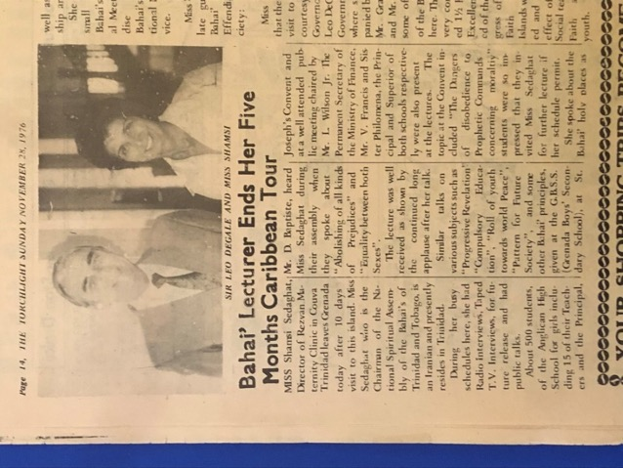
Shamsi with Sir Leo Degale on the right; article from The Torchlight

Letter from the Office of the President of Trinidad and Tobago
After my return from my teaching trip, the National Spiritual Assembly of Trinidad and Tobago wrote a letter of congratulations to the newly elected President of the country. It received the following letter in return:
“OFFICE OF THE PRESIDENT
Trinidad and Tobago
December 30th, 1976.
Sir,
I am directed by His Excellency the President to acknowledge receipt of and thank you for your congratulation extended to His Excellency on the occasion of his election to the Presidency.
His Excellency has also asked me to extend the season’s greetings to you and your Assembly, I have the honor to be, Sir, Your devoted servant,
J.Tam, Secretary to His Excellency the President”
Visit to Merida, Mexico, teaching conference, 1977
In its message of Naw-Ruz 1974, the Universal House of Justice had called for eight international teaching conferences: Anchorage, Alaska; Helsinki, Finland; Paris, France; Nairobi, Kenya; Hong Kong; Auckland, New Zealand; Bahia, Brazil; and the final one in Merida, Mexico. In February 1977, at the last minute, I was able to go to Mexico and participate in the Merida Conference which attracted 2,000 Baha’is, one third of whom were indigenous believers from Central America including 150 Mayans. Hands of the Cause Mr. Paul Haney, Mr. Rahmatu’llah Muhajir, and Mr. Enoch Olinga, as well as Counselor Mrs. Florence Mayberry, who had served on the first National Spiritual Assembly of Mexico, guided the friends. The Universal House of Justice wrote to the friends that the Conference might provide “…a unique opportunity to initiate what may well become the widespread reawakening of a people whose ancestors more than 1,200 years ago developed one of the most brilliant pre-Columbian civilizations known to modern man.” 'Abdu'l-Bahá had written in his Tablets of the Divine Plan that the people of these regions had “…a great destiny once they have accepted His Father's Cause.” The House of Justice expressed urgency in the teaching work:
“In less than thirty months…over 400 Local Spiritual Assemblies must be added to those already existing in the mainland and island nations of Middle America! To accomplish this challenging task, intensive effort to attract new believers, be they black, brown, red, or white, from all strata of society must be exerted. Hand in hand with this endeavor, particularly in local communities, goes the development of the distinctive character of Bahá'í life. Prompt attention must also be given to the acquisition of local Haziratu'l-Quds and endowments; and the translation and publication of Bahá'í literature, especially in indigenous languages, must be accelerated.”
Travel teaching in Central America
At the Conference, I consulted with the Hand of the Cause Dr. Muhajir, and he warmly encouraged me to continue my travel teaching trips pending guidance and approval from the House of Justice. However, I could not resist the call for travel teachers and pioneers, and so I volunteered myself for a one-year trip wherever I was needed, and Mrs. Edie Holbert from Antigua, who had been so helpful during my previous teaching trip to Antigua, offered to deputize a travel teacher to Central America if that travel teacher was Shamsi. Hand of the Cause Dr. Muhajir and Mrs. Baldwin asked that I please consider this offer. So, it was decided that I should visit several countries in Central America on the east coast and to have the trip last 6-12 months.
My letter to the Supreme Body, the Universal House of Justice
I wrote to the Universal House of Justice on February 1st seeking its instructions:
“The Universal house of Justice
P.O. Box 155
Haifa, ISRAEL.
Beloved Friends,
Enclosed please find the summary of my 4 ½ months (July 15th to Nov. 28th, 1976) Travel Teaching trips to the Caribbean Islands under the jurisdiction of the two N.S.A.’s of the Leeward and Virgin, and Barbados and Windward Islands as well as Xerox copies of the reports submitted by some of the islands. For your information, originally, I offered my humble services to the Continental Pioneering Committee for America, which unfortunately no reply was received to my two letters. So consequently, I offered my help to the above Assemblies which graciously was accepted. (I was self-supported except in some islands where hospitality was provided by the friends).
I would like to express my sincere gratitude for your prayers and bounties bestowed upon this humble servant, through your letter to the Hand of the Cause Mr. Jalal Khazeh who had kindly sent me a Xeroxed copy of it, when I was in Barbados.
There is no doubt, that those precious prayers, of which previously I was unaware, have been the sources of my strength and the cause of all the victories which we had in the islands. May I humbly beseech your further prayers towards my strength and steadfastness during my repeated tests in this pioneering post.
At this point I wish to seek your guidance on the following views:
a) As there are newly arrived pioneers in this island, is it advisable for me to offer my services to Cyprus, or
b) in the light of your letter dated December 19th, 1976, may I offer my services for 6 months or longer for a travel teaching project wherever is needed?
If either of these two views is approved, I will be ready to leave for my destination before Rezwan 1977…Humbly I supplicate myself at the threshold of the service of our beloved faith and imploring your guidance,
With loving greetings in His Service,
Shamsi Sedaghat”

A response from the Universal House of Justice
“Miss Shamsi Sedaghat
S.R.N., S.C.M.
REZVAN CLINIC
Isaac Settlement
Couva, Trinidad, W.I.
Dear Bahá’í Friend,
Your letter of February 1 from Trinidad and your handwritten letter from Merida with its important additional information have been received by the Universal House of Justice, and we are instructed to convey its advice.
Your several months of teaching in the Caribbean Islands were most productive, as the favorable reports from your host National Assemblies received at the World Centre indicate and the House of Justice is very pleased that you will be able…to undertake further travel teaching in the English-speaking lands and islands of Central America and the Caribbean. It is hoped that you will find it possible to devote some weeks to teaching in the Bahamas, a goal area of the National Spiritual Assembly of the United States; as you are aware, a new National Spiritual Assembly is to be established during May 1978 in the Bahamas, and strenuous endeavors are required. The National Assembly of the United States will have to be consulted when your plans are developed, and it will wish to coordinate your program.
With reference to your offer to serve the Cause once again in Cyprus, the delicacy of the situation on that island, and the problems of teaching there suggest that it is untimely for you to consider either travel teaching or a further period of pioneering. Nevertheless, the House of Justice deeply appreciates the spirit of your offer and recalls your important services to the establishment of the Faith in that now-divided island.
The House of Justice, while noting that your expenses are accounted for, wishes to express its willingness to support your travel teaching efforts should this become necessary. Meanwhile, it hopes that, in view of your valuable role in Trinidad, you will not schedule your extended travel until after Ridván less the important efforts now afoot on your home islands are weakened.
With loving Bahá’í greetings,
Margaret Bacherieh (Mrs.)
For the Department of the Secretariat”

Hand of the Cause Mr. Paul Haney’s visit to Trinidad February 1977
In the three months that followed the Merida Conference, Trinidad and Tobago were blessed with the successive visits from three Hands of the Cause—Mr. Paul Haney, Mr. Enoch Olinga, and Mr. Zikrullah Khadem. Two weeks after the close of the conference, we held a satellite conference in Trinidad which was blessed by the presence of Hand of the Cause of God Paul Haney, who had been the official representative of the Universal House of Justice in Merida, Mexico.
Mr. Haney served for many years on the National Spiritual Assembly of the United States before being appointed a Hand of the Cause. He arrived in Trinidad on February 19th. Dr. Harry Collymore and I met him at the airport, and we promptly ushered him to the VIP room to be interviewed by a journalist from The Express.
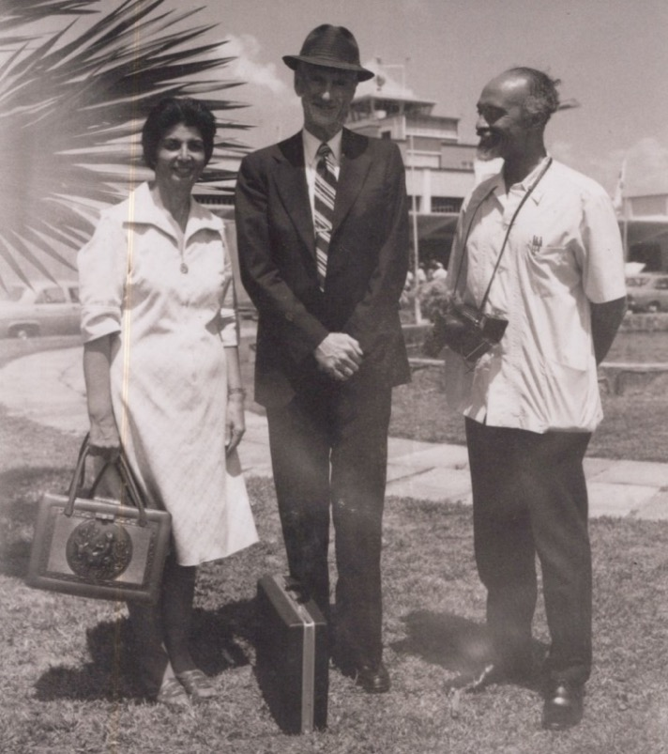
Hand of the Cause Mr. Paul Haney just arrived in Trinidad, and we met him at the airport.
L. to r.: Shamsi, Mr. Paul Haney, Dr, Harry Collymore

We then drove to the house of Dr. and Mrs. Jamalabadi where he could have a short rest before going to our national satellite conference which was already in progress at the Baha’i Center in Port of Spain.

Satellite Conference
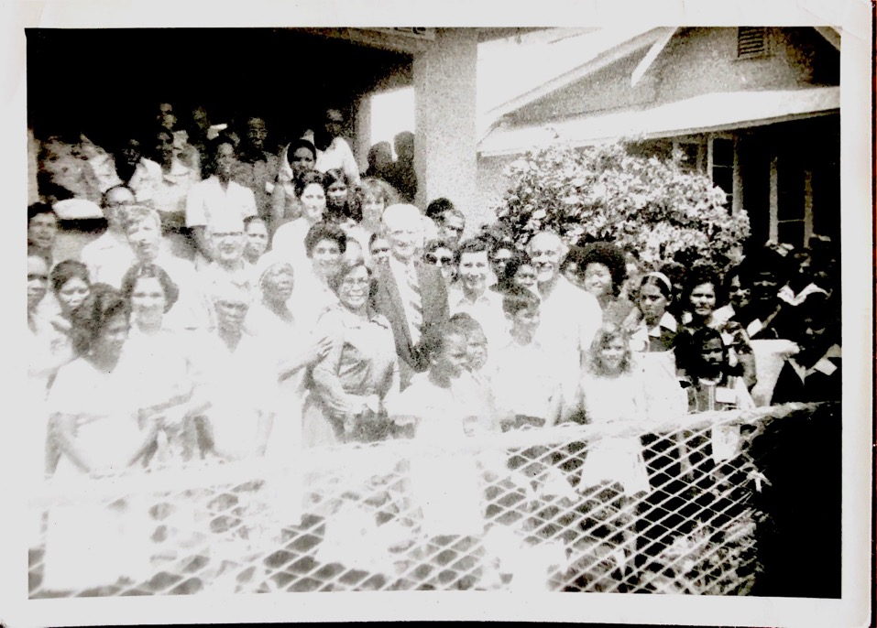
Hand of the cause Paul Haney in Trinidad
Standing behind the children in the middle row: 1) Dr. Harry Collymore, 2) Mr. Peter McLaren, Counselor for South America, 3) Hand of the Cause Mr. Paul Haney, and to his right, Shamsi.
The rest are lovely Baha’is and their good friends.. Everyone was happy and learned new principles and how to put them int o action.
Over seventy Baha’is attended the conference, and they arose to sing “Allah‘u’Abha” when the beloved Hand of the Cause entered. As the chairperson of that afternoon’s session, I introduced Mr. Haney to the enthusiastic gathering.
He rose and conveyed the love and greetings of the Universal House of Justice. He said that the Bahia Conference in Brazil which had taken place at the end of January had fulfilled the prophetic words of ‘Abdu’l-Baha concerning Bahia. Approximately 5,600 new Baha’is had enrolled just before that conference, and 6oo more just after. The next International Conference was in Merida, Mexico. It had a special spirit. It was held in the Mayan area where there were many Baha’is. He said there were over eighty declarations in the Merida area during the conference and in the days that followed. There were over 300 offers made for pioneering and travel teaching. It was the second largest of the eight conferences, with $140,000 raised for the construction of the Seat of the Universal House of Justice and for teaching projects. He said that the Baha’is were the only really happy people that he had seen on his trip. In reference to the construction of the Seat in Haifa, he said that the excavation was complete, and that the first shipment of marble had arrived, and the second was ready for transport to Israel. It was hoped that the outer shell would be finished in twenty-eight months. The construction of Baha’i buildings on Mt. Carmel, God’s Holy Mountain, was of tremendous significance. At the Satellite Conference in Panama the following Saturday of the Merida Conference, Mr. Haney said that 300 Baha’is attended, including ninety indigenous Indians.
Ms. Lillian Fraser said that a Baha’i conference was a different world, the way the world should be. There was a true spirit of family at a Baha’i Conference in which the world becomes one.
A story from Counsellor Peter McLaren
Counsellor Peter McLaren told a story about a connection between the conferences of Bahia and Merida. In 1963 he had visited an Indian tribe in South America teaching the Faith. One of the people, a small girl at the time, had heard and accepted the Faith without his knowing about it. When he returned to the area in 1969, he met this girl who told him her story. Her family did not approve of her interest in the Faith at first. Then she got married and pioneered for the Faith in the Amazon valley. Her father and two sisters became Baha’is and attended the Merida Conference. Mr. Haney spoke about the spiritual power in the teaching of the Faith and how these conferences will help to make us better spiritual instruments for Baha’u’llah’s purposes, which was followed by consultation on the Five-Year Plan.
A gold mine of inspiration and guidance
On Sunday morning, the second and last day of the satellite conference, Mr. Haney read selections from unpublished letters of the Beloved Guardian, which Mr. Haney called “a gold mine of inspiration and guidance.” He said that believers must not wait to be fully qualified for Baha’i work. They must plunge in. Becoming a Baha’i was a gradual process during which we open our hearts to the reality of the Manifestation. He said that we should not teach in a fanatical way, but through love and wise demonstration, as ‘Abdu’l-Baha did. He said the Baha’is must attain to a cordial unity and not dwell on the faults of others and backbiting. The believers must draw on the love and strength of one another. The Baha’i Administrative Order coordinates and unifies the efforts of the Baha’is in carrying out the Message of Baha’u’llah to the masses. We should not let the condition of the world discourage us. No obstacle is too great. We must be courageous. The burden of materialism in the world will lift, but we must work in the meantime. Our strength comes from the world of light. The consultation which followed these uplifting remarks centered on love and togetherness in the Baha’i community.
Dr. Said Khadem, our treasurer, gave a very illuminating talk about the Baha’i Fund, mentioning that contributing regularly and sacrificially to the Baha’i Fund is an essential part of Baha’i life. The flow of funds is like the lifeblood which must be continually flowing. A person is not a fully functioning member if he is not contributing to the fund. When all the members of the Faith contribute to the Fund, it expresses the truth of one soul in many bodies. He said that Baha’is must learn to contribute from one cent onward and, that there is a need for devotion and sacrifice to attain the goals of the Five-Year Plan. He happily reported that local donations had doubled during this year compared to the previous year, and he expressed the hope that this year the Baha’i community of this country will be self-supporting.
In conclusion, Mr. Haney said that the Writings of the Faith are like an ocean in which we should immerse ourselves. He said that very great things are expected from the Baha’is of the West, and that we should arise and realize the possibilities that are all around us.
The following cable was sent to the Universal House of Justice on behalf of the Satellite Conference:
“GRATEFUL PRESENCE GUIDANCE YOUR REPRESENTATIVE MERIDA CONFERENCE HAND CAUSE PAUL HANEY FIRST SATELLITE CONFERENCE STOP RADIANT SPIRIT ANIMATING 103 PARTICIPANTS FROM 4 COUNTRIES 31 LOCALITIES TRINIDAD TOBAGO STOP ONE COUNSELLOR TEN NSA MEMBERS TWO BOARD MEMBERS 15 ASSISTANTS PRESENT STOP 500 TRINIDAD DOLLARS CONTRIBUTED BESEECH PRAYERS ACHIEVEMENT GOALS
BAHA’I LOVE SATELLITE CONFERENCE TRINIDAD”
The following cable from the Universal House of Justice was received in reply:
“DELIGHTED SPIRIT MERIDA BROUGHT CONFERENCE HAND CAUSE HANEY EVOKED ARDENT RESPONSE YOUR COMMUNITY STOP PRAYING NEW WAVES TEACHING WILL UNLOOSE GREAT POTENTIALS PEOPLES ISLANDS PRODUCE TROOP ADHERENTS CAUSE BLESSED BEAUTY STOP LOVING GREETINGS ALL BELIEVERS
UNIVERSAL HOUSE OF JUSTICE”
Hand of the Cause Mr. Enoch Olinga’s trip to Trinidad and Tobago in March 1977
Hand of the Cause Mr. Enoch Olinga came to Trinidad several times including once during the Fast in 1977. He phoned me that he was coming, and he arrived in time to begin the Fast with us. He was travelling with his wife Mrs. Elizabeth Olinga and Mrs. Gale Woolson, a wonderful Baha’i teacher.
They broke the first day of the fast with us at the home of Ms. Lillian Fraser, the former radio host who was by then a member of the National Assembly.
Hand of the Cause Mr. Olinga and his companions attended the regular Wednesday evening fireside at the Center, and the friends joyously greeted him with cries of “Allah‘u’Abha” and stood up for him and sang a melody from Africa so he sang along.
I introduced Mr. Olinga on behalf of the National Assembly. I had met Mr. and Mrs. Olinga previously when I was in Uganda taking care of Hand of the Cause Mr. Musa Banani.
Mr. Olinga conveyed to us the loving greetings of the Universal House of Justice, the International Teaching Center, the Baha’is of Uganda, and the Baha’is of Central America which he had just visited. He encouraged the friends in our ever-increasing activities towards achieving the goals of the Five-Year Plan and the strengthening of our institutions. Mrs. Olinga and Mrs. Woolson also addressed the friends.
After that night, Mr. Olinga attended similar meetings in other parts of Trinidad in the homes of Dr. and Mrs. Jamalabadi, in the north, the homes of Dr. and Mrs. Khadem, Dr. and Mrs. Collymore, and Counsellor Peter McLaren in the south, and at the Rezvan clinic where I had the honor to act as their hostess during their visit to Trinidad. We ate Persian and Trinidadian food and had much joyful fellowship.
These dynamic meetings resulted in several declarations including two youth who had been attending children’s classes and had now reached the age of maturity, Savitri Hardeen and Premnath Seuwnarine, who were both privileged to have their cards countersigned by the Hand of the Cause Mr. Olinga.
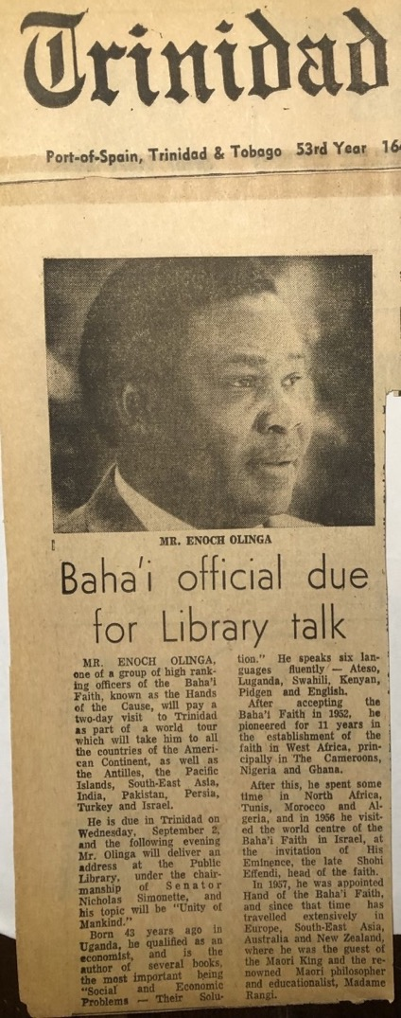
Article in the Trinidad Guardian announcing Hand of the Cause Enoch Olinga’s visit
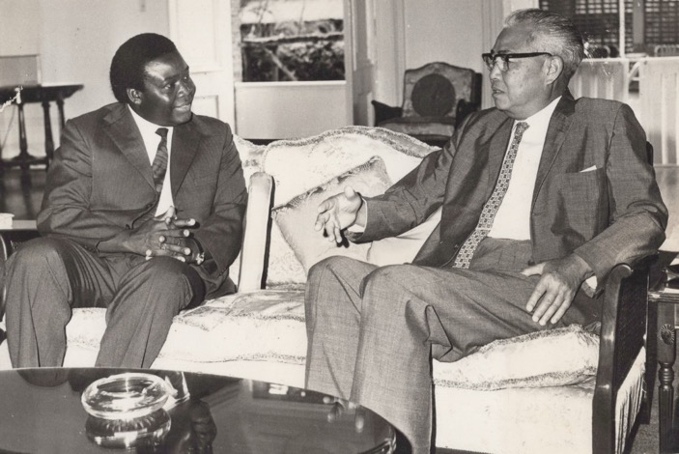
Hand of the Cause Mr. Enoch Olinga pays a courtesy call to the Governor-General of Trinidad and Tobago, Sir. Solomon Hochoy.
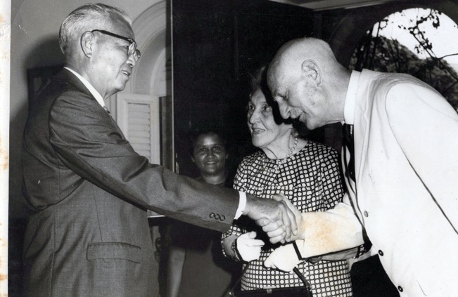
Courtesy call by Hand of the Cause Dr. Giachery and Mrs. Giachery to
to the Governor-General of Trinidad and Tobago, Sir Solomon Hochoy.

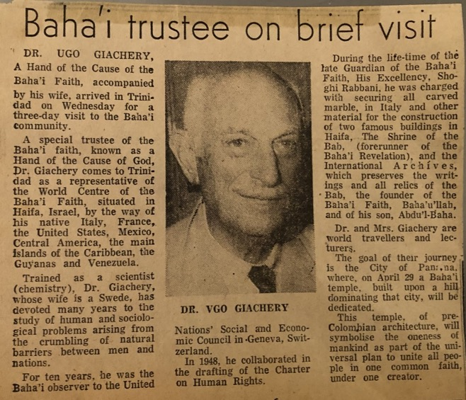
Article on Hand of the Cause Ugo Giachery’s visit to Trinidad
Hand of the Cause Mr. Enoch Olinga in Tobago
He left for Tobago on March 7th and right away set to work rallying the friends to teach the Cause in the villages. He divided the group of Baha’is who had come to meet him into two groups and assigned to each several villages to go to. He was taken to a radio station while the others went to their assignments, and he taught the faith to two young women who worked there. The interview was rescheduled for the next day, and Mr. Olinga went out to the village to teach. His plan had been to teach in five villages that day. Road travel in Tobago was very slow and uncertain at best but each of the two cars of teachers made it to two villages but the fifth village had not been visited. Then, upon returning, they learned that the two women from the radio station who had declared earlier were from that fifth village. A lesson was learned that day about the Faith.
Hand of the Cause Mr. Olinga met with the National Spiritual Assembly and conveyed the love and greetings of the Supreme Institution and encouraged us to win the goals of the current Five-Year Plan which was in its third year.
Declaration of several friends including Mrs. Collymore
We had a farewell dinner on March 9th, 1977, at the Rezvan Clinic, attended by the pioneers, Counsellor Peter McLaren, Mrs. Jamalabadi and Mr. L. Coward, the Auxiliary board Members, and other friends. Hand of the Cause Mr. Olinga clarified the role of the appointed arm, its duties, attitude towards and cooperation with elected institutions, especially the National Assemblies. The meeting ended with joyous singing and the declaration of our close friends Mr. Narine Ramdan, Mr. and Mrs. Lawrence Dookhoo, and Mrs. Collymore, wife of the esteemed Dr. Collymore, which so excited Mr. Olinga that he cabled to his fellow Hand of the Cause Mr. Paul Haney who had been to Trinidad and the Caribbean right before Mr. Olinga and was now back in Haifa.

A cable to the Baha’i World Center March, 1977
“HANDCAUSE PAUL HANEY
BAHAITEACH HAIFA
“HAPPY INFORM YOU DEAR DOROTHY COLLYMORE EMBRACE CAUSE GOD. PLEASE SHARE WORLD CENTRE HAPPY NEWS. WARMEST GREETINGS. ALL FRIENDS HERE SEND LOVE. ENOCH OLINGA”
This indeed was a joyous occasion for me as well as I had been present when her husband, Dr. Harry Collymore, had declared after three months of reading and investigating the Faith in 1975.

Hand of the Cause Mr. Zikrullah Khadem trip to Trinidad and Tobago, April 1977
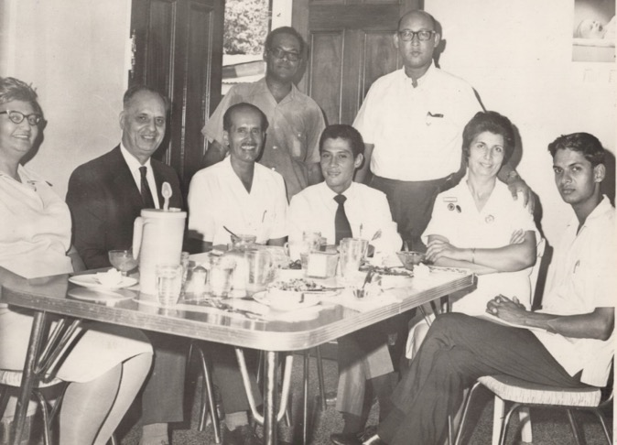
In the Rezvan Clinic: L. to r. 1) Mrs. Hanhfield, from Guyana 2) Hand of the Cause Mr. Z. Khadem, 3) Mr. Habib Rezvani, travel teacher from Colombia, 4) newspaper reporter, 5) Shamsi, 6) newspaper reporter, 7-8) ?
(question mark means I don’t remember their names)
Hand of the Cause Mr. Khadem was invited to attend the seventh National Convention of the Baha’is of Trinidad and Tobago on the 23rd and 24th of April 1977, prior to his participation as the official representative of the Universal House of Justice to the first National Convention of the Baha’is of Suriname and French Guiana held in Paramaribo, Suriname. He arrived in Trinidad in the evening of April 21st. Dr. Collymore and I picked him up and drove him to my clinic in Couva. The following evening, I had been invited to attend an “At Home” function at the residence of President Clarke of Trinidad. With the arrival of Mr. Khadem, I phoned the private secretary of the President which resulted in Mr. Khadem receiving a verbal invitation to attend. On our arrival, Mr. Khadem was presented to Mr. Johnson, the President’s Aide de Camp who welcomed him warmly and chatted during which time photos were taken. Mr. Khadem was introduced as a “Hand of the Cause of God” with a correct explanation of the term to the distinguished guests who included Brigadier General Jeff Serrette and several judges, including Sir Arthur McShine who was the Chief Justice of Trinidad, and his wife. In his conversation with the judges, Mr. Khadem praised their work and quoted Baha’u’llah’s passage from the Hidden Words, “The best beloved of all things in my site is Justice…” He elaborated further on this passage, and the judges appreciated hearing this praise of justice. When he was alone, Mr. Khadem seemed to be praying to himself which I believed was for the enlightenment of these officials. We left that evening knowing that friends had been made for the Faith. Mr. Khadem went to stay with Dr. and Mrs. Jamalabadi and participated in the convention during the next two days.
Dr. Collymore invited Mr. Khadem and me for the celebration of the 60th anniversary of his parents’ marriage in the home of his brother George Collymore who was a lecturer at the Law School of the University of the West Indies and who had helped us greatly with our incorporation of local assemblies. No one in the family was a Baha’i except Dr. Collymore yet they possessed many Baha’i qualities. In this welcoming atmosphere, Mr. Khadem was able to diffuse the divine fragrances.
After the convention, Mr. Khadem was taken on Monday evening, April 24th, to Radio Trinidad where he had four (five-minute interviews) taped by Ms. Lillian Fraser to be aired on the Tuesday morning Baha’i program. He was introduced to the Program Director, Mr. Hugh Blackman, and Production Manager, Mr. Gabriel Francis, who had recently enrolled in the Faith much to our joy. From the radio station, we went to the television station and though an interview could not be arranged due to the late notice, the meeting helped deepen our friendship with the station’s staff, and we were given a half-hour slot during which we broadcast a program on ‘Religious Unity’ in June.
Laying the cornerstone of the Baha’i Center in Palmyra
The next day, Hand of the Cause Mr. Khadem joined Dr. Collymore, me, and area Baha’is for the laying of the cornerstone of the future district Hazirat’ul-Quds on the land which Dr. Collymore had donated on the day he had accepted the Faith. Prayers were offered. Mr. Khadem chanted a prayer and laid the cornerstone after which Baha’is took turns shoveling earth over it. The ceremony was completed when Anthony Coward, aged 15, son of the Auxiliary Board Member, Mr. Lawrence Coward, enrolled in the Faith.

Departure of Hand of the Cause Mr. Zikrullah Khadem
On the evening before his departure, friends from the surrounding villages gathered at the Rezvan Clinic to wish him goodbye. He showered all of us with his love and encouraged us to work unitedly to ensure the success of the Five-Year Plan. A few hours before his departure on April 29th, Mr. Khadem met with Mrs. Jean Minshall, the writer of the ‘Talk of Trinidad’ column, at the offices of The Guardian newspaper, where we had an excellent interview that was published later.
April 30th-May 1st, 1977, National Convention of Suriname, and French Guiana
Hand of the Cause Mr. Z. Khadem, Ms. Terry Madison, a very knowledgeable and active American Baha’i, singer and radio announcer, and I travelled to Suriname, a country on the northern coast of South America with a distinctive mix of native, African, Asian, and European cultures, which was holding its first National Convention to elect its National Spiritual Assembly for the first time.
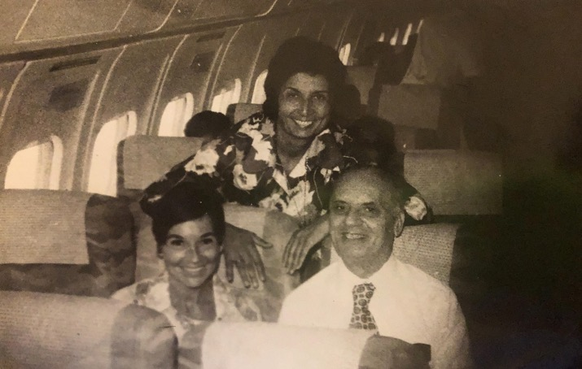
On the plane to the National Convention of Suriname and French Guyana, 1977
Ms. Terry Madison, Shamsi, Hand of the Cause Zikrullah Khadem
The Convention was held, and the first National Spiritual Assembly of Suriname and French Guiana was elected by the delegates in a spirit of love and unity.
A press conference was then held. Journalists asked Mr. Khadem and members of the National Spiritual Assembly a variety of questions on the history of the Faith in Suriname such as the jurisdiction of the new National Spiritual Assembly, its members and functions, and the location of its centers.
As Suriname was a former Dutch colony, the questions were asked in Dutch and were answered by Mr. John Veira, the new Treasurer of the National Assembly. Mr. Khadem was asked certain questions directly which were translated by Mr. Bob Vanlith including whether Baha’is accept people from all Faiths such as Hindus and Muslims, how Baha’is negotiate the teaching on obedience to government in situations such as South Africa where the government enforces racial segregation while the Faith teaches unity, and how were Baha’i activities funded.
Mr. Khadem addressed these questions with great wisdom drawing on the Baha’i Writings for his answers. To illustrate the point about obedience to government, I spoke of our visit to President Clarke of Trinidad and Tobago and showed the article covering the visit which described Baha’is as “A group of people belonging to the Baha’i Faith paid a courtesy call on President and Mrs. Clarke at their residence. Among the topics discussed was the Baha’i policy of non-interference in politics and strict obedience to the rules of the government in the lands where they reside.” I gave a short account of the activities of the Baha’i community of Trinidad and Tobago, the extent of the progress of the Faith there, and the amicable relations which existed between the community and the government. I also described the close collaboration of our community with the media which gave us free air time and newspaper coverage.
At that point, the meeting broke up, and the reporters were invited to take some Baha’i literature. Most were interested in having a copy of Christ and Baha’u’llah, but there were too few for everyone. Mr. Raymond Power, the Manager of Suriname Radio Service, invited the Chairman of the newly elected National Spiritual Assembly, Mr. Bob Vanlith, into the adjacent room to tape a 15-minute interview which would then be aired the same day, May 3rd, in the afternoon.
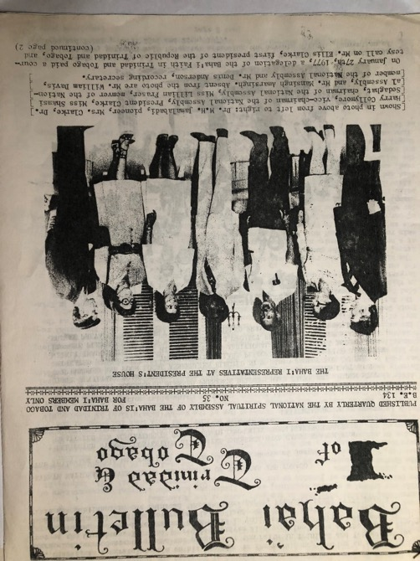
Article on the courtesy call to President Clarke by a Baha’i delegation, January, 1977
Later, Mrs. Tina Fernandes, Ms. Terry Madison, and I were at the Orlando restaurant where many of the customers were government officials such as a member of the Suriname Parliament, and Inspector of the Finance Department, an advisor to the Minister of Finance, an airport security officer, and a few more. We asked that the radio be turned on, so we could hear the interview. A broadcast of a debate in the Parliament of Suriname was in progress with much heated discussion in Dutch which we could not understand so a customer said that he would let us know when the interview had begun. Then we heard distinctively the word ‘Baha’i’ come over the air. The restaurant became quiet and all the customers seemed to be listening. The interview covered many aspects of the Faith such as its principles and the role of its Institutions.
After it was over, several of the officials in the restaurant came over to praise the ideals of the Faith, and we were able to discuss these with them further and give them some literature to read. One person recalled knowing Dr. Nosrat Rabbani, one of our pioneers in the islands, who was the doctor on Ruhiyyih Khanum’s Green Light Expedition, and Anthony Worley, an American pioneer, and a very active Baha’i. Another, who was Muslim, told us how happy he felt at hearing the name of the Prophet Muhammad during the interview. Before we left, Mr. Andre Morganslond, an advisor to the Minister of Finance, praised our good work and gave me a newly released two and a half Suriname Gulden note signed by him and his colleagues who were present on one side, and “May the Good Lord bless and keep you” inscribed on the other. In return I gave them my visiting card and invited them to come see me whenever they were in Trinidad.
Later that day, Hand of the Cause Mr. Khadem was brought to Television House. The interviewer explained that he would be asking two questions: “What is meant by the Hand of the Cause?” and “What is the Baha’i religion?” Mr. Khadem asked that the order be reversed which it was, and he proceeded to give succinct answers. The interview was broadcast that same night during the main evening newscast. We watched it at the house of Mr. Raymond Jong and his wife. He was a prominent businessman in Paramaribo and a friend of Terry Madison. After the showing, Mr. Khadem had an opportunity to elaborate further on the principles of the Faith. Mr. Jong was impressed by Mr. Khadem and asked many questions. During the group photo, he stood next to Mr. Khadem and said it had been a long time since he had stood next to a true gentleman.
Early the next morning, Wednesday May 4th, Mr. Khadem and I were driven to the airport by Mr. Jamshid Arjomandi, the Auxiliary Board Member for Suriname and French Guiana and whose command of the Taki-Taki language was the key to the success of the Paramaribo Conference; in later years, he and his family served the Faith in the Holy Land. He also translated from the Taki-Taki language into English for the Green Light Expedition. We arrived in Guyana at 8:30 a.m. and were met by Mr. Henry Dolphin, Chairman of the National Spiritual Assembly of Guyana who then drove us to his home where we stayed overnight.
Auxiliary Board Member Mr. Ed Widmer invited us to a luncheon reception in honor of Mr. Khadem at a hotel. The afternoon was spent at a fireside at the Dolphins attended by many of the friends. After an inspiring talk by Mr. Khadem, Mrs. Sukrah, wife of Mr. Sukrah, a postmaster and a Baha’i of only three months, enrolled in the Faith. Her daughter, son, and son-in-law were also present, and they expressed an eagerness to learn more about the Faith. Mr. Sukrah exclaimed that today he was the happiest man on earth. When he was asked why, he answered that it was because he had been praying that his wife accept Baha’u’llah as the Second Coming of Christ. His current wish was that soon his entire family would be Baha’i. He hoped that his eldest son would be next. He was a Muslim who then became a Christian and that since he knew quite a bit about the Qur’an and Christianity, he would be able to see that the Faith was the return of all the Holy Prophets. He added that his eldest grandchild was already a Baha’i because though only three years old, she knew prayers by heart and could sing Baha’i songs.
Mr. Sukrah’s happiness cheered our hearts. The second person to declare that evening was Mr. George Baltimore, a young Afro-Guyanese man who exclaimed, “My name is George Baltimore and I must say how happy I am to be a Baha’i”. When he was asked how long he had been a Baha’i, he replied, “15 minutes”. He continued, “I am feeling a joy that I never felt for a long time, and I think I will keep this joy ringing right through and let all my friends know that the Baha’i religion is one of the best religions for the unity of mankind.”
On this high note we left for the Baha’i Center to meet more of the local Baha’is. Though we were an hour late and some of the friends seemed tired, when Mr. Khadem stood in front of them with his glowing face and radiant spirit, the hearts of the believers responded. He spoke about the progress of the Faith around the world and his moving experiences during his travels. When I was asked to say a few words, I talked about the post-convention publicity and the press conference which was held for Hand of the Cause Mr. Z. Khadem’s visit. The high point of this gathering at the Center was when we introduced our two new believers and invited the other members of the family of Mr. Sukrah to join the family of Baha’u’llah which they did, followed by the declaration of another young woman in the audience. Our meeting ended in the joy of these new declarations and the inspiring presence of the Hand of the Cause, Mr. Z. Khadem. The next morning, after I thanked my co-workers and said goodbye to them, and Mr. Dolphin drove us to the airport for Trinidad. When I arrived in Trinidad, we met with the friends, and I explained all our achievements. The next day I continued my hospital work and services to the Faith.

Chapter 9

Travel Teaching 1977-1978:
The Caribbean Islands, Central America
On September 26th, I left Trinidad for seven months of travel teaching. I had received the following letter from the Universal House of Justice earlier in the summer blessing my travel teaching plans:
“June 16, 1977
Ms. Shamsi Sedaghat
Rezvan Clinic
Isaac Settlement
Couva, Trinidad
W.I.
Dear Bahá’í Friend,
The May 15 report of your plans for travel teaching to begin in October has been received, and the Universal House of Justice asks that we convey its pleasure at your prospects for a very productive period of assistance to the Baha’i communities which you hope to visit. In particular, the time to be spent in the Bahamas should provide additional energetic support for the strengthening of that emerging community toward the establishment of its National Spiritual Assembly. The time before your departure from Trinidad should, despite your heavy responsibilities, be used for the preparations by you and the Assemblies in whose areas you will be teaching, which are so necessary to ensure the best results.
The House of Justice keenly appreciates your resolute spirit and single-hearted devotion to the prosecution of the Cause in the Caribbean area, and anticipates a time of rewarding service for you, for which prayers will be offered at the Holy Shrines.
With loving Bahá’í greetings,
Margaret Bacherieh (Mrs.)
For the Department of the Secretariat”
My return to Couva – Trinidad & Tobago
I left my clinic in the hands of a non-Baha’i couple who had been referred to me by a friend. I gave them one room to sleep in, and a kitchen and a large sitting room to use. The rest of the rooms of the clinic, which was the entire hospital with all its equipment and medical facilities, was off-limits. I explained to them that these should not be touched or used except now and again such as to open the doors and air out the rooms. The car was in good working condition but should not be touched, except once or every other week to be taken for a short drive to help the charging of the battery. Unfortunately, when I returned after seven months, I could not recognize my beautiful clean and shining hospital. All the rooms downstairs and upstairs, the kitchen, all the bathrooms, and all the cupboards were opened and used and broken and could not be recognized that they had once belonged to this sparkling hospital. I would like to thank Baha’u’llah that he helped me to pass this great test. I practically cried many days and weeks openly and secretly because I could not believe that someone or some people could break their promise so easily and then leave the place before the owner returned. This was one of the early tests that I received during my humble experiences! But gradually I got stronger and any such experiences would not bother me so much.
I shall continue the same method of teaching
At each travel teaching stop, I decided to follow the same plan which was to make use of the media—radio, television, and newspaper—, to speak at schools with youth and educators, police training academies, clubs such as the Rotarians, Kiwanis, Jaycees, and Toastmasters and Toastmistresses, to use my visual aids on progressive revelation and the twelve principles, to meet with persons of prominence especially in the government, to engage in mass teaching, to have fireside meetings every night for seekers and new believers, to rouse the local believers and encourage them, to form local assemblies, and to model for others the life of an active Baha’i. My experience in Trinidad and elsewhere had shown me that such a comprehensive approach was best in spurring the growth of the Faith. I brought along with me recordings of Dr. Collymore’s one-minute programs on the Faith to play for people as an example of teaching through the media and my tape recorder with which to tape interviews and testimonials of people who declared. As I carried much baggage containing all the necessities with which to make presentations and record my travels, I had with me a letter from the National Spiritual Assembly of Trinidad and Tobago explaining the purpose of my travels to ease my transitions through customs:
“TO ALL AIRLINES CONCERNED
This is to certify that Miss Shamsi Sedaghat, Chairman of the National Spiritual Assembly of the Baha’is of Trinidad and Tobago, is currently embarking on an extended eight-month Baha’i lecture tour of Caribbean Islands and Central American countries.
As she will be carrying projectors, cameras, and charts related to her lectures, this Assembly would greatly appreciate if an extra luggage allowance could be granted to her.
Yours very sincerely,
NATIONAL SPIRTUAL ASSEMBLY OF THE
BAHA’IS OF TRINIDAD AND TOBAGO
William “Bud” Davis
Actg. Corresponding Secretary”
On the day of the departure, I got up at 5 a.m. and finished gathering the luggage which I needed for the trip. Then I had my prayers and breakfast. Then Mrs. Dolly Hanumansing, a good Baha’i and friend of mine, arrived and helped me in what I was doing. Soon after, Mrs. Joyce Ramlogan, a Baha’i and a well-known personality, owner with her husband of a beautiful restaurant in our town of Couva, arrived, and we all together put my suitcase in her car. Then Dr. Collymore arrived and then he went on ahead of us, and we followed him in Mrs. Ramlogan’s car. But as we were driving a bit slowly, he stopped, and he said he better take me to the airport earlier so that I could check on the flight until the others arrived with my suitcases. We reached the airport. There, we saw that Dr. and Mrs. Jamalabadi and Mr. and Mrs. Amarsingh and their two children, Bahiyyih and Diba—whom I had delivered—were waiting to say goodbye to me. Later Mrs. Joyce Ramlogan and Mrs. Dolly Hanumansing arrived. First the ticket agent told me that my name was not on the list of passengers, so I could not board. After a while, a seat was found for me, but my luggage was overweight. Fortunately, Mr. Sayers from Grenada, a friend of Mr. George Howard, helped me, and my luggage was accepted. Mrs. Shahnaz Jamalabadi bought a silver band ash tray to be given as a present to a lawyer in the Cayman Islands on behalf of Ms. Hazel Ward, which I gave to be delivered. Then I said goodbye to everyone and left Trinidad at 1 p.m. I arrived in Grenada’s Pearl Airport at 2 p.m., on September 26th.
Visit to Grenada, September 1977
Mr. Joseph Clifton was expecting me at the airport. We greeted each other. He put me and my luggage in his car and left for Sam’s Guest House, where I would be staying. We ate lunch, and then he took me to his house in Paradise, St. Andrews, where I met his wife. We greeted each other warmly, and we sat and talked a bit, and then we both went around and invited several friends, Baha’is, and non-Baha’is, to come to the Nineteen-Day feast.
I went back to the hotel, rested for a while, then got up and ate a meal. I spoke with the owner of the hotel and his friend who was an engineer with some effect. Then at 8 p.m., Mr. Joseph came and took me to the house of Mr. David Osbert and Mr. Rennie, the Secretary of the Spiritual Assembly of Mt. Horne, St. Andrew, which was located on the top of a beautiful hill. It was a bit dark in the room, and they were reading the prayer by torchlight. It was very spiritual. There were fifteen grownups, three children, and three non-Baha’is. The non-Baha’is were Mr. Kingsly Phillips and his wife, and a girl whose brother was a Baha’i. Mr. Joseph spoke first about the Baha’i Faith and its progress. Then he introduced me and asked me to say a few words. I got up and expressed my happiness to be among them. Then I spoke briefly about the suffering and exiles of the Founder of the Baha’i Faith, Baha’u’llah, and His early believers which resulted in his Faith reaching their parts of the world quickly and changing the lives of many of its citizens. I encouraged them to persevere and live according to the Baha’i Laws. They asked about the Baha’i principles which I explained briefly:
1. The oneness of God
2. The oneness of Prophets
3. The oneness of Mankind
4. The independent investigation of Truth
5. The equality of men and women
6. Universal compulsory education
7. A spiritual solution to economic problems
8. The elimination of prejudice of all kinds
9. The essential harmony of science and religion
10. Universal peace upheld by a world government and so on…
Mr. and Mrs. Kingsly Phillips were satisfied with the teachings and accepted the Baha’i Faith. We became full of joy, and we all happily welcomed them. Then they spoke about buying a piece of land on which to build a Baha’i center, Mr. Rennie said that there was one and a half acres of land near the airport which he could donate $600 for partial payment for the land, and Mr. Joseph Clifton said he would donate another $600. They could buy the land and donate it to the Assembly. They agreed to this suggestion. Everyone was so happy. Refreshments were served, and we left the house joyfully in the jeep of Mr. Joseph. There were fifteen of us. He took each person home and me to my hotel. I was a little tired but overjoyed said a prayer and went to bed.
Talk at GBS School
I got up at 6:30 a.m. on the morning of September 27th, 1977. I had to be at a government school by 11 a.m. to give a talk to the students. I phoned several places to get a taxi. At last the transport arrived at 10:25, and I left hurriedly for town and from there I went to the GBS School and met the Director of the School, Mr. Francis. He welcomed me but said that I had come late, but he would try and collect as many students as he could. He rang a bell and gradually ten students came. I spoke on the Baha’i teachings about the non-interference in politics, honesty, truthfulness, love, and respect towards all, and helping the poor and needy in any way you can. They asked many different questions to which I gave answers according to the Baha’i Faith. They were very satisfied. At 1:30 p.m., the Director of the school, Mr. Francis, came and thanked me and said that Mrs. Wilson wanted to talk to me on the phone. I said goodbye to the students and went to get the phone where Mrs. Wilson told me that I should have been at the radio department by 1:30 p.m. I rushed, took a taxi and went to the radio station and met Mrs. Morgan and Mrs. Wilson, whom I had known from last year’s visit, we warmly greeted each other, and they interviewed me on many different subjects. It was a very nice interview which they said would be aired on the 29th of September, at 8 p.m. I spoke with both for about thirty minutes during which I showed my charts. They would give me a copy of my interview after it had aired, and I would give them a copy of the “Living the Life.”
At 3 p.m., I went to the snack shop had a cup of Pepsi and a piece of roti and took a taxi back to my hotel. They said that Mr. Winner had come to see me while I was out. I rested for twenty minutes until 4 p.m. when Mr. Winner phoned and said that we should meet tomorrow. Then Mrs. Elenor phoned me and arranged to come to take me to the Nineteen-Day feast in Fontenoy, St. Georges. Mr. Ethelyn Jackson, a Baha’i of twelve years, his son and wife, both Baha’is, and her second daughter-in-law became a Baha’i at the age of twenty-seven, were in attendance. With three more Baha’is, they could have their first Assembly. Mrs. Elenor Wilson and Mrs. Clair Mendez were a great help to me during those days. The nineteen-day feast went smoothly. Everyone spoke, and I was asked to say a few words which I did. I mostly encouraged their good work and advised its continuation and being steadfast. Then we had refreshments. I took the nice cake which was given to me by Mrs. Dolly Hanumansing and cut it and served it which everyone enjoyed. Then the meeting finished, and Mrs. Elenor brought me back to my hotel. At 9:30 p.m. I phoned Dr. Collymore in Trinidad and thanked him and all other friends for their help and said that everything was going well so far. Then I had something to eat and went to bed.
Talk at Anglican Girls’ High School
On September 28th, I had a headache and took two tablets for relief. Mrs. Barbara Winner phoned me at 8 a.m. Mrs. Elenor Wilson was coming to take me to the Anglican Girls High School to meet the Director, Mr. Baptiste. She came, and we went to school. There were 500 female students and twelve teachers present. They welcomed me, and I spoke twenty minutes, and my talk was recorded. The subject was the youth and their role in developing society. As they were women and would be the mothers of the coming generation, it was very important to know about the education spiritual training, morality, and love amongst the members of her family etc.…They listened closely and when I was finished, they thanked me very much. As I had to go for a TV interview and the taxi was late, the director, Mr. Baptiste, took us himself to the TV station. We thanked him, and he left. We came and met with Mr. Peter Jones and Mr. Cuffie. Mr. James interviewed me and after that we spoke for another half an hour, and he recorded it again for a later release. Then I encouraged him to continue his profession and said that if he continued doing as he was, without any prejudice and with utmost love and unity and honesty and integrity, he would illumine the hearts and minds of his listeners and would create a new generation around himself, and this town would be united gradually, and love and unity would be established. He was pleased about what I said and thanked me. Then Mr. Cuffie guided me to the restaurant where we had a small snack. Then we went to the St. Joseph Convent where we met Sister Flemina (Fletcher). She welcomed me and took me to see the mother superior. She was very nice and dignified and welcomed me. Then they took me to a classroom where the students of two #6 classrooms were gathered. They all stood up and said, “Welcome sister Shamsi.”
I thanked them, and I asked them to be seated. Then I got up and said, “As your school has an atmosphere of peace and spirituality, and your teachers are the source of love and unity therefore you should also try to be the ‘essence of religion.’ Baha’u’llah, the Prophet founder of the Baha’i Faith says, ‘the essence of religion is testifying unto that which the Lord hath revealed, and following that which He hath ordained in His Mighty Book,’ and The Mighty Book is in every age, the Holy Book of the prophet of the age. For example, the Qur’an was the mighty book for the age of Mohammad, the Bible was the mighty book for the age of Jesus, the Old Testament, the mighty book for the age of Moses and now the mighty book of Aqdas is for this age, the age of the prophet, Baha’u’llah. If you read it, you will find many teachings which are suitable for this age. However, your future is very glorious.” They thanked me, and I thanked them, and we left with Mr. Arthur Inner for his home. There I met his wife, Mrs. Barbara, the Auxiliary Board Member. We ate snacks, and then we went to Mrs. Elenor Wilson, where her daughter Tahereh and her daughter’s friend Ladish were present. There we watched my interview on TV at 8:25 p.m. it was very nice. Then Mr. and Mrs. Graham Stratton arrived then Mrs. Clair Mendez and her son Ladish came, and we all sat and started to talk. I spoke about the progress of the Faith in Trinidad and service which the Baha’i youth are performing there. Here Tahereh and her friend Mr. Ladish accepted the Faith. We were all overjoyed and welcomed them to the Baha’i Faith. We said goodbye to all, and Mr. Stratton and his wife brought me home. They wanted ‘one-minute’ radio talks of Dr. Harry Collymore to copy. They would then return the originals to me. I thanked them for their lovely assistance to me. They left, and I went to my room refreshed myself and went to bed. We had a successful day today.

I was taken to a radio station
On September 29th, Mr. and Mrs. Arthur Winner came and took me to the village and got a copy of my speech from GBU and gave it to the Director Mr. Baptiste. Meanwhile a young African American man came and said, “Do you know me?” I said, “No?” He said he was Cudjoe from the Radio Station whom we have met last year. I said yes but now you have grown a beard, and I did not recognize you. He said it is correct. I heard the news of your arrival via Mrs. Stratton, and I informed the friends through the radio and wanted to meet you before you leave therefore, I came to the St. Ann’s guest house to meet you.
We spoke for some time about the Faith, and I finally told him he should sign his declaration card, so he could begin serving. He agreed, and I taped his verbal declaration with my tape recorder. On the way to the airport we spoke more about the Faith, and I told him that I would visit his family in Barbados and let them know about his declaration. I wrote a short release for the newspaper The Torchlight and asked him to take it to the editor.
Visit to St. Vincent, September 1977
By 2 p.m. on September 29th, I was on the island of St. Vincent, north of Grenada, which was part of the country, St. Vincent and the Grenadines. Mr. Lenox Sutherland and Mrs. Eva Statz and Mrs. Helen Marshall, two sisters who were both Canadian pioneers, came to the airport to welcome me. We drove to the home of Mrs. Marshall who was my hostess. There I reconnected with Mrs. Taylor, who had declared on my previous visit. Later, several other local Baha’is, Mrs. Howard, her husband George, and Emanuel Dick, came so we could consult on my activities during my stay.
The next morning, September 30th, Mrs. Eva Statz and I walked to the radio station where a Baha’i, Ms. Jena Duncan, worked. Ms. Duncan gave us a tour of the studio, and then we recorded an announcement about my arrival on the island. We then went to the office of Mr. Delamore, the Chairman of the Assembly, whom I encouraged in his Baha’i service because he was busy with his career and his family obligations. When he mentioned that he had to go pick up his child at school, I asked if I could speak there, and he said he would try to make that happen.
We ended up at the Technical College where he secured a speaking appointment for me. I spoke in the classroom of Ms. Monica Huggins to over one-hundred students and four teachers for forty-five minutes, and then answered questions for another forty-five minutes. The whole exchange was taped. I gave Ms. Huggins and Mr. Sanders, another teacher, copies of Gloria Faizi’s The Baha’i Faith and invited them to come to the evening meeting. Next, we checked the local library for books on the Faith and chatted with the librarians. For over an hour we spoke with a man named Mr. Frank Diabrou and invited him to come to the meeting.
The next day, October 1st, was devoted to street teaching. We met the fiancée of a local Baha’i, Don Providence, and I spoke with her for a long time. She did not declare, but she promised to come to the evening meeting. She did come with Mr. Providence to the meeting at 7:30 where I showed slides of the houses of worship.
That night I did not sleep well due to the heat, so I got up early to write my journals. Mrs. Marshall, though seventy years of age, got up early as well.
Visit to St. Lucia, October 1977
I left for St. Lucia in the eastern Caribbean on October 2nd, 1977, and arrived at Castres, the capitol, by 10 a.m. I went directly to Planter’s Inn where I had stayed before and which was owned by Mr. and Mrs. Hobbs, two Baha’is, who were there to welcome me. We drank tea and discussed the progress of the Faith. Four other local Baha’is came that evening, so we could consult on my activities during my stay. I also telephoned Mrs. Esther Evans who was the Knight of Baha’u’llah but too aged at this point to come out, and I told her I would come for a visit.

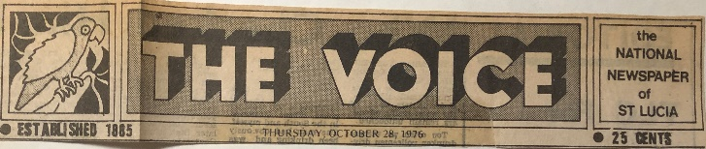

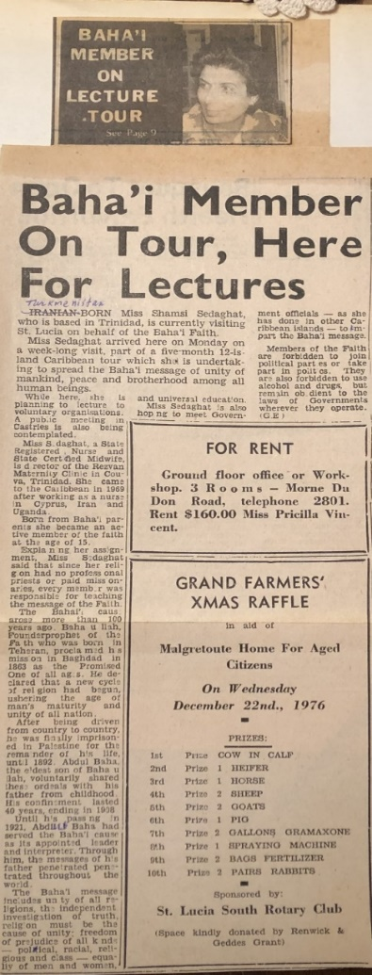
Article announcing Shamsi’s visit to St. Lucia, 1977
The next day, October 3rd, I invited Baha’is and their friends over to Planter’s Inn for a meeting that evening. After several attempts, I met with Mrs. Charles, a Baha’i who worked at a Caribbean Radio as the director of the program in English. She was very warm and asked many questions, so she could do a news release that evening. We spoke at length about the Faith, and she said her busy work schedule had prevented her from participating more in the Baha’i activities. I invited her and her mother for the next evening’s meeting.
The next morning, October 4th, Lenox Jerome, a member of the local assembly, very kindly took me to arrange my airplane tickets. When we met up with his wife who had declared last year, she apologized for not participating more, so I encouraged her in her Baha’i activity, showing her my photos of my travels and other Baha’i communities.
Lennox’s wife brought me to the new radio station where I had been interviewed last year by the director, Mr. Winston Hinkson. This time when he saw me, he asked if he should interview me every time I came to the island. I explained that I had been on many trips since last year and had many new stories and information so the fact that he had interviewed me last year was no reason not to do it again. He relented and turned me over to Ms. Margaret Steele who interviewed me on the progress of the Baha’i Faith and the difference between the Baha’i Faith and Christianity. The interview was scheduled to be aired on October 5th at 11:15 in the morning and then one more time after that. I thanked her and left on friendly terms.
Visited a radio station
The next stop was the radio station where the brother-in-law of Julian Rodgers, (a nice Baha’i reporter who had declared in Antigua in 1975), was now working. I bargained over prices for a spot on the Baha’i Faith and finally settled on $45 per week for three segments of forty-five seconds each on Mondays, Wednesdays, and Fridays after the 8 p.m. evening news. The station director admired my bargaining skills. Now the agreement had to be submitted to the National Spiritual Assembly for approval.
Secured a place for a public meeting
We then secured a suitable location for a public meeting. Through a contact of mine we were able to get a large room in the Anglican School after its director, Mr. Weeks requested it from the Cannon on our behalf who agreed that the topic— “Youth and the role of women in developing of society”—would be of interest to others.
The following morning, October 5th, at Planters Inn, I consulted with Frank and Pat Pacassi who were pioneers in Dominica, about funding for the radio program as she was a member of the National Spiritual Assembly of the Leeward and Windward Islands. She said this would be discussed in the Assembly meeting.
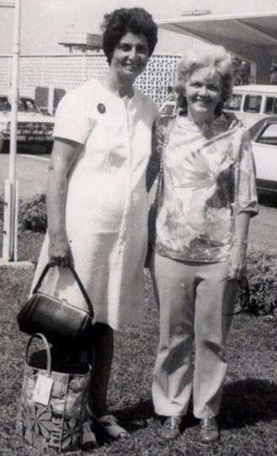
Shamsi and Mrs. Pat Pacassi, a very strong, energetic, and knowledgeable Baha’i who was in charge of the Archives and the Caribbean Baha’i news.
Then Lennox and I and nine others went to the Anglican School where I spoke and answered questions from students for two hours. Cudjoe was so energized by the experience that he suggested we reserve a room at the Red Cross building once a week for a public meeting. For the time being, we agreed to hold a fireside every Wednesday at the Evans home. Before leaving the island, I left my tapes of the Baha’i radio spots from Trinidad which could be used on the island and copies sent to Ms. Edee Holbert in Antigua.
Visit to Martinique, October 1977
By early next morning, October 6th, I was in Martinique. Since no one was there to meet me, I asked around to see if anyone knew a Baha’i on the island. Finally, I was put in touch with Ms. Michelle Margot Gilbert who was delighted to hear that I was there though she didn’t know I was coming. She gave me the address of the home of Ms. Darline Hodge where she was staying. Once I got there, we became acquainted over tea and then went to the home of Mr. Bob Hannevold, a local Baha’i staying in the home of Ms. Michelle Gilbert. With some other Baha’is, we made a few plans for my time on the island.
The following day, October 7th, we set about teaching on the island. Michelle brought Darline, me, and several others to the coastal village of Bellefontaine to the home of Louis Verres who had become a Baha’i in 1977 during the visit of Hand of the Cause Mr. Varqa. We chatted with several members of his family and after a period of time, his daughter accepted the Faith, and we all agreed that we would return on Sunday for mass teaching. From Bellefontaine we went north to the coastal town of St. Pierre. We attempted a visit to the radio station, but the weather turned bad, so we consulted on our plans. At 8 p.m. we tuned in to Radio Trinidad to hear Dr. Collymore’s spot, and I played cassettes for the friends of some of my talks. I went with Bob, Michelle, and Darline the following morning, October 8th, to the radio station where we secured an interview for Monday at 11 a.m. My arrival on Martinique would be announced that afternoon at 1 p.m. Then I was interviewed at the newspaper by Christian Modest, a well-known reporter with more than seventeen years of experience. In addition to interviewing us, he invited us to his home on Tuesday evening for dinner.

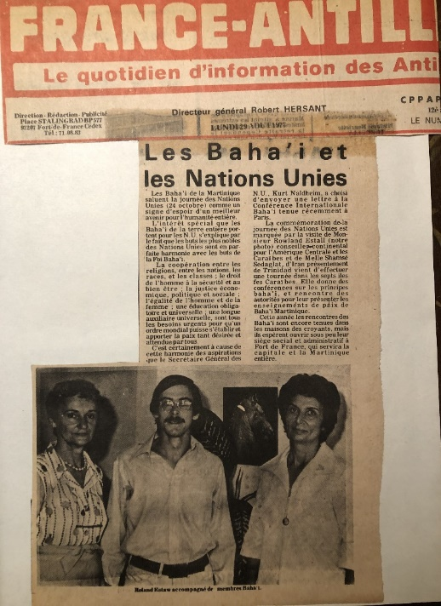
Article on United Nations Day and the Faith with a photo of Shamsi under it, Martinique, 1977.

On Sunday, October 9th, Bob and I returned to Bellefontaine where we organized a public meeting at the local canteen. We went door to door inviting people and by the time our meeting started, there were fifteen people including four non-Baha’i women and eight children to whom I taught several songs. Then I proceeded to speak about the role of women which was then translated into French for the audience. When I was finished, I invited those who were interested in becoming Baha’is to declare and three came forward. Those present then asked that we hold such meetings every Sunday in the canteen. After giving out literature on the Faith, the meeting came to an end, and we all thanked each other and left.
I had an interview at the radio station
Late the following morning, October 10th, Bob, Michelle, and I went to the radio station, but the director was in a bad mood and said that he would only interview me because I was the head of a clinic and would not ask about the Faith. I answered that I would have to bring up the Faith to explain why I was living in Trinidad. Mr. Luke Laventure interviewed us on the air for seven minutes and though he did not ask about the Faith, I brought it up anyway. After we were done, I asked if Dr. Collymore’s spots could be broadcast on the radio. The director said he would have to ask the sales manager. That evening, Mr. Modest came over with a photographer, and we had a wide-ranging interview on my work, the Faith, and my travels. At the end of it, I gave him a necklace with the Greatest Name on it. The next evening several of us went to his home for dinner where we spoke again at length about the Faith. The next morning, I said goodbye and thanked the friends and left for Guadeloupe.
Visit to Guadeloupe, October 1977
I landed in Guadeloupe in the morning of October 11th. Arnaud Basiege, and the Dagleys, whom I had known in Antigua where they had pioneered, were there to greet me. After dropping off my things at Mrs. Dada’s home in Capasterre on the Southeastern coast, we immediately went out visiting the friends and held an evening meeting that night at the home of Mr. Bozor, a Baha’i of twelve years. Then we visited John Sango and his sister Monique River who were two seekers living in Belle-eau, next to Capasterre, and we prayed and spoke with them about the Faith, and they accepted it. We were all very happy and welcomed them. Next, we went to the home of Alain Sininivassin, a seventeen-year-old who had declared six months earlier. He said he had just been praying when we showed up. His father welcomed us in and expressed his delight at his son becoming a Baha’i. That evening, five people came to the meeting including one seeker, Quins Victorius. I spoke on the harmful effects of drinking and using narcotics. By the end of the meeting, Quins had declared, and we all welcomed him.
The following morning, October 12th, I went with Darline, an active Baha’i who knew people there, to the town hall to meet the Mayor. The person at the desk asked that we write a letter to the Mayor requesting permission to use the Town Hall meeting room and then wait for a reply. I politely persisted until we were finally allowed to go to the Mayor’s secretary and put in our request. The secretary was friends with Darline’s father and accepted our letter of request. In a few minutes, the Mayor came in and we were introduced by the secretary. We met with him in his office, and he permitted us to hold our meeting in the Town Hall. After we left, we went around putting up announcements about a meeting on “The role of youth and women in the development of society.” We returned to the Mayor’s Office later to take photos with him and the city council and thanked them all before leaving.
When I had some free time the next day, October 13th, I wrote down updates and suggestions for the National Spiritual Assembly which I would be meeting with on Sunday. These included our four declarations in Bellefontaine, the provision of funds for radio spots, a thank-you letter to be sent to the Mayor of Bellefontaine, encouragement of the Assembly to hold receptions with press and guests as well as schedule radio interviews when there were capable travel teachers, courtesy calls to high officials to explain the Baha’i teaching on obedience to government so as to counter any impression that the Faith was a sect.
A radio interview in Capasterre
On the morning of October 14th, Mr. Frank Messe, a reporter and newly declared Baha’i, Bob, who had been asked to serve as my translator, three young pioneers from Canada and I were going into Capasterre. I asked Frank if we could stop at the radio station to schedule an interview. When we got there, the secretary said that an interview needed to be scheduled in advance and that neither the radio host nor the station director was there. The others were nodding but I explained to the lady that there was no time as I was only there for two days and added that in other places where I had been, I was usually given the chance to be interviewed on the same day or the next. However, before I left, I asked the others if there wasn’t anything more we could do, and Frank said he had a friend who might be able to help. We found his friend who suggested we tape an interview on the spot and broadcast it on later dates. So, I agreed and for twenty-one minutes he conducted an interview with me after which I thanked him and left.
Visited the Mayor of Capasterre
We arrived in Capasterre an hour late and went to the Town Hall and met with the Mayor who introduced us all to the City Council. He explained that I was a Baha’i and invited me to say a few words. I praised the Mayor for his loving and quiet manner, pointing out that this was the best way to deal with people. Looking around the room, I acknowledged that they were all young and that young people were the future strength because their zeal and energy could be the cause of progress. I then spoke about the Faith and its mission to serve society. I also showed everyone my photo album with photos of some of the heads of state whom I had met and invited them all to come to our meeting that night.
Several speakers at the Town Hall
I was at the Town Hall meeting room at 6:30 p.m. for our public meeting. Counsellor Roland Estall arrived later along with Baha’i friends. The audience grew to twenty-five including a group of youth. I spoke on the role of youth in society and on the harmony between science and religion. Counsellor Estall spoke in French for ten minutes followed by questions from the audience. I encouraged people to get to know one another and exchange addresses and announced that Darline would come back to Capasterre and hold regular meetings to strengthen the community. Mr. Frank Messe took photographs and wrote an article on the event.
I met with the National Spiritual Assembly the following day, October 15th, and offered my suggestions before setting off for the airport where I was able to board the plane despite my heavy bags because I presented a letter from the National Assembly stating that I was an international lecturer and requesting permission to board with overweight luggage which was then granted by the airline.
Visit to Antigua, October 1977
A half hour after take-off I landed in Antigua on October 16th, where I was met by Mr. Simons and Mr. Swiny who took me to Falnouth to the home of Mrs. Lake where I met Mr. Jody Owen the Auxiliary Board Member and Mr. Fitzsimmons. We went to a youth meeting and then a public meeting at which Mr. Swiny spoke about Baha’u’llah. I was asked to speak, so I got up first and I taught a song for children, ‘Family of Man’, which filled the meeting with a great deal of spirit. Then I went over my charts on progressive revelation and the twelve principles. We arranged to hold a children’s class at 4 p.m. the next day and a presentation for grown-ups at 6 p.m., and then we went home. That night I got very little rest because of the mosquitoes.
Meeting with Ms. Edie Holbert and many others
Ms. Edie Holbert, the owner of the Galley Bay Hotel in Antigua where we held our public meeting on October 17th, was there. Six non-Baha’is and twenty-five Baha’is came. I spoke about the Bab and compared the Faith to other religions. Afterwards, an audience member who had been a teacher and reporter expressed his appreciation for the presentation. His daughter was the director of a school, and he wanted to know if I would speak there. I asked permission from the Assembly of St. John’s, and we arranged for a visit.

Courtesy call on the Minister of Finance and Tourism, Sidney Prince

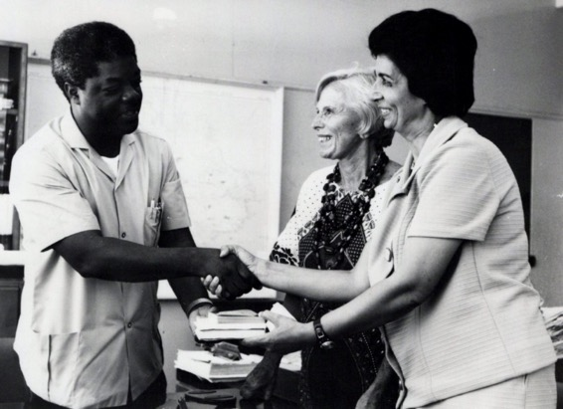
Ms. Edie Holbert and Shamsi making a presentation of Baha’i literature to the Hon. Sidney Prince, Minister of Finance and Tourism in Antigua.
Before going to the school, the next morning, October 18th, Edie and I studied the Long Obligatory Prayer. At the school, I joined the students for morning prayer. I was given ten minutes to speak. I talked to them about prayer and the importance of not being prejudiced towards others and finished by teaching them the song, “Good Neighbors Come in all Colors.” The school director and I spoke for some time afterwards. I showed her my photo albums and gave her the addresses where we would be holding meetings and presented a book to her about the Faith and warmly departed.
Talk at the Teacher Training College
Edie came to take me next to the teacher training college where I spoke to more than sixty students and teachers about the role of youth in today’s society. Mr. Francis, the director of the college, his assistant Mrs. James, and the professor, Mr. Mathias, listened throughout.
The talk was taped and after it was over students gathered around to ask questions about the Faith, so I took out my charts and explained these subjects to them for some time. The meeting was very successful. We left some booklets about the Faith and invited them to keep in contact with us if they wished.
Later that night I met with the local assembly and suggested that a one-minute radio spot be aired, that special events be organized for U.N. days, that appointments be made with high officials and that they be invited to homes to learn more about the Faith, and that talks be given in schools. I left a copy of the tape of the earlier presentation at the college if needed.
On October 19th, Mrs. Estall, wife of the counsellor, came to take me to the radio station where I taped two fifteen-minute interviews during which I was joined by Mr. Charles Fitzsimons who played several songs. In the afternoon, I spoke with a children’s class of fifteen and their four teachers about progressive revelation. That night we held a public meeting at the school in Cobbs Cross.
More than eighty people were there of all ages including Mr. Francis whom I felt was becoming very close to the Faith. By evening’s end, one girl had declared, and she was warmly welcomed.

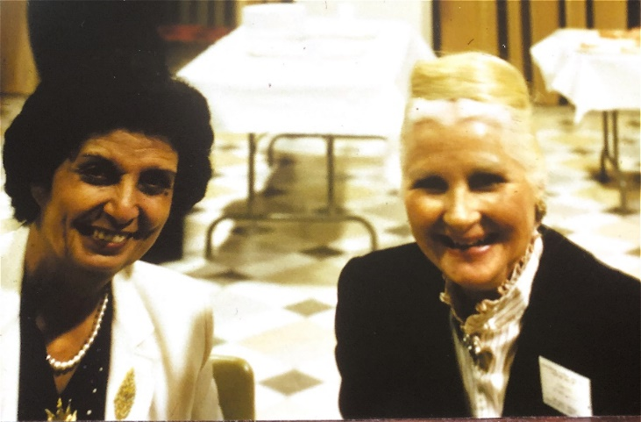
Shamsi with Mrs. Estall

Before leaving Antigua, I encouraged Mrs. Lake, who was married to a Baha’i, to pray as I would pray for her and then handed her a prayer book and asked her to open it.
When she did, the prayer to which she had opened was one that expressed her heart’s longing. I then interviewed her with my tape recorder which I often did on my teaching trips and as we spoke, her questions were all answered, and she signed her declaration card. I encouraged her to be steadfast and to grow in the Faith. We went downstairs, and I told the friends the good news of all of our declarations which delighted everyone.

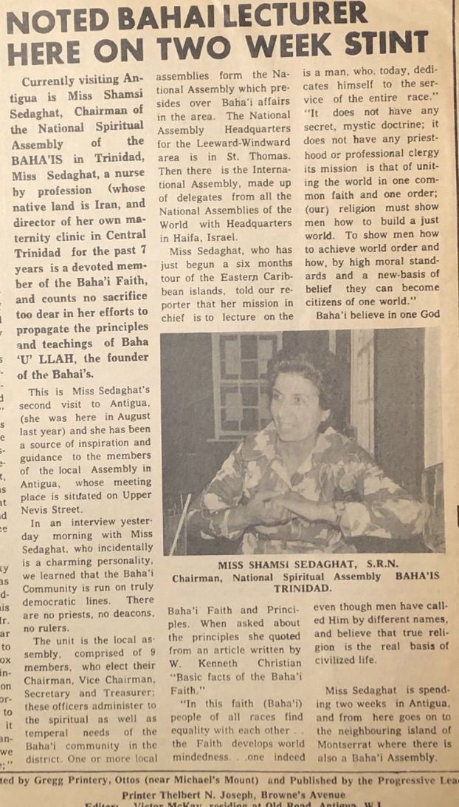
Article on Shamsi, Antigua, 1977
Visit to Montserrat, October 1977
During the twenty-minute flight to Montserrat on October 20th, I spoke with the pilot Mr. Eliot Francis and told him when we landed that I would invite him to the public meeting that Wednesday on St. Kitt’s where he lived. Mr. Greg Owen, Mr. Bob Martin and his wife, Mr. Dennis Molineaux, and Mr. Clyde Weeks—all new Baha’is—were all there to greet me. We went into the capital, Plymouth, and made some plans for my visit before proceeding to Radio Antilles where we arranged for an interview.
The following day, October 21st, began with a prayer meeting to which many of the Baha’is came including those who were not feeling well. I was inspired by their strength. We organized ourselves into two groups. One went to St. John’s parish to the north and the other to Parsons in the south. That whole day was spent inviting people to our gatherings including a nurse, her daughter, and two sons to whom we spoke for two hours and gave declaration cards. That evening at the home of the Martins eight non-Baha’is came and three declared. We gave them copies of The New Garden and declaration cards. They signed these and returned them to us. We were overjoyed and welcomed them to the Faith.
I went to the technical college the following day, October 22nd, and spoke with the director who said that it was difficult to arrange something at the last minute. I said that in Antigua, Dr. Francis had done so with no problem. The director said come back this afternoon, and I’ll set aside a room for a talk. From there I went to the newspaper where I met Mr. Howard Mrumece, the editor, and Mr. Wilsey White the manager, who interviewed me for twenty minutes and asked for permission to publish a photo of the National Spiritual Assembly of Trinidad along with the article. The day ended with a meeting at the Barrons home to which the three new Baha’is came.
Dr. Wooding, the director of the Glendon Hospital, came over the next day, and I spoke with him for several hours about a wide range of topics related to the Faith. He objected to the teachings on non-interference in politics and refraining from the drinking of alcohol. I explained these teachings to him further and gave him a copy of the Kitab Iqan to read. That afternoon I went to consult with the Spiritual Assembly of San Antonio to which I gave the recommendations that I had given to the Baha’i institution in Antigua.
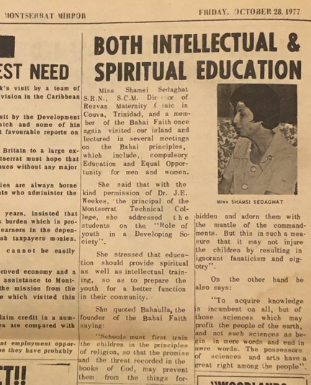
Article on Shamsi in the Montserrat Mirror
Greg Owen and I went on October 23rd, to the radio station and negotiated a contract for a one-minute radio spot to be aired on Mondays, Wednesdays, and Fridays, at 7:17 in the evening, for $5 per spot. I left a tape of the spot and asked that several copies be made. Next, we went to meet the Chief Minister of Montserrat, the Honorable Mr. Austin Bramble, and spoke with him for a half an hour while showing him photos of leaders who had accepted the Faith such as Queen Marie of Romania and Malietoa Tanumafili II, the King of Samoa. The Minister knew of the Faith because he had once attended a Baha’i summer school.
Before going to the airport, I said thank-you to the friends for their assistance, picked up a copy of the tape of the radio spot to send back to Antigua, and left for St. Kitts.
Visit to St. Kitts, October 1977
During my few days in St. Kitts, I met with several government officials, Mr. Fitzroy Bryant, the Minister of Health, Education, and Social Affairs, and Mr. Paul Southwell, the Deputy Prime Minister of Trade and Industry, who looked remarkably like an Iranian. I also gave an interview at the radio station and a twenty-minute television interview with Minister Southwell.
Mr. Nathan and I visited seekers and taught the Faith. In a bank we spoke about the Faith with an assistant accountant, Mr. Michael Archibald, who later came to a meeting and declared. He was warmly welcomed. While eating in a Syrian restaurant, I spoke about the Faith with a lady from Trinidad who knew Dr. Collymore. Several local believers and I went to the village of Tabernacle and spoke with a few people. A teaching opportunity even presented itself at the airport on my way to St. Martin when a lawyer from Guyana who had expressed interest in the Faith but could not come to a meeting came over to say goodbye. I told him I would send him a book on the Faith. Again, I said goodbye to all, and I left the island.
Visit to St. Martin, October-November 1977
Despite a plane malfunction, I landed on St. Martin. Robert Massey was there to meet me and take me to the home of Mrs. Barbara Joyce where I met several local Baha’is including Ms. Francis Griffith and Mr. Louis Guy. That evening despite the mosquitoes, I was able to write a letter to Hand of the Cause Ruhiyyih Khanum about my travels.
The first few days on St. Martin were spent on interviews and meeting the friends. I gave an interview to the New Age newspaper on the morning of November 1st, and I went to a radio station with Ms. Barbara Guy and Mr. Robert Massey for a radio interview. Barbara was a member of the National Spiritual Assembly of the Baha’is of the French Antilles and was a television announcer who possessed a wonderful voice. At the radio station, we secured an agreement to have one-minute spots on the Faith aired for the price of $3.50 per spot after I bargained down the price.
Ms. Barbara Guy brought me one morning to Milton Peters College where I spoke to a combined class about the role of youth in society and in the family. The teachers and students thanked me for coming and afterwards I met with the school’s director, Mr. Fransisco, and his wife, and they invited me to return the next day at 11:45 a.m., and they would arrange more appointments for me. After the school visit, we went to the radio station for a ten-minute interview with Van James Jr. which would be aired that same night. As was my practice, I interviewed Mr. James with my tape recorder. In the evening we had a public meeting in St. Tropez attended by ten people of whom five were non-Baha’is. By the end of the evening two people from Haiti declared.
On my last day on St. Martin, Mr. Roy Massey brought me to a luncheon of the Rotary Club at the Grand Hotel where many of the members knew me from previous visits and greeted me with great warmth. After lunch, I spoke to the audience of thirty or so about the Baha’i principles and my travels. I spoke with several individuals afterwards and gave the President of the Club, Dr. Gibbs, a copy of Baha’u’llah and the New Era. At the public meeting that evening I spoke using my charts to an audience of Baha’is and ten non-Baha’is including Mr. Ram Das and his wife who were friends of Ms. Barbara Guy. People were enthusiastic about getting together again.
Report of Mrs. Barbara Joyce
Mrs. Barbara Joyce wrote the following report about my visit to St. Martin:
“Report on the Teaching trip of Shamsi Sedaghat in St. Martin/St. Maarten, French West Indies.
Let me start by saying that she set the island afire! She gave Baha’i talks to the junior chamber of commerce and to the Rotary Club that were received with great enthusiasm. She had hour long interviews with two newspapers that were electric. She gave two proclamation talks, one on the French side and one on the Dutch side that were brilliant. She did 4 fifteen-minute TV Baha’i programs on our regular Baha’i TV show that moved many. One newspaper man (one that she did not meet) was so impressed with the TV show that he was going to write an editorial in his newspaper. She had a wonderful 20-minute radio interview with a very important local man and did a fifteen-minute Baha’i radio show on our regular program.
Needless to say, at many deepenings for the local Baha’is of both sides, she was inspiring, and at social gatherings for non-Baha’is (of which we had two), she was magnetic. She also was able to reactivate several Baha’is of great capacity who had drifted away. She visited our two children’s classes and not only taught the children but taught us how to teach. She inspired us with her devotion at dawn prayers and by her zeal at classes. Several people have declared because of her, many more are close to becoming Baha’is. Our only problem is to keep the momentum she has started, going.
My recommendation is, that she go to every English-speaking island (maybe French too) and especially that she come back here at least once a year!
Sincerely,
Barbara Joyce”
Visit to St. Croix, St. Thomas, and St. John November 1977
I landed in St. Croix at 1 p.m., on November 5th, 1977, but ran into visa problems. My visa which had been cut out from my old passport and stapled into my new one was not accepted, and there were no Baha’is there to help me. I went to the head of immigration who called around and said that I should have gotten a visa from Port of Spain. After several phone calls he issued a nine-day visa to me and told me that I should sort it out when I get to St. Thomas.
After leaving the airport we went to the home of Esther Harris where I would be staying. The next day, November 6th, we began with morning prayers. The first lady we visited was not interested in hearing about the Faith, but her husband drove us to the home of Josephine Collen whom we taught for several hours. Her daughter, Christophine, was there and declared by the end of our long talk, which made us happy, and we welcomed them into our community.
On the morning of November 7th, I spoke to a group of eleven children in a school where I spoke a little about Iran and taught them a song. After this I went to a college to arrange a talk for a future date. Next, I had two scheduled talks that day at College VI arranged by Dr. Batisfield from Tobago. There were fifteen women and one man to whom I spoke about progressive revelation and the Baha’i principles. During the recess before my next presentation, I went to the library and encouraged the librarian to read the Baha’i books which were in the stacks. There were twenty-five youth, so I spoke on the duty of youth in society. Afterwards, the weather became very rainy. Nevertheless, I went to the library in Christiansted where there were eleven Baha’is at a public meeting. I encouraged them in their service to the Cause.
The next day, November 8th, Ms. Ruth Johnson and I went to WRRA radio where I was interviewed by Mrs. Ward followed by my interviewing her. I worked out a contract with the station to broadcast two radio spots on the Faith, one in English at 6:30 a.m. and the other in Spanish at 2 p.m., which the staff would translate.
Mrs. Ward phoned me the next day, November 9th, to ask about any reaction to my interview and what I had thought of it, and I answered that I thought it was alright. After we spoke, I took an Antilles air boat to St. Thomas where I was met by Trish Kerr, the sister of Joyce Owen. We proceeded to the home of Linda Reed where we were joined by Bill Nedden, the secretary of the National Spiritual Assembly of the Leeward and Windward Islands, and Toni Isaac. We went out to invite people to the evening public meeting.
I met with members of the National Spiritual Assembly—Ms. Marjorie Harmon, Mr. Tom Millington, Mr. Bill Nedden, Ms. Joyce Owen, Mr. Cedrick Nathan, Mr. Alan Smith, Mr. Ken Scott, Mr. P. Paul, and Ms. Sandy Egerer; members of the National Teaching Committee, Ms. Magda Smith and Ms. Louise Anderson; the teaching committee for the Virgin Islands, Mr. Wally Cluett, Ms. Toni Isaac, and Mr. Jeff Bailey; and the Auxiliary Board Member, Ms. Shirley Mather. We had a spirited consultation regarding the enrollment of new believers. Some of the friends preferred to have them enrolled by an institution prior to accepting them as Baha’is while others thought that all new declarants should be accepted immediately. We all agreed that in either case, we had to keep in touch with new believers and deepen them, and those who continued in the Faith would become the Baha’is we could count on for our community. Ms. Toni Isaac brought me to her home, November 9th, that evening for a talk to the Baha’is.
The two immediate goals were to raise an Assembly on Tortolla and find one more waiting soul to complete the Assembly of St. John. For Tortolla I was given the contact information for Mr. Reimer who ran a school there. Mr. Bill Nedden told me that I’d be taken to the docks to catch a boat to St. John, a short distance away. On November 10th, I made phone calls to arrange my visits to St. John and Tortolla. That evening, in the home of Ms. Joyce Owen we had a fireside with women and children who all enjoyed the meeting.
The ferry left at 10:30 the following morning, November 11th. On St. John Ms. Toni Simeca was there to meet me. She was a talented photographer who gave me tips on how to better use my camera. We made our way to the home of Mr. Alan Smith, a Baha’i lawyer, and his wife Magda. After tea we proceeded up to the Hilltop restaurant for a public meeting at which I showed slides and spoke about the life of Baha’u’llah because it was the 11th of November (the Birth of Baha’u’llah), and the Holy Day had begun. During the social portion after the program, the owner of the hotel expressed interest in having more meetings there.
The friends and I consulted on finding a waiting soul to raise St. John to Assembly status. One of the Baha’is brought us to the home of an American friend whose wife had read a book about the Faith. He was lively and attentive as we spoke with him and his wife. They said they had everything in their home except a religion. She had been raised Catholic but had later rejected Catholicism. We showed him my charts on progressive revelation, spoke about prophecies—a topic that interested him—, and he said he would come by the next day to see me. I answered that this was the Birth of Baha’u’llah, an auspicious day to accept the Faith and that, if he did, St. John would have a Baha’i Assembly. We returned to Ms. Toni Isaac’s home, and prepared the food for the evening meeting. One seeker seemed especially interested, and as we spoke, I told him he could be the ninth person so that we could have an Assembly in St. John. We gave him a prayer book, and he said he would think about it and return the following evening.
The next day I suggested we go down to the seaside to teach. On the way we ran into Mr. Brian and Ms. Penelope Ramsdale who were not Baha’is. We gave them a lift home and spoke about the Faith during the ride. Then we gave him Gleanings and asked him to read some passages. He was very moved by what he read. I told him we needed a ninth person to have a Baha’i Assembly in St. John. I gave him a declaration card and encouraged him to sign it. Much to our joy he did. We told him that in becoming a Baha’i he may experience tests, so he must be steadfast. He replied that he was ready for anything. Then I asked Penelope, his wife, if she would like to become a Baha’i, and she answered that she had been waiting for me to ask. There was great joy among all of us, and we gave her a declaration card to sign, and the friends said that they would return later to elect the local assembly.
I returned to St. Thomas the following day, November 14th, and went straightaway to Charlotte Amalie High School for my speaking appointment in a history class. Ms. Mary Francis, the department chair, met me and brought me to Mr. Howard’s history class. When I walked in, I saw a map of the Parthian (Persian) Empire on the wall which was the same one as I had on my chart. I spoke to four classes that morning, each with more than fifteen students. When the teachers thanked me, several said they had Baha’i friends. Later, Mary Francis, the Chairperson of the Social Studies Department wrote a gracious letter to me in which she expressed the following:

“Charlotte Amalie High School
P.O. BOX 630
ST THOMAS, VIRGIN ISLANDS 00801
November 15, 1977
Miss Shamsi Sedaghat
Bahai Center, Garden street
Charlotte Amalie
St. Thomas, Virgin Islands 00801

Dear Miss Sedaghat,
The teachers and students of the Social Studies Department of Charlotte Amalie High School extend kindest appreciation to you for sharing with us your knowledge and experiences. We were very honored to have a world scholar and great lecturer as you are, to visit our school and talk to the students. We do hope that the students have taken the well-timed advice that you have given them, and it may help to make their future more meaningful.
Please visit us whenever you have an opportunity.
Good luck and may God bless you.
Yours Sincerely,
Mary Francis
Chairman, Social Studies Department
Charlotte Amalie High School”
Visit to Tortolla, November 1977
On November 15th, I reached Tortolla which was due north from St. Croix after a short boat ride. Mr. Wally Cluett lived there, and everyone seemed to know him, so I found him at the school where he taught, and he brought me to the home of Ms. Betty Shirtleff.
The next day I went back to his school and the director, Ms. Dorothy Turnbull, brought me to his classroom. The students were very interested in seeing this visitor. In fact, many children gathered outside at the open windows to look in at me. One of the teachers in the school was from Trinidad and had remembered seeing me on television there. The following day I gave two more presentations at the same school. One talk was on world religions. The students only knew about Christianity and thought that the different Christian sects were actually different religions. I showed them my chart to help them understand about the other world faiths and followed this with the chart of the twelve principles of the Baha’i Faith which greatly interested them.
On Tortolla I was also able to secure a contract from Mr. Walwyn Brewley at ZBVI radio for three one-minute spots per week. Once we were finished, I invited him to Joyce Owen’s home for dinner that evening. I was also interviewed by the island’s newspaper. The interviewer was very interested in question comparing the Faith to Christianity and said he found the teachings of the Baha’i Faith very appealing and would become a Baha’i if he could understand the difference between the Baha’i Faith and Christianity. He expressed interest in coming to Baha’i meetings.
That evening we had a fireside at the home of Ms. Joyce Owens. Dorothy Turnbull came, and one of Joyce’s friends was there and after answering some of the questions which she asked, she declared. Her declaration brought a great joy to all, and she was warmly welcomed.
On Saturday we held a public meeting and though the audience was sparse, the editor of the island newspaper was there. Mr. Wally Cluett had been kind enough to make beautiful charts for me on the life of Baha’u’llah and the life of the Bab, many questions were asked, especially about Christianity and the Baha’i Faith. I gave the editor a copy of the book, The Heart of the Gospel, so he could delve into these questions more deeply. At the end of the meeting I invited anyone who wished to accept the Faith to do so.
After Tortolla, my next stop was the United States. At the airport, Mr. Bill and Mrs. Linda Nedden showed me a cable sent by the Universal House of Justice in appreciation of my teaching efforts in the Caribbean:
“DELIGHTED NEW LOCAL ASSEMBLIES
PROGRESS SPECIAL ISLAND TEACHING PROGRAM
CONVEY SEDAGHAT OTHER FRIENDS DEEP APPRECIATION ASSURANCE PRAYERS.PRAYING ACCELERATION EFFORTS ABUNDANCE CONFIRMATION LOVE UNIVERSAL HOUSE OF JUSTICE”

To get to the U.S., I had to go through Puerto Rico. The airport personnel said I had to go to make a stop first in St. Thomas because the direct flight to Puerto Rico had left already but I insisted that I had to go directly to Puerto Rico as my family was expecting me. So, the pilot was called, and he turned the plane around and came back. They took me and as a result, I arrived on time.

Chapter 10

Visit to the United States: Washington DC, November 1977, and Subsequent Trips to Central and South America
After landing in Washington DC, on Sunday, November 20th, I was lovingly greeted by my mother and other family members and several local Baha’is who brought flowers and embraced me with great joy and happiness.
On November 22nd, I asked my nephew Esfandiar Aqdassi (who is now a businessman and lives in Sterling, Virginia, with his wife Shamila Khanum; both are very active Baha’is) to take me to the secretary of the Assembly of Washington D.C., Mrs. Anita Ioas Chapman, the daughter of the Hand of the Cause Mr. Leroy Ioas. At her home, I met Dr. Elsie Austin whose guest I had been in Nairobi, Kenya, early in 1968, and a few others. We had lunch. Later, at the Nineteen-Day Feast at the Baha’i Center in Washington D.C., I was introduced to the friends and given my program for my visit there. Then I was invited to say a few words. As the consultation was on the necessity of regularly contributing to the Fund and of starting a radio program, I offered a few suggestions. In terms of the Fund, I suggested that we could make small daily economies and set those aside for the Fund. In terms of the media, we should get to know the people who work in media and invite them to our private gatherings, acquaint them with the Faith and offer to be interviewed on any subject, and answers would be given according from the Baha’i perspective. In this way, many people would hear about the Faith and we could invite them to our public meetings and Baha’i Centers and deepen those who expressed interest to know more so that they would eventually enroll and serve humanity. In addition, I explained that on all my trips around the world, I paid courtesy calls to government officials, made friends with them, and familiarized them with the principles of the oneness of mankind and unity in diversity in our Faith. The friends appreciated my contributions. During the social portion of the feast, I met June Ritter, former secretary of the teaching committee for Europe and pioneer to Luxembourg, who expressed an interest in having me come out to Maryland to give an interview on the radio, and I agreed. We said goodbye after the social portion and returned home.
On November 23rd, I socialized with many of my Baha’i and non-Baha’i family members who all had a great deal of capacity and whom I hoped would one day become Baha’is and serve the Cause, and the 24th was Thanksgiving so more time to spend with family and see the sites. Later that day we went by the home of Frances Coley. I spoke with her family about the Faith, and one of the family members said that after many years, she finally understood the Faith more deeply and had become attracted to it.
The next morning, November 25th, Mrs. June Ritter planned to take me to an interview at The Sun newspaper in Westminster, MD. Mrs. Anita Chapman took me to Mrs. Ritter’s home where there were five newly declared Baha’i ladies. We were introduced, spoke about the Faith, and had lunch. Then we went to the newspaper office where we were met by The Sun editor, Mr. Carlos Downing, who interviewed me on a variety of subjects. After we were finished, we took photos together. Then we hurried out for an interview on the radio. I had a 5-minute taped interview there. Mrs. Ritter then drove me home.
In one of my trips in Maryland, Ms. Ann Booth and Mr. Heshmat Badie, two devoted Baha’is who were serving in this area during that time, remembered this trip. Mr. Badie wrote:
“About forty years ago an international teacher of the Baha’i Faith, Ms. Shamsi Sedaghat, who was a pioneer in Trinidad and Tobago, had come to the U.S. for a visit with her family in the DC area. While enjoying a family visit, she decided to render some service for Baha’u’llah in the field of teaching during the late 1970’s.
After consulting with the District Teaching Committee members namely Mrs. Anita Chapman, it was decided that Ms. Sedaghat should visit the newly formed Spiritual Assembly of Westminster, about sixty miles north of Washington D.C., for a day trip to help and encourage this new Baha’i community with their teaching projects to which Ms. Sedaghat immediately responded that she was ready to go. Mrs. Anita Chapman contacted Ms. Ann Booth who was a member of the Assembly of Westminster to arrange for the visit and Mrs. Chapman told Ms. Ann Booth that she would be willing to drive Ms. Sedaghat halfway to Westminster if Ms. Ann Booth could meet them halfway. Ann agreed with this arrangement and just before noon, Ms. Sedaghat and Ms. Ann Booth arrived in Westminster. Upon arrival at Ann’s house, lunch was served with the company of small number of friends. After lunch and a few minutes of socializing with the friends who were present, Ms. Sedaghat asked about the teaching activities or of the possibility to arrange a meeting at which she could give a talk and be of service to the community today? After a long pause she went on and asked if there were any forms of communication to the public in this town such as TV, radio stations, or newspaper? Ms. Ann Booth who was by now somewhat embarrassed that they had done not enough to prepare for this travel teacher who had traveled the world over, could not hold back and answered with resounding yes! And no! She went on to say that they didn’t have a TV station, but they had a radio station, and better yet, she had arranged with the Carroll County Times (local newspaper) to interview you. This made Ms. Sedaghat happy. When Ms. Sedaghat heard that there was a radio station in town, she turned to Ms. Ann Booth and said, “You have a car! Let’s get in the car right now and drive to the radio station.” Ms. Ann Booth reluctantly and hesitantly agreed to drive to the radio station since she had not made previous arrangement with the station. She was a bit nervous about what might happen there. So, Ms. Ann Booth shared her feeling with Ms. Sedaghat who calmed her by saying a prayer for “Remover of Difficulties” and told Ms. Ann Booth that we must rely upon God and His Manifestation Baha’u’llah. He would open the radio station for us to proclaim His Teachings. It is His doing and not ours. And we who are His instruments if it be accepted by Him, must remain completely detached from all that may be achieved except to Him. “Do not worry Ann, Baha’u’llah will take care of us,” she said. Now, Ms. Ann Booth became convinced that she had done the right thing by driving Ms. Sedaghat to the radio station and felt more comfortable.
Ms. Sedaghat and Ms. Ann Booth walked through the door of radio WTTR and met the manager of the radio station. After introducing themselves, Ms. Shamsi Sedaghat convinced the station manager that she had a profound story about her travelling around the world and the reason for doing such travelling which was to spread the message of love and peace, and unity of mankind which the world desperately needed, and to tell his audience about Baha’u’llah the Founder of these noble teachings of the oneness of God, the oneness of God’s Prophets, and the oneness of mankind. Ms. Ann Booth recalled: “I was witnessing Baha’u’llah’s miracle taking place in front of my eyes that Ms. Sedaghat in less than 2-3 minutes could convince the manager of the only radio station in the town of Westminster to interview her on the Baha’i Faith.” Ann continued that, “I was almost stunned and dazed by her strength, courage and audacity and yet loving way she spoke to the manager such that he had no choice but to agree to the interview. Since they could not put her on live radio that day, the manager decided to tape the interview and play it on Sunday. Ms. Shamsi Sedaghat proved to the Baha’is of Westminster that which appeared impossible became possible if you try hard enough and rely on the power of God.”
For the rest of that afternoon, Ms. Ann Booth took Ms. Sedaghat to the Westminster newspaper building (Carroll County Times) for an interview which Ann had arranged in advance. The newspaper interview with Ms. Sedaghat went smoothly and a very friendly atmosphere and good questions and great answers given by Ms. Sedaghat. This interview resulted in an article with the picture of Ms. Sedaghat printed in the next day’s newspaper which may be the first article on the Faith in the Carroll County Times.
The article included information on the basic principles of the Baha’i Faith and the name of the person of Baha’u’llah as the founder of this new religion. After the interview Ann Booth had to take Ms. Shamsi Sedaghat—this beloved teacher of our Faith—back to Washington. By the time they left Westminster, it was close to sunset, and when they reached the Washington beltway, it was pitch dark outside and neither of them had the address of Ms. Sedaghat’s relatives with whom she was staying. They became hopelessly lost in DC. They tried many roads and streets, and finally they stopped and said the prayer for Remover of Difficulties. Then they started the car again and found the house of Ms. Sedaghat’s relative half a block away on the same street. Ms. Sedaghat and Ms. Ann Booth were both overjoyed to have found the house of relatives but now they had to bid farewell to each other. Ms. Sedaghat went to Isfandiar’s home and Ms. Ann Booth started driving back to Westminster. As Ms. Ann Booth started driving back to Westminster, she began to remember the moments of that beautiful and life changing day that had affected her soul. The moments that were spent in the company of Ms. Shamsi Sedaghat had left an indelible mark on her soul, a life altering moment that would accompany her throughout her life and help her to be a better human being. So, we say thank you dear Shamsi for coming to Westminster.
Love, Ann and Heshmat”
I’d like to thank Ms. Booth for her remembrance, and Mr. Badie for writing this account.
The next day, Mrs. Tamina Parsons invited many people to her home. Over seventy people came to hear me. She asked me to speak about my international service and to tell the story of the declaration of Dr. Collymore which I did. Everyone was pleased to hear this moving story. I will explain later about Dr. Collymore’s declaration.
On November 27th I flew to Chicago where I was to pray in the House of Worship. After being spiritually refreshed despite the rain and cold, I gave a talk at the home of the Beyzais for the Ascension of the Master. There I met the son of Mr. Buluri whom I had known as a young woman in Mashhad, Iran. My sister Qamar Khanum and I went again the following day to have prayers in the House of Worship, this time joined by Mrs. Khadem, the wife of the Hand of the Cause, Mr. Z. Khadem.
I spoke with the staff of the National Center about the challenges and opportunities of travel teaching. Mr. Glenford Mitchell, the Secretary of the National Spiritual Assembly of the United States, (and, later, a member of the Universal House of Justice) gave us a private tour of the Temple and the National Center. My sister, Qamar Khanum Aghdassi, was present during the tour.
Then I spoke at a fireside in the home of the Buluris, who were related to a good friend of mine in Mashhad, Iran, and the next day I showed in Foundation Hall in the House of Worship footage about the Faith in Trinidad to a group of forty or more Iranian Baha’is followed by a fireside in the home of Mrs. Javiddokht Khadem, a very active Baha’i there.
Visit to Belize, December 1977
At 6:30 a.m. December 1st I got up for prayers and breakfast and then Mr. Bijan Beyzai came and took me and my sister Qamar Khanum to the airport. The weather was very rainy and cold. We reached the airport at 7:45 a.m. Mr. Beyzai took us to the Eastern Airlines section, paid the porter who carried our luggage, said goodbye to us, and we thanked him for all his assistance and generosity, and he left. After I got my luggage passed through customs, I came to help my sister Qamar Khanum to pass through customs. I saw that it was not yet time for my departure, so we asked a friendly lady there to help my sister through customs. She accepted. We thanked her, and I said goodbye to her and rushed towards my flight. I boarded at 1:10 p.m., and arrived in Miami. At 2:35 p.m., I boarded the plane and at 5 p.m., reached Belize. I was met by the wife of the Counsellor Ahmadiyyih, Mrs. Rezvaniyyih, the Secretary of the National Spiritual Assembly of Belize, Mrs. Gladys Stewart, the Auxiliary Board Member, Mr. Bart, the Secretary of the National Teaching Committee, and his mother, Mrs. Lilian Boch, a Baha’i teacher from Australia, and several others. We greeted each other and rode in two cars to the house of Mr. Ahmadiyyih, Counselor for the Americas, where we met other members of the National Spiritual Assembly and several of the pioneers. We all met and got to know each other. They had my work plan ready, explained what they needed, and then we had a delicious dinner together. They all left, and I went to bed as I was tired.
The following day, December 2nd, was a day full of teaching activities. Mr. Bart and his mother took me to a Junior Secondary School. The Director welcomed us and took us to a room where two classes were combined. There were fifty students in attendance. I was introduced and asked to speak about the role of youth in the development of society and the teachings of the Messengers of God. The students asked many questions. Many of them never heard the names of other religions. They only knew the names of some sects of Christianity such as the Catholics or Seventh-Day Adventists, or Jewish religion, and a few knew the name of Islam. Using my charts, I showed them all nine prophets and told them about the countries in which they had appeared, their backgrounds, their Holy Books, their teachings, and the advance of the different Faiths. Many of the students expressed interest, so I invited them to the youth meetings at our Baha’i Center and several promised to come. The mother of Mr. Bart took many photographs. Then they thanked us very much, and we said goodbye. We went to the government hospital and spoke to twenty-five nurses and two matrons (nursing directors), and one staff/nurse about the duties of the nursing staff, their love for their patients, their attitude towards the suffering relatives and friends of their patients, their respect of their doctors, their obedience of the rules of the hospital, their cooperation with co-workers, and their honesty and integrity. I spoke for about one hour. They were listening carefully and nodding their heads in agreement. In conclusion, I said these are the qualities of a Baha’i nurse. This was received with much applause. I thanked them and said that anyone who would like to know more about the Baha’i Faith could come to the public talk for which I gave the date and location. Then we left and went to the house of the Vice-Chairman of the National Spiritual Assembly, Ms. Burnice York. She had invited some seekers for afternoon tea. There were four non-Baha’is. One of them was the President of the Professional Woman’s Association. They were not much ready to hear about the religion, except one of them who knew about the Faith, spoke in favor of its principles, and read the closing prayer from a Baha’i prayer book. I encouraged her to investigate about the Faith and learn more about its teachings. She promised to continue her investigation.
From there we came to the Baha’i Center. The room was ready but there were not many people there yet. Gradually, the youth arrived, ten people from the school and several Baha’is, until we were eighteen in all. The meeting started with a prayer. Then we sang songs. The people liked these very much. They repeated them until they had learned them by heart. Then everyone introduced themselves and gave their understanding of the Faith. The atmosphere was positive, and four youth accepted the Baha’i Faith. We all clapped at the declarations. It was decided to come back the next night to the Baha’i Center. The meeting finished at 11:30 p.m. We went with Mrs. Lilian Block to Mr. Ahmadiyyih’s home, had our supper, and retired.
Interview at the radio station
On the morning of December 3rd, I went with Mr. Bart Bloch and his mother, Lilian, to the radio station and met the director of the program, Mr. Greenwood, who interviewed me for fifteen minutes which I taped for myself as well. We thanked them and then went to the Belize newspaper. They said that as it was election time, they could not interview me, but they would give me the address of other newspapers which were in the towns where I was going soon, and I would be interviewed there. We got the addresses, thanked them, and left. We went to the travel agent to confirm our tickets for Guatemala and bought a ticket for a Mayan town called Dangriga. We arrived at the counsellor’s home, Mr. Ahmadiyyih, while the members of the National Assembly were meeting. After greeting each other, we spoke for a while. Then I met with the Assembly officially for an hour, during which time I thanked them for their assistance and gave them my suggestions which were noted. We all ate supper together after the meeting and talked. Then they went back to continue their meetings, so I said goodbye and went to my room and rested.

Attended a teaching institute
I took a taxi with Ms. Bosh to the Baha’i Center to take part in the teaching institute from 9-2 pm, on the next day, December 4th. The meeting started at 9:30, with fifteen people present. Three were locals, and the rest were pioneers. After opening prayers, Neysan sang a song, and then Mrs. Grace Grant, the chairperson, introduced everyone. The first speaker was Ms. Gladys Stewart, the Auxiliary Board Member, who spoke about the Covenant. My talk was about the service of all Baha’is to the Faith of Baha’u’llah and the unity of the pioneers and their steadfastness during tests they encountered. Then Neysan sang a song, and we joined him. Mrs. Emma Laurence, an elderly American pioneer, invited us to a Chinese restaurant for lunch. We accepted, and we returned to our meeting place after lunch to continue our meeting. This time it was the regional teaching goals which were introduced by Mr. Bart Mickler on behalf of the teaching committee, and the friends were encouraged to help fulfill them. Then Mr. Art Wagner spoke about marriage and love and unity within the family. Several locals went out and brought a few more inactive Baha’is. I welcomed and encouraged them to attend the meetings and learn more about the Baha’i principles. The meeting finished. A few left and several of the pioneers stayed behind. We encouraged each other, and then they promised to be steadfast and continue their service to His Cause. We returned to Counsellor Ahmadiyyih and his wife Rezvaniyyih Khanum’s home. We refreshed ourselves, and then all drove to the Baha’i public meeting at the Fort George Hotel in Ms. Emma’s car.
Talk at the Ft. George Hotel
At the hotel there were thirty-five people, Baha’is, and non-Baha’i friends. The chairperson, Mrs. Gladys Stewart, introduced the chairman of the meeting, Dr. Phillip Duniga, to me, and then she introduced us both to the participants. She opened the meeting with a prayer, after which Mr. Phillip Duniga got up and introduced me and asked me to speak. I spoke for more than forty-five minutes about the world disease and its remedy and cure which are the principles of the Baha’i Faith. I gave a few examples of the rulers of the world who had taken notice of the Baha’i principles such as education for all, equal opportunity between men and women, prohibition of alcoholic drinks and narcotic substances, abolition of all kinds of prejudices and so on. Their citizens were healthier, better educated, and lived under better conditions. When my talk was finished, there were no questions. Then Mr. Phillip Duniga got up and praised my speech and thanked me for participating in the program. We thanked them also and invited them to our future meetings if they desired, and we left.
Talk at Junior School #1, grade 3
On the morning of December 5th, I prepared my luggage for my trip to Dangriga. Then Ms. B. Yorke came and took me to Junior School no.1, Third Grade, to give a talk to fifty students. The director, Ms. Nore, in the beginning was not very enthusiastic to see me. She asked me if I could wait for a while. I gave her my visiting card. She read it and took me to the classroom. She introduced me to the students. The director and students sat quietly, and I spoke for one hour about the great value of education which would help them progress and serve humanity. Then I spoke about the prophets and their teachings which give light and glory to all people and that we should know more about them and follow their teachings. I got out my chart of progressive revelation and briefly explained about the prophets, their places of birth, their holy books, their main principles, and their places of departure, and then, I said you can read the rest of your laws yourselves. The director and all the students listened attentively. I thanked the director for giving me the opportunity to speak to their wonderful students, and I sat down.
Mrs. Nore, Director, praised my talk
The director, Mrs. Nore, stood and said that my talk was excellent and that until now they had had many speakers, but my talk had impressed them greatly. She said that she was being sincere and not just trying to flatter me and that her mind had been opened. She thanked me very much for coming. I thanked her as well for giving me this opportunity. I had to run back to Dr. Ahmadiyyih and from there to the town of Dangriga. The Director, Mrs. Nore, lovingly offered to take me to the doctor’s house. So, we said goodbye and invited anyone who wished to learn more about spirituality to come to our meetings. We left for Dr. Ahmadiyyih’s home, we reached our destination, and Mrs. Nore said goodbye to us and left.
Visit to Dangriga and heard the pioneers
Several friends had gathered at Counselor Dr. Ahmadiyyih and his wife Rezvaniyyih Khanum’s home. We greeted each other and had lunch. Then I got a taxi and took my little bit of luggage and left for the local airport. I bought a ticket, boarded the plane at 1 p.m. and arrived in Dangriga at 1:25 p.m. I was surprised to see that Mr. Bart Mickler, who had left Belize 2.5 hours earlier and had just reached Dangriga, was there to meet me and go with me into town. We went to the house of Dr. Jack Bearden and his wife, Jan. They had been expecting us since 11 a.m., so the food was ready. I only ate a snack because I had a headache. They had prepared a delicious birthday cake for a young local Baha’i. We all enjoyed it and then went out with a young woman, Ms. Basilia, to invite the friends to a meeting at the office of Dr. Jack who was a chiropractor. Thirty-five people came to the meeting, all of whom were Baha’is except two whom we had met in the street and invited to come. Prayers were offered at the beginning of the meeting, and then each person introduced themselves. Several explained their long absence from Baha’i meetings due to a variety of reasons. When they welcomed me and asked me to say a few words. I got up, thanked them for their invitation. I said that “I am sorry to hear of your suffering, but I reassure you that these pains and problems will be cured only by being steadfast and spiritually strong. When experiencing a test, read Baha’u’llah’s Fire Tablet and, after understanding how much He had suffered, your pain will ease, your endurance will be strengthened, and your capacity will be increased. Through prayer, love, and understanding, your problems will be solved and, if they are not, you can report it to a higher administrative authority for a solution.” Friends were silent and listening to me. Then one of them got up and said: it is true, we should be more patient, attend the meetings and gradually understand each other better and serve the Faith as much as we can. Then our non-Baha’i seekers who were present after hearing our conversation asked a few more questions and to everybody’s delight happily accepted the Faith. We were overjoyed by their declaration. We all got up, old and new Baha’is, embraced and congratulated each other and happily departed.
The next day, December 6th, we got up, had prayers and breakfast, and went to the town of Belmopan. On the road we bought 120 mandarins and ten large sour oranges, all for $2. We were going to the home of Mr. Habib and Mrs. Fereshteh Barazandehkar, a very active and dedicated Iranian Baha’i pioneer couple who were serving the Baha’i community selflessly (and today they are serving the Faith in Virginia where they are running the bookstore at the Northern Virginia Baha’i Center). They had been awaiting our arrival for a long time. We greeted them. The lovely lunch was ready, and we enjoyed the plentiful fresh orange juice. After our meal, we all went to the Baha’i Center where I gave a talk. Mr. Bart said a few words as well. The meeting finished, and we all said goodbye to each other and returned to Mr. Barazandehkar’s home.
There we had a meeting with the Assembly and the pioneers. We met only Baha’i pioneers who felt overworked but had not seen result for their efforts. I explained to them that:
My talk about endurance and patience
“Always the results will come after your endurance and patience and prayers. Don’t be discouraged. You work for Him. He will not disappoint you. Try to have more gatherings—deepening classes, firesides, prayer meetings---to receive more spiritual assistance. Love each other sincerely and forget anyone’s shortcomings, and surely divine powers will bring you more success in your activities. Also, whenever you have a traveler teacher, try to make the most of their presence by arranging news media interviews, visiting town officials and inviting them to your meetings so that they will see that the Baha’i community and the writings of the Holy Prophets are all about the love and unity and obedience to the governments’ instructions.”
The pioneers appeared happier and expressed the hope of greater success. They had already had some success but wanted much more and were going to work a little harder. The Wilson family stayed behind. We had dinner together, and then they left, and I went to bed in the Barazandehkar’s home.
Visit to St. Ignacio
On December 7th, we left for St. Ignacio at 8:30 am. When we arrived there, we went straight to the building which was under construction to become the Baha’i center. There in the cold and rain, we saw two people working. One of them was Mr. Euli, an American Baha’i. He immediately changed and took us to the Hotel St. Ignacia, where we met one of the directors by the name of Mr. Eskandar Bedram who was Lebanese. I asked if the Lions’ Club or the Kiwanis had any meetings in their hotel that evening. He said that he did not know. He inquired further and found out that there would be a meeting but as there were elections going on in Belize many people would be busy with that. Then we paid five dollars, and a person announced over the loudspeaker that we would be having a public meeting in the hotel at 8 p.m. While we waited for the meeting, we went to a police inspector, Mr. Haylac, who was there, and we spoke with him about the Faith, and we said that we would send a book to him, and he was pleased. Then Mr. Ellis took us to Mr. Eskandar’s hotel for dinner, where we all were Mr. Euli’s guests. Mr. Eskandar said that his hotel was open to people of all religions who want to hold meetings there, and now he welcomed Baha’is also. We thanked him very much; I later suggested that the Baha’is visit him and thank him for his generosity. Then we went to the house of Mr. Joseph Moses, where I was going to stay for the night and met several of the friends.
Talk of Mr. Bart about the Teachings of God
The meeting began with the Baha’is asking Mr. Bart to say a few words. He spoke about the importance of the spiritual teachings of the Prophets of God. They were the source of progress of mankind where they appeared. They should not only preach but they must practice them themselves and teach whoever is ready to hear the message. The words were well-accepted by the people present. As I was not feeling well, I didn’t speak much. I encouraged the new friends and pioneers to be steadfast, unified, and forgiving with each other and to continue to serve the Faith. The rest should be left in the mighty Hands of God. I expressed my love for them and told them that I would pray for their success. Then we had a break for refreshments.
Then we went to the hotel where there were thirty people waiting. Dr. Rabbani, Mr. Wilson’s wife and his brother, Mrs. Gladys Stewart, the Board Member for Belize, and several members of the Kiwanis Club were present. The meeting started. The Chairman, Mr. Ellis, opened the meeting then I was asked to speak. The atmosphere became very warm and friendly. Mrs. Stewart answered one of the questions from an army sergeant. We had refreshments and returned to Mr. Joseph Moses’s home where food was prepared. All enjoyed the lovely food and gradually dispersed.
On the morning of December 8th, Bart arrived at 5 a.m. with a big wagon car, and we drove to Belmopan where we met Mr. Habib and Mrs. Fereshteh Barazandehkar, thanked them for their kindness and hospitality, wished them success in their service and said goodbye to them. We arrived at the home of Dr. Ahmadiyyih at 9 a.m. We were very hungry, and they fed us light food. We ate and then phoned Mr. Phillip Zuniga, a well-known lawyer who had been in charge of the meeting at the Fort George Hotel, to come to Dr. Ahmadiyyih for a cup of coffee and to continue our discussion about the Baha’i Faith. He arrived at 11 a.m. and was very kind and polite. We sat and resumed our friendly conversation. He asked many questions and was pleased with the answers that he received. We gave him the book The Proclamation of Baha’u’llah, he promised to read it and continue his investigation. He was very open-mined and interested. Then we all—Dr. Rabbani, Mr. Master, Mrs. Ahmadiyyih, and others had our lunch after which Dr. Rabbani and Mrs. Ahmadiyyih took me to the airport and, at 3:45 p.m., I said goodbye to them, thanked them sincerely for all their help and kindness during my visit to Belize and left for Guatemala.
Visit to Guatemala, 1977
The trip was comfortable. Although I was one day late and the visa was expired, I was allowed through customs. I looked to see if there were any friends there to meet me. I noticed there were three people with two children standing around, and the sixth one held a sign with the ‘Greatest Name.’ As soon as I saw them, I approached them and said “Allah’u’Abha.” They replied, “Allah’u’Abha.” The man holding the sign was a local Baha’i, Mr. Arnoldo Asencio, a member of the National Spiritual Assembly of Guatemala, and the others−Mrs. Ken and Laurel Cutler-Adam and Mr. Christopher. They put me in the car of Mr. Arnoldo and took me to the Hotel Pension Reforma. We left my luggage there and then all went to the house of Mr. Bob Porter, the Chairman of the National Assembly and a well-known musician. Several of the members of the National Assembly and the local Spiritual Assembly were there. We had supper, and then I asked what plans they had for my time there. They didn’t answer, so I suggested they give me a person, a car, and the permission, and we would start tomorrow with the news media. Some said that would be very difficult because we would not get permission to speak about the Faith on the radio. I said that with their permission—and the help of Baha’u’llah—we would be able to get an interview and speak to the news media. Finally, they permitted me, and we all said goodbye to each other, and Mr. Arnoldo brought me back to the hotel. While we were there, Mr. Soheil Mashhadinejad and his wife Zohreh Khanum, arrived. He was an auxiliary board member, and she was a member of the National Spiritual Assembly of Guatemala. They had been pioneers there for two years and were very active Baha’is. Zohreh Khanum Nikooi was a granddaughter of Mr. Naddafi who was the caretaker of the Baha’i center in Tehran. We got to know each other and then she invited me to be her guest in their home. I gratefully accepted her offer. Then everyone left, and I went to bed.
The next morning, December 9th, Mr. Soheil came with his wife Zohreh Khanum and took those who were at the hotel—Mr. Cutler and his family, Christy, and me—in Mr. Bob Porter’s car, drove to his home, dropped off the luggage, and we went to the interviews.
We had several newspaper and television interviews
1) First, we went to Guatemala News, where we met the Director, Mrs. Pat McNair, who was a good friend to Mr. Ken. She was very kind, had heard about me, and read my biography. She interviewed me for one hour in English. She asked many questions, and I gave her replies. She said the interview would be printed in next Friday’s newspaper. She took photographs of me, and I took several of her.
2) We went to the newspaper Prensa Libre and gave an interview to Ms. Alicia Carrera, a very nice lady, who said it would be published on Monday, December 12th. We thanked her and left.
Then we went to a restaurant and had a light lunch and again returned to continue our visits.
3) The third interview (see below) was with the newspaper El Grafico La Tarde and met the chief interviewer, Mr. Mario Rolando Sierra. He read my biography, and then he interviewed me and Zohreh Khanum while Paquico translated into Spanish. It became a very nice article with photographs, and they published it on December 12th.
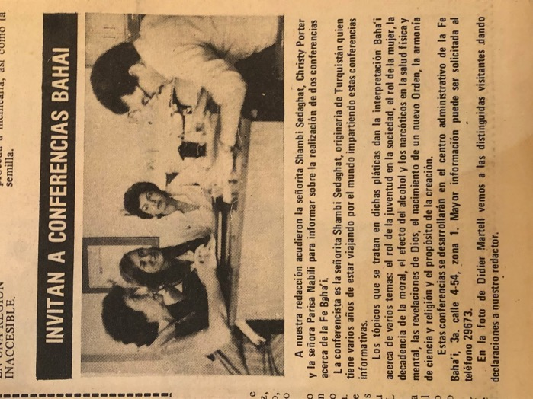
Shamsi, Chrissy Porter, and Parisa Nabili giving an interview to El Grafico
4) The fourth visit was at 4 p.m. at Canal 3 TV. We met the director of the program, Mr. Belle Villatoro. He graciously asked us to return at 6 p.m. for the interview. We went to Mr. Porter’s house, rested and we returned at 6 pm. He interviewed us for thirteen minutes. The subject naturally turned to the Faith, its principles, and the extent of its programs. We thanked him, drove back to Mr. Porter’s home for supper, returned to the home of Zohreh Khanum and happily and prayerfully went to bed.
On the morning of December 10th, Mr. Arnoldo came and along with Mr. Bob Porter, Ms. Christy, Zohreh Khanum, and Mr. Bill Matlock, we left for Quetzaltenango to meet with the members of the National Assembly of the Baha’is of Guatemala. We had two hours of very good discussions and consultation. I suggested we should meet with the news media more, to speak about the Faith so that the people would come to know more about the Faith and its principles, and to make courtesy calls to town officials, invite them to our public meetings and celebrations, and familiarize them with the content of our programs, so that they would be aware of our activities and be able to help us. The members were happy to have me there and hear my suggestions. I thanked them, and then the Secretary of the local Spiritual Assembly, Mrs. Joan Hernandez, with two other members of the National Assembly took us to the station to catch a bus to our destination, the town of Huehuetenango, where we would be participating in a teaching meeting. On the way, we stopped and bought food like sandwiches for lunch and several head scarves for the ladies to protect them from the cold weather before continuing our journey. We reached our destination in two hours. We took our luggage and went to the house of Ms. Suzi, an American pioneer who, in fifteen days’ time, was returning to America. She was not at home. I sat, but my friends, Connie and Christy, went to find the other friends to see what the program was for us and also to find a guest house where we could stay. After a while Ms. Suzi arrived. We were introduced. She said that they had no program prepared for me because they were not sure if I was coming. I said that was no problem. We would arrange one now. She had lunch ready, which she shared with us. Then we said we would wait until Antonio Gutierrez, the secretary of the local Spiritual Assembly, arrived, and we’d arrange tomorrow’s radio and newspaper programs. Then we went to the Pension Hotel, where her friends had found a room for me. I rested and after a while went to bed.
An interview with the radio station
In the morning of December 11th, we went for a radio interview with Mr. Antonio Gutierrez. We were told that his radio was for music only, but we were sent to the Libreria Publicidad to meet Mr. Alvarez, and he would interview me. We went immediately there, met Mr. Alvarez. He interviewed me for twenty-eight minutes, and he himself was very much interested in the principles so I interviewed him also. He congratulated us for having such beautiful teachings. I introduced him to Ms. Connie Craft for future connections. His full name was Hector Leonel Alvareza, Professor de Ensenanza Media, in Huehuetenango. We promised to take some Baha’i books to him. Then we went and had a lunch then went to Ms. Suzi, and we wanted to meet with the members of the local Spiritual Assembly. The permission was given by the Chairman, so Suzi took us to Mr. Rubin’s home, the Secretary. There were only four members present. I spoke very kindly to them and asked them to forget and forgive the shortcomings of each other and to try to be more active. They listened to my humble advice, and although they did not complain of any problems, they hoped for a more active community. Then we had some refreshments and said goodbye and returned to our hotel, the Pension House, and gradually went to bed.
Another radio interview at Quetzaltenango
I took the bus to Quetzaltenango the next morning, December 12th, where Mrs. Taylor and I went to the radio station for a half-hour interview.
On air the interviewer, Mr. Carlos Osperio Rivas Lopez, spoke about what a good person Mr. Bob Porter was and put on some of his music. After dinner we went to another radio station for a 15-minute interview where the interviewer knew Christie.
Then Ms. Joan Hernandez, an American living in Guatemala who was the Secretary of the National Spiritual Assembly, drove us to our next appointment but we had car problems which delayed us. Hurriedly we had to make it to Xelaju Radio whose director Mr. Lie Z. Rolando Oliva was a lawyer at the courthouse. Christie translated. He wanted to know why he had never heard of the Faith why in a city of 200,000 were there only 50 Baha’is. I told him that Baha’is had not approached the radio because they had been concerned about being rejected. I asked if he would give us free air time, so more people could hear about the Faith. He said he would read the book I had shown him, and then he would decide. From the station, Joan drove us to a fireside with twenty people. I gave a talk and encouraged people to study the Faith. By the end of the evening two young men who were sons of Mr. Moreno, had accepted the Faith. We finished by singing songs which I taped so the friends could use them later. Everyone left in an uplifted mood at midnight. Christie and I spent the night there.
At 5 a.m. the next day, December 13th, we got up and Mrs. Joan Hernandez, Secretary of the National Assembly, took us in her car, and we went to the bus station, and I fell asleep on the bus.
I woke up and we arrived at 9 a.m. at the home of Mr. Bob Porter who was a well-known Baha’i musician and excellent personality. We greeted each other and got to know one another, listened to his music, and then he signed several of his recordings for us. I told him that he was much loved in this country and encouraged him to use his music for the enlightenment of the hearts of the people.
I was then taken to the home of Mr. and Mrs. Soheil Mashhadinejad, and we ate a delicious Iranian dish, ‘ghormeh sabzi’, and rice. Then we thanked them, and they took me back home.
Mr. Orlando and his wife came over the next day, December 14^{th,} and as we spoke about the Faith, several other seekers came by. On December 15th, we arranged for my ticket at Avianca Airlines.
The original flight time had been changed but we had not been notified so we went to re-book the flight for the following morning at 7 a.m., and I cabled the National Spiritual Assembly of Honduras to let them know. We went back home and rested.
I got up at dawn the next morning, December 16th. After my morning prayers and breakfast, I wrote a letter to the National Spiritual Assembly of Guatemala and gave it the names of the media people I had met along with the suggestion that thank-you notes be written to them.

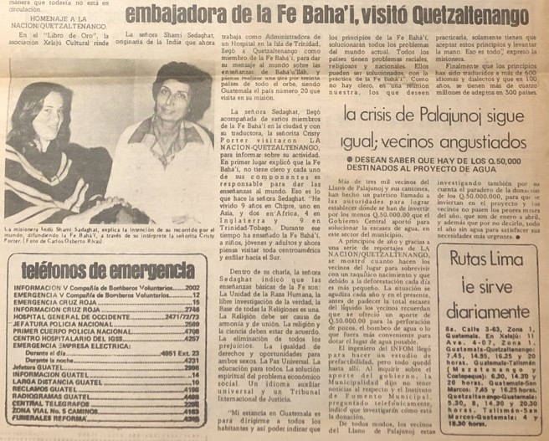
Article on Shamsi in La Nacion, 1977
Visit to Honduras, December 1977
At 5 a.m., Mrs. Zohreh Mashhadinejad and Mr. Soheil Mashhadinejad ordered a taxi which arrived. They helped me with my luggage and helped me through customs and waited with me until my plane arrived. After saying goodbye, I boarded the plane which then flew to San Pedro Sulas. At 7:35 a.m., it landed, and I transferred to Tan Sahsa Airline and flew to Tegucigalpa. In the airport, I met Mr. Luis A. Zeleya who took a photo of me because he had met two ladies in 1956 who were Baha’is from Tegucigalpa, but he had not heard of it again until meeting me in the airport. I gave him literature on the Faith to read as well as my business card.
I didn’t see anyone at the airport to meet me, so I walked over to the airline desk to get my ticket for Panama, my next destination after Honduras. Then I went over to the luggage area when a man came up to me and said, “Allah-u-Abha,” and I answered “Allah-u-Abha.” This was Mr. Hooshang Sabri, a pioneer from Isfahan, who had been in Honduras for two years with his wife Naime Khanum and their seven-year-old son, Shervin. He had come the day before to the airport to meet me and had waited a long time, but I had not come due to the change in the airplane departure time.
He drove me to the home of American pioneers, Mr. Dan, and Mrs. Pamela Wagener. Dan was the chairman of the National Spiritual Assembly of Honduras but unfortunately, he was suffering with hepatitis and was in the hospital. Naime and I went to visit him and say prayers for a speedy recovery. Then we took a taxi to the Baha’i Center for the public meeting.
Thirty people came to the Center including nine seekers. Mr. Timothy Thurber, an American pioneer and medical student who was a very active Baha’i, served as my translator and introduced me. I spoke using my charts which interested the seekers.
After my talk, I invited those who wished to accept the Faith to do so. One young man named Edmundo got up and said he was ready to accept the Faith which opened the door of declaration and soon each of the nine seekers accepted it. We gave them all declaration cards which they signed and gave back to us. We were all overjoyed and welcomed them into our community. Then we enjoyed refreshments all together.
After the meeting, I met with the Spiritual Assembly of Tegucigalpa including Mrs. Erma Nelly Vasques, who was serving as the secretary of the local assembly as well as the national assembly, and we consulted on plans for my visit. I said that we should visit high-ranking officials and the news media. The Assembly was also interested in having me go to teach in two other locations, the port city of La Ceiba and the island of Roatan. The members offered me transportation and translators and three of the nine new declarees said they wanted to go teaching with me. The Assembly gave me a green light to pursue my teaching efforts and asked that I approach the media before going to the teaching destinations. I thanked the assembly and asked for prayers.
Ms. Rafiyeh Khanum then drove me and five young people—Mr. Keith Bookwalter, Mr. Timothy Thurber, and the three new declares, Alexandro Elmundo and Leonidas and Heriberto Moncado—to the television station. The new declarees were Heriberto’s friends, and he knew someone who worked at the station, so his friend went to get the director of the radio and television network who gave us a tour and told me that when I came back to town in a few days, he would interview me because he liked what he heard. We thanked him, and I exchanged business cards with him.
Next, we met the director of the radio station with whom we spoke about the Faith and to whom I showed my charts on the Baha’i principles and progressive revelation. Before leaving Tegucigalpa, we had a quick interview at the newspaper.
I arrived in the town of Siguatepeque up in the mountains of Central Honduras. We were met by Mr. Nematollah Mondegari and his wife Ruhi Khanum who had lived there as pioneers for seven lean years. They had a good business now and were making a decent living selling peanuts, peanut butter, and biscuits and serving the Faith excellently.
They drove us to the home of American pioneers, Mr. Dick and Mrs. Linda Hicks, where we spent the cold night.
The next day, December 17th, there was a meeting to elect delegates for the National Convention. Mrs. Leatha Cooper was serving as the secretary, and I was asked to speak so I talked about how we must teach with love to be effective.
After this convention, which was characterized by a united atmosphere, I met with the local assembly and assured them that through consultation, an assembly can reach excellent decisions.
Later, at Leathea’s house, I spoke to the friends about the role of youth in society. We had a fireside afterwards at the home of Mr. Bill Stover, attended by twenty-five people of whom three-four were seekers where I spoke about the moral laws of the Faith which was well-received.
I flew to Roatan with Ms. Ellen Stover at dawn on December 18th. We took a minibus into town and asked around for Mr. Austin Sutherland and Mr. Napoleon Banner. An old man at the supermarket where we were dropped off knew him. Mr. Austin Sutherland was a baker, and he was in the middle of baking but would join us later.
Next, Mrs. Ellen Stover secured an appointment with the Mayor, Mr. James Wood, in his office. We introduced ourselves to the Mayor, and I gave an overview of the Baha’i teachings using my charts. He did not react one way or another. I asked him if we could use the town hall for our Baha’i meeting. He said that the room was very small and that it was rarely used for any such meetings. He suggested that we hold ours outside in the park, but I did not want it to be held outside. He showed me where to go to meet Mr. Louis Enrique Fernandez, the director of the Royal Majestic Lodge TE Grave, whom I could ask about our meeting.
The people at the lodge knew about the Faith because Mr. Sutherland had already spoken to them about it. We met the director of the lodge, Mr. Grant, but he was too busy to talk so we went to see the local commissioner, Mr. Polo, but he was busy as well.
We waited and eventually we were invited into his office. We gave him a book about the Faith, and he promised to read it. He was very friendly, so I asked him if he would convene our public meeting. He said he could not, but he could send a lady and her daughter who would be his representative—Mr. Bill Stover, Ellen’s husband, was this daughter’s teacher. He came with us to the lodge office, where we were able to secure a room.
After securing the location, we went to the radio station which was run by a young man from Istanbul who announced my arrival over the air and agreed to an interview. The half hour interview was conducted in English and translated into Spanish simultaneously.
At the public meeting at the lodge that evening there were twenty people. I explained the principles of the Faith, and we sang songs. Curious onlookers were standing at the open windows. The secretary of the mayor was there and was so delighted that he asked for the lyrics to the songs. Many asked that we hold another larger such meeting. Mr. Sutherland walked me back to the hotel by torchlight as there was no electricity after 11 p.m.
The bus came at dawn on December 19th, to take me to the airport. While we waited, we went down to the sea to say the Tablet of Ahmad. We said the prayer, and we went back to catch our plane.
We boarded, and the plane landed in La Ceiba where Mr. Tim Keith Naimi and three new Baha’is were there to greet me and bring me to San Pedro Sula.
There I went to the house of Mr. Parviz Rouhani and then to radio San Pedro with Ms. Leedia DeWarrella where I had a taped interview with Mr. Edmundo Espinal Diaz which would be broadcast the following morning.
The next interview was with Mr. Alfonso Ananiva Caliz at the newspaper, Diaro Tempo. Before returning to Tegucigalpa, we visited Mr. Jack and Mrs. Jacqueline Corner, American pioneers who were building a school.
Back in Tegucigalpa, Mr. Hooshang took me to the television station where I had a 15-minute interview on the ‘Panorama’ show. At the radio station, Mr. Rolando Suazo interviewed me for half an hour. We lent him a tape of Bob Porter’s music, so he could tape it and meanwhile we met Ms. Lee Maloff who had an hour-long show. We gave her a copy of the book Tahirih and the Renewal of Civilization. Though we could not be interviewed on her show, the television director interviewed me and said he would broadcast it on the San Pedro Sula station. We thanked him and left home to get ready for the next day’s trip.
Visit to Panama, December, 1977-8
The trip to my next stop, Panama, proved arduous. I had to insist at the Consulate of Panama that I be given a visa because the officials were resisting. Then I had to book a very circuitous route that took me through Nicaragua and Costa Rica before reaching Panama.
When I did finally land in Panama City at 1:30 a.m., December 23rd, I suffered a true loss. My suitcase containing the recordings of all of my interviews with officials had been stolen—cassettes were expensive in the Caribbean, so the thieves had helped themselves to mine! The airline offered me $500 in compensation, but the loss was priceless to me, and I sat and cried. These recordings could have been used for so much proclamation and teaching and now, they were all gone. I made my way to the hotel after bargaining with taxi drivers.
At dawn, I met a few Baha’is who were going to the House of Worship, including Ms. Lillian Frasier and Dr. Collymore from Trinidad, though I was still quite upset by the loss of my precious tapes. I was determined to persevere in my recording so the next day, I bought many more cassettes and a camera.
During the Conference, we all shared teachings stories about the progress of the Faith in our different countries. One evening we saw a film about the inauguration of the Radio Baha’i in Ecuador. Mrs. Barbara Joyce was the first person to give a talk over its airwaves. We received a copy of her talk as a gift, and the attendees gave $600 for the fund of the station. Barbara also showed the conference her children’s films including clips from our children’s classes in Trinidad.
Interview at Critico
Ms. Ruth Pringle, the Auxiliary Board Member, took Dr. Collymore, me, and a Baha’i from Venezuela for an interview at Critico which lasted an hour and would be published on December 28th.
We had an uplifting public meeting after the interview which was attended by 70-80 people, ten of whom were seekers. Mr. Bob Porter led a choir in song.
Ms. Shirley Baldwin brought Dr. Collymore and me to visit the Panama Canal about which I learned a great deal. After I went to the market and bargained with sellers over prices for gifts to bring back to Trinidad. Dr. Ahmadiyyih had just arrived from Trinidad and was greatly pleased with the work of the friends there.
I introduced him to Dr. Collymore whom he had not met before. He spoke to the conference the next day about the efforts of the pioneers in Trinidad.
Before the close of the Conference, I was able to speak with pioneers from Jamaica—Mr. Iraj Pakravan, Mr. Kamran Mansouri, and Mr. Hashemi. We were happy to have Mr. Osborne, the Counsellor, with us.
I spoke near the House of Worship on the morning of December 30th about chastity. The summer school had begun and there were children and young people.
After the talk, I taught a children’s class on Holy Days and Baha’i elections; Mrs. Castillo Bonifaca, a member of the summer school committee, was translating for me.
After lunch, Ms. Ruth Pringle, the auxiliary board member, brought me to an interview at the Star and Herald newspaper with Mrs. Kirkland. Ms. Susan Lich, Mrs. Barbara Joyce, and Mr. Kelly all came with me. That evening we had a Nineteen-Day Feast in which many children participated.
I began the new year of 1978 with prayers in the House of Worship for my teaching efforts. I spoke to Ms. Ruth Pringle’s children’s class about living the Baha’i life. Mrs. Castillo Bonifaca asked me to give a talk to the Baha’is who had come from villages.
Then we all went to say prayers in the House of Worship, after which we went home and gradually went to bed.
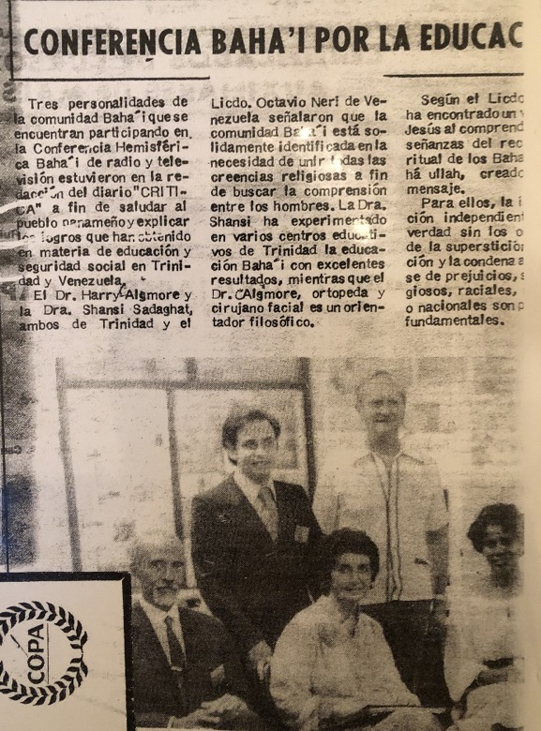
Article in Critico, Panama, 1977, during Conference; Dr. Collymore, front on the left; Shamsi in the front and center.
Visit to Jamaica, January 1978
By the next day, January 2nd, I was in Jamaica and was met at the airport by Mrs. Zohoori, her daughters, and several local believers, who drove me to the Baha’i center where I met the caretakers, Mr. John, and Mrs. Valerie Morley.
After a day of rest, I went on January 4th to the Prime Minister’s office with Mr. Fitz-Henley, the auxiliary board member, and Mr. Elias Zohoori, the Secretary of the National Spiritual Assembly. We were able to speak with Mrs. Daley, the secretary of the wife of Prime Minister Manley, to let her know that we wanted to arrange a courtesy call to them. Then we went to the office of the Mayor and spoke with his secretary, Mrs. Murray, who was very interested by what she heard about the Faith. She gave the names to me of her relatives in Trinidad to look-up and said that we should prepare a letter for the courtesy call to the Prime Minister which she would give to him.
At 4 p.m., we went to the radio station for an interview on Ms. Fae Ellington’s program. Mr. Fitz-Henley joined me and answered many questions. Another woman at the station, Ms. Casell, was planning to do a regular show on religion and asked that I be her first interview and said she would come later to the Baha’i Center to learn more. She came to the Center, and we had an interview which lasted for a half an hour.
We also had the opportunity to speak with Mr. Charles Hayat, the head of the station, and discovered that we had a Baha’i friend in common. I invited him to the Center for dinner that evening.
He came, and we spoke extensively about the Faith and how he could help the progress of the Faith. He said we should have more radio programs and that he would help us.
I stayed over at the home of the Fitz-Henleys, so we could get an early start on our teaching the next day. Before leaving Kingston, Mrs. Fitz-Henley and I visited the homes of John and Peggy Lord and then Mr. Sherman and Mrs. Lily Rosenburg.
In Mandeville, we first stopped at the home of Ms. Winsome Charlton, who was a woman of Mayan background. We spoke about the Faith and left her a copy of ‘Abdu’l-Baha’s Paris Talks and invited her to the meeting that night.
Then we went to the home of Ms. Josephine Hussein who was from Trinidad and knew the table tennis champion, Mr. Mansing Amarsingh. After eating some food and speaking about the Faith, she took us to the home of Mr. Douglas Sherman with whom we also spoke about the Faith and invited to our meeting.

Who should we teach?
We consulted with some of the friends there about teaching. Some expressed the view that we should concentrate on teaching the poor and downtrodden rather than meeting people of prominence. I explained that the Faith must be taught to people from all strata of society and all walks of life. They were also somewhat discouraged because people had not been coming to the meetings. I said I understood how they felt but they must not let this affect their Faith. They should pray and ask Baha’u’llah for strength and then go out and look for new waiting souls. They felt more positive and tried to think about which one of their friends they could invite to our meeting.

Many Baha’is in Mandeville but little activity
Mr. Hopton Fitz-Henley, the Auxiliary Board member, came out with us the next day and brought the list of twenty-six Baha’is in Mandeville.
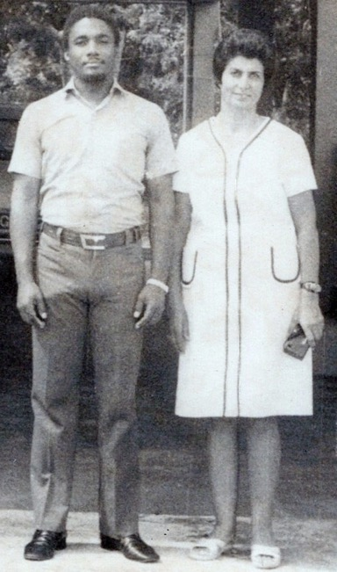
Mr. Hopton Fitz-Henley, Auxiliary Board Member for Jamaica, and Shamsi, at the Rezvan Clinic in Trinidad, 1970s

We were surprised that there were so many and yet there was little activity. We didn’t know where to find these people so when we came to the right general area, I stopped a car with a woman driving it, showed her the list of names, and asked her if she knew any of these people. She looked and said yes, she did. One was her mother, another was her sister—in fact, many of them were her relatives. She said that she went to church but sometimes listened to a program about the Baha’i Faith on the radio, so we also invited her to our meeting. Then we went to the home of Mrs. Joy Harris, a Baha’i, and asked her for help in finding the friends. She had five children, so I taught them the song “God is One” until they could sing it well. She took us to find Ms. Jean Blake. Though we did not find her, we met her father, Mr. George Blake, who was very warm and receptive. He assured us that he would send his daughter to our meeting. Next, we stopped by the store where Mr. Winston Dennis worked, and he agreed to come with us to the meeting. We saw a group of people sitting outside and talking so we joined them and ended up speaking with them for two hours about the Faith and invited them all to our meetings.

Article on the Baha’i Faith in The Gleaner
The morning of January 10th began with a visit from Mr. Ernell Mitchell who brought over a copy of The Gleaner newspaper which had published an article and photo about the Faith and our activities. Then Ms. Valery Morley came by to write a short bio of me which she was going to stencil and give out to contacts. Mr. Hopton Fitz-Henley phoned to tell me that we had been given an appointment on Thursday morning to meet with the Governor-General, and then we had a phone call from Mr. Zohoori about a meeting of the National Spiritual Assembly at which it would decide on an evening to have a dinner for Mrs. Manley, the Prime Minister’s wife. Hopton later arrived, and we both went to see Mr. Neville James at JBC radio. He said he would not be able to interview me that day due to equipment failure, but we sat and spoke about the Faith anyway and the possibilities for advancing the education of children and youth. I showed him my photo albums and offered him Baha’u’llah and the New Era and several films. He seemed very interested and said he would read the book and watch the films to see if they could use any segment of them. By Thursday, he hoped to be able to interview me. I told him not to worry because he had been placed in this important position for a reason which he would one day realize. He smiled and asked me if I was trying to convert him to which I answered that we could convert no one—each person had to investigate the truth for himself. We thanked him and left.
Hopton and I drove out to Mandeville which we reached by late afternoon. We went to get the keys to Progressive Hall where we would be holding our evening public meeting, and then we went out inviting people from the market to the evening meeting. We came back and started our meeting during which I sang songs with the children and then used my charts to speak about the Faith. Hopton then spoke and the fourteen seekers listened carefully. One asked about the significance of the number nine in the Baha’i Faith which we answered after further questions and answers. Then we gave out some literature and declaration cards, and I invited anyone who wanted to declare to do so. One young man said he read the Bible actively and prayed daily. I gave him the book Some Christian Subjects, and he said he would read it and see what God will put in his heart. He said he would come and meet us at the shop of Mr. Erol Williams in whose home I was staying.
The following morning, Mr. Liebert Henriks came over to Mr. Williams’ home and spoke with me about the Faith and by the end of our conversation, he declared. We were very happy and warmly welcomed him. Then we went out and did street teaching along Patrick Drive. A crowd gathered around. A man stepped out of a car and listened for a while. I was speaking on the ills afflicting the world. He said he had been everywhere and seen the same diseases and asked me what I could suggest. Then suddenly he realized that he had read about me in the paper and went to his car and got the paper and brought it to show me. I explained that there must be compulsory education, that everyone must work and try to have a profession, and that everyone should write a will. He responded that people would only do all this by force, and I answered him that nothing could be achieved by force. After I had gotten into the car and was going to be driven away, a girl came over and leaned in and asked me from where I had come. She seemed genuinely interested so I got out of the car, and we began to speak. Again, a crowd gathered around us and after our conversation, the girl said she wanted to declare. We gave out declaration cards and literature. In all, eleven people declared, and I said I would be back, and we could form an Assembly for the town. Mr. Erol Williams and I returned later, and under the shade of a tree, we gathered the Baha’is and conducted an election for the Assembly. Mr. E. Williams was elected the chairperson, Ms. Diana Watson, the secretary, and Mr. Haddan, the treasurer. We deepened the new believers on the functioning and duties of an Assembly and then explained the Nineteen-Day feast. We left them with booklets that had guidelines for Assemblies and told them the friends would help them with the rest of the work.
In Clark’s town we had five declarations
Ms. Marian Mathaya then drove us to Ms. Ruby Ramsay’s house in Clark’s Town near the northern coast. We arrived too late for the planned meeting, but Mr. Hopton Fitz-Henley put up loudspeakers outside over which we played music, and a crowd gathered. Hopton and I spoke about the Faith and showed slides of the Holy Land. We invited those who wished to declare and nine did, five of whom were grown-ups and four children whom we told that they should get the permission of their parents to be able to attend the meetings. The next day we called on the Mayor with Mr. Hopton Fitz-Henley, Mr. Zohoori, Ms. Dorothy White, and Ms. Irene Holla, and we spoke with him about the Faith. He was very attentive. We left literature with him and left. We then drove back to Kingston where we had a birthday party for one of the Baha’is there, and then a small meeting at the Center attended by Mr. Hayat from the government radio station, with whom we spoke about the Faith. He was very happy to be with us.
Talk at the police training school
On January 16th, Mrs. Elias Zohoori, Mr. Hopton Fitz-Henley, and I went to speak at the police training school in Port Royal. The inspector Mr. Kelley took us to a room where 107 police trainees in uniform awaited us. He introduced us to Commandante Maitland. He also welcomed us and asked me to speak. I told the trainees how much I respected their work and encouraged them to continue and serve mankind. I reminded them that they must be loving and caring and protect the lives of others and observe the rules of government, and then I explained the concept of progressive revelation. Hopton then spoke using the writings of Shoghi Effendi. The classroom was darkened so that we could show slides and when we were finished, we distributed literature and declarations cards, and Elias gave the address for the public meeting for those who were interested. The chief inspector there took the leftover materials to put them in his office so students could get them tomorrow. He said that I would make an “excellent policeman and that he would make me an honorary police inspector.” I thanked him for his confidence in me, and we left.
The following day, January 17th, Mr. Hopton and I went to Clark’s Town and went around inviting people to our public meeting. Twenty people came, and Mr. Elias spoke, and I showed slides. A mother and daughter declared. We embraced them and welcomed them to the Baha’i Faith.
While we were at the JBC radio station the next day, January 18th, with Mr. Elias and Mr. Mervyn Mitchell, and I learned that the station head, Mr. Hayat, now considered himself a Baha’i after he told me that he had arranged for a one-minute spot on the Faith to be aired regularly. To my great joy, he signed a declaration card. I welcomed him warmly and later, cabled the news to the Universal House of Justice in Haifa.
Before leaving Jamaica, I was treated to the singing of Roma Fitchet accompanied by Mr. Morley. I had one more interview, this time at the Baha’i center with Mr. William Mitchell which lasted for an hour. The trip in Jamaica was very encouraging, and I thanked everybody and was ready to move on.
Visit to Grand Cayman, January 1978
Mr. Elias Zohoori and I were met at the airport in Grand Cayman on January 20th, 1978, by Ms. Cathy McLoud, a nurse from Canada. The Baha’i goal for Grand Cayman was to raise two new local assemblies. We were brought to the home of Mr. Bob and Mrs. Joann Gilman who told me that they hoped I would help with the teaching in Baddentown and Georgetown. We read the Tablet of Ahmad and prayed for the establishment of those local spiritual assemblies.
Happily, at our first teaching meeting in the home of Ms. Joy Williams several people accepted the Faith: Mr. Linton Rankin, Ms. Clarice Barrett (a sixteen-year-old girl), Mr. Robert Seymour Rankin along with his wife, sister, and mother. We welcomed them to the Baha’i community.
On January 21st, I travelled to Georgetown and visited several homes to speak about the Faith but found little receptivity. While visiting Mrs. Joy Williams on January 22nd, I was introduced to Basil Hennings who then said he knew of me because I had delivered his last daughter in Trinidad. He brought over the girl who was now seven years old. I kissed her and told Mr. Hennings that I had been travel teaching outside of Trinidad which is why he had not seen me back there. He suggested I go to the Lions Club and AA of which he was a member. I told him I would be glad to and that I would visit him later and bring him a copy of Baha’u’llah and the New Era. I made some more home visits when we got the news that Ms. Angela Foz had declared. I gave an encouraging talk in one of the homes to the Baha’is and friends who had assembled, and we sang songs together which uplifted the spirit of everyone, and then we left.
We visited Mr. Hennings the next day January 23rd and left a few Baha’i books for him to read. At the radio station, I had a ten-minute interview with Mrs. Joann Lolling whose father was from Iran though she had been born in Guyana. We spoke about the hospital and the role of youth in society. Mrs. Lolling introduced me to her boss, Mr. Rees, who was the president of the Kiwanis Club. We spoke about the Faith, and we arranged that I would come on January 26th to meet them. Mrs. Lolling then took me to meet a friend of hers whom she thought would be interested in the Faith. At 5:30 p.m., Mr. Elias and I called on Mr. and Mrs. Hercules who had heard of me through a mutual friend. We spoke at length about the Faith and I left them with Shoghi Effendi’s Call to Nations and John Esselmont’s Baha’u’llah and the New Era.
The next day, January 24th, we went to the home of Mr. Gilman’s neighbor, Ms. Dorothy Solomon, in Baddentown. We taught the Faith, and she and her sister declared, and we welcomed them. Mr. Elias, Mr. Joseph Bermudas, Ms. Cathy Mcloud, and I went to the home of Mr. B. McLaughlin who was a fireman. We discussed the Faith for two hours and invited everyone there back to the Gilman home to view slides. By the end, Mr. McLaughlin and his wife declared. We were overjoyed and welcomed them to the Faith.
Two local spiritual assemblies of the Cayman Islands were elected
That evening, we had an election for the new Assembly of Baddentown at the home of Ms. Joy Williams. Eleven people were present to elect one of the two needed local Spiritual Assemblies in the Cayman Island—the local Spiritual Assembly of Baddentown.
Ms. Joann and I visited the Governor of Grand Cayman the next morning, January 25th, but he was not eager to learn about the Faith and was somewhat suspicious of new religious activities on the island. However, we were happy to meet him, and we left. We then went to the lunch meeting of the Kiwanis where thirty-eight people listened to me while I spoke about the education and training of youth and then went over my charts on progressive revelation and the Baha’i principles. They were happy. We left literature about the Faith and invited them to come to our meeting if they wished. That evening in the home of Mr. MacLoughlin—who worked as a clerk in the House of Representatives—, I spoke about the duties of women in society and went over the charts. In response to a question about the progress of youth, I said that today we should teach the girls useful crafts like sewing and dressmaking which could be used later and help to earn some income until better opportunities arose.
We returned to Georgetown the next day, January 26th, and visited several of Ms. Joy Williams’s friends. For two hours, we spoke with Mr. Franklin Webb and his wife, and they declared. I welcomed them with a great joy into the Baha’i Faith. In addition, we found Mr. Thomas Rankin who was a Baha’i but had not known if there were other Baha’is there, so he had not been coming to meetings. We gathered Baha’is in his house and collected the votes, and the Assembly of Georgetown was formed with Mr. Elias Zohoori, the Secretary of the National Spiritual Assembly, present. It was decided that the nine members would convene on Sunday to elect the officers of the second goal local Spiritual Assembly of the Cayman Islands.
With the successful creation of these two new assemblies, we decided to open new localities, so we went to the east end of the island to visit the mother of Mr. Leighton who declared after speaking about the Faith for a short while. Then we came to the home of Mr. Leonzie Connolly who was old and in poor health but enthusiastic about the Faith and encouraged us to speak in the town hall. We went to the home of Mr. John McLean, a member of the legislative assembly, and his wife. He had the key to the town hall, so we talked about the Faith and left him a book on the Faith. We scheduled a talk for January 30th, and he would convene it. We returned to Mr. Connolly’s house who said he had learned more from speaking with us than he had in many years in a church and was happy to have seen the light of truth. Mr. Zohoori left him some posters about the Faith and encouraged him to teach the Faith.
We met in the home of Mr. Franklin Webb the next morning to elect officers for the Assembly. We deepened the new believers in the proper functioning and role of the Assembly. The election took place: Ms. Cathy was elected chairperson, Ms. Joy Williams, the secretary, and Mr. Leighton the treasurer. Later, we met several young men whom we engaged in conversation. One was a Seventh Day Adventist. I assured him that everything taught about God and his prophets in the Bible was also in the Baha’i Writings and that Baha’is were taught to pray daily at home or in Baha’i Temples or at gatherings. I reviewed my charts with them and then gave out declaration cards and told them that when they were ready, they could sign. One young man, Mr. George F. Banks, signed immediately, and then following his example, the others did too: Ms. Carol Yates, Mr. Joseph B. Banks, and Mr. Joseph E. Banks. We welcomed them to the Baha’i Faith and invited them to come to a meeting later.
On January 30th, Ms. Cathy made copies of a tape by Hand of the Cause William Sears on which he explained Biblical prophecy and the Baha’i Faith, so we could give these out on this deeply Christian island. At the town hall meeting, more than twenty children came as well as youth and adults. I taught a song to the children, showed slides, and spoke with the adults. They were very happy to learn the songs.
The next day, January 31st, we had our public meeting in the town in the east end. Mr. McLean came to open and help me put up the charts. People came whom we had met during our home visits as well as children. I spoke for a short time, showed slides, and went over the progressive revelation chart. It was very well-received, and we left literature for them.
Before leaving Grand Cayman, I wrote thank-you letters to the many people who had helped me and then went for an interview at the radio station with Mrs. Ursulla Gill. Mrs. Hercules called before I left to tell me that her husband was reading the Baha’i books I had left with them and then she gave me the name of a friend in Nassau to whom she had written about me. I thanked her very much.
In transit from Grand Cayman to the Bahamas, I met Mrs. Soo Fouts, member of the National Spiritual Assembly of the Baha’is of the United States, who was on her way to pioneer in the Falkland Islands. We spoke with each other, and we exchanged our good news for a short time.

Chapter 11

Visit to the Bahamas, February 1978
On the flight to the Bahamas on February 1st, 1978, I struck up a friendly conversation with an accountant, Mr. Brian Smith, who was living in the Bahamas with his wife and working as director in a computer company. He was on a one-day trip to Miami and was returning home to the Bahamas where he lived. His father was the Minister for Youth Affairs in the Bahamas, and the Baha’is on the island knew his father. When he heard that I was a Baha’i, he became cheerful. I said, “What? Do you know about the Baha’i Faith?” Yes, he said, he had heard of the Faith while living in Ohio. He had read Thief in the Night, Nabil’s Narrative, God Passes By, and Baha’u’llah and the New Era. He had also attended firesides and Holy Day meetings in New York. I expressed my surprise at how much he knew about the Faith. He kindly inquired whether anyone was meeting me at the airport. I answered “yes.” After the short flight, we landed in Nassau, and he helped me with my bags and paid the tip to the porter. We exchanged contact information.
Mr. Glenn and Mrs. Lois Lissner were there to greet me, and I introduced them to Mr. Smith. As it turns out, Mr. Smith lived right behind the Baha’i Center in Nassau. Before we departed, the pioneers told him that we would have a meeting on Saturday at the Baha’i Center, and that he could join us, and he said he would be there. I had met the Lissners previously in Jamaica where they had been pioneering, and where we had served together. On the drive to the Baha’i Center, they gave me a telegram from the Universal House of Justice which was a reply to my report from the Caribbean trip.
Cable from the Universal House of Justice
“GRATEFUL YOUR ENERGETIC EFFORTS ADVANCEMENT CAUSE DURING INTENSE TEACHING PROGRAM CARIBBEAN ISLANDS PRAYING SHRINES FURTHER CONFIRMATIONS WILL ATTEND YOUR VISIT BAHAMAS ENABLE YOU WIN NEW LAURELS SERVICE BLESSED BEAUTY LOVE
UNIVERSAL HOUSE OF JUSTICE”
I was very happy to receive this lovely and promising cable which gave me new energy. I was given hospitality in a spacious room in the Baha’i Center where I met Mr. Henry Wigfall, chairman of the local spiritual assembly.
The next morning, I had to go take care of visa issues. The Lissners brought me to the Immigration Department where we met with Mr. Backford, the director of the department, and I also met Mr. Plakaris again who was of Greek origin and whom I had met on my previous visit to Nassau. Mr. Plakaris was very cordial, so I expressed my appreciation of his kindly demeanor. He pointed out that without his uniform he was like everyone else. I said no, that he had respect for all with or without a uniform. Then I told him about my talk at the police cadet school in Jamaica in which I had recommended that when policemen are making an arrest, they should treat this person kindly and respectfully even though this person maybe had committed an offense. Kindness should always be in their hearts. I told Mr. Plakaris that uniforms must not change this condition. A person must have in their heart love and respect for others which you have Mr. Plakaris! He thanked me.
I then showed my charts and told them about the progress of the Faith throughout the world. One of them knew about the Faith and said that many Indians had become Baha’is. I explained that this was because Baha’u’llah was a prophet like Krishna and fulfilled the prophecies of Lord Krishna. Then I went into the Biblical prophecies from Daniel and gave them the book, Thief in the Night, to read. They saw that in my album I had photos of myself with high-ranking officials from a variety of countries. They were very pleased to see what I had showed them. Before leaving I filled out a form for immigration, and they gave me a three-month visa.
Press Conference at the Baha’i Center, Nassau, the Bahamas
Back at the Baha’i center, the Baha’is had organized a press conference with two reporters: Ms. Jenny Diamond, from The Tribune newspaper, and Ms. Nell Boniny from The Guardian. Ms. Beryl McSweeney, Mr. Henry Wigfall and the Lissners were there also. I went over my charts with the reporters and explained to them that the purpose of the Baha’i Faith was the unity of mankind and love and peace among all. Then we gave them Baha’i pamphlets and my biography. Ms. Boniny left because she had another appointment, but Ms. Jenny Diamond showed great interest and stayed longer. I walked with her back to her newspaper’s offices which were near the Center. I encouraged her to read about the Faith before writing her article, so that her reporting would be accurate.

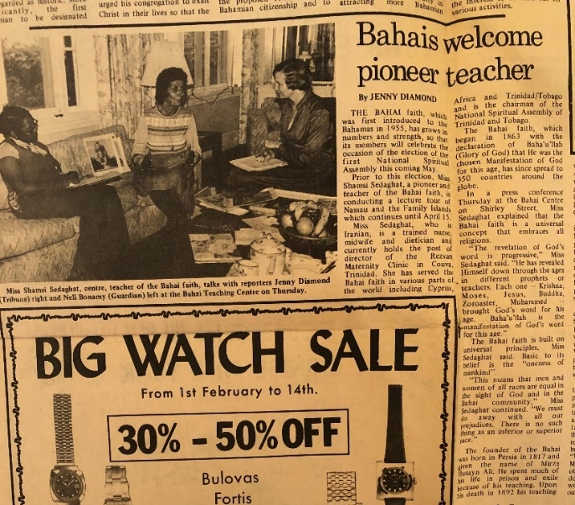
Shamsi being interviewed by Nell Boniny (left) and Jenny Diamond (right)
Out to visit media department
The Lissners, Ms. Beryl McSweeney, and I then went to ZNS radio and television where we met Mr. Curtis Smith, the news director. After learning about the Baha’i Faith from us, he was so impressed that he wanted to interview us right away but then stopped himself and said that more air time was needed to do justice to the subject. I told him that on St. Thomas, I had been on a call-in show that had generated so much interest that it went on for over two hours. He scheduled an hour-long interview with me and said he would announce my arrival on the island over the air immediately. I told him that I would bring him some books on the Faith for him to read.
Then we went over to the television section where we spoke with Mr. Carl Betel, the head of the television division. He knew Mr. Glenford Mitchell, the Secretary of the National Spiritual Assembly of the United States, who later was elected a member of the Universal House of Justice. Also Mr. Betel had visited the Temple in Chicago. I gave him some film footage for possible airing, and he promised to watch it. Before we returned to the Baha’i center, we stopped by the Immigration Department where Mr. Plakaris gave me my passport with the visa. I asked him if we were permitted to hold a public meeting without the permission of the police, and he said there would be no problem. I promised to invite him.
I met with the local Spiritual Assembly to consult on the plans for my visit, and it was decided that Ms. Beryl McSweeney would be my companion during my stay. Much work still needed to be done to bring the Bahamas up to National Spiritual Assembly status. I phoned Mr. Jim Wanders who lived on the island of Eleuthera and served as the chairperson of the Teaching Committee because I was concerned that we needed to solidify the plans for my visit. He said that there were some plans for me which he would convey when he saw me, and then I asked for permission to take some initiatives of my own as well.
I set up a talk at the St. Augustine School through Mrs. Margaret Slater who was a teacher there and the President of the Pilots Club and who was a friend of the Lissners. The Lissners and I went out on home visits to invite people for a public meeting. Then the next day, February 4th, we had a meeting and were expecting Mr. Brian Smith to come to the center, but he did not show.
Declaration of Mr. Brian Smith
On February 5th, there were activities at the Center including children’s classes. I phoned Mr. Brian Smith at 11 a.m. and asked him why he hadn’t come the day before, and he said that he had had to go to work but would come on Sunday. When he did come, we were all very happy to see him and welcomed him. He told us about his friendships with Baha’is in the U.S. I asked him why he had not become a Baha’i even though he knew so much about the Faith and if he had any outstanding questions to which he needed answers; if not, then he could sign his card and start serving the Cause of God. He said that he did not, and I invited him to sign his declaration card which he did. Everyone was filled with joy, and as the Spiritual Assembly of Nassau was in session we took him into its meeting room to be greeted. The Assembly members were very happy and welcomed him warmly. As we all drank tea and ate sweets, I compared the declaration of Mr. Brian Smith to that of Dr. Collymore in Trinidad. Later Ms. Beryl McSweeney showed me a very favorable article on me that had appeared in The Tribune.
I met with Ms. Jenny Diamond from The Tribune the following morning. I encouraged her to keep writing about the Faith and invited her to dinner at the Baha’i Center. She said she had children, and I told her that they would be welcome. There was also a photographer she knew who was interested in the Faith, but he could only come over on his lunch break. I welcomed her to bring him as well for lunch. After I got back to the Baha’i Center, the Lissners picked up the phone twice with callers—Mr. Musgrove and Ms. Parboosingh—who were interested in learning more about the Faith after they had read the article in The Tribune. A date was given for their attendance at a meeting.
We held the Nineteen-Day Feast later where I met several of the friends: Mr. Gadwill Newton and his wife who were very involved in the community, Mr. Newton’s mother-in-law, Mrs. Ann Reed, who lived in Freeport, and Ms. Rosemary Bailey. Another Baha’i, Mr. Jim Wanders, was not able to join us because—happily—there were three new declarants in his town, and the community there was ready to elect a local Assembly. I told him that I was ready to meet with the new Assembly at any time and offer my ideas for what we could do to advance the Faith.
Mr. Brian Smith joined us, and I introduced him as a jewel. He said that he had gone home and handed his liquor bottles to his wife to give to her friends. When she asked him the reason, he was doing this, he said that he had become a Baha’i. She did not believe him, so he told her that he was trying to change himself to show he was sincere.
The next morning the Spiritual Assembly of Nassau was meeting and at 10 a.m. Ms. Rosemary Bailey, the secretary of the Assembly, came out of the meeting chamber crying because they had just received the good news that the community in the town of Andres had elected its Assembly.
Mr. Lissner and I assigned for teaching
Mr. Lissner was assigned to accompany me in teaching as he had a car. I was ready to teach and wanted to have the Center open every night to receive seekers. I told the Assembly that I would take one break and leave the Bahamas for a short time to attend the International Convention in April, in Haifa, Israel, to elect the Universal House of Justice and then return to Nassau.
A new seeker came to the center
A man came to the Center who had read the article in The Tribune, and he wanted to know more about the Faith. His background was Baptist, so he was especially interested in questions regarding Heaven and Hell, forgiveness, the end of the world, resurrection, and other Christian topics. I explained to him that these questions were from the past, and we were in the present. We must take the Book of God and move forward rather than dwell in a past age. We must be concerned with the problems of today and work to alleviate the suffering around us. I turned off the light, and the room went dark. I told him that if he wanted to be a light in the darkness, he should turn the light on again. He did and there was light again. Everyone laughed. I encouraged him to read the materials we had given to him and if he agreed with what he read, he would accept the Faith and become enlightened. Then, wherever he goes, he would enlighten with his light those who were ready. After we had finished, we had some refreshments, and he left. Mrs. Ann Reed, Mrs. Lissner, and I ate our simple lunch of bread and cheese and tea.
A lady invited us to her home
While we were speaking, a lady then stopped in at the Center and asked us to come to her house to help her. When we got there, her husband went into another room, and the children were fighting. The Lissners and I spoke with her for a long time. She called her husband in, but he said he had no time. I got up and walked into the kitchen where he was and introduced myself. I told him about myself and asked him about himself. He answered that he was a construction worker and a night guard. He said he had to go to bed before work. I went back to speak with his wife. We talked about training children. I encouraged her to get the children to bed early so she could spend time with her husband. I called out to the husband after he had taken his shower. He came in, and I introduced the Lissners to him. We kept speaking, and I went over my charts. He kept standing the whole time. I gave him my calling card and then pointed out that the Lissners had been married for a very long time, and, like Layli and Majnun, the famous Persian couple, the “Romeo and Juliet”, they had never lost their love for each other. The husband smiled for the first time. He gave us a friendly goodbye, and I invited him to join us at our meeting on February 18th. The wife was very thankful, and we invited her too and left.
Meeting with teaching committee
I met with the Baha’i Teaching Committee the following day, and we consulted on my plans including bringing videos to be broadcast on television; I played a video from Jamaica for the committee. I suggested that we invite prominent citizens to the Center for dinner on the 14th. Mr. Henry Wigfall would let me know if Mr. Michael Horton, a prominent lawyer, and his wife, Boguslawa, would be visiting me at the Baha’i Center that night.
After our consultation, I went to the television station, but the director had still not watched the video which I had left for him, and he told me to call him when he had returned from his trip. Nevertheless, I invited him to our public meeting on the 18th. On my way out, I saw Mr. Carl Bettel, and I made sure to thank him for the article he had written about me. He thanked me in return with pleasure.
Visit of Mr. and Mrs. M. Horton to the Baha’i Center
That evening, our attorney, Mr. Michael Horton, and his wife came to the Center as well as a few others. He said that what Baha’u’llah taught, Jesus taught as well, but that the Bible stated that Jesus is the way, and it was he—not Baha’u’llah—who could save mankind. He asked many questions, saying he thought in two ways: one as a Christian, and the other as a Baha’i. We spoke for several hours. I told him that if it was God’s Will, the Faith would spread all over the world, so the Faith did not need any of us, it is mankind that needs the Faith. He agreed but said that his heart and mind had to agree with each other. I encouraged him to keep coming and reading Baha’i books. He said he would be back tomorrow and borrow the Kitab Iqan and Some Answered Questions. He said he would let me know when his wife was ready to declare because she was very open to the Faith.

Visit of Ms. Jenny Diamond to the Center
Ms. Jenny Diamond came for tea the next day. She was concerned because the Faith seemed so good to her, but she believed its spirit would eventually fade. I explained that the Baha’i Writings said that this was the day that would not be followed by night and that it was here for 500,000 years and any prophets who would come after Baha’u’llah would not change the essential principles of unity and harmony in the world. Before she left, she said she might come for the evening fireside.
Mrs. Horton came as well to pick up books for her husband. She was elated from the fireside and had wanted to jump up and sign her card that night but was waiting for her husband to be ready as well. I said I hoped she would sustain this spirit, and that her husband would be ready very soon.
Visit to Eleuthera Island
I flew to the island of Eleuthera the following day, February 10th. Mr. Jim Wanders met me and drove me to the home of Mr. Cyril Archer who was an ex-commissioner of the island and now ran his big grocery store. He was Bahamian and married to an American who was a Baha’i who had been recently elected to their local Assembly. At their home, we had a small gathering that included children. I taught children how they could learn prayers. After wards, Mr. Archer told me he would take me on a courtesy call to meet the current commissioner.
The Archers then took me to the Calvary Revival Baptist Church where Mrs. Archer’s friend Ms. Hilda Sands was a parishioner. Her father was the minister. After the sermon, Mrs. Sands and Mrs. Archer introduced me. I expressed my appreciation for the great warmth the church members had shown to me. Their warmth towards each other, I said, was a form of prayer. I told them how ‘Abdu’l-Baha used to pray and recited one of his prayers for them. I then spoke on some Christian subjects. I explained that salvation meant obedience to the Word of God. One parishioner asked me to speak about the decline of morals and said he hoped that I would guide people to a Godlier way of life. I said that I was doing this and would continue.
After lunch at the Archers, we went to visit Mr. Ward. He was not at home but in front of his house was a drunk and two other men—Bethel and Pierre. I was introduced as a nurse. We started talking with them about the Faith, and a crowd gathered around. I gave them all pamphlets and declaration cards. We returned later to the home of Mr. Ward and this time Bethel and Pierre came with us. Mrs. Ward was home. Inside, Mr. Jim Wanders and I showed slides. After we were finished, Bethel and Pierre declared, and we welcomed them warmly. When I was leaving, a woman came up to me outside who was the sister of the drunken man to say that she wanted to declare. We gave her a declaration card to sign. She signed the card which she gave to us, and we welcomed her sincerely, and we returned to the Archer home where we were all very joyful from the spiritual assistance we had received.
We had some difficulty securing a room in which to hold a public meeting because the priest who had arranged a room at the Red Cross had become nervous about getting in trouble with the Church.
We had more success in schools. At Governor’s Harbor High School, the principal, Mr. Longley gathered 200 students as well as several teachers to hear us. He introduced me, and Mrs. Archer and I spoke for an hour on the importance of education, developing one’s character, being chaste, honest, decent, and free of prejudice, and respecting elders. I taught them a song about racial unity, and we all sang together. The director asked if any students had questions, but they were all silent. I said it means that what I have expressed must have been accepted by everyone. They laughed and then I showed the students photos from the places I had been. The director had a group photo taken with me, Mrs. Archer, and all the teachers. After walking us to our car, he spoke with us for another half an hour. I invited him to come and have supper on the 18th and stay for our public meeting, and he agreed.
Invitation to talk at local Red Cross
At 5 p.m. that day, we got news that we were invited to attend a local Red Cross meeting and speak about the Faith, and we went. There were eighteen people in attendance, mostly women. When the regular agenda was finished, Mrs. Archer invited me to say a few words. I thanked them for giving me the opportunity to speak. Then I asserted that this was the day of the equality of men and women. Women must go beyond the home and their families and serve the broader world like those who were
involved in the work of the Red Cross and other charities. I gave them several examples of service such as helping in old age and convalescent homes, in nursing homes, and many other charitable institutions, to be more useful to humanity at large. The meeting finished with a prayer and everyone shaking hands, saying goodbye.
A room was secured for the public meeting when Mr. Archer and I went to the Cigatoo Hotel where the manager, Mr. Baldwin Johnson, agreed to prepare a room for our public meeting. I immediately telephoned Mrs. Archer to phone Radio Nassau and give the date, time, and address of the meeting so it could be broadcast. We would ask the commissioner of the island to be the chairperson, and money would be donated to the Red Cross. When she contacted him, he said he would come because it was a fundraiser for the Red Cross.
After we returned to the Archers, Ms. Doreen Fernandez, the daughter of Mr. Francis Fernandez, came over. I had met her at the home of the Wards and had given her a declaration card. She wanted to know more about the Faith before declaring. She was concerned, for example, about being able to answer questions correctly about the Faith. I asked her if she believed that God was the Creator, and she answered, “Yes.” I asked her if she believed that Buddha, Moses, Jesus, Mohammad, and other prophets were all sent from God. She answered, “Yes.” I asked her if they had all brought moral teachings, and she answered. “Yes.” I said that the same teachings had been brought by Baha’u’llah such as being honest, truthful, just, kind, generous, so if she accepted all of this, she was a Baha’i. Everyone laughed. Doreen began to cry as she spoke about the conditions she saw around her. I encouraged her to pray to Jesus Christ for guidance regarding the Baha’i Faith. I told her that Baha’u’llah had brought the remedy for all the ills she saw today and answered the prophecies of yesterday. The sooner she declared, the sooner she could apply the remedy to society. She was happier, and we left peacefully.
Attending several public and private meetings
We invited people to the public meeting including a friend of Mrs. Archer, Ms. Elizabeth Fay, who spoke several languages and had built a Catholic hospital and a monastery. Her home was large and sumptuous, and she made out a check to the Red Cross and another to cover the expenses of the public meeting. When she heard about the subject of my talk, she agreed to come and even bring a cake.
That evening at the home of Mr. Jim Wanders, we had a fireside. Doreen’s mother Francis came. She had signed a declaration card already, but it had not been forwarded to the local assembly. Jim asked her how long he should keep her card. She said two more weeks. I encouraged her to plug herself all the way into the Faith because without being fully plugged in, she could not get the spiritual electricity. We all stayed up late answering her questions, and she left happier.
The next evening, February 16th, was our public meeting at the hotel. Ms. Fay arrived with a big cake. The commissioner arrived. Musicians who were going to use the room later came to provide some music for our gathering. Mr. Butch Johnson, the son of Mrs. Valdez, a new declarant who was in charge of Bahama Air, came, as well as others. The meeting got underway with Mrs. Archer expressing appreciation for Mrs. Fay’s contribution for making this meeting happen. The commissioner then introduced me and presented me with a letter of recognition. I gave my talk on social principles, topics which I knew would not create problems with the churches that were very strong in the Bahamas−the education and training of children, the equality of men and women, and other important social principles. After the formal program, the commissioner sang for us accompanied by the musicians. We all drank tea and talked and took photos together. Before parting, many people thanked me for my enlightening speech, and I was given a Certificate of Appreciation from The Bahamas Red Cross Society of Eleuthera Island, “For devoted unselfish service to the welfare of the Community and Nation…and for the support and co-operation so generously given to the cause of humanity.” I extended an invitation to the commissioner to visit us in Trinidad for which he thanked me.
I left Freeport for Nassau
After the meeting, we visited a Baha’i musician, Mr. Lloyd Williams, and then returned to the home of the Archers. I called the Baha’is in Nassau to find out their plans, and they said I was needed to come and meet with the youth at the Nassau center.
Mr. Butch Johnson drove me to the airport early the next morning, and Mrs. Rosemary Bailey picked me up in Nassau and took me to the Baha’i Center. She informed me that Mr. Glenford Mitchell had phoned to tell me the National Spiritual Assembly of the Baha’is of the United States had appointed me one of the coordinators of the upcoming election of the National Spiritual Assembly in the Bahamas. Ms. Jenny Diamond, the journalist, phoned to say hello. I invited her to come to the youth meeting, and she said she was not sure she could come because she had children. I told her to bring them. After resting for a while, I went downstairs and saw that in the large yard, the grills were on, and the tables were covered with food. A young volunteer from America was asked to say grace but he said we had no such thing in the Faith, so I read a prayer because all the youth were looking to me. Then I was asked to speak. I spoke about the role of youth in developing society. Five youth declared. The youth cleaned up completely at the end of the meeting. Jenny Diamond stayed after people had left and expressed interest in becoming a Baha’i but wanted to know more because if she accepted something, she wanted to be fully informed. She said she would keep coming to meetings to learn.
Unfortunately, on the morning of February 18th, Mr. Balsam Golestaneh, the son of Mr. and Mrs. Golestaneh in Miami, who was teaching school in the Bahamas, was involved in an accident on his scooter. I rushed outside and saw that he was bunched up bloodied on the ground and in a lot of pain. An ambulance was called and several of us went to the hospital. At the hospital, the x-ray showed that he had broken his tibia bone. A cast was put on him, and he was given pain pills. Mr. Henry Wigfall brought him back to the Center to recuperate.

Speaking at the public meeting
That evening we had a public meeting. Mr. Brian Smith was chairing, and Mr. Henry Wigfall prepared the food and set-up. The topic for the evening was “Today is the day that the eyes of the world have not yet seen.” Brian’s parents attended the meeting as well as several other non-Baha’is, including a teacher from the school where Balsam taught and his family. Mr. Brian Smith opened the meeting with a reading of the Tablet of Ahmad then he introduced me. I spoke about the importance of this day and the prophecies and station of the prophets of the past. I told them that The Tribune newspaper had printed an article on the Faith that included the teaching of progressive revelation. A letter was written to the editor disputing the teaching by saying that Jesus and the Holy Spirit were God not the other prophets. I elaborated on this subject and gave an explanation which seemed to greatly interest the seekers. When I had finished my talk, they thanked me. Mr. Brian Smith’s parents, Mr. Cap and Mrs. Ruth Smith, were very pleased that their son had accepted this Faith and had told their daughter-in-law that these teachings were beautiful. They said they would come again. When everyone had left, I went up to check in on Balsam who was sleeping comfortably.
Mrs. Rosemary Bailey brought Balsam’s belongings the next morning from her house where he had been staying to the Baha’i Center where he would now be staying so we could look after him. At midday we held a bi election for the Nassau Assembly which was filled by Mr. Brian Smith though he had only been a Baha’i for fifteen days, and Mrs. Nabbil. After lunch we held our teaching institute. Counsellor Tucker gave a talk on Baha’i administration and the duties of the local and national bodies. Many questions were asked regarding the infallibility of the Universal House of Justice, its powers, legislation of future Baha’i Laws, all of which Counselor Tucker answered ably.
He explained that all the powers of the Universal House of Justice had been laid down by Baha’u’llah, explained by ‘Abdu’l-Baha, and put into practice by Shoghi Effendi. This plan was created by God and not man. Mr. Horton had been asking many of these questions, and I told him with a smile not to waste his time and to sign his card and serve humanity with us. I recounted for everyone the story of the declaration of Dr. Collymore. Mr. Horton said he agreed with Dr. Collymore that I had a very optimistic outlook, and he was delighted with the evening and was planning on coming to more firesides. We ended the fireside by eating the delicious dinner prepared by Mr. Gadwill Newton.
Health condition of Mr. Balsam
The next morning, Balsam was still not doing well, so Mr. Henry Wigfall wanted to take him to a private doctor rather than to the public hospital.
Balsam was taken to the x-ray department because he had been bleeding and had damage to his kidney. When he was brought back, we put him in a bed upstairs where we could watch over him, and I wrapped him in a blanket which I had bought at the market because the weather had turned cold. When he was still bleeding the next day, he was taken to the hospital and his father, Mr. Golestaneh, who lived in America, was phoned. His family wanted Balsam sent to Miami for treatment.
Talk at the Kiwanis Club in Nassau
Mr. Brian Smith took me on the evening of February 21st, to the Kiwanis Club where I had a talk to give. The President of the Kiwanis Club introduced me. I praised the club members for the good work they were doing to improve society. Drawing on the Baha’i Writings, I explained that man was a mine rich in gems and that these could be brought out through education. Children had to be trained from the beginning by their mothers and fathers otherwise the character of a youth could become spoiled. I read this passage from Baha’u’llah:
“Be generous in prosperity, and thankful in adversity. Be worthy of the trust of thy neighbor, and look upon him with a bright and friendly face. Be a treasure to the poor, an admonisher to the rich, an answerer of the cry of the needy, a preserver of the sanctity of thy pledge. Be fair in thy judgment, and guarded in thy speech. Be unjust to no man, and show all meekness to all men. Be as a lamp unto them that walk in darkness, a joy to the sorrowful, a sea for the thirsty, a haven for the distressed, an upholder and defender of the victim of oppression. Let integrity and uprightness distinguish all thine acts. Be a home for the stranger, a balm to the suffering, a tower of strength for the fugitive. Be eyes to the blind, and a guiding light unto the feet of the erring. Be an ornament to the countenance of truth, a crown to the brow of fidelity, a pillar of the temple of righteousness, a breath of life to the body of mankind, an ensign of the hosts of justice, a luminary above the horizon of virtue, a dew to the soil of the human heart, an ark on the ocean of knowledge, a sun in the heaven of bounty, a gem on the diadem of wisdom, a shining light in the firmament of thy generation, a fruit upon the tree of humility.”

The audience applauded this passage. At the end of the meeting, an Indian man asked me if the politicians in my country were following these teachings, and I agreed that politicians were not adhering to these. Several participants expressed to me individually that the presentation had opened their hearts. Two audience members came up to ask me to come to their clubs and speak, and I invited them to phone me, and I would go. Brian drove from the meeting to Paradise Island, a resort where there was drinking and gambling. He wanted me to see how many islanders spent their time and money for these so-called ‘entertainments’ which were the cause of all the distractions today. This was helpful for me to see to understand life in these islands. Back at the center, a message from Mr. Gadwell Newton was waiting for me inviting me to come to Freeport because the Kiwanis Club there wanted me to speak at its meeting.
Talk at Kiwanis Club in Freeport
On February 22nd, I flew to Freeport, where Mr. Gadwell Newton took me to the home of his mother-in-law, Mrs. Ann Reed. We went to the Kiwanis Club where I spoke privately with the President for ten minutes about the Faith. After our meal and the club’s regular meeting, I spoke for fifteen minutes about progressive revelation and read from the Writings which interested the audience very much. One person asked me about the Virgin Birth, and another wanted to take me to his hospital to meet the matron there. I met her, and we spoke about various subjects. She had the impression that Baha’is were rootless people who came and went. I reminded her that the Apostles travelled constantly, and that Baha’is were only given one-month visas, so they couldn’t stay on the island and deepen the people. Before leaving the Club, I gave a book on the Faith to the Club’s President.
A Baha’i fireside
The next day, Mrs. Ann Reed had a children’s class made up entirely of non-Baha’i children, and then we had a fireside. Fifteen people came, two of whom were students. I went over the teachings of the Baha’i Faith. A young man asserted that Jesus Christ was the first and the last and that no one except him could save us. I gave him a long reply. A woman in attendance, Mrs. Graham, whose mother-in-law was an English Baha’i who lived on the Isle of Wight and who had seen my photo in a newspaper, asked about the purpose of fasting and why God would want to see his followers hungry. Several people offered answers. She expressed the desire to come to a future meeting. A Chinese woman who had come with Mrs. Graham wanted to know how to become a Baha’i. We gave her a declaration card, and she said she would sign it later, and I asked her why wait? She laughed and signed the card. We all welcomed her warmly and gave her a few Baha’i books to read.
A phone call from Mr. Glenford Mitchell
After a cold night, I returned to the Nassau Baha’i Center the following morning. Mr. Glenford Mitchell, the Secretary of the National Spiritual Assembly of the United States, phoned me and asked about the progress we were making. He said that the National Spiritual Assembly of the Baha’is of the United States wanted me to coordinate with the friends for the national convention for the Bahamas which would be held in Nassau, and that this phone call was the official request. Mr. Mitchell would visit the Bahamas sometime in March after the conclusion of the election of delegates.
Visit of several seekers to the Baha’i Center
Mr. Michael Horton kept coming to the Center every evening with his wife and a young child. He asked numerous questions on each visit, often repeating himself which I pointed out to him. He told me about an article he had read on Mrs. Elsie Austin, a distinguished lawyer from the United States, on her last visit to the Bahamas. Everything he read and heard about the Faith was like spiritual water for him, but he had learned many ideas from childhood which he needed to change one at a time. I told him he was taking too long to accept the Faith, and that he didn’t need to know everything about it to become a Baha’i and serve humanity. We would read and learn gradually in our service to Him.
The next day was spent with a seeker, Ms. Joann Vanderpool, a medical technician with an advanced degree, talking around the table at the center about the prophecies in the Tablets to the Kings. She asked many questions and stayed until the end of the afternoon. I gave her a book on the Faith before she left. Then I went to the Camera Club at the College of the Bahamas where around fifty people were meeting to see photos of a Canadian visitor. I showed photos of the Baha’i Houses of Worship answered questions, gave them some Baha’i pamphlets and departed.
On the evening of February 28th, I hosted a dinner for people from radio and television including Mr. Carl and Ed Bettel and Ms. Jenny Diamond, and we were served by Mr. Henry Wigfall and the Lissners. Mrs. Cash from the West New Providence Assembly came as well. After dinner, Carl excused himself because Mr. Farukh Muhammad from Trinidad television was here, and he had to go to meet him. I gave Carl my calling card to give to Mr. Muhammad and let him know I was from Trinidad and would love to meet him. I also reminded Carl that we had an interview coming up. I contacted Mr. Muhammad directly later, and we made plans for him to come to dinner on Thursday.
When Mr. Muhammad and his wife were over at the Center for dinner, he told me that he thought the Baha’i Faith was only in Trinidad because he had not seen it in any other country. I assured him that it was not correct. The Faith has been spread to many parts of the world. I gave him the books The Divine Symphony and All Things Made New. I was eager for Mr. Muhammad to know more about the Faith because he was a person of prominence back home. Also, I entrusted to him several letters for Dr. Collymore to distribute to my Baha’i friends in Trinidad.
A young Baha’i, Ms. Cornelia Rutledge, came the next day to the Center and invited me to go and break the Fast at the yoga ashram they were having in Nassau. She wanted me to come and speak to the over 200 attendees including a reporter.
There was a lull in teaching activities for a day during which I assisted Mrs. Rosemary Bailey with the correspondence for the logistics of the National Convention, and I made some home visits to invite people to the evening firesides.
During the Fast, people sometimes came to the Center for morning prayers. One day, Mrs. Nabbie brought a seeker, Mr. Rudolf Glass, who claimed to be a Christian evangelizer. He asked me if I was an intuitive, and I told him that I did not mix superstition with my faith. Instead, we read prayers together after which he said he wanted to declare. Mrs. Ward arrived and spoke more with him. Our journalist, Ms. Jenny Diamond came around at noon with her two daughters. I made them some coffee and compote, and we discussed her questions about the Faith. I gave her The World Order of Baha’u’llah and explained the administrative structure of the Faith. Mr. Brian Smith arrived, and he sat with Jenny Diamond answering her questions. I suggested we give her a prayer book. We invited her to open the book to a random place which she did and landed on a prayer for tests and difficulties. She was amazed because this is just what she needed, and she believed greatly in the power of prayer. Then to our joy, she said she was ready to declare. We welcomed her with much warmth. I telephoned Mr. Henry Wigfall and his wife about her declaration. We invited her and her children to come to the yoga retreat with us that evening.
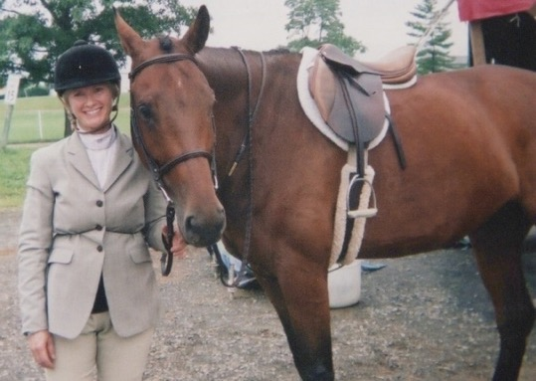
Ms. Cornelia Rutledge

Paradise Island
We all went to catch the boat from Nassau to Paradise Island. There at the ashram, Ms. Cornelia Rutledge introduced me to a young man from Saratoga, New York, who knew of the Faith and had a copy of Gleanings. He asked questions about the concept of justice in the Faith and the agreement of science and religion which I answered. We got to know other participants in the ashram such as several Israelis who had seen the Shrines on Mt. Carmel. I also met Cornelia’s grandmother, who was eighty years of age. We all sat for a lovely dinner with which I broke my fast and for which I had brought my homemade Persian rice which everybody enjoyed. After dinner there was a meditation session. Music was played. I was impressed by the spirituality and wondered how these people could be moved towards the Faith. Cornelia invited me to say a few words. I told them I was impressed by the prayerful atmosphere they had created and hoped that the fruit of this meditation would be that they would go forth and serve their communities. I said that I had seen Baha’u’llah’s teachings change many hearts. If they agreed with some of the teachings, they should study further when they get back to their homes. Afterwards, several people came up to speak with me to tell me with their eyes full of tears that they had been moved and would seek to learn more about the Faith back home. In a happy and uplifted mood, Mrs. Ward, Ms. Jenny Diamond, her two children, and myself left and took the boat back to Nassau.
Speech at the Lyfor Cay School
The next morning, Ms. Beryl McSweeney’s friend, Ms. Winnifred Sweeting came to take me to speak to the students at the Lyfor Cay School which was in a wealthy area. When I entered the classroom, the students stood and said, “Good morning, Ms. Shamsi.” The teachers wanted to dismiss the younger students, but I said they could stay. Then I started to conduct my Baha’i children’s class. I asked the students about prayer. To whom should we pray? “Moses…Jesus…Muhammad...” What should we ask for in prayer? “To become a better person.” I praised each child who answered. “Who is God?” I asked. This question was much more difficult, and the students were silent. Finally, an eight-year-old answered, “Jesus, the Father,” and I complimented him for his confidence in answering the question. One student was Muslim, so I asked, “Who was the prophet of the Muslims?” A teacher helped them by saying, “Moooo…”, and then a student said, “Muhammad!” I told the students to clap for the girl who had answered, and they did. They did not know about other prophets, so I had them repeat the names several times, and then I took out my chart on progressive revelation and went over the names. We finished with singing. I taught them the songs “God is One” and “Good neighbors come in all colors,” while a teacher went and got a guitar to accompany us. I encouraged them to sing, “Good neighbors come in all colors,” in all their classes:
“Chorus:
Good neighbors come in all colors,
Black, red, yellow and tan.
Our outsides may look different,
But we belong to the family of man.
1. When my doorbell starts to ring, I can’t see the ringer’s skin.
Even if he has bright blue skin, I would welcome him right in.
2. When my neighbor starts to cry, it hurts him and so am I
Even if he has black blue eyes, it hurts him when he cries.
3. When my neighbor wants to share joy and happiness everywhere,
Even if he has purple hair, I wouldn’t even care.”
To close, the students sang the school song for me. After the students said goodbye and left for their classes, I spoke directly with a group of teachers, and they thanked me for my good will.
Declaration of Ms. Sweeting
Then we went to the home of Ms. Winnifred Sweeting who had taken us to the school. She and her husband were not Baha’is. I invited her to say some prayers together. After we were finished, I asked her about becoming Baha’i and gave declaration cards to her and her husband. He said he was leaving for England where he would be studying, and I told him he could look up the Baha’is there to learn more about the Faith. I asked him if he had any objections to his wife declaring, and she smiled. She told me she had dreamt about the Baha’i Center. When she came to the Center later, she signed her declaration card. I telephoned Ms. Beryl McSweeney and other Baha’is to give them the good news, and they were very happy.

Talk at St. Augustine College
On March 6th, we went to ZNS radio to see if we could schedule an interview and though Mr. Carl Bettel was not there, Mr. Kurt Smith was, and he said we could schedule one for a future date. I invited him to the public meeting at the Center on the 18th, and he said he would come to see me at the Center on the 14th or 15th to learn more about the Faith. Later that morning, we went to St. Augustine College, a girls’ school, where our friend Mrs. Slatter, who was President of the Pilot’s Club, taught. The students all stood up when I entered the classroom. I thanked them and asked them to be seated. They introduced me and invited me to say a few words. I told them that my talk to them would be on “Love and Marriage.” One girl said, “Life and Sex,” and the other girls laughed. Mr. Henry Wigfall volunteered to leave the room, and everyone laughed again. I spoke to them frankly about sex and pregnancy based on my professional experience in my maternity hospital in Trinidad and Tobago. Baha’u’llah said in the Hidden Words: “Love Me, that I may love thee. If thou lovest Me not, My love can in no wise reach thee.” After giving some more examples on this topic, Mrs. Slatter, the teacher, thanked me very much as this was a popular subject to speak about—to love God is to obey His Teachings and commandments, and ‘chastity’ is one of the most valuable moral teachings to which we should be paying attention.
Talk about different Baha’i principles
The next morning, Mrs. Winnifred Sweeting came to the Baha’i Center. She said that Ms. Cornelia Rutledge had spent the night there and deepened her understanding of the Faith using the excellent book On Becoming a Baha’i. My first activity of the day was to speak at the Rotary Club meeting at the Atlantis Hotel. Mr. Glenn Lissner took me to the hotel where I met Mr. Jim Roberts, the Club President. He took me into the dining room which was decorated with the flags of other Rotarian Clubs, and he hung up my charts. I excused myself from eating because it was the fasting period. There were seventy people including guests from Germany, Austria, Canada, and the United States. I prayed in my heart for God’s Guidance during my talk. They introduced me and after thanking them for the invitation, I began my talk about the “Purpose of Creation,” and this led into progressive revelation. I spoke about Muhammad and his teachings, and how he united many of the Arab tribes. I said that as you are educated and accomplished individuals, you should know about this new Faith and its harmonious principles and gradually spread them as you can. A Greek man stood up and said that “although our ancestors were enemies in the ancient world, today, you have brought peace by speaking so well about the other Faiths which all come from one God.” Several attendees, including a Muslim and a Hindu, came up to me and said that they were moved by the conviction with which I spoke. Before leaving, I invited Mr. Roberts to our public meeting.
At dawn, the next morning, Mrs. Ward and I were driven by Mr. Gadwill Newton to the airport where I ran into a woman from the ashram. She had phoned the Baha’i Center, and Cornelia Rutledge had told her that I was at the airport. When she saw me at the airport, she told me that she had been interested by my talk at the ashram and wanted to learn more about the Faith. She was on her way back to Colorado, and I did not have any material with me, so I encouraged her to look up the Baha’is there and continue her search.
Reply to several questions
We had several international Baha’i guests at the Center that afternoon including Dr. Elsie Austin, the distinguished lawyer and former member of the National Spiritual Assembly of the Baha’is of the United States. Mrs. Rosemary Bailey brought several of her guests, one of whom had been to Iran and had a negative impression of the status of women. I explained that this was why Baha’u’llah came from that country. She was puzzled as to why Baha’u’llah had been rejected by the Persians while he had such progressive teachings and principles. I asked them which of the prophets were not rejected by the people of their countries. Some were tortured, some were martyred, and some were exiled from one country to another. All prophets were rejected in their homeland. Their early believers suffered, and many were martyred but gradually people read more, listened more, understood more, and accepted more. Another guest was an English woman who worked as a nurse and knew the head of nursing in Cyprus, so we had much in common to talk about. The last guest seemed genuinely interested in the Faith, so I invited her to my upcoming presentation at the Toastmaster’s Club.
Our lawyer Mr. Horton still not convinced
Mr. Michael Horton and his wife and their child came to the evening fireside. He began asking the same questions as he always did which his wife promptly pointed out to him. I reminded him that he must read the books he had. He agreed with the principles, but he had no time to study more deeply. I told him that his wife was waiting for him to declare so they could both do it together. He said he needed to study more deeply because he could not accept anything unless he knew it 100%. They said that on their next visit, they would pick up Baha’u’llah and the New Era.
Procedures about the election of the first NSA of the Bahamas
I spent the next day with Mrs. Rosemary Bailey going over procedures and logistics for the coming election of the first National Spiritual Assembly of the Bahamas. We spoke with Mr. Glenford Mitchell, the Secretary of the National Spiritual Assembly of the United States and later a member of the Universal House of Justice, on the phone. Very soon, the local Baha’is would take over these tasks but as of now, we needed each other’s help and advice. They were very supportive of my efforts on their behalf. Thanks to Ms. Beryl McSweeney, I was able to do some teaching that day when she took me to a school to speak.
Dr. Elsie Austin and I prayed intensely the next morning for Mr. Michael Horton. I went to see him in his office, and we talked from 2-4 p.m., but he asked the same questions as always. He said he needed more time but that he would come to the Center later. I was having a few Greek and Turkish guests over that night for dinner, so I went shopping.
Mr. Stephen and Mrs. Maria Antonas, Ms. Elpiniki and her two small children, and Mr. Mignon, the owner of a guest house in town, all came over. Mrs. Maria Antonas brought delicious homemade halva. Her husband was Turkish and had converted to Christianity. I spoke with him in Turkish. We spoke about religion, and he began belittling the station of Muhammad. I gently corrected his objections to Muhammad. An elderly guest was listening to us and agreed with my statements. Mrs. Antonas appreciated my comments and told me that knowing about the Baha’i Faith had opened her mind. She invited me to their home on the 12th of the month when their daughter was having many guests, mostly Greeks and Turks, including our friend in the immigration office, Mr. Plakaris.
A group of us—Mr. Lissner, Ms. Rutledge, Mrs. Bailey, and Ms. Austin—were sitting at the Baha’i Center the next day and talking together. They showed me a journal signed for me by the participants in the yoga ashram. Two of the recent new declarants had not been confirmed and tomorrow, we would be electing delegates to the National Convention. For the seekers who were hesitant, we could appoint someone to study On Becoming a Baha’i with them. I said that we must accept new believers immediately and not put barriers in their way. They could be enrolled, and the deepening continued. Cornelia and Rosemary wanted to understand The Seven Valleys and the Four Valleys better and asked for deepening. I explained each of the valleys which comprised the journey of the soul more easily according to our understanding which satisfied them.
Talk at the Toastmasters Club
That evening, I gave a talk at the Toastmasters Club. I was welcomed by Dr. Devaux and introduced by Mr. Henry Wigfall. I hung up my charts and began with a brief explanation of the Baha’i Faith and then spoke about compulsory education. Several of the audience members objected to seeing Jesus listed next to other prophets, saying that Jesus would return to judge the wicked and the good, and that he would cast the wicked into Hell and the good would be saved and attain everlasting life and the Kingdom of God. Another person said that everything I was telling them was very nice but seemed to be a utopia. I pointed out that Jesus had prophesied the coming of the Kingdom of God which−if we understood it correctly−, was a Kingdom but as people had not understood the teaching correctly, it was a utopia. The questions continued until we had to finish because of the lateness of the hour. Several people came up to me to tell me that this was the first time they had ever heard of the Faith. Dr. Deveaux told me privately that he was personally dissatisfied with other religions and liked what he heard about the Baha’i Faith and would investigate it later again.
Convention to elect the delegates
The following day, March 12th, we held our meeting to elect delegates to the National Convention. Ms. Beryl McSweeney’s son and I went to gather the Baha’is using a list of addresses. Once the meeting began, I went over the procedures for the elections, and Dr. Austin, Mr. Brian Smith, and Mr. Henry Wigfall were tellers. The delegates elected were Mr. Henry Wigfall, Mr. Brian Smith, and Ms. Beryl McSweeney.
In the evening, Mr. and Mrs. Antonas brought me and Mrs. Ward to the home of Ms. Elpiniki for a dinner in my honor. I was asked about the progress of the Baha’i activities. I said that I was giving talks, in schools, clubs, and various meetings, and showed them letters of appreciation from the Kiwanis and the JC’s. I also spoke about the Baha’i teachings and showed the photos of my travels.
Talk at the Toastmasters Club
Mr. Henry Wigfall took me the next night to the Toastmasters’ Club that met at the Ambassador Beach Hotel. There were twenty-five people in attendance including Mr. Christie, the brother of the Minister of Health. Mr. Gregory Hamilton chaired the meeting. I hung up the charts and spoke from them about the Baha’i teachings. Many in the audience agreed already with the principles of the Faith including Mr. Christie. There were questions about Heaven and Hell, prophecy, the stature of the different prophets, and the nature of God. I replied to each question using the explanations in the Baha’i Writings. At the end, I was presented with a letter of appreciation. I was asked for books about the Faith, and one attendee wanted to invite me to his Toastmasters Club, Bahama Blenders, on John F. Kennedy Drive. Mr. Anthony Gibson came up to me and said he had many more questions because he had studied many religions, but none satisfied him, so I invited him to join us at the Baha’i Center.
William, a young seeker, and a young girl from the ashram came to the Center the next day and spoke with me and Mr. Jim Wanders, Ms. Cornelia Rutledge, and Mrs. Ann Reed, about the Faith for four hours. William promised he would declare when he returned to his home in the United States. I also encouraged Cornelia to continue her service to the Faith when she returned to the U.S.
Arrival of Mr. Glenford Mitchell
Mr. Glenford Mitchell arrived in the Bahamas on March 15th. On our way to pick him up at the airport, Mr. Lissner’s car broke down. A young man who worked for Lufthansa helped us. I asked him if he had ever been to the Baha’i House of Worship in Germany. He answered that he knew nothing about it or the Faith. I showed him a booklet with a photo of the temple in it and explained the Faith a little to him and invited him to the Lissners if he wanted to learn more.
After we brought Mr. Mitchell to the Baha’i Center, he spoke to us about the goals and progress of the Cause. In the United States there was a goal of 400 new local assemblies. He said the Faith was growing rapidly in Jamaica with more than sixty new declarants, many of whom came during the time when I was travel teaching there.
Mr. and Mrs. Horton and their child came to the Center that evening for the fireside. This time he began to ask questions on the authority of Shoghi Effendi and why some people had rejected him. Right away I knew he had read materials from Covenant-breakers. I told him that he would not find his answers by reading misleading sources. He had been to the National Library and taken out The Divine Art of Living and Baha’u’llah and the New Era as well. Mr. Horton asked why there were no sects in the Faith since they existed in all other religions. I explained that Baha’u’llah and ‘Abdu’l-Baha had written Wills and Testaments and appointed a successor after themselves thereby safeguarding the unity of the Faith. He reiterated the point that he felt he needed to understand the Faith well before accepting it and asked for patience. He said that he had first heard of the Faith from a talk by Dr. Elsie Austin to a group of lawyers in which she said that she had always been ready to challenge and make arguments until she asked herself whether she was coming to Baha’i meetings to argue or to discover the truth. As a result, she decided to inquire from the bottom of her heart, and gradually she was convinced. During our conversation, Mr. Glenford Mitchell arrived and joined our discussion. He said that Mr. Horton should investigate the Faith freely and try to coordinate what his heart was telling him with what his mind could accept. I added that Mr. Horton should be very happy to declare his faith in the presence of Mr. Glenford Mitchell. Mr. Mitchell was quick to say, “Yes, this is Shamsi,” and we all burst out in laughter. Mrs. Horton had become tired and was sitting in the car with her child. I told her she did not have to wait for her husband to declare. If she was ready, she could join us. She said nothing but laughed. Mr. Horton asked for prayers, and he added, “I believe in your prayers.”
The Faith was still on Mr. Horton’s mind the following morning, March 16th, because he phoned me at the Center, and we spoke for three quarters of an hour. He wanted to assure me of the sincerity of his interest in the Faith. He was not asking as many questions as usual as he wanted to show that he was not rejecting the Faith anymore.
That day, I was taken to the Toastmasters’ Club at Bahama Benders. After being introduced, I spoke about the Faith using my charts, followed by questions. Mr. Gregory Hamilton gave me a letter of appreciation on behalf of the club “in recognition of outstanding support of the Toastmasters International communication and leadership program.” I suggested to him that he invite the presidents of each of the Toastmasters’ clubs to come to our public meeting at the Baha’i Center.
Back at the Baha’i Center, Mr. Glenford Mitchell was again speaking with Mr. Michael Horton and comparing the Faith to a university in which his education would never be finished. I made sure to invite Mr. Mitchell to our public meeting on March 18th before he left. In the evening, we broke fast together followed by Dr. Elsie Austin showing us her slides.
Dr. Austin was planning on settling in the Bahamas as a pioneer so the next day I went with her to look at some possible homes. I prepared the Center as well for our public meeting the next evening and called guests to remind them of it. In the afternoon, I met with the Teaching Committee of the Bahamas, and they thanked me for all that I had done, and we consulted on further activities. The committee wanted me to go and reconstitute an Assembly in a town which was ten minutes from Freeport. This would be the crown jewel of my service in the Bahamas. Mr. Jim Wanders assured the committee that I would know how to encourage the Baha’is to be more engaged.
The next day, March 18th, was spent preparing for the public meeting. We cooked a lot of food and had a bountiful buffet ready by evening. Mr. Plakaris, the immigration officer, and his wife, Mr. Horton and his wife, Mr. Gregory Hamilton, and many others came. Mr. Horton was speaking with one youth about the Faith and said to me that this young man was already a Baha’i but didn’t know it. The Plakarises were delighted with the evening. Mr. Plakaris announced that people came to him with immigration problems but now Shamsi would have an immigration problem as well because they would not let her leave. Mr. Horton promised to visit again before I left. I showed him passages from a book by E.G. Browne about the persecution of Baha’is in Persia over which I had wept the previous day and told him that I would say prayers for him.
Declaration of Mr. Michael Horton and his wife, Boguslawa
I got up the morning of March 19th and packed my luggage with Cornelia’s help. A few people came over to the Center for morning prayers. At 4 p.m., Mr. Brian Smith came over. He greeted me and said that the local assembly wanted to meet with me. I dressed properly and went into the meeting room. Brian spoke on the Assembly’s behalf and thanked me for all that I had done for the Faith during my visit. He specially thanked me on behalf of himself and his wife for guiding them towards the Baha’i Faith. He said that “If it was not because of you I do not know where I would have been today!” I thanked him for his spirit and his many good qualities and understanding and wished him great success in his endeavors. Then we all took a few photos together.
Mr. Horton and his wife came over. We had some prayers to break the fast and sat down for a small dinner. I said a prayer for the possible declaration of these two seekers, and we celebrated the Baha’i New Year with great joy. Mrs. Horton asked that Mr. Glenford Mitchell had said that Baha’u’llah had prescribed capital punishment for the murderer and wondered if this was accurate. I replied that if the Prophet of God has brought this Law, it should be obeyed because it was the command of God. There was the law of capital punishment in some countries which then repealed it. Then those countries saw that crime got worse, so they’ve re-applied the death penalty. Therefore, we must see what else Baha’u’llah has written about His law. If a judge or person in authority decides that leniency is preferable, then he would issue a lenient sentence. God created humanity through love. The Prophet Muhammad said that God said, “I was a Hidden Gem, I wanted to be known, therefore I created Thee as to be known.” Another cause for leniency is that the Baha’i Faith is a faith of love, unity, compassion, and a preference for others over oneself. Therefore, in the future we will have more unity in diversity, and people will be more kind to one another.
After further discussion, Mr. Horton said:
“Shamsi, in so far as I understand, I am satisfied, and I and my wife are ready to declare and enroll in the Baha’i Faith. Although there is much we still have to learn, we now know the essentials and can willingly accept the Faith so please bring a declaration card to be signed.”
Mrs. Ward and I got up and embraced them joyfully and welcomed them to our community. They signed the cards and handed them to us. We took photos together. I told everyone that I would be leaving tomorrow but would pass by the house to say goodbye. We were all very happy. The Hortons left, and those of us who stayed gave prayers of thanks to Baha’u’llah for the Bounty He had given us. I waited for the Lissners to come by and then gave them the declaration cards to take to the Assembly which they received with great happiness. They thanked me for all my help during this visit as well as my time in Jamaica to which my reply was, “This was a great honor for me to be here and work with you all.”
My travel-teaching trip to Freeport town
I received instructions from the Assembly the next morning through Mrs. Rosemary Bailey and Mr. Henry Wigfall who gave me a letter asking me to help in the formation of an assembly in a town near Freeport along with a letter of appreciation. On the way to the airport, we stopped by the office of Ms. Jenny Diamond to say goodbye. I taped a short interview with her. Then we stopped at the office of Mr. Horton where his wife was also waiting for us. I interviewed them as well, and we embraced. At the airport, Ms. Cornelia Rutledge had tears in her eyes, and I promised to pray for everyone when I arrived in the Holy Land. Before departing, I prepared a telegram to send to Haifa detailing the many successes in the Bahamas:
“BAHAI HAIFA ISRAEL Lt. Happy Naw-Ruz
Arrival Nassau received your most loving cable overjoyed assuring victories Beloved Faith BAHAMAS guided BTCB, LSAs, New Providence, Eleuthera commenced lecturing clubs, Red cross, public meetings, luncheons, Prominent citizens, press conference, resulting enrollment 11 natives including press reporter Jenny Diamond, attorney at law Michael Horton and wife, selected accounts manager Brian Smith who filled vacancy LSA Nassau. Just arrived Freeport Implore further prayers success assigned task
Deepest love Shamsi”
By the time I landed in Freeport, I was tired. Unfortunately, the plane had been delayed so there was no one there to meet me. The weather had turned cold, and there were no taxis. I made several attempts to contact local Baha’is, and I asked around to see if anyone knew them. After a good deal of effort and time, I was able to find a taxi and get to the house of Mrs. Ann Reed where Baha’is had gathered for Naw-Ruz. I played the tapes of Ms. Jenny Diamond and the Hortons talking about their declaration, and they were delighted to hear of the declaration of the first Bahamian lawyer. The friends there all promised to assist with the teaching work in and around Freeport. While Ann Reed read the fasting prayer, I prayed for assistance in making this teaching trip successful. I would be staying for twenty days in the home of Mrs. Ann Reed, a pioneer from England who had been a Baha’i for six years and was seventy-years old and completely dedicated to the Faith. Her daughter Patricia was married to Mr. Gadwill Newton. She was the Secretary of the Spiritual Assembly of Freeport of which Mrs. Reed was also a member, and all three were very active Baha’is.
March 21st, Baha’i New Year
The first day of the Baha’i New Year, March 21st, began with an invitation to speak at noon to the Kiwanis Club. The club’s president Mr. James Roberts greeted me at the hotel and then introduced me after the national anthem had been sung. Some members knew of me because my biography had been printed in the club’s newsletter. I prayed to myself before getting up, and then I spoke for forty minutes on the principles of the Faith using my charts beginning with an explanation of the Baha’i New Year, the spring vernal equinox. I also told them about my professional experience and gave them practical advice. Instead of sending funds to charities to provide medical care, I suggested that American doctors come to the Bahamas and treat people and train doctors as a service and to ask airlines to provide them with free transportation for this purpose. This act of generosity by the American doctors would also benefit them spiritually. I finished by reading a prayer from ‘Abdu’l-Baha about service as worship. The audience of sixty people of different backgrounds greatly appreciated these words. Mr. Lesley Burrow, who was in charge of the spiritual work of the Kiwanis, thanked me. He was a Catholic priest and had been dismissed from his church because his preaching was contrary to the Church’s teaching. He said that my talk had awakened him. He had an appointment to go to but had become so interested in what I was saying that he did not go. An American who had been seated next to me asked me for a booklet and my card and an address where he could meet Baha’is in Florida. He was the President of a Kiwanis Club in his town, and I recommended that he contact the Baha’is there for a speaker. Many Bahamians came up to me to express their gratitude for my words. Mrs. Newtown told me afterwards that she had been praying for me the whole time.
Afterwards, Mrs. Ann Reed and I made some home visits and went to the newspaper to see a reporter, Mr. Richardson Campbell. While he did not have time to give me an interview then, he promised to come to my talk at the Rotary Club the next day.
Then we went to Hawksbill High School where Mr. Keva Cartwright, a member of the Freeport Spiritual Assembly, and Mrs. J. Ferguson, the chairperson of the science department and a new Baha’i, were teachers. I spoke to a combined class of 11th grade students and five teachers. I put up my charts and spoke about the Faith and its principles. The students asked about Christ, the Resurrection, the Trinity, and the multiplicity of religions which I replied to all. After one and a half hours, I taught them the song “Neighbors come in all colors,” and then they were dismissed to class. The students were so interested that the talk ran over, and they were late for their classes. Once the students left, I spoke with the teachers for a while. I thanked the principal and invited him to our upcoming Baha’i meetings which he accepted.
Radio interview
From the high school, we went to the radio station where Mr. Lionel Dorset, the news director, interviewed me. He said people knew nothing about the Faith so the whole half hour interview was an in-depth introduction to the Baha’i Faith. I also invited him to our future Baha’i meetings. I listened to the interview broadcast at 6 p.m. Mr. Dorset announced on it that I would be in the Bahamas for two weeks.
Mr. Cartwright and I and several of the friends then went to visit a dressmaker from Haiti whom he knew. We ran into some friends of his outside the dressmaker’s shop and as we spoke, they became interested in hearing more about the Faith. So instead of continuing our home visits, we stayed and spoke with them. When the conversation was finished, we went to visit others and invited them to our public meeting.

A very nice fireside
The next day, many people gathered in the home of Mrs. Ann Reed to hear about the Faith. Two of the young men whom we had met near the dressmakers came. Mrs. Mary Alter who had lost a daughter three years earlier was there. While grieving, she had a dream in which she saw a heaven where everyone was carrying a lighted candle except her daughter, and she asked her why hers was not lit. Her daughter answered that it was because she saw her mother always crying. After Ms. Alter woke up, she decided to change. She was also reading a book which told her that she must leave old groups and join a new one as a part of the change in her life. At this point, she met Mrs. Pat Newton who told her about the Faith. Now, that she had heard my explanation about the Faith, she was ready to accept it. The two young men and Mr. Sanders Hychiel also wanted to declare. We were all overjoyed and embraced and took a photo together.
Speech at Rotary Club
The next day, I spoke at the Rotary Club lunch meeting at the Charter House Hotel. Mr. Ed Granger, the President of the Club, told me that some members may not like having someone speak about religion, so I told him that I would speak about the role of youth in society, compulsory education, and other such topics. At the meeting I was introduced by the chairman, Father Foster Pistain, and I spoke for about thirty minutes to an audience of about eighty people. At the end, I was presented with the Rotary Club’s banner, and I thanked the chairman, saying that even though he was a priest, he had shown no prejudice towards me, someone of another religion. He smiled as he had a good sense of humor. Among the people who came up to me was a Mormon who told me that Jesus was the only way to salvation. One of the employees in the hotel asked for a book on the Faith which I gave him.
Speech at the Kiwanis Eight Rock Club
At 7 p.m., I was at the dinner meeting of the Kiwanis Eight Rock Club. Mr. Bertram Pinder was the President. I was asked to speak about the role of youth in society but asked if I could first give some background about the Faith and myself which I did using my charts. Then I spoke about youth and how they should prepare themselves to serve mankind. One person asked me about my experience in Africa and another asked me why I played music at the beginning of my radio spots and interviews to which I answered that music attracted youth to listen. When the questions were over, Mr. Pinder presented me with a letter of appreciation from the Club.

Useful talks at the tailor’s shop
The next morning, we made teaching plans for the town of Pinder’s Point, and then I returned to the tailor shop where we had met the young men a few days ago. There was a new group of young men from Haiti standing outside, and again we engaged in a fruitful conversation about the Faith. The shop owner asked me many questions to which I replied. He warmed up to me and asked me to return on Sunday to give a talk in front of his shop, but it would have to be after he returned from church. One person disagreed with him about going to church saying there was little spirit left in the church. I diffused the disagreement by saying that one could grow close to God in a church, but one could also get nothing out of it. Finally, we agreed for me to come back on Sunday after 10 a.m. and speak about the Faith.
Attended Nineteen-Day Feast
We gathered for the Nineteen-Day Feast that evening and consulted about teaching in Pinder’s Point. I was going to spend all day there and invited others to join me. I said that Haitian people there seemed very receptive. We also consulted about what kind of programming we should have on the radio. Mrs. Alter came and said that she was returning to Toronto as a Baha’i, and her Baha’i friends there were going to be very surprised. All the friends clapped for her. She invited me to come see her in Toronto, and I gave her my calling card.

Election of the local Spiritual Assembly of Pinders Point
On March 25th, I went to the town of Pinder’s Point to gather the Baha’is and facilitate the election of their spiritual assembly. On my way, I listened to the program about the Faith with Mr. Jeff Reynolds broadcast over the radio in Freeport. He gave out contact information about the Faith for people who wanted to learn more. Once in Pinder’s Point, I went to the home of Mrs. Grant. At 2 p.m., the friends gathered for the election, including Mr. Charles Thompson and Sylvia, his wife, Mrs. Barbara Charles, and Mr. Clement Roxbury. After prayers, I explained the role and functions of the assembly, and the process of electing an assembly and its officers. The election proceeded, and I wrote the report of the results to the National Spiritual Assembly of the United States. Finally, we arranged for the assembly to meet again at the home of the Grants on April 9th, and to hold the next Nineteen-Day Feast at the home of the Roxburys and Sunday school at the home of Ms. Sylvia Theresa at 10 a.m. Thanks to God, one more LSA (i.e. Pinder’s Point was elected today).
Mrs. Newton drove me back out to Pinder’s Point the following morning, March 26th. On our way out, we stopped at the home of Mr. Jones. He was not in, but his wife and their eight children were there. We visited with her for a long time. I told her about the Baha’i teaching, and we talked about aspects of raising children. We gathered the children around and sang songs together. I gave a short children’s class, asking the children about God and prayer. Mrs. Smith thanked us and expressed her love for the teachings. She said she felt at home with us, and I said that, God willing, she would join us. I told her that if she did, she could train them according to the Baha’i teachings. She said that she felt she was already one of us. I gave her a declaration card and told her I would come back the next day and help her with a children’s class.
At 2 p.m. the next afternoon, March 27th, Mr. Preston Strachan, Mr. and Mrs. Sanders Hychiel, Mrs. Ann Reed, and Tanya, the five-year old daughter of Mr. and Mrs. Gadwill Newton, and myself all went out teaching. We arrived at the house of Mrs. Smith and gathered the children together. Mr. and Mrs. Hychiel began teaching them while Mrs. Reed, Mrs. Smith, and I went to visit the neighbors’ homes and spoke a bit about the Faith and invited them over to Mrs. Smith’s house to hear more and see slides. Mrs. Smith testified to each neighbor that she had only just heard about the Faith but liked it very much and wanted them to hear more about it. She said the Faith had changed her. We gathered with the neighbors and showed them two films about the Faith. We decided we would come back and hold a meeting for adults and another for children simultaneously.
The next morning, March 28th, the son of Mr. and Mrs. Gadwill Newton came up to me with his hands behind his back. I knew he was hiding something. When he brought his hands around, he had a cable from the Universal House of Justice for me. I was trembling with anticipation. I went into my room and faced the Qiblih and kissed the copy of the cable. I opened it and read that my humble services were appreciated and that the Supreme Body was praying for me and assuring me of success in these teaching activities. Cable is as follows:
“COMMEND MERITORIOUS SERVICES ASSURE PRAYERS CONTINUED SUCCESS
UNIVERSAL HOUSE OF JUSTICE”
I came out of the room with tears in my eyes and read the text to the assembled friends. I said that we must work ceaselessly in teaching through public meetings, firesides, children’s classes, youth gatherings, and the media, because we were assured of success as the Supreme Body was praying for us. They unanimously agreed.
Series of talks at the clubs
Mrs. Ann Reed phoned Baha’is in the area to come to a teaching meeting, and I made plans for my talks at the Toastmasters Clubs. Ms. Joan Hill and Mr. Taylor, the Vice-President of the Toastmasters, asked me to do an interview and pose for photographs for the talks I would be giving at their clubs. The first of these talks was given at the Charter House. I was taken there by Mr. Gadwill Newton. We hung up my charts, and I was introduced to the club members. A bell rang summoning us to dinner. The meeting started with a toast to Queen Elizabeth followed by the formal lunch. I chatted with Mr. Dennins about my travels around the world. He introduced me to the audience. I spoke for forty minutes about the major prophets, the Baha’i Faith, and its uniting principles. I encouraged them to serve the downtrodden, the afflicted, the poor, and the uneducated. They nodded to each other in agreement. At the conclusion of the meeting, I was thanked profusely and presented with the Club’s flag which the club members signed.
Talk at Toastmistresses’ club
The next Toastmistresses meeting (participants were ladies) was held at the Princess Hotel. A reporter and photographer from the Freeport News were there. The meeting was opened by the chairperson, Ms. Lina Shepperd, and then the National Anthem was sung followed by members participating in the Table Topics section when they were expected to speak briefly and concisely on random topics prepared in advance by the chairperson. After a break, I was introduced and thanked everyone for coming out in the inclement weather and for the chairperson’s dignified bearing by which I knew her immediately to be the chairperson, a comment which made everyone smile in agreement. I spoke briefly about myself and my travels around the world and then launched into my main topic, the equality of men and women. I also talked about the importance of rearing children from the earliest age in good manners, love, and humility. A well-trained child without education was far preferable to an educated child with poor manners and morals. I encouraged them to hold ladies’ meetings in different villages and towns to educate women and teach children important principles to help improve their lives. After the talk, Mrs. Shepperd and the secretary, Mrs. Hill, thanked me, and we all took photographs together, and the photographer expressed an interest in coming to our Baha’i meetings.
Meeting at Mrs. Reed’s home and at Toastmasters
The morning after these talks, March 29th, Mr. James Thompson, a Christian friend of Mrs. Ann Reed, came over to ask questions about the Faith. Before leaving, he said he would return for our meeting. At the evening meeting, several guests expressed their skepticism regarding religions. Mr. Leslie Burrows was the Catholic priest whom I had met at the Rotary Club. He had clashed with the Bishop in his parish over Church teaching. He had a work engagement scheduled for the same time as my talk at the Rotary Club but once he heard the ideas I was expressing, he decided to forgo his work to stay and hear the rest of my talk. I asked another guest, Mr. Jeno Benini, an Italian man, who had been silent until then, what he thought of the questions on religion that we were discussing, and he said that he had been like the priest but had found his own spiritual path that he discovered was similar to the Baha’i Faith which he is why he had come that evening. I said that he was welcome to join us and that we loved him and that one day he would understand why he had been guided here this evening. This moved him, and he got up and embraced me.
I went to British Airways to work on my ticket and luggage for my trip to London and then the International Convention in Haifa. I brought my official letter stating that I was an international lecturer but there were still some problems, so I was taken to see the director. When I walked into his office, I saw that it was Mr. Cartwright whom I had met at the Rotary Club. He greeted me warmly, and I explained my travel plans. He said he would be there at the airport the day of my departure and make sure that everything went well.
I had lunch with Mrs. Ann Reed’s neighbor, Ms. Rose Copeland, who was originally from Austria. She had been to a Baha’i meeting and had enjoyed my talk there. She was interested in learning more about the Faith. Lunch was followed by a children’s class at Ms. Ann’s house during which we showed footage of the Baha’i children in Trinidad which the children enjoyed seeing.
Talk about the importance of the education of women and children
That evening I spoke at another Toastmasters Club meeting at the Princess Hotel (this time it was the men’s club). There were thirty members and five guests. Mr. Shine opened the meeting with a prayer, followed by the National Anthem. The President of Toastmasters, Mr. Godfrey Knowles, said a few words of welcome. Then Mr. Donald MacCarthy, the Vice-President for Education, read out the questions for the Table Topics which included the status of youth in society and the status of women in society. Members answered that men must be educated to change their views about women, that a women’s political party was necessary, that women should forget the idea that they are second-class citizens and stand up for themselves, and that we should forget trying to change the adults and concentrate on educating children. I put my hand on the shoulder of the chairperson and said that I did not agree with these views, and he smiled. I asserted that if women were educated, change would happen organically. Behaviors such as smoking, drinking, and having children out of wedlock which caused many women to stay in poverty, would change. After a break, the chairperson gave me a lengthy and enthusiastic introduction. I began my talk with a humorous story about a man who was invited to come up and speak, and he asked if the audience members knew what he wanted to say; they said no, and he said that he could not speak with an audience that did not know anything. He was invited up a second time and asked the audience members if they knew what he wanted to say so they said yes, and he said, that, in that case, he didn’t have to say anything because they already knew everything. When he was invited up a third time, he asked the audience members if they knew what he wanted to say. By this time,
some answered yes and some, no. So, he said, those of you who know explain to those who don’t! I told the Toastmasters Club members that I knew they were all very knowledgeable, so I would only add a little bit. I spoke about progressive revelation and the twelve principles using my charts. I read passages from ‘Abdu’l-Baha on the equality of men and women from Paris Talks such as:

“Women have equal rights with men upon earth; in religion and society they are a very important element. As long as women are prevented from attaining their highest possibilities, so long will men be unable to achieve the greatness which might be theirs.”

I also read passages from the Master about the harm of cigarettes and alcohol. When I finished my remarks, the chairperson asked the audience members if they had enjoyed my talk, and they all applauded and nodded their approval.
The President thanked me and presented me with a plaque of appreciation. One by one the audience members came up to me to express their gratitude for my words. One said he was struck by the principle of the independent investigation of truth and another, Mr. Pat Baine—who was a disc jockey—wanted me to come again so I told him I had been to the Bahamas before therefore now it was his turn to come to Trinidad; the next day, this disc jockey played a recording of “Have you heard of Baha’u’llah?” on his radio show. I asked Mrs. Ann Reed to invite everyone to her home for her Baha’i meeting on Wednesday night which she did. We gave pamphlets to those individuals who seemed interested. I suggested to Mr. Shine that men’s and ladies’ (Toastmasters and Toastmistresses) hold joint meetings which he said was a good idea. We all took photographs together before leaving. Mr. Shine and his wife invited me to a gathering on April 7th to celebrate the Trinidadian carnival. Back home, Mrs. Ann Reed and I agreed that this wonderful meeting was due to the cable from the Universal House of Justice who promised to pray for me.
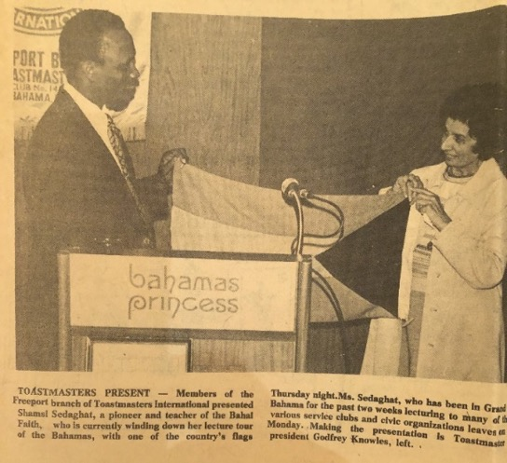

Shamsi being presented with a flag of the Bahamas at the Freeport Toastmasters Club by Gordon Knowles.
Photo in the Freeport News

A thank-you letter
On April 2nd, I received an encouraging letter from one of the newly declared Baha’is from this trip:
“Dear Sister Shamsi,
Allah-u-Abha, today I became a Baha’i. Words cannot express my thanks to you for introducing me to the teachings of Baha’u’llah and Abdu’l-Baha and to the Baha’i Revelation. As you said my life would be changed and it has. Life has now a meaning and a purpose. For me, becoming a Baha’i and accepting its teachings is the most wonderful thing that could ever happen to me. Through these teachings I have for the first time recognized and accepted God and realized that he is, “The Almighty, the Powerful, the all-Glorious and the all-Knowing,” and without Him life is nothing.
Thank-you, your Janet”
Some home visits and two declarations
After two days of running errands and deepening, we went to the community of Lewis Yard to teach. We visited several homes and then came to the home of Mrs. Barbara Charles. I asked her to go and gather local children. She came back after a bit with several children to whom I taught a prayer and songs. We discussed God and the prophets. I asked them to go clean-up and dress well and come back for the adult meeting. When the adults came for the three-p.m. meeting, the children were clean and dressed up and sang the song for the adults. Mr. Gadwill Newton conducted the session. There were four non-Baha’i ladies. I took the children who were restless back to their homes. I re-joined the meeting in progress and after a while, Mrs. Joyce Bootle from Jamaica declared, and we were all very happy and sang songs together. We decided we would get back together next Sunday at four p.m.
Home visits continued
The next day, April 4th, we made home visits inviting people to the fireside and members of the Assembly of Lewis Yard to its meeting. We also went to the laundromat where we met Mrs. Luis Garnell. We spoke with her for a while about the Faith, and, to our delight, she declared. When evening came, we went to the home of the Newtons who were having a dinner. On the way, we picked up two more guests, Mr. Lionel Dorset, and his wife. He was the director of Radio ZNS3. I discovered at the dinner that Mr. Dorset knew the people at Radio 610 in Trinidad and Tobago. He had also been in England for eight years. I encouraged him in his work and expressed the wish that we have Baha’is in radio on each island to make people aware of the Faith. I also hoped we would have a declarant on Freeport radio who could spread the news of the Baha’i Faith and its world-redeeming principles and make Freeport the port of unity where people of all backgrounds could live together as family. Mr. Dorset assured me that I had one such person in him. He agreed to interview me the following day. He said that he greatly enjoyed our dinner and conversation.

Radio interview
Mrs. Pat Newton took me to radio ZN3 the next afternoon after she had very graciously typed my report for the National Spiritual Assembly. Mr. Dorset interviewed me on Baha’i principles such as the equality of men and women and their effects on the world. He said he would broadcast the first half that evening and the second half on Sunday morning. He then walked me over to meet his colleague, Mr. Ferguson, who asked me if I liked the Bahamas. I told him that wherever I travelled, I wanted to meet educated people of capacity rather than swim in the water and lie under the sun (it is good, but I have no time for this). I brought out my charts and explained more about the Faith to him. He thanked me for my explanation. I asked Mr. Dorset—whom I had known for some years—when he would declare as I knew he had already been to many meetings. He smiled and asked for a declaration card. I was so happy; I gave him one. He accepted the declaration card and asked for one more for his wife which brought tears to my eyes. That evening, Baha’is were gathered for the election of the Assembly of Lewis Yard in the home of Mrs. Barbara Charles, including two newly enrolled believers, Mrs. Grant, Mrs. Charles Thompson, a new Baha’i, Mrs. Joyce, and a young Haitian who spoke only Creole. We went over some basics of the Baha’i Faith with the group. Then I left to do some more teaching and deepening in nearby homes while Mrs. Pat Newton continued the meeting with the Assembly members.
A stubborn Christian seeker
On April 5th, I got a call from Mr. James Thompson, a young lawyer who had come before and always brought up Christian questions and who wanted to come over again and hear more about the Baha’i Faith. I told him that he could if he set aside his Christian questions for now and listened to more about the Baha’i Faith. He agreed, and he came over. We spoke together from 10 a.m. to 1 p.m. The whole time he was saying that Baha’u’llah had brought nothing new and that the principles were ineffective because there was still war, prejudice, and poverty in the world. Since he rejected whatever I said, I finally said to him, “Brother, I don’t want to waste our time anymore and I hope the day would come when you understand the answers more deeply.”
An interview with a reporter
Still feeling somewhat discouraged by this, I went to the newspaper and had an interview. The reporter, Mr. Campbell Richardson, asked many questions such as how the Faith had progressed in other countries, had I encountered opposition to the Faith, what did the Faith teach about the Resurrection, and what about the end of the world, as well as social issues such as crime and punishment and family planning. He had to leave but wanted to continue the interview, so he could write a long article. I invited him to our Baha’i meeting, and he hoped to continue our discussions.
That evening Baha’is gathered for a fireside, including Mrs. Smith who had eight children and her husband Paul and Mr. Donald Glass from the Toastmasters Club. I brought out my charts and spoke. One person asked about how we could create more love between each other. Someone else answered that we must first love ourselves and then come to know God through his Manifestation so that we can create unity between people.
A passage on how to create love
I read the following passage of ‘Abdu’l-Baha:
“To be no cause of grief to anyone.
To be kind to all people and to love them with a pure spirit.
Should opposition or injury happen to us, to bear it, to be as kind as ever can be, and through all, to love the people. Should calamity exist in the greatest degree, to rejoice, for these things are the gifts and favors of God.
To be silent concerning the faults of others, to pray for them, and to help them, through kindness, to correct their faults.
To look always at the good and not at the bad. If a man has ten good qualities and one bad one, look at the ten and forget the one. And if a man has ten bad qualities and one good one, to look at the one and forget the ten.
Never to allow ourselves to speak one unkind word about another, even though that other be our enemy.
To do all of our deeds in kindness.
To cut our hearts from ourselves and from the world.
To be humble.
To be servants of each other, and to know that we are less than anyone else.
To be as one soul in many bodies, for the more we love each other, the nearer we shall be to God; but to know that our love, our unity, our obedience must not be by confession, but of reality.
To act with cautiousness and wisdom.
To be truthful.
To be hospitable.
To be reverent.
To be the cause of healing for every sick one,
a comforter for every sorrowful one,
a pleasant water for every thirsty one.
a heavenly table for every hungry one,
a star to every horizon,
a light for every lamp,
a herald to everyone who yearns for the kingdom of God.”
I read it slowly and the participants were moved by the words. I asked that if we did the things that ‘Abdu’l-Baha listed wouldn’t this create love and unity between people? Mr. Glass then asked about science and religion, so I elaborated on this Baha’i teaching. When the questions were finished, I took out several declaration cards and waved them and asked if anyone was ready to sign one. Three out of the five non-Baha’is present wanted to declare: Mr. Paul Smith, Ms. Brenda Sims, and Mr. James Hall. Mr. Glass took a card but said he wanted to read more about the Faith and that I would see him tomorrow at the Toastmasters Club. I said that he had been to the Toastmasters Club and listened to questions and answers for many years and knew about the Faith. People who were ready to accept, I asserted, were ready. So, he signed his declaration card. Mr. Smith said he had seen a great change in his wife since she had accepted the Faith—she seemed radiant and was always speaking about the Faith. They were both very happy. I had a few prayer books and photos of the Temple in Panama which I signed for the new believers. I invited everyone to come to a prayer meeting and dinner at the home of Mrs. Ann Reed, and that soon we may have a new assembly in this area.
The next morning, April 6th, I called Mr. Lionel Dorset from the radio station who had not made it to the evening fireside. We invited them to the Sunday dinner. I asked Mr. Dorset if I could interview him to which he agreed. I phoned Mr. Richardson Campbell at the Freeport newspaper and asked him if I could interview him as well as drop off several books about the Faith. He would be able to finish the article about the Faith, and it would appear in the Monday edition. At 4 p.m., Mr. Gadwill Newton and I went to the radio station to see Mr. Campbell but he was not there so we dropped off a few pamphlets, the book The Reality of Man, and copies of newspapers with articles in them about the Faith.
Mrs. Pat Newton and Shamsi gave a talk at the Toastmasters Club
Late in the afternoon, Mrs. Pat Newton and I consulted on logistics for the upcoming National Convention such as accommodations for delegates. Then we were off to the Toastmasters Club where everyone was happy to see us. I was warmly welcomed with the audience members standing up as I came up to speak. I spoke about using the writings of ‘Abdu’l-Baha as a guide for living our daily lives. When I had concluded my remarks, Mr. Stubb, who had attended our prayer meeting, asked what the difference was between Christ and Baha’u’llah. I replied that there was no difference between them on the spiritual plane and that the differences in their teachings were only due to the differences in capacity of the people of the age in which they taught. They were like teachers in a school each assigned to a different grade. After this answer, the questions regarding Christianity continued: the Resurrection, Baha’u’llah as the return of Christ, as well as questions about the power of the Universal House of Justice and the establishment of universal peace. Answers were given to all of these questions to everyone’s satisfaction. When there were no more questions, the Club’s President presented me with a certificate of appreciation “…in recognition of service to community” and a flag of the island. We posed for photos together and several audience members stayed to continue to ask questions.
Declaration of Mr. Lionel Dorset, Director of Radio ZNS
The next morning, April 7th, I telephoned Mr. Campbell at the paper to see if he had received the book, I had left it with his secretary, and he answered that he had but had been much too busy to read it. We agreed to meet on Sunday so that I could interview him. Then Mrs. Ann Reed and I went to Radio ZNS3 to see Mr. Lionel Dorset. He was very tired but wanted to sign his declaration card; his wife was already there and signed. I took a photo of him with his card and encouraged him on his Baha’i journey. I told him that he was the first person in radio in the Bahamas to become a Baha’i and that I would pray for his success when I got to Haifa as well as cable the Universal House of Justice about his declaration. I informed him that there would be a National Convention for the Bahamas April 19-21, in Nassau, for the election of the National Spiritual Assembly. I hoped he would come.
Seeing the slides of the Trinidad Carnival
At the home of Mr. Randy Shine from the Toastmasters Club, we celebrated the Trinidadian Carnival by seeing his slides that evening. Mr. Gene Edwards, the Director of the Kiwanis Club, was also there. Several of the guests had been at the Toastmasters talks which I had given, so they took the opportunity to ask me questions about the Resurrection, the time of the end, the Divinity of Jesus, and his miracles which I answered from the Baha’i perspective. We ended up staying until 2:30 in the morning.
A brief conversation with a disc jockey in the Bahamas
I was leaving the Bahamas in two days’ time on April 10th, so I spent the last few days tying up loose ends. I telephoned the radio station and spoke with the disc jockey, Mr. Pat Baine, who had played “Have you heard of Baha’u’llah?” on the radio a few days ago and asked him if he would play it again so I could tape it off the radio. He said he would be very happy to do so. He played it again over the air and, before doing so, read parts of my bio and of my activities in the Bahamas and then thanked me on behalf of the Toastmasters Club. He played the Baha’i program from 10:30-11 a.m.
Attended the local feast
I attended the local feast and during the consultation, I encouraged the friends to study the Baha’i Writings. One Baha’i asked me if the Bible could be read at Feast, and I assured him that it could, but we should give primary place to the Baha’i Writings simply because these contained the guidance for today.
My last day in the Bahamas
The day before my departure I prepared a lot of food for a large goodbye gathering. Twenty people came to express their appreciation for my service, I visited other homes to encourage people and say goodbye. On my last day, April 10th, I cleaned the Center and then went to the market to buy gifts. I stopped by the newspaper at 3 p.m. to meet Mr. Richardson. He said that he would write the article about me and my activities in the Bahamas, and I invited him to come and visit me in Trinidad. We posed for photos with Mrs. Ann Reed before leaving.
My departure from the Bahamas
At the airport, I was assisted by Mr. Cartwright as he had promised. Mr. James Hall, one of the new declarants, was there along with others to wish me safe travels. I boarded the plane in the evening and took off for London. I was quite tired from my many exertions in the Bahamas but was very happy about the results.
England and the International Convention, Haifa, Israel, April 1978
I landed in London midday on April 10th and was met by my sister, Soraya, and her son, Navid. The next day, I phoned around to change my plans because El-Al was on strike. Fortunately, Dr. Collymore had made reservations for me. I spent the next two weeks in England visiting friends from my time there and relatives as well as doing some teaching.
I was involved in some successful teaching activities in Eastbourne and cabled to Haifa the wonderful results.
I left for Tel Aviv on April 24th. In the airport waiting room I saw the friends from Trinidad and Tobago—Dr. Collymore, Ms. Nikoo Amarsingh, Dr. Jamalabadi, Mr. Joel Coverley, and Mr. Anderson. We landed in Haifa and were taken to the Hotel Avia where we saw Baha’is from around the world. The next morning, we were all taken to Haifa where we checked into the Carmelia Court Hotel. We began the Convention with a pilgrimage to the Shrine of the Bab. On our way, Dr. David Ruhe, a member of the Universal House of Justice, picked us up in his car. Mr. Salah Jarrah, a well-known Arab Baha’i who was serving at the Mansion of Bahji and whom I had met during my pilgrimage, was with him. We introduced Dr. Collymore to them. In the Bab’s chamber, I wept for my family, especially my father. Outside, I met Hand of the Cause Mr. Furutan whom I knew well. He asked me how I was doing to which I replied, “I am well, and I will meet you soon.” The sessions of the Convention were held in the Haifa auditorium. The assembled delegates were given slides, photos, and posters as gifts to take home. I met Mrs. Momen, mother of Dr. Moojan Momen (who grew up to be a pre-eminent historian of the Faith). She mentioned to me that Mr. Borrah Kavelin, member of the Universal House of Justice, had seen my cable from Eastbourne, and had it read aloud in front of the staff at the Baha’i World Center which greatly inspired them. The next day, April 26th, the delegates visited the House of Abbud in Akka where Mr. Abdullah Mesbah was our guide, and then the Most Great Prison where Mr. Salah Jarrah was our guide. Later, I showed my photos of the Bahamas to other delegates. I sat talking with Ms. Florence Bailey, Mrs. Marion Hoffman, and Dr. David Ruhe about my experiences, and they thanked me for everything that I was doing around the world.

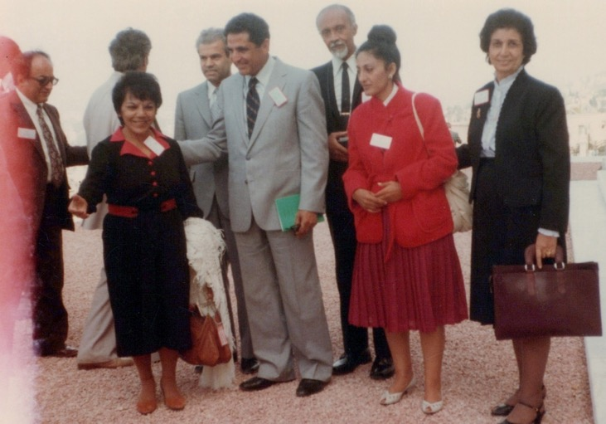

International Convention 1978
First row l. to r.: 1) Mrs. Nikoo Amarsingh, 2) Mr. Fatheazam, Member of the Universal House of Justice, 3) Mrs. Jamalabadi, 4) Shamsi
Second row l. to r.: 5) Counselor Dr. Ahmadiyyeh, 6) ?, 7) ? 8) Dr. Harry Collymore
(the question mark means that I know them but forgot their names)
Since I was widely travelled, I seemed to know more delegates than most
people. I had known Mr. Ma’navi from Istanbul, Mr. Salim Nunu, a well-known Baha’i, and Counselor Ahmadiyyih whom I had served with in Belize. He and his wife were my dear hosts.
Consultation on the use of mass media
Our pilgrimage continued with a visit to the House of Mazra‘ih on April 27th. At 5 p.m. that evening, the members of the National Spiritual Assemblies met together by regions.
The Assemblies of Trinidad, Surinam, Guyana, and French Guiana consulted together. We elected Dr. Collymore our group’s chairperson. We consulted on the use of mass media as a primary tool of expansion in addition to other subjects.
The consultations were free flowing, and delegates were permitted to move between groups. I went to sit in on the consultation which included the National Spiritual Assembly of the United States.
I asked the American members why the travel teachers from the United States did not consult more with institutions in the Caribbean. I also made a plea to have more travel teachers such as Mr. Glenford Mitchell, and the other members of the Assembly said: “go ahead and twist his arm!”
He and Mr. Dan Jordan expressed their gratitude for my recent service in the Bahamas. I let them know that I was willing to travel teach more in the Caribbean.
I gave out the gifts I had brought with me from England to the friends I knew at the Convention. Ms. Nikoo Amarsingh and I walked back to the hotel and ran into Hand of the Cause Gen. Khazeh who greeted us warmly. Mrs. Bates, whom I had known well in England, stopped to give us a lift in her car.
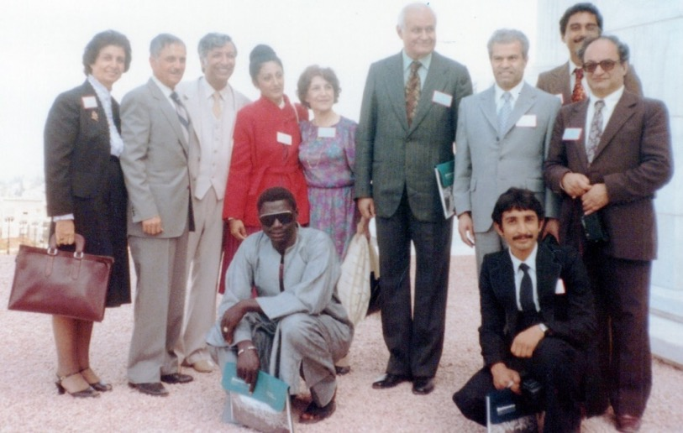
International Convention, 1978
L. to r.: 1) Shamsi, 2) Mr. Ali Nakjavani, Member of the Universal House of Justice, 3) Dr. Jamalabadi, 4) Mrs. Jamalabadi, 5) ?, 6) Hand of the Cause Dr. A. M. Vargua, 7)-8) ?, 9) Counselor Dr. Ahmadiyyeh, the two seated I don’t know
(the question mark means that I know them but forgot their names)
The delegates posed for the official Convention photograph on April 28th near the Shrine of Bab, and then we entered the sacred precinct for payers. I prayed for my family, the National Spiritual Assembly of Trinidad and Tobago, as well as all pioneers and teachers of the Faith. We proceeded to the Archives building where we viewed the photograph of Baha’u’llah and the Persian miniature of the Bab.
Official opening of the Convention
April 29th was the official start of the Convention. The members of the National Spiritual Assemblies sat together by country in the auditorium. Hands of the Cause of God Mr. Paul Haney, Gen. Jalal Khazeh, Mr. Ugo Giachery, and Mr. Ali Akbar Furutan and others sat in the front.
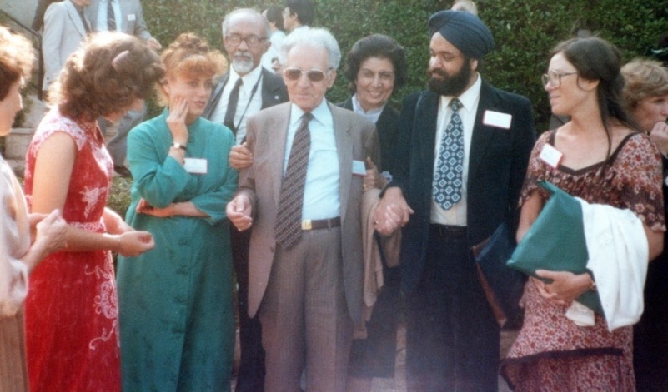
International Convention of 1978.
First row l. to r.: 1) ?, 2) Farideh Khanum, 3) Hand of the Cause of God Mr. Ali-Akbar Furutan 4-5) ? Second row l. to r.: 1) Dr. Harry Collymore, 2) Shamsi
(the question mark means that I know them but forgot their names)
When Hand of the Cause of God Ruhiyyih Khanum entered, everyone stood out of respect. She opened the proceedings with a prayer followed by other devotions in several languages including Spanish and German. She called for anyone who had mailed in a ballot and wanted to retrieve it to do so. Then the delegates filled out their ballots in complete silence. The name of each country represented at the Convention then appeared in alphabetical order on the auditorium screen. The delegates were also seated alphabetically by nation, with the ‘A’s’ down front. When Trinidad and Tobago appeared, we walked down to cast our ballots. As I approached to place my envelope in the ballot box, Hand of the Cause Ruhiyyih Khanum put her hand on my shoulder and observed that I had not changed at all and asked me how I was doing. I answered that I was well and quickly stepped to the side to make way for the next delegate.
The site of the seat of the Universal House of Justice
After the voting, the meeting was completed, we walked to the site of the seat of the Universal House of Justice which was under construction. Hands of the Cause Ruhiyyih Khanum and Mr. Ugo Giachery gave a history of the International Baha’i Council which had been appointed by Shoghi Effendi and preceded the Universal House of Justice. One of its former members, Ms. Ethel Revel, was present. She had served Shoghi Effendi directly as his secretary, and, when Ruhiyyih Khanum was away, she had done virtually all the secretarial and other work. We were also introduced to Mr. Husayn Amanat, the architect of the Seat, who had designed the famous Azadi Tower that stands at the west entrance to Tehran. Dust from the Shrines of the Bab and Baha’u’llah was brought and poured into a silver container which was then put into a wooden box. Then with great solemnity, was placed inside the roof of the chamber where the Universal House of Justice would be meeting and then cemented in. Prayers were said in several languages. Then Hand of the Cause Ruhiyyih Khanum rose and departed.
Celebration of the Ninth Day of Ridvan
The delegates then gathered at the Shrine of the Bab for the celebration of the 9th Day of Ridvan. We were seated on the grounds of the Shrine to hear Hand of the Cause Mr. Furutan give a talk followed by a circumambulation of the Shrine. Afterwards we had refreshments. Counselor Mr. Hooper Dunbar whom I had met before invited me to his home for dinner. I discussed future travel teaching possibilities with Mr. Borrah Kavelin, a member of the Universal House of Justice. He let me know that I was being prayed for every Tuesday at Bahji. He told me that these prayers assured me of success so that I must never be worried. It was my strong faith, he said, which made me an effective teacher.
Importance of loving each other for “God’s sake”
At the Conventions session the next day, Hand of the Cause Mr. Paul Haney introduced Hand of the Cause Ruhiyyih Khanum who instructed him to be brief, so he said that she was the wife of Shoghi Effendi and very dear to us. Ruhiyyih Khanum began by emphasizing the importance of love and loving one another for God’s sake. She also warned against any form of ambition in the service to the Cause because all Baha’is are in the station of servitude. She gave the example of the Master who was loving and encouraging to both the wealthy and the poor, making no distinctions. Baha’is must vie with one another in service not out of a desire for recognition. We must not want the Faith for ourselves but ourselves for the Faith.
The Convention then welcomed the newly elected members of the Universal House of Justice: Dr. David Ruhe, Mr. Amoz Gibson, Mr. Charles Wolcott, Mr. David Hoffman, Mr. Borrah Kavelin, Mr. Hugh Chance, Mr. Hushmand Fatheazam, Mr. Ali Nakhjavani, and Mr. Ian Semple. The convention came to an end, and the delegates returned to their countries with hearts full of love and mind refreshed. I went to Tel Aviv and then flew to London.
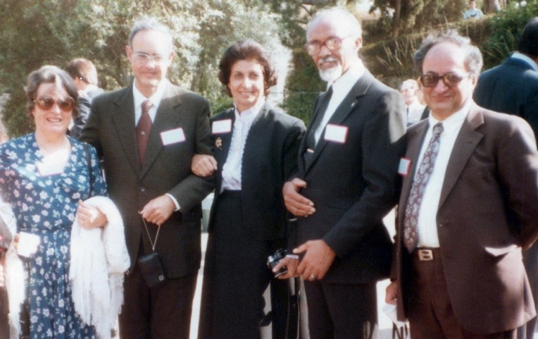
International Convention, 1978
L. to r.: 1) Mrs. Semple, 2) Mr. Ian Semple, Member of the Universal House of Justice, 3) Shamsi, 4) Dr. Harry Collymore, 5) Counselor Dr. Ahmadiyyih
Return to England
I was back in London, England, by May 11th where I met my sister Soraya Furutan and a few others, and they took me to Eastbourne. In Eastbourne, Mr. Roger Prentice, a young man took me to his school, Sherborne House.
The school provided a well-rounded program of academics, arts, and athletics. I encouraged him to speak openly about the Faith to his students and to close the school on Baha’i Holy Days.
In Eastbourne, I met up with friends from Yazd, Mr. Azizi and Mr. Zabihi, who had lived and taught the Faith in Afghanistan and whose father had been martyred in Yazd. We had a meeting to which Mrs. Denise Dewar and a friend also came. (Mrs. Dewar had done so much for me in the past when I was studying in Brighton, Sussex from providing a visiting room for our firesides and housing and helping me with my English writing) Unfortunately, the weather had turned cold, and one of the friends, Mr. Amini, was struck by a car after leaving the meeting. My sister, Soraya, who lived in Eastbourne, gave us an update the next day that he had bad injuries but would recover. We were going to cancel making an appointment with the Mayor, but she insisted that we keep it because the Baha’is there had wanted it for a long time. We went to visit Mr. Amini and gave him our love and support. Soraya, the Azizis, Mrs. Ala’i, and Mrs. Zabihi, and I visited him again the next day, and the doctor read his x-rays said his recovery would be long, but he would make it. That evening we had a fireside in the home of the Ala’is where we were joined by five seekers. One asked about the Station of Baha’u’llah, so I brought out my chart on progressive revelation to answer his question which seemed to satisfy him. We gave books to the seekers to take home.
Moving my sister Soraya and her children from the U.K. to the U.S.
Over the next few days, Soraya was busy with packing because she was moving with her children to the United States. Her husband had to remain in Iran for his work. Before leaving Eastbourne, we had a goodbye party at Mr. Amini’s house and prayed for his speedy recovery.
We arrived in London by train on May 17th and were picked up by Mr. Hezari. I was delighted to see him again after eleven years. We had been students together of Mr. Eshraq Khavari back in Iran. He seemed as young and vital as ever. We went to the hotel which was owned by his friend, and I told him all about the International Convention. I spoke with Mr. Rohani, the Secretary of the National Spiritual Assembly of the United Kingdom and through him, cabled the National Assembly of Cyprus to congratulate the friends there on the successful election of their NSA.
Mr. Habib Hezari and I met Hand of the Cause Mr. Balyuzi
I had the great privilege one day to go out and visit Hand of the Cause Mr. Balyuzi. Mr. Hezari and I took the train out to his house where Ms. Molly answered the door. We saw his library which was full of books on the Faith and lined with photos of Baha’is and martyrs of the Faith. I was invited to go and wait for him in his writing room. When he entered, my eyes filled with tears because he was so elderly and frail. He spoke slowly and laboriously. We remembered the earlier days when I had been a student there in England, and we had gone to committee meetings to assist Iranian students in the U.K. I thanked him for the many wonderful books he had written and encouraged him to keep doing so. He said he was revising his book on Baha’u’llah with books and sources from Iran and that Marion Hoffman, editor of George Ronald books, was coming from Haifa to organize the printing. The Universal House of Justice had appointed Mr. Moojan Momen to assist him with these projects. Mr. Momen was compressing three years of Arabic study into two, so he could do this historical research.
Other Baha’is, including Mr. Hezari, were assisting with various tasks related to completing these books. Hand of the Cause Mr. Balyuzi had a great many sources in Persian and Arabic which he was anxious to have photocopied and preserved. Many writings needed translation. The Universal House of Justice asked a young British Baha’i to study Persian and Arabic, so he could assist with this.
Mr. Balyuzi praised Baha’i scholar Mr. A.H. Eshraq Khavari
Then Mr. Balyuzi spoke about Mr. Eshraq Khavari who was one of our scholars in the Baha’i academy in Iran and with whom I had studied and whom I had helped with copying and proofreading some of his books. This had been a great honor for me. Mr. Hezari also worked with me on this project. Once Mr. Eshraq Khavari told me: “You should not be proud when someone praises you and do not be upset when they speak ill of you. None of this has any value. Don’t listen to others. If you think something you are saying is true and correct then ‘say it’ but with courtesy.” His passing had been a great loss as there were few scholars like him left. Hand of the Cause Mr. Balyuzi had met him twice−once at the 1963 World Congress and then when he was visiting with Hand of the Cause Ruhiyyih Khanum. He praised him tremendously.
New methods of teaching
Mr. Balyuzi and I spoke about new methods of teaching which focused more on the principles. He recalled how he had been approached by a family that was in possession of an original copy of a letter from Baha’u’llah and which was in their personal library. He said that in the future, many such documents would come to light. At present, his physical frailty limited him as he suffered with back pains and poor vision.
I showed Mr. Balyuzi a letter which had been signed by all the Hands of the Cause and asked him if he would please sign it, which he graciously did. Then I asked if I could take a photograph with him, and he was surprised because of his poor condition. Mr. Hezari said to him that this was Shamsi and that her memories were important, so he should allow it. So, we were able to take photos in different parts of the apartment after which we thanked Mr. Balyuzi. We told him that we were now going to the grave of the Guardian, Shoghi Effendi, and he asked with utmost humility that we pray for him and the successful completion of his writing efforts. Later, Mr. Hezari and I shared our respective experience in our Baha’i service, and we both agreed to ask God for more strength to serve the Cause. Then I humbly thanked Mr. Balyuzi for his permission to visit him and departed.
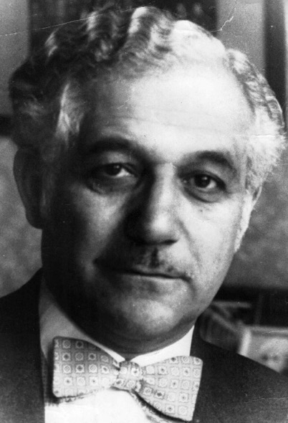
Hand of the Cause Mr. H.M. Balyuzi
Visit to resting place of Beloved Shoghi Effendi in England
At Beloved Shoghi Effendi’s grave site, I chanted aloud a prayer and requested assistance. I had no other thing in my heart except service to the Cause−no house, no car, no husband, no children. I asked for nothing except that my needs be met so that I could serve. I also prayed for the success of all the Hands of the Cause, the Universal House of Justice, the pioneers, and the members of Baha’i institutions in His Service, and my efforts. I prayed to forget the bad and see the good and hold the love of all people in my heart.
After I was finished, I knelt and picked up flower petals as blessings and kissed all of them and put them in my purse.

My return to Eastbourne then to the Bahamas - 1978
We returned to Victoria Station where we caught the train to Eastbourne.
On May 19th, before leaving, I asked Mr. Hezari to send me copies of the photos we had taken with Hand of the Cause Mr. Balyuzi (unfortunately I never received them due to my many travels). I called Mrs. Amini to check on her husband’s improvement which had only been slight. Before getting on the plane, I had to lighten my bags, so I gave my nephew my non-essentials.
I flew through Miami. At the airport there I saw Mr. Karl Collymore, the brother of Dr. Harry Collymore, and his family. They were all going to a Methodist conference in the Bahamas. The plane reached Nassau at 9:15 p.m. under heavy rain.
The friends met me, welcomed and took me to the Baha’i Center then we spoke about all that I had seen and experienced during my trips, and after that, I went to sleep.
The Bahamas: First National Convention, May 1978
I got up before dawn on the morning of May 20th, excited at the prospect of holding the first National Convention for the election of the National Spiritual Assembly. I went to the shopping center to get film for my camera.
While waiting for a taxi, I saw a small boy selling newspapers. I bought one and inside it, I saw an article on the Convention on the first page of The Nassau Gazette:
Wonderful historic National Baha’i convention underway
International exponents of the Baha’i Faith said Friday that the current National Baha’i Convention in the Bahamas promises to be a “wonderful and historic” one which will further enhance the faith’s major purpose of uniting the entire world in one religion and one social order.

“I feel that the establishment of this convention will bring about a great release of energy for the Baha’i Faith in the Bahamas,” said Glenford Mitchell, secretary for the Baha’i national center in Illinois.
Mr. Mitchell and other teachers of the Baha’i Faith began arriving here earlier this week for the first National Baha’i Convention in the Bahamas now being held at Pilot House. A public meeting is scheduled for 4 p.m.

Sunday to wind up the convention.
Scores of delegates from around the Bahamas and dozens of visiting Baha’is are participating in the three-day convention which represents the formation of one of six national assemblies now being formed around the world.
One of the convention’s highlights will be the election of nine persons to the National Spiritual Assembly of the Bahamas.
Hand of the Cause William Sears, visiting Nassau for the first time, pointed out that the Bahamian convention was quite timely. He mentioned that many important Baha’i conventions are held at this time of the year for the election of their National Spiritual Assemblies and consultation on the letter of the Universal House of Justice and other subjects. “It’s a very joyous occasion for us to be here,” Mr. Sears said, speaking for himself and his wife, Mrs. Sears….
Also speaking with newsmen Friday was Miss Shamsi Sedaghat, the travelling teacher. She stressed that newspaper and other news media play an essential role in the growth of the religion, particularly in the Bahamas and this part of the world.
Miss Sedaghat said that once writers and reporters realize their essential role, their subsequent work will be “everlastingly treasured by the whole world.””
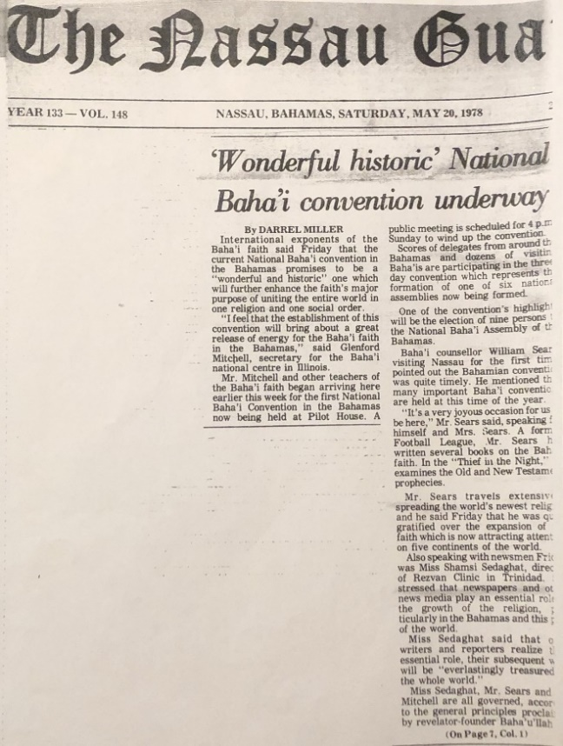
Nassau Gazette article on the National Convention in the Bahamas, 1978.

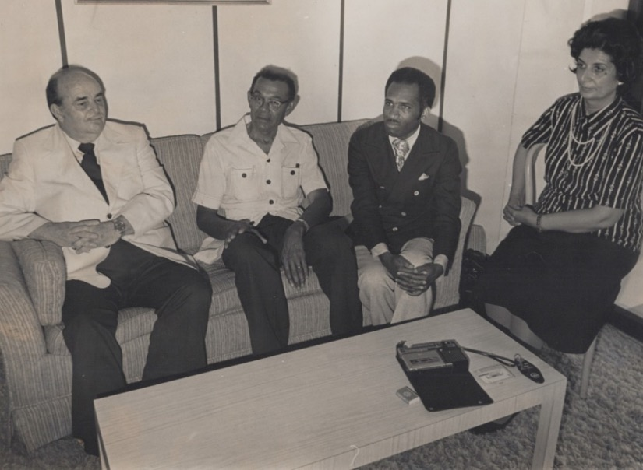
Sitting from l. to r.:
1) Hand of the Cause Mr. William Sears,
2) Mr. Ceril Archer, 3) Mr. Glenford Mitchell, Secretary of the National Spiritual Assembly of the United States and later Member of the Universal House of Justice, 4) Shamsi.
I bought several copies of the newspaper, and the young boy went over to the Baha’is who were having breakfast. They bought all his copies, and he ran to get more.
Mr. Glenford Mitchell, the Secretary of the National Spiritual Assembly of the Baha’is of the United States was its representative at the convention. We had opening prayers. The secretary and chairperson of the convention were elected. Mrs. Beryl McSweeney and Mr. Jensen were appointed as tellers by the delegates. Prayers were said again in preparation for election of the National Assembly. The votes were cast, and the ballots collected by the tellers. The delegates were all very happy with the proceedings. Counselor Mr. Lloyd Gardiner spoke and said that this was the international year of the child, and that the Canadian Baha’i publishing trust was publishing several books about Baha’i children, and we could use these in our children’s classes. Consultation followed on this suggestion, and the delegates made recommendations to the new Assembly. The tellers came and read the names of the first NSA of the Bahamas. We all were very happy, applauded them, and then they sat and continued their meeting and after a while, they adjourned.

The election of the officers of the NSA of the Bahamas
The next morning, May 21st, Hand of the Cause Mr. William Sears was invited to address the Convention. He got up and spoke with such great sincerity and purity of heart that he had tears in his eyes and as a result, so did all of us who were listening to him. He gave a talk on the life and suffering of Baha’u’llah. After it was finished, the chairman of the meeting lightened the mood with a few jokes, and Mrs. Bailey read a prayer in a tearful voice after which all the friends sang “Allah‘u’Abha.” I was then asked to address the meeting, and I spoke for forty-five minutes about the origins of the Baha’i Faith and its principles followed by many questions from the friends which I asked Counselor Tucker to come up and answer. While I was speaking, Mr. and Mrs. Plakaris from the Immigration Department arrived, and I welcomed them to our gathering. Many came up to me afterward to thank me for my talk.
I then went to supper back at the hotel with Dr. Elsie Austin, Counselor Tucker, and Mr. and Mrs. Henry Wigfall. Mr. Wigfall invited us all to his home for supper the following evening. After everyone had gone, I felt very tired and arranged my room and went to bed.
The following morning, May 22nd, I joined Counselor Tucker and his wife for breakfast after having packed my bags. We talked for a while. They were leaving the next day and needed help getting to the airport which we promised to give them. After the meal, we went to the market for necessities and then we went to the home of the Wigfalls. There were a few other guests including the family of Mr. George Plakaris and his wife, and Mr. Brian Smith and his wife. I asked Counselor Tucker to give a talk on the Declaration of the Bab (which was next evening) as the day which would be celebrated in the future with great love and unity.
The elected members were Mr. Michael Horton, Mr. Cyril Archer, Ms. Beryl McSweeney, Mr. Henry Wigfall, Mr. Gadville Newton, Mr. Brian Smith, Mrs. Patricia Newton, Mr. Paul Jensen, Ms. Rosemary Bailey (photo below). They all greeted each other, fixed the date of the next meeting, said a prayer for the success of their work, and departed.

-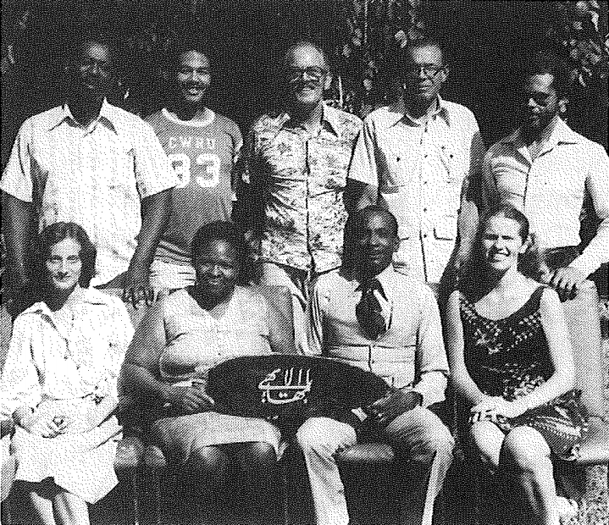
First National Spiritual Assembly of the Baha’is of the Bahamas
Front row, seated, l. to r.: 1) Rosemary Bailey, 2) Beryl McSweeney, 3) Henry Wigfall, 4) Mrs. Patricia Newton Back row, standing, l. to r.: 5) Gadville Newton, 6) Brian Smith, 7) Paul Jensen, 8) Cyril Archer, 9) Michel Horton

Below is photo of a subsequent National Spiritual Assembly of the Baha’is of the Bahamas below with me in it:
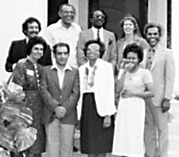
First row l. to r.: 1) Shamsi, 2) Dr. Manuchehr Mofidi, 3) Mrs. Wigfall, 4) ?
Second row l. to r.: 5) Scott Bowers (?), 6) Mr. Cyril Archer, 7) Mr. Henry Wigfall, 8) Mrs. Patricia Newton, 9) Mr. Michael Horton
(the question mark means that I know them but forgot their names)

Anniversary meeting of the Declaration of the Bab
The next morning May 23rd was the Holy Day, so I telephoned Mrs. Ruth Smith, the wife of Mr. Brian Smith, to tell her that this day was very auspicious because it was the day the Bab, the forerunner of Baha’u’llah, declared Himself and marked the beginning of the Baha’i era. I told her that I wanted her to declare and bring all the Glory of God into her home. Along with the inauguration of the first National Spiritual Assembly of the Bahamas, we would now have the formation of the new institution, and she could join her husband in service to the Cause. She answered that she was not ready, so I suggested she find some time today to clear her mind and say few prayers. I told her she still had time to receive this great blessing, and she said “Alright, you never know.”
I said goodbye to the Wigfalls and the other friends and asked that they show great kindness to the wife of Mr. Brian Smith until she accepts the Faith, and they assured me they would. At the airport, I got through customs with no difficulties and sat in the lounge waiting for the flight. The plane left at 10:25 a.m. arriving in Miami at 11:10 a.m. I made a layover in Caracas, Venezuela. On the plane to Trinidad I spoke with a gentleman from India with whom I spoke about many aspects of life. After we arrived in Port of Spain, he offered to help me with my luggage. I accepted, and he brought one of my suitcases through customs. I gave him my business card and thanked him, and he left. The friends were at the airport, welcomed me and took me to my home. We spoke for a while about my humble services and had some nice food which they had prepared then they left, and I gradually went to bed early.

Chapter 12

Travel teaching: United States, Africa, and Europe
In the fall of 1978, I began a months-long, multiple-continent travel teaching trip. I received a letter of encouragement from the Universal House of Justice:
“Miss Shamsi Sedaghat
c/o Mrs. Soraya Furutan
2939 Van Ness St. NW
Apartment 1202
Washington DC, 20008
U.S.A.
Dear Baha’i Friend,
The Universal House of Justice wishes us to commend you warmly on its behalf on your extensive travel teaching plans and to express its hope, and assurance of prayers, for the resolution of your problems,
With loving Baha’i greetings,
Mrs. Lorena Kerfoot
For the Department of the Secretariat”
My first place of service was the St. Louis area and Southern Illinois where a mass teaching effort was planned and in which I was asked to take part.
From the home of Ms. Georgie Edwards, a Greek woman who had only been a Baha’i for four years and was already serving as the secretary of the Spiritual Assembly of St. Louis, I phoned Mr. Glenford Mitchell. After a warm greeting, he consulted with me about future places where I might be of service. He told me that much progress was being made. October 1st there were 1,100 local assemblies and now there were 1,160. I said that there would soon be 1,161 because I assured him there would be one in Wood River, one of the goal towns for the project! He was overjoyed by this promise. I gave him an update on my current activities, and he would phone me with further guidance.
Then Ms. Georgie Edwards and I went to the St. Louis Baha’i Center and picked up some Baha’is along the way. At the Center I spoke about the importance of one-on-one teaching, and I told stories of the growth of the Faith in Trinidad as well as the recent mass teaching in Southern Illinois. I praised Ms. Edwards for her articles on the Faith. We finished the meeting with prayers and songs.

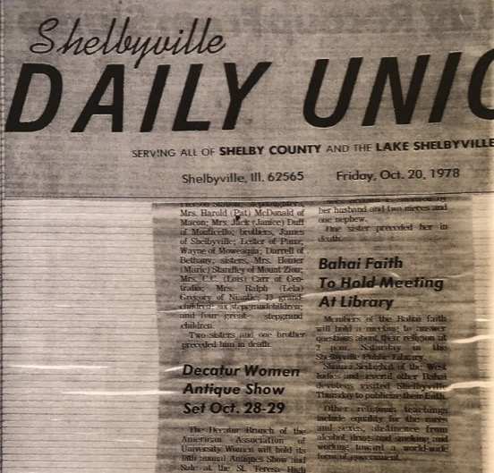

Article in the Shelbyville Daily Union, announcing talk by Shamsi
On the morning of October 25th, an article about my visit appeared in Peoria’s The Observer.
The Observer newspaper
“Shamsi Sedaghat was in town last week to talk about her faith…I tried to see if I could bring more knowledge to youth and women,” she said referring to one of the first laws of the Baha’i faith, “Educate yourself.”’ The source of all evil is ignorance,” said Miss Sedaghat.
Another important part of the Baha’i beliefs is that men and women are equal. “God has given to women the same rights He’s given to men,” she said, “But to be equal we have to have knowledge. Then we will get the jobs.”
Women possess more love and sympathy, Shamsi said. Men possess the virtues too, she said, but women have a greater capacity for such feelings. Once women reach positions of power and responsibility through their education, “women can prevent war,” Miss Sedaghat said.”
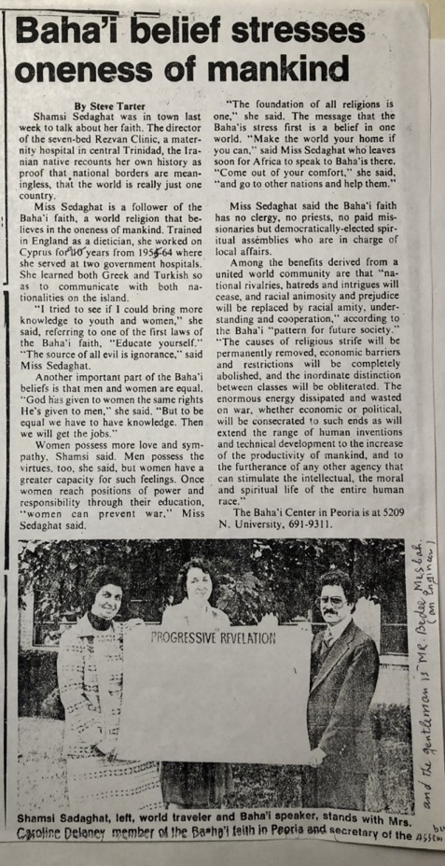
Article on Shamsi in Peoria’s The Observer
My consultation with Mr. Glenford Mitchell
In the morning, I spoke again with Mr. Glenford Mitchell, and we consulted on plans for my teaching trip. He suggested that I consider Bermuda and Georgia where I would be most needed.
Then I spoke with Mrs. Mesbah who very much wanted me to go teaching with her in the town of Wood River. Only two more Baha’is were needed to raise Wood River to Assembly status.
Declaration of Mr. Tony Talley
We drove to Alton and picked up Ms. Mary Lou McLoughlin and drove on to Carlton in Green County, IL, to register a youth, Tony Talley. He was not in, but we sat with his grandmother, Mrs. Kirbach, and I went over my charts with her and explained to her that her grandson wanted to become a Baha’i. She was very happy about this and encouraged us in our work.
Next, we met with Tony’s mother in her home, but she was not happy about the declaration of her son. I told her about my background as a nurse and as she was studying nursing herself, she became friendlier. She learned more about the Faith and told us where we could find her son.
When we finally found Tony, he was very happy to see us. He happily accepted the Faith, and we welcomed him warmly.
Visit to Calhoun County
Next, we drove to Calhoun County to see Mrs. Nancy Lippincot. We introduced ourselves to her and her two daughters as Baha’is and that we had heard that she was interested in learning more about it. She welcomed us in, and we sat down together. A local Baha’i had visited her three times already and had given her books. She could not yet accept Baha’u’llah as being of the same station of Jesus who was without any fault.
I took out my charts and explained progressive revelation to her. I gave her several pamphlets and a copy of Paris Talks. She promised to read it and share it with her daughters and let us know if she had any questions. We thanked her and bid her goodbye.
We returned to Alton, dropped Mrs. Mary McLoughlin off, and went home to dinner and bed after consulting about future plans.
Interview with Ms. Ann Keefe at the KMOX radio station, 1978
The next morning, October 27th, we drove to KMOX radio. On the way we picked up Mrs. Telma and spoke with her in the car about the Faith. At the station I had an interview with Ms. Ann Keefe, a well-known radio announcer. She read over my bio and asked me on what subjects I wanted to be interviewed. I told her anyone she wanted would be fine, and she suggested the Baha’i Faith to which, of course, I agreed.
The interview lasted forty-five minutes, and she taped the whole thing to be used in the coming weeks. I thanked her and went downstairs. As the Mesbah family had not arrived yet, I spoke with the security guard with whom I had already spoken on a previous visit. He asked questions, and I answered them even taking out my charts.
The Mesbah family arrived and joined the conversation. Before we left, I gave him a pamphlet on the Faith. After we said goodbye, Mr. Stevens took us to a restaurant, and treated us to lunch.
We drove to Wood River to find the seekers to whom we had spoken before about the Faith. Our first stop was the home of Mr. Mark James and his wife. They had heard about the Faith before from Mr. Mike McLoughlin.
Next, we visited two young women, Ms. Theresa Schaller, and Ms. Theresa Caldwell, who were staying in a hostel. They were very interested in the Baha’i teachings and asked us to return so they could learn more, and we promised we would return and, if they were ready, they could sign their declaration cards and start to build a new community.
We returned at a later date, met in an atmosphere of warmth, and continued our discussions and hoped that one day, gradually, the two would become Baha’is.
Then we drove to the town of Calhoun and met Ms. Nancy Lipp. She said she had not yet read the book she had received the last time., but that she would. We had a very friendly visit and promised to return.
We reached Pittsfield, IL, by 5:30 p.m., where the Baha’is who had been involved in the teaching project assembled to de-brief their day. There had been two declarations. I was asked to explain the method of mass teaching and my procedure for contacting the media, so I explained the steps that I took:
1) Dress with modesty and dignity.
2) Take a local Baha’i along with you.
3) Take a written bio of yourself and a recent photograph.
4) Take a photo album if you have one with photographs of places you have visited and dignitaries you have met.
5) Bring any references.
I told them that:
“Once the media person knows who you are, you can begin speaking about the Faith and tell them that Baha’is share their knowledge of the Faith with others so that others might turn to the way of God and, in turn, guide humanity. Then give them the Baha’i Writings to read and some ready-made visuals showing some of the Baha’i teachings.”
The Baha’is were very interested in what I had to say and appreciated my remarks. Mr. Samargandi, an active pioneer, took us to supper in a restaurant. After the meal we went to a community center.
As there were no seekers at the gathering, we said prayers, took photographs, and consulted on our teaching plans for the coming days. The meeting broke up, and Mrs. Jessy Wagner and Mr. Jim Wes brought me home where we spoke some more about the teaching work, and then I went to bed.
On October 29th, I spoke by phone with Dr. and Mrs. Jamalabadi who were active pioneers in Trinidad to tell them that a seeker, Mrs. Thelma, was coming to Trinidad with her son to visit relatives, and I asked Mr. Jamalabadi to reach out to them and invite them for deepening.
Mrs. Jamalabadi told me that Dr. Collymore was still doing his talks on the radio and that the television people had warmed up to the Faith and offered three program slots to the Baha’is. She asked me to send any cassettes of Baha’i programs by Mrs. Chapman for their use.
After I hung up, Mrs. Jessie Wagner came, and we drove to Wood River for the formation of the Assembly of Wood River. There Mr. Richard Hellman and Mr. Mike McLoughlin were expecting us. We sat together and read prayers including the tablet of Ahmad and then drove to the home of Mr. Mark and Mrs. Joyce James whom we had seen yesterday.
We spoke about the Faith, and they were very receptive, so I asked Mr. Mike McLoughlin to give them declaration cards. I told them that if they joined the Baha’i community, they could help in the transformation of the world and send peace and harmony out from their home, their town, and their country and eventually, to the whole world. They signed the cards immediately and without reservation. We were all overjoyed and embraced each other. Now we could form the assembly of Wood River by joint declaration.
We phoned the other Baha’is, and Mr. Mike McLoughlin went to get the necessary papers. When he returned, we drove around to the other Baha’is in the community to get their signatures−Mr. Mark and Mrs. Joyce James, Mr. Richard Hellman, Mr. Cecil Burrus, Ms. Blanche Lawrence, Mr. and Mrs. Dwight and Arlene Cox, and Mr. George Hasenstal. We went to Mrs. Chapman’s for dinner, and then I went to bed.
The following morning, October 30th, we collected all the nine signatures and helped to form the local spiritual assembly of Wood River by joint declaration.
Then Mr. Michael and Mrs. Sara Duiker who had declared three months ago, came to take me to St. Louis. We drove right to WKDS television where Ms. Jessica Brown greeted us and took us to the waiting room. We introduced ourselves to several of the staff members. I was speaking with one staff person who had recently moved from New York City and gradually the conversation turned to the Faith. I took out my charts to explain progressive revelation and the principles of the Faith.
When I was finished, she said, “You made my day delightful.” Just then Ms. Jessica Brown walked in and asked what had made her day delightful, and the lady to whom I had been speaking said that “I learned a great deal.”
Ms. Brown then took me into the studio under the bright television lights. She asked me if my purpose was to spread the Baha’i Faith. I answered that it was, and I could speak as well on a variety of topics such as the equality of men and women, and the role of youth in developing society, among others.
She wanted to ask me how I found the women’s rights situation in this country and what was missing. I gave examples from my profession of midwifery which had its shortcomings everywhere and unfair rules all of which could be solved through discussion and consultation.
Interview with Ms. Brown
A photo was taken of Ms. Brown and me together, and then the interview started. She began by introducing me and then asking me the question about women’s rights and the station of women in this society.
The next question was on the challenges of children and youth in our society and how to develop their character and cultivate good habits in them. The time for the interview was short so I had to be brief in my answers. I spoke from the Baha’i teachings. After the interview had ended, I showed my charts to Ms. Brown and explained more to her about the Baha’i Faith. She liked what she heard because it was true and logical. She said that she no longer attended church because many of its teachings were contrary to reason.
Then she introduced me to Mr. St. James Cliff, one of the other TV presenters. He told me how much he had enjoyed my interview. I gave him a copy of Baha’u’llah and the New Era. He promised to read it and wished me success in my future endeavors.
The two young Baha’i women who had watched the interview, Ms. Michelle Duiker and Ms. Sara Duiker, were astonished at how I had been able to guide a conversation towards the Faith without raising any objections. After leaving the station we went to change my plane tickets and made other travel plans.
On October 31st, a young Baha’i consulted with me about his pioneering plans to Zaire, and in the evening, we had a fireside in Carbondale, IL, in the home of Ms. Maria Parish which lasted until midnight. Then we returned home and retired to bed.
I had an interview with Mr. Randy Anderson on the television
We had a prayer meeting at dawn on November 1st, and then I was brought by Ms. Elaine Bailie to WHPI television where Mr. Randy Anderson interviewed me for twenty-five minutes. When we were done, I gave him Baha’u’llah and the New Era.
Next, I was interviewed at the Marion Daily Republican newspaper about my life. My last interview of the day was at WEBQ radio in Harrisburg where I was interviewed for fifteen minutes. I consulted with the Baha’is on their teaching activities and gave some advice to a young single mother on her service to the Cause.

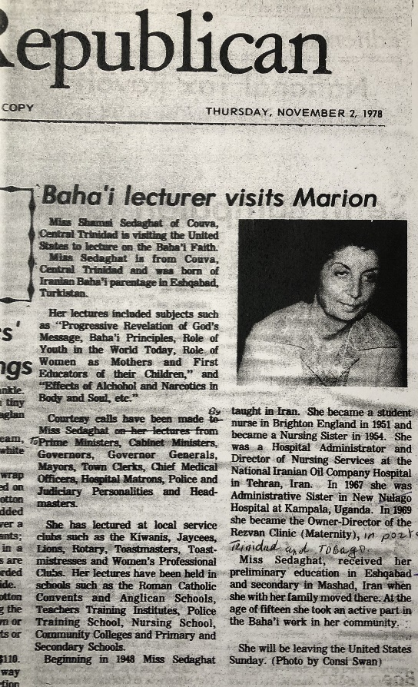
Article in the Marion Republican on Shamsi’s visit
News interview by Ms. Jeanette Oxford
I gave more interviews on the next day, November 2nd. We began at a newspaper in Herrin, IL, where Ms. Jeanette Oxford worked. She already knew a little about the Faith, and I explained the Baha’i teachings further using my charts. She liked what she heard so I gave her a few books to use for the article she was going to write.
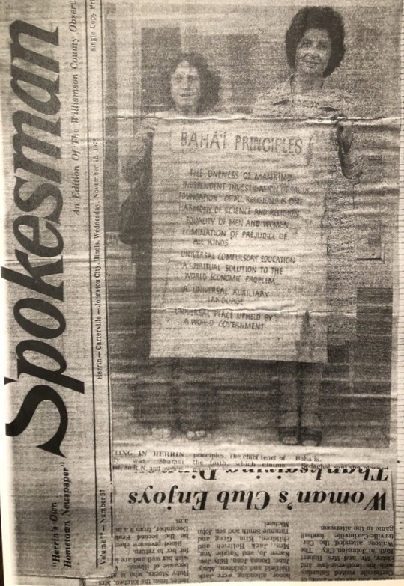
Photo of Shamsi and her chart in the Herrin, IL, local paper
Interview by Mr. Steve Land
At WDDD in Marion, IL, Mr. Steve Land interviewed me for fifteen minutes about the Faith, and I gave him a booklet on the Faith. In Champagne-Urbana, IL, Mr. Ted Height interviewed me about the Faith. When we were done, we took photos outside under a tree where we hung up my charts.

Public meeting at the University
After the media appearances, we went to Southern Illinois University’s Woody Hall, the Student Center, where Ms. Sharon Smith had organized a public meeting for people to meet me. Prof. Woodial, who taught communications at the University, came with her friends. We gave out pages from a teaching booklet, and I explained the Baha’i teachings.
Unity Feast
On November 3rd I gave interviews at WSIL and WINI in Murphysboro, IL. A unity feast was held that night with forty people including international students from China, Vietnam, Iran, and other countries. I was able to speak with them and answer many questions.
Baha’i speeches at the Law School library in Mounds, IL, and many other places
The next day at the law school library in Mounds, IL, Dr. Sharon Smith, Mr. Iraj Vokhshuri, and I spoke to the students. Several youths accepted the Faith. Then Ms. Maria Parish, Dr. Smith, and Mr. Mark Boese went out teaching and met youth who were open-minded.
There were three adults to whom we spoke who were also very interested, and one man gave me the contact information for Mr. John Jones at the local radio station and told me to mention that Mr. William Miller had recommended I contact him.
Then we went out direct teaching and went to the library where we spoke with several people. By evening, the direct teaching had resulted in twenty-seven declarations from the different teaching teams.
We gathered in the home of Mr. Joel Smith. Baha’i teachers including the Mesbah family and I spoke with the seekers and new believers. One man came who had been in prison and had studied Islam there. I explained to him the differences between the Baha’i Faith and Islam. The meeting came to an end with everyone in high spirits.
An appreciation for my contributions
The teaching project in Illinois was over, and it had been a great success. The Baha’i newsletter “The Heartbeat,” November edition carried the headline: “1433 ASSEMBLIES: GOAL EXCEEDED” and an appreciation of my contribution:
“…As you probably already heard, Miss Shamsi Sedaghat, Chairperson of the National Spiritual Assembly of Trinidad and Tobago, world traveler, lecturer, owner, and administrator of her maternity hospital, born in Ashgabat, Turkmenistan, pioneer to several areas of the world, arrived in Carbondale on October 31st and left on Nov. 5th.
She had interviews on radio, tv, and newspapers in Carbondale, Harrisburg, Herrin, Marion, and Murphysboro. She gave a fireside on campus, and at the unity feast at the Smiths’ home. She also visited many of the isolated believers. Due to her unrelenting spirit, her perseverance in teaching the Cause, her warm and open compassion, and her striking dignity, her presence among all of us was transforming and unforgettable…”
I received a kind note from one of the local Baha’is, Mrs. Gay Clough, who was kindly taking me and my assistants— if I had any—in her car around the town to visit the friends or participate in news media interviews or other engagements for which I thank her tremendously. May Baha’u’llah reward her abundantly. Her letter is as follows:
“Dearest Miss Sedaghat, world traveler and wonderful and devoted servant of Baha’u’llah, Allah’u’Abha!
I hope that someday this letter catches up with you, but I know the way you move, so it may be a while…but know that you are in my prayers as you travel so far and wide.
Yes, I have recovered from being your chauffeur and assistant as far as rest and sleep is concerned. But I am sure I will never be recovered from my love and admiration for you. I send along the latest newsletter for So. Illinois indicating the glorious results of the teaching efforts that you and so many other luminous Baha’is have sacrificed and prayed for.
I learned much in the few days we were together that I cannot explain. Please know that you have spiritually assisted me and that in turn I hope that I can use what I have learned for the promotion of the message of Baha’u’llah.
Wherever it is that we meet again, it will be a most happy day for me. I pray that God will keep you safe in your travels that you continue to reach the hearts of the worlds’ peoples and your loving spirit refreshed each morning.
Allah’u’Abha,
Much love from myself and all the So. Illinois Baha’is,
Mrs. Gay Clough.”
Back to Washington DC - 1978
When the Southern Illinois teaching project was successfully concluded, I flew to Washington D.C. on November 5th, 1978, where I was met by my mother, my sister Guitty Jan, and her husband Mr. Husayn Ejtemai.
For the next days, I rested from the weeks of intensive teaching I had just carried out.
I spoke with Mr. Glenford Mitchell, and he said I might be asked to go to Bermuda or to New York. The goal was to raise more than eighty assemblies by Ridvan.
I attended the Holy Day the Birth of Baha’u’llah in Washington D.C. and spoke with a young seeker from the Ivory Coast. I told him that this was an auspicious day for him to accept the Faith. He did accept and several members of the Assembly who were there, as well as us, were overjoyed and welcomed him warmly to the Baha’i Faith.
With the help of Mr. Hassan Sabri, a wonderful Baha’i pioneer who was a member of the teaching committee for Africa, I confirmed my West African teaching trip and went from embassy to embassy getting visas.
At the Embassy of Cameroon, the visa officer knew about the Faith and told me that Baha’is had had problems in several African countries. I explained to him about the Faith and how it was different from the other religions, and I told him that all new religions were rejected by the people first and then gradually they spread, and the troubles lessened in many places.

Connecticut, November 1978
When the arrangements were made, I flew to Connecticut on November 17th, where I was taken after landing by Mr. Terrance Powers, a very active Baha’i, to visit Dr. and Mrs. Krug. Dr. Krug had been in ‘Abdu’l-Baha’s house when he passed away. He had even been in the room and closed ‘Abdu’l-Baha’s eyes. He had also personally known Hands of the Cause Mrs. Dorothy Baker and Mr. Horace Holley. They had now passed away, and he was eager to join them.
When we visited him, Dr. Krug was homebound with rheumatism. This did not stop him from writing the Universal House of Justice to be allowed to make a one-day pilgrimage because on his last pilgrimage, he had been sick on the last day.
This town, Milford, CT, needed two more Baha’is to be raised to Assembly status. We prayed about this goal. We went to the home of Mr. George and Mrs. Jan Lanoue with Mr. Terry Powers. We decided to go out and do direct teaching the next day.
On November 18th, we went out meeting people. I went with Mrs. Jan Lanoue, and we spoke about the Faith with an Irish woman and her child, and she agreed to come to a fireside.
We also did door to door teaching. That evening there was a fireside in the home of Mrs. Bess Daniels whose husband was not a Baha’i. Mrs. Adrienne Reeves, the Auxiliary Board Member, spoke about marriage. We decided to go to West Hartford the next day for direct teaching.
Mr. George and Mrs. Jan Lanoue, Carol and I went out walking the next day, November 19th, to meet people. We spoke about the Faith with a young girl who was studying religions, a couple who was cleaning leaves off their roof, and a man with a Jamaican wife and invited them to a fireside.
Declaration of Mr. Michael Calestro
That evening we had a fireside in the home of Mr. George Lance attended by forty Baha’is and four non-Baha’is. After most people had left, I stayed to speak with Mr. Michael Calestro who was very interested by what he had heard. He said that everything was very logical, but his heart was not ready. I suggested he open a prayer book to see what God was saying to him. He opened the book and the prayer read “O God remove all these veils from eyes to heart…” This was a confirmation. I said that he must allow this confirmation to enter his heart. Suddenly he exclaimed that his heart had accepted the Faith. We both shook hands, and he signed his declaration card. Mr. Calestro was the second person that night to declare. We welcomed him warmly to the Faith.
On November 21st I gave an interview to the Milford Register and in the evening, I met with the ‘Connect with Connecticut’ teaching team in West Hartford. The next day, November 22nd, I gave a half-hour radio interview. At the home of the Lanoues that evening thirty-five people—including five seekers—came to a fireside. There were two declarations, Ms. Nancy Fannin, and Mr. Tom Mirbada, which brought the number of Baha’is in Milford to nine, so we were able to have a joint declaration and establish the new Assembly of Milford. I spent November 23rd, Thanksgiving Day, with the Powers and the de Araujo families in Ridgefield, CT. The morning after Thanksgiving, November 24th, there was a fireside at the home of the Powers which included two seekers. In the afternoon I went to New Haven to do direct teaching.
Formation of the LSA of New Canaan, CT
Later, I received an unexpected and gratifying cable from the Baha’is of New Canaan, CT:
“SHAMSI SEDAGHAT BAHA’I PORT OF SPAIN
DEAREST COWORKER SHAMSI JOYFULLY ANNOUNCE FORMATION L.S.A. NOV 27 CONVEY GRATEFUL THANKS YOUR PRAYERS EFFORTS INSPIRATION MARCHING ONWARD MUCH LOVE
BAHA’IS NEW CANAAN CT”
Bermuda, November-December 1978
After this successful teaching visit to Connecticut, I was in Bermuda where I was picked up by Mrs. Vivian who brought me to her home.
On the morning of the 29th of November, Mr. Frederick Warner came and took me to speak at a school whose director, Dr. Symonds, was a Baha’i. We met with him, and I showed my bio. He called in a teacher and explained to her that I wanted to give a talk on the harmful effects of alcohol and drugs. He expressed concern that the children might have a difficult time understanding my accent, but I assured him that I had spoken in many countries, and my accent had never been a problem. Two classes of thirteen-sixteen-year-olds were combined. I spoke to the students who paid close attention and at the end, I was asked to speak about the different languages that I knew such as Turkish and Russian as well as stories about my profession as a midwife, which I did. After a break, I spoke to the class belonging to Ms. Leanna Lee. I asked the teacher how the students had liked my presentation, and she said they had enjoyed it, and then I asked if they had understood my accent, and she answered that they had understood my English clearly.
Afterwards, I spoke with several people outside about the Faith including a man who was delivering bread. I asked him his name, and he answered “Neville Cameron,” and I asked him if he was related to Earl Cameron, a well-known British actor who was a Baha’i and lived in England, and he said yes, he was his uncle. I was very happy and gave him a book about the Faith and invited him to the Williams home that night and to a teaching meeting at the Baha’i Center the following night.
When I got back, the Teaching Committee of Bermuda was meeting which included Mrs. Mary Walker, a brilliant Baha’i teacher and a cousin of Hand of the Cause Ruhiyyih Khanum, and her husband Jordy, Ms. Georgia Sanchez, a dynamic pioneer from the United States, and Mrs. Vivian. We met together, and I made suggestions which they all accepted. We prayed to the Concourse on High for assistance and agreed that we would execute our plan and rely on the Divine Assistance.
Visit to the home of the Governor-General of Bermuda
Mrs. Mary Walker said that she was scheduled to go to the home of the Governor-General Sir Peter Ramsbothan to give him a letter and asked us to accompany her.
We arrived at the Governor-General’s mansion in Hamilton, the capital, and spoke with his social secretary. She was delighted to learn that I was Iranian as the Governor-General had been the United Kingdom’s Ambassador to Iran. She brought us into a room that had many high-quality Persian rugs. I said that I hoped I would be able to meet the Governor-General during my visit, and she gave us an appointment for the 6th of December. Then Mrs. Mary Walker gave her the letter about the U.N. Declaration of Human Rights to be delivered to the Governor-General.
In the evening we went to have dinner and a fireside at the home of Mr. Lloyd and Mrs. Milli Williams. Ms. Sharon Canne and her sister who was not a Baha’i, a doctor and his wife, Ms. Eleanor Hayward, and Ms. Vera Hayward who were the mother and sister of Milli were all there.
I told them about my talk at the school and then spoke about the Faith. By the end of the evening, Eleanor and Vera declared, and we were all overjoyed. I spent that evening in the home of Mrs. Vivian and her daughter, Valerie, and son-in-law, Mr. Marcus Richmond.
News media interviews and declarations
Next morning, Ms. Georgia Sanchez and I went to FZB television where we scheduled a time for an interview and then to the other television station where we arranged for a live interview. At the Royal Gazette, I gave an interview and arranged to have the newspaper send a reporter to the Baha’i Center to have a full and in-depth interview.
Mr. Morris then brought us to the tennis stadium to speak with Mr. Alan Simmons, Mr. Cyril Derosa, and Mr. Samuel Wilson, who were delighted to learn more about the principles of the Faith. Mr. Simmons asked me for a book, and Mr. Wilson invited me to speak with the young people at the Rembrook Youth Center tomorrow.
Two declarations at the Baha’i Center
At the Baha’i center that evening, we held a fireside where there were many people present. I spoke about the Faith and two people declared—Mr. Marvin Brock and Mrs. Esmay Shepperd. We all welcomed them warmly, and they signed their declaration cards.
By chance I ran into someone the next morning who had seen my photo and article in a newspaper when he was living in Barbados. We spoke for a while about the Faith, and he promised he would study it.
Checked a hospital for any vacancies
Mrs. Mary Walker brought me to the hospital to see if there were any vacancies in case I decided to pioneer to Bermuda. The hospital administrator informed that any vacancy that came up would go to a Bermudian citizen; nevertheless, we had a fruitful conversation about the Faith. He said that the Faith was way ahead of its time. I answered that God knew the right time to send teachings that were for the age and that gradually these would come to be recognized and accepted.
Short visit to the tennis center
We went over to the tennis center where Mr. Wilson and the youth were expecting us. He introduced me and told the young people to listen carefully because one day they might accept this Faith and live by these principles.
I spoke about the behavior and role of youth in society, and the young people shook their heads in agreement. When we were finished, they presented me with a map of Bermuda, and we took a photograph together.

Teaching the Faith until 4 a.m.
At Mrs. Vivian’s house, we had dinner in the company of five seekers. They had many questions and, then Vivian’s son came, and we stayed up until four in the morning talking about the Faith.

Informal gathering and meeting with the teaching committee, December 3rd, 1978
On the morning of Sunday, December 3rd, the Baha’i Center was full of people. I demonstrated with the children my approach to teaching a children’s class which pleased the Baha’is. I followed this with an informal talk, and then we prepared ourselves to go out for direct teaching.
We did not find many interested seekers but did give out information about the Faith and Baha’i meetings to a few people. When I came back, I met again with the Teaching Committee of Bermuda which thanked me for all my service and the seven new declarations and seekers which the teaching work had yielded. I suggested that Sundays be set aside for direct teaching with which they agreed.
Declaration of a student
I then went to visit Mr. Lloyd Williams who was teaching one of his students. Mr. Williams asked that I speak with the student about the Faith which I did for some time.
After our conversation was finished, I asked the student what he thought about the Faith, and he said he liked and accepted it. Mr. Williams and I were delighted to welcome him into the Baha’i community.

Interview with a newspaper reporter
December 4th, I spoke at the Baha’i Center for a while with a newspaper reporter. I gave him a book about the Faith, and he said he would write an article that would appear the following Tuesday.
Meeting with Mrs. Mary Walker
Mrs. Mary Walker then came to take me to the prestigious Girls’ High School. She reviewed my resume, and we scheduled a talk for the following day. Then Mary and I returned to her house for tea with ladies who were not Baha’is. One was interested in the Faith, and she asked questions which I was able to answer. Back at the Baha’i Center, we sat with Mr. Wayne Simmons who worked at the television station who had become a Baha’i but still had questions. We spoke together, and I tried to address his questions.
Very nice fireside
That evening, Mr. Austin and Mrs. Hilda Harford held a fireside which was attended by eight non-Baha’is and Baha’i friends including Mrs. Mary Douglas Lamon whose husband was not a Baha’i. I spoke about the ills in the world and the remedy which was the Faith. My words seemed to have an effect.
The Baha’is said they felt inspired. Mr. Douglas, whose wife had been a Baha’i for eleven years, said he had always been running from the Faith but that he liked what he heard tonight very much. Though no one declared, the evening seemed to have contributed to the spiritual progress of the people who had come.
December 5th, I phoned a young man from Barbados, Mr. Clay Carter, and invited him to come and meet me. He came, and we spoke at length about the Faith, and he felt that now that he understood it better, he could continue to study it. I gave him a prayer book and encouraged him to pray and ask God for His Guidance.
Mr. Lloyd Williams then took me to the Girls’ High School where Mrs. Mary Walker was waiting to meet us. I spoke to over a hundred students and encouraged them to improve their knowledge and prepare themselves to serve the world as well as to develop their spiritual qualities. When I had finished my remarks, they thanked me, and we left.

Meeting the Governor-General of Bermuda - December 6th, 1978
Ms. Georgia Sanchez, Ms. Joyce James, Mrs. Mary Walker, Mr. Jordy Walker, and I went to our appointment with the Governor-General, Sir Peter Ramsbothan. We were taken by the Governor-General and his wife into a room with Persian carpets he had acquired during his ambassadorship to Iran.

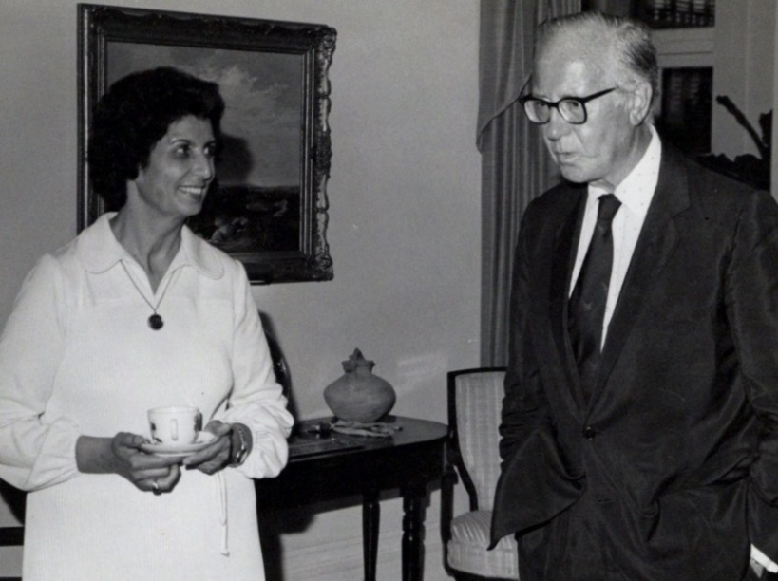
Shamsi and Governor-General of Bermuda Sir Peter Ramsbothan

Over tea, Sir Ramsbothan asked me if I knew Mr. Habib Sabet and Mr. Rahnama which I did. Then he spoke about Yazd, Tabriz, and other towns. He was interested to hear about my family’s history.
He wondered why the Baha’is were persecuted as they were such decent people and did not hurt anyone. Over the course of the conversation, I brought out my charts and explained the basic Baha’i teachings to him. At the end of our visit, I invited the governor to come to Trinidad, and we took several photographs together, and we warmly said goodbye and left.
Interview at the television station
From the Governor’s mansion, we went to the television station where I gave a twenty-five-minute interview. Then I came home and stayed up late into the night consulting with the National Spiritual Assembly about the teaching work.
Talk at Sandy High School
The next day, I went to Sandy High School. The principal, Mr. Joseph Christopher, brought me to the library where he introduced me to a hundred students as a “representative of the Baha’i Faith.” I began by speaking about the ills of the world and the role of youth. I quoted from the Baha’i Writings to encourage them to educate themselves in morals and spiritual principles. The Principal asked the students if they had ever heard of the Faith and if any of them were Baha’is, but no hands went up. I finished by teaching the students the song “Good neighbors come in all colors” which they very much enjoyed. Before leaving I invited each student to come to the Baha’i Center.

A meeting at City Hall of St. George and a new Baha’i
Then I went to City Hall where a Baha’i, Mr. Frederick Ming, had invited parents of the St. George School and officials to a meeting to discuss the problems with the school which was in a state of disrepair. I suggested that he approach this meeting amicably to gain the good will of people, and he said he would. I spoke during the session about the education of children and read from the Writings on this subject. The government representative, Mr. Swan, was very pleased by the peacefulness of the meeting. Over fifty were present, some of whom had heard about me from the radio and television coverage. A few people expressed their wish to be Baha’is to our great joy. I received small gifts in appreciation for my service. Afterwards I spoke for a long time with Mrs. Barbara who was the secretary of the teachers’ union. She asked many questions about the Faith until two in the morning at which point, she declared. I was so excited that I phoned Mr. Frederick Ming who had left several hours ago with the good news.

Interview at the television station
Early the next morning, December 7th, I was taken again to the television station for a twelve-minute interview. I answered initial questions about my professional life and then told the listeners how I had closed my clinic for several months so that I could travel and inform people in different countries about the appearance of a new religion, the Baha’i Faith, and its world redeeming teachings. Then I invited any listener who wanted to learn more to come by the Baha’i Center, and I gave out the address. Back at the Baha’i Center, I spent some time deepening the new believers Mrs. Stine and Mr. Brock. Then we drove to the gravesite of Mrs. Stine’s husband and prayed for the progress of his soul.

Poem by Mrs. Joyce Johnson
That same day, an encouraging poem and note was written to me by Ms. Joyce Johnson:
“WHAT BAHA’IS DO.
CALL OUT YOUR MESSAGE
O BELOVED FRIENDS
TELL EVERYBODY OF
THE DIVINE PLAN
SHOUT OUT THE NEWS
MY BELOVED FRIENDS
LET THIS MESSAGE, ECHO
ACROSS THIS LAND.
SING OF HIS PRAISES
GLORIFY HIS TEACHINGS
IN OUR DAILY LIVES
LET’S TEACH HIS LESSONS
FOR THE GLORY OF GOD WHICH
IS HIS STATION,
HAS COME TO UNITE MANKIND
MAKE US ALL ONE NATION.
UP ON THE MOUNTAIN TOP
WILL STAND HIS TEME
AND UNDER GOD’S PROTECTION
ALL MEN WILL ASSEMBLE
SO SING OUT YOUR PRAISES
O BELOVED FRIENDS
CAUSE THE KINGDOM OF GOD
IS HIGH IN THE LAND.
AND OUT FROM MT ZION
WILL GO GOD’S GREAT LAW
AND WE WILL REIGN ON EARTH
FOR EVERMORE.”
Please, accept this humble remembering of me, I have been inspired thru Divine Providence to write poems. It is this I am happy to share with you, as never got the chance when you were here. I hope God willing to publish my book of poems to share with my brothers around the world if they can bring some joy and happiness. Also, at my job, the fly airplanes I had privilege to go up in a helicopter. These are some pictures of Bermuda I took.
Please, I wish to share with you, Bermuda from the sky, a small reminder that beneath these clouds in this vast expanse of ocean beats hearts full of love for you, and gratitude for showing us how to be on fire, and ablaze with mention of and love for the Blessed Beauty and His glorious message. Truly, I pray to God the fire you have set ablaze will continue to blaze until all faces on this tiny island are uplifted, radiant and happy from recognizing the Glory of God. And Bermuda may be an example to the world of unusual brotherhood—unification of all mankind. May assistance, confirmations, and protection continue to rain on you from the Abha kingdom in His Service, I pray,
Deep Baha’i love,
Your Baha’i friends in Bermuda
Joyce Johnson
P.S. Please come back one day.”

Chapter 13

My departure from Bermuda to Liberia
I busied myself the next day, December 8th, with preparations for leaving and answering calls from well-wishers. At the airport, Ms. Georgia Sanchez, Mr. Clayton, and other Baha’is, came to see me off and wish me well. We took photographs together, and they asked to please return to Bermuda. I boarded the plane for New York City. While waiting for my connection to Liberia, I spoke for a while with a Nigerian couple who gave me their address so that I could contact them when I got there.
After I had left Bermuda, I received a follow-up letter from Ms. Georgia Sanchez:
“Dear Shamsi,
I am in a rush at this time but thought you would be happy to know that we formed the SPIRITUAL ASSEMBLY OF THE BAHA’IS OF ST. GEORGES PARISH last night at 9:20 p.m and I moved to St. Georges to secure the Assembly.
June and I moved to St. Georges to secure the Assembly….
You are truly my dearest sister,
In His Service,
Georgia Sanchez
P.S. Bruce Stevens became a Baha’i last Thursday evening (he was the blonde-haired man you talked to sitting on the couch) We also had 3 more declarations since you left beside him. Again, Shamsi we all love you dearly and hope to see soon in Bermuda…”
Liberia, December 1978
I landed in the small West African country of Liberia at dawn on December 9th. Unfortunately, my suitcase was missing which reminded me of previous problems I had experienced at other airports. Mr. Alex Folley and Mr. John Stephen who were members of the Assembly of Monrovia were there to greet me. They were expecting Mrs. Shamsi Navidi because the telegram they had received had been signed ‘Shamsi,’ and they thought this was the Shamsi who was married to Mr. Navidi, a well-known lawyer in Monrovia. Because of the misunderstanding, I introduced myself and told them a little about myself. They were very pleased to meet me and drove me to the home of Mr. William and Mrs. Laura Hill. He was an American who had declared in Monrovia. Mrs. Hill took me to the market to buy clothing, and I bought two dresses in the local style.
Youth celebration
That night, we went to a large youth celebration to mark the end of their classes at the home of Mrs. Parichehr and Mr. Jim Traub who were American pioneers in Monrovia. I was invited to say a few words. I encouraged the over two-hundred youth to acquire knowledge and use it to serve the world. Then I sang “Good neighbors come in all colors” with them and many came up to thank me.
Two declarations in Unification Town
On December 10th, we had a prayer meeting at the Baha’i Center. Mr. Mouhebat and his wife, pioneers from Hindustan, and Mrs. Dorothy Hanson, a Baha’i from Ghana, were also there. Dorothy was helping with the publicity for the upcoming Women’s Conference at the end of January. After prayers, Dorothy, Parichehr, Jim, and I went to Unification Town for teaching. We went out after meeting in the home of Mr. John Peters, the Chairman of the Assembly, Mr. Hill, Dorothy, and I then went to the home of Mr. Collic, a local man married to a non-Baha’i. We spoke with her and her daughter for some time about the Faith. To everyone’s great joy both Mrs. Collic and her daughter declared, and we welcomed them into the Faith. They were the first two women to declare in this town.
Meeting the NSA of Liberia
I met with the National Spiritual Assembly in the home of Mr. Edwards, an eighty-year-old pioneer from Jamaica. We consulted on teaching plans during my visit. I told the friends I was there to assist with the winning of the goals of the Five-Year Plan, and I could speak at schools, clubs, public meetings, and give interviews to the media. All I needed was the assistance of a local Baha’i and a vehicle. I could also help with the preparation of the women’s conference.
On the morning of the 11th, I went back out to the airport to look for my suitcase. We found it with the help of a young man with whom I began speaking about the Faith. Several young men gathered around, so I took out my charts and started to teach them. A young Liberian man came up to me and said ‘Allah-u-Abha’. It interested the Liberians to see a man from their country who as a Baha’i. I invited them to come to the meeting which would be advertised on the radio.
Children’s classes
Back at the Collics’ house, I gathered children together and started a class. We started with a prayer, and we discussed how we pray. Then I did a simple explanation of my chart on progressive revelation.

We had five declarations in one afternoon
Mr. John Peters arrived and when the class was over, we went to his house where we talked about the Faith to his wife and her non-Baha’i friend. They accepted the Faith. Greatly encouraged we went to his uncle’s house and spoke with his sister, and two other people. After a long conversation all three declared. We warmly welcomed them to the Faith.
As it was feast night, we gathered the Baha’is together in the home of the Collics. We were twenty adults and children, many of whom were new Baha’is. The spirit was high, and we decided to have a big public meeting on Sunday.
On December 12th, I had to work on my visa issues and met Mr. Lottie Nicolas who was in charge of the visa section of the immigration department. She knew about the Faith and was planning on attending the Women’s Conference. She came over to Mr. Hill’s house. She said she would arrange a talk for me at the Rotary Club and resolve my visa problems.
We met the mayor of the town
After we had eaten, Mrs. Hill took me to City Hall where the mayor was holding an event to give out awards to successful students. There were three-hundred students and a very celebratory atmosphere. After the ceremony, Mrs. Hill and I approached the mayor and introduced ourselves and asked him if we could pay him a courtesy call. He answered that we could contact his secretary, and she would set up a time.
Met the Teaching Committee
Later, I met with the teaching committee, and we consulted on ramping up Baha’i activities in Monrovia. I said that since the city was the capital of the country there needed to be much activity. We agreed to hold a daylong deepening on the 24th which would include the history of the Faith from Shaykh Ahmad to Shoghi Effendi, teaching, Baha’i administration, and moral laws.
Radio interview
On December 14th, I went with Mrs. Dorothy Hanson where Mr. Patrick Kugmeh interviewed me for twenty minutes about my profession, my travels, and my children’s classes. I wove the teachings of the Faith into the conversation. When we finished, I walked over to the television section to arrange an interview.
Two declarations at the electronics shop
After leaving the station, I walked to an electronics shop to show them my camera which needed repair. We began a conversation which led into talking about the Faith. I was standing out under the hot sun, while the shop owner and his brother were in the shade of the store. We continued for an hour and a half. At the end they were moved by what they heard, and they both declared. I was overjoyed and welcomed them to the Faith and guided them to our meetings.
The teaching continued when Mr. Hill and I visited the home of Mrs. Eileen Tyson and the home of Mr. John Stevens where we spoke to his pregnant wife. Mrs. Dorothy Hanson, a very active Baha’i, was with us and invited her to the Women’s Conference. After we had spoken for a while Dorothy asked her if she believed in Baha’u’llah, and she said she did. We all clapped and gave her a declaration card.
Back at the home of the Hills, we found Mrs. Hill weeping because we had just learned the news that her nephew had died. We said prayers for his soul and for her loss. Mr. Hill’s boss, Mr. Muhammad, came over, and we all talked about the Faith together until midnight. Mr. Muhammad loved the teachings and wanted to bring his wife to future meetings.

Mr. and Mrs. Hill, the godparents to the youngest child of the president of the country, Mr. Tolbert
On December 15th, Mr. Hill took me with him to the airport where a party had gathered to see the president off for his foreign trip to Angola. At the airport, I spoke with the wife of the president who invited me to come out to Providence Island where she would be participating in a Jamboree sail. She said she hoped she would see me again. I met the president of the University in Monrovia and asked her if we could hold the Women’s Conference there, but she said it was in disrepair, so this would not be possible. She invited me to come and give a talk at the University. Lastly, I spoke for a bit with the Vice-President and his wife who gave us an appointment to call on him later.
Meeting the mayor
Mr. Hill and I then called on the mayor. We met with the mayor and vice-mayor and spoke about the Faith for an hour and a half. I showed him the chart on progressive revelation. After a fruitful conversation and showing some photos, we returned to Mr. Hill’s home. The mayor’s press secretary, Mr. Neville Best, came with us because he wanted to write an article about the Faith for Palm magazine and was interested to learn more. We invited him to come again so we could speak more about the Faith.
After, we went out by bus to Caldwell Town over a dusty and rutted road to make some teaching home visits. We stopped at the home of Mrs. Mary Dennis whose husband was a Baha’i. After speaking together for a while, she also declared as did her aunt, Ms. Ruth Nabo. Now there were only two more people needed to form the Assembly. On the way back, a young Lebanese man stopped to give us a lift as it had grown dark, and I had a heavy suitcase.
The next day, December 16th, we went back out to Caldwell Town to see if we could find two more souls to complete the Assembly. We went to a store owned by Annie, a friend of a Baha’i, Mrs. Mahvash Benjamin. Mr. Robert Omo, a 63-yr old accountant, was there as well. We spoke for two hours. Over the course of the conversation, a young man named Sano Arron came in and joined us. He asked if we believed that Jesus was the Son of God. I replied yes and that all the prophets were Sons of God. He said he wanted to read more about the Faith. Eventually he said he believed what we were teaching and was ready to declare, so we gave him a declaration card to sign. He signed and returned it to us. We welcomed him to our community. The older man had been listening. I explained to him about the dangers of alcohol and that he would need to stop gradually for his health. He said he would stop drinking and then asked for a declaration card which we gave him. He signed it, and we very happily welcomed him also to the Baha’i Faith. Then only Mrs. Annie was left who had not declared. She said she would have to ask her husband before she could declare so we gave her a card to take with her, and when she was fully convinced, she might sign it.
After this successful direct teaching, Mrs. Mahvash Benjamin and I went out to Providence Island where we met Mrs. Tolbert in her personal room. We chatted for a while and took photos together. Back at the Hills’ home, we prayed for the Baha’is in Iran who were being terribly persecuted.
We prayed some more the following morning, December 17th, for the friends in Iran. The mayor’s press secretary came over at lunch to learn more about the Faith. In the evening, the two men from the electronics shop came, and Mrs. Hill put up mosquito netting, so we could sit outside and talk.
On December 18th we went to the home of Mr. Muhammad and Mrs. Mahvash to elect the Assembly of Caldwell. First, we stopped by Annie’s store, and she declared. Six Baha’is came for the election and others sent their votes with us. Mr. Dennis, the head of the local police stayed until one in the morning with one of his officers, and he declared as well.
A brief meeting with media
The next day at the Baha’i Center, there was a gathering for media about the upcoming Women’s Conference. Six members of the media came. Mr. Bill Frank Enoanyi, the chairman of the Assembly of Monrovia and a pioneer from Cameroon, opened the meeting and asked me to say a few words about the Faith. I gave a ten-minute overview of the Faith and its teachings. Mrs. Dorothy Hanson gave out press kits. The press asked a few questions, and the meeting came to an end.
We went out teaching in Bomi Hills afterwards. We took a taxi out there and asked to be taken to the Baha’i Center. Another person in the car asked if we were Baha’is and when we said yes, he said “Allah–u-Abha” and said that he was a Baha’i as well. He guided the driver to the Center. Ms. Elouise Sanders was there, and we had tea together. Eventually friends of the wife of Mr. Bill Frank came and after we spoke for some time about the Faith, one of them declared. All welcomed him.
We did some teaching and had declarations
The next day we went out visiting. Mrs. Elouise brought us to several homes including that of Mrs. Norman who was the director of a local school. Her children had been attending Baha’i children’s classes. She herself was more receptive to the Faith now because she had been injured in a car accident so after speaking for some time about the Faith, she declared. We also called on the town head, Mr. Jackson, who had great deal of authority locally. His wife was a Jehovah’s Witness. We each shared our faith, and her daughter was listening. Eventually, the daughter expressed her desire to declare, and her mother remained quiet. Mrs. Jackson accepted a declaration card but said she would have to speak with her church members about the Faith.
We gathered the old and new Baha’is of Bomi Hills together at the home of Ms. Elouise. The Baha’is felt encouraged about the growth of their community. I spoke about the Faith, and we ate and sang songs and gradually departed.
Back to Monrovia
I went back to Monrovia by bus the next day over a very bumpy road. I took a taxi for part of the trip back to the home of the Hills and, accidentally, left my charts behind. I was quite upset at losing these and offered a five-dollar reward for their return. We then went out teaching at Bong Mine, a town next to one of the largest iron ore deposits in the world. Mrs. Hill brought a film strip of the Baha’i Temple in Panama to the public meeting. I spoke about the Faith, and she showed the film strip. We gave out declaration cards. Three young men declared. I spent the night in a room of a building owned by the mining company. Mrs. Allen and I went out teaching next morning. We went to call on a friend of hers, but she was not in. In front of the small shop next door, several men were sitting and drinking. I asked them if they were celebrating Christmas. They answered that they were all on holiday and reuniting. They gave us several chairs to sit on, we sat down and started speaking with them. I introduced myself and my professional work in Trinidad and gradually brought the conversation around to the Faith. After a while, the four men said they wanted to declare. Two of them, Mr. Moses Kaine and Mr. Dennis Kaine, were students at Monrovia University. Their uncle was the Director of the Technical College in Maryland County. They came with us to Mrs. Allen’s home and signed their cards and said they would attend the Women’s Conference.
Made some home visits and formed the local spiritual assembly of Bong Mine
We continued our home visits. We came to the house of Mr. Musa Patrick and his wife Margarite, and their eighteen-year-old daughter, who had been at a fireside in the home of the Allens. After speaking together, the daughter declared. Then we came to the home of Mr. and Mrs. Ford who had also been at the Allens. We spoke for a while, but she was not ready to declare. We left and prayed for her enlightenment.
The Spiritual Assembly of Bong Mine was elected
On the morning of December 23rd, we went to the homes again of the new Baha’is and seekers and collected the votes for the local assembly and by midday, we had the ballots tallied, and the Spiritual Assembly of Bong Mine was formed which made everyone very, very happy. They elected their officers also and were ready to start their work with some deepening.
Deepening gathering
The whole of the next day, December 24th, was dedicated to the one-day deepening session organized by the teaching committee. Baha’is had come from Ghana, Upper Volta, Ivory Coast, Guinea, Togo, and Liberia. I spoke for an hour on the lives of the Bab and Baha’u’llah. Later I went to the shop where the men had declared the other day and did some deepening with them as well. I encouraged them to come to the Women’s Conference.
Meeting two of our dear Counselors
I had supper that evening at the home of Mr. and Mrs. Kazemi. He is the Counselor for West Africa. We were joined by Counselor Mrs. Thelma Khelghati who was an African woman married to a Persian Baha’i and living in Ghana. She was eager to meet me because she had heard about my teaching successes. She asked me to consider going to Sierra Leone and helping with the incorporation of the National Spiritual Assembly there. Mr. Navidi, an international lawyer, was helping with this task in French-speaking countries, and he said that I could go to English-speaking ones and help there. I said I would be quite willing if the Counselors approved of it.
Visited an army base, Camp Schieffler, with Mr. Hill
For our direct teaching efforts, the next day, December 25th, Mr. Hill brought me to an army base, Camp Schieffler, where several Baha’i soldiers had previously been stationed. I asked the person in charge, but no one seemed to know anything about Baha’i soldiers. Finally, I was introduced to the priest on the base with whom I spoke for some time about the Faith. He was very interested in the teachings and made an announcement over the loudspeaker that there were Baha’i visitors here and if anyone wanted to meet them, they would be at the All Purposes Hall at 2 p.m. No one came except a captain who showed only a little interest. I went to sit outside under a tree, and soon he joined me and then others began to gather around. I taught the children who gathered around a few songs which they enjoyed. Then I began to speak about the life of the Bab, and people listened including the priest and his deputy. At this point, Mr. Hill came to take me back home, but I told him to come later because I wanted to stay longer. I continued the talk and discussion and eventually the deputy declared . I was delighted and welcomed him to our community. Then we gave Mr. Hill’s address to him and said to come there for further discussions and left for home.
On December 26th Mrs. Kuchekzadeh brought a Muslim young man, Mr. Morris Moujai, and his sister to the home of the Hills. I spoke with them over supper, and our conversation continued until the sister wanted to leave. Mrs. Hill encouraged Morris to stay as Mr. Hill drove the sister home. By 11 p.m., Morris declared, and we joyfully welcomed him. He was very happy to be a Baha’i and promised to come to the Women’s Conference.
Formation of the local spiritual assembly of Camp Schieffler
On December 27th, I returned to the army base this time with Mr. Alex Foley of the National Spiritual Assembly, Counselor Mr. Friday Ekpe, Prof. Martin who had come from the University of Cameroon for the Women’s Conference, and Counselor Dr. Samandari. The Hall I was going to use was already in use by soldiers watching a movie. The soldiers on duty told us to come back another night, and we could use the Hall, but I insisted that we be given space on the camp to conduct our meeting even if it is a space under a single light bulb. The soldiers found us a space, and we went around the barracks inviting people to come out and hear us. About twenty people came out. Mr. Jim Traub sang songs, I spoke for a while, and then asked Dr. Samandari and Prof. Martin to say a few words. These remarks were followed by questions. When everyone seemed satisfied, I offered declaration cards and invited anyone who wanted to join our community and to help spread these beautiful teachings among friends and neighbors to sign them. Most signed the cards and gave them to us. Then I said that we could form an Assembly here tonight. We explained the roles and responsibilities of Assembly members, and then we held an election and the ballots were tallied. Officers were then elected and, to our delight, the deputy priest who had declared a day before was elected chairman. The newly elected members came up front and received the applause of those assembled. The first Spiritual Assembly of Camp Schieffler had been brought into being. We promised that we would return and take books and guidance on how the Assembly should function.
Registration for women’s conference
On the evening of December 28th, a unity feast was held in the cafeteria of the University of Liberia during which people registered for the Women’s Conference to take place the next day. Mr. William Inongra, the Feast chairman opened the gathering by praising the teaching that we had all done in the previous days, joking that he could never have done so much work even if he had been paid a high salary. Among those in attendance were the two new declarees who were Mrs. Hill’s neighbors.

Opening of the Conference
The conference began the next day, December 29th, attended by Mr. Peal, the Minister of information, many Baha’i pioneers and women from all over West Africa. Rastegar chaired the session, and Dr. Faily spoke about the role and duties of women followed by joyful songs. In the afternoon we had workshops and watched the Green Light Expedition, a film which recounted the trip made through the Amazon by Hand of the Cause Ruhiyyih Khanum accompanied by several Baha’i pioneers.
I was the first speaker
I was the first speaker on the second day of the Conference, December 30th. Mrs. Sharon Kazemi translated my talk into French for all the guests from French-speaking countries. I spoke about the importance of training the character of children from an early age and emphasized that a child with a good character, but less education is preferable to a child with poor character and an excellent education. In the afternoon we had workshops on consultation and the functioning of Assemblies. Mr. Frank, the Minister of Posts and Telegrams, came to the evening session. He was largely unfamiliar with the Faith and said from his heart that he believed religion should be spread only through peaceful means. After him, Dr. Faily spoke on the progress of women and children. At the end, an auction was held for the five pounds of rice and chicken brought by the Baha’is of Nimbo which raised $400.
Counselors encouraged my teaching trip to many countries
Counselor Kazemi spoke the next day, December 31st, about the importance of giving to the Fund and over $1,500 was raised. Counselor Khelghati approached me again about going to Sierra Leone to assist with the incorporation of its National Spiritual Assembly. I spoke with Ms. Judy Bryant, the Secretary of that Assembly, and Mr. Maurice Brown, the Chairman about it and took some decisions. At the afternoon session, the Chairperson, Mrs. Ella Johnson invited me, Mrs. Dorothy Hanson, and Dr. Faily up to the stage to thank us for our services. In turn, I thanked all those who had given me hospitality during my stay there. The members of National Assemblies, the Board Members, and the Counselors present were all introduced. We finished by all singing ‘Allah-u-Abha’ together.
Afterwards, members of the different institutions met with each other. Counselor Khelghati invited me to meet the other Counselors for West Africa—Mr. Kazemi, Mr. Ardakani, Dr. Samandari, and Mr. Ekpe. They asked me to go to Sierra Leone to help incorporate the National Assembly there and to go to Lagos to assist its local assembly and then to go to Cameroon for teaching.
Twenty-one declarations and formation of one local spiritual assembly, January 1979
On the first day of the new year, January 1979, Mr. Farad and Mrs. Nura Master invited me to the town of Kakata where they lived to help with teaching in the villages and the formation of assemblies. We went out teaching in several villages. One had a mayor who was a Baha’i. We asked him permission to hold a meeting there. He agreed, and then we went out and invited people to come. I spoke, and we showed slides. Twenty-one people in all declared of whom thirteen were adults so we were ready to elect an assembly which we did immediately. We congratulated them and let them know that we would be back to go over guidance regarding the functioning of an assembly.
Talk at a Muslim village
I stayed over in the home of the Masters, and we continued our teaching the next day, January 2nd. I spoke with their neighbor who was very combative, but I finished by giving her a book on the Faith, and she agreed to read it. We went to the Booker Washington Institute where several students were Baha’is and spoke with teachers. Then we went to a village that was all Muslim. We called on the Imam and asked permission to show slides and speak about the Faith to which he agreed. The son of a mullah acted as a translator. We were interrupted by the call to prayer, so everyone got up to go and said they would be back. Meanwhile, the Masters family had returned with a local Baha’i to the village where we had been the previous night, to help elect the officers of the Assembly and deepen the friends more. After the call to prayer, people returned, and I set up my charts and the slide projector. The young mullah who was translating said he would wait to hear what I was saying and if it was in accordance with true teachings, he would translate. I began speaking, and the villagers started shouting at the mullah to translate what I was saying. I spoke about the importance of a good character and abstaining from drugs and alcohol. I recited a few quotations from Baha’u’llah and ‘Abdu’l-Baha and explained that the world’s ills needed the remedy of these teachings. I showed slides of the Baha’i Temple in Panama, and everyone was pleased. The Imam and his son listened the whole time, and the young mullah raised no objections. Afterwards, in the Imam’s sitting room, he told the young mullah to listen to wise words no matter who was speaking them. Since the villagers looked to their religious leaders, no one declared though a few men wanted to go to the home of the Masters to learn more about the Faith.
Preparation for a trip to Sierra Leone
Though the friends wanted me to stay longer in Liberia to continue teaching, I had to go to Sierra Leone, so I spent several days packing, obtaining the proper visas, getting the necessary vaccines, and buying plane tickets. In addition, I was not feeling well. During these days, Mr. Neville Best, the mayor’s press secretary signed his declaration card and came over to finish researching and writing his article on the Faith.
Though I was not feeling well, I went out teaching with Mr. Mahabbat and Ms. Ilene Thompson to a nearby village. We gathered children and grownups. Ilene taught the children songs, and Mr. Mahabbat and I spoke with the adults. We explained the ongoing nature of God’s Revelation and about this new religion and its teachings. Mr. Mahabbat’s friend Emanuel, translated into the local language as he was quite educated. They asked questions, and we gave answers such that by the end, three people declared—Mr. Mohamad, Mr. Emanuel, and Ms. Esther, a nurse/midwife from another town.
Jean Bellows and a declaration
The next day we went teaching in another village, Mt. Barclay. People gathered around me and I began to speak of the Faith while a fifteen-year-old translated my words into the Susu language. The villagers said that my talk was very clear, and four adults and one youth signed declaration cards and gave them to us. We let them know that Baha’is would come back to deepen them further and that there was much they would learn over the course of their Baha’i lives. Ms. Jean Bellows had also gone out to teach, and there had been one declaration after her talk about which we were delighted. We prepared to elect an Assembly as there were now enough declared Baha’is. After the election of the Assembly and its officers, we arranged for a Nineteen-Day Feast to be held at Mr. Mahabbat’s home. We took a photo of the new Assembly, and its Chairman, Mr. Robert Cole, showed us a room he had in which the new Assembly could meet.
My chart on progressive revelation had been left in a taxi so Mr. Muhammad was kind enough to make a new one for me, and I helped him finish it before my departure. The morning that I was leaving, Mrs. Hill and I were in tears as we said goodbye. On my way to the airport, I stopped by the home of a woman who was soon to be married to Mr. Taylor, the deputy prime minister of Liberia. She knew the prime minister of Sierra Leone and wanted to introduce him to me when I got there. We spoke about the Faith for a while and took photos together.
Arrival in Sierra Leone, January 1979
I landed on January 9th, 3 p.m., at the airport in Sierra Leone. I took a boat and a bus to reach the Paramount Hotel. I made my way to the home of Ms. Judi Bryant, the Secretary of the National Spiritual Assembly of Sierra Leone, whom I had met in Monrovia. We watched a broadcast of an interview with several Baha’is—Mrs. Dorothy Hanson, Dr. Elsie Austin, and Mr. Charles Bullock, the Auxiliary Board Member. They spoke about their professional lives, the Women’s Conference in Monrovia, and the Faith.
Search for incorporation documents
On January 10th, my first full day in Sierra Leone, I began to work on getting the National Spiritual Assembly incorporated. This effort had languished in government offices for four years. I shuttled all day between the offices of the permanent secretary, the vice-president, the attorney general, and the Ministry of Trade and Industry. I impressed on them that the Baha’is had been waiting for some years for this to be done whereas it had taken one year in Trinidad and Tobago. I was shuttled around between offices the next day, January 11th, as well until finally I learned that the application and papers were now with the president who had to sign them and send them to the legislature.
Had a fireside and spoke about the Faith
We had a fireside that evening attended by Mr. Tofiq, an employee of the U.N., members of a poetry group, and a few people from the media. I spoke about progressive revelation, and Mrs. Dorothy Hanson spoke as well. A Canadian lady who was married to a Sierra Leonean asked questions about the afterlife and was pleased by the answers she heard. During the social portion, I spoke with a guest who worked at the Ministry of Information and was very interested by what he heard.
Paid a visit to the vice-president
On the morning of January 12th, Ms. Judy Bryant and I were able to secure an appointment and meet the vice-president in person. I mentioned that I had met his intended bride while I was in Monrovia and told her a little about my professional background. I asked the vice-president if he knew about the Baha’i Faith. He said he knew the name Baha’u’llah but not much else. I briefly explained the basic Baha’i teachings and principles using a teaching book I had with me. He asked me about the purpose of my visit, and I answered that it was to help incorporate the National Spiritual Assembly of Sierra Leone and that I was travelling at my own expense to spread the knowledge of the principles of the Faith. I showed him my album of photographs from the other countries I had visited. He said he was sure that the countries I had visited needed my skills. I asked if he could ask the President about signing the incorporation papers. He asked me if I would like to meet him myself, and I answered that this would be a great honor. He said he would ask the President if he had any time as he was leaving for vacation.
Interview at the radio station
I gave an interview on the radio the next day, January 13th. When we arrived at the station, we met Mr. Tony Tucker who looked over my resume and was very impressed, and he said he wanted to have me interviewed. The station manager, Mr. Abu Bakr, a young Muslim, was interested to learn more about the Faith and had me explain it to him and his colleagues. They asked many questions about the resurrection of the dead at the end of time, and I answered based on the Baha’i Writings. I was interviewed for fifteen minutes by Mr. Safumi Swill, and I watched the broadcast that same afternoon.
While consulting with the friends that evening, I learned that the goal was to raise four more local assemblies, so we agreed to meet the following afternoon to go direct teaching with Mr. Charles Bullock, the Auxiliary Board Member. Ms. Judy Bryant informed us that there was a new Seven-Year Plan coming and that the Universal House of Justice wanted the first two years of it to be spent deepening and strengthening the Baha’i Institutions.
On the morning of January 14th, we received word that the President and Vice-President were still too busy to look at the incorporation papers. Mr. Tofiq, Mr. Kuchekzadeh, Mr. Charles and Mrs. Sandy Bullock, and I went to the village of Aberdeen where we went to the headman to introduce the Faith to him and ask his permission to teach which he did. We gathered people under a tree and two of us taught a children’s class while the others spoke about the Faith to the villagers. There were several declarations, and we said that we would return to elect the assembly of village.
The next day, January 15th, teaching was in the village of Glendembu where the village chief, Mr. Adikoli Kargbo, allowed us to teach. We gathered in a meeting hall. Mr. Khalil Summah translated for us from English into the Temne language. Two young people held up my charts. The villagers were interested to hear about Muhammad in the context of ongoing revelation. Mr. Charles and Mrs. Sandy Bullock sang songs for everyone. The villagers were greatly moved, and seven declared including the village chief and his brother which made us all happy. They asked us to return the next day, and they would invite the whole village. We left the village to go down to the seashore and have a good dinner.
Meeting with the Vice-President
On January 16th, after several phone calls, I was able to get in to see the Vice-President and ask about the status of our incorporation papers. I showed him volume 12 of The Baha’i World which had the photos of many national assemblies which had been incorporated. He invited me to sit down and continue speaking. I showed him my charts and told him about the good work the Baha’is are doing around the world. He wanted me to speak directly with the President so that he could answer questions about the Faith which the Cabinet might pose to him.
Mr. Bullock, Mr. Towfigh, Ms. Bryant, and I returned to the village of Glendembu where we taught more about the Faith, and several more villagers declared. The Muslim villagers wanted to learn more before they declared. We arranged for the election of officers for the local assembly, and everyone was very pleased by the quick progress. We invited the Assembly members to our home on Wednesday evening.
I went to SLBS where I was interviewed for ten minutes by Ms. Betty Foster in the education of women and children, after which I walked over to the news department, and I said we were sorry that they could not attend our meeting because it was very interesting. I spoke about the Faith for a while and Mr. Festus Leslie Biekrstets, a reporter there, declared. Mr. Abu Bakr took a declaration card and said he would think about it. We also inquired about getting a regular radio spot, and Mr. Tunis told us that he knew we were interested in this, but it would first have to be approved by the Council of Churches.
I made the rounds of the government departments to move the paperwork for our incorporation along as I was leaving in a few days.
Met the Minister of Information and Broadcasting
The morning of January 17th, I met with the Honorable Mr. Thaimy Bangor, the Minister of Information and Broadcasting. He had studied in England, and I told him that I made friends among the African students and was sure they were in positions of prominence today in their countries. He asked me what brought me to Sierra Leone, and I explained that I had a clinic in Trinidad and Tobago. I closed it temporarily and had decided to travel and lecture on the education of women, youth, and children, and the harmful effects of drugs and alcohol. I asked him if he knew anything about the Baha’i Faith and since he did not, I opened my charts and explained the basic teachings to him. He stopped me and picked up the phone to call the media people to invite them to come in and hear what I had to say. After they arrived, I continued my explanation of progressive revelation and the twelve principles of the Faith. He praised the Faith in front of the media and said that this was the kind of religion which was needed in Sierra Leone. All politicians should accept this religion so as to govern better. I brought out declarations cards which he read. He said what was written on them was not enough. The signee, he felt, should make a written promise to complete spiritual transformation. I said that this card was a promise the individual made to God. I added that I wanted to meet high-ranking government officials to assure them that the Baha’is were not a political group and were obedient to government. He appreciated this teaching. I let him know that tomorrow a bill for the incorporation of the Faith would come up, and now he knew enough about the Faith to decide. I also informed him about our activities in nearby villages and the result. He said to the others that this is how we should all be and that he was a Muslim but knew little about Islam. These teachings had opened his mind to new ideas, and he would inform the other ministers about what he had learned. He would also look into getting us radio time. I asked him to please let me know before Friday about the time, so I could prepare the first radio program for the Baha’is. I then invited him and everyone to Judy’s house to learn more. We left him with declaration cards and several books—Baha’i World Faith, The Reality of Man, Pattern of Baha’i Life, and Foundation of World Unity—and warmly departed.
Visited the Minister of Education
Next, we went to the office of the Minister of Education, Mr. ‘Abdu’l Karim Korma. He arrived, and I told him he was the most difficult Minister to get a hold of, and he laughed. He said I should come back at two p.m., and I answered that I had already come several times, and I told him about my recent visit to the Minister of Information. I gave a brief explanation of the Baha’i teachings. He said he was Muslim but fascinated by the Buddhist teachings. I told him they were wonderful but not enough for today because we needed international teachings. I showed him my charts and gave him a book. He said that his brother’s son was a Baha’i. As Minister of Education, he should be familiar with these important principles, I explained, and there should be books on all religions in his schools. He agreed. I reminded him that one day he would retire and realize that he had been the Minister of Education and could have done all these things. Baha’u’llah has brought us true education, and the children of Sierra Leone would greatly benefit. I left him a pamphlet of education and several books—All Things Made New, The Hidden Words, and The Reality of Man. During this long meeting, the phone rang several times, and each time, he picked it up and said that he was in an important meeting. I invited him to come to Judy’s for tea the next day, and he promised he would try to come. Before leaving, I let him know about the incorporation papers that would come up in the Cabinet meeting.
We left his office and went to call on the Minister of Foreign Affairs, Dr. Abdulla Conteh, whose secretary, Mr. al-Husayn, was a Baha’i who had not been seen by the community in a while. After I had made a presentation about the Baha’i Faith, he said that it was a very good religion because it taught the unity of mankind. In response to my request regarding incorporation, he said that Sierra Leone allowed for freedom of religion and so there was no need for incorporation. I answered that the incorporation papers were needed so that the Baha’i institutions could own land and build centers. Before leaving I invited him to our meeting. Though he could not come, he wished us success. Mr. al-Husayn saw us off. I told him I would send him some Baha’i books, and he promised to come out to the meeting.
Deepening gathering at Ms. Judy Bryant
At the home of Ms. Judy Bryant that evening, I met with local Baha’is including five new declarees from the village of Gbendembu and spoke about the role and functions of Baha’i institutions. While we socialized, I was asked questions about topics such as obligatory prayer. I gave the villagers several books on the Faith and asked them to leave it with their headman so that others could read them as well. Mr. Bassi arrived with his family. He had taken a declaration card with him the last time but had not yet signed it. I encouraged him to do so and he did. His family and all the friends welcomed him warmly to the Baha’i community. I gave him The Reality of Man for his personal study. Mr. al-Husayn came as well. The Minister had told him to bring back some materials about the Faith, so I gave him Baha’u’llah and the New Era and materials on local assemblies. Mr. al-Husayn committed to being more involved in the work of the Baha’i community.
At 9 p.m. we viewed a news report of my meeting with one of the ministers which was an effective segment for the propagation of the Faith because it showed my charts and the minister pointing to it.
I made follow-up phone calls to the ministers the next day, January 19th, before heading back out to Gbenbembu where we picked up the head of the village and others and brought them to a deepening on assemblies in the home of Mr. Shylon Muhammad. As there was no electricity, I read from The New Garden by lantern light. One person asked how we could elect an assembly now if it was supposed to be elected on April 21st. I answered that the Universal House of Justice had given special permission to do so to fulfill the goals of the Seven-Year Plan which was soon coming to close. We made plans for another deepening that Sunday in the evening.
Participated in the Nineteen-Day Feast
Back at the home of the Bullocks, a large and festive Nineteen-Day feast had just taken place. Mr. Sultan thanked me on behalf of all the friends for all that I had done for them in the last ten days including all the new declarees, proclamation to prominent people, deepenings, radio interviews, and encouraging others to serve. I thanked them in return for all their assistance, and Baha’u’llah for His guidance.
My departure is delayed
I was supposed to leave on January 19th, but I got word that our petition for our assembly which was going to be incorporated had been turned down and delayed my departure. The next morning, I made phone calls to the ministries and secretaries with whom I had spoken but received no clear explanation. Ms. Judy Bryant and I sat and said the Tablet of Ahmad to help resolve this situation. We would not find out until after the weekend. So, we went out teaching on Sunday January 21st, to the town of Allentown. We spoke with head of the Muslims there, an elderly man, and our translator was the local Christian priest. The town was very religious with a new mosque and a new church being built. So, we had our talk and departed in good mood.
Monday morning, January 22nd, I went into action to find out what had happened to the incorporation application and how it could be passed. After phoning the various ministries, I learned from the Vice-President’s office that the title ‘National Spiritual Assembly’ had been confusing because there was already an application from the Assembly of Freetown for incorporation that had been passed. Mr. al-Husayn recommended a lawyer, Dr. Smart, to help us clear this up. We went to meet with the lawyer, and he said that he would resolve the matter and that we should return the next day. When we returned to the home of Ms. Judy Bryant, we found Mr. Jalloh, the Auxiliary Board Member, in an elated mood because several of them had returned from teaching in the villages where nineteen people declared in ten different places.
Went to Department of Immigration to extend my visa
January 23rd, Mr. Charles Bullock took me to see the head of immigration, Mr. Joe Stanley because I needed to extend my visa to help with the incorporation process. We had a very cordial meeting in which I was able to tell him about the Faith using my charts. I also touched on the importance of educating youth in morals and to avoid drugs and alcohol. We spoke about the terrible toll alcoholism took on children. He said he was reading a book on Hindu spirituality, and I encouraged him saying that all religions share the same spiritual principles and that these were in the Baha’i Faith as well. Before leaving, I left him some pamphlets and invited him to Trinidad, and he said he would have my visa extended.
Most of that afternoon, I spent phoning different officials and the lawyer for the Baha’is to try to keep things moving in terms of the incorporation. Fortunately, the Baha’is had an uplifting meeting at Mr. Towfigh’s that evening where we spoke about the Faith with two new Baha’is who worked in media. I encouraged them to study the Faith deeply and to be active in teaching. Mr. Towfigh gave us all beautiful printed cards from Iran as gifts.
Again, the next morning, January 24th, I got the run around from a government official regarding the letter I needed for the incorporation application. I was told to come at 10:30 and by 11:30, I had still not been seen and when I pointed this out, I was told to come back at 3 p.m. At this point I said to the official that I would not leave his office until I had the letter because I was leaving Sierra Leone the next day. Finally, it was produced, and it was short simple letter which had taken almost a week to get from him. Though he had not been especially helpful, I made sure to leave a thank-you card with the official’s secretary. I immediately took it over to the office of the lawyer Dr. Smart. He said the main problem was that the government did not allow the word ‘National’ to be the first word in a title ending with ‘Sierra Leone’.
I went back to the home of Ms. Judy Bryant and told her this was something about which the National Spiritual Assembly would have to consult with the Universal House of Justice.
My recommendations to the NSA of Sierra Leone
Then I wrote a report for the National Assembly listing my recommendations:
1) To consult with the Universal House of Justice regarding the incorporation issue.
2) To deepen new Baha’is and encourage them to enter the teaching field.
3) To invite government ministers and media to the Baha’i Holy Days.
4) To hold weekly firesides.
5) To hold regular deepening classes for youth.
6) To hold weekly children’s classes in which they are taught prayers, songs, and Baha’i principles.
7) To appoint a strong teaching committee.
8) To observe official U.N. days regarding children, youth, women, and peace.
9) To have daily or weekly one-minute or ten-minute programs on television and coverage in newspapers.
I spent the morning of January 25th writing thank-you cards to the officials who had helped me, and I gave a “Greatest Name emblem” to each of the news media people who had declared. I said goodbye to the Baha’i friends and went by bus down to the ferry which went to the airport. On the ferry, I met a man from Monrovia and told him I was going there and began to speak with him about the Faith. I gave him Mr. Hill’s address in Monrovia, and he said he would follow-up.
My return to Monrovia
I landed in Monrovia in the early afternoon. I had a lot of luggage and at the Pan Am office, a Pakistani who worked there and had lived in Iran began to speak with me. He offered to drive me and my luggage to the home of Mr. Hill. I met them again, they welcomed me, and we sat, relaxed, and they helped all my activities in Sierra Leone.
Mr. Neville Best, the Mayor’s Press Secretary, came over so we could work on the article for Palm Magazine. We talked about my trip to Sierra Leone, the meetings with Ministers, and the many declarations. To our joy, Mr. Best declared himself a Baha’i, so Mr. Hill and I welcomed him to the Baha’i Faith and went upstairs and woke up Mrs. Hill, and she came down and welcomed him as well, and we were all very happy.
The next day I went to the electronics shops to say goodbye to the two whom I had taught there. I took a taxi to the airport, but the taxi driver got pulled over by the police because he had not stopped when the policeman had blown his whistle to allow the Prime Minister’s car go by. The taxi driver apologized, saying that he had been trying to reach the airport on time and not been paying attention to what else was going on in the street. I intervened and said that the driver had been driving for my sake, so he must forgive him. The policeman responded that he had to apply the rules of the government. I smiled and said, “There is an exception to every rule.” The policeman smiled back, told us to be careful, and he let us go! We thanked him very much and continued our journey. We reached the airport on time for the plane, and I boarded the flight for Lagos.
Arrival in Lagos, Nigeria, January-February 1979
I landed at the large airport in Lagos, Nigeria, on January 26th. The airport was crowded so I waited for it to clear up. Then I waited outside but found no Baha’is there. I wanted to call someone, but the phones weren’t working. There were many individuals approaching me to take me into town and take my luggage. Fortunately, a representative of the Indian government was there and offered to take me into town. We couldn’t make it to the address of the Baha’i home I had because the roads to it had been shut down so instead, he took me to the Baha’i Center in Surulere, a residential neighborhood of Lagos where he happened to be living as well.
The Center was under repair out front and there was a small sign clipped to the door with an arrow pointing to the key which was on the ground under a plastic mat. Ms. Florence Assam, a Nigerian Baha’i had been waiting for me but left and had written this note. My Indian ride told me where he lived in case I needed anything and showed me a store where I could buy some food, and he left. I was discouraged because I was alone but very appreciative of the help given to me by strangers. I walked over to the store to buy some tea and sugar, and the owner tried to overcharge me but soon came down in price. Inside the center, I turned on a fan to try to blow off the numerous mosquitoes, so I could sleep.
Next morning, January 27th, several men came over to continue with the repair of the Center. Later in the morning, Mr. Edet Ekerendu stopped at the Center and asked me if I was Mrs. Jane Failey so I told him who I was. He confirmed that Mrs. Florence Assam had waited for me at the airport all day as they had gotten incorrect flight information.
The Indian family visited me
After he left, I was cleaning around the center when the Indian gentleman from last night with his wife and two children came by to see how I was getting along. He said he felt badly about having left me last night. I told the wife that she had a loving husband, and she said he had always been like that. We spoke about the Faith, and, before leaving, they invited me to their home Wednesday night for dinner.
Lagos unit convention
The next day, Sunday, January 28th, we held the unit convention for Lagos. The friends arrived, we said prayers, and they cast their ballots. When the votes were counted, Mrs. Florence Assam, Mr. Tunde Agba-Biaka, the Chairman of the local Assembly, Mr. Edot Ekerendu, the Secretary of the local Assembly, were elected as delegates to the National Convention of Nigeria. After the voting we consulted on our teaching plans and decided to pick-up Hand of the Cause Mr. Collis Featherstone and his wife and go to the town of Ife to teach, then to take me to various media outlets for interviews, to try and make appointments to meet government Ministers, and for me to meet with the local assembly of Lagos on Tuesday.
Interview with media and attending a dinner gathering
Mr. Agba-Biaka, who was originally from the Cameroon and had been a Baha’i for ten years, took me to the newspaper where the reporter agreed to interview me for the newspaper and television. That evening I went to dinner as the guest of the Indian family who had befriended me at the airport. I spoke with his guests about the Faith. A few of them had heard about it in India. We exchanged gifts, and new friendships were formed.

Visit of Mrs. Aina Lewis, a journalist, to me
I prepared the center the next day for Mrs. Aina Lewis, the journalist from the Daily Times. We discussed the Faith for almost three hours. She seemed genuinely interested so I took the opportunity to encourage her to study the Faith, understand its principles, and said I shall ask the friends to help her to know more about the Faith, and then in turn she would guide and educate others. She looked at me and asked me with tears in her eyes to help to guide her to the truth. I assured her that I had been praying for her that same morning and that I would continue to do so. Before she left, I showed her a Biblical prophecy about the New Jerusalem and how Baha’u’llah had come to spread this light. She told me that a few days ago, she had been reading this same prophecy. I gave her several Baha’i pamphlets and the book Pattern for a future Society and a declaration card which I told her she could sign whenever she was ready. She said she would come by on Thursday morning to take me to the television station for an interview. After she had left, I prepared the center for the meeting of the local assembly of Lagos. The members arrived, and we began our meeting during which I told them about this interview, and they were all delighted.
Visit of Auxiliary Board Member Mrs. Parvin Joneidy
I continued to have problems with the electricity which was out on January 31st. Despite this, I met with Mrs. Parvin Joneidy who was a pioneer in Niger for the last thirteen years. She was working as a dressmaker helping to support her family as her husband had difficulties finding work. Serving as the Auxiliary Board Member, she was on her way to Mauritius and Madagascar. She was in Niger with another Iranian pioneer, Mrs. Sadeqzadeh whose five-year old son had passed away from malaria. We enjoyed dinner together by candle light because there was no electricity.
Second visit of the journalist Mrs. Aina Lewis
Mrs. Aina Lewis came the next morning, February 1st. I went to the fridge to get her a cold drink and when I came back, I saw that she had signed her declaration card had put it out on the table. I was overjoyed and embraced her. I had been saying prayers for that morning again. We went to her offices, and we looked over her article and fixed a few things then she snapped my photo and took me to the television station to see a lady there. The time was too short for her to schedule an interview. I said that that was too bad because I had many interesting things to say about the role of women which might benefit women and children in this area. She called in her colleague and asked me what kind of advice I would offer. I said that I saw that there were two groups of women—some were highly educated professionals and others who are living under poor circumstances due to a lack of education. Women such as you could hold weekly classes to help educate and uplift these women and their children by teaching them to read and write as well as spiritual questions about our Creator. They were nodding their heads as I spoke. Finally, they said they would fit me in for an interview tomorrow afternoon.
Mrs. Lewis came and took me back to the Center where I made her a meal, and we talked. She told me about her private life, and I encouraged her to be steadfast and spend her free time to study the Faith and guide others. She happily agreed and said she had a friend who knew the head of the government Gen. Obasanjo. She would see if a courtesy call could be arranged so that the General could be informed of the Baha’i teachings. When Mrs. Florence Assam arrived, I introduced her to our new Baha’i, Mrs. Lewis, and she welcomed her warmly. We spoke, and then they left.
Television interview
We still had no electricity the next day. Mr. Tunde came to take me on February 2nd to the television station where I had an interview with Mrs. Florence Abadejo during which she asked me questions about the equality of men and women. She wanted to know if this equality had happened. I answered that in Baha’u’llah’s time, a man could marry four wives. Now I came to Nigeria and here was a woman in charge of a television station—what did she think? She laughed.
On February 3rd, Mr. Tunde, Mrs. Assam, and I went to the Apapa area of Lagos to a meeting at the home of Mr. Dada whose wife is a Muslim. There were Christian and Muslim friends gathered there, and we spoke all afternoon. Though no one declared, the people understood the Faith better and two seemed almost ready to accept the Faith. Mr. Dada and his wife very kindly drove me back to the Baha’i Center despite the rutted roads.
By chance I showed the picture of Ambassador Kolade
Back at the Center, a car belonging to the neighbors was blocking the entrance. I stepped to speak to the men who were standing there. We spoke for a while and when they heard that I was living in Trinidad, one of the men said that he had just been there last year because he was the commander of a Nigerian vessel. By extraordinary circumstance I had actually met him before. I told him that I had a photograph of him and rushed in to get the photograph of my meeting with the Prime Minister of Trinidad which included this man, Commander Omotehinwa, and the Ambassador from Nigeria, Ambassador Kolade. He was so shocked to see this photograph. He said that the Ambassador was now back in Lagos at the Ministry of Foreign Affairs and that he would bring him one day to the Baha’i Center. By extraordinary coincidence, I had wanted to find this Ambassador Kolade, and I was able to through this neighbor who—out of all the people in this enormous city—I happened to be living next to.
The next day, February 4th, a car was again blocking the entrance to the Center as we left to go out teaching. We asked the people out front to whom this car belonged, and we started chatting. One woman said she was interested in learning more about the Faith. We stayed for some time in the neighbor’s shop speaking with her about the Faith, and I gave her a book. She said she was very interested and would come to the Center another day to learn more.
Arrival of Hand of the Cause Mr. Collis Featherstone and his wife
On February 6th, Hand of the Cause Mr. Collis Featherstone and his wife arrived from Ghana and me and Dr. Jeff Gruber, a Baha’i and linguist who was teaching at Ife University and was a member of the National Spiritual Assembly of Nigeria, went to the airport to pick them up. Dr. Gruber was a distinguished scholar of linguistics who translated the Baha’i Writings into several indigenous African languages in Nigeria and Botswana and served on the National Assemblies of both those countries.
We had spent the night in the home of Mr. Charles and Mrs. Martha Garman who lived about an hour from Ife. The next day, February 7th, Hand of the Cause Featherstone, Dr. Gruber, and I went to Ife University in Ife, an ancient Yoruba city more than a two-hour drive from Lagos. After some effort we were able to get in to see the Vice-Chancellor of the University. I gave a little background about the Faith, and Hand of the Cause Featherstone spoke about progressive revelation using my chart. A young student who was a new Baha’i and the secretary of the student association was with us. The Vice-Chancellor said he was surprised that there were Baha’is in Nigeria and invited the student to visit him another time to speak about the Faith. We exchanged warm goodbyes and left.
In the late afternoon, we went to a village where the friends were building a Baha’i Center. Under a tent, there were twenty-two grown-ups and fifty-five children who had gathered for the Nineteen-Day Feast. Hand of the Cause Featherstone and I spoke to them to help deepen them on the Baha’i teachings.
We began our teaching the next day on February 8th with prayers in the botanical gardens of Ife. Then a few of us went to the University to set-up a display of Baha’i books in Oduduwa Hall. Various students came up to speak with us. One young man objected to the Faith saying that religion was just another way of controlling people. I encouraged another student who was reluctant to hear about the Faith to be open-minded and read one of the books because the Faith had brought progressive principles for this day which were worth considering. The other students who were listening agreed that educated people should be willing to learn, and they took some literature.
Dr. Gruber, member of the National Spiritual Assembly of Nigeria, and teacher at the University of Ife
That evening in Moremi Hall, Dr. Gruber, Mr. Massiah, and I spoke about the Faith to more than twenty students. There were many questions such as “could people become Baha’is and still worship their ancestral gods?” Dr. Gruber also answered questions. I was asked to say more about the history of the Faith which I did. Then I gave out declaration cards and said that whoever was ready could declare. A few did while others wanted more time, so they could study the Faith more before declaring and said they would be in touch with the Baha’i students.
Hand of the Cause Mr. Collis Featherstone met the NSA
The Hand of the Cause met with the National Spiritual Assembly of Nigeria on February 10th. Counselor Ekpe and I went to call on Mrs. Aina Lewis, the journalist. We also met other Baha’i travel teachers later—Dr. Failey, Mr. David Hanson, and Mr. Gert Dind Seid, a German Bahá’í who had driven from Ghana in a camper wagon. There was a terrible heat that day, so we went to Mrs. Assam to spend the night. Over tea the next day, Counselor Ekpe told me that he was very eager to have me go to the Cameroon and help establish contact with high officials.
I met the National Spiritual Assembly of Nigeria
The National Spiritual Assembly of Nigeria invited me into its meeting to report on my activities. I expressed my gratitude for all the assistance I had been given by Mrs. Florence Assam for coming out to the airport as well as taking me to many appointments, to Dr. Gruber for arranging the teaching and proclamation activities at Ife University, to Mr. Edit Ekerendu for his help, and to Mr. Tunde Agbabiaka for introducing me to Mrs. Aina Lewis. I told the Assembly that Mrs. Lewis was here and asked if the members wanted to meet her. They suspended their consultation and welcomed her in and wished her much success in her teaching endeavors. She said that with God’s assistance, she would do her best to serve Him.
I visited Amb. Kolade
That night and the next day, we had electricity but there was no more gas, so we used Dr. Jane Failey’s house for hot water. Mr. Sean Njang, the first Baha’i in Nigeria, came by the Center in the morning. Then Commander Omotehinwe came to take me to visit Amb. Kolade whom I had known in Trinidad when he had been stationed there as Nigeria’s Ambassador and had come to my clinic with many other dignitaries of the town for dinner. He lived with his wife in an elegant neighborhood of Lagos. He greeted us in western clothes and a new clean-shaven look. We talked about our memories of Trinidad and Tobago and spoke of Ms. Lillian Frazier, a well-known Baha’i radio personality. The Ambassador remembered that the first time that he had heard about the Faith was at the Rezvan Clinic in Trinidad, and recently he had learned that his school friend from the Cameroon, Mr. Tunde, was also a Baha’i. I told the Ambassador about my travels and showed him photographs of my meetings with high officials. He regretted that he had not known sooner that I was in Lagos because he could have arranged courtesy calls to various government ministers but that he was leaving for vacation the next day. He very graciously told the Commander to see what he could do to get us some appointments tomorrow.
Met several of the Ministers
So, the morning of February 13th, Dr. Failey and I called on several ministers. We got an appointment with the Minister of External Affairs scheduled for Thursday, and then went to the Ministry of Health where we were able to meet with the Minister for ten minutes. Dr. Failey told him about her work for the U.N., and then I introduced myself and asked about the possibility of opening my own clinic in Nigeria or working in a government hospital. He said there were many openings and that if I was interested, I could write him, and he would guide me through the necessary steps. Then I spoke to him about the Faith and its teachings and concluded that if there were more Baha’is in Nigeria, there would be more love and unity which pleased him to hear. We thanked him, and then we left. We finished the day by stopping by the Daily Times to see about the progress of the article being written by Mrs. Aina Lewis because I wanted copies to take back to the Caribbean. That evening my interview on television was broadcast.

Cameroon, February 1979
The next day, February 14th, I flew to Cameron and took a taxi to the home of Mr. Bhaskaran in Douala, the large port which was the economic center of Cameroon. Since no one was at home I waited across the street in a hotel for someone to come home. In the early evening, a car pulled up in front of the house with an Indian woman sitting in it. I went up to the car and asked her if she was Mrs. Bhaskaran. She said no but was a friend of hers. I told her I was a Baha’i, and she replied she had met many of the Baha’is who had come to stay with the Bhaskarans. She invited me to sit in the car with her and tell her more about the Faith which I did.
Then Mr. Bhaskaran arrived, invited me into his home, and, over tea, he let me know that we would go to meet with the National Spiritual Assembly tomorrow in Victoria. Mrs. Naz Yeganeh who had been in Cameroon for eight years and whose father had been a pioneer to Egypt, would also come with us. I had met her husband Mr. Iraj Yeganeh at the 1978 International Baha’i Convention in Haifa.
Met some of the friends
At the Baha’i Center in Victoria, the next day, February 15th, I was going to meet with the National Spiritual Assembly which included Mrs. Ursula Samandari, a very active British Baha’i who was the wife of the Counselor Mr. Mehdi Samandari. I also met Mr. Hessam Katebpoor Shahidi whose father was Mr. Katebpoor, a well-known Baha’i in Mashhad. He had heard my name many times from his parents. For two years, he had been pioneering in Cameroon but was having a hard time finding work. Ms. Mona Aghdassi was there as well. She was from Iraq and had been pioneering in Cameroon for three months.

Met with the National Spiritual Assembly of Cameroon
After meeting everyone, I went in to meet with the National Spiritual Assembly of Cameroon, and we consulted on my activities. I suggested that I go to the media to announce my arrival in the country, so people would be aware that I was there in case they wanted to meet me, and this way gradually proclaim the Faith. I also wanted to have daily classes with children and adults for the purposes of teaching and deepening. Counselor Sam was meeting with the Assembly and told it that I was a very effective teacher and would help motivate the Baha’is to act.
The Secretary of the Assembly, Mr. Alexander, took me to the Baha’i Center the next day, February 16th. Samuel Njiki, who had been taught the Faith by Hand of the Cause Enoch Olinga, lived there, so I asked him if he could take me to meet people for teaching. We went to the home of Mr. Robert Sass and his wife. His brother-in-law was a Baha’i, and he had a prayer book. We talked for two hours, and I gave them two declarations cards for when they were ready to declare.
That evening I was taken to a school to give a talk. There were 250 students all between the ages of thirteen and eighteen. I spoke about the harmful effects of drugs and alcohol and the general degradation of morals. Then a group of Baha’i youth came, and we all answered their questions such as why a man could only marry one woman. When all the questions had been asked and answered, one thirteen-year-old came forward and said that from the moment I had answered his question, he was a Baha’i, and I embraced him and said, “Welcome to our gathering but you should let your parents know that you want to become a Baha’i. If they permit you to come to our gatherings then you are welcome to come to any gatherings that we have until you become fifteen, then you will be officially registered as a Baha’i in your community” to which he agreed.” Then a fifteen-year-old student stood and said that he had been a Baha’i for one hour! People clapped and laughed. The room was filled with joy. We invited those who wished to come and hear Hand of the Cause Mr. Featherstone at the Center afterwards where they would be welcome. If they were below fifteen, they should go ask for their parents’ permission.
Mr. Hessam Katebpoor Shahid took me for teaching
I was taken out on teaching visits the next day, February 17th, by Mr. Hessam Katebpoor Shahid. We travelled to the town of Tiko. The taxi driver knew Chief Missellele. The Chief had two wives and sixteen children. After we sat and visited for a while and spoke about the Faith, he took us to a large rubber plantation where Mr. Tanny Tambe lived whose father had been taught by Hand of the Cause Enoch Olinga. Mr. Tambe was the assistant field supervisor. We were joined by Mr. Langmia Johnson who oversaw the plantation’s medical clinic. We all ate together and after conversation went back to the home of the chief. We spoke with two of his sons and two seekers about the Baha’i Faith and, after our conversation, both sons declared. The older son then helped me to get back to the town of Victoria.
At 9 a.m., the following morning, February 18th, which was a Sunday, 125 children and all the new declarees and pioneers came out to hear Hand of the Cause Mr. Featherstone. Mr. Samuel Njiki was introduced, and Mr. Featherstone spoke about how in the early days, five new declarees who had been taught by Hand of the Cause Mr. Olinga had then each pioneered to a different country and founded the Baha’i communities there. In fact, Mr. Olinga had been given the title of the ‘father of victories’ and named a Hand of the Cause in 1957, by the Beloved Guardian, Shoghi Effendi.
The chairman of the meeting then introduced me as the teacher and encourager guided by the Universal House of Justice who had spoken about the Faith at school last night and many students had declared. I stood and thanked him for these kind words and invited the new declarees to come up. I asked the thirteen-year-old boy to tell the story of his declaration and whether he had sought permission from his parents to declare. He replied “Yes”, amidst great joy, and we took photos of the students, the Hand of the Cause, and me all together.
Speech of Hand of the Cause Mr. Featherstone
Later in the afternoon we had a meeting with non-Baha’is, many of whom were students. The Hand of the Cause spoke for an hour after which there were questions. One challenged the authority of the Universal House of Justice by saying that the institution resembled the Papacy. Hand of the Cause Featherstone answered that the Universal House of Justice was made up of nine members who were elected by delegates from all over the world so authority in the Faith flowed from the group not an individual. Also, Baha’u’llah had created the Universal House of Justice in His Writings. It was not something made up later by human beings. After the meeting, audience members including two policemen came up to me to discuss their questions further. I explained more about the Faith using the teaching booklet and gave out declaration cards. I told the students that we could choose a day in the week to get together and deepen, and then we would travel teach around the area. They said goodbye as they had to return on time to their dormitories.
Hand of the Cause Mr. and Mrs. Collis Featherstone are leaving
The next morning, February 19th, the Hand of the Cause and his wife were leaving the country, so we all took photos together and parted. I took a taxi north with Mr. Hessam Katebpoor Shahid and Mrs. Alice Notobe, the Auxiliary Board member, to the town of Kumba. We went to the Cameroon College of Arts and Sciences to arrange for a talk the next day. Then we made some home visits and gathered members of the Assembly in Hessam’s home. I told them about my activities as a travel teacher and made some suggestions about what we could do in Kumba, and they all agreed.

Mr. Difo took us to see the doctor of a school
Mr. Difo came the next morning, February 20th, to take Hessam and me to the school where we met the Director, Mr. J.E. Lyonga, with whom we spoke for a half hour about the Faith. A teacher, Mrs. Christi Bespeak was brought in to meet us. She had studied in the United States and had known Baha’is before and had even held teaching meetings in her home, but someone had told her that Baha’is were trying to incite American Indians to revolt against the government. I told her more about the principles of the Faith and showed her my charts. She realized that the Faith taught unity. She said that she was busy that day, but we could come and speak at the general school assembly the next afternoon.
We went to government teacher training college
From this school we went to the Government Teacher Training College where we met the director, teachers, and the head of studies. After introducing ourselves we asked permission to speak with students. The director was familiar with the Baha’i Faith and offered us a time later that afternoon on the condition that we refrain from speaking about religion but instead focus on social issues. In the past, there had been speakers on religion which had caused problems between students afterwards. Over one hundred students attended the talk. I spoke on the dangers of alcohol and narcotics which was very well-received. That evening several staff members from both schools came to our fireside, and one person declared.
Visited Town prefect
Mr. Hessam Shahidi, Mrs. Alice Notobe, and I called on the town officials on February 21st. We were able to get in to meet the town Prefect who had already received a book on the Faith from Alice. He was open to listening to more about the Baha’i Faith and its teachings and its relationship to other religions. I let him know that the Baha’is were obedient to government and not involved in partisan politics. He said that he appreciated that he had never had any problems with Baha’is. Before leaving he gave his business card to us. We then went to the Office of Land Surveys where Alice worked and met the director and staff. We spoke for a while on the Faith and a variety of other subjects. They were very open to what we were saying and accepted literature on the Faith from us before we left.
Speaking at two different schools
That afternoon I spoke successfully at two different schools to a combined one thousand, two hundred and fifty students. I began by speaking about the problems of addiction to drugs and alcohol and the decline of morals and then said that the remedy was the Baha’i Faith, so I spoke about the Faith and its principles. After both sessions, the staff and students seemed happy by what they had heard and thanked me.

Hessam Shahidi’s landlord declared
The morning of February 22nd, several of us went to Mr. Hessam Shahidi’s home. His landlord, Mr. Nkemdum ‘Papa’ Aloysius, was standing outside. We greeted him, went inside and sat. I spoke with him. After a while it seemed to be that he was a good man, so I asked him why he didn’t accept the Baha’i Faith. He said that he could not because he had two wives. I said to him, “Who said you cannot? You were Muslim and according to Islam, you could marry four wives. Now you married only two! Thank-God! Now you are accepting a more up to date religion which has a principle of one ‘wife’ only at a time! So, you will keep your two, treat them equally with love and respect and live according to His Will and Commandments and serve humanity according to your ability.” Then he said he also had been politically active and had been jailed by the government at one point, and after his release because of his political activities, they had put a sign above his door that read: “Truth is bitter but will prevail.” Again, I encouraged him by saying that our past mistakes one day will be corrected. We must rely on our Creator and beg his pardon and forgiveness. He suddenly sat up right, very happy and strong, took the declaration card and enrolled in the Baha’i Faith and begged God to pardon his shortcomings. All who were present got up, embraced him, and welcomed him into the Baha’i Faith.
Visited Counselor Mr. Mahdi Samandari and his wife Ursula
Papa took me to the taxi stand to get a ride to the town of Buea where I was going to see the Counselor Mr. Mahdi Samandari and his wife, Ursula. The driver knew Mr. Samandari, took me to him, and I recognized the Samandari house because the photo of ‘Abdu’l-Baha could be seen in the window. I called out “Allah’u’Abha,” and Mrs. Ursula Samandari replied “Allah’u’Abha,” and came out with Mrs. Mary Perkins from England who was there as well. They took me inside. That day we visited with Mr. Tafaw Ngungo, a member of the National Spiritual Assembly, and Mr. Simon Mbwang, both of whom had been taught by Hand of the Cause Enoch Olinga. I also attended a ladies’ meeting in the home of Ms. Victoria Ngassa.
Had interview in Radio Buea
Mrs. Mary Perkins, Mrs. Ursula Samandari, and I went the next morning, February 23rd, to the radio station in Buea. We spoke with the director about the Faith. He called in Mr. Joseph Nyingcho and told him to interview us. The interview lasted a half an hour, and we spoke about the role of youth in society and the harmful effects of drugs and alcohol. Eventually the conversation turned to the Baha’i Faith. After the interview, we went into the control room. Mr. Emanuel Timah who worked there was very interested by what he heard. He had studied radio in Italy for two years and wanted to know if there were Baha’i radio stations. He spoke about the Faith for a while with Mrs. Samandari. Mr. Nyingcho was also very interested, so we invited them both to the fireside that night. The director walked us to the door and hailed a car to drive us back.
Mr. Ngungo took us to the ladies meeting in Victoria. There were five women there and a three-year-old child who read a prayer beautifully. I spoke to them about serving the Cause and their communities. I also emphasized the values of prayer, charity, and chastity. We spoke about many life issues which concerned them such as fidelity in marriage. I told them that first they should try as best as they can to resolve any problems at home and educate themselves and improve their own minds and characters. If after all these efforts the marriage was still bad, then it was possible to divorce but before divorcing they must separate for a year during which they try to forgive the shortcoming of each other and reconcile. If reconciliation was not possible by the time the one-year was over then the assembly could grant their divorce, and they would be free to marry again if they wished. There was much laughter as the women appreciated the Baha’i rule on divorce and our frank conversation.
A public meeting at Town Hall
That evening we held a public meeting in the town hall. A group of actors were using the room when I arrived, so I invited them to stay. A Bahá’í lived next door so we were able to use his electricity to have some light. The two men from the radio station came. We spoke about progressive revelation, and I showed them my charts. Mr. Joseph Nyingcho said that the Baha’i teachings were not new. I answered that the spiritual teachings of all religions such as honesty, truthfulness, trustworthiness, etc.…, were the same, but the social principles were new. He also wanted to discuss the question of the authority of the Universal House of Justice. I explained that the Baha’i Writings were interpreted by ‘Abdu’l-Baha, Shoghi Effendi, and the Universal House Justice according to explicit instructions. Individuals had no authority to interpret, but we were free to discuss the teachings according to our understanding. If an individual insisted that his or her view was the correct interpretation even when it was at odds with that of the official interpreters, then we encouraged that individual to study the Baha’i Writings for themselves and ask the senior institutions if there were any questions. Joseph said he would do so and be in touch with Mr. Samandari. Mr. Emanuel Timah wanted to know if the Baha’is were building schools and clinics and other institutions to help people. I said that the most important task today for Baha’is was to teach the Faith so that there would be the resources to carry out such charitable efforts. Money contributed to the Fund in the future would be directed to such efforts. Emmanuel was satisfied with these answers and, much to our joy, signed his declaration card. I wrote them both cards of encouragement and gratitude.
Had a fireside which resulted in two declarations
Next evening, February 24th, in the home of the Bhaskara, we had a fireside where the seekers spoke different African languages so much translation was required. I pointed out the value of a universal auxiliary language. I spoke about progressive revelation using my charts. I gave out declaration cards, but most were shy except two men, Mr. Ngassa Kackues and Mr. Thomas, who declared. We welcomed them warmly and invited them to the Baha’i meeting in Douala.
Talk of Hand of the Cause Mr. Collis Featherstone
Baha’is were going to gather at the Baha’i Center in Douala the next morning for the Unit Convention but decided to postpone it so more Baha’is could be invited. Hand of the Cause Mr. Collis Featherstone gave a wonderful talk on the roles and duties of the appointed and elected arms of the administrative order, and the prophecies from the past about the Baha’i Faith which the friends appreciated.
We decided to go for teaching in the town
As I had some free time, I wanted to go and do some teaching. So, I told Mr. Bhaskaran for help in identifying some areas where I could go to teach. I told him that I had been asked in the Cameroon to go to Douala specifically. He called several of the Assembly members, and we all sat together and consulted on where we might go for teaching the next days. I volunteered to call on people and after several home visits, wound up at the home of Mrs. Gregoire, the wife of the secretary of the local assembly of Douala. She said that people in her area were not so interested in religion. As we were speaking, her sister-in-law came by. We were introduced and after some conversation, I asked her if she knew anything about the Baha’i Faith. She answered that she was Presbyterian, so I asked her if she knew what Presbyterianism was. She laughed and said, “Yes.” I started to speak about the origins of Christianity and how different sects had developed from the minds of human beings and how it was better to call oneself Christian as all were followers of Jesus Christ. While we were speaking together, more people started to come in to listen, and soon we had a large group. They became very interested in what they were hearing and asked for literature on the Faith. Mr. Abu-Bakr was translating for them in their local language and sometimes he would explain a point himself. One person asked about having two wives and why this was not allowed. I answered that this was true because it was Baha’u’llah’s teaching, and he was the prophet of God for today. They all laughed. I elaborated that the marriage had been applicable centuries ago, there were tribal marriage customs to help women who had lost their husbands. Also, in past times, women had a lower social status than men, so they were not trained or educated and had to do tremendous amounts of manual work inside and outside the house. In this day, women could be educated, and there was a new prophet of God with new laws that asserted the equality of men and women. Baha’u’llah allowed for divorce which the woman could choose and after a year of waiting, they could re-marry if they wanted. Mrs. Gregoire’s sister-in-law said that if I lived near, I could answer all her questions, and she could accept the Faith. I invited her to upcoming Baha’i firesides. This rich conversation lasted three hours.
Had some nice discussions at Mr. Abu Bakr’s apartment
Mr. Abu-Bakr and I stopped at his apartment on the way back to check in on his mother. Though she was not at home, there were several young men sitting out in front of their houses, so I went over to speak with them. Gradually, the conversation turned to the Baha’i Faith, and I brought out my charts to explain the Baha’i teachings. Mr. Abu-Bakr invited them to sit with us by his house and soon his girlfriend, his brothers and few friends came by. Everyone seemed very interested by what they heard so I gave them all literature on the Faith and declaration cards and invited them to the home of Mr. Bhaskaran.
Mr. Bhaskaran and I went the next day, February 26th, to call on the director of the University of Douala. I asked him if I could speak with the students. He said he did not want a talk on religion given in the school, and he said the students had good characters, so they didn’t need to hear about social problems. Usually I responded nicely and politely to a person who refused to listen to us until they came into some kind of agreement, but in this case, I saw that he was not ready to hear more. So, we thanked him, and we left.
I then had to make my travel arrangements for France and in the evening, we had a wonderful dinner at the home of the Bhaskarans with Counselor Mr. Mehdi Samandari, Mr. Brad, Mrs. Aghdassi, Mrs. Zurmandan, and Ms. Bahiyyih Khavari, who was a pioneer in Chad but had to leave because of the unrest there. After dinner, we took Hand of the Cause Mr. Featherstone and his wife to the airport and bid them goodbye.
Interview in radio WKWO and Cameroon Tribune
Mr. Bhaskaran took me the next day to Radio WKWO where we met Mr. Zachary, the director, and spoke with him about the Faith after which he agreed to interview me. We had a sixteen-minute interview which would be broadcast several times in March. Then Mr. Bhaskaran and I went to the Cameroon Tribune where I was interviewed by Mr. Martin to whom I gave a Baha’i book before leaving.
Attended a fireside
We went to the airline to show my letter from the National Spiritual Assembly of Trinidad and Tobago, so I could take my overweight bags. Then I attended the fireside at the Rezvanis which was attended by Mr. Abu-Bakr and his friend, among others. There was much talk about Christian prophecies and the Baha’i Faith which seems to interest the seekers. Mrs. Abu-Bakr said she understood much more about the Faith now. I asked her if she would accept the Faith if Mr. Abu-Bakr stopped smoking, and she said yes. He pointed out to her that the time of the Fast was coming, and he would have to fast. We all laughed. The seekers seemed to have benefitted from the fireside greatly.
I left for France, March 1979
On February 28th, the Bhaskarans drove me to the airport, and I bid them goodbye and flew to France. I made my way through the cold weather to the home of Mr. and Mrs. Tarazu’llah Abrar. Mrs. Firuzeh Abrar was the daughter of Mr. Dehghan from Shiraz whom I had known from Iran. Mr. Tarazu’llah Abrar, her husband, was an active member of the French Baha’i community and the Assembly of Paris. Over dinner, I told my hosts about the many teaching activities in Africa.
My first morning in France, March 1st, Mr. Abrar and I went to the train station to purchase rail tickets. We bought my tickets for Belgium with a stop in Lille, a city in Northern France, where two more Baha’is were needed to form an Assembly. The National Teaching Committee of France asked me to go there and assist Ms. Ahdiyeh, a young pioneer, in the teaching work. Then we drove to the Baha’i Center in Paris. I was struck by the wealth I saw everywhere and compared it to the places I had seen and lived. At the Center, I met Mrs. Francoise Arie, the assistant secretary of the National Spiritual Assembly of France who phoned Belgium where I’d be going after France and finalized my travel plans.
Story of the bust of Shoghi Effendi at the train station in Paris
I suddenly remembered a story from my last trip to Paris. Mr. Golam Hussein Hakim, a precious pioneer with his wife and his daughter whom I knew from Brighton, had made a bust of Shoghi Effendi for the Baha’i Center in Paris but, when it was completed, he was dissatisfied with it and wanted to make a second attempt. I asked him if I could keep the first bust and take it to my first pioneering post in Cyprus. He agreed, and I took it with me to take to Cyprus. I had to go through Paris and as I waited at the train station in Paris, I put the box with the bust in it on the bench. When I got on the train, I forgot to take the box with me. My friends, Mr. and Mrs. Iqani, who had assisted me at the station, saw that I had left the box. They took it and let me know later that they had recovered the box and brought the bust to the Paris Baha’i Center to be kept there for me. When I heard the story, I wrote a letter saying that I wanted to donate the bust to the Paris Baha’i Center. After telling this story, Mr. Abrar and Mrs. Arie agreed that “when something has to reach its designated place, nothing can stop it.” Today, the bust is in the Baha’i Center in Paris.
Nineteen-Day feast in the home of Mr. and Mrs. T. Abrar
That evening, at the Nineteen-Day Feast in the home of the Abrars, I spoke to the friends through Ms. Ala’i, my translator, about the progress of the Faith in Africa and America. I encouraged the French-speaking believers to travel teach throughout the French-speaking world.
Arrived in Belgium
I left for Belgium on March 2nd. I got off in Lille in the evening and went to see Ms. Ahdiyeh. She was struck by the number of bags I had to lug around, and I told her about my travels to many countries. We sat and spoke for a while until I suggested to Ms. Ahdiyeh that we go out and teach by visiting some of her friends. I took some pamphlets and declaration cards with me. She was surprised by the cards because she said that people would not declare so quickly. She asked, “You’re taking the declaration cards with you?”, and I answered, “You never know!”
Visited home of friends of Ms. Ahdiyeh which resulted in one declaration
We visited a family she knew with two children in which the father was having trouble with his vision, and the mother was not well. They lived nearby so we walked over. I introduced myself and told them about my travels and lectures on women, youth, and children. They knew a little about the Baha’i Faith. A French woman and a Cambodian woman joined us, and we sat and talked about the Faith until 10 p.m. They agreed with several of the teachings and ideas which I explained but not others. I pointed out to the two young women that they were friends who had transcended national prejudices which were one of the Baha’i teachings. The guests accepted literature on the Faith before leaving. After they had left, the hosts and I went into greater depth about the Baha’i Faith. The husband stated that he did not believe in God and asked about the literal interpretation of creation and the story of Adam and Eve in the Bible. I explained the Baha’i perspective of a non-literal reading of these stories. This pleased the husband very much. Still, he said, he had to accept the Faith spiritually not just intellectually. For this, I told him, you must pray to God to open your heart. His wife said she was ready to declare—to the husband’s surprise—who said that she never accepted anything quickly. She said that she had known about the Faith for a while and now was ready to declare. She was concerned that fasting would create difficulties within the family. I encouraged her to try it for a day or two and see how it went. The husband asked about fasting’s purpose, and I answered that it helped to fortify ourselves spiritually, to experience moderation in our eating and other habits, and to remember the poor and needy. The wife signed her declaration card, and we welcomed her warmly. We gave her husband a card in the event that he would be ready at some point. When Ms. Ahdiyeh and I got back to her apartment, I explained to her that all that was needed in teaching was to pray and then to speak and rely on assistance from the Concourse on High.
Left for Belgium, March 1979
I arrived at the train station in Brussels in the late morning of March 3rd where Mrs. Samiee, a Canadian pioneer, greeted me. On the way to the home of my hosts, Mr. Peter, and Mrs. Annie Wise, she informed me that there were sixteen local assemblies currently in Belgium and that four more were needed to achieve the goals of the current Plan. I was needed in Mechelen where there were three more believers needed to form an Assembly.
Met with the NSA of Belgium and later had a fireside
The National Spiritual Assembly of Belgium was in session in Mr. Wise’s home, so I went into their meeting when we reached there. I conveyed the greeting of the National Spiritual Assemblies in the United States and the African countries I had visited and said that I was now under their Assembly’s instructions. I was asked to chant a prayer before leaving the meeting, which I did.
Mrs. Annie Wise, Ms. Petra, a Flemish Baha’i, and I visited the shop of Mr. Peter Wise. This couple, who had been Baha’is for four years, was planning on opening a shop that sold African artifacts. We then went to the home of Mr. John and Mrs. Phyllis Ruocco to consult on teaching activities. We decided to hold a fireside. After we broke our fast, we were joined by Mr. Rajindra from Singapore who had no religion and gradually warmed up to the Faith over the course of the night.
A meeting in Mechelen at the home of Mr. John Ruocco
The next evening, March 4th, I went to Mechelen where I attended an evening meeting at the home of Mr. John Ruocco which was 33conducted in Flemish. After he had spoken, the Secretary of the National Spiritual Assembly asked me if I would like to say something. A seventy-year-old guest had asked about whether the Baha’i Faith would become divided into sects like all other religions before it. The friends had given him answers but he had not been satisfied. I explained that the Will and Testament of Baha’u’llah had provided for a continuity of authority in the Baha’i Faith by appointing ‘Abdu’l-Baha, his son, as the Head of the Faith and interpreter of the Writings, who in turn appointed Shoghi Effendi the Head of the Faith. The Universal House of Justice had been called for in the Kitab Aqdas and was now the Head of the Faith and considered infallible and under the protection of Baha’u’llah. It alone could legislate on matters not found in the explicit text of the Baha’i Writings. Because of this continuity of a clear source of authority, the Baha’i Faith had not fallen apart into different sects. After these remarks, I talked about the progress of the Faith in the countries which I had visited. Then during the social portion, a young man asked me about Buddha, and I brought out my chart on progressive revelation, and he copied it down as we spoke. After a while, I asked him if he had any questions and that if not, he might consider accepting the truth and working to serve humanity. We all left that evening in good spirits.
Mr. Martin and I went out to teach
The weather was cold and rainy again the next day. We made plans for our public meeting which was going to be on “Recognizing the ills of society,” and “The purpose of creation of man and his destiny.” Posters were made, and we went out to distribute them. In the evening, Mr. Martin and I walked around, and I came to a bar where two men were drinking. I engaged them in conversation, and we started to talk about religion. One man bitterly denounced the effects of white missionaries in Africa and Latin America. I responded that they were there drinking instead of being at home with their families and reading the holy books and watching some light entertainment. If they were leading this more wholesome and satisfying life, they would be more interested in what I had to say. The other man then said, “Okay, tell us what you want to say.” I told them about the Faith and our public meeting. One responded that if we were successful in spreading love and unity in the area, he would try to find me and congratulate me. Meanwhile, Mr. Martin had been speaking with another man who expressed interest in coming to our meeting. We gave them Baha’i pamphlets and invited them to our future meetings and left. They brought me home and before going to bed, I prayed to Baha’u’llah to be guided to two more waiting souls to complete the formation of the first local spiritual assembly in Mechelen.
Went to the hospital and met the director of nursing
On March 6th, I was taken to the hospital to meet the Director of Nursing, Mr. J. Mies. He took me around the hospital introducing me to doctors and nurses. We had a lively conversation, and I gave literature on the Baha’i Faith and invited him to our public meeting before leaving.
A friend came back from pilgrimage in Haifa
Mr. Don Odriscoll arrived from Haifa on March 7th, where he had been on pilgrimage. He was travel teaching with a guitar. We went out to try to meet people around town. When we came home, Mrs. Annie Wise took me to the Mechelen Gazette and the Grote Mechelen to have my bio published in them. Afterwards, I went to the library with another local Baha’i, and we spoke briefly with the librarian about the Faith, they thanked us, and we left.
The desire of Mirza Mihdi – (Ghusn-i-Athar) was fulfilled
Then we went to a Baha’i meeting in the home of Mr. Henri Tallings, a retired sailor who had been a Baha’i for a year. He lived in an apartment behind the bar, which I’ve had visited the other night. There was a very diverse group of people who had assembled. One lady had been drinking and was very noisy. I had to quiet her down. I gave an account of Baha’u’llah’s life in the Most Great Prison in Akka, and the death of his youngest son, Mirza Mihdi-Ghusn-i-Athar, who fell through a sky light in the prison while in prayer and was seriously wounded. His injured son had begged Baha’u’llah to allow him to be a sacrifice for the opening of the doors of the prison to pilgrims. (The reason was that there were a few who were opposed to Baha’u’llah in Akka who would recognize Persian Baha’i pilgrims and inform the government for their possible arrest.) Baha’u’llah accepted His son’s wish for the unity of mankind. History says that Ghusn-i-Athar passed away after twenty-two hours and the doctors and the authorities came to inquire about the cause of his death. At that time, they found out the reasons for the imprisonment of this peaceful group. After a few months, the government permitted them to leave the prison and move into private homes. I pointed out that here we were assembled from many nations, and we were speaking and eating amicably. This was the result of that sacrifice. The guests had tears in their eyes. Mr. Henri Tallings thanked me for creating such a spiritual atmosphere, came over to me and took off my shoes. I was surprised by his actions and tried to stop him, but he insisted. He kissed my hands, feet, and forehead. Then he went into the next room, and we sat in silence with tears in our eyes. We were all greatly moved. Mr. Henri came back and served us all coffee and sweets. This action of his created much more unity among everyone in the room, and all gradually departed very happily.
A reply to my letter to the Universal House of Justice
I received an appreciation from the Baha’i World Centre about the report and materials I had sent regarding my travel teaching in Sierra Leone and Liberia:
“Miss Shamsi Sedaghat
Rezvan Clinic
Couva Clinic
Couva
Trinidad
Dear Bahá’í Friend,
The material you had forwarded to the Universal House of Justice on your visits to Liberia and Sierra Leone have been received and we have been instructed to convey to you the appreciation of the Universal House of Justice for the material sent and for the services you have rendered in those countries. It is the hope of the Universal House of Justice that your efforts will bear wonderful results for the Cause of Bahá‘u’lláh.
You are assured of the prayers of the Universal House of Justice in the Holy Shrines for your continuing success,
With loving Bahá’ís greetings,
Baharieh Ma’ani (Mrs.)
For the Department of the Secretariat”
Met several members of the media
On March 8th, I spoke by phone with Mrs. Lea Nys, the first woman in Belgium to become a Baha’i, and we made plans to see one another. Then I spent the day at media outlets. Mr. Dom took me to the newspaper Koerier where we spoke with Mr. Luc Van Balberghe who had a friend, Mr. Jack Brouwers, who had written an article on the Baha’i Faith after having met a Baha’i while on a trip to Ethiopia and having a very positive impression of it. He was always saying “I love the Baha’i Faith.” He said he would ask Mr. Brouwers to interview me on my return trip through Mechelen.
Next, we went to BRT2 radio and met with Mr. De Groof who knew nothing about the Faith. We told him a little bit about my background and gave him my resume and a press kit. He said that I was a convincing speaker and gave me the contact information for the show “People and Things” where I could go ask about an interview.
From the radio station we went to work on my train tickets at the station, and then we went to the newspaper De Nieuwe Gazet. We met Mr. Luk Wander Melker. Through a translator, he said he had met a woman who was a British Baha’i. I asked if it was Ms. Betty Reed, and he smiled in surprise and said ‘yes.’ I gave him my bio to look over and showed him my photos of my travels and the heads of state I had met. He said he wanted to interview me and would try to get a time on Saturday. I encouraged him to study the Faith and learn more about it because a person in his position could do much to spread these important teachings. He asked me how many Baha’is were in Belgium, and I answered that I didn’t know the number but those that were there were from all different races and nationalities. Some, I explained, were there to assist the Baha’i communities with the Five-Year Plan, and he asked me if I was one of those, and I said yes.
Went to Mechelen to help the friends with direct teaching
On March 10th, I took the train to Mechelen to prepare to do direct teaching. I gathered with the friends in the shop of Mr. Peter and Mrs. Annie Wise. We read from the Writings in English and in Dutch. When devotions were over, I went out teaching with Mr. Luc Verheecke, a young man who had been a Baha’i for two years. The weather was cold, and the streets were empty. We stopped into a shop to buy food with which to break the fast and sat down. A few people came in and out until a couple sat next to us. I asked them if they spoke English, and they said yes. I pointed to a sign on the wall and asked them its meaning, and they explained, and so we started talking. Luc showed them a flyer for my talk that evening on the “Problems of the world and their cure.” The man said that was a deep topic and asked me what I thought was the cause of the ills of the world. I laughed and asked him if I should give my talk on the spot. We spoke at great length, and I brought out my charts to explain the teachings of the Faith. He asked about prayer and the structure of the Faith both of which I explained to him. He said that though he was not spiritually ready, he liked the administrative structure of this Faith. I gave him two books in Flemish on the Faith, the subject of the talk that night, the address, and my business card. His wife was pregnant, so we also talked about the complications of her pregnancy, and we left with a lot of good feeling between us. He said he would read the materials at home and discuss them with his family. Luc had been hesitant about direct teaching but after this encounter was convinced that it was a good way to get to know people and tell them about the Faith.

Broke fast and had a nice fireside afterwards
We gathered back at Mr. and Mrs. Wise’s shop, and the teaching groups debriefed their experiences. The friends were from different countries—England, Australia, India, Belgium, Ireland, Holland, Scotland. We said prayers in different languages in a spirit of love and unity. We were joyful because here we were, Baha’is from many parts of the world, teaching the Faith in Mechelen altogether. We broke fast and then began our fireside. There was only one seeker who already knew much about the Faith, so I spoke to the friends about teaching and recommended that each of them sets aside one hour per day to teach the Faith to a friend, a neighbor, a coworker, so that the light of Faith would stay alive in their hearts.

I went to the town of Ghent
After the fireside I took a train east to Ghent where I was met by Mr. Marc Vloeberghs and Ms. Helen Grogan who had both been pioneers in India before marrying and moving to Belgium. We had nice discussions and then I retired to bed.
The weather turned very cold the next morning, so my young hosts gave me a jacket which they insisted that I keep especially since it was very cold in Denmark where I was going next. I was touched by the pure selfless spirit of these young pioneers. At 10 a.m., our meeting began. A Muslim man came who often attended the Baha’i gatherings, but it seemed he was more interested in the social aspect and would speak at great lengths about Islam and tire the other listeners. Mr. Rodney and Mr. Don O’Donell who had arrived from Antwerp joined our group. The Muslim man spoke about those who had claimed to be the Mahdi in Islam, one of whom was the Bab. When he had finished, I praised him for his knowledge of Islam, and then I asked him if he was Muslim. He said that he had studied Islam but had come to see that the teachings of Islam were insufficient for today. I agreed and said that although we believe in the prophethood of Muhammad and the truth of Islam, the Baha’i teachings address the concerns of today. I encouraged him to read a history of the Faith and speak to people about it in the same way he had done for Islam, and he would find that people would be very interested to hear what he had to say. After the meeting was over, a couple who had been sitting silently the whole three hours came up to me and wanted to talk about the Faith which we did.

Back to Mechelen
I returned to Mechelen and was taken to the home of the Wises where we had prayers and broke our fast. We had a fireside at Mr. Dom’s home during which I was asked to speak about the Resurrection, so I did this using ‘Abdu’l-Baha’s explanation from Some Answered Questions.
Information about the Baha’i Faith in the Battlesest newspaper
Next morning, March 12th, I got a call from Mr. Brouwers, the newspaper reporter, informing me that he had already written an article about me and the Baha’i Faith in the Battlesest newspaper which was distributed all over Belgium.

Back to Ghent and had newspaper interviews
Mrs. Annie Wise drove me the following morning with all my bags to the train to Ghent. When I got off the train, Mr. Marc Vloeberghs met me, and we went to the newspapers to arrange an interview. At each newspaper we were asked to come at another time, and I suggested that Mr. Vloeberghs not introduce me as a ‘Baha’i’ lecturer since there was resistance to religion but, rather, as an international lecturer on the advancement of women, the role of youth, compulsory education, and world peace.
We went back to Marc’s home and, we said some prayers and then went back to the first newspaper we had visited. We met the editor, Mr. Dirk Dauw, who greeted us and asked about the purpose of an interview. Marc explained who I was, and the editor agreed to interview me immediately which lasted for a half an hour. He said that, previously, he had interviewed an Indian Baha’i. The article would appear tomorrow, and we parted on very cordial terms.
Then I was interviewed by Ms. Sonja Vanoutryve for the Het Volk newspaper. I explained the Baha’i principles to her. She agreed with all of them and said she was impatient for collective change rather than one person at a time. I agreed that many well-wishers of humanity were working for the good of mankind as the Baha’is were doing with the power of God. Before leaving I gave her Baha’u’llah and the New Era and The Pattern for a Future Society. I said to myself “‘Ya Baha’u’l-Abha,’ see what a wonderful interview.”
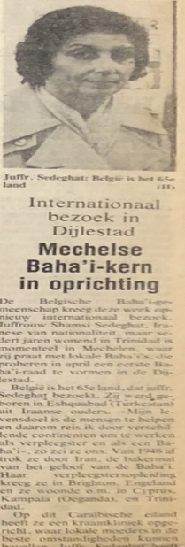
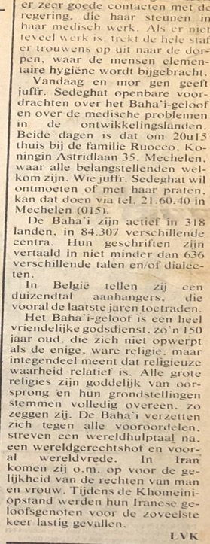
Article on Shamsi in a Belgian newspaper
I visited Denmark, March 1979
On March 14th, I arrived in Copenhagen and was met at the train station by Ms. Susan Abbot, a young woman who was wearing a “Baha’i Faith” button. She had been a Baha’i for eleven years and two years in Denmark. I said, “Allah-u-Abha.” She replied warmly and helped me with my heavy luggage and found a taxi to take us to the Baha’i Center where she lived. The Center was clean and cozy. She said she had not been able to find a hotel room for me, so she didn’t know what to do. I asked her why I couldn’t stay at the Baha’i Center. She said there was no extra room at the Center because it was very small. I told her not to worry because I’d be happy to sleep on the floor. She said that if I was willing to do that and stay with her, she would be very happy to have me stay at the Center. I replied that I would be happy to stay there and that anyway we would be out all-day teaching and only be at the Center in the mornings for breakfast and at night to sleep. I ate simply—usually bread, cheese, and tea—so I would be no imposition. A few other American pioneers came over, and Susan introduced me to them. They took my biography and translated it into Danish. They had not had my biography previously and only knew that an Iranian Baha’i lady was coming. They were not aware of all that I had done with the media in other countries and in terms of making courtesy calls to high officials.
While we were speaking, a letter arrived from Mr. Ole Helbo, the secretary of the National Teaching Committee. In the letter, the committee welcomed me to Denmark and provided a ten-day schedule of activities for me. We consulted on the plans and tried to prepare the materials which we would need for these activities.
Met several friends and discussed the Faith
Later that night, I was taken by Mr. Nodvig to his warm house where we said prayers and broke the fast. Then we went to a school where we spoke with a teacher and her students about the Faith. We returned to the Baha’i Center where I spoke there with Mrs. Peyman and Mrs. Malihah Vahman, and arranged to go to their town library in Fredensburg on Thursday for a teaching meeting as this town was one of the goal areas. At 10 p.m. they brought us to the train station, and we took two trains and then walked home where I was given extra blankets to stay warm then went to bed.
Visited the city of Copenhagen
The next morning, March 15th, we took the train to Copenhagen and walked through the cold to reach the radio station. Once there, we were told that the person in charge would be back at 3 p.m., so we went to get a taxi to a shopping area where I could buy some warm clothing. Then we went to a newspaper where the editor knew that I was from Iran. He asked me about the situation in Iran. I answered that I didn’t know because I was always travelling and not getting news from there so they probable knew more than I did. He told me there was unrest. I said that I hoped that everything would quiet down and that by the help of God there would be unity and peace very soon. Then he let me know that he had no time now but if I phoned next week, he would arrange a time for an interview. We exchanged business cards, and I gave him my biography and left.
Visited a Turkish language radio station
We took the bus to a Turkish language radio station where we met up with Mr. Rustam Yuksel, a Baha’i who worked there. I spoke for an hour about the Faith with his colleague who then turned to Rustam and asked him why he had never explained the Faith to him. Mr. Rustam answered that he preferred to live according to the principles of his faith, and he was not very good with words.
Visited the town of Fredensborg
That evening I took three trains to get to the town of Fredensborg which was north of Copenhagen, to attend a fireside. The seeker who was there listened to an explanation of the twelve principles followed by a discussion of Christian topics. The seeker said that nothing he had heard was new and that all of these teachings were in the Bible. I was asked to say a few words. I quoted the opening paragraphs of Baha’u’llah’s Book of Certitude:
“No man shall attain the shores of the ocean of true understanding except he be detached from all that is in heaven and on earth. Sanctify your souls, O ye peoples of the world, that haply ye may attain that station which God hath destined for you and enter thus the tabernacle which, according to the dispensations of Providence, hath been raised in the firmament of the Bayan.
The essence of these words is this: they that tread the path of faith, they that thirst for the wine of certitude, must cleanse themselves of all that is earthly -- their ears from idle talk, their minds from vain imaginings, their hearts from worldly affections, their eyes from that which perisheth. They should put their trust in God, and, holding fast unto Him, follow in His way. Then will they be made worthy of the effulgent glories of the sun of divine knowledge and understanding, and become the recipients of a grace that is infinite and unseen, inasmuch as man can never hope to attain unto the knowledge of the All-Glorious, can never quaff from the stream of divine knowledge and wisdom, can never enter the abode of immortality, nor partake of the cup of divine nearness and favor, unless and until he ceases to regard the words and deeds of mortal men as a standard for the true understanding and recognition of God and His Prophets.”
This illustrated the importance of letting go of acquired knowledge for a seeker who wanted to understand the truth. I explained the progressive nature of religion. Virtues such as love, compassion, unity, honesty, truthfulness, generosity, and justice, remained the same in all religions but new social teachings were revealed to address the times such as the equality of men and women proclaimed by Baha’u’llah. These ideas pleased the seeker whom we then invited to come to our public meeting.
I visited the town Humlebaek
Mrs. Susan Abbot then drove me from the fireside to her town of Humlebaek where she served as the secretary of the local assembly which had the goal of raising Fredensborg to assembly status. She appreciated what I read which she felt moved the seeker.
Attended a meeting at the Conference Hall, 1979
That night, the snow fell steadily, and I caught a cold. I was able to stay in, and the friends brought delicious food with which to break the fast. In the evening I bundled up and went to the conference hall for our meeting. Among the twenty people there was a young Turkish woman who wanted to become a Baha’i to which her father was opposed. I spoke about the development of the Faith around the world. After my talk, she came up to me and told me that she was happy that her brother had heard me speak. I assured her that if she accepted Baha’u’llah in her heart, the doors would gradually open, and her brother would see the truth. An Iranian Baha’i, Mr. Eshraq Khodadoost, came up to me and said that the mayor of the town in which he lived was a woman, and he wanted me to meet her. I also met two members of the National Spiritual Assembly of Denmark, Mrs. Helga Schioler and her son, Mr. Leif Schioler. We consulted about the use of the news media. They were hoping that at my next newspaper interview, I would correct the disinformation regarding Baha’is in Iran by using a statement issued by the Baha’i International Community office in New York City. I showed photographs of the Baha’i community in Trinidad, and everyone was amazed at the progress of Cause there.
Ms. Else came on March 17th to take me to the hospital to meet the Director of Nursing and Midwifery who took me to see the facilities. Back in her office, we spoke about the Faith. Afterwards, Ms. Else and I sat in the waiting room to meet people. One young woman had a father whose friend had come from Iran and told them about the Faith. There was also a man from Greenland there who was an artist and had done the cover of a Baha’i book. He took out his materials and drew a portrait of me in fifteen minutes which I have to this day.
Mr. Eshraq Khodadoost came on March 19th to take me to try to meet the mayor of his town but she was away, and then we went to schedule an interview at the newspaper, Politiken.
We met the Mayor of Copenhagen
Ms. Kama Jorgenson and I were successful in meeting the mayor of Copenhagen that day. Though the secretary said the mayor was busy and we would have to come back, we said a few prayers that God opens the doors. When the secretary heard that I was from Iran, she asked us to sit for a while. She was able to get the mayor out to meet us. I thanked him for taking the time to see us despite his busy schedule, and I said this showed that he respected others and reflected the Baha’i teaching that we are all “leaves of on tree and fruits of one branch.” I told him about my travels and that I had come to teach about this new religion and its universal principles. I showed him my photo album and informed him that the Baha’is in Denmark were working for the betterment of the people and were obedient to the government. He asked me about the clinic in Trinidad and the Baha’i community there. He signed a photo book about Copenhagen and gave it to me. I thanked him and gave him a copy of Baha’u’llah and the New Era. He asked me if I had been to their hospital and said that it was free for all people. I told him that I had seen it, and I praised it. I invited him to future Baha’i Holy Days and hoped he would attend. We thanked him for his time, and he walked us out. Once we were outside, Ms. Jorgensen expressed her surprise at having been able to meet the mayor and having been given such a warm welcome, especially since we had not made an appointment prior to coming to his office. I said that was the Bounty of Baha’u’llah.
Met the news media
Ms. Jorgensen was expecting me at the Politiken newspaper the next day, March 20th. I was taken there by Mr. Fereydoon Vahman whose wife was studying dental surgery in Denmark and both of whose children spoke Persian, English, and Danish. The reporter, Mr. Jan Stage, was interested in hearing about my background in Iran. Before the start of the interview, I gave him a brief overview of the Faith. He said that the chief editor was only interested in an interview about the conditions of the Baha’is in Iran, so I gave him the Baha’i international Community’s statement on this. He read it and wanted more details. I told him that the Baha’is did not engage in partisan politics and did not engage in criticism of the Iranian regime. The work of the Baha’is was to bring love and unity to the world. He said that he was travelling to Iran the next day and would try to meet Baha’is there. I showed him photos of the Baha’i Houses of Worship, so he could see the good work of the Baha’i community. He had been to the temple in India and had found it to be very beautiful. Before leaving, I invited him to our New Year’s party and explained that ‘Naw-Ruz’—meaning ‘new day’—was both the Spring Equinox and our new year. We were also celebrating the end of the fasting period. He asked me if we drank alcohol during this time, and I told him that taking alcohol and or narcotics was forbidden by Baha’i law. After a little more talk, we thanked him for his time and left.
Meeting at the Baha’i center
At the meeting later at the Baha’i Center, I was asked to say a few words. I got up and expressed my appreciation at being among them. I mentioned the cold and the snow outside of the Baha’i Center and the warm, loving, and peaceful atmosphere inside. Then I spoke about my visit to the Politiken newspaper and meeting Mr. Jan Stage and his gracious words about the Baha’is and the article which he would be writing about the Baha’is. I told them to go forward and put in practice the Baha’i principles of love, peace, and harmony, and help to educate people so they could progress. The day would come that all people and nations would understand each other and live and work peacefully together. Baha’u’llah wrote: “The world is but one country and mankind its citizens” so this would come to pass. The meeting broke up, and we socialized. Some seekers said that they were intellectually convinced about the Baha’i Faith, but their hearts needed more time to accept it. They promised to come to our future meetings. Everyone went home except Mrs. Shomeys who stayed behind and helped clean the pots and pans. A lot of food was left behind so we stored it for the next day’s Naw-Ruz celebration, and then we retired for the night.

Celebrated Naw-Ruz at the house of Mr. and Mrs. Khodadoost, 1979
The next day was March 21st, Naw-Ruz, the Baha’i New Year. When we got up, we wished each other ‘Happy New Year”. I had a headache due to some eggs having been in my food, so I took two aspirin and drank some tea. I packed my bags. Mr. Khodadoost phoned me, and we congratulated each other for our meeting with the mayor. He told me that there was a national newspaper strike, so we would not be going to the Politiken newspaper as it was a national publication. Therefore, Mr. Khodadoost said he would come to take me to his home and from there we would go to the train station. I agreed. Then Ms. Sasan phoned to tell us that Mr. Roling in Kolding informed them that I would be arriving there at 6 p.m. that day. Mr. Khodadoost arrived and helped me put my suitcases in his car. We took photos with me holding my suitcases while standing in the snow. At his home, I met his grandmother who was the daughter of Mr. Ebn-i-Asdaq, his two sisters, who were about eighty years old and had pioneered for eighteen years in Denmark. In 1914, they had been on pilgrimage for seventy-two days in the Holy Land and had wonderful photos from that time. The table was set for Naw-Ruz just like in Iran, with lots of sweets and fruits and other delicacies. I was warmly welcomed and ate a delicious lunch. Other Iranian Baha’is soon arrived: Mr. Vahman Senior with his wife and son; Mr. Fereydoon Vahman with his two daughters—his wife was home sick; Mr. Peyman Senior and his wife who had been pioneering for twenty years. We sat for a while, were served some of the delicious food, and we spoke about last night’s meeting and what we could do better. Time was short, so we took photos together and then said goodbye. Mr. Iraj helped me with my luggage by putting it in the car. We rushed to the train station, got on the train, and after a five-minutes, we took off. The train car came onto the ferry, and we crossed the water for an hour. On the train there were two young men who were travelling to France and Spain. We spoke about the Faith together. They already knew something about it because they had met Baha’is at their medical school. They said they would look up the Baha’is in the phone book and attend meetings.
Arrived in the town of Kolding
The train rolled back onto land and reached Kolding. Susan had given me some fruit which I brought for my hosts. At the Kolding train station, a young woman came up to me and said “Allah-u-Abha”. I replied, “Allah-u-Abha” and embraced her. She said that her name was Ms. Bente Jensen. She was Danish and had been a Baha’i for two years. She helped me with my luggage, and we went to her house by taxi. She welcomed me to her home and showed me a room that was warm and cozy. We put my luggage in it, and I gave her the food that Susan had given to me so that she did not have to cook. We warmed up the food and started to eat and then we said prayers for the meeting which she had organized for Naw-Ruz. She placed lots of fruits and sweets on the table for the meeting that night.
By 8 p.m., there were two young people who had come: one was Mr. Challoner Chute, a newly arrived young American Baha’i, and the other was Mr. Thierry Geradez, a Frenchman who declared in Denmark. We spoke for a while. I encouraged them to be active, and they countered that people there were not interested in religion. They had participated in direct teaching with fourteen other Baha’is but there had not been any declarations. Then Ms. Jensen phoned Mrs. Leila Kiersgaard Hansen whose husband had been a very good Baha’i, but he had become inactive. They had a house and a three-year-old child. Ms. Jensen told her about me over the phone and invited her to come see me. Ms. Hansen accepted, and soon, she came over. I was introduced to her, and we warmly greeted each other. I encouraged them and told them not to be afraid to speak about the Faith. Our teachings are good for the world and are the medicine that can cure the ills of today. They answered that in Denmark, people did not want to hear about religion. I said that this was true everywhere, and especially in the West, but we Baha’is could warm them up, invite them to our homes and public meetings, and gradually help them understand the teachings of God. I said they should invite their friends and relatives to the meetings where they could listen to a speaker. This would have some effect on them. They would feel happier which would encourage them to learn more. Thierry, the Frenchman, pointed out that it was 11 p.m. and the last bus was leaving so he had to go catch it, but he said that he liked what he heard and would be back tomorrow. I said to Leila that if she thought her husband would benefit from meeting me, I was ready to meet him. She said she did not think it would help because he had become an atheist, and soon she left. The only one who stayed behind was Mr. Chute. He said that he would come the next day to take me and Ms. Jensen to the newspaper for an interview. At night, we would go to the library where we would have a public meeting. We agreed, Mr. Chute left, and we all went home and retired for the night.
Visited a few members of the news media and others, 1979
Mr. Challoner Chute phoned the next morning, March 22nd, to say that he was expecting us at the Baha’i Center. Ms. Bente and I took the bus to the Baha’i Center and from there we went to the office of Kolding Folkeblad where we met Mr. Erling Grau, the managing editor. We sat together and explained the purpose of our visit and spoke about the Faith. We gave him booklets about the Faith and said that the same night; we would be holding a public meeting and asked him to attend if possible. He said that by all means, he would send a photographer and would write a favorable article. We thanked him and left and went to see Ms. Helle Jaahl, the reporter for the Jydske Tidende. We explained our purpose to her. She knew about the Faith, and we spoke about it. She asked us to come back at 3 p.m. We took a few photos together. In the meantime, we did some shopping and went to a restaurant to eat and wait for a hearing ear. Challoner started to speak with an old man. I went and found a long-haired man and sat next to him and gradually started to converse with him about religion. He said he had no interest in religion, and that he does not work much. He was homeless and showed me his bundle of old bags and said this was his home because he slept inside them. I explained to him about God and His prophets and their teachings. Then Challoner came, and we both continued and gently and lovingly explained about God and the purpose of Creation and the duty of us who were created to help others and then others would help us. We gave him some Baha’i pamphlets to read. He said that he had been working on ships and had travelled to many ports. He said he would read the materials. We said goodbye and left. We saw that Ms. Bente was no longer there. We did not know when she had left us, but she seems to have gone home. So, Challoner and I went back to the newspaper to have my photo taken for the article, but it seemed to be closed due to the strike. Therefore, we went home and saw that Ms. Bente was there but was not feeling well.
Attended a small public meeting and met a photographer from a newspaper
We made a meal and ate and then went to the public meeting which was held in beautiful big hall. Unfortunately, there were only four Baha’is in addition to me. The photographer from the newspaper came. We sat and talked for a while about the Faith and showed the photos of the Baha’i temples. The photographer thanked me because he said that this time he understood much more about the Faith. He took a few photographs for the article and left. We sat for some more time, and I spoke to the Baha’is about the Baha’i New World Order and the Baha’i Administrative Order which they liked very much. We all said goodbye and left. The weather was very cold. They brought me home.
I had a message from Hamburg
There was a message for me that the Baha’is of Hamburg had phoned me and said they were expecting me on March 24th as they have arranged a meeting for me. I phoned immediately and told them that I hoped to be there that day at 1 p.m. to which they replied that I would be most welcome!

Planned to go out for teaching, to get my ticket for Hamburg and visit news media
The next day, March 23rd, I planned to go teaching in the afternoon with Mr. Challoner Chute. Before that we phoned to work out my ticket to Hamburg. Duke—Mr. Chute’s nick name—called to volunteer to come and take me and my luggage to the Baha’i Center where I would be spending the night and tomorrow, we would go to the train station. He arrived, and we took the luggage and went to the Baha’i Center. There we sat and drank tea with Mr. Thierry Geradez. Mr. Rudi, a Baha’i who had not been active and had not been feeling well, arrived. He had seen the Baha’i Center sign, and the books in the window in front of which people were standing and reading. Seeing this, he was motivated to go in. He walked in, and we were introduced. We began speaking about the Faith and its progress. He was encouraged by what he heard. He took us to the Jydske Tidende newspaper where Ms. Helle Jaahl worked. She informed us that the photographer was not available yet and asked us to return in an hour, so we went to the other newspaper, Kolding Folkeblad, and spoke with the editor, Mr. Lars G. Hansen. He wanted to know if a photograph had been made of me, and we answered that one had not. He said that we should come back tomorrow at 6:30 a.m., and a photograph would be taken at that time. We returned to Ms. Helle Jaahl. The photographer was there and took a photograph of me. I saw that Mr. Jaahl had started to write the article. I asked him to please shorten the section about me and include more about the Baha’i teachings. He replied that I mustn’t worry as he would write about both. I asked a young man who was working there if there were any Baha’i books in the local library. He answered that there were, and he had found their number and location. I went to see the Baha’i books in the library. I found some books. One was Baha’u’llah and the New Era. These books were next to the books on Islam. I asked him if I could contribute to the library some additional books on the Faith. He answered that I could, and that these should be in Danish and English and, of course, they should be checked by a committee. If the books were accepted by the committee, they would be placed in the library and, if not, the books would be returned to you. I invited him to the Baha’i Center that night. He answered that he was not interested at all. I asked him how he could not be interested if he did not know the subject about which I would be speaking. I pointed out that he was an educated person and should not reject something without first hearing about it. He agreed, and I told him I would be speaking about God, His prophets, and His teachings such as the education of children and youth, the equality of men and women, the harmful effects of drugs and alcohol, and others. I took out my charts, explained them to him, and asked again if he was interested. This time, he laughed and realized that he had spoken too soon the first time. He was more interested now and gave us his name, Mr. Norman Christenson, so we gave him literature about the Faith and invited him to our future gatherings. We said goodbye and left.
Back to the Baha’i Center
When we got back to the Baha’i Center, Mr. Thierry Geradez was there, and we ate together. The Center was warm and cozy so, despite the lack of bedding, I decided to sleep there. Then, by the Grace of God, Ms. Laila and her child, and Ms. Bente came with blankets and pillows and a sleeping bag. We had a cup of tea and waited for people to come to the center, but no one came. I asked Mr. Duke to go out in the street and invite people in. When he came back, he said that there was no one about. Then we saw two women standing outside reading the materials in the window. Thierry quickly went outside and invited them to come in. We all introduced ourselves and in simple English began speaking about the Faith. The two women stayed and talked until 1:30 in the morning. One of them said that she had already read all the ideas we had been discussing in her schoolbooks. Ms. Bente said that these ideas were older than any of us and many people knew of them but did not know their source. The women liked this answer and asked for literature on the Faith. Before they left, they said they would come to future meetings. After everyone had gone, I slept on the floor which was warm if not comfortable.
I left for Hamburg, 1979
The next morning March 24th, I beseeched ‘Abdu’l-Baha to make these teaching efforts successful. I got my luggage together. Mr. Challonen Chute and Mr. Thierry Geradez came by unexpectedly, which made me happy. They hailed a taxi for me and loaded my luggage into it. On our way to the train station, I asked that two copies of my interviews in the Kolding newspaper be sent to me and gave them my address in England. We said goodbye, and I thanked them for their help and their service to the Faith and left for the train station. There I boarded the train at 8:57 a.m. and reached Hamburg at 12:10 p.m. In my compartment there was another lady who got up and went into another compartment as soon as I came in. The other compartment was too cold, so she returned. She asked me if I was Indian, and I answered that I was not, that I was Iranian but born and raised in Turkmenistan in the Soviet Union. She said she had been to India and would never go again. I realized that she needed much guidance, more than I had time to give her, so I simply listened as she spoke. She reached her destination and got off, and new passengers came in. Among them was a young girl who worked in an insurance department. We started talking and the subject of the Faith came up. She said that she was a Christian and did not believe that any other prophets would come other than Jesus Christ. I agreed and asked if he had not read the Biblical passage from John 16:13: “But when He, the Spirit of truth, comes, He will guide you into all the truth.” I said that Baha’u’llah was this ‘Spirit of Truth’, and He came over one-hundred years ago, and if she heard some of His truth, she could judge it for herself. She said nothing more. We arrived in Hamburg.
Arrival in Hamburg
No one was at the Hamburg station to meet me. I waited for a while until the ticket seller helped me to bring my luggage into the restaurant. I thanked him, and I sat and ate with the same Christian girl I had met on the train. I asked her to keep an eye on my luggage while I went to change money. I phoned the home of the Granfars. I had known Mr. Saeed Granfar when I had been a student in Brighton, England, from 1951-1954. Mrs. Parvin Granfar, his wife, answered. She welcomed me and told me that Mr. Mahdizadeh was coming to get me. They had guests who were waiting to have lunch with me. She said that I should go have him paged in the station and wait for him by the information counter. I did this, and Mr. Mahdizadeh came and welcomed me. He had been waiting for me in another area. He helped me with my luggage, and we took a subway train for a half hour ride to the Granfars’ home. I met several other Iranian families−Mr. Rahimi and his relatives, Mr. and Mrs. Granfar and their daughter Suzanne, the mother of Mrs. Granfar who was pioneering in Holland, among others. They all welcomed me warmly, and we ate delicious Iranian food. I told them all about my trip, and the wonderful Baha’is and non-Baha’is I had met and some of the teaching successes.
Celebrated Naw-Ruz at Mr. and Mrs. Maher and returned to the home of Mr. and Mrs. Granfar
After lunch, the guests left, and I was taken to the home of another Iranian Baha’i, Mr. and Mrs. Maher, who were having a Naw-Ruz gathering and wanted me to come celebrate with them. Several Iranian youths were there. I was asked to speak about my trip. First, I excused myself for being all bundled up because I found Denmark’s weather to be very cold. I spoke about the progress of the Faith in many of the places I had visited and especially in Trinidad and Tobago. The meeting finished, we had refreshments, and we returned to the Granfars. The Granfars had four daughters and one son who was studying to become a pilot. They had bought a large property which they were turning into a nursing home. We spoke about tomorrow’s plans, and then retired for the night.
The weather was very cold when I woke up on March 25th. The young Turkish woman who had been working in the house for two years for the Granfars was reading Baha’i books and going to Baha’i meetings and had a very positive impression of the Faith. After breakfast we prepared to go to the railway station. Mrs. Parvin Granfar gave me sweets and fruit for the trip and had arranged for my ticket such that I could stop off in Bremen on my way to Frankfurt. At the railway station we said goodbye, and I left.
Arrival in Bremen
At 4 p.m., I arrived in Bremen. Dr. Amir Hushang Amai and his sister, Khanum Mahvash Amai, met me. They welcomed me, and we put my luggage in the car and left for the house of his mother, Mrs. Sogra Khanum Amai. When we got there, we took my luggage in, and I was welcomed by the family. At 5 p.m., a young lady and an eighty-year-old German woman arrived. They apologized because they were so busy with their work. Dr. Amai said that he worked from 6 a.m. to 8 p.m. every day and had not time for anything but his work and home life. If he did not attend properly to his patients, his practice would suffer. I listened and then pointed out that this was a pattern everywhere I had been. We had to pray to Baha’u’llah for strength and endurance, so we could serve the Faith to the best of our ability despite our hardships. So, we said a few prayers together, and I read the passage from ‘Abdu’l-Baha: “O God I am prepared to endure any ordeal in the path and desire with all my heart and soul to meet any hardship.” Then we ate a delicious meal which had been prepared and went to sleep at midnight. My hosts phoned Mr. Mehraban Mehrain to let him know when I would be arriving in Dusseldorf.
Went to Dusseldorf, March 1979, met by Mr. Samimi
The next morning, March 26th, Dr. Hushang Amai, who had been pioneering in Germany for thirteen years, and his sister took me to the train station where I caught the 12:27 p.m. train to Dusseldorf. They gave me food for the trip, and I thanked them for all their help and left. I was welcomed by Mr. Samimi at the Dusseldorf station. I got off the train, and he helped me with my luggage. We went by car to a hotel and got a room. Then we went to the home of Dr. Mahdi and Mrs. Lamieh Varqa, the brother of Hand of the Cause Mr. Varqa, who were very good friends with my dear sister Qamar Khanum and her husband Rostam Aqdassi, in Karaj, Iran. We spoke about my travels and remembered the time when Hand of the Cause Mr. Varqa was visiting Trinidad and Tobago and had taken many photographs in my Rezvan Clinic which they said they had seen. Then we ate a delicious supper together and went to the home of Mr. Masood Misaqian who had a beautiful home and where a meeting was being held for Iranians, including Mr. and Mrs. Pezeshkian whose father had been martyred and Mrs. Bahereh Kardan who had been my dear friend for the past forty years. We all spoke about our activities and the progress of the Faith. I said that I was very surprised that they had put me in a hotel because wherever I had travelled, I had stayed in the homes of the Baha’is or in the Baha’i Centers. I had slept on floors, mattresses, and couches. I told them about American and Iranian Baha’i youth who were serving in the Caribbean and Africa and who slept in huts surrounded by mosquitos.
They said that Mr. Pezeshkian would come to take me to a newspaper interview the next day. Mr. Pezeshkian owned a store that sold rugs, and he had built a Baha’i Center in the memory of his departed mother in Victoria, Cameroon. I encouraged the Baha’is to follow his example of service. Then we had refreshments, and Mr. and Mrs. Samimi, Ms. Bahereh Kardan, and the mother of Mr. Samimi all accompanied me to my hotel. They left, and I went to my room and thanked Baha’u’llah before going to bed.
The next morning, March 27th, I got a phone call from the lobby that a woman wanted to meet me. I told them to send her up. I saw that it was my old friend, Ms. Bahereh Kardan. She said that since yesterday, she had not been able to sleep because they had put me in a hotel, and she wanted to explain to me the reasons but did not know when I was coming and was not able to plan for me. We spoke together about what we had been doing since we had last seen each other. Then we went downstairs with my luggage and had breakfast.
Arrival of Mr. and Mrs. Pezeshkian
I met these wonderful husband and wife pioneers, spoke for a while, and then they put my luggage in their car, and we left. Bahereh Khanum got off on the way, and Mrs. Pezeshkian got off when we arrived at her husband’s store. Then Mr. Pezeshkian and I went on to the newspaper where a young lady greeted us and sent us into the newsroom. Another young lady invited us to sit down while she made several calls. At 11:50 a.m., a young man, Mr. W. Tomek, came, and we were introduced. I told him a little about myself and my work for the Bahá’í Faith. He became very interested and said that he had not heard about the Faith until this moment. He said that if science and religion went hand in hand, if the origins of all religions are one, and if universal peace is needed then we welcome this idea. Then he asked Mr. Pezeshkian when the Faith had come to Germany, where did we meet, and what were some more of the teachings. Mr. Pezeshkian answered his questions, and we gave him a few pamphlets on the Faith. He said he would read them and would write a very positive article about the Faith. We gave him our address, thanked him, and left.
Mr. Pezeshkian took me to the train station. We were running late and had to hurry to catch the train. I said goodbye and boarded the train. The friends in Dusseldorf phoned ahead to let Mr. Ata’ullah Furutan, the brother of Hand of the Cause Mr. Ali Akbar Furutan, know that I would be arriving later than originally planned. When I got off the train in Koln, I saw a man in a leather hat and a big smile on his face running towards me. This was Mr. Mahmood (Isa) Rastegar, with whom I had studied in the class of Mr. Alavi, a Baha’i scholar, in Mashhad, Iran. We were very happy to see each other after all those years. He told me that Mr. Ata’ullah Furutan had already phoned him to say that Shamsi Sedaghat was arriving today, so he came to the station to pick me up. They hurried to the station but did not see me because I had been delayed so they waited until my arrival. He helped me put my luggage in a locker, and we went to the home of Mr. and Mrs. A. Furutan.
I received a warm welcome from Mr. Furutan’s family
At Mr. Furutan’s home, I met Mrs. Tahereh Khanum and their two sons, Farhad and Hootan. Their third son, Firuz was married and lived elsewhere. The Furutans had prepared a delicious Iranian meal. We spoke about Mr. Khosrow Foroutan, his nephew, and his wife, Soraya (my younger sister), and their children Navid, Omid, and Sholeh, whose photos I had and showed them. I told them what each one was doing in their lives, and they were happy to hear the news.
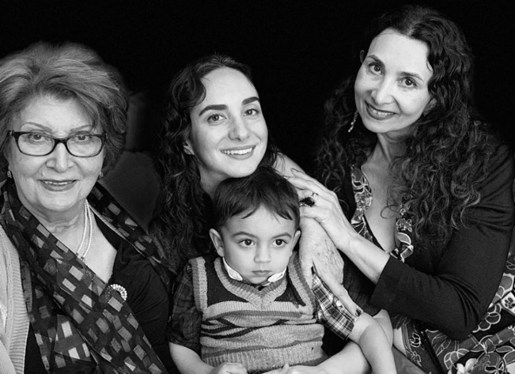
This picture has four generations: 1) Mrs. Soraya Foroutan, 3) Mrs. Sholeh Foroutan Wolpe, (daughter of Soraya), 2) Ms. Camille Wolpe, (daughter of Sholeh), and 4) small child, son of Camille, in her mother’s arms
Visited Mr. Issa Rastegar’s home, 1979
Then Mr. Rastegar took me to his home where I met his German wife, Mrs. Margaret, and his teenage daughter. Both spoke Farsi. They received me with great warmth and respect and served refreshments. His wife went to teach, and we looked at photos of their wedding and other gatherings. They had a beautiful house. On the ground floor there was a carpet store. The family was successful in its business and very active in the Baha’i community.

Went to the Baha’i Center
We went to the Baha’i Center where many Baha’is were gathering including Mr. Zamyadi and his family and Mr. Soheil Samandari. They welcomed me and asked me to speak. I thanked them for having me there and then I spoke about mass teaching in the schools where fifty students accepted the Faith (I had heard that Dr. Mahdi Samandari had written from Cameroon to Mr. Soheil Samandari about these declarations). Then Mr. Soheil Samandari spoke about some of my activities in different countries and praised and encouraged me. I thanked him for his encouragement. Then we had some refreshments and arranged for my media interview the next day to which Mrs. Margaret Rastegar and her son Farhad would accompany me. They were all thankful for me being with them. After, we returned to the Furutans where they arranged a place for me to sleep, and we retired at midnight.

We had breakfast and good teaching discussions
The next day, March 28th, 1979, after we ate breakfast, Mrs. Furutan and I spoke about the progress of the Faith in the countries which I had visited. Mrs. Furutan told me that people in Germany were not interested in religion and tended to be materialistic but, nevertheless, when they accept the Baha’i Faith, they become very active. She said that many Iranian Baha’is there had been financially successful and had the means to build or rent Baha’i centers. I encouraged her to be steadfast and go forward, and the day would come when they would have their own Baha’i center. Then Mr. Furutan joined us for breakfast, and we continued our discussion of past activities and the current situation. They enjoyed hearing about all the advancements of the Faith.
Had a good interview by Mr. Rudolf Spiegel
We got up, had our breakfast and drove to the interview at the newspaper office. We were joined by Mrs. Margaret Rastegar. At the newspaper office, we were taken to meet Mr. Rudolf Spiegel and introduced to him. When he heard the name ‘Furutan’, he said he knew a Furutan who was an architect and had designed his house. Farhad introduced us all to him. He became friendly and asked about my activities. I told him a little about them and showed photos of my visits to other countries and my meetings with prominent officials. He began to speak in German with others, and I asked that this please be translated. He said that Mr. Spiegel was saying that he would read the materials before writing the article. I asked for permission to speak for five minutes to explain the principles of the Faith. I showed my charts on progressive revelation and the Baha’i principles. Mr. Spiegel listened carefully and then asked questions. He wanted to know how many Baha’is there were in the world, how many in Dusseldorf, where Baha’i meetings were held, how donations were collected and handled, and whether we had built any schools. I gave him a photograph of the Bahá’í House of Worship in Germany and a few pamphlets. He said he would read them and write an article and that this was the first time he had ever heard of this religion. I said, “God bless you, I am sure you will be successful in writing a good article”. We said goodbye and left.
Mr. Mahmood (Isa) Rastegar joined us
Then we visited a 700-year-old church beautifully decorated with stone work and stained-glass windows. We had lunch nearby after which Mr. Rastegar joined us. I said goodbye, and he took me to the train station, got my luggage from the locker and put it in his car. We then drove to Langenheim to visit the House of Worship. I said prayers there for all my family and friends—those still alive and those who had passed on. I wished them the bounty of forgiveness and prayed for the success of my teaching trip. Then we went to the Baha’i bookstore where Mr. Rastegar bought me a few postcards of the temple and a book by Dr. Forel. Then I saw the Baha’i World volume #15 in which there were some photographs of me with Hand of the Cause Mr. Muhajir and Mr. McShine, the Attorney General of Trinidad and Tobago, and a few others.
Visited the Baha’i National Center of Germany
We went to the Baha’i National Center where we met the Secretary of the National Spiritual Assembly of Germany and his wife and family. We also met a few of the friends from Turkey for the Turkish Conference, as the German Baha’i community assisted with the teaching of the Faith to Turks, such as Mr. Jahed Vekil, an Auxiliary Board Member, Mr. Ali Aksinal, and Dr. Marufi. We spoke about the Faith and its progress in the countries where I had travelled. Then Mr. Rezvanu‘llah came and took me to the home of Mr. Hans-Peter Diebel and his wife Hildegard in Bad-Hamburg where a meeting was being held. There, I met Mr. Mohtady and his wife who was the daughter of Mr. Vafai whom I had met in Ahwaz, Iran, and their son, and Mr. and Mrs. Loui. They all welcomed me warmly and asked me to say a few words. I again spoke about my interviews with the news media, the mass teaching, and the courtesy calls to prominent officials which I had done in many places with good results. Then I said they should concentrate their work in these areas, and they will have great victories. They all listened attentively and thanked me for reminding them. We then arranged tomorrow’s plans to take me to the newspaper and from there to a newspaper interview in the town of Neckargemund. Then Mr. Khabirpoor phoned to say that they were expecting me as well. We all had some refreshments, and then Mr. Mohtady spoke about the Ahwaz and Pars hospitals where the people still remembered me and praised my hard work. When we were finished, we said goodbye, and Mrs. Peter Diebel took me to the Tannus Hotel and after saying a few prayers, I went to bed.
We spoke with the owner of the hotel about the Faith
The next morning, March 29th, I spoke about the Faith at breakfast in the hotel with Mrs. Bluthgen, the owner of the hotel. Mrs. Hildegard Dickel arrived with her child and joined us in our discussion on the Faith with the hotel owner. She exchanged addresses with the hotel owner for future contact.
Mrs. Dickel went to take her child to the doctor and then returned to pick me up and take me to Mr. and Mrs. Louis’s house. Mr. and Mrs. Khosrow Mohtady would come there to take me to the newspaper in Neckargemund for my interview and then to the Baha’i meeting.
When Mrs. Dickel returned, she took me to the shop of Mr. and Mrs. Loui. There Mr. and Mrs. Mohtady and their two sons were expecting me. They drove me to Neckargemund and the house of Mr. and Mrs. Khabirpoor where we immediately left for the newspaper office for an interview. We met a lady who was not very friendly. We spoke with her for a while. She said they had no reporters for the moment but if we wrote an article and brought it, she would print it on Monday. We spoke for a little while longer and gave her some Baha’i literature and thanked her and went back to the house of Mrs. Khabirpoor.

Visited Mr. Ardashir Hezari and his daughter Tahirih Khanum
On March 30th, I was taken to the home of Mrs. Tahereh Manavi and her father, Mr. Ardashir Hezari, who was a Baha’i of Zoroastrian background from Qazvin, Iran. He was a very young looking ninety-three-year-old and still had a very good memory. He chanted several prayers for us beautifully. He had been an active Baha’i in Iran and the other countries where he had lived. His son was Mr. Habib Hezari who was an active Baha’i in Iran. There, he had been a great help to our Baha’i teacher and scholar, Mr. Eshraq Khavari, who was writing numerous books on Baha’i subjects and translating books from Arabic to Farsi. Mr. Habib Hezari left Iran for England. He lived there with his family and was active in the Bahá’í community. He assisted Hand of the Cause Mr. Balyuzi with his research by getting books from libraries and individuals and finding photographs. He had also helped me personally to find a nursing school in England, the Royal Sussex County Hospital in Brighton. Mr. Ardashir Hezari was also the father of Tahereh Khanum who was married to Mr. Habib Manavi who was pioneering in Istanbul, Turkey. They served the Faith constantly, and their home was like a Baha’i ‘hotel’ for the Hands of the Cause, the Counselors, and travel teachers who stayed there. I had stayed there for one month when our family was pioneering in Cyprus.
We went to news media for interview
Ms. Gertrude Kuhn, a German lady, came over to Tahereh Khanum. She had accepted the Faith but had not been very active. I spoke with her for a while and encouraged her which made her happy. We ate a delicious lunch and then Mrs. Tahereh Manavi, Ms. Kuhn, and I went to the offices of the Mannheimer Morgen newspaper for an interview. We found the contact person, and I introduced myself and told him about my travels and then asked if it would be possible to arrange an interview. He was very busy at the time. He asked me if we were having a public meeting, so he could send a reporter. I said we were having one that night. I asked him if he had ever heard of the Bahá’í Faith, and he answered that he was in a hurry and had to go. I quickly showed him my chart on progressive revelation and said a few words about each prophet, and then I gave him pamphlets about the Faith. I said now he could read them if he wished, or he could discard them if he desired. I said I only wanted him to know about the Baha’i Faith. He said he would read them. Mrs. Tahereh Khanum asked for his business card so that she could bring future Baha’i visitors for interview. He went into his office and gave her his card. We thanked him and then left.
March 30th, 1979, we had a nice gathering at Tahirih Khanum Manavi
At Tahereh Khanum’s home, we prepared for the evening dinner with a few Iranian Baha’is and non-Baha’is. Mrs. Ari, who had met ‘Abdu’l-Baha, came over with a friend who was called Dr. Mashidi, and he, in turn, brought his non-Baha’i mother. There were four other seekers: a mother, her daughter, and her son-in-law, with his son, who were all Tahereh Khanum’s friends. When the meeting started, the hosts welcomed me and then asked me to speak about my travels. I got up and thanked everyone for their assistance and warm welcome even though, in some cases, they had not known me before. I described the many meetings at which I had spoken. The principle of unity had attracted people to the Faith. Mrs. Ari said that though she had been coming to Bahá’í meetings for a longtime, that night she had understood the Faith better than she had before and asked for books on the Faith which she received. All the guests then left except the family of seekers with whom I spoke at length about the Baha’i Faith’s fulfillment of Christian prophecies. The son-in-law liked what he heard but said he needed more time to study the Faith, so he could accept it with his whole heart and sign his declaration card. I told him not to hurry but to study diligently and, when his heart accepted the Faith, he could join and start serving humanity. He said he would and then the family left, and we stayed to wash up before going to bed.
Attended a Turkish Baha’i Conference
The next morning, March 31st, I had prayers and breakfast with Mr. Hezari. Afterwards, the family and I took photographs together, and then we went to visit the Bahá’í House of Worship, where we said prayers for the success of our endeavors. Then went to join the Turkish conference which began at 2 p.m. Mr. Berjis, the Secretary of the National Spiritual Assembly of Germany, graciously welcomed the attendees. Mrs. Margot, the representative of the committee for teaching minorities, welcomed everyone warmly and said she hoped we would all enjoy the conference. Then Mr. Mehmet Vekiloglu, (the nephew of Mr. Abbas and Samireh Vekil, who were the Knights of Baha’u’llah for Cyprus), got up to welcome us as well. They were followed by several representatives of the National Spiritual Assembly of Turkey: Mr. Jahit Vekil, Dr. Mehmet Marufi, and Mr. Habib Manavi. These three were very active and well-known Baha’is in Turkey. Each spoke on a specific topic, and then we had a break for lunch. The afternoon session began with songs followed by a question and answer period. A talk was given on the Five-Year Plan followed by a consultation on its implementation and finally, a closing prayer.
After the conference, visited several Baha’i families
After the Conference, we went to the home of Ms. Heidi, a Canadian who was the Assistant Secretary of the National Spiritual Assembly of Germany, for dinner. Then we were off to the home of Mr. Farhang Vafai, the brother of Mrs. Khosrow Mohtady for a fireside. Everyone there was Baha’i. Mr. Mohtadi Paymans’ two children and a daughter of Mr. Vafai were also there and said prayers for us by heart. I spoke about the lives of the Bab and Baha’u’llah and then spoke about the Holy Days on which work was suspended. After this we all had refreshments, and after everyone had left, I was taken home and went to bed.

Attended the second day of the conference, 1979
After the morning prayers and breakfast, Ms. Heidi took me to the Baha’i Center at 8:30 a.m. the next morning, April 1st. The Conference got underway, and I was asked to speak in place of Mr. Habib Manavi. I spoke for a half an hour about the training and education of children and youth especially in the West, where children who come from the East are confronted with a new language and a new culture. I said that a child must be trained from the cradle through childhood, first by the mother then the father. I told them about my father who had been very kind and hardworking and had provided for us and had also insisted on good and respectful character and behavior from us. He trained us according to the instructions of ‘Abdu’l-Baha. Although he was not a professor or highly educated, he had a well-trained mind and was sufficiently educated to be able to guide himself and educate his children especially when we were living in Ashgabat and Cyprus. He was appointed to serve on the Teaching and the Service Committee in Ashgabat, and the local Assembly in Cyprus, and was always helping whoever was in need. Then I spoke about the methods of mass teaching and individual teaching. During my talk, I spoke in Turkish which the friends appreciated very much. They asked me many questions and afterwards, they took photographs of my teaching charts and posters. The meeting ended with everyone having learned something, and we were happy.
Many photos were taken of my charts, and I was asked if I could speak later about the difference between ‘one by one teaching’ and ‘mass teaching’. The Conference continued with various subjects being presented, and the sessions concluded with a closing prayer after which everyone left for lunch. I went to eat with Mr. Isa Rastegar, the two Chelepi brothers, Mr. Usuf, Mr. Yashar, Mr. Aksoy, the convention photographer, and his mother, father, and brother. We ate a simple meal and had light conversation until it was time to go back to the conference.
Attended afternoon session of the conference
The afternoon session opened with prayers. Mr. Jahit Vekil, a member of the National Spiritual Assembly of Turkey, spoke about the Baha’i life and encouraged the friends to live accordingly, followed by Mr. Habib Manevi who spoke about Baha’i laws, and then I spoke about the importance of daily teaching. After a few more speakers, there was a closing prayer. Then we rushed over to the temple for the three-p.m. weekly public meeting. At the Temple, prayers were said in many different languages. Afterwards, many of us were asked to speak about different teaching methods. I told them that we should first begin our teaching in private homes, and then, in public places, we should speak according to the needs and interests of the audience. Mr. Vekil Oglu became very excited about the teaching work and invited me to return to Germany as his guest, and he would organize large public meetings for Baha’is and non-Baha’i Turks; He said he could also hold deepening class for the friends. I thanked him and answered that I would consult with the Universal House of Justice and let him know. After the meeting concluded, many came up to embrace me and exchange addresses, including Mr. Kazemzadeh. There was a young lady by the name of Mrs. Semra Erdogan, who had recently married to a non-Baha’i Alavi Muslim. She asked me if I could go and speak with her husband that evening so that he could be more enlightened. I had already accepted Mr. Vafai’s home for dinner and his sister, Mrs. Mohtadi, had already left to prepare the evening meal. Mr. Mohtadi phoned his wife to tell her I would be coming later as I had an opportunity to teach the Faith to Mr. Gazi Erdogan, the husband of Semra Erdogan, who was not a Baha’i.
I with several Baha’is visited the home of Mr. and Mrs. Erdogan
Mr. Isa Rastegar, Mr. Jahit Vekil, Mr. Ali Akpinar, Dr. Mehmet Marufi, Mr. Yusuf Chelepi and his wife, and Mr. Mohtadi, got into three cars and drove to the Erdogan home. The Erdogans welcomed us warmly, and we spoke about different aspects of the Faith. Mr. Erdogan agreed with what he heard and said that the principles of the Baha’i Faith were similar to those of the Alavi Faith with a few differences such as not permitting those who had been divorced or lived morally wrong lives to come to the Alavi meetings. I said that the Baha’i community does not restrict people from coming to meetings. Baha’is accepted all people with love. They taught Baha’i principles to every person and let them decide whether to accept them or not. If a person did not accept them, that individual would not be shunned by the Baha’i community but would be encouraged to live a moral life. Religion belief was a matter of private conscience. Mr. Erdogan accepted these ideas and said he would continue his study of the Faith after completing his upcoming University exams because at the time, he was studying engineering while working as an accountant.
We warmly thanked the Erdogans for the gathering, and then Mr. Rastegar and Mr. Mohtadi drove us all in two cars to Mr. Mohtadi’s home where a delicious dinner was served. Later, Mr. Farhang Vafai and his wife came downstairs and joined us as well. We sat up talking together until 12:30 a.m. I told them about all the enrollments I had seen in other countries, especially among the youth, during this teaching trip. I recounted all the courtesy calls I had made to the heads of African states, each of whom had shown interest in the Faith, and all the interviews I had given over the radio and on television even though we had often been initially refused. I told them the story of being admitted into the presence of an African chief who had been unwilling initially to admit us but after my gentle conversation, I was able to explain our purpose for coming which was to bring the Baha’i principles of love and unity and the method of the education and training of women, children, and youth. Then he invited us to sit down and join him. After listening to us, he invited us back for the following week when we could speak to a larger group. We returned the next Sunday. There were many people present. They introduced us, and I spoke about the Faith and its principles. When I finished, I asked if they thought these teachings were good. No one said a word. After a few minutes, the first person to accept the Faith was this chief! As soon as he accepted the Faith, many men and women who were under his authority also joined him. This gave us a great joy, and we regularly returned to deepen the new believers and gradually we had a very nice community there. I explained to the Vafais that what we needed was enthusiasm and zeal and to rejoice in whatever victories we experienced. These words seemed to inspire the friends that night. Mr. Farhang Vafai went upstairs to bring down his camera. He took photos of all of us and then gave me his camera which was very kind of him and fortuitous for me whose camera was not working well. Although I did not want to accept it, Mrs. Mohtadi encouraged me to take it, saying that it would be a memory of Mr. Vafai and that I could then pray for him as well. I accepted the gift and thanked him profusely as I really needed a good working camera to record my meetings with important figures and others whom I met in my travels. Mr. Rastegar left at 1 a.m., but we continued to talk until 2 a.m. Then we said a prayer and retired to bed.
Went to the railway station to adjust my tickets
The next day, April 2nd, 1979, Mr. and Mrs. Mohtadi, Keyvan, and I went to the home of Mrs. Semra in Frankfurt, and then we went to the train station. They wanted to leave me there and go on themselves to the class, but they realized that it would be difficult for me to accomplish what I wanted if I was alone, so they decided to stay with me. We exchanged my existing tickets and bought tickets from Frankfurt to Bern, Switzerland. The extra cost was generously covered by Mr. Mohtadi who did not accept my offer of payment. I told him I would donate the difference to the Baha’i Fund in Trinidad and send him a receipt. Then we went to Pan Am to change my ticket from Germany to Washington DC, instead of London, where I would rest for a few days before returning to Trinidad to help with the election of the local assemblies during the Ridvan period.
Then, I met two active Baha’is, Mrs. Nategheh and her husband, Mr. Hushang Saffar, a bone specialist, and their two children, Farid and Mitra, who both spoke Farsi. We went to the Baha’i Center and took my belongings, said goodbye to the friends, and went to Mr. Mohtadi’s home where we had lunch. From there we went to Mrs. Semra, a hairdresser who did my hair. When we saw the time, we realized that I could not catch my train back in time, so Mr. Mohtadi asked for Mrs. Saffar’s home address in Duisburg and said he would take me himself.
Arrived in Duisburg at the home of Mrs. Saffar
At the meeting in Duisburg, there were several Iranian and German Baha’is and two non-Baha’i friends. There was a lady from Sadiyeh in Shiraz, Iran, who had just come from there. She told us how people had looted their homes and set fire to their property. They were all very upset. I told her “not to be upset. I will tell you the result of these calamities later”. The meeting began with a few prayers. I began to speak though I was upset about the news that I had just heard from Iran, but I told them in a calm voice that “you are witnesses during these days to the different nationalities, religious backgrounds, and cultures that are gathered together in a spirit of love and unity here, speaking, eating, and sharing our views with each other. This is the result of the power of the love and unity which the prophets of God have brought for us which we can receive if we study and understand the teachings well. I have travelled throughout many parts of the world”, I told them, “and met people from the Caribbean, Africa, Americas, Europeans, and Indians and others. I have never seen a Baha’i from any of these countries think or do what the average non-Baha’i did in those countries. Baha’is love and respect all, even if they are hurt by others because the Bab, Baha’u’llah, Muhammad, Jesus, Buddha, Zoroaster, Moses, Krishna, and Abraham all came to enlighten humanity, so it can gradually grasp the purpose of creation which is to love and respect each other. Maybe some prophets had given teachings that were a bit stronger than others, but those teachings were for a specific time. As humanity matured, religion progressed, and new teachings were revealed for a new day. Jesus Christ had said: ‘Whosoever shall smite thee on thy right cheek, turn to him the other also’ which means that we must not retaliate but instead show love to those who hate us. This response makes the aggressor sorry for his actions and many become less aggressive. If this teaching spread, we will see more forgiveness and forbearance, and ultimately more love and unity which are the goals of all the prophets of God and, especially Baha’u’llah.” These words soothed the hearts of the friends who were present there after hearing about the terrible events in Iran. After we said a prayer, we all retired for the night.
Leaving for Nuremberg, 1979
The next morning, April 3rd, Mrs. Saffar phoned the train station to find out when the trains were departing. My train would be leaving at 1:30 p.m. She phoned ahead to the Baha’is in Nuremberg and told them I would be arriving at 4 p.m. We then ate lunch and left for the station as it was far away. At the station, Mrs. Saffar helped me put my luggage on the train. On the train, I sat with a black American and his white German friend. I could see they had a good friendship, and I praised them both for this saying that it was the new generation which would bring in love, peace, and unity. The old generation was too steeped in old prejudices. The youth were more open to new spiritual ideas and would not accept ideas that would prevent the progress of humankind towards a better and more prosperous life. The white German got off the train, and I continued speaking with the black American, Mr. Walter Hainsley, who was working with the American forces in Germany. Gradually, the subject turned to the Baha’i Faith. I showed him my charts and photos. He said he had heard the name ‘Baha’i’ but knew nothing about it. He was pleased to learn more about the teachings of the Faith. I gave him a photo of the Temple in Germany and a Baha’i pamphlet in English. He gave me his address, so he could learn more about the Faith, and he said he would look for Baha’is.

Arrived in Nuremberg
We arrived in Nuremberg at 4 p.m. Mr. Hainsley helped get my baggage off the train, and we said goodbye. Mr. Ata’ullah Enayati and Mr. Azizullah Panahi, my old friend and classmate in the Baha’i Academy in Tehran, were there to help me as well. We took the luggage and put it in the car and drove to Mr. Enayati’s home. The house was a beautiful two-story palace with beautiful carpets all over the floors; Mr. Enayati was a carpet dealer. His German wife opened the door and warmly welcomed us in. The mother of Mr. Enayati, Khanum Bashi Enayati, was also there and welcomed me. I brought in a small bag with me but left the rest of the luggage in the car. I had refreshments and reminisced with Mr. Panahi about our many beloved teachers such as Mr. Eshraq Khavari and Mr. Fazel Alavi from our days together over thirty years ago. Mr. Badiullah Panahi and his wife were also present. He was highly educated and was a successful carpet merchant.
Mr. Panahi gave the guests a long introduction about me. I spoke about the excellence of the Baha’i youth in the Caribbean, Africa, and America, in their knowledge of the Faith and their service to the Cause. I expressed my happiness at meeting the Baha’is of Europe and hoped that the German youth who had Persian parents would not forget the Farsi language of their parents. If it became possible, they might be able to visit Iran in future where they could share their knowledge of the Faith and the world with the believers. The meeting came to an end with a prayer and refreshments. I was later invited to stay on a warm room and went to sleep.
Tried to get an interview with Nuremberg Nachrichten
The next morning, April 4th, after breakfast Mr. Enayati and I went with Mr. Azizullah to the house of Mr. Badiullah and from there to the newspaper offices of Nurenberger Nachrichten. We introduced ourselves to a lady who said that we should come back at 1:30 p.m. and go to room 205 to meet the Director of Religious Affairs. So, we left and went to the carpet shop of Mr. Enayati and then to the office of Mr. Badiullah Panahi who was writing a book about the prejudices of non-Baha’is. We spoke for a while about the importance of the Five-Year Plan, my teaching trips, and pioneering to goal areas. After some refreshments, we headed back to the newspaper offices. There, the Director of Religious Affairs showed us news about the Baha’is in Iran. We said the information was not correct and wanted to give accurate information to the readers. He assured us he was into writing about politics. We explained to him the real situation and gave him accurate information. He said he would write an article about the situation. I asked him if it would be possible to get a copy of it for me, and I gave him my business card. We all thanked him as he walked us to the elevator, and we left.
The next morning, April 5th, Mehnaz, Fariba, Odet, and Simin, the daughters of Mr. and Mrs. Enayati, came by to say goodbye before going to school. Then we ate breakfast, and I got my luggage. Mr. and Mrs. Enayati, Khanum Bashi Enayati, brought me to the railway station. There, Mr. Enayati got a porter who took my luggage and put it on the train. Mr. Enayati bought me a packet of Polaroid film as a gift, and I thanked him. He invited me to return to Germany for one month and stay with them to help with the teaching and consolidation work. He gave me an envelope with a one-hundred-mark bill for my expenses. I thanked him but said I would be donating it to the Baha’i national fund of Trinidad and Tobago. I asked that he write his name and address on the envelope, so I could send him the receipt. I invited him to come to Trinidad and join in our teaching efforts.
After passing a few stations, arrived in Zurich, then to Bern
We were all very sad and had tears in our eyes as I boarded the train which then departed. On the train I met a young Greek man, and I spoke with him in Greek. He was very surprised that I spoke Greek especially since I had left Cyprus fifteen years ago. I changed trains in Stuttgart. In the station, I put several postcards of the German House of Worship in the mailbox for friends back home in Trinidad. Back on the train, I ate the sandwiches which had been given to me by Mr. and Mrs. Enayati. We arrived in Zurich and with the help of two Swiss people, took my luggage onto the next train bound for Bern. In Bern, Mrs. Margaret Zabih met me at the station. We were delighted to meet each other, and she helped me with my luggage. We took two trains to get to her house which was well-furnished and had good photo of her late husband, Mr. Manuchehr Zabih, on the table. We ate a delicious supper and then left for the meeting at the Baha’i Center. There I met a few people including Mrs. Agnes Hizschi from the newspaper Berner Zeitung BZ who was there to interview me. I spoke to her about the prophets and their teachings using my charts. She took some notes and waited for the meeting to start. More people arrived, including two seekers. Mr. Paul Stirnoman and his wife Bertha were there also. They had been pioneers in Germany for four years. He was Swiss and in charge of a library. His wife did not speak German
The meeting began, and I was introduced and asked to speak about the role of women as the first teachers of children. I expressed my pleasure at being there and meeting all of them and seeing Switzerland which I had always heard about its peacefulness and spirit of tolerance.

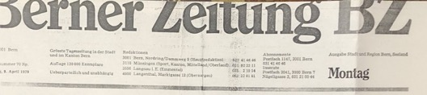
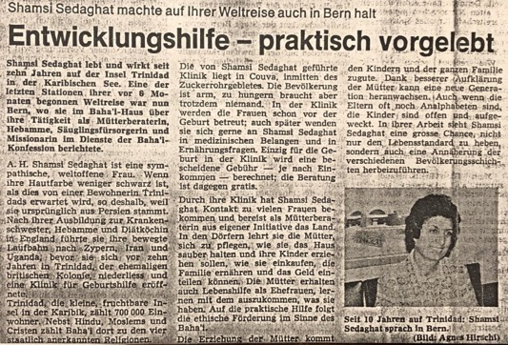
My short speech at the Baha’i Center
I said:
“Baha‘u’llah has taught this love between people for this Dispensation. The first duty of humanity is to know and to worship God, and we cannot know God except through his manifestation. Baha’u’llah wrote, “I loved thy creation, hence I created thee. Wherefore, do thou love Me, that I may name thy name and fill thy soul with the spirit of life.” He said, “Love Me.” How can we love Baha’u’llah or any of the other prophets of God if we do not obey their commandments? Their commandments are their teachings and principles. One of Baha’u’llah’s teaching was universal compulsory education. This education and training start in the mother’s womb through birth, childhood, and youth. The mother is the primary educator, and she teaches the child good habits such as getting up early in the morning, going to bed early, learning prayers, and virtues such as obedience, cleanliness, chastity, love, among many others. Of course, the mother herself should model these virtues so as to be able to teach her children. This kind of training of children is even more important than education. An educated child who is not virtuous will struggle in life.”
The reporter who was still there asked me about my clinic in Trinidad, and the services I provided my patients. I explained to her that I provided free service for women who came to my clinic before the birth of their child including anti-natal checkups and checking for any abnormalities about which I would alert a doctor. Then after the delivery, I would charge a very affordable amount and a sliding scale for those who did not have much money. In the clinic, I provided meals for the women in the common dining area. If they were open to it, I would speak to them about God, His Prophets and their teachings, and the importance of obeying the Divine teachings. If a patient had problems at home, I would counsel her. After the delivery I would provide free follow-up service for a month so if they had a problem with their newborn, they could come around to the clinic, and I would help them. The reporter, Mrs. Agnes Hizschi, was pleased by the interview. She said that initially she was planning on only staying for a short time but when she saw the warm gathering, she stayed for over two hours. She told Mrs. Zabih that I was “a remarkable woman.” We exchanged information and took a photo together then said goodbye and left. Then a Baha’i lady brought me a portable bed to sleep on, but we thanked her and left back to Mrs. Zabih’s home.
Preparing to leave for Austria
The next morning, April 6th, I packed a sandwich and some fruit for my trip to Austria. We stopped by the Baha’i Center where we saw Mrs. Eva Gloor, the secretary of the teaching committee. We spoke together about different teaching methods and meeting people in the news media and high-ranking officials. After our conversation, we drove to the Swiss Air offices and the train station to arrange my tickets to Austria, France, and then Washington DC, to arrive on April 15th. Then we returned to the Baha’i Center.
There, we had a snack at the Baha’i Center where Mr. Rastegar, Mr. Majzub, and Mr. Mohtady phoned to invite me to stop in Koln for a short rest. I thanked them for their generosity but had to decline due the lack of time I had left. I invited them to come to Trinidad and help us there.
Mr. Stirnman took me to the train station where I caught the 1:10 p.m. train to Zurich. On the train I met a young woman with whom I spoke about the Faith and gave her a booklet on the Faith and the address of Mrs. Zabih so she could get further information. The young woman said she lived in Zurich and had been in Haifa and seen the Baha’i holy places.
Arrived in Feldkirch in Austria
I changed trains and boarded a train for the town of Feldkirch, Austria, where the Baha’is were having a meeting to which I had been invited. The weather was very cold and snowy. I reached the station at 5 p.m. I didn’t see anyone at the station. A Filipino lady came up to me and asked me if I was looking for someone and I said, “Yes.” She apologized and said that she had sent a young man to meet me, but he could not find me. Another young Baha’i named Walter Haus came up and warmly said, “Allah-u-Abha.” I replied, and he took us to his car and drove to a shop. He had some work to do for a half hour and then we got back into his car and went to his house outside of town. We drank some hot tea to warm up.
Then we made dinner for the guests who were coming. The guests arrived. Mrs. Josie introduced me to the guests who included Mrs. Analise, a travel teacher from the U.S., and Mrs. Hedi Poor-Rahim, the wife of Mr. Iraj Poor-Rahim, son of Mr. Poor-Rahim, a tailor in Mashhad, Iran, who was also a travelling teacher. We ate dinner and then started the meeting. Mrs. Analise spoke for a half an hour and then she showed a slideshow “God’s Eternal Ocean” which was translated into German. The hour grew late, and the guests were growing tired. I was asked to say something, but I suggested we have some tea first to refresh ourselves. Refreshments were served then members started again at 11 p.m. I only spoke for a few minutes about the positive atmosphere in the meeting. After my talk I invited the youth to come visit us in Trinidad and said goodbye and left.
I got up early the next morning, April 7th and was taken to the train station. The Baha’is phoned ahead to Mrs. Ruth Hediger in the town of Chur. I thanked everyone and climbed aboard the train. The train was delayed so we sat in the station. When we arrived at the next town of Buchs, the train was again delayed. When we got to the town of Saragan, I transferred to the train for Chur. I had alerted Mrs. Hediger of the delay.
Finally arrived in the town of Chur
When we finally reached Chur, the snow was falling through the trees. The mountains looked very pretty like a Christmas scene with green trees capped by white snow. Near the ticket counter a young man came up to me hurriedly and asked, “Are you the traveler who has just arrived?” I answered, “Yes, Allah-u-Abha.” He took me and my luggage to his car and told me, “Barbara has sent me to pick you up. My name is Jean-Claude.” We stopped at the market to buy some food and then drove to Barbara’s home. She was a dedicated Baha’i and a pottery maker. Her fiancée, Jean Claude, was a potter and an engineer but not a Baha’i. They made lunch, and we spoke about the Faith. Jean-Claude was listening and agreeing with what I was saying. Then we went off to a fireside at the home of Mrs. Ruth Hediger. No one had arrived at the fireside, and Mrs. Hediger began to cry in disappointment. I assured her that, she had worked hard, prepared the meeting, supper, and then no one came but there were many reasons why people hadn’t come, and she couldn’t know all the reasons. She said that she was worried that I would think she had done nothing. I replied that she shouldn’t worry because I knew she had done all that was needed, and Baha’u’llah had accepted her service in His path. She became much calmer, and I retired to bed. Later that same night at 10 p.m., there was a knock on the door. It was a seeker who then sat for two hours with Mrs. Hediger spoke about the Faith, its principles, and the progress of the Faith around the world. She gave him literature on the Faith and invited him to future meetings. When I heard all this, I said to her, “You see God did not let too much time pass, this same night had sent a seeker to you and you yourself have taught him. This is your reward which I promised you would receive!”
The following morning, April 8th, Mrs. Hediger, Mrs. Barbara, her fiancé, Jean-Claude, and I sat for prayers after which I took out my charts. They listened carefully and when I was done speaking, I turned to Jean-Claude and praised him for being such an active and knowledgeable young man that I hoped he would investigate the Faith so that he might become a Baha’i and teach its beautiful principles to others. He answered that, God willing, he and Barbara would get married and pioneer to the South of France. I said “I pray that it will happen.” We had a quiet day, and I started to prepare for the rest of the trip. Then we went to bed early.
On April 9th, 1979, I got up and had breakfast with Mrs. Margaret Zabih and we spoke about what we had accomplished. Praise be God, for all His bounty. Mrs. Zabih suggested that we go to the Baha’i Center after breakfast to meet Mrs. Dorothy Samandari, who was the daughter of Mr. Masood Khamsi, a counselor for South America. I said I know Mr. Khamsi very well. He used to visit Trinidad and Tobago frequently to assist with the teaching work. He was loved by all of us.
At the Baha’i Center, we met Mrs. Dorothy Samandari who was a friendly and well-educated, American woman. We sat and chatted for a while and spoke about the work of the Faith. She invited me to go to their home in Commugny and from there to go on to Vernier. She phoned her husband, and they arranged that I stay overnight at Mrs. Zabih’s. Early the next morning we’d go to the railway station where Mr. Samandari would meet me and take me to his home in Commugny. We would have lunch and go to Vernier. We agreed on this plan and said goodbye to Mrs. Dorothy Samandari and left.
I did some work and met a few people and spoke about the Faith
Mr. Paul Sternman brought me to the railway station. I changed money and went to make six photocopies each of my two teaching charts, one of each to be sent to Mrs. Majzub, Mr. Isa Rastegar, and Mr. Mohtadi in Germany, as per their requests. When I had done this, I went to the waiting room and arranged my papers and waited for Mr. Paul’s return. Mr. Paul went to the Baha’i Center and returned with his wife and a friend.
Had an afternoon tea in a hotel
From there we went for afternoon tea to a hotel where several American, Swiss, and Greek ladies were sitting and having their afternoon tea. They welcomed us as we sat down and brought us a cup of tea. I added extra milk and sugar to my tea to give me a little strength as I’d had no lunch! Mr. Paul had brought two copies of today’s Berner Zeitung, the local newspaper, in which a short biography about me and several of the Baha’i principles were published. They translated aloud for me the article into English. The ladies learned a bit about the Faith, and so I had the opportunity to explain further about the Prophets and their Teachings and the Baha’i Faith and its principles which spoke of love and unity, peace, and harmony. Then one lady asked, “Why with all these good teachings is there so much animosity among people?” I replied that:
“This is our problem and not God’s! He has guided us and is still guiding but man does not want to hear Him, so as long as we disobey God, the problems of the world will continue and even worsen. The sooner we accept each other, and the sooner we disregard the differences of color and religion and love each other, the quicker peace and understanding will be established on earth. Baha’u’llah said: “The earth is but one country and mankind its citizens,” and this will come to pass.”
One person then asked why the Baha’is of Iran were persecuted though the teachings were so good. I answered that I did not know why and what was happening there since I had been on an eight-month long teaching trip. Baha’is, I explained, did not interfere in politics, and obeyed the laws of the Government except if we are asked to recant our religion. In that case, we are willing to suffer or be martyred. The ladies listening all nodded in agreement and said that they are tired of these problems around the world and that they hoped that one day, these would come to an end. We all said that we also hoped so as well. We invited them to our meetings and said goodbye and left.
Then, we returned to Mrs. Zabih’s home where we had a nice meal and read from Mr. Zabih’s teaching booklets. She presented me with one of these booklets for which I thanked her very much, and we said a prayer for the elevation of his soul and went to bed.
The next morning, April 10th, Mrs. Zabih phoned Mr. Sternman to come to the station to help me, and then she brought me to the railway station. She paid for the taxi and did not accept any money from me. I wrote in her notebook and thanked her for her hospitality and the teaching booklet which she had given me. I said goodbye to her, and she left.
Mr. Sternman arrived and helped me get my luggage from the baggage area and take it to the waiting room. He then went off and bought some postage stamps, and I sent the charts which I had photocopied for the friends in Germany. The train came at 9:36 a.m. Mr. Sternman helped me put the luggage in the cabin. The train left for Geneva, and I arrived at 11:48 a.m. Mr. Mahmoud Samandari, the auxiliary board member for France, was waiting for me. He was the son of Mr. Ruhullah Samandari, the Director of the Samandari Travel Agency in Tehran, Iran. He had been in Europe for ten years and was married with the daughter of Mr. Masood Khamsi, Mrs. Dorothy. He studied international law and in his free time, he worked for the Samandari Travel Agency which belonged to his father. He was a very polite, gentle, and active Baha’i. He spoke Farsi, English, and French, and at the 1978 International Convention in Haifa, he served as the French and English translator. His wife, Mrs. Dorothy Samandari came later. She welcomed me and then we went to a pizza restaurant and enjoyed a delicious lunch courtesy of Mr. and Mrs. Samandari.

Visited the home of Ms. Martha Rossier for a fireside
After we had finished eating, we drove to the house of Ms. Martha Rossier in Vernier for a fireside where Mr. John Paul, the auxiliary board member for Switzerland, was the speaker. Ten Baha’is and a Catholic clergyman were present. He spoke briefly and then there were questions and answers. Mr. Paul offered to the clergyman to speak about Biblical prophecies. The other Baha’is added that the Faith had other teachings which they could talk about if he liked. Then I asked permission to speak and said that I thought we should speak of both the prophecies and the teachings. I went over several of the logical teachings of past revelations and the twelve Baha’i principles. Then we had refreshments and after that, I asked the clergyman what he thought about what he heard. He replied that since he did not know much about the Baha’i Faith, he could not judge but from what he had understood that evening, it was a religion with very good teachings on love and unity. We asked him if he’d like to have a Baha’i book to read, but he replied that until the end of April, he would have no time for reading which I respected, and then he left.
I met Mrs. Ghaznavi, a member of the National Teaching Committee there, who asked me to write a brief report for her about my teaching trip with any recommendations. I said I would. We thanked the hostess, Miss Martin, and returned to Mr. and Mrs. Samandari’s home where Mr. Samandari’s mother, brother, sister, and grandmother all lived as well. I was given a beautiful warm room to sleep in.
On the morning of April 11th, Mrs. Shahin Samandari and I sat and reminisced about our happy days in England back in 1952 when I was a student. She knew my sister Soraya. She spoke about the training of the youth, saying that if the youth are trained and disciplined from childhood, they will grow up to have successful spiritual and physical lives, but if they are left to themselves, they won’t turn out well like many youths today.
After our conversation, we went to the Samandari agency to arrange my plane ticket to France and Trinidad. Then it was the time to go to a Baha’i meeting at the home of Mrs. Minoo Fallahi.
Then we went home and had tea together and went to the home of Mrs. Sobhaniyyih Fallahi, who was the eighteen-year-old daughter of Mr. Fazel Tehrani. They lived in Pully, near Logan Town.
We had a good meeting which included a newspaper reporter who was asked questions, and our replies were very simple. Refreshments were served, and the meeting ended at 11:30 p.m, and we returned to Mr. Samandari’s home and went to bed.
I left for France
Next morning after our breakfast, Mr. Samandari brought me to the railway station. He parked his car almost in the middle of the road, put his hazard lights on, and hurriedly helped me to the train and into my cabin. Then we said goodbye, and he ran back to his car.
I was the only person in my cabin, so I drew the curtains, arranged my luggage, and rested, using my shawl as a pillow and my raincoat as a cover. I had not slept much during my teaching trips, and this little rest helped me a lot. I was very hungry, though, because I had not had supper except for a sweet so I couldn’t sleep. When I arrived in France, two French girls helped me to bring my luggage to the tourist office where I got information about the Charles DeGaulle airport. I was given these directions: take the metro, change after two stops, take the tramway, and then the Air France bus. When I heard this complicated route, I thought of taking a taxi straight to Air France, but the price was 200 francs. I was very hungry, but I had no French money and Swiss money was not accepted. So, tired, thirsty, and hungry, I picked up two of my heavy suitcases down the metro station and then went back for the third, heavier one with great difficulty. I bought a metro ticket, but my ticket got stuck in the machine. I went to the officer in charge who came and opened the turnstile, but I still bought another ticket so that I would be able to exit the metro. A French policeman and a young Chinese person helped me. I had to repeat this procedure twice to transfer to reach the bus station of Roissy rail. I arrived at Air France where I caught the free bus to the airport at midnight. I had one hour to my flight to New York. I passed my luggage through and went and changed money and got a cup of coffee which—with lots of milk and sugar—I revived.
I left France for New York on Air France at 1:30 p.m. After drinking cup of tea, eating biscuits and a dinner, I slept a little. On the flight I also watched TV, received several free gifts from the airline, and spoke about the Faith with the person sitting next to me who said he had never heard about it. I encouraged him to visit the Baha’i temple in Chicago if he found the time. We reached New York in good weather after seven hours at 1:30 p.m. local time, while French time was 8:30 p.m.
I got off the plane, found my luggage, and passed through the customs. I had a problem with my booking which was resolved, and I went by bus to Braniff Airlines.

Chapter 14

Arrived in Washington DC, 1979
At 4:30 p.m. I boarded the plane and reached Dulles Airport, Washington DC, by 5:50 p.m. I put my luggage on the trolley, went out, looked around, and saw my sister Soraya Foroutan running towards me. Although this was the first time she had been to the airport alone, she drove us home safely. My mother and youngest sister Guitty Ejtemai, Mrs. Shahidian, mother of Shamila Khanum, my nephew’s wife, Mr. Esfandiar Aghdassi, who are very active Baha’is, were waiting at home to welcome me. I embraced each person and started to speak about my teaching trips. We had lunch and then I rested for a few hours. I woke up in a few hours and spoke more before we all went to sleep.
I slept until morning and woke up early still being somewhat groggy. I had lunch with my family the following day and at night, had a fireside. Several people came though I was still sleepy from jet lag but tried to be alert.
The next day, April 14th, I went to the shopping center with Soraya. When we returned home, I continued talking about my travels. Then we had lunch, and, in the evening, we went to the University for a public meeting. No one came except my family members. We sat, and I told them about my travels which they enjoyed. We went home and then to Mr. John Dugas’s home for coffee night where I was the speaker again. I spoke about my teaching trips including the newspaper interviews and declarations that took place wherever I went. Everyone enjoyed hearing about them and praised and thanked me. I told them that “if any one of you decide to go even for a one-month teaching trip, you will be successful as well as you will be nurturing others.” Many nodded in agreement. When I was finished, we had some refreshments and went home and gradually retired to bed.
Visited Mrs. Francis Coley
The morning of April 15th, I went to the home of Mrs. Coley, a very active Baha’i in the city. There were many people present for the fireside. I spoke about my trips, and the results of them. Everyone was very encouraged to the degree that several individuals had tears in their eyes from joy.
Afterwards, we went home where we had guests: Mr. Poor Rahimi, his daughter and her husband, Mr. Ardashir Yeganeh, and Mrs. Ruhi Huddleston, one of the most knowledgeable, educated, active, and generous Baha’is. Ruhi and her distinguished husband, Mr. John Huddleston, hosted Ruhiyyih Khanum whenever she was in Washington DC. Ruhi asked me to pray for her children, Taraz (Keith), the son, and Mehri-Bahiyyih, the daughter, so that they would become active Baha’is. I was very happy to see them. We sat down, and I spoke a lot about the past because Mr. Poor Rahimi was from Mashhad, Iran, and we knew each other very well. Then my cousins, Mr. Abbas Aqa Ejtemai (now passed away) and his Kobra Khanum Ejtemai, (friends of Baha’is), arrived. We all had supper together. Then they asked me about my trips, so I spoke about them, and again, all were pleased to hear my stories. Then I went with my luggage to the home of my eldest sister, Qamar Khanum Aghdassi, and slept there while the other guests returned to their homes.
I sent a report to the Universal House of Justice and asked for permission to stay in the U.S. with my family for a few weeks.
We stayed home from April 17th-19th and hosted family and friends who were happy to see me and hear my news. On April 20th I received a cable telegram from the Universal House of Justice. In preparation for reading it, I washed my hands and then opened it.
I also received a letter from the Spiritual Assembly of Sierra Leone which expressed that the Assembly appreciated my teaching trip to its country.
As we were going to the house of the Secretary of the Assembly of Alexandria for the annual election, we picked up Mrs. Teymourian on the way. While the votes were being tallied, I was asked to say a few words which I did, and everyone was very pleased to hear the great teaching news. When the election was completed, we had refreshments then we brought Mrs. Teymourian back, and we went home. Before I went to bed, I re-read the telegram of the Universal House of Justice and was very happy that it had asked me to undertake more teachings trips.
On April 21st, I said the Ridvan prayers and prepared the food for the Holy Day. At 11:30 a.m., we drove to the garden near George Washington’s Mt. Vernon estate. The weather was sunny and about 200 people were there, most of whom were Iranians with delicious Iranian foods. The Holy Day was lovely. I had many friends there such as Dr. and Mrs. Farhoumand, Mr. Yeganeh, Dr. Tirandaz, and Mr. and Mrs. Poor Rahimi, among others. I was introduced to many people and watched the musical program. At 5 p.m., we went home with my sister, Qamar Khanum, her son Esfandiar, and Shamila Khanum and her mother, Mrs. Shahidian. At home, we refreshed ourselves and went to a party in the evening in the cafeteria of George Washington University.
My mother made halva (Iranian pudding), and Soraya Khanum made “Sholeh Zard” (something like rice pudding). The gathering started with songs and piano music. I was asked to say a few words, so I got up and congratulated the youth for arranging such a celebration for the Anniversary of the Declaration of Baha’u’llah. I invited people to come to Caribbean Islands and African countries and witness how Baha’u’llah’s teachings on love, unity, peace, and harmony have transformed populations. People trust each other and help each other when needed. My words made a great impression on the audience.
Several non-Baha’is who were sitting at our table and were friends of my nephew, Navid Foroutan, were very pleased by what they heard and by seeing the love and friendship between the Baha’is and non-Baha’is at the celebration. There was a clergyman at our table, and I asked him if he had read any Baha’i books, and he answered that he had not and added that Christianity and the Baha’i Faith were different but that we had to tolerate and accept each other. I asked him why we had to just tolerate, why shouldn’t we investigate and find the truth. I asked him if he was expecting the return of Christ. He said that he was. I asked if Jesus had promised the appearance of peace and unity with His Return, and he said that he did. I asked if he knew the Biblical verse that, “You shall know the tree from its fruit?” and answered that he did. Then I said:
“Look at this gathering with a large crowd made up of people of different colors, creeds, nationalities and languages, sitting around the table in a spirit of love and harmony, eating and speaking together about believing in the principle of the “unity of mankind. Therefore, let us be united, let’s be friendly, let’s work together and make this world the Kingdom of God on Earth as it is in Heaven.”
Then he smiled and said nothing but everyone at my table got up and embraced me and wished me success in my future endeavors.
Mr. John Dugas came over to our table. He told us he had just been elected the Secretary of the Washington DC Spiritual Assembly, and that my sister Guitty Sedaghat Ejtemai was elected the Chairperson. He said he was very happy to serve with her on the Assembly. Then he said he was very pleased to meet the other members of my family—my older sister Qamar Khanum, her husband Mr. Rostam Aghdassi, Mrs. Soraya Khanum and her husband, Mr. Khosrow Furutan, and all their children, and my dear mother, who all serve our beloved Faith each according to their ability. I thanked him for his loving and encouraging words and wished him great success in his work and in our beloved Faith. We all said goodbye and went home.

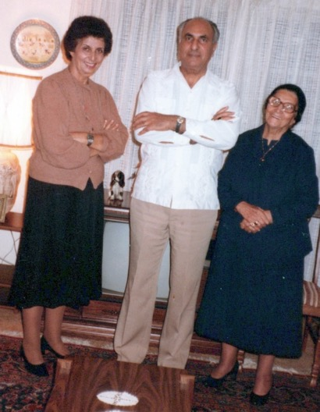
In Alexandria, Virginia, l. to r.: Shamsi, Mr. Rostam Aghdassi, my brother-in-law, Mrs. Leqaiyyih Sedaghat, my mother.

Cable to the Universal House of Justice
I cabled the Universal House of Justice a summary for this long and fruitful trip:
“BAHAIFAITH
Haifa-Israel
August body Humbly inform completion seven months Teaching trip North America Bermuda Sierra Leone Liberia Nigeria Cameroon France Belgium Denmark Germany Switzerland your prayers assistance host NSAs resulted presentation Baha’i literature seven African ministers Lord mayor Kopenhagen lecture Colleges Universities nursing schools public meetings excellent University lecturer Tribal chief formation 11 LSAs shared teaching experiences First West African Baha’i Women Conference Monrovia First Turkish Bahai conference Langenheim was invited return Germany help Teaching consolidation Turkish community Full report photos follow
Arrived Washington Implore Guidance whether advisable remain some months before returning Trinidad,
Respectfully, Shamsi”
Reply of the August Body, the Universal House of Justice
Two weeks later, I received the following guidance from the Universal House of Justice:
“Miss Shamsi Sedaghat
2939 Van Ness Northwest, Apt. 1202
Washington, DC
USA
30 April, 1979
Dear Baha’i Friend,
Following up on the cable of 19 April from the Universal House of Justice, we have been asked to convey for your consideration suggestions for your further travel en route home to Trinidad.
You may wish to consider visits of reasonable duration to Guatemala and El Salvador, to Costa Rica, Panama, and the Guianas before your arrival in Trinidad. Should you decide affirmatively you should contact the National Spiritual Assemblies concerned and the Continental Pioneer Committee for the Americas, suggesting a schedule and services you are prepared to undertake.
Trinidad and Tobago’s property goals were achieved at the last minute, its teaching and legal goals earlier, and total membership now is reported as being 6117. The fertile soil of these islands must be intensively cultivated, for a bountiful crop of souls can be harvested for the Cause of God.
Please be assured of the prayers of the House of Justice for your health and for your labors in service to the Blessed Beauty.
With loving Baha’i greetings,
Lorena Kerfoot
For the Department of the Secretariat.”

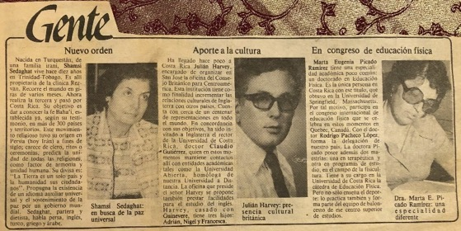
Article on Shamsi’s visit to Costa Rica
I expressed to the Continental Pioneering Committee my appreciation for all the support it gave me:
“Dearly Beloved Friends:
I wish to thank you cordially for all your devoted efforts and invaluable assistance in making my visits to the above areas a rewarding experience.
I am very much aware of all the details that normally go into making arrangements for such visits and this would like to express my deepest appreciation and gratitude to all those involved in scheduling and organizing these trips as well as to all the host National Assemblies and their committees who have offered help, assistance and hospitality in every conceivable form….”
I wrote a letter of appreciation to those who helped me on my trip
“Beloved Friends and Co-Workers,
One of the most cherished memories of my teaching trips to the various parts of the world is the acquaintance and friendship of the many friends whose assistance in innumerable ways have crowned these teaching efforts with success. If it had not been for those of you who either housed me, accompanied me in my contacts with the mass media and related dignitaries, it would indeed have been a most difficult, if not impossible, task to accomplish alone.
I will always dearly remember your kind help and the spiritual support and encouragement that every Baha’i teacher needs. I should have written this note of thanks earlier, but my tight schedule did not afford neither the time nor the appropriate frame of mind to do it in a befitting manner.
On my way to Trinidad, I have stopped in Washington DC to visit my family. On the recommendation of the Universal House of Justice, however, I will be soon leaving for further teaching trips to Central America, en route to Trinidad. I hope I will be in Trinidad by the middle of July, at which time my address will be as follows:
Shamsi Sedaghat
Rezvan Clinic
Couva,
Trinidad, WI
May God bless and confirm you in all your efforts. Please remember me in your prayers and do please convey to all whom I have met, my fondest regards,
Thank you again,
With Loving Baha’i Greetings,
Shamsi Sedaghat.”

Panama, June-July 1979
In the middle of the summer of 1979, I undertook a one-week travel-teaching trip to Panama. I received a warm welcome from a representative of the National Spiritual Assembly of Panama, Mr. Fred Berest, who was serving as the Auxiliary Board Member. He met me at the airport with his two daughters, Dian, and Barbara. They drove me to the home of Mrs. Winifred Morris and her daughter Kim who were my gracious hosts during my stay.
During my teaching trip, I attended the public meetings at the National Haziratu’l-Quds. There were about fifty people including Counselor Osborn. Some of the members of the National Assembly and the Auxiliary Board were present. Mr. Alan Pringle acted as my translator for this beautiful meeting.
I gave an interview to the television channel S.C.N. 8 program, “Que Pasa?” I gave a six-minute interview to Mr. John Stauter, a young American who was attracted to the Faith. The program would be aired on the 6th of July, at 6:35 p.m. I also had an interview with Capitan Masters of the Panama Canal Spillway newspaper. The article with photos appeared in the June 29th edition. Sgt. Harris who was in charge of the television production admired my interview and arranged the newspaper interview.
I had a twelve-minute interview with Ms. Migdalia Fuentes of Radio R.P.C. The translator was Mrs. Lucy Beres. The interview aired on the 27th of June around 7 a.m. I had a four-minute interview with Mr. Santamaria Llamas, a journalist on TV 4 R.P.C., which was translated by Mrs. L. Berest.
I attended a public meeting at the Baha’i Center in Colon which was the home of Mrs. Claries Buyal. Twenty-five Baha’is and several non-Baha’is attended this good meeting. Many questions were asked and answered.
I flew to David on the 28th-29th of June, where I was met at the airport by Mr. Hashemi and Mr. Golzari and their families who were Iranian pioneers. I was driven to the home of my host, Mr., and Mrs. Golzari. We consulted on our teaching activities. I asked the friends to take me to the radio station and other news outlets to see if interviews could be arranged. Subsequently, I had an interview at Radio Chiriqui with Mr. Rodney Querra for twenty-eight minutes which aired the same day at 6:30 p.m., after the news. I was fortunate to have an excellent translator in Mr. Hashemi. I had another seven-minute interview on VO2 del Baru radio station with Mr. Olmedo Morales. Soon after, I was interviewed by Mr. Monchi Cano on Radio Ondas Chiricanas. Listeners phoned in during my talk to thank the radio station and congratulate the manager for airing such an interesting program. The last interview was for live for five minutes with Mr. Onesimo Lezcano during the midday news on Radio Mia.
We had a small fireside at the home of Mr. Golzar attended by the Sanchez family who were very receptive to the Baha’i Faith and enrolled the next day. Soon the entire family became Baha’i. After giving a talk to ten people at a local school, I returned to the Canal Zone.
The following morning at 10 a.m., I met with fifteen youth at the home of Mrs. Morris. The meeting went very well, and I encouraged them to meet often and begin teaching activities. At noon, I gave a five-minute live interview on Radio Mia, translated by Mr. L. Berest.
I attended a tea party at the home of the Baldwins where there were over twenty guests. The atmosphere was warm and friendly. Many of the guests left with a better understanding of the Baha’i Faith and literature on the Faith. In the evening I attended a fireside at the home of Mr. Douglass in Pedro Miguel. Several Baha’is and their friends were present, and we had a very successful meeting.
During this busy teaching trip to Panama, I was greatly aided by Mrs. W. Morris and Mr. and Mrs. Golzar’s hospitality, Mr. Fred Berest, the Auxiliary Board Member, Mrs. Lucy Berest and Mr. Hashemi’s translation. Before leaving for Trinidad, I had a consultation with the members of the National Spiritual Assembly of Panama along with early morning prayers at the House of Worship.

Chapter 15

Pioneering to several other countries and islands
The Baha’i World was embarking on the new Seven-Year plan launched by the Universal House of Justice at Naw-Ruz, 1979. On an international level, the Plan called for nineteen new National Assemblies which included several in the Caribbean: Dominica, French Guiana, Grenada, the Leeward Islands, Martinique, St. Lucia, St. Vincent, and two Houses of Worship, one in Samoa and the other in India. There was a renewed call for travel teachers and pioneers who contribute, “So importantly to the unity of the Baha’i world and to a true understanding of the oneness of mankind….”

The letter from the Universal Houses of Justice
After returning in spring of 1979 to Trinidad from my six-month long travel teaching trip, I received an acknowledgement of my report from the Universal House of Justice. The letter is as follows:

“5 March 1979
Miss Shamsi Sedaghat
Rezvan Clinic
Couva, Trinidad, W.I.

Dear Baha’i Friend,
The material you had forwarded to the Universal House of Justice on your visits to Liberia and Sierra Leone have been received and we have been instructed to convey to you the appreciation of the Universal House of Justice for the material sent and for the services you have rendered in those countries. It is the hope of the Universal House of Justice that your efforts will bear wonderful results for the Cause of Baha’u’llah.
You are assured of the prayers of the Universal House of Justice in the Holy Shrines for your continuing success.
With loving Baha’i greetings,

Baharieh Ma’ani, For the Department of the Secretariat”

I began to plan to find a new pioneering post. The Faith had progressed well in Trinidad and was now firmly established, and I felt that I could pioneer to a new country where the Baha’i community was in greater need of assistance.
Guyana, Suriname, Cayenne (French Guyana)
In October 1979, I made a successful eleven-day teaching trip to Guyana, Suriname, and Cayenne. Upon its completion, I sent a cable to the Universal House of Justice:
“UNIVERSAL HOUSE OF JUSTICE
AUGUST BODY HUMBLY INFORM RETURNED TRINIDAD YESTERDAY FROM 11 DAYS TRIP GEORGETOWN, PARAMARIBO, CAYENNE COUNTY PRAYERS OF SUPREME BODY, ASSISTANCE HOST NSA’S, RESULTED GUYANA SHARING EXPERIENCES DURING THREE DAYS SUCCESSFUL TEACHING CONFERENCE, MEETING WITH NSA REPRESENTATIVES NEWLY ENROLLED DISTINGUISHED FRIENDS AND FAMILY, WISELY CONVEYING YOUR GUIDANCE. ASSEMBLYS REPORT FOLLOWS. PARAMARIBO EXCELLENT MEDIA PROCLAMATION, ENROLLMENT TWO KEY PERSONALITIES MEDIA AND BUSINESS. FREE 10 MINUTE WEEKLY RADIO PROGRAMS WELL ATTENDED RECEPTION MEDIA PERSONEL WHO PROMISED FURTHER COOPERATION, DEEPENING SESSION SOME BUSH NEGROES. TWO DAYS CAYENNE OBSERVED NO ACTIVITIES LOW SPIRIT ACCOMPANIED MY HOST WILLIAM NAYLOR PAID FIRST EVER COURTESY CALL GENERAL SECRETARY OF STATE, PRESENTATION LITERATURE BY HIS REQUEST, FAVOURABLE COMMENT. MEDIA INTERVIEW RESULTED EDITOR IN CHIEF TWICE WEEKLY LEADING NEWSPAPER PROMISE FREE PUBLICATION PASSAGES FROM WRITINGS. SUCCESSFUL FIRESIDE ONE ENROLLMENT.LEAVING NOVEMBER SECOND TEACHING EXPLARATORY TRIP DIFFICULT ISLANDS TURKS AND CAICOS. IMPLORING PRAYERS
RESPECTFULLY
SHAMSI SEDAGHAT”
A cable from the NSA of Suriname and French Guyana to the Universal House of Justice a few days earlier
The National Spiritual Assembly of Suriname and French Guyana had sent the following cable a few days earlier to the Universal House of Justice. The cable is as follows:
“BAHAI FAITH HAIFA
WITH HEART FULL OF EXCITEMENT INFORM AUGUST BODY FIRST DAY VISIT SEDAGHAT SHAMSI ACCOMPANIED TERRY MADISON, GUIDANCE BLESSED BEAUTY RESULTED FRUITFUL COURTESY CALL INDIAN HIGH COMMISSIONER. ENROLLMENT PROGRAM DIRECTOR LEADING RADIO STATION AND OBTAINING 10 MINUTES FREE WEEKLY BROADCAST IN DUTCH AND SURINAMESE COMMENCING SUNDAY 28 OCT 7 PM. HUMBLY BEG PRAYERS CONFIRMATION SERVICES ABOVE MENTIONED DIRECTOR.
LOVE NSA SURINAME FRENCH GUYANA”
Reply of the Universal House of Justice to Paramaribo
The Universal House of Justice cabled back:
“LT BAHAIPAR
PARAMARIBO
October 25, 1979
DELIGHTED TEACHING SUCCESSES SHAMSI SEDAGHAT TERRY MADISON ASSURE PRAYERS CONFIRMATIONS DIRECTOR RADIO STATION LOVING GREETINGS UNIVERSAL HOUSE OF JUSTICE”
Cable from the Universal House of Justice care of Port of Spain Assembly
The next day, I received a reply from the Supreme Body care of Port of Spain:
“BAHAIPORTOFSPAIN
PORTOFSPAIN
KINDLY CONVEY SHAMSI SEDAGHAT FOLLOWING QUOTE REJOICE YOUR TEACHING SUCCESSES GUIANA PRAYING SHRINES ASSISTANCE YOUR ENDEAVORS TURKS CAICOS ISLANDS LOVING GREETING UNQUOTE
UNIVERSAL HOUSE OF JUSTICE”
Visit to Grand Turk and Caicos Island
I considered pioneering to the Grand Turk and Caicos Islands because it was one of the goal areas in the Caribbean of the International Goals Committee.
In November 1979, I travelled to Grand Turk and the Caicos to assess the possibilities for the growth of the Faith there and of setting up a clinic or working in a hospital. On the plane ride there I sat next to a native of Grand Turk, Mr. Lewis L. Durham, a well-known contractor, and son of an ex-politician on the island. I introduced myself to him and told a little about my work and that I was interested in giving some interviews while on the island. Mr. Durham pointed to a gentleman who was sitting two rows back who was the manager of the Radio Station in Grand Turk whose name was Mr. Sam Taitt, and I could get in touch with him for my interviews.
The name ‘Taitt’ sounded familiar to me. In 1970 when my clinic was in Port-of-Spain, I had delivered the child of the wife of Mr. Teasly Taitt who was the Permanent Secretary of the Ministry of National Security in Trinidad and who was a good friend of ours.
To make his acquaintance, I left my seat and sat next to Mr. Taitt. I introduced myself and asked him if he knew Mr. Teasly Taitt of Trinidad. He replied that Teasley was his brother. “What a surprise,” I said, “I had delivered your sister-in-law, Sylvia’s baby in Trinidad!” “Are you the lady owner of the Clinic?” he asked excitedly. “Yes,” I said, “the Rezvan Clinic.” He recalled that he had seen me in 1970 when Sylvia had her baby, then he asked, “Don’t you remember me?” I looked at him closely and jokingly said, “I would have recognized you if you had not grown that entire beard!” and both of us laughed. Now that we had made a connection, I explained the purpose of my visit to the islands. He promised to help me and after we landed, he brought me to Turks Head Inn, where I got a room. He promised to get in touch with me as soon as he could. Truly, I felt that the Blessed Beauty had guided me to this man.
On Sunday, November 11th, I went to try and find the local Baha’i friends. I walked under a hot sun until I found the home of Mrs. Doris Williams who lived with six children in a modest house. We spoke for several hours from which I gathered that there was not much Baha’i activity going on. I visited several homes of people listed as Baha’is but found little spirit in them, and they were not living in accordance to the Baha’i teachings. I asked one of the men to call a meeting of the Baha’is for the next day to see if I could warm them up. He said he would try for next Tuesday, November 13th. I agreed and went out and said a prayer for a good outcome.
News media interviews and talks at the Clubs
On Monday evening, November 12th, I gave a radio interview. Mr. Sam Taitt the manager of the radio station sent a reporter, Ms. Lynette Grant, to my hotel for an interview which went well. For twenty minutes, we spoke about the Faith. Some of the interview was aired that same day and the next day in its entirety.
Mr. Taitt gave me the names of Mr. Clement Howell, the Permanent Secretary in the Ministry of Health. He suggested that I telephone the President of the Soroptimist Club and offer myself as a speaker for their meeting which was taking place that same day which I did, and my offer was accepted. Mr. Howell said he would meet me at my hotel for lunch to discuss my visit. He arrived at my hotel accompanied by Mr. Alfred Been, the Deputy Secretary to the Chief Minister of the Islands. During lunch, news of my visit was broadcast on television. My two lunch partners were very impressed by what they heard. Both promised to arrange a meeting for me with ministers and later that afternoon, Mr. Howell telephoned me and confirmed my appointment for 11 a.m. the next day.
I left the hotel to attend that evening’s Soroptimist Club meeting. Mr. Stanley Williams, the Police Commissioner, heard me asking for directions and stopped to give me a lift. On the way over, he told me he had heard me on the radio and was impressed with the work the Baha’is were doing around the world.
At the meeting, the President of the Club, Mrs. Louisa Williams welcomed me and introduced me to some of the members such as Mrs. Ena Woodstock, a Jamaican Magistrate who knew about the Faith and had met Mr. Hopton Fitz-Henley, and twenty other professionals. I gave a short talk, encouraged their humanitarian services, and pointed out that their activities were inspired by the same Holy Spirit in the Baha’i teachings. I wished them well in their efforts. They thanked me for my good wishes and for having come. The lady magistrate drove me back to the hotel, and I welcomed her to visit me in Trinidad.
After returning to the hotel at 7:30 p.m., Ms. Doris Williams came and for several hours, we discussed the progress of the Faith on the island which had been slow. We decided that the next day we would go to the friends once again and try to gather them together.
Meeting the Minister of Health in Grand Turk Island, 1979
On Tuesday, November 13th, from 11 a.m. to 1 p.m., I met with the Minister of Health, Education, and Welfare, the Hon. Oswald Skippings, and told him about the nature of my work and the purpose of my visit to the Grand Turk Island. He was very pleased to hear of my intentions of establishing a maternity clinic. He encouraged me to visit the Caicos Islands and Providenciales to ascertain the possibilities of opening a clinic on one of those smaller islands. We also spoke about the Faith, its principles, and the progressive revelation of God’s Message, and I showed her my chart which made a deep impression on him. He told me there was a great need for doctors and such as surgeons and bone specialists, among other specialties. He said that if some such doctors could volunteer their services for a time such as one week or more, the Government would be grateful. He suggested that they should come to Grand Turk at their own expenses but that the government would provide them with room and board at the home of one of the ministers or other government officials. He phoned Providenciales Island which was the most developed island in the Turks and Caicos and arranged for me to be met at the airport and escorted to a newly built private medical clinic to see if I could help them. I thanked him for his advice and left on cordial terms and promised to report my findings back to him.
Mr. Taitt joined me back at the hotel for lunch. He was quite sympathetic to the Faith. I had explained to him what I had achieved so far and thanked him for his help.
After he left, I was joined by a Baha’i lady who had not been active, and we spoke for a long time about the challenges of developing the Baha’i community on the islands. We went together to the home of Mr. and Mrs. George Stiles, the parents of Velma, a young local Baha’i who was married to Teapolis Counts, a U.S. Naval Serviceman. Mrs. Violet Stiles welcomed us and introduced herself as a “friend of Baha’is, not a Baha’i.”
She repeated this same statement several times, then said that her daughter Velma was a Baha’i, and she did not know how she had gotten ‘mixed up in that.’ Mrs. Stiles was the owner of a small dry goods store, and fairly well-known on the island. Her sister, Mrs. Ruth Blackman, a strong Christian, is the private secretary of the Governor, and Mr. Blackman is the Chief Customs Officer. They are members of the Soroptimist and Kiwanis Clubs respectively, and I met them both during my lectures at their clubs, and later, Velma took me to their home where we talked with Mrs. Blackman for a while. The Governor was out of the island otherwise a meeting could have been arranged.
In speaking with the Stiles, I explained that we need their love and friendship, whether they are Baha’is or not. I assured them that the path which their daughter, Velma, had taken was the true one, and that they mustn’t be disturbed. The slow activity of the Baha’i community there was due to a lack of enough knowledge of the Baha’i teachings on the part of the Baha’is and that will improve by getting together and hearing more about its principles.
Soon after, Velma took me to her house, situated in the front of her parents’ home on Hospital Road. From there, Velma, Doris, and I went to the Baha’i meeting, but the host no longer seemed interested in getting together so we left.
On November 14th at 6 a.m., I took a taxi to the airport. On the way I spoke with the driver, Mr. Jack Williams, who was a member of the Kiwanis Club of Grand Turk and a good friend of the Counts. He took me to the airport. On the way we spoke about the purpose of my visit and some of the principles of the Faith. The plane was late, so we sat with him and few others in the canteen and continued our discussion. He knew about the Faith from Haiti and had met many Baha’i teachers there. He was very impressed and promised to arrange a talk for me at their weekly Kiwanis Club the next day.
My visit to a new medical clinic in Providenciales (Provo)
The plane made stops on South, Middle, and North Caicos, which were all very small with only a few houses scattered about. At 10 a.m., we landed on Providenciales—‘Provo’ as it is commonly known—where Mr. Heart Chapron drove me to the newly built medical clinic which was soon to be opened as had been previously arranged.
The clinic belonged to Dr. Donnie Erickson who was from the state of Michigan in the U.S. She lived part of the time in Provo and hoped to provide better medical care for the island. The clinic was equipped by donations from well-wishers and operated by volunteer doctors and nurses who wanted to serve the island as well while vacationing in Provo. She was looking to have one or two full-time medical personnel. The doctor was away when I visited but her secretary, Mrs. Peggie Wittey, also an American, was there and thought I was a volunteer. I explained the purpose of my visit which was to set-up a maternity clinic on one of these islands. After familiarizing myself with the situation on the islands, I realized that the islands needed medical and surgical specialists because the clinic would not be able to function without them as it needed medical support. The secretary and I talked for a while, and I promised to spread the word that the clinic needed volunteers.
Return to Grand Turk
When I landed back in Grand Turk I was met at the airport by Mr. Dudley, another taxi driver who was a friend of the Counts, and he drove me to their home. We had a delicious dinner and then went to the military base to try to meet people for teaching, but it was raining, and no one was about.
On the morning of November 15th, I walked to the Ministry building to report back to Minister Skippings about my time in Provo. On the way I stopped at the post office where I met Mr. Been the Deputy Secretary Chief Minister, who told me that the Chief Minister was expecting me yesterday, but I had been on Provo. Today, all the Ministers were busy at a meeting at the Government House. So, I gave a brief report of my findings on Provo to the Secretary to be passed on to the Minister. I thanked him and promised to keep in touch, and he thanked me as well.
During my visit to the Soroptimist Club, I had seen the CEO, Mr. Eustace Esdaille, who had invited me to be present during an award ceremony. He left before the end of the meeting, so I had no opportunity to speak with him. Later that day, I met him at the Ministry and introduced myself and requested a few minutes of his time. For over thirty minutes we discussed various aspects of education and the relevant Baha’i principles. He was very impressed by what he heard and requested literature on the Faith.
Talk at the Kiwanis Club
After leaving the Ministry, I met Mr. Jack Williams who informed me that the President of the Kiwanis Club had accepted his suggestion and had invited me to be the Guest Speaker at their luncheon meeting that day, and he said that he would call for me at 1 p.m. According to the arrangement he came and drove me to the Kittina Hotel, where the meetings were usually held. I was introduced to the Vice and Acting President, Mr. Dereck Taylor, the past President, Mr. Oswald Simmons, and many others, who were all known and active members of the community. Lunch was served, and the meeting started with the Kiwanis pledge. Then the acting President introduced me—omitting the business portion of their meeting—and asked Mr. Simmons to read my resume. The atmosphere in the meeting was very friendly, the power of Baha’u’llah so strong that during the twenty-five-minute talk, I was able to speak briefly about the purpose of creation, progressive revelation, using a chart (which Mr. Simmons held up), and some of the social teachings including those on education.
The club members listened to my talk attentively. Several of the hotel staff and guests even stayed to listen. After my talk I was asked questions such as how long I had been a Baha’i, how the Baha’i Faith progressed in Trinidad and other Caribbean islands, and if I had encountered any opposition. I spoke about the progress of the Faith in the Caribbean by showing my album of photos and newspaper clippings about my teaching activities. This visual proof impressed them very much. When the members of the club expressed their appreciation to me, they described me as “a well-educated and widely experienced and travelled speaker!” and said that they had gained a deeper knowledge of the Faith and some practical suggestions for improving the world which they hoped to put into practice. Many of the members came up to me afterwards to shake my hand.
Visit to a library
I left the hotel with Mrs. Annie Williams who worked at the hotel but did not know much about the Faith though she had become a Baha’i, so I invited her to a deepening later on, and she agreed to come. Before the deepening, I made a stop at the public library where I met the chief librarian, Mr. Lloyd Roberts. I asked him whether he had any books on the Baha’i Faith in his stacks. He replied that they had one. He looked for it and found it hidden behind some books. The book was The New Garden presented by the Assembly of Grand Turk in 1978. I had an interesting conversation with Mr. Roberts. He knew about the Faith through Mr. Arthur Zucker. He said that Arthur was his favorite Baha’i. They were good friends. Though he agreed with the major principles of the Faith, some of the moral teachings were not for him. We had a very cordial conversation, and he agreed to accept more Baha’i books.
Walked home
From the library, I walked home and at 7 p.m., Doris came alone saying her sister Annie would come later. I began to explain some of the basic Baha’i teachings using my charts. I invited Mr. Counts to join us which he did. We consulted on the growth of the Faith on this island though at the time, there weren’t enough active Baha’is to attract others and build the community. The only solution I saw was to have full-time pioneers who could serve as doctors or medical personnel or a business person who could help the government development a factory to employ people on the island. Both would be difficult because the islands were small and thinly populated with little economic activity. We said prayers and then left.
On November 16th, I tried once again to see if the Chief Minister was available. Prior to that, I stopped by Doris’s house to get a few more Baha’i books to give to the Minister as I was on my way to see him. She did not have many books, but she said she would get some later and take them to him.
I took two leaflets and walked to the Ministry to collect some information about the salary scale for doctors and teachers who wish to work in the islands. Though they informed me that the Minister was not available that day, I had a long conversation with the secretary of the Minister of Health and Education, Ms. Jean Seymour. These being very small islands, it seemed to me that it would be difficult to settle there.

Unsuccessful visit to a TV reporter
After leaving the Ministry, Mr. Jack Williams, the taxi owner, drove me to the Navy base to meet Mr. Counts who had arranged for me to see Lt. Commander Fox. We met the Commander, and he referred us to Mr. Bill George, the television reporter. First, he said that the station interviewed only Navy personnel. Later during our discussion about the Faith and seeing the colored chart of progressive revelation, he and the cameraman were very much impressed, asked many questions, requested some literature, and arranged an interview for the next day to be recorded. On our departure from the studio, Mr. George told me not to “forget to bring your beautiful chart, you could show it during your interview.” I promised to do so, and we left gratefully.
By then it was late in the afternoon. I was driven home by some visitors and while resting, I packed for the following afternoon’s departure and retired into bed to be refreshed for the morning’s television interview. At midnight, I was woken up by Ms. Counts who told me that the television interview had been cancelled because the interview might cause controversy with the recent Iran crisis. I thanked her and said goodbye.
Received reply to my letter to International Goals Committee
The International Goals Committee had praised my efforts. The part of the letter is as follows:
“The Committee wishes to express its deepest gratitude to you for your recent trip to Turks and Caicos Islands…We are amazed and inspired by the amount of work you packed in to your few days there and are full of gratitude to Bahá’u’lláh for guiding your steps and directing your activities….”
My departure from the Turks and Caicos
On the morning of November 17th, Velma took me to home of her aunt, Mrs. Blackman, who was the Governor’s secretary. We deepened our friendship, and I thanked her again for the courtesy she showed me during my visit to the Soroptimist Club and extended an invitation to her to visit me in Trinidad. Then I conveyed the same to Mr. Sam Taitt in a phone call and to Counts and Stiles I extended my deep gratitude and appreciation for their love and hospitality.
Dudley, the taxi driver friend of Counts, took me to the airport, a tiny one, and at 4 p.m., I flew to Miami where I stayed for three days with my Trinidadian friends, Mr. and Mrs. Selvin Sankersing, whose three children I had delivered when they lived in Couva, Trinidad. They were very happy to have me there, and we remembered the good days on Trinidad and then I left Miami for Trinidad.
The Turks and Caicos did not seem like a feasible pioneering field therefore I wrote the Universal House of Justice about the conditions there and begged their guidance.
Letter of the Supreme Body
The cable from the Universal House of Justice regarding my pioneering choices is as follows:
“Your cabled reports to the Universal House of Justice of travel teaching in central and norther South America reveal your energetic promotion of our beloved Faith, for which we are instructed to convey the House of Justice’s keen satisfaction at your ability to utilize the media and to place the Teachings before persons of position and capacity.
…Your plan to pioneer to very difficult goal of Turks and Caicos Islands is most praiseworthy. Should you find doors closed to your settlement there with self-support you should feel free to consider the Bahamas of the Islands of the Caribbean where very intensive work must go forward if the goals of the Seven Year Plan are to be won. The House of Justice assures you of its prayers for your devoted work on behalf of the Faith and particularly that your aspiration for a new pioneering post may be filled…”

I phoned the Bahamas
After receiving this guidance, I immediately phoned the Chief Immigration Officer in the Bahamas with whose wife I had become a good friend during my teaching trip to the Bahamas in 1978. I asked about the possibility of settling in the Bahamas, and he suggested that I make an exploratory trip with which he would assist.

Chapter 16

Decision to pioneer to the Bahamas
Meanwhile, the National Spiritual Assembly of Trinidad and Tobago was eager to have me stay in Trinidad. The letter is as follows:
“…We are dismayed however to learn from your letter from the Universal House of Justice which was read to the Assembly, that you are planning to leave the country for another post and felt that the Baha’i Faith in Trinidad and Tobago would be very much the poorer for your loss. We regard you as a permanent member of our community…”
The National Assembly of Trinidad and Tobago also cabled the Universal House of Justice asking that they advise me the same. The Supreme Body cabled back its guidance. The letter from the Universal House of Justice is as follows:
“BAHAIPORTSPAIN
PORTOFSPAIN
SHAMSI SEDAGHAT
DECISION TO PIONEER ELSEWHERE OR REMAIN IN TRINIDAD WITHIN HER DISCRETION
UNIVERSAL HOUSE OF JUSTICE”
The intervention of the National Assembly and the reply from the Universal House of Justice made me supplicate His Threshold and beg His Guidance. I sent a complete statement of my pioneering decision to the Supreme Body, the Universal House of Justice.
The letter of the Universal House of Justice is as follows
“The Universal House of Justice
P.O.B. 155,
Haifa, Israel.
Our deeply loved August Body,
I am greatly honored in receiving your cable on Nov. 1st and the letter of Nov. 13th, 1979, commending my humble services to our Beloved Faith, praying for the assistance in my endeavors in Turks and Caicos Islands and naming alternative pioneering posts, in case the doors of settlement in those Islands were closed….
Briefly during my 10 days visit to those Islands, besides meeting a few registered Baha’is, I was able to meet and discuss the Faith and the purpose of my visit with the Minister of Health and Education, have lunch with two permanent secretaries and the Manager of the Grand Turk radio station, deliver talks at Soroptimists and Kiwanis Clubs as well as have an interview on the only radio station in the Islands. Also, I visited Providenciales Island (900 population) at the suggestion of the Health Minister.
After a full investigation it was revealed:
1-That the establishment of a Medical Clinic in those Islands would be very difficult because;
a) The Islands were very small, thinly populated…
b) No guarantee of its success, as most of the population use free services of the only Government Hospital and etc.
2-No Government jobs were available except for a few volunteer Doctors or Teachers who could help the Islands in their own fields…
However according to the above findings, I informed the Pioneer Committee that my settlement in those Islands was not possible, as I had to be self-supporting.
On my return to Trinidad I received your loving communication dated 13th Nov. 1979, advising me to try the Bahamas if the above plans failed….
Notwithstanding the repeated approaches by the friends to remain in Trinidad, I feel that my obedience to your Divine Guidance in the Letter of Nov. 13, would be the most proper decision to take…
If this conclusion is correct, then please confirm it so as to enable me immediately to close my Clinic and depart for Washington D.C. where I could lodge my personal effects with my family and make an exploratory trip to the Bahamas.
The only desire of this humble servant has been and will always be to serve our Beloved Faith wherever your Supreme Body deem it more effective.
I am eagerly awaiting, once again, your infallible Guidance and beseech prayers…
On January 21st, one of my longstanding contacts, Mr. Edwin Bryant, who is the news editor of a widely circulated local newspaper, the Trinidad Guardian, accepted the Faith at a luncheon held in his honor at the home of Dr. and Mrs. Jamalabadi.
Mr. Bryant is the first newspaper personnel in Trinidad to embrace the Faith and thus create a link between us and the newspaper. The National Assembly responded to our request and appointed him to the Media Committee. He attended our February 11 meeting and made some valuable contributions towards wider publicity for the Naw-Ruz celebrations to which representatives of all news media will be invited and special awards of appreciation will be presented to them.
At his request, a deepening session was arranged at the Rezvan Clinic to enable him to gather enough material for the newspaper articles. We beg your August Body to pray for his confirmation and service.
My deepest gratitude, love, and respect
To your Infallible Institution,
In HIS service,
Shamsi Sedaghat”
Reply of the August Body, the Universal House of Justice
The Secretariat acknowledged this correspondence and wrote:
“Miss Shamsi Sedaghat
Rezvan Clinic
Couva,
Trinidad.

Dear Bahá’í Friend,
The Universal House of Justice has received your letter of 13 February relating your explorations toward resettlement in another pioneering goal, and has asked us to convey its reply.
In the letter of 13 November, written on behalf of the House of Justice, suggestions were made for your assistance in making whatever decision might seem best to you, in view of the many considerations regarding your present home in Trinidad and the prospective goal countries.
You are assured of the fervent prayers of the House of Justice at the Holy Threshold that you may be guided to follow the path that will bring the richest opportunities for your valued service to our beloved Cause.
With loving Bahá’í greetings,
Lorena Kerfoot
For Department of the Secretariat”
In my Naw-Ruz greetings to the Universal House of Justice, I informed the infallible body of my pioneering plan:
“BAHA’I FAITH HAIFA ISRAEL.
BELOVED AND MOST AUGUST BODY,
EXTEND HEARTIEST NAW-RUZ GREETINGS. DEEP GRATITUDE CONFIRMATION MY CONCLUSIONS GRATEFUL YOUR LOVING GUIDANCE AND ASSURANCE PRAYERS. HOPE
DEPART DIRECT FOR BAHAMAS END MAY. IMPLORE FURTHER PRAYERS. UTMOST OBEDIENCE DEEPEST LOVE
SHAMSI SEDAGHAT”
The Supreme Body sent me an encouraging reply:
“SHAMSI SEDAGHAT REZVAN CLINIC
COUVA TRINIDAD
ASSURE YOU PRAYERS HOLY THRESHOLD SUCCESS NEW SERVICES FAITH LOVING GREETINGS
UNIVERSAL HOUSE OF JUSTICE”

Closing of the Rezvan Clinic in Couva, Trinidad
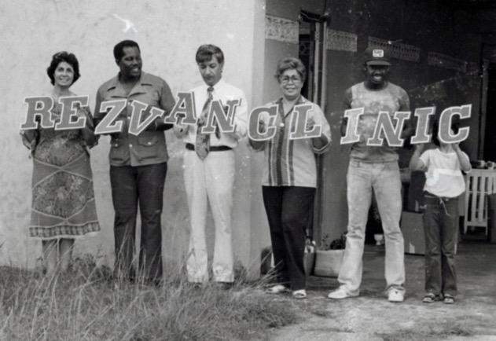
The closing of the Rezvan Clinic in Couva, Trinidad
L. to r.: Shamsi, Mr. Lancaster, Dr. Jamalabadi, Ms. Lillian Frasier, Mr. Junior Nicolas, and the daughter of Dr. Jamalabadi, Shahrzad

Letter to the NSA of the Bahamas
I wrote to the National Spiritual Assembly of the Baha’is of the Bahamas regarding my plans to pioneer there:
“Dearly loved friends,
Although it is a long time since I had the privilege of being with you and sharing in your teaching activities, nevertheless your love, hospitality, zeal, enthusiasm and dedication prior and during the election of your first National Assembly in 1978, had never been forgotten, to the contrary, I had often recounted them during my latest teaching trips to the Americas, West Africa and then Europe.
Recently the International Goals Committee of the United States wished me to make an exploratory trip to the Turks and Caicos Islands, to find out whether I could pioneer and establish my maternity clinic there. A short trip to those islands during Nov. 1979, revealed that the chance of success was very little...
Beloved friends, from the copy of my letter to our National Assembly, which is enclosed, you may notice that there had been several communications to and from that Exalted body, concerning my offer for a new pioneering post, their Guidance and Blessings and my unreserved submission to their guidance.
I am looking forward to be with you very soon and hope to be of some assistance to your community…”

My resignation from the NSA of Trinidad and Tobago was accepted
On May 18th, the National Spiritual Assembly of the Baha’is of Trinidad and Tobago sent me a very gracious letter accepting my resignation from the institution to be able to go pioneering.

The letter of the NSA of Trinidad and Tobago
“Miss Shamsi Sedaghat
Rezvan Clinic, Couva.
Dear Miss Sedaghat,
The National Spiritual Assembly has received with a feeling of regret your letter of resignation from the Assembly and the indication of your final decision to leave Trinidad and Tobago to pioneer to the Bahamas. We call to mind the fact that your coming to Trinidad in 1969 heralded a new era of expansion of the Baha’i Faith in this country; how your magnetic personality attracted many high-ranking dignitaries, persuading them to consider the claims of the Faith and secured their friendship for the Cause; how your persistence and persuasiveness gained for the Faith concessions from the media…We shall miss your wise counsel, your deep knowledge of the Faith which you dispense with a fluency and interesting manner which grip the attention. We shall miss your warm generosity and hospitality and your deep sense of justice and loyalty.
We bow to the need of your nature to explore new fields and break new ground, which is the work you are supremely fitted to do, and our sorrow for the loss of your valuable service is tempered by the certain knowledge that you’re going to the Bahamas will inaugurate a new epoch in the annals of the Baha’i Faith in the Bahamas. You may be sure that we shall follow your career with interest and hope that when your task in the Bahamas is completed you will consider returning to this country to blaze new trails for the Faith.
Our prayers go with you, that God may richly bless your labor and that your stay in the Bahamas will bring you great happiness and a sense of fulfillment.
With warmest Baha’i love,
THE NATIONAL SPIRITUAL ASSEMBLY OF THE
BAHA’IS OF TRINIDAD AND TOBAGO
Joel G. Caverly, Corresponding Secretary”

The letter of the NSA of Trinidad and Tobago to the Universal House of Justice
The National Spiritual Assembly of Trinidad and Tobago had kindly accepted my resignation and then it informed the Universal House of Justice about it. The letter to the Universal House of Justice is as follows:
“The Universal House of Justice
Baha’i World Centre
Haifa, Israel
Most August and Beloved Friends,
We have received with regret the letter from Miss Shamsi Sedaghat giving her final decision to pioneer to the Bahamas and tendering her resignation from the National Spiritual Assembly, although we had requested her to reconsider her decision. As her offer to pioneer elsewhere had been accepted and blessed by your supreme body, this Assembly had no choice but to accept her resignation.
We are grateful for her meritorious services to this country during the past eleven years, and our sorrow at one loss is mitigated only by the knowledge that her going to the Bahamas will be the means of furthering the development of the Faith in that country.
We hope that she will consider returning to Trinidad and Tobago, where she has her permanent residency after the accomplishment of her mission. We shall join our prayers with yours for the success of her services.
With loving Baha’i greetings,
In His Service,
THE NATIONAL SPIRITUAL ASSEMBLY OF THE
BAHA’IS OF TRINIDAD AND TOBAGO
Joel G. Caverly,
Corresponding Secretary”
Letter from the NSA of Trinidad and Tobago to the NSA of the Bahamas is as follows
“The National Spiritual Assembly of the Baha’is of the Bahamas.
Nassau, Bahamas.
Dear Baha’i Friends,
This letter serves to introduce to you, Miss Shamsi Sedaghat, who is about to pioneer to your country.
Her coming to Trinidad and Tobago in 1969 ushered in a period of rapid growth of the Faith in this country. She was a member of the local spiritual Assembly and the National Spiritual Assembly for seven years since its formation in 1971 and served as its Chairman for seven years. She is an able administrator, an excellent teacher of the Faith, and has considerable talent in the use of the media in the propagation and consolidation of the Faith and obtaining concessions from them for this purpose.
We are very sorry to lose her services, but know that her going to the Bahamas will have a salutary effect upon the growth of the Faith in your country.
With warmest Baha’i love,
THE NATIONAL SPIRITUAL ASSEMBLY OF THE
BAHA’IS OF TRINIDAD AND TOBAGO
Joel G. Caverly,
Corresponding Secretary”
Farewell dinner with the Baha’is of Trinidad and Tobago
The next day, May 19th, the National Assembly sent out a bi–election call to fill the vacancy, and a farewell dinner was held at the Holiday Inn on May 23rd. Many dignitaries and government officials and Baha’is were present to say goodbye. As usual in these kinds of meetings, many praises and complements were delivered, and many well-wishers prayed for my continued success and my humanitarian and spiritual services to mankind wherever I may be for which I thanked them very much and wished them the same.
Recommendations from Trinidadian doctors about my services in Trinidad
One of the reasons for my professional success in obtaining positions in hospitals was the positive recommendations I received from doctors.
Dr. Gopaul’s letter
1) Dr. Gopaul, the well-known personality and medical doctor, wrote:
“Miss Shamsi SEDAGHAT has worked for several years in the Couva area of Trinidad, where she set up and managed the Rezvan Clinic, which rendered maternity (mainly) and other nursing services to a large cross-section.
As Medical Officer of the Couva Hospital and a Practitioner in the area, I became aware of Miss Sedaghat’s expertise in general nursing and midwifery through the patients we managed together and the consultations which she sought of me. I found her to be very knowledgeable in her field, yet so deep was her concern for all of her patients that she would seek consultation whenever there was in her mind the slightest doubt about the normalcy of any patient’s progress. I wish to recommend Miss Sedaghat as a steady, reliable, well-balanced, knowledgeable nurse and midwife whose training and experience are enhanced by her abiding love of people—all people.
C.L. Gopaul, M.D.”
Dr. Max Awon’s letter
2) Dr. Max Awon, former Minister of Health for Trinidad and Tobago, wrote:
“Dr. Maxwell Philip Awon
M.Sc., M.B., BCH.
Fellow of the Royal College of Physicians (Ireland)
Fellow of the Royal College of Surgeons (Edinburgh)
Fellow of the American College of Obstetricians and Gynecologists
Fellow of the Royal College of Obstetricians and Gynecologists (England)

29th May, 1980

I first met Miss Sedaghat some ten years ago soon after she came to Trinidad and Tobago. I was Minister of Health at the time. I was impressed by her calm, confident personality. She was a nurse mid-wife and I soon realized that she had considerable administrative experience.
The hospitals in this country are state-owned and state-run and the top administrative posts are reserved for nationals who have the qualifications. It was therefore not possible to place Miss Sedaghat in a post commensurate with her qualifications and experience. Miss Sedaghat was persuaded to open a Private Maternity Clinic in conjunction with certain medical practitioners. As would be expected this clinic did well. She subsequently transferred her clinic from Port-of-Spain to Couva.
I have worked with Miss Sedaghat in our professional capacities and her work and conduct have always been of a high standard and quality.
Miss Sedaghat is now leaving the Republic of Trinidad and Tobago and I wish her well wherever she may go.
Max Awon”
Dr. Andrews’ letter
3) H.G. Andrews, the Chief Medical Officer for Trinidad and Tobago, described me this way:
“Miss Shamsi Sedaghat spent a little over ten years in Trinidad and Tobago during which time she organized and operated three maternity clinics in the capital city and in a semi-rural area.
Miss Sedaghat has a dynamic personality and possesses a deep understanding of human nature. She has a natural love for people, and this has been of tremendous value to her in her activities in this country.
In addition to working as a Nurse Administrator, Miss Sedaghat is an eminent member of the Baha’i Faith and in fact did pioneering work for the Faith in this country. She has been very successful in her endeavors here and will be greatly missed.
H.G. Andrews Chief Medical Officer”

Dr. H. Collymore’s letter
4) Dr. Harry Collymore wrote:
“I have known Miss Sedaghat as the owner and director of the Rezvan Clinic, a five bed well equipped maternity unit in Couva, Central Trinidad, dealing with all aspects of patient care, including antenatal and post-natal care, which she personally supervised. Using her skills as a nurse midwife, she devoted herself to the welfare of the community in Central Trinidad with remarkable success. Because of the efficient and humane manner in which she conducted this clinic her services were much sought after especially as she did much charity work among the people of the rural areas. She has from time to time referred to me babies with orthopaedic problems, and I have performed minor surgical operations at the clinic.
She brought to bear on her practice a sound nursing training in England and with experience in her field gained in the posts of Matron or Nursing Administrator of large hospitals in several countries. She has a natural talent for administration and management, and great executive capacity, especially when dealing with large institutions.
In addition, she has been actively involved in moral education and character building among the youth and in developing the potentialities of the women of the rural areas. She has worked eleven years in Trinidad and now wishes to render service to some other country. The closing down of the Rezvan Clinic is a great loss for the people of Central Trinidad. However, this loss will be compensated for by the great benefits which will accrue to that country and institution fortunate enough to secure her services.
I wish her the success that she richly deserves, wherever she may go, and assure her that she will be warmly welcomed back to Trinidad whenever she wishes to return.
H.M. Collymore, F.R.C.S.
Retired Medical Director of San Fernando General Hospital”
Kind letters to me
Among the many kind gestures I received from friends before and after leaving Trinidad were letters from Mrs. Jaitun Abdool, a local believer who was the wife of Mr. John Abdool, an avid fisherman who loved even more to fish for souls and introduce them to the Baha’i principles and both of them were lovely Baha’is. They were both very active, generous teachers of the Faith. Years later, Jaitun wrote her memories of my first meeting with her:
“My Dearest Mom
“I’m trying to put on paper my beautiful memories of you from the first glorious day we met. It was in the year 1972 between September and October, I was in Union Village at my sister Habiban Sonny waiting on the street for the bus to go to my home. She kept telling me, “Wait, I want you to meet my friend, a Baha’i lady.” But apparently while waiting for the bus, up comes this small white Hunter car. This lady came out and said, “Let’s go inside, I will take you home later.” I went back to Sonny’s house and this lady came also and sat on the floor. She started to teach the children and meanwhile had some snacks with them. This is the first time I saw a white lady sitting on the floor and eating with children. I was truly amazed.
After she drove me home. She kept telling me about the Baha’i Faith. When I got home my husband John Abdool welcomed her and we both listened to her. My home was an old house with kerosene lamp. When she finished my reply was “Listen lady I was born Muslim, I will live Muslim, and I will die Muslim.” But after another 45 minutes of her beautiful talks, I saw light the light of truth where I acknowledged I was not born Muslim. I was born a human being. This was my first lesson.
Well, she came another day, she taught me more and asked me to invite some friends. I did. I arranged a meeting at the home of one Anna Lutchman in Brickfield Carapichaima. Central Trinidad West Indies, She came with a projector, tea, sugar, bread and butter. As I read the card and signed it I fell unconscious to the ground. I was told that one person by the name of Junior Nicholas who was there gradually helped me to get up and slowly took me home This was one of the best days of my life---very beautiful and unforgettable….”
Mr. Abdool has passed away, but Mrs. Jaitun is living in Miami and corresponds with me affectionately. She wrote to me:
“My Beloved and Devoted Spiritual Mother,
…These few lines are to let you know how much you mean to me.
You have done so much for me and my family that my only regret is I should have met you as early as you arrived in this country…I feel I just could put my head on your shoulder and cry aloud. For at times I had no one to turn to except you and the Supreme Being.
You educated me so deep that my parents could not understand where I got all this knowledge in so quick a time. When someone is sick in my family, I believe I will still seek your advice and prayer no matter how far you are from me. And whatever I do I promise it must be to please and make you happy….”
Leaving for Nassau, Bahamas, 7 a.m., May 30th, 1980
I spent the night of May 29th packing. In the morning of May 30th, Mrs. Joyce Ramlogan, a good friend and loving Baha’i, came to help me and took four suitcases to the airport. There we met Dr. Harry Collymore, the chairman of the NSA of Trinidad and Tobago, and a Baha’i travelling teacher, Mr. Nagaratnam, Dr. M.H Jamalabadi and his wife Shahnaz Khanum, and their daughter Shahrzad, and our Baha’i radio producer “mainly for women”, Mrs. Lillian Fraser, all were there to see me off. The luggage was easily passed but our goodbye was a bit difficult as it had to be included with some tears. However, I left at 7 a.m. and reached Kingston, Jamaica, at 11 a.m. I phoned Mr. Zohuri, the Secretary of the NSA of Jamaica and his wife, and Mr. Hopton Fitz-Henley, ABM. They came to the airport. We greeted each other, exchanged news and then I left towards Montego Bay. There I changed my plane and got to Nassau Air Carrier and reached my destination Nassau late in the afternoon. I got the luggage, but one piece was missing. The baggage department promised to find it and let me know when it came in. Mrs. Pat Newton, the secretary of the Nassau Assembly and her husband Mr. Gadwill Newton, and others were there. They put me in their car and brought us to the Baha’i Center. There we unloaded the car and went into the Center. There was Mr. Frank, an American Baha’i. We got to know each other, spoke, and exchanged some ideas, had some supper together, then all left, and I was very tired, went downstairs, put some couches next to each other, put some covers on them and went to bed.
Meeting some friends in Nassau
The next morning, May 31st, friends came over, and we had breakfast together. After we were finished, we went to the home of the Minister of Health, but he was not home. We had a few other errands to do and then we went back to the Baha’i Center. I prepared lunch and invited the Chief of Immigration, Mr. and Mrs. Plakaris, and Mr. and Mrs. Michael Horton to come for lunch whom I had known from my previous visit in 1978. They came, and we ate together and had a very nice fireside.
On June 1st, we had a prayer meeting in the early morning. Then I met with the Spiritual Assembly of Nassau, after which I did some cleaning in the Center. After meeting some of the friends, I went to bed. On June 2nd, Mr. Horton came and took me to the Department of Immigration. I took with me my letters of recommendations from Trinidad. With the help of Mr. Plakaris, I got a three-month visa to stay in Nassau. Then Mrs. Horton took me to the bank where I opened an account and put the money I had into it. She brought me back to the Center and said good bye. After a simple lunch, I phoned Dr. Davis, a dentist, to come over and see my recommendations and then show them to Dr. Rosen who had a private hospital to see if he could employ me. Then Mrs. Newton prepared a delicious dinner, and we ate, and I went to bed.
On June 3rd, I phoned Mr. C. Brown at Eastern Airlines and asked about my missing luggage. He told me that it had been there since May 30th. With Mrs. Pat Newton, we went to the market and bought food for that night’s supper because Dr. Davis was coming as our guest. We went to look at apartments for me but didn’t find one which was suitable after which we came home to the Center. Our Baha’i youth from Canada were at the Center. With the help of one of them and five others we went to the airport and without any problem got my luggage. They brought me back, and we made some simple food for our youth. They ate and after they left, I began cooking for my guest, Dr. Davis. He arrived at 6 p.m. We had supper after which he looked over my recommendations and phoned his sister who was the Director of Nursing and introduced me to her. Then Mr. Horton phoned the Minister of Health, and we secured an appointment for the following day. The Canadian travelling teachers and Dr. Davis left, and I went to sleep.
On June 4th, I went to view more apartments, but none was suitable. On the way back to the Center, I bought food.
The next day, I phoned my contacts, went to the Ministry and met them. I gave them my letters of introduction. They saw them and as they knew me from my previous visit to the Bahamas and knew about my work, therefore they accepted the letters. They promised to reply to me.
Welcoming letter from the National Spiritual Assembly of the Bahamas
The National Spiritual Assembly of the Baha’is of the Bahamas welcomed me warmly and set me to work:
“Miss Shamsi Sedaghat
Nassau, Bahamas
Dearly Beloved Co-Worker,
It is a great honor to welcome you to the Bahamas and we are sure that your abundant knowledge and your capacity to teach the Baha’i Faith will assist this National body and all the communities in the Bahamas in many ways. The National Spiritual Assembly wishes to call upon your services to develop a nationwide spiritual enrichment program twice a month over a period of one year to inspire and deepen the friends, the Local Spiritual Assemblies, and communities. In developing such a program, we ask that you please send suggestions to us immediately about a well-organized weekend visit to achieve these aims which will be conducted in the five islands where we have communities and to include perhaps a unity feast to unite the friends on a social level too. We would be interested in any names of teachers that you feel could assist us in this program and would be so happy if a program of this nature was submitted to us immediately for our approval.
With fondest Baha’i love, Patricia Newton, Secretary.”

This spiritual enrichment program was a part of the broader teaching plan for the Bahamas for the period between November 1980 to November 1981. The objectives of the Plan were to strengthen the LSA’s and Baha’i communities such that they could sustain themselves, increase the number of Baha’is, and to lay the ground work for the incorporation of the institutions. Among the steps to carrying this out, there would be a spiritual enrichment deepening program, a nationwide children’s program, the establishment of a pioneering committee to identify prospective pioneers and give them training, pioneer-hosted firesides, the publication of a newsletter “Baha’i Sunshine” to inform the believers of the progress of our plan, and active use of newspapers and radio for proclamation. The National Spiritual Assembly of the Baha’is of Bahamas asked me and a few others to serve in the development of children’s classes in the first phase of the plan.
Letter of the Assembly
“Mrs. Bob Horton, Mrs. Winnifred Sweeting
Miss Shamsi Sedaghat (convener)
Dearest friends and co-workers,
The National Spiritual Assembly of the Bahamas has appointed you to develop programs for children during activities held for Phase I of teaching plans…During meetings held for the Spiritual Enrichment Program and Pioneer Institutes, your committee is asked to conduct Baha’i children’s classes and any other activities of a suitable nature for a portion of the meeting time, …These programs for children are for all of the islands but are not to be developed as local regular children’s classes. The programs would be only for these specific activities planned for Phase I, in which children would need to be taken off so that the friends can participate…. Ms. Sedaghat as Convener will be contacting you to call the first meeting. …
With fondest Baha’i love,
National Spiritual Assembly of the Baha’is of the Bahamas
Patricia Newton, Secretary”
Another kind letter to me
After my arrival in the Bahamas, I got a most unexpected letter of goodbye:
“Dear Sister Shamsi,
I know you will be very surprised when you get my letter. But I know also it will help cheer you up a bit, because probably you are still sort of missing your very many friends here in Trinidad, some of whom were very close to you. I am sure too that likewise, you are being missed by many people since you left Trinidad.
Before I continue, first you might be wondering who I am and how I got your address. The answer to the first part is I am the postman who you gave amongst other things, the blender, and I got your address right at the Post Office. Perhaps my biggest disappointment so far for the year was not being able to see you before your sudden departure. I know you were supposed to leave the Sunday, when I came to see you the Thursday, you weren’t there, and Granny told me you were leaving about 3 on Friday morning. I was very dejected on hearing this. I wanted to come in the evening but as you know, the weather was bad. However, I said a prayer for your safe journey, and for you to continue your good work wherever you go. It’s because I did not see you before you left, I had to write you. I was really disappointed. I hope you forgive me. I tried to persuade you to remain and make Trinidad your home, you are so well-known in this place, but apparently you had your mind made up.
I hope one day, in the very near future you will return for good, you are a true humanitarian in every sense of the word, and your type of people are very scarce not only in Trinidad, but worldwide. We need you here in Trinidad where the bad outnumbers the good. I haven’t seen Granny since the Thursday before you left, but I will drop in by her on Wednesday or Thursday this week. She also is a very good old lady, some people her age are helpless, sick, and bedridden, maybe Granny was a good lady at all time, so she hasn’t reached that stage. If you were not rewarded for your service to the people and this country as a whole. I am sure that your good deeds will not go unrewarded in the eyes of God. He never sleeps. For most of your life you served and are still serving mankind, you have helped so many people in distress, you understood and always listened attentively to other people’s problems giving them in return advice, hope, and courage, God is aware of this. There are very few people whom I met and whom I will remember always, you are one.
I will like to send you a gift by mail, first I have to find out from the Post Office how I can post it. In the meantime, if you change your address, let me know. Also, I would like you to drop me a few lines saying how you are getting along in the Bahamas, if you are getting a job at any hospital or Nursing Home, and if you regret you have left Trinidad. Perhaps you could have persuaded Dr. Collymore to open a maternity section in his institution on a joint basis. Anyway, with your flair to succeed in life, and with God’s guidance I have absolutely no doubt whatsoever that you are going to make it. You can drop me a line at the address here—Mr. Tag Kuar Singh, c/o Post Office, Couva, Trinidad, West Indies.
May God Bless You Always, May He Be With You Always, May He Guide and Protect You too, Always. Hoping that these few lines bring some cheer into your good heart, and that also you will drop me a line or two, Bye,
From a friend,
Taqe Kuar Singh
Postman”
The top priority is Freeport
The top priority for teaching would be the city of Freeport during December 1980, and January 1981. The goals set out for the Bahamas by the Universal House of Justice were:
1. Systematically using mass media
2. Fostering cordial relations with leaders of thought, etc.

3. Increase the number of believers
4. Recruit and train local believers
5. Consolidate communities
6. Consolidate LSAs

To implement this plan and achieve these goals, I was appointed to many committees.
The Spiritual Assembly of Nassau asked me in November to prepare a children’s class at the Baha’i Center.
In December, the National Spiritual Assembly appointed me to develop a program for children for Phase I of the teaching plan for classes to be held during the Spiritual Enrichment Program.
In February, 1981, the National Assembly appointed me to serve on the Public Relations Committee to—according to the Universal House of Justice—“foster cordial relations with leaders of thought and those in authority, familiarizing them with the tenets of the Faith.”
In the summer, the Assembly of Nassau asked to “call upon your talents and expertise to serve as a member of the Nassau Proclamation Committee whose chief responsibility is to plan and implement the monthly forums and the public meetings, which are to be held every three months.”
The National Assembly sent Mr. Charles Nightingale and me a letter in November calling on my experience as a pioneer and travel teacher to serve on the Pioneer Committee to encourage pioneers, to receive travel teachers, and to identify professions in high demand in the Bahamas to inform other Baha’i institutions of the opportunities on the island for prospective pioneers.
The National Spiritual Assembly also appointed me that summer to the Public Relations Committee.

Letter of the National Assembly of the Bahamas
“Mr. Michael Horton
Miss Shamsi Sedaghat
Mrs. Deborah Wigfall
July 4th, 1980
Dearest Friends,
The National Spiritual Assembly have appointed you to serve on a committee called Baha’i Public Relations Committee.
This committee has been formed to conform and to succeed the objective from the Universal House of Justice stated in their letter of Naw-Ruz 1979 “to foster cordial relations with leaders of thought and those in authority, familiarizing them with the basic tenets of the Faith.”
We would like your committee to be responsible to visit the Prime Minister with a book called “Proclamation of Baha’u’llah” and a letter has already been typed to be presented to him as at this time we have not had the privilege of meeting him to present this book.
The Universal House of Justice has asked for this National Assembly to incorporate as soon as possible and we hope that your committee will develop a well thought out plan to develop these cordial relationships with leaders of thought with a view of incorporation. We hope that you will accept this appointment,
With fondest Baha’i love,
Patricia Newton, Secretary.”

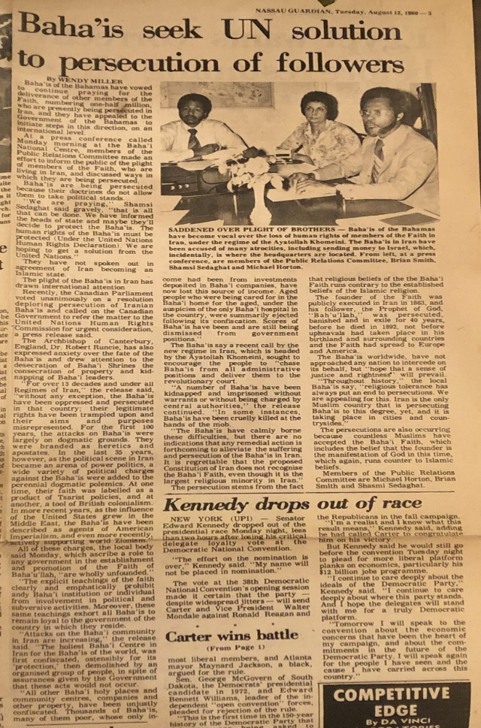
Public Relations Committee interview for the Nassau Guardian.
l. to r.: Brian Smith, Shamsi, Michael Horton
Once I was settled in the Bahamas and fully involved in Baha’i activities, I sent an update to the Universal House of Justice.
Cable to the Universal House of Justice is as follows
“BAHAIFAITH
HAIFA-ISRAEL
JOYFULLY INFORM AUGUST BODY ARRIVED NASSAU 30TH MAY 1980 WARMLY WELCOMED BY N.S.A. IMMEDIATE INTEGRATION ACTIVITIES FAITH PERSONAL FIRESIDES GAINED VALUABLE FRIENDS CROSS SECTION COMMUNITY RESULTING ENROLLMENT A DENTAL SURGEON AUTHOR STOP
PRIVATE PRACTICE NOT POSSIBLE YOUR PRAYERS COURTESY CALL HEALTH MINISTER FAVOURABLE REFERENCES FROM TRINIDAD RESULTED EMPLOYMENT ONLY GOVERNMENT HOSPITAL EXCELLENT OPPORTUNITY SERVICE COMMUNITY COMMENCED DUTY NOVEMBER 11TH OBTAINED PERMISSION OBSERVE 12TH AND SUBSEQUENT HOLY DAYS ESTABLISHED COURTEOUS RELATIONSHIPS AUTHORITIES
HUMBLY IMPLORE TEACHINGS. IMPLORE FURTHER PRAYERS ACHIEVE ASSURED NEW SERVICES FAITH
DEEPEST LOVE GRATITUDE
SHAMSI…”
I received a telegram of encouragement from the Universal House of Justice. The telegram is as follows:
“SHAMSI SEDAGHAT CARE BAHAI FAITH
NASSAU BAHAMAS HAPPY LEARN SUCCESS YOUR ENDEAVOURS PRAYING FULFILMENT HEARTS DESIRE UNIVERSAL HOUSE OF JUSTICE”
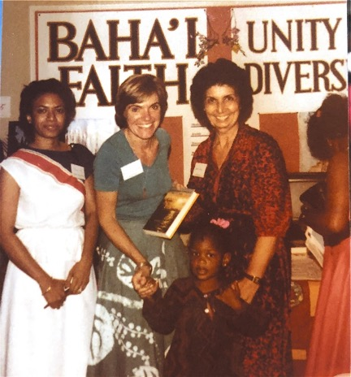
Teaching the Faith in the Bahamas in front of the display on the Baha’i Faith; Mrs. Wigfall on the far left, Shamsi on the right.
Declaration of Ms. Carole Smith
One day when we had a fireside meeting at the Baha’i Center in Nassau, I wanted to use one of my teaching charts for my talk. Therefore I decided to run back to my home which was near the Baha’i Center and bring it. When I was near my house, a dog started barking at me. I started running. He followed me all the while barking. I ran to a nearby house, knocked on the door and said “Please save my life!” I saw a lady running towards the door. She opened it and said, “What has happened?” I answered, “Please let me in and I’ll tell you.” She welcomed me in and brought me a glass of water and again said “Tell me what has happened.” By then I was a little calmer and told her that I was her neighbor and was at our Baha’i Center and then was going to my home to pick-up a chart and go back to the Center when the dog saw me and started barking and running after me. So I thought it better to run to a house for refuge. She asked, “Oh, you are a Baha’i?” I answered, “Yes, do you know about it?” She said, “My name is Carole Smith, and I am the sister of Brian Smith who is a Baha’i.” I got up, embraced her and told her all about how I met her brother two years before in the airplane from Miami, US, to Nassau, Bahamas, and that his great knowledge about the Baha’i Faith surprised me. Carole knew all about her brother’s acceptance of the Baha’i Faith. I was very pleased, and I invited her to our meetings. I spoke with Ms. Carole Smith for a while, and I invited her to my home as well. In later days, when she came to the Baha’i Center, she was very attentive, listened, asked questions and soon after, accepted the Faith. Ms. Smith was a British-trained accountant. She became very active and was appointed an Auxiliary Board Member for the Baha’i Faith in the Bahamas. Later, she applied and was accepted and honored by serving in the Finance Department at the Baha’i World Center.
+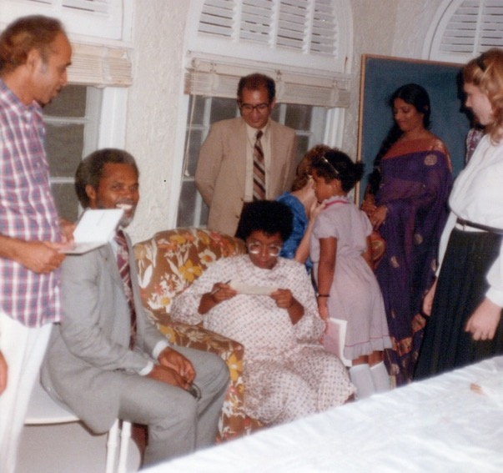
Ms. Carole Smith (seated) signs her declaration card. She later served at the Baha’i World Center in the financial department. Mr. Michael Horton, Chairman of the National Assembly is on the left; Dr. Manucher Mofidi, a hard-working pioneer, is standing behind her.

Andros, July 1980
I went on a short travel teaching trip July 4th-5th, 1980, which were my two nights off from hospital duty. This was my first time visiting the island of Andros. I left Nassau with Bahamas Air at 8 a.m. on Sunday 4th, and arrived at the San Andros airport fifteen minutes later. I was met by Mrs. Sadie Sommers, the wife of Mr. Stan Sommers, the American Baha’is who had been pioneering on this lovely island with their two loving daughters for some time. Both parents were teaching at the College of North Andros. Mrs. Sadie Sommers took me around the town and introduced me to almost all the Baha’is and some of her non-Baha’i friends. We exchanged greetings and invited them to a public meeting at 3:30 p.m., the same day at the Social Hall. Then she took me to her house, where I was going to stay. Strangely enough one of the individuals whom we met was a youth whom I had nursed at the Princess Margaret Hospital in Nassau some time ago. Of course, it was he who recognized me and welcomed me to Andros. One of the places which Mrs. Sommers took me was the Mastic Point where we met Mrs. Alice Russel, an American who is married to a Bahamian and had three children. She had heard about the Faith through the Sommers. She was very much interested to know more, therefore it was arranged for Sadie to pick her up and bring her to Nicholstown for the afternoon meeting, which Sadie did. We had a very long discussion about the Faith. She had many questions which I answered, and we had some refreshments, and she left with literature about the Faith.

A Letter from Mr. Ben Levy
Ben Levy, the Auxiliary Board Member, wrote me a letter of welcome and requested my help with the teaching work:
“Ms. Shamsi Sedaghat
P.O. Box N7105
Nassau, Bahamas
20 January 1983
Dearest Shamsi,
What a joy it was for Francine and me to learn from Lea that you will be coming to the Miami area for three months, sometime next month and what a privilege for the Florida friends.
To take maximum advantage of your offer to serve, I am writing to kindly ask that you send me a biographical sketch (which will clearly demonstrate your notable services!) and some photos (a negative that I can reproduce).My idea, if you concur, will be to share it with the four District Teaching Committees in Florida, and others too, with the idea in mind that they write you directly.

This will enable you to determine your own schedule in response to requests from Institutions. Should you have unused time available, I know many places where I can contact and who will want to use you….
With deep Baha’i love,
Ben Levy
Auxiliary Board Member for Propagation”
My reply to Mr. Ben Levy
I wrote back to Mr. Levy that I would make myself available on all days except Monday through Wednesdays when I was in class. I offered to speak on these topics or + which might interest the friends:
- A simple account of the history of the Faith
- Simple methods of teaching and consolidation
- The wisdom of fast and prayer and its effects on health.
- The Baha’i holy days and the importance of their observance.
- Some guidelines for potential pioneers and travelling teachers.
- Some successful methods in “the fostering of cordial relations with prominent persons and those in authority.
- Explanation of the emblem of the Greatest Name.
I moved to Miami where I undertook psychiatric studies, and then I attended the 5th International Convention in Haifa in the spring of 1983.
Letter from Universal House of Justice
I wrote a letter from Miami to our Supreme Body about my plans and asked their guidance. The Universal House of Justice approved of my plans and wrote a letter to me dated June 5th, 1983:

“Miss Shamsi Sedaghat
1441 N.W. 19th St. Apt 125
Miami, FL 33125
Dear Bahá’í Fiend,
The Universal House of Justice has requested us to acknowledge your letter of 2 May 1983 and to express its warm appreciation of your decision to qualify yourself further to enable you to practice in the United States and thus make it possible for you to devote much of your time to periodic teaching journeys. The House of Justice suggests that after you finish your studies and establish your base, you may wish to correspond with the National Spiritual Assemblies of those countries where you feel you can be of assistance and, of course, with the Continental Pioneer Committee of the area…It assures you of its ardent prayers in the Holy Shrines on your behalf.
With loving Bahá’í greetings,
(Mrs.) Loraine Johnson,
For Department of the Secretariat”
Letter of the NSA of the Bahamas to the NSA of the United States
The National Assembly of the Bahamas forwarded my credentials and expressed its gratitude:
“National Spiritual Assembly of the
Baha’is of the United States
536 Sheridan Rd.,
Wilmette, Illinois, 60091,
U.S.A.
Beloved friends,
It is with saddened hearts that we transfer the voting rights of MISS SHAMSI SEDAGHAT to your community.
Miss Sedaghat has served as a pioneer in various parts of the world for 30 years, for the last 3 years in the Bahamas. She has served on our National Spiritual Assembly and the National Public Relations Committee. We are sure that Miss Sedaghat is known to you through her international teaching services including her fruitful trip in the Bahamas just prior to the election of our first National Spiritual Assembly.
Miss Sedaghat with the approval of the Universal House of Justice arrived in Nassau on 30th May, 1980 as a pioneer. Soon after she secured employment with the Ministry of Health where she was assigned to work at a Private Surgical ward in Princess Margaret Hospital. Here she had the opportunity to meet and serve various high-ranking government officials or their families and thus be able to acquaint them with the spirit and principles of the Faith. She has assisted us greatly in reaching leaders of thought and people in high office here. She is well qualified in all aspects of the Faith and she was utilized in lecturing in the schools, service clubs and inter-religious seminars. Apart from her teaching efforts on the home front here Miss Sedaghat has recently received invitations from the National Spiritual Assemblies of countries such as Nigeria, Cyprus, and Guyana. Unfortunately, her hospital duties in Nassau have curtailed her international travel teaching activity and she has therefore decided to join her family in Virginia and secure a part time employment in her field and devote much of her time to home front teaching in the United States and international teaching trips. This wish of hers has been approved by the Universal House of Justice in a letter to her dated 5th June, 1983, a copy of which is enclosed.
We hope that your Assembly will utilize her abilities especially in the teaching field and lecturing at summer/winter schools or any other public or private gathering whenever she is not travelling.
Wishing you success in all your endeavors,
With fondest Baha’i greetings,
National Spiritual Assembly of the Baha’is of the Bahamas
Patricia D. Newton.”
Invitation to South Carolina by the Regional Teaching Committee
The South Carolina Baha’i Regional Teaching Committee wrote to me the following request to come join in the efforts around the Louis G. Gregory Baha’i Institute:
“Ms. Shamsi Sedaghat
424 North Ave., Apartment 202
Alexandria, Virginia
Dear Shamsi,
The Regional Teaching Committee decided at its meeting of February 10, 1984, to ask you to come to the Louis Gregory Baha’i Institute to assist with the education of the children in the area. There are twenty-five Baha’i communities within a thirty to fifty-mile radius of the Louis Gregory Baha’i Institute. Five of these communities are presently holding children’s classes. The remaining twenty communities, as well as the five communities presently having children’s classes can benefit from your assistance and input. The Regional Committee is extremely impressed with the video tape of your children’s classes in Trinidad. The Committee will provide you with hospitality until you are able to locate a place of residence. We will appreciate your immediate attention and response to this matter. If we can be of any assistance, please feel free to converse or correspond with us.
With warmest Baha’i love,
South Carolina Baha’i Regional Teaching Committee, Dr. Alberta Deas, Sec.”

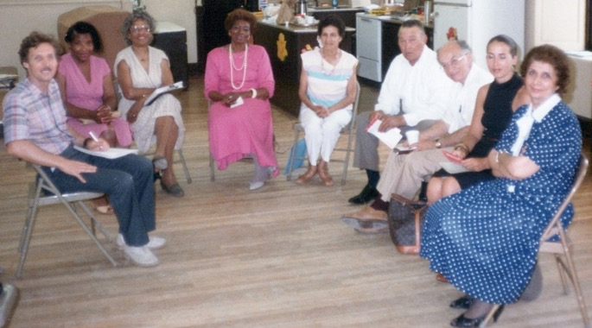
Baha’i meeting in South Carolina:
Dr. Alberta Deas sitting in the middle between two ladies in white, Shamsi first on the right; Fred Schechter (?) Knight of Baha’u’llah, third from the right; Bret Brenneman all the way on the left.
The other guests are lovely Baha’is, but I forgot their names
Letter to the Supreme Body, the Universal House of Justice
I wrote to the Universal House of Justice on September 3rd, 1984, informing it of my activities of the last months:
“THE UNIVERSAL HOUSE OF JUSTICE
HAIFA,
ISRAEL, 31000
The Most August Body:
After conveying my deepest love and gratitude for the bounties showered upon this humble servant through your letter of June 5th, 1983, I would like to inform you of the following:
Upon my return from the 5th International Convention in Haifa, I successfully completed my psychiatric studies in Miami, in July 1983, and thereupon returned to the Bahamas, where I resigned from my hospital post and left Nassau for Alexandria, Virginia in October. There I pursued further courses which led me to taking and successfully passing the American Board of Nursing examinations. Immediately after receiving my certification as a registered nurse, (March 15, 1984), I left Virginia (March 17th) for Hemingway, South Carolina, to participate in some of the teaching projects. While there, the Regional Teaching Committee of South Carolina asked me to assist them in the education of children and youth of that area and help towards the preparation of some radio programs on varying subjects, especially on maternal and child health, and child education.
As my visitor’s visa was on the verge of expiration, I had to obtain employment in order to be able to stay in the United States—having a British passport made me ineligible for the religious asylum status. This was achieved miraculously through your advanced prayers. I was offered employment in three different hospitals. I returned to Virginia and moved to South Carolina on April 20th, 1984, to help with the re-election of the LSAs. Later, on June 6th, I commenced my job at the labor and Delivery Section of the Obstetric Department of the “Georgetown Memorial Hospital” in Georgetown, South Carolina, which is about a half hour’s drive from the Louis Gregory Baha’i Institute, and the Baha’i radio station WLGI in Hemingway, S.C. My mother soon joined me which added in our number and my strength.
At present I am working under a temporary work permit granted by the department of Immigration in Charleston. This permit, which is of a two-year duration, and limited to working at the above hospital, has greatly restricted my freedom of movement. Under the present conditions and until such time as I have obtained my permanent residence permit, I will not be able to leave the country with any ease. When I am granted that permit, which will allow me to work part-time, I can once again commence my travel teaching projects.
Meanwhile, since my settlement in Georgetown, I have been given a number of responsibilities by appointed and elected arms of our Institutions, for the successful accomplishment of which I implore your continued prayers and assistance.
With loving Bahá’í greetings and utmost respect,
In the Service of our Beloved Faith,
Shamsi Sedaghat”
Letter of encouragement from Dr. Magdalene Carney
I received a letter of encouragement from Dr. Magdalene Carney who was serving at the time at the International Teaching Center at the Baha’i World Center:
“Magdalene M. Carney
P.O. Box 155
31 001 Haifa, Israel
5 October, 1984
Dearest Shamsi,
It is so good to know that you are serving the Faith and mankind in South Carolina. Because I am rather selfish, I hope that you will make that state your home even though you may be called upon for international travel teaching projects from time to time.
I am thrilled to hear that the teaching momentum is gathering steam. Obviously, I shall pray more fervently than ever for the friends to be confirmed in their service to the cause of our Beloved. Please remember this poor one in your prayers. The work is truly challenging and rewarding at the same time. Don’t take your time to write. Just wanted to touch base and thank you for all you’re doing to advance the Cause.
Abiding love, Mag”
My responsibilities on the Baha’i institutions in Georgetown
In Georgetown, I served on the elected and appointed arms of the Institutions, the Spiritual Assembly of Georgetown, the Teaching Committee, and on LEAP. We had many firesides, deepenings, travelling to towns to assist with the election of new assemblies, new declarations, summer schools, visitors, travelling teachers etc.… My life was working at the hospital and service to the Faith. There was abundant progress.
South Carolina had experienced many enrollments in the 1970s so there was consolidation work to be done. I acted as a mentor to several of the travelling teachers. Ms. Jean Rouhani from Long Island remembered:
“All Saturday and Sunday, Shamsi spent a lot of time deepening Ann and me. It was like having a private tutor for teaching the Faith. What an opportunity! I stayed over Saturday and Sunday nights. On Sunday morning, Shamsi, Ann and I went to the radio station antennae site and said prayers (read, chanted, and sang in English, Arabic and Farsi), as loud as we could.”
I was invited to speak at the Youth Conference organized by the South Carolina Eastern Two District Youth Committee over Thanksgiving weekend in 1984. I spoke on the subjects of teaching and chastity; other speakers included:

Dr. Alberta Deas on “Administration and Obedience,”
Dr. Jubin Matin on “History of the Baha’i Faith”
Mrs. Shida Mali on “Baha’i marriage”
Ms. Ellen McAllister on the “Feast and Local Spiritual Assembly”
Mr. Alenzo Neesmith on “Unity”

We were happy that the conference came to an end, with many praises and compliments.

I was invited to Houston, Texas
In 1985, in South Carolina, I received a letter from Mr. Parviz Khalilian, a very active Baha’i of Houston, to go to Houston, Texas, to be his guest and help with the teaching and consolidation activities which I happily accepted. I left, and they met me at the airport and took me to their home. There I met the friends and the members of the Houston Assembly and discussed the needed activities such as public meetings, firesides, deepenings etc.…They accepted. We started our gatherings. Many people attended and resulted in a few declarations.
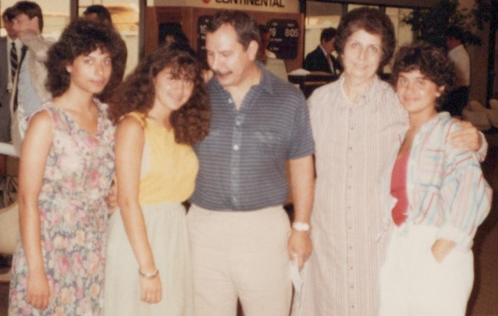
Mr. Parviz Khalilian (in the blue shirt) and his nieces and Shamsi.
Visit to Austin, Texas
One day Mr. Khalilian accompanied me to Austin and there we were invited to the home of Mr. and Mrs. Suhm where they invited many dignitaries and friends to meet me and discuss about the Faith. The meeting was very friendly and acceptable by the friends present. After Austin we went to Dallas, attended a public meeting where many people were present. My talk was very simple and easy to understand. Many questions were asked, and reasonable answers were given, and the result was very nice. Later during the tea break many private discussions continued and acceptable replies were given, and all received literature about the Faith before they departed. Later we were invited to another home where many members of the family were present and again beautiful discussions about the principles of the Faith took place. All were very happy, and many expressed their wish to continue their investigation. I was very pleased by the result of this gathering and hoped that they would continue in the future. We returned to Houston to Mr. Khalilian and after another well attended meeting with some new friends I thanked Mr. Khalilian, and family for their love and assistance. With that I said goodbye and left Texas. Unfortunately, after a short time I received a call that Mr. Khalilian had gone to the hospital for abdominal problems. The doctors decided to operate on him but unfortunately, he did not recover after anesthesia, and he passed away. They said that they had a very nice memorial meeting for him. He was a very active Baha’i and the community had missed such a lovely, hard-working and generous believer. May God exalt his soul.
Article from The Unifier, the community newsletter
The community newsletter The Unifier, wrote the following about this humble servant:
“Our area has the bounty of a visit from Ms. Shamsi Sedaghat this month. Mrs. Sedaghat is a distinguished Baha’i who has pioneered and travelled.
She was born in Turkmenistan of a Baha’i family. Before going to nursing school in England and a later pioneering post in Cyprus, she attended a special 3-year study program of the World’s Major Religions at a Baha’i college in Tehran. “Under the guidance and encouragement of the Beloved Guardian, Shoghi Effendi,” she completed the program with top honors.
Her other pioneering posts include: Uganda from 1967-1968, Trinidad from 1969-1980, where she was a member and chairman of the National Spiritual Assembly of Trinidad and Tobago from its inception in 1971 until 1978, the Bahamas from 1980-1983 where she also served on the National Assembly from 81-83. She currently resides in Georgetown, S.C.
Ms. Sedaghat has also attended numerous conferences and spent almost 3 years on a succession of teaching trips which took her to the Americas, West Africa, and Europe. It is indeed an honor to have her here in Houston.”
I was also invited to help with the teaching activities in Dallas by Dr. and Mrs. Golestaneh. Dr. Ali Golestaneh was a consultant working with the Mobile Oil Company as a geologist specializing in middle eastern oil. Mrs. Mahmehr Golestaneh was a leading architect, painter, and poet in the Baha’i community. The Golestanehs held a private gathering for prominent people in my honor in their home; several individuals from this dinner also attended the public meeting. I spoke on the topic, “Is the world ready for the brotherhood of man?” at the Southern Methodist University Campus. There were many questions. In the beginning, several listeners were skeptical, but they later agreed with the answers they heard and encouraged me to continue with talks and presentations.
Letter from the Spiritual Assembly of Houston
The summer of that same year I received the following letter of gratitude from the Assembly of Houston:
“Miss Shamsi Sedaghat
Indigo Hall #48
Georgetown, South Carolina 29440
Dearest friend,
On behalf of the Houston Baha’i community and all of the Baha’is in the surrounding areas, we would like to take this opportunity to express to you our appreciation and happiness for the time you spent here. You made several guest media contacts.
We are reforming our media committee into an inter-community committee and are on fire and ready to spread Baha’u’llah’s message now. We are blessed with one of our believers who happens to work for one of the cable stations. They love everything we have taken them.
We were so pleased to see two people enroll during the evening of your talk. Our friend from Pakistan has brought another into the Faith already. He was a waiting soul who studied the Faith and loved the Baha’is in Germany. Their friend is also from Pakistan. His father was very active in the Faith in Pakistan. It seems that they had been in this country for several years and had been looking for the Baha’i community.
They are bright and stalwart souls. We heard that your teaching in Dallas and Austin was very successful. Thank you for your efforts, for inspiring us and helping us to serve Baha’u’llah even more.
With warmest Baha’i love,
Jackie Cone, Secretary
For the Spiritual Assembly of the Baha’is of Houston”

Louis Gregory Institute, South Carolina
Over the weekend of April 5-7, 1985, I volunteered to plan, coordinate, and implement a week-long program for youth and pre-youth as a part of the Project Tabarsi at the Louis Gregory Institute.
I was assisted by Dr. Ann Brenneman. The speakers included Dr. Roy Jones on “Badasht 85: A Source of Inspiration…A Challenge to Action,” Ellen McAllister on “South Carolina’s Call to Action- Summer ’85,” and Carey Murphy on “A Special Measure of Love.” I spoke on “Descendants of the Dawnbreakers – 1985.”
When my two-year contract with the hospital finished, I was entitled to receive my green card which gave me residency in the United States.
Then I asked the hospital to release me so that I could go back to Virginia to be with my family. The hospital agreed, I received my green card, left for Alexandria, VA, and started a new life there.

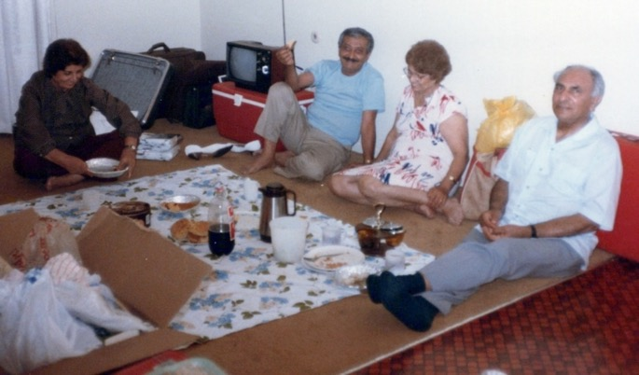
Before leaving South Carolina; some furniture was given away and some was taken to Alexandria, VA, and we are seated on the floor.
L. to r.: Shamsi, Mr. Farhad Sedaghat, Mrs. Qamar Aghdassi
(Shamsi’s brother and sister), Mr. Rostam Aghdassi, (Qamar’s husband, a very active Baha’i)
Leaving South Carolina; Shamsi’s car on the right with the license “Shams9”
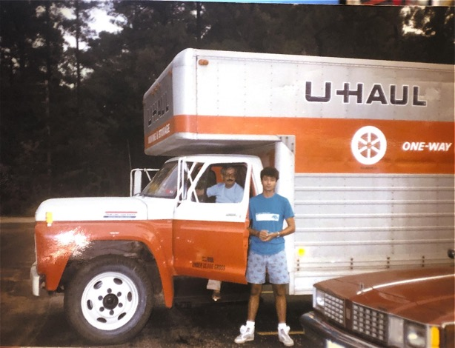
A thank you letter from Auxiliary Board Member for Propagation, Mrs. Elizabeth Martin
I had served as the assistant to the Auxiliary Board for Propagation in South Carolina, Mrs. Elizabeth Martin, who wrote me this letter of gratitude:
“Mrs. Shamsi Sedaghat
Indigo Hall Apt. 48
Georgetown, South Carolina
Dear Shamsi,
On behalf of the Propagation Board of the Continental Board of Counselors in the Americas, I want to thank you so very much for your warm and loving services as an assistant during the past two years. We can certainly appreciate your needing to be in the Washington DC area due to your international services and to be near to your dear family.
However, we don’t want you to leave South Carolina without knowing how very much we love you, how much we will miss you, and to remind you that we expect to have you come back and visit us often. And I know that the friends in the eastern districts of South Carolina and especially in the Georgetown area will certainly miss your hospitality.
Again, I want to thank you for your services to this institution and please don’t forget how very much I love you. Do keep in touch and remember us in your prayers.
Sincerest Baha’i love,
Elizabeth Martin,
Auxiliary Board Member for Propagation”
I also received a letter of appreciation for my service in South Carolina from the National Teaching Committee:
“13 June, 1986
Shamsi Sedaghat
Indigo Hall-Apt. 49

Dear Mrs. Sedaghat,
The National Teaching Committee wishes to express its appreciation to you for the work you have done as LEAP district coordinator. Your efforts on behalf of the children, youth, families in your area have meant very much to us.
We hope you will be willing to work with us again, and can be called upon for service in future projects carried out by the National Teaching Committee.
We hope you will offer your support and encouragement to the new LEAP coordinator. We know such assistance will be very welcomed.
Again, our heartfelt and affectionate thanks,
With warmest regards,
National Teaching Committee
Charles C. Cornwell
Secretary”

Memoirs of Ms. Shida Khosravi Mali from Florence, South Carolina
Ms. Shida Khosravi Mali was one of the most active and hard-working Baha’is in the town of Florence in South Carolina. Many Baha’i gatherings were held in her home. She had two daughters. She wrote her memories of my time in South Carolina:
“It was 35 years ago that we moved to South Carolina to pioneer. We settled in a small city called Florence and established a small school with the goal of admitting children from different races and religions so that they would learn that they could live together in peace without any prejudice. There were no Iranians living there. One day we were invited to a19-day-feast in a small city that was an hour and a half from us. When I arrived there, I saw that the host was Ms. Shamsi Sedaghat, one of my mother’s best friends. Ms. Sedaghat was a tall lady with a kind and loving face and eyes that were full of love for Baha’u’llah. She had been living in the city of Georgetown for some time and had many friends. Everybody loved her. She was a nurse and midwife. She studied Nursing in the UK and now in Georgetown was the Head nurse of the city hospital. Many people in the city, many doctors and physicians knew Ms. Sedaghat and respected her.
Her house was open to everyone. She had teaching classes in her house which was decorated with pictures of the Baha’i temples and Writings of the Baha’i Faith led people who came to her house to ask about them and learn about the Faith in this way. She was always ready to help. An example of this was my sister who with her husband were pioneers in Belize and Granada but could not get their visa renewed. They moved to the US and had to stay with us. My sister was pregnant and was very worried as they did not have a job or insurance coverage. And here again Ms. Sedaghat, as Florence Nightingale, who helped people, arranged everything for her and my sister gave birth to a baby girl, Mona. After two years of living in Georgetown, Ms. Sedaghat moved back to Alexandria, Virginia. The seeds of love and service she planted in this small city, Georgetown, grew and turned into beautiful trees and the local people who became Baha’is are all flowers of these trees.
Signed, Shida Mali”

Indiana Baha’i School Committee
In April 1987, I spoke at the Nur’u’llah School Spring Session in Indiana, at the invitation of Dr. Manshadi. The session was held on Sunday at the 4-H Leadership Conference Center near Purdue University, in West Lafayette, Indiana.
I offered to conduct a teaching project over the weekend. The overall theme of the school was “Consultation: Process for Peace.” The school’s sessions passed very successfully. Many people attended and learned from the talks which were very simple to understand and the reality of which was easy to grasp. The friends asked to have more of these kinds of gatherings. During the break, everyone enjoyed the dinner and conversations. They all departed happily after the sessions were over.

Antigua and Caribbean women’s conference July, 1988, and my letter to the Universal House of Justice
“THE UNIVERSAL HOUSE OF JUSTICE
P.O. BOX 155
HAIFA, ISRAEL
July 31st, 1988

Most August Body,

Please allow me to start by greeting the new members of that Supreme Body, Messrs. Hooper Dunbar and Adib Taherzadeh whom I wish every strength to share the burden of the ever-expanding Baha’i world administration especially in these the historic latter days of this century. The purpose of this letter is to inform that August Body of my upcoming travel teaching plans in connection with the Caribbean Women’s Conference to be held in Antigua in September. This will be my first teaching trip outside of the United States since I settled in this country. The enclosed letter outlines my itinerary.
Humbly beg your prayers for the success of this teaching trip.
With utmost love and humility at your service,
Shamsi Sedaghat.”
Letter to the National Spiritual Assembly of the Leeward Islands
That same day I wrote an enthusiastic letter to the National Spiritual Assembly of the Baha’is of the Leeward Islands:
“The National Spiritual Assembly
Of the Baha’is of the Leeward Islands
P.O. Box 832
St. John’s, Antigua
Dear Friends,
I am rejoiced at the news of your forthcoming Caribbean Women’s Conference in Antigua during the weekend of 9th, 10th, and 11th, September, 1988.
As you may know, my love for the friends in the Caribbean area is longstanding, and I was hoping to pay a visit to your area at the first available opportunity, especially as the Universal House of Justice expressed the same wish when they wrote:
“The House of Justice has greatly valued the services you have rendered in the Caribbean area and hopes that you will continue to give the Baha’i communities there your much-needed support. It assures you of its ardent prayers in the Holy Shrines on your behalf…”
They also suggested:
“…After you finish your studies and establish your base, you may wish to correspond with the National Spiritual Assemblies of those countries where you feel you can be of assistance, and of course, with the Continental Pioneer Committee of the area. In future, whenever you deem it possible to undertake a travelling teacher project, the House of Justice will be happy to hear from you about it…”
Therefore, your historic Women’s Conference prompted me to make a visit to Trinidad and Tobago, (on August 25th) and then to Antigua, …
I have informed Mrs. Linda Sawka, secretary of the Women’s Conference Committee of my intended visit, and she has graciously welcomed it, and furthermore, confirmed that the topic of my talk in the Conference will be “Child Care and Discipline”. She also stated that should I arrive earlier, I could help with advance publicity and media coverage.
I am deeply grateful to all the friends who have already expressed their love, especially Mrs. Edie Holbert, who as usual has offered me her gracious hospitality.
Looking forward to seeing you all and sharing this historic experience with you,
With loving Baha’i greetings,
Shamsi Sedaghat”

Antigua and Caribbean Women’s Conference
I went to Antigua with my younger sister Mrs. Soraya Sedaghat Furutan (the wife of Mr. Khosrow Furutan, the nephew of Hand of the Cause Mr. Ali Akbar Furutan) who was accompanying me on this trip. In Antigua, I spoke at a conference organized by the National Spiritual Assembly of the Baha’is of the Leeward Islands from September 9-11, 1988.
It was opened by a welcome from the National Spiritual Assembly of the Leeward Islands and another from the Director of the Women’s Desk of Antigua and Barbuda.
Topics of the conference included “Women, Children, and the Law” and “Consultation in the Family.” I spoke on the final day on “Childcare and Discipline.”

Caribbean Women’s Conference ended
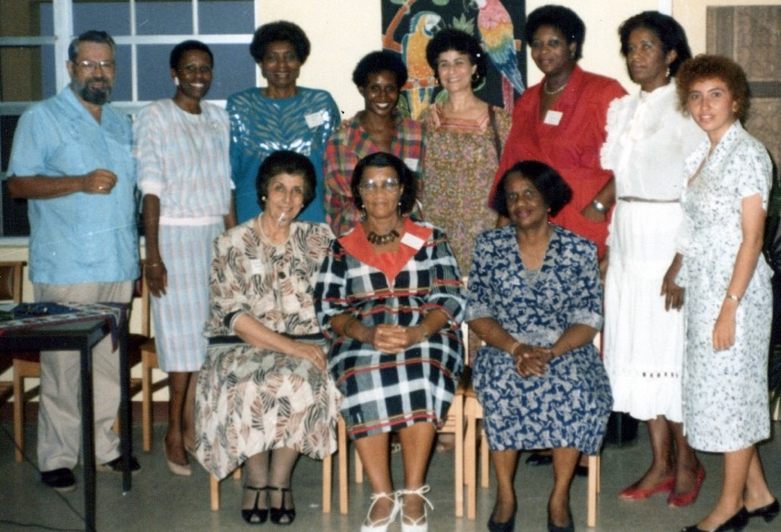

Caribbean women’s Conference:
Seated l. to r.: 1) Shamsi, 2) ?, 3) Director of the Caribbean Women’s Association, Mrs. Gwendolyn Tonge. Standing 3rd from the left is Dr. Alberta Deas, 5th from the left is Mrs. Ruhi Huddleston. The rest, I forgot their names but they are officials from various countries
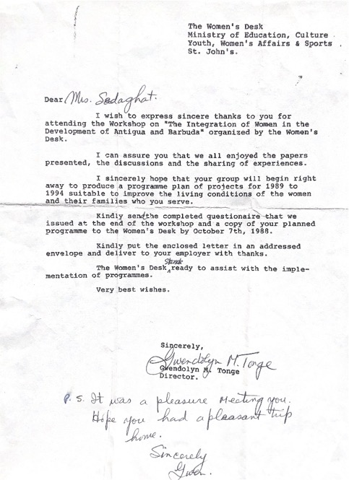
Letter from Mrs. Gwendolyn Tonge, Conference organizer
A few months after the end of Women’s Conference, I received this upbeat note from Mrs. Linda Sawka, the secretary of the Conference:
“Dearest Shamsi,
…One of the happiest moments for us was when Connie Michael asked us sisters to sing together like we use to do. It was the first time we had ever done radio program for her. It was the first time we had ever done radio and it was so much fun and the program turned out very nice. I guess we’ve always had a dream to travel teach together and use our music. I’m not sure whether you’ve heard or not, but Connie Michael did declare about 2 weeks after the Women’s Conference. She will really make a difference in the Baha’i Community of this island and hopefully the whole region.
We’ve continued contacts with several of the speakers and participants of that Conference. Last weekend we had a symposium on Peace—Let it Begin at home. Allison Barnes was one of the speakers and the lawyer, Karen DeFreitus was the moderator. Counsellor William Roberts was here and was also a speaker. He was really impressed with Allison Barnes…
Dear, dear, Shamsi, thank you so much for getting my nursing license. Armed with the Power of His Name—you can sure get a lot accomplished where others have failed! I can’t thank you enough for that job!...
We love you Shamsi and appreciate all your efforts on our behalf! Please give our warmest love to your lovely sister, Soraya….
Much, much love!
Linda and family”

The Goodwin House where I worked published in its newsletter that I had given this talk at the Conference in Antigua:
“…One of our Resident Health Supervisors, Shamsi Sedaghat, R.N., left on August 28 for Trinidad and the Tobago Islands where she once had been owner and manager of a maternity clinic for 12 years. She was scheduled to lecture in four places and had extensive news media interviews on nursing subjects. The culmination of her trip was a Baha’i Conference on Antigua Island where she had been invited to deliver the keynote address on “Child Care and Discipline.” We are so proud of our very own good will ambassador!”

Trinidad and Tobago teaching trip, 1988
Before the Antigua trip my sister Soraya and I visited Trinidad and Tobago Islands.
In anticipation of my arrival, the friends in Trinidad and Tobago sent out an invitation to all Baha’is and seekers:

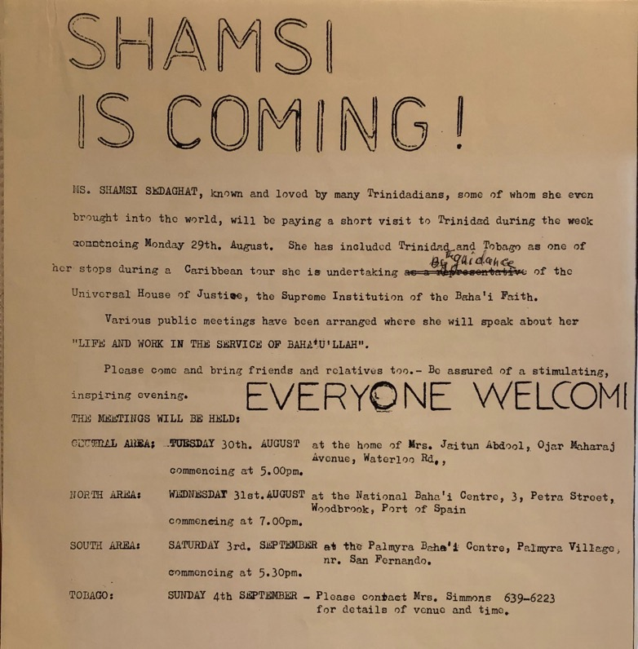

The Universal House of Justice wrote this letter to the NSA of Trinidad and Tobago:

“The National Spiritual Assembly of the Baha’is of Trinidad and Tobago

Dear Bahá’í Friends,
The Universal House of Justice was pleased to receive your letter of 26 September 1988 enclosing a copy of the minutes of the special meeting your National Spiritual Assembly had on 7 August 1988, as well as a photocopy of the article which appeared in the “Trinidad Guardian” concerning the recent visit of Miss Shamsi Sedaghat. This very positive article about the social services performed by Miss Sedaghat while she resided in Trinidad and mentioning her membership in the Faith is excellent publicity.
With loving Bahá’í greetings,
Priscilla Banks, For the Department of the Secretariat”
Letter from the NSA of Trinidad and Tobago
The National Spiritual Assembly of Trinidad and Tobago also expressed its appreciation for my visit:
“Miss Shamsi Sedaghat
5 September, 1988
Dear Baha’i Friend,
It was a privilege and a pleasure to have you visit Trinidad and meet with our National Spiritual Assembly.
We take this opportunity to express our gratitude for your past services to the Baha’i community of Trinidad and Tobago. We recognize that you have in large part been responsible for the rapid development of the Faith during your residence here. You have been in the forefront of the teaching work; you have pioneered the use of media in the service of the Faith; your contacts with personalities in the upper social strata have been outstandingly effective in making friends for the Faith in high places; you have been instrumental in acquiring most of the properties now owned by the Faith. These, and your other services too numerous to mention, have earned you our undying gratitude and love.
We pray that God will continue to bless your efforts for the growth of the Faith and the welfare of mankind.
Yours in service,
The National Spiritual Assembly of the Baha’is of Trinidad and Tobago
Joel G. Caverly, Secretary”
My reply to the NSA of Trinidad and Tobago
I wrote a letter of appreciation to the National Spiritual Assembly of Trinidad and Tobago for all the help I received from the friends and Institutions on the island during my teaching trip:
“The National Spiritual Assembly of the Baha’is of Trinidad and Tobago
PO Box 755
3 Petra Street
Woobdrock, P.O.S.
Trinidad, W.I.
December 23rd, 1988
Beloved Friends:
I was deeply touched by the kind words conveyed in your letter of 5th September, 1988. Our services to the Faith can only bear fruit if blessed by Baha’u’llah, and it is my sincere wish that we can all continue to serve, with the hope that our every step we will be guided and inspired by the Blessed Beauty.
I would like to take this opportunity to thank each and every member of that body for helping to make my trip to Trinidad and Tobago worthwhile. I dearly cherish the moments spent in your presence and would like to express my gratitude for all the efforts that went into making arrangements for me to meet the various representatives of the media, as well as the friends in public and private meetings.
I would like to address a special note of thanks to Dr. and Mrs. Jamalabadi who graciously hosted me and my sister, Soraya Foroutan, during our brief stay in Trinidad, and for the sumptuous dinner reception, attended by over fifty past and present dignitaries.
I would also like to thank Dr. Hamid Faraby who arranged and accompanied us on our courtesy visit on the President of Trinidad and Tobago, Mr. Nour Hassan Ali and Mrs. Hassan Ali, a visit that lasted two hours, in the most cordial of atmospheres.
I shall never forget the public meeting arranged by the LSA of Port of Spain with the heartwarming participation of Mr. and Mrs. Joel Caverley. At this meeting I had the wonderful opportunity of revisiting with many of my old acquaintances and Baha’i friends. It was at this memorable meeting also that our distinguished friend, Mr. Hamilton Holder, and his son signed the enrollment cards. Nor will I forget the lively and inspiring fireside at Dr. and Mrs. Faraby’s, or the wonderful dinner party hosted by Mr. and Mrs. Amarsingh at which I had the blessing of meeting many of the beloved pioneers and their families, including Dr. and Mrs. Rahimi, whose teaching and consolidation efforts throughout central Trinidad are indeed remarkable and praiseworthy.
And last, but not least, I would like to express my deepest appreciation to Dr. Harry Collymore for all of his efforts, from the warm welcome at the airport to the cordial introduction at the gathering of friends at the Palmyra Baha’i Center. My sister Soraya and I greatly enjoyed this trip, especially as it was crowned with a teaching success. Please convey our greetings to all the friends, and may Baha’u’llah bless your efforts,
With loving Baha’i greetings,
Shamsi Sedaghat”

Letter to Shamsi from the Universal House of Justice March 1989 re: teaching trip to Trinidad and Tobago

“Miss Shamsi Sedaghat
205 Yoakum Parkway, Apt. 212
Alexandria, VA 22304 USA
Dear Bahá’í Friend,
The Universal House of Justice has received your letter of 25 January 1989, together with copies of letters to and from the National Spiritual Assembly of Trinidad and Tobago and the photographs of your recent visit to that country and has asked us to express its happiness that you were able to return to your one-time home in Trinidad to assist with the teaching work.
The House of Justice was most pleased to note that you had an opportunity to meet with the President of Trinidad and Tobago as well as with persons from the media, and also attended the Caribbean Women’s Conference in Antigua. It is the hope of the House of Justice that you will find it possible to make frequent teaching trips in the Caribbean area where you are so warmly remembered. The House of Justice will continue to offer prayers in the Holy Shrines on your behalf that Bahá’u’lláh may bestow upon you continued strength to teach the Cause of God.
With loving Bahá’í greetings,

Shirley Macias
For the Department of the Secretariat”
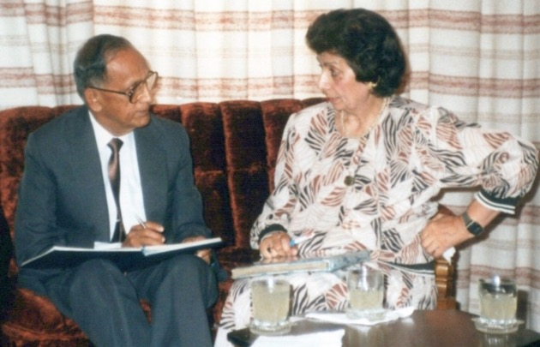
Shamsi paying a courtesy call to the President of Trinidad and Tobago,
Mr. Noor Hassanali, 1989
Alexandria, Virginia, United States, working at Goodwin House
In Alexandria, VA, I served on the Spiritual Assembly and as a Public Relations Officer. I opened my home for weekly firesides. I worked at the Goodwin House as a Resident Health Supervisor on its Nursing Care Unit. I started on December 1st, 1987 and was welcomed in this letter:
“Ms. Shamsi Sedaghat
205 Yoakam Parkway #212
Alexandria, Virginia 22304
Dear Ms. Sedaghat,
It was such a pleasure to meet and talk with you! We are looking forward to your joining our staff at Goodwin House on December 1, 1987, as a Resident Health Supervisor. Your responsibilities will include those listed on the job description with direct reporting to Carol Charles, Director of Nursing. I feel very strongly that you will join us in our mission of truly providing quality in our care giving.
Sincerely, Alice S. Biache, R.N.C., M.S.N.
In early 1989, I assisted with the planning of a Baha’i Conference for the region in Alexandria.
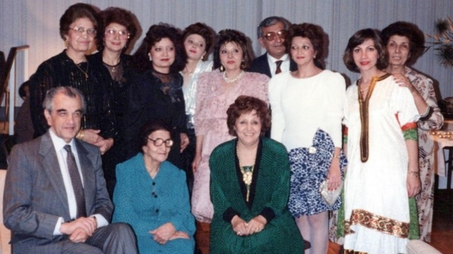
With family and some friends in Alexandria, Virginia:
Back row, l. to r.: my three sisters 1) Qamar, 2) Soraya,
3) Guitty, 4) ?, 5) Mrs. Nadi Sedaghat, my brother’s wife,
6) Mr. Farhad Sedaghat, my brother, 7) ?, 8) ?, 9) Shamsi
Front row: 1) ?, 2)our mother Mrs. Leqaiyyih Sedaghat, 3)?
(the question mark means that I know them but forgot their names)
The local newspaper, The Gazette, wrote an article covering my involvement and featuring a photo of me holding The Promise of World Peace message from the Universal House of Justice:
“Baha’i Faith spreads peace, brings conference to Alexandria
More than 1,000 adherents and interested followers of the Baha’i Faith from the Washington DC, area will congregate in Alexandria Feb. 24-26 for the 12th nationwide Baha’i conference.
The central focus of the conference will be a discussion of how Baha’is can promote peace at home and around the world, according to Shamsi Sedaghat of Alexandria…
Sedaghat who moved to Alexandria in 1986 and secured a nursing supervisor’s position at Goodwin House, said she has applied Baha’i principles throughout her lifetime. She has been a registered nurse and midwife in Cyprus, Iran, Uganda, and the United States, and a hospital owner and director in Trinidad and Tobago.
“It is difficult to be useful in the United States because it is such a well-developed country,” she said.
Sedaghat said she has helped to deliver more than 2,500 babies throughout the world. She also has visited 70 countries where, she said, she met with almost every head of state and delivered lectures on the Baha’i Faith.
“My way of living must bring someone else up from suffering,” she said, “I will have reached my goal when I see my entire life served for the betterment of mankind, not myself.”
According to Sedaghat, 80 to 90 Baha’is live in Alexandria. Sedaghat said other assemblies exist in Vienna and Fairfax….
On Feb. 24th James Nelson, one of the nine members of the National Spiritual Assembly of the Baha’is of the United States—the national governing body—will speak from 7:30 to 9 p.m. at the Ramada Inn on Seminary Road. The lecture is open to the public.
The conference officially opens for Baha’i members only Feb 25. David Hoffman, a Briton and former member of the Universal House of Justice, the Baha’is’ international governing body, will discuss the Baha’is’ recent publication, “The Promise of World Peace”
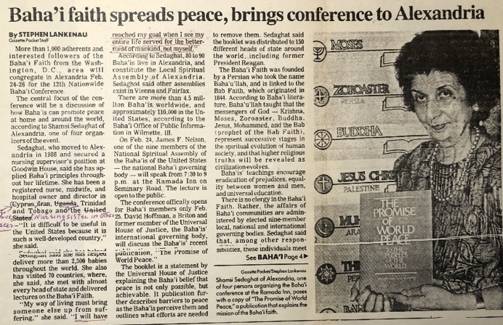
Article on Shamsi and the Baha’i Conference in the Alexandria Gazette

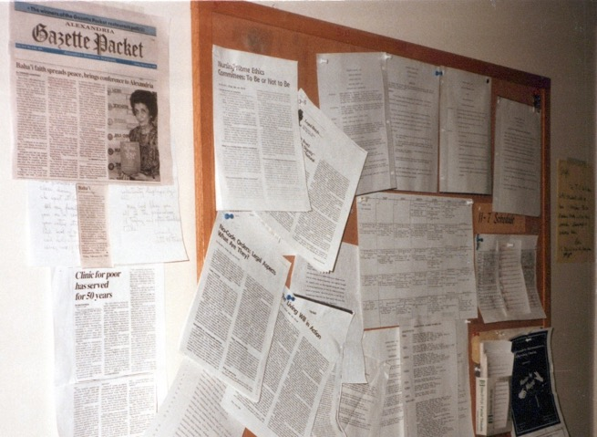
Article in the Gazette posted on the board of the Goodwin House nursing office with a photograph of me holding “The Promise of World Peace” message
I resigned the position in my hospital a year and a half later, on June 22, 1989. The Director of Personnel commended my work.
Mrs. Carol C. Billker writes
“July 6, 1989
To Whom it May Concern,
Ms. Shamsi Sedaghat has been employed by Goodwin House as a Resident Health Supervisor on our Nursing Care Unit. Ms. Sedaghat joined our nursing staff on December 1, 1987. She submitted her letter of resignation to us on June 22, 1989, giving us the required two weeks’ notice. Her responsibilities included the managerial responsibility for the planning, coordination, direction, and control of our Health Care Unit in order to provide a high level of quality patient care. She also functioned as the clinical resource person who coordinated communication with the physician in order to direct patient care on a designated tour of duty.
Ms. Sedaghat’s evaluation of May 1989 indicated that in many areas she met and exceeded the standards required for her position. She demonstrated a dedication to our residents and patients….
Sincerely yours,
Carol C. Billker, Director of Personnel, Goodwyn House”

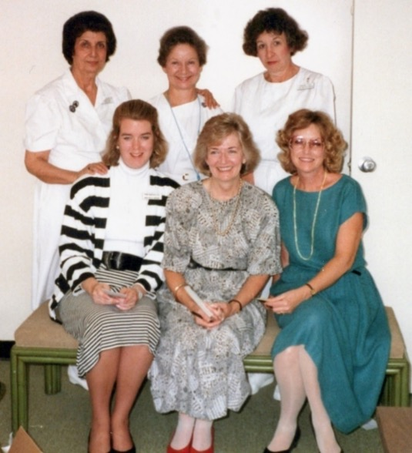
Supervisory staff at the Goodwin House in Virginia: Seated l. to r.: 1) Director of Nursing, Mrs. Carol Billker 2) Alice Biache, V.I.S.C., RNC, MSN for Health Services 3)? Sorry I forgot the name. The two ladies next to Shamsi were charge nurses.

Chapter 17

Decision to pioneer to Odessa, Ukraine, 1990
One day, in early 1990 while I was in Alexandria, VA, Dr. Alberta Deas, a member of the National Spiritual Assembly of the United States, came to me and during our conversation, asked me “Shamsi, why don’t you pioneer in USSR?” We have been advised by the Universal House of Justice to encourage the friends to pioneer to Odessa, Ukraine, or Alma-Ata (today Almaty), Kazakhstan. I replied that I would love to pioneer to those places, but I must first resign from my Hospital work, then secure the needed document etc. Dr. Alberta Deas said: “Do not be worry, write to the National Spiritual Assembly, and we will help you.” Then and there I decided to prepare myself for the next journey. The next day, I prayed and wrote a letter to the National Spiritual Assembly of the Baha’is of the USA, shared my desire and waited for their reply.
Afterwards, I wrote another letter to our Supreme Body informing it of my decision and appealing for its guidance and prayers.

My letter to the Universal House of Justice
“The Universal House of Justice,
Baha’i World Center
Haifa, Israel
Most August Body,
With utmost devotion and humility, I share with you my wish to go pioneering or travel teaching to the Soviet Union in response to the needs of the new Two-Year Plan. I have already contacted the National Spiritual Assembly of the Baha’is of the United States on this matter and am awaiting their response. A copy of the letter is hereto attached.
As always, I beseech your guidance and confirmation.
With loving Baha’i greetings,
Respectfully, Shamsi Sedaghat”

The Universal House of Justice wrote to me.
The reply from the August Body
“Bahai World Center
Department of the Secretariat
23 April, 1990
“Ms. Shamsi Sedaghat
205 Yoakum Parkway Apt. #212
Alexandria, VA 22304
Dear Baha’i Friend,
The Universal House of Justice received your letter of 2 March 1990 with its enclosures and was very glad to know of your wish to advance the Two-Year Plan in the Soviet Union. It notes that you are already in touch with the responsible Baha’i Institutions and it asks us to assure you of its prayers in the Holy Shines for the confirmations of your devoted services in this highly important field of endeavour.
With loving Baha’i greetings,
Lorena Kerfoot
For Department of the Secretariat”
CC: International Teaching Centre
National Spiritual Assembly of the United States”
The Office of Pioneering also wrote to me in support of my plans:
“Ms. Shamsi Sedaghat
205 Yoakum Parkway Apt. #212
Alexandria, VA 22304
Beloved Friends,
Our National Spiritual Assembly asked us to respond to your letter of February 23rd, 1990, regarding your generous offer to serve our beloved Faith in the Soviet Union, the land of your birth. It is a source of joy for us to know that you are ready to extend your pioneering services to this vital area, a country whose citizens are thirsting for the healing Message of Baha’u’llah.
As you know, the Universal House of Justice has assigned to our National Assembly two pioneering goals in both Kazakhstan and the Ukraine. With your knowledge of both Russian and Persian, we wonder whether you would consider fulfilling one of our goals to Kazakhstan. We know that there are Baha’is in Alma Ata, the capital of Kazakhstan, however, we do not know whether Baha’is reside in other cities.
The need for Baha’i pioneers is equally great in the Ukraine. There are four African students who are Baha’is attending university in Kiev, and we are certain that Baha’is live in other communities as well….
We are enclosing Pioneer Volunteer forms for you to complete and return to us to begin the formal process of your settling abroad. We will be contacting your Assembly as well.
We look forward to hearing from you and assure you of our daily prayers for the success of all your endeavors in service to our beloved Cause.
With warmest regards,
Yael R. Wurmfeld
Office of Pioneering”
Steps taken for entry to another new pioneering post
I filled out the forms of the pioneer committee for the United States of America and returned them. They organized my visa and all the necessary documents and sent them to me so that I could travel with the “Quddus teaching project group” to Moscow.
Therefore, I collected my needed luggage, said goodbye to my family. They took me to the airport. At the airport I missed my original plane, and I had to stay until 7 p.m. for the next plane and thus I had lost the Quddus teaching project group which I was travelling with. Therefore, I took the next plane the same day which flew through Frankfurt to Moscow. In Moscow I was met by Mr. Bill Mahoney and Mr. Alexander Forlov. Unfortunately, my luggage had not arrived with me, therefore we waited until its arrival. Then we were taken to Solut Hotel in Moscow, where our Quddus travelling teachers were staying. I was welcomed and received orientation for several days and shared in their activities. Then after consultation with Mr. Bill Mahoney, I decided to proceed to Odessa, therefore I was seen off on the 8th of August at the airport by the Quddus teaching project group: Mr. Jack McLean, Mr. Leo Missaghi, Mrs. Ann Clavin as well as Mr. Sergey, who was the representative of Mr. Bill Mahoney in Moscow. They all helped me with my luggage into the train for Odessa and themselves went to catch the train for the Kiev teaching trip on another side of the airport.

Mr. Jack McLean
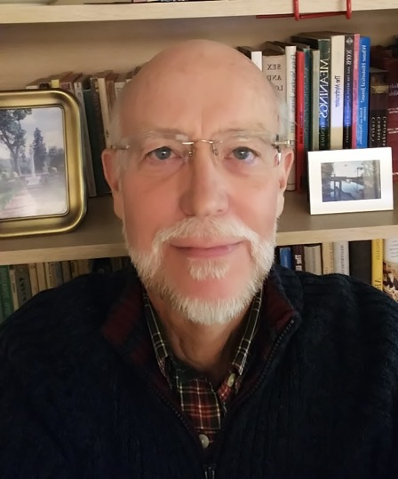
Mr. Jack McLean, a travelling teacher and author
The following account is from Mr. Jack McLean, who was one of the Quddus Teaching group in Moscow, USSR, whom I’ve met during my stay in Moscow, Russia is Solut Hotel, and the last time at the airport of Moscow on August 8th, 1990, when I left for Odessa. Now in America, I have received few pages of his Odessa memories.
Memoirs of Jack McLean, travel teacher in the Soviet Union
In 1990, Canadian Baha’i J. A. McLean wrote his memoirs of his travel teaching experiences in the USSR which included an appreciation of my teaching experiences in Odessa, portions of which I am re-printing with his permission:
“TO RUSSIA WITH LOVE Journal of a Member of the Quddus Team
J.A. McLean 1990
This journal is lovingly and gratefully dedicated to my parents JOYCE MARY HALSTED AND ALLAN JAMES MCLEAN who taught me the love, faith, and knowledge of God and to SHAMSI, ANN AND LEO with whom I shared a memorable moment of history in the making…
By this time Shamsi had been able to join the three of us. We were not to be a complete team of four for long however; Shamsi had planned to continue her journey directly on to Odessa, the port city on the Black Sea in southern Ukraine and to settle there as a resident pioneer….

…Shamsi Sedaghat: Lone Pioneer to Odessa
In the late afternoon, the Quddus Team headed for the railway station to see Shamsi off to Odessa where she would become the lone pioneer. The Victory’s (note: Mr. and Mrs. Victory were early pioneers-Shamsi) had been living there previously, but they had moved to Kiev. Like Leo Missaghi, Shamsi had been born in Russian Turkestan. (I suspect that Shamsi like Leo had been born in Ishqabad, but I cannot be sure). She naturally spoke Russian as well as Persian growing up, but at age 13 she and her family and the other Bahá’ís had been deported to Iran… Unlike Leo who had been able to keep his Russian fluent over the years, Shamsi had forgotten hers, but some Russian words were already starting to come back to her. (It would be just a matter of time until she became fluent again). Shamsi is one of those very exemplary senior Bahá’ís who has been a pioneer for over 40 years. She had the very great blessing of making the pilgrimage during the days when Shoghi Effendi was Guardian of the Faith. In Tehran she attended the first deepening institute in which she and other believers were taught by the prolific and distinguished scholar, Jenabi Fazeli Mazandarani, who had been sent to the United States to deepen the friends in the Covenant on the orders of ‘Abdu’l-Baha and later by Shoghi Effendi during the early 1920’s. The Hand of the Cause, Ali Akbar Furutan, and other eminent teachers had also instructed the friends at this same institute. Shamsi is a woman of action, an energetic believer who puts the Faith first in her life. She is assertive and determined without being aggressive or overbearing. Here she was at a time in her life when most people would be looking forward to a quiet retirement, but instead she pulled up stakes from her home in Alexandria, Virginia, to bring the light of this New Day to the faraway city of Odessa. She served on the first National Spiritual Assembly of the Bahá’ís of Trinidad and Tobago. In those twin island nations, she had brought a well-known doctor, Dr. Harry Collymore, into the Faith. …
Shamsi came prepared to live in Russia.…The seven suitcases she brought with her well exceeded the weight restriction; she was charged an extra $500.00 dollars by Pan Am Airlines. We were very concerned how Shamsi, with her 7 pieces of luggage, was going to get all her belongings onto the train. Most Russians travel with a small bag, or a few small bags, or depending on the distance, nothing at all. We knew that there would not be enough room in Shamsi’s compartment to accommodate all her luggage. We were all saying the Greatest Name as Sergey, one of Bill Mahoney’s agents, talked to the female conductor. After a brief conversation, she agreed to put some of Shamsi’s things in her own compartment. The rest of it would be packed in Shamsi’s berth. With a sigh of relief, we helped her on the train, and after thanking the conductor profusely, we said goodbye to this exemplary soul who had served the Cause with such great devotion for so many years. Her several fine qualifications will surely enable this steadfast pioneer to be a great asset to the Faith in the Soviet Union. The Love of Shoghi Effendi: A Mystical Experience in Shamsi’s Presence as I travelled on a bus with Shamsi in Moscow, I was possessed suddenly by that same heavenly love of Shoghi Effendi that I felt circa 1965 in Toronto when Hand of the Cause, Mr. Zikhrullah Khadem, spoke to the Bahá’í youth at a National Convention at York University. Each Hand of the Cause of God had distinctive, qualities that made him or her different from all other Hands. In that sense, each Hand was the essence of individuality, notwithstanding their collective devotion to the Guardian and to the needs of the Divine Plan. Mr. Khadem was noted particularly for his remarkable love, dedication, and devotion to the Guardian. Affectionate, humble, and courteous, a man of refined manners and finely tuned spiritual sensitivity, he was like an evanescent drop lost in the ocean of Shoghi Effendi’s love. Unusually rare in this world, and like all mystical experiences, difficult to describe in words, it was vastly different from any form of human love that one may feel for loved ones, whether friends, family, or fellow believers. What struck me suddenly at York University was an experience of much greater magnitude, but of the same origin nonetheless as the spiritual phenomenon that I felt sitting beside Shamsi. Now imagine a colossal, heavenly magnet suspended in the air above the stage where Mr. Khadem was speaking. Now picture yourself as the speck of a single iron filing. Would you be able to escape such a powerful, irresistible force? That force transported me to an unknown spiritual realm and ecstatic form of consciousness, a force that drew me out of my seat and down the aisle, and in full view of all the assembled friends, to mount the stage even as Mr. Khadem was speaking, and completely unembarrassed and forgetful of self, to throw my arms around him and kiss him on the cheek. Yes, as I think about it now, no one in his right mind would ever do such a thing, but I was not at all in my “right” mind, but fully a mad Majnun in the Valley of Love. He looked at me, a strange young man who had climbed the stage to interrupt his talk, but he seemed not at all surprised or disturbed by my unusual behavior. He said simply “God bless you.” Still oblivious to those around me, I left the stage blinded by my own tears and returned to my seat, as my everyday mundane consciousness gradually returned. I had not been able to precisely identify the origin of this Divine Love which drew me like a gigantic magnet in the sky, nor for some years did I really seek to comprehend the experience any further. But years later, after Mr. Khadem had passed on from this world, I met his wife, Javiddokht Khadem, at a conference in Quebec City. As she gathered with some of her children, I found a brief moment to tell her about my unusual experience. She responded with the simple but certain observation: “Yes, that was the love of Shoghi Effendi.” Mrs. Khadem’s insight was the master key that instantly unlocked the meaning of that rare spiritual event. Sitting beside Shamsi that day on a bus in Moscow, as she spoke about the Guardian, she too became the vehicle for the love of Shoghi Effendi. I wonder now whether or not every pilgrim who had been in the presence of the Guardian could be the vehicle for that same heavenly love.”
The above were a few pages from Mr. Jack McLean’s great memoirs. He was one of the members of the Quddus Teaching project group.
Story I heard in Odessa
The following story was told to me when I arrived in Odessa in August of 1990:
In 1984, four Ethiopian Bahá’í students—two men and two women−Tisge, Emayes, Siyun, and Derege, had arrived in the USSR to study medicine. They were the only Baha’is in the town where they lived outside of Odessa. In 1988, two of them, Tisge and Emayes left for Soviet Georgia. They stayed in a hotel where—by ‘God’s providence’—Ms. Lynda Godwin was also staying. She was an American Bahá’í who was serving as a coordinator of the Bahá’í travel teachers who were touring various regions of the USSR, including the Ukraine.

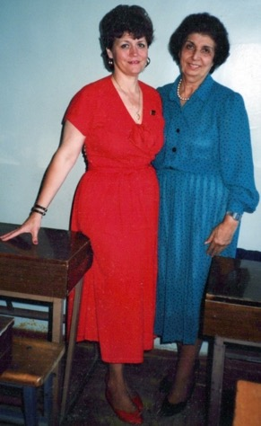

Ms. Linda Godwin, coordinator of the travelling teachers from abroad, and Shamsi
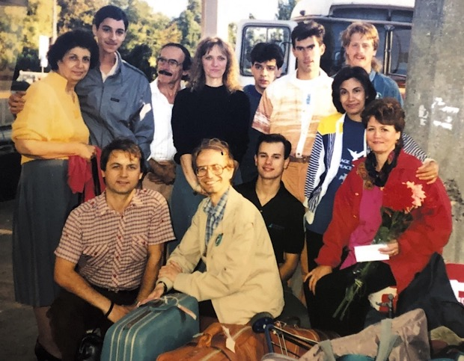
Shamsi with Lynda Godwin and travel teaching group, either arriving or departing from a town.
Shamsi on the left in yellow, Ms. Lynda Godwin on the right in red, Genna, energetic Baha’i young man in black
When the Ethiopian students and Ms. Godwin met, they were thrilled to discover that they were all Baha’is. Ms. Godwin took down their addresses and said she hoped to see them all again next time when the travel teaching group came to Odessa. As promised, Ms. Godwin looked up the students once she reached Odessa and invited them to their meetings where they could deepen themselves more on the Baha’i Faith and its principles. They also were able to meet the other Bahá’ís in the teaching group who were from different countries. They were promised that they will be seen again very soon.
Declaration of Mr. Alexander Rivas
In 1985, Mr. Alexander Rivas, a nineteen-year-old from Venezuela, arrived in the USSR on a scholarship to study Russian. The following year, he moved to Odessa. On March 1st, 1990, a friend invited him to go hear the Baha’i music group, El Viento Canta, which had come from South America. Alexander went and enjoyed the music. In subsequent months, more Baha’i musicians came through Odessa to perform: Mr. Red Grammer, an American singer, in April, and Day Star, a group, in July. After listening to these Baha’i performers, Alexander was very attracted to the Faith, and on July 19th, 1990, he declared and then joined Day Star to sing. Alexander was the first person to accept Baha’u’llah in Odessa, but he was an isolated Baha’i as there was no Baha’i community.

My arrival in Moscow
I (Shamsi) arrived in the USSR on August 5th, 1990. I missed my original plane from the U.S.A. on August 4th, so I was not able to travel with the Quddus Project teaching group. I flew on a 7 p.m. plane the same day which went through Frankfurt to Moscow. I was met there by Mr. Bill Mahoney and Mr. Alexander Forlov and taken to the Solyut Hotel in Moscow where several Baha’i travel teachers, the Quddus Project group was staying. I was welcomed, and I received an orientation with the Quddus group and shared in some of their activities.
I left for Odessa
Then on August 8th, 1990, I was seen off in Moscow by a few people from the Quddus travel teaching group, such as Mr. Leo Missaghi, Mr. Jack McLean, Mrs. Ann Clavin, and Mr. Sergey, (the representative of Mr. Bill Mahoney in Moscow), who all helped me with my luggage to be loaded, and I left, and the Quddus teaching group left for their own journey.
During the trip, I shared the cabin with three other men: a seventy-seven-year-old father and his twenty-three-year-old son who were travelling home to Odessa, and a road engineer from India. Over the long hours, we attempted to speak with one another in Russian and English. At night I went to the dining car to eat. I sat next to a gentleman who was an economic representative of Russia to Japan who spoke English very well. He was going to Odessa to pick up his car which had been shipped there. We had a wide-ranging conversation which eventually led to talking about God and his prophets and then the Baha’i Faith and its principles. He was interested, so I gave him a book titled A Pattern for a Future Society. He started to peruse it and said that these were very good principles. He asked me if he could find the name ‘Baha’i’ in the encyclopedia, and I answered, “Of course!” Then he said that he would look it up and wrote down the word ‘Baha’i’ in his notebook. We finished dinner and then returned to our cabins. There I rested until morning.
In the morning, the conductor brought some bread, tea, and other food for our breakfast, and we added the food we had brought with us to the meal. We ate and rested for a while until we reached Odessa. The father and the son gave me their telephone numbers and told me I could stay with them in case I had nowhere to stay until I found my friends. I thanked them for their kindness and assured them that I would be alright.
The train started to slow down. I walked to the window and stood in such a way that the Baha’i symbol on my necklace would be plainly visible. Suddenly I heard someone calling out, “Are you Shamsi?” and I replied, “Yes, I am Shamsi!” He said, “Allah’u’Abha,” and I replied, “Allah’u’Abha.” Then he called the other two friends excitedly, saying, “Come, I found her,” and all three young men followed the train until it stopped. They waited for the passengers to get off, and then they boarded.
We greeted each other, and they asked me, “Where is your suitcase?”, and I replied, “Where are your suitcases?” They laughed, and I said that they were in the conductor’s room. They went to the conductor, and she kindly helped them carry my seven big suitcases out. There was a man with a trolley waiting to find a client. I am sure that the trolley was sent for me by my Heavenly Father−no one needed such a big carrier but me as all the other passengers carried small handbags or one or two medium size suitcases! I said goodbye to the other passengers. We loaded the trolley, and we took my luggage out to the street.
Temporary place of my residence was arranged
I asked, “Where should we go?” They answered, “We have found nowhere yet as there are no empty apartments and no hotels are available for guests who do not come with personal or professional recommendations.” I asked my new friends, “What should we do?” The young men consulted amongst themselves and suggested that one of them, Sergey Sinyakov, go and phone his parents and ask permission to take me to their home for a day or two until other accommodations were found. He went to the phone box and called his mother, Mrs. Galina Sinyakova, who was a pediatrician. He explained the situation to her and asked permission to take me home as a guest until they could find a more permanent place for me. She kindly agreed to have me as a guest. Sergey returned to us and happily announced that he had arranged for me to stay with his family.
We were all cheered by this news and looked for a taxi to take us to his home. Unfortunately, it was very difficult to find a taxi big enough to accommodate all my luggage, so Sergey found one taxi and put several pieces of my luggage in it and then went on to his home, and we waited for another half an hour for a small bus in which we could put the rest of my luggage, and then we went on to his apartment. It took a good while before we reached our destination.
Mr. Sergey Sinyakov was waiting for us outside of his building when we pulled up, and he helped us to unload my bags. We had to make several trips up to the apartment because the tiny elevator could not hold much of my luggage. Upstairs we met Mrs. Galina Sinyakova, Sergey’s mother, a fairly young lady, who welcomed me warmly. We sat down and I introduced myself: “Shamsi Sedaghat, just coming from America through Moscow”. Soon after, Sergey’s father Mr. Vladislav Sinyakov, who was also rather young, arrived. I introduced myself to him again. He was kind and pleasant just like his wife. He welcomed me with great sincerity. Then they served some refreshments, as well as the fruits which I had bought on the way from Moscow to Odessa. Now I introduced myself again, that I was an Iranian woman born in Ashghabat, Turkmenistan, and I am a Bahá’í. I was trained to be a pharmacologist in Ashghabat, but before getting my final certificate of graduation we had to leave Ashghabat due to change of the government to my father’s birth place - Iran. Now that situation had improved, I was returning to this country, Odessa, Ukraine, which is near to my birth place, Ashghabat.
The Sinyakovs’ apartment
Their apartment had two rooms—one for the son, Mr. Sergey Sinyakov, and the other for his mother and father and their very big dog. They gave Sergey’s room to me and Sergey had to go to the small kitchen with a pillow and two bedsheets, one for underneath and the other for over himself to sleep. Although I begged them that Mrs. Galina Sinyakova could come into my room to sleep, they refused, and I slept in Sergey’s room which doubled as a guest room. Of course, we had supper and spoke about many subjects including the Baha’i Faith and the purpose of my returning to this part of the world to be near my birthplace, Ashghabat, and serve the physical and spiritual needs of the people until the day when I could go back to Ashghabat, God willing. Then we went to bed.
Search to find a residence
The next morning, August 10th, I got up early as usual, said my prayers, and the Sinyakov family rose a little later. We ate zaftrica (brunch) which included rice, cutlets, bread, and fruits, among other things. Then Vladislav, Sergey, and I left the house to search for an apartment. The roads were not as good as they are today, and the distances were great. We went to several places, but they were either not suitable or not available. So, we went to see Mr. Genna, a friend of Ms. Lynda Godwin. Genna informed us that there was a friend of Ms. Godwin’s called Mr. Nicolay who might be able to help us. He phoned Nicolay who replied that he knew a lady who had a nice, empty apartment and told us to give him time until tonight, and he would let us know then. So, we went to Genna’s home. Genna’s family graciously served us refreshments, and we spoke about the Faith. After saying goodbye to them, we took some of the refreshments out to Mr. Sinyakov who had been waiting for us outside in the car the whole time.
Visit to Ms. Ludmila
Then we drove to the home of Ms. Ludmila who had been introduced to us by Mr. Richard Hainsworth, a British Baha’i who had been pioneering with his family for many years in Moscow and they are very active Baha’is there. Ms. Ludmila was an elderly lady who lived with her daughter, a computer engineer. She had been expecting us and served us snacks, sweets, and soft drinks, and said that she would help find a place for me tomorrow. In the meantime, she said, I could stay free of charge in her nicely furnished kitchen which had a bed in it until I found permanent living quarters. I thanked her very much and told her that I would let her know about my decision. Then we said goodbye and left. We took Mr. Genna back to Mr. Nicolay’s apartment, and we went home to Mr. Sergey Sinyakov’s which took forty minutes. Sergey’s mother had prepared a delicious meal for us. We ate together and then went to sit in the living room where I spoke with Sergey about the Faith and the nine Baha’i Holy Days. His mother and father were busy taking their big dog for a long walk because he was sick. They returned at a late hour, and we all went to sleep. The weather was very warm, so we had to leave the windows open. There was a small table fan which helped.
Had a quiet day
I got up early the next morning, August 11th, and was going to refresh myself but a big dog was lying on the floor of the small corridor outside of my door, and I was afraid to step over him; nevertheless, I quietly stepped over him and went to the washroom, washed up, came back to my room, and said a few prayers. Everyone else got up, and we had brunch together. After that I stayed at home and waited for phone calls. No one rang so I sat with the family and discussed the Faith. After dinner, we retired to bed.
We had several errands to do
When I got up the next morning, August 12th, Mr. Vladislav Sinyakov had already left for work when Mrs. Galina Sinyakova and Mr. Sergey Sinyakov got up. We all had brunch. The Quddus travelling teaching group was coming soon to Odessa. Sergey arranged for the group to stay in the homes of Russian friends, and for Ms. Lynda Godwin to stay at Mr. Nicolay’s apartment. Then I went with Galina to buy food and soft drinks at the open market where they were very cheap because I was able to purchase them with U.S. dollars. We went home, and Mrs. Galina prepared a delicious ‘borsch’ which is Russian soup with lots of vegetables. We ate and then sat together, and I spoke about the Faith and its progress around the world, including its incorporation (registration as a religion) by several different governments. They were interested to hear this and did not object to anything which was a source of great joy for me. Then I spoke on the phone with Mr. Leo Missaghi, a half-Russian, half-Iranian Baha’i (he had two different nationalities) who was with the Quddus travel teaching group. He said he was hoping to see me in Kiev, but I said we had not been able to find tickets from Odessa. However, I told him to call my family when he returned to the United States and give my love and respect to them which he agreed to do. Then we rested.
I went to the immigration department
I ate brunch with the Sinyakovs the next morning, August 13th. We waited until 2 p.m. to start phoning for the apartment and spent the time in spiritual discussion. We ate the lunch we had prepared, and then I went with Mr. Vladislav Sinyakov and Mr. Sergey Sinyakov to register my visa at the immigration department.
The person in charge asked me, “Why have you not come to be registered until now?” I replied that I had not known that I had to register in every locality since I already had a Russian (USSR) visa. I later learned that I had to register in each city I went to as well. Therefore, I had come to the department on this day. I apologized for the delay. He said that it was okay but that I needed the following: 1) a request letter for registration, 2) the entry visa to USSR, 3) two photographs, 4) two rubles (money). He said that when I brought these, he would register me. I said thank-you, and we went home and got all the necessary documents and a registration letter from Mr. Sasha in Kiev which arrived after a few days. After three days, I took them back to the immigration office, and I was registered and given permission to stay in Odessa for one year. I thanked him and left. We went to see several more apartments, but these were not suitable. We came home, discussed the Faith with the family, ate supper, and then I went to bed.
Still searching for residence
The next morning, August 14th, I suggested after brunch that we phone the friends who had told us they would let us know if they found an apartment. The Sinyakovs were shy about phoning because they did not want to be too aggressive. I gently asked them to please phone them to find out if they had found a place for me, so we would know whether to wait or not. Mrs. Galina Sinyakova went next door and asked the neighbor if there was any news about a possible apartment, but the neighbor had no news. Then Mr. Sergey Sinyakov phoned a lady who had promised to rent her apartment to me. Ms. Tanya Kangoon picked up the phone and said that she was ready to rent her place to me. We spoke about the price and what I needed in terms of furnishings, dishwasher, and other items. She said she would provide these. I agreed to rent her apartment. She said she would start cleaning the apartment tomorrow, and we could stop by in the evening and see the place. I was very happy and thanked God for this bounty. I explained to the Sinyakovs that we should have courage, rely upon God’s Will, and be steadfast then everything would be accomplished with His Will! Any success I had in my life had been due to my ‘gentle persistence.’ Then we ate our supper and went to bed.
My new apartment
The next morning, August 15th, Sergey went to meet the group of travelling teachers who had arrived with Ms. Lynda Godwin, their coordinator. His father went to work, and his mother and I sat and spoke in my broken Russian about the world’s condition and the plan for world peace. Although she did not know much about the Faith, she listened and was very kind and hospitable. She got a basket and put some tea, sugar, salt, oil, bread, and cheese, in it for me to take to my future apartment until I could go to the market to buy food. I accepted the basket, thanked her very much, and gave her gifts from America.
I was very grateful to the Sinyakov family for all they had done for me during my first ten days in Odessa. They took me to their home from the train station with all of my luggage, helped me with the immigration office, took me around to visit apartments, and shop in the market. All of these trips required at least one of the Sinyakovs to take a bus to a car park where they had to keep their car, drive me around on my errands, drop me off back at their home, then drive back to park the car, and take two buses to get back to their home. They repeated this almost every day during my first ten days. May Baha’u’llah reward them with all they wished for in this world and the worlds to come.
At 2 p.m., the Sinyakovs helped to bring me and my suitcases to my future apartment. The owner, Mrs. Tanya Kangoon, was already there and cleaning the place which had been closed for six months without a renter.
We helped Tanya clean the sitting room and place the porcelain tea cups, plates, and other kitchen ware which Tanya had brought from her home into the large cupboards. Next, we cleaned the bed and spread out new linens. I unpacked my suitcases and put away my belongings. The flat gradually took shape until it was ready for occupation. Since the most important room was the kitchen, we cleaned it thoroughly including the refrigerator which we then plugged in. When we finished, we put the food which the Sinyakovs had given to me into it. Then we made tea and had snacks which we ate with relish. We offered a prayer of thanks to God for his bounties.
Now we were ready to start our Baha’i meetings, firesides, and deepenings. I was also very fortunate to have a telephone in this flat. Ms. Tanya Kangoon and Mr. Sergey Sinyakov left. I thanked them very much.
The apartment building had many stories. I lived on the sixth floor which I reached by a small elevator. On the ground floor, there was a grocery store. Though it was a crowded and noisy place, I was very happy that I could buy my daily food there rather than having to go all the way into town to do so. This was another gift to me from the Abha Kingdom. After I finished cleaning, I went to sleep, but I could not fall sleep because I was tired, a little hungry, and had a headache. I got up and had a piece of bread with cheese and took two pills and then went back to bed and was able to sleep until morning.
Almost settled in my apartment
I got up early the next morning, August 14th, and thanked Baha’u’llah that at last I had settled in my apartment and that now I could start my Baha’i activities and serve the people of Odessa. At 9:30 a.m., Ms. Tanya Kangoon, the owner of the flat, came over, and together we started to clean the bathroom and hallway again. We took a break for tea and refreshments, and I said prayers for the success of my service. Tanya had to leave but her mother arrived to help, and she continued to clean the rest of the apartment. When we were finished, the apartment was clean and presentable. Then I served her some tea and snacks, and she left, and as I was tired, I ate some more snacks and went to sleep.
The next morning, August 15th, I did not have any guests, so I slowed down the hectic pace I had been keeping and took things a bit easier. In the afternoon, I went to a big market and bought the food I needed and came home and made some preparation for tomorrow’s nineteen-day feast.
Sergey came at 6:30 p.m., while I was watching a film in the Russian language about the slaves and the cruel treatment that they had received. Mr. Sergey Sinyakov said he had seen this film and that it was very interesting, so we continued watching it together for another twenty minutes. After we stopped it, I said:
“This is what I was explaining to you and the others—that the time had come for God to correct these unjust conditions in the world. Humanity is progressing intellectually, so it should improve spiritually as well. The spiritual teaching always comes from the Creator of the world, God. In His appointed time, He sends chosen individuals by the title of ‘Prophets,’ gives them Principles and Laws which mankind must follow. Unfortunately, Man had never obeyed Him, so the prophets have been rejected by humanity which resulted in many wars and afflictions. Now, as the age of knowledge and understanding had come, and mankind had advanced, God had sent a prophet by the name of Baha’u’llah (the Glory of God) with spiritual principles suitable for today.”
Sergey listened very politely—he was a bit shy and not very talkative and thanked me for all my explanations and left. I went to bed after some prayers.
Declaration of Sergey Sinyakov, the first Russian Baha’i in Odessa, 1990
The weather the next morning, September 27th, was very cold and rainy. At 4:30 p.m., Mr. Sergey Sinyakov, Mr. Alexander Rivas, Tisge, Emayes, and Siyun arrived at my house; Derege was working and could not come. We had dinner, and then we started the feast devotions. Tisge, Emayes, and Siyun read from the Hidden Words in Russian, and I read the English part of it. I explained it as it was a bit difficult for them to understand in English. Then I asked Sergey to read an excerpt from a book called Promises. He read it and before I could say that Sergey was not a Baha’i, so we would omit the administrative section of the feast, Sergey said, “Excuse me before you continue, I would like to say a few words.” Then he said, “Until now I was not a Baha’i, but now I would like to tell you that I am accepting the Baha’i Faith!” As soon as he said this, we all got up and welcomed him into the Baha’i Faith with tears in our eyes. We all raised our hands in prayer to the presence of Baha’u’llah and thanked him that he had added the first Russian to become a Baha’i in the town of Odessa to our small Baha’i group. Now we had Tisge, Emayes, Siyun and Derege, four Ethiopian Baha’is who were all medical students, Alexander, a Venezuelan Baha’i, me, an Iranian Baha’i pioneer, and Sergey, a new Russian Baha’i, born in St. Petersburg. Sergey’s father, Mr. Vladislav Sinyakov, was an engineer born in Baku, and his mother, Ms. Galina Sinyakova was born in a town near Moscow, and they had lived in Odessa for five years, and they are good friends of the Baha’is.
One day the Sinyakovs visited me and we spoke at length about the Faith. My charts were hanging on the wall and through the charts, I spoke about the Faith. Although they did not declare, they were sympathetic and happy that their son accepted the Faith.
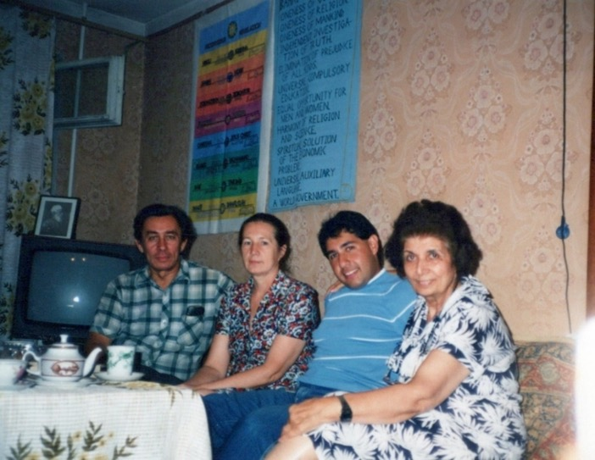
L. to r. Mr. and Mrs. Sinyakov, Mr. Alexander, and Shamsi
Forthcoming visit of Dr. and Mrs. M.H. Jamalabadi
We were very happy about this gift of Mr. Sergey Sinyakov’s declaration, so we took photographs of the occasion. We then consulted on the visit of Dr. M.H. Jamalabadi and his wife, Shahnaz Khanum, who were arriving from the island of Trinidad and Tobago to attend an ophthalmology conference. They would be staying for two extra weeks after the conference to help with the teaching work. Our nineteen-day feast finished in an atmosphere of love and unity. There was a lot food left over, so I gave some of it to Sergey to take back to his family who were always so kind to give me sugar, rice, and other foods without ever accepting any money for it. After everyone had left, I cleaned the kitchen and went to bed happy at midnight and said prayers for all His bounties.
Mr. Dimeter ‘Mitko’ Gerensky visits us
The next morning, Sunday, September 28th, I went downstairs to the shopping center to buy food. At 2 p.m., Alexander and his non-Baha’i friend, Mr. Dimeter ‘Mitko’ Gerensky, arrived. Mr. Gerensky was Bulgarian and studying engineering in Odessa. Sometime ago, a group of Baha’i travelling teachers had come from Canada to Odessa. Dimeter met them and since then, he had been participating in all the Baha’i meetings. He was extremely interested in the Faith and asked many questions.
When the Canadian teachers had been in Odessa, they spoke and sang songs about love and unity in the city’s public park and had local Baha’is translating their English into Russian. A crowd gathered around them, and even people driving by in cars would stop and listen from their vehicles. When the Canadians had finished their songs and presentation about the Faith, Baha’is would give literature to anyone who expressed interest in learning more and invite them to nearby meetings where seekers could learn more about the world-redeeming Message of Baha’u’llah. I was sitting and was in charge of literature, and Mitko—even though he was not a Baha’i—helped with this street teaching by distributing materials to anyone who was interested. He ran back and forth between the crowd and our stock of literature, enthusiastically giving out materials. The proclamation that day was highly successful, and everybody left with literature and the address of our fireside meetings.
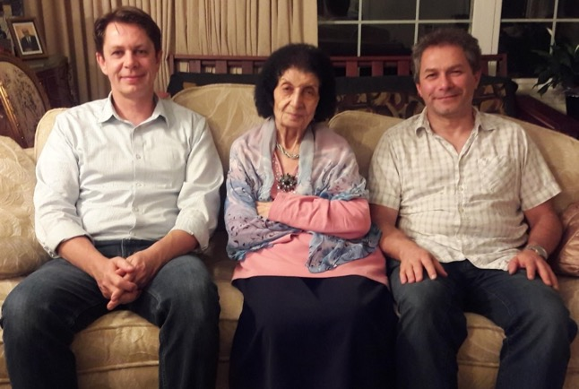
l. to r.: Mr. Sergey Sinyakov, Shamsi, Mr. Mitko Gerensky, in Virginia, 2018, taken when I was in the USA;
these are two of my spiritual children
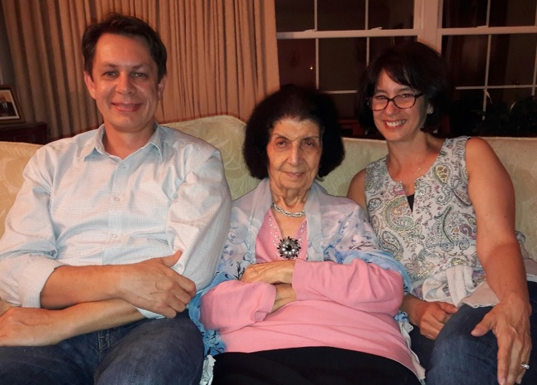
l. to r.: Mr. Sergey Sinyakov, Shamsi, Mrs. Lindalee Sinyakova, in Virginia, 2018, taken when I was in the USA

Mr. Dimeter Gerensky leaves for his home, Bulgaria
Several weeks later, Mr. Mitko (Dimeter) Gerensky phoned me to tell me that he had finished his training in Odessa and would be leaving for Bulgaria the next day. I immediately picked up several Baha’i books, pamphlets, and a prayer book which I signed and took to give him for his helpfulness along with foodstuffs and other things. When I reached the train station, he was not there. He arrived late and missed his train, so he had to take the next one. I gave him the small parcel which I had brought for him, said goodbye, and then Mr. Alexander Rivas and I returned home. Back in my apartment, I immediately phoned the town on the border with Bulgaria to inform them of Mitko’s late arrival and asked them to wait for him until the next train.
Acceptance of the Baha’i Faith by Mr. Gerensky
Mitko called me from Bulgaria and told me that he had arrived safely, and everything was alright. Then he said he had good news for me. He had decided to accept the Baha’i Faith, but he did not know what to do and whom to see. He had not met any Baha’i youth yet. He wanted to start translating the booklets that I had given him and was also very anxious to start teaching there. I was overjoyed to hear this new declaration. I congratulated him and counselled him not forget to pray that God Almighty to confirm him, keep him healthy, and give him strength to teach this message of peace to anyone who was ready to hear it. To make him happy, I informed him of the declaration of his friend, Mr. Sergey Sinyakov, about which he was very happy. I told him that I would inform the National Spiritual Assembly of the Baha’is of the United States of his declaration, provide it with his name and address, and ask that he be put in touch with the Baha’is of Bulgaria. Then we said goodbye to each other and hung up the phone.
Mr. Alexander Rivas and his friend, Mr. Michael Gorbatov
At 2 p.m. on September 29th, 1990, Mr. Alexander Rivas came to me with his friend Mr. Michael Gorbatov who was a friend of the Baha’is and knew something about the Baha’i Faith. We ate dinner together, and I spoke about the Faith and its teachings. Mr. Gorbatov replied that he could never forget and forgive the cruelty and violence suffered by his relatives and friends at the hands of his own countrymen. He said he could not accept a God who permitted that a member of His creation commits violence against another. I gently told him that he should not be so negative in his views, that there had always been people who could not accept the wrongdoings of others but in the Baha’i Faith, there were teachings that showed us how we should approach these people. Then I went to get a writing from Abdu’l-Baha about how ‘to live the life’ in the Baha’i way. I read these words calmly and loudly for him:
“Be no cause of grief to any one…Be kind to all people and love them with a pure spirit…
Should opposition or injury happen to us bear it; be as kind as ever we can be, and, through all, love the people…Be silent concerning the faults of others; pray for them, and help them, through kindness, to correct their faults…Look always at the good and not at the bad…If a man has ten good qualities and one bad one, we must look at the ten and forget the one…And if a man has ten bad qualities and one good one, we must look at the one and forget the ten…Never allow ourselves to speak one unkind word about another; even though that other be our enemy…Do all our deeds in kindness…Cut our hearts from ourselves and from the world…Be humble…Be servants of each other, and know that we are less than anyone else…Be as one soul in many bodies; for the more we love each other the nearer we shall be to God; but know our love, our unity, our obedience, must not be by confession but reality…Act with cautiousness and wisdom…Be truthful…Be hospitable…Be reverent…Be a cause of healing for every sick one, a comforter for every sorrowful one, a pleasant water for every thirsty one, a heavenly table for every hungry one, a star to every horizon, a light for every lamp, a herald to everyone who yearns for the kingdom of God.”
When I finished reading the passage, I asked him what he thought about ‘Abdu’l-Baha’s heavenly advice. He accepted a copy of it from me and said that his mind had been comforted a bit, but he had to study further. He thanked me very much for the time I had spent with him, and then they had refreshments, and the two young men left.

Arrival of Dr. and Mrs. Jamalabadi in Moscow, September 30^{th,} 1990
At 5:10 p.m., I received a phone call from Dr. Mohamad Hasan Jamalabadi who was in Moscow and wanted to let me know that tomorrow, September 30th, at 1:10 p.m., he would be arriving in Odessa. Dr. Jamalabadi was an eye specialist. He lived with his wife Shahnaz Khanum and two daughters, Shohreh and Shahrzad, and a boy, Shahram, as pioneers on the island of Trinidad and Tobago. For many years they were very active Baha’is and brilliant children and all of them are in America today and serving the Faith to the best of their ability. He was a member of the National Spiritual Assembly, and his wife was an Auxiliary Board Member in Trinidad. I immediately phoned the wife of Dr. Gratchov, a friend of Dr. Jamalabadi, and gave her the information. We decided that the next day we would go to the airport to meet them rather than have our regular study class and from there, we would go for lunch to Dr. Gratchov. Dr. Gratchov phoned me that night and said that he had not been able to invite many people or make the necessary preparations, so he suggested that tomorrow we could have a gathering ourselves and a larger one for later dates. I accepted the idea, and we said goodbye.

Arrival of Mr. and Mrs. Jamalabadi in Odessa
The next morning, September 30th, I prepared breakfast for our study class, but no one came except Alexander, and he had already eaten. Sergey arrived at 11:15 a.m., and our Ethiopian students came a little later. They had all eaten their breakfast already but as they did not know about the arrival of the Jamalabadis, they had already made other arrangements and could not come to the airport. They said they would come around another day. They drank tea and left.
Mr. Alexander Rivas, Mr. Sergey Sinyakov, and I got into a taxi and went to the airport. We met Dr. Gratchov and Mr. Michael Gorbatov there. The plane was delayed and arrived at 1:30 p.m. We presented them with flowers and took photographs of ourselves, and then we were all taken by Dr. Gratchov’s car to his home. Mrs. Gratchov was expecting us and had a delicious lunch prepared for us. We ate together and then, as the visitors were tired, they went to rest while Mrs. Gratchov, and I went to the market. She did some shopping, and then we went our separate ways. She went home, and I took two different buses to get home. After I’d rested, I started to prepare the ingredients for tomorrow’s dinner for the Jamalabadis in my home.

Visited the Interclub and arranged a meeting for our visitors
On the morning of October 1st, I went grocery shopping downstairs and then went back to my apartment. I phoned Ms. Sveta, an active Baha’i, to come over so we could go to Interclub, meet the assistant Director, and arrange a program for our visitors. She arrived, and we got into a taxi and went to Interclub. We met the assistant director and his wife. We told him all about our visitors. The assistant director was very receptive, so we arranged that they would come over for supper on October 7th and on October 10th, we would have a meeting in the Interclub which would begin with refreshments followed by a talk. After that was settled, we went and saw an opera about God, Satan, and Satan’s negative influence which helped illustrate our talks about God and His positive influence on the life of humanity. When the opera finished, we took a taxi and dropped Sveta at her home, and I returned to my place, did some cleaning, and then went to bed.
We arranged a welcoming gathering at my place
I cleaned the apartment the next morning, October 3rd. In the afternoon, Mr. Alexander Rivas, and Mr. Sergey Sinyakov came over. We ate lunch together and worked on plans for Dr. Jamalabadi and his wife’s visit. We invited several people over to dinner at my place on October 7th. For the Interclub meeting, we invited thirty-five people, most of them non-Baha’i doctors and other prominent people of Odessa. When we were done, Alexander and Sergey left, and I cleaned the kitchen and went to bed.
Discussed about needed materials for our coming gatherings
I went to the market the next morning, October 4th, where I found reasonable prices for items I needed for the kitchen and dining room. I bought them and carried them back home in a taxi. Then the owner of my apartment, Tanya, came by, and we spoke about the Faith. I felt that she was a very open-minded person and seemed almost ready to accept the Faith. We organized the living room so there would be more space for our guests. Then we discussed what more we needed to get for the meeting at the Interclub. She said she would bring thirty disposable plates and a few other things, and I would get the rest of the materials. We ate a little bit together and after she left, I went to bed.
Attended a medical lecture by Dr. Jamalabadi
I went to the market again the next morning, October 5th, and bought food, including fruits and sweets. They were very cheap for me because I was using U.S. dollars which were highly valued and so had an excellent exchange rate. I went home, changed, and then went to the medical conference where Dr. Jamalabadi was lecturing. I sat and listened to his excellent professional lecture. The audience enjoyed it. After his talk was finished, I was introduced to the doctors and professors there. Then refreshments were served, and I spoke privately to various individuals. Then I said goodbye, and I was brought home. At home, I did some work around the house and just as I was preparing for bed, I heard the doorbell ring. I walked over to the door and asked who was there, and I heard, “Me, Lena, and Boris Reznic.” I opened the door and welcomed them in. They told me that they had seen my telephone number on their answering machine, and they had come to see what the call was about. We sat and had tea and refreshments, and I explained that I had visitors from Trinidad and Tobago, and that I wanted to invite them to a public meeting at the Interclub which I and others were hosting.
A week earlier, I had visited Ms. Lena Reznic’s school, #119, to speak to her eighth-grade class about the Baha’i Faith. When I walked into the classroom, all the students stood up, and greeted me. I thanked them and asked them to sit down. Then I was introduced as a Baha’i, a nurse, a midwife who had delivered many babies, and who had been the director of the Rezvan maternity clinic on the island of Trinidad and Tobago. For several months I had been travelling and lecturing. They all clapped for me. I thanked them. They were very interested in my profession and asked me about delivering all those babies. I spoke a bit about the patients, babies, nurses, and doctors, about which they enjoyed hearing. Then I said, “Now that you have heard about science, I would like to speak with you about religion.” I asked them, “Are you ready?” and they said, “Yes.” I asked them, “Who is God and where is he?” I looked around the classroom and saw that no one had raised their hand. I repeated the question again and a small young student raised his hand, and I saw that Mrs. Lena Reznic was also tentatively putting up her hand. I asked the student to please stand up and answer in a loud voice so that l could hear! He stood up and said, “God is our Creator and lives in heaven.” All the students laughed! I said, “Very good! Very good! You answered my question correctly.” Then I read a passage from Baha’u’llah’s Hidden Words in which he writes:
“O Son of Man! I loved Thy creation hence I created Thee. Wherefore dost Thou love Me that I may name thy name and fill thy soul with the spirit of life.”
“O Son of Being, love me that I may love thee, if thou lovest Me not, My Love can in no wise reach thee; know this O servant.”
“O Son of Being, make mention of Me on My earth, that in My heaven I may remember thee, thus shall Mine eyes and thine be solaced.”
Again, I pointed out that Baha’u’llah wrote that God had created us so “if thou lovest Me not, My love can in no wise reach thee.” Then I explained the true meaning of ‘creation’ and ‘heaven,’ and many of the students understood. Ms. Lena Reznic’s belief in God and His Presence was strengthened and deepened.
Then we said goodbye, and I left. This was when I was in her school. When they came to my home that night, I spoke some more about the Faith. Her husband said that he believed in most of the teachings, and his wife said she did as well but wanted to read more. I gave them more literature. We enjoyed being with each other, and they left and promised to come regularly to our meetings, especially the gathering at the Interclub.
Later, they kept their promise and attended my firesides and other gatherings. Then after the formation of our local assembly, one day Mr. Boris Reznic and his wife, Lena, declared the Faith when their two children were present. I was very pleased and embraced them and welcomed them to our beloved Baha’i Faith. They began serving and studying the Faith immediately.
After I left Odessa, I heard no more from them but many years later, I received a phone call from Mr. Ahmad Mavliyanov. (He is an active Baha’i in Ashghabat today, member of the local spiritual assembly and the National Spiritual Assembly of Turkmenistan, and responsible for the Huquq’u’llah Fund; his wife, Makhim Khanum, who was a member of the local spiritual assembly and the National Spiritual Assembly of Turkmenistan, is today serving as an auxiliary board member for Turkmenistan, a duty she is performing admirably.
I can say Ahmad Jan and his wife are strong pillars of the Faith in Ashgabat). They have four daughters Homay, Soray, Aygozel, and Ayparcha. All speak Russian, Turkmen, and English, and all are very active Baha’i youth and serving according to the best of their ability the Cause of Baha’u’llah (Homay and Soray are studying today in England).
s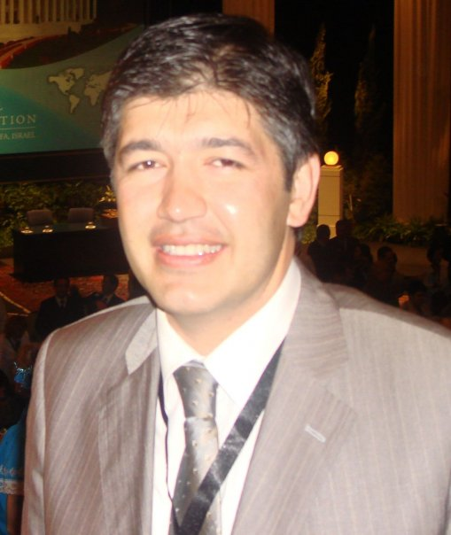
Mr. Ahmad Mavliyanov
Then back to our story: one day when the Reznics were in Haifa for pilgrimage, Ahmad Jan was in Haifa as well. He phoned me and said, “A person would like to talk to you.” He handed the telephone to a lady who said, “Shamsi Khanum, Allah’u’Abha. I am Lena Reznic with my husband Boris and my two daughters. We have all come for pilgrimage, and we are very happy that we are here. We will pray for your health and success in your service.”
I was thrilled with joy to hear that they were such strong new Baha’is that they have gone for pilgrimage so soon. I praised them and wished them best of success in their service to our Beloved Faith. We spoke for a few minutes and said goodbye. They are now living in Germany, I think. The purpose of writing this story is to show that we do not know what the results will be of our teaching efforts and that we should not look at our own shortcomings but look to the Power that is behind us when we take a step. We should always try to give the message and the rest is left to the Will of God, the Almighty.
Election of the first Spiritual Assembly of Odessa, November 12th, 1990
In Odessa, many people asked me to teach English classes. I agreed, it was arranged that a car come and take me to a class where doctors, teachers, business people, and students were in attendance. According to their understanding of English, I taught my classes. I
n casual conversation before and after classes, I spoke about my background and my Baha’i religion which accepted all of the religions of the past as God revealed Himself progressively in every age. I showed my chart on progressive revelation on which was printed the Names of the Messengers of God of the past. The students were interested and copied my charts down for themselves, asked many questions, and took books before they left.
Later they asked me to go to their homes and hold meetings. They invited their friends to hear about the Faith and if they liked what they heard, they could join us. I held deepenings more often, firesides at which I had many guests, and travel teachers came from America. Very soon, we were gathered together in big meetings, and we invited people from other cities around us.
We drew up teaching plans and projects to teach the Faith, including radio and television appearances. As a result, the Baha’i Faith became well known, ore so than other religions. With a drastic change in regime, people there were much more open to religion. Many were interested in hearing about this new religion, so I opened my home from 2 p.m. until late at night. Seekers and friends arrived at all hours. Soon, there were enough Baha’is to form our local spiritual assembly.
One evening, we had a big meeting at which I spoke. I saw a non-Baha’i lady come to me with a young woman. She asked me how many Baha’is were in Odessa? I answered, “Seven and we need two more to have our first local assembly of Odessa.” She said she had brought number eight—a young lady, Ms. Elena Afanasyevna, who had read about the Faith in the paper and was ready to declare. During the meeting, Elena declared—now we had eight.
In addition, a ninth person, Ms. Zhanna Tatarinsteva, who had read a book on the Faith, told us that she would come to our election and be our number nine.
We arranged that on the 12th November, 1990, all the Baha’is of Odessa would come to my home and in the presence of the representative of the Pioneer Committee of the National Spiritual Assembly of the Baha’is of the United States, Ms. Yael Wurmfeld, and her translator, Ms. Maya Plaksina, who both were strong and active Baha’is, to form the first local spiritual assembly of the Baha’is of Odessa by joint declaration.
On the 12th of November we all happily gathered at my place and arrived except the ninth member who was delayed in coming. We were very worried and started to pray. Baha’u’llah helped us. Fortunately, before sunset, she arrived. We all welcomed her with loud greetings and immediately started the meeting with prayers. Ms. Wurmfeld welcomed all, said nice and encouraging words and asked that the Assembly be formed by joint declaration which we all did (i.e.: we all signed the document of the formation of the local spiritual assembly of the Baha’is of Odessa, Ukraine). We all embraced each other and wished ourselves a happy and successful service to everybody.
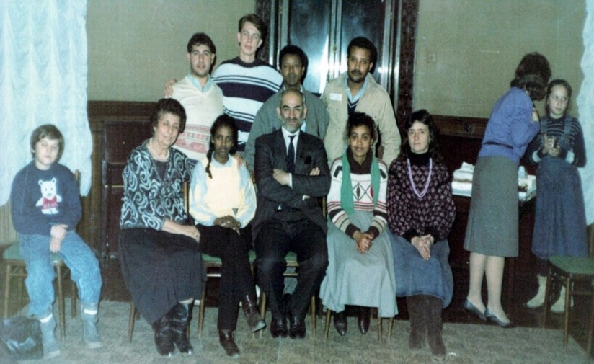
First Spiritual Assembly of Odessa. Front row seated l. to r.: 1) Shamsi, 2) ?, 3) Counselor Mr. Yousefian,
4) ?, 5) Ms. Elena Afanasyevna Back row standing l. to r.: 6) Alexander Rivas, 7) Mr. Sergey Sinyakov, 8) ?, 9) ? 2), 4), 8) 9) are four medical students from Ethiopia: Tisge, Emayes, Siyun, and Derege, (I’m not sure which name belongs to which photo) Missing: Ms. Zhanna Tatarinsteva

We sent a cable to the House of Justice about the formation of the Odessa Assembly. Ms. Yael Wurmfeld cabled the National Spiritual Assembly of the United States.
Then Mr. Hushmand Fatheazam wrote a personal letter to me in which he referred to this as “the crown of all your Baha’i services around the world.” (translation from Farsi) He told me that the Supreme Body was praying at the Shrines for my success.

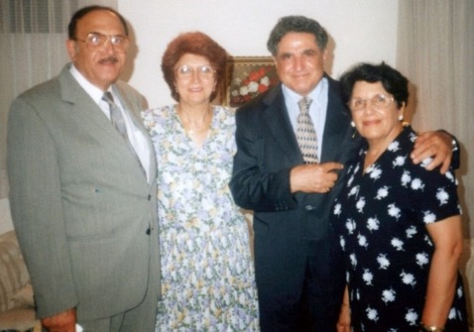
R. to l.: Mrs. Shafigheh Fatheazam, Mr. Hushmand Fatheazam, member of the Universal House of Justice, Mrs. Soraya Sedaghat Furutan, my younger sister, and Mr. Khosrow Furutan, her husband

Soon after, we assisted with the election of the first Spiritual Assembly of Gurzuf in Yalta, in the presence of Ms. Yael Wurmfeld and Ms. Maya Plaksina. Maya was an active Baha’i and years later while on my way to Beijing, China, I stayed with her in her home in Illinois where we served together. I have many fond memories of that time together. She is still active in the Faith.
Ms. Zhanna Tatarinsteva was one of several of the outstanding Baha’i youth from that early period who applied to serve at the Baha’i World Center in Israel.

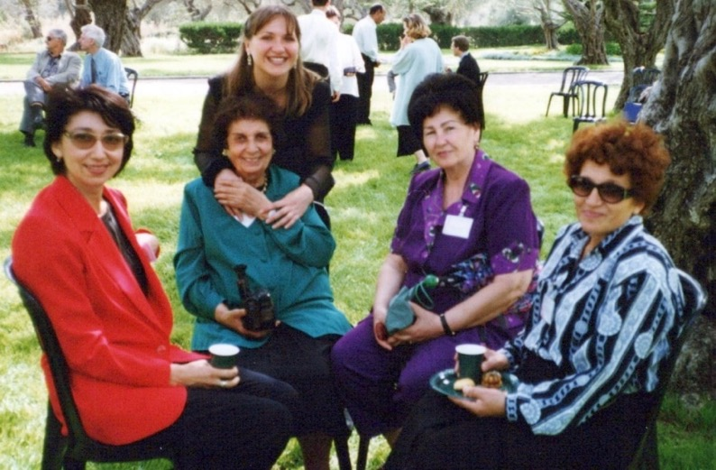

L. to r.: 1) Ms. Irina Begjanova of Turkmenistan, 2) Shamsi, standing behind Shamsi is 3) Ms. Zhanna Tatarinsteva of Odessa, 4) Mrs. Valedeh Khanum of Uzbekistan, 5) Ms. Sara Kazimova

They wrote to the World Centre and explained who they were and what qualifications they had for service. They were sent applications from their responsible assemblies—the ones where they were living at the time—which were filled out and returned to await an answer. Happily, they were all accepted. In addition to Ms. Zhanna Tatarinsteva, three Baha’i youth from Odessa served for several years diligently at different times at the World Center: Mr. Sergey Sinyakov, Mr. Andrey Kovalenko, and Ms. Julia Zhitkova. After their period of service in the Holy Land, they continued to serve the Faith admirably in other parts of the world. May God bless them for their services.
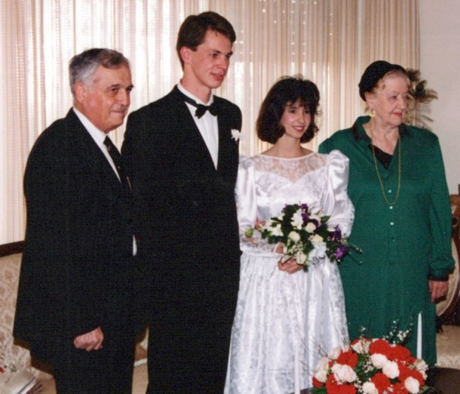
Sinyakov wedding in Haifa
L. to r.: 1) Mr. Ali Nakjavani, member of the Universal House of Justice, 2) Mr. Sergey Sinyakov, groom, first Baha’i from Odessa, 3) Mrs. Lindalee Sinyakova, bride,
4) Hand of the Cause Ruhiyyih Khanum Rabbani
Marion Jack musical concert and Counselor Mr. Yousefian
On November 21st, 1990, Marion Jack II, a teaching group sponsored by the Baha’is of Los Angeles, gave a musical concert at the University. At least nineteen people expressed an interest in coming to a meeting with Counsellor Yousefian who was assisting with the teaching efforts at the time.
On December 11th, Ms. Tanya Kiracirova came over. She had attended the concert and expressed interest in further contact with the Baha’is. I had invited her to Counselor Yousefian’s meeting which she attended and enjoyed. I had given her several booklets and my phone number, so she could come and pick up books later. She arrived at two p.m. and stayed for several hours during which she asked many questions. She finally accepted the Faith and said she would come to the Feast. She said her sixty-seven-year-old father was reading Baha’i books and was very interested and is eager to come to our meetings.
I called Ms. Elena Afanasyevna to inform her of the Nineteen-Day Feast on the 13th instead of the 12th. I also asked her to arrange a newspaper interview. She called me back to let me know she had arranged an interview for two p.m. on December 13th. I also called to invite Ms. Natasha Babinchuck for the feast, who said she would contact others; I was having difficulty reaching the Ethiopian students. I spoke with Ms. Lena Reznic about the feast and to have a meeting arranged at her school for the teachers. Natasha called back to say she would come to the Feast. We decided to have it on the 13th so that everyone could attend.
I spoke with Mr. Sergey Zverev who had expressed his wish to be a Baha’i. He said he had more questions, so I invited him to come over on Friday, Dec. 14th at 2 p.m., to talk. I then called Ms. Maria Poddubnaya who had also expressed her wish to become a Baha’i, but she was not in, and I left her a message to call me back.
After repeated attempts, I could still not get a hold of the Ethiopian students, so I asked Mr. Sergey Sinyakov to send someone with a note to their home informing them of the date and time of the Nineteen-Day Feast and of the assembly meetings at my home on Sunday. It would be up to them to see if they could make it.
At 11:38 p.m., Ms. Maria Poddubnaya called to let me know that she might come tomorrow. I told her this gathering was for Baha’is only but if she needed more information about the Faith, I would be happy to arrange a fireside for her.
After preparing my papers and photos for tomorrow’s interview with Ms. Larissa Burgo, the journalist from the Odessa Evening News, I went to bed at 2 am.
The next day, December 13th: Ms. Elena Afanasyevna arrived with Ms. Larissa Burgo. We had a cup of tea straight, and we started our discussion. I was asked about myself, my background, and my education. Then I spoke about the Faith, its history and principles, the Houses of Worship, the Letters of Baha’u’llah to the Kings, and I also mentioned the letter of Baha’u’llah to Tsar Alexander, the help given by Prince Dolgorukov to Baha’u’llah, and the Moscow Conference. I showed them the article about the Faith from the Moscow newspaper and gave the reporter many pamphlets and pictures, and Baha’u’llah and the New Era to read and write her article and asked her to “please do not write much about me but about the Baha’i Faith and its principles.”
We had supper together and then the Baha’is arrived for the Nineteen-Day Feast, including our three new believers. It was a joyful feast with bread, butter, cheese, calbasa, tea, and apples.
I cleaned the apartment the following morning, Friday, December 14th. At 2 p.m. Mr. Sergey Zverev, a fifteen-year-old son of a Jewish father and Jewish-Christian mother who had recently become a Baptist before attending the Marion Jack concert and an extremely interesting meeting with Counselor Yousefian. He had expressed interest in becoming a Baha’i, so he came to my home, and we studied the Faith for three hours. He is a very bright young man. I replied to his many questions, and he left with books. His father is reading books on the Faith as well. After he left, I went and bought thirty-two eggs and fresh bread at the shop.
I had a deepening the next day Saturday, December 15th, with Ms. Natasha Babinchuck, Ms. Julia Zhutkova, and Mr. Alexander Rivas, at 10 a.m. We studied two topics, and I provided additional explanation where necessary: 1) guidelines for youth for which we read letters from the Beloved Guardian, and 2) the appointed and elected bodies in the Baha’i administrative order. We took a break for dinner and then continued our study until six p.m., at which point they left. I cleaned up, said my prayers, and went to bed.
On Sunday morning, December 16th, I got fresh bread and then Ms. Julia Zhitkova, and Mr. Alexander Rivas came to lunch. At four p.m. the assembly members arrived except Ms. Zhanna Tatarinsteva, who was away, and Sergey who was sick. A report on the Moscow Conference was given by the medical students, and then the assembly appointed its committees for youth, publicity and proclamation, newsletter, teaching prominent people, child education, feast, and holy days. Most members selected in which committees they wanted to serve on. I was asked to write the guidelines for all the committees and the appointment letters because the Assembly’s secretary was going to be away in Moscow for the week.
Visit of Prof. Dwight Allen in 1990
We consulted on the visit of Prof. Dwight Allen, a distinguished educator from the United States. We had heard nothing new about this except indirectly. I heard he was coming on the 19th. Mr. Genna, who was his host, had arranged his activities for his itinerary. I asked Mr. Sergey Sinyakov a few days ago if the assembly could arrange anything for Prof. Allen, and he replied that Genna had arranged all the lectures, and he gave the name of two places at the university on the 20th and 21st. We had not been asked by Prof. Dwight Allen to arrange any activities, so we would wait until his arrival to find out his other plans for the Baha’i work. I called Genna to check the plans, and he said that all the appearances had been arranged and that all we had to do was arrange publicity for him.
I cleaned the apartment the following morning, December 17th, and then called Ms. Elena Afanasyevna to see if an interview could be arranged for Prof. Allen via Ms. Larissa Burgo, the reporter, as Elena already had his picture. She phoned me back to inform me that she had invited the reporter to the university for the 21st. If she did not come on that date, a Saturday morning might be possible. The reporter said that she was going to publish our article in the new year to give “good news” to the people of Odessa.
On December 19th, I called Genna’s home, and his mother said he had returned from Kiev and left for the airport to bring Dr. Dwight Allen from Leningrad. I asked her to call me when he came back which he did at 1 p.m. saying that all had gone well. They had made plans for sightseeing that afternoon. Tomorrow there would be three lectures, one in the morning and two in the afternoon. He asked me if tomorrow they could have lunch with me as there was nowhere else to get lunch. I accepted with pleasure and welcomed Dr. Allen to Odessa over the phone. I stayed home for the rest of the afternoon and finished various projects. At 10 p.m. Genna phoned me to invite me to the ballet, and I accepted. Then after eating, I went to bed.
On December 20th I prepared meat, rice, and potatoes, and bought fresh apple and pickled cabbage, and made the table ready for my guests who arrived at midday. After the meal, we left for school #37 and then after a two-hour lecture, went to speak at a philosophy class at the university. There were questions and answers.
We met Mr. Alexander Umanski at the university. He taught at an art school and invited us to go to his school to see its art museum. We arranged for Prof. Allen to go there on Saturday at three p.m. I made plans for Prof. Allen to come to my home on Friday December 28th, at two p.m., to speak about the Faith and for our Baha’i artist, Mr. Ashraf Gaybatov of Moscow, to present his art and speak about the Faith in the school.
We returned home in a taxi through the cold. I rested, then cleaned and went to bed.
On December 21st, I received two letters from the beloved members of the Universal House of Justice Mr. H. Fatheazam and Dr. Ruhe and his wife, which I picked up at the post office. These lifted my spirits. I cried while I read them at the Bounty of Baha’u’llah. After prayers, I caught a taxi and went to university.
At 4:15 p.m., Prof. Dwight Allen gave a lecture at the university about progressive revelation, free will and predestination, and good and evil. At the end of the talk, the Dean of the philosophy school thanked Prof. Allen and concluded with the remark that he had built a bridge between the Baha’i Faith and their society, and that we would continue to work together in the future. We asked the Dean for a date when we could present him with the Peace Message from the Universal House of Justice. He gave us Wednesday.
We then went to the dormitory of Mr. Alexander Rivas. There we met with Mr. Sergey Zverev who was close to becoming a Baha’i and a lady whom we had not met before. There were seven people in all, many questions were asked, and the gathering was positive. I took a taxi home at nine p.m., did my washing, bathed, and went to bed at two a.m.
On December 22nd, I phoned Ms. Lena Reznic and asked her to come to the University today at three p.m. for the lecture, and tomorrow at four p.m. to my home for a dinner party for all the Baha’is and contacts close to the Faith to meet Prof. Allen. I then spoke with the head teacher at school #37 about today’s talk at the University. Ms. Nana, the lady who works in the store downstairs, called me to tell me the chicken was ready to be picked up at the shop. Praise be Baha’u’llah! I live in a country where, with a coupon, you must stay in a queue for one hour to receive one or two chickens, that is, if any chicken is left when your turn arrives! So now—even though I had no coupons—I got a call saying there was a chicken ready for me. This happened because I had to feed my flock tomorrow, so Baha’u’llah provided their ‘portion’. I covered all the costs of this hospitality.
Just as I was about to go down, “Nana” rang the doorbell. She had five chickens wrapped in brown paper under her arms! She said that the weather was so cold that she thought it would be very difficult for me to come down, so she had brought my chicken up. The chickens had been given by Ms. Valiya, the lady in charge of poultry at the store. I was overwhelmed by this kindness, and I paid for the chicken. Nana and I sat in the kitchen where it was warmer and had tea and biscuits, and I offered her sweets which my sister Mrs. Soraya Furutan sent me from California via Ms. Lynda Godwin and crackers given to me by friends. Nana had to be back on duty in ten minutes, so she left. Praised be Baha’u’llah for all His bounties to His servants who try to serve the others.
At 3:15 p.m., I took a taxi to the University and went into a library-like room in the philosophy department. There twenty-five to thirty people in attendance to hear Prof. Allen speak about the Faith. Ms. Lena Resnik translated part of it; her daughters were there as well. Two brothers from the law school asked many questions. I will invite them to my home. Several others expressed interest for more information and continued contact, so they gave their telephone numbers and addresses. I had to take two buses—the #5 and #28—as well as one taxi to get home! The night was very cold. Before bed, I prepared my chickens and made my salads for the next day. After doing research, I went to bed at 2 am.
All next morning, Sunday, December 23rd, I prepared for my guests. I cooked meat, vermicelli, and rice, cleaned, and went out to the shop in the cold and drizzle to buy bread, macaroni, and salt.
At 2 p.m., my guests began arriving: Ms. Tanya Babinchuck and her sister, Prof. Allen, Mr. Genna, Mr. Sergey Zverev, and his friend, Anya, a Jewish girl, Ms. Natasha, Mr. Alexander Karassigov, Ms. Tanya Kangoon my landlady, and Ms. Lena Reznic, her two daughters, Alina and Julia, and Boris, her husband. He spoke about the Hands of the Cause in the time of Baha’u’llah. Then after we ate, Lena and Boris asked about the Trinity and talked about how they were experiencing the ridicule of their Christian friends about their conversion to the Baha’i Faith. I gave them a New Testament with markings in it to guide them to passages that would answer their friends’ questions. Gradually everyone left, and I cleaned the kitchen. Before going to bed I made a phone call to confirm arrangements for a newspaper interview at two p.m. the next day, for Prof. D. Allen.
The next day, Monday, December 24th, I went at 11:45 in the cold by taxi to the University for the lecture of Prof. Allen. There were fifty-sixty people in attendance. Several professors were present. The talk was on the ‘Study of the Future’ and some mention was made of the Faith. Questions and answers followed, and Prof. Allen invited them to come tomorrow at ten a.m. for a lecture on the Baha’i Faith at the same location.
At 2 p.m., Ms. Elena Afanasyevna arrived in a taxi. Prof. Allen, Ms. Afanasyevna, and I went together to the Odessa Evening newspaper, where we met Ms. Larissa Burgo, the reporter. She took us into her office and interviewed Prof. Allen for almost one hour. The interview went well. Genna translated beautifully. I gave Ms. Burgo a copy of Baha’u’llah and the New Era in Russian which I left on her table. She said she is in the process of writing the article and told us that it will be published in the new year. Then she invited me to her house to celebrate the new year with her children. I accepted, and we arranged to go with Ms. Afanasyevna.
Then Prof. Allen, Ms. Afanasyevna, and I decided to go to the radio station though we had made no prior arrangements. We went by tramway as we found no taxi. Ms. Irina Gorsachencko greeted us there and brought us to her room for an interview, but her tape recorder did not work so she took us into the small studio. She asked us many questions which Genna translated. The interview went very well. Then she gave me a few minutes to invite people to read the two articles about the Faith which were going to come out on New Year and tell the listeners that they could contact me for further information. We exchanged addresses, and I told her that I would invite friends in the news media to my house for New Year to thank them for giving us the opportunity to inform the residents of Odessa and surroundings about the Baha’i Faith. We each then returned to our homes in the cold. On my taxi ride, my young man asked me if I spoke English, and I said yes. He asked me if I could help him fill out an immigration form for South Africa. I said that I would, and he was very thankful.
On the morning of December 25th, I left my apartment at nine a.m. for the university where Prof. Allen’s lecture began at 10:15 a.m. He spoke about the Baha’i Faith to a room full of professors and students. One professor asked why Baha’u’llah had come so late— “Was the time not ready for Him?” Prof. Allen said that she had replied to her own question, and then he continued. The lecture was good, but there were not many questions. He gave my telephone number and asked other Baha’is to stand so others could see them in case anyone wanted more literature or other information. Ms. Natasha and Ms. Tanya Babinchuck were the other Baha’is present so they stood up, and their professors who were present looked at them and smiled. The students were very happy that now their teachers knew about their Faith. Now they would not feel so isolated. The lecture ended at 11:45 am. Dr. Allen was invited

to the office of the Director of the English Language Dept. for a cup of tea. Dr. Allen told me he would go to the Director’s office and then at 12:30 p.m., he would go to the seminary to give another lecture! The two Baha’i students went to their classes. I went home by myself through the freezing streets. I had to take two buses, #5 then # 28, and then walk! When I got home it took me two hours to warm myself up in the kitchen by the stove drinking hot tea and biscuits. I sat for an hour with my heating pad until I was sufficiently warmed up. I called the Sinyakovs to see how they were doing because they had both been ill. They were now feeling better. Mr. Sergey Sinyakov said he would come tonight because we had to go to the railway station to see Prof. Allen off at ten p.m.
I left home at 8:15 p.m. for the railway station. I walked in the bitter cold uphill for fifteen minutes to catch the #28 bus to the station. At the station I looked around and couldn’t find anyone. Finally, I saw Prof. Allen who had been accompanied by Mr. Genna Kolesnick; Mr. Genna Litviekov had been too ill to bring him there. He took Prof. Allen’s luggage to the train, and we spoke for a short while. Ms. Natasha was the only other Baha’i who had come.
We were sent home by Prof. Allen ten minutes before the departure of his train due to the cold. We were all frozen. Genna and I took the # 28 tramway. He got off before I did. I had to walk down the hill to get to my apartment because it was too late for any taxis or buses. Walking alone over the cold and icy roads was very dangerous! Praised be to Baha’u’llah, I reached home safely but was almost frozen. I turned on the gas oven and the burners to heat the kitchen and the other rooms because the existing radiators were not enough to keep the room warm. Eventually I warmed up with hot tea and a snack, said my prayers, and at 11:15, I went to bed.
Sometime later the phone rang. It was Mr. Toni Nelson from Kiev. He said he would be here by December 27th. Two Iranian Baha’is would be with him. He spoke of going to Yalta in the Crimea to help elect their Assemblies. I told him of the arrival of Prof. Allen and asked him to meet him at the railway station to help him with his heavy bags and because he did not speak the language. He promised he would meet him and take him to his hotel if there was no other place. I went back to bed and slept.
Several weeks later, Prof. Allen wrote to me this letter of appreciation after his fruitful visit to Odessa:
“Dwight W. Allen
5015 Newport Avenue
Norfolk, VA 23508
Hi Shamsi,
Let me tell you once again how much I appreciated our warm hospitality while I was in Odessa. I will long remember the welcome I received from all the Baha’is. They really are special. You are doing so much to help the friends’ success and to develop initiative and confidence in their new Baha’i identities.
The schedule was too frantic for the kind of leisurely discussion and contemplation I had hoped for everyone did a fine job of keeping me busy as I had requested! I felt I really got to know Odessa quite well, even in such a short time thanks to your tours and explanations.
It was also enjoyable to meet your many friends. Too bad there couldn’t have been more time. Thank you Shamsi, for your wonderful spirit of service. You managed to orchestrate effective planning on my behalf. I look forward to the opportunity to collaborate in the future.
You are working hard to help our new Baha’i friends to distinguish the teachings of Baha’u’llah for the actions of those who are attempting to serve Him. That is so important….
Since my return I have been busy with my classes, two freshman English of about 25 students each, the introductory course in education, with about 220, and my televised course on the technology of education which is broadcast nationally via satellite and for which we have students registered for credit in 6 states and 12 locations.
Carole and I continue to travel to other Baha’i communities sharing our African slides and now I am beginning to tour around with USSR slide show. Truly, my month in the USSR was one of the seminal moments of my life. And my friend you did much to make it successful. My plans for the summer are still very much up in the air, but I am sure something useful will be able to get organized.
The world continues to march to its destiny of unity though the process is filled with floundering blindness to our own common self-interest.
How often I think of my wonderful visit to the USSR and the warm friendship of the people I met. How much the world is missing. We must pray that world unity comes quickly. It was real privilege to be of service to our glorious Faith during my visit. When will the world realize that submission to the Will of God is the only safe refuge for mankind? I will long remember your spirit of service that continues to be so important for the welfare of us all in ways we cannot understand.
By now I hope that plans are coming along for the Baha’i Justice Society Conference at the end of September in Odessa, and that the Baha’is of Kiev have succeeded in contacting the Reznics to solicit their help and involvement. I am confident that you will be a wonderful help – the invisible wind in the sails.
The Baha’is of Kiev are coordinating the conference. How much I long to be there, though I see little chance at the moment of that being possible. The Baha’i community in Odessa is so enthusiastic. There was such a beautiful sense of unity. It is important that everyone be continually involved in the activities of the community. In the Baha’i Faith everyone must feel that he or she has an important role to play – both for personal spiritual development and for the growth of the community as a whole. Our spiritual quests as Baha’is never ends. Our knowledge and ability to reflect that knowledge in our actions is the challenge of our lives.
It was a bounty to be able to be with you, even for a few days. May God will that it be possible for us to meet again sometime soon. I admire your sense of perspective and your integrity, albeit as you struggle with no more that your share of foibles, a part of the human condition which characterizes us all. Thank you for arranging the newspaper and radio interviews – your audacity is awesome!...
Warm Regards,
Dwight”
Teaching in Odessa: Pioneers, visitors, December 1990
My apartment in Odessa was cold, and I used a heating pad which I had bought at the ‘Talchook Grey Market’ for fifteen rubles. It served me during these cold nights. At 10:30 a.m. on the morning of December 26th, a young man named Mr. Yuir Tkater came to my apartment bearing flowers. He was the taxi driver who needed my help to fill out his immigration forms for South Africa. He worked as a taxi driver and an assistant surgeon to a veterinarian. I helped him to translate his Russian Diploma into English. We also drank tea and spoke about the Faith. When we were done, he brought me to the projector shop and then drove me home. The weather was very cold, so I stayed home the rest of the afternoon. I rested then read about the Dispensations of the Bab, Baha’u’llah, Abdu’l-Baha, and Shoghi Effendi, and then I said my prayers and went to bed.
On Thursday, December 27th, the weather was better. At 11 a.m., I went to the post office but there was only one letter for Ms. Kangoon, my landlady, so I bought some rice and biscuits and went home. Mr. Sergey Sinyakov phoned to tell me that Mr. Toni Verderosa, Mr. David Magit, and Ms. Sandra Sparrow, would be arriving from Kishinev, Moldova, at 11:30 p.m. that night. Ms. Natasha then phoned me to say that they had arrived, and that she had given my telephone number to them to phone me. I took sausage out of freezer in case they came for lunch tomorrow and went to bed at midnight.
The next morning, December 28th, said prayers and ate breakfast. I started to prepare lunch when Mr. David Magit, a Canadian Baha’i living in Haifa, phoned. I replied, and I invited him and the other two to come at two p.m. which was when Mr. Alexander Umanski was coming to discuss the Faith and prepare for the visit of Mr. and Mrs. Ashraf Gaibatov, a Baha’i artist from Moscow. I defrosted chicken, cooked it along with macaroni, rice, potatoes and salad, and I cleaned the room. I went to the shop for bread, ice cream, and lemonade. At 2:30 p.m., my guests arrived. Mr. David Magit arrived first with his host Mr. Genya, a young man with limited English who had been in my home several times accompanying previous visitors. Then Mr. Toni Verderosa, a Californian Baha’i living in Haifa, and Ms. Sandra Sparrow, a Canadian Baha’i living in Haifa, came. We all had tea and talked. They told me they had been in Chernivtsi, Ukraine, where they met a Baha’i from Salt Lake City, the twin city of Chernivtsi, who had a letter from the Mayor of Salt Lake City to the Mayor of Chernivtsi, and a letter from the President of the University of Utah at Salt Lake City to the President of the University of Chernivtsi. As a result, they were able to meet the deputy Mayor who was fluent in English. He took them around to meet other dignitaries and have tea with them. They were given a very warm reception and were able to give Baha’i literature. In Kishinev, they had good meetings, and they expressed the desire to go back for further teaching.
Mr. Genya had to leave but we went ahead and had late lunch. After eating, we went to the store downstairs and bought potatoes, pickled cabbage, and apples. I saw my friends who worked in the store and ordered four chickens from them which I would pick up later at seven p.m. Back at the flat, we drank tea and continued our conversation. Mr. Genya returned, and I asked him what he thought about the Baha’i Faith since he had learned a lot about it during his time with us. He replied that the principles were good, but he could not believe in it. The principles Baha’u’llah had brought were not new. They had been brought by others in the past. Baha’u’llah was a clever and educated man, so he put all of these teachings on one page and called them his principles. I started to slowly and systematically explain to him about the life of Baha’u’llah, His knowledge, His letters to the Kings, the fate of the Kings and showing pictures of them, and how far the Baha’i Faith had influenced the world today. The rest of the friends sat and listened to my presentation which was very interesting and informative to them. Mr. Volodja, the host of the three visitors arrived to take them back. He sat for a few minutes and listened. As someone else was waiting for him in the car downstairs, they left. Before leaving the flat, Mr. Genya thanked me for my explanation, and that he would think about it. The other friends thanked me as well for the information they had received and left. I went downstairs to pick up the chickens. I came back up, cleaned the rest of the room, said my prayers, and went to bed.
The next morning, December 29th, I waited for Ms. Nana to call to go to the Talchuk market, but she did not call. I phoned Mr. Alexander Umanski to see why he had not come yesterday at 2 p.m. His wife apologized saying it was strange from him not to honor his appointments because he was very organized. He had not understood properly, and she said she would let him know and ask him to call me. Then I did some cleaning. At 6 p.m. Mr. Alexander Umanski called to apologize for not coming yesterday. There had been a misunderstanding. He thought he had to confirm his arrival and since he had not, he did not come. We would arrange to meet after the New Year. I said that was no problem. I did some more research and went to bed.

At the unity feast, the friends from the Holy Land spoke to us
On December 30th, I took cups and biscuits with me on two buses to get to the dormitory of Mr. Alexander Rivas for a deepening class. Gradually the friends arrived, and at three p.m., we had a unity feast. Our guests Mr. Toni Verderosa, Mr. David Magit, and Ms. Sandra Sparrow told us about their jobs and experiences in Haifa. It was paradise—like we were on pilgrimage ourselves. Mr. Toni Verderosa was a carpenter and builder who had been serving in the Holy Land for eight-ten years working to restore the Baha’i Holy places in Akka, Haifa, and Bahji. Ms. Sandra Sparrow had been serving there for three and a half years, first as a cook at the seat of the Universal House of Justice then as janitor. She helped clean all of the Holy Places as well as the homes of the friends. She said that janitorial work is the meanest in the entire world, but not at the Baha’i World Center where it is the most honorable and rewarding service. They were all full of humility and thankfulness for having been able to serve there. Now Mr. David Magit hoped to settle in Ulan Ude. Mr. Toni Verderosa would return to the United States, and Ms. Sandra Sparrow hoped to move to Chernivtsi to study Russian at the University there as a pioneer. We all hugged them with love and took photographs with them and then at five p.m., the Assembly met. The Assembly welcomed them officially and thanked them for their services and wished them success in their future services, then we had our Nineteen-Day feast. Twenty-one were present including two non-Baha’is, Mr. Senya, and Sasha, friends of Mr. Boris Reznic. We had prayers and omitted the administrative portion. During the social, we saw slides of the Baha’i holy places. The Feast was sponsored by Ms. Natasha and Mr. Alexander Rivas, two university students. There had been lots of preparation of sandwiches, sweets, and tea, and there was a very nice atmosphere. At the end, Sasha, a friend of Mr. Boris Reznic, accompanied me to the bus and left. I took bus #30 then walked one block and got home by 12:30 p.m., very cold but happy and gradually went to bed.
Arrival of Mr. Toni Nelson
On December 31st at 8 a.m., Mr. Sergey Sinyakov phoned from the railway station to tell me that Mr. Toni Nelson, a musician, and Baha’i pioneer, had arrived. He had stored his luggage in the station and wanted to come to my home. I told them to come in forty-five minutes to give me time to prepare the apartment. They arrived at 9:30 a.m., and we ate breakfast and caught up on news of our activities since Mr. Nelson arrived in Russia on October 25th. Then Sergey left, and Mr. Toni Nelson rested on the couch in the living room because he was tired from his overnight trip from Kiev. While he slept, I sat in the kitchen studied and prepared food.
At 6 p.m., Mr. Toni Nelson woke up. We ate dinner and discussed plans for going to Yalta in the Crimea for the election of their spiritual assembly.
Celebration of the arrival of the 1991 New Year
Ms. Elena Afanasyevna arrived and together, we went by bus and taxi to the home of Ms. Larissa Burgo for the New Year celebration. Then Ms. Elena Afanasyevna left us for another engagement. When we got there, we found Ms. Burgo’s table full of delicious food and drink. We took a photo of the spread and ate dinner together. Alcoholic drinks were offered but of course, we declined, stating that we did not drink due to our religious beliefs, so they gave us juice, and we all celebrated the approach of the New Year! There was a reporter from the radio station who said she had seen us at the station the day we had the interview at the radio. Her husband Mr. Burgo and two sons, the neighbors with their family and Larissa, her husband, and her two daughters and a niece., all were present. We drank coffee, ate sweets, watched TV, and spoke on a variety of subjects until midnight and the ringing in of the New Year celebration. We listened to President Gorbachev’s speech in which he expressed his hopes that after a difficult economic year, this new year would bring greater prosperity! We sang “One Family” song, and the children played the piano.
After celebration of New Year 1991, we spoke about the Faith
We were not able to simply leave at this point though Mr. Toni Nelson was very tired. We sat for another two hours. By four a.m. I thought that it was useless to spend a whole night in this way and not to speak about the Faith. I felt a deep urge to start speaking about the Faith. So, I looked at the other guests and asked that since we had eaten so well and enjoyed each other’s company, shouldn’t we speak about the problems of the world and plight of humanity and what we could do to help. Everybody became quiet, and I started to enumerate the existing problems and then give solutions based on the Baha’i teachings. I showed them Counselor Ahmadiyyih’s red teaching book and other books with pictures of the Baha’i temples and explained all this to the best of my ability. Then Ms. Larissa Burgo, the hostess, took away the book from me and started to explain its contents on her own to her guests. I admired her accuracy. The others asked her how she knew about this Faith. She answered that she had interviewed me and had read several books about the Faith. All present listened and asked a few questions. After this, I felt more comfortable that the time had not been wasted.
After some rest, left to see a flat
Mr. Toni Nelson and I returned to my apartment with the help of the husband of the radio announcer by taking buses #12 then #30 then walking. Mr. Toni Nelson went to bed, while I ate breakfast and then went to bed at 7:30 am. I was up by 10:10 am waiting for the telephone call of Ms. Natasha, the lady who had a possible flat for Mr. Toni Nelson. She called, and we arranged to meet at the bus stop at 1 p.m. Mr. Toni Nelson got up and ate his breakfast. Ms. Tanya Kangoon, my landlady, came over with a copy of the Odessa Evening News which had an article about Prof. Allen in it. Then Ms. Natasha came, and we went by tramway to see her flat. The location was not accessible, but the apartment was good. It had one big room, a kitchen, a big electric stove, a large refrigerator, and a balcony. We decided to let her know after we had seen the other three flats. We said goodbye, took the bus #28, and walked home through the cold. We warmed up inside and ate and arranged to see the other flats. Later after tea, he went to his room to read, and I slept in kitchen on my small aluminum bed which I had in case of guests.
The next morning, January 2nd, I waited for Mr. Genna to phone. I called his home. His wife said he would come to my place at 3 p.m., but he didn’t. When I called his home again. His wife said she had no news of him.
The morning of January 3rd, Mr. Sergey Sinyakov phoned to inform me that Mr. Brian Bullock, Mr. Scott, and Grisha Pavlov had arrived from Kiev. He wanted to bring a friend over, and I asked him to give me a few hours. I cleaned the flat and changed the bed linen. At 9:30 am, Ms. Tanya Babinchuck called to tell that it would be too difficult for her to bring Grisha over to my home every day and pick him up. Her parents agreed to keep him in their home. I was surprised because I did not know he was coming now though I knew he was going to come and deepen in the Faith with me. I asked to speak with Scott about this arrangement, and he said he knew nothing about this. The family spoke in Russian language amongst themselves and then called me. Scott said that Grisha would be under his supervision. He would bring him to my apartment, and one day he could even spend whole day with them and even sleep there. We both agreed to this plan, and they would come over in the evening. Mr. Toni Nelson and I went to the projector shop, but the director was not there, so we dropped it off and returned home.
We then went down to shop to buy cream cheese and sour cream. Back in the apartment we drank tea and returned phone calls from people asking about the Interclub meeting. I had to say that the club was not available so if they wanted, they could come to my place after dinner for tea and coffee and discussion. They said they would. Ms. Sveta’s mother, Ms. Kira, called to inform me that a single room and kitchen were available in a three-bedroom flat if Mr. Toni Nelson wanted. I answered that Mr. Toni Nelson needed a private flat so that would not work for him. I reviewed with Mr. Toni Nelson the route of the Bab’s exile.
At night, all the friends came over—Mr. Toni Nelson, Ms. Sandra Sparrow, Mr. David Magit, and new comers Mr. Scott, Mr. Brandon, Ms. Yelena (Scott’s friend) Mr. Alexander, Mr. Sergey, Sandra’s friend Ms. Natasha, and Grisha Pavlov. We discussed our plans and went over the names of new declarants and contacts. These were given to Mr. Scott and Mr. Brandon for follow-up. Then we ate snacks and took pictures, and everyone left. I said my prayers and went to sleep.
On January 6th, Mr. Ashraf Gaybatov called from Moscow saying he and his wife wanted to come to Odessa during the week 20th-26th January. I offered for them to stay with me, and I would arrange lectures for him at the art school of Odessa. I reported this later to the assembly as we were meeting. I spoke with Mr. Alexander the art teacher who expressed the hope of arranging a meeting for Mr. Brian Bullock.
I prepared food, and the friends came for the assembly meeting. When five people had arrived, the meeting began. At 3:25 p.m. Mr. Brian Bullock and others arrived to meet with the assembly. Soon we were fourteen in all. We ate the sausages, rice, macaroni, bread, and tea. And then we deepened on Islam, the Qur’an, the ‘Seal of the Prophets’ and other topics. Ms. Lena Pshenkovskaya, the friend of Mr. Scott, accepted the Faith, and the members of the assembly welcomed her. It was a warm gathering. Everyone left at 7:30 p.m. I washed up and cleaned and continued the lessons with Grisha and then said my prayers and each one went to rest.

We continued our studies with Grisha Pavlov
I woke up early on January 7th and made breakfast and ate with Grisha. We continued our study on the Life of Jesus Christ until Mr. Scott and Ms. Lena arrived. We had tea and biscuits, and they took Grisha back with them to their home. They planned then to go to the museum and then to a film on Jesus Christ in Russian which would be very good for Grisha as he had just learned about His life story.
I cleaned, read, and rested. The weather was very cold, damp, and dark, so I did not go out at all. I watched a TV show on the religious services in Russian churches and a film on the hardship, arrests, exiles, and killings of Soviets during the early years of communism. Now that there is freedom of expression due to perestroika, the cruelty of what had been done to so many thousands of innocent citizens and intellectuals became known.
Mr. Andrey called at 6:30 p.m. to say that Mr. Scott and others had been to his grandmother’s home, and now he wanted to meet me to learn more about the Faith. We agreed he would come over to my home on Wednesday January 9th from two-three p.m. After I hung up, I studied Bahiyyih Khanum by Ms. Marzieh Gail then washed the linen and the floors, said my prayers, and went to bed at one a.m.
On January 8th I started to clean the place and prepared chicken and rice. Grisha was coming back, and Mr. Scott and others might be coming with him, so I wanted to have food ready. They arrived at 2 p.m. They had eaten so they dropped Grisha off and Mr. Scott said he would return at seven p.m. to pick Grisha up and take him to the railway station from where he would leave for Kiev at 11:45 p.m. After Mr. Scott had left, Grisha said he was tired and wanted to sleep so he packed up first and then rested. I received a call from Ms. Larissa Burgo, the newspaper correspondent, who informed me that our article was being published in today’s edition of Evening Odessa. She would keep several copies for me but if I wanted to buy more, I could do so today. She asked me to read it and let her know what I thought. I went out immediately to buy copies but there were none. The lady at the newsstand said they would be available tomorrow at 11 a.m., and that she would keep several copies for me. I asked her to keep twenty copies, and she said I would have to come myself and buy them. I bought vermicelli and came home to find Grisha still sleeping. Then he woke up, had a meal and we were able to continue to study more until Mr. Scott arrived at 9:30 p.m. and took Grisha to the railway station. I prayed for his safe return to Kiev, cleaned, and went to bed.
The next day, Wednesday January 9th, I went out after prayers and breakfast to buy copies of the newspaper, but they were not in yet. The newspapers finally came in, and I bought ten copies and came home. I read the article with the help of a dictionary. It was an excellent half-page article on the second page with the title “We are leaves of one branch.” I was very happy and excited and thanked Baha’u’llah for all His Bounties.
At 2 p.m., Mr. Andrey Kovalenko and his girlfriend, Ms. Galla Borets, arrived with homemade cake. They had already been to four Baha’i meetings. I asked Andrey to read the article for me as I knew this would be good for their knowledge of the Faith because it was all about the history of the Faith, its principles, its progress in the world, its institutions, and its history.
I phoned Mr. Scott to find out why he was late. Ms. Lena Pshenkovskaya answered and told me that he was sleeping because Grisha’s train had been two hours late, and they had stayed at the railway station until two a.m. After that they still had to walk home in the cold as there was no available transport. In Odessa we often had to walk half an hour to an hour to reach our homes since very few people had a car. I asked her to wake Scott and ask him to call me back. He did and said he would be over very soon. He arrived with Ms. Lena Pshenkovskaya at 4:30 p.m. Mr. Andrey Kovalenko and Ms. Galla Borets were very happy because they knew Scott from his first visit here two weeks ago when he was teaching and giving concerts. We had tea and cake and good conversation and then Ms. Lena said that she now accepted the Faith. She became the 25th Baha’i in Odessa. After more discussion about the Faith, I asked Mr. Andrey Kovalenko and Ms. Galla Borets if they agreed that the world needed the Baha’i teachings and if so, were they ready to join our family and help to build this spiritual community here and everywhere else. Galla replied that she was ready. She became number 26! Then I asked Andrey the same question. He replied that in his mind, he had been a Baha’i for long time, but his heart had not been ready until today. These statements made us so happy that we all embraced them and welcomed them to our family. We invited them to come to our deepening class on Sunday at 2 p.m. and gave literature to them. Then they all left, and I washed and cleaned and praised our Beloved Baha’u’llah for His assistance. At nine p.m. I called Ms. Larissa Burgo. I thanked her for the lovely article. She said she had ten copies for me and would arrange to have them brought to my home very soon.
Ms. Marina Pavlova phoned from Kiev - 1991
On January 10th, Ms. Marina Pavlova rang from Kiev to thank me for all the help I had given to her son, Grisha, for his spiritual training during his stay with me. Then I asked her about the arrival of Mr. Andreya, the Baha’i teacher at school #77 in Kiev whom the assembly there had decided to send to me for guidance about his “plan of spirituality for his students.” She said he had already left Kiev on the six-p.m. train and would arrive in Odessa tomorrow at eight a.m. He would be met by Mr. Sergey Sinyakov who had already been informed of his arrival time and the need to place him in the home of a friend. He would come to me for study of the Faith and would be leaving on the 13th at ten p.m. I told Mrs. Marina that I knew nothing about these plans, but I would arrange it all immediately and as there were no other Baha’is with free accommodations who could take him home, I would have him in my apartment and would ask Mr. Alexander Rivas to come and stay with us. They would sleep in the main room, and I would sleep in the kitchen. I assured Ms. Marina that everything would work out fine. She then informed me of the news that our National Assembly of the U.S.S.R. would be formed by April 21st. Counsellor P. Rafat would come soon to make preparations. I immediately called Mr. Sergey Sinyakov and asked about the arrival of Mr. Andreya. He said he had called him today, and he would be arriving tomorrow at eight a.m. I asked him if he was going to meet him. He said no but he knew my address and will come on his own. Since I had no advance notice, my bed would have to be changed and food bought and prepared for a few days. I had to find Mr. Alexander Rivas tonight and then bring him to my place to stay for two days. Finding Alexander in the dormitory would not be an easy job. As it turned out, Alexander was with Sergey at that moment. I asked to speak to him, and we made plans to meet Andreya and stay at my place.
Mr. Toni Nelson would meet Mr. Andrey
At ten p.m. Mr. Toni Nelson phoned. He said he knew Andrey and would go to the railway station to bring him to my place. I said that was good because there would be universal participation with each person doing something to help Andrey receive guidance and Baha’i education.
At 11 p.m. I changed the bed sheets. I washed the ones I had in washing machine and dried them in the kitchen with the heat of the stove! Thank God I had them ready for my guests. Then I cooked rice and chicken as tomorrow we would start to study, and time must not be wasted on cooking. Then I swept the rooms and washed the kitchen floor and finally went to bed at two a.m.! Though I was very tired, everything was ready for the next day. I slept in the kitchen with the couch pillows as my mattress.
The next morning, Friday January 11th, I got up early, had breakfast, and went to the store to buy fresh bread and kefir. I came up and then went down again to wait for Mr. Andrey in the street where it was very cold. I saw a young man with a mustache which was the only mark of his that I remembered as I had only seen him once in Kiev when myself and Mrs. J. Khamsi of Haifa went to his school to give a talk to his class. The young man walked into the Universam store, and I followed him and called out to him, and he replied though he did not see me. We then bumped into each other by chance. We greeted each other, and we went up to my apartment.
I offered him breakfast, and we talked about the progress of his project. He was happy that he had started three lessons in all—one for each age group—young, older, and teenagers from seven to eighteen years of age. The families were happy but the headmistress who was an ardent communist was reluctant. Nevertheless, she had given permission that spirituality be thought in the classes after school, and a room was assigned for this purpose. Mrs. Khamsi sent some photographs and tapestry to be used for decoration of the room.
We started our study of God and His Messengers by Mr. David Hoffman which would be for all the groups each according to its capacity. When Baha’u’llah’s story was reached, Mr. Andreya could expand gently on social and moral principles. We read and translated the book until Alexander arrived at eleven a.m. and with his help, we continued with breaks for lunch and refreshments. We ate supper and then continued until 11:30 p.m. and then each one went to sleep.
The next morning, Saturday January 12th, Mr. Alexander Rivas went to school to take his exam. Mr. Andreya and I continued our study on the life of the Bab and its map until Alexander returned at two p.m. Then we ate a lunch of rice and chicken. We continued our study with Alexander’s help. We went over Baha’i administration, the appointed and elected bodies, and the Baha’i laws.
In the afternoon, my friend Ms. Nana from the shop below called and came up with two kilos of cheese for three rubles, praised be God for His Blessings! Our study continued on the topics of marriage, Baha’i Holy Days, the election of the forthcoming National Spiritual Assembly of the USSR in April this year, 1991, and many other subjects. When we were finished, Mr. Alexander Rivas had a bath as he had no cold or hot water in his dormitory, so I warmed up water for him to bathe. At midnight, each one went to his place to sleep without dinner as we had been snacking.
Early Sunday morning, January 13th, I cooked and at ten a.m., we ate breakfast. Mr. Andreya and Mr. Alexander Rivas went into town for sightseeing as this was Andreya’s first time in Odessa. Meanwhile, I cleaned the rooms, kitchen, and bathroom. Our deepening was supposed to begin at 2 p.m., so they returned at one p.m. to eat lunch. Mr. Andrey Kovalenko, our new Baha’i, arrived but his friend Galina could not come because she had an exam the next day. Others soon arrived, and I went to the shop to get more biscuits. When I got back, our class grew to twenty-one people. Three of these were non-Baha’is including one Ms. Alla Borets, a contact of Alexander’s. She declared later in the evening, and we all welcomed her warmly. Everyone spoke about their experience as Baha’is, and gradually they all left promising to come again. (In the future, Ms. Alla Borets, our new Baha’i, would receive the distinction of being appointed a Continental Baha’i Counsellor in this region.)
The next day, Monday, January 14th, I went to the post office to pick-up my registered letter which was from Ms. Maya Placsina from Chicago with several photographs. Then I stopped by the store for vegetables. Ms. Lena Reznic called to inform me that she had not found a room for our meetings, but she would try tomorrow for another place. If that one was not available for the Nineteen-Day Feast on the 19th at 4 p.m., I offered to hold it at my place. Then I went to bed.
We continued to study our Baha’i administration
Tuesday morning, January 15th, I followed my usual morning routine, and at two p.m. Baha’i students Mr. Andreya, Ms. Galina, and Ms. Tanya Kiracirova came, and we studied Baha’i Administration, including the Nineteen-Day Feast, the elections of the local assembly, the national assembly, and the Universal House of Justice. All the participants were alert, taking notes and repeating the lesson for me correctly. Then we had tea and biscuits, and they left at 6 p.m. Ms. Tanya Kangoon, my landlady, arrived at 4:30 p.m. She had joined the class at the end, and I had given her Baha’u’llah and the New Era in Russian and asked her start reading it. She said her director would permit us to use one of the classrooms once a week on Saturdays from two-four p.m. for our classes or meetings. We asked her to see if we could use it from three-five p.m. as these hours were more convenient. She said she would ask the director and let me know. If this was approved, we could hold our Nineteen-Day Feast there on the 19th. After everyone had left, I cleaned up and went to bed.
The weather was again very cold on the morning of Wednesday, January 16th. I stayed in until noon. I walked over to the post office to pay my telephone bill. There were no personal letters for me. I bought bread, salt, and jam, and went home to eat a little. I was reading a Russian children’s magazine when the doorbell rang. It was Jacob, the young Jewish University student. We spoke at great length about the problems of the world, this country, and its solutions. He was very negative, unsure of what he wanted. He did not believe in God and was very suspicious about new ideas. He felt as though people in this country had been cheated for seventy years. So, I went step by step on the purpose of creation, the function of man, and the purpose of our life. He listened—only arguing a few points—and then finally accepted my suggestion to meditate and think more until he found a way to accept God. We ate some food then began our study of the history of the prophets and finally the Baha’i principles. He agreed and promised to read all that I have given him, especially my January 2nd article in the Odessa newspaper which gave a positive portrayal of the Faith and information about the Baha’i community in the USSR. After he left, I had some snacks and listened to the 9 p.m. news which showed a story about the war between USA and its allies against Iraq. I was saddened by this and prayed for a solution, and then I went to bed.
I went to the store and then on my way home, I fell
The morning of Thursday, January 17th, was cold but the sun came out, and I went to the Universam store by taxi where I bought thirty-five small notebooks for one ruble and three pairs of stockings 1.2 rubles each, and then I went to the big bazaar but bought nothing except sunflower seeds. I got the bus #28 then went the rest of the way home on foot. I slipped and fell on my left-hand, the same one I had broken in Trinidad. Fortunately, I had no pain, so I got up and went home and ate. By evening, I started to have pain. I could not bend my wrist. I was very upset and worried because I thought I had broken it again! I made a big pot of hot water and salt and soaked my hand for a long time. Then I dried it and wrapped it in a bandage. I took two tablets and placed my hand in the electric heating pad. I went to bed and gradually felt better. I was careful with it all night and kept it warm.
The next morning, January 18th, my hand was much better with very little swelling. I cleaned and then went to the post office but there were no letters. The weather was cold with snow coming down, so I stayed at home and watched the news about the Iraq war. I phoned Mrs. Sinyakova, and she told me that Iraq’s rockets had hit Tel Aviv and Haifa. I was worried about our Holy places and how the friends there were affected. I prayed for their safety and then called the local friends to invite them to the Nineteen-Day Feast which would be at 4 p.m. at my place. I spoke with Sergey’s mother and invited them for lunch on January 22nd at 2 p.m. On TV there were more broadcasts about the war. I listened to Arabic news from Moscow. I took two tablets with a cup of tea and went to bed.
My phone conversation with Mrs. Lena Reznic
On the morning of January 19th, I cleaned the apartment and prepared the table and program for the Nineteen-Day Feast. I called Ms. Lena Reznic and encouraged her to come as she was not feeling well. I added that we had to see the Mayor of Odessa and other officials to present Baha’i literature to them after which we could arrange a nice dinner to which we could invite the news media and officials. Later we would have to go to Yalta, Kishinev, and Chernivtsi, to help the friends there. Then I spoke about holding children’s classes for her daughters and the son of my landlady, Ms. Tanya Kangoon, and a one-day Baha’i school for deepening. Soon we could also have our own Baha’i News. She listened and expressed the hope that she would be able to help.
Attended the Nineteen-Day Feast
At 4 p.m. Ms. Alla Borets arrived, followed by the others: Ms. Natasha Babinchuck, Ms. Youlia Zhutkova, Ms. Tanya Kangoon, Ms. Elena Afanasyevna, and of course Mr. Sergey Sinyakov. The devotional portion of the Nineteen-Day Feast proceeded with an English prayer, four readings in Russian, and a passage from the Qur’an read by Sergey in English for protection of Haifa and our Holy places. During consultation, Sergey reported that there were no letters, but he had heard of the arrival of Mr. Chad and Mrs. Cora Smith who might be here next week from Germany. Then Ulia reported on her visit to the Moscow Baha’i community where she attended a one-day study class by Prof. Dwight Allen. During the Treasurer’s report, we decided to prepare envelopes for each person and the treasurer would bring receipts with him each time as a reminder to show the friends of the privilege of contributing. We discussed teaching methods and read the letters from our beloved members of the Universal House of Justice, Mr. Hushmand Fatheazam, Mr. Peter Khan, and Dr. Ruhe (with his wife, Mrs. Ruhe), in which each encouraged me and praised the people of Soviet Union for their readiness to accept the beautiful Baha’i principles and wished me and our new and young community great success. Dr. Ruhe wrote to “strengthen the spiritual muscles of our young zealots” and prayed for our progress. Mr. Peter Khan encouraged me and prayed for our success He and Mr. Fatheazam gave the good news of the bounty of our Supreme Body praying at the Holy shrines for us. We thanked Baha’u’llah for all His blessings. We had refreshments during our social part and decided that our next deepening class would be at 2 p.m. next Sunday. After everyone had left, I washed up, cleaned the room, watched late news, said my prayers, and went to bed.
Had a deepening class - 1991
I followed my usual morning routine the next day January 20th and then watched TV for news of the Iraq war. At 2 p.m., Ms. Lena, Mr. Andrey Kovalenko, Ms. Tanya Kiracirova, and Ms. Tanya Kangoon, arrived for our class. We studied Baha’i administration including the appointed and elected arms, and I made them write and read about the Hands of the Cause from Baha’i News of Moscow in Russian. They understood all well. We had tea and sweets. They would come again next Wednesday and Thursday at 2 p.m. After everyone had left by eight p.m., I cleaned up and watched TV and later went to bed.
Had guests and spoke about the world’s problems
The next morning January 21st, it was dark and cold. I warmed the water, attended to my hair, and had a bath. At 11:30 am, Mr. Uri and then Mr. Jacob came over. We had tea biscuits, cheese, and calbasa, and spoke the whole time about the problems of their country. I tried to quieten them. I told them there would be better days if they believed and trusted in God, worked harder, were more optimistic, and stopped criticizing, but it seemed nothing could help them. They did not believe in anyone and anything—not even God! They had to leave by 2:30 p.m., and I washed and cleaned. I went out to the post office, but there was no news. At the Universam shop on the ground floor, I got bread and lemonade for tomorrow’s lunch as I have the Sinyakov family coming at three p.m. Then, I rested, watched TV, and gradually went to bed.
Dinner Guests - 1991
On Tuesday January 22nd, I woke up with a headache, so I took two tablets, drank some tea, warmed a pot of water for rice and then went back to bed. I rested for two hours. When my headache was gone, I went about my usual morning routine. Then I went to the kitchen to prepare dinner for my guests, the Sinyakov family. I cooked rice and chicken, made salad, and set the table. At 11:30 a.m., the telephone rang. It was Mr. Chad and Mrs. Cora Smith, our new pioneers from Germany. They had arrived the night before and were staying in a flat that belonged to their company for a week or two until they found a place of their own. I invited them to join us for dinner at two-three p.m. They said they would try to come. I went quickly to the shop downstairs to get some more soda and came home. At 2:15 p.m., Mr. and Mrs. Sinyakov arrived. We had not seen each other for almost two months. We had tea, and at 2:30 p.m. Chad and Cora arrived. They were a lovely couple. I served them tea and then everybody had dinner. After dinner we had tea, coffee, ice cream, and biscuits, and spoke about the Faith most of the time with the Sinyakovs. Mr. Sinyakov said he believed in these Baha’i principles but did not believe in God. He asked who was God? Where was He? He said, “My heart doesn’t accept any God, it is very difficult for us who for seventy years were told that religion was like an opium, not good etc.…and now I come and believe in one? How do I know that these prophets are true and what they say is not from themselves but from someone else whom you call God?” I gave many explanations and examples. His argument was still that the principles of the Baha’i Faith were not new. He believed in them even before he had heard about the Baha’i Faith! My reply was that this might be true, but these ideas were not his. They had been given by God to His prophet Baha’u’llah over 140 years ago, and the vibrations had been caught by his spiritual reception, like a radio when it was tuned to a station and catches its program. So, he knew all about the ideas but did not know their revealer. That was why Abdu’l-Baha said that we did not make Baha’is, we found Baha’is. These were people who were ready and knew all about the principles, so they should know the source and believe in it and pass this knowledge on to others. Then Mr. Stanislav Sinyakov said that he could accept all the teachings, but he could never sit and say a prayer. I gave explanation according to guidance of the Universal House of Justice where it writes that praying and fasting were personal responsibilities. Then he asked if we had other laws. I explained that all the laws are according to the Writings of Baha’u’llah or the guidance of the Universal House of Justice. He was satisfied after many of his questions were answered.
The Sinyakovs were good friends of the Faith, and their son was a good Baha’i and secretary of our assembly. Mr. Stanislav Sinyakov said that he and his wife were not against the Faith as their son was a Baha’i, and they never prevented him from serving. Their son was free to serve as he wished and free to participate in all Baha’i activities. Sergey’s application was accepted by the Baha’i World Center where he married a young Baha’i in the presence of three Hands of the Cause, Ruhiyyih Khanum, Mr. A.A. Furutan, and Mr. Varqa at the home of Mr. Ali Nakhjavani, a member of the Universal House of Justice. The couple later moved to Texas where they live today.
The Sinyakovs left at 8:30 p.m. Mr. Chad and Mrs. Cora Smith stayed later. We talked about their jobs, accommodations, and Baha’i activities. When they left, I accompanied them downstairs, hailed a taxi for them, and sent them off. The weather was very cold, and the roads were icy.
I went back up to my flat and cleaned up the kitchen. Just as I finished at eleven p.m., the doorbell rang! It was so late that I wondered who it was. I looked through the peephole. It was a postman, so I opened the door. He had a telegram for Ms. Shamsi Sedaghat. I signed for the cable, and I asked him to read it. He read it for me and translated one or two words in English. I understood it. The cable was from Counselor Pavel Semienof from Moscow informing us of the forthcoming election of our national assembly and the arrival of Counselor Agnes Ghaznavi in Odessa February 8th to assist with the election of delegates to the convention. He wanted us to meet her and arrange the meetings. I replied acknowledging receipt of the cable. I was very happy about this development. I would try to give a complete reply the next day with the help of Mr. Alexander Rivas who had called me earlier to say that he was back from Moscow, had much news, and would come to my home tomorrow at two p.m. I cleaned, said my prayers, wrote this account, and went to bed at 1:15 a.m.
The next morning, January 23rd, was dark and cold. I followed my morning routine. I made a few phone calls and studied some Russian. I prepared a lunch of kasha, Russian rice pudding. Mr. Alexander Rivas arrived at three p.m. He had letters from the Universal House of Justice and the National Assembly of Germany about the election of the National Spiritual Assembly of the USSR and delegates. We ate lunch. Alexander translated a cable from English to Russian for Counselor Semienof to be sent that day. After lunch, we went to the local post office near my home, but they had no cable service. We had to go to the central post office. I gave ten rubles to Alexander to go to the central post office and send off our cable agreeing to arrange gatherings for Counselor Gaznavi. Alexander went to the post office in town and then to meet the Smiths, while I went to shop. Ms. Nana was there. She said come back later for sausages.
Back home, I did some cleaning of the kitchen. I called Mr. Sergey Sinyakov and then Mr. Toni Nelson. I went back to the shop and bought calbasa and six chickens which I put into my refrigerator back at my place. Mr. Toni Nelson and Mr. Sergey Sinyakov phoned, and we arranged for them to come tomorrow at three p.m. to discuss forthcoming Baha’i events and the trip to Yalta. At 11:30 p.m. Mr. David Magit called from Pyatigorsk to find out about our plans for Yalta, but our plans were not definite yet. He would call again tomorrow. I watched TV and studied Russian and went to bed at 12:45 a.m.
I got up the next day January 24th with a headache. I took two tablets and had breakfast. I cooked macaroni and chicken, and made salad for my lunch with Ms. Marina, the secretary of Mr. Alexander Frelof, who was coming at eleven a.m. At 8:30 a.m. the doorbell rang. I opened the door. It was Ms. Marina who had arrived earlier than she had thought. We went into the kitchen where it was nice and warm and had tea and chatted about her and her future plans. I gave her general advice, and then we had lunch followed by ice cream tea. At three p.m. Mrs. Cora and Mr. Chad Smith arrived with bread and cheese. They went into the kitchen to eat. I offered them food, but they refused saying they would eat later.
Then Mr. Alexander Rivas arrived and joined us in the kitchen for a snack, followed by Mr. Sergey Sinyakov, Ms. Tanya Kiracirova, who brought nicely made handmade receipts for our treasurer, Mr. Toni Nelson, and lastly Ms. Lena Pshenkovskaya arrived for our lesson on the Life of the Bab. Then we had the tea and cake brought by Mr. Alexander Rivas and cooked supper. After eating, we hurried through the rest of the history lesson as it was almost nine p.m., and they had to take Ms. Marina to the railway station for her train back to Kiev. Alexander, Toni, and I decided to go to Yalta to help with the election of its local assembly, if we could get tickets. Alexander was going to try to purchase tickets that night if any were available. He phoned from the railway station to say that there were none available for Friday or Saturday. He would go to the central office and find out about tickets for Sunday or Monday. I went to sleep early at 11:15 p.m.
I went to see an apartment for rent and about buying a ticket for a trip to Yalta
On Friday, January 25th, I washed the bed cloths and my own dresses. At 3:30 p.m., Ms. Galia and Mr. Andrey Kovalenko came by to say that they wanted to show me the two-bedroom flat that belonged to Ms. Galia’s parents who were going to give it to her when they get married. So, we went first to her house to pick up the key and then to the flat which took us two buses in the cold. The flat had two bedrooms, a proper kitchen, a corridor, a lot of good furniture, and a telephone. They wanted the rent paid in dollars or German marks. We decided to offer this flat to Ms. Cora and Mr. Chad Smith because they needed a place urgently—I did not want to move apartments because the weather was very cold, and I had come to know many people in that area, especially the people in the shop who provided me with everything I needed. I came home through the cold and made myself hot tea and lit the gas stove to heat the apartment. Then Ms. Nana my friend from the shop called to say that she was bringing me butter at 8:45 p.m. She came with two kilos of fresh butter for nine rubles which was less than fifty cents U.S. She drank a cup of tea and left. I called Mr. Sergey Sinyakov and gave him the news about the flat for thirty dollars and asked him to let the Smiths know. I went to bed at 11:30 p.m., but Mr. Toni Nelson called soon after to say that tomorrow he would come to bring me the names and telephone numbers of the Baha’is of Yalta. I told him that Mr. Alexander Rivas had gone to get the tickets for the three of us. I told him be ready to go to Yalta. He said alright, he would come to me tomorrow before midnight to give me the information. He said he was not sure if he would stay in Odessa as other towns needed pioneers as they had none. I agreed and after a while, I went back to bed.
We busied ourselves with different duties
On Saturday, January 26th, I followed my usual morning routine and washed more clothes. I rearranged the sitting room, so we could have more space. I cleaned Sveta’s carpet for the second time, so I could return it to her next week. I prepared the table for a meal in case Mr. Toni Nelson arrived. Mr. Alexander Rivas called at one p.m. I asked him to go to the Smiths and let them know about the flat. We could meet at the railway station at four p.m. and then from there go with Mr. Andrey Kovalenko and Ms. Galia to see the flat. He agreed, so I took a taxi to the railway station where we all met—the Smiths, Galia, Andrey, and myself—and took a bus to the flat. The Smiths liked it. We arranged to meet tomorrow at three p.m. to go to Galia’s home to finalize the deal. We went back to the railway station to see about if there were tickets to Simferopol for tomorrow none were available. We returned to our homes. I had tea and a snack, wrote, studied, watched tv and then went to bed at midnight.
Sunday, January 27th was a quiet day as most of the friends had gone to Yalta so there was no one for our class. I studied and went to bed early.
I cleaned up the next day January 28th in preparation for going to Yalta. Mr. Toni Nelson had not found us a place to stay. He phoned over there but there was no answer.
Yalta
At 10:30 am on January 29th, Mr. Victor from Gurzuf arrived. I had gotten up early, cooked the meal, and prepared the room. I did my packing for the 6:25 p.m. train to Yalta. We talked about the exams at his university and then the Faith. They were holding assembly meetings but not Nineteen-Day feasts. We might be able to go one day to Gurzuf and help them. Mr. David Magit and Mr. Tony Verderosa had arrived from Pyatigorsk last night, and we had lunch all together. That day, they tried to get a hold of Ms. Cora and Mr. Chad Smith but were not successful. I hurriedly cleaned and tidied the room. I left at 5:12 p.m. with Victor, took a taxi to the railway station, went to the transit section, and waited. Tony and David met up with Cora and Chad at the ticket office where there was a telegram in my post box stating that they had not found Counsellor Semienof to pass on our cable in reply to the arrival of Counsellor Ms. Agnes Gaznavi, February 8th-11th, 1991. Therefore, I gave the cable to Tony to give to Mr. Sergey Sinyakov to call Mr. Hainsworth and inform them of the situation.
At the railway station, we said goodbye and at 6:25 p.m., we climbed aboard the train. We were in travelling class which was quite uncomfortable. I had to sleep on the upper level. It was challenging to climb there. I was able to get up there, but I dreaded coming down during the night to go to bath room. I slept in fits and starts throughout the night until morning.
Arrived in Simferopol, but had problems finding accommodation
On January 30th, I was up and ready by 8 a.m. to get off at Simferopol. The sun was shining, but it was very cold from a recent snowfall. We disembarked from the train, found our five pieces of luggage, and put them in the security room. We ate a small breakfast in a restaurant and went to town to buy a ticket for Lvov where we were going to help with the election of their assembly. We took two long bus rides and waited in line only to find out that this was the wrong office. We were informed of the correct location, and we took another bus to the correct office and bought tickets for February 3rd to fly to Lvov. Then we went back to the railway station to get our luggage. We got on a minibus for five rubles each and arrived in Yalta two hours later. The driver dropped us off at the bus stop. We had not been able to find a hotel, and he said he knew of no available hotel. We phoned ‘Babushka’, but there was no reply. I phoned Ms. Sveta, and she asked us to wait ten minutes and phone her back. She’d see what she could do. Fifteen minutes later I called back, but she had not had any luck. I told her that we were outside in the cold, and it would be helpful if she could pick us up and take us to her home. We could then make calls and arrangements from there. She agreed but she sent her mother to meet us at the bus stop. As we had not met before, we didn’t recognize each other. Sveta then arrived and walked straight over to Mr. Toni Nelson since I had told her he had a guitar. Once we had all met, we got into her father’s car—a car was a luxury in the USSR—and they took us to their home which was on the top of a hill. We warmed up with hot tea, toast, butter, calbasa, and kasha. We enjoyed it after the cold and hard journey. Sveta’s mother was Uzbek from Samarkand, and her father was Belorussian. Their three children had all been born in Samarkand. They had been in Yalta for thirteen years. They knew nothing about the Faith, so I explained it briefly and left some literature with them. Then Sveta called and said she had booked a hotel for us. Her father drove us to the Iznaya Hotel. We had a problem because I had not brought my passport or visa nor my tablets for headaches and allergies. The lady at the desk said that only Mr. Toni Nelson could stay there, and I could stay in the room with him. I said that although Toni was like my son, I would like, if possible, a separate room. She said there were none. She tried other hotels, but they said that without a passport, they would not take me. So we decided that Toni would stay at this hotel, and they would take me to Gurzuf to Baha’i friends who lived forty-five minutes away. We phoned them but got no answer. The night was cold and icy but when we brought Toni to his room, we saw that it was a suite with two rooms, one with beds and the other with a living room area. We were happy. Toni said he would sleep in the living room area which solved our problem. We shared the price of fifty ruble for one night. Sveta and her father left and told us to call them if we had any problems.
Started to contact friends
Then Toni went out to find babushka, while I prepared tea and ate bread and cheese. I phoned people whose addresses we had from the concert. I spoke with Mr. Vitali Makiva, and he said he would try to come to the hotel tomorrow to see us. I called two more people, but no one was home. I called Ms. Larissa who told me she worked near the seaside, and that I could go and see her tomorrow. Toni returned. He called Lvov and Odessa. We listened to the 9 p.m. news from England. The situation was still going on. We said prayers, and I went to my room and again said prayers and went to bed.
The next day January 30th, I woke up at 6:30 a.m. with a headache. I put a piece of mumiya under my tongue then washed, prayed, and had cup of tea with Mr. Toni Nelson after he got up. At 10 a.m. Mr. Vitaly, his wife Tamara, son Valodia and one-year-old daughter arrived at the hotel. We showed them photos of Baha’i Temples and spoke for an hour about the Faith. I gave them literature and the Odessa Evening News article to read. When we were finished, they helped us get to the house of babushka, and then agreed to call us in the evening. Babushka and her husband welcomed us. We went to our rooms which were nice and clean with two beds in each room. Volodia accompanied me to town, and Toni went to change his air ticket. We went and found Ms. Larissa and arranged to go to her shop and then to her house for Borsch and a chat. We got biscuits and sweets and bowl of soup and cabbage and walked back home. Valodia went to work.
Visited director of “Dom Actor”
Toni arrived, and we went to “Dom Actor” to see the Director. He took us to his office, where we renewed friendship. We explained the purpose, and he permitted us to use the salon on February 1st at 5 p.m. He would let everyone know and would put a note on the message board. The team ‘Purpose of Creation’ gave him more literature. He was a well-wisher of all religions and wished to create greater understanding between faiths.
We walked home and had tea and biscuits and listened to the news on the radio. Then we went to babushka, made more phone calls, chose names of contacts to visit tomorrow, and then came back home to go to bed.
Started to invite friends for the meeting of January 31, 1991
The next morning, January 31st, the Director of the “Dom Actor” called for more information. Then I phoned Ms. Sveta’s mother. She said she would pick us up at 11 a.m. to drive us around to the homes of our contacts so we could invite them to the meeting. We went to five homes. Everyone was out, so we left a note. At the sixth stop, a person was home. She opened the door but said she was having her hair colored and could not invite us in now. She apologized and accepted our invitation. We then drove to Sveta’s office where we met her boss. She made calls to find the telephone number of the friends in Gurzuf then took us to find train tickets for Lvov to leave at an earlier date than the plane ticket we had bought. They got a ticket for Saturday at 8 a.m. which upset me because Mr. Toni Nelson was leaving prior to our 5 p.m. meeting Saturday. He thought he should be in Lvov earlier to help with the election of their Assembly. So, I resigned myself to the fact that this might be the Will of God. Then we went with Sveta to find a translator. On the way to the Arian Hotel, we met Ms. Larissa in her kiosk and confirmed the place of meeting. We found no translators in the hotel except ones who charged thirty-two rubles per hour, so we returned home. Sveta said she would try her friend to see if she was available to come and translate. Toni left to go to return his airplane ticket and eat. I ate bread and cheese. My bedroom was very cold, but I went in and sat under the covers and said the “Remover of Difficulties” many times. Late in the evening, Toni returned. I said I would get up early the next morning and make tea for him since he had to leave early at 6 a.m. He said he had changed his mind and would not go. I was very happy and embraced him with tears in my eyes. Now, I said, we could unitedly prepare ourselves for tomorrow. We drank tea together, and he brought out his guitar and sang and played. He shed more tears when he sang the story of martyrs.
Arrival of Mr. Volodya, son of Vitali
At 9 p.m., Mr. Volodya arrived, and we went twenty minutes on foot through the cold to their home which was small but cozy, carpeted, and clean. We had tea, honey, nuts, jam, and sweets, and looked at the family photos of Valodia’s wife. We spoke for long time about the Faith. Their daughter-in-law asked many questions which I replied. It was a pleasant night. They offered to accompany us tomorrow to the radio and newspaper office. Back at home, it was very cold too, I got up and put on extra blankets, and I gradually warmed up.
On the next morning, February 1st, I said my prayers, had breakfast, and called the mother of Ms. Sveta about a translator. She was ill, so her daughter took the phone and said that they had a translator for us who would be there at 4:30 p.m.
Mr. Toni Nelson and I had tea and biscuits, and we went on foot through the snow to the newspaper office. We met the editor and briefly explained about the Faith. He told us to come back at 2 p.m. and speak with the reporter. He would talk to us, and then he as the editor would decide how to proceed. We thanked him and left. We decided to go over to the radio station. Outside, Toni slipped on the ice and fell and then I did as well! Mr. Vitali Gergeyevich helped us both up. We laughed so much that we stopped for a while.
We were hesitant about going to the radio station because there the show was only from 6-7 p.m., but Vitali insisted that we go. So, we walked over and met the director. He and the reporter both had seen the Baha’i musical group of the Marion Jack project and were very sympathetic. They were open to speaking with us more, and the director said he would send a reporter to our Five-Year-Plan meeting, and the reporter volunteered to come. We left literature with them and exchanged information.
Then we walked back to the hotel. Mr. Toni Nelson ate. We drank coffee and then took a taxi and arrived at the newspaper office and showed them the article from the Odessa Evening News about the Faith. The editor said he would print it on Tuesday or Wednesday.
We returned to the hotel on foot over the hilly wet roads. Mr. Vitali Gergeyevich left for his home. We ate bread and cheese and drank tea. Once refreshed, we left for Dom Actor, where we arrived at 4:30 p.m. The Director welcomed us. We arranged the room and pictures. At 5:30 p.m., about thirty people arrived from different towns. First, we spoke informally in Russian. When the translator arrived, we started with a prayer, and then we read the Odessa Evening Newspaper article in Russian language very clear and comprehensive article and then we asked the audience if they had questions or wanted further explanation. They asked questions, so I replied and talked about the purpose of creation and the duties of mankind. The translator would add something on her own occasionally such as reading a few passages from the Roses of Love. There were many questions about how we prayed, to whom we prayed, and what were our other laws. We explained several of the laws, and everyone was very enthusiastic. The lady from the radio was there with her tape recorder and recorded our talk. Mr. Toni Nelson spoke very nicely and sang. Then I invited those who wished to accept the Faith and help us to build this new order here and in other parts of the USSR, to please stay behind. Fourteen people stayed behind and as the salon was needed, eight of them came to our home and some stayed till midnight and had tea and biscuits. Natasha, a friend of Ms. Sveta, asked many questions. We arranged to meet at school #9 the next day, Saturday, for the election of the assembly, then everyone left.
Election of the local spiritual assembly of the Bahai’s of Yalta
The next morning, February 2nd, Ms. Sveta’s mother and father and Mr. Vitalii and his wife arrived to take us to the school. We went part of the way by car and the rest on foot. It was a cold day. At the school we met the teacher, Ms. Anna Ernestenovna. There were eleven people all together, and we sat in the conference hall. The first Local Spiritual Assembly of Yalta and their officers were elected, their duties were outlined in a few minutes. Then we moved to the classroom to discuss the arrival of a Counselor to Gurzuf and the possibility of her coming to Yalta. I guided them on what to do. A booklet on the duties and responsibilities of the assembly was given to Anna so she would know them and could explain them to the friends. We had closing prayers, and the meeting finished.
Mr. Toni Nelson left, and Mr. Vitalii Georgeyevich brought me home. We rang the bell and looked through the windows, but no one opened the door — dedushka (grandpa) was old and deaf and would not open the door. We went to Vitalii’s home by taxi to warm up and drink a cup of tea.
Preparing to travel to Gurzuf town.
We returned from Vitalii’s home and started to pack for Gurzuf. (Ms. Sveta’s father took my ticket to the office and changed it from an open car to a coupe, leaving on February 3rd 6:28 p.m.) Ms. Tamara would not permit me to go without eating, which she prepared even though I did not have much time. When the food was ready, it turned out to be fish which I was allergic to, so I hurriedly ate potato, bread, and a piece of jelly chicken. Out in the street, I waited for a taxi for a long time, and the weather was cold and icy. I finally got back and rang the bell, and dedushka opened the door. Mr. Toni Nelson was there. I packed quickly and said goodbye to Toni and went with Vitalii and his wife to Gurzuf. (Vitalii had been elected chairman of the local assembly, and Ms. Tamara, the treasurer; their son was a member of the local assembly, and their daughter-in-law also declared the Faith—everyone in their family was Baha’i). We waited outside a long time for a taxi, but none was available, so we went on foot on icy roads to the center of town and hired a private car to Gurzuf for fifteen rubles. We drove away in the cold and dark at 6:30 p.m. We arrived in Gurzuf but went to the wrong address. Then the driver went to Arteck, Leningradskaya #13 and helped me to room 16R. Edik, Vida, and I talked for a while had some rice and meat and discussed the plan for the next day. I explained about the elections of the officers of the local spiritual assembly (as the LSA itself had been elected previously) and delegates and then went to bed.
On Sunday February 3rd, I ate my own bread and cheese for breakfast, and then went with Mr. Edik to the home of Mr. Victor Malko to invite him to the assembly meeting. The roads were icy, and the sidewalks slippery. After a thirty-minute walk, we arrived. Victor, his wife, and daughter were home. We all went on foot back to Edik’s home. Six members of the assembly were present. The officers were elected, and their functions explained. All the letters from individuals and institutions were read, and I explained who Counselor Muschlegel was and why he was coming to Gurzuf. The hotel was arranged, and we were going to have our meeting on Sunday the 10th. We were all happy and at 3:30 p.m., Edik’s friend took me to the bus for Simferopol. I waited for twenty minutes in the cold until the bus came. It cost three rubles and took two hours to get to Simferopol. I disembarked. The ground was icy. I proceeded with difficulty to the train and got in at 5:30 p.m. I shared the compartment with an educated wife and husband from Yalta who were travelling to Odessa. Ms. Sveta joined us. She was going to Odessa for two weeks of study. I had nothing to share to eat but the other two did. We all ate. The conductor brought tea. We enjoyed our time together. Sveta returned to her coupe and then came back an hour later asking for permission to take several of my books to show people in her coupe. Later, she returned with two young men who were training in the navy. They listened to me explain in Russian about their role in society and then the Baha’i principles. They were very interested and then left. We all tried to sleep in the coupe, but it was very cold as there was no coal available. At 8:35 a.m. we pulled into Odessa. There were piles of snow and ice all over the roads. We got a taxi for ten rubles and arrived home safe in one piece.
The gift of Baha’u’llah was that after a month, we had hot water—we never had hot water in the tap. After tea, bread, and cheese, I took a hot bath and then wrapped myself in a blanket and rested, thanking Baha’u’llah for all His bounties in enabling us to form the first assembly of Yalta and electing the officers of Gurzuf. I rested all day and went to sleep after I did the washing.
Today we exchanged our news
The next day, Monday, February 4th, I followed my usual morning routine, then I washed the floors. I received many phone calls. Mr. Alexander Rivas called and read the letter of Mr. Namdar to me. Ms. Nana from the shop called me, and I invited her to come tomorrow for lunch. Then I called Mr. Namdar. We spoke about the election of the Yalta assembly and of the officers of the assembly of Gurzuf. I gave him all the information about the three assemblies and asked if he knew about Ms. Ghaznavi’s arrival. He did not but said he knew about Mrs. E. Muschlegel’s schedule. She would be in Odessa on the 9th and stay at the Yalta Hotel. I phoned Mr. Vitali Gergeyevich, the chairman the Yalta Assembly and gave him all the information I had.
The next day, Tuesday, February 5th, I got up early to prepare rice and sausage and set the table. At 10 a.m., I called the mother of Ms. Sveta Vasiliyeva in Yalta. I thanked her for all her help. She told me that the radio had announced that my interview would be broadcast at 6:20 p.m. She said Mr. Vitali Gergeyevich had phoned her, and they were arranging a meeting place for Counselor Mrs. Muschlegel. Then she gave Sveta’s number at the Aracadia Hotel in Odessa. I phoned her. She was on her way to the University. She would not be able to come for the Nineteen-Day Feast tomorrow.
Ms. Nana did not come for lunch, but Mr. Alexander Rivas did. At 3:30 p.m. Mr. Andrey Kovalenko arrived. We ate and then studied about the elected and appointed arms of the Baha’i administrative order to help them understand the role of the counselors. They left. I called few of the friends for tomorrow’s Nineteen-Day Feast at 5 p.m. at my place. I was very tired and went to bed at 1 a.m.
On February 6th, I got up and followed my usual routine and then went to the store for fresh bread. Ms. Nana was there and sold me one kg. of cheese, five kgs. of biscuits, and fresh bread. I invited her again to come for lunch, and she accepted.
Had a very nice 19-Day Feast
I went home, prepared the food, and set the table. Ms. Nana came at 1 p.m. with two bottles of peach compot and a large dry calbasa. We ate, and then she went back to work 2 p.m. I prepared the program for the Nineteen-Day Feast and the refreshments--lots of biscuits, bread, cheese, calbasa, butter and tea. Seventeen Baha’is attended, and we had to sit on the floor. Though this was not comfortable, there was a wonderful spirit. We consulted on the feast, the Fast, the Intercalary days, and Naw-Ruz, and decided to celebrate one of the Intercalary days. We sang songs. It was a very warm gathering. There was no water to clean up, so I left that for tomorrow. I made a few calls and went to bed at 12:30 a.m.
Counselor Muschlegel’s visit to Yalta
On Wednesday, February 7th, there was still no water. I still had some in the samovar and kettle and used it for tea and to wash my face. I phoned Mr. Vitalii Sergeyevich in Yalta. He said all was well but that it was cold and there was a lot of snow. I let him know what needed to be done for the meeting with Counselor Muschlegel. I asked if he and his wife could accompany her to Gurzuf on Sunday at 2 p.m., and I would go with them to translate. He said he could and told me that on Monday, he had gone to the newspaper and gave them the Odessa Evening News article. They said they would print the whole thing in their newspaper, Kurortnaya Slit, very soon. He had also phoned the radio reporter, but she had been sick for several days. He would try again. I prayed and went to bed.
On February 8th, I followed the usual morning routine. At 10 a.m. Counselor Mrs. Agnes Gaznavi (from Switzerland) called me to inform me that she had arrived in Odessa the night before and was staying in the Black Sea Hotel. I arranged to go and see her at 4 p.m.
Unfortunately, I had a problem with my water pipe in my apartment, so I called Mrs. Gaznavi and told her I would not be able to go to meet her. But Mr. and Mrs. Smith, Mr. Sergey Sinyakov, and Mr. Alexander Rivas will be there. I invited her and the others to come to me the next day.
Visit of Counselor Mrs. Agnes Gaznavi
The next day, February 9th, I prepared for the visit of Counselor Gaznavi. At 11:30 a.m., she, the family Smiths, and Mr. Alexander Rivas arrived. We discussed plans over lunch. By 2 p.m., seventeen friends had gathered in my apartment. Counselor Gaznavi gave them copies in Russian of the guidelines for Baha’i elections, which we read, and she explained them. After we agreed to meet again tomorrow from 10-5 p.m. at Alexander’s dormitory. He brought twenty cups back with him, and we would all bring our own lunches.

I phoned to Yalta
I phoned Mrs. Elizabeth Muschlegel, Ms. Ana Enestenovna, and Mr. Vitalii Sergeyevich in Yalta and asked for information about their meeting. They told me it was at the Yalta hotel. Ana had asked the hotel permission to allow the Russian friends to come to the hotel as it was only for foreigners which they did. They had a Baha’i class during which they had watched a film and then had their orientation by Counselor Muschlegel. Tomorrow they would be going to Gurzuf. I talked at length with Counselor Muschlegel and gave her background information about the two communities. Before going to bed, I called Ms. Sveta and asked her to come over to see me tomorrow. And then I said my prayers and went to bed.
We continued yesterday’s meeting
I got up early on February 10th and took a taxi through the icy roads to the meeting room carrying bags with food, a thermos with tea, and cups. Only a few people were there when I arrived. The room was not prepared. We found the heating unit and put on the samovar and tea by 11 a.m. The meeting began with finishing the readings from yesterday. We broke for lunch and it was quite pleasant because the room had warmed up. By 3 p.m. several participants had to leave while Ms. Sveta just arrived. We were all happy to see her. She read over the passages.

Received the news from Gurzuf
The weather was very cold. I had three big bags with me. One contained twenty cups, another had all the pots and plates we used for lunch, and my own handbag with my books. These were very difficult to carry over the ice and snow to the bus stop. There were no taxis. I took tramway #5 and then #28 and then a taxi. The walk home was very slippery. I prayed hard not to fall and break limbs as always! Thanks to Baha’u’llah, I arrived home safely. Once I had warmed up, I called Yalta and asked about the Gurzuf trip. Counselor Muschlegel and the others gave their impressions of Gurzuf. Among those present were Mr. Victor, Mr. Sergey and their wives and Ms. Vita as well as their four children so the meeting was very lively—noisy and crowded. There were ten to twelve people in all. Counselor Muschlegel told me that anything they had explained, the participants said that Shamsi had explained it to them already! Ms. Ana Enestenovna said, “They are more sophisticated than us! They know more as you have been there, and Yael and Mark visited them.” I was very happy to hear that Mr. Viktor Murza, a member of the assembly of Yalta, had taken them around with his car. I phoned Mr. Namdar in Moscow to inform him of these developments in Yalta. We now had twenty-two local assemblies in the USSR. I was tired but very happy and went to bed at midnight.
Visit of Counselor Agnes Gaznavi
On February 11th, I was up early. I invited Counselor Gaznavi to come to lunch. I prepared borsch, rice, and chicken. She arrived a 11 a.m., and we ate and looked at photographs. Then we went to the Universam, bought food and then went back to her hotel. She wanted to see me off in a taxi, but it was very cold and there were no taxis. I walked to the tramway stop, and when I got off, I took a taxi home where I warmed up and had a snack. Mr. Genna, the English school director, phoned to tell me he would come over at three p.m. tomorrow to take me to the school to show me the room where the meeting would be held. I thanked him, said my prayers later and went to sleep.
Visits of Mr. Genna, the English school director to my home and
Counselor Muschlegel to Yalta
The next morning, February 12th, I prepared a meal for Mr. Toni Nelson who came over for lunch and left with all his belongings to take them to his new place. At 3 p.m., Mr. Genna came. We spoke about the Faith, and I gave him some books over coffee. At 4 p.m., we went with his car to his school, met the secretary, and saw the classroom. He wanted me to sign a contract for teaching a conversation class three times a week on Mondays, Wednesdays, and Thursdays from 2:30-4 p.m. to adults. I did not sign it and said I would give a lesson or two for free and then see the result. His driver brought me home. He wanted some Baha’i literature, and I promised to send him some. I went to the shop and saw Nana. She had bought some bed linen for me and would bring it tomorrow. I bought fresh bread and had my usual bread, butter, and cheese supper with tea. I called the Yalta hotel. All the friends there were having dinner with Counselor Muschlegel. They were very happy and satisfied with their meetings. Ms. Ana Enestenovna thanked me for all the “supervision, care, and concern” which I had shown them. She said that they were “all very lucky to have me as their assistant!!” She told me that the radio reporter Ms. Elena Marazave had been ill but would soon be joining the activities when she felt better. I was happy about the good news of the Yalta community being kept alive by the visit of Counselor Muschlegel. I invited each one of them to stay with me in Odessa and get further deepening and meet our young vibrant community. After a snack and prayers, I went to bed.
February 13th, 1991 Counselor Muschlegel left Yalta
On February 13th, 1991 Counselor Muschlegel left Yalta. I went to the post office to pay my telephone bill, but it was closed for the day and would re-open tomorrow. I went back home.
Nana from the store came over and brought two sets of bed linen. Mr. Toni Nelson called to say he would be coming over tomorrow to collect photocopies of Abdu’l-Baha’s Writings on reincarnation from Some Answered Questions. One of the youth had already received this information from a friend and was teaching others about this subject. I did some cleaning and went to bed at 11 p.m.
February 14th – 15th – 16th 1991 I was engaged in a variety of activities
The next morning, February 14th, I had breakfast and said my prayers and went to the post office to pay my telephone bill as well as do shopping. I came back by trolley bus. The weather was beautiful. Mr. Toni Nelson came over, and we had lunch. Then we called Mr. Genna’s home and asked for the photocopies, that he had offered to make. He said he was busy but as Toni was leaving the next day, I asked Genna to help him and bring them today by 2 p.m. He did and offered to take Toni to the railway station. After they left, I read and watched tv and then went to bed.
On February 15th, I followed my usual morning routine. It was very cold and snowing. I stayed at home and read Stories of Baha’u’llah by Hand of the Cause Mr. Furutan. I made a few more telephone calls. Nana will get batteries for me. At 10 p.m., I called Ms. Sveta of Yalta and invited her for lunch on Sunday. She said would come to our deepening and bring her friends. Later I had my snack, said my prayers, and went to bed.
On February 16th, I followed my usual morning routine and got dressed to go to the Talchuk market, but it was too cold and icy. The Universam store was closed due to the rise in prices. In the evening at 7 p.m., Nana called and came up to my apartment with smetana, kefir, and white cheese, and we had tea together. I was cooking chicken and rice for tomorrow’s guests, and I invited Nana to come as well. After she left, I finished cooking and then cleaned and washed the whole kitchen. I said my prayers and went to sleep at midnight, but I could not sleep. I realized I had not eaten much since lunch time, so I got up and had kefir, a liquid yogurt, with bread and tea and then went back to bed.
I dreamed that my mother was holding the hand of Hand of the Cause Mr. T. Samandari and bringing him to our home. I rushed towards him and greeted him. Then I was in a place where people had just been and then departed hurriedly leaving many things scattered all over place like fresh grapes, so I started to gather them. Then I saw on the ground large and fresh potatoes. I was collecting them when I heard someone telling me to take those potatoes because they had been left there for us by Baha’u’llah. I collected as many as I could carry!
Then next morning February 17th, I got up at a more leisurely hour as I had already prepared everything for the day. I had breakfast and then started to get the table ready. Ms. Nana and Ms. Sveta came, but Ms. Natasha had not been able to get a train ticket in Yalta, so she had not come. We ate my lunch of curry chicken, sweet chicken, rice, salad, juice, and compote. They enjoyed the food. Sveta especially liked the sweet chicken which was the Trinidadian way of cooking it.
The Baha’i youth arrived at 2 p.m. We chatted first and had tea. Before Ms. Nana left, I gave her some rice and chicken to take with her. Then Sveta left with some rice and chicken. The youth had brought sweets, and Ms. Sveta homemade treats made by her mother. Then Sveta left, we had our refreshments and then started to learn the story of the Bab. Mr. Alexander Rivas and Mr. Sergey Sinyakov were absent. We also made plans for the Ayyam-i-Ha gathering to be held on February 26th at my place at 4 p.m. as a pot luck, March 1st at the Smiths, and March 2nd (Bahai Fast Day) for the election of our delegate to the National Convention at 2 p.m.
Tomorrow, I planned to go to see Ms. Dora Simenova, a Jewish lady who had visited me. If she had a larger place than mine, we could hold a few of our meetings at her flat. Then I said my prayers and went to bed.
On the morning of February 18th, Nana brought eight chickens up to my apartment, and though there were many, they were not expensive. I put four in the fridge, and four outside on the balcony. At 2:30 p.m., I took a taxi for five rubles to Dora’s apartment and took cooked rice, chicken, and English tea with me. We chatted and enjoyed a meal together. She was not interested in the Faith but liked the friendship. She showed me her extra room. Though it was too small for our meetings, a Baha’i teacher could rent it for a week or so. She came out with me at 5 p.m. to see me off. She said the five-ruble fare for a taxi was too expensive, and she would get me a cheaper one. She stopped three taxis but none of them took me. The weather was very cold and icy. I asked her to let me try it my way! I stopped the first taxi and said, “five rubles to Frunze”, and he answered, “get in, sit down.” I said goodbye to her and drove away. When I got home, I warmed up with tea then read and watched TV news. After saying my prayers, I went to bed at midnight.
I went to visit eighty-six-year-old Mrs. Kira, an English teacher
On the morning of February 19^{h}, I followed my usual morning routing and then called Mrs. Kira, Sveta’s mother, and let her know that I would take them back their carpet—they lent me their small carpet which I used for a month or so. In January I bought two rugs from the Talchuk market and since then I had removed and cleaned their carpet and set it aside to take it back to them. I took the carpet over to them along with four chickens, two kilos of rice, and a small amount of butter and white cheese (twarox), in two large bags in a taxi and went to their home. They were very happy to see me. The mother, Mrs. Kira, was eighty-six years old and the aunt is eighty-seven. Mrs. Kira was disabled and has been an English teacher for forty-five years. The daughter Sveta was a very good translator. None of them believed in God, but they liked the Baha’i principles. I stayed for an hour. They thanked me for the small gifts, and I had some refreshments before leaving for the big market (privos). The weather was cold and grey. I walked a long distance to get to the market but there was nothing much to buy. I bought three pairs of German stockings that were warm for the winter weather and some semichka, sunflower seeds, after which I went home. After being out in the cold, I had to warm up and read Hand of the Cause Mr. Furutan’s book.
Arrival of some Baha’i business personnel
Mr. Sergey Sinyakov phoned to inform me that on March 2nd, fifteen Baha’i businesspersons organized by Ms. Linda Godwin would be coming to Odessa for five days as guests of the Odessa Business Club. I told him that we had not been asked to arrange any Baha’i gatherings for them. But if they wanted us to arrange one, they could let us know, and we would organize a gathering for our community. Mr. Alexander Rivas called. I had not heard or seen him for a week! He said he had been sick with the flu but felt better now and would be coming on Sunday. Nana rang to say that she would be coming tomorrow morning with batteries for me. Later, after snacks and prayers, I went to bed.
Nana came over the next morning, February 20th, and we had lunch together. She took an oil container to fill with cooking oil for me. After she left, I cleaned and read. At 6 p.m., I went downstairs to the shop to pick up the oil. That evening, I finished Mr. Furutan’s book, prayed, and went to bed late.
I phoned Mr. Namdar who had come from Germany to Moscow
The next morning, February 21st, I washed clothes, read, and had a quiet afternoon. At night, I called Mr. Namdar in Moscow who informed me that the National Spiritual Assembly of Germany had given us permission to hold our elections for a delegate to the National Convention on the 1st or 2nd of March. He also said that our letter with the names of adult Baha’is in Odessa, Yalta, and Gurzuf, had not reached him, and that his letter had not reached us yet. Then I phoned Mr. Edic in Gurzuf and told him to go to Yalta visit Mr. Vitali and his family and collect the 100-ruble donation left by Ms. Muschlegel for their fund. I also explained the procedure to elect their delegate. Then I phoned Mr. Vitali Gergeyevich in Yalta who said that everything was fine but that the article in the newspaper had not come out yet. I asked him if he could remind them. Here once again I gave some guidance for their delegate election. He had given the book Baha’u’llah and the New Era to the director of “Domactore”. After we hung up, I did some home repair, sewed, and later ate dinner. Mr. Namdar phoned to inform me that they had not yet found a place big enough for the conference. After prayers, I went to bed at midnight
.
I went to do shopping and heard that our Yalta radio interview has been broadcast - 1991
The weather the next morning, February 22nd, was very cold. I stayed home and read. At 2 p.m. I went out to the bakery for Lavash bread. The owner was from Georgia and spoke Turkish. I bought the bread after a conversation with him and then went on to the Universam store where I picked up vermicelli, biscuits, and a tart, and then lastly went to the post office to check for mail but there was none. Back at home, I ate, read, and called the newspaper reporter, Ms. Elena Morozova, in Yalta. She was ill but would attend the meetings. She told me that the day when the radio interviews—with me at the domactore, (with Mr. Toni Nelson and me), and again a personal interview—had been broadcast. Many people had phoned the radio station and inquired about what they had heard because they had liked the principles very much. I encouraged Ms. Morozova in her endeavors and told her I would be sending the book called Baha’u’llah and the New Era to her. She could read quotations from the book on the radio now and again. She said she would be very happy to do so. I invited her to come to our Odessa meetings and even to our Moscow convention in April.
Then I called the Arkadii Hotel in Odessa and spoke with Ms. Sveta Vasiliyeva from Yalta. As her departure for 28th was delayed, she said she would come tomorrow late afternoon. I said, I will expect you. Then I cleaned up, I said my prayers and went to bed.

Had a visitor Ms. Sveta Vasiliyeva for deepening
On February 23rd, I got up, said prayers, and had breakfast and went out to buy food at the Universam store. Back at home, I read, wrote, and prepared food stuff for Ms. Sveta Vasiliyeva’s visit. She came in the late afternoon, and we studied about the Baha’i principles. I answered her questions, she was satisfied and left.
We had a deepening class
I followed my usual morning routine on February 24th and then cooked and laid the table. Ms. Sveta Vasiliyeva did not arrive until 1:30 p.m., because it had been difficult to find transport. She ate as the Baha’i students arrived for the deepening class. They were all happy to see Ms. Sveta. They joined her for late lunch and we started class at 3 p.m. Ms. Sveta participated in our discussions and then left. The other students stayed on longer and then left. After cleaning up, I prayed and gradually went to bed.
I got up early and followed my usual routine on February 25th and become ready to be picked up and taken to teach my English class. I put on my warm clothing and packed up many pamphlets, photographs, and other teaching materials, and went outside to meet Mr. Genna, the school director, whose driver usually picked me up.
When they arrived after a long delay, we went to the ‘central school’ where there were ten adult students—three men and seven women. They introduced themselves in English, and then I introduced myself. I went over what they needed to know for daily conversation and asked each to give a short talk next time on a subject such as, “What am I planting in my garden?,” “How I trained my five-year old daughter,” “Our life in Siberia,” and “How to prepare borsch” among others. We had to postpone our next class until March 1st because I had to go to the medical university during the same time as our class to speak about world religions. They expressed the interest in having our classes on Monday, Wednesday, and Friday.
I accepted to do this but said I would sometimes have to change the dates due to other demands on my schedule. I told them that one day I would be asking them to speak for five minutes about the existing religions. I named each religion and then the latest one, the Baha’i Faith. When they heard this, they asked that I show them slides or films about the United States. Unfortunately, my video tapes were on NTS system and would not work on the VCR machines in the USSR. However, I could show them slides. The class finished 4:10 p.m., and the students for the beginner class came in next. They asked me how it had gone, and I answered very well. The class finished, and all dispersed.
Back at home, I took six chickens out of the freezer and defrosted them, and six cups of rice washed with warm water, two packs of vermicelli. I cooked them all separately and put them in the fridge.
On February 26th, I got up at 6 a.m. with a headache so I took two tablets. I had breakfast and said my prayers. I cooked chicken and vermicelli. I called Mr. Garric about a meeting time to go to see his flat for our future classes. We went. The place was too small for the classroom. We thanked him and his family.
I took a taxi came home and then went to shop and bought carrots, cabbage, and apples. Then I stopped at the post office where I picked up letters from the National Spiritual Assembly of Germany and Dr. A. Vossough in Germany also! I was very happy and opened them at home.
The National Assembly of Germany had sent me nine copies of an introductory letter—one for me and one for each of the eight towns in the USSR which I would need when visiting them to assist with the teaching plans. The eight towns were Baku, Marv, Samarkand, Dushanbe, Tashkent, Frunze, Alma-Ata, and Ashkhabad. I was overjoyed by this assignment and thanked Baha’u’llah for this bounty and honor.
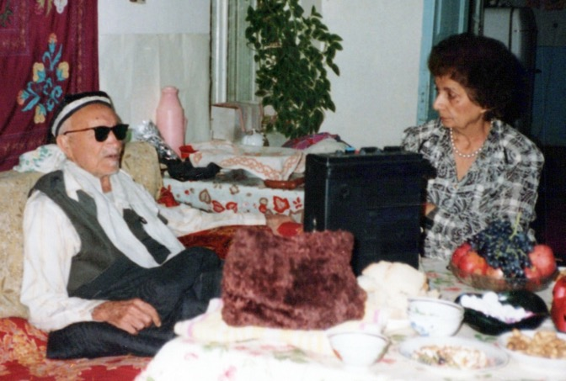
Aqa Sadeq of Samarkand, father of Mr. Nosratollah Monjazeb, telling stories about the early Baha’is of Samarkand and some people from Lotf Abad who were my mother’s relatives.
Dr. Vossough’s letter
The second letter was from Dr. Vossough. I think he was the pharmacist whom I knew when I lived in Mashhad, Iran, in 1950. I had not seen him since I left Mashhad for England and from there pioneered to Cyprus in 1955. I did not know where he was and how much his family had grown. His wife was sister of our dear Mr. Ali Akbar Nadji, a well-known Baha’i who lived in Ashkhabad. However, he had learned from Mr. Hadi Rahmani in England that I was pioneering in Odessa and had read one of my letters to my sister Qamar Khanum via Mr. Hadi Rahmani. I’m not sure how he came to see the letter--maybe Mr. Aghdassi my brother-in-law sent a copy to him. This must have prompted him to write one of the most gracious letters I have ever received, full of praise, encouragement, sincerity, and honesty. I told myself that it was nice to hear good words about oneself before dying! Usually people say nice things after one’s death.
I made the salad, warmed up the rest of the food, and set the table, and before 4 p.m., Ms. Lena Pshenkovskaya arrived followed by the others—including three non-Baha’is, Yura, Gala, and Alexander. They enjoyed the meal and hospitality. We read and sang songs, and I gave them the gifts—ten albums and five pocket calendars. I had gotten just the right amount. I numbered them and then each guest took a number and received their gift. They were appreciative. Mr. Alexander Rivas brought an enlargement of Abdu’l-Baha’s picture as a gift for me from the Ethiopian students. We read the prayer for the Intercalary Days, then drank tea and coffee with sweets. After everyone had left, I washed and cleaned and thanked Baha’u’llah for giving me the strength and bounty to serve.
Mr. Garric the actor had been invited too but had phoned me at 9 p.m. and apologized for not being able to come due to the illness of his mother. I told him not to worry. I would invite him for another gathering. Ms. Tanya Kiracirova left her ballot paper with me because she could not come for the election of delegates. Ms. Tanya Babinchuck called, and we arranged to meet each other at 1 p.m. the next day outside the Medicinskaya Institute of dentistry. Ms. Lena Pshenkovskaya, Ms. Natasha Babinchuck, and Ms. Julia Zhulkova would join us too. I said my prayers and though I was tired, I was happy and went to bed.
I woke up on February 27th with a headache again. I took two tablets and rested. At 10 a.m. Mr. Tony Verderosa phoned me from Ulan Ude. He wanted the telephone number of Mr. Toni Nelson and Ms. Linda Godwin, but I did not have them. These two friends were in the group of Baha’i businessmen who were coming to Odessa on March 2nd. He wanted to ask them if they wanted to go on a teaching trip to Kishinev. He gave me the names of several friends there. Ms. Lydia, a Baha’i lady whom we had met in Moscow, was active. He also gave me the name of a female professor who taught English language in Kishinev. Her name is Ms. Lena, and she is a good friend of Mr. Volodia, Toni’s host. I’ll ask Volodia for her full name and address, and we’ll visit them.
I got ready to go to the Medical Institute by taking my large plastic charts down from the walls which was quite difficult because I had to climb up on the table to do this. Baha’u’llah protected me, and I didn’t fall. I brought pamphlets, photographs, and books, and went by taxi to the medical institute. When I got there, I waited in the reception area. The weather very cold. Ms. Lena Pshenkovskaya, Ms. Tanya Babinchuck, Ms. Natasha Babinchuck, and Ms. Julia Zhulkova, and then the professor of philosophy arrived, and we all introduced ourselves and talked. Then we entered the auditorium where fifty fourth-year dental students were sitting. They rose, and I asked them to please “sit down”. I was introduced by the professor using an article written in the Odessa newspaper about me and the Faith. We hung the charts on the wall, and Natasha translated for me. I spoke for an hour on progressive revelation, the Baha’i Faith, and its principles. They asked questions, and wanted my phone number, and I provided my telephone number. They enjoyed the talk, and many came up to thank us. Afterwards, the professor brought us to his office which was a few streets away. We had coffee and cake and spoke for one hour on different subjects such as hypnotism which had been used on a patient who had then undergone an operation without anesthesia. The hypnosis had been done by television and not in person. I gave my views on this subject, and then we left to go to a place called Gvorey Moryakov where Portofranox, an economic organization, was housed, to meet the Director and see if the place was suitable to rent for our meeting. After we had seen it, Ms. Lena and I caught a taxi home where we prepared a food bag and fruit for Ms. Sveta Vasiliyeva from Yalta who was leaving. At 6:25 p.m., we sent rice, sweet chicken, and calbasa, for her mother, and several brown bags for her to take it on the train. We took a taxi to the railway station where others came to see her off as well. She was very happy to see us. We gave her the food, said goodbye, and the train left. We took the bus #28 then walked the rest of the way home.
At 7 p.m., we ate leftovers. At 9:30 p.m., Ms. Lena and I studied the life of Moses and his teachings. She was very interested. She borrowed the book God and His Messengers. Usually I do not let any book go out of my library, but this was an exception. They left, and I cleaned and went to bed after my prayers, thanking Baha’u’llah for this opportunity to serve His Faith.
I attended to my English class and other activities
The next morning February 28th, I again had a headache and took two tablets before having breakfast. I spent a quiet morning preparing papers for the English class. At 2 p.m. the school director’s car came to take me to my class. The students were all adults and spoke English fairly well. The class finished at 4 p.m. I asked my driver and Mr. Genna, the school director, to take me to the dormitory of our Baha’i medical students. It was very far but they still took me and dropped me near it. I asked passersby where the dormitory was, and they showed me the building. I bought fresh lavash bread to go with the tins of sardines and the tea I had with me. In the dormitory, I found the Ethiopian students—Tsiga, Emayesh, and Derege—, and we were all happy to see each other. They had a guest with them. I stayed there for two hours. Then Seyum came, and we were all together. I updated them on all the Baha’i activities as they had been away for a few weeks and then invited them to come tomorrow to the Polytechnic Institute for the election of a delegate to the National Convention. Mr. Namdar had stressed that all Baha’is should know about the election’s time and place. We drank tea and ate fresh lavash (bread), with sardines and then all saw me off.
Stopped at the Universam shopping center
One student helped me get a taxi back to my apartment. Before going in, I stopped by the Universam shopping center. My friend Mr. Valia asked me if I would like some chicken, and I said yes because chicken is not always available, sometimes requiring people to stand in line for 1-2 hours. So, I went to my flat and got a big bag and returned. At the store, I bought six chickens for twenty-three rubles in all—not even $1--two kgs. of biscuits, and two kgs of rice cookies, and then I went home. I ate dinner and then cut up the chicken and put the meat in the fridge and kept the bones to make soup tomorrow. I thanked Baha’u’llah for all his bounties and went to bed.
Election of a delegate for the National Convention and participation at the
Nineteen-Day Feast
On March 1st, I followed my usual morning routine. At 9 a.m., Ms. Tanya Kangoon, my landlady, called and then came over. She had dreamt that someone was trying to kill her. We talked, and we prayed. She said she wanted to come and live in her flat. I told her that I was living in it, and when I found a new one, I would vacate it.
I went to the post office and picked up a letter from Ms. Sheila Dolphin. Then I bought bread for the election and Nineteen-Day Feast that evening and went back home for lunch. At 2 p.m., I packed a big suitcase with sweets, thermoses of tea, bread, and tart. The school director’s car came and took me and my bag to the English class. After class, at 4 p.m., I was taken to the Polytechnic Institute where we had our election for a delegate to the National Convention and the Nineteen-Day Feast. Fifteen Baha’is attended--eight adults and one youth. The director of the school came and greeted us; I knew him through Ms. Tanya and though he was not interested in the Faith, he was polite. Ms. Tanya assisted with setting up the tea table after the election. I had the honor of being elected as the delegate. We then held our Nineteen-Day Feast and had a quick social due to having to vacate the premises by 7 p.m. Tanya went home soon after the election because her son was ill, and then we left. I came home and after a while I went to bed.
I got up very early on March 2nd to breakfast before dawn. I ate chicken, bread, tea, and read from The Family Repairs and Maintenance Manual by Mrs. Agnes Gaznavi, former Counselor of the Baha’i Faith, and a known psychiatrist in Switzerland (who visited Odessa on July 11th on behalf of the National Assembly of Germany and CBOC Europe to prepare our community for the election of our delegate to the first National Convention of the USSR, April 26-28 1991). Then I called Mr. Namdar in Moscow and gave him the result of the election of our delegate. He was very pleased and told me that they had secured a tourist hotel for 350 people at which to hold the Convention. Now, he said, I should try and encourage many people to come. He said the Secretary of the National Spiritual Assembly of Germany had left Moscow but Counselor Mr. Pavel Semienof had arrived. Then I called Mr. Alexander Frelov in Kiev. He had returned from a trip to England with his family. He was in charge of arranging the accommodations in Moscow for the friends. I was very happy, and I asked him if he could arrange visas for the towns I would be visiting and to write a special letter so that I could pay rubles instead of dollars. He said he would ask Mr. Sergey Sinyakov to prepare the letter. He said he might come to Odessa soon. I waited until 7:30 p.m. for a bus or taxi on the corner of the street. Finally, I offered five rubles to a taxi driver, and he brought me home. I warmed up, broke fast, said my prayers, and went to bed.

Conducted my English class and then had a Baha’i discussion meeting
On March 3rd, I got up early, had breakfast before down, prayed and read the Writings for an hour and rested, watching a documentary on TV. At 2 p.m., I was taken to the class. Eleven students were present. A lady named Maria who had attended the meeting of Baha’i businessmen at the Victoria Hotel with her husband and daughter gave her impressions of the “Baha’i discussion meeting”. She spoke very positively, first about the central principles of the oneness of God, religion, and mankind, and then about a few of the other principles. Then she stressed the friendliness of all the participants and their love and warmth towards all. She said she thought that this religion would progress because of the principles it brought and the way it was taught. She spoke about the Baha’i idea of serving in the army in a noncombatant role. I explained this subject further, and then I spoke about the approach of the Lesser Peace and fulfillment of prophecies especially that of the Prophet Daniel about the “Lamb and the Lion will pasture together”. Everyone listened, and one person asked about the meaning of the ‘Unity of religions’ which I explained. The class heard about the Faith and its principles. This lady already had spoken about Mohammad and Zoroaster. She had done a good deal of research.
Saw an apartment for sale but not suitable
Then we went to see an apartment for sale which had two rooms, a kitchen, and bath and toilet. The rooms were old, on the 5th floor, and had no light. At $3,000, this was not a good deal. Then I went home. The weather was very cold, so I warmed up, said prayers, and was going to break my fast when Nana came over with a jar of homemade compote. Then I broke fast.
Mr. Chad Smith called to inform me that tomorrow, they were leaving for Minsk for two weeks. Then I would be leaving for a teaching trip and, God-willing, we would see each other at the Moscow Convention. At 11:15, I went to bed, but I could not sleep because of allergies. The soup may have contained canned vegetables or preservatives. I drank fluids and by midnight I felt better and went to bed.
The next morning March 12th, I got up for fasting. I had a headache. I said prayers, ate breakfast, and took two tablets.
Visit of Ms. Olga Kangoon, the mother of my landlady
After a while I felt better and cooked chicken and soaked rice because Ms. Olga Kangoon, the mother of my landlady, was coming to talk about the problem of her daughter and this flat where I was living. The daughter wanted to move back in, and they wanted to know if I could find another place. I cleaned the flat and did a little bit of washing. At noon I watched the news and rested.
At 2 p.m., Mr. Andrey came, and we spoke. He was fasting. We deepened together. Since March 20th was his birthday, he bought a medallion of the Greatest Name for ten rubles. I gave him a birthday gift of a Baha’i ring which was on sale for ten rubles.
Ms. Olga Kangoon called to say that she could not come but I stressed that she should come because I may be leaving soon for a teaching trip, and we should solve the problem of the apartment. She arrived at 3:30 p.m., and we spoke about her daughter Ms. Tanya Kangoon and her problem. I told her to help her daughter and be kind and loving towards her. She was grown up and wanted greater freedom. About the flat, I said that she wanted me to leave so she could move in and live separately from her mother, but it was not available at this moment. Could she wait until I came back from my teaching trip, and then I would find a new place and move out? She told me, “do not be worried, she will not move here, she will live with me.” I gave several Baha’i books to her. She had a late lunch 5 p.m., but I was fasting. When she left, I gave her some butter to take home. Then it was time to break the fast. I said my prayers, had my meal, and gradually went to bed.
On March 13th, I got up early, before the sunrise for the fast, had breakfast, prayed, and packed many books and papers for my trip. At 4 p.m., Ms. Maria’s husband came over, and we took a taxi and went to see a new apartment for me but there was a misunderstanding because the owners thought we wanted an office building. When we saw the building, we apologized saying that this was not what we wanted. We needed a flat. We returned home. I warmed up, said prayers, after sunset broke the fast, and gradually went to bed.
I had some homework and spoke with several Baha’is
The next morning, March 14th, I got up early for the fast, ate breakfast, prayed, and then cooked two kinds of macaroni, and sausages for dinner to arrive he came to 12:50 PM and after our class. Then I did a lot of washing and swept the rooms. Then Ms. Gita Shauman from Germany called to inform me Mr. Mark Ochu, an American pianist, was coming to Odessa, April 4-6, to perform a concert and speak about the Faith. She wanted to know if we could organize the program and book a hotel for him. Then I let her know that I was going soon on a teaching trip, which she was very happy to hear. Then she said that Mr. Jack Banani was there and asked if I’d like to speak to him. I said “Of course”. We spoke for a few minutes. I was thrilled to hear his voice, although Mr. Banani sounded old and tired. I had known him in London, 1951-54. He said that he was not well. His wife, Iran Khanum, whom I had known as a teenager in 1948 was not well either. They had three children—their son was living in the United States and their two daughters were in Germany. I gave all my love and best wishes to all the members of his family and said goodbye.
Attended my English class
At 2 p.m., I left for my English class and then returned home. I prepared the table to break the fast at 7 p.m. Thirteen youth arrived, we spoke about the forthcoming meetings. Mr. Chad and Ms. Cora Smith, and I would be away, so the Soviet Baha’i youth would have to carry out the local activities, so we prepared them. Everyone was happy and excited. We broke our fast after prayers and enjoyed fellowship then we spoke about the Faith. They were very satisfied and left.
I cleaned and tidied the apartment. Then I called Mr. Gary Volk the actor and told him that his TV program was great, and I asked him if he could help me with getting a train ticket. He said he would come to the hotel tomorrow to help. Then I went to bed as usual.
On the morning of March 15th, I woke up early to keep the fast, say prayers, and write in my diary. Mr. Gary Volk the actor was coming at 12:45 p.m. to the hotel to help me. Then I caught a taxi to the hotel.
The ticket agent asked me if I had a visa, and I said yes. She said that for Baku, there was only availability March 29th. (I wanted to leave on the 19th to be there in time for the Naw-Ruz celebration on March 21th). I told her that date was too late. She looked at other routes--Odessa-Kiev, Baku-Odessa, and others, but nothing was available. She suggested going to Ashkhabad first and then to Baku. Since there was no other way, I agreed to go to Simferopol on the 18th by rail and then by air to Ashkhabad. (I told her, I will think about it, and let her know later).
I waited for Mr. Gary Volk to arrive. He came at 12:50 p.m. and tried to find a friend he knew, but she was not there. He asked others to help us and buy railway tickets. No one was able to help. We were told to stay in line or come back tomorrow when Gary’s friend Ms. Natasha would be there to help. I agreed. The car came and took me to my English class. Only four people were there because this was an extra class. Since I was leaving for my trip, I only spoke about the Baha’i Faith and showed the students all my photographs of the Holy places and temples and spoke about the principles and progress of the Faith and the early persecution of its believers. The students listened carefully and asked questions. Then I explained the challenges I was having in buying a ticket. Ms. Natasha Kasperovia, a TV reporter of Jewish background who had been born in Baku, (where her mother still lived), was present with her. And her husband Mr. Anatoli Kontush said they had a friend at the airport, and that he may help me to fly on 19th. We all said goodbye to each other, and the car took me to the hotel to buy my tickets. Ms. Larisa was very nice and sold me a ticket. She wanted US dollars, but I showed my letter from Mr. Alexander Forlov. She was satisfied. The plane was #667, 29.03.91, 10:30 am, seat 17E, but I had to confirm all of this. Then I tried to book the seat from Baku to Ashkhabad. The only flight there was on the 27th. I agreed to the date, but the computer was not working. So, I left, and I went out into the street to catch a taxi, but no one stopped or took me. The weather was very cold, and I was fasting! At last I hailed a car and told the driver my destination, Frunze St. He said he did not want to take me there. I said I would pay him four rubles, and he looked at me and heard by my accent that I was a foreigner, so he told me to get in. On the way home, he asked me about myself. He said his wife, Felshir, worked at the Emergency Department and would be happy to visit me. At the end of the ride, he did not charge me. I insisted, and he refused. We exchanged telephone numbers, and I promised to call them on my return. I gave him pamphlets on the Faith and told him to read them for the next time we meet. He wanted me to phone his wife and speak to her in English. Soon after I had prayed and broken fast, I called her. She spoke little English, but we said we would see each other on my return. Her father-in-law and mother would be back from Baku. He was a professor. They wanted to come to my classes.
I informed the Baha’is of Baku of my arrival
Then I called Baku multiple times until I got Mrs. Rana and spoke for long time. The local assembly was meeting on Saturday, and she’d inform them of my arrival. The Naw-Ruz festival would be held in one of the hotels on March 21st. I’d call her about the exact time of arrival and see if I could contribute food to the celebration.
I called Mr. Namdar in Moscow and told him all the news and heard his. The goals were to have 155 NSAs in the world by Ridvan 1992. Hand of the Cause Mr. Furutan would attend the Moscow National Convention and Hand of the Cause Ruhiyyih Khanum would go to Romania and Yugoslavia for the election of their National Spiritual Assemblies. Mr. Arbab and his wife had been on teaching trips to Moscow, Kazan, and Leningrad. We spoke for a long time about all our friends such as Mrs. Mehrain in Finland etc…I wrote in my diary until 12:30 a.m. after which I went to bed.
Arranged my needed facilities and bought Baku tickets
I stayed home all day on March 16th, cleaning, packing, and sorting through what I wanted to take in terms of books and notes in case I needed them for lectures. I went to Universam. There Ms. Nana helped me, and I got five kgs. of biscuits to take for the trip. Then I went to the post office to ask them to keep my letters until my return or to put them in POB 96. Back in my apartment, I broke my fast and continued to sort papers. I went to bed late.
I woke up early on March 17th for sahari (break the fast). Ms. Natasha Kasperovia called, and we arranged to meet tomorrow at 9 a.m. At 11 a.m. I went to the Hotel Red to pick-up my ticket for Baku-Ashgabat. Ms. Larissa helped me greatly by booking my ticket for Odessa-Moscow on April 25th in case I was not able to get a ticket from other cities to the Convention in Moscow. Then I took a taxi to Maryakov. Two of the Baha’is were there. The rest came slowly but Ms. Inara and the four medical students did not come.
We were able to have a meeting with Mr. Alexander Rivas, Mr. Sergey Sinyakov, Ms. Elena and myself present. We consulted about the Naw-Ruz party and the April 4th meeting for Mr. Mark Ochu, the pianist from the United States. They would arrange programs, refreshments, books for display, and music. Ms. Marina Oryol, my student, and her husband, Mr. Vitali, the photographer arrived at 2 p.m. per my invitation.
Then they stayed with us till 4:30 p.m., and we spoke about the Faith. We were sitting and talking when a Bulgarian lady approached us and asked who we were? After we told her, she said the wife of the Bulgarian Consul to Odessa was here, and she wanted to introduce her to us. She came back with a lady who knew very little English but by using some English, some Russian and some Bulgarian, we were able to introduce the Faith. We exchanged addresses. She was leaving for Bulgaria soon for good. I would give her the phone of Ms. Anna Marie the pioneer in Sophia. We went home. Mr. Alexander Rivas and Mr. Sergey Sinyakov would come to me tomorrow to get instructions for the meetings, and Ms. Marina and Mr. Vitali would come at 8 p.m. to bring some blank slide films.
Repair of leaking water pipe
I went home in a taxi and soon after, Ms. Tanya Kangoon, the landlady, came over. The workers whom I had phoned in the morning came to repair the leaking water pipe which had leaked for the second time. The workers came but they didn’t have the proper tools so all they could do was tighten the screws, then they left. Tanya was disturbed about the flat. I told her that on my return in May, we could sign a contract, and if not, I would look for another place.
After she left, I prayed, broke the fast, and started to pack. At 7:40 p.m., my phone rang. It was my niece in the United States, then her mother, my sister, Guitty, my other sister, Qamar, and then my mother, Leqaiyyih. They all spoke with me and said they were sending me a few things with Mrs. Iran Muhajir and Hand of the Cause Mr. Furutan, who would be attending the Moscow Convention. They would send other items via other visitors. I told them all my news as well. I said I would phone them tomorrow Monday 18th. Then I set up for the following morning’s sahari and continued packing before going to bed.
Friends helping with Baku trip
I woke up early on March 18th to keep the fast. After praying and eating, I continued sorting my papers. At 9 a.m. Ms. Natasha called to say that they would be at my place at 1 p.m. to pick-up passports and take me to the airport. After my phone call with my family in the United States, I packed, sorted, and cleaned. Ms. Olga, Ms. Tanya Kangoon’s mother, called. I told her she could come to the flat if she wanted. She would clean, and I asked her to check for pipe leakage.
Ms. Natasha arrived to take me to the airport. Her friend Mr. Anatoli, a well-educated Jewish engineer was with her. We went to the airport where I sat in the car for an hour until they had found the ticket agent. They stood in line. Their friend changed the date of my departure from March 29th to March 20th, praised be to Baha’u’llah for His bounties and miracles!
Then we went to the administrative office in town to have the ticket stamped. We repeated the procedure at another office. Again, Anatoli came, and Natasha stood in line. They finally got through and were very happy. They smiled and said to me, “You will be in Baku for your Naw-Ruz celebration.”
She lived in Baku and knew all about the New Year plans there. Her daughter and her in-laws were going to Baku on the same plane. I got the VIP seat: 1B! Then we went to the visa office for Anatoli to get visas for his forthcoming travels, but the line was long, so we did not wait. He brought me home.
Back at home, they saw my video tapes. He took one to see if he could convert it to the Russian system. Natasha’s six-month old baby had been left since morning with a babysitter, so she was worried and wanted to get back. I saw them off and then went to the store where I saw Nana and asked her to post my letter.
I informed friends in Baku of my arrival
I called Baku immediately to inform the friends there of my arrival on 20th at 1 p.m. Baku time. Then I called Mr. Khazeh who was very pleased to hear from me and warmly welcomed me. He said that the assembly had arranged for me to stay with a family. I stressed that if it was inconvenient, he should arrange a hotel for me. He said it was no problem, and he would see me at the airport. He also said that after the Naw-Ruz party, I would go to Ganja for the 22nd and 23rd, then I’d come back to Baku and meet with the friends. He asked for the date of my departure to Ashkhabad. I told him I wanted to go on the 26th but the only available ticket was for the 29th. He said he could take care of this when I got to Baku. I asked what I could bring in terms of food. He said nothing but maybe a little compot. He said they had baklava and other deserts.
After we hung up, I said prayer of thanks to Baha’u’llah for all His Blessings and broke my fast and then continued packing, sorting cleaning, and washing. I called several friends to say goodbye including Ms. Lena Reznic, and Ms. Larissa Burgo, the newspaper reporter. I spoke with the wife of the Bulgarian consul in Odessa and gave her the address of Ms. Annamarie Kruger in Sofia and Mr. Mitko Gerensky in Blagoevgrad. I spoke with the consul himself and encouraged him and his wife to get in touch with Annemarie in Sophia. After more work, I went to bed.
The next morning March 19th, I woke early, prayed, and ate my sahari. After my bath, I went to the market to buy compot and gifts. Back at home, Mr. Alexander Rivas, and Mr. Sergey Sinyakov came over, and I gave them all the instructions for the meetings and the concert of Mr. Mark Ochu.
I gave them an accounting of the assembly funds, and all money I had for the assembly. I broke the fast at 7:30 p.m. Mr. Andrey came and got the ballots and left. Ms. Marina Oryol, the wife of the photographer, Mr. Vitali Oryol, came and brought blank films and slides.
After she left, I finished packing and went to bed dead tired. Ms. Natasha called the next day at noon to say she would be there soon. Ms. Natasha came by car with her friends and her mother and father who were also going to Baku. We drove to the airport, and they helped me with my luggage.
Election and photo of the National Spiritual Assembly of the Soviet Union, April 1991
In Ridvan, 1991, I was elected to the first National Spiritual Assembly of the Soviet Union.
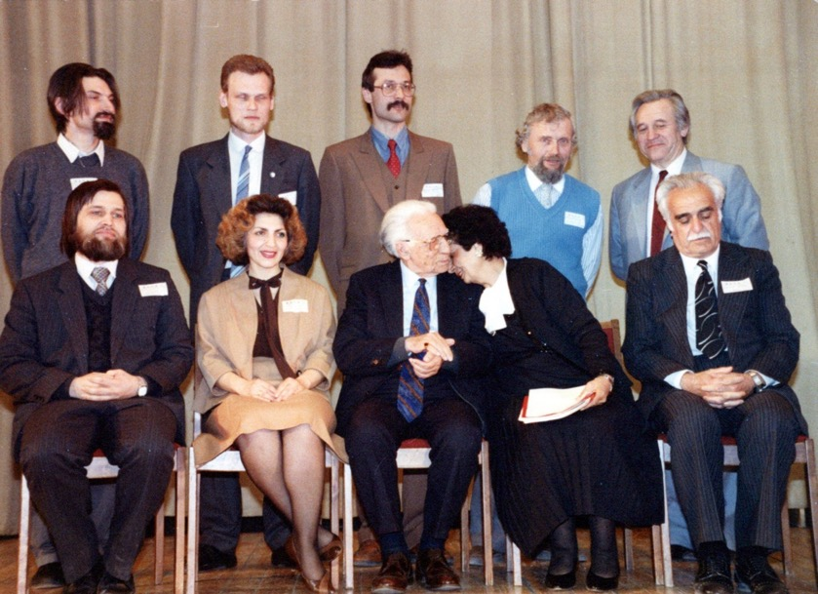
Members of the first National Spiritual Assembly of the Soviet Union
Back row l. to r.: 1) Mr. Stanislav Kontsebovskiy. 2) Mr. Sergey Kichigin, 3) Mr. Shamil Fattakhov, 4) Mr. Vladimir Khadzhinov, 5) Mr. Lev Evgravov
Front row l. to r.: 6) Mr. Richard Hainsworth, 7) Ms. Marina Pavlova,
8) Hand of the Cause Mr. Furutan,
9) Shamsi, 10) Mr. Vahid Khazeh
Letter of introduction from the National Spiritual Assembly of Germany regarding my summer of 1991, travel teaching
In the summer of 1991, I travel taught throughout Central Asia under the auspices of the National Spiritual Assembly of Germany who wrote the following letter of introduction:

“February 9th, 1991
Der Nationale Geistige Rat Der Baha’i in Deutschland E.V.
We would like to introduce to you
Ms. Shamsi Sedaghat
Presently residing in Odessa/Ukraine, as an international travel teacher with rich experience. During her extensive travel teaching trip through the USSR this summer she will be visiting the communities of Baku, Dushanbe, Ashkabad, Tashkent, Mary, Frunze, Samarkand, Almaty.
We would like to ask your community to meet with Ms. Sedaghat as much as possible, hold deepening with her the plans that your community made for the development of the Faith in your area.
We are sure that your community will greatly benefit from Ms. Sedaghat’s experience and hope that you will be inspired and uplifted by her visit.
With loving Baha’i greetings,
National Spiritual Assembly
Of the Baha’is of Germany Christopher Sprung”

Chapter 18

Turkmenistan
Ashgabat
Seeing that there was a strong Baha’i community in Odessa, I thought I would pioneer in the land of my birth, Turkmenistan. I consulted with the Pioneer Committee in the United States. By the end of 1991, at the invitation of the Assembly of Ashgabat, Turkmenistan, the approval of the National Spiritual Assembly of the USSR and the blessings of the Counsellors for the region, I moved to Ashgabat, my birthplace, to continue my humble services.

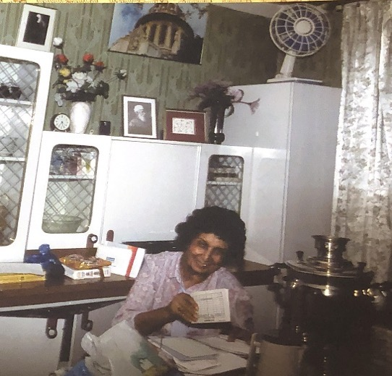
Shamsi in her apartment in Ashghabat

I also promised to assist with the teaching goals in Kazakhstan, where the efforts of Mrs. Soraya Abou Said would lead to the formation of the first Assembly of Alma Ata, and in Kyrgystan with the help of Dr. Ezatollah Safapour.
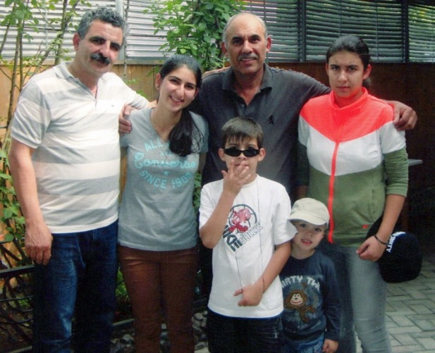
L. to r.: 1) Mr. Naim Nadji, 2) his daughter, Anisa Nadji, 3) Mr. Ziaullah Miyadev from Kazakhstan and three children?
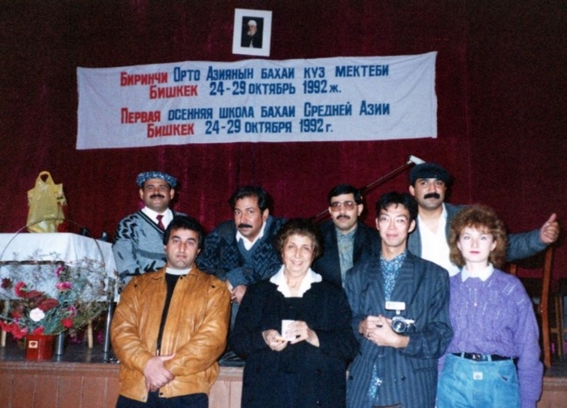
Kyrgystan, 1992
Front row l. to r.: 1) Mr. Habib Ghafurov, 2) Shamsi, 3) ?, 4) ?
Back row: Baha’is from Arabic countries who came to help Central Asia?

In its Ridvan message of 1992, the Universal House of Justice reviewed the accomplishments of the preceding Six-Year Plan and announced the activities of the Holy Year and the formation of new ‘Regional’ Spiritual Assemblies. Several of these took the place of the National Spiritual Assembly of the Soviet Union in anticipation of further growth and following the political changes in that region. The House of Justice wrote:
“At the outset, we welcome with joyous and grateful hearts the further expansion and consolidation of the Administrative Order which will accrue from the formation this Ridván of twelve National and Regional Spiritual Assemblies. How striking it is that the number of these Assemblies is the same as the total number of National Spiritual Assemblies which existed at the launching of the Ten-Year World Crusade in 1953! This is gratifying evidence of the rapidity of the expansion of the Administrative Order in less than forty years. With these new Assemblies and making allowance for the absorption of Sikkim into India and the disruption of the Bahá'í Administration by the unsettled situation in Liberia, the number of National Spiritual Assemblies which will take part in the seventh International Bahá'í Convention next Ridván will reach 165.
We are pleased to announce that the following Hands of the Cause of God will attend, as our representatives, six of the founding Conventions. Amatu'l-Bahá Ruhíyyíh Khánum will attend the Conventions of Bulgaria and of Poland; Mr. `Alí Akbar Furútan will attend those of the Baltic States and of Hungary; and Dr. `Alí-Muhammad Varqá will attend those of Greenland and of the Ukraine, Belarus and Moldova. At the remaining Conventions, our representatives will be Counsellors: Mr. George Allen, the Congo Republic; Dr. Farzam Arbab, Central Asia; Mr. Rolf von Czekus, Angola; Mrs. Parvin Djoneidi, Niger; Mr. Hartmut Grossmann, Albania; and Mr. Mas`ud Khamsi, Azerbaijan.”
The National Spiritual Assembly of the Soviet Union was replaced by four Regional Assemblies and one National Assembly:
- The Baltic States is formed with its seat in Tallinn, Estonia.
- The former Spiritual Assembly of the USSR with its seat in Moscow became the Regional Spiritual Assembly of Russia, Georgia, and Armenia.
- The Republics of Kazakhstan, Kirgizia, Tajikistan, Turkmenistan, and Uzbekistan (Central Asia), is formed with its seat in Ashkhabad, Turkmenistan.
- The Ukraine, Belarus, and Moldova with the seat in Kiev, Ukraine.
- The National Spiritual Assembly of Azerbaijan.

Regional Assembly of Central Asia, April 1992
(Turkmenistan, Uzbekistan, Tajikistan, Kazakhstan, and Kyrgyzstan)
The elections were held in Firuze, a beautiful small town near Ashgabat, in the presence of Mr. Farzam Arbab who was there representing the Universal House of Justice along with guests from many countries.

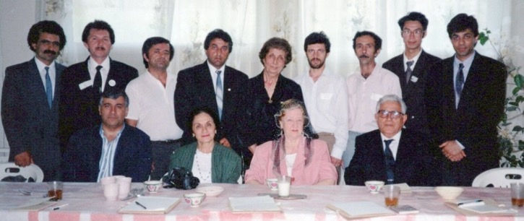
Hand of the Cause Ruhiyyih Khanum and Members of the Regional Assembly of Central Asia, 1992:
Seated r. to l.: 1) Counselor Katirai, 2) Hand of the Cause Ruhiyyih Khanum Rabbani,
3) Mrs. Violette Nakjavani, 4) the son of Counselor Katirai
Members of the Regional Assembly of Central Asia
Standing l. to r.: 1) Mr. Naim Nadji, 2) Mr. Durdy Amansariev,
3) Mr. Nosratollah Monjazeb, 4) Mr. Habib Gafurov, 5) Shamsi, 6) ?, 7) Mr. Kamal Gusaynov, 8) ?, 9) ? sorry, I forgot the names
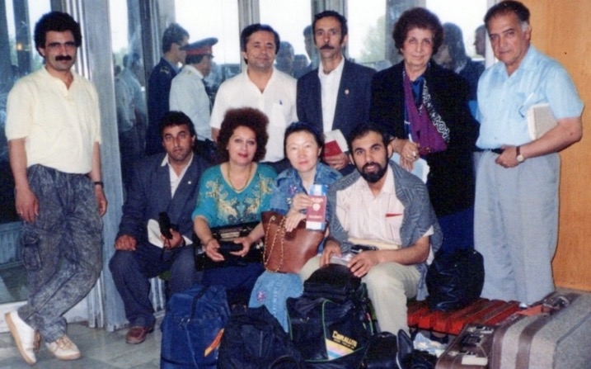
Members of the Regional Assembly of Central Asia on their way to the International Convention, 1993
The Regional Assembly developed an extensive three-year plan:
“1. To increase the number of Local Spiritual Assemblies in Central Asia to 220.
2. To organize the propagation of the Faith through mass media according to the plan of action to be drawn up by each National Administrative Teaching Committee.
3. To organize the publication of a Baha’i bulletin of the Regional Assembly of Central Asia and newsletters of the National Administrative and Teaching Committees, to fully support the Local Spiritual Assembly of Asghabat in publication of the magazine “Khoshide Kohvar”.
4. To organize, annually, in each country the pursuit of 4 teaching projects, i.e. one every three months, 60 projects in all.
5. To arrange one teaching project for teenagers and youth of 12 to 21, every year.
6. To strengthen the local spiritual assemblies by sending pioneers, 192 in the region in all.
7. To establish one permanent deepening institute in each country except Uzbekistan, where there will be two deepening institutes, one is Samarkand and the other in Tashkent, by the end of the first year of the three year plan.
8. To promote teaching the Cause to the people of high position, prominent people and leaders of thought.
9. To centralize the translation, publication and distribution of Russian literature in Ashghabat, and to translate and publish the following 5 books during the three years: “Some Answered Questions”, “The Baha’i Administration”, “The New Garden”, “Blessed Beauty”, and “Family Life”. To prepare for publication a daybook in Russian language.
10. To publish, translate and distribute 9 books in local languages during the three years: preference must be given to those 6 titles decided for publication in 149 BE.
11. To undertake at least one social and economic development project in each country (establishment of kindergartens, teaching languages, free medical treatment etc…)
12. To help out the Local Spiritual Assemblies so that at least 70% of them work out their own annual plans.
13. To hold national Conferences for the members of the Local Assemblies twice a year (before Ridvan stressing the Baha’I election and after Ridvan stressing on planning) as well as holding a regional conference every year.
14. To help all Local Spiritual Assemblies hold Nineteen Day Feasts and observe the Baha’i Holy Days.
15. To print 5,000 copies of a Baha’i wall calendar with necessary comments in Russian language.
16. To organize summer and winter schools at least once a year in each country.
17. To organize local conferences in large cities on the subject of “The Baha’i Family Life” and to invite Baha’is as well as non-Baha’is to these conferences.
18. To organize a summer camp for the Baha’i and non-Baha’i youth in the region.
19. To provide training courses, through the deepening institutes, for teachers of children’s moral classes.
20. To organize moral classes in each country of Central Asia: during the first year at least 50% of the local assemblies; during the second year in 70% and in the last year of the plan to make every effort that each local assembly would have a moral class for children.
21. To provide training courses, through the deepening institutes, for teachers of weekly deepening classes in large and central cities in each country.
22. To provide training courses, through the deepening institutes, for teachers of the Faith on how to conduct firesides.
23. To consider the purchase of National Baha’i Centers in Uzbekistan, Turkmenistan, and Kyrgyzstan as soon as possible after approval by the Universal House of Justice.
24. To purchase if possible, or to rent apartments for the local Baha’i Centers for the needs of communities.
25. To consider the purchase of suitable sites in all the countries of the Region for future construction of Houses of Worship after the approval of the Universal House of Justice.”
Early Baha’is in Ashgabat (according to early historians)
The first Iranian Baha’is who arrived in Samarqand and Bokhara (Uzbekistan – the Former Russian Republic in Central Asia) were Mr. Fazel Qaeni and Mr. Mirza Abol-Fazl. Gradually, the first town in Turkmenistan where the Bahais started to reside in 1880 was the town of Ashgabat which was situated near the Alborz mountains, between Iran and Russia. There were about 500 “obbeh” (houses were built like tents). The Russian government started to build some roads, houses, and railway stations etc. and many Iranian Bahais moved there to buy cheap land, build houses for themselves and to sell. They brought their families to live a safer and more comfortable life than in Iran, where anti-Baha’i activities were a regular threat.
Ashgabat became the center of trade and business and its population grew. Unfortunately, the situation in Iran started to become more troublesome. Attacks and restrictions against the Baha’is worsened. In Yazd and Isfahan, the situations became more precarious and Baha’is were attacked, their belongings were confiscated, and they were arrested.
Later the Baha’is of the town of Mashhad intervened. When detained Baha’is were brought to Mashhad, they intervened and got them released. These newly freed Baha’is knew that they could not go back to their homes, so they moved to Ashgabat where they bought land and built houses and other needed buildings for themselves and for sale. They brought their families and gradually settled down there. These Baha’is included: Aga Abdul-Rasul Yazdi and Aga Mohammad Reza Arbab Esfehani and after them, Aga Hadji Mirza Hassan-Afnan-Kabir (one of the relatives of His Holiness the Bab) who also was going for pilgrimage to Holy Land via Ashgabat. When he noticed that inexpensive land was available, he bought a few parcels for himself and encouraged the other Bahais to do the same, which they did. Then he asked his son Mirza Seyyid Ahmad who lived in the town of Sabzevar to do the same. He obeyed and arranged to buy a few parcels and advised the other Bahais to buy as well which they did. Sometime later, Aga Seyyid Mohsen Afnan (“Afnan” means “the small branches”, which is the title given to the relatives of His Holiness the Bab and “Aqsan” means “greater branches” the title which is given to the relatives of His Holiness Baha’u’llah) decided to buy few choice parcels of land.
Haji Mirza Mohammad Taqi Afnan when he was traveling for a pilgrimage to the Holy land via Ashgabat bought several plots of land. When he arrived in Haifa, he explained the situation about the lands in Ashgabat in the Presence of Baha’u’llah who advised him that that a piece of land be acquired for the construction of the Mashriqu’l-Adhkar (the place for remembrance of God- a House of Worship). Hadji Mirza Mohammad Taqi obeyed His Instructions and arranged immediately to purchase a piece of land from an Armenian man called “A’azam”. The land from that time was called “Zamin-e A’azam” (meaning A'azam’s land). Hadji Mirza Mohammad Taqi arranged that a large hall should first be built for gatherings. Every day before the dawn you may see some people outside in the street was going somewhere, you may ask yourself where these people are going so early? The answer was, they were going to: “Zamin-e A’zam”. And everyone knew that they were going to: “Bahai Temple”. That was the way we used to live without much problems.

Arrival to Ashgabat from Odessa
The Faith in Odessa had progressed and many high-ranking people such as media personnel, the assistant director of music conservatoire and his family, a businessman, a photographer, Mr. Vitaly Ariol and his wife, an active Baha’i, Mrs. Marina Ariol and their daughter, a news media personality, and many other individuals added to our community. The Baha’i community of Ashghabat, Turkmenistan, invited me to join them. I consulted with the counselors of Central Asia and other Baha’i institutions, and they agreed. Therefore, I collected the needed luggage of mine and said goodbye to the friends and left for Ashghabat, my birthplace. There at the airport, I was met by many Baha’is such as Mr. Ali Akbar Nadji, a very active and famous Baha’i, and his son Mr. Naim Nadji, Mr. and Mrs. Habib Gafurov, and Prof. Rezvanollah Seyfuddinov and many other active Baha’is with their cars and other means of transportation with difficulties took me and my very heavy luggage to the fourth floor of home of Mr. Habib Gafurov and his wife, Rada Khanum and settled me there. The apartment was under repair, but I had one big sitting room, a bedroom, and a small kitchen and bathroom. They lived next door to me. I lived there for eight months free of charge and they helped me in many ways they could and originally, they were the cause of my preliminary settlement in Ashghabat (I am indebted to them). There I gradually started my activities. There were some people whom I knew since my childhood in Ashghabat such as Mr. Muzaffar Aliev who was now married and had children. We were delighted to be reunited. Habib jan immediately employed me in his company as a translator, and I had my immigration papers in order and gradually we started our activities—our firesides and youth and children’s classes. We started our traveling teaching and formed communities, many local spiritual assemblies and thus Turkmenistan progressed. Then we decided to go to the town of Firuze and have our meetings, conferences, and so on, there. Many travelling teachers from Arabic countries (Oman, Yemen, Qatar, etc…), Canada, and so on, came such as my three sisters from America: the eldest Mrs. Qamar Aqdassi, Mrs. Soraya Khanum and her husband, Mr. Khosrow Furutan, Mrs. Guitty Ejtemai (she came several times), Dr. Abbas Bashir-Elahi who came once as a travelling teacher and helped with teaching activities, visited one of our doctors in his office, exchanged an interesting conversation which resulted in a good friendship between us and the said doctor, and the visit of Mrs. Shahin Safapoor from America who was the source of encouragement and many others.

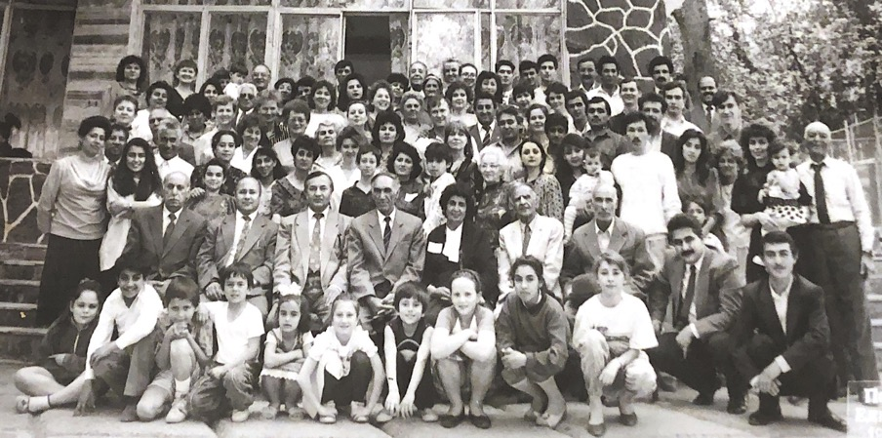
Baha’i Celebration in Firuze, Turkmenistan; Shamsi in the second row, middle, dark suit
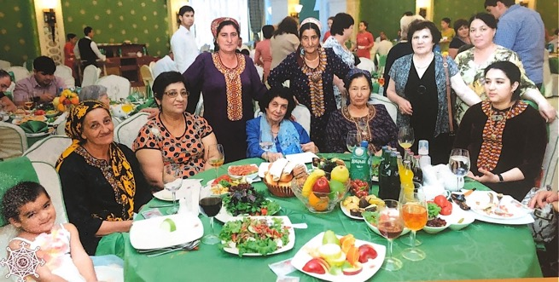
Baha’i gathering in Turkmenistan; Shamsi in the middle in blue
Seated third from the left is Mrs. Qadimi, active Baha’i; standing left to right: Mrs. Alfepoor, Mrs. Amineh Bakhshandegi, a very active Baha’i pioneer
I started to visit other towns, met the few friends there, encouraged them, gave them
the needed literature, if we had declarations, helped them to form their local spiritual assemblies.
We encouraged them first to help themselves and then their fellow citizens with the Baha’i principles of love and fellowship. We used to receive many letters of appreciation after returning to Ashgabat. One of the letters is from Mrs. Sonya Zaripova which follows.

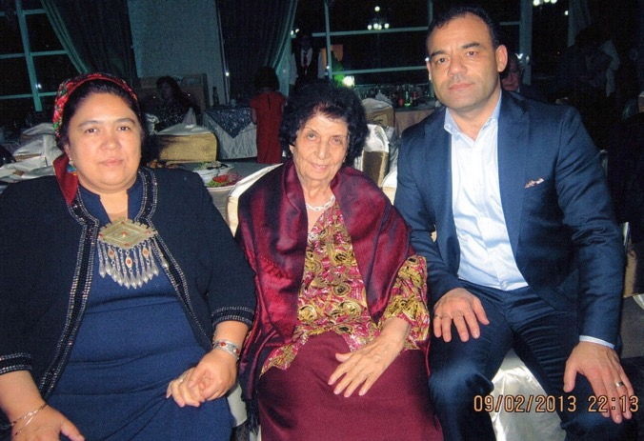
L. to r.: Mrs. Shahsanam Garlieva, Shamsi, Mr. Makhtum Garliev, beloved, hard-working, and respected Baha’is of Ashgabat
Travel Teaching in Turkmenistan and meeting Mrs. Sonya Zaripova
I was able to travel teach throughout Turkmenistan. In this letter, Sonya Khanum Zaripova remembers my time in the city of Chardjow, one of the rather large cities in Turkmenistan. The letter says:
“Dear Friends,
I would like to share the wonderful events that changed my life. In 1993, Shamsi Khanum together with Delara Nadji-Alikperova from Ashgabat visited our town, Chardjow. They came to meet with the Baha’i friends there. There were only 5 Baha’i-zadehs (meaning born to Baha’i families) in Chardjow at that moment. I remember those 3 days full of the joy of meeting with Shamsi Khanum, her stories about the Faith and the Teachings of Bahaullah. During those 3 days, we were inviting our friends and relatives. Nobody wanted to leave the meetings till late at night.

Shamsi Khanum, with her charm, love, and knowledge shared her Baha’i life experience with all of us. And on the third day! Oh miracle, 4 more friends accepted the Baha’i Faith and declared themselves as Baha’is. That very moment the Local Spiritual Assembly was formed in Chardjow and the first meeting of the Spiritual Assembly took place, as well as when the first minutes of the Assembly was written with the signature of our dear Shamsi Khanum as she was there as “as an observer”.

In the following years, I was extremely glad that Bahaullah gave us such an example, such a loving and dedicated believer as Shamsi Khanum. She always was an example of steadfastness, patience, and love. And that candle that she helped to kindle in the town of Chardjow is still shining.
With love and prayers,
Sonya Khanum (Zaripova)”
The members of that first Assembly were: Hoshzaban Gualla, Dehkani Megrangis, Aliyeva Sitara, Zaripova Sona Azizovna, Dehkani Lyudmila Ildyshovna, Dehkani Bahram, Haydarova Ligaya Azizovna, Guseynova Jamal, and Aliyeva Tabandeh.
Praise of Mr. Ali Akbar Nadji from the Universal House of Justice in a letter to Hand of the Cause Mr. Ali Akbar Furutan
The Universal House of Justice wrote a letter to Mr. Ali Akbar Furutan who was its representative to the Convention for the election of the first National Spiritual Assembly of the USSR. In that letter the House of Justice praised Mr. Ali Akbar Nadji for his service to the Faith in that part of the world. The letter is as follows:
“March 26, 1991
Hand of the Cause Mr. Ali Akbar Furutan
We hope that on your trip to Russia which will take place during Ridvan and then election of the Spiritual Assembly of the Soviet Union, we will receive special glad tidings from that country. Undoubtedly, divine confirmation will surround you and your great spirit will help guide new friends and influence their service in the path of the Beloved.
In addition to duties you will be shouldering on behalf of the Universal House of Justice, we request that you convey our love to Mr. Ali Akbar Nadji. The services of this devoted servant will never be forgotten. He accepted exile and imprisonment in the path of the Blessed Beauty and, as such, became a source of encouragement for the friends, especially in Ashgabad and other parts of Russia, and it was as a result of his enduring steadfastness that in recent years, before the opening up of Russia, he was the only source of contact between the Baha’i World Center and the friends in that country. He ignited the flame of faith in the hearts of older Baha’is or descendants of early Baha’is in Russia. The reward of Mr. Nadji’s historic services is great and his elevated station in the history of important developments in Russia is ascertained. Please reassure this true servant that the Universal House of Justice will remember him and his illustrious services in the Holy Shrines and will pray that he will be granted everlasting joy and felicity.
With loving Baha’i greetings,
The Universal House of Justice”
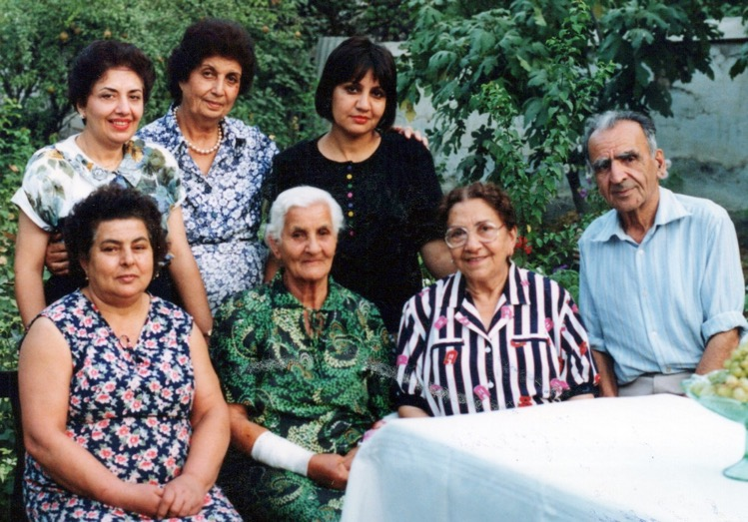
Photo of Mr. Nadji (on the right) and Ashghabat Baha’is
Front row l. to r. 1) Mrs. Malakeh Nadji, 2) mother of Mrs. Nadji? 3) Mrs. Ghodsi, visitor, 4) Mr. Ali Akbar Nadji
Standing l. to r.: 5) daughter of Mrs. Ghodsi?, 6) Shamsi, 7)?
Teaching Trip to Azerbaijan, March 1994
During the spring of 1994, I undertook a travel teaching trip to Azerbaijan. The following is a report of my trip to the Universal House of Justice, Supreme Body of the Baha’i Faith. The letter is as follows:
“The Universal House of Justice
P.O. Box
Haifa, Israel
August 13, 1994
Most August Body,
Humbly I would like to submit the delayed report of my trip to Azerbaijan which took place on March 19 – April 2, 1994.
I visited Azerbaijan on the invitation of friends from Baku, approval of our Regional Assembly and the encouragement of Counsellor Afshin.
During my two-week visit, aided by the Concourse on High, and assisted by the friends in that region, we were able to form the first local spiritual assembly of Sumgait and later, the first local spiritual assembly of the Baha’is of Nakhjavan.
At the Naw Ruz celebrations in Baku, attended by over 150 Baha’is and their friends, including television crews, I spoke about the Baha’i principles of love and unity which was well received by the audience. At this gathering five ready souls enrolled. While in Baku, I met with the local spiritual assembly and with their guidance and the assistance of Messrs. Vahid Khazeh and Agha Najaf and others, we went to Sumgait. There we met with the friends and on our second visit, we were able to form the first spiritual assembly of Sumgait and find new ready souls.
Entry to the town of Nakhjavan needed a special permit from the Nakhjavan authorized in Baku, which was obtained after a few visits to that department and making the acquaintance of its most courteous director.
Upon arrival in Nakhajavan, I was met by our dedicated pioneer Mrs. Farangis Razi Floriano and later with her assistance, I met some prominent local residents, such as Mrs. Sibil, the Deputy Chief Minister of Nakhjavan, and a lady chief doctor of the town and a few others with whom we had dinner later. Mrs. Sibil arranged for me to visit a government maternity hospital and for a TV crew to cover my visit. Accompanied with Mrs. Razi I was given a tour of the hospital, where I met with its Director, doctors, midwives, nurses, and other staff…This visit was taped by the TV crew and later aired on Nakhjavan television and a copy of that video was presented to me as a souvenir.
As stated above, the highlights of this trip were the formation of the local spiritual assemblies of Sumgait and Nakhjavan.
As a result of a few firesides and dinner gatherings arranged through the hard work and dedication of our pioneer family, Mrs. Farangiz, and the few newly enrolled native Baha’is, we were able to find seven more new souls, raising the number of believers to 13 and elect the first local spiritual assembly of Nakhjavan. Amongst the declarees were Mr. Ali Akbar, director of a new puppet theater of Nakhjavan, and his wife, Mrs. Aghideh Khanum. Also, there was an accomplished teacher/musician and her teacher husband, who are both well-known personalities in Nakhjavan and a few young businessmen and their wives.
…The peaceful nature of the Baha’i message and the love emanating from the young community has provided hope for the resolution of the age-long conflicts and the creation of a unified community in this region.
The friends in Nakhjavan are very enthusiastic. Mr. Ali Akbar, soon after his declaration, attended a week-long conference in Kazakhstan, sponsored by the Counsellors, which greatly deepened and consolidated his faith.
The friends in Azerbaijan, despite their hard work and dedication, need further assistance and guidance which we hope will be extended to them by our beloved Counsellors.
Finally, I would like to inform the August Body that in order to take care of some of my personal affairs and acquire my American citizenship, I have been in the United States for the past two months and believe that this stay may be extended for another month or so in order to finalize my citizenship. During my stay in the United States, I attended many meetings in various states, including California and Illinois, where I encouraged the friends to take part in teaching projects and pioneering in the Central Asian republics….”
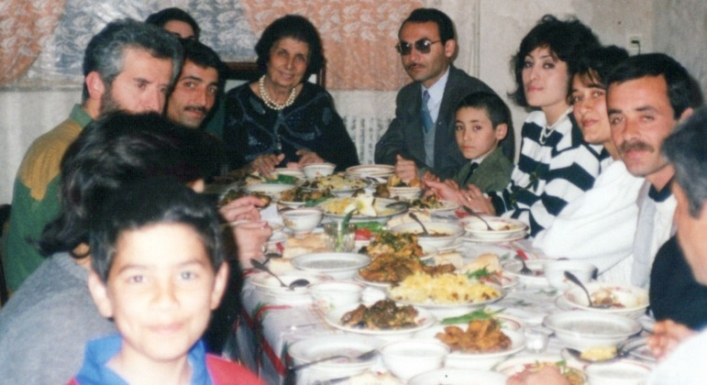
Shamsi giving a fireside in a home in Azerbaijan. She is sitting in the middle to the right of the man with the dark glasses, Mr. (?) and Shamsi is to his right with several of the Baha’is of Azerbaijan
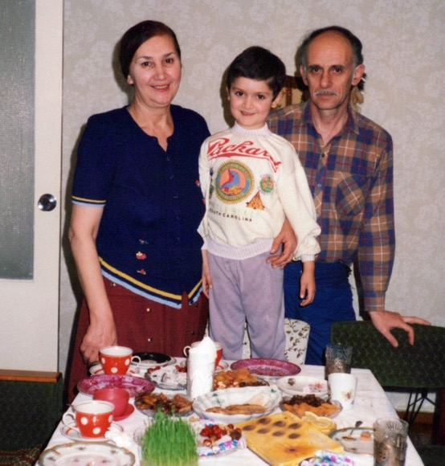
Mother of Dr. Lailae Foroutan (wife of my nephew, Dr. Navid Foroutan), her grandchild, and her husband in Baku, Azerbaijan
I received the following reply from the Universal House of Justice:

“Miss Shamsi Sedaghat
Nakhimova #6, Apt. 16
Ashgabat
Turkmenistan

Dear Baha’i Friend,
The Universal House of Justice received, on 26 October 1994, your letter dated 13 August 1994, and was delighted by the news you conveyed of your visit to Azerbaijan from 19 March to 2 April 1994. Your visits to the friends and the encouragement you gave them, the election of the Local Spiritual Assemblies of Sumgait and Nakhjavan, the televising of part of the visit to Nakhjavan—all of these are sources of great joy to the House of Justice….
Be assured that the House of Justice will offer loving prayers in the Holy Shrines on your behalf.
With loving Baha’i Greetings,
Janet Smith
For the Department of the Secretariat.”

Declaration of Rustam Altyev
Rustam Altyev, a young twenty-two-year-old man of Turkmen background read about the Faith in an article published by the local newspaper in Ashgabat and became very interested in its principles. He immediately contacted the newspaper and asked how he could meet Baha’is. The editor replied that the reporter who had written the article was away and that the only way he could find the Baha’is was to contact the Religious Department in the government and request the address of the Baha’is.
Rustam phoned the Department and asked about the Baha’is. The Department was surprised that a young Turkmen wanted to know about the Baha’i Faith and asked many questions such as why he wanted to contact the Baha’is, and he answered all of their questions. The Department was very impressed by this young man, and the department head—who knew me personally—gave him my telephone number for him to call me.
When he phoned me, I was out. But he managed to find another Baha’i to meet and hear more about the Faith.
The next day, he came to my fireside and, by the end of the meeting, he enrolled. He was twenty-two when he was elected to the Spiritual Assembly of Ashgabat as its Secretary and then to the National Spiritual Assembly of Turkmenistan as its Treasurer. He served the Faith in Ashgabat and other towns and later emigrated to the United States where he remained an active Baha’i.
He visited me when I lived in Maryland with Mr. Vahid Khazeh from Baku, Azerbaijan, who was a very active member of the first National Spiritual Assembly of the Soviet Union. He was also a member of the Spiritual Assembly of Baku when he lived there.
Later he left Baku for Boston, in the United States, where he served the Faith to the best of his ability until a few months ago when he ascended to the Abha Kingdom. May Baha’u’llah accept all his admirable services.

National Spiritual Assembly of Turkmenistan, Ridvan, 1994
In Ridvan, 1994, the National Spiritual Assembly of Turkmenistan was elected. Its members were Mr. Rustam Altyyev, Mr. Durdy Amansaryyev, Mr. Ataollah Bakhshandagi, Ms. Irina Begjanova, Mr. Habib Gafurov, Mr. Kamal Guseynov, Ms. Sara Kazimova, Mr. Naim Nadji-Alikperov, and Ms. Shamsi Sedaghat.
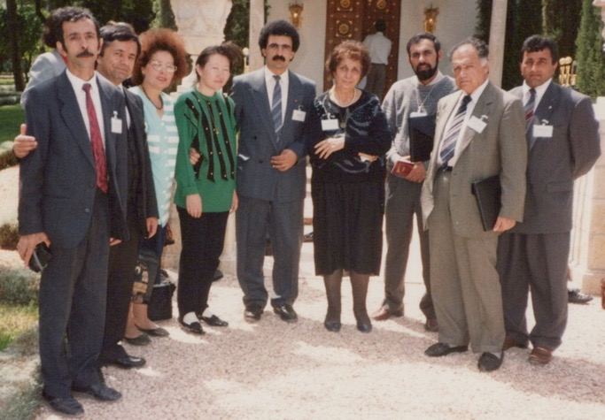
Regional Assembly of Central Asia at the International Convention
L. to r.: 1) Mr. Kamal Guseynov, 2) Mr. Nosratullah Monjazeb,
3) Khanum Ghaffari, 4) Ms. Akbermet, 5) Mr. Naim Nadji, 6) Shamsi, 7) Mr. Zia Miyadiyev, 8) Mr. Hassan Pishrow, 9) Mr. Habib Ghafurov

Travel Teaching in Central Asia, written by Dr. Ezzatullah Safapour
During my years in Turkmenistan, I made extensive travel teaching trips to the Republics of Central Asia. In this letter, Mr. Ezzatullah Safapour, who himself was a great light a generous personality and astonishing star of those regions, remembers this:
“Dedicated, devoted, lifetime teacher of the Baha’i Faith, Shamsi Khanum Sedaghat.
Dear Shamsi Khanum, I have been thinking of you for a long time and your outstanding service to the Cause of Baha’u’llah. Now, I have an opportunity to share some thoughts and my experience with you during my teaching in Central Asia, especially Kyrgyzstan.
You have been instrumental in establishing of four National Spiritual Assemblies and one Central Asian (Regional) Baha’i Assembly around the world as well as many Local Spiritual Assemblies were formed due to your efforts. Your teaching efforts have been so great and impressive that it is difficult to even describe.
My direct experience with you started 1991 in Moscow at the National Convention of the Soviet Union. Afterward, when I was teaching in Central Asia and was facing many hurdles, you were extremely helpful to me. The member of our beloved Universal House of Justice, Mr. Hushmand Fatheazam, The Knight of Baha’u’llah Mr. Abbas Katirai, were divine angels that came to my rescue and provided guidance on many occasions.
As you know prior to 1991, Kyrgyzstan was not open to the Baha’i Faith. There was no single Baha’i in the country. With your guidance, Thanks to Baha’u’llah, Kyrgyzstan was opened, and we had a Local Spiritual Assemblies for the first time in Bishkek and Osh, and later several Local Spiritual Assemblies in different cities in Kyrgyzstan.
As a result, a National Spiritual Assembly was formed in 1993 and in 1994 the Baha’i Faith was officially recognized by the government of Kyrgyzstan as an independent worldwide religion.
This accomplishment would not have happened without the blessing of Baha’u’llah, you, Mr. Katirai, and Mr. Fatheazam.
My dear wife Shahin Safapour recalls the wonderful time she had with you in Ashgabat witnessing your teaching activities and love and affection toward the Baha’is and Non-Baha’is.
I remember hearing many times from the Hand of the Cause of God Mr. Furutan and the member of the Universal House of Justice, Mr. Hushmand Fatheazam, that you are an outstanding teacher of the Baha’i Faith.
My wife Shahine and I are very proud to know you, to be associated with you and especially to have worked with you on various teaching projects.
Sincerely yours, Ezzatullah Safapour”

My letter to Mr. and Mrs. E. Safapour
I wrote him my appreciation for his kind words:
“To Dear Ezzatollah and Shahine Khanum Safapour,
My dearest Baha’i co-workers and precious believers in Baha’u’llah. Now permit me to thank-you sincerely for all your unforgettable, unbelievable, and admirable services to our beloved Faith in Central Asia, especially in the Republic of Kyrgyzstan between 1991-1993.
I witnessed there during my 1991 short teaching trip how much time, energy, money etc.…was needed to be able to start and complete a Baha’i project or a teaching plan or to buy a house to be used as a Baha’i Center or rent a hotel or a salon in which to hold a conference, summer school or other necessary activities.
But with all these obstacles and expenses, you were successful with the assistance of a few other able Baha’is to overcome all these shortcomings and provide the energy and financial assistance and start and build a new active community and when I arrived there we had a few strong and capable individuals which we started visiting some government officials had many news media interviews some public meetings and made the Faith more known and had some declarations.
I also remember my visit to Kalamazoo as a house guest of your family as a travelling teacher. Your firesides for newcomers who were there (to know more about the Baha’i Faith), your love and hospitality which was above normal and was showered to everyone present, your informal but satisfying discussions which was according to the knowledge of all who were present and many other bounties which I shall never forget.
May Baha’u’llah bless you both Mr. Ezzatollah and Shahine Khanum for all your services to our beloved Faith and keep you healthy and safe to continue as long as you can.
With appreciation,
Shamsi Sedaghat”
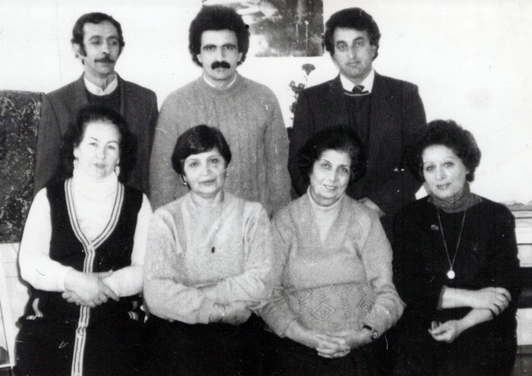
Baha’is of Central Asia
Seated l. to r.: 1) Valedeh Khanum (Uzbekistan), 2) Jahan Ara Khanum (Tajikstan), 3) Shamsi (Turkmenistan), 4) Khanum Ghaffari (Tajikstan)
Standing l. to r.: 1) Mr. Kemal Gusinov (Turkmenistan), 2) Mr. Naim Nadji(Turkmenistan), 3) Mr. Habib Ghafurov (Turkmenistan)
National Spiritual Assembly of the Baha’is of Uzbekistan
In my travel teaching efforts, I was able to assist with the formation of the first Spiritual Assembly of Tashkent. Later we formed the National Spiritual Assembly of Uzbekistan also. Mr. Subhonqul Mavloni, Auxiliary Board Member for this region, strong and active Baha’i, remembered this:
Letter of Auxiliary Board Member Mr. Subhonqul Mavloni
“To the dearly loved Shamsi Khanum Sedaghat!
“Dear Shamsi Khanum,
It is with a great joy and honor I am writing about your dedicated service and wonderful experience that I had with you during our travel teachings.
For the first time I met with Mrs. Shamsi Sedaghat in 1992 in the city of Dushanbe, Tajikistan. For me, a Bahá'í with a two-year experience, she made an indelible impression. Her wide outlook on many issues, not only religious, like a

magnet attracted me. On her initiative, a program on the Baha’i religion was organized on the first state program, on the main aspects of the teachings of Bahá'u'lláh. For that troubled period, it was a heroic deed.
Learning that there are a large number of Baha’is in the city of Tashkent, Shamsi Sedaghat asked me to urgently buy an air ticket to Tashkent. The next day in the early morning we were in the city of Tashkent.
In the evening, gathering the local Bahá'ís, we, with the blessing of Baha'u'llah, helped me to form the Local Spiritual Assembly. Subsequently, the core of this spiritual meeting was the National Spiritual Assembly of the Bahá'ís of Uzbekistan.
In 2011, while on a business trip in the city of Ashgabat, my friend and I visited Shamsi Sedaghat in her apartment. In addition to the warm words of greeting, Shamsi khanum, organized a presentation of the Bahá'í religion. Then there was a treat with a very tasty Iranian pilaf, prepared by Ms. Shamsi Sedaghat herself.
I am grateful to fate and remember those days when I was awarded a meeting with her.
With loving Baha’i regards,
Subhonqul Mavloni.”

I would like to mention Mr. Nosratollah Monjazeb. He lives in Uzbekistan with his family. He is the son of a very well-known Baha’i, Mr. Agha Sadeq, and he is a member of the Assembly. Any Baha’i who was a travel-teacher or visiting, he’d invite to their home and help them as much as he could for their activities. When I arrived in Uzbekistan, he invited me to his home, and he arranged many of my activities, meetings, and visits to dignitaries.

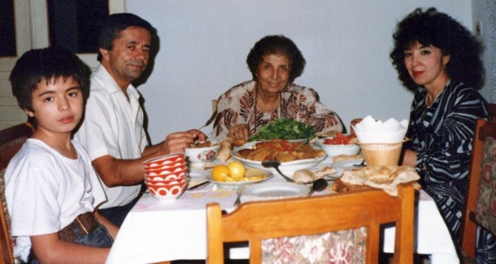
From r. to l.: 1) Mrs. Monjazeb, 2) Shamsi, 3) Mr. Monjazeb, and 4) his child.

Appointment as a representative of Huququ’llah
In 1995, I received an appointment letter to serve as a representative of the Huququ’llah for Turkmenistan:

“THE INSTITUTION OF HUQUQU’LLAH
OFFICE OF THE DEPUTY
Mrs. Shamsi Sedaghat
Nakhimova #6 Apt 16
Ashkabad, Turkmenistan
1 June 1995
Dear Baha’i Friend,
As you know, your greatest responsibility is to educate and deepen the friends on the Huququ’llah. Just as the friends know about the importance of prayer and fasting, they should know about the importance and bounties of the Huququ’llah. The friends should also know that no one will ever ask them why they haven’t paid their Huququ’llah. They should know that no one will ever ask why they gave so little, or so much. The friends must be assured that the payment of Huququ’llah is strictly confidential. Payments of the Huququ’llah must not be discussed with anyone at all. No one in the community must know if someone has or has not paid the Huququ’llah or how much they have paid….
Katirai CPO BOX 381 Osaka, Japan”

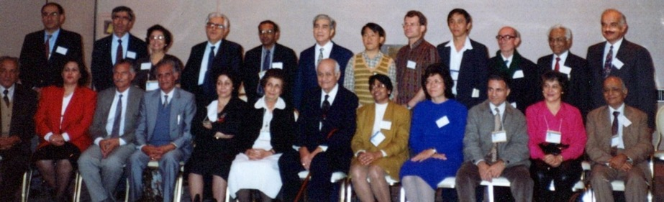
Meeting about Huquq’u’llah in Haifa. Hand of Cause Mr. Varqa, Chief Trustee of the Huquq’u’llah, in the middle, front row;
Shamsi in a white dress seated to his right. The rest are representatives of Huquq’u’llah from around the Baha’is world.
Passing of our mother
My 92-year-old mother was hospitalized due to dementia. In April 1998, I was in Haifa, Israel for the election of the Universal House of Justice.
I returned to Alexandria to be a help to my youngest sister Mrs. Guitty Ejtemai and her husband Mr. Hossein Agha. We decided to bring her to Guitty and Hossein’s home for the last earthly days of her life, so we ourselves could look after her.
We arranged all the necessary nursing and medical care until the minute her pure soul left us peacefully to the Abha Kingdom. May Baha’u’llah bless her pure soul.

My letter to the Universal House of Justice about my mother
“The Universal House of Justice
Haifa, Israel
Most August Body,
Your prayers and loving words of sympathy on the occasion of the passing away of our dear mother, Leqaiyyih Sedaghat, was a source of great consolation and gratitude to all the members of our family. We are deeply touched by the bounty you bestowed upon us, her children, by making mention of our meagre contributions to our Beloved Cause. We implore your further prayers for the continuation of our humble services.
As the Most August Body is aware, I have been in Maryland, USA, since my return from Haifa on May 4th, 1998. I came here primarily to help my sisters who were taking care of my ailing mother. During this period, I was constantly in touch with Turkmenistan and in consultation with the secretary of our NSA, Ms. Irina Begjanova via email in Turkmenistan…
…I would like to request your guidance about the time of my return to Turkmenistan. I can remain in the United States until the end of September, the expiration date of my return visa to Turkmenistan, during which time I could travel teach. I have been invited by Dr. and Mrs. E. Safapour to go to Michigan for a ten-day travel teaching trip. Also, the friends in Bermuda have asked me to visit that island to participate in their teaching plans for the 50th anniversary of the Baha’i Faith in that island…
I humbly implore your guidance on this matter. As always, I am obedient to the wishes of that Most August Body.
With Deepest Love and respect,
Shamsi Sedaghat”
Letter of my sister Guitty Ejtemai about my mother
This is the description of our mother’s life written by my sister Mrs. Guitty Ejtemai:
“During her eighteen years stay in Iran, my mother served the Faith diligently, focusing attention foremost on the education of her children. She showed love and hospitality to everyone, especially her non-Baha’i family, who were beginning to see the Baha’i Faith in a different light.
In 1955, with the approval of our Beloved Guardian, Shoghi Effendi, my parents and three of their children, including this servant, left Iran for the Island of Cyprus to join Shamsi Khanum in her first pioneering post. Upon our arrival in Cyprus, the Beloved Guardian, in a short telegram, assured us of prayers and success in our pioneering post.
My parents stayed in that troubled island for 9 years during which time they served the Cause of God with selflessness and humility, especially in the Turkish community, whose language they spoke fluently. They had the honor of being elected to the first local Spiritual Assembly of the Baha’is of Nicosia North, Cyprus.
Unfortunately, in 1964, after consultation with the NSA of Great Britain, my parents and Shamsi Khanum, like other pioneer families, left the island of Cyprus due to internal strife. At that time, I was studying in France.
Soon after their return to Iran, my father, Ali Sedaghat, passed away and my mother remained in Iran with her daughters until she emigrated to the United States in 1976. Except for a short stay in Trinidad and Tobago while Shamsi Khanum was pioneering there, my mother spent the rest of her life in the United States mainly with my eldest sister, Qamar Khanum, and her husband Mr. Rostam Aghdassi, a fervent teacher of the Faith, whose selfless dedication to the welfare of my mother, especially during the latter years of her life, have earned them a special place in our hearts. My mother’s unfailing kindness stemming from her deep love for Baha’u’llah, positively influenced the growing number of her non-Baha’i family members, as evidenced by their touching remarks during her funeral yesterday. We are most blessed to have had her as our mother.
To remember our mother, Leghaiyih Sedaghat befittingly, a memorial service has been planned for Sunday, July 1st, 1998 at 11 am which we hope will develop into a big proclamation event. My husband, Hossein Ejtemai, and I, have lived in the Washington DC area for the past 24 years and, as a result, have numerous friends in the business and professional circles of the non-Bahai Persian and American communities, many of whom will be attending, including the new chief of VOA Farsi Service, Mr. Ali Jalali, an Afghan-American, who has so far shown great confidence in me as one of the editors of the Farsi Service, and who I hope will retain his fair and non-biased attitude towards the Faith.
Humbly beseech your prayers for the success of this event, which the family hopes will fulfill the wishes of both of my parents, Leghaiyih and Ali Sedaghat, whose foremost goal in life was to serve and teach our beloved Faith.
With loving Baha’i Greetings,
Respectfully
Guitty Sedaghat Ejtemai”
Letter to Mr. Omar Ertur - 1999
Mr. Omar Ertur, the UN Resident Coordinator in Turkmenistan was very helpful in protecting the Baha’is in Turkmenistan so on the occasion of his departure, I wrote him the following letter of appreciation:
“January 15th, 1999
From: Shamsi Sedaghat, Ashgabat, Turkmenistan, Nakhimova 6, Apt. 16.
To: Mr. Omer Ertur, UN Resident Coordinator in Turkmenistan
Dearest Mr. Ertur,
It has been a great honor and pleasure for me to know you and receive your loving support and guidance in all our official and personal problems, during the past 3 years in Ashgabat.
Your humble attitude, your deep composure, and spiritual qualities, according to our Faith “Can be the cause of the spiritual illumination of a continent”.
I wish you and your dear family a Happy and Prosperous 1999 and hope one day somewhere in the world we meet again.
With deep respect and sincere love,
Shamsi”
Request to have a teaching trip to Cyprus, 1999
In 1999, I wrote to the Universal House of Justice regarding a possible teaching trip to Cyprus and asked permission to go there:
“The Universal House of Justice
P.O. Box 155
Haifa, Israel
July 19, 1999
The Most August Body,
Please accept my deepest love and highest respect from Ashgabat….
Presently I am engaged in the following: a) keep close touch with the old steadfast Baha’is, and, b) enlarge my English classes and make some new friends in the higher levels of society (of course all tuition is free as a service to my birth place).…I received a heart-warming phone call from our Beloved Mr. Fatheazam who suggested to make a teaching trip to Cyprus.
Apparently, this request has been made by the friends from Cyprus and the same message was conveyed to me by my sister Soraya and her husband Khosrow Foroutan while they were in Haifa this year. I was delighted to hear about this proposed trip as it was my desire to visit that island last year after the Eighth International Baha’i Convention by the invitation of Mrs. Anita Graves and the other members of their NSA. Now, that the conditions in Ashgabat are as I mentioned, I would like to receive your divine guidance should I leave Ashgabat for several months and visit Cyprus and Republic of Czech (by invitation of Mr. Khosrow and Mrs. Soraya Furutan) and return by the end of the year? If permission is granted, I would like to request your approval for a three-day pilgrimage after the completion of my trip to Cyprus. I eagerly wait for your earliest infallible guidance and implore your prayers for the completion of my humble services.
With sincere love and gratitude,
Shamsi Sedaghat”
Welcome letter from the National Spiritual Assembly of Cyprus
The National Spiritual Assembly of Cyprus encouraged me in my teaching efforts on the island. The letter is as follows:
“Ms. Shamsi Sedaghat
24 October 1999
Dear Baha’i Friend, Shamsi,
The National Spiritual Assembly of Cyprus sends its warmest greetings and loving thanks to you for your short-term pioneering services to north Cyprus and for the opportunity to receive from you the memories and remembrances of your life in Cyprus many years ago. Your presence with us is invaluable, and we are grateful, indeed, for your years of experience which form the foundation of your excellent teaching and consolidation work. We know the Universal House of Justice has asked you to come to Cyprus and we are certainly grateful for this gift to our community. Shamsi, the National Spiritual Assembly that is responsible for the teaching and consolidation work in the northern part of the Island, and they surely will have plans and guidance for you. We hope you will remain with us here in Cyprus as long as you can, and that you will always feel free to contact the National Assembly or the Executive Committee for north Cyprus to offer your suggestions or advice intended to guide and help the growth of the Cause of God in north Cyprus. We also hope you will assist us in recruiting pioneers and travel teachers to both sides of the Island, and to this end, we attach a copy of our Cyprus Profile, written especially for south Cyprus, and some miscellaneous materials of interest to pioneers. We shall pray for you and beseech the Blessed Beauty to shower you with His love and His confirmations in your devoted services.
With our Baha’i love and greetings,
National Spiritual Assembly of Cyprus
Anita Graves, Secretary”
I undertook a return visit and teaching trip to the island of Cyprus where my family and I had pioneered for nine years.
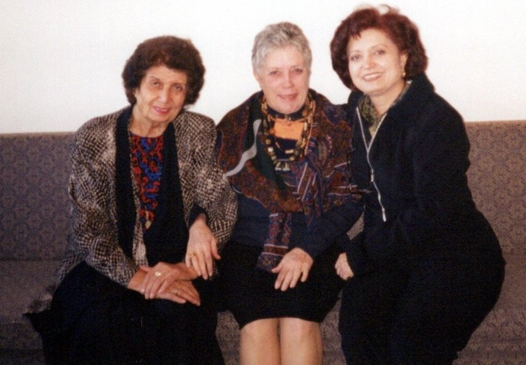
L. to r.: 1) Shamsi, 2) Ms. Anita Graves, in charge of Baha’i news archives in Cyprus if I am correct, 3) Mrs. Guitty Ejtemai, my sister
I left America for Cyprus – September 1999
In the morning of September 3rd, 1999, many members of my family and friends such as Mr. Hussein Ejtemai and my sister, Mrs. Guitty Ejtemai, Mehri Khanum Ejtemai and her mother, Hosniyeh Khanum, Mr. Omid Furutan, and Ms. Ira Begjanova from Ashgabat, came to see me off as I was leaving for the island of Cyprus for a three-month teaching trip under the guidance of the Supreme Body, the Universal House of Justice. My brother Farhad Sedaghat took me to the airport at 3:45 p.m. They brought a wheelchair for me. I sat on it then we took my luggage and without any problem with the help of the people who were serving us at the counter, passed me through customs. My friends and family left, and I sat on my wheelchair until we left for Istanbul at 6 p.m. We boarded the plane and reached Istanbul by 3 a.m. on September 4th.
Arrival in Istanbul
A wheelchair was brought for me and with the help of people who were working there, brought me to the transit lounge, checked my ticket and passport through Cyprus immigration department and then I sat and spoke with several travelers. Then a person from the airline came to me and gave me a card with which I could pick up a free dinner and fruits which we did and enjoyed eating them. We had to wait until 10:20 that night to board the plane for Cyprus.
I sat next to Mr. Yilmaz Chanitez, a very kind man whom I met in New York. When he heard that I lived in Cyprus from 1955-1964, worked in government hospitals in Nicosia and Famagusta, he suggested that I go to the Greek side to get my passport stamped because if I had this done on the Turkish side, I would not be allowed to go to the Greek side. I should ask Immigration Department to issue me a visa on a separate piece of paper and not to stamp my passport, then I could easily go for a few days visit to the other side. I agreed with this good advice.
My second arrival in Cyprus
When we landed, they helped with my luggage. Mr. Mustafa Salman, a very nice, strong, and active Baha’i, and a member of the NSA of Cyprus and our other good friends from those days were waiting to greet me outside. He helped me load my luggage into his car and brought me to the Baha’i Center in Nicosia. It was 2 a.m., September 5th, 1999. He showed me the room where I would be sleeping and left. I was awake until 4 a.m., so I arranged my luggage and then slept until 7 a.m.
Met the members of the National Spiritual Assembly of Cyprus
In the morning, I got up, said my prayers, and ate breakfast. Then eight Baha’is arrived for the meeting of the National Spiritual Assembly of Cyprus. They met me and welcomed me warmly. I spoke about my intended activities. They proposed their suggestions, and we started to work. First, we started teaching in Famagusta.
We did village teaching in the Famagusta District and met many contacts and friends of the local Baha’is. We held several firesides with distinguished people whom I met through Mr. Mesut Merter and his wife Susan Khanum, a very knowledgeable Baha’i, as well as one on one conversations with prominent people (lawyers, doctors, etc..) at the coffee shop owned by a local believer. We had the chance to meet with hospital personnel, including the medical director of Famagusta hospital, the matron and assistant matron in the nursing service, and look up former Baha’is in the area, and their children (who have since grown up). We deepened youth, met with several of the local believers, including all members of the local spiritual assembly, and participated in the Nineteen Day Feasts. We witnessed four declarations. There was a need for a Baha’i Center. Therefore, we started to search for an appropriate Haziratu’l-Quds because the friends had no suitable place to meet. My sister and brother-in-law, Mr. and Mrs. Hussein and Guitty Ejtemai offered to donate funds for the purchase of a Baha’i Center in the name of the Sedaghat family. Their offer was warmly accepted and very soon a nice place was found and purchased and now a welcoming Baha’i Center stands there.
I was a guest at the home of Mr. and Mrs. Nalbandoglu in Kyrenia
In Kyrenia, I spent substantial time with the Nalbandoglu family, once for one week, and many other times for a few days each. I attended the open house of the Nalbandoglu family as a guest and became acquainted with the other guests who were local people, including the Baha’is from the area. On the first occasion of my consolidation work, we searched together for the believers whose names were on the membership list, and invited various people, especially the members of the local spiritual assembly and others, who came together in a group of fifteen to the Nineteen-Day Feast and a simultaneous meeting of the local assembly of Kyrenia. We participated in the creation of the firesides, getting acquainted individually with local believers at their work places and in their homes. Women’s gatherings were organized for women believers in the area, along with other deepening activities. We were successful in locating believers who had been lost to our contact. A Holy Day was celebrated at the home of other local believers.
In Lapta, visited family of Sevcan and Niyazi Cetin
In Lapta, I attended women’s gatherings, children’s classes, and firesides, and spent a lot of time in the home of Sevcan and Niyazi Cetin teaching the brother and sister-in-law of Sevcan, who were very close to declaring. In the company of Counsellor Dr. Ilhan Sezgin and Mr. Mustafa Salman, I visited the owners of the Marmaris and Manolya hotels, where they held deepenings with these Baha’is.
In Alsancak, I attended a women’s meeting at the home of Senay and Husamettin Tekcam, had a teaching experience of some significance with Mr. Tekcam following the meeting (he is not a Baha’i).

Met Mr. Ali Atun, former Minister of Health, and others
In Nicosia, I attended all the meetings and Nineteen Day Feasts, gave some talks to the friends, created firesides in my home (I rented a local apartment), entertained Baha’is and non-Baha’is, including an extended family, resulting in one declaration. The friends have arranged a one-day deepening with me. Met many prominent persons, met with local man who was a Baha’i there thirty-five years ago and then dropped out of sight. Now he seems hopeful to be revived, met friends whom I had known when I lived here. I met with Mr. Ali Atun, former director of Famagusta hospital, and former Minister of Health. I phoned him, introduced myself, and with a Baha’i friend, we visited him in his home and renewed our friendship then invited him to the Baha’i Center. He came to the Baha’i Center for nearly four hours. It resulted in a fireside with me and several members of the local and national Baha’i assemblies and presented literature on the Faith. It created a very close contact with him.
Attended funeral of Dr. Niyazi Manyera
At a later date, I attended the funeral of Dr. Niyazi Manyera, the former Minister of Health (during the 1960s), at which time I met many former hospital colleagues, and I was asked to sign a memorial document there which I did.

Presentation of small Greatest Name rugs to the National Assembly of Cyprus
One day, Mrs. Ruhi Huddleston and I presented to the Baha’is of Cyprus two small handmade rugs of the Greatest Name, which were made by a Baha’i lady in Turkmenistan for which we received this letter of appreciation:
“Mrs. Rouhi Huddleston
Ms. Shamsi Sedaghat
16 November 1999
Dear Baha’i Friends, Rouhi and Shamsi,
The National Spiritual Assembly of Cyprus has been graciously and lovingly presented with two beautiful handmade wall carpets of the Greatest Name made especially for the Baha’is by a lady in the country of Turkmenistan.
One of these exquisite carpets will be mounted, one in each of our twin Haziratu’l-Quds of Cyprus and will be treasured by the believers of the Island for generations to come.
On behalf of all the Baha’is in Cyprus, we send our loving and sincere thanks to each of you for these special Greatest Name carpets. Whenever we see them, we shall be reminded of your sacrificial services as pioneers in Cyprus.
Be assured of our prayers on your behalf that the Blessed Beauty may shower on each of you His tender mercies and blessings as you continue your devoted services to His Cause.
With our Baha’i love and greetings,
National Spiritual Assembly of Cyprus
Anita Graves, Secretary”
Poem in Turkish
On November 11th, 1999, I received this wonderful poem in Turkish from a Baha’i in Pazar:
“Şemzi teyzeme saygilarimla
Mücessem öder
DOGUM GUNU
Bir işik gibi girdin evime
Söndüren olmasin
Umut doldun yüregime
Dagitan olmasin
Irmak gibi akip gidersin
Durduran olmasin
Seninle dogdom ben
Öldüren olmasin
***
Bütün dünyaya seslendin
Din, irk, mezhep ayni diye
Haykirdilar böyle şey nasil olur diye
Sana inananlar sana baglananlar
Duyurdular bu böyle diye
Bindiler seninle birlikte bu güzel gemiye
Elbet birgün herkes gelecek görmeye
Mücessem Öder, the poetess”
An invitation to attend the opening ceremony of the Famagusta Baha’i Center
I received a special invitation from the National Spiritual Assembly of Cyprus:
“Beloved Shamsi Khanum,
You are officially invited by the National Spiritual Assembly of Cyprus to attend the opening ceremony of the Baha’i Centre of Famagusta which you have been instrumental in providing this wonderful source of inspiration and love to our community.
Although our direct communication was through Mrs. Guitty Ejtemai, it was just because herself, you her dear elder sister and your dear parents are very well known to us, yet our appreciation always goes to the family as a whole and Mr. Hossein Ejtemai as a member of that family and as the donor of the center, he is very much appreciated for his noble contribution. The Cyprus Baha’i Community is very grateful for this gift. I delayed the reply for one day, for I just came back from our first Executive meeting at the Magusa Baha’i Center, and I wished to express the feelings of our friends to you. After chanting prayers of appreciation and thankfulness to Baha’u’llah for this wonderful gift, I was asked by the friends to convey to your dear family that everyone has been eager to thank you personally and share the joy together, therefore no one wished to send you just a card or a mail to express their happiness and appreciation, but waiting for you to come. We realize that the notice for the ceremony is not long enough yet the Local Assembly of the area which will be in charge of the local usage of the center is anxious to have the opening soon. The neighborhood is very curious and little bit worried not knowing anything about the new owners of the house where many different people are showing up all the time. The friends believe that the opening would be a very good opportunity to introduce our selves by inviting them soon.
We hope you will honor us with your presence, and if you cannot come for the opening, we will be very happy to host you in your convenience.
With Loving Baha’i Greetings,
NSA of Cyprus
Suha Vekil Fanaian”
I wrote this appreciative reply to the Cyprus NSA:
“The Secretary, National Spiritual Assembly of the Baha’is of Cyprus
Dear Mrs. Suha Vekil Fanaian:
It is with great honor that I acknowledge your official invitation to attend the opening ceremony of “Our Magusa” (Famagusta) Baha’i Center on October 1st, 2000. Why do I call it “Our Magusa”? because out of our family’s 9 years of challenging pioneering in Cyprus, 4 of them were spent in “Famagusta” (Magusa) where I worked in the Famagusta General Hospital and my parents, Ali and Leqaiyyih Sedaghat, were humbly serving the Cause by offering their love and hospitality to all with whom they came into contact.
My sister Soraya Sedaghat (now Soraya Furutan, who with her husband Khosrow Furutan are pioneering in the Republic of Czech) was also with us during 1956-59 in Nicosia, where she trained as a Midwife in “Nicosia General Hospital” and served on our incorporated Assembly during 1959. Soraya, after the completion of her training was not allowed to work, as she had temporary residency, therefore she left Cyprus for Iran. My brother Farhad, who was a student, also had to leave Cyprus, due to the same restrictions.
Fortunately, my youngest sister Guitty (now Guitty Ejtemai) studied at the “Nicosia French Convent” and stayed with us until 1963 when we all attended the first Baha’i World Congress in London. After the Congress she remained in London for a short period to study and then proceeded to France where she studied and obtained her Diploma of “Proficiency in French language”.
Due to the internal disturbances in 1964, we left Cyprus for Iran. A few months later Guitty jan joined us in Iran, but unfortunately, she did not meet our dear father, as during our flight from Cyprus to Beirut and then to Tehran, he experienced a mild stroke on the airplane and soon after our arrival in Tehran his noble soul passed away. (We are thankful to Dr. Ezzatullah Rassekh who was a heart specialist who attended to him with utmost love and care and free of charge.)
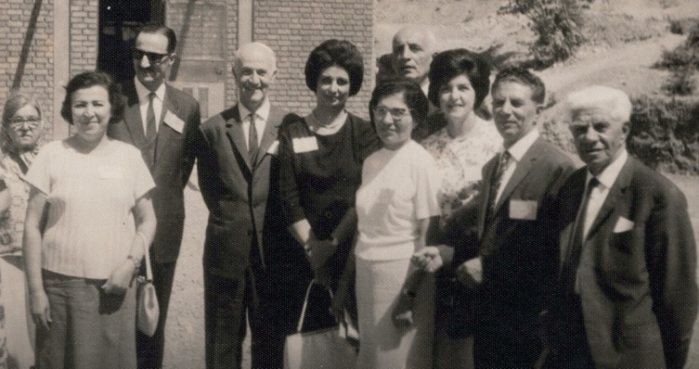
L. to r.: 1)?, 2) Mrs. Mavaddat, 3) Dr. Ezatollah Rassekh, my father’s doctor, 4) ?, 5) Shamsi, 6) Ms. Muluk Khadem, behind her is 7) Mr. Anvar,
8, 9,10) I forgot their names; they are well and very active Baha’is.
Guitty remained in Tehran with my mother and was employed in Government departments and gradually rose to responsible positions.
Guitty Khanum is married to Mr. Abdu’l-Hossein Ejtemai, who is a very devoted, generous, and active Baha’i. It is through their generous contribution on behalf of our family that the Baha’i Center in Magusa was purchased. For the past 26 years they have lived in Washington DC area in USA, where Guitty worked as an editor for the Voice of America Farsi Service and Mr. Ejtemai as an independent entrepreneur. Meanwhile, both are actively involved in many Baha’i projects which are too numerous to mention.
It was in this historic town, i.e. Magusa, that we hosted our great visitors during 1962. They were the Beloved Hands of the Cause of God, Mr. Ali Akbar Furutan and Mr. Taraz’ullah Samandari, who were accompanied by Mr. Ali Nakhjavani, former member of the Universal House of Justice.
Magusa was blessed by their visits and visits of many other devoted Baha’is who supported and encouraged us during our many tests and trials.
Also, it was in this town that we met our two precious friends, Mr. Mustafa Salman, and Mr. Erol Olkar, who were searching for the truth and finally found it years after our departure from Cyprus. My love and respect to both of them.
Now after 36 years of our departure from that historic island, “The Island of Satan,” as the Beloved Guardian, Shoghi Effendi, repeatedly called it, we notice that through the steadfastness and endurance of all pioneers at that period, including the Knights of Baha’u’llah Mr. and Mrs. Abbas Vakil and Mr. Violet and Hugh McKinley due to the sacrificial labors of your past and present pioneers, and above all, because of the hard work, dedication, and devotion of your energetic Cypriot and Turkish Baha’is, who under the guidance of our Supreme Body and assistance of the beloved Counselors, performing their services, this island of “Satan (Shetan) is turning to the Island of the Clement” according to the wishes of the Beloved Guardian.
During my pilgrimage in 1955, prior to my pioneering to Cyprus, he asked me, “Did you know that the Island of Cyprus was called “Sheytan Jazirasi”? (The Island of Satan). I replied “Baleh Qorban” (Yes Beloved). Then he said, “Now the Baha’is should change it to “Jazirat’ul Rahman,” (The Island of the Clement One).” I replied “Ensha’u’llah” (God willing). Paraphrased by me.
No doubt that you, the valiant Angels of the Cause of Baha’u’llah, during the long years of service, with many tests and tribulations have been able to change the Island of “Sheytan” to the Island of “Rahman”. WELL DONE!
Concerning your kind invitation to me to attend this Historic Occasion unfortunately due to the special rules and regulations here, we cannot obtain an exit visa in a short time, therefore, please accept my apologies and deep regrets for missing this honor and privilege….
Also please accept my love and sincere congratulations for your new Baha’i Center and convey my respects and greetings to all participants at this auspicious occasion, especially to the friends in Magusa including the dear Aksoy family who personally phoned me in Ashghabat and once again confirmed your cordial invitation and personally invited me to join you all in this joyous event. My love and respect to the representatives of our Supreme Body and the beloved Counselors if they are present, and to each member of your noble Assembly.
MAY BAHA’U’LLAH BLESS ALL YOUR FUTURE ENDEAVORS IN HIS PATH.

With fondest love and respect,

Shamsi Sedaghat”
The National Assembly of Cyprus sent an announcement for the opening of the new Baha’i Center in Famagusta for which Mr. Hossein and Guitty Ejtemai had donated the funds on behalf of our family:
“OPENING OF THE NEW BAHA’I CENTRE IN FAMAGUSTA (MAGUSA)
October 1st, 2000
Beloved Friends,
In our deep gratitude we offer up prayers and supplication to the Almighty God and ask that the new Famagusta (Magusa) Baha’i Centre “…will act as a powerful magnet and attract the manifold blessings of the Almighty and lend a tremendous impetus to the organized activities of the believers…”
On October 1st, 2000, friends from all over the island have gathered to rejoice and celebrate the new center. Auxiliary Board Member for South Cyprus, who travelled a long way to be with us, the friends of the Faith, neighbors and municipal officials were among the total eighty people who gathered at this joyful occasion.
The hearts were gladdened and touched deeply by the loving message of the Beloved House of Justice, the prayers that have been offered by Them because the cornerstone of the future victories of the Faith, which have already been laid in this Centre. The very first flower blossomed by this newly planted prayers at the Holy Souls when one of the participants who was investigating the Faith seriously, decided to declare her belief in Baha’u’llah that day and signed her card.
Messages from Beloved Counsellors were read by their Auxiliary Members, messages from the NSAs were expressed and all the happiness, love and well wishes were shared with attendances. Ms. Shamsi Sedaghat and her sister Ms. Guitty Ejtemai – whom were dedicated pioneers of Famagusta, with their parents and other family members, couldn’t be with us on this day but the messages they and Guitty and her husband Hossein Ejtemai were true reflection of their love and devotion.
During the memorable meeting, the soul of the first Baha’is who arrived to the island, the first pioneers, the souls of the Beloved Hands of the Cause of God and the dear friends who served on the island were remembered. They were called upon and got invited to join us, to “dance around with joy and happiness”, to assist us with the powers of the Kingdom of Abha.
Another highlight of the Ceremony was Ms. Semira Vekil, one of the Knights of Baha’u’llah for the Island, who was able to respond to the invitation and attend the opening. She expressed her love and longing that she always has in her heart towards Cyprus and the Cypriots. She also joined everyone else in appreciation to the people who made this purchase possible and offered it as a gift to the Baha’is of Cyprus.
The prayer beads that belonged to Ms. Violet McKinley, one of the Knights of Baha’u’llah for Cyprus, were brought out from the NSA of Cyprus Archives. These prayer beads, which was originally belonged to ‘Abdu’l-Baha, added even more Divine Sunshine to the day were the friends had a chance receive further warmth.
All the participants enjoyed both spiritual and a physical Feast during the day. Prayers and gifts were offered to the new place as well.
“And now as I look into the future, I hope to see the friends at all times, in every land, and of every shade of thought and character, voluntarily and joyously rallying round their local and in particular their national centres of activity, upholding and promoting their interests with complete unanimity and contentment, with perfect understanding, genuine enthusiasm, and sustained vigour. This indeed is the one joy and yearning of my life, for it is the fountain-head from which all future blessings will flow, the broad foundation upon which the security of the Divine Edifice must ultimately rest. May we not hope that now at last the dawn of a brighter day is breaking upon our beloved Cause?”
The day ended up by visiting the graveyard of Violet McKinley and offering prayers for her Beloved soul.
We would like to ask you to please keep showering us with your prayers.
Sincere Baha’i Love and Greetings
NSA of Cyprus”
A letter of gratitude from the Secretary of the NSA of Cyprus to our family
Our family received a letter of gratitude on this occasion:
“Beloved Friends Shamsi Sedaghat, Mrs. Guitty Sedaghat, Mr. Husayn Ejtemai and all family members,
Please find the report that we have prepared to be sent out as a formal form of the day. Yet I would like to personally share with you that the day was full of Blessings and true reflections of Love, Unity and Dedication of the friends. Your Family and the history of the achievements, the dedication of your beloved parents was the main focus of the day. The messages from all of you were shared with friends; it was read with friends clapping with joy and thankful hearts. The eyes were tearful and the hearts were filled with appreciation and gratitude for such a noble gift! All the speakers, all the participants acknowledged the services that your family has rendered on this island.
The day was full of gifts of the friends, LSAs and NSA; some brought flowers, plants, others presented pictures of Abdu’l-Baha, Holy Shrine and the Baha’i Temples. All the friends brought food and deserts to be shared, therefore the table was really colorful and tasty! Friends of Famagusta served everyone with real love and dedication, they have been the key people of course in cleaning and preparing the place for the ceremony. You just should see the excitement and the joy they have! They already prepared and placed really nice “Baha’i Centre” sign for outside of the center which added an attraction to the center. When the weather is more suitable, the friends are planning to plant flowers around the building.
As an NSA we had special meetings with their LSA regarding the purchase of the Centre, the use of it and the responsibilities of the place. Since this is a local Baha’i Centre, LSA of Magusa will be responsible for its daily running needs. There are some general principles that it has to be maintained either by NSA or/and North Executive Committee with the collaboration of the Local Assembly. The local people are already taking care of the place, trying to complete the needs one by one. Executive committee are supporting them by sending books, pamphlets etc. to be displayed there, and planning activities to be conducted at the center. The Baha’i Centre of Magusa already hosted the youth workshop group from Turkey, Teaching Training Institute and local activities.
We had lots of friends came from South, most of them said that the place was beyond their imagination and it reminded them houses in Akka because of the outside design of the place and the Palm trees in front of the place. We all hope to see you soon here.
All the friends asked me to send their love and gratitude to you all, and asked you to remember us in your prayers as you all are in our prayers.
May Baha’u’llah Bless you and your loved ones who passed to the Abha Kingdom, and Bless your precious gift and showers you with His Love in this world and the world to come.
With sincere love and greetings,
Suha Vekil Fanaian”
After this wonderful travel teaching trip to Cyprus, I was allowed the privilege of a three-day visit at the Baha’i World Center in Haifa, where I consulted with several members of the Universal House of Justice about the place of my future services to our beloved Cause.

The Universal House of Justice “endorses” my humble decision
After my return to Ashgabat, I received a follow-up letter from the World Centre:
“Mrs. Shamsi Sedaghat
Nakhimova 6, Apt. 16
Ashgabat, Turkmenistan
26 March 2000
Dear Baha’i Friend.
In the course of your visit to the Holy Land at the end of last November, having just come from a period of service in Cyprus, you had discussions with some of the members of the Universal House of Justice regarding your future services to the Cause. In the meantime, the National Spiritual Assembly of Cyprus, aware of the great impact your visit had on the friends of Cyprus to explore the extent to which you might continue to assist the work of the Cyprus community, with which you have had such a long and fruitful association. In your discussion at the Baha’i World Centre you expressed the view that, as you have established a home in Ashgabat which, in addition to being a meeting place for Baha’is, serves as a center to which prominent non-Baha’i may be brought, you prefer to continue to retain your residence in that city, making visits to Cyprus and other places from time to time. This view has been conveyed to the National Assembly of Cyprus.
The House of Justice, mindful of your constant sacrificial efforts to promote the Cause, wishes you to know that it endorses your decision in this matter, and assures you that, in a spirit of loving appreciation, it will offer prayers in the Holy Shrines for your continued well-being and happiness and for the success of all your undertakings in the service of the Blessed Beauty.
With loving Baha’i Greetings,

Department of the Secretariat”

Letter from the Universal House of Justice to the National Spiritual Assembly of Cyprus
In addition, the Universal House of Justice wrote to the National Assembly of Cyprus in support of my plan. The letter is as follows:
“The National Spiritual Assembly of the Baha’is of Cyprus
9 January 2000
The Universal House of Justice received your emails of 14 and 22 November 1999 and was pleased to learn of the energetic activities of Mrs. Shamsi Sedaghat in North Cyprus. Further positive comments regarding her endeavours have also been received from Counsellor Ilhan Sezgin. The report of your thorough consultation with Mrs. Sedaghat and your comments regarding how she might best serve the Faith in Cyprus in the future are appreciated.
In the course of discussions held at the Baha’i World Centre during her visit in December, Mrs. Sedaghat stated that she wished to maintain her permanent home in Turkmenistan, but to travel teach in Cyprus for part of each year. It is hoped that this will be satisfactory for all concerned,
Department of the Secretariat”
Letter from Mrs. Jamalabadi
On March 18, 2000, I received a letter from Mrs. Jamalabadi, a devoted Baha’I with whom I had served in Trinidad many years before:
“Dearest Miss Sedaghat, Allah’u’Abha,
This time was great pleasure to open the email and realize that we have correspondence from the friend which we love and admire so much. We are very sorry to hear that upon your return you are not feeling very well. We pray that God grant you good health and happiness in continue such a splendid service you have always rendered and still doing in His path. Believe us any community have such a dedicated believer like you is really blessed. Last week we sere invited to Dr. Farabi’s home and met Mr. and Mrs. Dulphine from Barbados. They spoke so highly about you.. In the field of teaching you are like a magnet and in friendship you stand like a rock behind your friends and are supporting and encouraging them.
Our Baha’i community in some respect is really progressing such as IRO. Every week we have three times television programme which are conducted by the IRO representative and in all programmes a Baha’i is included. Sometimes moderator is a Bahai and then we have two Baha’is in the programme….
…Please remember we love you very much. Hope to hear from you soon.
With warmest Baha’i love,
Mohammad and Shahnaz Jamalabadi”
Letter from Alexander Mikhaylov
In 2001, I received a letter from a Baha’i to whom I had taught English in Ashghabat:
“Allah’u’Abha! Dear Shamsi Khanum,
How are you doing?
That’s Alexander, your eternal student on the line. I’m going to start by words which I didn’t tell but I have to. You know even every day of my life I’ll be telling “thank-you” it wouldn’t be enough to express my appreciation for the Teachings you gave me.
I don’t know whom I would be if I wouldn’t meet such a great Baha’i as you are. So, there are many compliments in the “world” and the best of these I dedicate for you my beloved teacher….
With love and prayer Alexander, your Baha’i student.”
Second letter of Mr. Alexander Mikhailov
The following he wrote again from his rig on the Caspian Sea:
“Allah’u’Abha!
How are you doing, my dear, dearest teacher Shamsi Khanum?...
First of all let me say a few words of appreciations to my spiritual Mom whose name is Shamsi Khanum, really until the last days of my life I will be gratitude to you Shamsi Khanum, for the precious gift you gave me, there is no any priceless treasure around the world which can be compared with this great Gift, with a Gift I call “The way of Bahai”, thank you for giving me , guiding me and showing me this Way.
…. You know, dear Shamsi Khanum that we’ve got a good, no wonderful news about my brother and very soon declaring Baha’i Gulshirin? Yes, yes, yes actually the prayers did the most difficult job. I spoke only a little with them face to face and separately because I didn’t have such possibility to sit and talk longer and finally after less than a month Yuriy took a solution to get marry with such a beautiful girl as Gulshirin. The time is arranged already it’s June 15, 2002, there would be a small wedding party with close friends and after that straight on the next day they are going to have wedding trip to Turkey just for 7-8 days. And I’m happy for both of them. Really, they have much in common and anybody who meet them confirm the same.
Shamsi Khanum actually one of the reasons of so long silence of mine was not only the job but final decision from the Most holy Land whether I’ll be accepted for service. There or not. And the decision has been made I knew it on May 12, 2002 when I was having my vacation. They called me and made happy all Baha’i community of Turkmenistan offering such a great privilege as service at the Bahai World Center for 18 months for me. Really now it’s quite difficult to describe how was I happy, how I was exciting and enjoying the desirable words of my recruiter when she was announcing the decision. How and what should I feel after that, which words shall I find to express all my appreciations and congratulations to you my dear, dear Teacher, because all This and to her beautiful and wonderful Things I’m having owing to the fact that you showed me the Way of Bahai….so that’s how Baha’u’llah is taking care of us and our appreciation to Him for positive and negative moments in the lives of our will be a service for Him and the only thing I’m going to ask of Him to guide me on this precious, wonderful, interesting, magical, beautiful, desirable Way of Baha…
Dear Shamsi Khanum, let me finish this message with the words I started because I can’t live without them, because they are making my life sensible and meaningful, because they are filling the darkness of mine with a light because they are my life AllhuAbha!!!’
2002: Taking care of Qamar Khanum
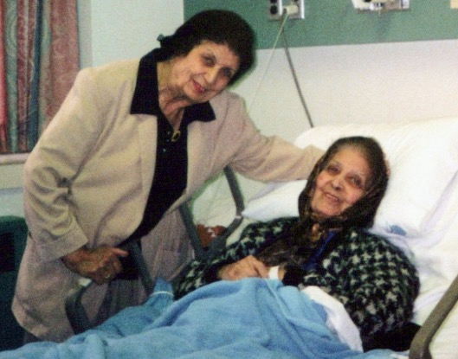
Shamsi visiting her sister Qamar Khanum Aghdassi in the hospital during her illness,
2004, Alexandria, VA
While I was in the United States taking care of my sister, the National Spiritual Assembly of Turkmenistan wrote a letter of support and appreciation to me:
“Ashgabat, Turkmenistan
October 20, 2002
Dear Shamsi Khanum! Allah’u’Abha,

With great respect and sincere love to you, the National Spiritual Assembly of the Baha’is of Turkmenistan, on behalf of all the Turkmen Baha’is, would like to express its gratitude for the work which you have done in creating and developing the Baha’i community in Turkmenistan and for your love and sincerity that you have extended for bringing up and consolidating young Baha’is while being the Chairman of the NSA of the Baha’is of Turkmenistan and a teacher to the Baha’i community.
During each NSA meeting we pray with trembling hearts, ask Baha’u’llah for His help, and have you, Shamsi Khanum, in our thoughts trying to imagine how you would answer difficult questions that arise during our consultations.
We miss you very much and beg Baha’u’llah for His Grace to let us see you again among us, the Baha’is of Turkmenistan, to listen to your bewitching talks, and to experience the power of the Spirit of Baha’u’llah, which we could feel through your enthusiasm that you always kept up and devoted for the sake of the Cause of God.
We also pray God for the quick recovery of Qamar-Khanum.
On behalf of the entire community and the National Spiritual Assembly, we ask you to pass our kindest regards on to your family and the Baha’i friends of the State of Maryland.

We all love you and call you our Mother Shamsi,

Sincerely,

National Spiritual Assembly of the Baha’is of Turkmenistan
Khoja Charyeve, Chairman”

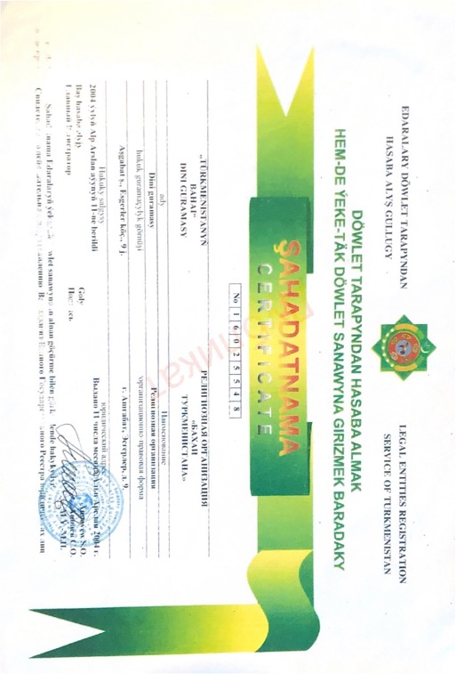
Certificate of Incorporation, Turkmenistan, 2004; this was very helpful for the Baha’is in that country to be able to show this legal document when it was needed

Conference in Kiev, Ukraine, 2009
From 28 February–1 March 2009, I attended one of the forty-one Regional Conferences called for by the Universal House of Justice.
The last of the forty-one, this Conference in Kiev, Ukraine, included 283 participants from the Ukraine, 68 from Moldova, 15 from Armenia, 65 from Belarus, 21 from Estonia, 19 from Lithuania, and 15 from Latvia.
Counsellor Dr. Ayman Rouhani and Counsellor Dr. Penelope Walker, members of the International Teaching Centre, were the representatives of the Universal House of Justice to the Cypriot conference which was held in the House of Cinema, the same location which had hosted Ruhiyyih Khanum during her visit in the 1990’s.
The lively and interactive gathering attracted fifteen seekers to the Cause.

My reunion with Mrs. Marina Pavlova
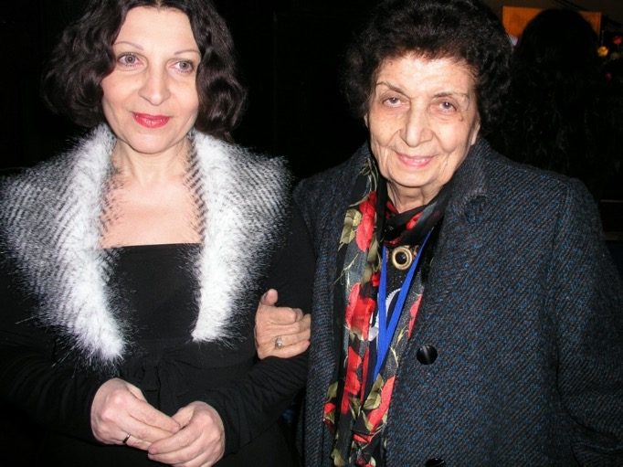
Mrs. Marina Pavlova with Shamsi at a regional conference in Kyiv

There in Kiev, I was reunited with my dear friend, Marina Pavlova, who had been the Secretary of the National Spiritual Assembly of the Soviet Union while I served as its Chairperson. We spent a great deal of time together and became close friends. She wrote me in anticipation of seeing each other at the Conference:
“Dearest Shamsi,
Words really fail to express my joy after getting news of your visit. You were always in my heart and so many times I wanted to tell you this personally. You are and will be one of the most significant figures in our Faith, I mean it. I really mean it.
You know I met a lot of Baha’is in my life but very few of them became “epoch-making” in my growing as a Baha’i. Actually, you are the first fundamental and practical teacher for me. I will be grateful to you for the rest of my life. The same feelings have Victor and especially Grisha.
I wish I could meet you at the airport but unfortunately won’t be able to do it. One of the friends who has a car will do it, they will let you know.
See you very very soon,
Marina”

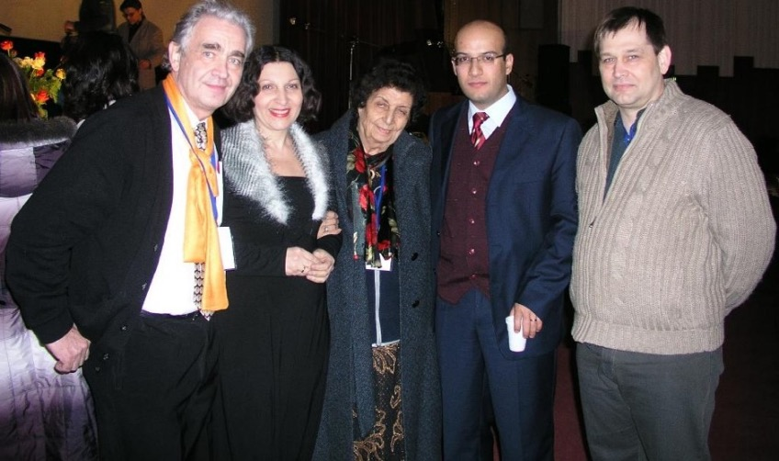
L. to r.: 1) Mr. Victor Pavlov, 2) his wife, Mrs. Marina Pavlova, 3) Shamsi, 4) ?, 5) ? I forgot their names but I’m sure they are active Baha’is

Letter of appreciation from the Universal House of Justice
In response to a letter I had written to the Universal House of Justice on the progress of the cause in Turkmenistan, I received this letter:
“Mrs. Shamsi Sedaghat
Turkmenistan
Dear Baha’i Friend,
Your email letter of 11 February 2010 has been received with appreciation by the Universal House of Justice. It was pleased to learn that the believers in Turkmenistan, in ever larger numbers, are engaging in the teaching work and in building vibrant communities. You are undoubtedly delighted that a new generation, many of who are your spiritual children, has arisen to carry forward the work of the Faith in that country. Rest assured of the supplications of the House of Justice in the Holy Shrines that you may be surrounded by the healing grace of the Blessed Beauty and favoured with His loving guidance and protection. Prayers will also be offered for the friends in Turkmenistan. The three original letters of the Guardian…. that were sent with a confirmatory copy of your email letter were also received with warm gratitude….
With loving Baha’i greetings, Department of the Secretariat”
The passing of Mr. Hooshmand Fatheazam, 2013
I received the very sad news of the passing of dear Mr. Fatheazam, the former member of the Universal House of Justice and my longtime guide and advisor who encouraged me all of the time in my pioneering and travel teaching for the Cause of God.
This encouragement helped me greatly during my tests and difficulties in the field of service and helped to fortify me and keep going forward. I have many personal letters from him which I treasure. May God exalt his soul in the Abha Kingdom. I sent my sincere condolences to his wife, Shafigheh Khanum and his two sons, Mr. Shahab and Mr. Shahram Fatheazam.
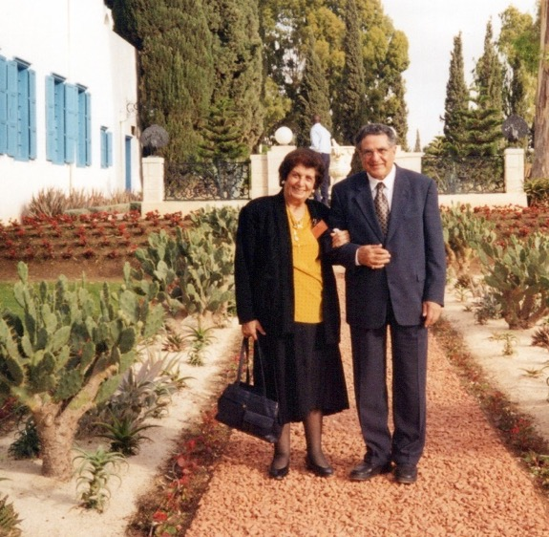
Mr. Fatheazam, member of the Universal House of Justice, and Shamsi in Haifa
The House of Justice remembered him warmly:
“We have learned with profound sadness, of the passing of our dearly cherished, greatly esteemed former colleague Hushmand Fatheazam. Tenderness of spirit, profound knowledge, noble humility, and tireless endeavour characterized his highly valued services rendered over the course of many decades, whether as a member of the Universal House of Justice for forty years beginning in 1963, as Secretary of the National Spiritual Assembly of India, or as an enkindled pioneer, avid proponent of teaching among the masses, and inspired author. His wholehearted and resolute defense of the community of the Greatest Name was unwavering, and his determination in the face of adversity unyielding. Gifted with a unique eloquence in Persian prose and verse, he leaves a remarkable legacy of deploying the power of that language in service to the Cause. Beyond a distinguished record of consecrated exertion in the path of the Blessed Beauty, he will also be remembered for his manifold outstanding personal qualities, for his delightful humour, and for his kindly and radiant heart that exuded an all-embracing love.
We extend our deep condolences to his dear wife, Shafiqih, and to his bereaved sons and other family members and assure them of our ardent supplications at the Sacred Threshold that his illumined soul may reap a rich reward in the Abhá Kingdom. The friends throughout the world are called upon to hold memorial meetings in his honour, including befitting commemorative gatherings in all Houses of Worship.
The Universal House of Justice”
In 2015, I wrote to the Universal House of Justice about my biography
In the summer of 2015, I wrote to the Universal House of Justice about writing my memoirs:
“Universal House of Justice
P.O. Box 155, Haifa Israel
From: Ms. Shamsi Sedaghat
Apartment 31, House 73-A,
Turkmenbashi Street
Ashgabat, 744000, Turkmenistan
Date: June 10, 2015
Our Beloved, Highly Respected and Adorned Institution,
First, I would like to humbly convey my love and respect to each member of your precious institution and wish you continuation of your admirable services, in establishing HIS plan of Peace, love and Unity around the world.
Secondly, allow me to recall a fact:
Six months ago, our Baha’i community in Ashgabat arranged a surprise anniversary party for my 90th birthday in a restaurant. One day, Mr. Ahmadjan Mavlyanov phoned and told me that they had arranged a small gathering of 15 or more friends of “High Capacity” and they would like me to be present and say a few words about the Baha’i Faith.
I was very pleased to hear that, collected all the necessary materials, and at the appointed time they arrived and took me to the restaurant. On our arrival, a dear Baha’i, helped me with my charts and other materials, and Ahmadjan took my hand and helped me to walk up the small stairs, into the hall, where the gathering was taking place. As soon as I arrived in the hall, I saw more than 100 Baha’is, with some of the friends, present there. Some of them were clapping and chanting “Happy Birthday to you.” It was at that moment when I understood what it was all about.
Of course, I was very surprised by seeing such a magnificent place, decorations, dancers, musicians, gifts, foods, and fruits. Above all those loving participants!!
But I was also very sad and felt sorry for not having our small teaching gathering for the friends of “High capacity,” as the teaching of the Faith has been always a priority in my life.
However, the celebration was very professionally organized: friends spoke, read poetry, and we had a few surprise Skype-video conference calls (which was previously arranged) with my sister Guitty Ejtemai and her family, Soraya Furutan and her family, my brother Farhad, Doctor M. Jamalabadi and his wife Shahnaz Khanum, who were very active Baha’is in Trinidad and Tobago and presently in Miami, where he is having a medical treatment for his heart, for which I am requesting your blessed prayers, Mr. Ibrahim Badakhshan and his wife Mahdokht, from Holland and etc.…
They showed some pictures of my activities around the world (which friends had copied at my house from my photo albums, without my knowledge). Later, they prepared a nice two-hour video film from their gatherings and presented it to me, which is a very precious and lasting memory for my relatives and the friends.
I always remember my mother (who died in USA when she was 92 years old), who was very sorry for my “life of loneliness.” That night when I saw the glory of the above gathering, with the eyes full of tears I thanked all the friends for their kind efforts and then I looked up and said to my mother “Do not be sad and sorry for my ‘life of loneliness’. Baha’u’llah has given me so many children, who look after me and help me, wherever I happen to be, especially now, at this old age, in my birthplace, Ashgabat, Turkmenistan.”
However, Beloved Friends, the reason for all the above explanations is that although I am 90+6 months old (with two broken wrists, broken shoulder, and broken leg, with too large stomach and vertebral operations in the past), I have still, a very important duty to perform and that is: to write a book, including some of my activities which was accomplished, first, by the will of Baha’u’llah, the advice of the Beloved Guardian, the direction and guidance and prayers of your infallible Body, and second by the assistance of entire administrative institution and individual Baha’is wherever I have been living or travelling.
I would like to mention some of my activities such as:
My travels to over 70 countries and islands, visiting many dignitaries, lecturing in many schools, universities, clubs, public meetings, appearing in news media, helping the formation of Local Spiritual Assemblies and National Spiritual Assemblies, enrollment of many ready souls such as doctors, lawyers, tribal chief, businessmen, students, and many others like myself, in a humble position, with hearts ready to hear and accept the Divine Revelation of this Age and dedicate some of their time to serve HIM.
When someone reads this kind of book, then they will realize what Baha’u’llah can do with people who give their time and energy entirely to serve His Cause. They must not see to themselves and their shortcomings, they must offer their services to HIM, pray, and ask to be accepted. Surely, He will accept and will honor them to serve his Beloved Cause.
Therefore, I have two humble ways to achieve the goal of writing this book:
1. With your will, permission and approval, should I collect all the needed materials in my suitcases, get a Baha’i friend to accompany me to Vienna, USA, where my sister Guitty and her husband Mr. Hussein Ejtemai live, and stay there for six months or so to write the book or find some other people there to help me. Then I will return to Ashgabat and be ready for His Will to be done. I really want to die at my birthplace and my last pioneering post, where I have been living for the last 24 years.
2. If your infallible Body does not advise me going to the USA for this project, (as I would like to be back to Ashgabat in time for my burial)., therefore, it is too much if I appeal to your August Body’s bounty and prayers for completing writing this book in Ashgabat with the help of Ms. Irina Begjanova provided she will have time as she is very busy with her Ruhi classes, devotional meetings, translations, etc.…
As I cannot accomplish this very heavy task alone and to find other person is very difficult as they do not know the English language well, (as the book will be in English), then may I appeal your August Body’s prayers for the solution of this problem.
Finally, I wish to ask your August Body, can I copy or quote some of the writings of Beloved Guardian or your infallible Body, or some National Spiritual Assemblies around the world to me, wherever is needed in my book? I will be honored if I received your guidance over this question as well.
Please forgive me for this long letter with its mistakes and poor English (but looking to my age and my health, it is only the power of Baha’u’llah and your loving prayers, which has given me all this energy and has kept me writing till 2:45 a.m., June 10th, 2015.
With utmost love, humility and obedience to your advice and guidance,
In His great service, Shamsi”
Mr. Dariush Movaffagh
While I was writing my book in the U.S.A., I was living in McLean in Northern Virginia not far from where my sister, Guitty jan, and her husband Mr. Hussein Ejtemai were living. Although I was busy with my work, I was able to attend nineteen-day feasts and other celebrations where I met Mr. Dariush Movaffagh and his wife, Nilufar (“Lily”), whose father was Mr. Gholam Hossain Lotfi, a Shi’a Muslim, and her mother, Sabiyyih Lotfi, was a Sunni from Izmir, Turkey. From the age of thirty to forty Nilufar practiced Sufism and went to the Sufi meetings with her friends. When she was forty, she and Dariush got to know each other, and they went to Haifa for the first time. With tear-filled eyes and a heart full of love, she declared her belief in the Baha’i Faith there. Since that moment, she’s been a servant of Baha’u’llah. They have an adopted son Kourosh who is now eleven-years-and fluent in several languages.
The family is active in the Faith with firesides once a week in their home which are very successful. I knew them through this kind of activities in their home. Guitty had to go to the Persian Conference in Chicago to help with the preparations earlier than I could so she couldn’t take me with her therefore I asked the Movaffaghs to accompany me to the 2017 Conference, Friends of Persian Culture in Chicago at the end of the August. We left Virginia for Chicago where I met up with my family. On the return trip, the Movaffaghs accompanied me again and helped with everything at the airports and looked after all my necessities. I thanked them and said I wanted to write about Dariush’s background. He wrote in Farsi a few lines, and I have translated it below (please forgive my English):
“My name is Dariush Movaffagh. The last name “Movaffaq” was given to our family by the Beloved Guardian Shoghi Effendi. My father was from Hamadan and was from Jewish background. His name was Mahdi. He was sixteen years-old with his two other brothers who were eighteen and Yuda, twenty-one, had declared the Faith in the house of Mr. Hafezolsehhe in Hamadan. For a year they were begging their father to permit them to become Baha’i, but their father would not permit it. Therefore, they wrote a letter to the Guardian to explain their problem and ask what they should do. The Beloved Guardian replied (my translation): “You are Baha’is in heart. Do not disturb your father’s heart. I shall pray for you.”
After a while, their grandfather noticed that the boys were getting up early in the morning, pray, and fast (i.e. eat their breakfast before sunrise and then refrain from food and tobacco and drink until sunset. The Baha’i Faith has nineteen days of fasting every year from March 2-20 and the 21st is the first day of the Spring Equinox and is the Baha’i New Year, and we celebrate it as our New Year’s Day.) One day the father of Dariush opened the door and saw his sons sitting quietly and praying. He looked at them and said, “Have you become Baha’is?” and then unhappily closed the door and went to work. When the three brothers saw the reaction of their father, they remembered the words of the Beloved Guardian who told them not to disturb the heart of their father.
They got up and followed their father to his work to apologize to him. When they reached him, he asked them again, “You became Baha’is?” Then he said again “Nevermind but please do not let anybody know about it” They became very happy and soon the three brothers wrote a letter to the Beloved Guardian and told him about their father’s permission.
The Beloved Guardian replied in Farsi “Hala Movaffaq shodid” “now you are successful”. The word ‘movaffaq’ means “successful” and since then all of Dariush’s family have taken the name of “Movaffaq” as their surname.
After his maternal grandfather, Hakim Momeni, became a Baha’i, eight people, some Jewish, some Muslim, came to his home and took him with his horse to pay a visit to a patient outside of the town. There, they killed him and threw him in a well. Family found the body. They took it out of the well and washed him and put a Baha’i burial ring on his finger which bore the Arabic inscription: "I came forth from God, and return unto Him, detached from all save Him, holding fast to His Name, the Merciful, the Compassionate." And buried him in the Malayier graveyard. People thinking that the ring was expensive since he was a doctor and wealthy, therefore they opened the grave, pulled the hand out of the coffin and removed the ring and left. Again, the family came back and replaced the ring.
Mr. Hakim Momeni had 13 children. Now, after 6 generations he has more than 500 plus members of his family: such as children, grandchildren, great-grandchildren and so on. (May God bless his soul, and may God give Mr. and Mrs. Dariush Movaffagh and their son Koroush long life to serve our beloved Faith as they are serving now).”
Dariush Movaffagh and his wife, Lily Khanum, are amongst the most active Baha’is in Virginia. At their home they observe public meetings, Holy Day celebrations, firesides, Nineteen-Day Feasts, and many other Baha’i gatherings to which everyone is welcomed. May God bless and assist them always.”

Appendix A

Baha’i services
Pioneer Posts:
(Pioneering means to move to another town or country for the purpose of teaching the Faith and serving mankind.)
- 1951-1954: Brighton, England—nursing education
- 1954-1964: Cyprus
- 1964-1967: Iran (Ahwaz, Tehran)
- 1967-1968: Kampala, Uganda (several months)
- 1968-1969: Brighton, England—continuing nursing and midwifery education
- 1969-1980: Trinidad and Tobago
- 1980-1983: Nassau, Bahamas
- 1984-1986: Georgetown, South Carolina, United States of America
- 1986-1990: Alexandria, VA, USA
- 1990-1991: Odessa, Ukraine, USSR
- 1991-present: Turkmenistan (including travel teaching trips and visits around many parts of the world and sometimes travel to U.S.A. to assist my ailing mother and my sister, Qamar Khanum, until her passing to the Abha Kingdom and then I returned to Ashgabat)
- 2015-2019: United States of America—to write my memoirs and attend to my medical problems
Baha’i Administrative Service:
- National Spiritual Assemblies:
  - 1971-1978: National Spiritual Assembly of Trinidad and Tobago
  - 1981-1983: The Bahamas
  - 1991-1992: Soviet Union
  - 1992-1994: Chairperson, Central Asia (Turkmenistan, Kazakhstan, Uzbekistan, Kyrgyzstan, Tajikistan)
  - 1994-2001: Chairperson, Turkmenistan (Turkmenistan was administratively separated from the other central Asian republics and was given its own National Spiritual Assembly)
- Local Spiritual Assemblies: (Assembly which is responsible for the affairs for the town in which you live)
  - 1952-1954: Brighton, England (member)
  - 1956-1959: Nicosia, Cyprus (Secretary)
  - 1964-1966: Ahwaz, Iran (Chairperson)
  - 1970-1980: Port of Spain, Trinidad (Chairperson)
  - 1981-1983: Nassau, Bahamas
  - 1984-1986: Georgetown, S.C.
  - 1986-1990: Alexandria, VA
  - 1990-1991: Odessa, Ukraine (Chairperson)
  - 1992-2001: Ashgabat, Turkmenistan (Chairperson)
Travel-Teaching:
- 1949-1950: Khorasan Province, Iran
- 1972: Jamaica and Barbados (Under the auspices of the Continental Pioneer Committee for the Americas)
- 1974: Barbados (Invited by the N.S.A. of Barbados and W.I. to assist in News Media publicity and teach at the Teacher Training Institute)
- 1975: Antigua (Invited by the N.S.A. of the Leeward and Virgin Islands to teach at the summer school)
- 1975: Guyana (Invited by the N.S.A. of that region to assist with the publicity and proclamation of the Faith through the news media and meet officials)
- 1976: Caribbean Islands including US Virgin Islands (five months)
- 1977-1978: Eight months energetic travel teaching in over 25 Caribbean, North and Central American countries and islands, including two and a half months in the Bahamas, prior to the election of the First National Spiritual Assembly of that region in May 1978. (Under the auspices of the Continental Pioneer Committee for the Americas and approval of the Universal House of Justice).
- 1978-1979: Seven months extensive teaching trips to several regions in the United States, Bermuda, West Africa (Sierra Leone, Liberia, Nigeria, Cameroon) and Europe (France, Belgium, Denmark, Germany, Switzerland, and Austria). Under the recommendation of the Universal House of Justice and auspices of the Continental Pioneer Committees concerned.
- 1979: One-month teaching trip scheduled upon the recommendation of the Universal House of Justice to the following Central American Countries: Guatemala, El Salvador, Costa Rica, Panama, Guyana, Surinam, and French Guyana.
- 1979: Ten-day teaching trip under the auspices of International Goals Committee of the United States to the Turks and Caicos Islands.
- July 1981: short teaching trip to Andros Island.
- July 1988: teaching trip to Trinidad and Tobago
- August 1988: teaching trip to Antigua
- Summer, 1991: teaching trips throughout Central Asia: (Turkmenistan, Kazakhstan, Uzbekistan, Kyrgyzstan, Tajikistan, Azerbaijan)
- March 1994: teaching trip to Azerbaijan
- November 1999: teaching trip to Cyprus
Travels and International experiences:
- Travelled widely in Asia, Africa, Europe, the Caribbean Islands and the Americas, and lectured on a variety of subjects:
  - Role of youth in society.
  - Role of women as mothers and first educators of their children.
  - Downfall of morality.
  - Effect of alcohol and narcotics on physical and mental health.
  - Progressive revelation of God’s Message.
  - Dawn of a new world order.
  - Harmony of science and religion.
  - Purpose of creation: the Baha’i perspective.
  - Equality of men and women.
  - Universal Peace upheld by world government.
- Lectured and gave addresses at the following:
  - Service clubs: Kiwanis, Jaycees, Lions, Rotary, Toastmasters, Toastmistresses, and women’s professional clubs.
  - Schools: Primary, Secondary, Colleges and Universities, including Roman Catholic Convents and Anglican schools as well as Professional Schools such as Police Training Schools, Nursing Schools and Teacher Training Institutes.
  - Churches: various denominations of Christianity, as well as other religious institutions.
  - Others: Parks, Auditoriums, City Halls, Baha’i Centres and Private Homes.
- Interviews with the news media on the principles of the Baha’i Faith, courtesy calls on Heads of State and/or their wives; Governor or Governor-Generals; Prime Ministers or their Deputies, Cabinet Ministers, Mayors or Deputy Mayors, Tribal Chiefs, Director of Medical Institutions, Matrons and Hospital Administrators. Books were presented. The Baha’i Faith and the extent of its progress were discussed.
International Conventions for the election of the Universal House of Justice:
- 1973, 1978, 1983, 1993, 1998

National Conventions:
- 1970: First National Convention of the Baha’is of Guiana, Surinam and French Guiana in Georgetown, Guiana.
- 1971: First National Convention of the Baha’is of Trinidad and Tobago, Port of Spain, Trinidad and Tobago
- 1977: First National Convention of the Baha’is of Surinam and French Guiana, in Paramaribo, Surinam
- 1978: First National Convention of the Baha’is of the Bahamas, in Nassau, the Bahamas
- 1979: 70th National Convention of the Baha’is of the United States, in Wilmette, IL, U.S.A.
Conferences summer schools:
- Summer school in Hull, England, 1951
- International Conference in Stockholm, Sweden, 1953
- Summer School in Exeter, England, 1954
- International Conference in Frankfurt, Germany, 1958
- Baha’i World Congress in London, England, 1963, served as private translator Persian/English
- Summer school in Tehran, Iran, 1965
- Centenary of Baha’u’llah’s Proclamation to the Rulers of the World in New Delhi, India, 1967, served as a representative of the Pioneer Committee for Asia and chaired one of the sessions of the Conference.
- International Conference in Palermo, Sicily, 1968, preceding attendance at the celebration of the Centenary of Baha’u’llah’s Exile to Akka in Haifa, Israel
- International Conference in La Paz, Bolivia, 1970
- Oceanic Conference in Kingston, Jamaica, 1971
- Dedication of the Panama Temple, Panama City, Panama, 1972
- Merida Conference, Yucatan, Mexico, 1977
- Hemispheric Radio and T.V. Conference, Panama City, Panama, 1977, served as a teacher
- Summer School, Panama, 1977
- First West African Baha’i Women’s Conference, 1978, Monrovia, Liberia
- First Turkish Baha’i Conference, 1979, Langenheim, Germany
- Montreal, Canada, 1982
- Masanetta, Virginia, 1984
Committees in various countries:
- Youth Committee
- Child and Women Education Committee
- Teaching and Programming Committee
- National Regional teaching Committee (Iran)
- Continental Pioneering Committee for Asia (Iran)
- National Goals Committee (Trinidad and Tobago)
(This committee was responsible for media publicity, property acquisition, legal transactions, Assembly Incorporations, Reviewing Bahai materials for publications, etc.…)

Appendix B

Professional Resume

Education
Primary: Ashgabat and Mary, Turkmenistan (former Republic of the USSR)
Secondary: Mashhad, Iran
Special: Three-year study program at first Baha’i Academy in Tehran, Iran, which was called Clase Aliye Tabliq, at which were taught:
-History, teachings, and prophecies of the world’s major religions, including the Baha’i Faith.
-Child Education
-Logic
-Philosophy
-The Arabic Language
-A few other subjects

Nursing College:
- The Royal Sussex County Hospital, Brighton, England. Received State Registered Nurse Certificate (S.R.N.), from 1951 to 1954
- Brighton Technical College, Brighton, England. Received Diploma in Cookery-Dietetics, during 1952
- Nicosia General Hospital, Nicosia, Cyprus. Received Cyprus Registered Midwife Certificate (MIDWIFE), from 1957 to 1958
- Sussex Maternity Hospital, Brighton, England. Received State Certified Midwifery Certification (SCM MIDWIFE), from 1968 to 1969
- Further nursing education in the United States resulted in obtaining the American Nursing Certificate, R.N., and American Midwifery Diploma

Languages: Persian, English, Turkish, some Greek, some Russian, in addition can read and translate Arabic.

Positions and a part-time refresher course studies:

- 1948-1951: Language teacher in Iran, Farsi to English; British and American officials.
- 1951-1954: Student nurse, England.
- 1955-1956: Nursing sister St. Barbara’s Polyclinic, Nicosia, Cyprus.
- 1956-1964: Nursing sister in two government hospitals, Nicosia and Famagusta, Cyprus.
- 1964-1966: Hospital administrator, Pars Hospital, Ahwaz, Iran.
- 1966-1967: Oil Company Hospital, Tehran, Iran.
- 1967-1968: Makerere University Hospital, Kampala, Uganda.
- 1968-1969: Midwifery refresher course, England.
- 1969-1980: Owner and Director of Rezvan Clinic (medical, maternity, and minor surgery), Port of Spain (with partner), Plaisance Park (Pointe a Pierre), and Couva, Trinidad (Maternity Nursing Home).
- 1980-1983: Princess Margaret Hospital, Nassau, Bahamas.
- 1984-1986: Labor and Delivery Department of Georgetown Memorial Hospital, Georgetown, South Carolina, U.S.A.
- 1986-1987: Nursing Supervisor, Camelot Hall Health Care Center, Arlington, Virginia, U.S.A.
- 1987-1988: House Supervisor, Goodwin House, Health Care Center, Alexandria, Virginia, U.S.A.
- 1988-1989: Nursing Supervisor, Livingston Health Care Center, Fort Washington, MD, U.S.A.
- 1989-1990: Nurse-Midwife, Labor and Delivery Department, Greater Southeast Community Hospital, Washington D.C.
- 1990-present: I retired from the nursing profession and started to pioneer and travel to various countries around the world under the auspices of Baha’i institutions and the guidance of the Universal House of Justice.

Additional Photos
The reason we have added these additional photos below is because they did not fit easily into the manuscript above, and I hope you will enjoy these.

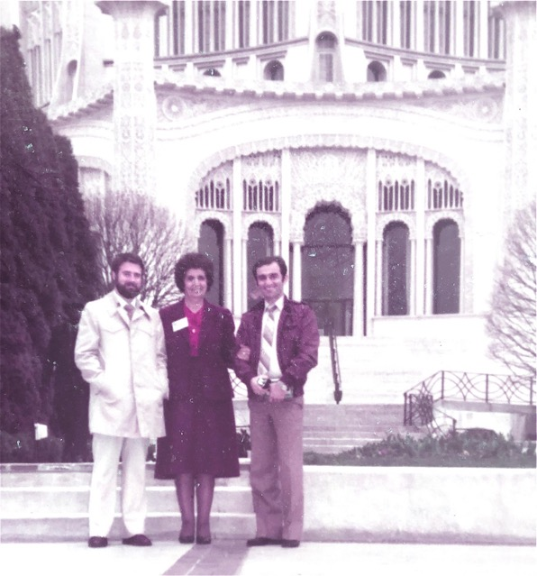

America, Chicago. In front of the Baha’i Temple. Two lovely friends next to me; I forgot their names. But I know them and their services to the Faith. May Baha’u’llah reward them in both worlds.

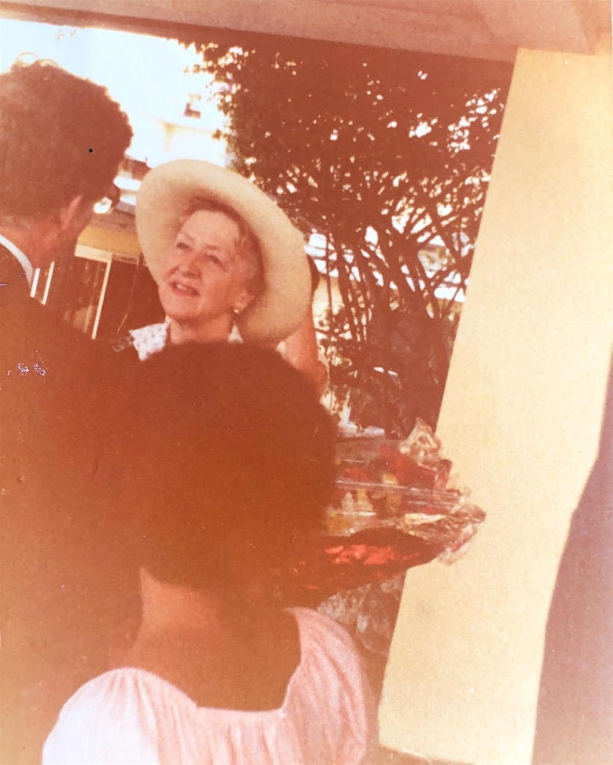

Nassau, Bahamas: Hand of the Cause Ruhiyyih Khanum Rabbani, the wife of the Beloved Guardian

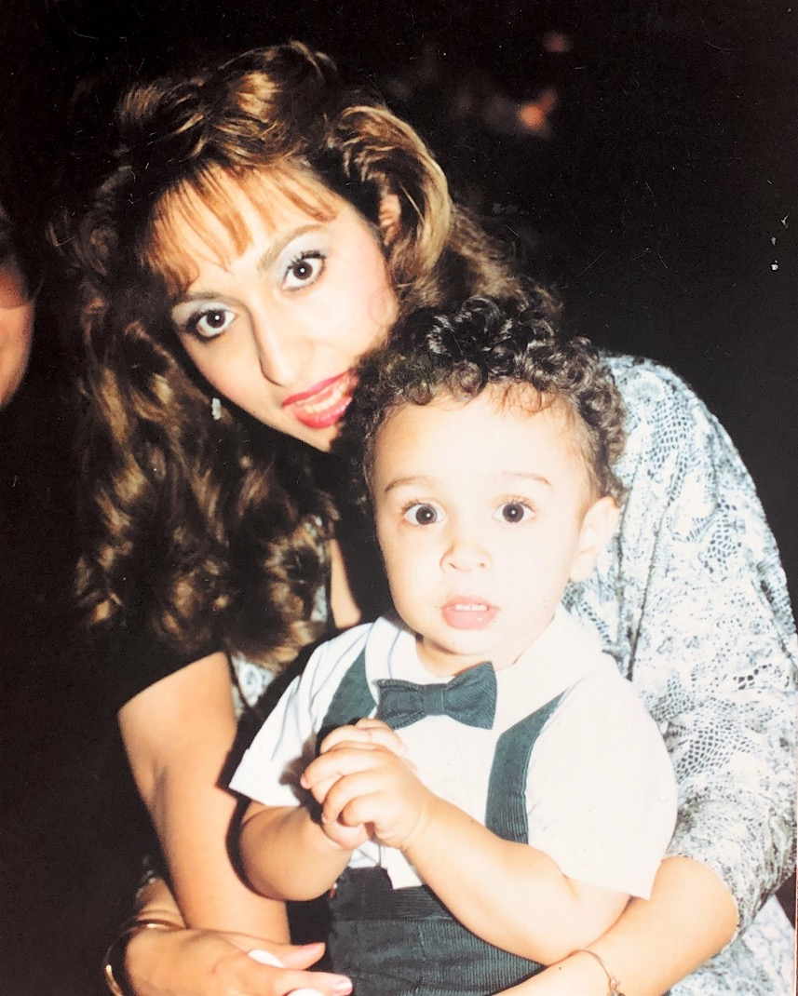

America, Feb. 2020. This is my wonderful nephew’s wife ) Mr. Esfandiar Aqdassi’s wife), Mrs. Shamila and their son Adib Aqdassi, now Adib will be a heart surgeon very soon.

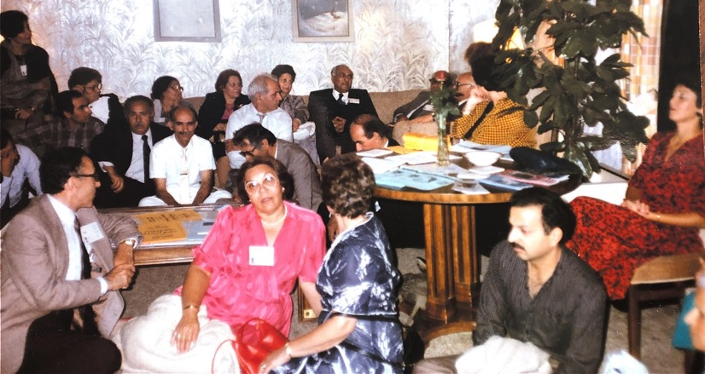

America: At the fireside, Baha’is and their friends.
Right to left, last row next to the wall: 2) Mr. Rostam Aqdassi (my brother-in-law), 3) Mrs. Qamar Aqdassi, 4)?, 5) Mrs. Leqaiyyih Sedaghat (my mother), 6) Mrs. Qamar Aqdassi (my sister, wife of Mr. Aqdassi). They have passed away. They were each very active Baha’is, each one in a different way. Mr. Aqdassi was a sincere lecturer and a believer. My sister Qamar was a member of various Baha’I committees and with my mother, an excellent hostess. May God exalt the spirits of all three.

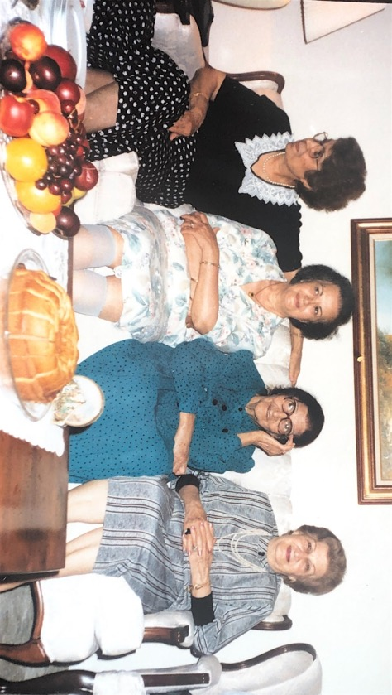

America-Alexandria (?).
Sitting l. to r.: 1) Mrs. Qamar Aqdassi, 2) I forgot the name, 3) Mrs. Leqaiyyih Sedaghat, 4) I forgot her name. All Iranian Baha’is and all jewels of the Baha’i Faith. May Baha’u’llah exalt them in both worlds.

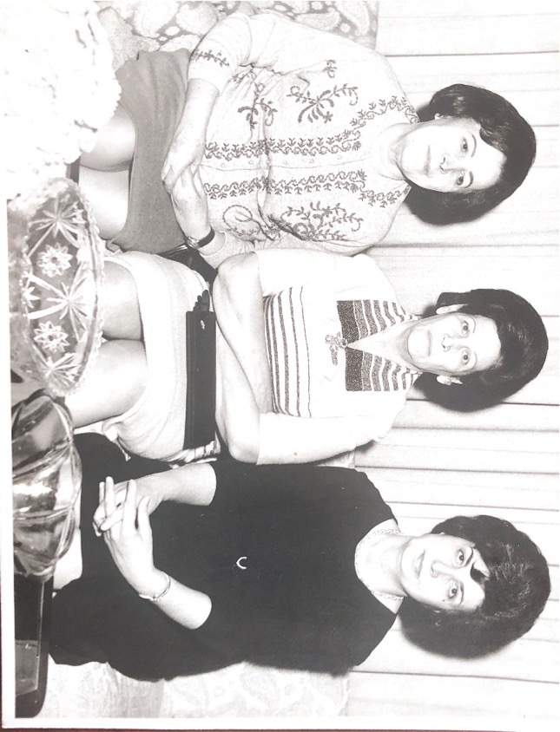

Central Asia: Two Baha’i friends sitting with Shamsi

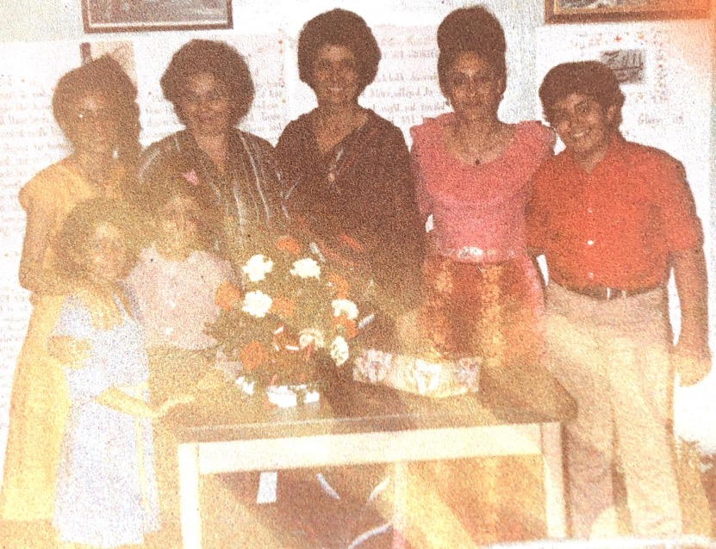

Trinidad: Group of Baha’is.
r. to l.: 1) son of Dr. Jamalabadi, 2) His mother Mrs. Jamalabadi. 3) Shamsi and other excellent friends and beautiful children!

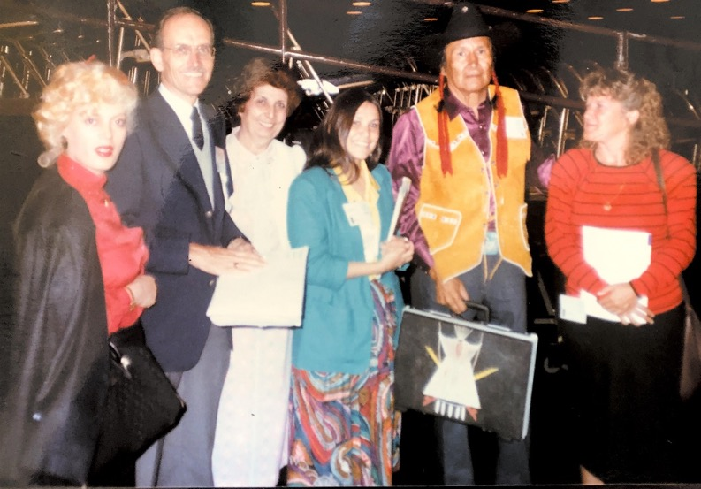

Baha’i group after a conference.
l. to r.: 1) Miss Farideh, 2) Beloved Counselor Hooper Dunbar, 3) Shamsi, 4) Jaqueline Lefthand-Bull, 5) ?, 6)?

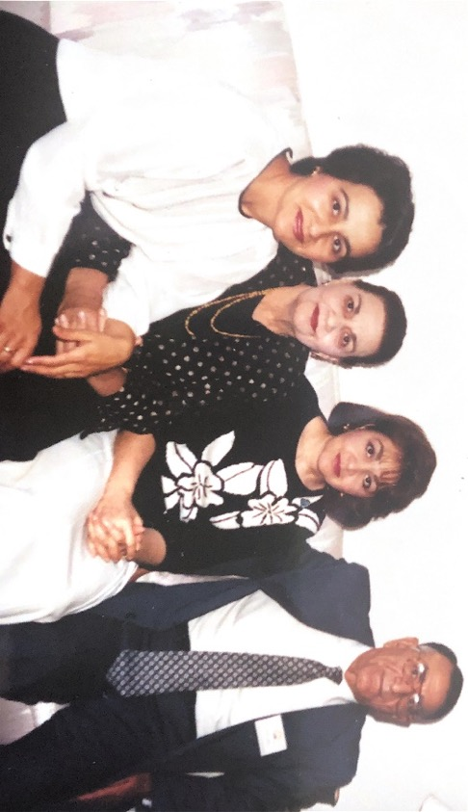

This is a photograph of the family of Mrs. Shida Mali, my good friend, in Florence, SC. I think this is a family photo of Mrs. Mehrangiz Khosravi, mother of Mrs. Shida Mali, who is sitting 2nd from the left with her daughters and her husband.
R. to l.: 1) Mr. Khosravi, her husband, 2) Shirin Khanum, her daughter, 3) Mehrangiz Khanum, 4) Shohreh Khanum. All very active Bahai’s. The oldest daughter is Mrs. Shida Mali, excellent Baha’i, who is not in the picture.

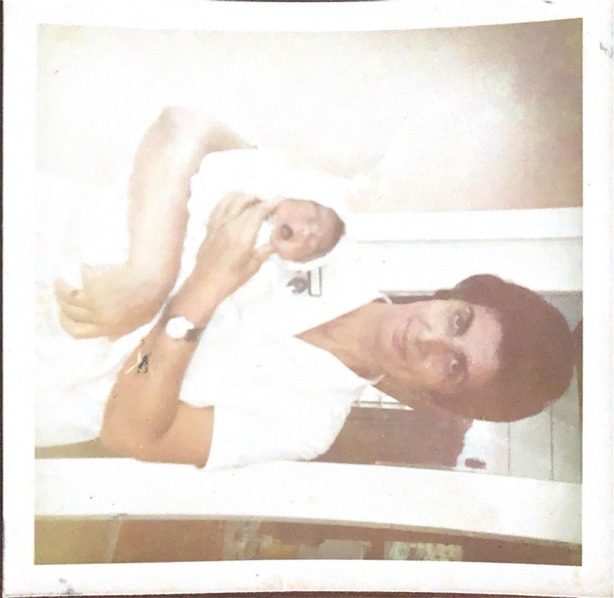

Baby “Soraya Hosingby” born at Rezvan Clinic. I had no problems with her delivery. May she grow to serve humanity to the best of her ability.

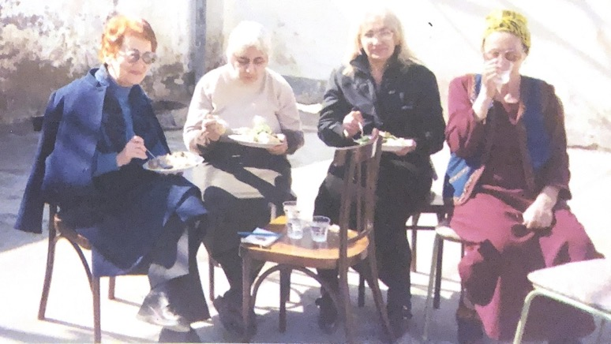

Ashgabat, Turkmenistan. Outside of the Baha’i Center. Baha’i ladies are enjoying refreshments after their meeting at the Baha’i Center. There were many present who were discussing the joy at what they heard.

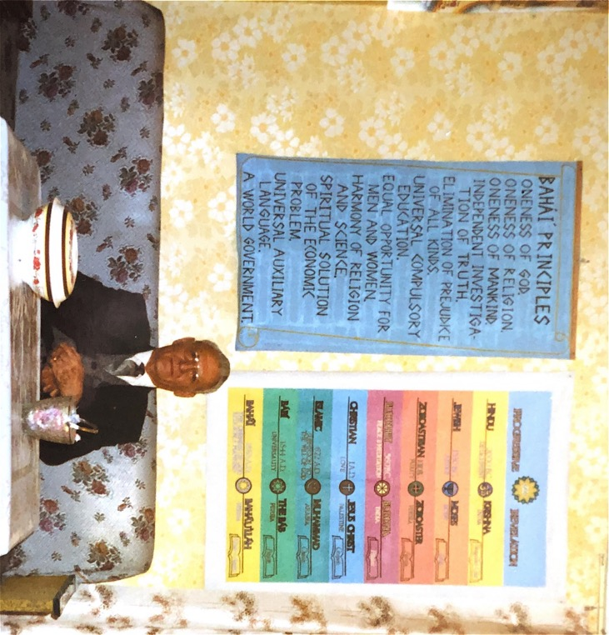

This is Ziaullah Adlparvar from Beirut. He came to us as a travelling teacher, helped and encouraged the friends tremendously. We knew him and his family from Iran. Unfortunately, after he returned to his permanent pioneering post in the Arabic countries, he assed to the Abha Kingdom. May Baha’u’llah exalt his soul.

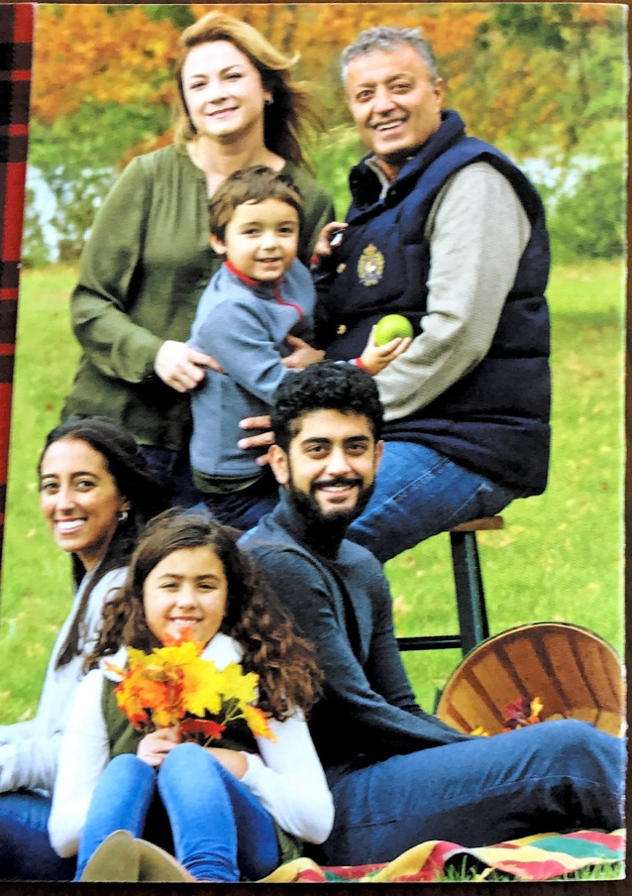

My niece David Sedaghat and his wife Yuliya and their four children: Ariana, Matean, Darya, and Ayden

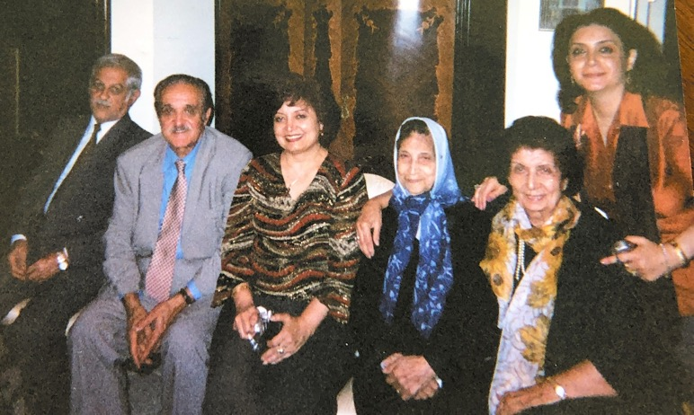

My family in America
Sitting l. to r.: 1) Mr. Pirzadeh, son of my cousin Khavar Khanum; 2) Mr. Abbas Ejtemai, my maternal cousin , a very kind person; 3) my youngest sister Mrs. Guitty Ejtemai; 4) Khavar Khanum Pirzadeh, maternal cousin; 5) Shamsi; 6) Mrs. Shida Pirzadeh

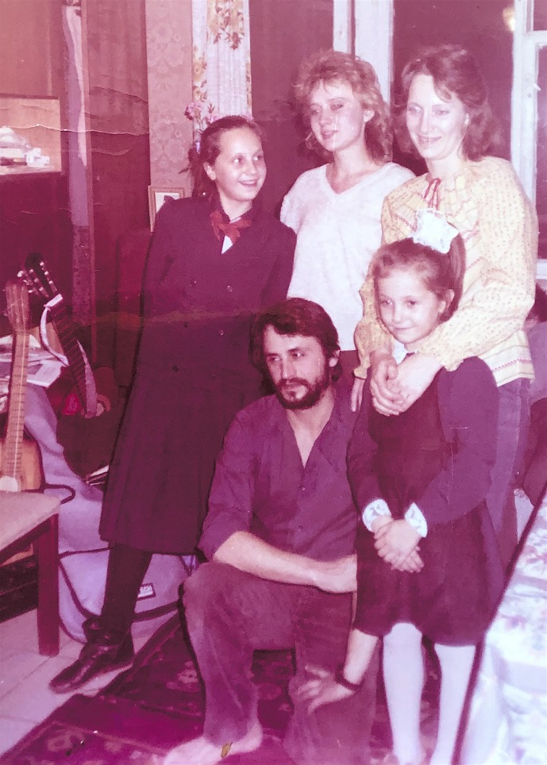
The Reznik family, Odessa, Ukraine.
In the middle: Mr. Boris Reznik
Standing l. to r.: 1) his daughter, Alina; 2) Miss Jana Tatarinsteva who later served in Haifa; 3) Mrs. Lena Reznik; his daughter, Julia

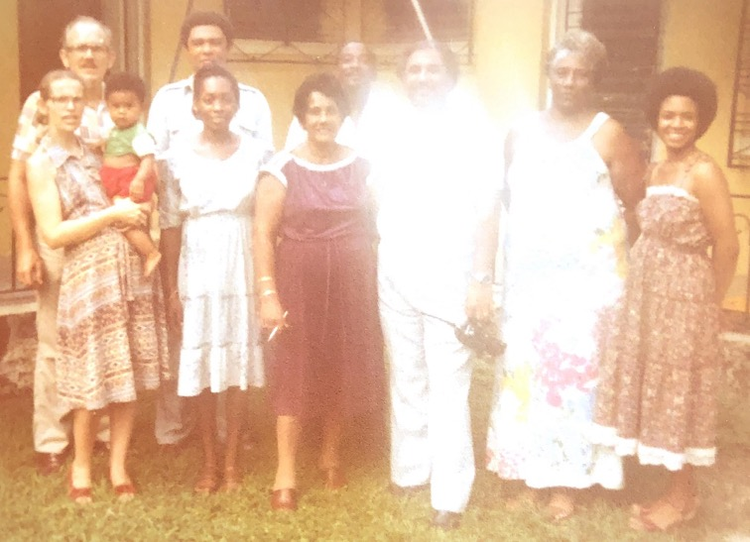

Nassau, Bahamas. Very active and friendly and generous Baha’is who invited some of their friends to their fireside.
From l. to r.: 1) Mrs. P. Newton; 2) Mr. Lissener (behind her); 3) ?; 4) Mr. Wigfall
From r. to l.: 1) Mrs. Wigfall; 2-3) Mr. and Mrs. Plakaris; 4) Mrs. Ramlogan

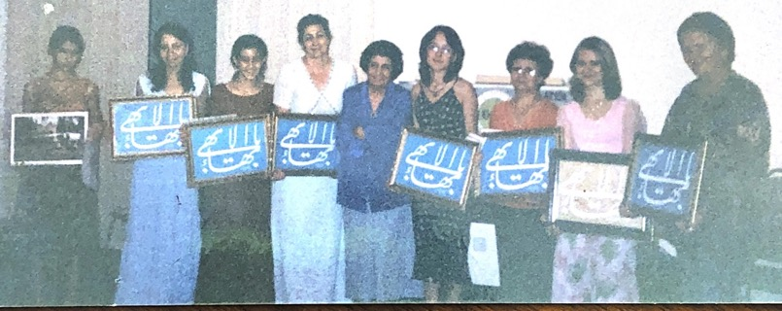

This photograph of all of our participants in our Baha’i class, where we studied the meaning of the Baha’i Greatest Name “Ya Baha’u’l-Abha” which means “O Glory of the Most Glorious” and we use it on our rings which we wear on our right hand and second finger from the right, and it is used in many Baha’i buildings and books, etc… It has a strong spiritual effect and power.

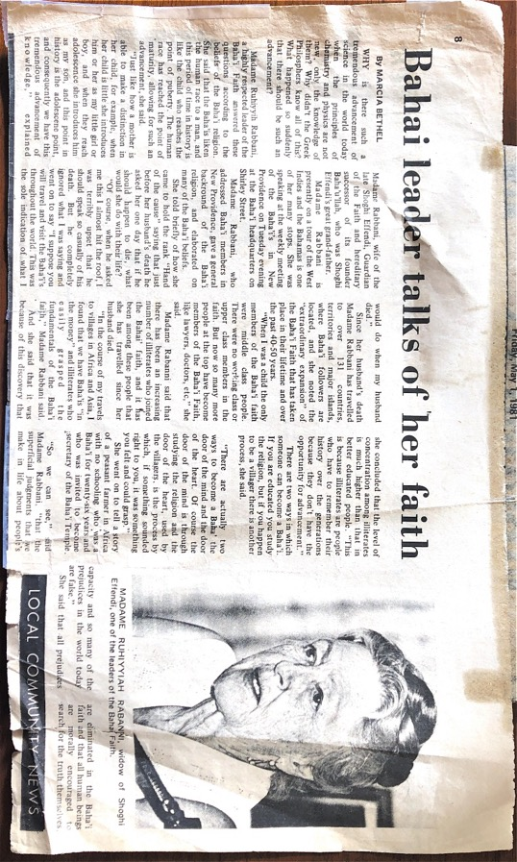

Article on Hand of the Cause Ruhiyyih Khanum’s visit to the Bahamas, 1980.

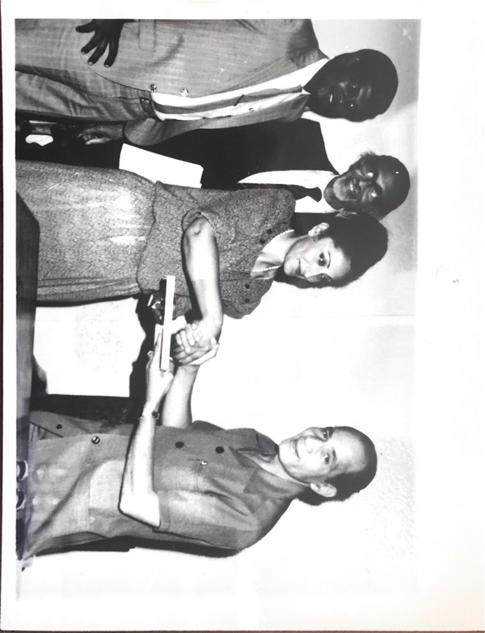
Trinidad and Tobago
Mrs. Shahnaz Jamalabadi (Iranian pioneer) presenting Baha’i literature to an official of Trinidad, during a courtesy call. All the way on the left I think is Mr. Amarsing, then Dr. Harry Collymore. I don’t remember the name of the official.

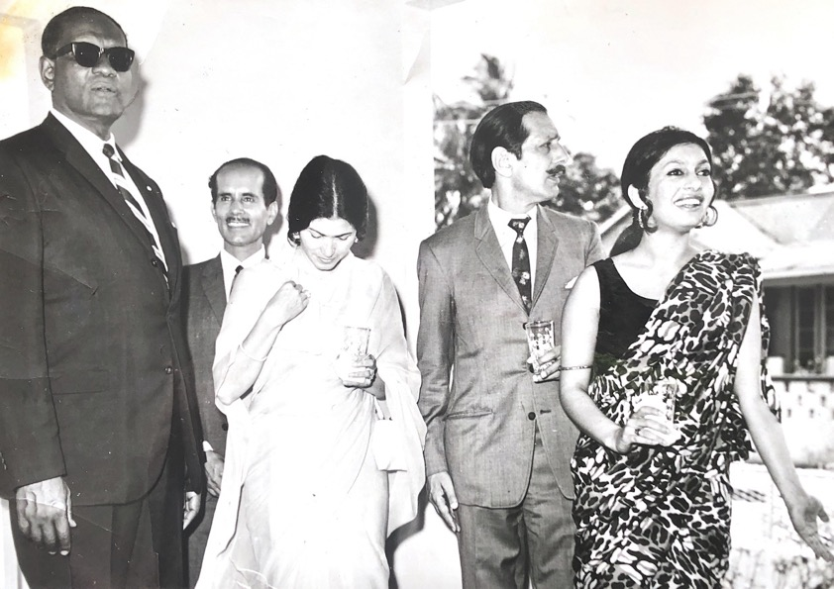

Port of Spain, Trinidad, Conference.
This group of the friends took the photograph after the end of our conference.
l. to r.: 1) Mr. Hamilton Holder, Mayor of Port of Spain; 2) Mr. Habib Rezvani, ABM, from South America; 3) Mrs. S.M. Aqa, wife of the Indian High Commissioner; 4) Mr. S.M. Aqa, the Indian High Commissioner; 5) daughter of the Indian High Commissioner. All of them were our good friends, of course the Hon. Hamilton Holder and Mr. Rezvani are members of the Baha’i Faith but we love them all. Some are deceased and we pray for them all, for their progress in both worlds.

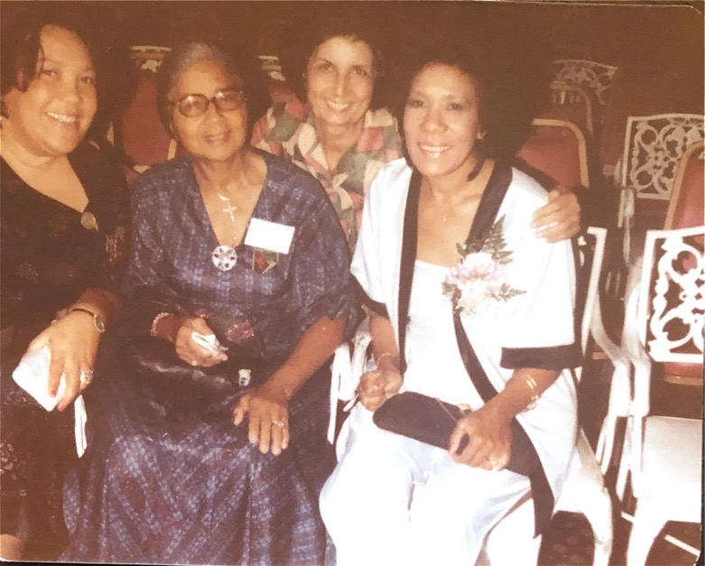

Nassau, Bahamas.
Three of the participants of a Nursing Conference in Nassau, Bahamas. I am #2 from the right. The lady all the way right is a lovely trained nurse from America (Ms. Herikaya?). We knew each other before. May God bless her. The other two are nursing staff from other countries who were all pleased to meet each other.

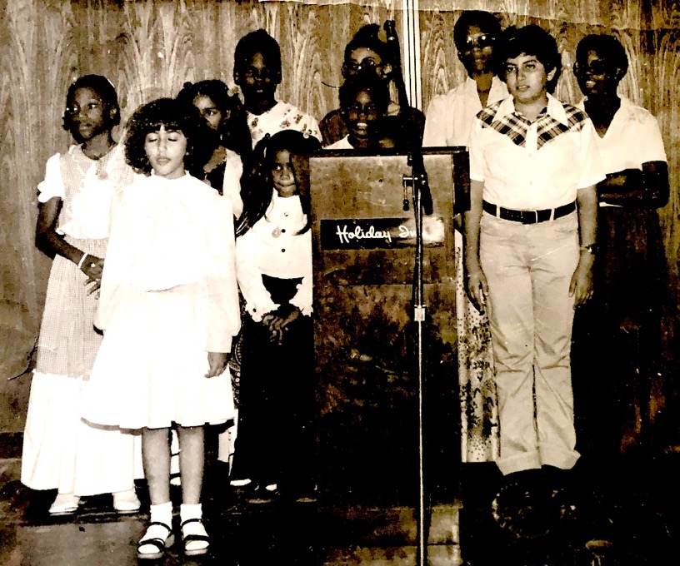

Port of Spain, Trinidad.
The Baha’I children, singing songs with other children in a gathering in a hall (to youths in the back also).
Standing l. to r. with eyes closed is Shahnaz Jamalabadi (the youngest of all the children of Dr. Jamalabadi. Standing over on the right is her brother, Shahram Jamalabadi and last row from right to left: 3) their oldest sister, Shohreh (with glasses). All three are professionally serving humanity and serving mankind spiritually! May Baha’u’llah bless them. The Jamalabadi children are now serving the Faith in America, each in their separate professions. May all the family be under the protection of Baha’u’llah and as always serve the Cause to the best of their ability. I have written about this family in my memoirs.

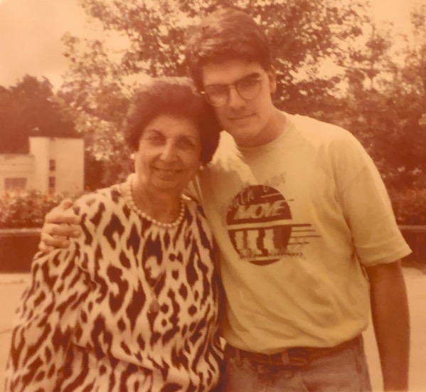

Shamsi and Jian Khoddadad

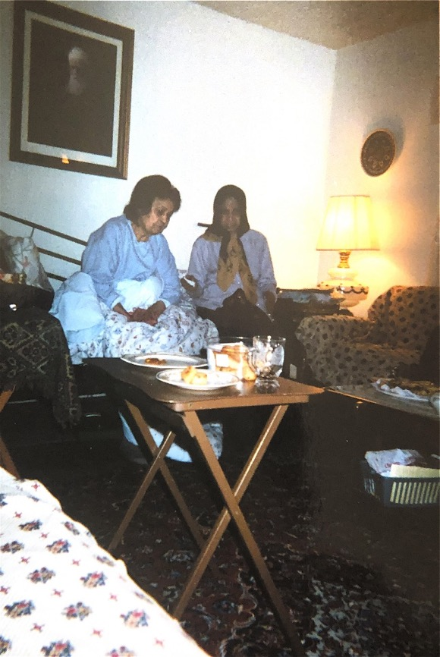

My sister Qamar towards the end of her life.

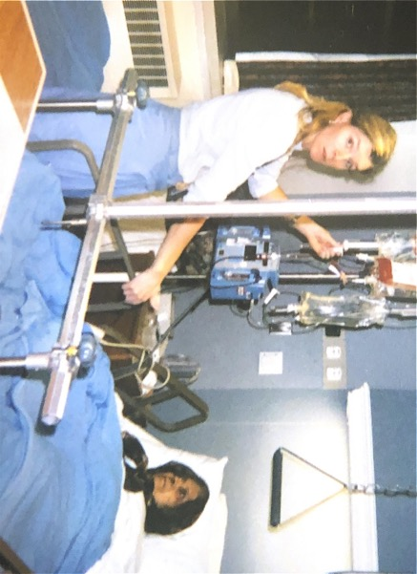

Qamar in the hospital with a nurse.

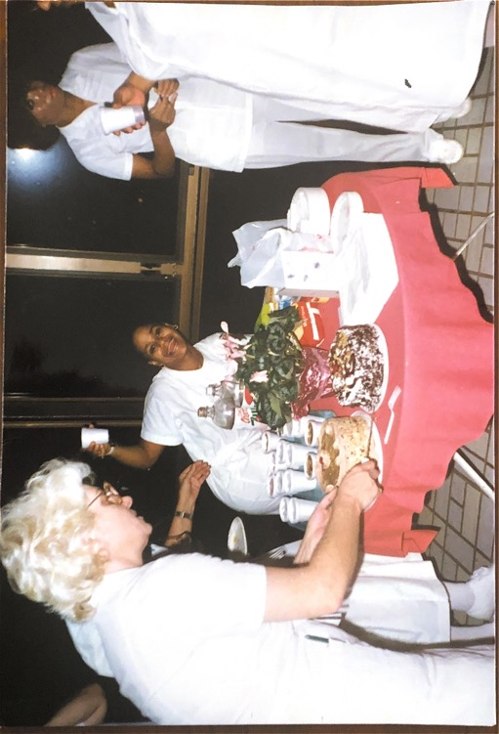

Nursing staff, Alexandria, VA.
There were some guests at hospital and we were trying to serve them some refreshment to guests. I am standing second from the left. You can only see my hand with my watch!

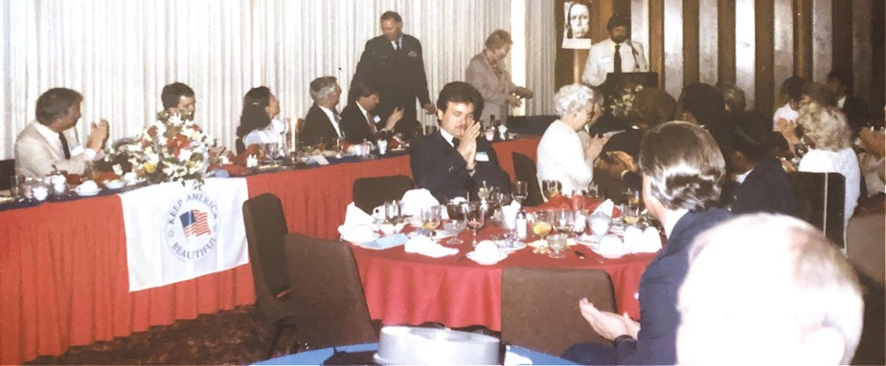

Florence, South Carolina.
This is part of a group, Baha’i and non-Baha’is, in a celebration gathering for Mr. Jubin Matin, a Baha’i youth and his friends for their voluntarily cleaning of the rubbish from parts of town and rivers from garbage! They received much praise and encouragement

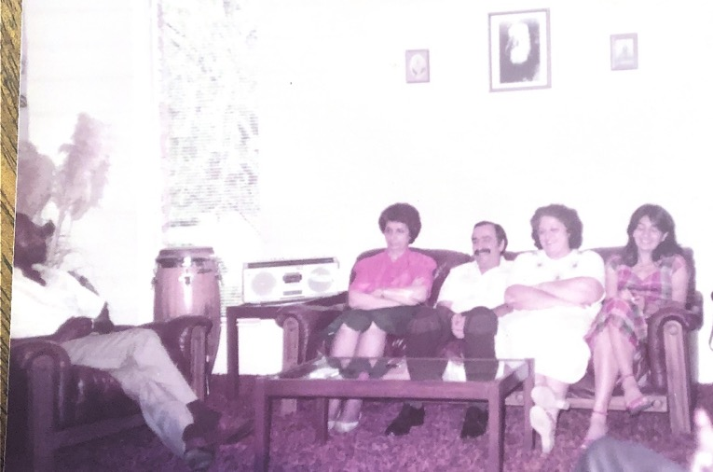

Shamsi with a group of Baha’is consulting on community affairs. I know these Baha’is by their face but have forgotten their names.

Letter from the Department of the Secretariat on behalf of the Universal House of Justice to Ms. Shamsi Sedaghat, 14 July 2015.
The above quotations and information are taken from Zarandi, The Dawnbreakers, 39-45.
Ibid., 65.
Baha’u’llah, The Kitab-i-Aqdas, (Bahá’í World Centre, 1992 edition) 29.
Mirza Abu’l-Fazl Gulpaygani, The Martyrdom of Haji Muhammad-Rida, trans. By Dr. Ahang Rabbani, http://bahai-library.com/gulpaygani_martyrdom_muhammad_rida
Baha’u’llah, Epistle to the Son of the World, (US Baha’i Publishing Trust: Wilmette, IL 1988) 181.
Shoghi Effendi, God Passes By, (Wilmette, IL: US Baha’i Publishing Trust, 1979) 300.
Shoghi Effendi, Unfolding Destiny, (UK Baha’i Publishing Trust, 1981 edition) 245.
256-7.
A prominent Baha’i family in Qazvin, Iran.
Letter from Mrs. Duke to Ms. Shamsi Sedaghat dated 9th March, 1951.
Letter from Rev. Woodward to Ms. Shamsi Sedaghat dated March 7th, 1951.
Later, Mr. Kazemzadeh immigrated to the United States to study at a university and eventually served for many years on the National Spiritual Assembly of that country as its secretary. Tabandeh Khanum with her husband also served the Faith admirably as a pioneer.
Located on Eastern Road in Brighton.
Mr. John Ferraby was appointed a Hand of the Cause by Shoghi Effendi in 1957.
Cable from Ms. Shamsi Sedaghat to Shoghi Effendi, December 28th, 1952.
Cable from Shoghi Effendi to Ms. Shamsi Sedaghat, 1952.
Shoghi Effendi, Messages to the Bahá'í World, (Baha’i Publishing Trust, Wilmette: IL) 152–153.
Letter from the NSA of the British Isles to Ms. Shamsi Sedaghat, July 9th, 1953.
Shoghi Effendi, “European Intercontinental Conference”, Messages to the Baha’i World: 1950-1957, (Baha’i Publishing Trust, Wilmette: IL 1971) 175.
Ibid, 175.
Cable from Shoghi Effendi to Ms. Shamsi Sedaghat, 1954.
Email from Eva Grant to the US NSA, dated August 18th, 2020.
Graham Hassall, “Bahá'í Community of Randwick: A Survey of 75 Years”.published in Australian Bahá'í Studies, 1:1 1999
Baha’u’llah, “Lawh-i-Karmil (Tablet of Carmel), Tablets of Baha’u’llah Revealed After the Kitab-i-Aqdas, (U.S. Baha’i Publishing Trust, Wilmette: IL 1988) 3.
Shoghi Effendi, God Passes By, (US Baha’i Publishing Trust, Wilmette: IL, 1979) 276.
Ruhiyyih Khanum, quoted in Earl Redman, Shoghi Effendi: Through Pilgrim’s Eyes, Vol. 1, (George Ronald: Oxford, UK 2015) 305.
The account includes a paraphrase of the words Shoghi Effendi spoke to me in Farsi.
Shoghi Effendi, God Passes By, (Baha’i Publishing Trust: Wilmette, IL 1974) 185-6.
Ibid, 188.
Bahá'u'lláh, The Kitáb-i-Aqdas, (Bahá’í World Centre, 1992 edition) 1.
Telegram from Shoghi Effendi to Ms. Shamsi Sedaghat.
Shoghi Effendi, from a letter written on behalf of Shoghi Effendi to an individual believer, July 4, 1949.
Earl Redman, The Knights of Bahá’u’lláh, (George Ronald, Oxford UK, 2016).
Letter from Hassan Shashmaz to Shamsi Sedaghat, 1979.
Shoghi Effendi, Guidance for Today and Tomorrow, (London, UK: Bahá'í Publishing Trust, 1953) 232-233.
From a letter written on behalf of the Guardian to the Bahá’í Group of Key West, Florida, March 31, 1955: Bahá’í News, No. 292, pp. 9-10).
From a letter written on behalf of the Guardian to an individual believer, March 6, 1957: Bahá’í News, No. 317, July 1957, 4.
From a letter to Shamsi Sedaghat from the Spiritual Assembly of Cyprus, 7 July 1960.
Certificate of Incorporation, Spiritual Assembly of the Baha’is of Nicosia Limited, 20th of October 1959.
Letter of recommendation from the Director of the Pars General Hospital, March, 1966.
Letter from Dr. Carapetian to Ms. Shamsi Sedaghat, September 10th, 1967.
Proceedings of the Inter-Continental Baha’i Conference in New Delhi, October 7-11, 1967.
Proceedings of the Inter-Continental Baha’i Conference in New Delhi, October 7-11, 1967.
Ibid.
Cable from Mrs. Violette Nakhjavani to Ms. Shamsi Sedaghat, 1967.
Cable from Mr. Ali Nakhjavani to Ms. Shamsi Sedaghat, 1967.
Letter from Mrs. Samiheh Banani to Ms. Shamsi Sedaghat, 14th September 1971.
Universal House of Justice, Messages, http://bahai-library.com/uhj_messages_1968_1973#n9.
The Universal House of Justice, excerpt from a message addressed to the friends attending the First Bahá'í Oceanic Conference in Palermo, Sicily, August 1968; ‘Messages from the Universal House of Justice, 1963-1986’, 137-138.
Letter from the Universal House of Justice to Ms. Shamsi Sedaghat, 22 September 1968.
Letter from Shamsi Sedaghat to the Universal House of Justice, 27th September 1968.
Letter from the Universal House of Justice to Ms. Shamsi Sedaghat, 6 October 1968.
Letter from Cecil E. Alleyne to Shamsi Sedaghat, 2nd January, 1969.
Letter from Ms. Shamsi Sedaghat to the Universal House of Justice 12th January 1969.
Letter from the Universal House of Justice to Ms. Shamsi Sedaghat, 27 January 1969.
“Her story is a simple one of dedication, hard work,” Trinidad Guardian, Thursday, May 22, 1969.
Letter from Ms. Shamsi Sedaghat t the Universal House of Justice, 26th of May 1969.
Letter from the Universal House of Justice to Ms. Shamsi Sedaghat, 12th of June 1969.
Letter from Mrs. La Barde, one of the patients, to Ms. Shamsi Sedaghat on 21st of November 1969.
Letter from the National Spiritual Assembly of Venezuela to Ms. Shamsi Sedaghat, 18th of February 1969.
Letter from Mr. Peter McLaren to Ms. Shamsi Sedaghat, 18 March 1969.
Haziratu’l Quds means Baha’i Center, where the local assembly meets and where many small public and private gatherings take place.
Letter from the National Spiritual Assembly of Venezuela to Ms. Shamsi Sedaghat, 9th of June 1969.
Letter from the National Spiritual Assembly of the Baha’is of Venezuela to Ms. Shamsi Sedaghat, February 28th, 1970.
Letter from Ms. Shamsi Sedaghat to the National Spiritual Assembly of Venezuela, 27th of January 1970.
“Talk of Trinidad,” Trinidad Guardian, Monday, November 16, 1970.
Shoghi Effendi, Directives from the Guardian, India/Hawaii, 1973, 87.
Letter from Sir Arthur McShine to the Chief Representative of the National Spiritual Assembly of the Baha’is of India, 10 January, 1971.
Letter from Dr. Ramnick Shah to Ms. Shamsi Sedaghat, 11 January, 1971.
Letter from Ms. Shamsi Sedaghat to Hand of the Cause Ruhiyyih Khanum, May 20, 1970.
The Trinidad Guardian, “First for ‘Unity in diversity’,” September 13, 1970.
Letter from Luis Barradas, Ministry of Education to the Spiritual Assembly of Port of Spain, July 9, 1970.
“First Baha’i national body to be elected,” Trinidad Guardian, Friday, April 23, 1971.
Letter from the Secretary of the Parliament of Trinidad to Ms. Shamsi Sedaghat, 4 November, 1971.
The Universal House of Justice, “Message to the Caribbean Conference,” Messages from the Universal House of Justice 1968-1973, (Wilmette, IL: Baha’i Publishing Trust, 1976) 72-4.
Messages from the Universal House of Justice 1968-1973 by Universal House of Justice (Wilmette, IL: Baha'i Publishing Trust, 1976) 86.
From a personal letter from Mrs. Lois and Mr. Glen Lissner to Ms. Shamsi Sedaghat, December 12, 1972.
Letter from Mrs. Lois Lissner to Ms. Shamsi Sedaghat, February 26, 1973.
Humming Bird, “Talk of Trinidad,” Trinidad Guardian, July 12, 1972.
Letter from Ms. Shamsi Sedaghat to the Universal House of Justice, 25 January, 1973.
Letter from the Universal House of Justice to Ms. Shamsi Sedaghat, 12 February, 1973.
Letter from the Universal House of Justice to Ms. Shamsi Sedaghat, 9 April, 1973.
Letter from the Universal House of Justice to Ms. Shamsi Sedaghat, May, 1973.
Official statement from the Ministry of Health on the occasion of the opening of the Rezvan Clinic in Couva, June 23, 1973.
Letter from Mr. Peter McLaren, Auxiliary Board Member and later Counselor, to Ms. Shamsi Sedaghat, September 25, 1973.
Letter from the National Spiritual Assembly of the Baha’is of the Leeward and Windward Islands to Ms. Shamsi Sedaghat, 8 October 1973.
Letter from the National Commission on the Status of Women to Ms. Shamsi Sedaghat, 4 March 1975.
Letter from Alcoholics Anonymous of Trinidad and Tobago to Ms. Shamsi Sedaghat, 29 May 1975.
Universal House of Justice, Naw-Ruz, 1974, To the Baha’is of the World, retrieved February 8, 2016: http://www.bahai.org/library/authoritative-texts/the-universal-house-of-justice/messages/#d=19740321_002&f=f1
Shoghi Effendi, The World Order of Baha’u’llah, (Wilmette, IL: US Bahá’í Publishing Trust, 1991) 196-7.
Cable from the Universal House of Justice to Ms. Shamsi Sedaghat, 1975.
Letter from the Universal House of Justice on the occasion of the passing of Dr. Harry Collymore, 2001.
Letter from the National Spiritual Assembly of the Baha’is of Guyana, Surinam, and French Guiana to Ms. Shamsi Sedaghat, 20 November 1975.
Letter from Ms. E.G. Holbert to Ms. Shamsi Sedaghat, 11 May 1976.
Benita Cannon, “Shamsi Sedaghat, Joyful Pilgrim,” The St. Croix Avis.
Letter to Ms. Shamsi Sedaghat from the National Spiritual Assembly of the Baha’is of the Leeward and Virgin Islands, August 17, 1976.
Letter from Ms. Edee Holbert for the Spiritual Assembly of St. John’s, Antigua, to the National Spiritual Assembly of the Leeward and Windward Islands, 12 October 1976.
“Baha’i Member on Tour, Here For Lectures,” The Voice, Thursday, October 28, 1976.
“Baha’i official on one-week visit,” Advocate-News, Friday, November 5, 1976.
“Baha’i Teaching Aims at World Peace,” The Vincentian, November 19, 1976.
“Baha’i Lecturer Ends Her Five Months Caribbean Tour,” The Torchlight, November 28, 1976.
Letter from the Office of the President, Trinidad and Tobago, to the National Spiritual Assembly of Trinidad and Tobago, 30 December, 1976.
Universal House of Justice, Messages 1963 to 1986, (Wilmette, IL: Baha’i Publishing Trust, 1986) 186.
Universal House of Justice, Naw-Ruz, 1974, Messages from the Universal House of Justice 1963-86, (Wilmette, IL: Baha’i Publishing Trust, 1996) 355.
Letter from Ms. Shamsi Sedaghat to the Universal House of Justice, February 1, 1977.
Letter from the Department of the Secretariat, Baha’i World Center, to Ms. Shamsi Sedaghat, 13 March, 1977.
Letter of the Satellite Conference in Trinidad to the Universal House of Justice.
Message of the Universal House of Justice to the Conference in Merida Mexico, 1977.
Mr. Enoch Olinga telegram to Mr. Paul Haney, March 7th, 1973.
Letter from the Department of the Secretariat, Baha’i World Center, to Ms. Shamsi Sedaghat, June 16, 1977.
Letter from the National Spiritual Assembly of Trinidad and Tobago to airlines, September 21, 1977.
Report by Mrs. Barbara Joyce on behalf of the Spiritual Assembly of St. Martin.
Letter from Mary Francis, Chair of the Social Studies Department of Charlotte Amalie High School, to Shamsi Sedaghat, November 15, 1977.
Private cable from the Universal House of Justice to Ms. Shamsi Sedaghat, November 18, 1977.
Letter written by Ms. Ann Booth and Mr. Heshmat Badie regarding Ms. Shamsi Sedaghat’s visit to Westminster, MD, November, 1977.
Private cable from the Universal House of Justice to Ms. Shamsi Sedaghat, January 30, 1978.
Certificate of Appreciation, the Bahamas Red Cross Society, February 16th, 1978.
Certificate of Appreciation, Toastmasters International, 16th of March 1978.
Cable from Ms. Shamsi Sedaghat to the Universal House of Justice, March 20, 1978.
Cable from the Universal House of Justice to Ms. Shamsi Sedaghat, March 23, 1978.
Abdu'l-Baha, Paris Talks, (London, UK: Baha’i Publishing Trust, 1972) 133.
Private note to Ms. Shamsi Sedaghat from Janet, April 2, 1978.
Toastmasters International Certificate of Recognition, to Shamsi Sedaghat, 6th of April 1978.
Darrell Miller, “’Wonderful historic’ National Baha’i convention underway,” The Nassau Gazette, Saturday, May 20, 1978.
Letter from the Department of the Secretariat of the Universal House of Justice to Ms. Shamsi Sedaghat, 15 September 1978.
Steve Tarter, “Baha’i belief stresses oneness of mankind,” The Observer, October 25, 1978.
“The Heartbeat,” November, 1978.
Ibid.
Letter from Gay Clough to Ms. Shamsi Sedaghat, date unknown.
Cable from the Baha’is of New Canaan, CT, to Ms. Shamsi Sedaghat, 20 December 1978.
Letter from Ms. Joyce Johnson to Ms. Shamsi Sedaghat, December 7, 1978.
Letter from Ms. Georgia Sanchez to Ms. Shamsi Sedaghat, December 17, 1978.
Letter from the Department of the Secretariat on behalf of the Universal House of Justice to Ms. Shamsi Sedaghat, 5 March 1979.
Baha'u'llah, The Kitab-i-Iqan, (Wilmette, IL: US Bahá’í Publishing Trust, 1989) i.
Cable from Ms. Shamsi Sedaghat to the Universal House of Justice, 1 April, 1979.
Letter from the Department of the Secretariat of the Universal House of Justice to Ms. Shamsi Sedaghat, 30 April, 1979.
Letter from Ms. Shamsi Sedaghat to the Continental Pioneering Committee, May 30th, 1979.
Circular letter from Ms. Shamsi Sedaghat, June 1, 1979.
Universal House of Justice, Ridvan 1979, Baha’i Era 136
Letter from the Department of the Secretariat of the Universal House of Justice to Ms. Shamsi Sedaghat, 5 March, 1979.
Cable from Shamsi Sedaghat to the Universal House of Justice, 31st October, 1979.
Cable from the National Spiritual Assembly of Suriname and French Guyana to Ms. Shamsi Sedaghat, 25 October 1979.
Cable from the Universal House of Justice to the NSA of Suriname and French Guyana, October 25, 1979.
Cable from the Universal House of Justice to Ms. Shamsi Sedaghat, November 1, 1979.
Letter from the International Goals Committee to Ms. Shamsi Sedaghat, 21 February 1980.
Cable from the Universal House of Justice to Shamsi Sedaghat, 13th November 1979.
Letter from the National Spiritual Assembly of the Baha’is of Trinidad and Tobago to Shamsi Sedaghat, 14 January, 1980.
Cable from the Universal House of Justice to Shamsi Sedaghat, 17 December, 1979.
Letter from Ms. Shamsi Sedaghat to the Universal House of Justice, 13 February, 1980.
Letter from the Department of the Secretariat to Ms. Shamsi Sedaghat, 6 March, 1980.
Cable from Ms. Shamsi Sedaghat to the Universal House of Justice, 21 March, 1980.
Cable from the Universal House of Justice to Ms. Shamsi Sedaghat, 25 March, 1980.
Letter from Ms. Shamsi Sedaghat to the National Spiritual Assembly of the Baha’is of the Bahamas, 4 May, 1980.
Letter from the National Spiritual Assembly of the Baha’is of Trinidad and Tobago to Ms. Shamsi Sedaghat, 18 May, 1980.
Letter from the National Spiritual Assembly of the Baha’is of Trinidad and Tobago to the Universal House of Justice, 18 May, 1980.
Letter from the National Spiritual Assembly of the Baha’is of Trinidad and Tobago to the National Spiritual Assembly of the Baha’is of the Bahamas, May 19, 1980.
Recommendation from Dr. Gopaul for Ms. Shamsi Sedaghat.
Recommendation from Dr. Max Awon, former Minister of Health of Trinidad and Tobago for Ms. Shamsi Sedaghat.
Recommendation from Dr. H.G. Andrews for Ms. Shamsi Sedaghat.
Recommendation from Dr. H.M. Collymore for Ms. Shamsi Sedaghat.
Letter from Mrs. Jaitun Abdool to Ms. Shamsi Sedaghat, date unknown.
Letter from Mrs. Jaitun Abdool to Ms. Shamsi Sedaghat, May 27, 1980.
Letter from the National Spiritual Assembly of the Baha’is of the Bahamas to Ms. Shamsi Sedaghat, 6 September, 1980.
Letter from the National Spiritual Assembly of the Bahamas to Ms. Shamsi Sedaghat, December 27, 1980.
Letter to Ms. Shamsi Sedaghat, 6 October 1980.
Universal House of Justice, Naw-Ruz letter, 1979.
Letter from the Spiritual Assembly of the Baha’is of Nassau to Ms. Shamsi Sedaghat, July 8, 1981.
Letter from the National Spiritual Assembly of the Bahamas to Ms. Shamsi Sedaghat, July 4, 1980.
Cable from Shamsi Sedaghat to the Universal House of Justice, November 1980.
Cable from the Universal House of Justice to Ms. Shamsi Sedaghat, 1980.
Letter from Mr. Ben Levy to Ms. Shamsi Sedaghat, 20 January, 1983.
Letter from the Department of the Secretariat on behalf of the Universal House of Justice to Ms. Shamsi Sedaghat, June 5, 1983.
Letter from the National Spiritual Assembly of the Baha’is of the Bahamas to Ms. Shamsi Sedaghat, 30 September 1983.
Letter from the South Carolina Regional Teaching Committee to Ms. Shamsi Sedaghat, April 4, 1984.
Letter from Ms. Shamsi Sedaghat to the Universal House of Justice, September 3, 1984.
Letter from Dr. Magdalene Carney to Ms. Shamsi Sedaghat, 5 October, 1984.
Jean Rouhani, quoted in Annette Reynolds, Trudy and the Baha’is’ Spiritual Path in South Carolina, Xlibris, 2015.
The Unifier, August 1985, 142 BE.
Letter from the Local Spiritual Assembly of the Baha’is of Houston, Texas, to Ms. Shamsi Sedaghat, September 25, 1985.
Letter from Ms. Elizabeth Martin to Ms. Shamsi Sedaghat, 6 June, 1986.
Letter from the National Teaching Committee to Shamsi Sedaghat, 13 June, 1986.
Translated from Farsi.
Letter from Ms. Shamsi Sedaghat to the Universal House of Justice, July 31, 1988.
Letter from Ms. Shamsi Sedaghat to the National Spiritual Assembly of the Baha’is of the Leeward Islands, August 1988.
Letter from Mrs. Linda Sawka to Ms. Shamsi Sedaghat, January 27, 1989.
Goodwin House Gazette, September 26, 1988.
Letter from the Department of the Secretariat on behalf of the Universal House of Justice to Ms. Shamsi Sedaghat, October 19, 1988.
Letter from the National Spiritual Assembly of the Baha’is of Trinidad and Tobago, 5 September, 1988.
Letter from Ms. Shamsi Sedaghat to National Spiritual Assembly of Trinidad and Tobago, December 23, 1988.
Letter from the Department of the Secretariat on behalf of the Universal House of Justice to Ms. Shamsi Sedaghat, March 7, 1989.
Letter from Ms. Alice S. Biache to Ms. Shamsi Sedaghat, November 18, 1987.
Letter of recommendation for Ms. Shamsi Sedaghat by Ms. Carol C. Billker, July 6, 1989.
Letter from Ms. Shamsi Sedaghat to the Universal House of Justice, March 2, 1990.
Letter from the Universal House of Justice, April 23, 1990.
Letter from the Office of Pioneering to Ms. Shamsi Sedaghat, March 9, 1990.
‘Abdu’l-Baha, quoted in Christophil, The Promise of all Ages, (NY, NY: Baha’i Publishing Committee, 1935) 233.
Letter from Dr. Dwight Allen to Ms. Shamsi Sedaghat, February 10, 1991.
Letter from the National Spiritual Assembly of the Baha’is of Germany to Ms. Shamsi Sedaghat, February 9, 1991.
Universal House of Justice letter, Ridvan Message, 1992.
Translated from the Farsi. Letter from the Universal House of Justice to Hand of the Cause Ali-Akbar Furutan, August 13th, 1991.
Letter of Ms. Shamsi Sedaghat to the Universal House of Justice, August 13, 1994. Personal translation from the Persian original.
Letter from the Department of the Secretariat on behalf of the Universal House of Justice to Ms. Shamsi Sedaghat, 2 November, 1994.
Letter from A. Katirai on behalf of the Institution of the Huququ’llah to Ms. Shamsi Sedaghat, 1 June 1995.
Email from Ms. Shamsi Sedaghat to the Universal House of Justice, July 6, 1998.
Letter from Ms. Shamsi Sedaghat to the Universal House of Justice, July 19, 1999.
Letter from the National Spiritual Assembly of the Baha’is of Cyprus to Ms. Shamsi Sedaghat, 24 October, 1999.
Letter from the National Spiritual Assembly of Cyprus to Ms. Shamsi Sedaghat.
Email from the National Spiritual Assembly of Cyprus to Ms. Shamsi Sedaghat, August 16, 2000.
Email from Ms. Shamsi Sedaghat to the National Spiritual Assembly of Cyprus September 13, 2000.
Shoghi Effendi, Bahá’í Administration, US Bahá’í Publishing Trust, 1974 edition, 67.
Official statement from the National Spiritual Assembly of the Baha’is of Cyprus on the occasion of the opening of the new Baha’i Centre in Famagusta, October 1, 2000.
Letter from Ms. Suha Vekil Fanaian to the Sedaghat family, October 5, 2000.
Letter from the Department of the Secretariat on behalf of the Universal House of Justice to Ms. Shamsi Sedaghat, 26 March, 2000.
Letter from the Department of the Secretariat on behalf of the Universal House of Justice to Ms. Shamsi Sedaghat, 9 January 2000.
Email from Mrs. Jamalabadi to Shamsi Sedaghat March 19, 2000.
From an email from Mr. Alexander Mikhaylov to Ms. Shamsi Sedaghat, September 6, 2001.
From an email from Mr. Alexander Mikhaylov to Ms. Shamsi Sedaghat, May 27, 2002.
Letter from the National Spiritual Assembly of Turkmenistan to Ms. Shamsi Sedaghat October 20, 2002.
Email from Mrs. Marina Pavlov to Ms. Shamsi Sedaghat, February 21, 2009.
Letter from the Department of the Secretariat to Ms. Shamsi Sedaghat, 10 June 2010.
Message from the Universal House of Justice to all National Assemblies, 14 August, 2013.
Email from Ms. Shamsi Sedaghat to the Universal House of Justice 14 July, 2015.

