31
The Bahá’í Faith in England and Germany 1900-1913

BY ROBERT H. STOCKMAN

Copyright © 1996 by Robert H. Stockman.
from World Order Magazine, Spring 1996, pages 31 - 42

While many books and articles have been published about the spread of the Bahá’í Faith in North America, the development of the European Bahá’í communities remains comparatively obscure. The first two decades of the spread of the Bahá’í Faith in the Occident saw a much more rapid growth in North America than in Europe; on the eve of Abdu’l-Bahá's visits to the West between 1911 and 1913, North America had between fifteen hundred and two thousand Bahá’ís, while Western Europe had about one hundred.* The European Bahá’ís were concentrated in four localities (Paris, London, Manchester, and Stuttgart) and three countries (France, England, and Germany) and maintained ties through correspondence and travel in spite of formidable barriers of language and culture.
Because the Paris Bahá’í community was made up largely of expatriate Americans, its story has been told elsewhere.¹ Many parallels exist between the growth of the Bahá’í Faith in Germany and England and that in North America. A shared Protestant cultural background and American influence through traveling American Bahá’í teachers—often from Paris, which served as the hub of much Bahá’í activity in Europe—are two reasons. However, several factors caused European development to differ from that in North America. One was national and social class influences within each local community. Another was the more frequent contact with Abdu’l-Bahá and the Middle Eastern Bahá’ís; because of Europe's proximity, a larger percentage of the active European Bahá’ís went on pilgrimage to pray at Bahá’u’lláh's tomb and visit Abdu’l-Bahá.

Early Bahá’í History in England
The first individual to accept Bahá’u’lláh on English soil was Marian Brown, the aunt of the wife of Ibrahim Kheiralla, a Bahá’í of Lebanese Christian background who introduced the Bahá’í Faith to the Occident.² Brown became a Bahá’í in 1895 but did not remain active. Hence England, like Hawaii and Quebec, traces its first Bahá’í community to Bahá’í teaching in Paris. When Phoebe Hearst, an early American Bahá’í, visited Paris on her way to Palestine to go on pilgrimage in the fall of 1898, Mrs. Mary Thornburgh-Cropper, an American friend of Hearst’s liv-
—————————————————
* Abdu'l-Bahá (1844-1921) was the son and appointed successor of Bahá’u’lláh (1817-92), the Founder of the Bahá’í Faith. Bahá’u’lláh stated that all Bahá’ís must turn to and accept Abdu’l-Bahá, both as authoritative interpreter of the Bahá’í teachings and as their perfect exemplar. In 1894, when the first Americans became Bahá’ís, 'Abdu’l-Bahá had been the head of the Bahá’í Faith for two years. In 1896 He was placed under house arrest for His teachings and remained confined until 1908. In 1911 He visited Europe. In 1912 He traveled from Egypt to North America, where He spent nine months. He then returned to Europe, where he stayed from December 1912 to June 1913 before returning to His home in Akka, Palestine.
32 WORLD ORDER: SPRING 1996

ing in England, heard about the Bahá’í Faith.* Thornburgh-Cropper joined the pilgrimage and became a confirmed believer. Upon her return to England she told a friend, Ethel Rosenberg (1858-1930) about the religion, and she also became a Bahá’í. In 1901 and again in 1904 Thornburgh-Cropper went on pilgrimage. Soon Thornburgh-Cropper and Rosenberg told a Mrs. Scaramucci about the Faith, and the English Bahá’í community had three members.³
Primarily through the efforts of Ethel Rosenberg, a Bahá’í group gradually grew in London. The first man to become a Bahá’í on English soil was Arthur Cuthbert. Little is known about his life or attitudes toward the Bahá’í Faith, partly because he did not remain a member. In 1906 he wrote Abdu'l-Bahá and asked a series of questions, one of which may have been how the Bahá’í Faith could expect to supplant the other religions of the world. The tablet (letter) he received in reply stressed the power of the Manifestations of God, especially Bahá’u’lláh, to transform the world:
The differences among the religions of the world are due to the varying types of minds. So long as the powers of the mind are various, it is certain that men's judgements and opinions will differ one from another. If, however, one single, universal perceptive power be introduced—a power encompassing the rest—those differing opinions will merge, and a spiritual harmony and oneness will become apparent. For example, when the Christ was made manifest, the minds of the various contemporary peoples . . . were at variance with one another. But once His universal power was brought to bear, it gradually succeeded, after the lapse of three hundred years, in gathering together all those divergent minds under the protection, and within the governance, of one central Point, all sharing the same spiritual emotions in their hearts. . . .
. . . Such in particular is the case with the divine reality of the Most Great Name, the Abhá Beauty [Bahá’u’lláh]. When once He standeth revealed unto the assembled peoples of the world and appeareth with such comeliness, such enchantments— alluring as a Joseph in the Egypt of the spirit—He enslaveth all the lovers on earth.⁴
Abdu’l-Bahá also explained that the power of the Manifestations of God was not revealed to its greatest extent until after their deaths. He sought to encourage Cuthbert, who apparently was disheartened by the Bahá’í Faith's slow growth:
Grieve thou not over the slow advance of the Bahá’í Cause in that land. This is but the early dawn. Consider how, with the Cause of Christ, three hundred years had to go by, before its great influence was made manifest. Today, not sixty years after its birth, the light of this Faith hath been shed around the planet.⁵
Indeed, slowness seems to have characterized the growth of the Faith in London. Most of the converts apparently were from the upper classes, and this may have made it more difficult to attract Londoners.
Another reason for the slow growth of the Faith was the social attitude toward religion, which made mentioning the Faith to people a "delicate and difficult process."⁶ At the turn of the century Protestant belief was less influential on people's everyday thinking in England than in the United States, but Protestantism in the form of the Church of England remained the center of the religious identity of most of the English. Hence assuming another identity was virtually unthinkable. A certain fraction of the popula-
————————————
* In late 1898 Phoebe Hearst, the mother of the famous newspaper magnate William Randolph Hearst, organized the first group of western Bahá’í pilgrims to meet 'Abdu’l-Bahá. For a description, see Stockman, Bahá’í Faith in America, Volume One, chapter 11.
33 THE BAHA'I FAITH IN ENGLAND AND GERMANY

tion was "evangelical" Protestant (Baptists, Seventh Day Adventists, Presbyterians), but no early English Bahá’ís are known to have come from those religions, which were a common background for Bahá’ís in some American cities. Because of their roots in the more liberal Church of England, British Bahá’ís showed relatively less interest in the fulfillment of biblical prophecy than the American Bahá’ís.
A third reason for the slow growth of the Bahá’í Faith in Britain may have been the early Bahá’ís' strong interest in Theosophy. In America a Theosophical background often brought an interest in religious speculation and an insistence on individual interpretation of the Bahá’í Faith. In contrast, a biblically grounded evangelical background tended to stress acceptance of scripture and obedience to divine law. The latter values helped to give individuals a strong Bahá’í identity and shared beliefs and thus produced stronger Bahá’í communities. The greater individualism of the Theosophists may explain why English Bahá’í community life was weaker than that in the United States.⁷
Sir Wellesley Tudor-Poole, a prominent English Bahá’í or Bahá’í sympathizer—it is difficult to say which—epitomizes the link between Theosophical beliefs and an individualistic approach to the Bahá’í Faith. He first heard about the Faith in Constantinople before the Turkish Revolution in 1908 and was impressed by Abdu’l-Bahá's influence in spite of His imprisonment for His beliefs. In late 1907 Sidney Sprague, an American who had become a Bahá’í in Paris, visited Tudor-Pole in England, answered many of his questions about the Bahá’í Faith and provided him with literature to give away, for Tudor-Pole wanted to tell others about the new religious tradition. He had many contacts in the British government that during World War I proved instrumental in informing government ministers about the dangers Abdu'l-Bahá faced during the British invasion of
Palestine. In 1911 Abdu’l-Bahá asked Tudor-Pole to read to the Universal Races Congress a paper He had prepared, for He was unable to attend the conference. Tudor-Pole saw the Bahá’í Faith not as a new religion as much as a spiritual leaven. In addition to Theosophy, he also had considerable interest in psychic research.⁸
Also among those to become Bahá’ís in London during the first decade of the twentieth century were George Palgrave Simpson, Eric Hammond, Alice Buckton, Annie Gamble, and Elizabeth Herrick. In 1910 a Bahá’í reading room was established in the "Higher Thought Center." By 1911 the London Bahá’ís had established a "Bahai Press" to maintain a good supply of literature. Tudor-Pole's presentation of Abdu’l-Bahá's paper on the Faith at the Universal Races Congress greatly increased exposure of and interest in the Faith.⁹
Abdu’l-Bahá's visits to London in 1911 and 1913 provided many opportunities to publicize the Faith and resulted in an increase in interest. After His departure, London may have had as many as forty-five Bahá’ís.¹⁰ Inspired by His visit, and by the ideals of Honoré Joseph Jaxon, a North American Bahá’í interested in socialism who visited London in 1911, the Bahá’ís began an effort to reach out to and materially assist the East Indians residing in Britain's capital.¹¹ Abdu'l-Bahá also called for the London Bahá’ís to elect a Council to collect funds, coordinate publications and rent public meeting space. It first met during 1914. The Council, however, lapsed in 1916 and was not revived until 1920.¹²
London was the hub of Bahá’í activities in England, but it did not long remain the only Bahá’í community there. In 1906 the Bahá’í Faith reached Manchester. In contrast to London, the community was largely composed of lower- and middle-class English women and men. It was started by Sarah Ann Ridgeway, who was born in Manchester in
34 WORLD ORDER: SPRING 1996

1848 and at an early age learned silk weaving, a skill that provided her with a livelihood for the rest of her life. While a young woman she moved to the United States and in 1899 studied Kheiralla's lessons in Baltimore. When she returned to Manchester in mid-1906, she began to share the new religion by trying to live an exemplary life at the silk factory, although she did not intend to establish a community.¹³
In October 1910 Edward Theodore Hall of Manchester read an article about the Bahá’í Faith by Sir Wellesley Tudor-Pole in the Christian Commonwealth. A traveling salesman of Quaker background, Hall was an omnivorous reader and was interested in religion. At the time he felt no pressing spiritual need; he was thirty years old, happily married, the father of two children, and was more prosperous than he ever had been. Nevertheless, he wrote Tudor-Pole for more information. Tudor-Pole forwarded Hall's letter to Ethel Rosenberg, who sent Hall literature and put him in touch with Sarah Ridgeway. Edward and Rebecca Hall soon became confirmed believers. They told John Craven—Rebecca's brother and Edward's best friend—and his wife, Hester, about the Bahá’í Faith, and they also accepted Bahá’u’lláh. In January 1911 Ethel Rosenberg visited Manchester to speak to the five Bahá’ís and to address the city's Theosophical societies. By 1914 Mr. and Mrs. James Chessel and a Mr. Treuber had joined the Manchester community, and interest was being expressed by Theosophists, Esperantists, and a few church goers. By 1920 the city had a community of about twenty Bahá’ís.¹⁴
The growth of the Bahá’í Faith elsewhere in the British Isles is at the present time poorly known. In October and November 1907 Sidney Sprague embarked on one of the first traveling teaching trips for the Bahá’í Faith in England. His itinerary included a Tolstoi colony in Gloucestershire, where he spoke about the Faith informally and gave two lectures; Sheltenham; Bath, where he spoke to the Theosophists and obtained newspaper coverage; Bristol, where he gave two lectures and stayed with Mr. Fisher, a Bahá’í; Exeter; Plymouth, where he gave lectures and was mentioned in the papers; Birmingham, where he delivered two extremely successful addresses; Oxford, where he met professors; Southampton; Bournemouth, where he rested and stayed with two Bahá’ís, a Mr. Jenner and a Miss Jenner; and Reading, where he spoke to a few persons and made an appointment to speak to the literary society at a later date. Sprague planned to repeat the tour the next year. Such traveling teaching trips were a significant means for strengthening the Bahá’í Faith in England.¹⁵

Early Bahá’í History in Germany
In Germany the growth of the Bahá’í Faith was much more rapid than in England and France. Coincidentally, German Bahá’í history repeats the early years of the American Bahá’í community between 1894 and 1900: Both communities were established by a charismatic but egotistical "doctor"; individuals interested in "metaphysical" movements were attracted to the Bahá’í Faith through interpretation of biblical prophecy; efforts to introduce correct teachings undermined the authority of the first teachers, and eventually some Bahá’ís who resisted the correct Bahá’í teachings became Covenant-breakers.*
Dr. Karl Edwin Fisher introduced the Bahá’í Faith to Germany. Born into a Lutheran family in Ludwigsburg, Germany, he became a dentist in the United States, but he is not known to have practiced dentistry. He ac-
—————————————————
* Covenant-breakers are people who claim to be a Bahá’ís but refuse to accept the system of authority established in the Bahá’í scriptures. Because Covenant-breakers usually rebel against legitimately established authority in the Bahá’í community, Bahá’ís are asked to cease all contact with them.
THE BAHA’I FAITH IN ENGLAND AND GERMANY 35

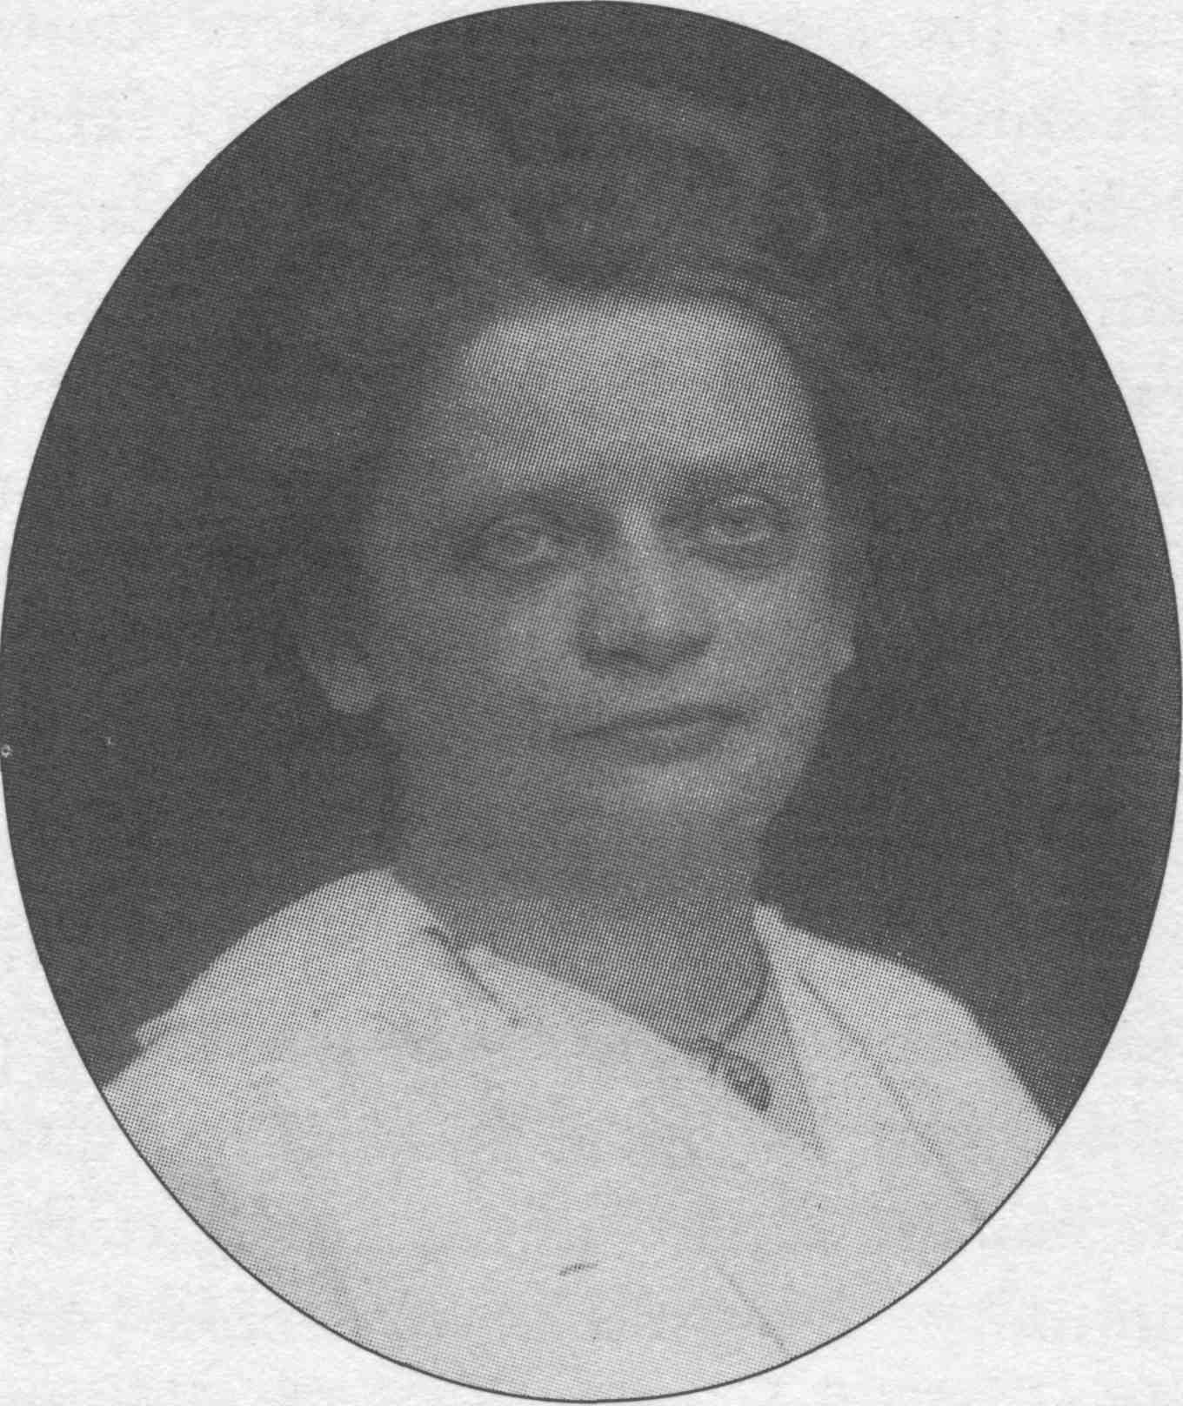
Alma Knobloch the leading Bahá’í teacher in Germany from 1907 to 1920.

cepted Bahá’u’lláh in 1903 in New York. In 1905 he went on pilgrimage; apparently Abdu'1-Bahá urged him to return to Germany to establish the Faith there. Fisher arrived in Stuttgart in the latter part of April 1905. He seems to have experienced modest success, for when Carl Scheffler, an American Bahá’í of German background, visited Stuttgart in mid-1907 he found six or seven Bahá’ís¹⁶
Fisher probably wrote Abdu’l-Bahá for assistance, for Abdu’l-Bahá sent a tablet to Ahmad Sohrab, a Persian Bahá’í residing in Washington, D.C., requesting that an additional teacher go to Germany. Alma Knobloch (1864-1943) responded. Like Dr. Fisher, she had been born in Germany, but she had moved to the United States with her parents as a child. In 1903 she and her family had accepted the Bahá’í Faith in Washington, D.C.; one of her sisters was Pauline Hannen, wife of Joseph Hannen and teacher of Louis G. Gregory, the most prominent African-American Bahá’í in the twentieth century.¹⁷ Knobloch set out for Germany on 17 July 1907 and arrived in Stuttgart on 9 August, after stops in Leipzig and Bremen. She found Fisher to be ill, earning little money, and spending almost all of it on his Bahá’í efforts. She noted in one letter that sometimes he had so little money left that he had to live on "bread & tea."¹⁸
Knobloch gave the first public address on the Bahá’í Faith in Germany at the Frauenclub (women's club) in Stuttgart on Tuesday, 29 October 1907. "It was a great success," noted Knobloch, in a letter to her family in Washington. "The Spirit simply filled the rooms & every one felt it, my it is wonderful.... there were a great many present the large room was filled & [in] the adjoining room were some."¹⁹
Knobloch was a deepened and dedicated Bahá’í teacher. Bahá’í meetings were held in homes in Stuttgart nearly every night, and the weekly meetings usually had about nineteen attendees. Soon the number of Bahá’ís in Stuttgart had increased to thirty. In January 1908 Sidney Sprague, who had undertaken the first teaching trip in England in late 1907, and Hippolyte Dreyfus, the first French Bahá’í, visited to give talks. In February 1908 the Stuttgart Bahá’ís organized a community and chose Mr. A. Eckstein as its chairman. Apparently they also selected a four-member working committee: Eckstein, the librarian; Wilhelm Herrigel, the treasurer; Mr. Reiger Vorstand; and Alma Knobloch. Although the committee did not last, it was the first Bahá’í consultative body in Europe. In March Knobloch informally celebrated Naw-Rúz (Bahá’í New Year), the first Bahá’í Holy Day known to be commemorated in Germany.²⁰
Regular Friday evening community meetings, with a structure similar to those held in the United States, were begun at the Burger Museum on 9 March 1908. The meetings began with a prayer, which was followed by a reading from the Bible, a reading from a Bahá’í tablet, a talk, another reading of a second tablet, and a closing prayer. In at least
36 WORLD ORDER: SPRING 1996

one case, a hymn was sung.²¹
Knobloch soon discovered that "Dr. F. aims for people of rank & position, others tire him & he has no time for them." In other letters Knobloch said that most of the converts resulting from Fisher's efforts were individuals of "education & culture" and that many had "government positions." She mentioned specifically a school principal and a "noted lawyer" among the new Bahá’ís. Most of the converts had been members of the Stuttgart Christian Science church; Knobloch observed that "we have almost all of the Gentlemen" of the church, and "their Reader is not very much pleased after having worked so hard for a number of years & now we come along & swipe their best members." Possibly other churches lost members to the Bahá’í Faith as well; Knobloch reported that at least one church denounced the Bahá’í Faith in its Easter sermon in 1908. One exception to the church converts was A. Eckstein, who became one of the most prominent Bahá’ís in Stuttgart; he had been the "head" of the city's United Swedenborgian group. The upper middle- to upper-class status and the often aristocratic background of the Stuttgart Bahá’í community concerned Knobloch. She felt that the other classes "make the best believers, & do not take it [the Bahá’í Faith] up as a fad." She apparently concentrated her effort on middle-class people; although she was not successful in reaching the "laboring or working class," she believed it was potentially very receptive. Her teaching of individuals of various social classes created a problem, because in Stuttgart, she explained, the classes usually didn't mix socially.²²
According to Knobloch, Edwin Fisher was not a particularly effective teacher: "he can't teach at all, he takes to [sic] much for granted; I mean [he assumes] that others know as much as he about the Truth [Bahá’í Faith] & tells them at once that God has appeared on Earth, but can't prove it in a way that they can understand, & is apt to get himself into trouble." Because Knobloch was apparently able to explain biblical prophecies much more persuasively than Fisher, the large number of seekers Fisher had been teaching became Bahá’ís after she arrived. Knoblochs articulate explanation of the Bahá’í teachings, coupled with her deep faith, her loving personality, and her great likableness, quickly made her the center of the Stuttgart Bahá’í community. "It would be a terriable [sic] test if I would get sick," she noted, "for the people think I am to [sie] spiritual that nothing could harm me, being in the service of God. They have such a high opinion of me. . . ."²³ Knobloch was extremely uncomfortable being the center of attention; she wanted to strengthen the Stuttgart Bahá’ís enough to be able to leave them and establish a Bahá’í community in another German city. Dr. Fisher was even less happy about her popularity, for it had caused a decrease in his status. As a result the relationship between Knobloch and Fisher deteriorated. When Knobloch first arrived, Fisher, like everyone else in the Stuttgart Bahá’í community, instantly liked her. In fact, he became so attracted to her that he asked her repeatedly to marry him. Knobloch noted that Fisher, though liked by many of the women in the Bahá’í community, wanted to marry an American and considered her arrival a providential response to his wish. Later she ascribed his request to marry her partly to a desire to control her and make her subservient to his opinions: "he can't bare [sic] to give in to a girl." In 1908 Fisher left Stuttgart for the resort of Homburg* for several months. When he returned, Knobloch noted that "his feeling towards me is anything but pleasent [sic] & is hard to bear, he likes me & hates me at
————————————————————
* This may be Homberg or Bad Homburg; Knoblochs spelling is notoriously imprecise.
37 THE BAHÁ Í FAITH IN ENGLAND AND GERMANY

the same time." As months passed, the latter feeling intensified.²⁴
In late 1909 Fisher began to work actively against Knobloch. He tried twice to organize a committee of men to govern the Stuttgart community; the committee that Knobloch had organized was probably functioning informally at most. The community was not interested in organization, and Fisher's efforts failed. He then asked Herrigel to write to Abdu’l-Bahá about organization; Abdu'l-Baha's reply, according to Knobloch, was that the time had not yet come for the German Bahá’ís to establish a consultative body of men. Fisher and Herrigel then organized a Friday meeting to compete against the Friday community meeting, held in a rented room, at which Knobloch spoke. The Friday community meeting continued; to minimize the disunity and encourage the Stuttgart Bahá’ís to become more independent of her, Knobloch stopped giving the talk and took as low a profile as possible.²⁵
On 30 January 1910 Fisher brought a Mr. Schnabel to the regular Monday evening gathering at the home of Emil Ruoff and told the Bahá’ís that Schnabel was a medium who was in psychic communication with Abdu'l-Bahá.* Knobloch protested that the Bahá’ís did not have mediums, but no one listened. The medium proceeded to receive questions from the Bahá’ís and write out answers "from" Abdu’l-Bahá, much to the Bahá’ís' interest and enjoyment. Through the entire evening Knobloch prayed silently to herself and received a psychic scolding that "it was not right for a soul to be uneasy & annoyed when He wishes to speak to us." She refused to ask any questions but the medium reported that Abdu’l-Bahá had a message for her: she was a "precious pearl" and would be "blessed," but there was "other work" for her—bringing "the pure Word of God in another Country."²⁶
Knobloch did not accept the "divine" guidance that she should leave Stuttgart and attempted—with little success—to dissuade the Bahá’ís that Schnabel could receive messages from Abdu’l-Bahá. The Stuttgart believers became extremely uneasy about the disagreement between their two teachers. Schnabel began to "reveal" "ugly things" about Knobloch and wrote that Fisher would marry one of Abdu’l-Bahá's daughters, whom Fisher had met while on pilgrimage. Knobloch wrote, then telegraphed Abdu’l-Bahá requesting advice. In early April she received two tablets promising Abdu’l-Bahá's "help and assistance. '
Meanwhile, Schnabel had attempted, and failed, to heal Mrs. Herrigel, who was ill. This proved to be a serious blow to his prestige because most of the Bahá’ís, who were former Christian Scientists, believed strongly in psychic healing. He left Stuttgart in early April 1910, much to Fisher's disappointment. The Bahá’ís continued to correspond with him, and for some time Knobloch's reputation continued to be clouded. But apparently Fisher ceased to attack her directly.²⁸
Despite the disunity, the Bahá’í Faith continued to grow in Stuttgart. The visits of other Bahá’ís gradually strengthened the Bahá’í community. Marion Jack, an active American Bahá’í teacher, visited in the fall of 1908 and Ahmad Yazdi, a prominent Persian Bahá’í, in September 1909.²⁹
The lack of Bahá’í literature in German, which was a severe problem, began to be remedied when Fanny Knobloch, one of Alma Knobloch's sisters in Washington, D.C., translated many tablets, and some of the German converts who knew English began to translate Bahá’u’lláh's Hidden Words, a significant Bahá’í scriptural work containing the eternal mystical and ethical truths of religion, and
————————————————
* Schnabel may not be the correct spelling, for Knobloch spelled the name several different ways— including Schnobeli—in her letters.
38 WORLD ORDER: SPRING 1996

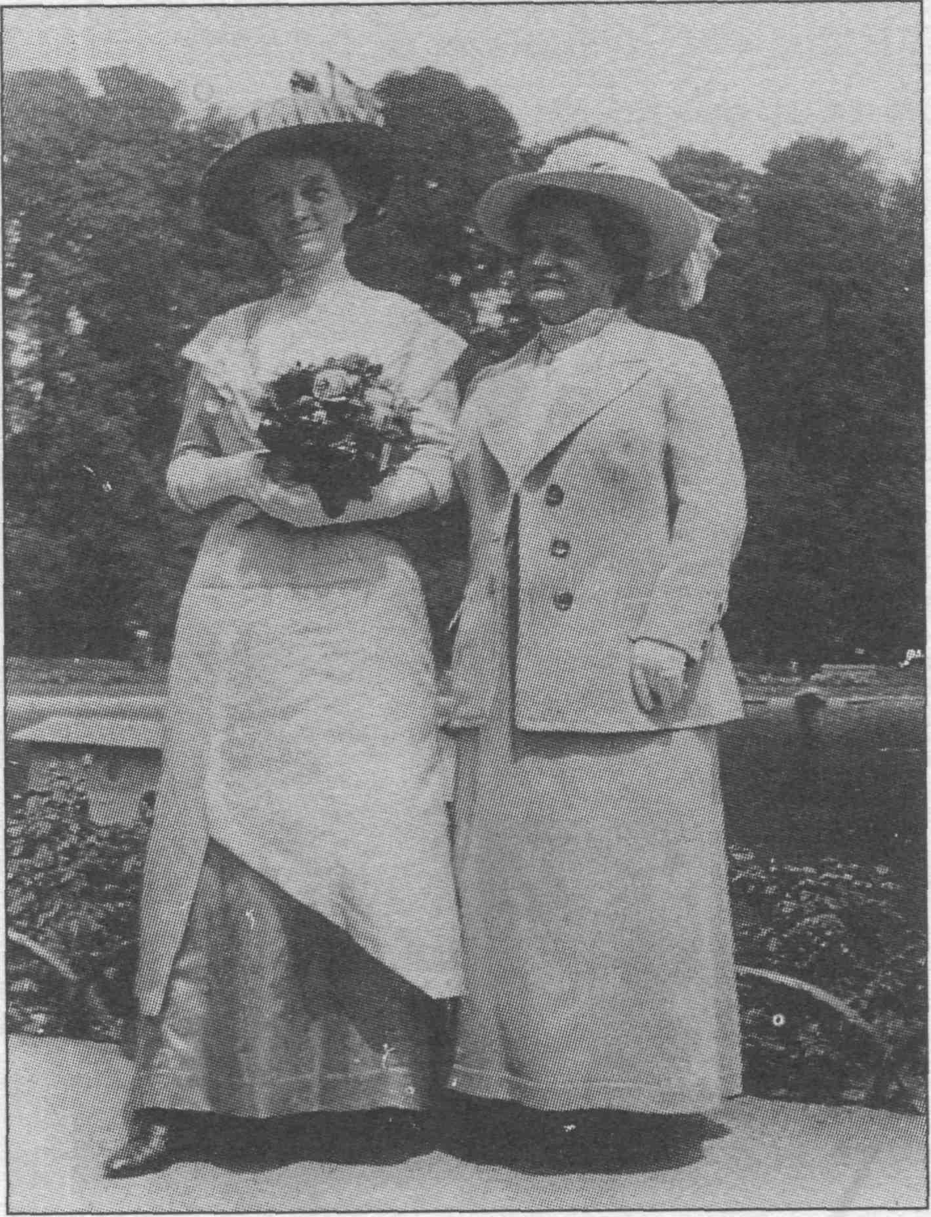
Fanny and Alma Knobloch Fanny (left), one of Alma's sisters,
helped translate many of the Bahá’í writings into German.

Abdu'l-Bahá's Some Answered Questions, an important summary of many basic Bahá’í teachings and the Bahá’í understanding of many Christian beliefs. Translations were first read at community meetings and then circulated in typed form. In the fall of 1909, two years before the English Bahá’ís established a Bahai Press, Wilhelm Herrigel organized a Bahá’í publishing organ. By 1911 it had printed German translations of The Hidden Words, Words of Wisdom and Communes; seven tablets by Bahá’u’lláh; two books by Sidney Sprague— The Story of the Bahai Movement and A Year Among the Bahais of India and Burma; one work by Isabella Brittingham— The Revelation of Bahá’u’lláh; a pamphlet by Thornton Chase—Before Abraham Was I Am. It also published a pamphlet by Herrigel written in German— Universal Peace, Universal Religion: The Bahai Movement?*
In the spring of 1909 several persons in Esslingen, six miles east of Stuttgart, became interested in the Bahá’í Faith. Knobloch visited, and by the fall a small community had formed. By 1911 Alma Knobloch had also taught the Bahá’í Faith in Switzerland and Austria through contacts made in Stuttgart.³¹
In 1911, when Abdu’l-Bahá was in Paris, many Stuttgart Bahá’ís went to meet Him. Because He was unable to visit Germany, He sent two Persians who had been traveling with Him—Ahmad Sohrab, a young and capable speaker, and Mírzá Asadu'llah, a knowledgeable, senior Persian Bahá’í—and Lady Blomfield, one of England's most experienced Bahá’ís, to meet with the German Bahá’ís. They arrived on 2 December 1911 and stayed several days. The meetings were well attended by Bahá’ís from Stuttgart, Esslingen, Zuffenhausen, Aalen, Felbach, and other places. At a dinner meeting, Knobloch and the visitors sat at one table, Fisher and the Herrigels at another, suggesting that the breach between the parties in Stuttgart had not completely healed and that Knobloch still held the place of honor. In April and May 1913 Abdu’l-Bahá visited Stuttgart. The meetings were crowded, one being attended by 250 persons. The Stuttgart Bahá’ís later wrote Abdu’l-Bahá to thank Him for His visit; sixty-three signed the letter, which probably represented the entire community.³²
By 1913 Germany had more Bahá’ís than England and France combined. The greater growth in Germany probably resulted from three factors. First, Alma Knobloch was an effective teacher. Second, the converts were natives. In contrast, all the Bahá’ís in Paris, except one family, were expatriates from America and England; even in London some of the Bahá’ís were American-born. Third, many of the new German Bahá’ís were middle class. Knobloch noted that upper middle-and upper-class individuals often became Bahá’ís because it was a "fad"; otherwise, they would be unlikely to convert to a strange and little-known religion. This may have been
39 THE BAHA'I FAITH IN ENGLAND AND GERMANY

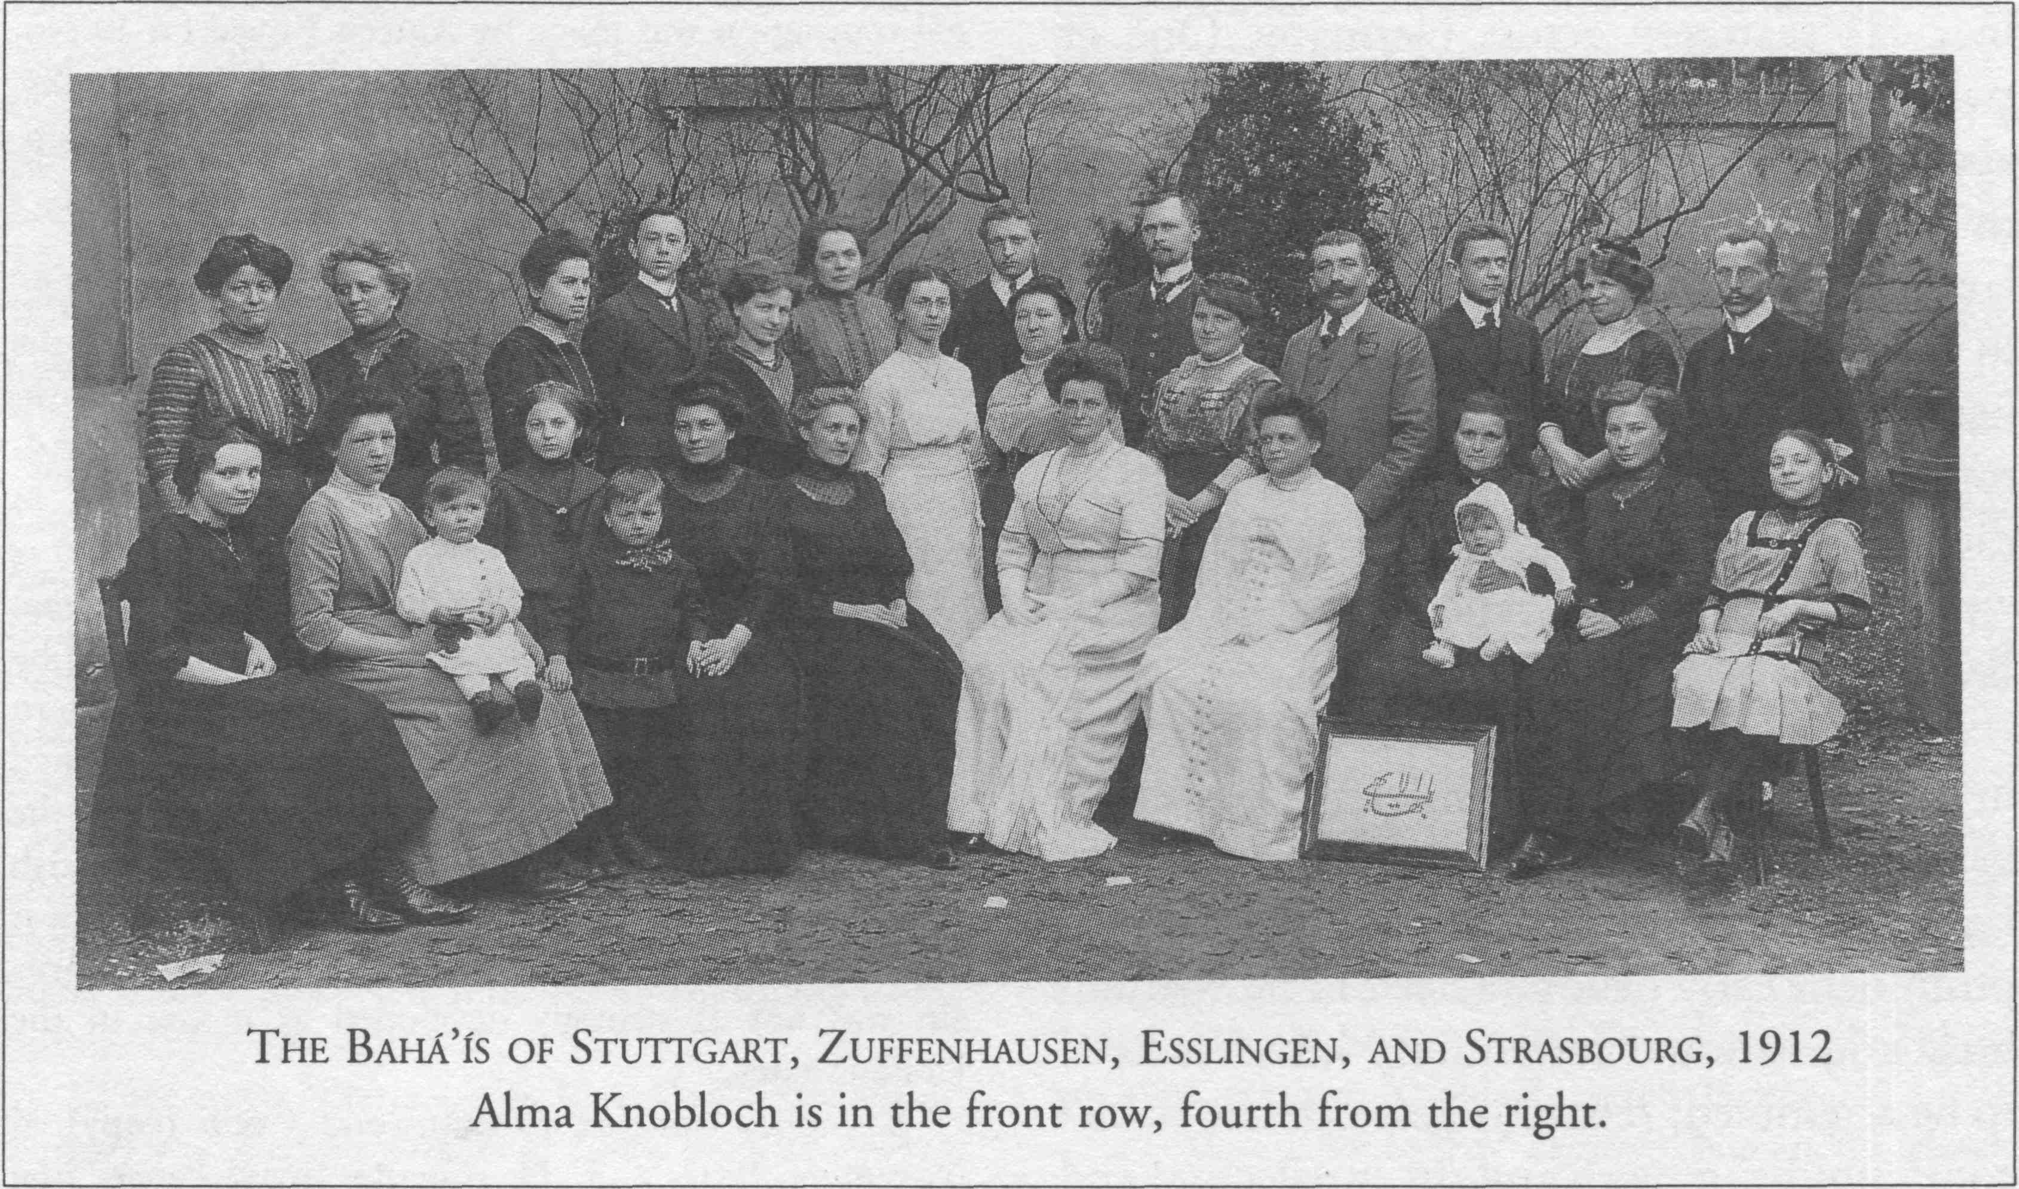

a reason why the Bahá’í Faith grew slowly in London, for the Bahá’ís there were upper class.
In 1914 Edwin Fisher left Germany for the United States where he remained until his death in Los Angeles in 1936. Alma Knobloch stayed in Germany until 1920, establishing communities in Leipzig and Hamburg as well as Stuttgart and teaching the Faith in Berlin, Chemnitz, Degenloch, Gera, Gotha, Munich, and many small towns. The German Bahá’ís had many trials ahead of them. In the 1920s Wilhelm Herrigel denied the authenticity of Abdu’l-Bahá's Will and Testament—one of His most important writings and a basic work of Bahá’í scripture in which He appointed His successor—and was expelled from the Bahá’í community. In the 1930s and 1940s the Nazis severely persecuted and nearly destroyed the community. Nevertheless, the Bahá’í Faith had been permanently established on German soil and was to grow to such an extent that in 1964 the first Bahá’í House of Worship on the European continent would be erected in Langenhain, near Frankfurt am Main.³³

Conclusion
Determining the number of Bahá’ís in Europe at the time of Abdu’l-Bahá's visit between 1911 and 1913 is difficult because records often do not exist. The number of Bahá’í in Paris can be roughly calculated by adding up all the names of persons who are known to have converted there. The community had acquired about two dozen members between 1899 and 1902, but many of them subsequently moved away; another dozen had joined the Faith by 1913. Most likely by 1913 the number of Bahá’ís in Paris had stayed about constant at two dozen or had declined. London is an enigma. A 1912 photograph of the Bahá’ís shows fifteen individuals; a 1913 photograph, forty-five. No statistics of its membership have been found in archival records. Manchester had about a half dozen Bahá’ís, and possibly as many as another half dozen were scattered across the rest of the British Isles. In Stuttgart sixty-three signed a letter to Abdu’l-Bahá in April 1913. It probably included Bahá’ís living in nearby cities, such as Esslingen and Zuffenhausen. Perhaps a half dozen or dozen Bahá’ís lived elsewhere
40 WORLD ORDER: SPRING 1996

in cities scattered across Germany. One or two German-speaking Bahá’ís who heard about the Faith through friends and relatives in Stuttgart resided in Austria and Switzerland. American Bahá’ís occasionally resided in Italy; no other Bahá’ís are known to have been permanent residents of any other European countries in 1913.³⁴ Adding up all of these very approximate numbers suggests that western Europe had about one hundred Bahá’ís at the beginning of 1913.
Much research is still needed, in archives in Europe and North America, to recover basic information about the early European Bahá’í community. More biographies of prominent early believers need to be written; local and national community histories need to be assembled; relations between the Bahá’í communities' growth and the intellectual and political trends of the times must be explored. Such work will illuminate the early roots of a community that, two generations later, embraces more than ten thousand western Europeans.

———————————————————
1. See Robert H. Stockman, The Bahá’í Faith in America: Origins, 1892-1900, Volume 1 (Wilmette, Ill.: Bahai Publishing Trust, 1985) 141, 156, and Robert H. Stockman, The Bahá’í Faith in America: Early Expansion, 1900-1912, Volume 2 (Oxford: George Ronald, 1995) 150-56.
2. The life of Ibrahim Kheiralla (1849-1929) is described in Stockman, Bahá’í Faith in America, Volume 1, especially chapters 2, 3, 4, and 12.
3. An excellent source of information on the early London Bahá’í community is Robert Weinberg, Ethel Jenner Rosenberg: The Life and Times of England's Out-standing Bahá’í' Pioneer 'Worker' (Oxford: George Ronald, 1995) 29-39.
4. Abdu’l-Bahá to Arthur Cuthbert, in Abdu'l-Bahá, Selections from the Writings of Abdu’l-Baha, comp. Research Department of the Universal House of Justice, trans. Bahá’í World Centre and Marzieh Gail (Haifa: Bahá’í World Centre, 1978), 63-64. The original translation was made by Ameen Fareed on 10 November 1906 and was published in Abdu’l-Bahá, Tablets of Abdul-Baha Abbas, vol. 3 (New York: Bahai Publishing Society, 1909-16) 541-44.
5. Abdu’l-Bahá, Selections 65.
6. Weinberg, Ethel Jenner Rosenberg 82.
7. The only published sociological analysis of the early British Bahá’í community is Phillip R. Smith, "The Development and Influence of the Bahá’í Administrative Order in Great Britain, 1914-1950," in Richard Hollinger, ed., Community Histories: Studies in Bábí and Bahá’í Religions, Volume 6 (Los Angeles: Kalimát Press, 1992) 153-215. Smith's analysis is dominated by the view that the British Bahá’ís—and the Western Bahá’ís in general—were not aware that they had joined an independent religion until Shoghi Effendi made the fact clear in the 1920s. The evidence about the British Bahá’ís that he cites may exaggerate the situation, but it does underscore the point that Bahá’í identity in Britain was not as strongly developed as it was in the United States.
8. Sidney Sprague to Stanwood Cobb (copy), 4 November 1907, 2-3, Dr. Duane Troxel Papers (the author expresses his gratitude to Dr. Troxel for a copy of the letter). National Spiritual Assembly of the Bahá’ís of the British Isles, The Centenary of a World Faith: The History of the Bahá’í Faith and Its Development in the British Isles (London: Bahá’í Publishing Trust, 1944) 51. Alice Buckton, another English Bahá’í, did not see the Bahá’í Faith as an independent religion; see "Abdul- Baha in London: A Word from Miss Alice Buckton,"Star of the West, 3.17 (19 Jan. 1913): 9.
9. Weinberg, Ethel Jenner Rosenberg 117-18.
10. Weinberg, Ethel Jenner Rosenberg, photo 18, shows 45 people in London in 1913, but it is impossible to know whether all of them considered themselves Bahá’ís or whether the picture included all Bahá’ís in London.
11. "News Item," Star of the West 2.16 (31 Dec. 1911): 14; National Spiritual Assembly of the Bahá’ís of the British Isles, Centenary of a World Faith 50-52. Jaxon, an early North American Bahá’í born in Canada, was interested in anarchism and socialism; for a short biography of him, see Stockman, Bahá’í Faith in America, Volume 1 90-93.
12. Weinberg, Ethel Jenner Rosenberg 142, 155-66, 175.
13. The Beginning of the Bahá’í Cause in Manchester (Manchester: Manchester Baha i Assembly, 1925) 2-3; O. Z. Whitehead, Some Bahá’ís to Remember (Oxford: George Ronald, 1983) 31-32.
14. Whitehead, Some Bahá’ís to Remember 32-33, 35, 36, 45, 60; The Beginning of the Bahá’í Cause in Manchester 3-6, 8.
15. Sidney Sprague to Stanwood Cobb (copy), 4 November 1907, Dr. Duane Troxel Papers.
16. Card for Karl Edwin Fisher, Bahá’í Historical
THE BAHÁ I FAITH IN ENGLAND AND GERMANY 41

Record Cards, microfilm collection K-18, National Baha í Archives, Wilmette, Ill.; Alma Knobloch to Pauline and Joseph Hannen, 31 December 1909, 3, Hannen-Knobloch Family Papers, Washington, D. C., Bahá’í Archives; Chase to Wilhelm Herrigel, 5 May 1910, Thornton Chase Papers, National Bahá’í Archives, Wilmette, Ill. For another summary of the establishment of the Bahá’í Faith in Germany, see R. Mielck, "On Bahaism in Germany," trans. Leslie Zanieh, Bahá’í Studies Bulletin, 1.2 (Sept. 1982): 50-56. Alma Knobloch's account of the establishment of the German Bahá’í community may be found in Moojan Momen, ed., "Esslemont's Survey of the Bahá’í Community in 1919-20, Part V: Germany, by Alma Knobloch," Bahá’í Studies Bulletin, 2.2 (Sept. 1983): 3-7. Knobloch also describes her efforts in Germany in "The Call to Germany," in The Bahá’í World: A Biennial International Record, Volume VII, 1936-1938, comp. National Spiritual Assembly of the Bahá’ís of the United States and Canada (New York: Bahá’í Publishing Committee, 1939) 732-45.
17. See Gayle Morrison, To Move the World: Louis G Gregory and the Advancement of Racial Unity in America (Wilmette, Ill.: Bahai Publishing Trust, 1982).
18. Alma Knobloch to "Most dearly beloved ones," 3 November 1907, 4, Hannen-Knobloch Family Papers.
19. Knobloch, "Call to Germany," in Bahá’í World, Vol VII 732-33; Alma Knobloch to "Most dearly beloved ones," 2-3 November 1907, 2, Hannen-Knobloch Family Papers.
20. Alma Knobloch to "Dearly beloved ones at home," 4 January 1908, Hannen-Knobloch Family Papers; Alma Knobloch to Fanny Knobloch, 4 April 1908, 5, 1-2, Hannen-Knobloch Family Papers. In Knobloch, "Call to Germany," in Bahá’í World, Vol VII 735, she says Stuttgart's committee had nine members and all were men.
21. Knobloch, "Call to Germany," in Bahá’í World, Vol VII 735; Alma Knobloch to Pauline Hannen, 13 June 1908, Hannen-Knobloch Family Papers; Alma Knobloch to "Dearly beloved ones at home," 5 December 1911, 3, Hannen-Knobloch Family Papers. Compare the format of the Stuttgart meeting with that of a similar weekly Bahá’í meeting held in Jersey City, New Jersey (Stockman, Bahá’í Faith in America, Volume 2 341).
22. Alma Knobloch to Pauline Hannen, 3 June 1908, 2, Hannen-Knobloch Family Papers; Alma Knobloch to "Dearly beloved ones," 2 June 1908, Hannen-Knobloch Family Papers; Alma Knobloch to Fanny Knobloch, 4 April 1908, 2, Hannen-Knobloch Family Papers; Alma Knobloch to "Dearly beloved ones at Home," April 1908, 2, Hannen-Knobloch Family Papers; Alma Knobloch to Pauline Hannen, 11 March 1908, Hannen-Knobloch Family Papers; Alma Knobloch to Fanny Knobloch, 4 April 1908, 4, Hannen-Knobloch Family Papers; Alma Knobloch to "Dearly beloved ones," April 1908, 1-2, Hannen-Knobloch Family Papers; Alma Knobloch to Fanny Knobloch, 4 April 1908, 5; Alma Knobloch to Pauline Hannen, 3 June 1908, 2-3, Hannen-Knobloch Family Papers.
23. Alma Knobloch to Pauline Hannen, 13 June 1908, 5, 2, Hannen-Knobloch Family Papers.
24. Alma Knobloch to "Most dearly beloved ones," 3 November 1907, 4, Hannen-Knobloch Family Papers; Alma Knobloch to Pauline Hannen, 13 June 1908, 5, Hannen-Knobloch Family Papers; Alma Knobloch to Pauline and Joseph Hannen, 31 December 1909, Hannen-Knobloch Family Papers; Alma Knobloch to "Dearly beloved ones at Home," 18 July 1908, 1, Hannen-Knobloch Family Papers.
25. Alma Knobloch to Pauline and Joseph Hannen, 31 December 1909, Hannen-Knobloch Family Papers; Alma Knobloch to Pauline Hannen, 14 February 1910, Hannen-Knobloch Family Papers.
26. Alma Knobloch to Pauline Hannen, 14 February 1910, Hannen-Knobloch Family Papers.
27 Alma Knobloch to Pauline Hannen, 14 March 1910, Hannen-Knobloch Family Papers; Alma Knobloch to Pauline Hannen, 21 May 1910, Hannen-Knobloch Family Papers.
28. Alma Knobloch to Pauline Hannen, 30 March 1910, Hannen-Knobloch Family Papers; Alma Knobloch to Pauline Hannen, 2 April 1910, Hannen-Knobloch Family Papers.
29. Alma Knobloch to "Dearly beloved ones at Home," 2 October 1908, 2, Hannen-Knobloch Family Papers; Alma Knobloch to Pauline Hannen, 27 September 1909, 1, Hannen-Knobloch Family Papers.
30. Alma Knobloch to Pauline Hannen, 13 June 1908, 3, Hannen-Knobloch Family Papers; Alma Knobloch to Pauline Hannen, 16 June 1909, 2, Hannen-Knobloch Family Papers; Alma Knobloch to "Dearly beloved ones at home," April 1908, 5, Hannen-Knobloch Family Papers; Mielck, "On Bahaism" 51, 55-56.
31. Alma Knobloch to Pauline Hannen and Fanny Knobloch, 12 May 1909, 1, Hannen-Knobloch Family Papers; Alma Knobloch to Fanny Knobloch and Pauline Hannen, 23 August 1911, 2, Hannen-Knobloch Family Papers; Alma Knobloch to Pauline and Joseph Hannen, 31 December 1909, Hannen-Knobloch Family Papers.
32. Alma Knobloch to "Dearly beloved ones at home," 5 December 1911, Hannen-Knobloch Family Papers; "Address by Abdul-Baha at Stuttgart and Esslingen, Germany," Star of the West, 4.9 (20 Aug. 1913): 155; "Address by Abdul-Baha at Stuttgart," Star of the West, 4.9 (20 Aug. 1913): 156-57; "Budget of Letters from German Bahá’ís," Star of the West, 4.9 (20 Aug. 1913): 158-59, 161.
33. Card for Karl Edwin Fisher, Bahá’í Historical Record Cards, National Bahá’í Archives; Momen,
42 WORLD ORDER: SPRING 1996

“Esslemont's Survey of the Bahá’í Community in 1919-20, Part V: Germany by Alma Knobloch," Bahá’í Studies Bulletin, 2.2 (Sept. 1983): 3; Rosa Schwartz, "Alma Knobloch," in The Bahá’í World: A Biennial International Record, Volume IX, 1940-1944, comp. National Spiritual Assembly of the Bahá’ís of the United States and Canada (Wilmette, Ill.: Bahá’í Publishing Committee, 1945) 641-43.
34. All the records of Paris Bahá’ís that I have discovered in archival sources I have included in my card file of early American Bahá’ís, 1894-1912. No data is available on London, except the photograph of the community in O. Z. Whitehead, Some Early Bahá’ís of the West (Oxford: George Ronald, 1976), opposite 84, and photograph 18 in Weinberg, Ethel Jenner Rosenberg. All known Manchester Bahá’ís have been mentioned in the text; "Budget of Letters from German Bahais," Star of the West, 4.9 (20 Aug. 1913): 161; Alma Knobloch to Pauline and Joseph Hannen, 31 December 1909, Hannen-Knobioch Family Papers; Alma Knobloch to Fanny Knobloch and Pauline Hannen, 23 August 1911, 2, Hannen-Knobioch Family Papers.

