Bibi Tuba, the Sister of the Martyr Varqá
by Vedad Theophilus
2021

Here is a very rough translation and abridgment of a certain passage of a Persian Bahá’í history book published by the father of Adib Taherzadeh and transcribed and sent to me by Adib Taherzadeh in a letter. I do not know the name of this book or where it can be found. The history book, written in Persian, and the letter containing the transcribed passage, also written in Persian, were rendered in English here with the help of my son. Starting at the third paragraph, the notes about Bibi Ridvan Tabib (Tabib meaning Doctor) is from my own knowledge.
- Vedad Theophilus, 2021

The revered Bibi Tuba, the daughter of Haji Mulla Mihdi-i-‘Atri, was a wellspring human virtue. This family was, in every aspect, a new creation; they were true Bahá’ís. The sole token and solace for Haji Mulla Mihdi-i-‘Atri was this holy leaf, Bibi Tuba, who was then living alone in the town of Yazd. Suddenly, this bright house was cast into darkness with the passing of her father, and she stayed alone in this sad home, without her father, without her mother, without her brother, and surrounded by enemies of the Faith. She then married and had children with Mirza Husain Ali Tabib, son of Mirza Mohsen Tabib. She had three children: two daughters and one son. Her youngest child was her son Zikrullah, who would be killed at the age of twelve for reasons which remain unknown.
Now you may get a picture of how Bibi Tuba suffered. This tragedy occurred during the time of Jalal od-Dowleh. After this tragedy, her husband, Mirza Husain Ali Tabib, passed away. Bibi Tuba, who lost her young husband and youngest son, living with her two fatherless children, would soon suffer another tragedy, the martyrdom of both her innocent brother and nephew, Varqá and Rúḥu’lláh. Finally, amid these calamities and her anguish, she passed away and her remains were laid to rest in the Bahá’í Cemetery in Yazd. Many tablets were revealed for Bibi Tuba, which are now housed in the International Baha'i Archives in Haifa, Israel.
My grandmother on my mother’s side, Bibi Ridvan Tabib, was the oldest daughter of Bibi Tuba. As a doctor, she was renowned in all of Yazd for her miraculous healing abilities, known for saving the life of patients resigned to death by other doctors.

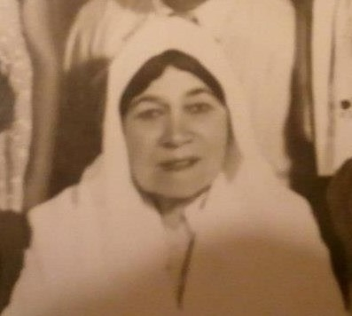
This is a photograph of Doctor (Tabib) Bibi Ridvan Vargahi, daughter of Bibi Tuba.

