Faith, Art, & Spirituality

Have you ever received a card that spoke to you — became a saver? This is one I’ve saved. I think you’ll definitely be moved by the poem, authored by someone named “Drew.”
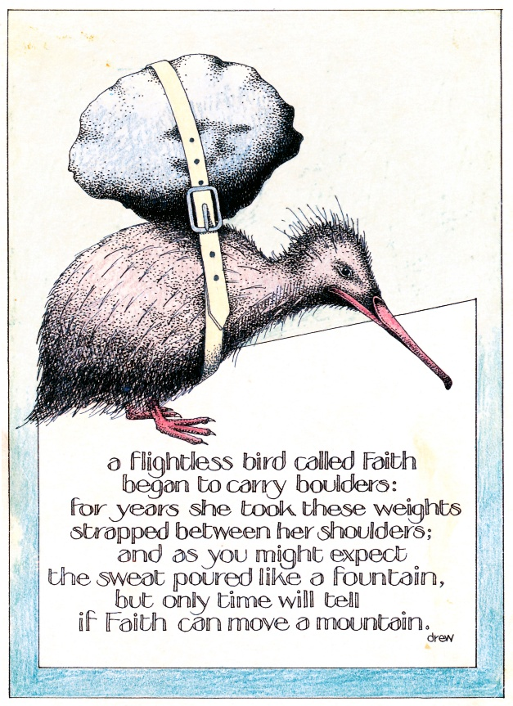

There’s probably not one of us who hasn’t carried boulders around at some time in her life. For many years, the boulders I moved from place to place were ones blocking my identity. Oh, yes, I was Jaine, the wife, mom, daughter, friend. But if I were to take away the husband, parents, friends, etc., I wasn’t sure just who would be there — if I’d want to spend time alone with her — and if I did, whether I’d like her. I felt lost and spiritually bankrupt.
The Bahá’í teachings direct us, as all religions do, to seek spiritual sustenance through daily prayer, meditation and study of Scripture. But as I began to study the Bahá’í Writings in earnest, I discovered another very interesting area that is also addressed. The Writings of the Bahá’í Faith assert that the arts are a key to spiritual transformation.
Artists have always known this, and many of those who are moved by art have at least suspected so. But never before has it been as clearly stated in religious text. I was intrigued by the vast number of references in Bahá’í Scripture that relate to the arts.
I learned that the source of art, the inspiration for the artist, comes from the realm on high: from the Light radiated by the Prophets, and from the souls who remained firm and unwavering in their faith before moving on to the next plane of existence.
The station of art is seen differently than in general society: it is actually equated with worship:
If a man engages with all his power in the acquisition of a science or the perfection of an art, it is as if he has been worshiping God in the churches and temples.¹
It is also said to be an important service:
What greater bounty than this, that science should be considered as an act of worship and art as service to the Kingdom of God.²
And it is a gift:
All Art is a gift of the Holy Spirit. When this light shines through the mind of a musician, it manifests itself in beautiful harmonies. Again, shining through the mind of a poet, it is seen in fine poetry and poetic prose. When the Light of the Sun of Truth inspires the mind of a painter, he produces marvelous pictures.³
You may well wonder why this is so. Bahá’u’lláh, Prophet-Founder of the Bahá’í Faith, explains:
...the true worth of artists and craftsmen should be appreciated, for they advance the affairs of mankind.⁴
Let’s repeat “they advance the affairs of mankind.”
Our Writings assert that the arts will, if managed with propriety,
...become the means of sociability and affinity, and sociability and affinity themselves tend to guide others to the truth.⁵
How is this possible? How does it work? Here are just a few excerpts from our Writings that provide some explanation:
Poetry is much more complete and effective than prose. It stirs more deeply, for it is of a finer composition.⁶
Endeavor your utmost to compose beautiful poems to be chanted with heavenly music; thus may their beauty affect the minds and impress the hearts of those who listen.⁷
...music assists us to affect the human spirit; it is an important means which helps us to communicate with the soul.
They go on and on, from drama to literature to architecture and other areas of the arts.
I took these and many other references to heart. They were the emotional calisthenics that helped me to develop the spiritual muscles to keep moving those boulders around in my search for my identity, my spiritual reality.
I actively sought a creative outlet. After feeble attempts at the typical “womanly” ones: handcrafts like sewing, knitting and crocheting, it quickly became apparent that old fumble-fingers lacked the necessary dexterity. Drawing was definitely not my forté, although I took a drawing class in order to rid myself of that dirty four-letter word “can’t.” Dancing was out; even though I had grace and a good sense of rhythm, my knock knees and tree trunk ankles were a stumbling block. Singing wasn’t an option; I can’t hold a tune; my voice is not one that would move others, except maybe to leave the room. But I avoided being discouraged by realizing that each boulder I dropped lightened my load.
My faith came from the Bahá’í explanation that the teaching “we are all made in the image of God” is not meant in a physical sense, but rather that latent within us are all the names and attributes of God, like kindness, mercy, generosity, trustworthiness, etc. and our spiritual growth is dependent on, and equal to, the extent to which we develop those attributes. Whenever I start to list them, invariably the first I come up with is God, the Creator. It stands to reason then that we are all, inherently, creative beings. I became more determined to discover the creative being that was lurking in the shadows of my soul.
I beseeched God for direction and soon recognized that my talent was with words and speech, so I pursued both acting and writing. Inspiration poured forth in abundance.

So excited was I about what was taking place in my life that I wanted to share it, so I developed workshops on The Arts: a Key to Spiritual Transformation, Art and Spirituality and Discovering the Artist Within to assist others to, to trust in the validity of their efforts, and to know this is neither a frivolous nor an unimportant pastime. I also present one called The Art of an Eloquent Tongue which fine tunes speaking skills and helps eliminate the fear of speaking before an audience.
These three areas, acting, writing, and workshops, as well as public speaking, have become the passions of my life.
In all my efforts, I include quotations from the Bahá’í Writings, like:
By the power of the Holy Spirit, working through his soul, man is able to perceive the Divine reality of things. All great works of art and science are witnesses to this power of the Spirit.⁸
and
Meditation is the key for opening the doors of mysteries....This faculty brings forth from the invisible plane the sciences and arts. Through the meditative faculty inventions are made possible, colossal undertakings are carried out...⁹
These words remind me that I am not alone—that my inspiration comes from a higher Source. I just need to remember to humble myself and tap into it. So, on those occasions when I am able to detach myself from my out being—my ego—and seek inspiration from the Prophets and the blessed souls who’ve gone forth to the life after this life, I become removed from intellectualizing and analyzing and can allow the inspiration to flow.
Bahá’ís are taught that our purpose in life is twofold:
The primary purpose of life is to know and to worship God, and to contribute to an ever-advancing global civilization.¹⁰
I linked to the latter half of that statement this quotation from Chinese dramatist Cao Yu:
Art for art’s sake is a philosophy of the well-fed.¹¹
and to the Bahá’í admonition:
Let deeds not words be your adorning.¹²
Therefore, I now direct my art to issues within myself or society that call for growth and change.
I began to address my acting to parts that will move others and help create change in the world, especially ones that address social issues like the status of women and race unity. I performed as part of Re-Generation, an inter-racial group that presented a program called Soul-Searching, which addressed race relations in the United States. These types of programs are important because as Rollo May wrote,
Art is an antidote for violence.¹³
And the Bahá’í Writings say that the arts have the power to
...promote the well-being and harmony of all the kindreds of the earth.¹⁴
because
Art can better awaken...noble sentiments than cold rationalizing.¹⁵
For myself, I work out questions of life, frustration, fear, anger—with the pen. It’s very cathartic. Although, the vast majority of my writing is of a joyous nature. It celebrates life and is full of hope and expectation.
The more feedback I get from people who’ve been touched by the message I convey, whether through a performance, poem, story or workshop, the more determined I become to further hone my skills and reach out through the arts to more of my human family. When someone tells me of an actual change is spurred them to effect in their own life, I know that it was not my words with which they connected, but the spirit.
And I’ll share a secret with you. I never really gave up singing. I sometimes use song, and movement, in offering my prayers, provided of course, I have complete privacy when doing it. Try it sometime. You may find a whole new dimension in your communication with the Beloved.
In the process of creating, interpreting and presenting my art, I’ve undergone significant changes. I’m more in tune with who I am, and am delighted to admit, I like myself! Not only don’t I mind being alone with Jaine, I definitely enjoy it.
I’ve developed a spiritual strength I wish I’d had in my younger years. It has served me well in times of crisis. Some of this results from coming to terms with who I am: identifying my God-given talents, developing them, and putting them to practical use. But it also comes from prayer.
For most of my life, when I prayed, I’d beseech God for some specific need or want, but I’ve gotten to the point now where I fear it’s presumptuous, and realize that what I wish for perhaps might not be in my best interest, or the best interest of another person for whom I may be praying if I simply ask for what I want. Instead, I let God know what is in my heart and then pray only for His Will. But I do ask that if His Will be other than what I hoped for, He give me the strength and wisdom to accept it without feeling hurt, let down, sad or bitter.
I still have my moments of frustration and anxiety, but I’m able to recover from them faster. I’m still moving boulders, but each one shrinks my shadow mountain and adds to my mountain of enlightenment. All this has come about through faith—my faith in a loving, benevolent, yet just, God, and my understanding that His Wisdom obviously transcends mine. This, too, is a sign of spiritual growth. Faith is the foundation for spirituality.

See online, with related works, at https://bahai-library.com/toth_four_talks
¹‘Abdu’l-Bahá, Bahá’í World Faith, pp. 377-378
²‘Abdu’l-Bahá, Bahá’í World Faith, p. 378
³‘Abdu’l-Bahá, quoted in Lady Blomfield, The Chosen Highway
⁴Bahá’u’lláh, quoted in Guidance to Poets, with Compilation on Writers and Writing, compiled by the Universal House of Justice
⁵‘Abdu’l-Bahá, Bahá’í World Faith
⁶‘Abdu’l-Bahá, quoted in Bahá’í Writings on Music
⁷‘Abdu’l-Bahá, Tablets of ‘Abdu’l-Bahá, vol. 1, p.59
⁸‘Abdu'l-Bahá, Paris Talks, p. 85
⁹‘Abdu'l-Bahá, Paris Talks, p. 175
¹⁰Bahá’í International Community, 1992, Magazine - The Bahá’ís
¹¹www.greatquotes.com
¹²Bahá’u’lláh, The Hidden Words (#5 from the Persian)
¹³Rollo May, quoted in Larry Chang, Wisdom for the Soul: Five Millennia of Prescriptions for Spiritual Healing
¹⁴Bahá’u’lláh, Tablets of Bahá’u’lláh, p. 72
¹⁵In a letter written on behalf of Shoghi Effendi, quoted in the U.S. Bahá’í News, #73, May 1933, p. 7

