SCRIPT: MARTYRDOM OF THE BáB

Today we are gathered to commemorate the martyrdom of the Báb. For those of you new to the Bahá’i Faith and its history, this Bahá’i Holy Day recalls an event which took place 163 years ago in Persia and yet is believed to have initiated changes that impact the world today and will continue to do so for hundreds of years more.

The basic questions are: Who was the Báb? What did He teach? Why was he killed? What relevance does His Life and Death have for us today?

(No images of the Báb are shown in this program.)
Each (check mark) symbol means you should click to advance the program. Read the narration before clicking!
 | Image on Screen | Narration | Click(s)
 |  |  | 
1 |  |  | leave  Title on  Screen 3  seconds
2 |  | Now let’s roll the earth counter-clockwise | 
3 | 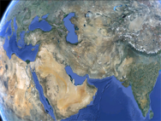 | Now we see the Caspian Sea, the Persian Gulf and the Indian Ocean. | 
4 | 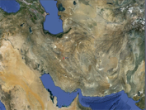 | Let’s go closer. | 
5 | 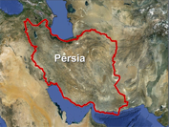 | Finally we have reached the land where our story begins. Persia, called the “Land of the Lion and the Sun”. | 
6 | 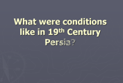 | What were conditions like in 19th Century Persia? | 
7 |  | Modern inventions had not yet penetrated Persia. There were no trains; no system of communication beyond the ship or the horse; electricity didn’t arrive until very late in the century. | 
8 | 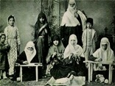 | Unlike its neighbor, the Ottoman Empire, Persia throughout the 19th century lagged behind in military, educational, economic and social advancement. | 
9 | 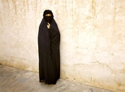 | Women had few rights in Persian society and their roles were largely confined to that of mother and home-maker. Men had absolute authority over their wives and children. And under the prevailing custom, a man could have up to four wives. | 
10 | 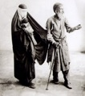 | Poverty and ignorance were widespread. The government had no systems of social welfare or public education. Beggars abounded in every city. | 
11 | 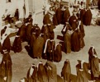 | Women were completely closeted in solitary confinement under their chadors. They could tbe seen but had no voice in public affairs. They did not get the vote until 1963. | 
12 | 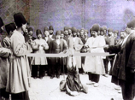 | In those days the bastinado was a common punishment meted out in public to the offender. This consisted of binding the victim’s feet to an upraised pole—permitting the bottoms to be struck with sticks or whips. After such punishment walking was well-nigh impossible. | 
13 | 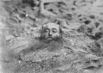 | This man was buried alive for the crime of theft. | 
14 | 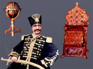 | At the top of society sat the royals— a dynasty of rulers known as the Qajars [caw-jars]. This Shah’s grandfather had over 1,000 wives and nearly 300 children; hence the Persian proverb ‘Camels, fleas, and princes exist everywhere.’ | 
15 | 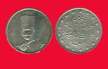 | Nearly every government position was purchased by “gifts” — known by a less polite word elsewhere. | 
16 | 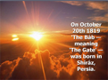 | On October 20th, 1819 The Báb, meaning ‘The Gate’, was born in Shíráz [sheer-Oz], Persia. | 
17 | 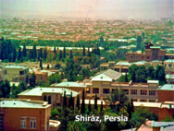 | Shíráz [sheer-Oz] is a beautiful city, the cultural heart of Persia, a city celebrated for its beauty and the poetry of Hafez. | 
18 | 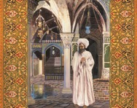 | The Báb’s father died when the Báb was still a child and He was raised by His maternal uncle. | 
19 | 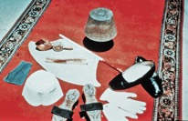 | Every account of the Báb’s childhood indicates that He was an extraordinary Child. There were many reports of His pure character and charming presence. | 
20 | 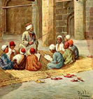 | When He was sent to school, He so surprised [His] school-master, with His wisdom and intelligence that the bewildered man took the child back to His uncle, and said that he had nothing to teach this gifted pupil: 'He, verily, stands in no need of teachers such as I.' | 
21 | 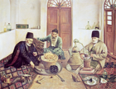 | The Báb became a merchant in His uncle’s business So astute was He that His Uncle gave over management of his trading house to Him when He was only 20. | 
22 |  | At the age of 22 the Báb took a wife. | 
23 | 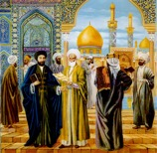 | It was around this same time that a very wise spiritual teacher and his leading disciple were teaching that the advent of a promised Holy One was soon to appear in the world. Their names were Shaykh Ahmad [shake-a-h-mad] and Siyyid Kazim [say-yed-caw-zem] [say-yed-caw-zem]. | Shaykh  Siyyid  
24 | 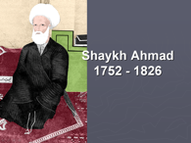 | When Shaykh Ahmad [shake-a-h-mad] died his leading disciple, Siyyid Kazim [say-yed-caw-zem] gave his followers a description of the age and attributes of the Promised One. | 
25 | 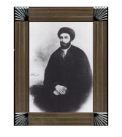 | On the last day of 1843 Siyyid Kazim [say-yed-caw-zem] died, but not before he instructed his followers to scatter far and wide and search for the Promised One, Who appearance was imminent. | 
26 | 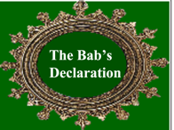 |  | leave  Title on  Screen 3  seconds
27 | 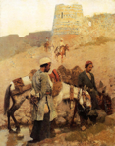 | The disciples scattered far and wide, praying for guidance. Mulla Husayn [mo-law ho-sane], foremost disciple of Siyyid Kazim [say-yed-caw-zem] [say-yed-caw-zem], and his companions reached the outskirts of Shíráz [sheer-Oz], on 22 May 1844. | 
28 | 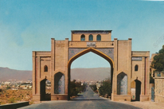 | At gate of Shíráz [sheer-Oz], Mulla Husayn [mo-law ho-sane] instructed his brother and his nephew to proceed to lodgings in the city where he would meet them later for evening prayers. | 
29 | 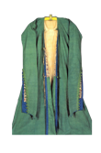 | While walking outside the gate just before sunset Mulla Husayn [mo-law ho-sane] saw a Young Man walking towards him. He said, He greeted me with a smile of loving welcome, embraced me and invited me to His home. | 
30 | 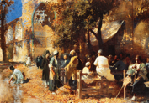 | Mulla Husayn [mo-law ho-sane] pleaded to be excused as his companions were now awaiting his return. The Young Man said, “Commit them to the care of God, He will surely protect and watch over them.” | 
31 | 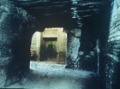 | “As I followed Him, his gait, the charm of His voice, the dignity of His bearing only enhanced my first impression of Him”. | 
32 | 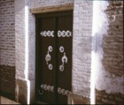 | As Mulla Husayn [mo-law ho-sane] entered the house his Host uttered this holy verse: | 
33 | 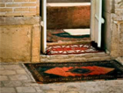 | “Enter therein in peace secure”. | 
34 | 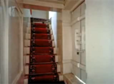 | They ascended the stairs | 
35 | 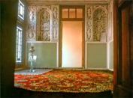 | and entered the upper chamber, where they were seated. The Báb asked the purpose of Mulla Husayn [mo-law ho-sane]’s journey. Mulla Husayn [mo-law ho-sane] explained he was searching for the Promised One. | 
36 | 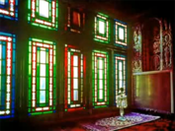 | The Báb asked what were the proofs this Promised One must give. After Mulla Husayn [mo-law ho-sane] had cited each one the Báb exclaimed: | 
37 | 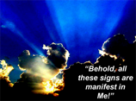 | “Behold, all these signs are manifest in Me!” | 
38 | 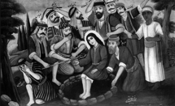 | Unasked, the Báb then gave an additional proof, known only to Mulla Husayn [mo-law ho-sane]. With incredible speed He wrote a commentary on the story of the Biblical Joseph, unraveling a mystery that had perplexed Muslim divines for hundreds of years. | 
39 | 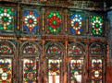 | Mulla Husayn [mo-law ho-sane] was overcome with joy. The Báb cautioned him not to tell anyone. He said 18 souls must, uninvited, find Him through visions and dreams. Then He would give them each a special mission. | 
40 | 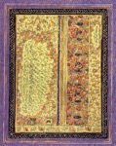 | Within a short time the remaining souls found the Báb; to each He wrote a Tablet assigning a specific task. These souls the Báb collectively titled: “The Letters of the Living”. Before sending them on their missions He called them together. Here are a few sentences of what He said. | 
41 | 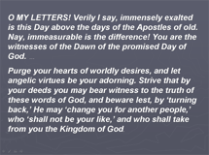 | O MY LETTERS! Verily I say, immensely exalted is this Day above the days of the Apostles of old. Nay, immeasurable is the difference! You are the witnesses of the Dawn of the promised Day of God. Purge your hearts of worldly desires, and let angelic virtues be your adorning. Strive that by your deeds you may bear witness to the truth of these words of God, and beware lest, by ‘turning back,’ He may ‘change you for another people,’ who ‘shall not be your like,’ and who shall take from you the Kingdom of God. | O M  Strive  
42 | 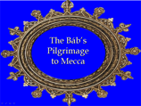 | Accompanied by a Letter of the Living named Quddus [kod-dooss] and His servant the Báb set out for Mecca to make His Declaration to the keeper of the Holiest Shrine in Islam. | leave  Title on  Screen 3  seconds   
43 |  | In October of 1844 the Báb sailed from the port city of Bushihr [boo-shair] in Persia to Jiddih [jed-dah], in Arabia. [AFTER CLICKING ONCE WHEN YOU ARRIVE ON THIS SCREEN, WAIT 2 SECONDS AFTER THE SHIP SAILS OFF THE SCREEN TO THE LEFT BEFORE CLICKING AGAIN.] | wait  
44 | 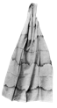 | “Upon His arrival in Jiddih [jed-dah], the Báb donned the [traditional] pilgrim’s garb”. | 
45 | 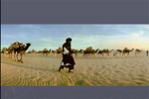 | He then mounted a camel and set out for Mecca, a 40 mile journey. | 
46 | 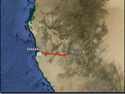 | ] | 
47 | 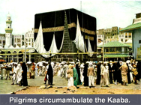 | In Mecca, Pilgrims circumambulate the Kaaba [ca-beh], the holiest shrine in all Islam. | 
48 | 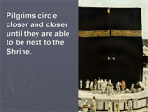 | Pilgrims pray while circling closer and closer until they are next to the Shrine. | 
49 | 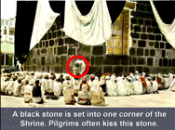 | A black stone is set into one corner of the Shrine. Pilgrims often kiss this stone as a sign of reverence. | 
50 | 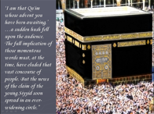 | “The Báb stood against the structure of the Ka'bah[ca-beh], laid hold of the ring on its door and thrice repeated, in a clear voice: ‘I am that Qa'im [caw-‘em] whose advent you have been awaiting.’ a sudden hush fell upon the audience. The full implication of those momentous words must, at the time, have eluded that vast concourse of people. But the news of the claim of the young Siyyid soon spread in an ever-widening circle.” | 
51 | 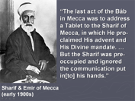 | “The last act of the Báb in Mecca was to address a Tablet to the Sharif of Mecca, in which He proclaimed His advent and His Divine mandate. But the Sharif was pre-occupied and ignored the communication put in[to] his hands.” | 
52 | 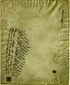 | Once back in Persia, the Báb then gave instructions to His foremost disciple—Quddus [kod-dooss]—advising him of the persecution he would soon endure and promising they would meet again, this time in Paradise. | 
53 | 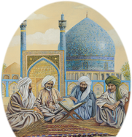 | Quddus [kod-dooss] and another follower of the Báb began to teach the new Revelation in Shíráz [sheer-Oz] They were audacious. A loud clamor soon followed. Shiah [she-eh] fanatics branded them enemies of Islam. | 
54 | 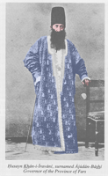 | They were brought in chains before the merciless provincial governor, Husayn Khan [ho-sane-con]. A book revealed by the was taken from them. Husayn Khan read these words aloud: 'Divest yourselves of the robe of sovereignty, for He who is the King in truth, hath been made manifest!’ The governor indignantly wanted to know if he and the Shah should yield their leadership to this new Messenger. In so many words he was told, ‘Yes’, they should. | 
55 | 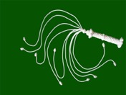 | The governor was furious. He ordered the man stripped and whipped with a thousand lashes. “He then commanded that the beards of both [men] should be burned, their noses be pierced, and through this incision a cord should be passed, and with this halter they should be led through the streets of the city” as an object lesson of the penalty for heresy | 
56 | 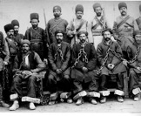 | The governor then ordered his personal guards to arrest the Báb and bring Him in chains to his presence. Before the guards could seek out the Báb He found them and surrendered Himself. So surprised were they that they didn’t put Him in chains. | 
57 | 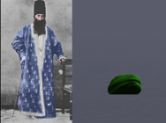 | The Báb was brought before Husayn Khan, who publicly insulted Him, blaming Him for disgracing the Holy Faith of Islam. The Báb responded with a quotation from the Quran that inflamed the governor; he ordered his attendant to strike the Báb’s in the face; which he did with such violence that the Báb’s turban fell to the ground. | 
58 | 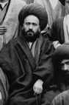 | The chief Mulla of Shíráz [sheer-Oz], impressed by the Báb’s quoted verse, intervened saying the matter required “great care”. He then questioned the Báb, asking if He was the Qa'im’s [caw-‘em] representative. The Báb denied that He was. The Mulla then demanded the Báb publicly deny this in the city’s main mosque. | 
59 | 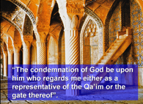 | That Friday the Báb mounted the pulpit and said “The condemnation of God be upon him who regards me either as a representative of the Qa’im [caw-em] or the gate thereof”. Of course the Báb wasn’t the representative of the promised Qa'im. He was the promised Qa’im! | 
60 | 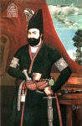 | Around this time the king of Persia, Muhammad Shah, delegated his top religious expert to interrogate the Báb and report back. Not only did the Báb answer all his questions satisfactorily. He even answered an unasked question that the divine told himself would be the ultimate proof He was the Promised One. The divine became a Bábí and resolved to devote his life to this Faith. | 
61 | 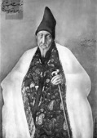 | At that time the Shah had put the entire government into the hands of his prime minister—Haji Mirza Aqasi [haw gee mere zaw awe caw see]. Aqasi was also the Shah’s chief spiritual adviser. He is known to history as the ‘Antichrist of the Báb’s Revelation’. | 
62 | 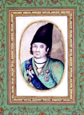 | The Shah then ordered the Governor of Isfahan, who was hosting the Báb, to send Him on to Tihran [teh-Ron]. | 
63 |  |  | leave  Title on  Screen 3  seconds
64 | 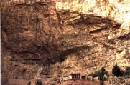 | But the sinister Prime Minister prevented the Báb from meeting the Shah by having him sent to the remote prison fortress of Mah-Ku [maw-coo] where He would languish nine months. | 
65 | 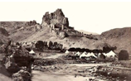 | In April of 1848 the Báb was transferred to another remote fortress. This time it was to Chihríq [cheh-reek], which He designated as the “Grievous Mountain”. | 
66 | 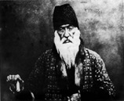 | At Chihríq [cheh-reek] the Báb was under strict confinement by order of the Prime Minister. Nevertheless, the warden, Yahya Khan [ya-h-ya-con] felt the love of the Báb penetrate his heart and “claim his entire being”. So too the Kurdish inhabitants who begin to invoke His name and clamor to seek His blessings. | 
67 | 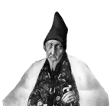 | Again the meddling Prime Minister intervened. In July of 1848 he ordered the Báb be brought from Chihríq [cheh-reek] to Tabriz [tab-reez] to be examined by a panel of religious experts. | 
68 | 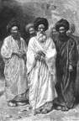 | The most distinguished doctors of divinity were assembled together in [tab-reez]. | 
69 | 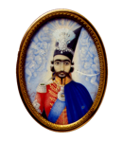 | Also present in that gathering was the 17 year old Crown Prince Nasiri’d-Dín Mírzá—then governor of Tabriz [tab-reez]—and who—in just three months—would become the reigning Shah of Persia. | 
70 | 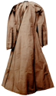 | The Báb was ushered in. “A deep, a mysterious silence, suddenly fell upon” the gathering. The only vacant seat was reserved for the Crown Prince. Without hesitation the Báb sat in it. | 
71 | 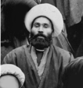 | The president of the proceedings broke the silence asking, “Whom do you claim to be, and what is the message you have brought? | 
72 | 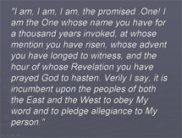 | The Báb responded: "I am, I am, I am, the promised .One! I am the One whose name you have for a thousand years invoked, at whose mention you have risen, whose advent you have longed to witness, and the hour of whose Revelation you have prayed God to hasten. Verily I say, it is incumbent upon the peoples of both the East and the West to obey My word and to pledge allegiance to My person." | 
73 | 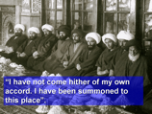 | The chief Mulla “insolently reprimanded the Báb: “You wretched and immature lad of Shíráz [sheer-Oz]!” Saying he was attempting to foment turmoil. The Báb responded, ‘I have not come hither of my own accord. I have been summoned to this place.’ | 
74 | 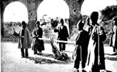 | It was decided that the priest who was the highest religious authority in Tabriz [tab-reez] should administer punishment to the Báb. Eleven times he struck the Báb on the bottoms of His feet. One of his errant blows struck the Báb on the face. (Later that same year this same priest was struck with paralysis and died.) | 
75 | 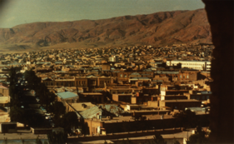 | It was at this time we get our first glimpse of the Báb through Western eyes. After the bastinado was inflicted on the Báb, the Crown Prince’s personal physician was sent to attend Him, along with two Persian doctors. They were to ascertain whether the Báb was sane or not. And to report whether or not the Báb should be executed. | 
76 | 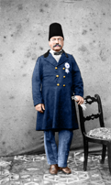 | The Prince’s physician was Dr. William Cormick. He later wrote [The Báb] “was a very mild and delicate-looking man, rather small in stature and very fair for a Persian, with a melodious soft voice, which struck me much.” …[A]s the Báb was aware of my having been to see whether he was of sane mind or merely a madman, ,,,he was lo[a]th to answer any questions put to him. To all enquiries he merely regarded us with a mild look, chanting in a low melodious voice …. | 
77 | 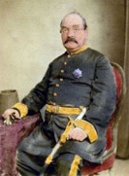 | Two of his intimate friends, were also present, who subsequently were put to death… . He only once deigned to answer me, on my saying that I was not a [Muslim] and was willing to know something about his religion, as I might perhaps be inclined to adopt it. He regarded me very intently on my saying this, and replied that he had no doubt of all Europeans coming over to his religion. Our report to the Sháh at that time was of … to spare his life.” | 
78 | 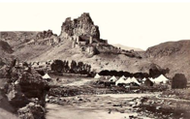 | The Báb was then returned to the fortress castle of Chihríq [cheh-reek], where he languished for nearly two more years. | 
79 | 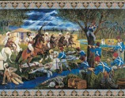 | During this time over 300 followers of the Báb were entrapped by the Shah’s army and were brutally slaughtered. Two of the Báb’s foremost disciples, Mulla Husayn [mo-law ho-sane] and Quddus [kod-dooss], perished. | 
80 | 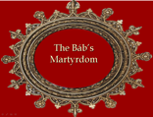 |  | leave  Title on  Screen 3  seconds
81 | 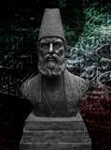 | The chief minister of the Shah, called the Amír Kabir [am-eer cab-ear], signed the death warrant of the Báb. | 
82 | 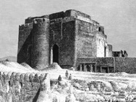 | The Báb was taken under guard from Chihriq [cheh-reek] to Tabriz [tab-reez] in June 1850, and again installed in the building known as the Ark. | 
83 | 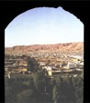 | In early July guards came to His cell to escort the Báb and His secretary to the barracks where they would be held until the time of execution. | 
84 |  | The guards took away the Báb’s green turban and belt the two emblems of His noble lineage. | 
85 | 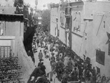 | Under guard, the Báb and His amanuensis were conducted through the streets of Tabriz [tab-reez] enroute to the barracks where He was to be executed. | 
86 |  | “Suddenly, a young man pushed through the crowds of onlookers, “breathless with excitement and exhausted with fatigue, he flung himself at the feet of the Báb and, seizing the hem of His garment, passionately implored Him: "Send me not from Thee, O Master. Wherever Thou goest, suffer me to follow Thee." | 
87 | 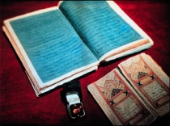 | Amazingly the Báb addressed him by name and said, "arise, and rest assured that you will be with Me! Tomorrow you shall witness what God has decreed." | 
88 | 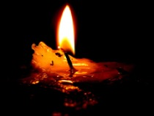 | "That night the face of the Báb was aglow with joy, a joy such as had never shone from His countenance.” . He said, Tomorrow will be the day of My martyrdom.” | 
89 | 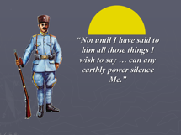 | Early the next morning, while the Báb was speaking with His secretary, a guard interrupted Him. The Báb boldly remarked, “Not until I have said to him all those things I wish to say can any earthly power silence Me.” The guard conducted the Báb to his regimental commander, Sam Khan. | 
90 | 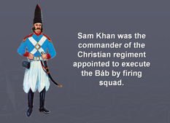 | Sam Khan spoke to the Báb: “I profess the Christian Faith and entertain no ill will against you. If your Cause be the Cause of Truth, enable me to free myself from the obligation to shed your blood.” The Báb said, “Follow your instructions and if your intent be sincere, the Almighty is surely able to relieve you from your perplexity.” | 
91 | 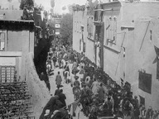 | Thousands crowded the rooftops to catch a glimpse of the Báb and His companion enroute to the place of execution. | 
92 | 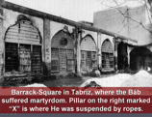 | The Báb and His companion were suspended by ropes from a spike driven into the wall of the barracks. The head of the young man was placed against the chest of the Báb. | 
93 |  | At the command to fire, the smoke from hundreds of black powder muskets filled the barracks square, blotting out the sun. | 
94 | 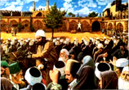 | “As soon as the cloud of smoke had cleared away, an astounded multitude were looking upon a scene which their eyes could scarcely believe. There, standing before them alive and unhurt, was the companion of the Báb, …. had vanished …from their sight.” | 
95 | 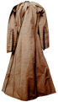 | After a frenzied search they found Him, “seated [unruffled and uninjured] in the same room which He had occupied the night before, engaged in completing His interrupted conversation.” The Báb calmly said to the guard, "Now you may proceed to fulfil your intention." | 
96 |  | Sam Khan resolutely refused to attempt a second execution, even should it cost him his life. |   
97 | 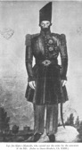 | As Sam Khan’s soldiers were leaving, the Colonel of the body-guard volunteered to carry out the order for execution. It was now noon, July 9th, 1850. | 
98 |  | Before the muskets were about to be fired the Báb addressed the thousands of onlookers: “Had you believed in Me, O wayward generation, every one of you would have followed the example of this youth, who stood in rank above most of you, and willingly would have sacrificed himself in My path. The day will come when you will have recognized Me; that day I shall have ceased to be with you." | 
99 | 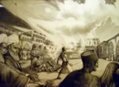 | “The very moment the shots were fired, a gale of exceptional severity swept over the whole city” | 
100 |  | “A whirlwind of dust of incredible density obscured the light of the sun and blinded the eyes of the people.” | 
101 | 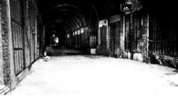 | The bullet-riddled Body of the Báb was cast into a moat to be eaten by dogs. Devoted Bábís rescued it and hid it for nearly 50 years. | 
102 | 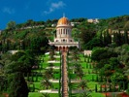 | The Báb’s remains now rest in glory in the Holy Land in the bosom of Mt. Carmel, where it is a point of pilgrimage for all Bahá’ís. | 
103 |  |  | leave  Title on  Screen 3  seconds
104 | 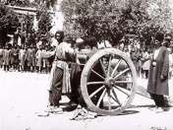 | Following the Martyrdom of the Báb the persecution against His followers increased all over the country. Thousands were brutally put to death in ways so heinous we show only one of the milder forms of execution here. | 
105 | 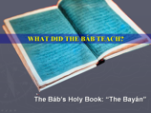 | Now we will address the question posed at the beginning: what did the Báb teach? |   
106 |  | God has a Plan to spiritualize mankind, because we are essentially spiritual beings. Like pupils in a school, we advance as our understanding increases. This process is called Progressive Revelation. |   
107 |  | In every age God sends His Heavenly Messenger to take humanity another step forward. | 
108 | 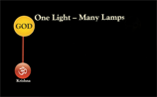 | Some of those Messengers were: Krishna | 
109 | 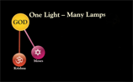 | … Moses | 
110 | 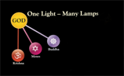 | … Buddha | 
111 | 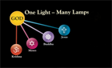 | … Christ | 
112 | 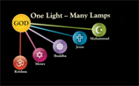 | … Muhammad | 
113 | 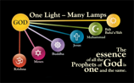 | … and the Twin Manifestations of the Báb and Bahá’u’lláh. | 
114 | 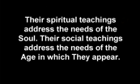 | Their spiritual teachings address the needs of the Soul. Their social teachings address the needs of the Age in which They appear. | 
115 | 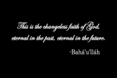 | Bahá’u’lláh said, “This is the changeless faith of God, eternal in the past, eternal in the future.” | 
116 |  | The Báb’s mission was to prepare humanity for global transformation—this went well beyond the provincial thinking of the time. His duty was to give the Message: their duty to use God’s Words to purify their hearts. | 
117 | 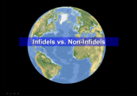 | His message challenged the narrow perspective of hidebound beliefs that divided the world into infidels and non-infidels. |   
118 | 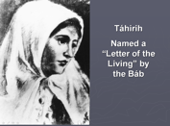 | Though there are many specific teachings of the Báb there is not time to enumerate them today. We should note, however, that the Báb elevated the status of women; going so far as to appoint the famous poetess, Táhirih [taw-hair-eh], one of His Disciples. |   
119 | 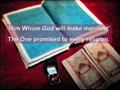 | The second part of the Báb’s mission was to prepare humanity for ‘Him Whom God will make manifest’. Like John the Baptist, the Báb prepared for an even greater Advent: The Coming of the Promised One of all religions. |   
120 | 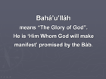 | Nearly all Bábís embraced the Faith of Bahá’u’lláh: Who is ‘Him Whom God would make manifest’. Bahá’u’lláh’s name means ‘the Glory of God’. | 
121 | 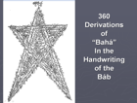 | The Báb addressed a Tablet to Bahá’u’lláh in the shape of a star which consisted of 360 derivations of the word “Bahá”. | 
122 | 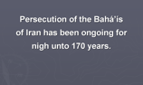 | Persecution of the Bahá’ís of Iran has been almost constant for well-nigh 170 years. | 
123 | 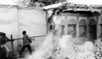 | In the early 1980s the beautiful House of the Báb in Shíráz [sheer-Oz] was reduced to rubble by religious fanatics. | 
124 | 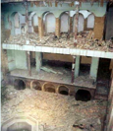 | In 2004 the House of Bahá’u’lláh In Tihran was destroyed by enemies of the Faith. | 
125 | 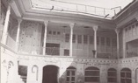 | In just the past two weeks word has reached the world that the House of Bahá’u’lláh in Baghdad was destroyed. That’s three Bahá’í Holy places in recent memory. | 
126 | 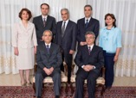 | Currently, seven Bahá’is—our brothers and sisters—completed five years of a 20 year sentence. Their crime: believing in the Báb and Bahá’u’lláh and refusing to recant those beliefs. In the words of a U.S. government official: The “plight of the seven Bahá’i leaders is emblematic of the persecution suffered by the entire Bahá’i community there and also of other religious minorities in Iran. | 
127 | 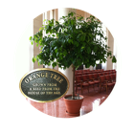 | This Holy House of Worship holds one living treasure originating from the Hand of the Báb. Upstairs, in the temple, is an orange tree. Though a fortuitous chain of events, seeds from an orange tree of the Báb’s House have become a living legacy here in this holy House of Worship. | 
128 | 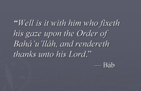 | I would like to close this part with a quotation from the Báb: “Well is it with him who fixeth his gaze upon the Order of Bahá’u’lláh, and rendereth thanks unto his Lord.” | 
129 |     

